

Understanding Workflow in Windows SharePoint Services and the 2007 Microsoft Office System

Version 1.0, 7/11/06

David Chappell, Chappell & Associates

© Copyright Microsoft Corporation 2006. All rights reserved.
Contents
The Value of Human Workflow 3
Technology Basics 4
Windows Workflow Foundation 4
Windows SharePoint Services 5
Workflow and Windows SharePoint Services Version 3 7
Combining Windows Workflow Foundation and Windows SharePoint Services 7
Workflow in Windows SharePoint Services: A Scenario 8
Authoring a Workflow 9
Associating a Workflow with a Document Library or List 9
Starting a Workflow 9
Interacting with a Workflow 12
Summarizing the Process 14
Authoring Windows SharePoint Services Workflows 16
Authoring Workflows with Visual Studio 2005 and WF Workflow Designer 17
Authoring Workflows with Office SharePoint Designer 2007 19
Workflow and Office SharePoint Server 2007 22
Combining Windows Workflow Foundation, Windows SharePoint Services, and Office SharePoint Server 22
Workflow in Office SharePoint Server: A Scenario 24
Authoring Office SharePoint Server Workflows 29
Authoring Workflows with Visual Studio 2005 and WF Workflow Designer 29
Authoring Workflows with Office SharePoint Designer 2007 30
Making a Technology Choice 30
Conclusion 31
Resources 31
About the Author 32

The Value of Human Workflow
Businesses depend on business processes. While those processes often involve software, the most important processes in many organizations depend on people. Automating interactions among the people who participate in a process can improve how that process functions, increasing its efficiency and lowering its error rate. Using software that supports this kind of human workflow can make organizations more effective.
Many kinds of processes in many different kinds of organizations can benefit from automated support for human workflow. Examples include:
- Approval: A common aspect of human-oriented business processes is the need to get approval from multiple participants. What’s being approved can vary widely, ranging from a Word document containing next year’s marketing plan to an expense report from a trip to a conference. In every case, some number of people must review the information, perhaps appending comments, then indicate approval or rejection.
- Coordinating group efforts: Whether it’s preparing a response to an RFP, managing the translation of a document into one or more languages, or something else, many processes require people to work together in an organized way. By defining the steps of the process in an automated workflow, the group’s work can be made more efficient and the process itself more predictable.
- Issue tracking: Many business processes generate a list of outstanding issues. An automated workflow can be used to maintain that list, assign issues to the people capable of resolving them, and track the status of that resolution.
To support these kinds of automated business processes, Microsoft Windows SharePoint Services version 3 can run human workflow applications. Based on Windows Workflow Foundation (WF), these applications interact with people through a Web browser and, if necessary, with other software as well. To create workflow applications, developers use WF’s Workflow Designer and Visual Studio 2005, while information workers use the new Office SharePoint Designer.
Microsoft Office SharePoint Server 2007, part of the 2007 Microsoft Office system, adds more capability to workflow applications built on Windows SharePoint Services. Using this product, workflows can use custom forms created with Microsoft Office InfoPath 2007 to interact with users through Office applications such as Word 2007 and Outlook 2007. Office SharePoint Server also includes several pre-defined workflows, letting information workers create automated business processes for approval and other common situations.
Both Windows Workflow Foundation and Windows SharePoint Services version 3 will be standard parts of Windows, while Office SharePoint Server is a separately licensed product. All of these technologies, together with the tools for creating workflows that use them, are scheduled to be released around the end of 2006. This paper introduces these tools and technologies, describing what they do and how they do it. The goal is to provide a big-picture view of Microsoft’s support for human workflow in Windows SharePoint Services and the 2007 Office system.

Technology Basics
Understanding Microsoft’s support for human workflow requires a basic grasp of the two fundamental technologies that underlie this support: Windows Workflow Foundation and Windows SharePoint Services. This section briefly describes each one.

Windows Workflow Foundation
It’s common for software to implement some kind of process, with multiple steps performed one after another in a defined order. Given how often this approach is used, why not provide explicit support for creating this kind of application? The goal of Windows Workflow Foundation is to do exactly this. An application built with WF consists of one or more workflows, each of which contains some number of activities. A workflow’s activities are executed one at a time by WF’s runtime engine, with the execution order determined by the workflow itself. By providing direct support for process-oriented applications, WF can make those applications easier to create and maintain.
The figure below shows WF’s main components. A workflow, built from activities, executes using the runtime engine. This execution depends on a set of runtime services, provided by WF, that allow persisting a workflow’s state, tracking its execution, and more. All of this runs inside some host, which can be any Windows process ranging from a simple desktop application to a scalable server. And to accommodate different requirements imposed by different hosts and different kinds of applications, the WF runtime services can be replaced if necessary.

As the figure indicates, workflows can be created using WF Workflow Designer. This tool runs inside Visual Studio 2005, and it provides a graphical environment for organizing activities into workflows. An activity is just a class, so it’s also possible to create workflows purely in code—using a graphical tool isn’t required. Although a workflow can use any activities a developer chooses, WF provides a Base Activity Library (BAL). The BAL includes a number of fundamental activities, including the following:
- IfElse: executes the activities contained in two or more possible paths based on whether a condition is met.
- While: repeatedly executes one or more activities as long as a condition is true.
- Sequence: executes a group of activities one at a time in a defined order.
- Parallel: executes two or more groups of activities in parallel.
- Code: executes a defined chunk of code.
- Listen: waits for one of a set of events, then executes one or more activities when that event is received.
- InvokeWebService: calls a Web service.
- Policy: allows defining and executing business rules using a WF-supplied rules engine.
WF provides two types of built-in workflows:
- Sequential workflows, which execute activities in a defined order. A sequential workflow can contain IfElse, While, and any other activities.
- State machine workflows, which implement a traditional finite state machine. This type of workflow can also contain IfElse, While, and other activities, but it depends on other activities such as State to represent states and transitions.
It’s important to understand that WF isn’t itself a complete workflow application. Instead, it provides a foundation for developers to create workflow-based software. And because it can be hosted in any Windows process, WF can be combined with other technologies to provide workflow services. Windows SharePoint Services version 3 does exactly this, and so the next step in understanding Microsoft’s support for human workflow is to understand the basics of this technology.

Windows SharePoint Services
Sharing information is a fundamental part of modern life. Whether in our jobs, as part of a volunteer organization, or in some other way, we frequently need to share documents and other information with a group of people. Windows SharePoint Services, a standard part of Windows Server 2003, can make this sharing easier.
As the figure below illustrates, users of Windows SharePoint Services can create sites, each of which contains document libraries and lists. The information in each site, including documents and list items, is stored in SQL Server. Using Internet Information Services (IIS), people can interact with sites from Microsoft Office applications or a Web browser such as Internet Explorer. Users can also customize the browser interface using Web Parts, allowing each user to create an interface that works well for her.

Version 3 of Windows SharePoint Services also adds support for content types. A content type provides a schema that defines a document or list item. By default, every document in a given library has the same schema, as does every item in a particular list. Attaching a content type to a document or list item allows specifying the schema of that document or item independently from the other elements of the library or list it belongs to. Policies can also be attached to content types, specifying things such as how long a document should be retained. These polices will then be applied to any document or item to which that policy is attached.
It’s possible for multiple machines running Windows SharePoint Services to access a single SQL Server database or a group of databases with sites partitioned across them. This improves scalability, allowing access to the same sites by a large number of users. It’s also worth pointing out that although they’re logically separate and appear to users differently, documents and items are actually quite similar under the covers: both are just entries in SQL Server tables. There are some differences—documents can be checked in and out, for example, while items cannot—but the distinction between the two has more to do with how a user sees them than with how they’re implemented.
Windows SharePoint Services also relies on other standard Windows technologies. It can use Active Directory to identify users, for example, and its user interface, including Web Parts, is built on ASP.NET. Both because it’s a standard part of Windows and because it addresses a common set of problems, Windows SharePoint Services has become a very popular technology. It’s used by many organizations for sharing many different kinds of information. Until Windows SharePoint Services version 3, however, there was no built-in support for creating workflows. How version 3 makes this possible is described next.

Workflow and Windows SharePoint Services Version 3
Both WF and Windows SharePoint Services are useful on their own. The ability to create human workflow applications built on the document-oriented features of Windows SharePoint Services would be even more useful, however. Windows SharePoint Services version 3 makes this possible. Built using WF, this new release will be included with the forthcoming version of Windows Server code-named “Longhorn”, and will also be freely available as an optional update for Windows Server 2003 via Windows Update.

Combining Windows Workflow Foundation and Windows SharePoint Services
As described earlier, the WF runtime engine can be hosted in any Windows process. Windows SharePoint Services version 3 takes advantage of this, acting as a host for this engine. One or more workflow templates, each containing the code that defines a particular workflow, can be installed on a server. Once this is done, an association can be created between a specific template and a document library, list, or content type. This template can then be loaded and executed by the Windows SharePoint Services-hosted WF runtime engine, creating a workflow instance. The figure below shows how this looks.

Like all WF workflows, those based on Windows SharePoint Services version 3 rely on WF’s runtime services. To better support workflows hosted in Windows SharePoint Services, however, version 3 replaces some of those built-in services. WF’s standard persistence service has been modified, for example, to allow the state of a persisted workflow to be linked with the document or item with which that workflow is associated.
Having an architectural view of how the parts fit together is useful, and it’s an essential aspect of understanding workflows in Windows SharePoint Services version 3. The best way to understand what’s really going on, however, is to look at a typical scenario using this technology. The next section walks through a simple example of using a Windows SharePoint Services workflow.

Workflow in Windows SharePoint Services: A Scenario
The most common example of human workflow in most organizations is some variation of approval: a group of people must approve or reject some document, perhaps adding comments to explain their decisions. Reflecting this popularity, the example here shows how an approval workflow implemented using Windows SharePoint Services might look. Before walking through this example, it’s useful to define the roles played by different people. Those roles include:
- Workflow author: the developer or information worker who creates a workflow template.
- Windows SharePoint Services administrator: the person who installs a workflow template and associates it with a document library or list.
- Workflow initiator: the person who starts a running workflow, causing a workflow instance to be created from a particular workflow template.
- Workflow participants: the people who interact with a workflow instance to carry out the business process it supports.
As described next, individuals in each of these roles have their own parts to play in creating, installing, instantiating, and using a workflow.

Authoring a Workflow
Microsoft provides two options for creating workflows that target Windows SharePoint Services. Developers use Visual Studio 2005 and WF Workflow Designer, while information workers use the simpler rules-based approach provided by Office SharePoint Designer. In both cases, the result is a workflow template that must be deployed to a server running Windows SharePoint Services. Workflow authoring is described in more detail later in this paper, so for now, this scenario assumes that a template has already been created.

Associating a Workflow with a Document Library or List
Before it can be used, a workflow template must be installed on a Windows SharePoint Services system, then associated with a particular document library, list, or content type. After this is done, the workflow can be started from any document or item in that library or list. Workflows operate in the same way on items and documents, and so a workflow template can typically be attached to either (although it’s possible to create a template that can be associated only with an item or only with a document). And while workflows can’t be explicitly started from content types, a workflow associated with a content type can be started from a document or list item to which that content type has been attached.
Both installation and association are done automatically for workflows created using Office SharePoint Designer. For those created using WF Workflow Designer and Visual Studio, however, a Windows SharePoint Services server administrator must explicitly install the workflow template. Once this is done, the template must be associated with a library, list, or content type, something that can be performed by someone with lesser permissions than a server administrator. Whoever creates this association also assigns it a unique name, allowing it to be referenced by users. Optionally, the workflow’s author can let the person who creates the association set options for the workflow’s behavior, such as specifying a default list of people who should always participate in the process. The same template can be associated with multiple libraries, lists, or content types, with each association customized as required. After the association has been created and any options set, a workflow initiator can create a workflow instance from this association, as described next.

Starting a Workflow
Windows SharePoint Services provides three options for creating a workflow instance. All three run the workflow from the beginning every time. (In fact, if a workflow instance created from a particular association is currently running, it’s not possible to create another instance from that same association.) The choices are:
- The workflow can be started manually by a Windows SharePoint Services user.
- The workflow can be configured to run automatically when a document or item is changed.
- The workflow can be configured to run automatically when a document or item is created. For example, a Microsoft Word user might save a new document into a site’s document library, thereby causing an instance of a workflow associated with that library to be executed. A workflow initiator can use Microsoft Word 2007 or older versions to do this. It’s even possible to start workflows in this way from non-Microsoft applications.
This scenario uses the first of these three options: starting a workflow manually. The screen below shows how a document in a document library can appear to a Windows SharePoint Services user. To start a workflow instance from this document, the user clicks on the document and chooses Workflows from the menu.
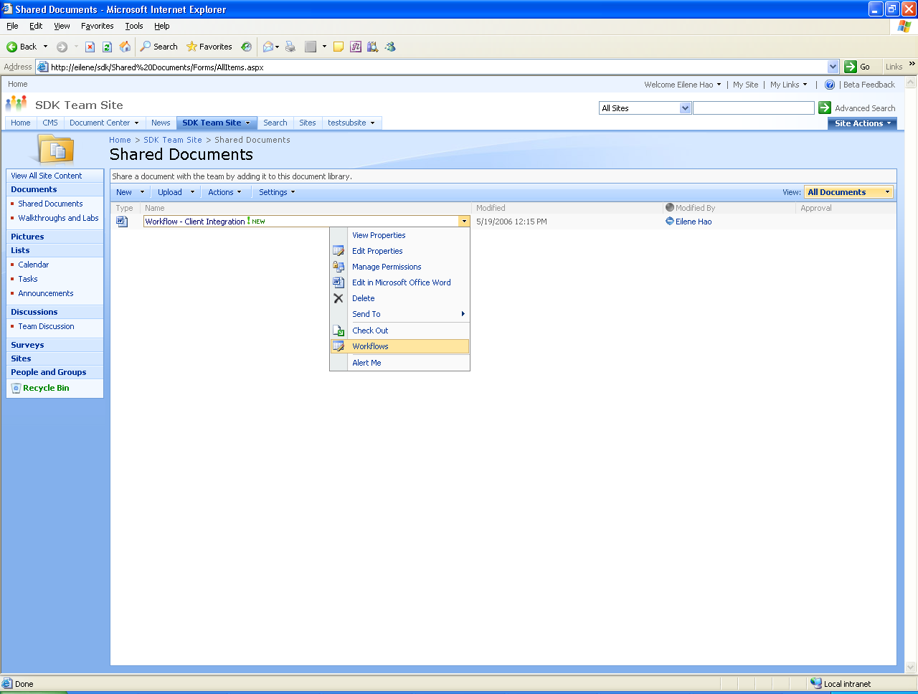

Making this selection brings up the following screen:
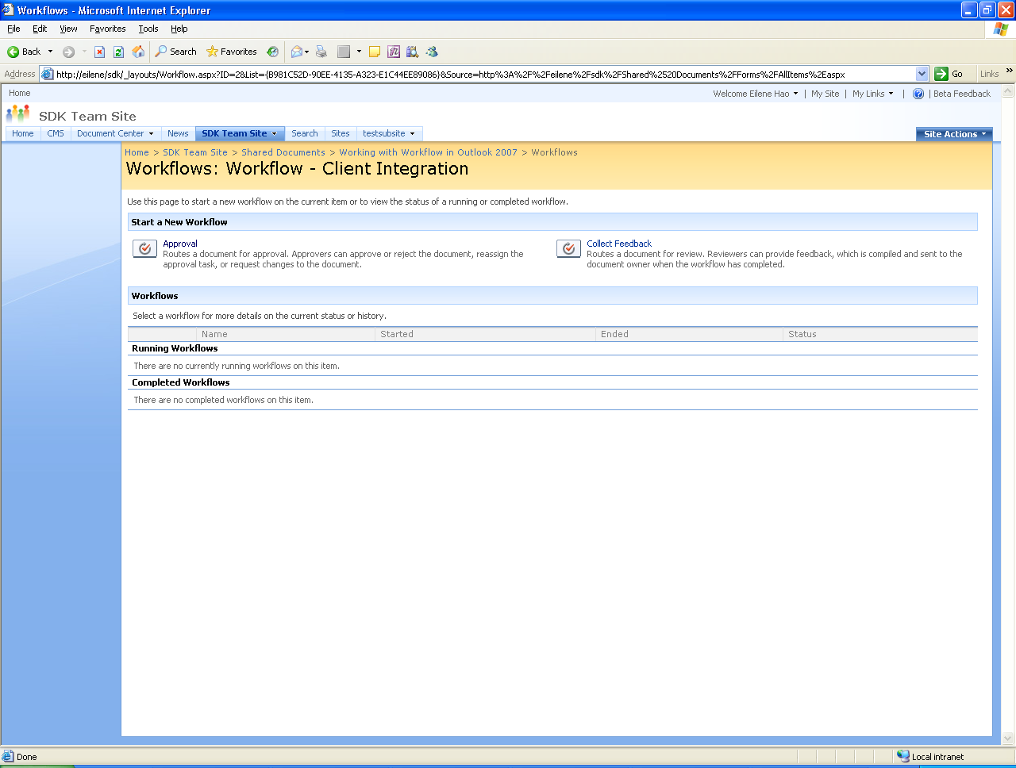
Under the heading Start a New Workflow appear the names of all workflows that can be started from this document. In this example, there are two choices—Approval and Collect Feedback—but if an administrator has associated other workflow templates with this document library, their names would also appear. In this example, the initiator selects Approval, and this screen appears:
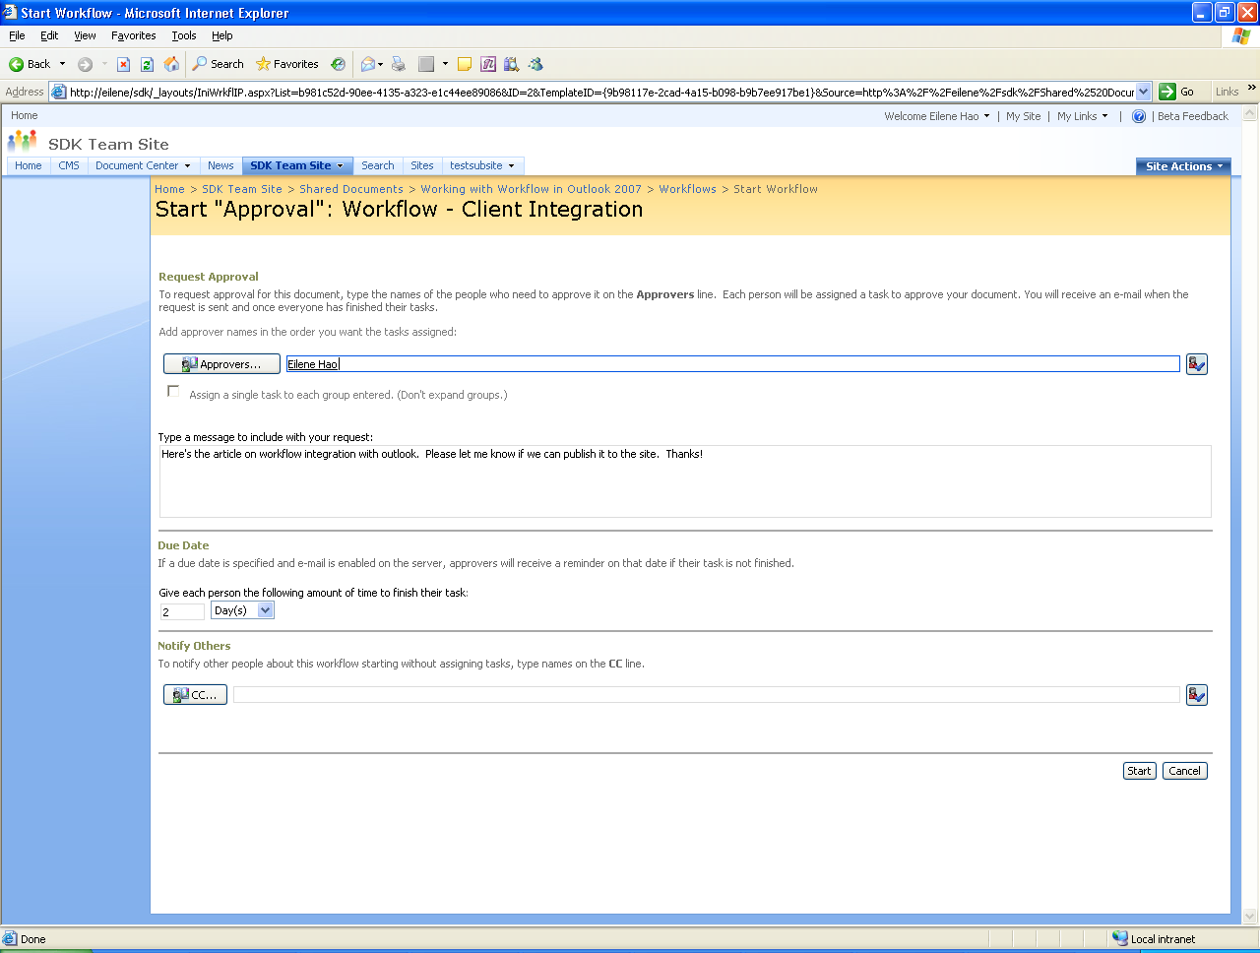
Unlike all of the screens shown so far, the contents of this one are defined by the workflow itself. When a workflow is started (i.e., when a workflow instance is created), it can optionally display a screen that allows its user to specify relevant information. For the Approval workflow shown here, this information includes the name of each person who should approve this document, an indication of when each approval is due, and a list of people who should be notified. Once this information has been supplied, the user clicks the Start button in the lower-right corner of this screen. The workflow will now begin executing, requesting that each participant review this document in the order in which their names were entered on this screen.
When a workflow is started, it can also optionally send an email message to the person who started it. Similarly, a workflow can inform its creator by email when it has completed. In this example, for instance, the Approval workflow might send mail to its creator informing her when the approval process is complete. It’s also possible for the participants in the workflow—in this example, the people who are approving the document—to be notified via email that the workflow has something for them to do.

Interacting with a Workflow
Interaction between a person and a running workflow is modeled using the notion of tasks. A task is a unit of work that’s assigned to some individual. In this example, each person on this workflow’s approval list will be assigned a task requesting approval of the document. Windows SharePoint Services maintains a task list for every site, and a running workflow can add tasks to this list, specifying who each task is for. Each user of that site can see what work is waiting for him either by accessing his task list via a Web browser or by synchronizing this site’s task list with his Outlook 2007 task list The screen below shows how browser access to the task list looks for one of the people assigned to approve the document used in this example.
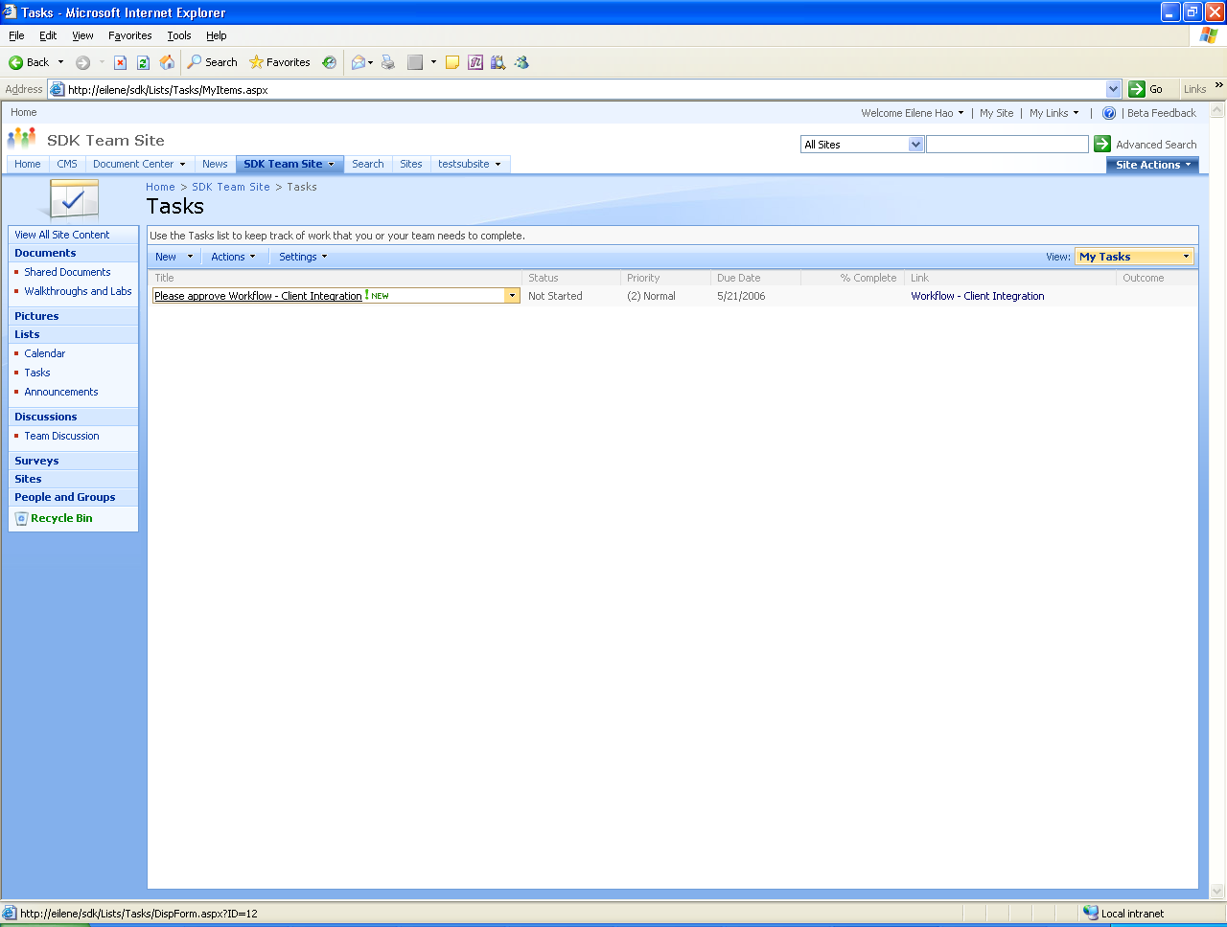
To a Windows SharePoint Services user, his list of waiting tasks is just another list. In the screen shown above, the user has selected the Tasks list from the options visible on the left side of the screen. The only task that’s currently in the list is a request to approve the document. (The document itself is accessible through the Link that appears on the right side of the screen.) To work on the task, the user in this example clicks on the task name, bringing up this screen:
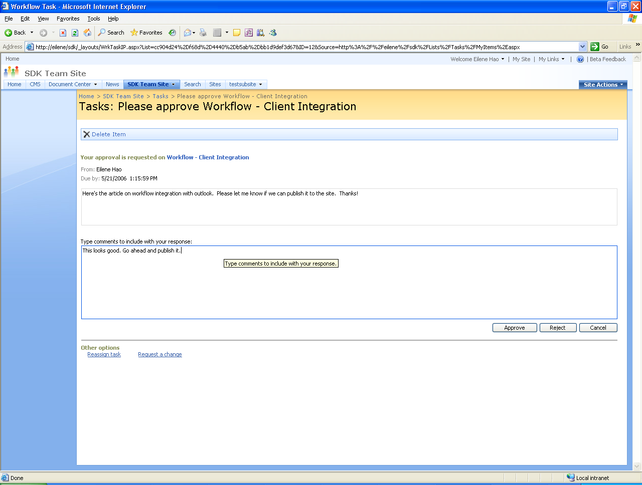
How a workflow interacts with participants can vary, and so this screen is defined by the workflow itself. In this example, the participant is provided with a field for comments along with buttons to approve or reject the document. Other options are also available, letting him reassign the task to another person or request a change. Here, the user might enter a comment, then click the Approve button. The workflow will then create a task in the task list of the next person in its list of approvers. Once every participant has responded, the workflow ends.
Windows SharePoint Services workflows also provide other options, including the following:
- A workflow’s initiator can check its status. In the scenario described here, for instance, she might check to see how far the approval process has gotten.
- A workflow can be modified while it’s executing. What modifications are allowed, if any, is determined by the workflow’s author. An approval workflow, for instance, might allow adding a new approver while the workflow is in progress. The ability to modify in-flight workflows is important, as it’s a reflection of how people actually work. Spontaneous change to business processes is an inescapable reality, and so Windows SharePoint Services workflows provide a way to handle this.

Summarizing the Process
There are plenty of moving parts in a Windows SharePoint Services workflow. The figure below gives an overall view of how the process works.

To summarize: Once a workflow template has been installed and associated with a document library, list, or content type, a step not shown here, a user of that site can create an instance of this workflow. The process begins with the workflow initiator selecting a document and an associated workflow template (step 1). The initiator creates a workflow instance from this association (step 2), then customizes this new instance and starts it (step 3).
Next, the running workflow instance adds a task to the task list of a participant (step 4). (The approval workflow used in this scenario assigns these tasks sequentially, but it’s also possible for a workflow to assign tasks to many participants at once, letting them all be carried out in parallel.) Participants in the workflow can learn about tasks the workflow assigns to them by checking their task list (step 5). Each participant then interacts with the running workflow instance to complete this task (step 6). In the example described here, this required approving a document, but it could be anything the workflow author chooses.
It’s worth noting that the document a workflow is running on is not itself sent from person to person. Instead, the document remains on the site, and each workflow participant is given a link to it. In fact, there’s no requirement that the workflow make any use of the document or item with which it’s associated. Another point worth emphasizing is that what a workflow’s initiator and participants see in steps 1, 2, and 5 is defined by Windows SharePoint Services itself. The forms used in step 3 and step 6, however, are defined by the workflow author. This allows the author to control how users customize and interact with the workflow.
Along with providing a platform for creating human workflow applications, version 3 of Windows SharePoint Services also provides a pre-defined Issue Tracking workflow that can be used as-is by end users. This workflow allows assigning active issues to participants and tracking those issues. Once created, an issue can be moved first to a Resolved state, indicating that it’s been handled by the responsible workflow participant, then to a Closed state, indicating that the workflow initiator has accepted the resolution and closed the issue.
Understanding the basics of how people use workflows in Windows SharePoint Services is an essential part of grasping this technology. Yet it’s also useful to know something about how a workflow author creates those workflows. The next section looks at the two approaches available for doing this.

Authoring Windows SharePoint Services Workflows
What is a Windows SharePoint Services workflow? Fundamentally, it consists of two things: the forms a workflow uses to interact with its users and the logic that defines the workflow’s behavior. Understanding how Windows SharePoint Services workflows are created requires knowing something about both.
Because it communicates with users through a Web browser, a Windows SharePoint Services workflow relies on ASP.NET to display its forms. Accordingly, those forms are defined as ASPX pages. A Windows SharePoint Services workflow can potentially display its own forms at four points in its lifecycle:
- Association: When a Windows SharePoint Services administrator associates a workflow template with a particular document library or list, he might be able to set options that will apply to every workflow instance created from this association. If a workflow author chooses to allow this, she must provide a form that lets the administrator specify this information.
- Initiation: The initiator of a workflow might be allowed to specify options when he starts a running instance. In the approval scenario just described, for instance, the options included specifying the list of workflow participants and defining how long each one had to complete his or her task. If a workflow allows this, its author must provide a form to allow the initiator to set these options, as shown in step 3 of the previous diagram.
- Task Completion: The running workflow instance must display a form to the participants in the workflow to let them complete their task. Shown in step 6 in the previous diagram, this form is what allowed the approvers in the earlier scenario to make comments on the document and indicate their approval or rejection.
- Modification: Although it wasn’t shown in the scenario above, the creator of a workflow can allow it to be modified while it’s running. For example, a workflow might allow adding new participants after it’s begun executing or extending the due date for completing tasks. If this option is used, the workflow must display a form at this point to let a participant specify what changes should be made.
Workflows built solely on Windows SharePoint Services define their forms as ASPX pages, while those using Office SharePoint Server can also use forms created with InfoPath, as described later. In either case, a workflow’s logic is always defined as a group of activities, just as with any WF-based workflow. To specify the logic and forms for a workflow, Microsoft provides two different tools, each targeting a different audience. Software developers can use WF Workflow Designer hosted in Visual Studio 2005. Information workers, a less technical group, can use Office SharePoint Designer to create workflows without writing code. The next two sections examine how Windows SharePoint Services workflows can be created using each of these tools.

Authoring Workflows with Visual Studio 2005 and WF Workflow Designer
In many ways, a workflow is like a flowchart. Given this, it makes sense to provide a graphical tool that lets developers specify a workflow’s actions. For WF, this tool is Workflow Designer, part of Windows Workflow Foundation Extensions for Visual Studio 2005. Developers can use WF Workflow Designer to define graphically a workflow’s activities and the order in which those activities should be executed. The screen below shows a simple example of how this looks.

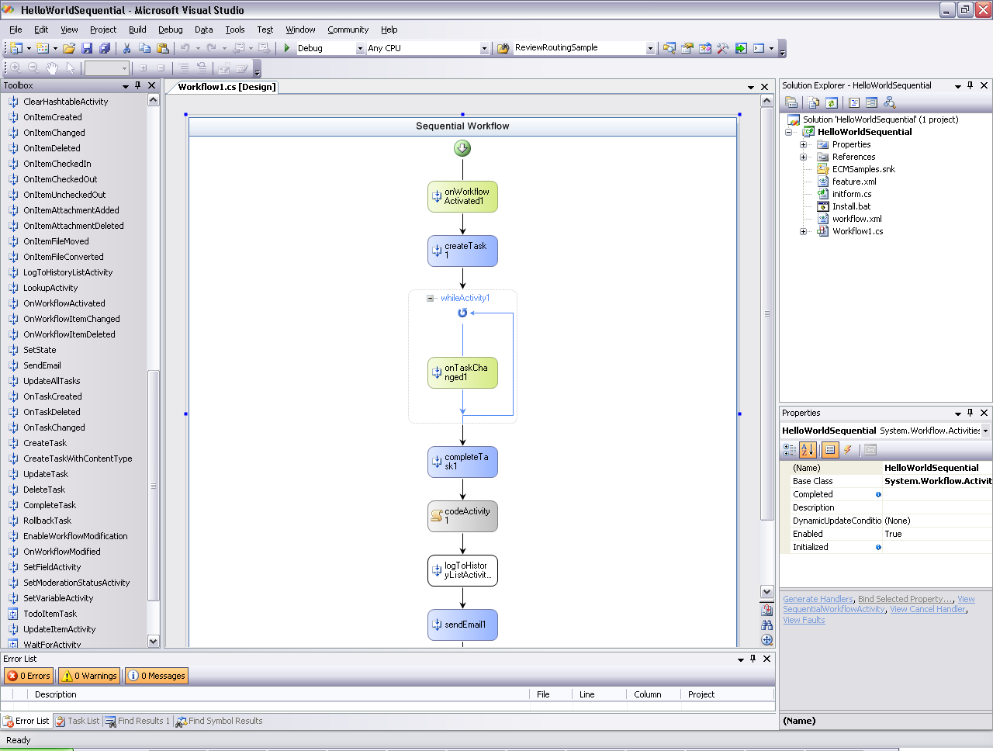
The activities available for use appear in the Toolbox on the left side of the screen. A developer can drag these activities onto the design surface to define the steps in a workflow. The properties of each activity can then be set in the Properties window that appears in the lower right corner.
WF’s Base Activity Library provides a group of fundamental activities, as described earlier. Windows SharePoint Services also provides a set of activities designed expressly for creating Windows SharePoint Services workflows. Among the most important of these are the following:
- OnWorkflowActivated: provides a standard starting point for a Windows SharePoint Services workflow. Among other things, this activity can accept information supplied by a Windows SharePoint Services administrator via the Association form when the workflow is associated with a document library or list. It can also accept information supplied via the Initiation form when the workflow is started. Every Windows SharePoint Services workflow must begin with this activity.
- CreateTask: creates a task assigned to a particular user in a task list. For example, the approval workflow in the scenario described earlier used this activity to add a task to the task list used by each of the participants. This activity also has a SendEmailNotification property that, when set to true, automatically sends an email message to the person for whom this task was created.
- OnTaskChanged: accepts information from the Task Completion form. The approval workflow in the earlier scenario used this activity to accept the input of each participant when the document was approved.
- CompleteTask: marks a task as completed.
- DeleteTask: removes a task from a task list.
- OnWorkflowModified: accepts information from the Modification form, which can then be used to change how this instance of the workflow behaves. If the workflow’s creator chooses not to include any instances of this activity in the workflow, that workflow cannot be modified while it’s running.
- SendEmail: sends email to a specified person or group of people.
- LogToHistoryList: writes information about the workflow’s execution to a history list. The information in this list is used to let users see where a workflow is in its execution, look at the workflow’s history after it’s completed, and more. To allow this kind of monitoring, the workflow’s author must write information to a History list at appropriate points in the workflow’s execution. Because it provides its own mechanism for tracking workflows, Windows SharePoint Services doesn’t support WF’s standard tracking service.
A typical pattern for a simple Windows SharePoint Services workflow begins with an OnWorkflowActivated activity, then uses a CreateTask activity to assign a task to a participant in the workflow. The BAL’s standard While activity might then be used to wait until the user completes the task. To learn when this has happened (perhaps the user makes multiple changes to the task, then checks a box on the Task Completion form when she’s done), an OnTaskChanged activity executes within the While, extracting whatever information the user has entered on that form. When the user has completed the task, a CompleteTask activity might execute, followed by a DeleteTask. The workflow can then go on to the next participant, using CreateTask to assign a task to him, and so on. And of course, other things can occur, such as sending email, logging information to the history list, or even including the BAL’s Code activity, which allows running arbitrary code.
All of the activities provided by Windows SharePoint Services are concerned with letting workflows operate within the Windows SharePoint Services environment. The business logic a workflow implements is entirely up to the creator of that workflow. In fact, a developer authoring a Windows SharePoint Services workflow is free to create and use her own custom activities—she’s not required to use only those provided by Windows SharePoint Services and WF.
As described earlier, Windows Workflow Foundation supports both sequential and state machine workflows. A Windows SharePoint Services workflow created with the WF Workflow Designer can also use either option. To allow this, Windows SharePoint Services adds two project types to Visual Studio 2005, one for each of these workflow styles.
Whatever style is chosen, the developer must define more than just the workflow’s logic; he must also specify the ASPX forms it should use. To do this, the developer relies on a file named workflow.xml. This file provides a template that the developer fills in to specify what form, if any, should be displayed at each of the four points at which a Windows SharePoint Services workflow is allowed to do this.
A developer must do some work to pass information between a Windows SharePoint Services workflow and the ASPX forms it uses. Windows SharePoint Services provides a namespace, Microsoft.Windows.SharePoint.Workflow, that exposes an object model for developers. Using the types in this namespace, the creator of a Windows SharePoint Services workflow can pass information from an ASPX form to the workflow and vice-versa.
Once a Windows SharePoint Services workflow and its forms have been created, the developer must package them into what Windows SharePoint Services version 3 refers to as a feature. A Windows SharePoint Services administrator must then install this feature, which includes installing the workflow’s assemblies to the target system’s global assembly cache. The new workflow will now be visible to the administrator as a workflow template that can be associated with a document library or list.
For a software developer, creating a Windows SharePoint Services workflow using Visual Studio and the WF Workflow Designer isn’t especially hard. The developer needs to understand the specifics of working in this environment, but much of what he’s doing will be familiar. Yet software developers aren’t the only people who’d like to author Windows SharePoint Services workflows. As described next, people who aren’t professional developers can also create workflows using Office SharePoint Designer.

Authoring Workflows with Office SharePoint Designer 2007
Office SharePoint Designer 2007, a separately licensed component of the 2007 Office system, allows information workers and others to add application logic (implemented as a workflow) to Windows SharePoint Services sites. This is certainly a useful goal, but Office SharePoint Designer also addresses another important problem. If a developer creates a Windows SharePoint Services workflow using Visual Studio, that workflow must be installed on a Windows SharePoint Services server like any other application. Yet many Windows SharePoint Services administrators won’t allow arbitrary code to be deployed on their servers, believing that the risk of destabilizing the system is too great. Being able to create straightforward business logic tied to documents and list items is very useful, however, and it’s something that many Windows SharePoint Services users need. Along with allowing less technical people to create workflows, Office SharePoint Designer also addresses this problem by providing a safer way to define and deploy business logic on Windows SharePoint Services servers.
The workflow scenarios that Office SharePoint Designer is intended to address are different in some ways from those addressed by Visual Studio and WF Workflow Designer. While it’s certainly possible to create complex applications, the intent of Office SharePoint Designer is to let users add business logic to Windows SharePoint Services sites. For example, suppose that a site contains a list that allows its users to submit change requests. Office SharePoint Designer could be used to create a workflow that automatically informs the submitter when her change request is accepted or rejected. Similarly, a custom workflow might inform a particular group of users whenever a new document is added to a particular document library. Performing this kind of custom notification isn’t complicated—creating the workflows is easy—but it’s challenging with earlier versions of Windows SharePoint Services because of administrators’ reluctance to install user-written code.
There’s an obvious question here: why should logic created with Office SharePoint Designer be treated any differently? What makes Windows SharePoint Services administrators willing to allow workflows built with this tool to be deployed on the systems for which they’re responsible? The answer is that workflows built with Office SharePoint Designer can only use activities from an administrator-controlled list. While a site’s administrator can choose to include custom activities created by a developer on this list, he’s not required to. By defining exactly what workflows are allowed to do, a Windows SharePoint Services administrator can have more confidence that deploying logic created using Office SharePoint Designer won’t destabilize his system.
Both because it’s intended for information workers rather than developers and because it emphasizes simpler scenarios, Office SharePoint Designer uses a different model for creating workflows than the Visual Studio-hosted WF Workflow Designer. Instead of a graphical approach, Office SharePoint Designer uses a rule-based approach. It’s somewhat similar to the Rules Wizard in Outlook, a tool that’s familiar to many people. The screen below illustrates how a user of Office SharePoint Designer defines a step in a workflow.
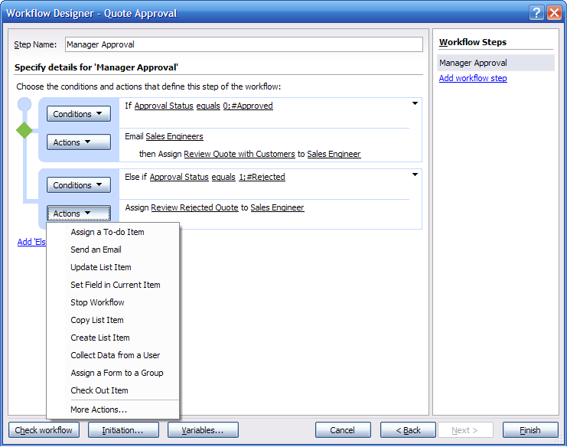
Each step can have a condition and an action. The condition determines whether this step’s action should be executed, as in the If statements shown above. The choices for actions include things such as assigning a To-do item to a workflow participant, sending email, and many more. Each of these actions is actually carried out by some Windows SharePoint Services activity, and the activities used here are the same as with Visual Studio and WF Workflow Designer. For example, the Send an Email option shown above corresponds to the SendEmail activity, while Assign a To-do Item corresponds to a slightly specialized version of the CreateTask activity. The list of actions can also include any other activities allowed by the Windows SharePoint Services administrator for this site, including custom activities created by developers.
Even though its user interface looks quite different from the graphical approach used with Visual Studio and WF Workflow Designer, Office SharePoint Designer creates a standard WF workflow. What’s actually produced is a sequential workflow with conditions expressed using the WF rules engine. Workflows created with this tool do have some limitations, however. For example, they can’t be modified while they’re running, unlike those built using Visual Studio and WF Workflow Designer, and only sequential workflows can be created—state machines aren’t supported. Also, workflows built with this tool must be authored against a specific document library or list when they’re designed. Creating a general workflow template that can later be associated with any library or list or with a content type isn’t possible. While this does place limits on how a workflow can be used, it also makes deploying the workflow much simpler. In fact, when a user finishes authoring a workflow with Office SharePoint Designer, the tool automatically deploys the workflow to the target site. This is significantly less complicated than the multi-step deployment process required for workflows created using Visual Studio and WF Workflow Designer.
Workflows created using Office SharePoint Designer can also display customized forms. Rather than require workflow authors to create ASPX pages directly, however, the tool instead generates those pages. The author specifies details about how the generated pages should look, such as what fields they should contain, and Office SharePoint Designer takes care of the rest. Of the four points in a Windows SharePoint Services workflow’s lifecycle where forms can be used, however, only two are used with workflows created using Office SharePoint Designer: Initiation and Task Completion. Because every workflow created with this tool must be associated with a particular document library or list, there’s no need for an association step and hence no Association form. And since these workflows can’t be modified while they’re running, there’s no need for a Modification form.
Office SharePoint Designer can be used for things other than creating Windows SharePoint Services workflows. The tool can be used to create a Windows SharePoint Services site, for example, or to customize the look and feel of a site’s pages by editing the site’s master page. It can also be used to connect to external data, something that relies on the data binding support in ASP.NET. For information workers who need to create logic that executes on a Windows SharePoint Services site, however, the most important aspect of Office SharePoint Designer is surely its support for authoring workflows.
Windows SharePoint Services provides a great deal of functionality for creating document-oriented workflows. Yet ultimately, it’s a platform for development and execution. On its own, it provides no workflow functionality that’s directly usable by end users. If what’s required is out-of-the-box workflow applications—and it often will be—Windows SharePoint Services isn’t enough. Workflows created using just Windows SharePoint Services also have other restrictions, such as the inability to interact with participants via Office client applications. As described next, Office SharePoint Server offers a way to overcome all of these limitations.

Workflow and Office SharePoint Server 2007
The 2007 Office system includes new versions of the Office desktop applications, including Word, Excel, Outlook, and PowerPoint. It also includes a separately licensed suite of servers that address various areas. The member of this suite that’s most relevant to workflow is Office SharePoint Server 2007.
Office SharePoint Server supersedes earlier Microsoft products, including SharePoint Portal Server and Content Management Server, to provide a range of enterprise content management functions. These include several useful additions to the workflow capabilities built into Windows SharePoint Services. As in Windows SharePoint Services, all of these rely on Windows Workflow Foundation.

Combining Windows Workflow Foundation, Windows SharePoint Services, and Office SharePoint Server
The workflow-related additions that Office SharePoint Server provides to Windows SharePoint Services can be grouped into three areas: support for Office 2007 clients, the ability for workflows to use forms created with InfoPath, and pre-defined workflows. This section looks at each of these three areas.
Workflows created using Windows SharePoint Services alone must use ASPX forms. Accordingly, the only way for people to interact with these workflows is via a Web browser. Yet the Office desktop applications are widely used, and many Windows SharePoint Services workflows will reference documents created with these applications. Why not allow users to interact with these workflows directly from Word, Excel, Outlook, and other Office applications?
Office SharePoint Server provides this ability. Rather than relying on a browser to communicate with users, a Windows SharePoint Services workflow running with Office SharePoint Server installed can display its forms directly in Office 2007 applications. For many workflows, this will allow a more natural interaction with users. A Windows SharePoint Services task list, for example, can be synchronized with the task list maintained by Outlook 2007, giving the user a single To Do list. Tasks can also be represented in Word 2007 documents, Outlook 2007 emails, and other ways, letting users input information to a running workflow directly from Office applications.
Displaying forms directly in Office applications requires some way to define those forms. The ASPX pages used by standard Windows SharePoint Services workflows will no longer suffice. To address this, Office SharePoint Server allows workflow authors to define forms using InfoPath 2007. For most people, these forms are easier to create than ASPX pages, and they can also provide capabilities such as built-in validation. It’s important to note, however, that the InfoPath-based forms used with a workflow, referred to in this paper as InfoPath workflow forms, provide only a subset of the capabilities offered by standard InfoPath forms. Much of the InfoPath object model isn’t available, for instance, as the focus is entirely on creating and using forms as part of workflows.
Letting workflow authors interact directly with Office applications through InfoPath workflow forms is certainly useful. Yet so far, everything described in this paper targets developers—there’s nothing that’s immediately usable by information workers. Office SharePoint Server changes this by including a group of pre-defined workflows. All of these workflows are meant to be used directly by information workers, and all can be customized to meet various requirements. The pre-defined workflows that Office SharePoint Server provides include the following:
- Approval: routes a document for approval. The workflow initiator specifies a list of approvers, each of whom can approve or reject the document, reassign the approval task, or request changes to the document. The example workflow scenario described earlier for Windows SharePoint Services was actually this pre-defined Approval workflow. (It’s worth noting that while the earlier scenario illustrated only aspects of Windows SharePoint Services, executing this pre-defined Approval workflow actually requires Office SharePoint Server. A developer could create a workflow that behaved exactly like the earlier scenario using only Windows SharePoint Services, however.)
- Collect Feedback: routes a document for review, much like the Approval workflow. Participants can provide feedback, which is compiled and sent to the document owner when the workflow has completed. Unlike Approval, which by default assigns tasks to participants sequentially, this pre-defined workflow defaults to parallel task assignment, allowing feedback to be returned in any order.
- Collect Signatures: routes an Office document for required signatures. This workflow can be started only from within an Office client.
- Disposition Approval: helps manage document retention by allowing participants to decide whether to retain or delete expired documents.
- Translation Management Workflow: helps manage the process of document translation. This workflow can be used to assign specific translation tasks to the participating translators, then track the progress of those tasks. It can also assign new translation tasks when a source document changes.
- Group Approval: implements a group-oriented approval process. This workflow is available only in East Asian versions of Office SharePoint Server.
All of these pre-defined workflows use InfoPath workflow forms, and so all allow access directly from Office 2007 applications.
Office SharePoint Server also provides other workflow-related services, including the ability to create reports on workflow history directly in Excel and support for bulk task completion, allowing a user to approve many outstanding tasks at once. The product provides a range of other functions as well, such as enhanced search, the ability to load, calculate, and render Excel spreadsheets on the server, and more. This large set of functionality is provided in two versions: a base edition and an enterprise edition. The product’s base edition includes the pre-defined workflows just described, but it doesn’t provide support for InfoPath workflow forms—users must interact with these workflows via a Web browser. The enterprise edition supports all of the capabilities described in this section, including using InfoPath workflow forms.

Workflow in Office SharePoint Server: A Scenario
As before, the best way to get a sense of how a workflow works in an Office SharePoint Server environment is to walk through a scenario. This section shows the same workflow used as an example in the Windows SharePoint Services section of this paper. As mentioned earlier, this is actually the pre-defined Approval workflow provided with Office SharePoint Server. In the Windows SharePoint Services example, the workflow interacted with its users via ASPX forms displayed in a Web browser. Because this scenario uses Office SharePoint Server as well, however, all interaction with the workflow now happens via InfoPath workflow forms displayed in Office 2007 applications.
Once again, the process begins the workflow’s installation and association with some document library or list, and once again, those details are omitted here. What’s most interesting begins with the workflow initiator creating a running workflow instance. As the screen below shows, this can now be done directly from a Word 2007 document. If Office SharePoint Server is deployed, a Start Workflow option appears when the Microsoft Office button is clicked.

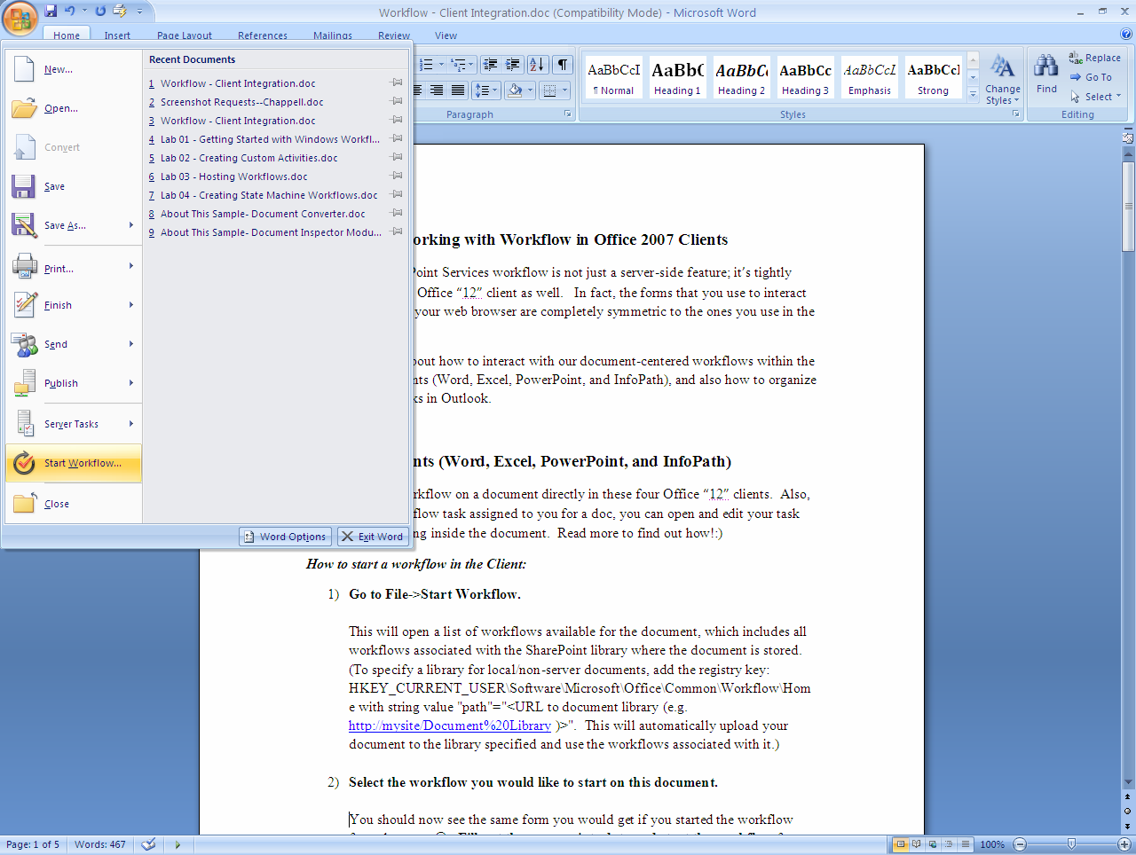

Choosing this option brings up the Start New Workflow window, as shown below.
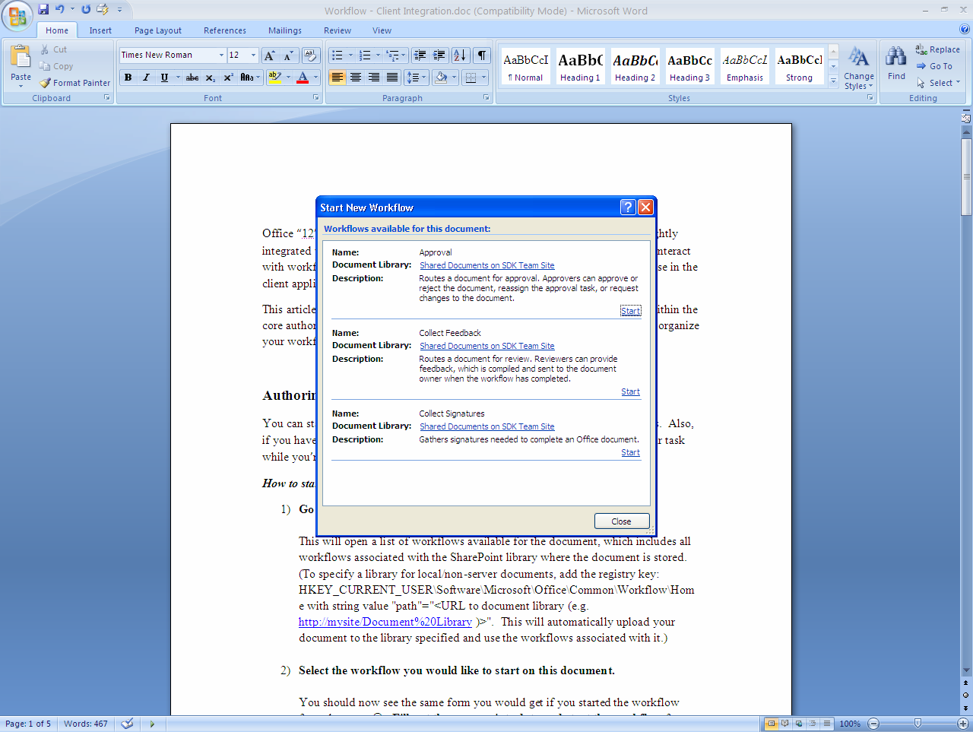

As in the earlier scenario, all workflow associations that are available for this document are shown. Clicking the Start link for the workflow named Approval causes that workflow to begin, bringing up the window shown below (which is actually an InfoPath workflow form). As illustrated in the earlier scenario, the pre-defined Approval workflow allows its initiator to customize its behavior by specifying a list of approvers, setting how long each one has to perform his task, and more. The fields in the form below—the workflow’s Initiation form—allow setting these things.
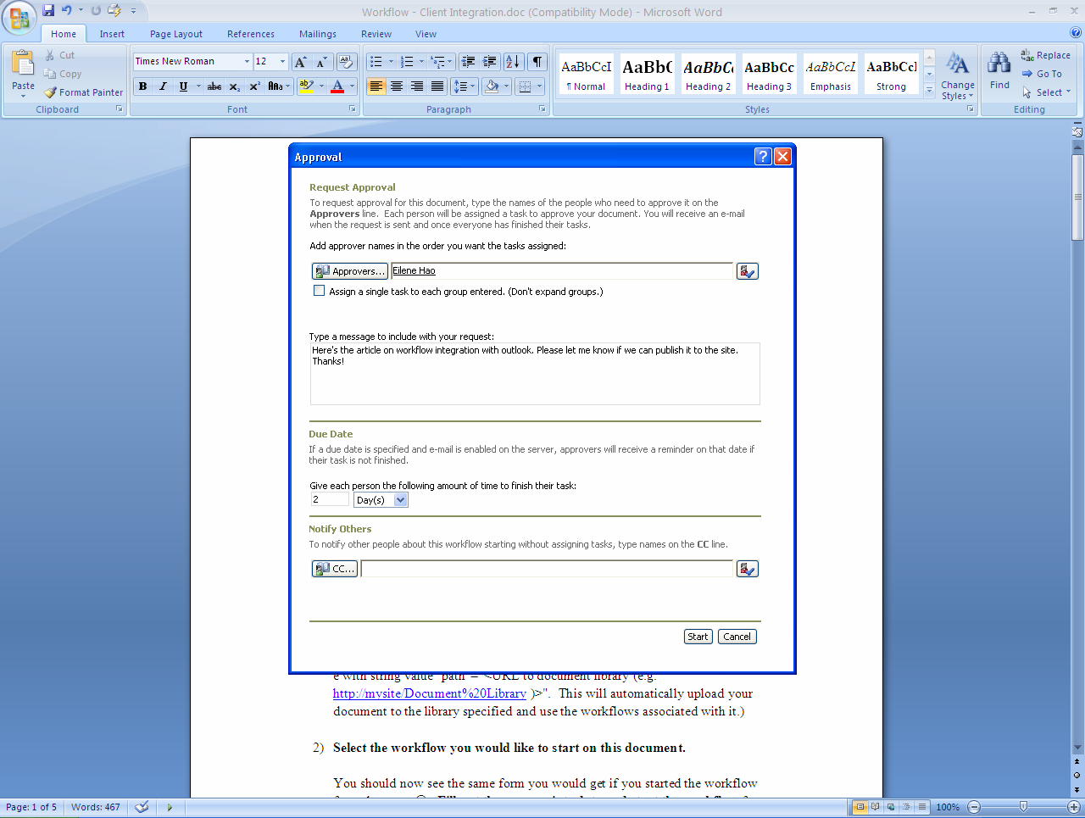
The people listed as approvers in this workflow will now each be sent an email message in the order their names were entered. Assuming those approvers are using Outlook 2007, that message might look like this:
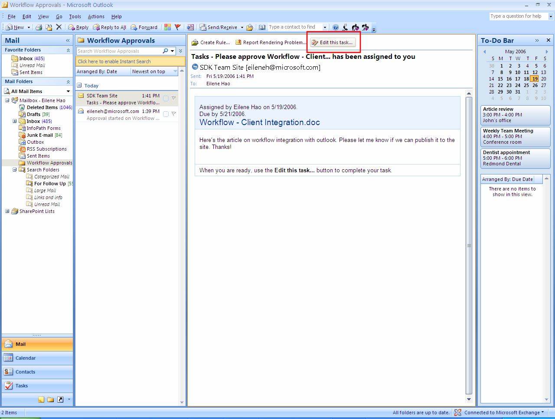
The approver can examine the document by clicking on the document name link in the body of the mail. Clicking on the Edit this task… button at the top of the message (here marked with a red square) brings up the form shown below.
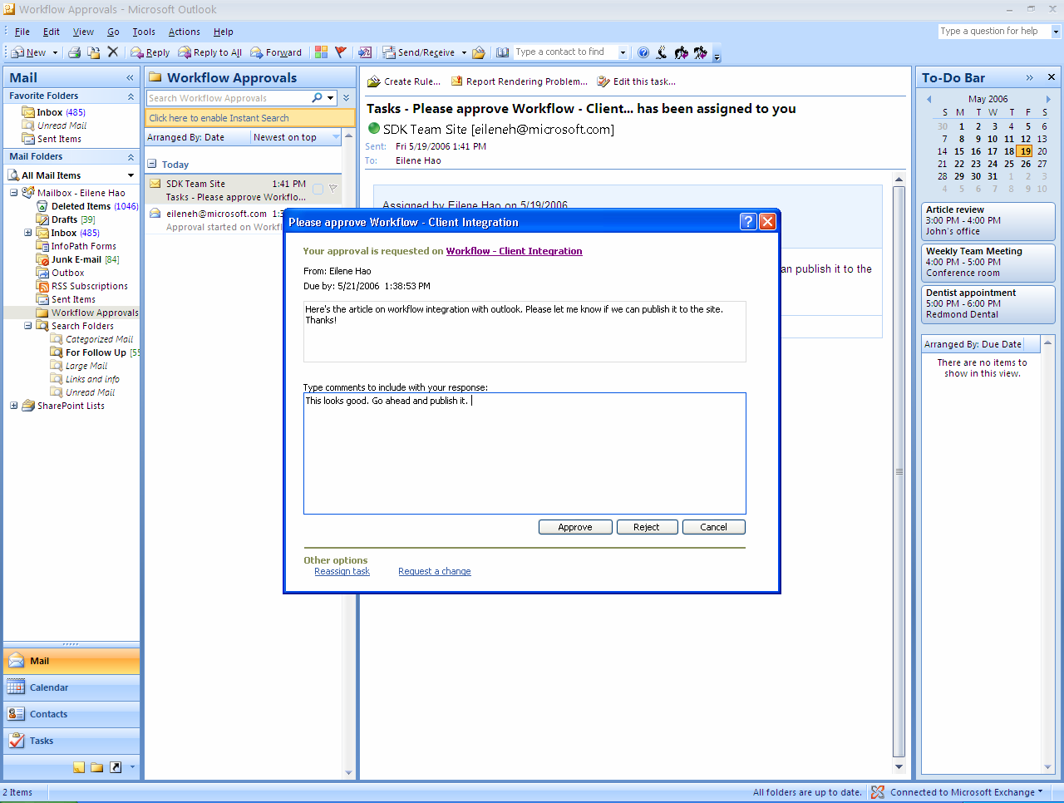
This is the workflow’s Task Completion form. Its contents are identical to those shown in the Windows SharePoint Services example earlier. This time, however, the form was defined as an InfoPath workflow form, and it’s displayed directly in Outlook 2007. As before, the approver can add comments, then approve or reject the document.
The operation of this workflow is identical to the Windows SharePoint Services example. Yet there are important differences. With Office SharePoint Server, the workflow initiator creates a workflow instance directly from Word rather than using a browser to access a Windows SharePoint Services site. Similarly, the workflow’s participants interact with this running instance entirely through Office 2007 applications. As with the initiator, there’s no longer any need to access the site itself. This ability to create and use workflows in a purely Office-based environment is likely to be important for a significant number of workflow applications.

Authoring Office SharePoint Server Workflows
Like those built solely on Windows SharePoint Services, workflows that use Office SharePoint Server can be created using either Visual Studio 2005 and WF Workflow Designer or Office SharePoint Designer. This section describes both approaches.

Authoring Workflows with Visual Studio 2005 and WF Workflow Designer
Using Visual Studio 2005 and WF Workflow Designer to author an Office SharePoint Server workflow is much like using this tool to author a workflow based solely on Windows SharePoint Services. As shown earlier, a developer can drag and drop activities onto a design surface, then write code as needed. Office SharePoint Server doesn’t provide any extra activities beyond those supplied by Windows SharePoint Services, so developers have the same building blocks for workflow logic.
The big difference, however, is that workflows using Office SharePoint Server can use InfoPath workflow forms rather than just ASPX forms. To create these forms, a workflow author uses InfoPath 2007. This tool provides a graphical editor that lets the author define the form’s content. Developers who prefer to work entirely within the Visual Studio environment can use Visual Studio Tools for Office, which allows hosting InfoPath inside Visual Studio.
Once they’re created, InfoPath workflow forms are attached to a workflow via a workflow.xml file, just as with ASPX forms. Unlike ASPX forms, however, developers don’t need to write custom code to move information between InfoPath workflow forms and a workflow. Instead, Office SharePoint Server and InfoPath provide this link, making life simpler for the people who create workflows.

Authoring Workflows with Office SharePoint Designer 2007
Just as with Windows SharePoint Services, information workers can use Office SharePoint Designer to author workflows that run in an Office SharePoint Server environment. Unlike workflows created using Visual Studio and WF Workflow Designer, however, those created using Office SharePoint Designer can’t use InfoPath workflow forms. This also means that they can’t be accessed directly from Office 2007 applications. Instead, these workflows must be accessed via a Web browser.
This constraint stems from the way that Office SharePoint Designer handles forms. As described earlier, information workers don’t directly create forms using this tool. Instead, a workflow author sets options provided by the tool, then lets the tool generate the required forms. This makes life easy for the author, but the usual tradeoff between ease of use and power also applies: only ASPX forms are supported.

Making a Technology Choice
Windows SharePoint Services, version 3 offers a general foundation for human workflow applications. Office SharePoint Server 2007 provides extra capabilities built on this foundation. When is the workflow support in Windows SharePoint Services sufficient, and when is Office SharePoint Server also required? Here’s a short summary of the major factors in making this decision.
Windows SharePoint Services alone is appropriate for:
- Adding application logic to Windows SharePoint Services sites that works with documents and list items.
- Building workflow applications where user interaction via ASPX forms in a Web browser is sufficient.
Office SharePoint Server is required for:
- Using most of the pre-defined workflows that Microsoft provides. (The exception is Issue Tracking, which ships with Windows SharePoint Services and uses only ASPX forms.)
- Building workflow applications where user interaction via Office 2007 client applications is required. This option also allows using InfoPath workflow forms, which are simpler to create and provide more functionality than ASPX forms.
It’s worth pointing out that either technology can provide a foundation for independent software vendors (ISVs). A tool-focused ISV might build specialized tools for creating workflows, targeting either developers or information workers. An application-oriented ISV might provide pre-defined workflows addressing specific problems, such as a help desk application or a process for digital asset management. Depending on the requirements, the ISV might choose to base its application solely on Windows SharePoint Services or to require Office SharePoint Server as well.

Conclusion
Human workflow applications can improve the efficiency and accuracy of many business processes. By creating Windows Workflow Foundation and making it a standard part of the operating system, Microsoft has provided the basis for a broad set of workflow applications. By hosting WF workflows, Windows SharePoint Services version 3 offers developers and information workers the ability to construct document-oriented human workflow applications. Adding Office SharePoint Server lets these applications interact with their users through InfoPath forms presented in Office 2007 desktop applications. It also provides a group of pre-defined workflows that address common business scenarios.
Adding support for workflow to Windows SharePoint Services and Office SharePoint Server is a significant step. Windows SharePoint Services and Microsoft Office are popular technologies, and so it’s fair to expect that these new workflow features will be quite widely used. Going forward, look for workflow applications to become more common in the lives of both information workers and developers.

Resources
- Windows Workflow Foundation:
http://msdn.microsoft.com/workflow
- Windows Workflow Foundation discussion forum:
http://www.windowsworkflow.net/forums
- Windows SharePoint Services, version 3:
http://www.microsoft.com/office/preview/technologies/sharepointtechnology/highlights.mspx
- Office SharePoint Server 2007:
http://www.microsoft.com/office/preview/servers/sharepointserver/highlights.mspx
- Office SharePoint Designer 2007
http://www.microsoft.com/office/preview/programs/designer/highlights.mspx
- SharePoint discussion forum:
http://www.microsoft.com/office/community/en-us/default.mspx?dg=microsoft.public.sharepoint.portalserver&lang=en&cr=US
- Enterprise Content Management Starter Kit:
http://www.microsoft.com/downloads/details.aspx?FamilyID=38ca6b32-44be-4489-8526-f09c57cd13a5&displaylang=en

About the Author
David Chappell is Principal of Chappell & Associates (www.davidchappell.com) in San Francisco, California. Through his speaking, writing, and consulting, he helps technology professionals around the world understand, use, and make better decisions about enterprise software.

