

Best Practices Using Microsoft BizTalk Adapter Pack 1.0

November 2008

Author

Suresh Natarajan, Senior Program Manager Lead, Microsoft

Stefan Korn, Premier Field Engineer, Microsoft

Copyright

The information contained in this document represents the current view of Microsoft Corporation on the issues discussed as of the date of publication. Because Microsoft must respond to changing market conditions, it should not be interpreted to be a commitment on the part of Microsoft, and Microsoft cannot guarantee the accuracy of any information presented after the date of publication.

This White Paper is for informational purposes only. MICROSOFT MAKES NO WARRANTIES, EXPRESS, IMPLIED OR STATUTORY, AS TO THE INFORMATION IN THIS DOCUMENT.

Complying with all applicable copyright laws is the responsibility of the user. Without limiting the rights under copyright, no part of this document may be reproduced, stored in or introduced into a retrieval system, or transmitted in any form or by any means (electronic, mechanical, photocopying, recording, or otherwise), or for any purpose, without the express written permission of Microsoft Corporation.

Microsoft may have patents, patent applications, trademarks, copyrights, or other intellectual property rights covering subject matter in this document. Except as expressly provided in any written license agreement from Microsoft, the furnishing of this document does not give you any license to these patents, trademarks, copyrights, or other intellectual property.

Unless otherwise noted, the example companies, organizations, products, domain names, e-mail addresses, logos, people, places and events depicted herein are fictitious, and no association with any real company, organization, product, domain name, e-mail address, logo, person, place or event is intended or should be inferred.

© 2008 Microsoft Corporation. All rights reserved.

Microsoft, BizTalk, Outlook, PowerPoint, SharePoint, Visual Studio, Windows, and other Microsoft products and services mentioned herein as well as their respective logos are either registered trademarks or trademarks of Microsoft Corporation in the United States and/or other countries.

SAP, R/3, mySAP, mySAP.com, xApps, xApp, SAP NetWeaver, and other SAP products and services mentioned herein as well as their respective logos are trademarks or registered trademarks of SAP AG in Germany and in several other countries all over the world. All other product and service names mentioned are the trademarks of their respective companies. Data contained in this document serves informational purposes only. National product specifications may vary.

The names of actual companies and products mentioned herein may be the trademarks of their respective owners.

Content

Introduction 5

BizTalk Adapter Pack - Adapters 5

Which Adapter to Use? 6

1.0 Usage scenarios 7

1.1 Using Biztalk Adapter Pack with a Custom .NET Application 8

1.2 Using Biztalk Adapter Pack with BizTalk Server 9

1.3 Using Biztalk Adapter Pack with SQL Server Integration Services and SAP 10

1.4 Using Biztalk Adapter Pack with Microsoft Office SharePoint Server 11

FAQ 13

Connecting to SAP 14

Known Issues with SAP Adapter 15

Fixes for BizTalk Adapter Pack 1.0 15

References 16

Conclusion 16

Bio 16

**Summary**

This article provides you with the best solutions for implementing and achieving optimal performance, scalability, and functionality in your applications; it also covers best practices when using the Microsoft® BizTalk® Adapter Pack as stand-alone or in association with Microsoft BizTalk Server and offers suggestions that can help you optimize the design of your application.

**Applies to**

Microsoft BizTalk Server 2009

For additional information, see [***Q&A: What’s Next for BizTalk Server***](http://www.microsoft.com/presspass/features/2008/sep08/09-05BizTalk.mspx)**1**available in PressPass - Information for Journalists.

BizTalk Server 2006 R2

<http://msdn.microsoft.com/en-us/library/bb430723.aspx>

Microsoft Office SharePoint Server 2007

<http://www.microsoft.com/Sharepoint/default.mspx>

BizTalk Adapter Pack

<http://www.microsoft.com/biztalk/en/us/adapter-pack.aspx>

Windows Communication Foundation (WCF)

<http://msdn.microsoft.com/en-us/library/ms735119.aspx>

Microsoft Windows Communication Foundation (WCF) Line of Business (LOB) Adapter SDK (WCF LOB Adapter SDK)

<http://www.microsoft.com/downloads/details.aspx?FamilyId=0F8007D7-F0C9-4169-8B9C-BA55F8F4C153&displaylang=en>

**Keywords**

BizTalk Server 2009, BizTalk Server 2006 R2, Windows Communication Foundation (WCF), SAP

NetWeaver, SAP NetWeaver ECC, Microsoft SQL Server, Visual Studio, Microsoft .NET

**Audience**

IT Management, Technical Architects, Technical Consultants, Developers

**1*Q&A: What’s Next for BizTalk Server***

[**http://www.microsoft.com/presspass/features/2008/sep08/09-05BizTalk.mspx**](http://www.microsoft.com/presspass/features/2008/sep08/09-05BizTalk.mspx)

# Introduction

As part of our continuing commitment to simplify interoperability, Microsoft has released the BizTalk® Adapter Pack 1.0, a set of adapters based on the Windows Communication Foundation (WCF) programming model. The BizTalk® Adapter Pack provides a single solution to easily and securely connect to Line of Business (LOB) data from any custom-developed .NET application, SQL Server-based business intelligence solution, or an Office Business Application (OBA).

This article contains:

* Information about the adapters included with the Microsoft BizTalk Adapter Pack.
* Comparisons between using as a stand-alone option or in association with Microsoft BizTalk Server.
* An explanation on how to use the Microsoft BizTalk Adapter 3.0 for mySAP Business Suite.
* General tips and issues.

The following list provides additional information about BizTalk Adapter Pack:

* BizTalk Adapter Pack  
  Help documentation at: <http://msdn.microsoft.com/en-us/library/bb927658.aspx>
* BizTalk Adapter Pack Forum  
  Web browser at: <http://go.microsoft.com/fwlink/?LinkId=87695>
* BizTalk Adapter Pack Samples at <http://go.microsoft.com/fwlink/?LinkId=106690>.

# BizTalk Adapter Pack - Adapters

The adapter serves as a bridge between an application and a data source. This article includes tips on how to determine which adapter is most suitable for particular usage scenarios from a Microsoft point of view and furthermore outline how the technologies can be applied to real world applications.

# Which Adapter to Use?

Microsoft delivers the BizTalk Adapter Pack to enable a flexible integration and application infrastructure connecting Line of Business (LOB) systems with a unified open approach on the technology of Microsoft Windows Communication Foundation (WCF) programming model. There are a number of adapter options for use in your applications. The following table provides information about the Line of Business (LOB) systems and their versions and the corresponding adapter in the BizTalk Adapter Pack.

|  |  |
| --- | --- |
| **Adapter** | **Details** |
| Microsoft BizTalk Adapter 3.0 for Oracle Database  (Oracle Database Adapter) | Enables adapter clients to invoke operations on Oracle database artifacts such as tables, views, procedures, etc. The adapter can also be configured to receive “inbound” messages from Oracle using polling.  Supported versions:   * Oracle 9.2.0.2 * Oracle 10.1.0.2.0 * Oracle 10.2.0.1.0 |
| Microsoft BizTalk Adapter 3.0 for mySAP Business Suite (SAP Adapter) | Recommended to connect to SAP featuring IDOC, BAPI and RFC communication. It mainly focuses on connecting SAP R3 4.6c/4.7 and ECC 5.0/6.0 systems.  Supported SAP server versions:   * SAP R/3 4.6c Non-Unicode * SAP R/3 4.7 Non-Unicode * SAP R/3 4.7 Unicode * SAP R/3 5.0 Non-Unicode * SAP R/3 5.0 Unicode * SAP R/3 6.0 Unicode   **Note**  The .NET Framework Data Provider for mySAP Business Suite (Data Provider for SAP) is included with BizTalk Adapter Pack. Adapter clients can use the Data Provider for SAP to write ADO.NET applications to perform operations on an SAP system. |
| Microsoft BizTalk Adapter 3.0 for Siebel eBusiness Applications (Siebel Adapter) | Enables adapter clients to invoke Siebel artifacts such as business components and business services.  Supported versions:   * Siebel 7.5 (7.5.3.15 [16279] with FP[QF0F65]) * Siebel 7.7 (7.7.2.8 [18379]) * Siebel 7.8 (7.8.2.6 [19230]) * Siebel 8.0 (8.0.0.1 [20408]) |

# 1.0 Usage scenarios

Often it is unclear how the BizTalk Adapter Pack can be used with your custom .NET application and when to use BizTalk Adapter Pack in association with a managed middleware component like BizTalk Server. Microsoft makes it easy for customers who need a highly available solution for mission-critical processes to consider using BizTalk Server and leverage the BizTalk Adapter Framework which is tightly integrated with the adapters from the BizTalk Adapter Pack.

There are different supported ways in which the BizTalk Adapter Pack can be consumed, which are through a custom .NET application, using BizTalk Server and Microsoft Office SharePoint Server. Also there are ADO.NET providers for SAP and Siebel to be used with SQL Server 2005 Integration Services and SQL Server Reporting Services 2005.

|  |
| --- |
| **http://i.msdn.microsoft.com/Aa560657.note(en-us,MSDN.10).gifNote** |
| The BizTalk Adapter Pack can be used by any .NET server or application that supports .NET Framework 3.0 or ASP.NET Web services. This includes BizTalk Server 2006 R2, BizTalk Server 2009, SQL Server 2005 Integration Services, and Microsoft Office SharePoint Server 2007.  SQL Server Reporting Services 2005 is limited to the ADO.NET SAP provider. |

## 1.1 Using Biztalk Adapter Pack with a Custom .NET Application

The BizTalk Adapter Pack provides a single solution to easily and securely connect to Line of Business (LOB) data from any custom-developed .NET application, SQL Server-based business intelligence solution, or an Office Business Application (OBA). The BizTalk Adapter Pack simplifies custom development to business applications.

<http://www.microsoft.com/biztalk/evaluation/adapter/default.mspx>

Typically you want to install the BizTalk Adapter Pack on the same system your application is running on. As this may increase licensing costs you would want to think about having a single system to connect to and expose your WCF services to your custom application. For licensing information see: <http://www.microsoft.com/biztalk/en/us/adapter-pack-pricing.aspx>

**Figure 1: Scenario connecting a customer .NET application to LOB systems**

|  |
| --- |
| **http://i.msdn.microsoft.com/Aa560657.note(en-us,MSDN.10).gifNote** |
| The BizTalk Adapter Pack is included with BizTalk Server 2006 R2, as of March 1, 2008. It is included in the Developer, Standard, and Enterprise Editions. |

## 1.2 Using Biztalk Adapter Pack with BizTalk Server

BizTalk® Server provides the infrastructure to connect existing applications (regardless of the platform) and to compose, expose, and consume new services. This allows you to get more out of the investments that you have already made and minimize the cost of integrating the new pieces of technology that you have acquired. Because BizTalk Server includes tools to connect both proprietary and standards based systems and pre-integrates with the .NET Framework, BizTalk Server is a central part of any SOA strategy. <http://www.microsoft.com/biztalk/>

**Figure 2: Scenario connecting BizTalk Server to LOB systems**

The only required components for this solution are BizTalk Adapter Pack 1.0 with Microsoft Visual Studio 2005 and BizTalk Server 2006 R2 or BizTalk Server 2009.

BizTalk Server provides a ready-made package, with everything needed to tie together all of the different endpoints needed to communicate with.

## 1.3 Using Biztalk Adapter Pack with SQL Server Integration Services and SAP

SQL Server Integration Services provides the infrastructure to connect to a Line of Business (LOB) System like SAP.

**Figure 3: Scenario connecting SQL Server Integration Services to SAP**

The only required components for this solution are BizTalk Adapter Pack 1.0 with Microsoft Visual Studio 2005 and SQL Server 2005 Integration Services. This solution is developed using the .NET Framework Data Provider for mySAP Business Suite, which is part of the SAP Adapter released with the BizTalk Adapter Pack.

Tip: From a performance point of view you should notice that this provider does not support batch operations.

|  |
| --- |
| **http://i.msdn.microsoft.com/Aa560657.note(en-us,MSDN.10).gifNote** |
| The .NET Framework Data Provider for mySAP Business Suite is currently not certified by SAP. |

Technically SQL Server Integration Services leverages the ADO.NET technology available in the .NET Framework. This is a unified and extensible approach where the BizTalk Adapter Pack 1.0 supports ADO.NET providers to connect to SAP and Siebel.

For additional information, see [***Using the Data Provider for SAP with SSIS***](http://msdn.microsoft.com/en-us/library/cc185548.aspx)**1** available in the MSDN Library.

There are various other providers available to choose from. Connecting to a SAP system is just an example where the BizTalk Adapter Pack enables SQL Server Integration Services to connect to a Line of Business (LOB) system.

**1*Using the Data Provider for SAP with SSIS***

[**http://msdn.microsoft.com/en-us/library/cc185548.aspx**](http://msdn.microsoft.com/en-us/library/cc185548.aspx)

## 1.4 Using Biztalk Adapter Pack with Microsoft Office SharePoint Server

Microsoft Office SharePoint Server 2007 allows you to connect to a Line of Business (LOB) system without writing code.

**Figure 4: Scenario connecting Microsoft Office SharePoint Server to SAP**

Figure 4 shows how Microsoft Office SharePoint Server 2007 allows you to connect to a Line of Business (LOB) system. In detail those scenarios are:

* Custom-developed web part in Microsoft Office SharePoint Server communicates with an adapter hosted by Microsoft Internet Information Services (IIS) to interact with a Line of Business (LOB) system.
* Custom-developed web part hosting the adapter in-process.
* Configuring the Business Data Catalog in Microsoft Office SharePoint Server to communicate with an IIS-hosted adapter to interact with a Line of Business (LOB) system.
* Custom-developed web part or the Business Data Catalog using the ADO.NET provider capabilities of the BizTalk Adapter Pack to communicate with the Line of Business (LOB) system.
* An Office Business Application communicating with an IIS-hosted adapter to interact with LOB data.
* An SSIS package in SQL, configured to communicate with an IIS-hosted adapter to interact with LOB data

|  |
| --- |
| **http://i.msdn.microsoft.com/Aa560657.note(en-us,MSDN.10).gifNote** |
| Microsoft Office SharePoint Server 2007 with Service Pack 1 is a pre-requisite to enable integration with the BizTalk Adapter Pack. |

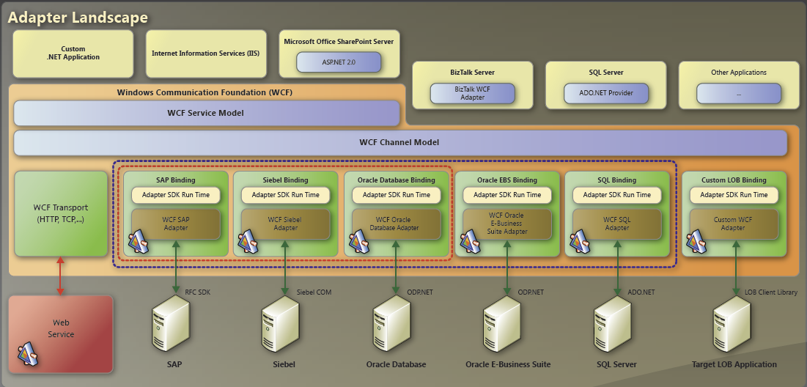

**Figure 5: Poster for upcoming BizTalk Adapter Pack 2.0**

**Conclusion**

Every time you need a robust platform for Business Process Management, providing high performance, high availability, scalability combined with tools for design, operating and monitoring, you should have a look at BizTalk Server. If you just need to connect to a Line of Business or data centric system, you want to use BizTalk Adapter-Pack as a stand-alone product.

|  |
| --- |
| **http://i.msdn.microsoft.com/Aa560657.note(en-us,MSDN.10).gifNote** |
| The BizTalk Adapter Pack is included with BizTalk Server 2006 R2, as of March 1, 2008. It is included in the Developer, Standard, and Enterprise Editions. |

**FAQ**

**Q:** What files from SAP do I need for BizTalk Adapter Pack installation?

**A:** Copy the latest DLLs from the SAP RFC SDK. A more detailed list is available at <http://download.microsoft.com/download/e/6/a/e6a2d71d-b4bb-4c7c-959d-0b0f14b6e5df/InstallationGuide.htm#ID0EUHAC>

More information is available at: <http://www.microsoft.com/isv/sap/technology/interop/bi.aspx>

Also the Microsoft Visual C++ Runtime Version 8 is required.

|  |
| --- |
| **http://i.msdn.microsoft.com/Aa560657.note(en-us,MSDN.10).gifNote** |
| The librfc32u.dll is backward compatible. |

**Q:** How can I retrieve data from SAP BI?

**A:** There is an option with SQL Server 2005 Reporting Services featuring a certified provider to access SAP BI data through the XML/A web service.

More information is available at: <http://www.microsoft.com/isv/sap/technology/interop/bi.aspx>

Also you can use the Microsoft Connector 1.0 for SAP BI released with SQL Server 2008 SSIS as feature pack.

|  |
| --- |
| **http://i.msdn.microsoft.com/Aa560657.note(en-us,MSDN.10).gifNote** |
| Since NetWeaver 7.00 (2004s) SAP changed the naming from BW to BI. As of today, the latest version is SAP NetWeaver 7.10 BI.  Usage of official SAP interfaces or unloading data from SAP NetWeaver BI may imply additional licensing. This might be a reason to consider a legacy interface for data processing tasks. Licensing questions regarding SAP data or similar topics have to be worked through SAP. |

**Q:** Where can I find sample code?

**A:** There are a bunch of samples available in the MSDN Library.

<http://msdn.microsoft.com/en-us/biztalk/cc196386.aspx>

**Connecting to SAP**

For best performance when connecting to SAP, use the Microsoft BizTalk Adapter 3.0 for mySAP Business Suite. This adapter has a LOB and a data centric part as SAP offers several interfaces for data retrieval and storage. The SAP adapter is most useful when connecting to a SAP ECC 5.0/6.0 system.

|  |
| --- |
| **http://i.msdn.microsoft.com/Aa560657.note(en-us,MSDN.10).gifNote** |
| A Microsoft Connector for SAP BI comes with SQL Server 2008 feature pack and allows retrieving and sending data with SSIS using an Open Hub Service connection to a SAP NetWeaver BI system.  IMPORTANT: Please keep in mind that ‘UNLOADING’ data from SAP BI requires additional SAP licensing. The customer has to be aware of this and it is recommended that the customer checks this with SAP. |

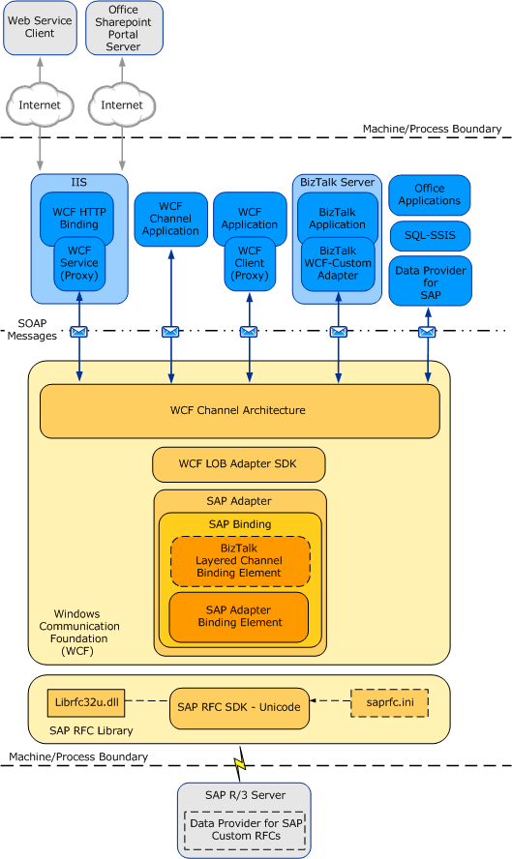

**Figure 6 Architecture for BizTalk Adapter for mySAP Business Suite**

# Known Issues with SAP Adapter

.NET Framework Data Provider for mySAP Business Suite

* The provider can be used to extract data from SAP tables or views. Only *SELECT* statements with joins at a maximum of two tables are supported.
* The *no_conversion* option does not work through all datatypes. For example it does not work for the NUMC datatype.

# Fixes for BizTalk Adapter Pack 1.0

[**FIX: The Oracle Database adapter fails and an Error event is logged in the Application log when you run a stored procedure in BizTalk Server 2006 R2**](http://support.microsoft.com/kb/950101/en-us)

950101 - Describes a problem that occurs when you run a stored procedure in BizTalk Server 2006 R2, and the Oracle Database adapter fails and an Error event is logged in the Application log. <http://support.microsoft.com/kb/950101/en-us>

**FIX: The receive location loses its connection when you use a WCF-based SAP adapter in BizTalk Server 2006 R2**

950854 - Fixes a problem in which IDOCs cannot be received.  
<http://support.microsoft.com/kb/950854/en-us>

[**FIX: The .NET Framework Data Provider for mySAP Business Suite returns an error in the Report Project wizard**](http://support.microsoft.com/kb/954233/en-us)

954233 - Describes a problem in which the .NET Framework Data Provider for mySAP Business Suite returns an error in the Report Project wizard.  
<http://support.microsoft.com/kb/954233/en-us>

[**FIX: When the BizTalk Server SAP adapter reads a valid SAP sequence of zeros, the adapter throws an exception and ends the current operation**](http://support.microsoft.com/kb/954539/en-us)

(954539) - Describes a hotfix that adds the new DataTypesBehavior property in the SAP adapter.  
<http://support.microsoft.com/kb/954539/en-us>

**FIX: The Windows Communication Foundation (**WCF**) based** SAP **adapter from BizTalk Server 2006 Adapter Pack v1.0 does not support the** SAP **TABLE type**

956635 - Fixes a problem in which the Windows Communication Foundation (WCF) based SAP adapter from BizTalk Server 2006 Adapter Pack 1.0 does not support the SAP TABLE type.  
<http://support.microsoft.com/kb/956635/en-us>

**FIX: You may receive an exception error message when you run the WCF Adapter Service Wizard to generate a service that can be consumed by Office SharePoint Server or other clients**

(957913) - Describes a problem that may occur when you use BizTalk Adapter Pack 1.0, and you receive an exception error message.  
<http://support.microsoft.com/kb/957913/en-us>

# References

1. Microsoft BizTalk Adapter Pack  
   <http://www.microsoft.com/biztalk/en/us/adapter-pack.aspx>
2. BizTalk Adapter Pack/WCF LOB Adapter SDK Poster  
   <http://download.microsoft.com/download/6/4/3/643401c2-406f-4b7b-b70a-ffc55675b7bd/AdapterPack_ASDK.pdf>
3. WCF LOB Adapter SDK and BizTalk Adapter Pack  
   <http://blogs.msdn.com/adapters/default.aspx>
4. Microsoft SAP Customer Information Center  
   <http://www.microsoft.com/sap>
5. Microsoft SQL Server BI  
   <http://www.microsoft.com/sql/solutions/bi/default.mspx>
6. SAP Help Portal  
   <http://help.sap.com>

# Conclusion

This white paper has presented best practices, known issues, and information about resolutions that are related to using the Microsoft BizTalk Adapter Pack.

For more information and additional best practices when using the Microsoft BizTalk Adapter Pack, see <http://msdn.microsoft.com/en-us/library/bb927658.aspx>.

# Bio

Stefan Korn is a Premier Field Engineer working as a dedicated support resource at the SAP HQ based in Walldorf, Germany. He supports and takes care of integrations in regards to SAP and Microsoft components. In detail those components are Microsoft BizTalk Adapter Pack featuring Microsoft BizTalk Adapter 3.0 for mySAP Business Suite and SQL Server Integration Services leveraging the .NET Framework Data Provider for mySAP Business Suite (Data Provider for SAP).