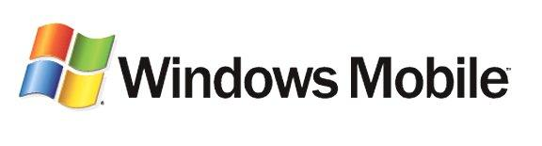

Network Security for the Windows Mobile Software Platform
White Paper
Published: December 2004
For the latest information, please see http://www.microsoft.com/windows/mobile/

Abstract
This paper presents information to enterprise-level network administrators who are exploring network security standards and best practices related to Microsoft® Windows ServerTM 2003 networks that include mobile devices running Microsoft Windows MobileTM 2003 software. Readers should be familiar with enterprise-level network and system administration and technology, as well as have an understanding of mobile technologies and devices.

The information contained in this document represents the current view of Microsoft Corporation on the issues discussed as of the date of publication. Because Microsoft must respond to changing market conditions, it should not be interpreted to be a commitment on the part of Microsoft, and Microsoft cannot guarantee the accuracy of any information presented after the date of publication.
This white paper is for informational purposes only. MICROSOFT MAKES NO WARRANTIES, EXPRESS OR IMPLIED, IN THIS
DOCUMENT.
Complying with all applicable copyright laws is the responsibility of the user. Without limiting the rights under copyright, no part of this document may be reproduced, stored in, or introduced into a retrieval system, or transmitted in any form or by any means (electronic, mechanical, photocopying, recording, or otherwise), or for any purpose, without the express written permission of Microsoft Corporation.
Microsoft may have patents, patent applications, trademarks, copyrights, or other intellectual property rights covering subject matter in this document. Except as expressly provided in any written license agreement from Microsoft, the furnishing of this document does not give you any license to these patents, trademarks, copyrights, or other intellectual property.
© 2004 Microsoft Corporation. All rights reserved.
The example companies, organizations, products, domain names, e-mail addresses, logos, people, places, and events depicted herein are fictitious. No association with any real company, organization, product, domain name, e-mail address, logo, person, place, or event is intended or should be inferred.
Microsoft, Active Sync, Outlook, Windows, Windows Mobile, Windows Server, and the Windows logo are either registered trademarks or trademarks of Microsoft Corporation in the United States and/or other countries.
The names of actual companies and products mentioned herein may be the trademarks of their respective owners.
Contents
Introduction 1
Integration with Existing Windows Security Technology 1
Windows Mobile Security Management 2
Configuration Service Providers 2
Device Management and Provisioning 2
The Windows Mobile Security Infrastructure 3
The Microsoft Cryptographic Application Program Interface 3
Cryptographic Service Providers 4
Security Service Providers 5
Microsoft Public Key Infrastructure 5
Windows Mobile 2003 Security Technologies 6
Local Device Security 6
Application Installation and Execution Security 6
Network Security 7
Information Service Encryption 8
Wireless Security 8
Scenarios 10
Connecting to a Corporate Network using 802.1x and EAP-TLS 10
Connecting through a Wireless Hotspot or Third-party WWAN 11
Connecting by using Exchange ActiveSync 11
Conclusion 13
Appendicies 14
Supported Encryption Algorithms 14
Network Security Terminology and Definitions 14

Introduction
One of the most difficult tasks for enterprise network administrators is finding methods and technologies that can prevent malicious attacks to their systems from sources located both inside and outside corporate firewalls. Securing servers, client computers, and mobile devices becomes even more important as workers and contractors connect from multiple-wired or wireless networks where security levels can vary greatly. Employees can inadvertently put their businesses at risk by connecting remotely to mission-critical systems and applications and transmit unintended threats over mobile networks.
However, with the right technology and network architecture in place, network administrators can dramatically improve security for mobile device connections. Careful planning of how to handle permissions and security rights for these mobile users is the key to a successful deployment.
Microsoft® technologies offer a multiple-layer approach to defending Microsoft Windows®-based networks that include mobile devices. This paper provides information about e-mail and Internet communication, Virtual Private Network (VPN), and wireless security technology for devices running on Microsoft Windows MobileTM 2003 software, including Windows Mobile-based Smartphones and Pocket PCs. These technologies help network administrators manage and protect Microsoft Windows Server 2003 networks that include mobile devices.
In addition, this paper presents information about the following:
- Integration of Windows Mobile-based devices with existing Windows networks
- The Windows Mobile security infrastructure
- Security features and technologies for Windows Mobile-based devices
Readers should be familiar with Windows networking technology for enterprise deployments along with Microsoft certificate technology, and they should have an understanding of mobile devices.

Integration with Existing Windows Security Technology
Windows Mobile-based Pocket PCs and Smartphones can integrate with existing Windows networks and conform to existing network security policies by using Windows Mobile 2003 software. Therefore, these mobile devices can use many of the same Microsoft security features used in Windows desktop and laptop computers. The technologies described in this paper apply generally to devices running Windows Mobile 2003 software. However, support for these technologies can vary depending on the actual device.

Windows Mobile Security Management
Mobile devices can enter a corporate network as part of an enterprisewide deployment or as personal devices purchased by employees. One important aspect of managing network security for Windows Mobile-based devices is managing how these devices interact with mission-critical applications and third-party service providers, such as cellular service providers. Windows Mobile software allows network administrators to control device security settings through comprehensive provisioning features for Smartphones and Pocket PCs.

Configuration Service Providers
Many of the network features in Window Mobile-based devices are enabled by configuration service providers, which carry out all application configuration queries and changes. After data has been passed to a configuration service provider, it makes any changes and reports the success or failure of the transaction. Windows Mobile software uses configuration service providers as Dynamic Link Libraries (DLLs). These DLLs provide the network security features, such as encryption algorithms for certificate software and VPN software, for all Windows Mobile software.
For example, the SecurityPolicy configuration service providers use custom, XML-based security policy provisioning documents to apply security roles and policies to Windows Mobile-based devices. This enables network administrators to standardize security administration. Security roles determine which operating system resources a Windows Mobile-based device can access.

Device Management and Provisioning
Windows Mobile-based devices can be managed using XML-based provisioning documents to set security configuration service provider settings for multiple mobile devices. The XML provisioning documents are distributed through over-the-air synchronizations with a trusted configuration (or “bootstrap”) server on the network. For large deployments of Windows Mobile-based devices, the XML provisioning not only reduces deployment efforts, but also helps standardize security settings.
Along with security settings, XML provisioning allows network administrators to create a standardize configuration, including wireless and other network settings, Internet connection, and e-mail synchronization settings, for mobile devices. The XML provisioning features can also manage how mobile devices connect to third-party voice and data service providers.
This paper will cover security features in Windows Mobile 2003 software that can be configured for enterprisewide deployments of Windows Mobile-based devices by using the provisioning features built into the software. The information provided in the following sections should help network administrators determine which security features will best suit their corporate networks.

The Windows Mobile Security Infrastructure
Most mobile devices connect from outside the security perimeter of corporate networks, exposing them to varying levels of risk. In addition, today’s mobile devices offer many of the same features and applications employees use on their laptops or desktop computers, including access to the Internet, business applications, and personal e-mail. As a result, many of the security threats that exist for desktops also exist for mobile devices.
Windows Mobile 2003 software offers some of the most advanced security technologies that connect mobile devices to enterprise networks, and takes advantage of many of the same Windows security features used in typical desktop/server network architectures. The security architecture built into Windows Mobile 2003 enables Windows Mobile-based Smartphones and Pocket PCs to integrate easily with the existing security protocols in an enterprise Windows Server-based network.
Windows Mobile software includes three architecture features that provide security functionality to Windows Mobile-based Smartphones and Pocket PCs: the Microsoft Cryptographic Application Program Interface, Cryptographic Service Providers, and Security Service Providers.

The Microsoft Cryptographic Application Program Interface
The Microsoft Cryptographic Application Program Interface (CryptoAPI) provides encryption and authentication functionality to Windows Mobile-based devices to help secure applications. CryptoAPI also supports encryption services for local data stored on a mobile device or removable media.
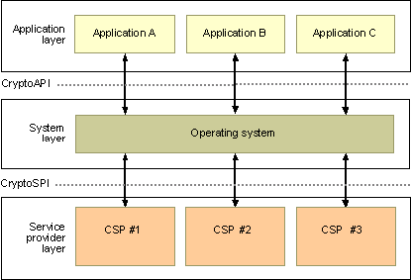
Figure 1. The Microsoft CryptoAPI security architecture
As shown in Figure 1, CryptoAPI architecture provides network administrators with the technology backbone required to integrate Windows Mobile devices into existing enterprise networks securely, and includes the following features:
- Encryption. Encryption provides privacy and authentication between two communicating parties who have exchanged a shared secret key.
- Hashing. Hashing helps ensure data integrity of information sent over a non-secure channel, such as the Internet.
- Digital signature. Digital signatures authenticate received data or information sent by a third party who is not using encryption based on a shared secret key.
A cryptographic service provider (CSP)—composed of independent modules within CryptoAPI—performs CrytoAPI functions and uses a variety of algorithms to perform all of the security needed for the applications running on an employee’s mobile device. There are several cryptographic service providers that can be used with CryptoAPI, and each one uses a different combination of algorithms.

Cryptographic Service Providers
A CSP contains implementations of cryptographic standards and algorithms. Windows Mobile 2003 software supports a full host of encryption algorithms that allow network administrators to integrate Windows Mobile-based devices into the existing security infrastructure of a corporate network. As with desktop applications, Windows Mobile software does not communicate directly with a CSP. Instead, these applications call the CryptoAPI functions exposed by the operating system. The operating system filters these functions calls and passes them on to the appropriate CSP. Each CSP provides the application calling it with one or more symmetric or asymmetric encryption algorithms.
Network administrators can use encryption to secure data communication, such as e-mail messages, calendar information, or line-of-business applications, between mobile users and company network resources. Data is encrypted by using a public key that provides cryptographic algorithms for the sender’s mobile device. Data from the sender is converted into a cryptic string of data that can only be deciphered by using a secret cipher known as a private key. This private key is provided to only the receiver of the information, a security measure that helps to protect the data as it travels over various networks and over the Internet.
There are myriad of encryption technologies, and Windows Mobile software supports a host of reliable, industry-standard technologies. The following are encryption algorithms supported by CSPs in Windows Mobile software:
Data Encryption Standard(DES). Data Encryption Standard (DES) is a widely-used method of data encryption using a private (secret) key that offers 56-bit encryption for each 64-bit block of data. For greater security, companies can implement Triple-DES, which provides 112-bit encryption for 2-key connections and 168-bit encryption for 3-key connections.
RSA. RSA is an Internet encryption and authentication system that provides encryption algorithms developed for Web browsers. The encryption system is owned by RSA Security. The company licenses the algorithm technologies and also sells development kits. The technologies are part of existing or proposed Web, Internet, and computing standards. Microsoft Windows Mobile software supports RSA Key Exchange and RSA Signature, both of which offer 512- or 1024-bit encryption.
RC2, RC4, RC5. Like DES, RC2, RC4, and RC5 provide encryption to 64-bit blocks of data, with up to 128-bit encryption. Typically, RC2 and RC4 are faster and more secure than DES-based encryption standards.
For technical specifications of these encryption technologies supported by Windows Mobile software, see the Appendix.

Security Service Providers
Security Service Providers (SSPs) are predetermined CSPs that are most commonly used for securing applications on Windows-based operating systems. Through the Security Support Provider Interface (SSPI), SSPs enable applications to access CSP authentication and cryptographic data schemes. Depending on existing software, line-of-business applications, and network resources, Windows Mobile software provides security services for four SSPs.
SSPs help make securing network resources less difficult for network administrators. Windows Mobile-based devices offer network administrators the same SSP functionality as in Windows-based desktop computers. With support for SSPs, network administrators can expect the same level of security between applications and platforms they rely on in typical desktop-server deployments.
Depending on a network’s existing infrastructure, Windows Mobile software supports the following SSPs.
- Microsoft Windows NT® LAN Manager (NTLM) Security Support Provider
- Secure Channel Security Support Provider

Microsoft Public Key Infrastructure
Windows Mobile-based devices can be easily integrated into existing Public Key Infrastructure (PKI) deployments and can take advantage of the same certificate and encryption technology available to desktop and laptop users. Microsoft PKI is a system of digital certificates, certificate authorities, and other registration authorities. This system uses public key cryptography to verify and authenticate the validity of server and client computers or users involved in an electronic transaction.
For more information on Microsoft PKI, see Public Key Infrastructure.

Windows Mobile 2003 Security Technologies
In addition to an architecture that provides the technology backbone to integrate Windows mobile devices into enterprise-level networks securely, Windows Mobile software includes built-in technologies that provide out-of-the-box functionality to manage local device security, Web and application security, network security, and wireless security for Windows Mobile-based Pocket PCs and Smartphones.

Local Device Security
Network administrators should be able to control which applications can be installed on any device within their network, including mobile devices that connect directly to resources located behind corporate firewalls. In addition, network administrators should be able to protect the data located on mobile devices in case the device is stolen or lost.
The local device security features included with Windows Mobile software works together to allow network administrators the functionality they need to secure sensitive data moving between corporate networks and mobile devices. This multifaceted approach to device security helps ensure system configurations remain updated and protected.

Strong password technology for Windows Mobile-based Pocket PCs
Mobile devices are subject to loss or theft, even more so than laptops. This susceptibility means that ensuring that locally stored data on mobile devices is secure becomes a high priority. Windows Mobile-based Pocket PCs allows network administrators to implement strong password policies, such as power-on passwords and Smartcard authentication, to help secure access to mobile devices and the data they store.

SIM lock support
Windows Mobile-based Smartphones and Pocket PC Phone Edition devices also support a Subscriber Identity Module (SIM) lock, which allows network administrators to set a password for the device’s SIM card. Because the SIM card has the ability to store personal and confidential information, it is crucial to protect that information from being accessed should the device be lost or stolen.

Application Installation and Execution Security
For Smartphones, network administrators can control which applications, such as games or ring tones, can be installed on a mobile device by managing user rights and security privileges. This control includes application execution levels on specific devices based on predetermined trust models.
Smartphones running Windows Mobile 2003 software can restrict or limit access to device applications, depending on three application privilege settings:
Privileged trust. Applications with a Privileged trust setting have full access to the operating system and APIs.
Unprivileged trust. Applications with Unprivilged trust settings have limited access to the operating system and APIs.
Untrusted. Untrusted applications cannot be installed on a Smartphone and have no access to the operating system or APIs.
By using these application security settings, network administrators can designate which applications can be installed on mobile devices that connect to corporate network resources.

Microsoft SQL Server 2000 Windows CE Edition
In addition to strong password technology, network administrators have the option to implement Microsoft SQL ServerTM 2000 Windows CE Edition (SQL CE) on Windows Mobile-based Pocket PCs to provide application and file-level security. SQL CE technology stores local information in encrypted databases. The information can be accessed, viewed, and modified only by a user who has the correct credentials and user rights.

Network Security
With mobile devices becoming more versatile and able to store and transmit large packets of data, the risk of these devices introducing malicious code or viruses to a network has increased dramatically. Windows Mobile 2003 software can take advantage of advanced authentication technology to help ensure network resources stay protected when accessed from mobile devices.

Microsoft certificate technology
Windows Mobile software supports x.509 encryption certificate technology, which enables network administrators to apply enterprise-level certificate standards to Windows Mobile devices using Microsoft PKI. The following applications use certificates for most Windows Mobile-based devices:
- Microsoft Pocket Internet Explorer for Secure Sockets Layer (SSL) connections for Pocket PCs
- Microsoft Exchange Server 2003 for SSL over-the-air and server-based synchronizations
- 802.1x Extensible Authentication Protocol / Transport Layer Security for wireless connections
- Addrootcert.exe to install root certificates on Pocket PC 2002 and Pocket PC Phone Edition 2002 devices.
- Spaddcert.exe to install root certificates on Windows Mobile-based Smartphones.
- Windows Mobile-based Pocket PC and Pocket PC Phone Edition devices contain Certinst.exe to install root certificates.
Network administrators can control where certificates are stored, locally or on removable media, such as a Smartcard. This control helps prevent certificate information and associated privileges from being used by unauthorized users should the mobile device be stolen or lost.

Virtual Private Network
Windows Mobile-based devices can connect to corporate networks through secured VPNs. Windows Mobile software not only supports traditional Point-to-Point Tunneling Protocol (PPTP) VPN connections, but also allows employees and network administrators to create VPN connections that use Layer Two Tunneling Protocol (L2TP) technology with IP Security Protocol (IPSec) encryption, which uses client certificates to authenticate connections.
VPN software can apply a number of supporting technologies to protect data traveling over VPNs from Windows Mobile-based devices. These technologies include public key certificates, pre-shared keys, encryption, and Internet Key Exchange (IKE) protocol, which supports authentication and key exchange using the Diffie-Helman (DH) algorithm. When these technologies are used in combination, network administrators can create VPN connections that provide multiple layers of security to authenticate sender and recipient credentials and protect data and the communication lines it travels over.

Extensible Authentication Protocol
Windows Mobile-based Pocket PCs can also create VPN connections by using the Extensible Authentication Protocol (EAP). The feature provides a layer of protection for communication between mobile devices and enterprise networks that use Protected Extensible Authentication Protocol (PEAP) authentication methods and Transport Layer Security (TLS) encryption to create a security-enhanced channel of communication.

Information Service Encryption
For employees who use Microsoft ActiveSync® technology to connect to e-mail, calendar, and personal contacts applications, Windows Mobile software supports Microsoft Exchange ActiveSync features that can create a protected connection to the company’s Microsoft Exchange Server 2003. With Exchange ActiveSync, network administrators can allow Windows Mobile-based devices to create SSL-encrypted connections with Exchange Server 2003. By default, SSL-encrypted connections are 128-bit.
Employees who use Pocket Internet Explorer to retrieve personal information, for example through Microsoft Outlook® Mobile Access, can also create 128-bit SSL connections with Web servers, and use Hypertext Transfer Protocol over SSL (HTTPS). Wireless Transport Layer Security (WTLS) handles Wireless Application Protocol (WAP) security for mobile devices when employees connect to WAP-enabled Web sites. WTLS class 2, which provides server authentication with encryption, is also supported.

Wireless Security
Wireless security is important to consider when implementing mobile devices as part of an enterprise-level network. Most mobile devices offer some type of wireless connectivity to both public and private wireless access points. Eavesdropping and “packet sniffing” (intercepting and inspecting data packets by using software or hardware devices) have become a major threat to users of public and, sometimes, private wireless connections.
Windows Mobile-based devices include support for wireless connections and can be configured to work with multiple enterprise-level wireless protection technologies, including the 802.1x protocol, Wireless VPN, and Wired Equivalent Privacy (WEP) wireless encryption.

802.1x wireless security with EAP-TLS
The standard typically used for wired networks, the Institute of Electrical and Electronics Engineers’ (IEEE) 802.1x, has been adapted to provide wireless networks encryption and authentication services. The 802.1x standard allows large organizations to protect and control access to network resources that offers better wireless security than traditional WEP or nonsecured networks. The protocol defines port-based network access control by using the physical characteristics of the switched LAN infrastructure to authenticate devices attached to a LAN port. Access to the port can be denied if the authentication process fails.
Windows Mobile-based devices support wireless 802.1x authentication standards for wireless connections. A typical 802.1x-protected network will use EAP-TLS, in which all of the EAP-protected exchanges are secured by the TLS protocol. Depending on existing network resources, network administrators can include a number of 802.1x-supported security technologies, including username and passwords, certificates, Smartcards, or biometrics, to protect mobile devices.

VPN over Wireless Networks
VPN for wireless connections enables Windows Mobile-based devices to use 802.11-based connections to communicate to a corporate network by using the same VPN technologies available to wired clients. With VPN security for wireless connections, employees are provided with user authentication and a strongly encrypted connection.

WEP Wireless Encryption
Windows Mobile-based Pocket PCs and Smartphones also support WEP wireless security, which uses a preshared wireless key to encrypt wireless connections. WEP provides the least amount of wireless security for mobile devices, and the technology’s security flaws have been well documented. WEP-based wireless connections can be used in combination with a more secure authentication method, such as a VPN connection.

Third-party Wireless Wide Area Networks
Many Windows Mobile-based Smartphones and Pocket PC Phone Edition devices connect to voice and data wireless wide area networks (WWAN) by using Global System for Mobile communication (GSM)/General Packet Radio System (GPRS) or code-division multiple access (CDMA)/1xRTT technology. Using these WWAN connections, mobile users can connect to the Internet and then to corporate networks and e-mail accounts. Because of this extensive connectivity, many of these service providers allow mobile users to take advantage of network security features for mobile devices, such as SSL- and VPN-based connection protocols and technologies. For devices that connect to network resources using third-party carriers, network administrators should make sure that all security settings and technologies required to connect to network resources will be supported by these carriers. And network access should be denied to mobile users who connect without meeting these security requirements.

Scenarios
The following section describes usage scenarios for employees who connect to corporate networks by using a Windows Mobile-based Pocket PC or Smartphone.

Connecting to a Corporate Network using 802.1x and EAP-TLS
With Windows Mobile-based devices, employees can easily connect to their corporate Windows-based network by using a secured wireless connection between their mobile device and the network equipped with the 802.1x protocol with EAP-TLS.
The most common reason that employees connect to the network is to retrieve personal e-mail and calendar information. To do so, an employee first accesses his or her device by entering a password or SIM lock code. If the password or lock code is incorrect, access to the device will be denied. When access has been granted, the employee can use the Microsoft Connection Manager to establish a VPN connection to the company’s corporate network. Network administrators can also integrate smartcard or biometric modules onto mobile devices to provide a two- or three-factor authentication process.
As show in Figure 2, when an employee is connected to an 802.1x-protected wireless access point, the network authenticates access against the mobile device’s machine certificate. Wireless encryption is handled by using dynamic WEP keys that change on a predetermined time frame. Because WEP keys are changed at predetermined time intervals and authentication is controlled with machine certificates, the threat of an unauthorized user stealing local data, WEP keys, or user credentials over the wireless connection can be dramatically reduced.
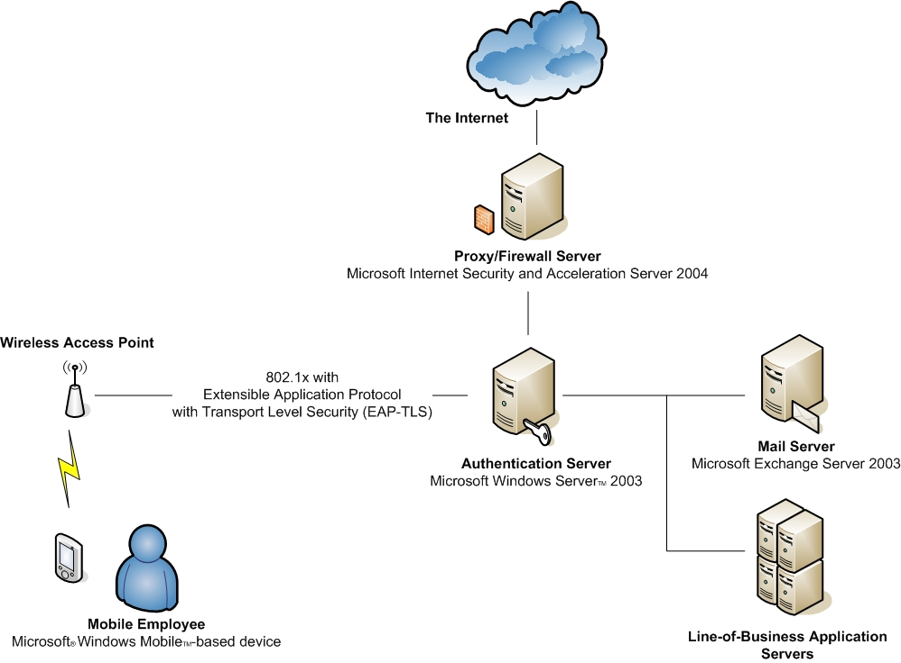
Figure 2. Connecting to a Microsoft® Windows® network using 802.1x with EAP-TLS.

Connecting through a Wireless Hotspot or Third-party WWAN
If the same employee wants to access the corporate network from a wireless hot spot, for example in a coffee shop, or a third-party WWAN, security features built into Windows Mobile software allow her access with increased security, as well. Depending on the type of wireless connection, the employee can connect to her corporate account and maintain a high level of security. For example, if she connects while using a wireless hot spot in a coffee shop that uses no type of wireless protection, she can connect to her corporate network by using her VPN connection. Data sent over the VPN connection is encrypted, and Internet access is made available through the corporate Proxy server rather than the hot spot’s local router.
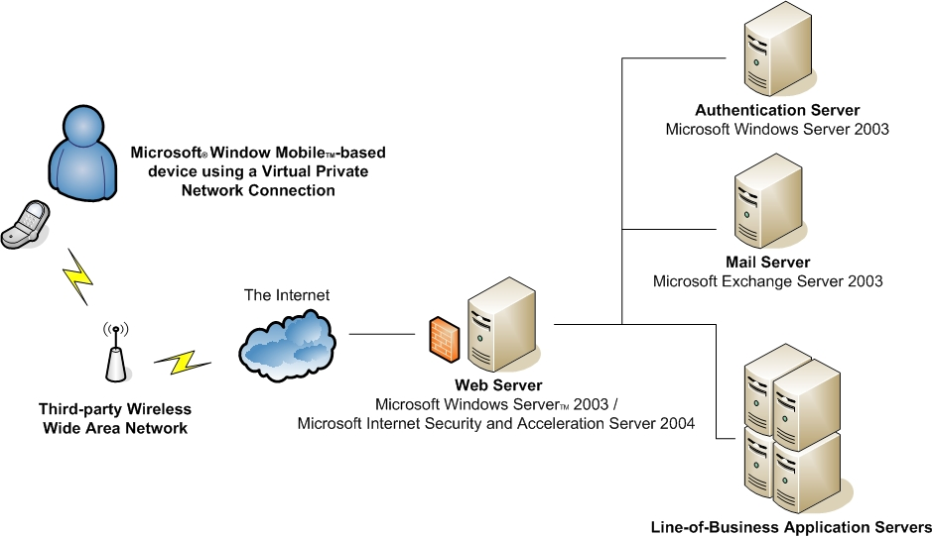
Figure 3. Mobile connection to a corporate network using a third-party WWAN.

Connecting by using Exchange ActiveSync
Alternatively, the employee can access her e-mail account by using Exchange ActiveSync, which will allow her to communicate to the corporate network that uses a 128-bit-encrypted SSL connection.
Her e-mail, calendar information, and other Exchanged-based features can be accessed quickly from off-site locations. She can create a synchronization schedule for working hours (peak), non-working hours (off-peak), and while roaming. Synchronization can be set to occur automatically from as often as every 5 minutes to as seldom as every 4 hours for each of these “profiles”, or even to only occur when manually invoked. Alternatively, synchronization can be set to occur when a new message arrives at the Exchange 2003 server for any of these “profiles”. When a new message arrives in her Inbox, Exchange 2003 sends a notification to the employee’s mobile device. Upon receiving this message, the mobile device automatically synchronizes with Exchange 2003 and updates her mobile device
If her corporate network includes Microsoft Internet Security and Acceleration (ISA) Server 2004 and PKI, network administrators can easily configure ISA Server 2004 to allow incoming requests from mobile devices to maintain existing security policies for incoming Web traffic. With certificate services, the employee’s user information is verified against the company’s CA server. With proper authentication and a secured line of communication, the employee can access network resources directly from her mobile device. However, if authentication cannot be verified, access to all network resources will be denied.

Conclusion
Microsoft Windows Mobile software employs a multiple-layer approach to security that allows network administrators to take advantage of existing Windows technologies to safely deploy and protect networks that include mobile devices. As a result, network administrators can provide feature-rich mobile application to workers with a high level of security so that businesses can fully realize all the benefits of a mobile work force, including increased productivity, real-time information sharing and communication, and extended access to information to remote or dynamic locations.
Additional technical and business oriented information can be found at the Windows Mobile Business Homepage.

Appendicies

Supported Encryption Algorithms

Algorithm | Base | Enhanced
RSA Key Exchange | 512 bit | 1,024 bit
RSA Signature | 512 bit | 1,024 bit
RC2 block | 40 bit | 128 bit
RC4 stream | 40 bit | 128 bit
RC5 block | Not Supported | 128 bit
DES | Not Supported | 56 bit
Triple DES (2-key) | Not Supported | 112 bit
Triple DES (3-key) | Not Supported | 168 bit

Network Security Terminology and Definitions
3DES – Triple Data Encryption Standard
- Data is encrypted by separating the original text into fixed-length blocks and then using an encryption key of differing strengths. 3DES is three successive DES encryptions (64-bit blocks and 56-bit key) with different keys equivalent to 168-bit key. AES (Advanced Encryption Standard) is considered the successor to DES.
- DES is a U.S. Government standard created to protect unclassified data
Biometrics
- Using “something you are” such as a fingerprint or digital signature as a way to authenticate oneself.
Smartcard
- Credit card or SIM card-sized device for storing security certificates and small amounts of information (e.g. passwords, business data, financial account data, personal medical data, airline & hotel loyalty program data). These cards are used to authenticate users as the “something you have”, typically combined with a PIN as the “something you know”.
802.1x
- A draft standard for port-based, network access control used to provide authenticated network access and encryption for Ethernet networks and wireless local area networks such as 802.11b
EAP-TLS – Extensible Authentication Protocol - Transport Layer Security
- A method for authenticating users and encrypting data associated with the 802.1x wireless LAN security standard

VPN – Virtual Private Networking
- Using the Internet as a passthru mechanism to access a private network
- Some enterprises use VPN gateways (from companies like Alcatel, Avaya, Check Point, Cisco, Hewlett-Packard, Intel, Lucent, Netscreen, Nortel Networks, Radguard, Secure Computing, and Symantec) that utilize the IPSec tunnel mode protocol. PPTP and IPSec L2TP are additional VPN standard protocols used in the Microsoft Windows server platform and in other VPN gateways from companies such as Cisco.
  - IPSec L2TP – Internet Protocol Security Layer Two (2) Tunneling Protocol
  - PPTP – Point to Point Tunneling Protocol
SSL – Secure Socket Layer
- Industry standard method for protecting Internet communications. SSL security protocol provides data encryption, server authentication, message integrity, and optional client authentication for a TCP/IP connection. SSL has been renamed to TLS by the IETF standards body.
WTLS – Wireless Transport Layer Security
- Encryption used with Wireless Application Protocol (WAP) phone-Internet service and is based on SSL
PKI – Public Key Infrastructure
- Digital certificates designed to provide strong user authentication, ensure integrity of transmitted data, assist with transaction integrity, and encrypt data.
S/MIME – Secure/Multipurpose Internet Mail Extensions
- Digitally signed and encrypted email using certificates
- Being phased in as a requirement by US Dept. of Defense, U.S. government contractors, and other international government organizations

