

Step By Step Guide to Deploying Microsoft Mobile Messaging: Appendices

Published: March 3, 2005
Applies To: Microsoft® Exchange Server 2003 Service Pack 1

The information contained in this document represents the current view of Microsoft Corporation on the issues discussed as of the date of publication. Because Microsoft must respond to changing market conditions, it should not be interpreted to be a commitment on the part of Microsoft, and Microsoft cannot guarantee the accuracy of any information presented after the date of publication.
This white paper is for informational purposes only. MICROSOFT MAKES NO WARRANTIES, EXPRESS OR IMPLIED, IN THIS DOCUMENT.
Complying with all applicable copyright laws is the responsibility of the user. Without limiting the rights under copyright, no part of this document may be reproduced, stored in, or introduced into a retrieval system, or transmitted in any form or by any means (electronic, mechanical, photocopying, recording, or otherwise), or for any purpose, without the express written permission of Microsoft Corporation.
Microsoft may have patents, patent applications, trademarks, copyrights, or other intellectual property rights covering subject matter in this document. Except as expressly provided in any written license agreement from Microsoft, the furnishing of this document does not give you any license to these patents, trademarks, copyrights, or other intellectual property.
© 2005 Microsoft Corporation. All rights reserved.
The example companies, organizations, products, domain names, e-mail addresses, logos, people, places, and events depicted herein are fictitious. No association with any real company, organization, product, domain name, e-mail address, logo, person, place, or event is intended or should be inferred.
Microsoft, Active Directory, ActiveSync, BizTalk, Hotmail, JScript, MS-DOS, MSDN, MSN, Outlook, SharePoint, Visio, Visual Basic, Visual Studio, Windows, Windows Media, Windows Mobile, Windows NT, Windows Server, and Windows Server System are either registered trademarks or trademarks of Microsoft Corporation in the United States and/or other countries.
The names of actual companies and products mentioned herein may be the trademarks of their respective owners.

Contents

Appendix A: Troubleshooting Microsoft Exchange 2003 ActiveSync 1
Introduction 1
Server Configuration 1
Device Configuration 2
Sync Protocol Version and Device Support 4
SSL Requirement 5
Exchange ActiveSync Profile 10
Exchange ActiveSync Checklist 11
Device Logging 15
Server Logging 18
Error Message, Explanation, and User Action 19
Frequently Asked Questions and Answers 31
Complete List of Errors 34
Common Issues and Associated KB Articles 37
Appendix B: Windows Mobile Client Configuration Guide 38
Setting Up Exchange ActiveSync 38
To Set Up EAS on a Cradled Device (recommended method) 38
Set Up with an Existing Partnership 43
Uncradled Device EAS Setup 48
Up-to-Date Notifications (UTD) 49
Appendix C: ActiveSync Data Architecture – A Reference 62
Appendix D: Resources 66

Appendix A: Troubleshooting Microsoft Exchange 2003 ActiveSync

Introduction
Exchange ActiveSync (EAS)

This appendix is focused on troubleshooting Exchange ActiveSync connections from both the server and client perspective. It was developed by Microsoft Product Support Services as part of their experience in supporting Windows Mobile-based devices.

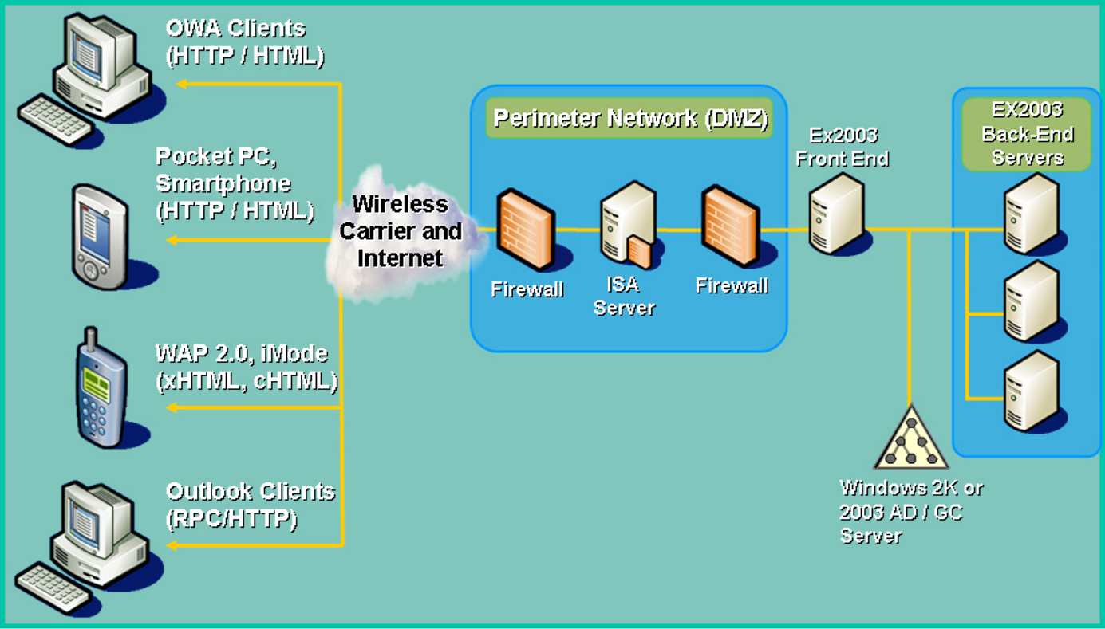

Server Configuration

Exchange ActiveSync is installed by default with Exchange 2003. No server side configuration is necessary. If you have a single Exchange server and wish to use Exchange ActiveSync with Forms Based Authentication or have an SSL requirement on the Exchange virtual directory, please use the additional configuration steps described later in this document.

Enabling Users for Exchange ActiveSync

All users are enabled by default. The Exchange administrator can globally disable Exchange ActiveSync by unchecking “Enable user initiated synchronization”. This setting is configurable in Exchange System manager under Global Settings, Mobile Services.

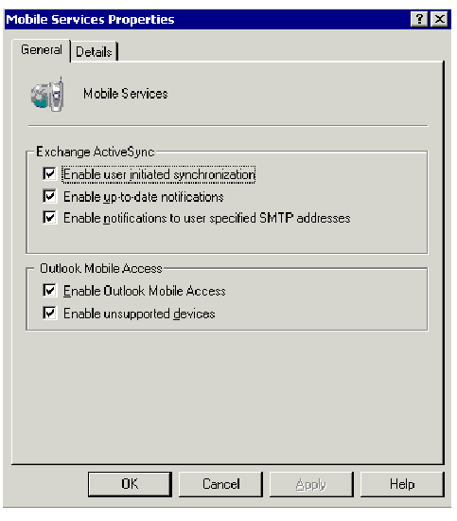

This setting is also available on individual user objects.

Users can be enabled/disabled on a per user basis through the Exchange Features tab in AD Users and Computers. It is possible to enable or disable users in bulk by multi-selecting users and choosing enable or disable.

Device Configuration

To set up Exchange ActiveSync on the client
1. Set up a data connection for your device running Windows Mobile 2002 or 2003 software.
2. Set up your device to sync with your Exchange 2003 server by typing in the URL of the server in the Use this server section. In the example below exchange.microsoft.com is used.
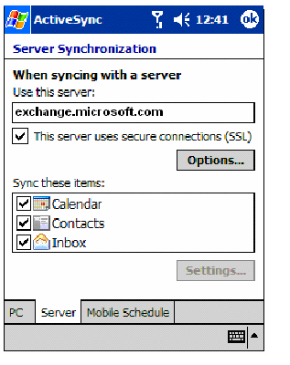
3. Provide your credentials.

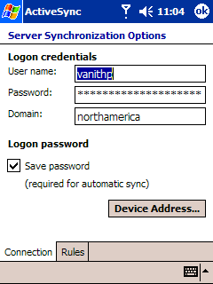

4. Sync manually or set up a schedule for synchronization.

If you are using a device with Windows Mobile 2003 software, you can use the Up-to-Date Notification functionality included with Exchange 2003 server. Up-to-Date (UTD) is a new feature in Exchange Server 2003 that provides the user with the ability to automatically synchronize the mobile device with the server as new items are received on the server.

Sync Protocol Version and Device Support

Exchange ActiveSync uses the AirSync protocol for synchronization. Exchange ActiveSync requires that the client (device) and the server use the same protocol version.

Mobile Information Server uses the AirSync Protocol v1.0 for ActiveSync. Exchange Server 2003 uses the new and improved AirSync protocol v2.0 for ActiveSync, but also supports AirSync protocol v1.0 for backward compatibility.

Server | Protocols supported
Mobile Information Server 2002 | 1.0
Exchange Server 2003 | 1.0 and 2.0

Devices with Windows Mobile 2002 software (such as Pocket PCs and Smartphones) use AirSync protocol v1.0 for ActiveSync. Devices with Windows Mobile 2002 software can be used against MIS and Exchange Server 2003 using v1.0.

Devices with Windows Mobile 2003 software (Pocket PCs and Smartphones) support v1.0 and v2.0 protocols. They negotiate the protocol with the server.

Device | Protocols supported
Windows Mobile 2002 | 1.0
Windows Mobile 2003 | 1.0 and 2.0

Therefore Windows Mobile 2002 and 2003-based devices can be used against MIS and Exchange 2003.

Server | Devices supported
Mobile Information Server 2002 | Windows Mobile 2002 and 2003
Exchange Server 2003 | Windows Mobile 2002 and 2003

Implementation

Exchange ActiveSync (EAS) is implemented as an ISAPI extension. The AirSync Protocol was developed to allow the synchronization of mobile devices with servers. The client and server use this protocol to communicate changes to each other. The AirSync Protocol rides on top of the HTTP protocol and uses the message body area of the HTTP protocol to send and receive changes. The protocol itself is a collection of commands and parameters expressed in XML.

SSL Requirement

Pocket PCs with Windows Mobile 2002 Software

The Exchange ActiveSync client on a device with Windows Mobile 2002 software is hard coded to use SSL. Therefore an SSL certificate should be installed on Exchange 2003 server or the Exchange 2003 front-end server to terminate the SSL connection, unless the SSL session is terminated before it reaches the Exchange server.

The Exchange ActiveSync client does certificate validation. The following is a list of root certificates installed by default on Pocket PCs with Windows Mobile 2002 software:
- Verisign/RSA Secure Server
- Verisign Class 1 Public Primary CA
- Verisign Class 2 Public Primary CA
- Verisign Class 3 Public Primary CA
- Verisign Class 3 Public Primary CA (2028)
- GTE Cybertrust ROOT
- GTE Cybertrust Solutions ROOT
- Thawte Server CA
- Thawte Premium Server CA
- Entrust.net Secure Server
- Entrust.net CA (2048 bit)
If you are using a certificate that is not signed by a CA listed above (not trusted on the Windows Mobile 2002 software), you can disable certificate validation on the device by running the CertChk.exe tool. The Disable Certificate Validation tool can be used in a test environment and is part of the Exchange 2003 All-in-one Tools package available from
http://www.microsoft.com/downloads/details.aspx?FamilyId=E0F616C6-8FA4-4768-A3ED-CC09AEF7B60A&displaylang=en
Please see the readme that is provided with the tool for more information.

Using this tool does not remove the requirement for a certificate. It simply disables certificate validation by changing a registry setting on the device.

To do this manually, use a registry editor on the device and navigate to

HKEY_CURRENT_USER\Software\Microsoft\AirSync\Connection. Choose New DWORD, type "Secure" for value name and 0 for value data.

Root certificates can also be added to the Pocket PCs with Windows Mobile 2002 software by using the process outlined in KB 322956 Sample to Add Root Certificates to Pocket PC 2002.
http://support.microsoft.com/default.aspx?scid=kb;en-us;322956

Pocket PCs with Windows Mobile 2003 Software

The Server ActiveSync client on Pocket PCs with Windows Mobile 2003 software does not require SSL. There is a check box on the client “This server uses secure connections (SSL)” to enable SSL. It is highly recommended that SSL be used to secure communications.
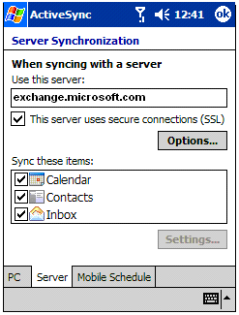
When you uncheck the box “This server uses secure connections (SSL)” you will receive the following warning.
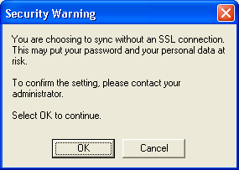

The following is a list of root certificates installed on Pocket PCs with Windows Mobile 2003 software:
- Equifax Secure Certificate Authority
- Verisign Class 2 Public Primary CA
- Verisign Class 3 Public Primary CA
- GTE Cybertrust ROOT
- GTE Cybertrust Solutions ROOT
- Thawte Server CA
- Thawte Premium Server CA
- Entrust.net Secure Server
- Entrust.net CA (2048 bit)
- GlobalSign Root CA
To install a certificate on a Pocket PC with Windows Mobile 2003 software manually, copy the certificate to the device. This can be done via IR connection, copying it to a memory card that can be accessed to the device or via ActiveSync among other methods. Once the certificate is on the device, use the File Explorer under programs to navigate to the location of the certificate. By Clicking on the certificate itself you should receive a pop up message asking whether to install the certificate. By clicking yes, the certificate will be installed on the device.

Smartphones with Windows Mobile 2002 and 2003 Software

The root certificates that are included with Smartphones with Windows Mobile 2002 software represent the following certificate authorities:
- Verisign
- Cybertrust
- Thawte
- Entrust

The root certificates that are included with the Smartphones with Windows Mobile 2003 software represent the following certificate authorities:
- Verisign
- Cybertrust
- Thawte
- Entrust
- Equifax
- GlobalSign

Adding Root Certificates to Smartphones with Windows Mobile 2002 and 2003 Software

Obtain SPAddcert.exe outlined in KB 841060 from
http://download.microsoft.com/download/0/3/b/03b3162a-c093-4434-917c-4b289d027ceb/SmartPhoneAddCert.exe

1. Export the Root certificate a Microsoft Windows®-based computer in DER encoded binary X.509 format with a file extension of CER. For example smartphone.cer

2. Connect your Smartphone to the computer.

3. On your computer, start ActiveSync and click Explore.

4. Copy the SPAddcert.exe onto the Smartphone in the following location:
- Smartphone 2003 - copy the file to \Storage\Windows\Start Menu\Accessories on the phone.
- Smartphone 2002 - copy the file to \IPSM\Windows\Start Menu\Accessories on the phone.

5. The exported root certificate file needs to be copied to the following location:
- Smartphone 2003 - To either \Storage on the phone or the root folder of a storage card.
- Smartphone 2002 - To either \IPSM on the phone or the root folder of a storage card.

6. On the phone, select Start, Accessories, SPAddCert.

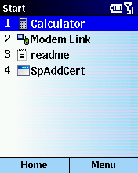

7. Select the certificate using the Dpad and click OK. This displays the certificate details.

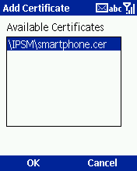

  - Click OK when prompted “Are you sure want to add the certificate \IPSM\smartphone.cer?

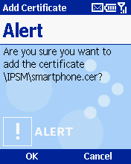

9. This completes the installation of the root certificate. Restart your phone.

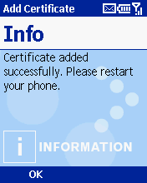

Notes:

The SPAddCert utility will only run on software unlocked phones. If your device has been software locked by the mobile operator you will get a pop up “This device is currently secured such that certificates cannot be added to the root store. For support please contact your device administrator.”

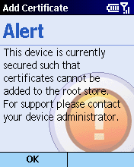

In order for this application to run on software locked phones, it must be signed and distributed by the mobile operator. Please contact your mobile operator.

Windows Mobile-based Smartphones implement an application security model based on digital code signing. Application security helps protect the integrity of the end-user’s device by not allowing the user to run applications from an unknown source.

The mobile operator decides on whether or not to implement application security before they bring a phone to market. The mobile operator can change the policy decision at any time.

Exchange ActiveSync Profile

Synchronization state information for each user is stored in a hidden folder in the user’s mailbox on the Exchange server. The sync state for e-mail, calendar, and contacts is located in the Microsoft-Server-ActiveSync/Devicetype/DeviceId folder in the NON_IPM_SUBTREE of a user’s mailbox.

For example, you will see three messages in this folder.
CalendarSyncFile
ContactsSyncFile and
80e4d0981f339e40a418e03fc924986e-5775
The hexid corresponds to the flat URL of the inbox.

Sync Session

A typical sync session when using a device with Windows Mobile 2002 software is comprised of the following commands.

GetHierarchy
GetItemEstimate
Sync

A typical sync session when using a with Windows Mobile 2003 software is comprised of the following commands.

FolderSync
GetItemEstimate
Sync

Devices with Windows Mobile 2003 software issue the OPTIONS command. Make sure that this command is not blocked on the Exchange server. If you are using an ISA server, make sure that this command is not blocked. Verify that the ISA server has ISA SP1 and has the registry key below to enable it to pass the OPTIONS command to the server. If the key does not exist, add the following registry key:

HKLM\System\CurrentControlSet\Services\W3Proxy\Parameters

Value Name: PassOPTIONSToPublishedServer

Data Type: REG_DWORD

Data: 1

Default: 0

Set this parameter to 1. The data can be any non-zero value

Exchange ActiveSync Checklist

Device Side

- Verify that the correct server name is entered on the device. For example server.domain.com
- Verify that the correct credentials are entered on the device. Domain name, username, and password information must be entered on the device. Exchange ActiveSync does not support UPN type logins (Example user@microsoft.com). The credentials can be verified on the device by clicking Start, ActiveSync, Tools, Options, Server, Advanced.

On the device, make sure that you can have connectivity. An easy way to do this is to use Pocket Internet Explorer or other internet applications. If this fails, there may be network coverage issues or proxy configuration issues. You can obtain third-party utilities to verify that your device has an IP address and that you can ping the Exchange ActiveSync server successfully.

Server Side
If you are using an Exchange 2003 FE-BE configuration:
- Verify that Exchange 2003 Outlook Web Access is working.

- If you are using devices with Windows Mobile 2002 software or using devices with Windows Mobile 2003 software with SSL, make sure that a certificate is installed on the Exchange server unless the SSL session is terminated before the Exchange server.

If you are not using SSL, launch Internet Explorer on the desktop and verify that http://servername/Microsoft-Server-ActiveSync returns Error 501/505 - Not implemented or not supported. Verify the same from the device.

- If you are using SSL, launch Internet Explorer on the desktop and verify that https://servername/Microsoft-Server-ActiveSync returns Error 501/505 - Not implemented or not supported. Verify the same from the device.
- Verify that Exchange ActiveSync is enabled globally using Exchange System Manager. This is the default setting.
- Verify that massync.dll is listed as an Application map on the Microsoft-Server-ActiveSync virtual directory on the front-end server. This can be viewed in the Internet Service Manager MMC Snap in under Web Services Extensions. Within the Web Services Extensions click on Microsoft Exchange Server and then click on the properties button. Within the properties window which pops up look in the Required Files panel to review the DLL.

- Verify that the user is enabled for Exchange ActiveSync using AD Users and Computers. This is the default setting.

- On the Exchange server, verify that the authentication settings on the Exchange virtual directory include Integrated Windows Authentication. This can be viewed in the Internet Service Manager MMC Snap in Web Sites Section. Right click on the Exchange Web site and select properties. Then select the Directory Security panel. Click on edit under the Authentication and Access Control section. From this window you can review that Integrated Windows authentication has been setup

Exchange ActiveSync uses Kerberos authentication when communicating with the Exchange server and therefore requires that Integrated Windows authentication be checked on the Exchange virtual directory.

The Exchange front-end server can be located within the intranet or in the DMZ depending on the deployment. Make sure that the firewall has ports 443 open to allow connectivity.

If you are using a single Exchange 2003 server:

- Verify that Exchange 2003 Outlook® Web Access is working.
- If you are using devices with Windows Mobile 2002 software or using devices with Windows Mobile 2003 software with SSL, make sure that a certificate is installed on the Exchange server unless the SSL session is terminated before the Exchange server.

If you are not using SSL, launch Internet Explorer on the desktop and verify that http://servername/Microsoft-Server-ActiveSync returns Error 501/505 - Not implemented or not supported. Verify the same from the device.

- If you are using SSL, launch Internet Explorer on the desktop and verify that https://servername/Microsoft-Server-ActiveSync returns Error 501/505 - Not implemented or not supported. Verify the same from the device.
- Verify that massync.dll is listed as an Application map on the Microsoft-Server-ActiveSync virtual directory on the Exchange server.

- Verify that Exchange ActiveSync is enabled globally using Exchange System Manager. This is the default setting.
- Verify that the user is enabled for Exchange ActiveSync using AD Users and Computers. This is the default setting.

On the Exchange server, verify that the authentication settings on the Exchange virtual directory include Integrated Windows Authentication.

Exchange ActiveSync uses Kerberos authentication when communicating with the Exchange server and therefore requires that Integrated Windows authentication be checked on the Exchange virtual directory.

- If you are using a single Exchange 2003 server and have either configured your Exchange virtual directory to “Require SSL” or have turned on Forms Based Authentication (FBA), then follow the procedure below to create an alternate Exchange virtual directory for ActiveSync to use.

The new virtual directory needs to be created through Internet Services Manager for Exchange ActiveSync to work.
If you are using Microsoft Windows Server™ 2003 or later, follow these instructions:
- Start Internet Information Services (IIS) Manager
- Locate the \exchange virtual directory (default location is Web Sites\Default Web Site\Exchange)
- Right click on the Exchange virtual directory, choose All Tasks, Save Configuration to a File.
- Type a name in the File name: text box (for example, ExchangeVDir).
- Click OK.
- Right click the root of this Web site (Default Web Site), choose New, Virtual Directory (from file).
- On the Import Configuration dialog box, select the Browse button and locate the file from step #4, then click Open.
- Next, select the Read File button.
- In the Select a configuration to import text box, select Exchange and press OK.
- A dialog box will appear stating the virtual directory already exists. In the Alias text box, type a name for the new virtual directory that you want the Exchange Server ActiveSync and Outlook Mobile Access processes to use. For example, type Exchange-OMA.
- Click OK.
- Right click on the new virtual directory and choose Properties, in this example, Exchange-OMA.
- Select the Directory Security tab.
- Click the Edit button in the Authentication and access control section.
- Verify only the following authentication methods are enabled:
  - Integrated Windows authentication
  - Basic authentication
- Click OK.
- Click Edit under IP address and domain name restrictions.
- Click Denied access, and then click Add.
- Click Single computer (if this option is not already selected), type the IP address of the server that you are configuring, and then click OK.
- Click the Edit button in the secure communications section.
- Verify require secure channel (SSL) is not enabled and click OK.
- Click OK, and then quit IIS Manager.
- Click Start, click Run, type regedit in the Open box, and then click OK.
- Locate the following registry subkey:
HKEY_LOCAL_MACHINE\SYSTEM\CurrentControlSet\Services\MasSync\Parameters
25. Right-click Parameters, point to New, and then click String Value.
26. In the New Value #1 box, type ExchangeVDir, and then press ENTER.
27. Right-click ExchangeVDir, and then click Modify.
28. In the Value data box, type a forward slash (/) followed by the name of the new virtual directory that you created in step 10. For example, type /Exchange-OMA.
29. Click OK, and then quit Registry Editor.
30. Restart the IIS Admin Service. To do this:
  - Click Start, click Run, type services.msc in the Open box, and then click OK.
  - In the Name list, right-click IIS Admin, and then click Restart.

Device Logging

It is possible to enable logging on the Windows Mobile-based device; setting the logging level to brief logs the headers whereas setting it to verbose logs sync requests and responses in addition to the headers. The log file is called Serverlog0.txt and can be accessed by exploring the device when connected to the desktop.

The log file gets cleared at the beginning of a sync session. It is important to rename the file before you start sync. If you have configured automatic synchronization, it is especially important to rename this file to prevent it from being overwritten.

Steps to Enable Logging on Pocket PCs with Windows Mobile 2002 Software

- Click Start, ActiveSync, Tools, Options, Server, Advanced.
- Minimize the keyboard.
- Change the logging level to Brief or Verbose.
- Close the Options dialog.

The log is saved in text format in the Windows\ActiveSync folder.

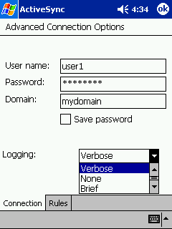

Steps to Enable Logging on Pocket PC 2003

- Click Start, ActiveSync, Tools, Options, Server, Options, Rules.
- Change the logging level to Brief or Verbose.
- Click OK.

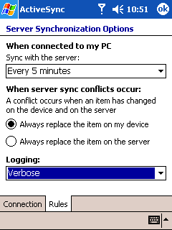

The log is saved in text format in the Windows\ActiveSync folder.

Steps to Enable Logging on Smartphone 2002

- Click Programs, ActiveSync, Menu, Options, Connection.
- Scroll down to Logging.
- Change the logging level to Brief or Verbose
- Click Done.

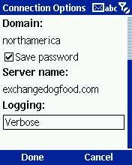

Steps to Enable Logging on Smartphone 2003

- Click Start, ActiveSync, Menu, Options, Server Settings, Connection, Menu, Rules.
- Change the logging level to Brief or Verbose.
- Click Done.

The log is saved in text format in the IPSM\Windows\Activesync folder.

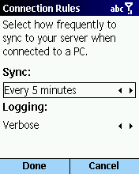

The log is saved in text format in the Storage\Windows\Activesync folder.

Server Logging

Server tracing can be enabled by using the Nextags tool. This tool is not included on the CD. Product Support Services (PSS) uses it to gather logs as needed.

Error Codes

Errors received after a synchronization attempt on the device have error codes appended to them. These codes help determine the source of the error. They are of the following types:

Error code: DEV_errorcode – This error code indicates that the error was from the Server ActiveSync client on the device.

Error code: MIS_errorcode – This error code indicates that the error was from the Mobile Information Server with the Server ActiveSync component installed.

Error code: SYNC_errorcode - This error code indicates that the error was from the Exchange 2003 server. MIS_errorcode errors were replaced with SYNC_errorcode errors on Windows Mobile 2003-based devices.

Error code: HTTP_errorcode – Standard HTTP error (Internet related)

Error code: CONNMGR_errorcode –Connection Manager error

Error code: INTERNET_errorcode – Standard WinInet error (Internet related)
For example: Error code: INTERNET_29

Error code: hexerrorcode For example: 0x80004005

For a list of the most common error messages with explanation and user action, please refer to the next section of this document.

Error Message, Explanation, and User Action

Error code: MIS_3

Error message: Sync key mismatch error. To restart sync, disable and re-enable Server ActiveSync on the device for the particular data type that failed (for example, Calendar, Contacts, or Inbox).

Explanation: This error can be reported if the device was restored from an older backup or the user’s Exchange account was restored or moved to a different server.

User Action: Disable and then re-enable ActiveSync for the data types that are being synchronized by clicking on Start, ActiveSync, Tools, Options, Server.

Error code: MIS_5

Error Message: Synchronization failed due to a server software error. If the problem continues, contact your network administrator.

Explanation:

a. Windows Integrated Authentication is not enabled on the Exchange virtual directory on the Exchange server. The Exchange ActiveSync component uses Kerberos authentication when communicating with the Exchange server.

b. Windows Integrated Authentication is enabled on the Exchange virtual directory on the Exchange server, but Kerberos is disabled via the IIS metabase.

c. Kerberos is enabled, but IIS may return HTTP Status 401 every 30 Days when using Kerberos on Windows 2000.

d. The TMP/TEMP environment variable on the Exchange server is not pointing to a valid directory or there is not enough disk space or the user performing sync does not have access to the TMP/TEMP folder on the Exchange server. For large sync requests, IIS uses temporary storage.

e. Large sync requests could exceed the default size limits for requests sent to IIS.

f. Sync state on the device is corrupt.

User Action:

a. To enable Integrated Windows Authentication on the Exchange virtual root:

1. Start Exchange System Manager.
2. Expand Servers, expand Server Name, and then expand Protocols.
Expand HTTP, and then expand Exchange Virtual Server.
3. Right-click Exchange, and then click Properties.
4. Click the Access tab, click Authentication, and then click to select
the Integrated Windows Authentication check box.
5. Click OK, and then click OK again.

b. Re-enable Kerberos on the Exchange server by following the instructions in the KB Article 215383.

HOW TO: Configure IIS to Support Both Kerberos and NTLM Authentication
ID: 215383

c. If you are using Exchange 2003 with Windows 2000, obtain the hot fix outlined in KB 329938 by calling Microsoft Product Support Services.

d. Verify the TMP/TEMP configuration.

e. The MaxClientRequestBuffer can be increased as outlined in the KB 260694 Description of the MaxClientRequestBuffer Registry Value

f. Deselect the datatype(usually calendar) and then reselect the datatype.

Error code: MIS_8

Error Message: Synchronization of <inbox> cannot be completed successfully. Your device must sync all inbox information with sync server.

Explanation:

This error can occur if the synchronization server is unable to open the inbox folder on the Exchange server. This can occur with calendar and contacts as well.

The PUT verb is blocked on the Exchange server.

User Action:

A recovery sync will be performed automatically during a subsequent sync.

If UrlScan is configured on the Exchange server, make sure that this verb is allowed on the Exchange server.

Error code: MIS_9

Error Message: Synchronization failed. There is not enough space on your Microsoft Exchange mailbox to synchronize information. Delete old items to increase space and try again.

Explanation:

This error can occur if you are approaching the mailbox limits set on your Exchange server.

The TMP/TEMP environment variable on the Exchange server is not pointing to a valid directory or there is not enough disk space or the user performing sync does not have access to the TMP/TEMP folder on the Exchange server. For large sync requests, IIS uses temporary storage.

Large sync requests could exceed the default size limits for requests sent to IIS.

User Action:

Try to delete items in your mailbox to bring it within limits. Contact your Exchange administrator to change the limits on your mailbox.

Verify the TMP/TEMP configuration.

The MaxClientRequestBuffer can be increased as outlined in the KB 260694 Description of the MaxClientRequestBuffer Registry Value.

Error code: MIS_20

Error message: A critical error has occurred and sync failed. When you next sync, you will be prompted to overwrite the data on your device with data from the server. This may take several minutes.

Explanation: This error could occur if there are multiple front-end servers and some of them have not been upgraded.

User Action: Sync should recover on its own.

Error code: SYNC_3

Error message: A critical error has occurred and sync failed. The next time you sync, you will be prompted to overwrite the data on your device with data from the server. You will lose only the changes made since your last successful sync.

Explanation: This error could occur if host headers are being used and the request goes to the wrong Web site.

User Action: Verify that host headers are configured correctly.

Error code: SYNC_5

Error Message: Synchronization failed due to a server software error. If the problem continues, contact your network administrator.

Explanation:

a. Windows Integrated Authentication is not enabled on the Exchange virtual directory on the Exchange server. The Exchange ActiveSync component uses Kerberos authentication when communicating with the Exchange server.

b. Windows Integrated Authentication is enabled on the Exchange virtual directory on the Exchange server, but Kerberos is disabled via the IIS metabase.

c. An alternate Exchange virtual directory was created, but the sync state information on the server contains reference to the default Exchange virtual directory.

d. The TMP/TEMP environment variable on the Exchange server is not pointing to a valid directory or there is not enough disk space or the user performing sync does not have access to the TMP/TEMP folder on the Exchange server. For large sync requests, IIS uses temporary storage.

e. Large sync requests could exceed the default size limits for requests sent to IIS.

f. Sync state on the device is corrupt.

User Action:

a. To enable Integrated Windows Authentication on the Exchange virtual root:

1. Start Exchange System Manager.
2. Expand Servers, expand Server Name, and then expand Protocols.
Expand HTTP, and then expand Exchange Virtual Server.
3. Right-click Exchange, and then click Properties.
4. Click the Access tab, click Authentication, and then click to select
the Integrated Windows Authentication check box.
5. Click OK, and then click OK again.

b. Re-enable Kerberos on the Exchange server by following the instructions in the KB Article 215383.

HOW TO: Configure IIS to Support Both Kerberos and NTLM Authentication
ID: 215383

c. Force an initial sync by deselecting the datatypes on the device and then reselecting them.

d. Verify the TMP/TEMP configuration.

e. The MaxClientRequestBuffer can be increased as outlined in the KB 260694 Description of the MaxClientRequestBuffer Registry Value

f. Deselect the datatype (usually calendar) and then reselect the datatype.
Error code: HTTP_401

Error Message: Unable to connect to sync server due to authentication failure. Check your connection configuration.
or
Error Message: Access was denied. Check your server username and password in ActiveSync Options.

Explanation: The credentials provided to access the server are incorrect or you are not enabled for synchronization or your password has expired.

User Action: On the device, go to ActiveSync, Tools, Server, verify that the server name is correct. Click on Advanced and verify the username, password and domain information. Please contact your administrator and make sure that you are enabled for synchronization.

Error code: HTTP_403

Error Message: Your account does not have permission to sync with your current settings. Contact your Microsoft Exchange administrator.

Explanation:

a. The Microsoft-Server-ActiveSync virtual directory on your server is configured to require SSL and you are using a device without SSL.

The Exchange virtual directory on your mailbox server is configured to require SSL.

c. This error could occur if host headers are being used and the request goes to the wrong Web site.

User Action:

a. On your Pocket PC 2003-based device, click Start, ActiveSync, Tools, Options, Server and check the box “This server uses an SSL connection”.

b. On your Smartphone 2003-based device, click Start, ActiveSync, Menu, Options, Server Settings, Connection and check the box “This server uses an SSL connection”.

c. Verify that host headers are configured correctly.

Error code: HTTP_404

Error Message: The server you are synchronizing with is not an Exchange ActiveSync server, or is running incompatible software. Specify the correct server in ActiveSync options.

Explanation: The server name specified on the device resolves to the IP address of a server that does not have Exchange installed on it.

User Action: Verify the server name and DNS configuration.

Error code: HTTP_500

Error Message: Synchronization failed due to an error on the server. Try again.

Explanation:

a. Windows Integrated Authentication is not enabled on the Exchange virtual directory on the Exchange server. The Server ActiveSync component uses Kerberos authentication when communicating with the Exchange server.

b. Windows Integrated Authentication is enabled on the Exchange virtual directory on the Exchange server, but Kerberos is disabled via the IIS metabase.

c. Kerberos is enabled, but IIS may return HTTP Status 401 every 30 Days when using Kerberos on Windows 2000.

d. Sync is attempted while the mailbox is being moved.

e. User attempting sync is a member of more than 200 groups.

f. The Left Hand Side(LHS) and Right Hand Side(RHS) of the user’s primary SMTP address are both different from the SMTP address based on the default recipient policy.

g. The Exchange virtual directory on the Exchange Server is configured to require Secure Sockets Layer (SSL). Server ActiveSync communicates with the Exchange Server over port 80.

h. Windows SharePoint® has been installed on the Exchange server.

i. The user composes e-mail on the device and attempts a sync when mailbox limits have been reached on the Exchange server.

j. Anonymous authentication is enabled on the Microsoft-Server-ActiveSync virtual directory on the server.

User Action:

a. To enable Integrated Windows Authentication on the Exchange virtual root:

1. Start Exchange System Manager.

2. Expand Servers, expand Server Name, and then expand Protocols. Expand HTTP, and then expand Exchange Virtual Server.

3. Right-click Exchange, and then click Properties.

4. Click the Access tab, click Authentication, and then click to select the Integrated Windows Authentication check box.

5. Click OK, and then click OK again.

b. Re-enable Kerberos on the Exchange server by following the instructions in the KB Article 215383. HOW TO: Configure IIS to Support Both Kerberos and NTLM Authentication ID: 215383

c. If you are using Exchange 2003 on Windows 2000, obtain the hot fix outlined in KB 329938 by calling Microsoft Product Support Services.

d. Attempt sync later.

e. Reduce the group membership or obtain the QFE fix outlined in KB 818526 by calling Microsoft Product Support Services.

f. Add a registry key. Use Regedt32 and locate

HKLM\System\CurrentControlSet\Services\MasSync\Parameters. Under the Parameters key create a Reg_SZ value called SMTPProxy. Set the value to the domain defined by the default recipient policy. For example, Microsoft.com. Restart the IIS Admin service. If you are using a front-end/back-end configuration this registry key needs to be added on the front-end server.

g. To configure the Exchange virtual directory to not require SSL

1. On the Exchange server click Start, Programs, Administrative Tools, and then click Internet Services Manager.
2. Expand the <ServerName> and the <Default Web Site> nodes.
3. Right-click the Exchange virtual root, and then click Properties.
4. On the Directory Security tab, click Edit under Secure
Communications.
5. Verify that the "Require Secure Channel (SSL)" check box is not
selected, and then click OK two times.
6. Close Internet Services Manager.

If you must use SSL on the default Exchange directory, create an alternate Exchange virtual directory for Exchange ActiveSync to use and add a registry key as per the steps provided in the Checklist section.

h. Configure Windows SharePoint to use Kerberos authentication by following the steps in KB 832769 HOW TO: Configure Windows SharePoint Services to Use Kerberos Authentication

Try to delete items in your mailbox to bring it within limits or contact your Exchange administrator to change the limits on your mailbox.

j. Uncheck anonymous authentication on the Microsoft-Server-ActiveSync virtual directory on the server. Basic authentication should be enabled.
Error code: HTTP_502
Error Message: Synchronization failed due to an error on the server.

Explanation: The device is using a proxy server to connect to the Exchange Server. The proxy server encountered an error.

User Action: Please use a different proxy or report the issue to the proxy server administrator.
Error code: HTTP_503
Error Message: Synchronization failed due to an error on the server. Try again.

Explanation: The Web service is unavailable. The service may have been stopped temporarily.

User Action: Attempt sync later.
Error code: HTTP_504
Error Message: Synchronization failed because of a server error. Try again.

Explanation: The device is using a proxy server to connect to the Exchange Server. The proxy server connection timed out.

User Action: Use a different proxy or report the issue to the proxy server administrator.
Error code: DEV_1
Error Message: Synchronization failed. You do not have enough free memory on your device to synchronize information. Delete unused files from your device or close programs that are running to free up memory, and then try again.

Explanation: Insufficient memory.

User Action: The storage memory holds all the applications that are loaded in RAM on the device. The program memory is used by programs that are running. The shell adjusts allocation of storage and program memory. The shell will close applications to free program memory. You can also close applications manually by clicking Settings, System, Memory, Running Programs, and stopping the unnecessary applications. To free up storage memory remove unnecessary programs that have been loaded.
Error code: DEV_2
Error Message: Synchronization cannot be completed successfully due to a server time out. Disconnect, reconnect and try again.

Explanation: This error is reported when the server fails to respond to a command sent from the device.

User Action: Attempt the sync later.
Error code: DEV_3
Error Message: You have stopped synchronization.

Explanation: This error is reported when you disconnect the connection that was being used for synchronization. For example, if you were using a CDPD modem for connectivity and you clicked on Disconnect in the middle of an ActiveSync session, you could get this error.

User Action: Reconnect and attempt the sync.
Error code: DEV_4
Error Message: Synchronization failed. If the problem continues, contact your network administrator.

Explanation: This error is caused by corruption in the data store.

User Action: Unselect the datatypes on the device by clicking Start, ActiveSync, Server, and then reselect them. This will delete all the data on the device. On the subsequent sync, all selected items will be synchronized to the device.
Error code: DEV_9
Error Message: The connection failed due to missing server information or user credentials. Tap Options, and then the Server tab to verify that your server name is correct. Then, tap Advanced to verify that your user credentials are correct and try again.

Explanation:

User Action: Verify the server information and credentials.
Error code: DEV_10
Error Message: Synchronization failed because the device timed out waiting for the server to respond. Try again later.

Explanation: This error is reported when the device times out while trying to establish a connection with the server. The error is reported after around 4 minutes.

User Action: Attempt the sync later.
Error code: INTERNET_7
Error Message: Synchronization failed. Verify that you have entered the correct server name and try again.

Explanation:

User Action: Verify the server information on your device.
Error code: INTERNET_19
Error Message: Synchronization failed due to a device software error. Contact your network administrator.

Explanation: This could be caused by transient network issues.

User Action: Attempt the sync later.
Error code: INTERNET_29
Error Message: Synchronization failed. Information cannot be synchronized because a connection to the network was not detected. Check your device connection settings and try again.

Explanation:

- There is no connectivity to the server.
- A certificate is not installed on the server.
- The configuration settings on the device for Exchange ActiveSync are incorrect.

User Action:

a. If you are using desktop pass through, make sure the device is in the cradle. If you are using an 802.11 card, make sure the connection settings are configured correctly. Check to see if your device has a valid IP address. Verify that you have Internet connectivity by browsing a Web site. Freeware utilities are available for Windows Mobile-based devices to assist in determining your IP address and verifying basic network connectivity.

b. If you are using a Windows Mobile 2002-based device, install a valid certificate on the server.

c. Verify that you have entered the server name correctly on your device. If you have a front-end/back-end configuration use the name of the front-end server and not the mailbox server.
Error code: INTERNET_31
Error Message: Synchronization failed due to a communications failure. Try again.

Explanation:

The connection with the server was reset. You are using a Windows Mobile 2002-based device or a Windows Mobile 2003-based device with SSL. However an SSL connection could not be established and the connection was reset.

User Action:

Verify that the server you are connecting is listening on the SSL port. Ensure that you can connect to the server over SSL using Internet Explorer on the device.
Error code: INTERNET_37
Error Message: Synchronization failed. The security certificate on the server has expired. Check that the date and time on your device are correct and try again.

Explanation: The date and time on the device are incorrect.

User Action: On your device, click Start, Settings, System, Clock, and set the correct date and time.
Error code: INTERNET_38
Error Message: Synchronization failed due to an incorrect SSL certificate common name.

Explanation: The name of the Exchange server specified on the device does not match the common name on the certificate.

User Action: On your device, click Start, ActiveSync, Tools, Options, Server, and make sure that the correct server name is entered.
Error code: INTERNET_45
Error Message: Synchronization failed. The security certificate on the server is invalid. Contact your system administrator or ISP to install a valid certificate on the server and try again.

Explanation: The sync client does certificate validation and has detected that an invalid certificate is installed.

User Action: Attempt sync after a valid certificate is installed on the server.
The following root certificates are installed by default on Pocket PCs with Windows Mobile 2002 software.
- Verisign/RSA Secure Server
- Verisign Class 1 Public Primary CA
- Verisign Class 2 Public Primary CA
- Verisign Class 3 Public Primary CA
- Verisign Class 3 Public Primary CA (2028)
- GTE Cybertrust ROOT
- GTE Cybertrust Solutions ROOT
- Thawte Server CA
- Thawte Premium Server CA
- Entrust.net Secure Server
- Entrust.net CA (2048 bit)
If you are using a certificate that is not trusted, you can disable certificate validation on the device by running the CertChk.exe tool. The Disable Certificate Validation tool is part of the Exchange 2003 All-in-one Tools package available from
http://www.microsoft.com/downloads/details.aspx?FamilyId=E0F616C6-8FA4-4768-A3ED-CC09AEF7B60A&displaylang=en
Please see the readme that is provided with the tool for more information.

Root certificates can also be added to the Pocket PCs with Windows Mobile 2002 softwareby using the process outlined in KB 322956 Sample to Add Root Certificates to Pocket PC 2002.
Error code: INTERNET_55
Error Message: Synchronization failed. If the problem continues contact your Network Administrator.

Explanation: The sync client does certificate validation and has detected that an invalid certificate is installed.

User Action: Attempt sync after a valid certificate is installed on the server.
The following root certificates are installed by default on Pocket PC 2003 devices.
- Equifax Secure Certificate Authority
- Verisign Class 2 Public Primary CA
- Verisign Class 3 Public Primary CA
- GTE Cybertrust ROOT
- GTE Cybertrust Solutions ROOT
- Thawte Server CA
- Thawte Premium Server CA
- Entrust.net Secure Server
- Entrust.net CA (2048 bit)
- GlobalSign Root CA
If you are using a certificate that is not trusted, you can disable certificate validation on the device by running the CertChk.exe tool. The Disable Certificate Validation tool is part of the Exchange 2003 All-in-one Tools package available from
http://www.microsoft.com/downloads/details.aspx?FamilyId=E0F616C6-8FA4-4768-A3ED-CC09AEF7B60A&displaylang=en
Please see the readme that is provided with the tool for more information.

Root certificates can also be added to the Pocket PC 2003-based device. Copy the .DER file for your root certificate to the Pocket PC 2003-based device. Then browse to the file and just click on it. Pocket PC 2003-based devices will prompt you to add the certificate to the root store.
Error code: INTERNET_152
Error Message: Synchronization failed due to a communications failure. Try again.

Explanation: An invalid response was received from the server. This could occur if a problem was encountered while the server was in the midst of transmitting data. This could occur if there was a proxy in between the device and server that did not honor the HTTP Keep-Alive setting. This could also occur if the default Web site has been stopped.

User Action: Attempt the sync again. Configure the proxy to enable the HTTP Keep-Alive setting. If the default Web site was stopped, Click Start, Programs, Administrative Tools, and then click Internet Services Manager. Click to expand your server object, right-click Default Web site, and then click Start.
Error code: CONNMGR_33
Error Message: Unable to connect. Verify you have network coverage and try again.

Explanation: There is no connection available for the device to communicate with the server.

User Action: Verify the connectivity settings on your device.
Error code: CONNMGR_36
Error Message: Unable to connect. Verify your dialup or proxy settings are correct, and try again.

Explanation:

There is no connection available for the device to communicate with the server.

The user has more than 372 top level folders in their mailbox and is using a Windows Mobile 2002-based device.

User Action:

- Verify the connectivity settings on your device.

Reduce the number of top level folders to 372 or less by moving some top level folders to be subfolders or use a Windows Mobile 2003-based device.
Error code: CONNMGR_37
Error Message: Unable to connect. Verify you have network coverage, and try again. If the problem persists, contact your network administrator.

Explanation:

There is no connection available for the device to communicate with the server.

User Action:

- Verify the data connectivity settings (GPRS/dial-up settings) on your device.
Error code: CONNMGR_38
Error Message: Unable to connect. Voice call is in progress. End the voice call and try again.

Explanation:

It is not possible to start a data session while a voice call is in progress.

User Action:

Attempt sync after the voice call ends.
Error code: 0x80042256
Error Message: Synchronization failed because the user aborted connection.

Explanation: User clicked Stop when the sync was in progress.

User Action: In ActiveSync, click Sync to initiate the server sync.
Error code: 0x80070008
Error Message: Synchronization failed. If the problem continues, contact your network administrator.

Explanation:

User Action: Obtain the latest Pocket PC End User Update from your service provider.

Error code: 0x8007000e

Error Message: Synchronization failed. You do not have enough free memory on your device to synchronize information. Delete unused files from your device or close programs that are running to free up memory, and then try again.

Explanation:

- Attempt to sync a meeting request that contains an attendee list that exceeds 16K characters.
- Attempt to sync a calendar item that contains a large number of exceptions.
c. Make sure you have enough free memory on the device.

User Action:

Obtain the latest Pocket PC End User Update from your service provider.
Try a soft reset of the device.
Error code: 0x80004005
Error Message: Synchronization failed due to a device software error. Contact your network administrator.

Explanation:

User Action: Obtain the latest Pocket PC End User Update from your service provider.
Error code: 0x 80070057 or 0x80830003
Error Message: Synchronization failed. If the problem continues, contact your network administrator.

Explanation: The Exchange server is configured to require client certificates.

User Action: On the Exchange server, launch Internet Services Manager. Right click on the Microsoft-Server-ActiveSync virtual directory and choose Properties. Select the Directory Security tab. Click the Edit button in the Secure Communications section and select the option to “Ignore client certificates.”

Frequently Asked Questions and Answers

- What types of data can be synchronized using Exchange ActiveSync?

E-mail, Calendar, and Contact information can be synchronized using Exchange ActiveSync.

- Can I synchronize Inbox, Calendar and Contact information with the desktop as well?

No, you can either choose to sync Inbox, Calendar and Contact information with the server or with the desktop. If you have chosen to sync with the server, you can still do so when cradled via the desktop pass-through option which all Windows Mobile-based devices support.

- Is it possible to synchronize folders other than Inbox?

Yes, after the initial synchronization it is possible to select other folders in your mailbox to synchronize. On the device, choose Inbox, Manage Folders, and select the folders you want to synchronize.

- Can synchronization be configured from the device?

Yes, if you are interested only in e-mail, Calendar, or Contacts, you can configure this information on the device.

- Can synchronization be scheduled?

Yes, synchronization can be scheduled. In fact, you can configure different sync schedules based on whether you are connected to the computer or not.

Windows Mobile 2003-based devices provides more granularity with respect to scheduling.

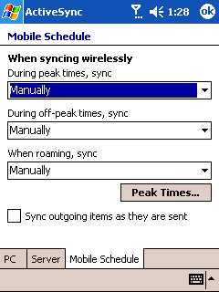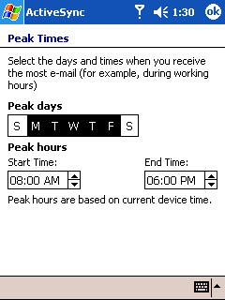

6. Does unselecting the data types on the device delete items on the server?

No. When you unselect the data types on the device by clicking Start, ActiveSync, Server, you are deleting the data store on the device. On the subsequent sync, all selected items will be synchronized to the device.

7. When I synchronize e-mail, can I synchronize only header information?

Yes, you can choose to synchronize only header information. In ActiveSync, choose Tools, Options, Server. Click on Inbox and choose Settings. Change the setting “To save space, copy at most: “ to Headers.

When viewing the headers in your Inbox, if you want to download the message body for a particular message, you can choose Edit, “Mark for Download.” On the subsequent sync, the entire message will be synchronized.

8. If I choose to synchronize header information only on the initial sync, can I change this later to synchronize the message body as well for existing and new messages?

To do this, you will have to unselect inbox and reselect it. This will delete your e-mail on the device, but will not delete items from the Exchange Server mailbox. Then change the selection for Inbox from “Headers” to “All.” On the subsequent sync, messages will be synchronized with the message body.

9. What happens when I change the selection from “Headers” to “All? ”

When you sync with the selection set to "Headers," only header information is synchronized. If you change the selection to “All” and then sync, only messages synchronized after the change will have the message body.

10. Why are attachments not synchronized to the device although the device is configured to synchronize attachments?

Exchange ActiveSync uses the X-MS-ENUMATTS verb to retrieve attachments from the Exchange server. If UrlScan is configured on the Exchange server, make sure that this verb is allowed on the Exchange server.

11. Items are not being downloaded to the device.

Server ActiveSync uses the “If” header when retrieving items from Exchange. If UrlScan is configured on the Exchange server, make sure that If is not included under [DenyHeaders].

Complete List of Errors

Device Errors

DEV_1 = E_SYNC_OUTOFDISK - Run out of storage even after system closed other processes.
DEV_2 = E_FAIL_CONNECTION_TIMEOUT - Connection failed due to sync server time out.
DEV_3 = E_FAIL_ABORT - The user manually aborts the sync process.
DEV_4 = E_FAIL_CODE_MAJOR - Programming errors
DEV_5 = E_FAIL_CODE_MINOR - Skippable code errors: error inside device side AirSync protocol, failed to sync an individual items.
DEV_6 = E_FAIL_SERVER - Sync failed due to server side reason but no server originated error code received, or any other unknown server errors.
DEV_7 = E_FAIL_CONVERSION_DEVICE - Error in writing an item's properties to the database.
DEV_8 = E_PURGE_ERROR - Sync key data is not valid since a data purge failed.
DEV_9 = E_FAIL_CONN_INFO_ABSENT - Required connection info not present.

MSAS Errors

MIS_0 = SYNC_STATUS_CODE_INVALID
MIS_1 = SYNC_STATUS_CODE_SUCCESS
MIS_2 = SYNC_STATUS_CODE_PROTOCOL_VER = AirSync protocol version mismatch
MIS_3 = SYNC_STATUS_CODE_SYNCKEY = Invalid SyncKey error
MIS_4 = SYNC_STATUS_CODE_PROTOCOL = AirSync protocol error
MIS_5 = SYNC_STATUS_CODE_SYNC_SERVER = Sync server failure error
MIS_6 = SYNC_STATUS_CODE_CONVERSION = Error in the Client/Server conversion
MIS_7 = SYNC_STATUS_CODE_CONFLICT = Conflict between the matching Client and Server object
MIS_8 = SYNC_STATUS_CODE_OBJ_NOT_FOUND = Object not found (the object is currently deleted)
MIS_9 = SYNC_STATUS_CODE_DISK_SPACE = User is out of disk space

HTTP Errors

HTTP_400 = E_HTTP_BAD_REQUEST
HTTP_401 = E_HTTP_DENIED
HTTP_403 = E_HTTP_FORBIDDEN
HTTP_404 = E_HTTP_NOT_FOUND
HTTP_405 = E_HTTP_BAD_METHOD
HTTP_406 = E_HTTP_NONE_ACCEPTABLE
HTTP_407 = E_HTTP_PROXY_AUTH_REQ
HTTP_408 = E_HTTP_REQUEST_TIMEOUT
HTTP_409 = E_HTTP_CONFLICT
HTTP_410 = E_HTTP_GONE
HTTP_411 = E_HTTP_LENGTH_REQUIRED
HTTP_412 = E_HTTP_PRECOND_FAILED
HTTP_413 = E_HTTP_REQUEST_TOO_LARGE
HTTP_414 = E_HTTP_URI_TOO_LONG
HTTP_415 = E_HTTP_UNSUPPORTED_MEDIA
HTTP_416 = E_HTTP_REQ_RANGE_NOT_SAT
HTTP_417 = E_HTTP_EXPECTATION_FAILED
HTTP_500 = E_HTTP_SERVER_ERROR
HTTP_501 = E_HTTP_NOT_SUPPORTED
HTTP_502 = E_HTTP_BAD_GATEWAY
HTTP_503 = E_HTTP_SERVICE_UNAVAIL
HTTP_504 = E_HTTP_GATEWAY_TIMEOUT
HTTP_505 = E_HTTP_VERSION_NOT_SUP

Device Connection Manager Errors

CONNMGR_0 = E_CONNMGR_UNKNOWN = Unknown status
CONNMGR_16 = E_CONNMGR_CONNECTED = Connection is up
CONNMGR_32 = E_CONNMGR_DISCONNECTED = Connection is disconnected
CONNMGR_33 = E_CONNMGR_CONNECTIONFAILED = Connection failed and cannot not be reestablished
CONNMGR_34 = E_CONNMGR_CONNECTIONCANCELED = User aborted connection
CONNMGR_35 = E_CONNMGR_CONNECTIONDISABLED = Connection is ready to connect but disabled
CONNMGR_36 = E_CONNMGR_NOPATHTODESTINATION = No path could be found to destination
CONNMGR_37 = E_CONNMGR_WAITINGFORPATH = Waiting for a path to the destination
CONNMGR_38 = E_CONNMGR_WAITINGFORPHONE = Voice call is in progress
CONNMGR_64 = E_CONNMGR_WAITINGCONNECTION = Attempting to connect
CONNMGR_65 = E_CONNMGR_WAITINGFORRESOURCE = Resource is in use by another connection
CONNMGR_66 = E_CONNMGR_WAITINGFORNETWORK = No path could be found to destination
CONNMGR_128 = E_CONNMGR_WAITINGDISCONNECTION = Connection is being brought down
CONNMGER_129 = E_CONNMGR_WAITINGCONNECTIONABORT = Aborting connection attempt

WININET Errors

INTERNET_1 = ERROR_INTERNET_OUT_OF_HANDLES
INTERNET_2 = ERROR_INTERNET_TIMEOUT
INTERNET_3 = ERROR_INTERNET_EXTENDED_ERROR
INTERNET_4 = ERROR_INTERNET_INTERNAL_ERROR
INTERNET_5 = ERROR_INTERNET_INVALID_URL
INTERNET_6 = ERROR_INTERNET_UNRECOGNIZED_SCHEME
INTERNET_7 = ERROR_INTERNET_NAME_NOT_RESOLVED
INTERNET_8 = ERROR_INTERNET_PROTOCOL_NOT_FOUND
INTERNET_9 = ERROR_INTERNET_INVALID_OPTION
INTERNET_10 = ERROR_INTERNET_BAD_OPTION_LENGTH
INTERNET_11 = ERROR_INTERNET_OPTION_NOT_SETTABLE
INTERNET_12 = ERROR_INTERNET_SHUTDOWN
INTERNET_13 = ERROR_INTERNET_INCORRECT_USER_NAME
INTERNET_14 = ERROR_INTERNET_INCORRECT_PASSWORD
INTERNET_15 = ERROR_INTERNET_LOGIN_FAILURE
INTERNET_16 = ERROR_INTERNET_INVALID_OPERATION
INTERNET_17 = ERROR_INTERNET_OPERATION_CANCELLED
INTERNET_18 = ERROR_INTERNET_INCORRECT_HANDLE_TYPE
INTERNET_19 = ERROR_INTERNET_INCORRECT_HANDLE_STATE
INTERNET_20 = ERROR_INTERNET_NOT_PROXY_REQUEST
INTERNET_21 = ERROR_INTERNET_REGISTRY_VALUE_NOT_FOUND
INTERNET_22 = ERROR_INTERNET_BAD_REGISTRY_PARAMETER
INTERNET_23 = ERROR_INTERNET_NO_DIRECT_ACCESS
INTERNET_24 = ERROR_INTERNET_NO_CONTEXT
INTERNET_25 = ERROR_INTERNET_NO_CALLBACK
INTERNET_26 = ERROR_INTERNET_REQUEST_PENDING
INTERNET_27 = ERROR_INTERNET_INCORRECT_FORMAT
INTERNET_28 = ERROR_INTERNET_ITEM_NOT_FOUND
INTERNET_29 = ERROR_INTERNET_CANNOT_CONNECT
INTERNET_30 = ERROR_INTERNET_CONNECTION_ABORTED
INTERNET_31 = ERROR_INTERNET_CONNECTION_RESET
INTERNET_32 = ERROR_INTERNET_FORCE_RETRY
INTERNET_33 = ERROR_INTERNET_INVALID_PROXY_REQUEST
INTERNET_34 = ERROR_INTERNET_NEED_UI
INTERNET_36 = ERROR_INTERNET_HANDLE_EXISTS
INTERNET_37 = ERROR_INTERNET_SEC_CERT_DATE_INVALID
INTERNET_38 = ERROR_INTERNET_SEC_CERT_CN_INVALID
INTERNET_39 = ERROR_INTERNET_HTTP_TO_HTTPS_ON_REDIR
INTERNET_40 = ERROR_INTERNET_HTTPS_TO_HTTP_ON_REDIR
INTERNET_41 = ERROR_INTERNET_MIXED_SECURITY
INTERNET_42 = ERROR_INTERNET_CHG_POST_IS_NON_SECURE
INTERNET_43 = ERROR_INTERNET_POST_IS_NON_SECURE
INTERNET_44 = ERROR_INTERNET_CLIENT_AUTH_CERT_NEEDED
INTERNET_45 = ERROR_INTERNET_INVALID_CA
INTERNET_46 = ERROR_INTERNET_CLIENT_AUTH_NOT_SETUP
INTERNET_47 = ERROR_INTERNET_ASYNC_THREAD_FAILED
INTERNET_48 = ERROR_INTERNET_REDIRECT_SCHEME_CHANGE
INTERNET_49 = ERROR_INTERNET_DIALOG_PENDING
INTERNET_50 = ERROR_INTERNET_RETRY_DIALOG
INTERNET_52 = ERROR_INTERNET_HTTPS_HTTP_SUBMIT_REDIR
INTERNET_53 = ERROR_INTERNET_INSERT_CDROM

Common Issues and Associated KB Articles

- Mapping Multiple Proxy Addresses to Multiple Back-End Virtual Root Directories on the Same Server Is Not Supported http://support.microsoft.com/default.aspx?scid=kb;en-us;817317

- You receive HTTP_500 error message when you synchronize your mobile device with Microsoft Exchange Server 2003 http://support.microsoft.com/default.aspx?scid=kb;en-us;886346

- Fine-tuning and known issues when you use the UrlScan utility in an Exchange 2003 environment http://support.microsoft.com/default.aspx?scid=kb;en-us;823175

- Add certificates to SP 2002 http://support.microsoft.com/default.aspx?scid=kb;en-us;841060
Note: This works for 2003 also but some devices are locked so this won't work. For example VZW who has signed a version for use on their 2003 i600. 2003-based devices have native support for this if you run the .cer file from a file manager-type application or an e-mail attachment. It will install. The same applies to PPC.

Appendix B: Windows Mobile Client Configuration Guide

Introduction
This appendix goes reviews in greater depth the steps in setting up and configuring Exchange ActiveSync® and Up-To-Date (UTD) for Windows mobile devices. This guide is based on the online device help located at http://www.microsoft.com/windowsmobile/help/pocketpcphone/supportsetup.aspx.

Setting Up Exchange ActiveSync
Whether you use a Pocket PC, Pocket PC Phone Edition, or Smartphone --setting up your mobile device to sync via EAS is easy!

To Set Up EAS on a Cradled Device (recommended method)
Use the instructions below if you are setting up EAS with a new partnership.
NOTE: Before completing the steps below, be sure to install the latest version of ActiveSync on your desktop PC. You can get the latest version of ActiveSync at http://www.microsoft.com/windowsmobile/downloads/default.mspx.
Then, cradle your device and complete the steps below.
- Upon cradling the device the following window should appear.
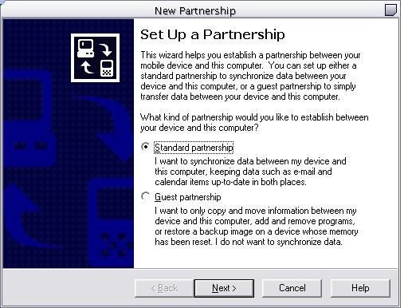
- Choose Standard Partnership, and then click Next.
- The next screen is where the decision is made to implement EAS on your device.
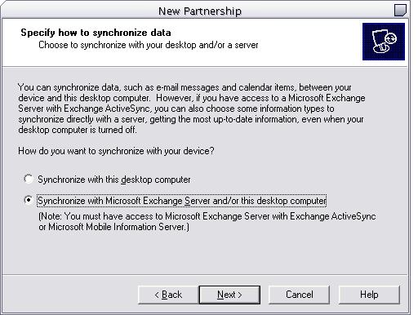
- Select Synchronize with Microsoft® Exchange Server and/or this desktop computer, and then click Next.
- The next screen is where you input information specific to mailbox location.
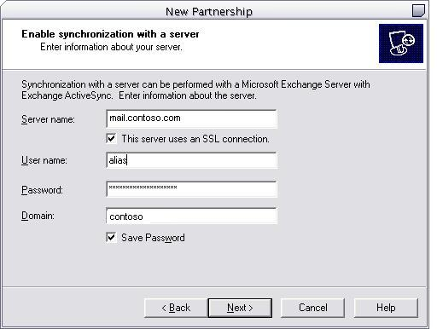
- Configure your mailbox specific information, and then click Next.
- On the next screen you choose which items to sync via EAS on your device. The option(s) you leave unchecked will be available to sync via the desktop.
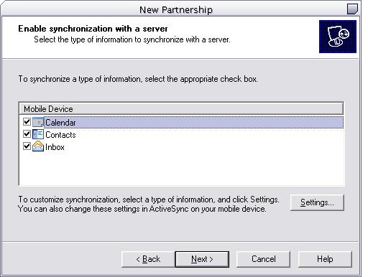
- Select the Calendar, Contacts, and Inbox check boxes, and then click Next. Note: Exchange ActiveSync (EAS) does not support the syncing of Tasks and Notes. To sync Tasks and Notes, you must use Desktop ActiveSync.
- Notice the Settings button towards the bottom-right of the screen. If you want to change any settings (such as file size, days to sync, and to include file attachments), highlight the item you want to change, and then click Settings.

- The next screen is where you make a decision on how many machines you would like to synchronize with.

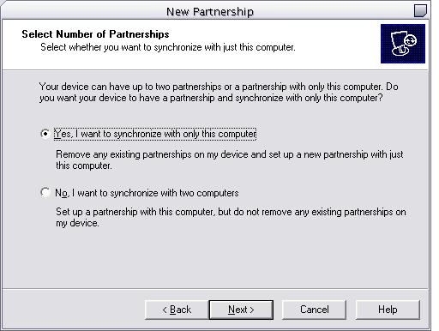
- Make the appropriate selection and then click Next.
- The next screen allows you to select which items will be synchronized on the desktop machine when cradled. Notice that when EAS is enabled, Inbox, Calendar, and Contacts do not appear. This is by design to avoid conflicts and duplicates.
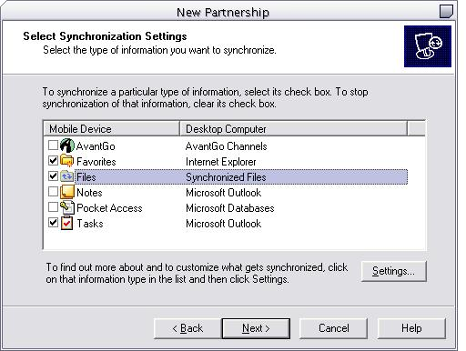
- Make the appropriate selections, and then click Next.
- Again, there is a Settings button to further configure each item.
You should now the see the following screen. Congratulations you are now ready to use EAS!

Set Up with an Existing Partnership

Use the instructions below if you are setting up EAS using an existing partnership.
NOTE: Before completing the steps below, be sure that you have installed the latest version of ActiveSync on your desktop PC. You can get the latest version of ActiveSync at http://www.microsoft.com/windowsmobile/downloads/default.mspx.
Then, cradle your device and complete the steps below.
- Upon cradling the device the following window should appear.
- Select Tools from the Menu and then select Options.
  - The next screen is for configuring items you want to synchronize and what to synchronize with.
- Select Tools from the Menu and then select Options.
- Select the Enable synchronization with a server check box and then select the Configure button.
  - Both are located towards the bottom of the Options window under the Server section.
  - The next screen is for all of your server configuration settings.
- Select the Calendar, Contacts and Inbox check boxes and then select Connection. Note: Exchange ActiveSync (EAS) does not support the syncing of Tasks and Notes. To sync Tasks and Notes, you must use Desktop ActiveSync.
  - Notice the Settings button towards the middle of the screen. If you want to change any settings (such as file size, days to sync, and to include file attachments), highlight the item you want to change, and then click Settings.
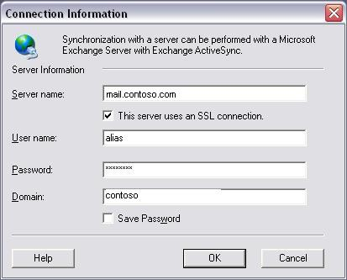
- Configure your mailbox specific information, and then select OK.
  - If you were previously synchronizing Calendar, Contacts, or Inbox items on your device you will see the screen below. Because your device has been cradled and synchronized prior to enabling EAS, please select Delete any items on my device and replace them with the items on the server and hit OK. This will greatly reduce the possibility of duplicates on your device.
  - The next screen illustrates what is being synchronized with the desktop and server. Notice that when Server synchronization is enabled you will not see Calendar, Contacts and Inbox as an option for desktop synchronization. This is by design to reduce the possibility of duplicates and conflicts.

- Select the OK button.
  - This will bring you back to the main ActiveSync screen. Notice the Calendar, Contacts, and Inbox Status indicates Sync status is on the device.
Congratulations you are now configured for Exchange ActiveSync!
If you cannot cradle your device, use the following instructions for EAS setup:

Uncradled Device EAS Setup

Pocket PC & Pocket PC Phone Edition 2002 and 2003:
- On your uncradled device, go to Start>ActiveSync>Tools>Options
- Select the Server tab and input your Exchange ActiveSync URL in the Server Name field. Please choose the URL that corresponds to the location of your mailbox server.
- Click the Options button, and then enter your Active Directory username, password, and domain.
Smartphone 2003:
- Go to Programs>ActiveSync>Menu>Options>Server Settings>Connection and enter your Active Directory username, password, and domain, server name.
- In the Server name field, input your Exchange ActiveSync server name. Please choose the URL that corresponds to the location of your mailbox server.
Smartphone 2002:
- Go to Programs>ActiveSync>Menu>Options>Connection and enter your Active Directory username, password, and domain.
- In the Server name field, input your Exchange ActiveSync server name. Please choose the URL that corresponds to the location of your mailbox server.

Up-to-Date Notifications (UTD)

Exchange ActiveSync can be configured on the device to sync with the server at intervals, syncing as frequently as every 5 minutes. This however does not provide up-to-date information on the device as there is a possibility that a new email, calendar, or contact item--or a change to an existing item--could occur during the synchronization interval, in which case the information contained on the Windows Mobile-based device would be slightly out of date until the next scheduled synchronization. The user might also incur higher data charges due to the frequent sync sessions. This is of course dependent on the type of network being utilized (your company's wireless LAN vs. a Mobile Operator network, for example) and the data plan you've selected (unlimited vs. pay-as-you-go, for example).

Up-to-date Notification (UTD) is a new feature in Exchange Server 2003 that provides the user with the ability to automatically synchronize the mobile device with the server as new items are received on the server. UTD requires Pocket PC Phone Edition running Microsoft Windows Mobile™ 2003 or a Smartphone running Windows Mobile 2003. UTD is a feature of ActiveSync that is installed with every Exchange 2003 server.

An event is generated in a user’s exchange account when a new mail is received in any of the selected folders. This event results in a Short Message Service (SMS) notification being sent to the user’s device. The device synchronizes in the background. The user data is updated to the most current information with no intervention on their part.

The notification is sent as an SMS control message to the device. It is different from a regular SMS in that it does not appear as an SMS message in the inbox. The SMS router and ActiveSync on the device process the notification. The notification itself does not carry any sensitive data.

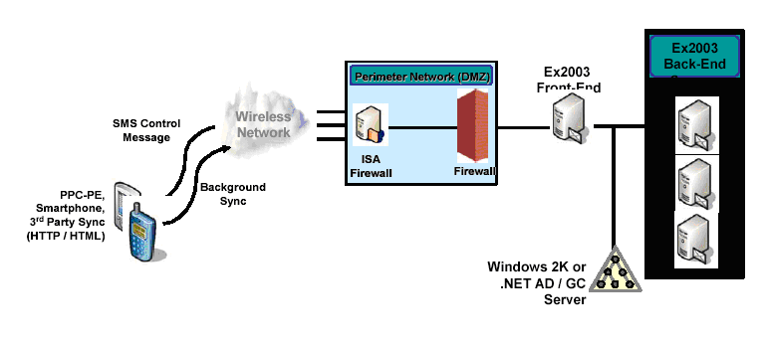

Enabling Up-to-Date Notifications

All users are enabled by default. The Exchange administrator can globally disable notifications. The administrator can also disable SMTP Pass-Through. These settings are configurable in Exchange System manager under Global Settings/Mobile Services.

Enable user initiated synchronization - Selecting this checkbox allows users to synchronize their Exchange information with their mobile device.
Enable up-to-date notifications - Selecting this checkbox allows users to receive UTD notifications in order to keep their mobile device up to date with information on their Exchange server.
Enable notifications to user specified SMTP addresses - Selecting this checkbox allows notifications to be sent directly to the SMS address of the device. If this checkbox is not selected, notifications can only be sent through the corporate service provider.

These settings are also available on individual user objects.

Users can be enabled/disabled on a per user basis through the Exchange Features tab in AD Users and Computers. It is possible to enable or disable users in bulk by multi-selecting users and choosing enable or disable. However the setting for the SMTP Addressing Enable bit applies only at the global level.

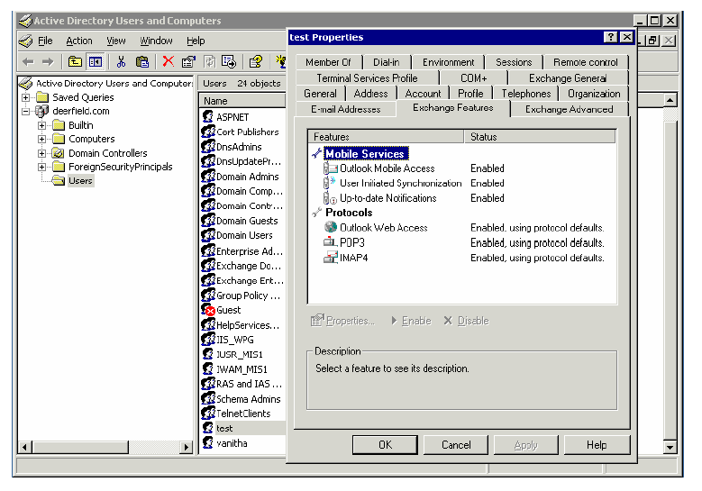
Creating Carriers

The notifications can be sent from Exchange Server 2003 directly to the SMS address of the device if Enable notifications to user specified SMTP addresses is enabled, or through a corporate service provider configured by the Exchange administrator. For notifications to be sent to the corporate service provider, the Exchange administrator has to create an SMTP carrier in Exchange system manager.

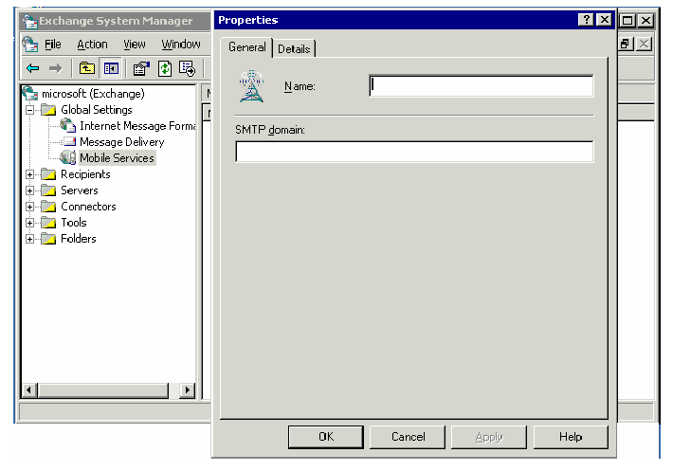

The carriers created in Exchange System Manager will be shown in the drop down box on your device.

UTD – How It Works

When a user with a device running Windows Mobile 2003 synchronizes for the first time with a server that supports UTD (Exchange Server 2003), there is a bubble (prompt) on the device to setup UTD. The client sends the OPTIONS command during the sync and if the response contains the NOTIFY command, a bubble is shown. If the user is disabled for push notifications, NOTIFY is not included in the response and therefore the bubble does not come up. If the device is cradled, the bubble is not triggered until the device is disconnected from the desktop.

When a user provisions the device, store event bindings are created in the mailbox on the folders that the user has specified for UTD. Bindings can be created in all email folders, calendar and contacts. When the user provisions the device for the first time only Inbox, Calendar, and Contacts folders can be set up for UTD. After the first sync they will get their folder hierarchy, after which any mail folder can be selected for UTD. When a binding is created, a WirelessOnSave hidden message is saved in the folder and the folder is monitored for new items. Information about the user’s devices, folders that are setup for notifications and the device state information is stored in the user’s mailbox.

If you choose No on the UTD prompt, you can setup UTD at a later stage by configuring the Schedule to “When new items arrive” and specifying the Device Address.

Steps to Set Up UTD on the PPC Client
- Set up a data connection for your device running Windows Mobile 2003 software.
- Set up your device to sync with your Exchange 2003 server.

- Launch Sync manually and let it complete. If you used desktop pass-through, uncradle your device now.
- As shown in the pop-up bubble below, if your server and account support this feature, your device will prompt you as to whether you would like to start using UTD.
- If this bubble comes up, click Yes and skip to step 6 of these instructions, if you don’t see the bubble, then proceed on to step 5.

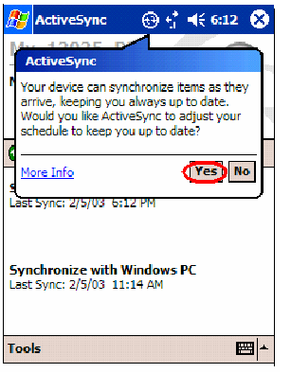
- If you did not see the above bubble, you will need to check that your device is enabled for UTD. To do so, simply go to Start | ActiveSync | Tools | Options | Mobile Schedule. Pull down one of the sync frequencies, for peak or off-peak times. You should see “When new items arrive” 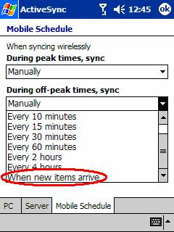

- If that entry is missing, then your device can NOT use UTD. See the checklist below.
- From the screen below, you will configure when you want to be always up to date. The recommended sync settings are shown.
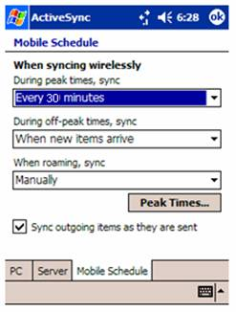
Notice that you can enable to use UTD during peak times, off-peak times, or both. Since UTD utilizes SMS messages to force the device to sync, it is recommended that such method of synchronization only be used when your mail activity is low.
- Now you can adjust the scheduling options to define your own “peak” times (when you receive a greater influx of mail). To do so, click on “Peak Times” to take you to the following screen:
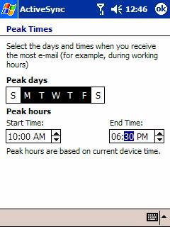
- OK out of these screens. If you have never set up your device to use this feature, you will receive an error letting you know that you need to provision your device address. Clicking OK will take you to the screen of step 9.

- Enter the “Device Address” screen which should resemble the one below

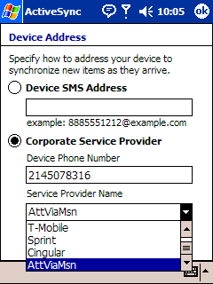

Enter the SMS address of your device under Device Email Address. If your administrator has setup corporate service providers you can select your operator from the dropdown box and enter just your device phone number under Corporate Service Provider.

- OK out of that Device Address screen. If you enabled your device to use UTD your device will launch a sync automatically to provision itself.
Checklist

- Verify that your device is running Windows Mobile 2003 software.
- Verify that you can connect to an Exchange 2003 server.
- Verify that UTD is enabled globally and at the user level.
- Verify that your mobile operator supports UTD,(that is, they support the conversion of SMTP e-mail message into SMS message).
- Verify that your device is capable of receiving SMS.
- If you are using a device running Windows Mobile 2003 software against an Exchange 2003 server, verify that the OPTIONS command is not blocked.

Steps to Set Up UTD on the SmartPhone Client
  - Set up a data connection for your device running Windows Mobile 2003 software.
  - Set up your device to sync with your Exchange 2003 server.
    - Ensure that the Smartphone is configured to synchronize with a server. Select Start, select ActiveSync, select Menu, select Options, select Server Settings, select Inbox, and select the Sync Inbox with a server check box:
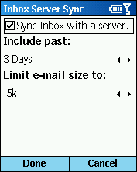

    - Ensure that the device is set up to synchronize with the correct server running Exchange ActiveSync. Select Start, select ActiveSync, select Menu, select Options, select Server Settings, select Connection, and then enter the server name into the Server Name field. Note: You also need to enter your domain credentials.
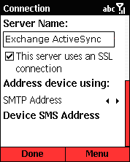

  - Start synchronization manually, and wait for it to complete. If you used desktop pass-through, remove your Smartphone from the cradle now.
  - If your server and account support UTD, your device may ask you (with a pop-up balloon) whether you want to start using UTD. If this occurs, click Yes and proceed to Step 6. If you do not see this pop-up balloon, proceed to next Step.
  - Check that your device is enabled for UTD. Select Start, select ActiveSync, select Menu, select Options, and then select Mobile Schedule. Select one of the synchronization frequencies for peak or off-peak times. If your account is enabled for UTD, you see When new items arrive as one of the available options.
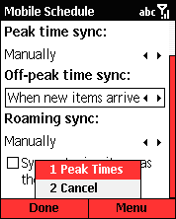

Note: If you do not see the When new items arrive option, your device may not support UTD. However, if you are sure your device does support UTD, confirm that you have synchronized successfully to a server running Exchange ActiveSync and that you meet the requirements listed in Requirements, later in this article. Then, try restarting your device and repeat the previous steps. If you still do not see When new items arrive, contact your system administrator
  - In the Mobile Schedule screen, specify how often you want your device to synchronize during peak times and off-peak times.
Note: The default Peak Times setting is 8:00 A.M. to 6:00 P.M.
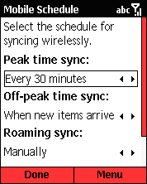

- You can configure the following options:
  - Use Peak time sync and Off-peak time sync to specify how often you want your device to synchronize during peak times and off-peak times.
  - To enable UTD, select When new items arrive.
  - To specify a synchronization interval in minutes, select an interval in minutes.
- Select Sync outgoing items as they are sent to force the device to synchronize after you have composed e-mail messages or marked items to be downloaded. This option works even if the device is not configured for UTD.
- Use When roaming, sync to control cost by forcing the device to synchronize manually when it is roaming. You can tell if your device is roaming by selecting the connectivity icon at the top right; if a triangle is shown in the connectivity bubble, your device is roaming. Mobile devices are determined to be roaming based on your wireless service plan and your wireless service provider's billing system. Therefore, being in roaming mode may not mean that your roaming connectivity is more expensive than in your home area. Refer to your data and calling plan to change this setting appropriately.
  - Now you can adjust the scheduling options to define your own peak times (when you receive a greater influx of mail). To access the Peak Times screen, from the Mobile Schedule screen, select Menu, and then select Peak Times.
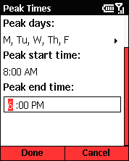
  - Select Done.
Note: If you have never set up your device to use this feature, you may receive a message letting you know that you need to provision your device address. To configure your device address, proceed to the next step.
  - To specify how to address your device to synchronize new items as they arrive, go to the Connection screen (select Start, select ActiveSync, select Menu, select Options, select Server Settings, and then select Connection), and then do one of the following:
Standard method. In Address device using, select Service Provider. In Service Provider Name, select your service provider from the scrolling list, and then enter your device's phone number into the Device Phone Number field.
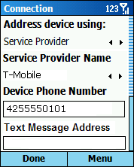
Note: If you do not see this screen, you need to manually specify your device address (also called the SMS address) by following the alternative method instructions.

Alternative method. In the Text Message Address field, manually enter your device address (SMS address).
Some examples of common SMS address formats include the following:
Example phone number: (425) 555-0101
T-Mobile: <1+area code+number+@tmomail.net>
Example: 14255550101@tmomail.net
AT&T Wireless: <area code+number+@mobile.att.net>
Example: 4255550101@mobile.att.net

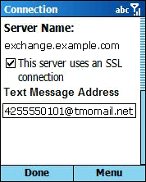
  - Select Done to close the Device Address screen. If you enabled your device to use UTD, your device automatically provisions itself. When that succeeds, you have successfully configured your Smartphone.

To Change Your Device's SMS Address
  - Select Start, select ActiveSync, select Menu, select Options, select Server Settings, and then select Connection.
  - Follow the instructions beginning on step 9.

SMS Gateway Information for US Carriers
The information below is the current implementation of SMS/SMTP mail addresses for mobile operations in the United States at the time of the writing of this document. It is subject to change without notice.

ATT
your cell phone number@mobile.att.net
4443332222@mobile.att.net
Cingular
your cell phone number@mobile.mycingular.com
4443332222@mobile.mycingular.com
Nextel
your cell phone number@messaging.nextel.com
4443332222@messaging.nextel.com
Sprint PCS
your cell phone number@messaging.sprintpcs.com
4443332222@messaging.sprintpcs.com
T-Mobile
your cell phone number@tmomail.net
4443332222@tmomail.net
Verizon Wireless
your cell phone number@vtext.com
4443332222@vtext.com

Appendix C: ActiveSync Data Architecture – A Reference
Introduction

Exchange ActiveSync® (EAS) allows you to synchronize data between your mobile device and Microsoft® Exchange Server 2003. E-mail, contacts, and calendar information (PIM data) can be synchronized with the Exchange Server. This feature was previously available through Mobile Information Server (MIS) and was referred to as Microsoft Server ActiveSync or MSAS. It has now been integrated with Exchange Server 2003.

With Exchange ActiveSync, devices running Windows Mobile™ 2002 and 2003 software are supported. This includes Pocket PCs, Pocket Phone Editions, and Smartphones with Windows Mobile 2002 or 2003 software. Devices with Windows Mobile 2003 software allow more granularity in scheduling sync and also support the Up-to-Date functionality that is introduced in Exchange Server 2003.

Outlook Mobile Access (OMA) – Originally in Mobile Information Server 2002, Outlook® Mobile Access has been enhanced in Exchange Server 2003:

More protocols. In addition to supporting Wireless Application Protocol (WAP) 2.x and XHTML browser–based devices, Outlook Mobile Access now supports full HTML browsers as well as i-Mode devices such as mobile phones and personal digital assistants (PDAs). Mobile phone browsers in Japan can now access servers running Exchange Server by using compressed HTML (CHTML) on i-Mode devices.

Lower cost of ownership. Because of the built-in mobile functionality, a separate server is no longer required, thus reducing deployment complexity and licensing requirements.

Easier management. Administration and management of mobility is now part of Exchange Server.

The general question regarding both ActiveSync and OMA is: How do both of these services really work under the “covers.” Over the next few paragraphs we will briefly cover how these services operated.

ActiveSync—Data Architecture

Exchange ActiveSync is installed by default with Exchange 2003. No server side configuration is necessary. If you have a single Exchange server and wish to use Exchange ActiveSync with Forms Based Authentication or have an SSL requirement on the Exchange virtual directory, please use the additional configuration steps described later in this document.

How Does It Work?
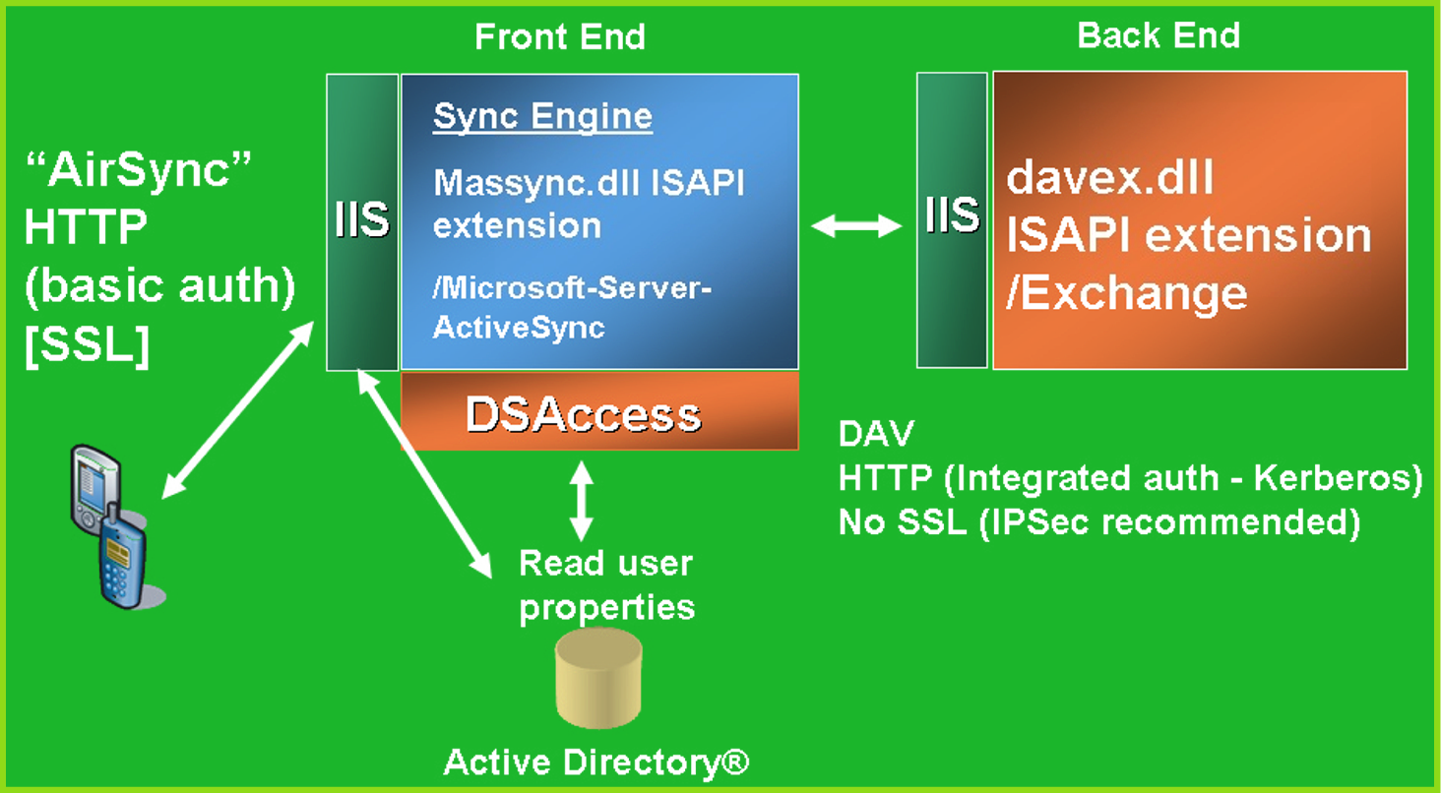

- When a user request arrives to the Exchange Front-End IIS server, IIS attempts to authenticate the user, grabbing a request from the user.
- IIS then loads the Massync.dll which parses the URI and user request.
- For ActiveSync the DSAccess is used for AD caching (shared with other components) and detecting the existing domain topology. The process does the following:
  - First, it looks for DSAccess errors in logs for AD problems.
  - This process only reads from the directory. It performs no writes to the directory.
  - It read the user’s display name, e-mail address, back-end server name, and the version of the back-end server.
  - It verifies the user and global wireless enable flags to see if the user is authorized to have wireless access. If this is not the case it returns and HTTP 403 error code.
- DSAccess forces the process to run in the local system account, which is a member of Exchange Domain Servers, and a member of Exchange Enterprise Servers account.
  - For IIS 5 the process must run in-proc.
  - For IIS 6 the process can run in the Exchange Application pool which is already configured.
- The mailbox name is computed from the LHS of the user’s primary SMTP address.
- Because authentication is Windows Integrated, the following takes place:
  - Authentication uses Kerberos if it is available otherwise it will fall back to NTLM. If neither are available,
  - All the I/O is done by the process on the user’s behalf.
- Because the Exchange front-end servers are stateless, the following is also true:
  - The state resides on the back-end server.
  - There is no support for SSL to the back-end thus it is recommended that both IPSEC and IP filtering be configured between the front-end and the back-end for secure communications.
- Single box setup
- DAV is used to the user’s mailbox on the back-end server
  - SEARCH, PROPFIND, PROPPATCH
- ICal to the user’s mailbox on the back end
  - GET, integrate user’s properties, PUT object back
- Save sync state
  - If client doesn’t get result (e.g. lost connection) recovery sync
- Recommend FE/BE deployment
  - ActiveSync components live on the front-end with OWA and Browse
- Sync components reside in the DMZ.
- ISA and regular Firewall protect network.
- Sync engine is extremely scalable for HTTP.
- Scale the front end by adding front ends with NLBS.
- Scale the back end by using Exchange Clustering.

Appendix D: Resources

For information about Microsoft® Exchange Server, see the Microsoft Exchange Server Web site (http://go.microsoft.com/fwlink/?linkid=21573). Additionally, the following technical articles, resource kits, and Microsoft Knowledge Base articles provide valuable information regarding disaster recovery concepts and processes.
Note
To download a self-extracting executable file of all Exchange Product Team technical articles and online books, see http://go.microsoft.com/fwlink/?LinkId=10687

Windows Mobile Device Materials
Functional Review of Microsoft Pocket PC Phone Edition-based 2003 and SmartPhone 2003
(http://www.microsoft.com/windowsmobile/about/tours.mspx)
Management and Provisioning of Windows Mobile Devices
(http://www.microsoft.com/technet/archive/itsolutions/mobile/evaluate/pctpcmgt.mspx)
Windows Mobile-based Devices and Security
(http://www.microsoft.com/windowsmobile/business/whitepapers/security.mspx)
PocketPC 2003 Review's Guide
(http://download.microsoft.com/download/8/3/e/83e64acc-a0f7-481b-8097-499ed8ce2b55/Smartphone2003ReviewersGuide.doc)
Windows Mobile-Base Smartphones: Improving Business Productivity
(http://www.microsoft.com/windowsmobile/business/whitepapers/businessproductivity.mspx)
Mobile Access Using Microsoft Exchange Server 2003
(http://www.microsoft.com/exchange/techinfo/outlook/MobileAcc.doc)

Exchange ActiveSync Scalability
Microsoft IT Scalability Experience with Windows Mobile 2003 and Exchange Server 2003 Mobile Messaging
(http://www.microsoft.com/windowsmobile/business/whitepapers/scalability.mspx)

Messaging at Microsoft Corporation
Messaging Backup and Restore at Microsoft
(http://www.microsoft.com/downloads/details.aspx?FamilyID=1bcf89b5-4e61-40bc-87b5-1e33542adfd0&DisplayLang=en)
Exchange Server 2003 Design and Architecture at Microsoft
(http://www.microsoft.com/downloads/details.aspx?FamilyID=5c76219a-4e30-4b51-a963-4a3896c9bb78&DisplayLang=en)
Achieving High Availability with Exchange Server at Microsoft
(http://www.microsoft.com/downloads/details.aspx?FamilyId=A8CF167D-E23C-4A14-86CB-02D19EE3B8FE&displaylang=en)
Exchange Server 2003 General Resources
Microsoft Exchange Server 2003 Technical Library
(http://go.microsoft.com/fwlink/?linkid=14576)
Exchange Server 2003 Tools and Updates
(http://go.microsoft.com/fwlink/?LinkId=21316)
What’s New in Exchange Server 2003
(http://www.microsoft.com/technet/prodtechnol/exchange/2003/library/newex03.mspx)
Planning an Exchange Server 2003 Messaging System
(http://www.microsoft.com/technet/prodtechnol/exchange/2003/library/messsyst.mspx)

Exchange Server 2003 Books
Exchange Server 2003 Administration Guide
(http://go.microsoft.com/fwlink/?linkid=14576)
Exchange Server 2003 Deployment Guide
(http://go.microsoft.com/fwlink/?linkid=14576)
Exchange Server 2003 Operations Guide
(http://www.microsoft.com/technet/prodtechnol/exchange/2003/library/opguide.mspx)

Exchange 2003 Tools
Exchange Server 2003 Tools and Updates
(http://go.microsoft.com/fwlink/?LinkId=21316)
Exchange Stress and Performance Tool (ESP)—Build 5531.0
(http://go.microsoft.com/fwlink/?LinkId=1709)
Exchange Capacity Planning and Topology Calculator
(http://go.microsoft.com/fwlink/?LinkId=1716)
Load Simulator in the Exchange Server Resource Kit
(http://go.microsoft.com/fwlink/?LinkId=1710)
Exchange Best Practice Analyzer
(http://www.microsoft.com/exchange/downloads/2003/exbpa/default.mspx)
Windows and Exchange Resource Kits
Windows Server 2003 Deployment Kit
(http://go.microsoft.com/fwlink/?linkid=25197)
You can order a copy of Microsoft Windows Server 2003 Deployment Kit from Microsoft Press at http://go.microsoft.com/fwlink/?LinkId=27096.
Windows 2000 Server Resource Kit
(http://go.microsoft.com/fwlink/?LinkId=6545)
You can order a copy of Microsoft Windows 2000 Server Resource Kit from Microsoft Press at http://go.microsoft.com/fwlink/?LinkId=6546.
Microsoft Exchange 2003 Deployment Guide
(www.microsoft.com/exchange/library)
Microsoft Exchange 2000 Server Resource Kit
(http://go.microsoft.com/fwlink/?LinkId=6543)
You can order a copy of Microsoft Exchange 2000 Server Resource Kit from Microsoft Press® at http://go.microsoft.com/fwlink/?LinkId=6544.

Technical Articles
Deploying Microsoft Exchange 2000 Server Clusters
(http://go.microsoft.com/fwlink/?LinkId=6271)
Storage Solutions for Microsoft Exchange 2000 Server
(http://go.microsoft.com/fwlink/?LinkId=1715)
Best Practice Active Directory Design for Exchange 2000
(http://go.microsoft.com/fwlink/?LinkId=17837)
Best Practice Active Directory Design for Managing Windows Networks
(http://go.microsoft.com/fwlink/?LinkId=18348)
Design Considerations for Delegation of Administration in Active Directory
(http://go.microsoft.com/fwlink/?LinkId=18349)
Deploying Microsoft Exchange 2000 Server Clusters
(http://go.microsoft.com/fwlink/?LinkId=14578)
Disaster Recovery for Microsoft Exchange 2000 Server
(http://go.microsoft.com/fwlink/?LinkId=18350)
Migrating Mailboxes from Microsoft Exchange Server Version 5.5 to Exchange 2000 Server
(http://go.microsoft.com/fwlink/?linkid=18351)
Monitoring Exchange 2000 with Microsoft Operations Manager 2000
(http://go.microsoft.com/fwlink/?linkid=18177)
Multiple Forest Considerations
(http://go.microsoft.com/fwlink/?LinkId=21177)
Microsoft Knowledge Base Articles
The following Microsoft Knowledge Base articles are available on the Web at http://support.microsoft.com/.
266096, "XGEN: Exchange 2000 Requires /3GB Switch with More Than 1 Gigabyte of Physical RAM"
(http://go.microsoft.com/fwlink/?linkid=3052&kbid=266096)
266768, "XSTR: How to Modify the Store Database Maximum Cache Size"
(http://go.microsoft.com/fwlink/?linkid=3052&kbid=266768)
272314, "XADM: Preparing a Mixed Mode Organization for Conversion to Native Mode"
(http://go.microsoft.com/fwlink/?linkid=3052&kbid=272314)
305145, "How to: Remove the IFS Mapping for Drive M in Exchange 2000 Server"
(http://go.microsoft.com/fwlink/?linkid=3052&kbid=305145)
311898, "XADM: Hot Split Snapshot Backups of Exchange"
(http://go.microsoft.com/fwlink/?linkid=3052&kbid=311898)
315407, "XADM The 'HeapDeCommitFreeBlockThreshold' Registry Key"
(http://go.microsoft.com/fwlink/?linkid=3052&kbid=315407)
810371, "XADM: Using the /Userva Switch on Windows 2003 Server-Based Exchange Servers"
(http://go.microsoft.com/fwlink/?linkid=3052&kbid=810371)
238573, "XADM: Installing, Configuring, and Using the InterOrg Replication Utility"
(http://go.microsoft.com/fwlink/?linkid=3052&kbid=238573)
238642, "XADM: Troubleshooting the InterOrg Replication Utility"
(http://go.microsoft.com/fwlink/?linkid=3052&kbid=238642)

