Delivering Value with Microsoft® Office OneNote™ 2003
The Microsoft Office Note-Taking and Management Program

Abstract
Microsoft® Office OneNote™ 2003 is a new digital note-taking and management program that enables information workers to capture, organize, reuse, and share their notes more productively on laptops, desktops, or Tablet PCs.
OneNote 2003:
  - Makes it easier to take notes and organize vital information.
  - Enables teams to more effectively manage, prioritize, and act on information.
  - Enables teams to get a higher return on meetings and discussions by sharing information more effectively.
This whitepaper presents:
  - An introduction to the capabilities and feature sets for OneNote 2003.
  - The customer value proposition for using OneNote 2003.
  - A customer scenario example.
July 2003
The information contained in this document represents the current view of Microsoft Corporation on the issues discussed as of the date of publication. Because Microsoft must respond to changing market conditions, it should not be interpreted to be a commitment on the part of Microsoft, and Microsoft cannot guarantee the accuracy of any information presented after the date of publication.
This document is for informational purposes only. MICROSOFT MAKES NO WARRANTIES, EXPRESS OR IMPLIED, AS TO THE INFORMATION IN THIS DOCUMENT.
Complying with all applicable copyright laws is the responsibility of the user. Without limiting the rights under copyright, no part of this document may be reproduced, stored in or introduced into a retrieval system, or transmitted in any form or by any means (electronic, mechanical, photocopying, recording, or otherwise), or for any purpose, without the express written permission of Microsoft Corporation.
Microsoft may have patents, patent applications, trademarks, copyrights, or other intellectual property rights covering subject matter in this document. Except as expressly provided in any written license agreement from Microsoft, the furnishing of this document does not give you any license to these patents, trademarks, copyrights, or other intellectual property.
© 2003 Microsoft Corporation. All rights reserved.
Microsoft, the OneNote logo, OneNote, Outlook, Sharepoint, and Windows are either registered trademarks or trademarks of Microsoft Corporation in the United States and/or other countries. The names of actual companies and products mentioned herein may be the trademarks of their respective owners.
Contents
Introduction 1
How Note-taking Creates Challenges for Individuals and their Productivity 2
The tasks 2
The individual challenges 3
How Organizations and Productivity are Impacted by the Challenges Individuals Face 5
Individual Challenges Become Team Challenges 5
Team/Organizational Challenges 5
How OneNote Meets the Note-taking Challenges 9
The User Interface Notebook Metaphor 9
The Features that Enhance Individual Information Worker Productivity 10
How OneNote Delivers Organizational Business Value 13
Customer Scenario Example 16
Conclusion 17
For More Information 17

Introduction
Microsoft® Office® OneNote™ 2003 is the new note-taking and management program in the Microsoft Office System. OneNote 2003 provides a single place for information workers to capture, organize, reuse, and share notes using a laptop, desktop, or Tablet PC.
Microsoft developed OneNote after studying the ways people take notes and what they do with those notes afterwards. Microsoft realized that a program like OneNote could help individuals and organizations change the way they work, allowing them to dispense with routine and burdensome tasks while enhancing organization productivity and business value.
OneNote provides these information workers with all the advantages of traditional note-taking and storage while offering them a much more effective and flexible way to manage, prioritize, and share their notes. OneNote, through its innovative design, fosters sharing, communication, and collaboration among teams or organizations.
Figure 1 shows the interconnectedness of individual and organizational challenges and solutions. As individuals and organizations apply solutions, they add business value to the organizations they serve.
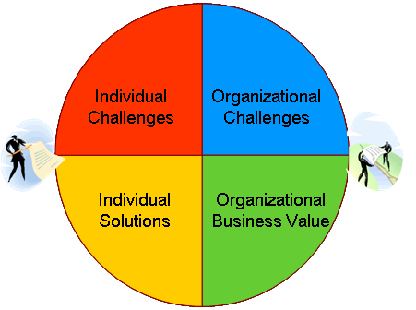
Figure 1: Individual and organizational solutions produce business value

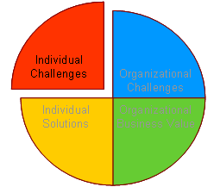
How Note-taking Creates Challenges for Individuals and their Productivity
Information worker productivity is vital to helping businesses establish a competitive advantage, yet most information workers still handle the note-taking function in much the same way that earlier generations of workers did it. They jot down meeting notes by hand; take copious conference or lecture notes on lined paper or with tape recorders; and talk on the phone while noting highlights on slips of paper, sticky notes, or backs of envelopes. Some workers file those notes very carefully; others treat them haphazardly.
In nearly all these cases, the worker must later reorganize and translate their notes or recordings into an accessible, printable, sharable format, and then distribute or file them for future use. In many cases, such notes are lost, misfiled, or discarded before they can be properly translated into a usable format.
Today’s information workers face serious challenges as the complexity level of their tasks continues to increase. Since nearly every task involves taking notes — during meetings, research, phone calls, interviews, conferences, and similar activities — the need to increase productivity in this area becomes obvious. Individual workers have to find ways to handle routine tasks more efficiently so that they have more time to focus on the value creation aspects of their work.
Moreover, it is important that organizations benefit from both the time individuals spend taking notes and the actual content of those notes. If individual workers can easily communicate the contents of their notes to their teams and organizations, and better use their notes for collaborative purposes, then the crucial information derived from those notes becomes knowledge capital and provides business value to the company.

The tasks
In 2001, Microsoft conducted an extensive note-taking research study and found that notes are central to all aspects of the job that information workers customarily perform:
  - Authoring — Taking down accurate and comprehensive notes at time of the conversation, meeting, or research.
  - Deciding — Making decisions about what information is worth keeping, what should be discarded, and what needs follow-up.
  - Communicating — Publishing or presenting the information in the notes. This often requires retyping or transcribing handwritten or recorded notes.
  - Accessing — Finding the notes, deciphering and retrieving information from them.
  - Absorbing— Analyzing and understanding information pulled together from various types of note formats (Web, text, handwriting, diagrams, documents, recordings).
  - Collaborating — Working with others to develop reusable knowledge.
Figure 2 shows all these tasks and illustrates the importance of note-taking to all of them.
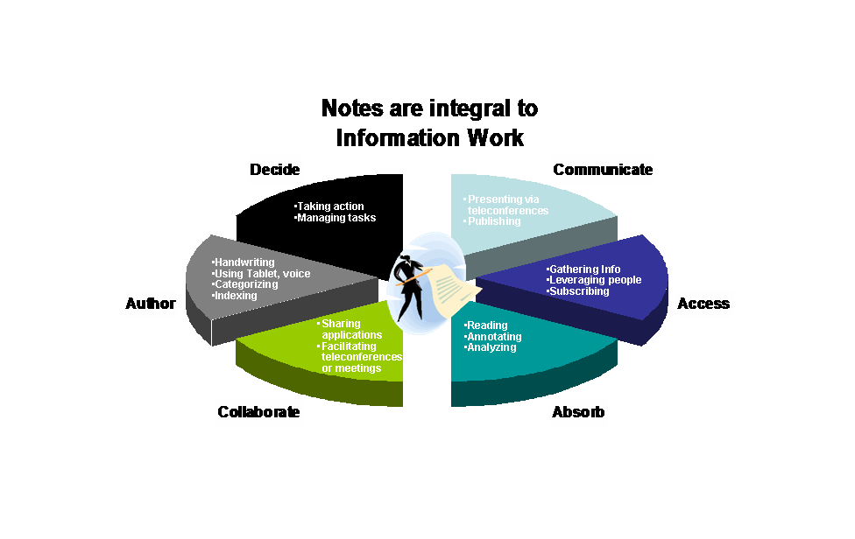Figure 2: Information workers use notes for many purposes

The individual challenges
Note-taking and note-handling, when done in the traditional way, present challenges to individuals who engage in any of the information work activities.

Authoring
Traditional note-taking requires people to either write down on paper or record on tape the information that they need for future reference. While these media offer a number of advantages in terms of availability, portability, and familiarity, they also present problems for organization, storage, and reuse. They offer little flexibility for information workers who need to continually add, revise, and delete information from their notes.

Deciding
When information workers depend on hand-written or recorded notes, they cannot always provide up-to-date information to the people who must make decisions because the notes that they take may be difficult or impossible to locate, or the vital information in them may not be searchable.

Communicating
Information workers who take notes by hand often have trouble communicating the content in those notes to other people because it means they have to invest considerable time in making that content available to others. They may need to transcribe the notes into electronic format and send them via e-mail, communicate the information verbally, or photo-copy the notes and send them by inter-office mail. All these methods leave room for inconsistencies and errors, or even total loss of information.

Accessing
One of the most vexing tasks connected with notes is finding them and searching for relevant information within them. The Microsoft study showed that 23% of information workers cannot find the information they need after they have taken notes. Another study, conducted by IDC, showed that knowledge workers spend between 15% and 30% of their time just searching for the information they need to do their jobs. This is understandable, considering that many people take notes on whatever scrap of paper happens to be handy and then they do not have or take the time to file the notes afterwards.

Absorbing
Workers usually take notes as rapidly as they can while listening as carefully as they can to a speaker. In that circumstance, it is often difficult to actually absorb what is being said at the time it is being said. For many people, it is even harder to return to those notes and understand what was written. The notes may not be in a logical sequence, or organized by specific topic, speaker, research source, or date.

Collaborating
Even when very organized people keep very good track of their notes, diagrams, recordings, and other pieces of information connected with a specific topic or task, they still have to find a way to pull all that information together so that it is coherent, cohesive, and useful when collaborating with others. Given that information can come from hand-written notes, e-mail, Web research, meeting notes, tape recordings, diagrams, spreadsheets, digital documents, and other media, it takes real effort to gather it all into a useful and shareable format. The simple fact is that many people just cannot, or do not, take the time to recreate their notes in a digital, reusable format. That means that crucial business information may never be shared, or may even be lost.

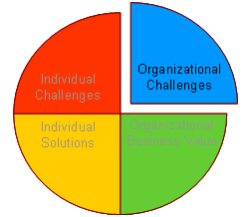
How Organizations and Productivity are Impacted by the Challenges Individuals Face

Individual Challenges Become Team Challenges
Most information workers have a need to share information and to collaborate with fellow team members. Since each member of each team faces similar note-taking and note management challenges, the impact on organizational productivity can be significant. If each person spends time searching for or recreating notes, the individual challenges actually replicate into a team or organization (See Figure 3) and the problems increase exponentially. The team, in effect, grapples with the same problems that individuals face, multiplied many times.
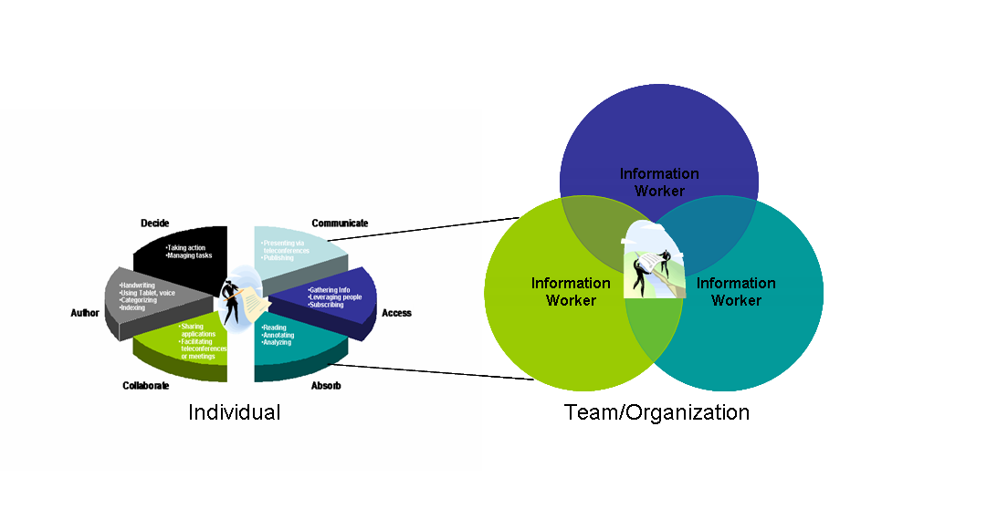
Figure 3: Individual challenges replicate into teams and organizations

Team/Organizational Challenges
Note-taking and note-handling create challenges for organizations in four major areas:
  - Productivity
  - Knowledge management
  - Decision making
  - Opportunity costs

Productivity
Information workers can truly add value to their organizations by working efficiently and effectively, focusing on their primary tasks rather than the logistics of accomplishing those tasks. As long as they must use the note-taking and note-handling methods of the past, organizations cannot realize their productivity potential.
A number of specific problems keep organizations from meeting productivity goals when information workers rely on traditional note-taking:
Inefficiencies and errors resulting from unnecessary re-creation of information and knowledge. When people have to type, or retype, information collected in notes from various sources, the potential for errors or omissions is great, creating the likelihood that the notes that are shared across teams may be inaccurate or incomplete. The Microsoft study showed that information workers commonly reuse, repurpose, or retype notes.
    - 28% always reuse notes.
    - 62% sometimes repurpose notes for more formal documents.
    - 77% have retyped their handwritten notes into a PC.
If individual information workers had a means of taking notes just once, and either sending them by e-mail or posting them to a shared resource, they would have no need to retype their notes. Inefficiencies and errors could be reduced, or even eliminated.
Organizations also experience inefficiencies and errors when workers leave a team or the organization. When that happens, the departing workers tend to either throw out their notes or take them, thereby depriving the team or the organization of the value of the content in those notes. If the organization had a means of capturing and keeping those notes in a shared location, the value of that content would remain with the organization. New team members would then be able to access the notes and come up to speed more quickly.
Inefficiencies resulting from poor access. It is an unfortunate truth that many people misplace, lose, or discard the notes they take. When they need the content of those notes, they have to search for them or redo their original research, in effect undoing the value of their original note-taking activities. If they are unable to find or recreate their notes, their project teams will either not realize the value contained in those notes, or they will have to determine other approaches to obtaining the information they need.

Knowledge Management
Sharing, collaboration, and preservation of intellectual property are three important aspects of knowledge management in any organization. When information workers capture information, it only becomes useful to the company when it is available and accessible to the people and teams who need it.
Otherwise, poor note management habits can lead to communication and collaboration problems, which, in turn, may lead to knowledge management problems.
Ineffective cross-team communication. The problems associated with locating, collecting, transcribing, and sharing notes have a ripple effect on teams and their communication needs. The Microsoft study showed that 35% of the respondents share notes some of the time and that 24% share notes all the time. These percentages show that there is a real need for teams to share internal information efficiently and effectively across organizations. They also need a dependable means of storing and retrieving the information contained in notes so that team members can access it readily.
Complexities of sharing notes among dispersed workers. When workers are separated physically, into different buildings, cities, states, or even countries, the problems of accessing and sharing notes become more complex. Dispersed team members find it difficult to stay up-to-date with new or changed information, especially when they do not, or cannot, meet regularly.
Loss of intellectual property and organization knowledge. Some organizations have an interest in retaining records of the intellectual property captured and documented in notes. That record contributes to the body of organizational knowledge, which should remain with the organization as individuals leave or teams disband. If notes are discarded, lost, misfiled, or leave with the individuals who created them, then the organization may lose that part of its intellectual property.

Decision making
Because of the rapid pace of technology, today’s information workers must gather most of the information they need from current sources, such as meetings, phone calls, Web articles, conferences, speeches, and recordings. Notes, therefore, often contain business-critical information that must be communicated and shared in a timely manner.
When workers fail to save and share the information contained in their notes, they may be impeding the decision makers in their organization:
Inadequate access to information. Information workers who use traditional note-taking and note-handling techniques do not generally have a means of making those notes rapidly available to others. They may have to retype the notes to be able to send them in e-mail or post them on the intranet or the Web. They may not have a common place to store the information they are collecting in notes, and they may not even be able to find their notes when they need them. These logistical problems can keep organizations from making good, timely decisions.
Outdated or incomplete information. When information workers do not have a reliable place to create, store, and retrieve notes, it is unlikely that they can maintain current and uniform notes readily available for the organization’s decision makers. This means, effectively, that many decision makers cannot be sure that they have the most up-to-date information when faced with important choices.

Opportunity costs
When economists use the term “opportunity cost,” they mean that the true cost of a decision consists of everything that an organization must give up in order to implement that decision.
Inefficient use of resources. When high-value information workers spend time doing low-value tasks, the organization does not realize the value of those workers. If, for example, James, a developer, spends time searching for the notes he took at an off-site meeting, typing them, creating a distribution list, and sending them out by e-mail, he cannot spend time working on the test plan he was assigned to create. The opportunity cost of handling those notes, then, equals the cost of not having a test plan in place on schedule. The organization must weigh the value of having those notes prepared and available against the value of having James deployed to an important project and the possibility of slipping a deadline. If organizations had better note-taking resources available, they would not be faced with such unpleasant choices.
Missed opportunities. Organizations can miss opportunities for sales, acquisitions, or other business opportunities if they do not have accurate information at the time that they need it. This can easily happen when information workers have incomplete or inaccurate notes after meetings with key clients. If these workers could preserve their hand-written and typed notes, including audio notes, they would be much less likely to forget or misinterpret what a client or fellow team member has said since they would be able to refer back to the actual conversation.

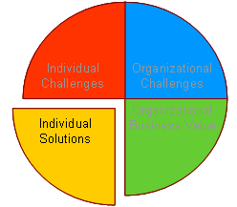
How OneNote Meets the Note-taking Challenges
Microsoft® OneNote™ 2003 provides information workers with a single place to create, collect, customize, and store notes as they like—capturing information in multiple ways and organizing it according to their needs. It also allows teams to share, access, and update notes almost effortlessly. OneNote is designed to work seamlessly with the Office System, but you do not need Microsoft Office to realize the benefits of using OneNote 2003 as a stand-alone program.
OneNote 2003 turns the act of note-taking into a dynamic and integral part of every work day. OneNote allows users to:
  - Take down notes as they like
  - Organize information easily
  - Access information quickly
  - Reuse and share notes effectively
Before developing a solution, Microsoft carefully studied the various note-taking and note-handling challenges that information workers face, and then used that information to address the concerns expressed by the people who participated in the study. The result is an easy-to-use, versatile program that works flexibly with the Microsoft Office System.

The User Interface Notebook Metaphor
The user interface is specifically designed to look like a 3-ring binder, complete with tab dividers. Users can divide the notebook into multiple topics and subtopics for the various types of information they want to record and save. Workers have all the advantages of an old fashioned notebook binder with the additional advantages of being able to copy information from one section to another, to do full-text search, to find and share information easily, to annotate text, to grab information from other Office programs or from the Web, to flag key items, and even to record and play back audio notes.
Figure 4 shows the OneNote user interface.
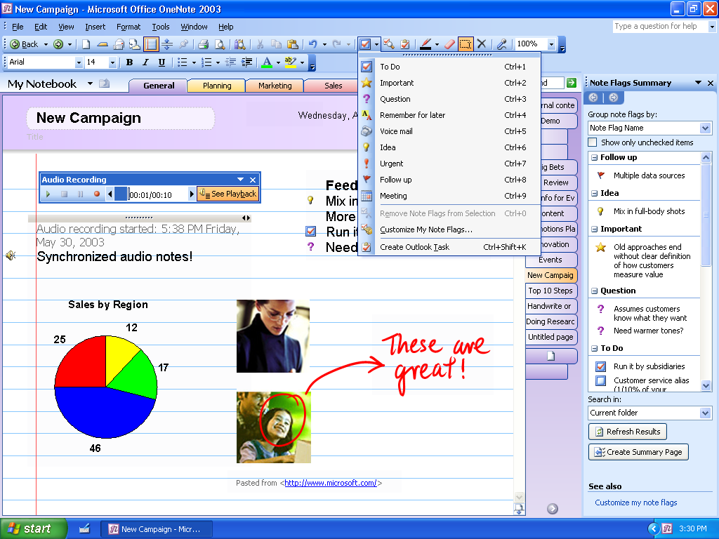
Figure 4: OneNote offers a simple, intuitive interface
OneNote is very convenient. Information workers can use it on a laptop, desktop, or Tablet PC. Using OneNote with the Tablet PC is especially convenient because users who have a pen-input device can hand write their notes and draw pictures directly into OneNote. OneNote can also convert those handwritten notes into text.

The Features that Enhance Individual Information Worker Productivity
OneNote has many features that address the needs of individual information workers and the kinds of tasks they have to perform when taking or handling notes. These features enable workers to go far beyond the simple acts of taking and sharing notes. They give users real control over and access to the information they are gathering in the form of notes. OneNote provides genuine value to information workers as they go about the note-taking and note-handling tasks identified earlier in this paper.

Authoring
Users can capture information in multiple formats—including text, handwriting, diagrams, Web research, audio notes, spreadsheets, e-mail, and graphics from other Office programs and the Web—collecting all related information into a single notebook. Furthermore, they can take advantage of the Research Pane that allows users, from within OneNote, to quickly find material in reference works such as a dictionary and a thesaurus, Web research sites, and Web business and financial sites. Once workers capture the notes, they can move, copy, or paste the notes wherever they want and as often as they like. OneNote saves all entries automatically, so users never have to worry about losing their notes.

Deciding
OneNote provides useful features that help with decision-making tasks. Users can flag important information and urgent tasks, and quickly review flagged items before making decisions. Users can send important information to key decision makers or set up Outlook tasks without leaving OneNote (This feature requires installation of Microsoft® Office Outlook™ 2003).

Communicating
OneNote allows users to quickly transfer notes, through drag-and-drop or cut-and-paste, from OneNote to other Office programs such as Word, PowerPoint, Excel, or Outlook. This capability is very useful when workers need to rapidly publish information, create presentations, or send information to co-workers. OneNote users can confidently send notes via e-mail to OneNote users and non-users alike because OneNote automatically converts messages to HTML format when sending notes to non-users (This feature requires installation of Microsoft® Office Outlook™ 2003) and adds a .one file so that OneNote users can easily add the notes to their own notebooks.

Accessing
OneNote is especially useful to information workers who need to quickly locate information in their notes. It offers:
- Organization—Workers can develop their own categories and subcategories, if they choose, organizing their notes as methodically as they want.
- Powerful search capabilities—Information workers can search their notes for the information they need. OneNote provides full-text search organized by key word, date, or notebook section.
- Note flags—Workers can attach various flags to notes to indicate that they are important, that some questions apply, or that some follow-up is required at a later date. This feature allows roll-up of highlighted items into a summary view.
- Side notes—Workers can copy critical information into side notes that they can keep on top of other applications for quick, easy access or for pasting into other programs.

Absorbing
The real point of taking notes, of course, is to be able to understand, know, and use the content in them. When workers are actively taking or recording notes, they may not have the time to actually absorb everything that is being said. OneNote gives them the opportunity to return to their notes and fully comprehend the crucial information contained in them. They can annotate their notes by attaching various kinds of flags, and they can read or listen to them, analyze them, and share the content they have captured.

Collaborating
OneNote promotes and facilitates effective team collaboration, making it an important asset for any organization. With OneNote, team and organization members can share information in such a way that all members, no matter how far apart they are, have the same view of the notes and the same up-to-date information. Users can host a OneNote notebook, folder, or section that is saved on a Microsoft® Windows® SharePoint™ Services site, an option that provides intelligent document collaboration capabilities, improved version control, and the ability to share information in real time. Workers can also save notes in HTML format and store them on a file share, a Web server, or a SharePoint site.
OneNote, in conjunction with Microsoft Office and Windows SharePoint Services, provides a powerful set of capabilities. Teams can use these tools to engage in real-time communication and collaboration while using very familiar tools and processes.

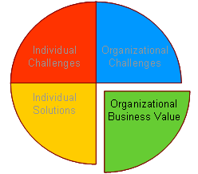
How OneNote Delivers Organizational Business Value
OneNote is a product that genuinely enables individuals and groups to work in new and more efficient ways. OneNote strips away many of the roadblocks to information sharing and effective team collaboration, while preserving intellectual property. This translates into significant business value at the organizational level.
OneNote delivers organizational business value in 4 specific ways:

Productivity
Information workers will be more productive because they will not be tied down with note-taking and note-handling logistics.

Reduction in inefficiencies and errors
Once individual information workers are routinely using OneNote to capture notes, they can easily share them with their co-workers and they will be much more likely to do so because they will not have the burden of searching for notes, organizing them, and transcribing them into readable, sharable format. Since they can share original notes directly, the opportunities for errors will decline.

Costs Savings
OneNote offers the rare opportunity to increase productivity while minimizing ramp-up costs. OneNote is simple to use and requires no special training classes. If workers are already accustomed to working with core Office programs such as Word, PowerPoint, or Outlook, they will find it especially easy to adapt to the OneNote and use its most powerful search, communication, and collaboration features.

Knowledge management
Organizations can expect improvements in their knowledge management capabilities because information workers and teams will be able to communicate and collaborate more effectively and with less effort.

Increased cross-team communication
Knowledge sharing will increase almost effortlessly. Since OneNote allows easy search, access, and sharing, team members should find it very easy to find and communicate information. Clearly, when teams and organizations are communicating better, they are more likely to achieve their business objectives with speed and agility.

Elimination of note-sharing issues among dispersed workers
With shared OneNote folders and sections on Windows SharePoint sites, all information workers on a team will be able to view the same versions of notes. When the notes are updated, all team members, no matter where in the world they reside, will have the updates instantly.

Preservation of intellectual property and organizational knowledge
Because OneNote allows users to store their notes in one place where they can be shared with everyone who has permission to view them, the value of those notes will remain with the organization when individual members leave a team or the organization. In fact, the notes will remain even if the team disbands.

Decision making
Teams will have the ability to access the information they need and the advantage of having instant, up-to-date information that allows them to make more informed decisions. OneNote, especially in combination with Outlook and Windows SharePoint Services, can provide collaboration opportunities not previously available to information workers.

Easy access to information
Information workers no longer have to spend time searching their notes for that critical piece of information. Fast searching and organizational capabilities allow team members to easily satisfy ad-hoc requests for information from colleagues, partners, and customers. This not only saves companies time and money by enabling team members to be more productive, but can also increase customer and employee satisfaction.

Up-to-date information
When OneNote is deployed in combination with Outlook and Windows SharePoint Services, users can update the information contained in the notes and make it instantly available to all team members. Those members who have to make critical decisions can do so with the assurance that they have the latest information.

Opportunity costs
The opportunity costs of note-taking and note-sharing will plummet because high value information workers will no longer be bogged down with low value tasks like searching for notes and retyping them. Retrieval will be fast and sharing can be almost instantaneous. Moreover, the number of missed opportunities should also decrease because more people will have faster, more accurate, more up-to-date information.

Efficient use of resources
Companies using OneNote will be more efficient because their high valued workers will no longer have to decipher and retype meeting notes, or spend time searching for them days or weeks after a meeting. These workers can, instead, spend their time performing high value tasks.

Fewer missed opportunities
OneNote provides a single location in which information workers can preserve their handwritten, typed, and recorded notes. Since this location is searchable and sharable, companies can depend on that information, knowing that they have up-to-date, reliable, retrievable information to which they can refer at will, and minimizing the risk of misinterpretations and inaccurate notes which can lead to missed opportunities. Companies that take advantage of this capability enhance their opportunities for success with clients and team members.

Customer Scenario Example
A common business scenario is the team meeting where one team member is missing or calling in late due to “being on the road.” In this example, the team manager, Christine, leads her customary weekly team meeting at which team members come together to give status and receive new task assignments. This week, Dave, a sales rep on the team, is out of the office, meeting with one of the company’s most important potential new customers, Contoso.
Dave meets with the Chief Financial Officer (CFO) of Contoso, Ltd., who tells him that the contract can not be signed unless they can figure out how to expense the purchase and thereby reduce Contoso’s tax burden. Dave, very frustrated, reviews the audio and typed meeting notes he took directly in OneNote. Since he is unable to independently deliver a solution, he posts his notes onto a team Windows Sharepoint site, goes back to his hotel room, and calls Ed in accounting to explain the situation.
Ed opens the shared view of the notes and listens to the problem in the CFO’s own words. Understanding the dilemma, Ed uses the Research pane in OneNote to search the tax Web sites for “capital assets” and “expensing.” He realizes that, with the new tax laws and a lot of work from the team, Contoso’s purchase could meet the criteria for the new expensing qualification. Ed uses the drag-and-drop feature to paste the article into OneNote where it is instantly saved to the team-hosted Sharepoint site.
Later, at the team meeting, Christine is pleased to hear and see the research that Ed and Dave had uncovered. The team views the notes, research, and analysis on the overhead projector and realizes what must be done.
In OneNote, Christine flags the notes with “Julie to work with legal to draft the new contract,” “Dave to close the loop with Contoso,” and “Ed to work out the details of the tax law implications.” At the conclusion of the meeting, Christine instantly sends the team an e-mail with the action items and notes. As the team members complete their tasks, they check off their action items in their own view of the OneNote shared section, letting Christine keep current on their status. Because of their timely action, the contract is signed.

Conclusion
Microsoft Office OneNote 2003 is a robust note-taking program for information workers. It is powerful when installed as a stand-alone program, but even more powerful when combined with other Microsoft Office System programs. Information workers, for the first time, have an opportunity to not only change the way they take notes, but also to manage, store, prioritize, and act on those notes in ways that can actually change the way business is done.
In combination with other Office System programs, OneNote can transform internal business processes, enabling information workers to be more productive in meetings, at their desks, at presentations, in brainstorming sessions—anywhere they work with ideas and notes. More importantly, OneNote will substantially enhance the ability of individuals and teams to share information, collaborate successfully, improve decision-making, and respond quickly to changes in the workplace and marketplace.

For More Information
For information about OneNote 2003, see http://microsoft.com/onenote

