Entice customers and increase sales with Publisher flyers
Applies to
Microsoft® Office Publisher 2003
Microsoft Publisher 2002

This article and related articles available on Office Online.
It's time for your annual holiday sale. Or, you just received great new merchandise that you'd like to promote. Get the news out quickly to the right people by creating a flyer that you can mail to them, or post around town.
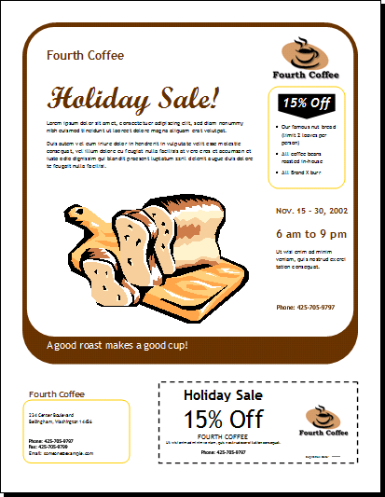
Microsoft Publisher includes pre-designed flyer publications, set up specifically to provide information about special offers. By starting with a pre-designed publication, you can:
- Base your flyer on a publication with a ready-made professional design.
- Replace placeholder text and graphics with your own text and graphics, instead of creating text boxes and picture frames from scratch.
- Reformat the flyer with just the click of a button to include a tear-off coupon, order form, or response form.
Tip If you have more information than will fit on a flyer, you can create a brochure publication instead, and take advantage of more layout flexibility. A brochure can have a 3-panel or 4-panel design, include a customer address on one of the panels, and include an order, response, or sign-up form.
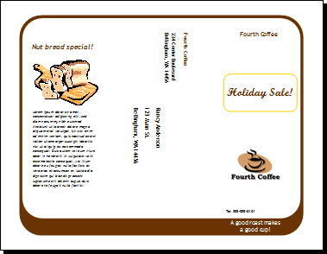

Create your flyer
When you create a flyer, you can decide which elements, such as customer address and coupon, that you want the flyer to contain. You can also personalize the flyer by choosing the color and font schemes that best reflect your company identity.
Follow these steps to creatre a flyer that includes a customer address and a coupon:
To | Do this
Start your flyer | - Start Publisher  - In the New Publication task pane, under New from a design, click Publications for Print, and then click Flyers.  - Note If you are using Publisher 2002, in the New Publication task pane, click Flyers.  - Under Flyers, click Informational or Special Offer.  - Click the preview image for the flyer design you want.
Specify flyer layout and content in the Flyer Options task pane | - Under Graphic, click Include.  - Under Customer address, click Include.  - Under Tear-offs, click the coupon or form you want to add.  - Click Color Schemes, and then choose the color scheme you want.  - Click Font Schemes, and then choose the font scheme you want.
Replace the placeholder text | - Click the placeholder text, and then type.  - If you have already created a personal information set, your business contact information and logo will automatically replace some of the placeholder text.  - In most cases, text will resize automatically to fit within the text box.  - Repeat as needed for side 2 of your publication.
Control text size in text boxes | - Click the text box.  - On the Format menu, point to AutoFit Text, and then click Do Not AutoFit (if you are using Publisher 2002, click None).  - Select the text, and then choose a new font size from the Font Size list on the toolbar.
Replace placeholder pictures | - Right-click the placeholder picture, click Change Picture, and then choose the source of the new picture.  Tip If you don't see Change Picture when you right-click, click the placeholder picture once until you see the white circles surrounding the picture's frame. Click the picture again until you see gray cricles with x's in them surrounding the picture itself, and then right-click the picture. (For more information about working with pictures, see Publisher Help.)  - Repeat as needed for side 2 of your publication.
Complete the flyer | - When the flyer looks the way you want, save the file.  - Prepare the flyer for mailing and printing by merging customer addresses into the publication.  Tip If you don't already have your addresses in a data file, you can create a new address list in Publisher. Point to Mail and Catalog Merge Wizard on the Tools menu, and then click Create Address List. If you are using Publisher 2002, point to Mail Merge Wizard on the Tools menu, and then click Create Address List.  - Print the flyers.

