Create brochures that help you sell in Publisher

Applies to
Microsoft® Office Publisher 2003
Microsoft Publisher 2002
This article and related articles available on Office Online.
Microsoft Publisher includes pre-designed brochure publications, set up specifically to provide information about special offers. By starting with a pre-designed publication, you can:
- Base your brochure on a publication with a ready-made professional design.
- Reformat the brochure with just the click of a button, to switch from a 3-panel brochure to a 4-panel brochure, and to include reply forms, a customer address section, and more.
- Ensure that your company's marketing materials project a consistent identity, when you select a single Master Design Set as the basis of each piece you create.
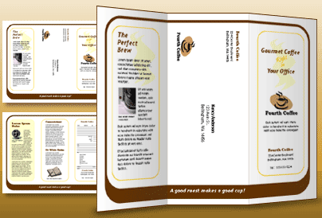
Of course, as with all publications created in Publisher, you can also start from scratch to create a completely unique look.
Tip If you have less information than is appropriate for a brochure, or just want a more casual look, consider creating a flyer instead.

Create your brochure
When you create a brochure, you can decide which elements, such as customer address and response form, you want it to contain. You can also personalize the brochure by choosing color and font schemes that best reflect your company identity.
Follow these steps to create a brochure:
To | Do this
Start your brochure | - Start Publisher. In the New Publication task pane, under New from a design, click Publications for Print, and then click Brochures.  Note If you are using Publisher 2002, in the New Publication task pane, click Brochures.  - Under Brochures, choose a type (for example, Informational, Special Offer).  - Click the preview image for the brochure design you want.
Specify brochure layout and content in the Brochure Options task pane | - Under Page size, click 3-panel or 4-panel.  - Under Customer address, click Include or None, depending on if you will be mailing your brochure to customers.  - Under Form, click a type of response form to add, or click None.  - Click Color Schemes, and then choose the color scheme you want.  - Click Font Schemes, and then choose the font scheme you want.
Replace placeholder text | - Click the placeholder text, and then type.  Notes  - If you have already created a personal information set, your business contact information and logo will automatically replace some of the placeholder text.  - In most cases, text will resize automatically to fit within the text box.  - Repeat as needed for side 2 of your publication.
Control text size in text boxes | - Click the text box.  - On the Format menu, point to AutoFit Text, and then click Do Not AutoFit (if you are using Publisher 2002, click None).  - Select the text, and then choose a new font size from the Font Size list on the toolbar.
Replace placeholder pictures | - Right-click the placeholder picture, click Change Picture, and then choose the source of the new picture.  Tip If you don't see Change Picture when you right-click, click the placeholder picture once until you see the white circles surrounding the picture's frame. Click the picture again until you see gray circles with x's in them surrounding the picture itself, and then right-click the picture. (For more information about working with pictures, see Publisher Help.)  - Repeat as needed for side 2 of your publication.
Complete the brochure | - When the brochure looks the way you want, save the file.  - If you will be mailing your brochure to customers, prepare it for printing by merging the addresses into the brochure.  Tip If you don't already have your addresses in a data file, you can create a new address list in Publisher. Point to Mail and Catalog Merge Wizard on the Tools menu, and then click Create Address List. If you are using Publisher 2002, point to Mail Merge Wizard on the Tools menu, and then click Create Address List.  - Print your brochures.

