Use Publisher to keep in touch with loyal customers

Applies to: Microsoft® Office Publisher 2003
See Also (related templates available on Office Online)
Coupon (Stripes theme, for desktop printing)
Direct Marketing Catalog (for commercial printing)
E-mail Newsletter (Stripes theme)
Newsletter (Barcode, 2-pp., design 2)
Referral Postcard (Stripes theme, for desktop printing)

Whether the business you run is a financial services firm, a pet grooming service, or a deli, the majority of your business is probably from repeat customers who continue to come to you for goods or services. In order to build and grow a solid base of repeat customers, it's important to communicate regularly with your customers to let them know that they are valued and to provide them with current information about your business. This article discusses two primary ways that you can use Publisher to promote repeat business from your best customers:
- Reward customers for their good business by sending them notices about special offers, new products, or events; and
- Provide regularly updated information about your business, services, or industry by creating informative publications like newsletters, catalogs, or a business Web site.
After you decide what approach you want to use, you can choose from a wide variety of publications available in Publisher or on the Microsoft Office Online Web site, and then tailor your message for your customers. When you are ready to distribute your publications to customers, try to schedule both your promotional offer mailings and your regular information mailings with sensitivity to their frequency to avoid overwhelming customers with too many offers.

Reward customers with offers that keep them coming back
One of the most basic ways to cultivate repeat business is to provide your customers with an incentive to return. Sending printed materials through the mail can be a great way to extend a special offer or deal to your customers. Customers can share your offer with others or keep the mailer in a convenient location to remind them to take advantage of the special deal. Make certain that everything you send out by mail aligns with company branding standards so that you establish brand recognition with these valuable customers.
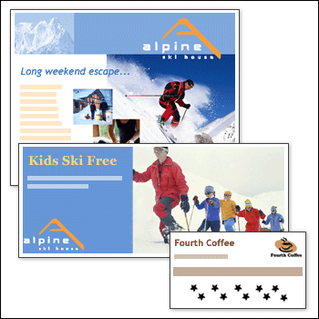
Direct mail marketing pieces you may have created for a broader audience can easily be customized to target existing customers. Here are several ideas for ways that you can use different kinds of publications to promote repeat business.
top

Publication | Ways to use this publication to promote repeat business
Postcards or flyers | - Announce special offers. Make it clear that the special offer is available only to a select group of customers.  - Announce new products early. Send a postcard or flyer to let customers know that certain products or services are available at a special price and for a limited time before they are advertised to the public.
Gift certificates | - Send a special discount to a customer as thanks for a large purchase or repeated business. Include the gift certificate in a thank you card or letter.  - Offer gift certificates for holiday giving with additional savings awarded to the giver for purchasing the certificate.
Greeting cards or invitations | - Say thank you! Even though the reward may not be tangible, customers feel valued any time you thank them for their business.  - Send holiday greetings to all of your loyal customers to let them know you are thinking of them.  - If you have birthday or anniversary records in your customer contact database, send one of the many greeting card designs in Publisher on these occasions. If appropriate, include an offer for a discounted product or service that can be redeemed in honor of the special occasion.  - If you have a real estate, mortgage, or contracting business, send congratulations on a new home purchase.  - If your business is healthcare, day care, or infant merchandise, send greeting card congratulations for a new addition to the family.  - Plan a customer appreciation night. Send out invitations or cards inviting loyal customers to the event. Let customers know that they will need this special invitation to get in the door after normal business hours. Or provide a special discount if they bring the invitation in during normal business hours.
Business cards | - Provide customers with your business card so that they always have your contact information and they can easily refer you or your business to others.  - Launch a frequent buyer club by creating punch cards that reward customers with a free purchase after a certain number of purchases have been made. A customized business card publication works well for this.
Referral cards | Use a referral card with a reply tear-off to inspire customers to refer their friends. Provide a discount for both the customer and the friend. You can find Publisher templates for referral postcards by searching on Office Online.
Tip To customize any of these publications for specific target customers, you can use the mail merge feature to add the customer's name, a personalized greeting, or a specially chosen photo to these publications.

Stay in touch with customers: provide regular updates about your business
In addition to providing your customers with occasional notices about special offers, deals, or events, it is important to provide your customers with up-to-date information about your business or industry on a regular basis. An excellent way to keep your business in customers’ minds is to send out monthly or quarterly mailings that inform them about your company, give them news about your industry, or notify them of new events, services, or products.
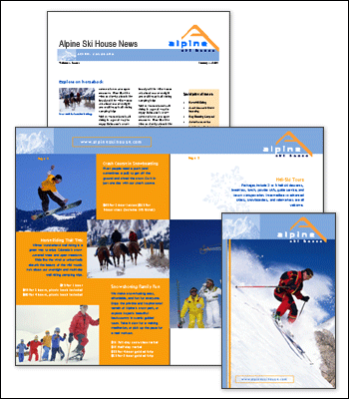
There are several types of content-rich publications that you can create in Publisher if you want to provide customers with up-to-date information on a regularly scheduled basis.
Publication | Ways to use this publication to promote repeat business
Newsletters | Use newsletters to stay in touch with customers and keep them current with your business. There are several ways you can use the newsletter format to deliver information to your customers and encourage them keep your business in mind:  - Include news about your business or industry.  - List new products or services, or include coupons for special discounts.  - Educate customers about new products or new developments in your industry.  - Include customer testimonials about their experience with your products or services.  - If appropriate, provide tips or tricks on using or maintaining products they have purchased from you.  - Present profiles on your employees.  - Highlight any honors or awards your business has received.  - Include a customer feedback form to find out what customers want to see in future newsletters.

Catalogs | Catalogs are an effective way to inform customers about new products or services and reach out to potential new customers. If your budget allows, send out catalogs regularly so that customers learn to expect them.  Note If you maintain a list of products or services in a data source such as a spreadsheet or a database, you can use the catalog merge feature to quickly create updated versions of your catalog whenever you update the information in your data source.
Brochures | Use brochures to announce new products or services, publicize seasonal event calendars, or provide updated information about your business hours or locations.
E-mail | E-mail publications can be an efficient and cost-effective way to stay in touch with customers. Publisher makes it very easy to create and send attractive, graphically rich e-mail publications that are consistent in design with the print publications that you create in Publisher. There are several ways you can use e-mail to supplement or replace printing marketing materials:  - Use one of Publisher's E-mail Wizard publications to create attractive e-mail newsletters, announcements, letters, or product lists.  - Use Publisher e-mail templates on Office Online Template Gallery.  - Send a page from an existing Publisher publication, such as a newsletter or flyer, as the body of an e-mail message.  Notes  - To avoid overwhelming your customers with e-mail, it is a good idea to establish a regular schedule for your e-mail and stick to it.  - It is good business practice to let customers decide if they wish to receive similar mailings in the future. Provide customers with an option to remove themselves from your e-mail mailing list at any time.
Web site | Maintaining a business Web site is an effective way to provide customers with accessible and up-to-date information about your business. You can use Publisher to create a Web site that is consistent in design with the print publications that you create in Publisher. There are several ways you can make your Web site useful to customers:  - Update your Web site regularly to keep the information current and encourage customers to visit often.  - Include pages listing products or services.  - Include links to articles about your company or industry.  - Create special "Web only" promotions or offers to encourage customers to visit your Web site.  Note Be sure to include the URL for your Web site on any printed materials that you distribute so that customers will know how to visit your site.

top

Choose a publication design
Once you've decided on a publication type, it's time to choose a design. You can use:
- One of the many pre-designed publications available in Publisher for each publication type.
- A publication design that matches a Master Design Set, if you've used such a Set to establish your company identity and brand.
- One of the new templates available on the Office Online Template Gallery Web site.
Tip You can also design a publication from scratch. In Publisher, in the New Publication task pane, under New, click Blank Print Publication.

To use a pre-designed publication
- Start Publisher. In the New Publication task pane, click Publications for Print. Click the publication type you want, and then, on the right, click the pre-designed publication you want to use.

To use a publication from a Master Design Set
- Start Publisher. In the New Publication task pane, click Design Sets, and then click Master Sets.
- Click the design you want, and then, on the right, click the publication type you want to use.
Tip You can use a unique design for a direct mail publication and still keep the color scheme and fonts that reflect your company identity. With the publication open that you want to use, on the Format menu, click Color Schemes. Under Apply a color scheme, choose the color scheme that you use for your Master Design Set. On the Format menu, click Font Schemes. Under Apply a font scheme, choose the font scheme that you use for your Master Design Set

To use a template from the Office Online Web site
- On the Help menu in Publisher, click Microsoft Office Publisher Help.
- Note The Publisher Help task pane opens.
- Under Search for, type "templates" and then click the green arrow.
- Click the link at the top of the list called Templates for business reports, cards and banners, databases, and more.
- On the Templates site, search for the publication type you want. Most of the Publisher templates are located under the template category Marketing, under the subcategory Marketing Materials.
top

