
PURCHASING

Microsoft Dynamics™ SL

Benefits
- Make smarter choices
Provide instant access to purchasing
information. Flexible vendor ID structures provide meaningful identification and help you analyze vendor performance for more
informed decisions.

- Work the way you want
Flexible setup options fit the way you work and can be changed as your operations evolve. Define default shipping addresses, printing options, and data retention periods. Or, specify default general ledger accounts and decimal precision options.

- Gain efficiency
Enter purchase orders, receipts, and
vouchers — at the most sensible times
in the cycle — quickly and easily through the seamless integration of information inherent in all Microsoft Dynamics SL modules.

- Streamline processes
Enter simple purchase orders with only
three pieces of information: vendor
ID, inventory item ID, and quantity. Everything else — including unit cost, unit of measure, and account/sub-account information — is entered by default, based on your business rules.

- Maximize buying power
Make informed decisions using a variety of targeted reports that help you negotiate the best prices by understanding what products and services your company needs, the right time to order them, and the best vendors.

Boost productivity and reduce transaction costs with increased purchasing accuracy, speed processing, streamlined receiving, and efficient invoice matching and vouchering. Microsoft Dynamics SL Purchasing provides buyers with accurate, up-to-date vendor and pricing information to help them make consistent, cost-effective buying decisions.

Straightforward
and easy to use, buyers can work smarter and faster with instant access to information and streamlines order processing.

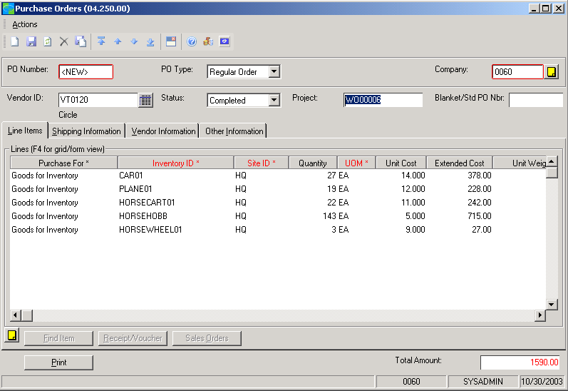

Easily identify
whether order items are for inventory
or internal use, such as office supplies.

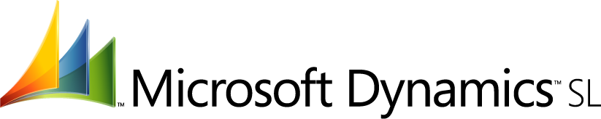

features

BENEFITS

Instant Updating | Update inventory immediately, rather than when the vendor’s invoice  arrives. Simply enter the packing slip PO number when an order arrives  to create a receipt on the spot.
One-Step Invoice Accounting | Create accounts payable vouchers automatically when purchase orders  are received, helping eliminate redundant data entry.
Targeted Reports | Create reports with Crystal Reports and save in various formats, including  Microsoft Office Excel, Microsoft Office Word, IBM’s Lotus, Open  Database Connectivity (ODBC), and HTML. Reports include purchase  order register, purchase order status/history, and anticipated deliveries.
Multiple Order Type/Addresses | Bill any type of order to one address and ship it to another. Purchasing  supports multiple ship-to addresses as well as a variety of order types,  including regular, standard, blanket, and drop ship orders.
Flexible Receipt Processing | Track open orders, override unit costs, and receive quantities larger than  original orders. Units of measure, which can differ from an item’s stock  unit, are automatically converted on receipt to stock unit measures, to  update inventory accurately.
Robust Integration | Microsoft Dynamics SL Purchasing integrates with other Microsoft  Dynamics SL modules, including Accounts Payable, Inventory, and Order  Management, to reduce redundant data entry and improve overall  efficiency.
Inventory/Non-Inventory Identification | Distinguish between stock and non-stock items by indicating on the PO whether items are for internal use, such as office supplies, or for inventory, such as resale or production items.
Change Order Support | Maintain comprehensive, long-term records on purchase order activity,  including up to 99 change orders such as quantity, price, and shipping  instructions.
User-Specified PO History | Specify during setup how long you want to keep information stored in  your Purchasing system. Purchasing supports up to 99 periods of  transaction detail.

For more information about Microsoft Dynamics™ SL, visit: http://www.microsoft.com/dynamics/sl

This document is for information purposes only.
MICROSOFT MAKES NO WARRANTIES, EXPRESS, IMPLIED, OR STATUTORY, AS TO THE INFORMATION IN THIS DOCUMENT.

© 2005 Microsoft Corporation. All rights reserved.
Microsoft, The Microsoft Dynamics Logo, are either registered trademarks or trademarks of Microsoft Corporation or Microsoft Business Solutions ApS in the United States and/or other countries. Microsoft Business Solutions ApS is a subsidiary of Microsoft Corporation.

