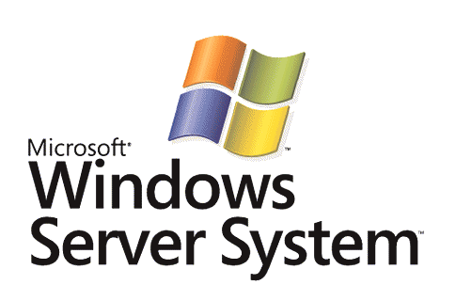

IEEE 802.1X for Wired Networks and Internet Protocol Security with Microsoft Windows

Microsoft Corporation
Published: November 2005

Abstract
Microsoft® Windows Server™ 2003 and Windows® XP support both the IEEE 802.1X standard for wired networks and the Internet Protocol security (IPsec) Internet standard. The IEEE 802.1X standard for wired networks provides authentication and authorization protection at the network edge where a host attaches to the network. IPsec provides peer authentication and cryptographic protection of IP traffic from end-to-end. This white paper describes the security and capabilities of 802.1X for wired networks and IPsec based on industry standards and their support in Windows Server 2003 and Windows XP, and provides comparison information when evaluating deployment of these security technologies.


This is a preliminary document and may be changed substantially prior to final commercial release of the software described herein.
The information contained in this document represents the current view of Microsoft Corporation on the issues discussed as of the date of publication. Because Microsoft must respond to changing market conditions, it should not be interpreted to be a commitment on the part of Microsoft, and Microsoft cannot guarantee the accuracy of any information presented after the date of publication.
This White Paper is for informational purposes only. MICROSOFT MAKES NO WARRANTIES, EXPRESS, IMPLIED OR STATUTORY, AS TO THE INFORMATION IN THIS DOCUMENT.
Complying with all applicable copyright laws is the responsibility of the user. Without limiting the rights under copyright, no part of this document may be reproduced, stored in or introduced into a retrieval system, or transmitted in any form or by any means (electronic, mechanical, photocopying, recording, or otherwise), or for any purpose, without the express written permission of Microsoft Corporation.
Microsoft may have patents, patent applications, trademarks, copyrights, or other intellectual property rights covering subject matter in this document. Except as expressly provided in any written license agreement from Microsoft, the furnishing of this document does not give you any license to these patents, trademarks, copyrights, or other intellectual property.
© 2005 Microsoft Corporation. All rights reserved.
Microsoft, Active Directory, Windows, and Windows Server are either registered trademarks or trademarks of Microsoft Corporation in the United States and/or other countries.
All other trademarks are property of their respective owners.
Contents
Introduction 1
IEEE 802.1X 2
Elements of 802.1X 2
Supplicant 2
Pass-through Authenticator 2
Authentication Server 3
Controlled and Uncontrolled Ports 3
EAP Overview 4
EAP Over RADIUS 4
Security Provided by IEEE 802.1X 5
Windows Support for Wired 802.1X 6
IPsec 7
IPsec Security Properties 7
How IPsec Protects IP Traffic 8
AH 8
ESP 9
Common Misconceptions about IPsec 10
Security Provided by IPsec 10
Windows Support for IPsec 10
Comparing 802.1X for Wired Networks and IPsec 12
Changes in Support for 802.1X for Wired Networks and IPsec in Windows Vista and Windows Server "Longhorn" 14
Choosing 802.1X for Wired Networks and IPsec 14
Summary 15
Related Links 16

Introduction
Organizations that are investigating the deployment of network security technologies to protect intranets from unknown hosts are faced with selecting security technologies that provide a desired level security at an affordable cost and with achievable deployment. Unknown hosts are computers that are not part of an intranet's management or security framework, such as the Active Directory® directory service. Two such security technologies are IEEE 802.1X for wired networks and Internet Protocol security (IPsec).
- IEEE 802.1X for wired networks provides authentication and authorization protection at the wired attachment point (the switch port). IEEE 802.1X helps prevent unknown hosts from attaching to an intranet. Alternately, some switches can assign an unknown host to a virtual LAN (VLAN) that does not contain sensitive intranet resources.
- IPsec provides peer authentication and end-to-end cryptographic protection of IP traffic. IPsec helps prevent unknown hosts that do not have the proper credentials or policy settings for IPsec protection from accessing hosts on your intranet.
This white paper examines each of these technologies, the security that they provide, and their support in Windows so that you can decide the appropriate technologies to deploy on your intranet.

IEEE 802.1X
The IEEE 802.1X standard defines port-based, network access control that is used to provide authenticated network access for wired and wireless networks. Port-based network access control uses the physical characteristics of a switched LAN infrastructure to authenticate devices attached to a LAN port. Use of the port is denied if the authentication process fails. Alternately, the port can be assigned to a VLAN that does not contain sensitive resources.
Note Although IEEE 802.1X can be used on any network, this white paper describes only the use of 802.1X for intranets.

Elements of 802.1X
IEEE 802.1X defines the following terms:
- Supplicant
- Pass-through authenticator
- Authentication server
Figure 1 shows these components for a wired network.
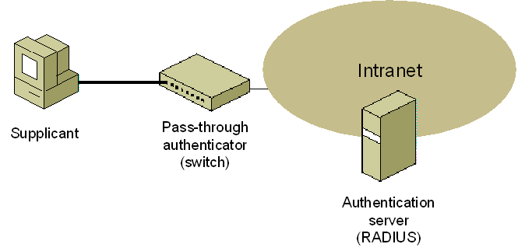
Figure 1 The components of IEEE 802.1X authentication for wired networks

Supplicant
The supplicant is a computer that requests access to a network attached to the pass-through authenticator. For wired connections, the supplicant is a computer with a network adapter that is physically attached to a switch port and requests access to the intranet.

Pass-through Authenticator
The pass-through authenticator is the switch that enforces authentication before allowing the use of the LAN ports of the switch. The pass-through authenticator typically does not perform the authentication and authorization determination. Instead, the pass-through authenticator passes the supplicant's credentials and other connection information to an authentication server.

Authentication Server
The authentication server authenticates and authorizes a connection attempt on behalf of the pass-through authenticator. The authentication server validates the credentials of the supplicant, evaluates the authorization of the connection attempt, and then responds to the pass-through authenticator, indicating whether or not the supplicant is allowed to connect. The authentication server can be the following:
- A component of the switch. In this case, the switch must be configured with the sets of user credentials corresponding to authorized supplicants and authorization policies. This is typically not implemented for switches due to centralized management and scaling issues.
- A separate computer on the intranet. In this case, the switch forwards the credentials of the connection attempt to an authentication server. This white paper describes how a switch can use the Remote Authentication Dial-In User Service (RADIUS) protocol to send a connection request message to a RADIUS server.

Controlled and Uncontrolled Ports
IEEE 802.1X defines the following different types of logical ports that access an intranet through a single physical LAN port:
- Uncontrolled port The uncontrolled port allows the pass-through authenticator to communicate with other nodes on the intranet (such as the authentication server). Frames sent by supplicants are never sent using the uncontrolled port.
- Controlled port The controlled port allows a supplicant to exchange frames with nodes on the intranet only if the supplicant is authenticated and authorized by 802.1X. Before authentication and authorization, the controlled port toggle is open and no frames are forwarded between the supplicant and the intranet. When the supplicant is successfully authenticated and authorized using IEEE 802.1X, the toggle is closed and frames can be sent between the supplicant and nodes on the intranet.
Figure 2 shows the different types of ports.
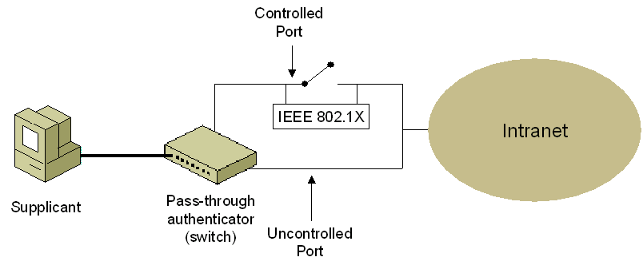
Figure 2 Controlled and uncontrolled ports for IEEE 802.1X
On an authenticating Ethernet switch, the wired Ethernet client can send Ethernet frames to the intranet as soon as authentication and authorization is complete. The switch identifies the traffic of a specific supplicant through the physical port to which the supplicant is connected.
To provide a standard authentication mechanism for 802.1X-authenticated connections, the IEEE chose the Extensible Authentication Protocol (EAP). EAP is a Point-to-Point Protocol (PPP)-based authentication mechanism that was adapted for use on point-to-point LAN segments. For PPP-based connections, EAP messages are sent as the payload of PPP frames. To adapt EAP messages to be sent over Ethernet LAN segments, the IEEE 802.1X standard defines EAP over LAN (EAPOL), a standard encapsulation method for EAP messages.

EAP Overview
EAP was originally created as an extension to PPP that allowed for the development of arbitrary network access authentication methods. With typical PPP authentication protocols, a specific authentication mechanism is chosen during the link establishment phase of the PPP connection. During the authentication phase of the PPP connection, the negotiated PPP authentication protocol is used to authenticate the connection using a fixed series of messages sent in a specific order.
With EAP, the specific authentication mechanism is not chosen during the link establishment phase of the PPP connection. Instead, each PPP peer agrees to perform EAP during the connection authentication phase. When the connection authentication phase is reached, the peers negotiate the use of a specific EAP authentication scheme known as an EAP type. After the EAP type is agreed upon, EAP allows for an open-ended exchange of messages between the supplicant and the authentication server (the RADIUS server). The conversation consists of requests for authentication information and the responses. The length and detail of the authentication conversation is dependent upon the EAP type. EAP is described in RFC 3748.
Architecturally, EAP allows authentication plug-in modules at both the supplicant and authentication server. To add support for a new EAP type, install an EAP type library file on both the supplicant and the authentication server. This extensibility provides vendors with the opportunity to supply a new authentication scheme at any time. EAP provides the highest flexibility to allow for more secure authentication methods.
You can use EAP to support authentication schemes that provide different levels of security strength such as Generic Token Card, One Time Password (OTP), MD5-Challenge, Transport Layer Security (TLS) for smart card and certificate support, and future authentication technologies. EAP is a critical technology component to help secure connections.
In addition to support within PPP, IEEE 802.1X defines how EAP is used for authentication by IEEE 802 devices, including Ethernet switches and IEEE 802.11 wireless access points (APs). IEEE 802.1X differs from PPP in that only EAP authentication methods are supported.

EAP Over RADIUS
EAP over RADIUS is not an EAP type, but the passing of EAP messages of any EAP type by the pass-through authenticator to a RADIUS server for authentication. An EAP message sent between the supplicant and pass-through authenticator is formatted as the EAP-Message RADIUS attribute (RFC 2869, section 5.13), and sent in a RADIUS message between the pass-through authenticator and the RADIUS server. The pass-through authenticator passes EAP messages between the supplicant and the RADIUS server. Processing of EAP messages occurs at the supplicant and the RADIUS server, not at the pass-through authenticator, as Figure 3 shows.
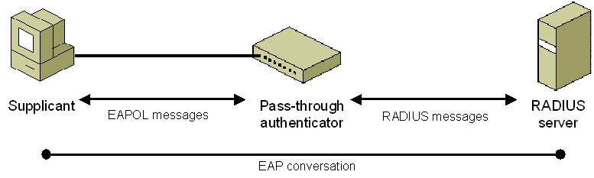
Figure 3 EAP over RADIUS
EAP over RADIUS is used in environments where RADIUS is used for authentication, authorization, and accounting (AAA). An advantage of using EAP over RADIUS is that EAP types do not need to be installed at each pass-through authenticator, only at the RADIUS server. However, the pass-through authenticator must support EAPOL, the initial negotiation of EAP, and the passing of EAP messages to a RADIUS server.
In a typical use of EAP over RADIUS, the pass-through authenticator is configured to use EAP and to use RADIUS for AAA. When a connection attempt is made, the supplicant negotiates the use of EAP with the pass-through authenticator. When the client sends an EAP message to the pass-through authenticator using EAPOL, the pass-through authenticator encapsulates the EAP message as the EAP-Message attribute of a RADIUS Access-Request message and sends it to its configured RADIUS server. The RADIUS server processes the EAP message in the EAP-Message attribute and sends an EAP response message as a RADIUS Access-Challenge message with the EAP-Message attribute to the pass-through authenticator. The pass-through authenticator then forwards the EAP message to the supplicant using EAPOL.

Security Provided by IEEE 802.1X
IEEE 802.1X enforces both EAP-based authentication of computer or user-level credentials and explicit authorization evaluation by a RADIUS server prior to allowing traffic between the supplicant and the intranet. Wired hosts can physically connect to a port and can send frames to the switch, but cannot send or receive frames with hosts on the intranet until successful authentication and authorization.
However, 802.1X does not provide cryptographic protection for frames after authentication and authorization is successful. The authenticating switch cannot verify that the frames it receives on the switch port were actually sent by the physical or logical host that performed the authentication. For example, it is possible for an attacker to attach a hub between the authenticating host and the switch and connect an attacking computer to the hub that spoofs the authenticating host's IP and media access control (MAC) addresses (a different physical host using the same MAC address). Because the switch cannot distinguish between the frames of the authenticating host and the attacking host, the attacking host can send frames on the intranet. This type of attack requires physical access to the switch port. Switches also cannot distinguish between the frames sent by different operating systems running simultaneously on a single authenticating host (different logical hosts using the same MAC address). For more information on this type of attack, see Mitigating the Threats of Rogue Machines—802.1X or IPsec?.
Note For IEEE 802.11 wireless LAN networking, traffic for IEEE 802.1X-authenticated connections is typically protected between the wireless client and the wireless AP. However, the cryptographic protection is being provided by Wired Equivalent Privacy (WEP), Wi-Fi Protected Access (WPA), or WPA version 2 (WPA2) (IEEE 802.11i), not by 802.1X.

Windows Support for Wired 802.1X
The following versions of Windows support 802.1X authentication for wired connections:
- Windows Server 2003
- Windows XP
- Windows 2000 with Service Pack 4
Wired connections for these versions of Windows can use the following EAP types:
- EAP-Message Digest 5-Challenge Handshake Authentication Protocol (MD5-CHAP) A simple challenge-handshake protocol that uses a user or computer name and password credentials. EAP-MD5-CHAP is susceptible to an offline dictionary attack and is not recommended.
- Protected EAP (PEAP)-Microsoft Challenge Handshake Authentication Protocol version 2 (MS-CHAP v2) A combination of an encrypted TLS channel (created by PEAP) and a mutual authentication challenge-handshake protocol that can use user name and password credentials. Because of the TLS channel, PEAP-MS-CHAP v2 is not as susceptible to an offline dictionary attack. To perform the one-way TLS authentication for PEAP, the RADIUS servers must have a computer certificate installed that the supplicant computers trust. At this writing, PEAP-MS-CHAP v2 is the recommended EAP method for user name and password-based credentials.
- EAP-TLS A two-way mutual authentication method using TLS and digital certificates. EAP-TLS requires a public key infrastructure (PKI) to issue and renew computer or user certificates to supplicant computers and computer certificates to RADIUS servers.
- PEAP-TLS A combination of an encrypted TLS channel (created by PEAP) and a two-way mutual authentication method using TLS and digital certificates. Like EAP-TLS, PEAP-TLS requires a PKI to issue and renew computer or user certificates to supplicant computers and computer certificates to RADIUS servers.
Note Windows XP with no service packs installed does not support PEAP-MS-CHAP v2 or PEAP-TLS.
Additional EAP methods are available from independent software vendors (ISVs).

IPsec
IPsec is the Internet Engineering Task Force (IETF)-recommended security technology for protecting communications over IP networks through the use of cryptographic security services. The Windows Server 2003, Windows XP, and Windows 2000 implementations of IPsec are based on RFCs 2401-2409, developed by the IETF IPsec working group.
IPsec is the long-term direction for IP version 4 (IPv4) and IP version 6 (IPv6) networking security. It provides protection against intranet and Internet attacks through end-to-end security. The only computers that must know about IPsec protection are the sender and receiver in the communication. IPsec can protect communications between computers in workgroups, Active Directory® directory service domains, branch offices (which might be physically remote), and extranets.

IPsec Security Properties
Both public and private networks are susceptible to unauthorized monitoring and access. Internal attacks might be a result of minimal or nonexistent intranet security. Risks from outside the intranet originate from connections to the Internet and extranets. Password-based user access controls alone do not protect data transmitted across a network.
IPsec was designed to address the lack of built-in security for IP-based traffic in the TCP/IP protocol suite. IPsec provides the following:
- Tampering and spoofing protection
Protects against tampering with or spoofing of IP packets. IP packets use checksums so that the receiving node can verify whether any of the bits were changed in error during transmission on a link. However, the checksums do not provide integrity or security for the IP packet. Therefore, an intermediate IP node can receive an IP packet, alter its contents, update the appropriate checksums and forward the packet to its destination. Because the checksum calculation does not provide integrity, the destination host cannot determine if the packet was tampered with in transit. IPsec uses a cryptographic checksum that incorporates a shared secret key known only to the two communicating IPsec peers. Any attempts to modify the packet contents or to spoof addresses can be detected because the attacker cannot easily calculate the correct cryptographic checksum for the changed packet.
- Payload encryption
An optional IPsec security service that encrypts IP packet payloads. Without encryption, a node between two IP hosts exchanging data can capture the packets sent between them, analyze the payload portion of the packet, and determine the data that is being exchanged. For example, a file sharing client makes a connection with a file server containing sensitive data. Access control lists on the file server computer determine which users or computers can access which files and what they are allowed to do. However, once a valid user has made a connection to the sensitive file server and begins copying a file across the network, an attacker between the file server and the client can capture the packet stream and reconstruct the file contents without needing the client's credentials to connect to the file server. With payload encryption, an attacker between the file server and the client can still capture the packet stream but cannot easily interpret and reconstruct the file contents.
- Peer authentication
Requires IP nodes to authenticate each other's computer credentials before any IP-based communication begins. IP has no built-in authentication of peers; IP hosts can initiate communications with other IP hosts without having to prove that they are members of a trusted security framework and have the correct credentials. With IPsec however, peers must authenticate each other with computer credentials before initiating communication. IPsec peer authentication reduces the number of computers from which communication can be initiated to those computers that provide correct peer credentials. This reduces the number of computers from which network attacks can originate. For example, if IPsec authentication requires a certificate issued from a specific CA, then only those computers that have been issued a certificate from the CA can initiate IP-based communication.

How IPsec Protects IP Traffic
Figure 4 shows an IP packet containing a Transmission Control Protocol (TCP) segment that is not protected with IPsec.
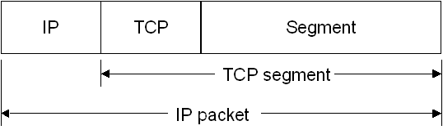
Figure 4 An IP packet without any IPsec protection
As previously described, there is a checksum in the IP header that allows detection of bit-level errors in the IP header and a checksum in the TCP header that allows detection of bit-level errors in the entire TCP segment. However, neither of these checksums is intended to provide security protection and the IP packet is susceptible to various types of network attacks such as spoofing, data modification, and data determination.
To provide security protection for the IP packet, IPsec typically adds one of the following to the IP packet:
- An extension header between the IP header and the IP packet payload (in our example, the TCP segment) known as the Authentication Header (AH).
- An extension header and trailer around the IP packet payload known as the Encapsulating Security Payload (ESP).

AH
Figure 5 shows the original IP packet of Figure 4 that has been protected with AH.
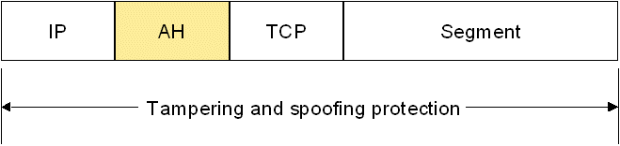
Figure 5 An IP packet with AH protection
AH provides tampering and spoofing protection for the entire IP packet, except for specific fields in the IP header that are allowed to change in transit. The AH includes a cryptographic checksum known as a hashed message authentication code (HMAC), whose calculation incorporates a shared secret key. Windows IPsec supports the use of HMAC-Secure Hash Algorithm 1 (SHA1) and HMAC-MD5. Microsoft recommends using HMAC-SHA1 because it provides better protection than HMAC-MD5.

ESP
Figure 6 shows the original IP packet of Figure 4 that has been protected with ESP and encryption. ESP includes both a header and trailer.
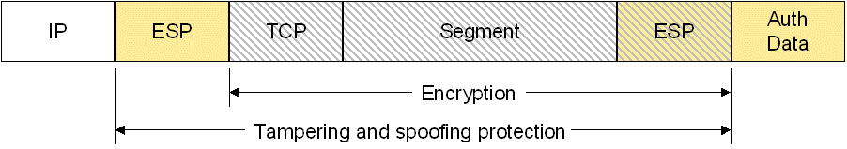
Figure 6 An IP packet with ESP and encryption protection
ESP with encryption provides tampering and spoofing protection for the IP packet payload, the ESP header, and part of the ESP trailer and encryption for the IP packet payload and part of the ESP trailer. The Auth Data field in the ESP trailer includes the results of the HMAC-SHA1 or HMAC-MD5 calculation. For Windows IPsec, the IP packet payload and part of the ESP trailer is encrypted with either Data Encryption Standard (DES) or Triple-DES (3DES). Microsoft recommends using 3DES because it provides better protection than DES.
Encryption with ESP is optional. You can use ESP with no encryption, also known as ESP-Null. Figure 7 shows the original IP packet of Figure 4 that has been protected with ESP and no encryption.
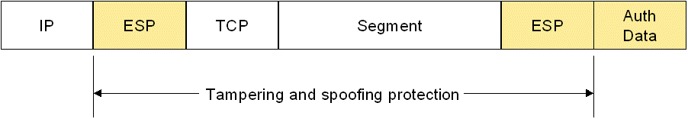
Figure 7 An IP packet with ESP and no encryption protection
ESP with no encryption provides tampering and spoofing protection for the IP packet payload, the ESP header, and part of the ESP trailer. Unlike AH, ESP does not provide protection for the IP header. However, the checksum calculation in the TCP header includes the values of the source and destination IP addresses in the IP header. Because the checksum field in the TCP header is protected from tampering, an attacker cannot change the IP addresses in the IP header without invalidating the protected TCP checksum value in the TCP header. Therefore, even though ESP does not directly protect the IP header, ESP does provide protection against attacks that modify IP addresses in the IP header.
If packet payload encryption is not required, Microsoft recommends using ESP with no encryption rather than AH because IPsec network address translator traversal (NAT-T) does not support AH-protected packets.

Common Misconceptions about IPsec
The most common misconceptions about IPsec are the following:
- IPsec is a virtual private network (VPN) technology
Although IPsec is used for VPN connections across the Internet to connect remote clients to an intranet or remote sites to each other, IPsec was designed to protect both intranet and Internet traffic in a variety of scenarios.
When using IPsec to protect IP traffic that is sent across the Internet, some VPN implementations use an additional mode of AH and ESP known as tunnel mode, in which an entire IP packet is encapsulated and protected. Computers running Windows Server 2003, Windows XP, or Windows 2000 can use Layer Two Tunneling Protocol (L2TP) with IPsec (L2TP/IPsec) for VPN connections. However L2TP/IPsec does not use tunnel mode. Instead, L2TP provides encapsulation for an entire IP packet and the resulting IP packet payload is protected with ESP and encryption.
- Using IPsec requires encryption
As described earlier in this paper, IPsec only encrypts IP packet payloads when you choose to use ESP with encryption. Encryption is optional but recommended in many circumstances, including when sending private data across a public network (such as the Internet) or when sending highly sensitive data across an intranet (such as personal or financial data).

Security Provided by IPsec
IPsec enforces computer-level authentication of IPsec peers and negotiation of IPsec protection of data prior to protecting the traffic between the IPsec peers. An unknown host can send packets to an IPsec-capable host. If the IPsec-capable host requires that all incoming data packets be protected, the IPsec-capable host will discard the packets from the unknown host. Only after successful IPsec authentication and negotiation of security settings will IPsec-capable hosts accept incoming IPsec-protected packets.
IPsec-protected packets are protected from end-to-end. The cryptographic protection on each IPsec-protected packet makes it very difficult for a malicious host to either spoof packets or to tamper with packets without being detected. A malicious host can spoof an IPsec host's MAC and IP address, but they cannot easily calculate the correct cryptographic checksum for packets that they create. If the IPsec protection includes encryption, the malicious host that captures packets sent between IPsec hosts cannot easily determine the contents of the packets.

Windows Support for IPsec
The following versions of Windows support IPsec:
- Windows Server 2003
- Windows XP
- Windows 2000
IPsec-protected communication can use the following authentication methods:
- Kerberos Requires the exchange and validation of Kerberos tokens. This is the default IPsec authentication method in Windows and leverages an Active Directory infrastructure.
- Certificate Requires the exchange and validation of computer certificates. This method requires a PKI to issue and renew certificates to IPsec peers.
- Preshared key Requires the configuration of a common string on both IPsec peers. This authentication method is supported for standards compliance and compatibility with non-Microsoft IPsec implementations.
To specify IPsec behavior, you must configure IPsec policies through Computer Configuration Group Policy for an Active Directory container (such as a domain, site, or organizational unit) or an individual computer. An IPsec policy specifies the types of IP traffic to allow, block, or protect. For protected traffic, an IPsec policy specifies how to protect the traffic (using AH or ESP) and how IPsec peers must authenticate each other.

Comparing 802.1X for Wired Networks and IPsec
The following table summarizes the security provided by 802.1X and IPsec for wired networks.
Security property | 802.1X for wired networks | IPsec
Authentication | X | X
Tampering and spoofing protection |  | X
Encryption |  | X
The following table compares 802.1X for wired networks and IPsec based on the 802.1X and IPsec standards.
802.1X for Wired Networks | IPsec
Authenticates and authorizes connections to a network  With 802.1X, the enforcement of the requirement of valid credentials is performed at the network edge by the switch. Wired 802.1X is a Data Link layer security barrier. A computer cannot just plug into an available network port and begin communicating on the network. | Authenticates communications between endpoints  With IPsec, each end of the communication performs the enforcement of IPsec authentication. IPsec is a Network-layer security barrier. A computer cannot initiate communications with IPsec-protected intranet resources after obtaining a connection to the network.
Enforces security protection at the switch  IEEE 802.1X for wired networks is only applied at the switch port. Other methods of accessing the intranet might not be protected with 802.1X. | Enforces security protection at the host  IPsec policies are enforced by the host and apply regardless of the way that the host connects to the intranet or whether the host is connected to the intranet.
Does not provide cryptographic protection of traffic between the supplicant and the switch  After authentication and authorization, there are no facilities within the 802.1X standard that protect the traffic on the 802.1X-authenticated link. | Provides cryptographic protection of traffic between endpoints  After authentication and negotiation of security options, IPsec protects packets with tamper-proofing and optional encryption.
Does not provide protection against attackers with physical access to a switch port  After obtaining physical access to a switch port, an attacker that spoofs the MAC address of a valid host can gain access to the intranet. | Provides protection against unknown hosts  An IPsec-protected host will discard spoofed packets sent by an unknown host.
Can provide protection against denial of service attacks that consume bandwidth  Protection against denial-of-service (DoS) attacks in which an attacker tries to overwhelm the network with packets is not an inherent function of 802.1X, but a capability of many switches that support 802.1X authentication. | Can provide protection against DoS attacks launched against hosts  IPsec is not designed to prevent a malicious host from transmitting packets. However, IPsec can prevent received packets from being processed. IPsec can silently discard unprotected packets upon receipt.
Works for all networking protocols  IEEE 802.1X operates at the Data Link layer before a connecting host sends any network protocol frames or packets. | Works only for IP-based traffic  IPsec can only protect packets that have an IP (IPv4 or IPv6) header.
Requires that your switches support 802.1X  The switches in your switching fabric must support 802.1X authentication. | Requires no additional support from the network infrastructure  IPsec operates at the Network layer and works over any IP-based network.
Requires that your network hosts support 802.1X  The connecting network hosts must support 802.1X authentication for LAN connections and the EAP methods required by the RADIUS server. | Requires that your network hosts support IPsec  The network hosts must support IPsec, common authentication methods, and common cryptographic algorithms for key determination, HMACs, and encryption (optional).
Requires an authentication infrastructure consisting of RADIUS servers and account databases  To perform authentication and authorization, you must deploy account databases to store computer and user accounts and their credentials, and RADIUS servers to evaluate the connection attempt. | Requires an authentication infrastructure (depends on the IPsec authentication method)  To perform IPsec authentication, you must deploy an authentication infrastructure that can authenticate the credentials of IPsec peers.
Simple or group-based network access  IEEE 802.1X provides a simple allowed/denied access to intranets. Whether the access is simple or group-based, 802.1X allows all traffic from an authenticated host. Many switches also support the use of VLANs to group ports together or to specify the types of traffic allowed on the switch port. | Isolated or granular network access  You can use IPsec policy and authentication methods to isolate portions of your network. IPsec settings can specify different levels of protection for network traffic to the granularity of IP addresses and TCP or UDP ports.
Requires no changes to applications  Because it operates at the Data Link layer, 802.1X does not require application support. | Requires no changes to applications  Because it operates at the Network layer, IPsec does not require application support.
Cannot protect against a trusted attacker  If a host has the proper credentials for 802.1X authentication, the switch cannot prevent the host from attacking the network. | Cannot protect against a trusted attacker  If a host has the proper credentials for IPsec authentication and the correct policy settings for IPsec protection of traffic, IPsec cannot prevent the host from attacking other hosts.
The following table compares 802.1X for wired networks and IPsec support in Windows Server 2003, Windows XP, and Windows 2000.
Wired 802.1X | IPsec
No support for deployment through Group Policy or scripting  Windows Server 2003 and Windows XP do not support a way to deploy wired 802.1X settings through Group Policy or through a set of scripting commands. | Support for deployment through Group Policy and scripting  IPsec settings are primarily deployed through Group Policy. You can also configure IPsec settings through scripts that use commands in the netsh ipsec context.
Computer or user authentication  Windows-based computers can use either computer or user credentials to authenticate 802.1X wired connections. | Computer authentication only  Windows-based computers can only use computer credentials (a Kerberos token, a computer certificate, or a preshared key) for IPsec authentication.
Works for both IPv4 and IPv6  Because 802.1X is not specific to network protocols, it works for both IPv4 and IPv6 traffic. | Deployable only for IPv4 traffic  Windows Server 2003 and Windows XP support IPsec for both IPv4 and IPv6. However, IPsec for IPv6 must be manually configured and is not deployable in a large organization.
Requires account properties and remote access policy configuration for authorization  Authorization for 802.1X connections is based on the properties of the account in Active Directory and remote access policies in Internet Authentication Service (IAS), the Windows implementation of a RADIUS server. | Requires group-specific server isolation for authorization  IPsec in Windows by default does not perform an explicit authorization during the IPsec authentication process. You can add a layer of authorization using group-specific server isolation.
Requires IAS servers, Active Directory, and an optional PKI for authentication  IEEE 802.1X authentication and authorization requires an authentication infrastructure consisting of IAS servers, Active Directory, and, when using EAP-TLS or PEAP-TLS, a PKI to distribute and renew computer or user certificates. | Requires either Active Directory or a PKI for authentication  IPsec authentication requires Active Directory when using Kerberos authentication or a PKI when using certificate authentication.

Changes in Support for 802.1X for Wired Networks and IPsec in Windows Vista and Windows Server "Longhorn"
Windows Vista™ (now in beta testing) and Windows Server "Longhorn" (now in beta testing) also support 802.1X for wired networks and IPsec with the following enhancements:
- Network Access Protection supports 802.1X-authenticated connections and IPsec-protected communications. For more information, see the Network Access Protection Web site.
- With integrated support for IPsec and IPv6, IPsec policies can now be centrally specified for IPv6 traffic.

Choosing 802.1X for Wired Networks and IPsec
When determining how to best protect your intranet and its assets, you do not have to choose between 802.1X for wired networks and IPsec. Because they operate at different layers and perform different functions, the use of one does not exclude the use of the other. From a security standpoint, it is better to deploy security technologies to provide defense-in-depth to create a series of barriers against an attacker. Deploying 802.1X for wired networks helps prevent unknown hosts from gaining access to your intranet. Deploying IPsec helps prevent unknown hosts from communicating with IPsec-protected hosts on your intranet.

Summary
IEEE 802.1X for wired networks provides authentication and authorization protection when attaching to an authenticating switch but does not provide cryptographic protection of traffic after a successful connection has been made. IPsec provides mutual peer authentication and cryptographic protection for traffic between endpoints of communication. The choice of whether to use one or both depends on many factors, including switch support for 802.1X, level of security desired, the presence of Active Directory, Group Policy, and other elements of an authentication infrastructure, and what types of traffic that you are trying to protect.

Related Links
See the following resources for further information:
- Extensible Authentication Protocol Web site and http://www.microsoft.com/windowsserver2003/technologies/eap/default.mspx
- Windows Server 2003 IPsec Web site at http://www.microsoft.com/windowsserver2003/technologies/networking/ipsec/default.mspx
- Deployment of IEEE 802.1X for Wired Networks Using Microsoft Windows at http://www.microsoft.com/downloads/details.aspx?familyid=05951071-6b20-4cef-9939-47c397ffd3dd&displaylang=en
- Network Access Protection Web site at http://www.microsoft.com/windowsserver2003/technologies/networking/nap/default.mspx

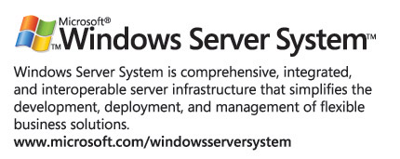
For the latest information about Windows Server System, see the Windows Server System Web site at http://www.microsoft.com/windowsserversystem.

