
Contract Management

Microsoft Dynamics™ SL

Benefits
- Effectively manage subcontract agreements
Create and track agreements from the
pending stage through commitment, then
manage subcontractor performance by
linking payments to the achievement of
contractual commitments, including on-time
document submittals.
O L O M O
- Boost productivity
Increase the profitability of project work
and change orders by reviewing budgets,
margin, and schedule impacts before work
proceeds or changes are approved.

- Streamline change order approval and tracking
View, track, and approve change orders
easily to help eliminate delays, reduce the
risk of miscommunication or unauthorized
work, and more quickly turn change orders
into billable tasks.

- Take control of documentation
Keep on top of compliance documents,
drawings, permits, proof of insurance
submittals, performance bonds, and other
important documents to help prevent lost,
late, incomplete, or missing paperwork
including tailoring of payment controls for
subcontractors based on their insurance
policy expirations.

- Stay on schedule with automated
alerts
Receive prompts about unapproved change
orders and pending deadlines for document
submittals.

- Improve financial leverage
Protect cash flow, track outstanding
liabilities, and make disbursements
contingent on performance through
automated payment controls that tighten
financial safeguards and easily handle
retention calculations and pay-when-paid
subcontracts.

Streamline time-consuming contract management tasks and increase the productivity of subcontractor interactions for even the most complex projects. By improving control over change orders, document tracking, and subcontractor disbursements, you can help ensure timely completion, enhance cash flow, and boost project profitability.

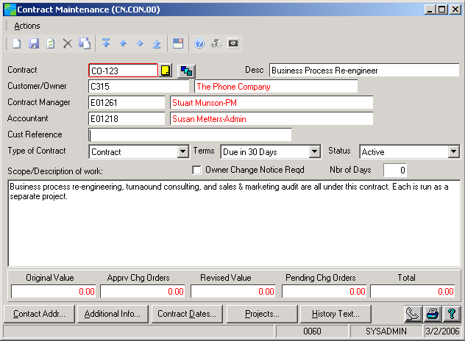

Manage Contract
documents, change orders,
and disbursements to
optimize project cash
flow and profitability.

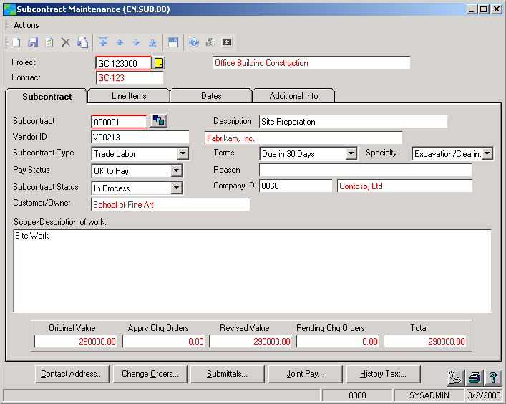

Control subcontractor
payments, lien waivers, and
pay-when-paid subcontracts.

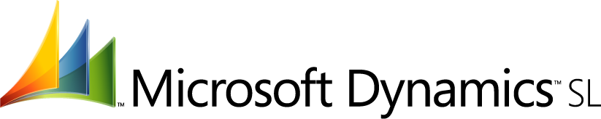

FEATURES

BENEFITS

Convenient Contract Management | Easily record pending agreements to monitor progress throughout  bidding and negotiation processes and track commitments.
Flexible Change Order Processing | Create, analyze, approve, and track change orders by line item or by the  original budget to meet your business requirements.
Tight Fiscal Control | Help prevent charges against unapproved change orders, and link cash  disbursements to performance milestones, pay-when-paid triggers, and  timely document submittals.
Streamlined Disbursement Administration | Link processes and information with accounting systems to manage and  automate subcontractor payments subject to retention percentages, obligations, or entitlements.
Convenient Transmittal Tracking | Record the status and location of important contract and subcontract  documents throughout submittal, review, approval, and information-  sharing processes. Quickly sort and view outstanding documents.
Automated Alerts | Receive advance warning, sent via Microsoft Dynamics SL Communicator,  when unapproved change orders age or when paperwork is due to or  from subcontractors, government agencies, or other project participants.
Flexible Recordkeeping | Capture and easily access important contract-related data such as  insurance and worker’s compensation expiration dates, draw requests,  and retention percentages.
Data Integration | Help eliminate redundant data entry and ensure accurate accounts with  full integration across Microsoft Dynamics SL, including financial  management, payroll, field service management, and distribution  modules.

For more information about Microsoft Dynamics™ SL, visit: http://www.microsoft.com/dynamics/sl

This document is for information purposes only.
MICROSOFT MAKES NO WARRANTIES, EXPRESS, IMPLIED, OR STATUTORY, AS TO THE INFORMATION IN THIS DOCUMENT.

© 2005 Microsoft Corporation. All rights reserved.
Microsoft, The Microsoft Dynamics Logo, are either registered trademarks or trademarks of Microsoft Corporation or Microsoft Business Solutions ApS in the United States and/or other countries. Microsoft Business Solutions ApS is a subsidiary of Microsoft Corporation.

