Microsoft Office Home and Student 2007

September 2006



Table of Contents

Cover is for   
position only

Overview of Microsoft Office Home and Student 2007 1

Create High-Quality Documents 2

Work with Enhanced Reliability and Security Features 2

Find Commands and Help More Easily 4

Organize Your Notes and Information in One Place 4

Create High-Quality Documents 5

Microsoft Office Fluent User Interface 5

Improved Advanced Formatting 6

SmartArt Diagramming and Enhanced Charting Capabilities 7

Improved Templates and New Fonts 9

Improved Document Themes 10

Live Preview and Galleries 11

Save as PDF or XPS 11

New Custom Slide Layouts 13

Work with Enhanced Reliability and Security Features 14

Improved Document Recovery Tool 14

New Digital Signature 14

New Document Inspector 14

Find Commands and Help More Easily 16

New Command Tabs 16

Improved Tutorials 17

Improved and Easy-to-Use Help 17

Enhanced ScreenTips 18

Organize Your Notes and Information in One Place 19

New Organizational and Navigational Pane 19

Improved Ways to Find Many Types of Information 20

Improved Tools for Getting More Organized 21

Summary 22

Resources 23

System Requirements 24

# Overview of Microsoft Office Home and Student 2007

Welcome to Microsoft® Office Home and Student 2007, the exciting new release of the familiar and widely used productivity software. Office Home and Student 2007 is the office software suite that empowers you to quickly and easily create great-looking documents, spreadsheets, and presentations and orgainze your notes and information in one place. With the Microsoft Office Fluent™ user interface, enhanced graphics and formatting capabilities, new information organization tools, and more reliability and security, Office Home and Student 2007 makes it easier and more enjoyable for you to get things done.

Office Home and Student 2007—consisting of Microsoft Office Word 2007, Microsoft Office Excel® 2007 spreadsheet software, the Microsoft Office OneNote® 2007 digital notebook, and the Microsoft Office PowerPoint® 2007 presentation graphics program—offers easy access to a comprehensive set of powerful tools and resources. The redesigned Office Fluent user interface, one of the most significant visual makeovers in the history of the Microsoft Office system, helps you access the commands you need while you work.

This guide provides an overview of new and improved features in Office Home and Student 2007. You’ll also see examples of Office Home and Student 2007 in action that demonstrate its powerful new capabilities.

Office Home and Student 2007 in Action

There’s always someone in the Alexander family in front of the computer. David tracks the household budget and taxes with Office Excel 2007 spreadsheets. His wife, Michelle, uses Office Word 2007 to work on her book of short stories and write letters and flyers. Their children, Sean and Michael, use the computer to do homework, play games, and listen to music.

## Create High-Quality Documents

Office Home and Student 2007 simplifies the way you work with documents. The redesigned Office Fluent user interface enables you to quickly and easily create high-quality documents, spreadsheets, and presentations. Enhanced graphics and formatting capabilities help make your user experience more enjoyable and productive.

* **New! Microsoft Office Fluent user interface** makes it more straightforward to find and use the product features you use most to get the results you want.
* **Improved! Enhanced formatting** capabilities makes it easier to consistently format documents.
* **New! Text effects** **and diagram and graphics galleries** enable you to easily format items.
* **Improved! Document Themes** can be used to create a consistent appearance across Office Word 2007 documents, Office Excel 2007 spreadsheets, and Office PowerPoint 2007 presentations.
* **New! Save as Portable Document Format (PDF) or an XML Paper Specification (XPS) file[1]** option gives you the ability to share your documents, spreadsheets and presentations with people who may not have Word, Excel or PowerPoint.

## Work with Enhanced Reliability and Security Features

Powerful new security features enable you to work with confidence.

* **Improved! Automatic** **document recovery** helps retrieve Word documents you were working on when your system fails.
* **New! Digital Signature** can be added to your document to help others verify that content has not been changed since it was published.
* **New! Document Inspector** helps protect your private information by automatically removing personally identifiable information, comments, and tracked changes from documents.

## Find Commands and Help More Easily

Office Home and Student 2007 offers the Office Fluent user interface that significantly simplifies how you access commands. Commonly used commands appear on the results-oriented Ribbon instead of in drop-down menus. In addition, an enhanced Help system, including tutorials with step-by-step instructions, enables you to quickly find answers to your questions.

* **New! Command tabs** on the results-oriented Ribbon reveal commonly used commands that previously appeared only in lengthy drop-down menus.
* **Improved!** **Tutorials** provide you with step-by-step instructions for common tasks.
* **Improved! The easy-to-use Help system** offers a smooth transition between Help in a program and Help on the Internet (when you’re connected).
* **Improved! Enhanced ScreenTips** provide quick access to information about a command directly from the command’s location.

## Organize Your Notes and Information in One Place

Office Home and Student 2007 helps you organize the increasing amount of information you face every day. With new and improved features in Office OneNote 2007, you can gather, organize, and search virtually any type of information in one place. As a result, you can stay on top of everything and work more efficiently.

* **New! The organizational and navigational pane** enables you to quickly and easily navigate the sections in your notebook.
* **New! Drag-and-drop functionality** has the same look and feel as Microsoft Office Outlook® 2007, making it familiar and easy to use.
* **Improved! Powerful Instant Search** enables you to quickly find nearly any type of information, including digitally handwritten notes, the text in pictures, and spoken words in audio recordings.

# Create High-Quality Documents

Office Home and Student 2007 makes it easier than ever to format your documents, spreadsheets, and presentations. New and improved features such as enhanced graphics and advanced formatting capabilities help you deliver high-quality documents in lightning-fast time. In addition, new features in Office PowerPoint 2007 make it easier to share and reuse presentations, providing a more enjoyable experience.

## Microsoft Office Fluent User Interface

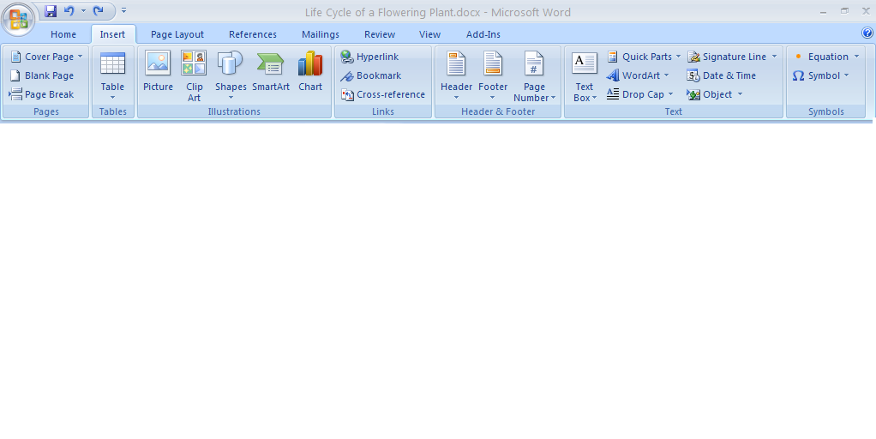The Microsoft Office Fluent user interface reflects an overall effort by Microsoft to deliver a more user-driven product. Rather than rethinking the product from a *feature-oriented* viewpoint, Microsoft focused Office Home and Student 2007 on the user’s *results-oriented* perspective. The end product delivers one of the most significant makeovers in the history of the Microsoft Office system. The Office Fluent user interface is more intuitive and offers more easily accessible features. It’s less about commands and more about results. At the same time, although the look is very new, its evolution from previous versions of the Microsoft Office system will make it feel extremely familiar.

Figure 1: Office Word 2007 task-based Office Fluent user interface

The Office Fluent user interface interface significantly simplifies how you author documents by:

* Making the experience more predictable, with less-complicated features and less guesswork.
* Maximizing your workspace and being less intrusive by not popping up images and dialog boxes on top of your work.
* Putting a majority of the most commonly used commands on the first tab so you don’t have to dig for commands in lengthy drop-down menus.

Office Home and Student 2007 in Action

Michelle serves on the Parent Teacher Association (PTA) board for her children’s school and volunteers at the zoo. She uses Office Home and Student 2007 to write letters to parents and design zoo flyers. Although comfortable with the menus in previous versions of the Microsoft Office system, she was frustrated with having to hunt down commands in the drop-down menus. With the Office Fluent user interface in Office Home and Student 2007, all of the tools she needs become available automatically when and where she needs them. As a result, she can spend less time on formatting documents and more time doing what is important to her.

## Improved Advanced Formatting

With the addition of more consistent numbering, bullet, and table features in Office Home and Student 2007, you won’t have to waste time formatting and reformatting your Office Word 2007 documents. Office Home and Student 2007 simplifies document formatting by:

* Making it possible for you to create and apply Quick Styles for text and tables with a single click.
* Providing previews of your formatting changes.
* Maintaining formatting across Microsoft Office system programs when you copy text or tables from one program to another.
* Providing more consistent and stable bullet and number formatting.

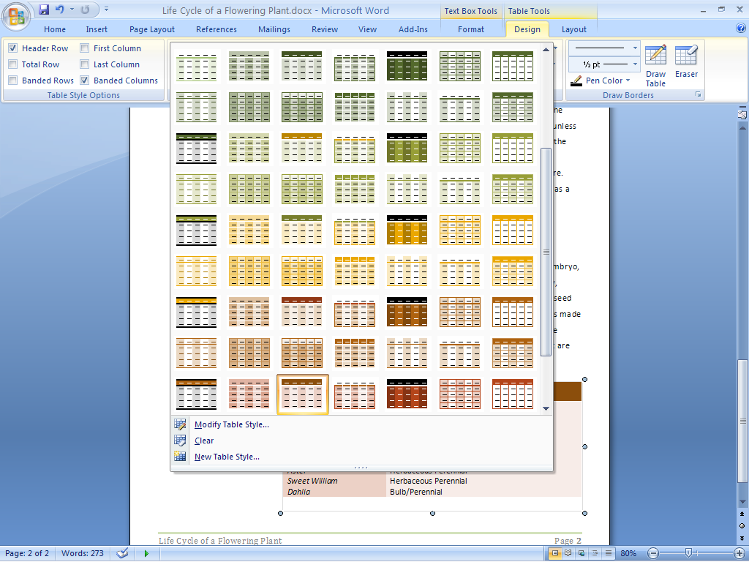

Figure 2: Table formats in Office Word 2007

## SmartArt Diagramming and Enhanced Charting Capabilities

The new SmartArt™ diagramming and enhanced charting capabilities in Office Home and Student 2007 applications make it easy to create great-looking diagrams and charts. Just choose the chart type, the layout, and the format from visual galleries of predefined options. Or take a bulleted list and convert it to a compelling diagram with just a couple of clicks. You can also reuse content by saving your favorite charts as chart templates. In addition, the SmartArt graphics capabilities have been enhanced so you can easily use professional effects such as shading, reflections, glow, transparency, and other 3-D effects.

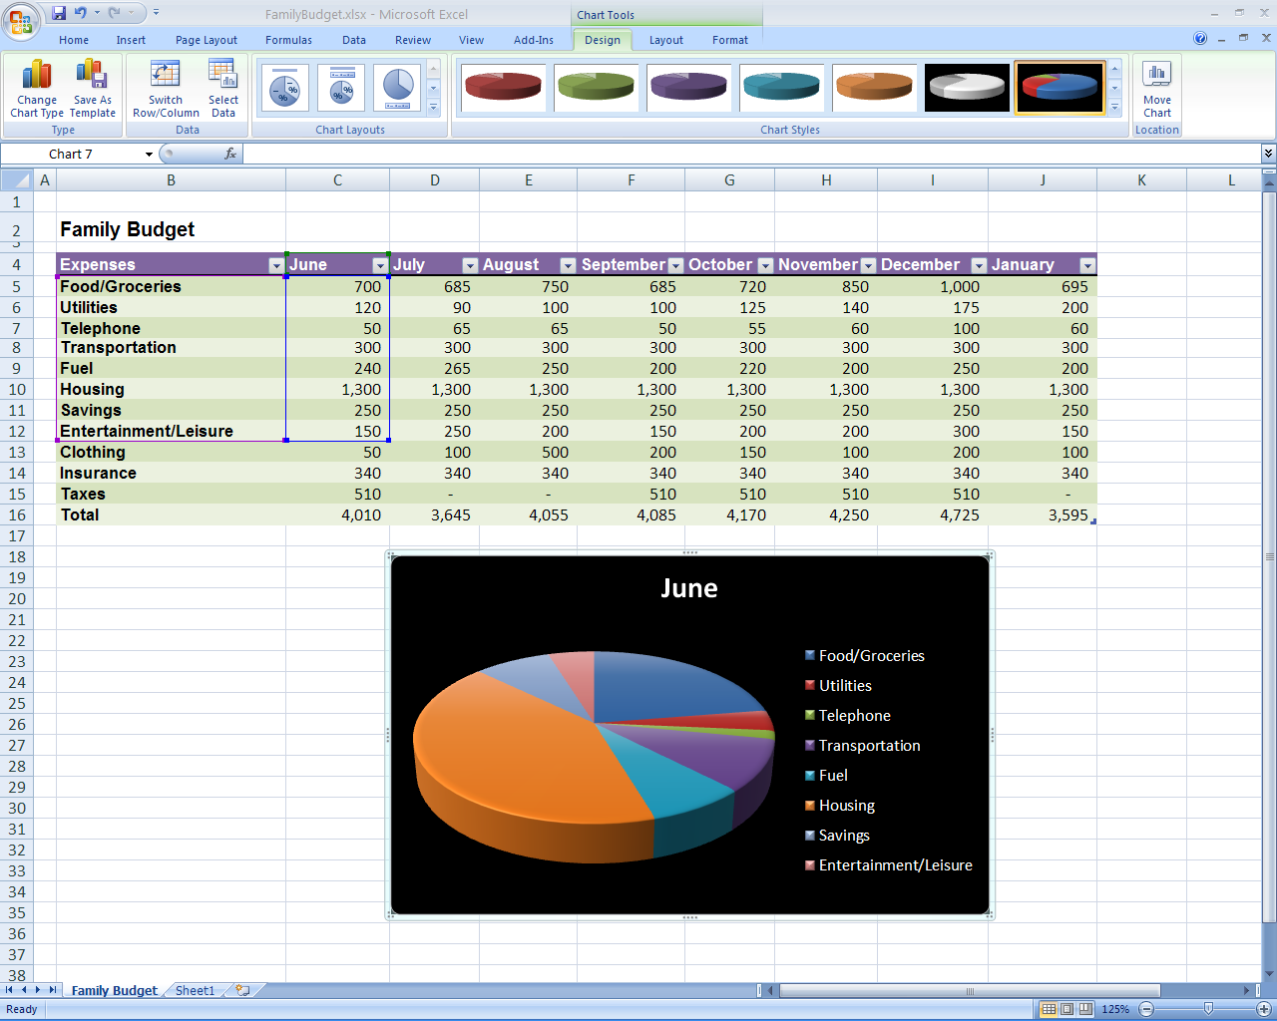

Figure 3: Charting tools in Office Excel 2007

Office Home and Student 2007 in Action

Michael used to find all schoolwork boring. Now he’s excited about working on his presentation for his fourth grade class about the three branches of the United States federal government. He has already written the paper, but that’s only part of what he wants to do. He’s looking for that “wow” factor to win over his peers. Right now, he’s adding sound effects in certain places and using 3-D effects to make his work come   
alive on the screen.

## Improved Templates and New Fonts

New and improved out-of-the-box templates in Office Home and Student 2007 enable you to create professional-looking documents more quickly and easily. You can either get started with the templates that are included in the product or search the preformatted templates available at Microsoft Office Online at [www.microsoft.com/office](http://www.microsoft.com/office). In addition, Office Home and Student 2007 includes new and improved fonts that make on-screen reading easier.

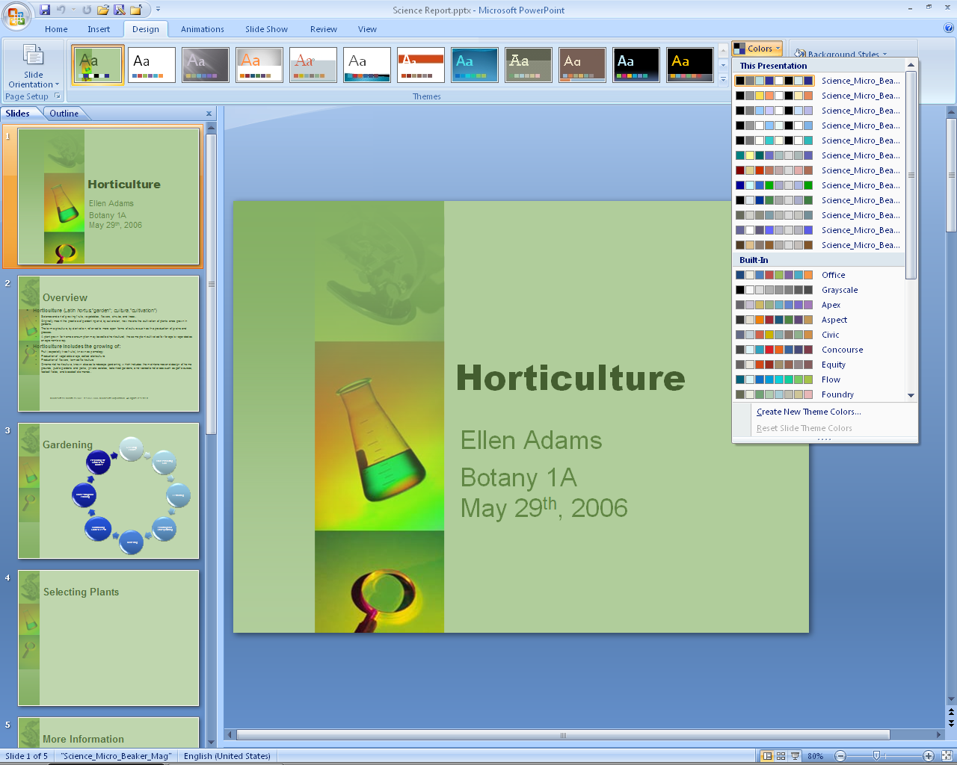

Figure 4: Slide templates and color gallery in Office PowerPoint 2007

## Improved Document Themes

Document Themes is an improvement that helps you maintain a consistent look among your Word documents, Excel spreadsheets, and PowerPoint presentations. This predictability means that when you copy tables and objects between programs, the items maintain their appearance. As a result, working simultaneously with different programs becomes more consistent and less frustrating.

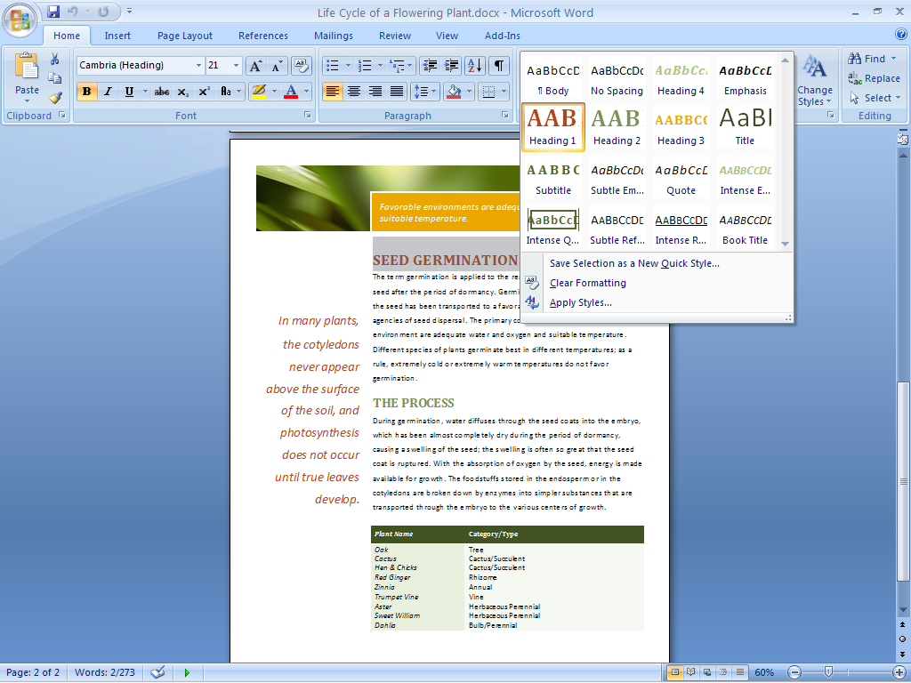

Figure 5: Quick Styles in Office Word 2007

Office Home and Student 2007 in Action

David and Michelle are considering building an addition to their house. They use Office Excel 2007 to analyze and track the projected costs. They also use Word documents and PowerPoint presentations to record their design ideas and logistics. Document Themes in Office Home and Student 2007 help ensure that all information transferred between programs maintains its appearance. As a result, David and Michelle can quickly shuffle information between different programs, knowing that what they see is what they will get. This helps them plan more efficiently and with greater confidence.

## Live Preview and Galleries

Everyone wants to create the highest-quality documents possible in the shortest amount of time. Accomplishing this often requires experimenting with different styles and formats. Office Home and Student 2007 enables you to quickly preview proposed changes to your document. With Live Preview when in one of the galleries, you can actually view formatting choices right inside your document while you’re working on it, without having to repeatedly search through drop-down menus. By test-driving your proposed formatting, you can save time and experiment more easily. The end result is a quickly created document that looks the way you want it to look. These galleries can be found in Office Word 2007, Office Excel 2007, and Office PowerPoint 2007.

## Save as PDF or XPS

Ensure broader distribution of your documents and presentations. New support for Portable Document Format (PDF) and XML Paper Specification (XPS) file formats helps ensure broader distribution of your documents with others.[2]* Now you can post your documents on the Internet or share them with others, knowing that users can view them regardless of the type of computer or programs they are using.

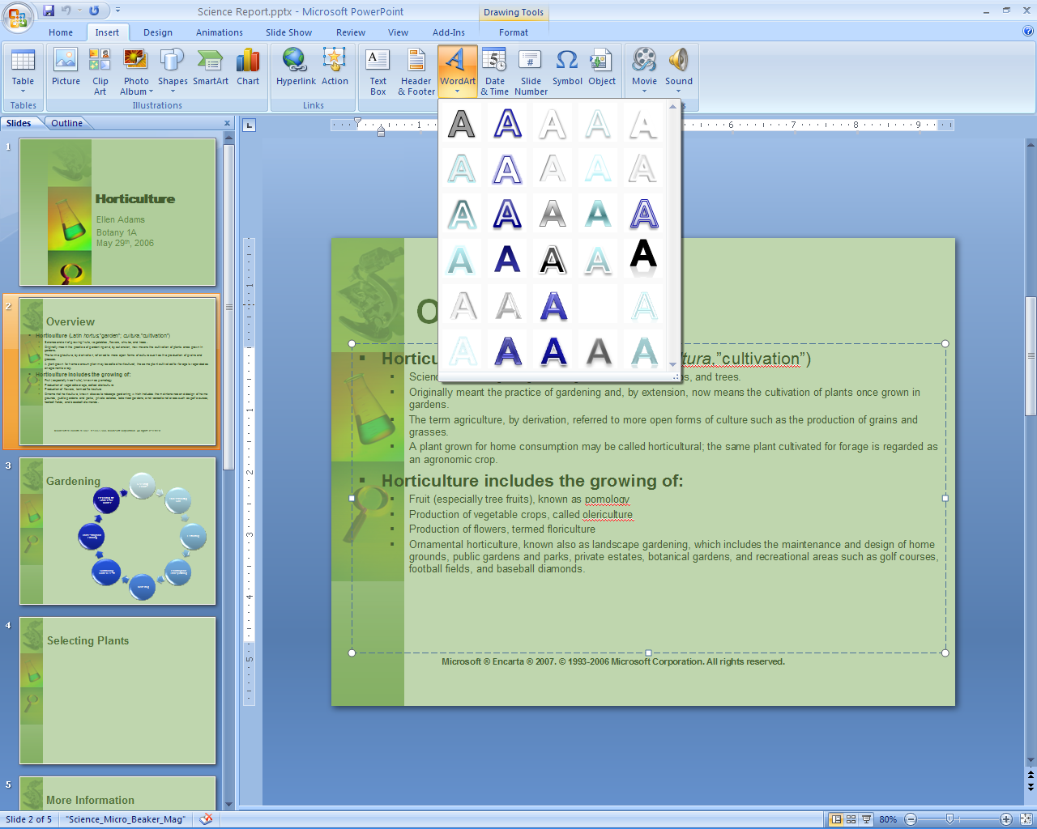

Figure 6: Word Art Gallery in Office PowerPoint 2007

Office Home and Student 2007 in Action

Michelle wants to design a baby shower invitation for her sister. She knows the details of the event but can’t decide upon the design. With Live Preview in Office Home and Student 2007, she can preview different fonts simultaneously within her document before making a decision. For help with margins, she can quickly preview visual images of multiple options. She finds that these new preview features make her feel more comfortable experimenting with different looks.

## New Custom Slide Layouts

The new Custom Slide Layouts feature in Office PowerPoint 2007 frees you from confining prepackaged layouts. Now you can quickly create and save information-rich layouts with multiple charts, tables, and text. You can then save these layouts as templates for future presentations.

# Work with Enhanced Reliability and Security Features

Office Home and Student 2007 offers new and improved features such as automatic document recovery and Document Inspector that give you peace of mind by automatically recovering documents after a system failure and giving you the option to remove personally identifiable information from your documents before you share them with others. Digital Signature verifies that no one has altered or edited your document since you created it.

## Improved Document Recovery Tool

The automatic document recovery tool in Office Home and Student 2007 helps protect your documents if your system suddenly fails. If a Microsoft Office system program encounters a problem or stops responding, you can now close the program in a controlled manner. The files you had open are analyzed for errors, and whenever possible, recovered. You can then view any repairs that were made to the files.

## New Digital Signature

Office Home and Student 2007 helps you create a digital signature that lets others know that your document has not been modified since you created it. Simply add a signature line to each Word document. This line will require a digital signature for any of your documents that are edited by others. People reading digitally signed documents can easily verify that your document has not changed since it was signed.

## New Document Inspector

The Office Home and Student 2007 Document Inspector provides an easy and efficient way to help protect your personal information. This tool automatically searches your documents for comments, revisions, tracked changes, headers and footers, and hidden text. You can delete your choice of personal information in a matter of seconds. When you distribute your documents, you can be confident that no unwanted personally identifiable or other information is accidentally included.

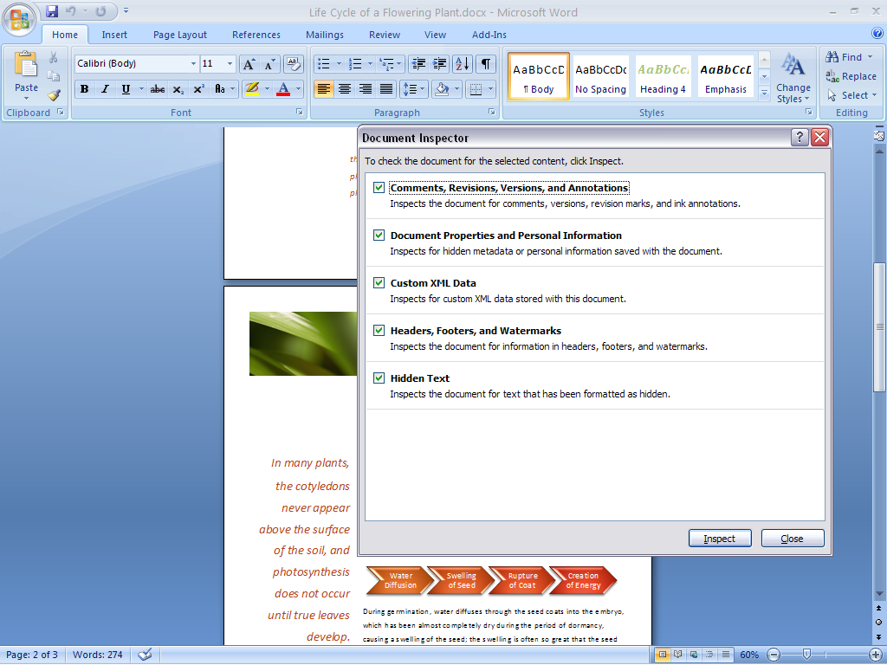

Figure 7: Document Inspector in Office Word 2007

Office Home and Student 2007 in Action

Twice a year, the Alexanders send a family newsletter to friends and family. Michelle used to reread the finished product several times because she was afraid that she’d inadvertently left something in the letter that should have been edited out. Now, with Office Home and Student 2007, she can use Document Inspector to search her newsletter and automatically remove personal information such as tracked changes before sending it out.

# Find Commands and Help More Easily

Office Home and Student 2007 offers the Office Fluent user interface that makes document creation easier, faster, and more intuitive. The design emphasizes user efficiency and feature discoverability to help you quickly find relevant answers to your questions. Tutorials and templates help you get started and understand more about the software’s capabilities.

## New Command Tabs

Most people use only a small percentage of the commands available in Microsoft Office system programs. With the Office Fluent user interface in Office Home and Student 2007, you can learn more about the capabilities of the Microsoft Office system through command tabs, which replace the previous drop-down menus. Commonly used commands, once buried, are now available at your fingertips. You get access to the right tools when you need them, so you learn more and get the results you want.

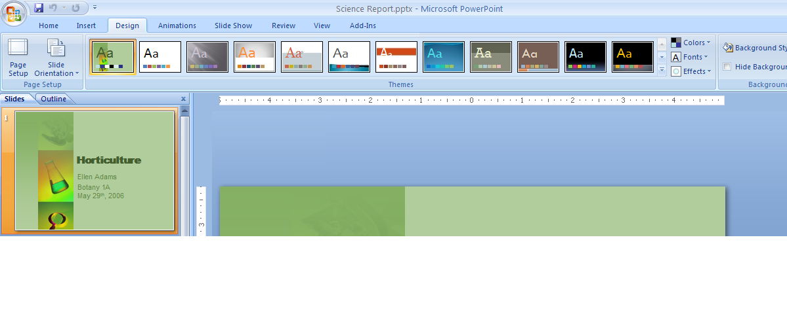

Figure 8: Design command tab in Office PowerPoint 2007

Certain sets of commands are relevant only when editing objects of a particular type. These sets are known as contextual command tabs. The tabs change automatically depending upon the task that you are trying to complete.

Office Home and Student 2007 in Action

Michelle rarely feels like there are enough hours in the day. As a result, she has never taken the time to discover all the functionality available in the Microsoft Office system. With hundreds of commands in Word alone, this means she hasn’t benefited from capabilities that could simplify and improve her experience. By using the contextual command tabs in Office Home and Student 2007, she can get fast access to commands that relate to what she is doing at the moment. Now she can complete whatever she is working on faster than before.

## Improved Tutorials

An improved Getting Started experience in Office Home and Student 2007 significantly reduces the learning curve for new users. Tutorials offer step-by-step instructions for using your Microsoft Office system software. The new Getting Started experience brings to the surface additional Help options, such as Office Online integration.

## Improved and Easy-to-Use Help

Tired of wasting your time trying to find answers to your functionality questions? Office Home and Student 2007 provides more direct links to Help content than ever before. Take advantage of the smooth transition between Help in a program and Help on the Internet (when you’re connected).

## Enhanced ScreenTips

Office Home and Student 2007 offers larger, more informative ScreenTips than were available in previous releases of the Microsoft Office system. ScreenTips provide quick access to information about a command directly from the command’s location. By popping up when you rest your mouse pointer on any command, a ScreenTip often gives you enough information about a feature to enable you to use it immediately without further assistance. This capability gives you easy access to all of the functionality of the Microsoft Office system interface. As a result, you can save time and become more productive.

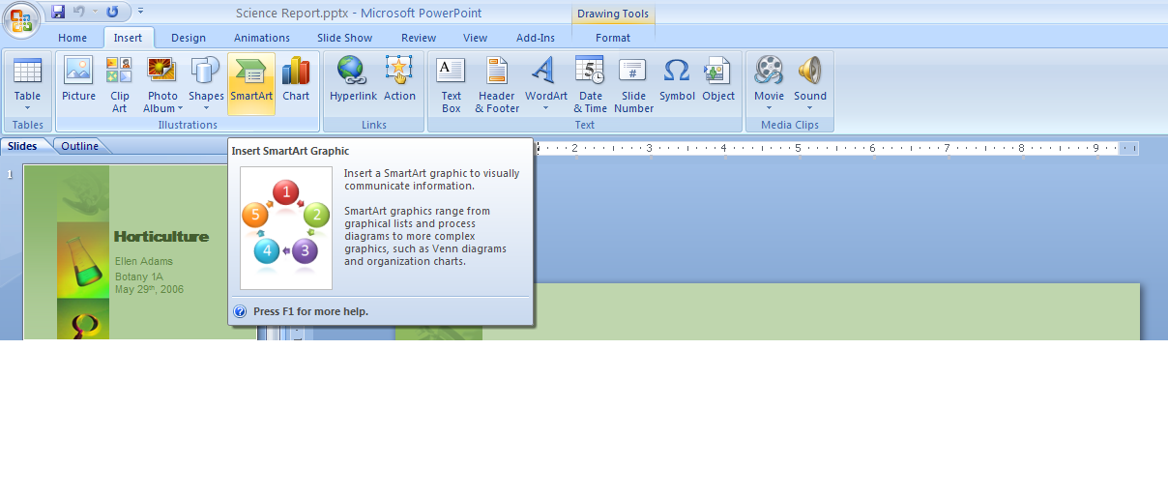

Figure 9: SmartArt ScreenTip in Office PowerPoint 2007

# Organize Your Notes and Information in One Place

Office OneNote 2007, included in Office Home and Student 2007, is a digital notebook that helps you gather, organize, and search many types of information in one place. Gather many different kinds of information—typed text, images, audio and video recordings, digital handwritten notes, Web clippings, and more—on the same page. With Office OneNote 2007, you’ll easily complete tasks by getting quick access to the information you need.

## New Organizational and Navigational Pane

Office OneNote 2007 comes with a new organizational and navigational pane that enables you to easily navigate your notebook. Quickly gather your information in multiple ways and then organize and search that information according to your needs. Features such as drag-and-drop functionality save you time by helping you work with your notes more productively.

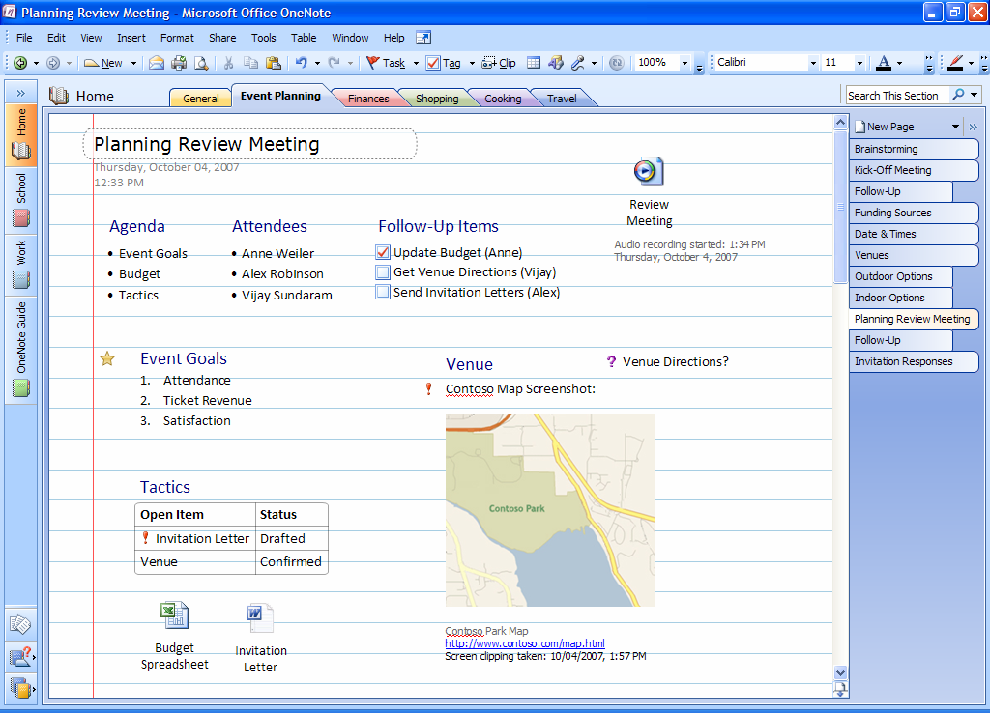

Figure 10: Office OneNote 2007 with expanded Navigation pane

## Improved Ways to Find Many Types of Information

With Office OneNote 2007, you can quickly find nearly any type of information you are looking for, which saves you time and helps you be more productive. The powerful Instant Search feature of Office OneNote 2007 enables you to find information you are looking for quickly. With it you can even search digitally handwritten notes, the text in images and scanned documents, and spoken words in audio recordings.

## Improved Tools for Getting More Organized

Office OneNote 2007 enables you to rearrange, separate, or combine content anywhere on the page. You can create as many folders, sections, and pages as you want, and then customize and organize them according to your needs.

Other exciting organizational features within Office OneNote 2007 include the following:

* **Track** important action and to-do items with more customizable note tags.
* **Timestamp** notes on the page so you know when they were taken and so you can track your information more easily.
* **Reuse** your notes in other Microsoft Office system programs.
* **Create** individual notebook sections for each project you work on.

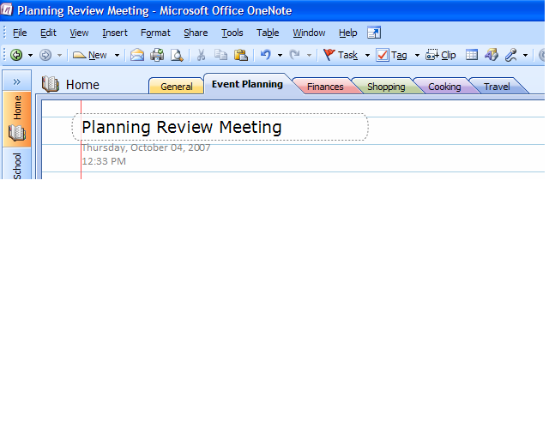

**Figure 11: Timestamp in Office OneNote 2007**

Office Home and Student 2007 in Action

David is interested in genealogy. He hopes to pass on his family’s history to his children. He uses Office OneNote 2007 to gather and organize all his research in a single location. This research includes audio and video recordings, scanned documents, even information downloaded from the Internet. For example, he digitally recorded interviews with relatives and dragged census records from genealogy Web sites into his Office OneNote 2007 notebook. He also sends his notes as e-mail messages (when connected to the Internet) directly from Office OneNote 2007 to relatives around the country.

# Summary

Office Home and Student 2007 is a new and exciting office software suite that provides you with all the essential tools you need to quickly and easily create great-looking documents, spreadsheets, and presentations at home. Focusing its efforts more on results than on features, Microsoft has developed a suite that makes it easier and more enjoyable for you to get things done. You get the tools you need to quickly deliver the quality outcome you want. You can also coordinate your time and tasks in a simpler, more efficient manner. The end result is that your computer tasks are a lot easier and more fun.

# Resources

For more information about Office Home and Student 2007, please visit <http://www.microsoft.com/office/suites/homeandstudent>.

# System Requirements

For complete system requirements, visit <http://www.microsoft.com/office/suites/homeandstudent>.

This document is developed prior to the product’s release to manufacturing, and as such, we cannot guarantee that all details included herein will be exactly as what is found in the shipping product. The information contained in this document represents the current view of Microsoft Corporation on the issues discussed as of the date of publication. Because Microsoft must respond to changing market conditions, this document should not be interpreted to be a commitment on the part of Microsoft, and Microsoft cannot guarantee the accuracy of any information presented after the date of publication. The information represents the product at the time this document was printed and should be used for planning purposes only. Information is subject to change at any time without prior notice.

This document is for informational purposes only. MICROSOFT MAKES NO WARRANTIES, EXPRESS OR IMPLIED, IN THIS DOCUMENT.

© 2006 Microsoft Corporation. All rights reserved. Microsoft, Excel, Fluent, the Office logo, OneNote, Outlook, PowerPoint, and SmartArt are either registered trademarks or trademarks of Microsoft Corporation in the United States and/or other countries. All other trademarks are property of their respective owners. The example companies, organizations, products, domain names, e-mail addresses, logos, people, places, and events depicted herein are fictitious. No association with any real company, organization, product, domain name, e-mail address, logo, person, places, or events is intended or should be inferred.

1. The Save as PDF or XPS functionality is available as a free download from Office Online.
2. * You can save as a PDF or XPS file from a 2007 Microsoft Office system program only after you install an add-in. For more information, see [Install and use a PDF or XPS add-in](http://r.office.microsoft.com/r/rlidOOPDFXPSAddin?clid=1033).