

Upgrade Technical Resource Guide
SQL Server Technical Article

By Solid Quality Learning
Editors: Ron Talmage, Kathy Blomstrom, Carl Rabeler
Contributing Authors: Randy Dyess, Dave Fackler, Michael Hotek, Michael Otey, Carl Rabeler, Ron Talmage, and Joe Webb

Reviewers: Haydn Richardson, Jonathan Tom, Michael Raheem
Published: June 2006
Applies To: SQL Server 2005, SQL Server 2000, and SQL Server 7.0

Summary: SQL Server 2005 offers exciting new possibilities and opportunities for SQL Server administrators, developers, and IT decision makers. But to make use of the new features found in SQL Server 2005, companies must first upgrade their existing database environments.
This document contains guidance for SQL Server administrators, developers, and IT decision makers who want to move their SQL Server 2000 or 7.0 databases to SQL Server 2005. The primary purposes of this document are threefold:
- Increase confidence and reduce uncertainty about upgrading previous versions of SQL Server to SQL Server 2005.
- Lower upgrade risks by providing prescriptive, best-practices technical guidance about how to upgrade specific SQL Server features across all editions.
- Provide Microsoft partners and field representatives with appropriate SQL Server 2005 upgrade resources to serve customers.
Section 1.0, “Upgrade Planning and Deployment,” provides a comprehensive overview of the key planning and deployment considerations for upgrading to SQL Server 2005. Sections 2.01-2.05 cover special upgrade considerations for high availability and very large databases (VLDB). Sections 3.01-3.08 cover upgrading relational databases to SQL Server 2005, including specific discussions on security, Transact-SQL queries, full-text catalogs, maintenance plans and SQL Server Agent jobs, Notification Services, Management Tools, and MSDE. Sections 4.01-4.03 then cover moving to the SQL Server 2005 business intelligence components: Reporting Services, Integration Services, and Analysis Services.
See the appendices for detailed feature and edition comparisons and highlighted upgrade tips and tricks.

Copyright

The information contained in this document represents the current view of Microsoft Corporation on the issues discussed as of the date of publication. Because Microsoft must respond to changing market conditions, it should not be interpreted to be a commitment on the part of Microsoft, and Microsoft cannot guarantee the accuracy of any information presented after the date of publication.

This White Paper is for informational purposes only. MICROSOFT MAKES NO WARRANTIES, EXPRESS, IMPLIED OR STATUTORY, AS TO THE INFORMATION IN THIS DOCUMENT.

Complying with all applicable copyright laws is the responsibility of the user. Without limiting the rights under copyright, no part of this document may be reproduced, stored in, or introduced into a retrieval system or transmitted in any form or by any means (electronic, mechanical, photocopying, recording, or otherwise), or for any purpose, without the express written permission of Microsoft Corporation.

Microsoft may have patents, patent applications, trademarks, copyrights, or other intellectual property rights covering subject matter in this document. Except as expressly provided in any written license agreement from Microsoft, the furnishing of this document does not give you any license to these patents, trademarks, copyrights, or other intellectual property.

Unless otherwise noted, the example companies, organizations, products, domain names, e-mail addresses, logos, people, places and events depicted herein are fictitious, and no association with any real company, organization, product, domain name, e-mail address, logo, person, place or event is intended or should be inferred.

© 2006 Microsoft Corporation. All rights reserved.

Microsoft, Internet Explorer, Internet Information Services, SQL Server, and Visual Studio are either registered trademarks or trademarks of Microsoft Corporation in the United States and/or other countries.

The names of actual companies and products mentioned herein may be the trademarks of their respective owners.

Table of Contents
Section 1.0: Upgrade Planning and Deployment 13
Introduction 13
Reasons for Upgrading to SQL Server 2005 13
Upgrade Methods 13
Upgrade Paths 17
Versions 17
Components 17
Upgrading to 64-bit Systems 18
Upgrade Paths by Edition 19
Upgrade Paths for SQL Server 7.0 Editions 19
Upgrade Paths for SQL Server 2000 32-bit and x64 Editions 20
Upgrade Paths for SQL Server 2000 Itanium IA-64 Editions 20
Upgrade Paths for SQL Server 2005 Editions 21
Languages 22
Choosing an Upgrade Method 22
The In-Place Upgrade Method 22
The Side-by-Side Upgrade Method 25
Considerations for Choosing an Upgrade Method 27
Upgrade and Migration Tools 28
Backward-Compatibility Issues 28
Using SQL Server 2005 Upgrade Advisor 29
Upgrade Advisor Overview 30
Updating Upgrade Advisor 31
Using the Analysis Wizard 32
Using the Command-Line Version of Upgrade Advisor 40
Guidelines for Developing an Upgrade Plan 41
Minimizing Upgrade Variables 42
Viewing the Upgrade as an IT Project 45
Additional Environment Requirements 46
Application Connection Requirements 46
Review and Resolve Issues 47
Select the Appropriate Upgrade Method 47
Formulate an Upgrade Plan 48
Practice and Test the Upgrade Plan 49
Testing an In-Place Upgrade 49
Testing a Side-by-Side Upgrade 50
Deploy the Upgrade Plan 52
Perform Post-Deployment Tasks 53
Troubleshooting an Upgrade 53
In-Place Upgrade 53
Side-by-Side Upgrade 53
Section 2.01: Minimizing Upgrade Downtime 54
Introduction 54
Minimizing Downtime During an Upgrade 54
High Availability Technologies and the Upgrade Process 54
Choosing an Upgrade Method to Minimize Downtime 55
In-Place Upgrade 55
Side-by-Side Upgrade 56
Upgrade Methods and Minimal Downtime 58
Section 2.02: Upgrading Databases on Failover Clusters 60
Introduction 60
Upgrade/Migration Options 60
In-Place Upgrade 60
Side-by-Side Upgrade 61
Migration from a Standalone Instance 61
Additional References 61
Potential Upgrade Issues 62
Issues Preventing Upgrade 62
Objects and Settings Not Upgraded 62
Behavioral Changes 62
Additional References 62
Pre-Planning for the Upgrade 63
Establish Security 63
Install .NET Framework 2.0 64
Planning for a Rollback 64
Immediate Rollback 64
Delayed Rollback 65
Highly Available Rollback 65
Post-Upgrade Tasks 66
Cluster Node Reboot 66
Additional Tasks 66
Section 2.03: Upgrading Log Shipping 67
Introduction 67
Choosing Among Upgrade Options 67
Highly Available Upgrade (with Failover) 67
Partially Available Upgrade (without Failover) 68
Offline Upgrade (Redeploy) 69
Determining and Evaluating Potential Upgrade Issues 69
Issues Preventing Upgrade 69
Discontinued Functionality 69
Behavioral Changes That May Require Corrective Action after the Upgrade 69
Log Shipping Monitor 69
Post-Upgrade Tasks 69
Removing SQL Server 2000 Log Shipping Tables and Jobs 69
Review Upgraded Databases 70
Resolve Upgrade Issues 70
Section 2.04: Upgrading Replicated Databases 71
Introduction 71
Replication Architecture Impact 71
Choosing Among Upgrade Options 72
In-Place Upgrade 72
Side-by-Side Upgrade 72
Offline Upgrade 72
Upgrading Replication Scripts 72
Determining and Evaluating Potential Upgrade Issues 73
Edition- and Version-Related Issues 73
Discontinued Functionality 74
Deprecated Features 75
Behavior Changes 77
Planning for a Rollback 79
Immediate Rollback 79
Delayed Rollback 80
Upgrading a SQL Server 2000 Replication Environment 81
Preliminary Steps 81
Steps Common to All Upgrade Paths 81
Remote Distributor Upgrade 82
Side-by-Side Upgrade of the Replication Architecture 82
In-Place Upgrade of the Replication Architecture 84
Post-Upgrade Tasks 85
Merge Replication Post-Upgrade Actions 85
Review Upgraded Databases 85
Resolve Upgrade Issues 85
Section 2.05: Upgrading Very Large Databases 86
Introduction 86
Upgrade Challenges for VLDBs 86
In-Place Upgrade and VLDB 87
Side-by-Side Upgrade and VLDB 88
Section 3.01: Upgrading Relational Databases to SQL Server 2005 92
Introduction 92
Relational Database Configurations 92
Upgrade Considerations 92
In-Place Upgrade vs. Side-by-Side Upgrade 93
In-Place Version Upgrade 93
Side-by-Side Upgrade 94
Determining and Evaluating Potential Upgrade Issues 98
Issues Preventing an Upgrade 98
Discontinued Database Engine Functionality 99
Behavioral Changes That May Require Corrective Action 100
Preparing for an Upgrade 100
Preparing for an In-Place Version Upgrade 101
Preparing for a Side-by-Side Upgrade 103
Performing an In-Place Upgrade 105
Performing a Side-By-Side Upgrade 105
Post-Upgrade Tasks 107
Connecting Client Applications to SQL Server 2005 107
Section 3.02: Upgrading Database Security 109
Introduction 109
New Security Features and Upgrading 109
SQL Server 2005 Security Features 109
The Surface Area Configuration Tool 110
Metadata Visibility 112
Security Issues Preventing an Upgrade 114
Discontinued Security Features 114
Behavioral Changes That May Require Corrective Action 115
Metadata Visibility Issues 116
Reversing Metadata Visibility Limitations 118
Reversing Application Role Restrictions 118
Deprecated Security Features 118
Pre-Upgrade Security Tasks 119
Post-Upgrade Security Tasks 121
Post-Upgrade Security Testing 121
Section 3.03: Upgrading Transact-SQL Queries 123
Introduction 123
Upgrade Options 123
Possible Upgrade Issues 124
AUTO_UPDATE_STATISTICS 124
Reserved Keywords 124
Issues That Might Prevent an Upgrade 125
@@VERSION 125
CREATE STATISTICS Statement 125
UPDATETEXT 125
System Object Name Collation Matching 125
Query Hints 126
Extended Stored Procedures 126
Trace Flags 126
Triggers 126
Indexed Views 127
Backup and Restore Scripts 127
Configuration Options 127
DBCC COMMANDS 129
Database-Creation Syntax 129
Login Creation 130
Join Syntax 130
System Object Removal 130
sysperfinfo System Table 130
sp_helptrigger System Stored Procedure 130
Query Governor Cost Limit 133
Objects and Settings Not Upgraded 133
syslocks Virtual Table 133
Behavioral Changes That Might Affect Your Upgraded System 133
INFORMATION_SCHEMA Views 133
System Tables 134
System Stored Procedures 135
Security 137
Functions 138
Additional References 139
Section 3.04: Upgrading Full-Text Catalogs 140
Introduction 140
In-Place Upgrade vs. Side-by-Side Upgrade 140
Determining and Evaluating Potential Upgrade Issues 140
Issues Preventing Upgrade 141
Discontinued Full-Text Search Functionality 141
Behavioral Changes That May Require Corrective Action 142
Preparing for the Upgrade and a Possible Rollback 143
Side-by-Side Upgrade with Third-Party Filters 144
Upgrade the Database 144
In-Place Upgrade of Relational Database 144
Side-by-Side Upgrade of Relational Database 144
Post-Upgrade Tasks 145
In-Place Upgrade of Full-Text Search Databases with Third-Party Filters 146
Using Customized Noise Word Files from a Previous SQL Server Version 146
Section 3.05: Upgrading SQL Server Maintenance Plans and SQL Server Agent Jobs 148
Upgrading SQL Server Maintenance Plans 148
Introduction 148
Understanding Maintenance Plan Upgrade Issues 148
Upgraded Maintenance Plan Functionality 149
Upgrading SQL Server Agent Jobs 149
Introduction 149
Understanding SQL Server Agent Upgrade Issues 150
Understanding Additional SQL Server Agent Upgrade Issues 152
Additional Resources 152
Section 3.06: Upgrading to SQL Server 2005 Notification Services 154
Introduction 154
Upgrade Considerations 154
Database Versioning 154
.NET Framework Versioning 155
Obsolescence of the Notify() Function 155
Deprecated Classes in the Notification Services API 157
Upgrade Options 157
In-Place Upgrade 157
Side-by-Side Upgrade 157
Creating New Instances 157
Preparing for the Upgrade 158
Uninstall Notification Services Sample Instances 158
Contingency Planning 158
In-Place Upgrade of Notification Services Instances 158
Stop the Notification Services Instances 158
Install SQL Server 2005 Notification Services 159
Recompile Custom Components 160
Update the Notification Services Metadata 161
Update the Notification Services Instance 162
Start the Notification Services Instance 165
Review an Upgraded Notification Services Instance 166
Resolve Upgrade Issues 168
Side-by-Side Upgrade 169
Stop the Notification Services Instances 169
Migrate the Databases 169
Completing the Upgrade 172
Creating New Instances 173
Section 3.07: Upgrading Management Tools 174
Introduction 174
Upgrading to New Tools 174
SQL Server Management Studio 174
SQL Server Configuration Manager 174
Business Intelligence Development Studio 175
Possible Upgrade Issues 175
Database Diagrams 175
Reporting Services Tools 175
SSIS Tools 176
Index Tuning Wizard 177
osql Utility 177
bcp 177
isql Utility 178
Rebuild.exe 178
Setup.exe 178
SQL Mail 178
Behavioral Changes That May Require Corrective Action 178
Registered Servers 179
Maintenance Plans 179
Keyboard Shortcuts 179
SQL-DMO 180
osql Utility 181
Discontinued Tools 181
English Query 181
Meta Data Services 181
Additional References 181
Section 3.08: Upgrading MSDE to SQL Server 2005 Express 183
Understanding MSDE Upgrade Issues 183
Number of MSDE Instances 183
MSDE Install Method 184
MSDE Language 184
Upgrading MSDE to the Different Editions of SQL Server 2005 184
Upgrading to Workgroup Edition Instead of SQL Server Express 185
Upgrading to Standard Edition Instead of SQL Server Express 186
System Requirements for SQL Server 2005 Express 186
Hardware 187
Software 187
Performing an In-Place Upgrade 187
Upgrade Steps 187
Verify the SQL Server 2005 Express Installation 190
Performing a Side-by-Side Upgrade 191
Side-by-Side Upgrade Steps 191
Performing Scripted Upgrades 193
Additional Features in SQL Server 2005 Express 194
Additional References 194
Section 4.01: Upgrading to SQL Server 2005 Reporting Services 196
Introduction 196
Reporting Services Configurations 196
Reporting Services Editions 198
Upgrade Considerations 198
In-Place Upgrade vs. Side-by-Side Upgrade 199
Determining and Evaluating Potential Upgrade Issues 200
Issues Preventing an In-Place Upgrade 201
Discontinued Reporting Services Functionality 202
Behavioral Changes That May Require Corrective Action 203
Report Projects and Definitions Must Be Updated for Use within BIDS 203
Preparing for an Upgrade 204
In-Place Upgrade of Reporting Services 206
Upgrading via the Setup Application 206
Troubleshooting a Failed Upgrade 213
Side-by-Side Upgrade of Reporting Services Installations 214
Installing the New Instance 214
Configuring the New Instance 217
Uninstalling Reporting Services 2000 226
Deploying Custom Extensions and Assemblies 227
Verifying Configuration Files 227
Post-Upgrade Tasks 227
Moving Reports Between SQL Server 2000 and SQL Server 2005 Installations 229
Section 4.02: Migrating DTS to SQL Server Integration Services 231
Introduction 231
Upgrade/Migration Considerations 231
Installing SQL Server Integration Services 232
Continued Use of DTS with SSIS 234
Understanding the Package Migration Wizard 235
Migrating DTS Packages 238
Running the Package Migration Wizard 240
Example 1: Simple Data Transformation 248
Example 2: Complex Data Transformation 261
Example 3: Dynamic Properties Task 268
Section 4.03: Upgrading to SQL Server 2005 Analysis Services 280
Introduction 280
In-Place Upgrade vs. Side-by-Side Upgrade 280
32-bit vs. 64-bit 281
Determining and Evaluating Potential Upgrade Issues 281
Issues Preventing an Upgrade 282
Discontinued Analysis Services Functionality 282
Behavioral Changes That May Require Corrective Action 284
Preparing for an Upgrade 288
In-Place Upgrade of Analysis Services 288
Troubleshooting a Failed Upgrade 297
Post-Upgrade Tasks 298
Resolve Upgrade Issues 310
Side-by-Side Upgrade to Analysis Services 2005 310
Preparing for a Side-by-Side Upgrade 311
Installing the New Instance 311
Migrating Databases to the New Instance 314
Post-Migration Tasks 320
Removing Analysis Services 2000 321
Redesigning Databases for Analysis Services 2005 321
Data Source Views 322
Dimensions 323
Cubes 325
Connecting Client Applications to Analysis Services 2005 331
Section 5.0: Conclusion—Preparing for a Smooth Upgrade 332
Appendix 1: Upgrade Tips and Tricks 334
Section 1.0: Upgrade Planning and Deployment 334
Section 2.01: Minimizing Upgrade Downtime 335
Section 2.02: Upgrading Databases on Failover Clusters 336
Section 2.03: Upgrading Log Shipping 337
Section 2.04: Upgrading Replicated Databases 337
Section 2.05: Upgrading Very Large Databases 338
Section 3.01: Upgrading Relational Databases to SQL Server 2005 339
Section 3.02: Upgrading Database Security 340
Section 3.03: Upgrading Transact-SQL Queries 341
Section 3.04: Upgrading Full-Text Catalogs 342
Section 3.05: Upgrading SQL Server Maintenance Plans and SQL Server Agent Jobs 343
Section 3.06: Upgrading to SQL Server 2005 Notification Services 343
Section 3.07: Upgrading Management Tools 345
Section 3.08: Upgrading MSDE to SQL Server 2005 Express 345
Section 4.01: Upgrading to SQL Server 2005 Reporting Services 346
Section 4.02: Migrating DTS to SQL Server Integration Services 348
Section 4.03: Upgrading to SQL Server 2005 Analysis Services 349
Appendix 2: SQL Server Feature and Edition Comparison 352
Appendix 3: SQL Server 2005 Feature Upgrade Matrix 353
Appendix 4: SQL Server Upgrade Paths by Edition 361

Section 1.0: Upgrade Planning and Deployment

Introduction
The purpose of this chapter is to lay out general guidelines for planning a SQL Server 2005 upgrade. You will learn about upgrade methods and tools such as the Upgrade Advisor, as well as considerations for testing and rollback as part of the planning process. The sections following this will give you much more technical detail about upgrading or migrating specific SQL Server components and scenarios.
A successful transition to SQL Server 2005 should be smooth and trouble-free. To achieve that smooth transition, you must devote sufficient planning for the upgrade that will match the complexity of your database application, or else your risk of errors and problems with the upgrade will rise accordingly.
The upgrade process is like all IT projects. If you plan and test with the appropriate detail, you will become justifiably confident that you will succeed. But if you ignore the planning process, you raise the risk of running into difficulties that can make the process costly and stressful.

Reasons for Upgrading to SQL Server 2005
SQL Server 2005 contains improvements and additional features in every area of the product. Often one or a few of these features taken alone can make compelling reasons for upgrading, depending on the needs of current systems for high availability, performance, and added functionality.
Among the principal reasons for upgrading to SQL Server 2005 are:
- Significantly lowering IT costs through increased scalability
- Delivering high availability options including faster failover with database mirroring
- Reducing data management complexity and manageability
- Maintaining stronger, more flexible security
- Greater manageability for larger databases
- Accelerating the development and deployment of line-of-business applications
- Delivering advanced business intelligence solutions that result in a faster return on investment
For more information about the business case for upgrading to SQL Server 2005, see the document "Why Upgrade to SQL Server 2005" on the Microsoft Web site at http://www.microsoft.com/sql/techinfo/whitepapers/why-upgrade.mspx.

Upgrade Methods
There are two fundamental methods in the SQL Server 2005 upgrade process: an in-place upgrade and a side-by-side upgrade. These two methods provide the background for the various paths available to you for upgrading.
The general term “upgrade”' refers to any type of transition from an earlier version of SQL Server to SQL Server 2005. However, there are two fundamental strategies you can use for upgrading:
- An in-place upgrade
- A side-by-side upgrade
SQL Server 2005 gives you the ability to automatically and directly upgrade an instance of SQL Server 2000 or 7.0 to SQL Server 2005. This automatic process, in which you replace an earlier version of a SQL Server instance with a SQL Server 2005 instance, is called an in-place upgrade. The reason it is called in-place is because a target instance of SQL Server 2000 or 7.0 is actually replaced with a SQL Server 2005 instance. You do not have to worry about copying data from the older instance to SQL Server 2005 because the old data files are automatically converted to the new format.
There are cases where you will not want to replace the older SQL Server instance. Instead, you might want to transition from SQL Server 2000 or 7.0 on one server to SQL Server 2005 on the same server or another server. In this case, the new SQL Server 2005 instance runs alongside, potentially in parallel, with the legacy SQL Server instance. This is called a side-by-side upgrade. You will have to manually migrate the data files and other supporting objects from the older version to the SQL Server 2005 instance to upgrade the database. You might have to recreate some objects in the process. Table 1 summarizes the distinction between the two upgrade strategies.
Table 1 - Summary Characteristics of an In-Place Upgrade and a Side-by-Side Upgrade
Process | In-Place Upgrade | Side-by-Side Upgrade
Number of resulting instances | One only | Two
Number of servers involved | One | One or more
Data file transfer | Automatic | Manual
Server instance configuration | Automatic | Manual
Supporting utility | SQL Server Setup | Various migration and data-transfer methods
The important point to note is that the distinction between an in-place upgrade and a side-by-side upgrade hinges on the resulting instances. An in-place upgrade replaces the old instance, so that only one working instance remains.
Another way to look at the distinction between an in-place upgrade and a side-by-side upgrade is by focusing on how much of the legacy instance you want to upgrade. If you want to upgrade an entire SQL Server 2000 or 7.0 instance or one of the SQL Server components, you can use the SQL Server 2005 Setup program and do an upgrade in-place, just replacing the old instance with a new one. But if you just want to upgrade a single database or any other sub-component, you must manually upgrade databases by migrating them to a separate SQL Server 2005 instance, leaving the original legacy SQL Server instance intact.
Table 2 shows how you can use the resulting number of instances combined with the component level of upgrade to determine what type of upgrade strategy is available.

Table 2 - Classify the Type of Upgrade Strategy to Use
Component Level | Single Resulting SQL Server 2005 Instance | Two Resulting Instances
All components | In-place | Side-by-side
Single component | In-place | Side-by-side
Single database | Not available | Side-by-side
If you want to upgrade an entire SQL Server 2000 or 7.0 instance or one of its components, you can use Setup to perform an upgrade in-place, replacing the old instance with the new SQL Server 2005 instance.
Note: If you want to upgrade just one database from a legacy SQL Server and leave the other databases alone and available, you will need to use a side-by-side upgrade method. The reason is that after the upgrade, you want to have two SQL Server instances, the legacy instance and the new SQL Server 2005 instance, either on the same server or on different servers.
Figure 1 illustrates the before and after states of an in-place upgrade.
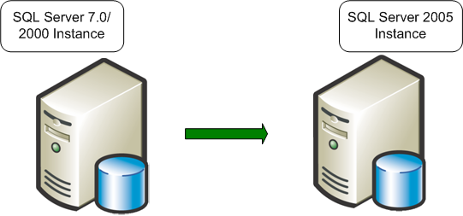
Figure 1 – An in-place upgrade replaces a legacy SQL Server 2000 or 7.0 instance.
The in-place upgrade works by using SQL Server Setup on an entire set or subset of SQL Server components. However, the in-place upgrade is only as granular as an entire component, such as the database engine or Analysis Services. If you want to upgrade only a single database, you cannot use an in-place upgrade.
If you want the legacy instance to continue in existence, you can decide whether the new SQL Server 2005 instance will reside on the same database server or on a new server. If you want your SQL Server 2005 instance to reside on a new server, you must use a side-by-side upgrade, because you must manually transfer data files, database objects, as well as configuration and security settings from the legacy server to the new server. The diagram in Figure 2 shows the before and after states of a side-by-side upgrade onto two servers.
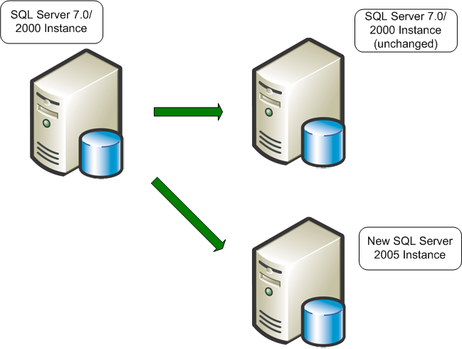
Figure 2 – A side-by-side upgrade to a second server leaves the legacy SQL Server 2000 or 7.0 unchanged.
If you use a new server for SQL Server 2005, you can run both the legacy server and the new server side by side for testing and comparison purposes.
You can, however, install your new SQL Server 2005 instance on the same server as the legacy SQL Server instance. In that case, you might run them side by side or you might not. A classic example of this scenario is upgrading a 32-bit version of SQL Server 2000 running on an x64 server under the WOW64 environment. You cannot perform an in-place upgrade, so you must install the 64-bit version of SQL Server 2005 separately and manually migrate database files, objects, and settings to perform the upgrade. Figure 3 shows an upgrade on the same server:
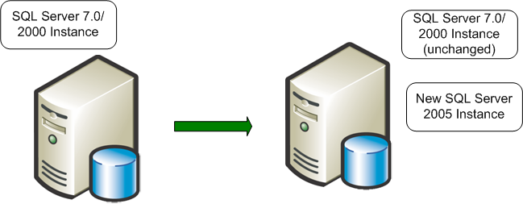
Figure 3 – You can also perform a side-by-side upgrade on the same server and leave both instances running, or remove the legacy instance.
When you upgrade to SQL Server 2005 on a single server, you might want to run the two instances side by side, in which case you would have a single-server side-by-side upgrade. More often, however, you will want to remove the older instance at some point.

Upgrade Paths
We've mentioned that certain versions and components of SQL Server can be upgraded to SQL Server 2005. Now let's be more specific about what versions, components, and upgrade paths are available.

Versions
For an in-place upgrade, SQL Server 2005's Setup program will require that you have certain versions of either SQL Server 2000 or 7.0. Specifically, you can use the in-place method provided by SQL Server 2005 Setup to directly upgrade the following versions:
- SQL Server 7.0 Service Pack 4 (SP4) or later
- SQL Server 2000 SP3, SP4, or later
- SQL Server 2005 RTM or later
If you migrate the databases yourself by using a side-by-side upgrade method, you can upgrade earlier versions of SQL Server 2000 or SQL Server 7.0. (SQL Server 6.5 databases and instances cannot be directly upgraded and must be manually upgraded.)

Components
SQL Server is a complex product and has many components that are comparatively independent. The following table shows the components that can be upgraded or migrated and what paths are available. Table 3 shows the components of SQL Server 2005 and the available upgrade strategies.

Table 3 - SQL Server 2005 Components and Upgrade and Migration Strategies
SQL Server 2005 Component | In-Place Upgrade | Side-by-Side Upgrade
Database Engine | SQL Server Setup  (upgrades all databases and preserves server configurations when possible) | One or two servers (use backup/restore, detach/attach, or Copy Database Wizard)
Analysis Services | SQL Server Setup | Analysis Services Migration Wizard  (with recommended cube redesign)
SQL Server Integration Services (SSIS) | None | DTS Migration Wizard*  (with recommended package redesign)
Reporting Services | SQL Server Setup (for a default configuration only) | Manual migration of reports
Notification Services | None | Notification Services Migration
* Note: The DTS Migration Wizard will not migrate all DTS packages; some DTS packages may continue to require the DTSrun.exe file on the SQL Server 2005 instance.
The basic components of SQL Server 2005 are the relational database engine, Analysis Services, and the remaining supporting components.
Tip: You can also add components to an existing instance of SQL Server through the Add or Remove Programs applet in Control Panel.
Some components, such as SQL Server Integration Services (SSIS) and Notification Services, cannot be directly upgraded but must be migrated. Reporting Services cannot be directly upgraded unless the configuration uses certain default values. For Analysis Services, some types of objects are more easily upgraded than others, and some items (such as cubes) should be redesigned. For more information about each of these components and their restrictions, see Section 3 on upgrading the database engine and Section 4 on upgrading business intelligence components.

Upgrading to 64-bit Systems
You can upgrade or migrate to SQL Server 2005 on either a 32-bit or 64-bit system. On the x64 64-bit version of Windows, you can run SQL Server 2000 or 7.0 instances within a 32-bit WOW64 subsystem.
Note: You cannot perform "cross-bit" upgrades using the in-place upgrade method. There is no direct upgrade path from a 32-bit instance of SQL Server to a 64-bit version of SQL Server 2005, or vice versa. If you want to upgrade a 32-bit version of SQL Server to a 64-bit version of SQL Server 2005, or a 64-bit version of SQL Server to a 32-bit version of SQL Server 2005, you must use the side-by-side upgrade method.
To upgrade from SQL Server on a 32-bit system to SQL Server 2005 on a 64-bit system, install SQL Server 2005 separately on the 64-bit version of Windows and then migrate the database objects and settings of the legacy instance to the new instance.

Upgrade Paths by Edition
There might be restrictions on what paths you can take when upgrading. For a side-by-side upgrade, because you handle the data transfer yourself manually, there are no restrictions. However, when you use SQL Server 2005's Setup program for an in-place upgrade, the program will check that you follow certain rules.
Note: You must keep the different components of SQL Server 2005 at the same edition level when they are on the same instance. For example, if you are running SQL Server 2005 Enterprise Edition of the database engine on a particular instance, you must also install the Enterprise Edition of Analysis Services as part of that instance.

Upgrade Paths for SQL Server 7.0 Editions
Table 4 shows the paths you can take for directly upgrading (in-place) SQL Server 7.0.
Table 4 - Allowed Paths for an In-Place Upgrade of SQL Server 7.0 to SQL Server 2005.
From SQL Server 7.0 32-bit | In-Place Upgrade to SQL Server 2005 32-bit
From SQL Server 7.0 32-bit | Enterprise  Edition | Developer  Edition | Standard  Edition | Workgroup  Edition | SQL  Express
Enterprise Edition SP4 | Yes
Developer Edition SP4 | Yes | Yes
Standard Edition SP4 | Yes |  | Yes
Desktop Edition SP4 |  |  | Yes | Yes
Evaluation Edition SP4
Desktop Engine (MSDE) 7.0 SP4 |  |  |  |  | Yes
Note that you cannot directly upgrade to a lower edition. Also note that you cannot perform a direct in-place upgrade of SQL Server 7.0 Evaluation Edition to SQL Server 2005.

Upgrade Paths for SQL Server 2000 32-bit and x64 Editions
The available in-place upgrade paths for SQL Server 2000 are a bit more complex because SQL Server 2005 has more editions and also supports the WOW64 subsystem on the x64 platform. Table 5 shows a similar set of paths for the 32-bit editions of SQL Server 2000.
Table 5 - Allowed Paths for an In-Place Upgrade of SQL Server 2000 to SQL Server 2005
From SQL Server 2000 32-bit and WOW64 (on x64) | In-Place Upgrade to SQL Server 2005 32-bit
From SQL Server 2000 32-bit and WOW64 (on x64) | Enterprise  Edition | Developer  Edition | Standard  Edition | Workgroup  Edition | SQL  Express | Evaluation Edition
Enterprise Edition SP3 or later | Yes
Developer Edition SP3 or later | No
Standard Edition SP3 or later | Yes | Yes | Yes
Workgroup Edition | Yes | Yes | Yes | Yes
Personal Edition SP3 or later |  |  | Yes | Yes | Yes
Evaluation Edition SP3 or later |  |  |  |  |  | Yes
Desktop Engine (MSDE) 2000 |  |  |  | Yes | Yes

Upgrade Paths for SQL Server 2000 Itanium IA-64 Editions
SQL Server 2000 also supports two editions on the Itanium IA-64 platform. They also can be directly upgraded, as Table 6 shows.
Table 6 - Allowed Paths for an In-Place Upgrade of SQL Server 2000 Itanium IA-64 versions to SQL Server 2005
From SQL Server 2000 IA-64 | In-Place Upgrade to SQL Server 2005 64-bit (IA-64)
From SQL Server 2000 IA-64 | Enterprise Edition | Developer Edition
Enterprise Edition SP3 or later | Yes
Developer Edition SP3 or later | Yes | Yes
In this scenario, you are using SQL Server 2005 Setup to directly upgrade a 64-bit Itanium version of SQL Server 2000 to a 64-bit Itanium version of SQL Server 2005.

Upgrade Paths for SQL Server 2005 Editions
Finally, you can use the in-place upgrade features of SQL Server 2005 to upgrade the edition level of SQL Server 2005. While this does not change data file structures, you can use it to enable required features of a more advanced edition without requiring a reinstall of SQL Server. Table 7 shows the allowed paths for upgrading SQL Server 2005 editions.
Table 7 - Allowed Paths for an In-Place Upgrade of SQL Server 2005 to a Higher Edition of SQL Server 2005
From SQL Server 2005 | In-Place Upgrade to a Higher Edition of SQL Server 2005
From SQL Server 2005 | Enterprise  Edition | Developer  Edition | Standard  Edition | Workgroup  Edition | SQL  Express
Developer Edition | Yes |  | Yes | Yes  (32-bit only)
Standard Edition | Yes | Yes
Workgroup Edition (32-bit only) | Yes | Yes | Yes
Evaluation Edition | Yes | Yes | Yes | Yes  (32-bit only) | Yes  (32-bit only)
SQL Server Express (32-bit only) | Yes | Yes | Yes | Yes
Warning: You cannot perform an in-place upgrade between 32-bit and 64-bit versions of SQL Server. In Table 7, it is assumed that all upgrades are on the same level of CPU unless stated otherwise.
For example, you can directly perform an in-place upgrade of the SQL Server 2005 Developer Edition to Enterprise, Standard, or Workgroup Edition on a 32-bit system (including running under WOW64.)
On the other hand, you can perform an in-place upgrade of SQL Server 2005 Standard Edition to either the Enterprise or Developer Editions on all platforms. (Note that you cannot perform an in-place upgrade of SQL Server 2005 Enterprise Edition, because there is no edition more advanced than it.)
Note: When you perform an in-place upgrade of a SQL Server 2000 or 7.0 failover cluster, you must upgrade the virtual server. For more information about upgrading a failover cluster, see Section 2.02, “Upgrading Databases on Failover Clusters.”

Languages
The SQL Server in-place upgrade process supports all languages, but there are some restrictions on changing the localized language. Table 8 shows the valid SQL Server language paths when you perform an in-place upgrade.
Table 8 - Allowed Paths for SQL Server Language Support in an In-Place Upgrade
From SQL Server 2005, 2000, or 7.0
From SQL Server 2005, 2000, or 7.0 | English Language | Different Localized Language
English language | Yes | Yes
Localized language | No | No
As you can see from the table, you can change a language from English to any localized language during the upgrade process, but you must keep the same localized language if the SQL Server being upgraded has a localized language.
Note: The English language version of SQL Server is supported on all localized versions of Windows. Localized versions of SQL Server are supported only on localized versions of Windows with the same localization setting. For more information about localization issues, see the SQL Server 2005 Books Online topics “Version and Edition Upgrades” and “Additional cross-language support.”

Choosing an Upgrade Method

The In-Place Upgrade Method
With an in-place upgrade, you use the SQL Server 2005 Setup program to automatically replace an instance of SQL Server 2000 or 7.0 with an instance of SQL Server 2005. The in-place upgrade will convert the system metadata while preserving all user data. The resulting instance name will remain the same.
For the most part, an in-place upgrade is an automated process. You might have to make some changes to work around some backward compatibility issues, which you'll learn about in the next section.

The In-Place Upgrade Process
Because the in-place upgrade actually replaces the legacy instance with a new SQL Server 2005 instance, there must be a certain duration in which no instance is available.
The following list illustrates the major steps taken when you use the SQL Server 2005 Setup program to perform an in-place.
- The SQL Server 2005 Setup prerequisites are installed (Microsoft .NET Framework 2.0, SQL Server Native Client, and so on). The legacy instance databases continue to be available.
- Setup checks for upgrade blockers, a small set of issues that will completely block an upgrade. If any are found, Setup will warn and exit.
- Setup installs the required SQL Server 2005 executables and support files
- Setup stops the legacy SQL Server service. At this point, the legacy instance is no longer available.
- SQL Server 2005 updates the selected component data and objects.
- Setup removes the legacy executables and support files as well as the legacy tools. The new SQL Server 2005 instance is now fully available.
For specific components that can be directly upgraded, such as the database engine or Analysis Services, the details might differ, but the overall process is the same.

Advantages of an In-Place Upgrade
The advantages of an in-place upgrade include the following:
- An in-place upgrade is easer and faster, especially for small systems.
- It is mostly an automated process.
- The instance will be offline for only the minimum amount of time.
- The resulting upgraded instance has the same name as the original.
- Applications continue to connect to the same instance name.
- No additional hardware is required because only the one instance is involved.
An in-place upgrade will cause the least disturbance to existing applications because the database server and SQL Server instance name remain the same. Because it is mostly automated, it also takes the least deployment resources.

Disadvantages of an In-Place Upgrade
An in-place upgrade might not be appropriate for large and complex databases. Some relative disadvantages of an in-place upgrade include:
- You must upgrade an entire instance or a major SQL Server component.
- An in-place upgrade is not available for all SQL Server components.
- You cannot directly upgrade a single database.
- There might be some disk use growth during the metadata upgrade process.
- You must inspect the entire instance for backward compatibility issues.
- Upgrading in place is not recommended for all SQL Server components.
- You cannot run the newly upgraded version alongside the legacy version for comparison.
- Rollback of upgraded data and the upgraded instance is complex.
The fact that an in-place upgrade must upgrade an entire SQL Server component or instance means that you cannot use it for parts of a system such as a single database or a set of databases.

Rolling Back an In-Place Upgrade
Because the legacy SQL Server instance is replaced by a new SQL Server 2005 instance, rolling back an in-place upgrade can be complex. The new data file structures for SQL Server 2005 are not compatible with legacy SQL Server instances. Therefore, to roll back, you will have to uninstall SQL Server 2005, removing the data files and other components, and then install the legacy instance of SQL Server and rebuild the original server.
If you can make a backup or an image of the initial system, you might be able to shorten the time required to restore the original system on the server. You could copy the legacy data files from a backup location to the appropriate disk volume, apply the ghost image to retrieve executables, and then apply any scripts or components to complete the rebuild of the original system. See the section "Testing an In-Place Upgrade," below, for further discussion.
Once the new system is in production, however, it will start capturing new data. Typically, you would not want to attempt a rollback. After a certain point in time, enough new data might be captured so that a rollback would not be realistic. And if other problems are encountered, it might be better to make adjustments or “patches” to the new instance rather than to attempt a rollback.

In-Place Upgrade Scenarios
The following scenarios illustrate where an in-place upgrade method would be most appropriate.
1. Upgrading remote regional servers. A company has several database servers, each located at its divisional offices. The database structures and components are all identical, there are no blocking issues, and only minor changes are required in supporting components. The databases are mission-critical and must be down for a minimal amount of time. In this case, an in-place upgrade is appropriate. After thorough testing, the remote servers can be directly upgraded during a scheduled time that users are alerted to. Because the database servers are identical, testing provides confidence in the resulting success of the in-place upgrade method. From the central office, database administrators are able to use Windows Remote Desktop to monitor the upgrade process.
2. Upgrading a failover cluster. A company has a two-node failover cluster using SQL Server 2000 Enterprise Edition and wants to upgrade to SQL Server 2005. It wants to take advantage of new SQL Server 2005 Enterprise Edition features such as online restore. The company also wants minimal downtime. In this case, an in-place upgrade is appropriate. Database administrators install the .NET Framework 2.0 and SQL Server 2005 drivers ahead of time. The resulting upgrade process takes only the time necessary for SQL Server 2005 Setup to migrate the new data files. The database administrators test the process first on standalone servers to determine the time required for the data migration.
3. Upgrading Analysis Services. A company has an OLTP database server running SQL Server 2000 for a call center. The firm exports data nightly to a separate data warehouse server with SQL Server 2000 Analysis Services. The company wants to take immediate advantage of new features in SQL Server 2005 Analysis Services and wait until later to upgrade the OLTP server. In this case, an in-place upgrade of the data warehouse server is appropriate. After testing, the database administrators upgrade the data warehouse server to SQL Server 2005. They rebuild their Analysis Services cubes in order of importance and continue to run DTS packages using the redistributable DTSRUN tool that comes with SQL Server 2005. DTS packages will be gradually converted to SSIS packages. The in-place method did not require moving or copying the underlying data warehouse relational data because it was automatically migrated by SQL Server 2005's Setup program.

The Side-by-Side Upgrade Method
In some cases, to transition to SQL Server 2005, it will be more appropriate to migrate your databases from a legacy database server to a separate server or a separate instance. Whether you migrate to a separate instance on one server or to a new instance on another server, you must manually transfer data. The result is two instances, one legacy and one new, which can run side by side. This is mostly a manual process.

The Side-by-Side Upgrade Process
The following list illustrates the major steps you will need to take when you perform a side-by-side upgrade of SQL Server 2000 or 7.0 to SQL Server 2005.
- Install a separate instance of SQL Server 2005 on the legacy server or on a separate server. The legacy instance continues to be available.
- Run the SQL Server 2005 Upgrade Advisor against the legacy instance and remove any upgrade blocker issues.
- Stop all update activity to the legacy instance. This may involve disconnecting all users or forcing applications to read-only activity.
- Transfer data, packages, or other objects from the legacy instance to the SQL Server 2005 instance.
- Apply supporting objects such as SQL Server Agent jobs, security settings, configuration settings, and DTS packages to the new SQL Server 2005 instance.
- Verify that the new instance supports the required applications, using validation scripts and user-acceptance tests.
- If the new instance passes validations and acceptance tests, redirect applications and users to the new instance. At this point, the new instance is available and databases are online.
- If the new instance does not pass validation or acceptance tests, direct users and applications to the legacy database server.

Advantages of a Side-by-Side Upgrade
The advantages of a side-by-side upgrade include the following:
- You gain more granular control over what database objects you want to upgrade.
- You can run the legacy database server alongside the new server, perform a test migration, and research compatibility issues without disturbing the production system.
- The legacy database server remains available during the migration, although it cannot be updated for at least the time it takes to transfer data.
- You can roll back to the legacy system if the migration does not pass validation and acceptance tests.

Disadvantages of a Side-by-Side Upgrade
A side-by-side upgrade is clearly more difficult than an in-place upgrade. Among the disadvantages of a side-by-side migration are the following:
- A side-by-side upgrade might require new or additional hardware resources.
- If the side-by-side upgrade takes place on the same server, there might be insufficient resources to run both instances alongside each other.
- You must redirect applications and users to a new instance and possibly a new server. This may require some recoding in the application.
- You must manually transfer data, security, configuration settings, and other supporting objects to the new instance.
- The downtime might be longer in some cases because large amounts of data must be transferred from one server to another.

Rolling Back a Side-By-Side Upgrade
In a side-by-side upgrade, the new SQL Server 2005 instance resides alongside the legacy SQL Server instance, either on the same server or on a different server. As a result, the legacy instance is available for a rollback scenario.
However, once the new SQL Server 2005 instance is in production, you might capture data that you do not want to lose if you revert to the legacy instance. You might be able to use SSIS to transfer new data from the SQL Server 2005 instance to the legacy instance and bring it up-to-date. This could become a complex process, depending on the complexity of the data. See the section "Testing an In-Place Upgrade," below, for further discussion.
After a certain point in time, enough new data might be captured that a rollback is not realistic. If problems are encountered, it might be better to make adjustments or “patches” to the new instance than to attempt a rollback.

Side-By-Side Upgrade Scenarios
The following scenarios illustrate where a side-by-side upgrade method would be most appropriate.
1. Server consolidation. A company wants to upgrade several database servers to SQL Server 2005 and move all the databases to a newer more powerful server. In this case, a side-by-side method is appropriate. After installing SQL Server 2005 on the new server, you can move databases and applications incrementally to the new server and redirect applications over time.
2. Upgrading from 32-bit to 64-bit. A company has a 32-bit instance of SQL Server 2000 running on a 64-bit system under the WOW64 subsystem. It wants to upgrade to the 64-bit version of SQL Server 2005 on the same server. The applications can easily be redirected to connect to a named instance. In this case, a side-by-side method is appropriate because a direct in-place upgrade of a 32-bit instance to a 64-bit instance is not possible.
3. Upgrading from a two-node clustered instance of SQL Server 2000 Enterprise Edition to a two-node clustered instance of SQL Server 2005 Standard Edition. A company uses SQL Server 2000 Enterprise Edition because it needs more than 3GB of RAM and the failover capability of Windows failover clustering. You cannot "downgrade" an instance of SQL Server 2000 Enterprise Edition to SQL Server 2005 Standard Edition. If the company upgrades to a two-node cluster using 64-bit machines, SQL Server 2005 Standard Edition will support both the cluster, and under 64-bit Windows, will recognize more than 3GB RAM. However, the upgrade will not be able to take advantage of SQL Server 2005 Enterprise Edition features such as online restore.

Considerations for Choosing an Upgrade Method
The upgrade method that you can choose depends on numerous factors, including the components you want to upgrade and the editions you want to use.
- Components. A certain upgrade strategy might not be possible because the component does not support it. For example, there is no in-place upgrade for SSIS or Notification Services. Also, Microsoft recommends that most Analysis Services components should be migrated. Tools are supplied for these tasks (See Table 3 for more information about SQL Server components and available upgrade strategies.)
- Editions. The in-place upgrade strategy does not support all paths between editions. For example, if you want to upgrade a SQL Server 2000 Enterprise Edition instance to SQL Server 2005 Standard Edition, you must perform a migration, because Setup will not support this upgrade path. (See "Upgrade Paths by Edition," above, for detailed tables of the supported edition paths.)
You might also find that your choices are restricted by other requirements.
- Partial upgrading. If you want to transition only a few databases on a server to SQL Server 2005 and leave the rest on the legacy version, then you must perform a manual migration. SQL Server 2005 Setup will upgrade all databases and replace the instance.
- Upgrading over time. If you want to transition databases gradually, a few databases at a time, from a legacy instance to SQL Server 2005, you must use side-by-side migration and not in-place upgrading.
- Effect on applications. If you require minimal disturbance to the existing applications and users, you should choose an in-place upgrade.
- Availability. Both an in-place upgrade and a migration require that the databases be unavailable for a certain amount of time. The amount of downtime required depends primarily on the size of the data sets. At first, it might seem that an in-place upgrade would be faster than a migration because the data is not transferred from one server to another. However, an in-place upgrade also requires time for the installation of SQL Server 2005. In a migration, SQL Server 2005 is already installed on another instance. If the data transfer proceeds quickly and few changes are needed on the new instance, a migration may be faster than an in-place upgrade.
Some factors, alone, might be enough for you to decisively choose one strategy over another.
- Rollback. For many database systems in production, it is impossible to justify a change without a rollback strategy in case the results are not acceptable. The side-by-side migration strategy supports rollback at the time of acceptance testing because the legacy instance can still be made available. However, once users update the databases in the new instance, rollback may no longer be feasible.
No matter what strategy you choose, do not forget testing and validation. Even if you choose an in-place upgrade strategy, you should test the upgrade process and results on a separate server first. Testing, validation, and acceptance will be discussed more in "Guidelines for Developing an Upgrade or Migration Plan" later in this section.

Upgrade and Migration Tools
SQL Server 2005 provides numerous tools to assist you with upgrading or migrating.
- SQL Server 2005 Upgrade Advisor is the major analysis tool for all SQL Server components. You should run Upgrade Advisor on your legacy systems whether you choose an in-place upgrade or a migration. You will learn more about Upgrade Advisor in this section.
- SQL Server's Setup program is the in-place upgrade tool for the database engine, Reporting Services, and Analysis Services. For more information about upgrading Reporting Services and Analysis Services, see Sections 4.01, “Upgrading to SQL Server 2005 Reporting Services,” and 4.03, “Upgrading SQL Server Analysis Services.”
- The Analysis Services Migration Wizard can assist you with a migration of Analysis Services. You can use this tool in conjunction with side-by-side migrations. For detailed information about this wizard, see Section 4.03, “Upgrading to SQL Server 2005 Analysis Services.”
- When you install SSIS, the Package Migration Wizard is also installed. You can use this wizard to assist in migrating DTS packages to SSIS. For detailed information, see Section 4.02, “Migrating DTS to SQL Server Integration Services.”
- You cannot perform an in-place upgrade of Notification Services; you must use a migration technique. For detailed information, see Section 3.06, “Upgrading to SQL Server 2005 Notification Services.”
The most important tool for upgrade or migration planning is Upgrade Advisor.

Backward-Compatibility Issues
For the most part, SQL Server 2005 is backwardly compatible with SQL Server 2000 and 7.0. However, there are some feature changes, mostly related to enhanced security, that can affect your planning for upgrading or migrating to SQL Server 2005. The chances are good that you will encounter only a few issues at the most. However, databases with older Transact-SQL constructs as well as security vulnerabilities might require changes to fully function on SQL Server 2005. Let's take a closer look at those backward compatibility issues.

Blocking Issues
The most serious kind of issue related to backward compatibility that will affect your planning are those that will block an in-place upgrade and prevent an installation of SQL Server 2005. If the SQL Server 2005 Setup program detects these issues in the process of an in-place upgrade, it will abort the install, leaving the legacy instance unchanged. You will have to resolve the blocking issues to proceed.
At this writing, according to the Upgrade Advisor documentation, there are several known blocking issues documented for the database engine. For more information about blocking issues, see the sections on the relevant components in Sections 3 and 4.
If you transition to SQL Server 2005 by using migration and you do not fix blocking issues, the above conditions will either not be allowed or else you might not be able to access a database. So even if you choose migration, you still need to resolve these issues.

Feature Changes
Other kinds of changes that affect backward compatibility due to feature changes in SQL Server 2005 will not block an upgrade, but most should be addressed.
- Discontinued features. Each component of SQL Server 2005 might have some features that are discontinued. These are features that functioned in earlier versions of SQL Server but do not function in SQL Server 2005. Often these features are options that are still present but no longer operate. You should remove references to them, but they will not block an in-place upgrade. However, your application may not behave correctly, so they need attention.
- Deprecated features. Features that are deprecated in SQL Server 2005 still operate the same as in the legacy versions but will be removed in the next version of SQL Server. These features do not need to be removed, but they should eventually be addressed because they may cause problems for the next upgrade.
- Feature changes that may break an application. These are feature changes that could actually result in an application receiving a fatal error. For example, using a legacy network library such as Banyan Vines, that is no longer supported, will result in a connection failure.
- Benign behavior changes. These are behavior changes that may not visibly affect your database code or applications, but you need to be aware of them because you may need to interpret certain things differently. For example, the size of input parameters to some system stored procedures has been increased. In such cases, these feature changes will have no effect at all.
Note: Upgrade Advisor will detect most of the above issues. Most are also documented later in this guide, in the Upgrade Advisor documentation, or in SQL Server 2005 Books Online.

SQL Server Tool Changes
Also related to backward compatibility are changes to the SQL Server client and server tools. There are significant tools changes for all the major SQL Server components. For more information about changes to the client tools, see Section 3.07, "Upgrading Management Tools," and Section 4.01, “Upgrading to SQL Server 2005 Reporting Services,” 4.02, “Migrating DTS to SQL Server Integration Services,” and Section 4.03, “Upgrading to SQL Server 2005 Analysis Services” for the relevant BI components.

Using SQL Server 2005 Upgrade Advisor
The purpose of Upgrade Advisor is to make it easier for you to identify upgrade blocking issues or backward compatibility issues that might affect the success of your transition to SQL Server 2005. Upgrade Advisor is a tool that you can download at no cost from the Microsoft Download Center Web site. It requires the .NET Framework 2.0 to run.

Upgrade Advisor Overview
Upgrade Advisor smoothes the transition to SQL Server 2005 by anticipating issues in your legacy SQL Server 2000 and 7.0 instances. Upgrade Advisor analyzes your legacy instances and produces reports detailing upgrade issues by SQL Server component. The resulting reports show detected issues and also guidance on how to fix the issues or work around them. The reports are stored on disk, and you can review them by using Upgrade Advisor or export the report data for further analysis, for example to Excel.
In addition to analyzing data and database objects, Upgrade Advisor can analyze Transact-SQL scripts and SQL Server Profiler/SQL Trace traces
You can execute Upgrade Advisor from a local or remote server. Additionally, you can execute it from the command window by using a configuration filename as an input parameter.
You can only run Upgrade Advisor against SQL Server 2000 and 7.0 instances. You cannot run it against SQL Server 2005 instances.
Note: For SQL Server 7.0, Upgrade Advisor does not support OLAP Services. You should upgrade SQL Server 7.0 OLAP Services to SQL Server 2000 Analysis Services to analyze cubes via Upgrade Advisor.
Upgrade Advisor performs only read operations on the target instance and does not cause much overhead on the target SQL Server. However, report generation and analysis is CPU intensive, so you should always try to run it remotely when working with production database servers.
When you start Upgrade Advisor, all the choices available to you are contained in the Welcome screen, as shown in Figure 4.
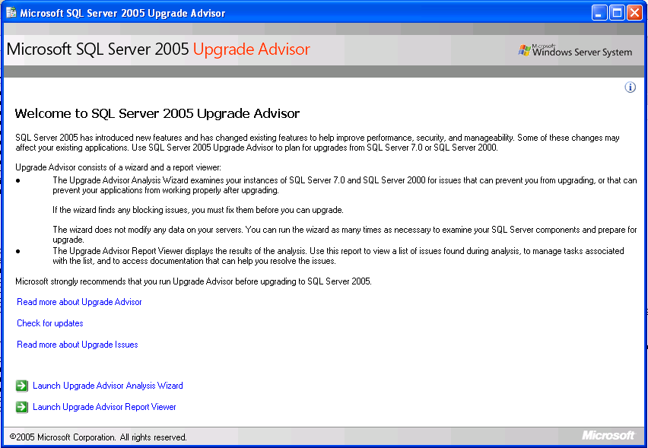
Figure 4 – The Welcome screen contains all your Upgrade Advisor choices.
There are essentially four types of activities you can perform by using Upgrade Advisor:
- Read the Upgrade Advisor documentation
- Update your copy of Upgrade Advisor
- Launch the Analysis Wizard
- Launch the Report Viewer
The options Read more about Upgrade Advisor and Read more about Upgrade Issues launch the Upgrade Advisor documentation system at different locations.

Updating Upgrade Advisor
You have an option to check for updates to Upgrade Advisor. As more becomes known about rarer upgrade issues and as best practices for upgrading become established, Microsoft will update the Upgrade Advisor's Help system as well as its analytical and reporting characteristics.
Tip: If you freshly download Upgrade Advisor, you are assured that you have the latest version. If you are working from an older version or a version you have copied from a CD or DVD, always make sure you have updated your Upgrade Advisor version on disk.
You can determine the version of Upgrade Advisor you are using by clicking the information button (see the 'i' icon in the upper right corner of the initial screen in Figure 4 above).
The last two options at the bottom of the Welcome screen are activities you can perform that will assist you in planning for an upgrade or migration.

Using the Analysis Wizard
When you launch the Upgrade Analysis Wizard and skip past the Welcome screen, you must pass through the screens that let you connect to a desired instance of SQL Server 2000 or 7.0. You can analyze a local or a remote instance and either a default or a named instance.
For example, the first screen you see is the SQL Server Components dialog box, which you can use for starting an analysis of the default instance of the machine you are on, as Figure 5 shows.
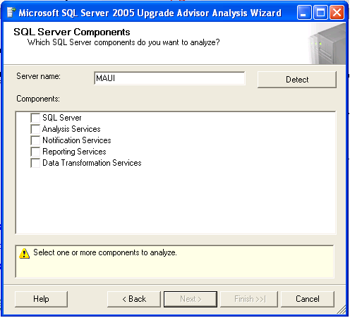
Figure 5 – The SQL Server Components screen can detect local components.
You can use the Detect button to detect which components are installed on the local machine, for the default instance. For example, Figure 6 shows the results of pressing the Detect button on a default instance that has three components installed in it.
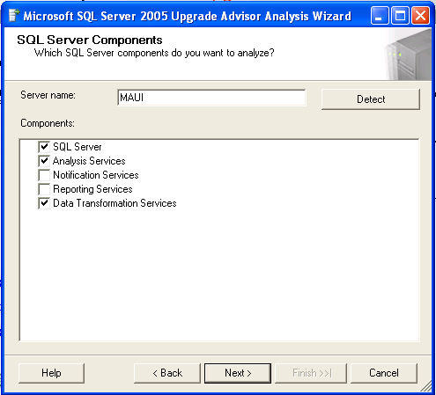
Figure 6 - If you click the Detect button, the local components will be detected and listed.
On the Components screen, you cannot choose a named instance. You only enter a database server name in the Server name text box. Therefore, if you are going to connect to a remote SQL Server instance or to a named instance locally, just put the correct server name in the Server name text box.
No matter what type of connection you want to make, check the components you want to analyze in this run of Upgrade Advisor. If you are connecting to a remote server, the Detect button will show you available components if you have registry access permissions to the server.
Once you have chosen a server name and have selected the components you want to analyze, you can click Next to reach the Connection Parameters dialog box. At this point, you can choose an instance in the Instance name text box and a form of authentication. You can use the period (.) or (local) to specify a local instance or use the instance name for a named instance of the server. Figure 7 shows the selection of a named instance of SQL Server 2000 called SQL2KA on a server called Lahaina.
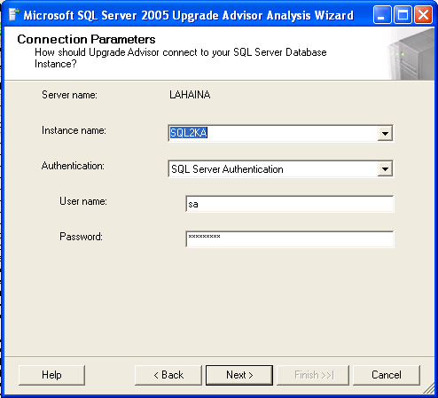
Figure 7 – Selecting a named instance to analyze.
Once you have chosen your instance, click Next, and if the connection is successful, you'll be taken to a set of dialog boxes for each of the components you chose. For example, Figure 8 shows the SQL Server parameters dialog box, based on the earlier choice of the SQL Server component and the existence of the component on the instance.
Note: When you run Upgrade Advisor, make sure your SQL Server login, whether using Windows or SQL Server authentication, has system administrator rights to the target SQL Server.
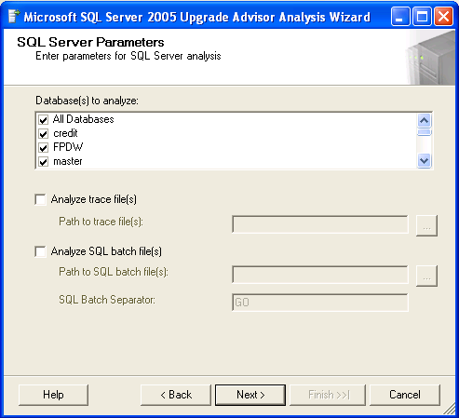
Figure 8 - You use the SQL Server Parameters dialog box for choosing the type of database analysis to do.
At this point, you can choose the databases you want to analyze. If you choose All Databases, the Upgrade Wizard will also analyze the SQL Server database engine configuration settings.
Tip: If you intend to perform an in-place upgrade of an instance, always choose All Databases to force inspection of server-wide configuration options.
Upgrade Advisor will analyze all non-encrypted database objects such as configuration and security settings, as well as all Transact-SQL objects such as triggers, functions, and stored procedures. However, it will not analyze encrypted Transact-SQL objects.
You can also direct Upgrade Advisor to analyze SQL Trace (and Profiler) trace files from SQL Server 2000 if they are saved on disk with the .trc extension. Upgrade Advisor will inspect the traces, so you can have actual code submitted either ad hoc by users and applications as well as dynamic SQL that was generated by stored procedures or functions.
Tip: When preparing a trace file for Upgrade Advisor, collect a representative set of queries and not a voluminous set of repeating queries. The SQLProfilerTSQL_Replay template is the preferred template to use when capturing trace information for Upgrade Advisor. Forcing Upgrade Advisor to analyze a set of repeating queries adds no value to the analysis.
Finally, you can direct Upgrade Advisor to analyze Transact-SQL script files that you have saved on disk. You can analyze a series of scripts just by adding them in the dialog box, and you can specify a custom batch separator if you need one.
You will then be taken to two other component-specific dialog boxes if you chose the components and they exist on the instance: the Notification Services Parameters and DTS Parameters dialog boxes. At each of these dialog boxes, Upgrade Advisor will present you with relevant choices. For more information about these choices, see the Section 3.06, “Upgrading to SQL Server 2005 Notification Services;” Section 4.01, “Upgrading to SQL Server 2005 Reporting Services;” Section 4.02, “Migrating DTS to SQL Server Integration Services;” and Section 4.03, “Upgrading to SQL Server 2005 Analysis Services.”
At the end of the Wizard steps, you'll have a chance to confirm your choices, as Figure 9 shows.
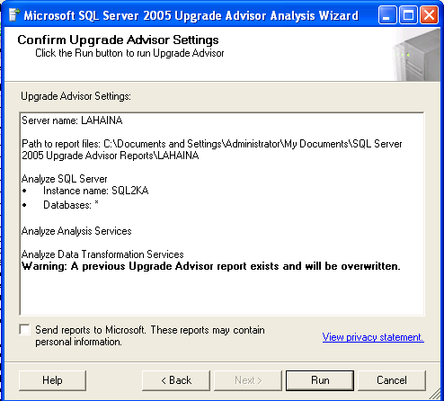
Figure 9 - You can review your choices in the Confirm Upgrade Advisor Settings dialog box.
Upgrade Advisor at this point is prepared to run and save reports. If you have previously run a report and saved it, Upgrade Advisor will warn you that it will overwrite the old report.
By default, Upgrade Advisor reports will be stored in your login's My Documents\SQL Server 2005 Upgrade Advisor folder, with a subfolder for each server. The report files are stored as XML documents, with names for each component, as well as a configuration file that can be used for the command-line version of the program. (See the section "Using the Command-Line Version of the Upgrade Advisor," below, for more information about using the configuration file.)
You can also send reports to Microsoft over a secure Watson pipe. The purpose is to give Microsoft further information about upgrade issues affecting customers. Notice that no actual database data will be sent, just Upgrade Advisor reports.
Upgrade Advisor's analysis can take some time, especially for complex databases, and it is very intensive on the client side. Therefore, when analyzing production databases, you should always run Upgrade Advisor remotely—for example, from your desktop.

Using the Report Viewer
Once you've run your analysis, you can view the resulting reports. You can launch the Upgrade Advisor Report Viewer from the final Analysis Wizard dialog box or by clicking the Launch Upgrade Advisor Report Viewer link on the main Upgrade Advisor Welcome screen.
When you launch the Report Viewer, you can view particular reports from the View Report screen, as Figure 10 shows.
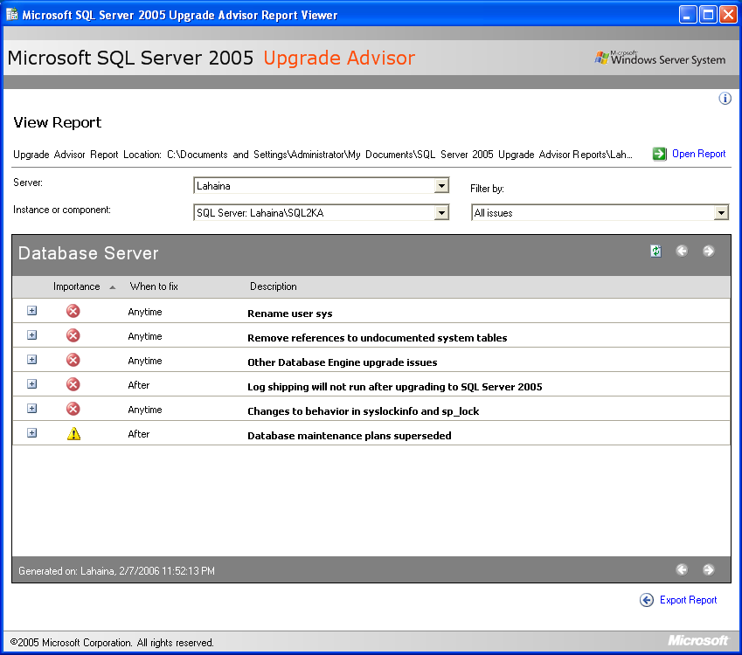
Figure 10 - You can use the Report Viewer to select reports and filter by issue.
You can choose a particular server, then component, to find a particular report. You can then filter your reports by issue type to narrow your focus.
In each report, the Importance column for each item will have a red X, indicating that the required action should be taken before the upgrade process, or a yellow triangle, indicating that you should take an additional action after the upgrade. An issue with a red X is one that will either stop the upgrade or cause some kind of failure.
The yellow triangle indicates actions you need to take to prevent errors that may not show up immediately or that will show up when you change the compatibility mode. For example, if you have Transact-SQL constructs that work in earlier compatibility modes but not in the 90 mode, you need to fix those before you change a database's compatibility mode to 90.
The "When to fix" column is a guide for when you should address issues. Anything marked "Before" requires immediate attention. For example, in Figure 10, there is a user named sys in one of the databases, and this user must be removed. (These "before" blocking issues are listed in the "Blocking Issues" section above.)
Issues with an "After" value in the "When to fix" column are things you can fix only after the upgrade or migration. Usually, they imply a feature issue related to SQL Server 2005. For example, the WITH keyword is required on query hints in the SQL Server 2005 database engine, and you must use it if the database will be put into compatibility mode 90.
Issues with an "Anytime" value can be fixed either before or after the upgrade or migration. However, they must still be fixed. For example, references to undocumented system tables that may have worked in SQL Server 2000 or 7.0 will not work at all in SQL Server 2005, and you can remedy that issue either on the source or the target system. The issue will not block the upgrade or migration.
Finally, issues with an "Advisory" value do not require any change on your part, but there is some change of behavior that you need to be aware of. Your application may return slightly different results or behave differently, and in those cases, you will need to adapt to the new features.
You can open a particular issue and get more information by clicking on the plus (+) sign. Figure 11 shows the resulting expansion for the sys user error.
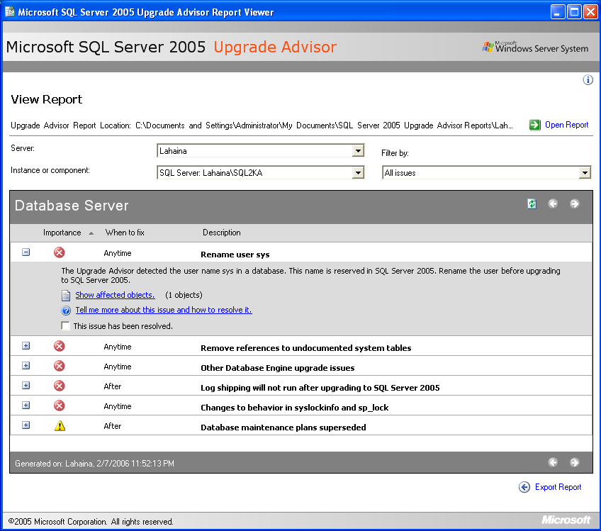Figure 11 - You can open an issue for additional assistance.
In this case, clicking the Show additional objects link will show what objects (in this case, databases) have a user named sys. You can also click the Tell me more about this issue and how to resolve it link to bring up the relevant section in the Upgrade Advisor Help system for additional information.
Once you have resolved an issue, you can check that it is resolved; the issues marked as resolved will no longer show up in the report, so you can use the reports as a method of tracking your fixes.
Note: Do not rely exclusively on the check box to indicate that an issue has been fixed. You should always run another analysis and view the resulting reports to be fully assured that you have corrected all instances of a particular issue.
You can also open other reports or export a report. To open a report, click the Open Report link in the upper right of the View Report dialog box. To export a report, click the Export Report link at the bottom right of the View Report page.
Tip: To find the Export Report link, you might need to maximize the View Report page.
You can export a report to a text file and choose either CSV or XML format.

Using the Command-Line Version of Upgrade Advisor
You can run Upgrade Advisor from the command line if you have a configuration file available. If you have already run Upgrade Advisor interactively once, it will have generated a configuration file for you, and you can use it again or clone it for further purposes. For example, the following XML document from Upgrade Advisor reflects the choices of analyzing all databases, Analysis Services, and DTS packages on a server named LAHAINA and an instance named SQL2KA:
- <Configuration>
<Server>LAHAINA</Server>
<Instance>SQL2KA</Instance>
- <Components>
- <SQLServer>
- <Databases>
<Database>*</Database>
</Databases>
</SQLServer>
<AnalysisServices />
<DataTransformationServices />
</Components>
</Configuration>
You can modify the file in an XML editor such as Visual Studio and save the file with a new filename. Then, you can use the new file as input to the command-line version of Upgrade Advisor.
Note: For a more comprehensive list of the elements in Upgrade Advisor's configuration files, see the Upgrade Advisor Help section “UpgradeAdvisorWizardCmd Utility.”
The command-line executable is called UpgradeAdvisorWizardCmd.exe, and it takes parameters for:
- Command-line Help
- The configuration path and filename and path
- The SQL Server login and password for either SQL Server or Notification Services (if SQL Server authentication is being used rather than Windows authentication)
- An optional flag to indicate whether to output reports in a comma-separated value format
If you supply a configuration file with a server name (and optionally also an instance name), then do not include the server name (or instance name) on the command line. If they are not in the configuration file, you must include them as command-line arguments.
Note: As of this writing, releases of Upgrade Advisor for 9.2016 and earlier do not contain the path to its location in the Windows PATH parameter. If you would like to have it contained in the PATH parameter, you can add C:\Program Files\Microsoft SQL Server 2005 Upgrade Advisor to the path by adding it to the PATH environment variable in My Computer's Properties/Advanced tab.
For example, the following example shows the command prompt entry required to run the command-line version of Upgrade Advisor using Windows authentication. The configuration file already contains names for a remote server named LAHAINA and an instance named SQL2KA, and the PATH environment variable now contains the path to the Upgrade Wizard. The command is:
C:\UpgradeAdvisorWizardCmd -ConfigFile "C:NewConfig.xml"
As the command-line version runs, it will indicate progress of its analysis and place reports in the same location as the interactive version.
To use the command-line version of Upgrade Advisor across a large set of servers, remove the server name and instance name from the configuration file. You can then specify the different server and instance names in copies of the configuration file and call them individually. For example, you could have a batch file with the following calls:
C:\UpgradeAdvisorWizardCmd -ConfigFile "C:NewConfig1.xml"
C:\UpgradeAdvisorWizardCmd -ConfigFile "C:NewConfig2.xml"
C:\UpgradeAdvisorWizardCmd -ConfigFile "C:NewConfig3.xml"
In this way, you can collect reports from sets of servers, provided you can connect to them from a single place.

Guidelines for Developing an Upgrade Plan
Every upgrade of a production database system that contains valuable data should take place in the context of a good plan. In this document, you will learn a number of guidelines and best practices for upgrading to SQL Server 2005. Let's start with two general best practices you should adopt when planning for your upgrade:
1. Minimize the number of variables in the upgrade project. As an experienced IT professional, you realize that the more changes you undertake in a project, the more complex the testing becomes and the higher the risk of problems. The same is true of upgrading. Because an upgrade to SQL Server 2005 involves some downtime, you may be tempted to "slipstream" in other changes to the databases or database server. But if you do, your required testing will accordingly be more complex and time-consuming, and your deployment much more stressful. You will be happier with the upgrade process if you can minimize changes to those required for the upgrade process.
2. Treat the upgrade to SQL Server 2005 as you would any major change to a production database environment. Don't treat an upgrade as a one-off procedure that you can deal with informally. Instead, treat it as a major database upgrade. This approach will include the following steps:
- Apply database change control procedures to the upgrade project.
- Ensure adequate integration and quality assurance (QA) testing.
- Develop verification and acceptance tests.
- Script and automate the deployment process and tests as much as possible.
- Develop a rollback plan as well as a priority patch strategy.
The important principle here is that an upgrade is not a minor change to your production database system; instead, it should fit into your existing procedures for major database changes.

Minimizing Upgrade Variables
In any major software system upgrade, the more variables involved in the process, the more complex the process and the testing will become. As a result, you should attempt to minimize the number of variables that will affect the upgrade.
The key point is that the fewer the changes, the easier it is to plan, verify, and troubleshoot the upgrade.
The following lists contain most of the key upgrade variables that will affect how the application connects to the server.

SQL Server-Level Changes
Because you are transitioning to SQL Server 2005, you must deal with changes to the SQL Server instance, which can include the following types of variables:
- Change of version (e.g., SQL Server 2000 to 2005)
- Change of edition
- Change of instance type (default/named)
- Change of configuration (settings, language, file placement/sizes, and so on)
- Change of authentication
Change of Version. First and foremost, you must deal with the consequences of changing SQL Server versions. These issues are detailed for you by Upgrade Advisor, which is your best source for that kind of information. These changes cannot be avoided. For more information, see the above coverage of Upgrade Advisor and Backward Compatibility Issues.
Change of Edition. You may also be upgrading and changing the type of SQL Server edition you are running, which can be of significant consequence. If you are using an in-place upgrade, your result will be at the same edition level or higher. Even this might present you with issues: For example, if you are upgrading from SQL Server 2000 MSDE to SQL Server 2005 Express, you will no longer be able to rely on SQL Server Agent jobs. In this case, you may find it better to upgrade to SQL Server Workgroup Edition.
If you choose a side-by-side upgrade, you may change edition level in any direction. For example, you might transition, via a side-by-side upgrade, from a SQL Server 2000 Enterprise Edition two-node failover cluster to a SQL Server 2005 Standard Edition two-node failover cluster. However, in that case, you might lose other Enterprise Edition features that you need.
In general, you will minimize the number of changes to your system if you stay at the same edition level, but it all depends on what features you need.
Change of Instance Type. If you perform an in-place upgrade, the instance type will remain the same. If you upgrade a default instance of SQL Server 2000 or 7.0, your result will be a default instance of SQL Server 2005. However, if you choose a side-by-side upgrade method onto two servers, or even on a single server, you may end up with different instance types.
Changing from a default to a named instance is a variable that could add complexity to your upgrade and make changes necessary in applications and users connecting to the resulting instance. You should not undertake this change unless you are prepared for the effects it might have.
Change of Configuration. If you make changes to the SQL Server configuration at the server level, you again may be introducing changes that could complicate the upgrade. For example, suppose that on the current system there is no value set for the maximum degree of parallelism. But in the new system, you decide you want it set to 4. Such a change could negatively affect the behavior of some queries. To make sure you have the upgrade under control, you should not change configuration values unless you are sure of the consequences.
Change of Authentication. You might find it desirable to change the type of authentication you want to use for a given database server. For example, you might want to change the server to use only Windows authentication. However, that type of change would be better reserved for another time unless you are sure that such a change will not adversely affect the system. If you have problems due to the authentication change, users might mistakenly blame the upgrade.

Database-Level Changes
At a more granular level, you may decide to make changes at a database level. These might include the following:
- Consolidation or distribution of databases
- Change of database compatibility level
- Change of database objects
Again, it will make the upgrade process smoother if you can minimize any changes. Therefore, if you can, make consolidation or distribution of databases a separate project. Also keep the new databases at the same compatibility level and move them to the new level after the upgrade success has been validated. Finally, avoid making upgrades to the database schema, structure, or code objects part of the upgrade project. In complex systems, you do not want to obscure the success of the upgrade with problems due to other changes.
For a fuller discussion of the consequences of making these types of changes, see Section 3.01, "Upgrading Relational Databases to SQL Server 2005."

Infrastructure Changes
You may also be tempted or forced to make changes to your database server infrastructure while you upgrade. These changes might include:
- Change of physical server (with renaming issues)
- Change of CPU type: 32-bit to 64-bit
- Change of server hardware (number of CPUs, memory, disk sets)
- Change of Windows version
- Moving to a failover cluster
- Installing replication or log shipping
With an in-place upgrade, you must use the same server. However, with a side-by-side upgrade, you may place the resulting instance on a different server. Such a change implies a change of IP address and server name in the network, unless you rename and readdress the servers in some fashion. Users and applications must now adapt to the new server name and IP address, which may be a complexity that you cannot avoid.
For a side-by-side upgrade, you may decide to keep the same server and instance name by pulling the legacy server out of the domain, adding in the new server, giving it the same IP address as the legacy server, and renaming the new server to the legacy server name. However, with an in-place upgrade, where the new SQL Server 2005 instance becomes a named instance, be aware that you cannot rename an instance name or change a named instance into a default instance.
You might also view a side-by-side upgrade as an opportunity to put the new instance on a 64-bit server instead of your current 32-bit server. In this case, you should be prepared to install the correct editions and be aware of restrictions (such as no 64-bit Windows SQL Server 2005 Workgroup Edition).
Even when you are staying with the same system with an in-place upgrade, you might view the downtime as an opportunity to change server hardware. You might, for example, add memory or CPUs or add or modify the disk configuration. Such changes could affect the resulting acceptance of the upgrade if problems arise. The lesson still applies: The fewer changes you make, the less complex the process will be and, in turn, the more smooth the process will be.
When you use a side-by-side upgrade method, you might also decide to change the Windows version. For example, you might decide to place the new instance on a Windows 2003 Server, while your legacy SQL Server 2000 or 7.0 system resides on a Windows 2000 Server system. Again, this may have unintended consequences if you do not configure the new operating system correctly and in the same fashion as the legacy machine.

Viewing the Upgrade as an IT Project
If you treat your upgrade tasks for production databases as a major change to your systems, you will go through the normal steps you would use in any significant IT database project. These steps include, but are not limited to, the following:
- Identify upgrade requirements
- Select the appropriate upgrade strategy
- Run Upgrade Advisor and review the resulting reports
- Identify and resolve upgrade issues
- Develop tests for upgrade validation and acceptance
The actual steps you use should conform to the rules and procedures that are already in place within your organization, but most likely all of the above will be included.
You will probably work as part of a team and will need to document your planning process so that you can communicate it effectively and use the documentation as a basis for executing the upgrade during the deployment phase. Your plan should be as detailed as possible, and you should store your resulting document or documents by using some form of change control such as a source control system. In the remaining part of this section, we will detail these steps.

Identify Upgrade Requirements
Just as with any IT project, you need to specify the requirements for your upgrade project. By clearly identifying your requirements, you make the scope of the project explicit and make the job of testing the validity and acceptability of the deployment much easier.
The types of requirements you should identify include the following considerations:
- SQL Server configuration requirements
- Collation requirements
- Compatibility levels
- Hardware and Windows version requirements
For more detailed information about the various SQL Server 2005 components and their potential settings, see the relevant coverage in Sections 2, 3, and 4.
Often, the feature sets of the various SQL Server 2005 editions will also dictate what edition you need to upgrade to. For more information about the SQL Server editions and their features, see Appendix 1.0, “SQL Server Feature and Edition Comparisons.”
In any case, attempt to keep the scope of the upgrade under control and as clear as possible. If you are transitioning a complex and sensitive system, strive to keep the number of changes to a minimum. See "Minimizing Upgrade Variables," above, for more detailed information.
You should explicitly document your requirements and gain agreement from relevant stakeholders, just as you would for any major database server change.

Value and Importance
You should also determine the relative value and importance of the data on the instances you have targeted for upgrading. Some legacy instances may have mission-critical importance, and it is vital that you be able to test side-by-side to ensure that the transition will succeed. The instances may also require that a rollback be possible at any point in time. Other databases may be less important or have lower value or less importance.
If you classify your targeted database servers based on value and importance, the choices you make later about an upgrade method will be easier.

Additional Environment Requirements
There may be additional requirements affecting the upgrade that depend on the environment of the resulting SQL Server 2005 instance.
Linked Servers. Your current system may depend on linked server relationships and definitions that you must apply in the case of an upgrade. Failures in the application may result if those linked servers are not correctly defined and tested.
Imports and Exports. The legacy database system may receive data imports and be the source of data exports. They may use DTS, be converted to SSIS, or they may use other tools. You need to isolate these requirements and ensure that the resulting upgraded instance participates correctly.
Components Referring to Older SQL Server Versions. You may be selectively transitioning legacy SQL Server instances. You need to ensure that the resulting SQL Server 2005 instance has components that can still connect successfully to the older SQL Server versions.
Drivers Required for Changing to a 64-bit Version of SQL Server. This may include drivers for accessing other database systems and mainframes from a 64-bit server.

Application Connection Requirements
Applications based on the .NET Framework 1.x can still work unchanged when connecting to a SQL Server 2005 instance. However, these applications cannot take advantage of new SQL Server 2005 capabilities unless they are upgraded to ADO.NET 2.0 and the new SQL Server .NET Managed Data Provider. For example, some new features such as Notification Services or Multiple Active Result Sets (MARS) require the new drivers.
Applications developed without the .NET Framework, using OLE DB or ODBC, will still work when connecting to SQL Server 2005. Although the recommended method for connecting to SQL Server 2005 for non-.NET applications is via the new SQL Native Client, the current drivers may continue to be used until the clients can be upgraded. ADO applications can use either the SQL Native Client or the new SQL Server 2005 OLE DB driver.
DB-Library client tools (such as isql.exe) are no longer supported, but you can still connect to SQL Server 2005 using DB-Library. However, unless you use the SQL Native Client, which supports all the new SQL Server 2005 features, through built-in new OLE DB and ODBC interfaces, your clients will not be able to take full advantage of all the new SQL Server 2005 features. Therefore, you must identify what client connectivity requirements you need as part of your upgrade. Embedded SQL (ESQL) applications are still supported.
There may also be issues related to upgrading client applications. If client applications need to take full advantage of new SQL Server 2005 data types such as the XML data type, the client applications will need to be upgraded to .NET Framework 2.0. Some new technologies such as MARS require the new SQL Server drivers. For more information, see the "Data Access Technologies Roadmap" on the Microsoft Web site, and "Updating an Application to SQL Native Client from MDAC" in SQL Server 2005 Books Online.
There are very few issues when moving .NET 1.1 applications from SQL Server 2000 to SQL Server 2005. However, the clients will not be able to take full advantage of new SQL Server 2005 features: SQL Server 2005 user-defined types written using the Common Language Runtime (CLR) will appear as binary large objects (BLOBs), and XML data will be retuned as NText. Some features such as snapshot isolation will only be available through Transact-SQL commands. Also, SQL Server 2005 Notification Services is not available for .NET 1.1 clients.
If you upgrade clients from .NET 1.1 applications to .NET 2.0, using SQL Server 2005, the client applications will be able to take full advantage of new SQL Server 2005 capabilities, but there will be some subtle changes. Some error codes and messages will be changed, and use of System.Transactions will require MSDTC, for example.
For additional information about data access considerations, see http://msdn.microsoft.com/data, the main data access site for Microsoft technologies.

Review and Resolve Issues
You may need to revise the requirements or scope of your project based on the work you need to perform. Before finalizing your requirements, make sure that you run Upgrade Advisor and identify issues that need resolution.
In your plan, you must isolate all issues that will affect the success of your upgrade, and verify that you can resolve them. The straightforward method for finding and resolving such issues is to run Upgrade Advisor on a test system.
You may find issues that prevent an upgrade, issues that must be resolved before an upgrade can commence, or issues that must be dealt with after an upgrade is complete. All those need to be identified clearly, a resolution found, and the resolution codified in your upgrade plan.
While most upgrade issues are relatively easy to resolve, some issues may imply a level of work that takes the upgrade project out of current scope for some instances. You may decide that some legacy instances can be upgraded at this time, while some can be upgraded later after some development effort fixes the issues. These issues may also dictate what type of strategy you choose.

Select the Appropriate Upgrade Method
Once you know what your upgrade requirements are and you have identified and resolved upgrade issues, you can select the appropriate upgrade method.
If you require that a rollback to the legacy system be possible at any time during the transition process, you should probably choose a side-by-side upgrade. Such an upgrade method will also make testing and validations easier, because you can run the two systems in parallel (the legacy in production and the migrated instance in a test environment).
You may find that you can use an in-place upgrade for some legacy SQL Server instances, and that others cannot tolerate an in-place upgrade.
Note: If you do choose an in-place upgrade, you should always test the process on a test system first and prepare a backup plan.

Formulate an Upgrade Plan
When you document your plan, include the upgrade requirements as well as your rationale for choosing an upgrade strategy for each instance or class of instances. You can use the rest of the plan to detail remaining issues.
For example, your plan should include the following tasks:
Identify Pre-Upgrade Tasks. This includes installing .NET Framework 2.0 and the SQL Native Client on the target instances. Because these steps do not affect the application, you can perform them before the actual upgrade deployment begins.
Establish Performance Baselines. If performance is a critical feature of the current legacy system, you should gather data indicating typical performance measurements for important and common queries. You may need to refer to these baselines after the upgrade if you receive reports that performance has changed. You may find that users are mistaken and that the new system performs equally well or better.
Estimate Required Downtime. The deployment of an upgrade will involve some downtime for the targeted database servers. When you perform the actual upgrade, you should budget enough downtime so that you are confident you can complete the processes.
Determine Deployment Steps. The actual server environment for your targeted database servers may have their own infrastructure complexities. You need to detail the steps required for taking the systems offline for a period and bringing them back online. You also need to detail the steps you will take during the upgrade processes. The migration steps in particular may be more complex. In either case, you may need to apply scripts at certain critical points to resolve the issues you've identified by using Upgrade Advisor.
Identify Backup and Restore Operations. Although a part of the deployment process, this task is worth calling out separately. One of the first steps in your deployment plan should be to back up the targeted databases. You should also verify the backups and have a strategy for restoring them if required.
Determine Upgrade Validation Criteria. You should state clearly what criteria you will use to validate that the upgrade has been successful—in other words, that it produced the result you expected. This may consist of scripts you run to inspect the SQL Server 2005 instances to verify that issues are resolved, that configuration settings are as expected, and so on.
Formulate Acceptance Tests. The upgrade may succeed at the SQL Server 2005 instance level, but some other unaccounted variable in the server infrastructure may still prevent applications from running correctly. In any case, you need to identify how the organization will accept the upgrade, or how you will make the "go/no go" decision. This goes beyond validating the upgrade result: It concerns whether the applications using the targeted database servers run as expected and required. You may need to enlist the support of your QA team to develop appropriate acceptance tests.
Formulate a Rollback Plan. If the upgrade does not succeed or if the acceptance tests do not succeed, you should be prepared to back out of the process and restore the original conditions. This is much easier to do with a side-by-side strategy than with an in-place upgrade. But the importance is clear. For example, with an in-place upgrade, your rollback plan may require restoring a ghost of the SQL Server 2000 image, and then restoring the SQL Server 2000 databases from your deployment backup.
Identify Post-Deployment Steps. Even after the upgrade has been accepted, you may have remaining steps that you should detail. For example, you may need to update statistics in the relational database or rebuild cubes in Analysis Services. You might need to reconfigure log shipping, re-establish replication, test a failover cluster, or verify that certain SQL Server Agent jobs run correctly.

Practice and Test the Upgrade Plan
Testing is easy to specify but often difficult to do in practice, usually due to pressing work. But if you value your data, you will test your upgrade plan fully before taking it into production. Most organizations will require this, and you will need to work with your QA team to ensure that the testing takes place. Do not forget to also test the rollback plan.
Be sure to test the plan with the people who will actually execute it. You do not want people unfamiliar with the plan trying to troubleshoot mistakes due to unfamiliarity during the deployment process.

Testing an In-Place Upgrade
To test an in-place upgrade, you should place a copy of the target SQL Server 2000 or 7.0 on a test server. You may need to place the test server in a test environment within a separate domain so that you can use the same server and SQL Server instance name. In addition, the initial state of the test server must duplicate all essential components (SQL Server 2000 or 7.0 database engine, DTS packages, Analysis Services, Reporting Services, Full-text search, and Notification Services, for example).
Once the test server is built, you must verify that it behaves correctly with the same, or copies of, application components that connect to the production system. Make sure the servers match in terms of disk volume assignments and free disk space.
You will want to quickly restore the test server to run the test upgrade more than once. It may be helpful to make a “ghost” image of the database server, as well as copies of all data files. You can then restore the ghost image and data file copies to more quickly rebuild the test server in its original state.
Another option might be to use a Virtual PC image as the test server. This can work only if you can ensure that the VPC image really can support all the components and behavior of the production server. If you are satisfied that the VPC image is sufficient, you can run the in-place upgrade and test the result. You can revert the VPC image to its original state when closing it down, making a second test run much easier.
If you can, you should include the .NET Framework 2.0 in the baseline test server. In some cases, you cannot disturb your production system in any way before the scheduled downtime for the upgrade process. If that is the case and the production server does not have the .NET Framework 2.0 installed, you can let the SQL Server 2005 Setup program automatically install it as part of the upgrade process. However, that will increase the time required for the upgrade. To reduce the time required for the upgrade process, you should attempt to install the .NET Framework 2.0 components ahead of time on the production server. Then, you can include the same components on the baseline image of the test server.
Next, you can execute Upgrade Advisor remotely against the test server and validate that its output matches what you receive when you execute it against the production system. At this point, you may need to apply scripts to fix blocking issues that Upgrade Advisor reveals. In some cases, fixing blocking issues may break the legacy application. If that is so, you may need to apply additional scripts or code as workarounds to update the database code or the application so that it continues to operate. Again, you must verify that the application operates correctly.
Once blocking issues have been removed, you can then apply the in-place upgrade method by executing SQL Server 2005 Setup against the test server. You should time the process so that you have a realistic estimate of the time required for the upgrade process.
Once the upgrade is finished, you should apply any subsequent scripts that might be required for post-upgrade issues uncovered by Upgrade Advisor. Your upgraded relational databases will have a compatibility level of 70 or 80, depending on whether you are upgrading SQL Server 7.0 or SQL Server 2000, respectively. At this point, ensure that your databases have the compatibility level that you require for continued production after the upgrade.
Once your test server reaches its final state, you should test it again using the application components that must continue to operate, after having applied all relevant scripts and code changes. To build confidence in and gain practice with the upgrade process, you should re-run the test upgrade process more than once. Just the act of re-running the test may bring to mind some factors that might affect the production upgrade and improve your upgrade plan. You should also test the process of rolling back the in-place upgrade.

Testing a Side-by-Side Upgrade
Many of the steps for testing a side-by-side upgrade are the same as those for an in-place upgrade, but the testing will be somewhat more complex because more SQL Server instances will be involved, either on one server or on two distinct servers.

On a Single Server
If you intend to perform a side-by-side upgrade on a single server, you should test the entire process first in a test environment. For example, suppose you are going to upgrade a 32-bit SQL Server 2000 instance to a 64-bit SQL Server 2005 instance that will reside on the same 64-bit server. In this case, you should build a test 64-bit server with a copy of the production 32-bit SQL Server 2000 instance that has the same characteristics as your production server.
Again, you may need to place the test server in a test environment within a separate domain so that you can use the same machine and SQL Server instance names. If you can install the .NET Framework 2.0 and SQL Server 2005 drivers on the production machine by using the SQL Server 2005 Setup before the upgrade process, do so now.
Verify that the test server and its SQL Sever instances behave correctly and that the servers match in terms of disk volume assignments and free disk space as will occur in production. This is particularly critical because you will be running two instances of SQL Server simultaneously for some length of time.
In this case, you may not need to restore the test server from a ghost image because you can simply uninstall SQL Server 2005 and remove data files to repeat the upgrade tests.
Execute Upgrade Advisor remotely against the test server and validate that its output matches what you receive when you execute it against the production system. Apply all scripts required to fix blocking issues and adapt the database or application code to those changes. Again, you must verify that the application operates correctly.
Once blocking issues have been removed, you can then begin the side-by-side upgrade method by executing SQL Server 2005 Setup against the test server and installing a new instance.
You need to decide whether the production system will be online during the install of SQL Server 2005. If it will be, then you should also test what impact SQL Server 2005 Setup has on performance, although it should be small.
Once you have installed the parallel SQL Server 2005 instance, you can manually migrate data and components to the new instance. When you have finished the migration and have applied all subsequent scripts, you may need to set the database compatibility level to the desired value.
You can now perform final tests on the new SQL Server 2005 instance. At this point, you can start by making changes required for the application components to connect to the new SQL Server 2005 instance, and then perform application testing procedures. To repeat the tests, you can uninstall SQL Server 2005 and remove any remaining data or other files to set the test server back to its original state.
You may be able to run the two systems in parallel for a time, but on a single server, this might require too much of the server's resources. When you have cut over to the new SQL Server 2005 instance and it is verified as ready for production, you can stop the legacy instance of SQL Server, leaving it dormant for a period of time as a potential rollback instance. Once you have determined that a rollback will not be needed, you can uninstall the legacy instance without disturbing the new production instance.

On Separate Servers
For a side-by-side upgrade to a separate server, as always, you should begin with a test server in a test environment. If you have access to the production environment and are confident of operating in it, you might use the new target production server as the test server and run the two in parallel. If you do not have access to the production environment, however, you will have to run your tests in a separate testing or QA environment.
Because you have a new server, you can install the .NET Framework 2.0 and SQL Server 2005 drivers using the SQL Server 2005 Setup program to establish the baseline server. If you can create a ghost image of the machine, you should also make an initial install of SQL Server 2005 with the default settings first. Then, the baseline that you restore for repeating your tests will have the characteristics of a fresh install of SQL Server 2005.
Even if you have access to the production environment, you should still build a test version of the production server. You need to simulate fully the methods you will use for migrating data and components from the production server to the new target server without disturbing the production environment. Compare the output of Upgrade Advisor on both the production and test versions of the legacy server to help ensure that you have a good copy of the production server in the test environment.
If Upgrade Advisor reports blocking issues, you may be able to correct them ahead of time on the production system as a separate preparatory step. This will save you time during the migration process.
Once you have installed the parallel SQL Server 2005 instance, you can begin the process of manually migrating components to the new instance. At some point you must test the process of cutting over to the new system and what method you will use. Some methods, such as database backup and restore, detach and attach, and the Copy Database Wizard, will require that the production system go offline. When you have finished the migration and have applied all subsequent scripts, you may need to set the database compatibility level to the desired value. All of these operations should be performed in a separate test environment first.
If your upgrade plan includes removing the old server from the domain and renaming the new server with the legacy name and legacy IP address, you should test that step as well.
You can now perform final tests on the new SQL Server 2005 server. To repeat the tests and gain confidence in your plan and deployment, you should repeat the process by restoring the baseline target server.

Deploy the Upgrade Plan
If you've rehearsed and verified your plan well, the deployment process consists of executing steps that are familiar to you. However, an actual deployment always involves issues that you may not have anticipated. For example, an actual deployment may involve people such as personnel from Operations or Networking that were not available during your testing of the plan. Also, when you deal with live production systems, often there are some issues or dependencies that you could not anticipate in a test environment.
In any case, when you deploy the upgrade plan, you may need to include some additional steps. For example, you may want to check the database consistency using DBCC commands on relational databases, checking the legacy instance health before starting. You should back up the legacy system, and verify the validity of the backups.
Once you have executed the upgrade plan, you should monitor the system and inspect the relevant Windows event logs and SQL Server 2005 logs.
After you execute your tests for the validity of the upgrade, you need to also perform your acceptance tests. Commonly, the entire deployment team then makes the collective decision on whether to accept the upgrade or migration.
If the consensus is that a rollback is required, you should be fully prepared to back out of the process and restore the legacy system.
During the deployment process, you should manually log your steps and the actions you take, as they may be relevant if you have to roll back the process.

Perform Post-Deployment Tasks
Even after acceptance of the upgrade, you may have other tasks to perform that you identified in the plan, such as updating statistics or rebuilding cubes. You may also need to monitor the system for a period of time.
Often after being in production for a short period of time, the new SQL Server 2005 instances will change due to user updates and other activity. Depending on the type of system, after a certain period, a rollback will no longer be possible without loss of data. So if any other issues are found, you may need to apply emergency patch procedures. Often systems only need a few hours of activity before they reach a point of no return, when it is impossible to return to the legacy system.
Even though your team and organization may have accepted the transition to SQL Server 2005, users may find problems that eluded all your testing and validation. This could occur days and even weeks after your deployment, depending on the complexity of the applications.

Troubleshooting an Upgrade
The best time to discover problems with an upgrade is when you are testing your upgrade plan in a test environment. Almost all upgrade issues, and the techniques you can use to resolve them, are fully documented in Upgrade Advisor. However, there are some other general techniques that you can apply.

In-Place Upgrade
Troubleshooting an in-place upgrade is essentially the same as troubleshooting a SQL Server 2005 installation. The SQL Server 2005 Setup program will log a summary of its actions in the Summary.txt file located in the Program Files\Microsoft SQL Server\90\Setup Bootstrap\LOG\ folder. The Summary.txt file contains a section for each SQL Server component's installation summary.
Detailed log files are located in the Files folder beneath the path just mentioned, providing one file for each component and also for numerous sub-components. For more information about interpreting the log files, see "How to: View SQL Server 2005 Setup Log Files" in SQL Server 2005 Books Online.

Side-by-Side Upgrade
You can use the same log files for troubleshooting a side-by-side upgrade as you do for an in-place upgrade, except that the actual deployment as such will not be logged because it is a manual process. The steps for troubleshooting a side-by-side upgrade are essentially based on the technique that you use for transferring data. If you use backup and restore, or detach and attach, you can capture the output of those processes to text files if you use the SQLCMD command-line tool and redirect the output to a file. If you use the Copy Database Wizard to transfer data, the process is interactive, and you will need to observe it live for potential errors.
For more information about these methods, see Section 3.01, “Upgrading Relational Databases to SQL Server 2005.”

Section 2.01: Minimizing Upgrade Downtime

Introduction
When you address the issue of minimizing system downtime during an upgrade, special issues begin to surface that may not be apparent in less critical or smaller systems. This can happen if you are working with highly available systems as well as very large databases (VLDBs). In this section, you will learn how the requirement to minimize downtime can affect your choice of an upgrade method.

Minimizing Downtime During an Upgrade
Every upgrade process will involve some amount of time when the databases being upgraded will be unavailable. In particular, you have to deal with two significant issues:
- Minimizing downtime: How to minimize the duration that your system must be offline for the upgrade process.
- Maximizing protection: What protection you have if the upgrade must be rolled back.
When planning to upgrade database systems where high availability is a paramount requirement, you must balance the trade-off between minimal downtime and adequate protection if you encounter an error during the upgrade process and must revert to the legacy system.

High Availability Technologies and the Upgrade Process
There are three SQL Server 2000 technologies that support high availability, and upgrading systems that use those technologies requires an approach tailored to each.
Table 1 summarizes the high availability technologies supported by SQL Server 2005 and how they may be affected.
Table 1 - High Availability Technologies in SQL Server 2005
SQL Server 2005 High Availability Technology | Automatic  Failover | Supported in SQL Server 7.0 | Supported in SQL Server 2000 | May affect the Upgrade process
Failover Clustering | Yes | Yes | Yes | No
Log Shipping | No | No | Yes | Yes
Replication | No | Yes | Yes | Yes
Failover clustering has been the high availability technology of choice for legacy systems because it supports automatic failover. There are no specific issues within the Windows clustering technology that directly affect the upgrade process, but there are some important guidelines to follow within the process.
- For information about upgrading clustered instances, see Section 2.02, "Upgrading Databases on Failover Clusters."
SQL Server 2000 log shipping is not directly supported by SQL Server 2005. You must reconfigure log shipping on an upgraded SQL Server 2005 instance, using SQL Server 2005's own log shipping technology. If you use a custom-coded approach, you may be able to upgrade leaving your log shipping intact. The metadata of databases that are not recovered, such as a log shipped destination, will not be upgraded immediately during an in-place upgrade.
- For information about upgrading log shipped databases, see Section 2.03, "Upgrading Log Shipping."
SQL Server 2005 fully supports legacy replication topologies and adds important new features as well, such as peer-to-peer transactional replication, which can also be used to implement high availability. In the case of replication, however, there are some legacy settings or configurations that may prevent an upgrade or must be changed once an upgrade takes place.
- For information about upgrading replicated databases, see Section 2.04, "Upgrading Replicated Databases."
SQL Server 2005 also introduces a new high availability technology, database mirroring, which has the capability of automatic failover. It does not affect the SQL Server 2000 or 7.0-to-SQL Server 2005 upgrade process directly because it is not available in earlier versions of SQL Server.

Choosing an Upgrade Method to Minimize Downtime
The requirement for minimal downtime has an immediate impact on your choice of upgrade method. There are important trade-offs involved in choosing either an in-place upgrade method or a side-by-side method.

In-Place Upgrade
In an in-place upgrade, you can use the SQL Server 2005 Setup program, which will automatically upgrade a single SQL Server 2000 or 7.0 instance to an instance of SQL Server 2005.
When you use the in-place upgrade method, SQL Server 2005's Setup program will automatically take the old instance offline and bring the new instance online. The new instance will have the same name as the one being replaced, so users can reconnect immediately. You can test the in-place process to produce reasonable estimates about the time that SQL Server 2005's Setup program will require the system to be offline.
Table 2 shows the basic steps taken by SQL Server Setup during an in-place upgrade and how you can estimate the time required for databases to be offline.
Table 2 – Steps SQL Server 2005 Setup Takes during an In-Place Upgrade
SQL Server 2005 In-Place Upgrade Steps | Control | Is the Database Available During This Step?
Install SQL Server 2005 Setup prerequisites | Can be done manually ahead of time | Yes
Check for upgrade blockers | Automatic | Yes
Install SQL Server 2005 executables and support files | Automatic | Yes
Stop the old instance, start SQL Server 2005 instance, upgrade metadata in place | Automatic | No
Remove the previous SQL Server version's executables and support files | Automatic | Yes
Notice that your databases are not available when SQL Server 2005 Setup stops the old SQL Server service and transfers the database data. There are several important considerations here that affect availability.
You can increase availability by reducing the duration of databases being offline:
- You can manually install the Setup prerequisites (.NET Framework 2.0, SQL Server Native Client, and so on) without affecting database availability. If you are working on a clustered instance, you can apply these prerequisites beforehand to each node of the cluster. You may see some performance impact on your database processing due to the installation process.
- SQL Server 2005 Setup automatically upgrades logins and their passwords and permissions from the previous version.
However, the following factors may tend to decrease availability because they may contribute to the duration that databases are offline:
- The automatic in-place method upgrades all databases in sequence. All user databases are offline. They are brought online, one by one, on the SQL Server 2005 instance. The duration of database unavailability will be least for the first database brought back online and possibly as long as it takes to bring the last one online.
- You do not have direct control over SQL Server 2005's Setup program timing. Therefore, you may need to inform users that an upgrade will be occurring during a certain time and that they will not be able to access the databases during that time. So in most cases, you should take applications and users offline at the start of the automatic upgrade process.
- There may be some post-upgrade tasks that you must complete, such as running scripts to resolve issues found by Upgrade Advisor, before you can let users and applications connect to the database.
- If the end result is unacceptable, rolling back an in-place upgrade can be time-consuming. You will need to stop SQL Server 2005, reinstall the legacy SQL Server instance, restore the legacy databases, and apply scripts to reconfigure the system correctly.
The last bullet concerning the time and risk required for a rollback is significant. You can reduce this risk through careful testing. As you test and work with SQL Server 2005's Setup using an in-place upgrade, the risk of a rollback rapidly decreases.

Side-by-Side Upgrade
You can also manually upgrade after installing a distinct instance of SQL Server 2005 on a different server or on the same server as the legacy SQL Server instance.
The primary consideration in a side-by-side upgrade is the effort required to build the target database server. Unlike an in-place upgrade, the side-by-side upgrade method does not automatically take care of the database server configuration. You must manually transfer or rebuild objects such as logins, permissions, SQL Server Agent jobs, DTS packages, linked servers, extended stored procedures, and custom messages to the new server. As a result, you may have significant extra effort involved. The more complex your database environment is, the greater the effort you must put into building and configuring the new server. In addition, testing and verifying the new server becomes more complex and time-consuming. For many situations, this additional effort may be prohibitive.
Another consideration in a side-by-side upgrade is how you move the data from one instance to another. At some point, you must take the legacy database offline and end up with the database online on the new instance. During that time, the database is unavailable. Therefore, the primary consideration is how to minimize the time required for moving or copying the database to the new instance.
Additional factors affecting the upgrade process include:
- Number of instances: You will always have two instances of SQL Server involved—the legacy instance and the new SQL Server 2005 instance.
- Number of servers: You may choose a side-by-side upgrade with two servers or just one server.
- Database transfer strategy: You must choose some mechanism for transferring the data (such as detach/attach, backup/restore, so on) from one instance to the other.
- Instance name change: In a side-by-side upgrade, the new SQL Server 2005 instance must have a different name than the legacy instance.
- Database server renaming: Your application may require that the new database server have the same name and IP address as the old one. In that case, you might rename the old server and give it a new IP address, and then rename the new server to the old server name, give it the old server's former IP address, and rename the SQL Server.
- Redirecting clients to a new server: If your target server name and IP address will be different or if the new SQL Server 2005 instance has a different name than the old one, you will have to reconfigure client or middle-tier applications to connect to the new server.
In regards to the database-transfer strategy, there are several methods you can use that can affect the duration of downtime:
- Entire database copy: You can copy an entire database from one server to another, during which time the database is unavailable. You can use a database backup and restore, detach and reattach, the Copy Database Wizard, or your own combination of extraction and load (possibly using BCP.) For more information about these strategies, see Section 3.01, “Upgrading Relational Databases to SQL Server 2005.”
- Filegroup transfer: If you are moving a database that has multiple filegroups and you are working with SQL Server 2005 Enterprise Edition, you can take advantage of piecemeal restore. (See "Performing Piecemeal Restores" in SQL Server 2005 Books Online.) You can back up the source server's primary filegroup and restore it to the target server, bringing the database online, and repeat the process for each filegroup. You can bring over the most important filegroups first and less important filegroups later.
- Database transaction log restore: You can back up the database on the legacy instance, leaving it online, and restore the backup to the new SQL Server 2005 instance without recovery. Then, you can take the legacy database offline, take one last transaction log backup, and restore all transaction logs to the legacy instance. With the last transaction log restore, you bring the new SQL Server 2005 database online. For more information about this strategy, see Section 2.02, “Upgrading Databases on Failover Clusters.”
- Transactional replication: You can use transactional replication from SQL Server 2000 to a new SQL Server 2005 instance, and transfer clients from the Publisher to the Subscriber very quickly. Transactional replication can have a very low latency and provide faster manual failover than log shipping. In addition, when running in a side-by-side configuration, you can replicate from the new SQL Server 2005 instance to the old SQL Server 2000 instance, thereby keeping the older version's data up-to-date in case of the need for a rollback.
If you use the combination of database and transaction log backup and restore, you can minimize the time a particular database is offline to just the time required for the last transaction log backup and restore. You can also use transactional replication to achieve very little downtime. However, in either case, you still must address how to connect clients via a new server name and other configuration issues.

Upgrade Methods and Minimal Downtime
Table 3 summarizes the factors you can use to minimize downtime and rates them according to how well they can minimize downtime.
Table 3 – Rating Factors for Minimizing Upgrade Downtime
Upgrade Scenario | Data Transfer Method | Manual Effort to Move Server and Database Objects Required | Server Renaming or Client Redirection Required | Minimal Downtime Capability
In-Place | None | No | No | Best
Side-By-Side | Detach/Attach | Yes | Yes | Low
Side-By-Side | Database copy | Yes | Yes | Lowest
Side-By-Side | Filegroup restore | Yes | Yes | Medium
Side-By-Side | Transaction log restore | Yes | Yes | Best
Let's look at each of these possible scenarios from the standpoint of availability, from lowest to highest:
- Lowest: A side-by-side upgrade with a full database or set of databases copy will have the lowest availability because the databases will have to be offline for the duration of the copy, whether you use detach/attach, backup restore, or a data copy technique. No matter what data copy technique is used, you must stop updates to a database before the copy starts, and then you can allow updates again only after the copy is finished and the server is properly configured.
- Lower: Detaching a database, copying the data files to the target server, and then attaching the database, may prove to be faster than a backup and restore. The Copy Database Wizard also can use this approach.
- Medium: Using a filegroup restore, you can bring the new database online faster. Some filegroups may not be immediately available, but if they are seldom accessed, it may be acceptable to restore them later.
- Best: Two methods fit into this category, the in-place upgrade method and the side-by-side upgrade method using a transaction log backup and restore.
In-place upgrade: SQL Server 2005 Setup will directly upgrade the source server databases and, when finished, bring them online automatically in the new SQL Server 2005 instance. No instance renaming or transfer of additional objects such as SQL Server Agent jobs, DTS packages, and so on is required. The in-place upgrade method only requires your databases to be offline during the time that it directly upgrades the databases on your new system. You can get a reasonable estimate of that time during your testing, but it is normally no more than a few minutes. No time for copying data is required. It is important, however, to reduce the risk of rollback through careful testing.
Side-by-side upgrade with transaction log backup and restore: Normally, a transaction log backup and restore will be a very brief process, and so this method may greatly reduce the time required for databases to be offline. However, the side-by-side upgrade method does require that clients connect to a different instance of SQL Server, which may significantly increase the perceived offline time. In addition, you must also budget time for either renaming the new server to the old server name or reconfiguring clients to connect to the new server name. The side-by-side method does have the advantage of a clear rollback path, with minimal switchover time, using a number of technologies such as log shipping or transactional replication.
During the upgrade process, your databases will have to be unavailable for some amount of time. In the case of an in-place upgrade, this could be from 30 seconds up to a few minutes, depending on your environment. In a very controlled side-by-side upgrade, it could be just a matter of minutes. By taking the complexities of your own database server environment into account, you can find a strategy that will give you minimal downtime during the upgrade process.

Section 2.02: Upgrading Databases on Failover Clusters

Introduction
With the introduction of the Virtual Server product, we have some new terminology to learn. To ensure that customers do not get different technologies confused, Microsoft has changed how it refers to different technologies. In SQL Server 2000, the instance installed was called a virtual server. Now, the installd instance is a failover cluster instance. The databases that reside within the failover clustered instances are called either databases on failover clusters or databases on failover clustered instances.
While many SQL Server components have changed with SQL Server 2005, SQL Server failover clustering has undergone few modifications that affect the ability to upgrade current SQL Server failover clusters to SQL Server 2005 failover clusters.
This section of the Upgrade Technical Resource Guide assumes that all general requirements for upgrading a database have already been met for each database residing within a failover cluster instance or each database being migrated to a SQL Server 2005 failover cluster. Please refer to the other sections of this document for guidance on database-specific upgrade issues.
Note: An installation of a clustered SQL Server 2005 instance may fail if Microsoft Distributed Transaction Coordinator (MS DTC) is not configured as a clustered resource. MS DTC is required for all SQL Server 2005 clustered installations. Unlike in Windows 2000 Server, the process for configuring MS DTC is a bit different under Windows Server 2003. For instructions, see the Microsoft article “How to configure Microsoft Distributed Transaction Coordinator on a Windows Server 2003 cluster,” at http://support.microsoft.com/kb/301600/. And to ensure that MS DTC has the proper network access, see “How to enable network DTC access in Windows Server 2005,” at http://support.microsoft.com/kb/817064/en-us.

Upgrade/Migration Options
The upgrade options for SQL Server failover cluster instances are:
- In-place upgrade
- Side-by-side upgrade
- Migration from standalone instance to failover clustered instance

In-Place Upgrade
An in-place upgrade will directly upgrade a SQL Server 2000 failover cluster instance to a SQL Server 2005 failover cluster instance. This will upgrade all registry keys, binaries, and security settings related to the SQL Server 2000 failover cluster instance.
An in-place upgrade is the recommended method because it minimizes the downtime of the SQL Server. Because an in-place upgrade will replace the existing SQL Server 2000 failover cluster instance, it is recommended that all upgraded instances be thoroughly tested before implementing them in a production environment.
The only downtime incurred during an in-place upgrade is the small amount of time required to restart the service as well as a small amount of time required to upgrade the internal structures within the database.

Side-by-Side Upgrade
A side-by-side upgrade is performed by installing a new SQL Server 2005 failover cluster instance. This can be installed on either the same Windows cluster where the SQL Server 2000 failover cluster instance is currently running or on a newly created Windows cluster. Once the new SQL Server 2005 failover cluster instance is verified to be operating normally, the databases within the SQL Server 2000 failover cluster instance are upgraded to SQL Server 2005 using either the backup/restore or detach/attach upgrade methodologies, which are covered in other sections of this document.
Note: You can also find detailed steps for each of these methods in the hands-on labs in the accompanying document.
Side-by-side upgrades will allow the cluster to maintain partially available. Databases within the SQL Server 2000 failover cluster instance will remain online and accessible by applications while the SQL Server 2005 failover cluster instance is built. A brief period of unavailability will occur during the upgrade of the database from the SQL Server 2000 failover cluster instance to the SQL Server 2005 failover cluster instance.
To accomplish a side-by-side upgrade, you will need to perform several manual steps such as copying logins, moving jobs, and re-pointing applications.
Note: Installation of the Windows cluster, MSCS, is beyond the scope of this document. Side-by-side upgrades that involve building a new cluster will assume that the Windows cluster has already been built and verified prior to starting the upgrade process.

Migration from a Standalone Instance
In previous versions of SQL Server, an upgrade from a standalone instance to a failover cluster instance was supported. This upgrade path is no longer supported. You also cannot upgrade a SQL Server 2000 failover cluster instance to a SQL Server 2005 standalone instance.
Either of these scenarios requires installation of the SQL Server 2005 instance, and then the databases are migrated from SQL Server 2000 using either the backup/restore or attach/detach methodologies.

Additional References
You can find additional information about the steps to install a SQL Server failover clustered instance in the following SQL Server 2005 Books Online articles:
- Creating a Virtual Server, Installing a Failover Cluster
ms-help://MS.SQLCC.v9/MS.SQLSVR.v9.en/udb9/html/381827a1-ecb9-4726-9975-231a76d7f5dc.htm
- Using the Copy Database Wizard
ms-help://MS.SQLCC.v9/MS.SQLSVR.v9.en/udb9/html/7a999fc7-0a26-4a0d-9eeb-db6fc794f3cb.htm

Potential Upgrade Issues
While many SQL Server components have changed with SQL Server 2005, SQL Server failover clustering has undergone few modifications that affect the ability to upgrade a current SQL Server failover cluster to a SQL Server 2005 failover cluster.
Database administrators upgrading a SQL Server 2005 failover clustered solution have only one issue to worry about outside the normal issues faced when upgrading to SQL Server 2005. To upgrade a SQL Server instance to a SQL Server 2005 failover clustered instance, the instance being upgraded must be in a clustered environment; database administrators wanting to upgrade databases on a non-clustered instance to a clustered instance should build the SQL Server 2005 failover cluster instance and then manually migrate the databases from the non-clustered instance over to the new faillover cluster instance.

Issues Preventing Upgrade
Due to major architectural changes, a SQL Server 7.0 failover cluster instance cannot be upgraded to a SQL Server 2005 failover cluster instance.

Objects and Settings Not Upgraded
Objects and settings that are not upgraded or migrated are the same for failover clustering as they are for standalone SQL Server instances.

Behavioral Changes

Encryption
SQL Server 2000 did not support encryption when running on either a Windows 2000 or Windows 2003 cluster. After upgrading to a SQL Server 2005 failover cluster instance on a Windows 2003 cluster, you will be able to encrypt the file system.
Note: Before encrypting the files on the operating system, you will need to consider the performance implications of the encrypt/decrypt processes.

Additional References
You can find additional information about issues when upgrading failover clustered instances in the following SQL Server 2005 Books Online articles:
- Upgrading the Database Engine
ms-help://MS.SQLCC.v9/MS.SQLSVR.v9.en/instsql9/html/b5f6549a-1e6f-486c-aa58-f12e3eb9fefa.htm
- Before Installing Failover Clustering
ms-help://MS.SQLCC.v9/MS.SQLSVR.v9.en/udb9/html/a655225d-8c54-4b30-95fd-31f588167899.htm
- Creating a Virtual Server, Installing a Failover Cluster
ms-help://MS.SQLCC.v9/MS.SQLSVR.v9.en/udb9/html/381827a1-ecb9-4726-9975-231a76d7f5dc.htm

Pre-Planning for the Upgrade
There are several tasks required before upgrading that apply to any upgrade path chosen. Tasks specific to failover cluster instances are discussed below.
Note: For general pre-planning steps that need to be taken for all databases, please refer to Section 1.0, “Upgrade Planning and Deployment.”

Establish Security
With all of the changes in the security infrastructure of SQL Server 2005, there are several changes to the way Windows permissions are handled for service accounts.
In previous versions of SQL Server, permissions were granted directly to the SQL Server-related service accounts. This did not pose a significant problem because the Windows accounts needed to have administrative authority on the machines.
SQL Server 2005 does not require service accounts with administrative authority in Windows. This has created the issue in which a Windows account could have dozens of individual permissions granted to it. This would make changing service accounts very complicated. To simplify changing service accounts, Windows groups are created for permissions on the various resources that will be accessed.
On a standalone machine, these groups are created by default of the form:
SQLServer2005MSSQLUser$<machine name>$<instance name>, SQLServer2005SQLAgentUser$<machine name>$<instance name>, and SQLServer2005MSFTEUser$<machine name>$<instance name>.
Note: There are additional groups created for other SQL Server services, but these three are relevant to a standalone instance.
For a SQL Server 2005 failover cluster installation, you will need to create domain groups that will include the SQL Server 2005 service accounts. The domain groups created do not need any special permissions granted to them, and they do not need to be granted access to any node in the cluster. During the installation of the failover cluster instance, all appropriate permissions will be granted to these groups.
Permissions on the directories, registry keys, and other resources needed to allow a SQL Server to function are assigned to the respective group. The service account is then added to the respective group.
While this works on a standalone machine, it is not as simple in a failover cluster. Within the cluster, a SQL Server failover cluster instance could execute on any physical machine in the cluster. Local Windows groups do not have a valid security context across machines. Therefore, the groups for the SQL Server service accounts need to be created at a domain level.
You will need to define three groups within the domain that will be used for permissions on the following service accounts:
- SQL Server service account
- SQL Server Agent service account
- SQL Full Text service account
Optional:
- Analysis Services service account
Once you create these groups, you will be specifying these groups during the final stages of the installation routine.
Security best practices would create a domain-level group for each type of service and for each failover cluster instance installed. Management simplicity would create a domain-level group for each of the three services, and all SQL Server failover cluster instances would specify the same set of domain groups. You will need to determine where to balance a very secure, but highly complex domain group scheme with a less complex, but less secure domain group scheme.

Install .NET Framework 2.0
During the installation of SQL Server 2005, the .NET Framework 2.0 is installed on the machine. This is a required element for the installation.
The installation of the .NET Framework 2.0 will require several minutes; you can install the .NET Framework 2.0 separately before the upgrade is started. To reduce the amount of time required for the installation routine to upgrade the SQL Server 2000 failover cluster instance, you should install the .NET Framework 2.0 on every node in the failover cluster before running SQL Server 2005 Setup.
You can find the .NET Framework 2.0 installation routine at ...\Tools\redist\2.0\dotnetfx.exe. You should execute the installation routine against all nodes in the cluster before to upgrading.

Planning for a Rollback
While it is unlikely that you will need to revert back to SQL Server 2000, you will need a plan in the event the upgrade does not go as expected. The planning process for rolling back from an upgrade will differ depending on when the rollback is going to occur.

Immediate Rollback
An immediate rollback is defined as rolling back an upgrade from SQL Server 2005 back to SQL Server 2000 before any data had been changed in the original database.
If the original SQL Server 2000 failover cluster instance still exists, then a rollback will consist of bringing the failover cluster instance online and re-pointing the applications back to the original SQL Server 2000 failover cluster instance.
However, if the original SQL Server 2000 failover cluster instance no longer exists either because it was eliminated due to an in-place upgrade or has been otherwise removed, then the rollback process will vary depending on whether it was a side-by-side upgrade or an in-place upgrade.
With a side-by-side upgrade, the original SQL Server 2000 failover cluster instance will need to be reinstalled, followed by the restoration of all system and user databases. Prior to the restore, you must ensure that all service packs and hotfixes that existed on the original SQL Server 2000 failover cluster instance have been applied or the database restore process will fail.
An in-place upgrade of a SQL Server 2000 failover cluster instance will remove all SQL Server 2000 binaries and registry keys from all nodes in the cluster. In their place will be the appropriate SQL Server 2005 binaries, registry keys, and local Windows groups. The SQL Server 2005 failover cluster instance must be uninstalled using the Add or Remove Programs applet. Once removed, the SQL Server 2000 failover cluster instance will need to be reinstalled, and all service packs and hotfixes that were installed prior to the upgrade must be reapplied. Once the instance is at the proper version level, all system and user databases will need to be restored.

Delayed Rollback
A delayed rollback occurs following an upgrade to SQL Server 2005 when data has changed within the upgraded database.
This type of rollback cannot rely on backups of the databases because you cannot restore a SQL Server 2005 backup to SQL Server 2000. All of the data will need to be exported and moved back to the SQL Server 2000 failover cluster instance.
Note: See "Recovery Options" in SQL Server 2005 Books Online if the upgrade fails after data has been changed.

Highly Available Rollback
A highly available rollback can be performed only with a side-by-side upgrade along with implementation of replication.
Note: If you have a table without primary keys, you can use only merge replication. However, merge replication requires a GUID column on each table, which needs to be evaluated before implementation. If the tables have primary keys, you will want to use transactional replication.
Because a side-by-side upgrade leaves the SQL Server 2000 failover cluster instance intact as well as having all of the databases still available, it is possible to configure the environment to allow a rollback, either immediate or delayed, while also maintaining very high levels of availability.
All of the steps for doing a side-by-side upgrade remain the same. Once the databases are upgraded, you will implement replication from the SQL Server 2005 databases back to the corresponding database in the SQL Server 2000 failover cluster instance.
To ensure that data consistency is maintained as well as minimizing downtime, you will want to follow the steps below:
- Install the SQL Server 2005 failover cluster instance.
- Perform a test upgrade of the databases from SQL Server 2000 to SQL Server 2005 using the backup/restore method.
- Configure replication on the SQL Server 2005 failover cluster instance.
- Generate a script to replicate the SQL Server 2005 databases back to the SQL Server 2000 databases that are still processing user requests.
- Revoke access from the SQL Server 2000 databases.
- Perform the side-by-side upgrade, replacing the databases from the test upgrade from Step 2.
- Establish replication from SQL Server 2005 back to SQL Server 2000 by running the script created in Step 4.
- Point all applications to the SQL Server 2005 instance.
There are three very important steps in this process.
You must revoke user access to the SQL Server 2000 databases to ensure that no one can make changes directly to the SQL Server 2000 version of the database. You will want to generate a script to reestablish user access and permissions in the event that you need to roll back.
You must also establish replication using the “no synch” option. The SQL Server 2000 database already has all of the objects along with the data being at exactly the same state as the SQL Server 2005 database, so it is not necessary to apply a snapshot to the SQL Server 2000 database.
Make certain that all applications are prevented from modifying data in the SQL Server 2000 database. This also includes any scheduled processes that would normally run via SQL Server Agent such as archive or purge routines.

Post-Upgrade Tasks

Cluster Node Reboot
Following the installation of a SQL Server 2005 failover cluster instance, a reboot may be required to complete the installation due to open file locks during the installation process. If your installation log does not contain any 3010 errors, then a reboot is not required.

Additional Tasks
All other tasks needing to be performed after an upgrade are the same as with all other upgrade scenarios. Please see Section 1.0, “Upgrade Planning and Deployment,” for a summary of post-upgrade tasks.

Section 2.03: Upgrading Log Shipping

Introduction
SQL Server log shipping allows the database administrator to automatically send a transaction log backup from one database to another and apply that backup. This lets the database administrator have one or more secondary databases synchronized with a source database for disaster recovery purposes.
Log shipping in SQL Server consists of three basic operations:
- Backing up the transaction log of the source database
- Copying that transaction log backup file to the secondary server(s)
- Restoring the transaction log backup to the secondary database(s)
SQL Server 2000 implemented log shipping through the Database Maintenance Plan Wizard and xp_sqlmaint. SQL Server 2005 no longer implements log shipping using xp_sqlmaint.
Note: Both SQL Server versions allow a database administrator to implement log shipping through a series of system stored procedures.
It is this difference in the implementation of log shipping that prevents log shipping from functioning after an upgrade to SQL Server 2005. This change in implementation means that log shipping cannot be directly upgraded from SQL Server 2000 to SQL Server 2005. Database administrators will need to reconfigure log shipping using either SQL Server Management Studio (SSMS) or log shipping system stored procedures.

Choosing Among Upgrade Options
While a SQL Server 2000 log shipping configuration will not directly upgrade to SQL Server 2005, database administrators do have three different methods to indirectly upgrade their log shipping: highly available upgrade, partially available upgrade, and offline upgrade.

Highly Available Upgrade (with Failover)
A highly available upgrade allows the database administrator to make use of log shipping’s ability to fail over and the fact that an offline database does not automatically upgrade when upgrading a SQL Server 2000 instance to SQL Server 2005.
Note: To perform a highly available upgrade, the current log shipping configuration must allow failover.
To perform a highly available upgrade, database administrators will perform the following basic steps:
- Upgrade the secondary instance to SQL Server 2005. Database administrators will keep the log-shipped database offline during the upgrade process.
- Fail over log shipping to the newly upgraded secondary database.
Note: SQL Server will automatically upgrade the database to SQL Server 2005 once the database is brought online.
- Once the old primary database has gone offline, the database administrator can upgrade this database to SQL Server 2005.
Note: This database will remain offline and will be utilized as the secondary server in the SQL Server 2005 log shipping configuration.
- Reconfigure log shipping under SQL Server 2005.
- Manually change the roles of the databases, if desired.
Exact steps for the highly available upgrade can be found under the “Migrating with Failover” section of the SQL Server 2005 Books Online article “Upgrading a SQL Server 2000 Log Shipping Configuration” at ms-help://MS.SQLCC.v9/MS.SQLSVR.v9.en/udb9/html/70612059-b0d2-45a6-b74c-8cb3b9bdc921.htm.
The only outage that will occur during this upgrade path is the time it takes to perform the role reversal within the configuration.
Note: You will be running in an exposed configuration while you are reconfiguring log shipping under SQL Server 2005. During this configuration process, select the No, the secondary database is initialized option on the Initialize Secondary Database tab of the Secondary Database Settings dialog box. This will eliminate the downtime required to initialize the log shipping secondary server because the databases remain synchronized during the upgrade process.
You will want to disable the backup, copy, and restore jobs after you have initiated the failover to the secondary server. Log shipping cannot function from SQL Server 2005 to SQL Server 2000. This step prevents transaction log backups from accumulating during the subsequent upgrade of the other server and reconfiguration of log shipping.

Multiple Secondaries
Upgrading configurations with multiple secondaries is simply a process of upgrading each secondary participating in the log shipping configuration to SQL Server 2005 before initiating the failover. There are no special considerations that need to be made for a configuration with multiple secondaries.

Partially Available Upgrade (without Failover)
If database administrators cannot or do not want to perform a highly available upgrade, they can perform a partially available upgrade.
To perform a partially available upgrade, database administrators will upgrade the secondary instance while the secondary database is offline, upgrade the primary database (which will not be available for use during the upgrade), and reconfigure log shipping between the two upgraded instances. The offline secondary database will upgrade to SQL Server 2005 once log shipping has been reconfigured.
Exact steps for the partially available upgrade can be found under the “Migrating without Failover” section of the SQL Server 2005 Books Online article “Upgrading a SQL Server 2000 Log Shipping Configuration” at ms-help://MS.SQLCC.v9/MS.SQLSVR.v9.en/udb9/html/70612059-b0d2-45a6-b74c-8cb3b9bdc921.htm.
Log shipping cannot function from SQL Server 2005 to SQL Server 2000. This step prevents transaction log backups from accumulating during the subsequent upgrade of the other server and reconfiguration of log shipping.

Offline Upgrade (Redeploy)
The last method database administrators can use to upgrade a SQL Server 2000 log shipping configuration is removing log shipping from the SQL Server 2000 databases, upgrading both databases, and reconfiguring SQL Server 2005 log shipping between the databases.

Determining and Evaluating Potential Upgrade Issues

Issues Preventing Upgrade
The only issues that will prevent an upgrade of log shipping are related to the inability to upgrade a database. If a database can be successfully upgraded to SQL Server 2005, then log shipping can be upgraded.

Discontinued Functionality
Log shipping functionality is the same between SQL Server 2000 and SQL Server 2005. It is just implemented using a different code set.

Behavioral Changes That May Require Corrective Action after the Upgrade
Because log shipping is implemented as a database property, it will need to be completely reconfigured following an upgrade.

Log Shipping Monitor
The log shipping monitor is a place to log error and status information as well as raise alerts. The monitor does not have a role during the upgrade of log shipping. Because log shipping needs to be reconfigured after upgrading to SQL Server 2005, all you will need to do is to upgrade the monitor server to SQL Server 2005 at any time prior to reconfiguring log shipping.

Post-Upgrade Tasks

Removing SQL Server 2000 Log Shipping Tables and Jobs
After upgrading log-shipped databases to SQL Server 2005, database administrators have to perform a few cleanup tasks to remove the old log shipping tables and jobs from the upgraded instances.
SQL Server 2000 log shipping table names needing to be deleted can be found under the “Removing SQL Server 2000 Log Shipping Tables and Job” section of the SQL Server 2005 Books Online article “Upgrading a SQL Server 2000 Log Shipping Configuration,” at ms-help://MS.SQLCC.v9/MS.SQLSVR.v9.en/udb9/html/70612059-b0d2-45a6-b74c-8cb3b9bdc921.htm.

Review Upgraded Databases
Each upgraded database should be reviewed to ensure security was properly upgraded and all objects behave as expected.

Resolve Upgrade Issues
You will need to resolve any outstanding issues that are identified for post-upgrade review. These are generally those items identified by Upgrade Advisor that will not prevent upgrade of the database but that need to be resolved for either proper operation or to address deprecated code structures.

Section 2.04: Upgrading Replicated Databases

Introduction
When performing an upgrade to a replicated environment, database administrators must make sure that all changes have been applied to all the databases that are involved in the replication topology before they attempt the upgrade. They must also account for the order in which the databases are upgraded. Databases must be upgraded in the following order: Distributor, Publisher, Subscribers.
This upgrade order must be followed to satisfy the version requirements for Publisher, Distributor, and Subscriber. While there are slight variations depending on the method of replication that you are using, the Distributor must be at the same version or higher than the version of the Publisher while the Subscriber must be at the same version or lower than the Distributor.
Database administrators upgrading replication topologies that are multi-leveled, with Subscribers republishing the replicated data to other Subscribers, must make sure that they upgrade all Distributors in the replication hierarchy, followed by all the Publishers in the hierarchy before upgrading bottom-tier Subscribers.
Note: All steps in this section assume that any replicated database to be upgraded has already had all issues noted in other sections of this document addressed.
You will always upgrade all Distributors first within the architecture. Once all Distributors are upgraded, you will upgrade all Publishers. Once all Publishers have been upgraded, you will complete the process by upgrading all Subscribers. This process is the same regardless of the replication methods that you are using within your architecture.
For the purposes of this documentation, a remote Distributor is defined more restrictively than usual. A remote Distributor is defined as an instance of SQL Server in the role of a Distributor that does not contain any other databases participating within your replication architecture. A local Distributor is defined as an instance of SQL Server in the role of a Distributor while also in the role of Publisher or Subscriber.
In the case of transactional replication, the distribution database will only contain changes that need to be sent to each Subscriber. In the case of merge replication, the distribution database does not contain any data that you will want to upgrade.
In either case, we can safely overwrite the distribution database because a SQL Server 2005 Distributor can service both SQL Server 2000 and SQL Server 2005 Publishers and Subscribers.
Note: Before upgrading replication from SQL Server 2000 to SQL Server 2005, the security model changes for replication agents will be required reading. You can find all of the security model details in the SQL Server 2005 Books Online article “Replication Agent Security Model,” at ms-help://MS.SQLCC.v9/MS.SQLSVR.v9.en/rpldata9/html/6d09fc8d-843a-4a7a-9812-f093d99d8192.htm.

Replication Architecture Impact
The processes outlined within this section apply to all replication methods in your replication architecture. The upgrade path does not vary if you have merge, transactional, queued updating, or immediate updating replication. It also does not vary if you have a multi-level replication hierarchy.
This document will refer to the top-level Publisher for several processes. The top-level Publisher is defined as the database that you have used to initialize your entire replication architecture.

Choosing Among Upgrade Options

In-Place Upgrade
An in-place upgrade of replication will cause the SQL Server, databases, and replication to be upgraded directly with fewest steps. While an in-place upgrade is the most direct way to upgrade, the previous SQL Server 2000 instance will be overwritten and will no longer exist on your computer. Before upgrading, back up SQL Server databases and other objects associated with the previous SQL Server instance.

Side-by-Side Upgrade
A side-by-side upgrade will create a new instance of SQL Server 2005, and then you will migrate databases to the new instance. But because the databases are migrated to the new instance, the applications may have to be reconfigured to point to the new instance, and thus, it may not be viable.
This upgrade option is only possible for merge replication if all data changes are prevented throughout the architecture. This upgrade option is possible for transactional or snapshot replication while changes are being issued against the existing architecture.

Offline Upgrade
An offline upgrade is not actually an upgrade method at all. Offline upgrades involve completely removing replication from SQL Server 2000, upgrading the database to SQL Server 2005, and then recreating the replication architecture.
If you can take the entire replication architecture offline and reinitialize everything, this will give you an opportunity to clean up anything within your existing architecture.

Upgrading Replication Scripts
Due to the security model changes in SQL Server 2005, you should upgrade your replication scripts. If you have generated replication scripts in SQL Server 7.0 or SQL Server 2000, these scripts will execute without errors only if you are executing under the security context of a sysadmin. Otherwise, you will receive errors, and the scripts will not complete.
Each replication agent can run under separate security contexts with minimal permissions. Replication stored procedures that are affected by this behavior change are:
- sp_addpublication_snapshot
- sp_addpushsubscription_agent
- sp_addmergepushsubscription_agent
- sp_addpullsubscription_agent
- sp_addmergepullsubscription_agent
- sp_addlogreader_agent
- sp_addqreader_agent
Note: You can find explicit steps for upgrading replication scripts along with additional guidance and sample scripts in the SQL Server 2005 Books Online article “How to: Upgrade Replication Scripts (Replication Transact-SQL Programming),” at ms-help://MS.SQLCC.v9/MS.SQLSVR.v9.en/repref9/html/0b8720bd-f339-4842-bc8f-b35a46f6d3ee.htm.

Determining and Evaluating Potential Upgrade Issues

Edition- and Version-Related Issues
Previous versions of SQL Server allow multiple versions to exist in a replication topology. SQL Server 2005 continues to allow multiple versions of SQL Server to participate in a replication topology provided that you follow a few simple rules:
- SQL Server 7.0 SP4 and SQL Server 2000 SP3 are the minimum versions required to participate in a replication topology with SQL Server 2005.
- The Distributor can be any version of SQL Server as long as its version is greater than or equal to the version of the Publisher.
- The Publisher needs to be a version that is equal to or less than the Distributor.
- The Subscriber’s version depends on the publication type:
- Read-only Subscribers to a transactional publication must be within two versions of the Publisher.
- Updateable Subscribers to a SQL Server 2005 transactional publication must be equal to or greater than SQL Server 2000 SP3.
- Merge publication Subscribers can be any version equal to or less than the Publisher’s version.
- The replication functionality of each SQL Server edition is taken into account when upgrading a replication topology.
If you are upgrading the Publisher to SQL Server 2005, the Distributor must be upgraded as well.
You cannot publish from SQL Server 2000 to SQL Server 2005 if you are using merge replication. However, this is possible if you are using transactional or snapshot replication.
Note: When deciding on which editions to use in a replication topology, database administrators are encouraged to review the replication section of the following SQL Server 2005 Books Online article to help determine which replication features are supported by the different SQL Server 2005 editions: “Features Supported by the Editions of SQL Server 2005,” at ms-help://MS.SQLCC.v9/MS.SQLSVR.v9.en/instsql9/html/81f3e917-884a-4cc8-aca2-0a5fea89f355.htm.

Discontinued Functionality

Issues That Affect All Replication Methods
Several discontinued functions affect all replication methods:
- Creating push subscriptions without an active connection
- Using file transfer protocol (FTP) to initialize Subscribers running SQL Server version 7.0
- Creating subscriptions in Windows Synchronization Manager
- Subscribing to a publication by locating it in Active Directory
- Snapshot ActiveX control
- Remote agent activation
- Subscriptions using Microsoft Access (Jet 4.0)
In previous versions, the Replication Wizard did not require a connection to a Subscriber during configuration. All Subscribers need to be known during configuration.
While FTP can be used to initialize Subscribers, there has been an increase in the version support. FTP initialization is now only supported for SQL Server 2000 Subscribers.
Windows Synchronization Manager was used to manage synchronization and could be used to create new subscriptions as well. The subscription-creation functionality has been removed. You will now need to create your subscriptions using either the replication stored procedure, the Replication Wizard, or Replication Management Objects (RMO).
Previous versions allowed a publication to be registered in Active Directory by using the @add_to_active_directory parameter when creating publications of any type. This would then allow you to browse Active Directory to subscribe to a publication. Since adding publications to Active Directory has been eliminated, you can no longer use Active Directory to create a new subscription. You will now need to create your subscriptions by using either the replication stored procedure, the Replication Wizard, or Replication Management Objects (RMO).
The Snapshot ActiveX control has been replaced with a new managed agent. Your applications should be changed to use the new managed Snapshot Agent.
SQL Server 2000 provided a new feature referred to as “offloaded agents.” This allowed the Distribution and Merge agents to be configured on another server and activated with a DCOM call. For SQL Server 2000 Distributors, this functionality can still be used. For SQL Server 2005 Distributors, this feature has been eliminated and there is no replacement.
In previous versions, the Jet 4.0 engine could be a Subscriber within replication. This is no longer supported. For applications that used this feature, the database engine should be upgraded to SQL Server 2005 Express Edition.

Transactional Replication
The following discontinued function affects transactional replication:
- The Microsoft Message Queuing (MSMQ) option for queuing updating subscriptions is no longer available.
Queued updating subscribers were allowed to specify either SQL or MSMQ for the change queue. The MSMQ option has been removed in SQL Server 2005. You will need to rewrite any applications that depended on MSMQ functionality to transfer changes to use the SQL Server queue only.

Merge Replication
The following discontinued function affects merge replication:
- Publishing from SQL Server 2005 Express Edition
MSDE was allowed to be a Publisher in a merge replication architecture. SQL Server 2005 Express does not support this feature. While the Express Edition can be a Sbscriber for any replication method, it requires at least the Workgroup Edition for the Publisher.

Deprecated Features
Several replication features have been deprecated in SQL Server 2005. While these features will continue to work in SQL Server 2005, you should not use them for new applications because these features will be removed in a future release.

All Replication Methods
The following changes affect all methods of SQL Server 2005 replication:
- Attachable subscriptions
- Subscriber registration
- SQL-DMO
- Sp_repladdcolumn and sp_repldropcolumn
- Checksum validation
- Adding publications to Active Directory
- -UseInProcLoader parameter
Attachable subscriptions provided the ability to pre-package a snapshot so that it could be deployed to a large number of subscribers quickly and efficiently. If you have partitions within merge replication, this feature can be replaced with the new partitioned snapshots. For any others, a subscription can now be initialized from a backup.
You no longer need to register a Subscriber at the Publisher, so the stored procedure sp_addsubscriber is no longer necessary.
SQL-DMO has been replaced as a programming API. Any replication functionality that uses SQL-DMO should be upgraded to use the new Replication Management Objects (RMO) calls.
SQL Server 2000 allowed columns to be added or dropped from tables that were participating in replication by using two special stored procedures: sp_repladdcolumn and sp_repldropcolumn. Almost all DDL statements are fully supported by the replication engine in SQL Server 2005. Therefore, you can remove calls to these stored procedures.
Note: Any Subscribers at an 8.0 compatibility level cannot receive DDL changes via replication.
Checksum validation is still within the product for SQL Server 7.0 Subscribers. This is replaced with a binary checksum for any newer Subscribers.
Because subscribing to a publication through Active Directory has been discontinued, there is no longer a need to be able to register publications in Active Directory. Any code that uses the @add_to_active_directory parameter should have this parameter removed.
The InProcLoader has not been upgraded to handle XML data. If you are replicating XML data, this parameter cannot be used. If you are not replicating XML data, it is still safe to use this parameter.

Snapshot Replication
The following change affects SQL Server 2005 snapshot replication:
- Updateable subscribers
Using the immediate updating or queued updating options for snapshot replication is no longer allowed. These options, however, can be used for transactional replication.

Transactional Replication
The following changes affect SQL Server 2005 transactional replication:
- Subscription expiration
- “No synch” subscriptions
- ODBC subscribers
- Transformable subscriptions
- Distribution ActiveX control
- Replication Distributor Interface
The @retention property is no longer applicable. All subscriptions still obey the maximum distributor retention value and will expire if this value is exceeded. There are no changes required to take advantage of this functionality. The @retention parameter should be removed from all calls to sp_addpublication.
No synch is the common expression for setting the @sync_type parameter to none. This value should be changed to replication support only.
Any ODBC subscribers will need to be changed to use OLE DB instead.
Note: For supported OLE DB providers, please see the SQL Server 2005 Books Online article “Non-SQL Server Subscribers,” at ms-help://MS.SQLCC.v9/MS.SQLSVR.v9.en/rpldata9/html/831e7586-2949-4b9b-a2f3-7b0b699b23ff.htm
Transformable subscriptions use a DTS package through which all transactions traverse from the distribution database to each Subscriber. DTS has been replaced with SQL Server Integration Services (SSIS) in SQL Server 2005, and this capability was never added to SSIS. To continue to use transformable subscriptions, you must install support for DTS in SQL Server 2005. If DTS support is not installed, these subscriptions will fail to execute.
The Distribution ActiveX control has been replaced with a new managed provider. You should change all code using the ActiveX control to use RMO instead.
SQL Server 2000 provided an API to the distribution database through the Replication Distributor Interface. This allowed you to create applications that would write changes into the distribution database to be forwarded to SQL Server Subscribers. This method was primarily used to enable publishing from Oracle to SQL Server, although custom code had to be written to accomplish this. Existing code will continue to execute. Any code that was used to publish from Oracle should be replaced with the new Oracle publishing feature.

Merge Replication
The following changes affect SQL Server 2005 merge replication:
- Alternate synchronization partners
- Merge ActiveX control
- Multi-column update
Hierarchies created with merge replication frequently used the alternate synchronization partner feature to allow data to continue to be replicated across the entire environment—even in the event an up-chain Publisher had failed. This feature will continue to function in this release. There is no replacement or alternative.
ActiveX controls have been replaced with managed providers. Any code referencing the Merge ActiveX code should be rewritten to use the new RMO interface.
Multi-column updates could be broken into a series of single-column updates by using the fast_multicol_updateproc option. This option existed to improve performance under very specific circumstances. Due to the performance improvements in SQL Server 2005, this option is no longer needed.

Behavior Changes
It is important to review and understand changes made to SQL Server 2005 replication that will change the behavior of current SQL Server replication functionality. These behavioral changes need to be reviewed, understood, and accounted for in any SQL Server 2005 upgrade plan.
Several changes to SQL Server 2005 replication may require application changes and should be reviewed and understood during upgrade planning.

All Replication Methods
The following functionality behavior changes will affect all methods of replication:
- Security accounts for replication agents
- Synchronization Manager not enabled by default
- Replication Conflict viewer not packaged separately
- Local connections for replication agents
- distributor_admin account password
- SQL Server Express Edition does not include SQL Server Agent
The default behavior in previous versions of SQL Server was to proxy the replication agents to the service account of SQL Server Agent. Replication in SQL Server 2005 now allows each agent to run under separate security contexts to allow very fine-grained permission control. Each agent will make integrated connections by using these accounts. After upgrading, you will want to evaluate your replication security model and change replication agents over to accounts with the minimum permissions required.
If you want to use Windows Synchronization Manager to manage subscription synchronization, it must be explicitly enabled by an administrator.
The Replication Conflict Viewer was created as a redistributable application in previous versions. The conflict viewer in SQL Server 2005 is no longer generated as a redistributable application.
A local connection is defined as a connection that a replication agent makes to a SQL Server residing on the same computer as the agent. Any local connections that use SQL Server Authentication are changed to Windows Authentication during the upgrade.
A trusted connection between a Publisher and remote Distributor were allowed in previous versions. This trusted connection did not require a password. This is no longer allowed. If you have a remote Distributor, you must convert this connection from trusted to non-trusted.
When upgrading to SQL Server Express Edition, replication must be reconfigured because Express Edition does not package SQL Server Agent. You should upgrade the code to use either Windows Synchronization Manager or RMO.

Transactional Replication
The following functionality behavior changes will affect transactional replication:
- Object owners specified during the creation of publications
- Changes to the @security_mode parameter of the sp_link_publication stored procedure for immediate updating subscriptions
The object owner in previous versions defaulted to the context of the account associated with the Distribution Agent when the snapshot was applied at the Subscriber. In SQL Server 2005, the owner of the object now defaults to the value of the owner of the object on the Publisher when the snapshot is applied.
The accepted values for the @security_mode parameter for sp_link_publication have been changed. You will need to make changes to your environment to reflect these changes.
- 0: Uses SQL Server Authentication with the login specified in the stored procedure as login and password.
- 1: Uses the security context (SQL Server Authentication or Windows Integrated Authentication) of the user making the change at the Subscriber.
- 2: Uses an existing, user-defined linked server login.

Merge Replication
The following functionality behavior changes will affect merge replication:
- Publication compatibility level
- Error compensation
- Multiple conflict tables
- Retention-based metadata cleanup
- @keep_partition_changes parameter defaults to true in SQL Server 2005
- Change batching
- Identity range assignment
In previous versions, when a feature was implemented that required a higher version than was specified in an existing publication, the compatibility level was automatically modified. The compatibility level now needs to be manually changed before a feature requiring a higher version can be used.
Previously, when errors occurred during a synchronization, compensating actions were automatically applied to correct the error. This could have unintended consequences within the architecture. SQL Server 2005 introduced the @compensate_for_errors parameter to the sp_addmergearticle stored procedure to let administrators control whether they wanted compensating actions to be taken or not. For more information about this behavior, see the compensating actions section of the Microsoft article “Behavior Changes in SQL Server 2005 Replication” at ms-help://MS.SQLCC.v9/MS.SQLSVR.v9.en/rpldata9/html/8614e5a8-bd22-4b0d-a916-7da214471d74.htm
Previous versions of SQL Server used a single conflict table. SQL Server 2005 uses two conflict tables. MSmerge_conflict_info and a set of tables named as MSmerge_conflict_<PublicationName>_<ArticleName> now contain all of the conflict information. Conflict tables are also recreated during upgrade with an owner of dbo, so applications that referenced conflict tables with a different object owner will need to be modified.
All metadata in SQL Server 2005 is now based on a retention interval.
The default setting for @keep_partition_changes used to be False. For publications set at the 90RTM compatibility level or higher, the default is now True.
Note: During upgrade, if the publication meets the appropriate requirements, this option will be enabled.
All changes in previous versions were executed one row at a time. To improve performance, all changes are now batched. Multiple INSERT, UPDATE, and DELETE statements can execute in a single transaction. If you have triggers that fire when the replication engine writes changes to a table, you will need to ensure that the triggers can handle multi-row modifications.
If you have implemented automatic identity-range management, the identity ranges might be reset during the upgrade process.

Planning for a Rollback

Immediate Rollback
An immediate rollback occurs when you roll back the upgrade before any data has been changed within the new SQL Server 2005 databases.
If you choose to perform an in-place upgrade, you will need to perform the following steps:
- Reinstall SQL Server 2000.
- Applying all necessary service packs and hotfixes.
- Restore master and msdb databases.
- Restore all user databases.
- Drop any SQL Server Agent jobs corresponding to replication.
- Execute your replication scripts to recreate the replication architecture.
If you choose to perform a side-by-side upgrade, all SQL Server instances, databases, and replication configurations should still exist. The only thing you will need to do in this case is to reconfigure the applications to connect to the previous version of SQL Server.

Delayed Rollback
A delayed rollback occurs at any point in time after data has been changed in the upgraded database. Because backups from SQL Server 2005 cannot be restored to earlier versions, this rollback process becomes more complicated.
If you are doing an in-place upgrade, you will need to follow the steps above for an immediate rollback of an in-place upgrade as a starting point for the delayed rollback. If you are doing a side-by-side upgrade, you should already have everything from the previous version in place to start the rollback process.
A delayed rollback can be performed using two different methods: DTS/SSIS or replication.
You can use DTS or SSIS to export data and objects from SQL Server 2005 and import them into the previous version of SQL Server. If you are using this method, it will require an application outage to ensure that data is not changed in the SQL Server 2005 database. Here is the process you will need to follow:
- Lock out all applications.
- Disable any process that would change data in SQL Server 2005.
- Remove all publications and subscriptions from SQL Server 2000.
- Create a DTS or SSIS package to move all of the objects and data from SQL Server 2005 back to SQL Server 2000.
- Execute replication scripts to recreate the entire architecture.
- Reconfigure all applications to connect to SQL Server 2000.
The other rollback path uses replication from SQL Server 2005 back to SQL Server 2000. This rollback process minimizes the downtime on the application during the rollback and can make this process nearly invisible to end users. In this case, you will need to perform the following steps:
- Remove all publications and subscriptions from SQL Server 2000.
- Create a transactional publication for all tables in SQL Server 2005.
- Create a subscription to the top-level Publisher in the SQL Server 2000 replication architecture.
- Script all objects and security settings that are not created when the snapshot runs for Step 3 in this process.
- Execute the script generated in Step 4 against the top-level Publisher in SQL Server 2000.
- Execute replication scripts to recreate the entire architecture within the SQL Server 2000 environment.
- Reconfigure all applications to connect to SQL Server 2000.
- Once all changes have been moved from SQL Server 2005 back to SQL Server 2000, drop the subscription created in Step 3 of this process.
- Drop the publication created in Step 2 of this process.
When you use the replication engine to move data from SQL Server 2005 back to SQL Server 2000, you allow applications to continue to process changes while you are reinitializing the SQL Server 2000 architecture. This lets you switch your applications from SQL Server 2005 back to SQL Server 2000 without incurring an outage because applications can immediately begin issuing transactions because the database contains a current copy of data.

Upgrading a SQL Server 2000 Replication Environment

Preliminary Steps
Upgrading a replicated environment can become very complicated. A replication architecture can have multiple Distributors, multiple levels of Publishers, and changes occurring at multiple locations. To mitigate the upgrade complexity, it is essential that you control the data change complexities that can occur.
As an initial step, you will want to prevent any applications from making changes to any database in the architecture except for the top-level Publisher. This limits the data changes in the environment to a single database, thereby allowing you to treat all other databases as logically read-only.
Once you have locked out all applications from making changes at any database except the top-level Publisher, you will want to ensure that any changes from a Subscriber have successfully replicated across the environment.
Once all Subscriber changes have replicated, you will have an environment that has all data changes flowing from the single, master Publisher to all other databases. You will then want to stop all replication agents at all levels in the architecture. Once all changes have been sent to all Subscribers and the databases have been validated, you will want to clean up as much metadata as possible to reduce the amount of replication data that needs to be upgraded. At this point, you are ready to begin the upgrade process.
Note: When attaching a replicated database that has been copied rather than detached, you must do one of these two actions:
- If the database remains on the same server as the source instance, you must execute the sp_vupgrade_replication system stored procedure to upgrade replication after the attach process is complete.
- If the database is moved to a different server, you must execute the sp_removedbreplication system stored procedure after the attach process is complete.

Steps Common to All Upgrade Paths
The following steps need to be performed for all upgrade paths.
- Disable all SQL Server Agent jobs.
- Back up all system and user databases.
- Generate a script for the entire replication architecture.
- Ensure that you have installation media along with appropriate service packs and hotfixes for the current version installed.

Remote Distributor Upgrade
If your architecture has a remote Distributor, then your upgrade path should upgrade the Distributor in-place. This will minimize the downtime and replication that is incurred during the upgrade process.
The steps to upgrade the remote Distributor in-place are as follows:
- Stop all replication agents.
- For transactional publications, you will need to wait for all changes to be sent from the distribution database to all Subscribers.
- Upgrade the remote Distributor to SQL Server 2005.
- Verify the SQL Server 2005 instance.
- Start all of the replication agents.
- Verify that changes are picked up from the Publisher and sent to each Subscriber.
You will be tempted to over-complicate this part of the process, particularly in architectures that have multiple levels of Distributors. The process above is simply repeated, one level at a time. Once the top-level Distributor is upgraded, you will start the Log Reader Agent/Distribution Agent or Merge Agent for only the top-level Publisher. This first level will be verified. At this point in the process, the second-level republisher is only acting as a Subscriber within the architecture. The second-level remote Distributor will then be upgraded in place. Once the second-level Distributor is upgraded in place, you will start the Log Read Agent/Distribution Agent or Merge Agent for this level only. Once this level is verified, the same process repeats at each remote Distributor down the hierarchy.

Side-by-Side Upgrade of the Replication Architecture
The side-by-side upgrade of your replication architecture involves installation of a SQL Server 2005 instance on all servers participating in the replication architecture. Once you have installed SQL Server 2005, you will be re-creating the entire SQL Server 2000 replication topology within the SQL Server 2005 environment.
The steps to perform this upgrade process for transactional or snapshot replication are as follows:
- Install SQL Server 2005 instances on all servers in the replication architecture.
- Configure publishing on the SQL Server 2005 instance at the top-most level in the architecture.
- Optional: Configure publishing on any SQL Server 2005 instances that will be republishing.
- Generate replication scripts for all publications and subscriptions within the existing replication architecture.
- Upgrade the replication scripts generated, as noted previously in this section.
- Modify the replication scripts to reflect the names of all of the new SQL Server 2005 instances.
- Ensure all changes have propagated from all Subscribers within the architecture if you have updateable subscriptions.
- Stop all replication agents at all levels in the architecture.
- Create a new subscription from the top-most SQL Server 2000 Publisher to the top-most SQL Server 2005 Publisher.
- Apply the initial snapshot from SQL Server 2000 to the new SQL Server 2005 instance.
- Ensure that data changes are correctly flowing from SQL Server 2000 to the new SQL Server 2005 instance.
Note: At this point, you should have the existing SQL Server 2000 replication architecture intact along with a mirror architecture within the new SQL Server 2005 architecture. Applications will still be configured to connect to the top-most Publisher in SQL Server 2000. Changes written to the top-most SQL Server 2000 Publisher are being sent to the new SQL Server 2005 instance.
- Turn on all of the replication agents within the architecture.
Note: At this point, applications can connect to any database within the SQL Server 2000 replication architecture that they are allowed to connect to once all changes have propagated. If you have updateable subscribers (i.e., immediate or queued), you can process changes on any of the Subscribers.
- Verify that all changes propagate successfully across the SQL Server 2000 architecture as well as being sent to the SQL Server 2005 Subscriber.
- Execute the replication scripts created in Step 6 against the SQL Server 2005 instances to create the publications and subscriptions.
Note: For multi-level architectures, you will want to perform these actions one level at a time and verify that all data changes propagate in all valid directions before moving on to the next level in the architecture.
- Verify that data propagates as expected throughout the SQL Server 2000 environment and within the SQL Server 2005 environment.
- Once the replication architecture is validated, re-configure all applications to connect to the SQL Server 2005 architecture.
- Verify that all data modified on the SQL Server 2000 side of the architecture has successfully propagated to the SQL Server 2005 architecture.
- Remove the subscription from the top-level SQL Server 2000 Publisher to the top-level SQL Server 2005 Publisher.
- Validate the replication architecture.
- Disable the SQL Server 2000 instances and remove them once you have verified that you will not be reverting back to SQL Server 2000.
Note: If your upgrade involves SQL Server CE subscribers, you must perform additional actions on the IIS server. You will need to install SQL Server 2005 client connectivity components along with SQL Server Mobile Edition components on the IIS server. You will also have to replace sqlcesa30.dlll, sqlcerp30.dll, and all the replication components on the IIS server.
The steps to perform a side-by-side upgrade for merge replication are slightly different. You could upgrade transactional or snapshot replication without incurring downtime on the application because you are allowed to publish from SQL Server 2000 to SQL Server 2005 through a SQL Server 2005 Distributor. Merge replication does not allow a Subscriber to be a greater version than the Publisher. Because this is not possible, the upgrade for merge replication requires downtime for the application.
The steps to perform a side-by-side upgrade for merge replication are:
- Install SQL Server 2005 instances on all servers in the replication architecture.
- Configure publishing on all SQL Server 2005 instances that will be Publishers.
- Generate replication scripts for all publications and subscriptions within the existing replication architecture.
- Upgrade the replication scripts generated, as noted previously in this section.
- Modify the replication scripts to reflect the names of all of the new SQL Server 2005 instances.
- Lock out all applications to prevent any data changes.
- Ensure all changes have propagated to all Subscribers within the architecture.
- Stop all replication agents at all levels in the architecture.
- Back up the SQL Server 2000 database and restore it to the SQL Server 2005 instance.
- Execute the sp_removedbreplication stored procedure to ensure all replication settings have been removed from the database.
- Execute the replication scripts created in Step 5 against the SQL Server 2005 instances to create the publications and subscriptions.
- Verify that data propagates as expected throughout the SQL Server 2005 environment.
- Once the replication architecture is validated, re-configure all applications to connect to the SQL Server 2005 architecture.
- Disable the SQL Server 2000 instances and remove them once you have verified that you will not be reverting back to SQL Server 2000.

In-Place Upgrade of the Replication Architecture
An in-place upgrade will incur an outage for the application. The steps to perform an in-place upgrade are the same regardless of replication method being used. While this is the most direct way to upgrade replication, it removes the SQL Server 2000 installation during the upgrade process.
The steps to perform an in-place upgrade are as follows:
- Lock out all applications.
- Ensure all changes have propagated throughout the replication environment.
- Remove all metadata related to data changes.
Note: For merge this is MSmerge_contents and MSmerge_genhistory. For transactional replication, this is MSrepl_commands and MSrepl_transactions.
- Back up all databases.
- Generate scripts for the entire replication architecture.
- Archive the SQL Server 2000 scripts.
- Upgrade the scripts to SQL Server 2005, as noted previously in this section.
- Execute the SQL Server 2005 installation for each Distributor within the architecture.
- Execute the SQL Server 2005 installation for each Publisher within the architecture.
- Execute the SQL Server 2005 installation for each Subscriber within the architecture.
- Verify that all database successfully upgraded to SQL Server 2005.
- Run all Snapshot Agents.
- Turn on all Log Reader, Distribution, Queued Reader, and Merge Agents where applicable.
- Verify that all agents start without errors.
- Execute test scripts that process insert, update, and delete transactions, and verify that data flows within the replication architecture as expected.
- Enable all applications to connect to the new SQL Server architecture to process changes.

Post-Upgrade Tasks

Merge Replication Post-Upgrade Actions
You must run the Snapshot Agent for each merge publication and the Merge Agent for each subscription to update replication metadata. This action is required to update the publication and subscription metadata stored in a variety of replication system tables. Database administrators only have to generate a new publication snapshot; they do not have to apply the new snapshot because it not necessary to reinitialize the subscriptions. The subscription metadata will be upgraded the first time the Merge Agent is run after the upgrade.
Note: If a merge publication uses parameterized filters, each partition also has a snapshot. It is not necessary to update these partitioned snapshots.

Review Upgraded Databases
The review process for replicated databases is the same as with any database upgraded to SQL Server 2005. Additionally, you will need to verify that all publications successfully validate and that conflict resolution functions as expected where applicable.

Resolve Upgrade Issues
The resolution process for upgraded replicated databases is the same as for any SQL Server 2005 instance or database. Additionally, you will need to address security-model changes along with any other issues noted above.

Section 2.05: Upgrading Very Large Databases

Introduction
Some special considerations apply when upgrading a very large database (VLDB) system from prior versions of SQL Server to SQL Server 2005. The purpose of this section is to address issues affecting an upgrade due specifically to large data size.
When you upgrade a VLDB system to SQL Server 2005, you can use the same upgrade methods—in-place or side-by-side—that smaller-sized database systems can use.
- For a discussion of planning an in-place or side-by-side upgrade, see Section 1.0, "Upgrading Planning and Deployment."
You may be using the VLDB system for OLTP purposes or as a data warehouse.
- For discussion of upgrading relational databases, see Section 3.01, "Upgrading Relational Databases to SQL Server 2005."
- For upgrading Analysis Services, see Section 4.03, "Upgrading to SQL Server 2005 Analysis Services."
You may also be using a clustered SQL Server instance for the VLDB, and it may involve use of replication or log shipping. For more specific information about upgrading a database using these technologies, see the following sections:
- Section 2.01, "Minimizing Upgrade Downtime"
- Section 2.02, "Upgrading Databases on Failover Clusters"
- Section 2.03, "Upgrading Log Shipping"
- Section 2.04, "Upgrading Replicated Databases"
What is distinctively challenging about upgrading VLDB databases is the size of the data involved. Although the cutoff point where a database is considered very large is not exact, in this document, we will assume VLDBs to have at least two characteristics:
- Normal database operations become problematic: In a VLDB, certain operations that are of a short duration in a small or medium-sized database become problematic or even impossible with a VLDB. In particular, backing up a database to disk, whether for an OLTP or a data warehouse system, may take much longer or may not be even be possible.
- Data is stored on a SAN: VLDB database files are normally stored on a storage area network (SAN). SANs provide redundant data storage as well as a degree of independence from the data in database servers. SANs have become a de facto standard for VLDBs.
SANs provide an important feature that can help the upgrade process for a VLDB: low-level, disk-based backups called business continuance volumes, or clones. This technology can greatly speed up disk-based backup and restore. We will assume that even if cloning is not available, the SAN has access to parallel tape arrays for backup and restore to provide faster-than-normal disk-level backups.

Upgrade Challenges for VLDBs
Upgrading a VLDB presents special challenges due to the size of the data. Among the challenges are:
- Difficulty making the initial database backup: You should always back up all databases before beginning the upgrade process and verify the backup. In some cases, you cannot permit updates to the database after the initial backups, so the databases must become unavailable to users once the backup process starts. However, in some cases, it would be unacceptable for a database to be unavailable for the length of time it would take to back up the VLDB.
- Testing the upgrade: Ideally, you should always test an upgrade, whether in-place or side-by-side, on a true copy of the production system. It may be impossible to reproduce the size of the production VLDB in a test environment, and so your upgrade testing may not give a completely reliable prediction of how much time the production upgrade will take. In a test environment that does not contain a full copy of the VLDB data, you may not encounter all the issues you might see when upgrading the production system.
- Free disk space on the SAN. There may not be enough free disk space on the SAN for storing backups or additional copies of the VLDB data files. This will restrict your ability to run two systems in parallel during a side-by-side upgrade.
- Upgrade rollback: Provisioning for a rollback of a VLDB upgrade can be time-consuming if you have to restore from your backups. The restore process will take at least as long as the initial backup process.
If you have sufficient free disk space on your SAN, you may be able to leverage the disk-based backup technologies available on new SAN systems and mitigate these challenges. Using the SQL Server 2005 and 2000 Virtual Backup Device Interface (VDI), you may be able to clone the VLDB database or data files to provide for faster initial backup and fast restore in case the upgrade must be rolled back.

In-Place Upgrade and VLDB
Using an in-place upgrade has special advantages for a VLDB system.
- SQL Server 2005's conversion of user metadata is just as fast for a VLDB as for smaller databases with the same metadata complexity. When SQL Server 2005 upgrades the source SQL Server 2000 or 7.0 databases, it only converts database metadata for user databases. The time required for changing the metadata depends only on the complexity of the metadata, not the size of the data.
- An in-place upgrade does not transfer data, reducing the time required for the upgrade.
However, you still must allow for the time required to back up the databases before you begin the process and the time required for a restore if you must roll back the upgrade.
In the in-place upgrade scenario that Figure 1 shows, a SQL Server 2000 instance is upgraded to SQL Server 2005 on a SAN, using the SAN's cloning technology and the SQL Server VDI.
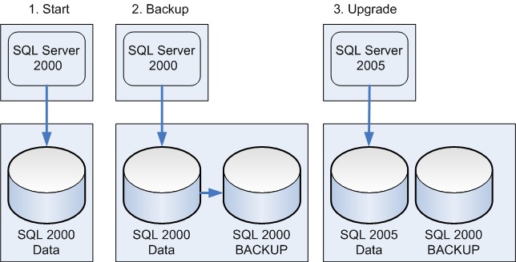
Figure 1 - Using an in-place upgrade with a VDI backup on a SAN.
In Step 1, all updates to the database are stopped to prepare for the backup.
In Step 2, the VLDB is cloned by using the SQL Server VDI interface. This forms the initial backup to be used in the event of a rollback. No updates are accepted to the database because they would not make it into the backup.
In Step 3, users are disconnected from the system during the upgrade process. When SQL Server 2005 completes its upgrade, database administrators apply other scripts, jobs, and components as required. After database administrators have tested and verified the upgrade, users are allowed back into the system, and the database begins accepting updates.
However, the resulting databases are in a SQL Server 2005 format and cannot be converted back to an earlier version. If the upgrade must be rolled back, SQL Server 2005 must be uninstalled and SQL Server 2000 reinstalled and reconfigured, then the databases restored from the SQL Server 2000 backup.
If cloning the SQL Server data on the SAN is not possible, an external tape system might also be used in place of the disk-based backup. Newer tape arrays, when used in parallel, can provide fast backups for large data sets. However, the tape backup and restore will not be as fast for backup and restore as the disk-based use of the SQL Server VDI.

Side-by-Side Upgrade and VLDB
In addition to the time required for a backup, in a side-by-side upgrade, you must also allow for the time required to copy the VLDB data files or not. In a normal side-by-side scenario, generally this will depend on whether there is sufficient free disk space on the same or a new SAN to support the data files.
Figure 2 shows a side-by-side upgrade scenario between two servers using the SAN cloning technology combined with attaching the data files.
Figure 2 - A side-by-side upgrade using the SAN cloning of SQL Server data files.
In Step 1, updates are stopped. In Step 2, the SQL Server 2000 data and log files are cloned to a new volume (LUN) on the SAN. The new SQL Server 2005 server has been built and is ready to connect to the SAN. In Step 3, the new SQL Server 2005 server connects to the SAN using the new volume. The SQL Server 2005 data files are attached to SQL Server 2005, the metadata is converted, and testing of the new server can begin. When the new instance is verified, users can connect to the new SQL Server 2005 instance.
In Figure 2’s scenario, two servers are assumed. If you are using just one server, an in-place upgrade would be more appropriate.
The major advantage of the above side-by-side approach is that you can run both systems in parallel and repeat the process during testing. The major disadvantage is that you must build the new server carefully. The more complex the database application is, the more time required for making sure the new SQL Server 2005 server will behave correctly.
You may also be able to combine transaction log backups and restore, or transactional replication, to shorten the time required for a cutover in a side-by-side upgrade. In Figure 2’s scenario, for example, instead of copying the data files and attaching them to the new server, you can make a backup of the original SQL Server 2000 VLDB and restore it to the new SQL Server 2005 server without recovery. Then at cutover time, you can apply SQL Server 2000 log backups in sequence to the SQL Server 2005 system, applying the last one with recovery. You might also use transactional replication from the SQL Server 2000 server to the SQL Server 2005 server. These techniques are discussed in Section 2.01, "Minimizing Upgrade Downtime."
The side-by-side upgrade method can also be used for upgrading server hardware. For example, suppose you want to upgrade your system from a 32-bit to a 64-bit server. You can use the same side-by-side steps shown in Figure 2.
A different strategy may be required if you are upgrading server hardware and there is insufficient free disk space on the SAN for a copy of the data. In that case, you can combine some features of a side-by-side method with a detach/attach data file method, as Figure 3 shows:

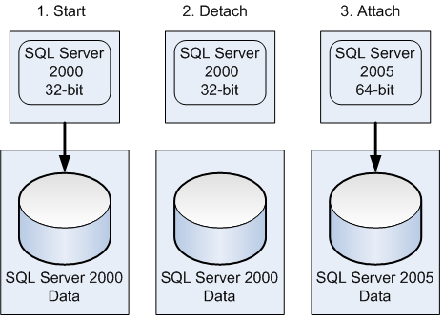
Figure 3 - A side-by-side upgrade from a 32-bit server to a 64-bit server using the SAN with detach/attach.
In Step 1, users are disconnected, and the VLDB has been backed up to an external tape array. A new 64-bit SQL Server has been built and is ready for deployment. In Step 2, the data files are detached cleanly from SQL Server 2000. The SAN volume is dismounted from the 32-bit SQL Server. In Step 3, the new 64-bit SQL Server is connected to the SAN, and the data volume is mounted. The VLDB data files are then attached to the 64-bit SQL Server. After testing and verification, users are allowed to connect to the 64-bit SQL Server.
This scenario is still a side-by-side upgrade because there are two servers involved and the upgrade process is manual. But it is somewhat like an in-place upgrade because there is no data transfer or copy involved. And it no longer has the capability of running two systems in parallel.
The key challenge for upgrading VLDB databases concerns the time required for backing up and potentially copying large amounts of data. If your SAN has sufficient free space for disk-based backups, you can meet these challenges with disk-based backups that use the SQL Server VDI on a SAN.
The in-place upgrade method using SQL Server 2005 Setup provides a significant advantage for VLDB databases. The size of a database does not affect the time that SQL Server takes to upgrade database metadata, so you can greatly reduce the time required for an upgrade.

Section 3.01: Upgrading Relational Databases to SQL Server 2005

Introduction
People currently using SQL Server 2000 or 7.0 have a number of options for upgrading relational databases to SQL Server 2005. The best approach depends on
- How the SQL Server 2000 or 7.0 instances and databases are deployed
- The level of database availability required during the upgrade
- The desired degree of upgrade testing

Relational Database Configurations
When deploying a SQL Server 7.0 relational database, customers could only install to a default instance of the database engine. When deploying a SQL Server 2000 database, customers could choose to install to a default instance or a named instance of the SQL Server database engine. Relational databases can be created in a clustered instance or can be log-shipped or replicated for availability or other reasons. Relational databases can also be enabled for full-text indexes. This section discusses upgrading relational databases in any of these configurations. However, special considerations are involved for relational databases that are part of a cluster, log-shipped, replicated, or enabled for full-text indexes. For specific information about upgrading these configurations, see the following sections:
- For upgrade issues specifically related to clustered relational database instances, see Section 2.02, “Upgrading Databases on Failover Clusters.”
- For upgrade issues specifically related to relational databases involved in log shipping, see Section 2.03, “Upgrading Log Shipping.”
- For upgrade issues specifically related to replicated relational databases, see Section 2.04, “Upgrading Replicated Databases.”
- For upgrade issues specifically related to full-text-enabled relational databases, see Section 3.04, “Upgrading Full-Text Catalogs.”
- For upgrade issues specifically related to MSDE, see Section 3.08, “Upgrading MSDE to SQL Server 2005 Express.”

Upgrade Considerations
The following upgrade issues should be considered:
- Always back up your databases before performing an upgrade.
- Only instances of SQL Server 2000 Service Pack 3 (SP3) or later and instances of SQL Server 7.0 SP4 or later can be upgraded to SQL Server 2005.
- To minimize potential problems when a relational database is upgraded to SQL Server 2005, the relational database retains its existing compatibility level (other than system databases, which have a 90 compatibility level). If a database is upgraded from SQL Server 7.0, it will have an initial compatibility level of 70, and if upgraded from SQL Server 2000, it will have an initial compatibility level of 80. Before you change the compatibility level of an upgraded relational database to 90, you must assess how such a change may affect your applications. For specific guidance, review the sp_dbcmptlevel topic in SQL Server 2005 Books Online.
- On a server containing multiple instances of the SQL Server database engine (SQL Server 2000 and/or SQL Server 7.0), each instance must be upgraded individually; upgrading one instance has no affect on other instances on the same server. From the SQL Server 2005 point of view, instances can be upgraded in any order and at any time.
- You cannot upgrade from a 32-bit edition of SQL Server 2000 or 7.0 to any 64-bit edition of SQL Server 2005, although databases from a 32-bit edition can be attached to a 64-bit edition of SQL Server 2005 and they will be automatically upgraded.
Note: There are significant tool upgrade issues to be aware of. For more information, see Section 3.07, “Upgrading Management Tools.”

In-Place Upgrade vs. Side-by-Side Upgrade
There are two fundamental ways to upgrade a relational database from SQL Server 2000 or 7.0 to SQL Server 2005: an in-place upgrade or a side-by-side upgrade.
- For issues related to planning and deploying an in-place or side-by-side upgrade, see Section 1.0, "Upgrade Planning and Deployment.”

In-Place Version Upgrade
An in-place upgrade is the quickest and simplest upgrade method because
- It upgrades all system and user database objects and settings for you.
- Client applications do not have to be updated to connect to a new instance of the relational database engine.
However, an in-place upgrade is an all-or-nothing approach. In the unlikely event that an in-place upgrade of the relational database engine fails, you cannot quickly roll back to SQL Server 2000 or 7.0 once the setup program finishes. There is a go/no-go point within the setup program before which you can simply cancel the upgrade. After this point, to roll back to SQL Server 2000 or 7.0 you need to
- Uninstall the SQL Server 2005 database engine.
- Reboot.
- Reinstall the previous version of the SQL Server database engine.
- Restore the system and user databases from database backups.
Downtime in the event of upgrade problems can be significant.
With an in-place upgrade, SQL Server 2005 Setup installs SQL Server 2005 on the server, switches the source SQL Server instance's services over to the new SQL Server 2005 instance, upgrades the databases in place, and then removes the SQL Server 2000 or 7.0 binaries. All system and user databases are upgraded along with the relational database engine. During actual database upgrades, users will not be able to access any relational databases on the SQL Server 2005 instance. After the in-place upgrade is complete, only the SQL Server 2005 relational database engine will remain. With an in-place upgrade, the upgraded databases and the database engine can be tested by the database administrator only after the SQL Server 2000 or 7.0 relational database engine is removed.

Side-by-Side Upgrade
With a side-by-side upgrade, the SQL Server 2005 relational database engine is installed as a second instance, and the SQL Server 2000 or 7.0 relational database engine remains installed. You then migrate (move or copy) one or more SQL Server 2000 or 7.0 user databases to the SQL Server 2005 instance (each migrated database is automatically upgraded). During the side-by-side upgrade process, users can continue to access the SQL Server 2000 or 7.0 relational database engine and its databases (which are unaffected by the migration process) while the new SQL Server 2005 server is being built. Once you are ready for the switchover to the new instance, users must stop activity on the older instance while you transfer databases to the new SQL Server 2005 server. Once the side-by-side upgrade is complete, the SQL Server 2005 relational database engine and the SQL Server 2000 or 7.0 relational database engines co-exist. After the SQL Server 2005 relational database engine is verified, you can allow applications to access the new server. Once in production, the SQL Server 2000 or 7.0 relational database engine can be uninstalled from the old server.
A side-by-side upgrade can require considerably more effort than an in-place upgrade. In an in-place upgrade, SQL Server 2005 Setup ensures that the new SQL Server 2005 instance has the same name as the old instance, and Setup automatically preserves server configuration and server objects, such as logins, SQL Agent jobs, and so on. In a side-by-side upgrade, you must perform all those tasks yourself, either manually or through scripting techniques.
With a side-by-side upgrade, you either install the SQL Server 2005 relational database engine as a new named instance on the same server or on a new server as either the default instance or a named instance.
- Same Machine – If you install a new instance of the SQL Server 2005 relational database engine on the same computer on which your existing version of the SQL Server relational database engine is installed, you must upgrade the operating system and SQL Server to the required service-pack level, and Setup also requires Microsoft Data Access Components (MDAC) 2.8 SP1 or later. In addition, SQL Server Setup will install Microsoft Windows .NET Framework 2.0, which is installed side-by-side with Microsoft Windows .NET Framework 1.1.
- Separate Machine – If your goal is to minimize any possible downtime due to the installation of these service packs and additional components or if you want to install the SQL Server 2005 relational database engine as a default instance, you must install the SQL Server 2005 relational database engine on a separate computer. Installing the SQL Server 2005 relational database engine on a separate computer also gives you the opportunity to update your computer hardware and possibly your computer software at the same time.
Licensing Note: With respect to licensing, if you install SQL Server 2005 on a separate computer or as a separate instance on the same computer as part of the migration and upgrade to SQL Server 2005, you have 60 days to complete the migration from the previous version (by removing the previous version) before you are out of licensing compliance.
Warning: A relational database that has been upgraded to SQL Server 2005 cannot be migrated back to a previous version of SQL Server. You might be able to extract the data out of the SQL Server 2005 instance, but if the upgrade fails due to a persistent issue such as disk corruption, you need to have a verified backup of your original databases to retrieve data from.
A side-by-side upgrade of the relational database engine simplifies a rollback process (should that be required) and may result in simpler testing scenarios (because both versions are available at the same time). A side-by-side upgrade lets you continue using the existing relational database environment until you are ready to switch over to the new relational database environment. This approach can help maximize the ability to quickly roll back to the prior instance should any difficulties arise.
However, a side-by-side upgrade is not as fast or simple as an in-place upgrade because of the extra effort required to transfer all server objects and redirect clients to the new instance. The side-by-side upgrade method does not upgrade any system databases. This means that the database objects in these databases (such as server logins, jobs, alerts, maintenance plans, user-defined error messages, and DTS packages) must generally be migrated separately and/or recreated manually. (You can use the Copy Database Wizard to assist you with migrating some of these objects.)
Important: If you continue using the SQL Server 2000 or 7.0 instance while you are testing an upgraded database in a SQL Server 2005 instance, the databases will not remain synchronized. Data changes made to the existing database will not be made to the upgraded database. To bring the SQL Server 2005 instance forward in time, you need to bring the data from the SQL Server 2000 or 7.0 instances forward by using some type of data transfer, such as data file detach and attach, transaction log backup and restore, or transactional replication.
Note: When you install a new instance of the SQL Server 2005 relational database engine and then migrate one or more user databases to this instance, you need to be aware that the following SQL Server 2000 and 7.0 relational database features are disabled by default in new installations: ad hoc distributed queries, OLE automation, SQL Mail, Web Assistant stored procedures, named pipes, and xp_cmdshell. To enable some or all of these features, use the SQL Server Surface Area Configuration utility and select Surface Area Configuration for Features.
If you want to use the side-by-side method of upgrading to the SQL Server 2005 relational database engine, there are several side-by-side methods for you to choose from. These include the following:
- Backup and restore
- Detach and attach
- Manual schema rebuild and data export/import
- Copy Database Wizard

Backup and Restore
You can upgrade a SQL Server 2000 or 7.0 relational database by performing a database backup of that database and then restoring it to a SQL Server 2005 relational database instance. You can create a database backup by using SQL Server Enterprise Manager or by executing a Transact-SQL script. You can then restore this database backup into the SQL Server 2005 relational database instance by using SQL Server Enterprise Manager or a Transact-SQL script. The database will automatically be upgraded as it is restored.
This side-by-side upgrade method lets you leave the SQL Server 2000 or 7.0 relational database online and available to users until you are ready to switch over to the upgraded database in the new SQL Server instance. Before switching over, be sure to perform post-upgrade compatibility and functionality testing and any necessary application modifications (such as connection string changes, modifications required by the database engine upgrade, and Transact-SQL changes).
The advantage of using the backup/restore method of a side-by-side upgrade is that the database backups are usually smaller in size than the original database files because the database backup process captures only actual database data, not reserved but unused database space—and does not back up the log file (other than the tail of the log file). This decrease in file size usually makes any file transfer across the network faster than trying to transfer the original data and log files (see the next two methods discussed in this section). You can also use third-party utilities to compress the backup before transferring across the network. However, the backup and restore upgrade method (to disk, but not to tape) does require more disk space than simply moving the underlying data and log files (but it ensures the ability to easily roll back if needed).
Note: With the backup and restore upgrade method and backing up to disk, you need to allow for the disk space needed for the original database files, the database backup file itself, and the new database files (after restoration).
Important: If you continue using the SQL Server 2000 or 7.0 instance while you are testing an upgraded database in a SQL Server 2005 instance, the databases will not remain synchronized. Data changes made to the existing database will not be made to the upgraded database. You will need to perform another backup/restore of the database when you are ready to switch over to SQL Server 2005.

Detach and Attach
You can also upgrade a SQL Server 2000 or SQL Server 7.0 relational database by detaching that database from its current relational database instance, moving or copying the underlying data and log files (if necessary), and then reattaching those data and log files to a SQL Server 2005 relational database instance. The database will automatically be upgraded as it is attached. If the data and log files were copied, the original data and log files can be reattached to the existing SQL Server relational database instance with only minimal disruption to the availability of the databases to be migrated. The detach and attach upgrade method has the safety advantage in that the current relational databases remain available until you are ready to switch over after performing post-upgrade compatibility and functionality testing and necessary application modifications (such as connection string changes, modifications required by the database engine upgrade, and Transact-SQL changes).
Note: Copying a data or log file with a significant amount of empty space takes just as much time as copying a data or log file with a little empty space. This means that it will generally be faster to use the backup and restore upgrade method with a database that is using data or log files that have a significant amount of empty space.
Important: If you continue using the SQL Server 2000 or 7.0 instance while you are testing an upgraded database in a SQL Server 2005 instance, the databases will not remain synchronized. Data changes made to the existing database will not be made to the upgraded database. You will need to perform another detach/attach upgrade of the database when you are ready to switch over to SQL Server 2005.
When moving a very large database (VLDB) from one instance to another on the same server, detach and attach can have the advantage of requiring less disk space than some of the other upgrade and migration methods if you simply reuse underlying data and log files rather than copying them. On systems using a SAN disk configuration, you can detach the SAN volume from the older SQL Server instance and then present it to the SQL Server 2005 relational database instance. These options will save disk space and may save database administrators from having to move the database files over the network. But they will eliminate the ability to roll back if the relational database upgrade should fail for any reason.
With a SAN disk configuration, you can also clone the disk volume while the original SQL Server relational database is online and then recreate that clone on another disk array, which can then be attached to the SQL Server 2005 relational database instance for upgrade. Database administrators with a SAN disk configuration should meet with their disk engineers to discuss possible methods for moving the database files without having to perform a copy over the network and without attaching the original files if possible.
Caution: It is recommended that you create a copy of the relational database file (or perform a backup) before attaching it to a new relational database instance for rollback purposes. Once you have attached a relational database file to SQL Server 2005, you cannot reattach it to an earlier version of the SQL Server relational database engine.

Manual Schema Rebuild and Data Export/Import
You can also upgrade a SQL Server 2000 or SQL Server 7.0 relational database by generating a database creation script for the database (by using SQL Server Enterprise Manager) and then executing the script in the desired SQL Server 2005 relational database instance. Once this is done, you can then manually copy the data from the original relational database to the new relational database by using Transact-SQL scripts, Data Transformation Services (DTS) packages, SQL Server Integration Services (SSIS) packages, BCP commands, or any number of other methods available to SQL Server database administrators for copying data from one database to another.
Most database administrators do not choose this method to upgrade their relational databases because it is primarily a manual process and provides few advantages over the side-by-side upgrade methods previously discussed. However, it does leave the current relational database online and enables you to schedule the upgrade at a convenient time (such as overnight or over a weekend). This upgrade method also enables you to modify database schema, clean up database data, and/or filter data being moved to the upgraded databases during the upgrade process.

Copy Database Wizard
You can also upgrade a SQL Server 2000 or 7.0 relational database by using the Copy Database Wizard. This wizard supports two migration methods:
- Detach and Attach – This method is identical to the detach and attach upgrade method previously discussed and lets you choose to move or copy the underlying relational database files after they are detached and automatically reattaches the detached files after a copy (and optionally after a failed move).
- SQL Management Objects (SMO) – This method is similar in concept to the manual schema rebuild and data export/import upgrade method previously discussed. This method uses SMO to read the definition of each database object in the relational database being migrated, without taking it offline, and then recreates each object in the destination database. It then creates and executes an SSIS package to transfer the data from the source table to the newly created destination table, recreating indexes and metadata.
Each of these methods enables you to automate and schedule the migration process at a convenient time. Each method within the Copy Database Wizard also enables you to select one or more of the following additional object types to migrate:
- Logins
- User stored procedures in the master database
- SQL Server Agent jobs
- User-defined error messages
With the Copy Database Wizard, you cannot copy extended stored procedures, alerts, DTS packages, or linked server configurations. These must be migrated manually.

Determining and Evaluating Potential Upgrade Issues
Regardless of whether you choose to perform an in-place upgrade or a side-by-side upgrade of a relational database, there are a range potential issues you may face during such an upgrade. To obtain a report that identifies many of these potential issues before you begin an upgrade, you should run SQL Server 2005 Upgrade Advisor to analyze the SQL Server 2000 or 7.0 relational databases that you want to upgrade. For more information about installing and running this tool, see Section 1.0, “Upgrade Planning and Deployment.” There is also a category of issues that either cannot be detected by Upgrade Advisor or the detection of the issue would result in too many false-positive results.
The following section discusses the most important upgrade issues, whether detected by Upgrade Advisor or not. For a more complete list of backward-compatibility issues, see the "Backward Compatibility" topic in SQL Server 2005 Books Online. For a complete list of the database engine upgrade issues detected by Upgrade Advisor, review the “Data Engine Upgrade Issues” topic in the SQL Server 2005 Upgrade Advisor Help file.

Issues Preventing an Upgrade
There are some settings that will prevent the SQL Server 2005 Setup program from starting the upgrade process for the database engine. The upgrade process will stop, and the legacy system will remain in place. You can use Upgrade Advisor to detect each of the issues in Table 1.
Table 1 - Issues That Will Prevent an Upgrade
Issue | Corrective Action
Username of sys in a database – SQL Server 2005 does not permit a username of sys in a database. | Create a new user with a different name, transfer ownership of all database objects to that new user, and drop the user sys from the database.
Duplicate login SIDs – SQL Server 2005 does not permit duplicate login SIDs for SQL Server authentication. | Drop and recreate the duplicate SQL Server logins on the legacy system.
Login names matching fixed server role names – SQL Server 2005 does not allow login names to match fixed server role names. | Rename the logins on the legacy system.
Database ID 32767 – SQL Server 2005 does not permit a database ID of 32767. | Detach and reattach the database and ensure that it gets a new database ID.
Duplicate index names – SQL Server 2005 does not permit duplicate index names on a table. | Rename the indexes so that all indexes are unique within each table.
If you are performing a side-by-side migration, only the username sys and the duplicate index names need to be corrected on the legacy system. SQL Server 2005 will prevent you from applying any of the other settings.
There some additional issues that will prevent the upgrade to SQL Server 2005 of a SQL Server 2000 or 7.0 relational database. You must resolve these issues before beginning an upgrade, or the upgrade will fail. Table 2 lists the most likely issues of this type along with the recommended corrective action.
Table 2 - Issues to Resolve Before Beginning the Upgrade Process
Issue | Corrective Action
Compressed drives – SQL Server 2005 cannot create or upgrade relational databases residing on compressed drives. | Verify that the relational databases to be upgraded do not reside or will not reside on compressed drives. READ-ONLY relational databases and files can be placed back on compressed drives after the upgrade is completed.
Read-only filegroups – SQL Server will not upgrade filegroups in relational databases set to READ_ONLY because non-writeable files will not be upgraded. | Ensure that all filegroups in relational databases scheduled for upgrade are set to READ_WRITE.
Disk space – Additional space is required for data files during an upgrade due to additional system metadata, 40 bytes per column required for large object columns, and the storage of a full-text mapping table for each full-text indexed table within the data file rather than in the file system. | During setup, ensure that each user database is set to autogrow and that the PRIMARY filegroup of each user database has sufficient disk space. Insufficient disk space will cause an upgrade to fail.
Named pipe naming – During the upgrade, the Setup program starts the SQL Server 2005 relational database engine with shared memory support, a named pipe that accepts only local connections. If the pipe name specified on the server is not blank, it must begin with “\\.\pipe\” to be valid. | If the pipe name is invalid, change it to a valid name.
Service Account – The SQL Server service must not be running under the Local Service or the Network Service account if SQL Server is running on a Windows 2003 domain controller. | Change the service account to Local System, a local user account, or a domain user account.

Discontinued Database Engine Functionality
There are a number of features from earlier versions of the SQL Server database engine that are not supported and that will require you to use a replacement feature. Table 3 lists the discontinued features you will be affected by most along the with recommended replacement feature.
Important: Backward compatibility with previous versions of SQL Server was a high priority in SQL Server 2005 so that in most cases applications will behave as in the past. See "Discontinued Database Engine Functionality in SQL Server 2005" in SQL Server 2005 Books Online for further information.
Table 3 - Discontinued Features and Replacement Features
Discontinued Feature/Functionality | Replacement Feature/Corrective Action
Sp_configure with the ‘allow updates’ option – Used to directly update system tables. Direct updates to system tables are no longer supported, and this option, although present, will have no effect. | Modify scripts that update system tables directly to use documented commands instead of direct updates.
Network Protocols – The NWLink IPX/SPX, AppleTalk, Banyan Vines, and Multiprotocol network protocols are no longer supported | Use TCP/IP sockets, named pipes, VIA, or shared memory.
Rebuildm.exe – Used for rebuilding system databases. This executable is obsolete. | This executable is replaced by the REBUILDDATABASE option in setup.exe. Modify any scripts that use the rebuildm.exe executable.
Sample Databases – The Northwind and Pubs sample databases have been discontinued. | These are replaced by the AdventureWorks and the AdventureWorksDW sample databases. Northwind and Pubs can be downloaded or migrated/upgraded from a SQL Server 2000 or 7.0 instance.
Remote setup – Used to install SQL Server on a remote computer. This option is no longer available in the setup program. | Use a remote connection to run the SQL Server Setup program on the remote computer.
Named pipe backup devices – No longer supported. | Contact your backup vendor to see if it has a new version that supports VDI (the replacement for named pipes). Alternatively, you can use the native tools of SQL Server to back up to disk or tape.
Mail attachments using SQL Mail – No longer supported. | Use Database Mail to send mail attachments.

Behavioral Changes That May Require Corrective Action
There are a number of behavior changes that may require corrective action after the upgrade is complete. Table 4 lists the objects of this type that you will be affected by most along with the recommended corrective action.
Important: Backward compatibility with previous versions was a high priority so that in most cases applications will behave as in the past.
Table 4 - Behavioral Changes That May Require Corrective Action
Behavior Change | Corrective Action
Log file disk space – Additional space is required by transaction log files. | Ensure that the log files for each user database are either set to autogrow and have sufficient additional disk space or increase the size of each log file manually. Monitor the impact of workloads on transaction log space after upgrade.
tempdb disk space – Additional space is required by tempdb data and log files due to its use by new features and enhancements to existing features. | Ensure that the data and log files for tempdb are either set to autogrow and have sufficient additional disk space or increase the size of each file manually. Monitor the impact of workloads on data and log space after upgrade.
Extended stored procedures – Extended stored procedures that were previously registered without a full path for the DLL name may fail because the old BINN directory is not added to the new path during upgrade. | Drop the extended stored procedure by using the sp_dropextendedproc, and then register the extended stored procedure with the full path name by using using the sp_addextendedproc.
Dbo-owned objects – System objects are now owned by sys rather than dbo. | Modify scripts containing statements that query system tables or have search criteria specifying dbo.
Note: The above table lists general behavior changes in SQL Server 2005 related to relational databases. For additional behavioral changes specific to a relational technology, see the remaining relational database-related sections.

Preparing for an Upgrade
Before beginning the actual relational database upgrade, regardless of type, there are a number of steps that you should take to prepare for the upgrade and a possible rollback.
Important: It is recommended that you perform a test run of a side-by-side upgrade for any critical database to enable extensive application testing before doing an actual upgrade visible to the online application. This enables you to perform any modifications necessary to the application environment in the test environment for verification. If this is not done, and a rollback to the prior version is then performed, it could be embarrassing to the IT group.

Preparing for an In-Place Version Upgrade
You should take the following steps to prepare for an in-place upgrade of an instance of the relational database engine and its databases:
- Verify that SQL Server 2005 hardware and software requirements are met. If you do not meet these requirements, the System Configuration Checker (SCC) portion of the SQL Server Setup program will not permit setup to continue.
- Run Upgrade Advisor to analyze installed SQL Server 2000 or 7.0 relational engine components, as Figures 1 and 2 show. And then review the generated report, as Figure 3 shows, to verify that you have addressed all issues that must be resolved before the upgrade and that you understand the upgrade issues that you must resolve after setup completes.
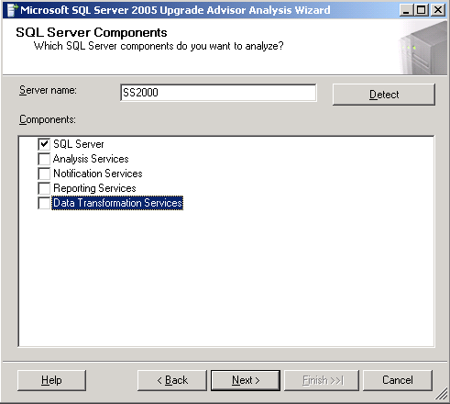
Figure 1 – Selecting Components to Analyze
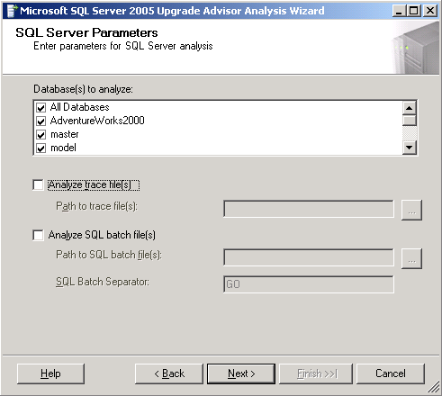
Figure 2 – Selecting Parameters for Database Analysis
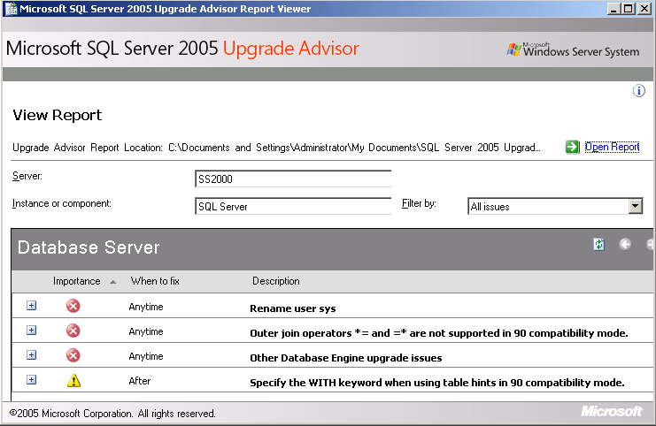
Figure 3 – Viewing Upgrade Advisor Report
- Back up all system and user databases to ensure that you can roll back the upgrade if necessary.
- Run DBCC CHECKDB on all databases to ensure that they are in a consistent state.
- Configure the system databases for autogrow and ensure that they have sufficient hard disk space. Additional disk space is required for the system databases in SQL Server 2005 due to changes in system database schema. Autogrow can be turned off after the upgrade is completed.
- Ensure that each user database is set to autogrow and that the PRIMARY filegroup of each user database has sufficient disk space. Additional disk space is required to allow for the additional space required for the PRIMARY filegroup when installing SQL Server 2005. Autogrow can be turned off after the upgrade is completed.
- Ensure that the log file for each user database is set to autogrow and has sufficient additional disk space. Additional space is required by transaction log files of user databases. Autogrow can be turned off after the upgrade is completed.
- Set the AUTO_UPDATE_STATISTICS option to ON for each database before upgrading to SQL Server 2005 (or run UPDATE STATISTICS after the upgrade is complete rather than wait until the first query hits old statistics). By setting the AUTO_UPDATE_STATISTICS option to ON, all statistics are updated when they are first referenced.
- Disable all startup procedures because they may block the upgrade process. Disabled startup procedures can be re-enabled after the upgrade is completed.
- Disable all trace flags before upgrading to SQL Server 2005. Some SQL Server 2000 and 7.0 trace flags do not exist in SQL Server 2005, and some trace flags have different functionality in SQL Server 2005. If you use trace flags, after the upgrade you should verify that the trace flag has not changed before enabling any previously used trace flags.
- Stop replication, and make sure that the replication log is empty.
- Prune backup history tables in the msdb database to save time during the upgrade (excessively large backup history tables can slow the upgrade process).
- Quit all applications, including all services with SQL Server dependencies. Upgrades may fail if local applications are connected to the instance being upgraded.

Preparing for a Side-by-Side Upgrade
You should take the following steps to prepare for a side-by-side upgrade (the steps will vary somewhat based on the side-by-side method selected):
- Run Upgrade Advisor to analyze the database(s) you want to upgrade, as Figure 4 shows, and then review the generated report to verify that you have addressed all issues that must be resolved before the upgrade and that you understand the upgrade issues that you must resolve after setup completes.
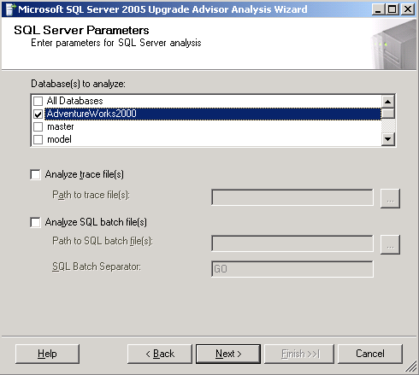
Figure 4 – Selecting Parameters for Database Analysis
- Run DBCC CHECKDB on the databases to be upgraded to ensure that they are in a consistent state.
- Ensure that the user databases to be upgraded are set to autogrow and that the PRIMARY filegroup of each user database has sufficient disk space. Additional disk space is required to allow for the additional space required for the PRIMARY filegroup when installing SQL Server 2005. This option can be turned off after the upgrade is completed.
- Ensure that the log file for each user database is set to autogrow and has sufficient additional disk space. Additional space is required by transaction log files of user databases. This option can be turned off after the upgrade is completed.
- Set the AUTO_UPDATE_STATISTICS option to ON before upgrading to SQL Server 2005. Statistics are not upgraded as part of the upgrade process, and relying on statistics from previous SQL Server releases may result in suboptimal query plans. By setting the AUTO_UPDATE_STATISTICS option to ON, all statistics are updated when they are first referenced.
- Ensure that you have current, verified database backups before actually starting the backup process. If you plan to use a detach/attach method, you should back up the data files as well.

Performing an In-Place Upgrade
You should take the following steps to perform an in-place upgrade of a relational database:
- Start the SQL Server 2005 Setup program.
- Install required SQL Server 2005 components.
- Select SQL Server Database Services and any other desired components, such as Workstation Components, Books Online, and Development Tools.
- Select default or named instance.
- Specify the appropriate service account.
- Specify the logon account information if the instance being upgraded is configured to use Mixed Mode authentication.
Note: All system and user databases will be upgraded automatically by the in-place upgrade process.

Performing a Side-By-Side Upgrade
You should take the following steps to perform a side-by-side upgrade of a relational database using one of the side-by-side upgrade methods discussed in this section.

Install the New Instance
Install the SQL Server 2005 relational database instance to which you plan to upgrade the SQL Server 2000 or 7.0 relational database. If performing a side-by-side upgrade on the SQL Server 2000 or 7.0 instance of the database engine, make sure to specify a named instance during install so as not to overwrite the current instance.
Note: In some cases, you may want to copy the system databases, including the master database, from the source SQL Server 2000 instance to the SQL Server 2005 instance before transferring user databases. See the topic "Moving System Databases" in SQL Server 2005 Books Online to see how to do this.

Upgrade the User Database to a SQL Server 2005 Relational Database Instance
The steps to upgrade the SQL Server 2000 or 7.0 database to a new SQL Server 2005 relational database instance depend on the side-by-side upgrade method chosen.

Detach/Attach Upgrade Method
Take the following steps to upgrade a user database by using the detach/attach upgrade method:
- Detach the database to be migrated from the SQL Server 2000 or 7.0 instance by using SQL Server Enterprise Manager, SQL Server Management Studio, or the sp_detach_db stored procedure.
- Copy (or move) the detached data file(s) and log file(s) to the new server.
- Attach the copied data and log files to the SQL Server 2005 instance using SQL Server Management Studio or the CREATE DATABASE Transact-SQL statement with the FOR ATTACH or FOR ATTACH_REBUILD option.
- Optionally, if you copied the original data and log files, re-attach the original data and log files to the previous instance of SQL Server.
Important: Master and msdb database objects related to the database being upgraded (e.g., logins, jobs, alerts) must be manually migrated to the SQL Server 2005 instance.

Backup/Restore Upgrade Method
Take the following steps to upgrade a user database by using the backup/restore upgrade method:
- Back up the database to be migrated from the SQL Server 2000 or 7.0 instance by using either SQL Server Enterprise Manager or the BACKUP DATABASE Transact-SQL statement.
- Use SQL Server Management Studio to connect to the SQL Server 2005 relational database instance to which you want to restore the SQL Server 2000 or 7.0 relational database.
- Restore the relational database from the backup file, changing the database or file names and locations as necessary.
Important: Master and msdb database objects related to the database being upgraded (e.g., logins, jobs, alerts) must be manually migrated to the SQL Server 2005 instance.

Copy Database Wizard Upgrade Method
Take the following steps to migrate and upgrade a user database by using the Copy Database Wizard upgrade method:
- Ensure that you have the required permissions on the appropriate servers.
- For the detach and attach method, you must be a member of the sysadmin fixed server role on both the source and destination servers.
- For the SMO transfer method, you must be a database owner for the source database and must either have been granted the CREATE DATABASE permission or be a member of the dbcreator fixed server role on the destination server.
- Specify the source and destination servers.
- Specify the databases to be moved or copied.
- For the detach and attach method, active sessions must not exist when the copy or move operation is attempted, or the Copy Database Wizard does not execute the move or copy operation.
- For the SMO transfer method, active connections are allowed because the database is never taken offline.
- Specify the name of the target database, if different from the source database.
- Specify other objects to be moved, such as logins, shared objects from the master database, jobs, maintenance plans, and user-defined error messages.
- Specify a schedule for the copy or move operation, if you want it scheduled for a later time.
- If you are not a member of the sysadmin fixed server role, you must specify a SQL Agent Proxy account that has access to the SSIS package execution subsystem.
Important: Certain master and msdb database objects related to the database being upgraded (such as backup devices, linked server definitions, and alerts) must be manually migrated to the SQL Server 2005 instance.

Post-Upgrade Tasks
You should take the following steps after performing an upgrade of a relational database to ensure that the upgrade ran smoothly and to configure the relational database engine as well as the upgraded relational database:
- Execute DBCC UPDATEUSAGE on all attached databases to update usage counters to ensure that correct values exist for table and index row counts.
- Execute DBCC CHECKDB WITH DATA_PURITY to check the database for column values that are not valid or are out of range. Once DBCC CHECKDB WITH DATA_PURITY has been run successfully against an upgraded database, DBCC CHECKDB checks column-value integrity by default.
- Configure your new SQL Server installation. To reduce the attackable surface of a newly installed instance of SQL Server 2005, only key services and features are activated.
- Ensure that the relational databases are working correctly by executing a sample set of queries.
- Update any scripts affected by SQL Server 2005 behavior changes.
- If a side-by-side upgrade was performed:
- Update logins in the master database for the upgrade relational database.
- Configure jobs for the upgraded relational database.
- Configure alerts for the upgraded relational database.
- Configure DTS/SSIS packages related to the upgraded relational database.
- Update connection strings at clients so that they can connect to the new instance, unless you are replacing the old server with the new server with the same identity.

Connecting Client Applications to SQL Server 2005
Table 5 describes issues that may affect client applications connecting to a SQL Server 2005 relational database instance.
Table 5 – Issues That May Affect Client Connections
Issue | Description
Network protocols | The only supported network protocols are now TCP/IP Sockets, Named Pipes, VIA, or shared memory. If your application is using network protocols that are not in this list, it will not work.
SQL-DMO-based WMI providers | If your application uses DMO-based management APIs, you must upgrade to either the SMO-based management APIs or the WMI for Configuration management APIs. SMO is written using the managed code APIs. WMI for Configuration is written using non-managed code APIs.
DB-Library | Before SQL Server 7.0, the primary mechanism for client-server communication between SQL Server and client applications was DB-Library (DB-LIB). Although DB-LIB was still included with SQL Server 2000, Microsoft made it clear that it was being deprecated. With the release of SQL Server 2005, DB-LIB support is limited to SQL Server 7.0 features.
Network communication | Network communication may be disabled by default in new SQL Server 2005 installations and must be enabled through the Server Network Communication tool.

Section 3.02: Upgrading Database Security

Introduction
The number of security factors affecting the upgrade of the SQL Server relational engine is not large, and for most systems, the changes will be almost invisible. Almost all the existing SQL Server security configurations will upgrade automatically without intervention by the database administrator. In this section, you'll learn more about security-related upgrade issues for the database engine.

New Security Features and Upgrading
Security in SQL Server 2005 has been enhanced and strengthened. Your database administrator must remove any blocking issues and follow up in newly upgraded environments to make use of the security enhancements in SQL Server 2005. If you address these issues early, your upgrade experience will be much smoother.

SQL Server 2005 Security Features
Table 1 gives a general summary of the new security features in SQL Server 2005 and how they may affect the upgrade process from SQL Server 2000 or 7.0 to SQL Server 2005.
Table 1 – SQL Server 2005 Security Features
New SQL Server 2005 Security Features | Benefit | When Available | Affects the Upgrade Process
Services and configurations  "off by default" | Greater security at install time | Immediately after upgrade | No (for in-place);  Yes (for side-by-side)
Metadata visibility configuration | Less exposed surface area | Immediately after upgrade | Yes
Strong password policies for SQL Server authentication | Integrated Windows and SQL Server behavior | Immediately after upgrade (requires Windows 2003) | No
All permissions grantable | Permissions easier to manage and more granular | Immediately after upgrade | No
User/schema separation | No recording when staff change, separates dbo and developers | Immediately after upgrade | No
Keys and encryption | Compliance with privacy requirements, secure communications | Minimal work to leverage | No
Execution context,  signed procedures | Principle of least privilege, audit ability | Design and architect | No
As you can see from the table, the new security features that can affect your upgrade arise from the enhanced security of having features and services "off by default" and by strengthened metadata visibility. The other features imply enhancements that you can take advantage of after your upgrade, but they will not block or impede the upgrade process.
Note: In an in-place upgrade, SQL Server 2005 Setup will preserve the services settings of the SQL Server instance you are upgrading. If you are using a side-by-side method, you need to configure the SQL Server 2005 services to match the settings of your source SQL Server instance.

The Surface Area Configuration Tool
The SQL Server 2005 Surface Area Configuration tool lets you configure SQL Server services as well as configuration settings.
When you install SQL Server 2005, if you do not explicitly enable certain services and configurations, they will be off by default. You need to review your SQL Server 2005 installation plan to make sure that any components required by current applications are installed or enabled. You can change these defaults at installation time or afterward by using the SQL Server Surface Area Configuration tool. The tool has two independent components:
- Surface Area Configuration for Services and Connections
- Surface Area Configuration for Features

Configuring Services and Connections
The Surface Area Configuration for Services and Connections component lets you configure SQL Server 2005 services and (when relevant) remote connections. If you use an in-place upgrade, SQL Server 2005 Setup will preserve your source SQL Server instance's service configurations. However, if you use a side-by-side upgrade, you may need to adjust the default service settings.
Table 2 lists the SQL Server 2005 services and their default status after an initial installation.
Table 2 – SQL Server 2005 Services’ Default Status After Installation
SQL Server 2005 Service | Explanation | Initial Service State (if installed)
MSSQLSERVER | Database engine service | Enabled by default
MSSQLServerOLAPService | Analysis Services service | Enabled by default
ReportServer | Reporting Services service | Enabled by default
SQLSERVERAGENT | SQL Server Agent service | Manual startup
MSFTESQL | SQL Sever Full Text Search service | Enabled by default
MsDtsServer | SQL Server Integration Services (SSIS) service | Disabled
SQLBrowser | SQL Server Browser service—provides information about multiple instances | Disabled
MSSQLServerADHelper | Enables integration with Active Directory | Disabled
SQLWriter | Supports Windows Volume Shadow Copy for backup and restore | Disabled
The new services are the SQL Server Browser service (now separated from the SQL Server service), the MsDtsServer (SSIS) service, and SQL Writer. SQL Server 2005 now includes an instance-specific full-text service, and no longer uses the MS Search service.
Some of these services may be optional for your instance. You can enable and disable these services depending on the function that your SQL Server instance has. You should review these new service accounts and the security requirements of the service accounts before attempting an upgrade to SQL Server 2005. Use the principle that if a service is not needed, it should be disabled. You can also enable and disable remote connections from many of the services.

Service Account Security
Unlike SQL Server 2000 and 7.0, service accounts in SQL Server 2005 do not require local server administrative rights on the database server.
You should assign domain accounts to each SQL Server service and not use the Local System or Network Service accounts. If you create the accounts ahead of time, the SQL Server 2005 Setup program will grant the minimal privileges to the accounts for the services to run properly.
Note: Although the Network Service account has low privileges, it is used by other services and, therefore, violates isolation guarantees.
For details about the Windows security settings and Access Control List (ACL) settings required for each SQL Server 2005 service, see the topic “Setting Up Windows Service Accounts” in SQL Server 2005 Books Online at ms-help://MS.SQLCC.v9/MS.SQLSVR.v9.en/instsql9/html/309b9dac-0b3a-4617-85ef-c4519ce9d014.htm.

Configuring Features
The Surface Area Configuration for Features component lets you interactively set many of the same server options that you will find in the system stored procedure sp_configure for the database engine, as well as configuration options for Analysis Services.
The database engine configuration features are as follows:
- Ad hoc remote queries
- CLR integration
- DAC (Remote use of the Dedicated Administrator Connection)
- Database Mail
- Native XML Web services (if HTTP endpoints are defined)
- OLE automation
- Service Broker
- SQL Mail
- Web Assistant stored procedures
- xp_cmdshell
All of these options are off by default with a new installation, although the DAC on clusters will have remote use enabled by default. The purpose of having these options off by default is to reduce the potential attack surface of a new installation. You can selectively enable these options as required for your SQL Server 2005 instance.
For more information about using the SQL Server 2005 Surface Area Configuration tool, see the relevant sections in SQL Server 2005 Books Online.

Metadata Visibility
SQL Server 2005 has an entirely new approach to metadata. And although it does have mechanisms to preserve backward compatibility, there are some important behavioral changes.
The most important change is probably the limitation on viewing metadata. Access to catalog views and system metadata is no longer available by default to guest users or members of the public role. This restriction is also reflected in users' ability to inspect metadata using SQL Server Management Studio. You can see SQL catalog metadata for objects you own or have some permission on, and you can see information in dynamic management views if you have been granted the VIEW SERVER STATE permission.
Further, in SQL Server 2005, the base system tables are hidden. For backward compatibility, SQL Server exposes legacy system base tables as views called compatibility views. They expose the same metadata as the legacy versions but are read-only. For example, in SQL Server 2000 and 7.0, sysindexes is a table in each database, but in SQL Server 2005, sys.sysindexes it is a compatibility view.
Note: Some compatibility views have behavioral changes that differ from the legacy system tables. The rowmodctr column in the sys.sysindexes compatibility view, for example, displays values somewhat differently from the way the sysindexes system table does in prior versions of SQL Server. For more information, see “sys.sysindexes” in SQL Server 2005 Books Online.
If you have code that continues to refer to legacy system tables, some behavior will change. You cannot update system base tables, and therefore you cannot update compatibility views. If you have any code that updates system base tables in a prior version of SQL Server, you need to remove it because the code will fail in SQL Server 2005.
In addition, some code will not work if it accesses undocumented tables or columns in system objects. For example, the following security-related columns in compatibility views will return NULL or 0 in SQL Server 2005:
- syscomments.ctext
- syslogins.password
- sysremotelogins.status
- sysoledbusers.rmtpassword

Security Issues Preventing an Upgrade
There are three security-related issues that will be detected by the SQL Server 2005 Setup program that will prevent an in-place upgrade from starting. In a side-by-side upgrade, they are still blockers but can be dealt with slightly differently. Table 3 lists the blocking security issues.
Table 3 – Security Issues That Will Block an Upgrade
Blocking Issue | Explanation
User name of sys. | The database being upgraded cannot have a user with the name of sys. The sys name is reserved in SQL Server 2005, and any database user with this name must be renamed before starting the upgrade process.
Duplicate login SIDs. | SQL Server 2005 does not allow duplicate security identifiers (SID). Database administrators must remove one of the logins and its associated users with a duplicate SID before starting the upgrade process.
Login name that is the same as a fixed server role. | Fixed server role names are reserved in SQL Server 2005. You must rename the login before starting the upgrade process.
In the case of a side-by-side upgrade, a user name of sys in a system database (master, model, and msdb) will block the upgrade, and you must remove the user name before the upgrade process.
If you have a user named sys in a user database, the attach process will result in a suspect database. You will have to bring the database online in single-user mode, transfer objects owned by that user name to a new user name, and drop the user name. For more details, see "Rename user sys" in the Upgrade Advisor Help file. You will not be able to create logins on a new SQL Server 2005 instance that have duplicate SIDs or that match fixed server role names.

Discontinued Security Features
A number of security features are discontinued in SQL Server 2005, and you will need to adjust your application accordingly, or it will not work properly. Many of these issues you can address before the upgrade process, but in any case, they will not block an upgrade. Table 4 lists the currently documented discontinued features that are security-related.
Table 4 – Discontinued Security-Related Features
Discontinued Feature | Explanation
Remote logins no longer trusted | SQL Server 2005 no longer supports setting remote logins as trusted. Scripts using the sp_remotelogin system stored procedure to mark remote logins as trusted must be modified.
Network libraries no longer supported: Multiprotocol, Banyan VINES, AppleTalk, and IPX/SPX (see note below) | Change the network library for connections to use TCP/IP (preferred) or named pipes. Data transmission encryption can be accomplished by using a certificate and SSL.
Remove references to security-related undocumented system stored procedures | The following security-related system stored procedures do not function in SQL Server 2005:  xp_eventlog  xp_GetAdminGroupName  xp_GetFileDetails  xp_GetLocalSystemAccountName  xp_IsNTAdmin  xp_MSLocalSystem  xp_MSnt2000  xp_SetSecurity
Remove references to the sysxlogins table | Replace references to sysxlogins in SQL Server 2005 with references to the sys.server_principals catalog view or syslogins compatibility view.
Column-level permissions on system objects | Remove statements from your application that grant, deny, or revoke column-level permissions on system objects. These are not supported in SQL Server 2005.
SQL Mail and mail attachments | SQL Mail in SQL Server 2005 no longer supports attachments. Use Database Mail for attachments.
Unconverted SQL Server 6.5 passwords | SQL Server 6.5 logins that were upgraded but never activated on SQL Server 2000 or 7.0 must have their passwords reset to function on SQL Server 2005. Password hashes from SQL Server 6.5 are saved in a format that is no longer supported in SQL Server 2005.
Winsock Proxy configuration | SQL Server 2005 cannot configure Windows components.
Note: The SQL Server service will not start if it fails to listen on at least one network protocol or if there are errors related to SSL communication. If such failures occur, SQL Server will log an error message to the SQL Server error log indicating the problem.

Behavioral Changes That May Require Corrective Action
Finally, there are a number of security-related features that will not cause an error but nevertheless have a different type of behavior. You need to address these issues as well because the behavior change might lead to user complaints. Table 5 lists these behavioral changes.
Table 5 – Security-Related Behavior Changes in SQL Server 2005
Security Feature Behavior Change | Explanation
By default, system metadata is no longer viewable by PUBLIC. | By default, access to virtual tables and system metadata is no longer available to guest users or members of the public role. Scripts and processes that view system metadata in virtual tables or system objects should be modified accordingly or sufficient permissions granted to the person or process running the scripts.
The ALL permission is deprecated. | Database administrators can no longer use the ALL permission to grant all object or statement permissions to a user. Scripts assigning permissions to users will need to be reviewed and this grant modified.
Case-sensitive passwords are required. | Case-insensitive password comparisons are no longer supported. Users and applications using SQL Server authentication must be modified to use case-sensitive password submissions.
Metadata visibility permission strengthened. | SQL Server 2005 requires that users have the VIEW SERVER STATE or VIEW DATABASE STATE permission to access dynamic management views and must have VIEW (ANY) DEFINITION for system catalog metadata.
Application roles are constrained to a given database. | Application roles cannot read data from dynamic management views (DMVs) and cannot read server-level metadata in compatibility views.
Schema names shown in INFORMATION_SCHEMA views. | SQL Server 2005 schema names are now returned in the schema column of INFORMATION_SCHEMA views, not user names.
Additional permission requirement for sp_changeobjectowner. | Users executing the sp_changeobjectowner system stored procedure must also have the CONTROL permission set for target objects as well as membership in the db_ddladmin and db_securityadmin fixed database roles.
Permission for sp_addtype strengthened. | Users must be a member of the db_ddladmin or the db_owner fixed database role to execute permission the sp_addtype system stored procedure.
Permissions for BCP strengthened. | Users must have the ALTER permission in addition to the INSERT and SELECT permissions to insert data into a table if they disable CHECK constraints on the target table. Disabling CHECK constraints is the default BCP behavior.
User ID range expanded. | SQL Server 2005 allows user IDs in the range [16400-32767], which was not allowed in prior versions of SQL Server. Modify any code that makes assumptions about user ID numbers.

Metadata Visibility Issues
There are a number of behavioral changes related to metadata visibility that can affect your upgraded applications.
- User access to metadata about other users' objects. By default in SQL Server 2005, users do not have visibility to metadata about each other's objects. A given user cannot see catalog view metadata about objects belonging to other users unless the user is privileged or has explicit permissions granted, such as CONTROL, IMPERSONATE, ALTER, or VIEW DEFINITION. You can write a DDL trigger to automatically grant those permissions to users when they are newly created.
- Users cannot see each other's metadata. A given least-privileged user cannot see the metadata of other least-privileged users. For example, a least-privileged user User1 cannot GRANT permissions to a second user User2 because the second user is not visible to User1 in the sysusers view. You can write a DDL trigger to automatically grant VIEW DEFINITION permission on newly created users if you want to override this behavior.
- Metadata visibility and ownership chaining. Even if a user has access granted to execute a stored procedure that inserts into another user's table, that user will not be able to view metadata about that table from sysobjects where xtype = 'U' or the sys.tables catalog view.
For example, suppose you have a stored procedure that inserts data into a table and also makes a call to a metadata view, as the following code shows.
CREATE PROCEDURE S1.P
AS
INSERT INTO S1.T VALUES (1,1)
-- Metadata call
SELECT * FROM sys.tables WHERE OBJECT_ID = OBJECT_ID('S1.T')
RETURN
User1 owns schema S1 and creates a table T in schema S1. User1 grants EXECUTE on the procedure S1.P to User2. When User2 executes P, the INSERT will succeed, but the SELECT will not return any rows because User2 by default does not have visibility to User1's metadata. Ownership chaining does not apply to metadata views.
To work around this restriction, you can grant callers of the stored procedure VIEW DEFINITION to the table, or use a certificate-signed procedure and grant VIEW DEFINITION to the certificate user. For example, suppose that User1 next executes
GRANT VIEW DEFINITION ON OBJECT :: S1.T TO User2
Now when User2 executes S1.P, the SELECT from sys.tables will return the expected row because User2 has been granted visibility to the metadata for table S1.T.
- By default, the VIEW ANY DATABASE permission is granted to the PUBLIC role. Therefore, any user can see a list of all databases from the sysdatabases compatibility view or the sysdatabases catalog view. To make even the existence of a database not visible to users, revoke the VIEW ANY DATABASE permission from public and selectively grant it to users requiring it. A user can always see the databases owned by that user in sysdatabases, and members of the sysdamin server role can always see all databases. The master and tempdb databases are always visible in sysdatabases to all users.
- User-schema separation and deprecated system stored procedures. Once you upgrade to SQL Server 2005, users and schemas are no longer implicitly connected. This can cause differences in metadata results only if you start using the new user-schema features such as CREATE USER and CREATE SCHEMA DDL. Your upgraded applications will continue to function correctly only as long as you stick to the old SQL Server 2000 APIs such as sp_adduser. In SQL Server 2005, a given user can own two tables with the same name that exist in separate schemas belonging to that same user—something not possible in earlier versions of SQL Server. The catalog view sys.sysobjects will reflect that there are two tables for that user, whereas in earlier versions of SQL Server, only one row would be returned. For example, suppose a user named Test owns two schemas: S1 and S2. User Test can create a table in each schema called T. User Test inspects sysobjects for that table, using the query
select * from sysobjects where name = 'T' and uid = USER_ID('Test')
In SQL Sever 2000, the query could return only one row. Because user and schema were implicitly connected, a user could own only one table named T. However, in SQL Server 2005, the query will return two rows—one for each schema S1 and S2.

Reversing Metadata Visibility Limitations
If your application demands it, you can reverse the limitations on metadata visibility and restore behavior similar to that of SQL Server 2000 and 7.0. You can increase the permissions for the PUBLIC role by executing following statements:
GRANT VIEW ANY DEFINITION TO PUBLIC
GRANT VIEW SERVER STATE TO PUBLIC
The result will be that any user will be able to see the compatibility views but also all the new metadata through dynamic management views (DMVs) and functions (DMFs).

Reversing Application Role Restrictions
You can also expand the permissions available for an application role, if required, by using the trace flag 4616 or certificates and signed modules.
- For more information about using the trace flag, see "Troubleshooting Metadata Visibility" in SQL Server 2005 Books Online. (The RTM and December refresh of SQL Server 2005 Books Online incorrectly lists this trace flag as 1416.)
- For more information about using certificates and signed modules, see the Microsoft article 906549 at http://support.microsoft.com/kb/906549/.

Deprecated Security Features
Some security-related features are deprecated and will be removed in a future version of SQL Server. These features will be discontinued, but they continue to operate in SQL Server 2005. They have no immediate effect on your upgrade to SQL Server 2005, but they will have an effect on your upgrade to a later version.
For more information about these features, see the tables in the “Deprecated Database Engine Features in SQL Server 2005” topic in SQL Server 2005 Books Online at ms-help://MS.SQLCC.v9/MS.SQLSVR.v9.en/instsql9/html/c10eeaa5-3d3c-49b4-a4bd-5dc4fb190142.htm. In each table, you can find the security-related features by scanning the leftmost column and looking for “Security.”
The first table covers features that will not be supported in the version of SQL Server after SQL Server 2005; these are primarily stored procedures related to roles. In addition, the SETUSER command will be removed, and you should replace it with the EXECUTE AS command.
The second table details features that will not be supported in some future version later than the version after SQL Server 2005. The list consists primarily of system stored procedures that are now replaced by Transact-SQL commands. For example, sp_adduser and sp_dropuser can be replaced by CREATE USER and DROP USER, and SETUSER is replaced by EXECUTE AS. These procedures are deprecated because they do not work with user/schema separation. As soon as you take advantage of new security commands such as CREATE USER and CREATE SCHEMA, you should also switch from using compatibility views such as sysobjects and use catalog views such as sys.objects instead.
Database administrators wanting to understand these security upgrade issues should review the SQL Server 2005 Books Online article “SQL Server 2005 Database Engine Backward Compatibility” at ms-help://MS.SQLCC.v9/MS.SQLSVR.v9.en/instsql9/html/10de5ec6-d3cf-42ef-aa62-1bdf3fbde841.htm.

Pre-Upgrade Security Tasks
The following is a suggested list of security-related tasks you should accomplish before upgrading the relational engine to SQL Server 2005. They should be incorporated into your upgrade plan.
- Assess the Current Database Security. Start by assessing the security level of your current system. Make an inventory of the security features for each legacy server, including:
- Type of authentication (Windows only or Windows and SQL Server)
- Vulnerability of passwords (for SQL Server authentication)
- Results of Microsoft Baseline Security Analyzer (MBSA) or equivalent
- Privileges of service accounts
- Use of xp_cmdshell
- Required auditing
SQL Server 2005 has made enhancements to SQL Server login passwords. Database administrators creating and maintaining SQL Server logins now have the ability to apply the local Windows password policy to their SQL Server logins, if the SQL Server is running on Windows 2003. If possible, you should plan to incorporate stronger passwords and Windows-level password policies from your SQL Server logins.
You should review applications and scripts that create new SQL Server logins to determine whether the logic of those applications and scripts will need to be modified to account for the new password security enhancements.
- Back Up Databases. No matter what upgrade method you use, you must make an initial backup of your databases from the server you plan to upgrade. You should also verify the backup file or tape.
Apply the same security considerations to the backup you take before upgrading as you do for any backup: Apply a password to the backup, and store the backup media securely. If you need to transport the media to a secure location, ensure that your method of transfer is also secure and trusted.
- Review and Resolve Issues Identified by Upgrade Advisor. Be sure to run SQL Server 2005 Upgrade Advisor, address all blocking issues, and find solutions for all other issues. Many of the issues are security-related. There are some security-related issues that will be listed in the topic "Other Database Engine Upgrade Issues" in Upgrade Advisor Help.
- Choose an Authentication Mode. Whenever possible, use Windows authentication for user and application connections to SQL Server 2005. This may not be possible for third-party applications, but for users and middle-tier servers, it just makes sense: Why not let Windows manage the passwords and password aging rather than SQL Server?
- Determine Service Account Security. As mentioned above in "Service Account Security," you do not need to grant local administrator rights to SQL Server 2005 service accounts. Before you upgrade, you need to determine the rights those accounts will have or let SQL Server Setup do that automatically for you. In either case, you must be ready with the accounts created.
- Choose an Upgrade Method. Make sure that the method of upgrade you choose will not compromise your security. For example, you may determine that some data is so sensitive that you do not want it to leave the server, but you also do not want to perform an in-place upgrade. Provided that you have enough resources on the server, you could perform a side-by-side upgrade on the same server.
- In-Place Upgrade. In SQL Server 2005, services and configuration settings are off by default unless required. During an in-place upgrade, the SQL Server 2005 Setup program will maintain the SQL Server 2005 services on, until the upgrade is finished. Therefore, you are assured that the upgrade process will not fail for those reasons.
Because an in-place upgrade occurs on the same database server for the legacy and resulting SQL Server instances, your data remains as secure as the server. There may be a brief time when the legacy SQL Server service has stopped before the SQL Server 2005 Setup program can start the new SQL Server 2005 instance, and for that duration, your data files are not being exclusively used by a SQL Server service. Ensure that your database server's files are secured from outside users attempting to access those files during the upgrade process.
- Side-by-Side Upgrade. During a side-by-side upgrade, you will have installed a new instance of SQL Server 2005 on a new server or on the same server. In this case, you should use the SQL Server Surface Area Configuration tool to ensure that services and configuration options are set in such as way as to guarantee your successful migration. For example, the following features are off by default in a new SQL Server 2005 installation to help reduce the attack surface of your new installation: ad hoc distributed queries, OLE automation, SQL Mail, Web Assistant stored procedures, named pipes, and xp_cmdshell.
If your new installation requires any one of these, you will need to enable them using the Surface Area Configuration for Features option in the SQL Server Surface Area Configuration tool.
When you migrate your data, you must choose a transfer method such as backup and restore, detach and attach, BCP, DTS, or the Copy Database Wizard. In the case of the first two methods, you will be copying files over some distance, and you must ensure the security of the copy process and the media used in the copy.
If you use the Copy Database Wizard, be aware that your SQL Server logins must be a member of the sysadmin fixed server role on both the source legacy SQL Server instance and on the SQL Server 2005 destination instance. For more information about using the Copy Database Wizard, see Section 3.01, "Upgrading Relational Databases to SQL Server 2005."
- Create, Document, and Test the Upgrade Plan. Good planning is the best method for preventing errors. Not only should you document your upgrade plan, you should test the upgrade steps in a test environment. If you must use production data, ensure that the test environment is at least as secure as the production environment. For a more detailed discussion on planning for an upgrade, see Section 1.0, "Upgrade Planning and Deployment."

Post-Upgrade Security Tasks
There are number of security-related tasks that you should perform after the upgrade. These steps can help ensure that your resulting upgraded instance is as secure as possible.
- Review service account settings. Ensure that you have enabled only the services that you need on your upgraded SQL Server 2005 instance. Use the Surface Area Configuration for Services and Connections option in the SQL Server Surface Area Configuration tool to verify the settings.
- Review configuration settings. Verify that you have the correct configuration settings, including those that are off by default. Enable only those that are necessary. Use the Surface Area Configuration for Features option in the SQL Server Surface Area Configuration tool to verify the settings.
- Verify service account security. Review the Windows privileges given to the service accounts on your new SQL Server 2005 instance, and ensure that they are the minimally required.
- Review the authentication mode. If possible, require Windows authentication for all connections to SQL Server.
- Use strong passwords. For SQL Server authentication, require strong passwords for all logins. Also require a strong password for the sa account, even if you are using Windows authentication. Finally, enable password policy checking.

Post-Upgrade Security Testing
Your upgrade plan should include a post-upgrade test of your security settings for all databases where data must be secure.
There are primarily two ways you can test the security of your upgraded instance of SQL Server: manually or with automated tools.
- Manual testing. A manual test is an inspection of all the various configuration settings while logged into the server. You can use a checklist of hardening strategies, and simply check off the options as you verify them. Settings to look for in such a test would include all the options mentioned in this chapter that affect services and configurations.
- Automated testing. Another option is to run an automated tool or set of tools to assist you in probing for vulnerabilities and in suggesting fixes. For example, you can run your standard utilities for assessing SQL Server security, such as the MBSA or third-party tools.
You may find that a combination of manual and automated testing will actually give you the most confidence in the security level of your upgraded SQL Server 2005 system.

Section 3.03: Upgrading Transact-SQL Queries

Introduction
A significant but often overlooked component of every upgrade process is upgrading queries and scripts. And although most database administrators expect the normal upgrade process to upgrade their stored procedures, they fail to realize that new releases of SQL Server contain both subtle and dramatic changes that will affect most query-intensive environments. This section covers changes in SQL Server 2005 that may affect your stored procedures, queries, scripts, and applications.
Whether you choose to perform an in-place upgrade or a side-by-side upgrade to the new SQL Server release, the stored procedures in your database will remain in the database after you upgrade it. However, unlike other components in SQL Server, stored procedures will not automatically be upgraded to new functionality when you execute them or when the database is upgraded. Nor will the upgrade process upgrade queries embedded in your applications.
This section covers the key query-related issues that could prevent an upgrade as well as other changes that may affect how your stored procedures, queries, scripts, and applications behave after an upgrade. You must manually review stored procedures, ad hoc queries, and scripts used against the database for any upgrade issues before you begin the upgrade process. However, you can significantly reduce the amount of manual review you need to perform by executing the Microsoft SQL Server 2005 Upgrade Advisor against SQL Server 2000 and 7.0 databases and resolving any issues Upgrade Advisor reports. Upgrade Advisor analyzes the databases you select, including stored procedures and text in the syscomments system table, noting items to fix before, during, or after the upgrade as well as advising you of new behaviors that you might need to address. You can download Upgrade Advisor from http://www.microsoft.com/downloads/details.aspx?familyid=6107C27A-662C-4319-AFE7-B52D1568C30A&displaylang=en. Here are the key considerations for upgrading your queries, stored procedures, and scripts.

Upgrade Options
Database administrators and developers upgrading queries to SQL Server 2005 have just a few upgrade options available to them. One of the main options is setting the compatibility level of their upgraded databases.
During the upgrade process to SQL Server 2005, a database will retain its existing compatibility level:
- 60 = SQL Server 6.0
- 65 = SQL Server 6.5
- 70 = SQL Server 7.0
- 80 = SQL Server 2000
- 90 = SQL Server 2005
Note that compatibility levels 60 and 65 are deprecated and will be removed in a future SQL Server release. SQL Server Management Studio and SQL Server Management Objects do not support compatibility level 60 and may produce errors if you try to use them against a database with this compatibility level.
You can determine the compatibility level of your databases either by reviewing the Database Properties, Options page for the databases in SQL Server Management Studio or by executing the following script:
SELECT name, cmptlevel
FROM master.dbo.sysdatabases
The compatibility level of a database governs the ability of database administrators and developers to use some of the new features in SQL Server 2005 as well as their ability to retain some legacy behaviors. If you want to use all the features available in the new release of SQL Server, you should resolve any upgrade issues before changing the compatibility level of a database to 90.
To change the compatibility level of a database, you configure the compatibility level either by using the Database Properties, Options page for the database in SQL Server Management Studio or by executing the sp_dbcmptlevel system stored procedure.
Note: You cannot change the compatibility level of the master database, but you can change the compatibility level of the model database so that you can create a new database with a non-default compatibility level. The default compatibility level for new SQL Server 2005 installations is 90.
Be sure to review the SQL Server 2005 Books Online article “sp_dbcmptlevel (Transact-SQL)” (at ms-help://MS.SQLCC.v9/MS.SQLSVR.v9.en/tsqlref9/html/508c686d-2bd4-41ba-8602-48ebca266659.htm) to understand the behavior changes between the different compatibility levels of SQL Server; these behavior changes must be accounted for in stored procedures, ad hoc queries, and administrative scripts.

Possible Upgrade Issues

AUTO_UPDATE_STATISTICS
To make sure that database statistics are updated as part of your upgrade—and that your queries get optimal query plans—make sure you set the AUTO_UPDATE_STATISTICS configuration option to ON before you upgrade any databases to SQL Server 2005. When you set AUTO_UPDATE_STATISTICS to ON, SQL Server updates all statistics when they are first referenced, ensuring the system is using the most up-to-date information to try to create the best plans for your queries. You can use the ALTER DATABASE statement to turn on this option, and then run a manual update of statistics to ensure optimal performance immediately.

Reserved Keywords
One possible issue you may face when upgrading a database and changing the compatibility level of that database regards keywords that are marked as reserved. Upgrade Advisor will flag stored procedures, queries, and scripts for usage of new reserved keywords. But make sure any manual review also looks for these new reserved keywords.
New reserved keywords when upgrading from SQL Server 2000 to SQL Server 2005 are
- PIVOT
- UNPIVOT
- REVERT
- TABLESAMPLE
New reserved keywords when upgrading from SQL Server 7.0 to SQL Server 2005 are:
- PIVOT
- UNPIVOT
- REVERT
- TABLESAMPLE
- COLLATE
- FUNCTION
- OPENXML
Database administrators and developers who determine that their stored procedures, queries, or scripts use these new keywords need to either modify the keyword usage or enclose the keyword in quotation marks or brackets.

Issues That Might Prevent an Upgrade
The changes covered in this section may prevent an upgrade to SQL Server 2005. To make sure your upgrade goes smoothly and that your stored procedures, queries, and scripts continue to work as expected, you need to review them for these issues and make required changes before you begin the upgrade process.

@@VERSION
The @@VERSION function returns additional detail in SQL Server 2005. You need to modify any scripts executing this function to account for the new format: major.minor.build.incremental-build.

CREATE STATISTICS Statement
SQL Server 2005 does not support the WITH ROWS option for the CREATE STATISTICS statement. You must modify any scripts that create statistics by using the CREATE STATISTICS statement so that they specify a SAMPLE number between the WITH and ROWS keywords.

UPDATETEXT
Text pointers in UPDATETEXT statements that read or write to the same binary large object (BLOB) are no longer supported in SQL Server 2005. You need to review your stored procedures, ad hoc queries, and administrative scripts for instances of UPDATETEXT using text pointers to read and write to the same BLOBs. Modify these scripts to copy the BLOB to a table variable or temporary table and then reassign the value back to the original BLOB column.

System Object Name Collation Matching
Earlier releases of SQL Server match system object names against the collation of the master database. SQL Server 2005 matches system object names against the collation of the current database. You need to review your stored procedures, ad hoc queries, and scripts to determine whether matching against the collation of the current database will cause a system object name search to fail.

Query Hints
With a few exceptions, SQL Server 2005 requires the WITH keyword when you use a table hint in the FROM clause of a query. You need to review your stored procedures, ad hoc queries, and administrative scripts for table hint usage and modify the table hint syntax to include the WITH keyword. For information about which hints do not require the WITH keyword, see the SQL Server 2005 Books Online topic “FROM (Transact-SQL)” at ms-help://MS.SQLCC.v9/MS.SQLSVR.v9.en/tsqlref9/html/36b19e68-94f6-4539-aeb1-79f5312e4263.htm.

Extended Stored Procedures
If your database environment uses extended stored procedures, you may need to reregister them as extended stored procedures. Extended stored procedures that were registered without the full path for the DLL may not work after an upgrade because of changes in the directory structure of SQL Server 2005. These directory structure changes may leave SQL Server unable to locate the DLL for the stored procedure.
You can use the sp_dropextendedproc and the sp_addextendedproc system stored procedures to reregister your extended stored procedures.
If your database environment uses custom extended stored procedures, you need to review those extended stored procedures for use of the SRV_PWD field in the SRV_PFIELD structure when there has been an impersonation context switch from the original login; this functionality has been discontinued.

Trace Flags
Many database administrators use trace flags to manage the behavior of their SQL Server instance. Trace flag behavior can change between SQL Server releases, so you need to review any use of trace flags in stored procedures, queries, scripts, and SQL Server startup parameters. Microsoft recommends that you disable these trace flags during the upgrade process and re-enable them only after testing the functionality of the trace flag under the 90 compatibility level.
In SQL Server 2005, one change in trace flag behavior concerns trace flags that you issue in query sessions. In previous releases of SQL Server, trace flags set in one query session did not affect the behavior of already established sessions. However, trace flags set in SQL Server 2005 query sessions will immediately affect other concurrent sessions.
Additionally, DBCC TRACEON syntax has changed in the new release: If you do not specify the second argument of DBCC TRACEON, the trace flag is valid only for the current (local) connection. In SQL Server 2000, the default behavior of this second parameter is to set the trace flag for all connections (global).

Triggers
In SQL Server 2005, the ability to use data-definition language (DDL) statements on inserted and deleted tables inside of data-manipulation language (DML) triggers has been discontinued. Before you begin your upgrade, be sure to review your DML trigger-creation scripts and modify them to remove any DDL statements.

Indexed Views

Function Determinism
Database administrators wanting to set the compatibility level of an upgraded database to 80 should review the index-creation scripts for their indexed views because the following function expressions are now considered nondeterministic in SQL Server 2005. These functions may interfere with indexed view creation:
- References to string literals that are implicitly converted to datetime and smalldatetime
- Implicit conversion of non-Unicode character data between collations
You should modify your index-creation scripts by explicitly converting the literal to the preferred date data type, using a deterministic date format style.

IGNORE_DUP_KEY
The IGNORE_DUP_KEY option must be set to OFF in SQL Server 2005 when you create a unique clustered index on a view; this is the default setting. Setting this option to ON could lead to index view corruption, which would require you to rebuild the index on the view with this option removed or set to OFF. Make sure you review index-creation scripts for indexed views to determine whether the IGNORE_DUP_KEY has been turned ON during the index creation.

Backup and Restore Scripts
Database administrators should review database backup and restore scripts and modify named pipe usage for backup devices. Named pipes are no longer supported, and all references to named pipes should be changed to either disk or tape devices.

Configuration Options
SQL Server 2005 has changed several options of the sp_configure system stored procedure. Database administrators should review their stored procedures, queries, and scripts for the following discontinued functionality of this stored procedure:
- ‘allow updates’: This option is present, but direct updates to system tables are no longer supported.
- ‘open objects’: This option is present, but its functionality is deactivated.
- ‘set working set size’: This option is present, but its functionality is deactivated.
Additionally, database administrators should review their current stored procedures, queries, and scripts to determine whether they update system tables directly. Stored procedures created in earlier releases of SQL Server retained the ability to update system tables directly if the procedures were created when the ‘allow updates’ option of sp_configure was enabled, even after this option was disabled.
During your review process, you may want to execute the following script to help restrict your search to stored procedures that have the ability to directly update system tables. You must manually review ad hoc queries and other scripts to look for system table updates.
To find user stored procedures that directly update system tables, you can create and execute the following stored procedure:
USE tempdb;
GO
IF OBJECT_ID('dbo.usp_ListProcsWithSystemTableRefs') IS NOT NULL
DROP PROCEDURE dbo.usp_ListProcsWithSystemTableRefs
GO
CREATE PROCEDURE dbo.usp_ListProcsWithSystemTableRefs
AS
-- Checks all stored procedures in user databases
-- with references to system tables.
-- Returns an error message and the list if any are found.
BEGIN
SET NOCOUNT ON
DECLARE @DatabaseName VARCHAR (255);
DECLARE @SQLstr NVARCHAR(4000);

-- Create temporary table to hold procedure names.
CREATE TABLE #ProcList
(
ProcListID INTEGER IDENTITY(1,1)
, DatabaseName VARCHAR(255)
, ProcedureName VARCHAR(255)
);
-- Get first database name.
SET @DatabaseName = (SELECT MIN(name) FROM master.dbo.sysdatabases
WHERE name NOT IN ('master','model','msdb','tempdb'));
WHILE @DatabaseName IS NOT NULL
BEGIN
-- Load data into temp variable
SET @SQLstr = 'INSERT #ProcList SELECT ''' + @DatabaseName
+ ''' AS DatabaseName,
name FROM ' + @DatabaseName + '.dbo.sysobjects
WHERE status & 1 >0 AND type = ''p''';
EXEC dbo.sp_executesql @SQLstr;
SET @DatabaseName = (SELECT MIN(name) FROM
master.dbo.sysdatabases
WHERE name NOT IN ('master','model','msdb','tempdb')
AND name > @DatabaseName);
END;
END
IF (SELECT COUNT(*) FROM #ProcList) > 0
BEGIN
RAISERROR ('The following stored procedures make updates to system tables. Remove these updates before upgrading to SQL Server 2005.', 16, 1)
SELECT * FROM #ProcList
END
RETURN
You can execute the stored procedure by using the following command:
EXEC tempdb.dbo.usp_ListProcsWithSystemTableRefs
If the procedure finds any stored procedures that update the system tables, it will return an error message and a list of the database name and stored procedure name for each.

DBCC COMMANDS
The DBCC commands that Table 1 lists have been discontinued, and references to these commands should be changed in all stored procedures, ad hoc queries, and scripts.
Table 1 – Discontinued DBCC Commands
Discontinued Command | Modification
DBCC DBREPAIR | Modify code to use the DROP DATABASE statement
DBCC NEWALLOC | Modify code to use DBCC CHECKALLOC
DBCC PINTABLE | No replacement
DBCC UNPINTABLE | No replacement
DBCC ROWLOCK | Row-level locking is now automatic
DBCC TEXTALL | Modify code to use DBCC CHECKDB
DBCC TEXTALLOC | Modify code to use DBCC CHECKTABLE

Database-Creation Syntax
The new release of SQL Server includes several changes to the syntax for creating databases that could affect your current database-creation scripts. Remember to review your administrative scripts for the discontinued options that Table 2 lists and modify the code before executing the scripts against a SQL Server 2005 installation.
Table 2 – Discontinued Database-Creation Syntax
Discontinued Syntax | Modification
DISK INIT | SQL Server 6.X legacy behavior with no replacement.
DISK RESIZE | SQL Server 6.X legacy behavior with no replacement.
FOR LOAD option of CREATE DATABASE statement | Modify code to create the database during the RESTORE operation.

Login Creation
Before beginning your upgrade process, be sure to review stored procedures, ad hoc queries, and administrative scripts containing login creation to determine whether logins are being created with the following names; these names are now reserved in SQL Server 2005:
- sysadmin
- serveradmin
- setupadmin
- securityadmin
- processadmin
- dbcreator
- diskadmin
- bulkadmin

Join Syntax
Under the 90 database compatibility mode, SQL Server 2005 has discontinued the older join syntax *= and =*. If you are running under this mode, you need to modify any stored procedures, ad hoc queries, and administrative scripts that use the old syntax to join tables so that they use the JOIN syntax of the FROM clause.

System Object Removal
SQL Server 2005 now contains system objects in a read-only Resource database, which means you can no longer drop system objects. Before upgrading, make sure you review stored procedures, ad hoc queries, and administrative scripts to determine whether those scripts try to drop system objects. If they do try to drop system objects, you need to modify the code by removing the DROP statement call.

sysperfinfo System Table
The sysperfinfo system table has been modified in SQL Server 2005 to return a BIGINT value for the cntr_value column. You may need to modify your applications to account for this larger value.

sp_helptrigger System Stored Procedure
The sp_helptrigger system stored procedure adds an additional column to the end of its return set in SQL Server 2005. This additional column (trigger_schema) needs to be accounted for in upgraded stored procedures, ad hoc queries, and administrative scripts. Be sure to review your code for calls to this system stored procedure and modify the handling of the result set to account for the additional column.

Query Governor Cost Limit
SQL Server 2005 changes how the database system does query cost modeling. Thus, if you apply SET GOVERNOR_QUERY_COST_LIMIT or the query governor cost limit option of sp_configure, queries that ran fine in an earlier version of SQL Server may not run in SQL Server 2005. Make sure you set the connection or server instance’s query governor cost-limit settings to an appropriate value or to 0, which specifies no limit on how long a query can run.

Objects and Settings Not Upgraded

syslocks Virtual Table
The syslocks virtual table has been discontinued in SQL Server 2005. All references to this table should be modified to use the new sys.dm_tran_locks dynamic management view.

Behavioral Changes That Might Affect Your Upgraded System
SQL Server 2005 changes the behavior of a number of features that your stored procedures, queries, and scripts might use. These changes likely will not prevent an upgrade to SQL Server 2005, but they may affect how your query-intensive system works after the upgrade. Be sure to review your code for the changes covered in this section to make sure that it works correctly after your upgrade.

INFORMATION_SCHEMA Views
SQL Server 2005 introduces several changes to INFORMATION_SCHEMA views, and database administrators and developers should review their stored procedures, ad hoc scripts, and administrative scripts to determine whether the changes listed in Table 3 will affect their scripts.
Table 3 – INFORMATION_SCHEMA Views Changes
View | Change
All INFORMATION_SCHEMA columns that return the schema of an object | Now return the schema and not the user.
SCHEMATA | Now returns all schemas in a database instead of all databases in an instance.
COLUMNS | This view’s ORDINAL_POSITION column has been changed from smallint to int.
PARAMETERS | This view’s ORDINAL_POSITION column has been changed from smallint to int.
REFERENTIAL_CONSTRAINTS | This view’s MATCH_OPTION column has been changed from varchar(4) to varchar(7); the default value has changed from 'NONE' to 'SIMPLE'.  Also, this view’s UPDATE_RULE and DELETE_RULE columns have been changed from varchar(9) to varchar(11).
ROUTINE_COLUMNS | This view’s ORDINAL_POSITION column has been changed from smallint to int.

System Tables
SQL Server 2005 includes many changes to system tables, so you need to review your stored procedures, ad hoc queries, and administrative scripts to determine whether the changes will affect your code. Table 4 lists some of the key changes; for a full list of the changes, see the SQL Server 2005 Books Online topic “Behavior Changes to Database Engine Features in SQL Server 2005” at ms-help://MS.SQLCC.v9/MS.SQLSVR.v9.en/instsql9/html/65eaafa1-9e06-4264-b547-cbee8013c995.htm.
Table 4 – System Table Changes in SQL Server 2005
System Table | Change
Syslockinfo | Will return a value of 0 for the rsc_objid and rsc_indid columns instead of the object id and index id, respectively.
Sysaltfiles | The name column has been changed from nchar(128) to sysname, and the filename column has been changed from nchar(260) to nvarchar(260) .
Sysconfigures | The config column has been changed from smallint to int.
Syscursorcolumns | The data_type_sql column has been changed from smallint to int.
Sysfiles | The name column has been changed from nchar(128) to sysname, and the filename column has been changed from nchar(260) to nvarchar(260).
Sysmessages | The severity column has been changed from smallint to tinyint.
Sysperfinfo | The cntr_value column has been changed from int to bigint.
Sysprocesses | The waittime column has been changed from int to bigint, the hostprocess column has been changed from nchar(8) to nchar(10), and the request_id column has been added.
Sysprotects | The columns column has been changed from varbinary(4000) to varbinary(8000).
Sysservers | The srvcollation column has been changed from int to sysname, the nonsqlsub column has been added, and the topologyx column will now return a 0.
Sysoledbusers | The rmtpassword column will now return a NULL.
Sysindexes | The keys column and the statblob column will now return a NULL.
Syscomments | The compressed column will now return a 0.
Sysdevices | The size column will now return a 0.
Sysobjects | The schema_ver column will now return a 0.
Sysremotelogins | The status column will now return a 0.

System Stored Procedures
The new release of SQL Server has also introduced several changes to system stored procedures. Be sure to review your stored procedures, ad hoc queries, and administration scripts to determine whether the changes that Table 5 lists will affect your code.
Table 5 – System Stored Procedure Changes in SQL Server 2005
System Stored Procedure | Change
sp_lock | Will return a value of 0 for the objid and indid columns instead of the object id and index id, respectively.
sp_bindefault | The @objname parameter has been changed from nvarchar(517) to nvarchar(776).
sp_bindrule | The @objname parameter has been changed from nvarchar(517) to nvarchar(776).
sp_changeobjectowner | The @objname parameter has been changed from nvarchar(517) to nvarchar(776).
sp_detach_db | The @keepfulltextindexfile parameter has been changed from nvarchar(517) to nvarchar(776).
sp_fulltext_service | The @action parameter has been changed from archar(20) to nvarchar(100), and the @keepfulltextindexfile parameter has been changed from an int to sql_variant.
sp_getapplock | Has added the @DbPrincipal parameter.
sp_releaseapplock | Has added the @DbPrincipal parameter.
sp_setapprole | Has added the @fCreateCookie and @cookie parameters.
sp_settriggerorder | Has added the @namespace parameter, and the @stmttype parameter has been changed from varchar(10) to varchar(50).
sp_sproc_columns | Has added the @fUsePattern parameter.
sp_stored_procedures | Has added the @fUsePattern parameter.
sp_table_privileges | Has added the @fUsePattern parameter.
sp_table_privileges_ex | Has added the @fUsePattern parameter.
sp_tables | Has added the @fUsePattern parameter.
sp_tables_ex | Has added the @fUsePattern parameter.
sp_addtype | The permission has changed from any user being able to execute this stored procedure to users must be members of the db_ddladmin or db_owner database role to execute sp_addtype.
sp_altermessage | Will no longer specify whether or not a system message is written to the Windows Application log.
sp_changedbowner | The permission has changed: Members who execute this system stored procedure under the security context of the db_ddladmin or db_securityadmin fixed database roles must also be granted CONTROL permission on the securable.
sp_help | Will now return two result sets for functions instead of the previous one result set.
xp_cmdshell | If an error occurs during the execution of this extended stored procedure, it will not raise an error message and will terminate the execution of the extended stored procedure.

Security
Security created and maintained through Transact-SQL statements has undergone some changes in SQL Server 2005. Database administrators and developers should review their stored procedures, ad hoc queries, and administrative scripts to determine whether any of the security behavior changes listed in Table 6 will affect their scripts.
Table 6 – Changes to Security-Related Transact-SQL Statements
Security Feature | Change
GRANT ALL | Granting ALL permissions has been deprecated in SQL Server 2005. GRANT ALL will grant only permissions that were grantable in SQL Server 2000. The system will display an informational message stating the deprecation.
Password Comparisons | SQL Server 2005 has changed the behavior of password comparisons. Now, precise case is checked for password comparisons.
DROP LOGIN | SQL Server 2005 lets you drop logins even if database users are mapped to the login.
System Metadata | System metadata is no longer viewable through the public role. Users will see metadata only for objects they own or have some permissions on, either directly or through a role.
Virtual Table Access | Users need the VIEW SERVER STATE and SELECT permissions to access system virtual tables.

Functions
SQL Server 2005 has changed the behavior of referencing built-in functions. In the new SQL Server release, each reference to a built-in function produces a different result because it is evaluated one time for each outer query reference. Multiple references to such columns in a subquery will not cause the function to be evaluated multiple times, and you can reuse the value produced by these functions in the subquery. Review your code to make sure it accounts for the function behavior changes listed in Table 7.
Table 7 – Changes to Built-in Functions
Function | Change
fn_servershareddrives | The permission to execute this function has been changed; the function now requires the VIEW SERVER STATE permission on the server.
fn_virtualfilestats | The permission to execute this function has been changed; the function now requires the VIEW SERVER STATE permission on the server.
fn_virtualservernodes | The permission to execute this function has been changed; this function now requires the VIEW SERVER STATE permission on the server.
HOST_ID | Will now return a char(10) instead of a char(8).
SERVERPROPERTY | The ProductVersion property has been changed from varchar to nvarchar.
UPDATE() | Will now detect changes to timestamp columns, and will return TRUE if checked inside of a trigger.
Note: In SQL Server 2005, user-defined functions can include most nondeterministic built-in system functions.

Additional References
For additional information about considerations when upgrading Transact-SQL queries to SQL Server 2005, see the following SQL Server 2005 Books Online articles:
- “Discontinued Database Engine Functionality in SQL Server 2005”
ms-help://MS.SQLCC.v9/MS.SQLSVR.v9.en/instsql9/html/d686cdf0-d11d-4dba-9ec8-de1a5f189f25.htm
- “Deprecated Database Engine Features in SQL Server 2005”
ms-help://MS.SQLCC.v9/MS.SQLSVR.v9.en/instsql9/html/c10eeaa5-3d3c-49b4-a4bd-5dc4fb190142.htm
- “Breaking Changes to Database Engine Features in SQL Server 2005”
ms-help://MS.SQLCC.v9/MS.SQLSVR.v9.en/instsql9/html/47edefbd-a09b-4087-937a-453cd5c6e061.htm
- “Behavior Changes to Database Engine Features in SQL Server 2005”
ms-help://MS.SQLCC.v9/MS.SQLSVR.v9.en/instsql9/html/65eaafa1-9e06-4264-b547-cbee8013c995.htm
- “sp_dbcmptlevel (Transact-SQL)”
ms-help://MS.SQLCC.v9/MS.SQLSVR.v9.en/tsqlref9/html/508c686d-2bd4-41ba-8602-48ebca266659.htm

Section 3.04: Upgrading Full-Text Catalogs

Introduction
SQL Server 2005 introduces a number of full-text search performance, programmability, and manageability enhancements. These enhancements include:
- Massively improved full-text indexing performance
- New data definition language (DDL) statements for creating, modifying, and implementing full-text catalogs and indexes
- Searches across multiple columns
- Specification of a language in the query
- Integrated backup and restore
- Inclusion of full-text catalogs in backup files
- Support for indexing of XML data
- Support for detach and attach
Because of these changes, customers using full-text search with SQL Server 2000 and who will be upgrading to SQL Server 2005 will need to determine the best approach to upgrading their full-text search enabled relational databases. Generally, you will upgrade a full-text search enabled relational database in the same manner that you would upgrade any other relational database.

In-Place Upgrade vs. Side-by-Side Upgrade
You can upgrade a full-text search enabled relational database by performing either an in-place upgrade of the database engine and all of its databases or by performing a side-by-side database upgrade. With a side-by-side upgrade, you use either the backup/restore method or the detach/attach method.
For information on choosing between an in-place relational database upgrade and one of the side-by-side relational database upgrade methods, see Section 3.01, “Upgrading Relational Databases to SQL Server 2005.”

Determining and Evaluating Potential Upgrade Issues
Regardless of whether you choose to perform an in-place upgrade or a side-by-side upgrade of a full-text enabled relational database, there are a range of potential issues you may face during such an upgrade. To obtain a report that identifies many of these potential issues before you begin an upgrade, you should run the Microsoft SQL Server 2005 Upgrade Advisor to analyze the relational database that you want to upgrade. For more information on installing and running this tool, see Section 1.0, “Upgrade Planning and Deployment.” There is also a category of issues that either cannot be detected by Upgrade Advisor or the detection of the issue would result in too many false-positive results.
The following section discusses the most important upgrade issues, whether detected by Upgrade Advisor or not. For a more complete list of backward-compatibility issues, breaking changes, and behavior changes to full-text search in SQL Server 2005, see the SQL Server 2005 Books Online topic “Full-Text Search Backward Compatibility” at ms-help://MS.SQLCC.v9/MS.SQLSVR.v9.en/instsql9/html/1b5a9bbc-beb8-44fd-ab03-4c14908c604c.htm. Also, for a complete list of the full-text search upgrade issues detected by Upgrade Advisor, review the “Full-Text Search Upgrade Issues” topic in the Upgrade Advisor Help file.

Issues Preventing Upgrade
In SQL Server 2000, the MSSearch service was required to run as local system, whereas in SQL Server 2005, the account (now called MSFTSQL) can run under the account of the MSSQLSERVER service or you can specify a different account. If you run this service using an account that requires a password, you must enter that account name and password during the upgrade. However, if this account does not have “Full control” permission on the directories that contain the full-text catalogs, the full-text catalogs will fail to upgrade.

Discontinued Full-Text Search Functionality
Table 1 describes the most important functionality changes in SQL Server 2005 full-text search that will break custom applications, scripts, or reports. It also discusses the replacement features or functionality.
Table 1 – Discontinued Full-Text Search Functionality
Discontinued Feature/Functionality | Replacement Feature/Corrective Action
Noise files - In Microsoft SQL Server 2005, Full-Text Search uses enhanced noise word files to populate full-text indexes. Any customized word noise files are replaced by these new word noise files. | If you customized the noise word files in the previous version of SQL Server and you want Full-Text Search to continue using the customized files after upgrade, you must replace the SQL Server 2005 noise files with the old customized noise files (copied to the ..mssql\binn\fteref folder).
sp_fulltext_catalog – This stored procedure has been replaced. | Use the CREATE/ALTER/DROP FULLTEXT CATALOG command.
sp_fulltext_table and sp_fulltext_column stored procedures – These stored procedures have been replaced. | Use the following commands:  - CREATE/ALTER/DROP FULLTEXT CATALOG  - CREATE/ALTER/DROP FULLTEXT INDEX
Full-text indexes on master, model and tempdb databases – Full-text indexes on these system databases are not permitted and are deleted during an upgrade. | No corrective action is available.
Unsigned third-party components – The Microsoft Full-Text Engine for SQL (MSFTESQL ) will not load components that are not signed by Microsoft. In SQL Server 2005, third-party filters (such as a PDF filter) that is currently installed will not be loaded by the MSFTESQL service by default after upgrade. | To correct this after an upgrade to enable an instance of the MSFTESQL service to load a third-party filter, use the sp_fulltext_service stored procedure to set the service property, load_os_resources, to 1 and set verify_signature to 0 on that instance.

Behavioral Changes That May Require Corrective Action
There are a number of behavior changes that may require corrective action after the upgrade is complete. Table 2 describes the most important of these changes.
Table 2 – Full-Text Changes That May Require Corrective Action
Behavior Change | Description
Word breakers and filters – Word breakers and filters have been modified significantly to achieve improvements in functionality and reliability.  - In some cases, changes made to the word breakers have the potential to impact how some data is tokenized, which can result in tokens being created in SQL Server 2005 that are different from the tokens created in SQL Server 2000. For example, in SQL Server 2005, compound word tokenizing for German has been improved and now compounds with more than two component words tokenized. This could impact query results.  - SQL Server 2005 allows the instance-level registration of new word breakers and filters, which provides functionality and security isolation between instances. More information will be forthcoming in an upcoming Microsoft Knowledge Base article. | Changes may require application modification or instance-level word breakers and filters.
Full-text search catalog path – The path in the sysfulltextcatalogs view and the path returned by the sp_help_fulltext_catalogs and sp_help_fulltext_catalogs_cursor system stored procedures has changed. | In SQL Server 2000, a full-text catalog’s path points to its root directory, whereas in SQL Server 2005, its path points to the catalog directory.
Noise word in predicate or function – In SQL Server 2005, a query that uses a full-text search predicate or function containing a noise word will return no rows and a warning is issued. In SQL Server 2000, a similar query would return an error. | Modify your application to properly handle such a warning.
Rows with a rank of 0 - In SQL Server 2005, rows with a rank of 0 are returned by full-text queries. In SQL Server 2000, rows with a rank of 0 were not returned. This change may affect the results of stored procedures and other queries. | You may need to modify your applications to filter out rows with a rank of 0.

Preparing for the Upgrade and a Possible Rollback
Before beginning an upgrade of a full-text search enabled database, take steps to ensure that a failed upgrade can be rolled back and also take steps to ensure that sufficient space exists in the database for the upgrade to complete successfully. While the in-place upgrade process has been designed and tested to handle almost all situations, unforeseen problems may occur and result in a failed upgrade. In extreme cases, a failed upgrade may even result in an unusable SQL Server 2000 installation. Thus, planning for a failed upgrade process is critical.
A side-by-side upgrade of an existing full-text enabled database to SQL Server 2005 should not encounter the same types of problems that can affect an in-place upgrade. However, similar steps should be followed to ensure the ability to roll back if necessary.
If a failed in-place upgrade occurs, in many cases the easiest resolution is to re-install SQL Server 2000 (or SQL Server 7.0) and restore the installation to its state before the upgrade process was started. To ensure all of the data and configuration files needed to restore the existing installation are available, complete the steps outlined in Section 3.01, “Upgrading Relational Database to SQL Server 2005” as well as the following steps before the upgrade process begins.
- Verify that SQL Server 2005 hardware and software requirements are met. If you do not meet these requirements, the System Configuration Checker (SCC) portion of the SQL Server Setup program will not permit setup to continue.
- Run Upgrade Advisor to analyze the Reporting Services instance, and then review the generated report to verify that you have addressed all issues that must be resolved before the upgrade and that you understand the upgrade issues that you must resolve after setup completes.
- Back up the full-text enabled database by using any supported method for backing up a SQL Server database. In addition to the data in the database, this backs up the system table for full-text catalogs.
- On a standalone computer, stop the Microsoft Search service (but leave it running on a clustered SQL Server configuration).
- Back up the full-text catalogs, folders, and files in the Windows file system by using any supported method for backing up file system files.
- Back up the full-text search registry entries. For more information, see the Microsoft article “How to Move, Copy, and Back up Full-Text Catalog Folders and Files,” Article ID 240867, at http://support.microsoft.com/default.aspx?scid=kb;EN-US;Q240867.
- Ensure that the file group associated with the base table of a full-text index has enough space to accommodate the additional space required by SQL Server 2005 full-text catalogs. Use the following formula to estimate the space required:
(2*FTK + 34bytes) *RC
Where
FTK = Full-Text Key Size
RC = Row Count of the Table

Side-by-Side Upgrade with Third-Party Filters
If you are performing a side-by-side upgrade of a full-text enabled database with third-party filters, perform the following additional steps:
- Use the sp_fulltext_service stored procedure to set the service property, load_os_resources, for the third-party filter.
- Turn off the Verify_signature option.
- Start the upgrade by using the selected side-by-side upgrade method.
Note: For more information about this topic, see the “Discontinued Full-Text Search Functionality” discussion above.

Upgrade the Database
When the planning steps performed, you are now ready to perform either an in-place version upgrade or a database migration and upgrade. For information about the steps involved, see Section 3.01, “Upgrading Relational Databases to SQL Server 2005.” Issues unique to a full-text search enabled database are discussed in the following sections.
Note: In SQL Server 2000, the MSSearch service was required to run as local system, whereas in SQL Server 2005 the account (now called MSFTSQL) can run under the account of the MSSQLSERVER service or you can specify a different account using SQL Server Configuration Manager. If you run this service using an account that requires a password, you must enter that account name and password during the upgrade. However, if this account does not have “Full control” permission on the directories that contain the full-text catalogs, the full-text catalogs will fail to upgrade.

In-Place Upgrade of Relational Database
For information about the standard steps involved with performing an in-place relational database upgrade, see Section 3.01, “Upgrading Relational Databases to SQL Server 2005.”

Side-by-Side Upgrade of Relational Database
For information about the standard steps involved with performing a side-by-side relational database upgrade, see Section 3.01, “Upgrading Relational Databases to SQL Server 2005.”

Backup and Restore Method
A SQL Server 2000 or 7.0 backup does not contain the full-text catalog directory. So restoring a SQL Server 2000 or 7.0 database copy will try to create a new full-text catalog directory. If the full-text catalog path in the database’s system table is not a valid path, full-text catalogs will be offline after a database restore. To address the problem described above, you will need to choose one of the workarounds listed below for your upgrade process:
- Use select * from sys.master_files to view the catalog path. Most likely the path is not valid—for example, the drive does not exist. You can use the ALTER DATABASE MODIFY FILE command to change the full-text catalog path. Then, use the ALTER FULLTEXT CATALOG REBUILD command to rebuild the full-text catalog.
- Drop all existing full-text catalogs that are not being used before backing up the database.

Detach and Attach
A SQL Server 2000 or 7.0 database file does not contain the full-text catalog directory. So attaching a SQL Server 2000 or 7.0 database will try to create a new full-text catalog directory. If the full-text catalog path in the database’s system table is not a valid path, full-text catalogs will be offline after a database restore. To address the problem described above, you will need to choose one of the workarounds listed below for your upgrade process:
- Use select * from sys.master_files to view the catalog path. Most likely the path is not valid—for example, the drive does not exist. You can use the ALTER DATABASE MODIFY FILE command to change the full-text catalog path. Then, use the ALTER FULLTEXT CATALOG REBUILD command to rebuild the full-text catalog.
- Drop all existing full-text catalogs that are not being used before detaching the database.

Post-Upgrade Tasks
Repopulation of the full-text catalogs commences automatically. It is a good practice to check the crawl log right after the upgrade to make sure the crawl is running without a problem and that the full-text population completes. Full-text catalogs with third-party filters will require special attention, which is discussed in the following section.
- Begin by verifying that the catalogs are online by issuing the following Transact-SQL commands:
SELECT * from sys.database_files
SELECT * from sys.master_files.
Look for file names that start with sysft_ and with type of fulltext. Make sure they are all online. If they are not, resolve the problem before restarting the crawl.
- If you need to pause the crawl temporary (in case of an in-place upgrade), use the following command:
sp_fulltext_service ‘pause_indexing’, 1
you can resume the crawl later using following command:
sp_fulltext_service ‘pause_indexing’, 0
Important: If there are many full-text catalogs being upgraded, the repopulation of each of these catalogs will happen automatically and simultaneously. This can utilize 100 percent of the CPU resources and a significant amount of memory. You may need to pause indexing and resume when SQL Server is idle or in a low-load state.
- Check the crawl log. Make sure no massive indexing error happened.

In-Place Upgrade of Full-Text Search Databases with Third-Party Filters
- Stop full-text catalog repopulation immediately after the server is online and before full-text search population has progressed very far (it will simply generate errors in the log if third-party filters are present).
- Use the sp_fulltext_service stored procedure to set the service property, load_os_resources, for the third-party filter.
- Turn off the Verify_signature option.
- Restart full-text population.
Note: For more information about this topic, see the “Discontinued Full-Text Search Functionality” discussion above.

Using Customized Noise Word Files from a Previous SQL Server Version
If you customized the noise word files with a previous version of SQL Server and want to use those customized noise word files with SQL Server 2005, you need to take the following steps:
- Stop the full-text catalog population by using the ALTER FULLTEXT INDEX command with the STOP POPULATION option. If change tracking is enabled, you must disable change tracking before stopping the full-text catalog population by using the ALTER FULLTEXT INDEX command with the SET CHANGE_TRACKING OFF option.
- Stop the Microsoft Full-Text Search service. Note: SQL server will automatically start the full-text search service when it is needed. So you will either need to stop the SQL Server service or disable the search service temporary during noise word file replacement.
- Copy the customized noise word files from $SQL_Server_Install_Path\Microsoft SQL Server\MSSQL.1\MSSQL\Binn\FTRef folder to the $SQL_Server_Install_Path\Microsoft SQL Server\MSSQL.1\MSSQL\FTDATA\ folder.
- Make a copy of the SQL Server 2005 noise word files, and then rename the noise word files from prior releases to match those of the SQL Server 2005 noise word files.
- Based on Step 2, you will need to enable the full-text service or start the SQL Server service.
- Repopulate the full-text catalogs by using the ALTER FULLTEXT INDEX command with the START FULL POPULATION option. To restart a population and enable change tracking, use the ALTER FULL TEXT INDEX command with the SET CHANGE_TRACKING {MANUAL|AUTO} option.
Note: A separate instance of MSSearch 3.0 exists for each instance of SQL Server 2005, and the service account for each instance of MSSearch 3.0 is the same as the service account for the SQL Server service. Because separate instances of MSSearch 3.0 exist, each instance has its own copy of the noise word files. To have all the instances of SQL Server share the same noise word files, you must manually copy the noise word files to the locations specific to each instance of SQL Server (mssql\binn\ftdata).

Section 3.05: Upgrading SQL Server Maintenance Plans and SQL Server Agent Jobs

Upgrading SQL Server Maintenance Plans

Introduction
Many database administrators rely on maintenance plans to manage key aspects in their SQL Server environments. After upgrading to SQL Server 2005, you will find changes to the way you create maintenance plans. In earlier versions of SQL Server, you use a single wizard to create database maintenance plans that, in turn, result in multiple SQL Server Agent jobs. These jobs contain command-line parameters that indicate which maintenance functions to perform. The wizard that earlier SQL Server versions use, however, has shortcomings in not letting database administrators define all SQL Server-related maintenance tasks, including the important task of performing differential backups.
SQL Server 2005 introduces a completely renovated design for creating maintenance plans that gives you the ability to define almost any SQL Server-related maintenance task. The redesigned functionality even lets you use the power of the SQL Server Integration Services (SSIS) designer to define a workflow within the maintenance plan.
Before upgrading to SQL Server 2005, you need to note that upgrading SQL Server does not automatically upgrade your SQL Server 2005 maintenance plans to SQL Server 2005 maintenance plans. To gain the advantages of the new maintenance plan functionality, you need to migrate your maintenance plans to SQL Server 2005, which is an easy process that we discuss later in this section.

Understanding Maintenance Plan Upgrade Issues
As with all facets of the upgrade to SQL Server 2005, planning is essential to success. If you would like to keep the functionality of your current maintenance plans after your upgrade to SQL Server 2005, you need to review and understand the changes to the Maintenance Plan Wizard and how your current maintenance plans will be upgraded and function after the upgrade.

Side-by-Side Upgrade
If you decide to perform a side-by-side upgrade, you will need to review your current maintenance plans so that you can manually recreate them in the new SQL Server 2005 instance.

In-Place Upgrade
If you perform an in-place upgrade, you should note that although the upgrade process to SQL Server 2005 will move the maintenance plans by copying them into the upgraded versions of the system tables, the upgrade will leave those maintenance plans disabled. You must manually re-enable upgraded maintenance plans and their associated scheduled jobs.
You can use SQL Server Management Studio to enable upgraded jobs by performing the following steps:
- In Object Explorer, connect to an instance of the SQL Server database engine, and then expand that instance.
- Expand SQL Server Agent, expand Jobs, right-click the job you want to modify, and then click Properties.
- In the Job Properties dialog box, click the Enable check box, and then click OK. (Only members of the sysadmin fixed server role can modify jobs they do not own.)
After the plans have been upgraded, you can view the upgraded plans in SQL Server Management Studio’s Management, Legacy folder.

Upgraded Maintenance Plan Functionality
As noted at the beginning of this section, to gain the advantages of the new maintenance plan functionality, you need to migrate your maintenance plans to SQL Server 2005. To migrate a SQL Server 2000 maintenance plan to the SQL Server 2005 format, based on SSIS packages, you simply need to navigate to the maintenance plan under the Legacy folder, right-click the maintenance plan, and click Migrate.
Although an in-place upgrade will upgrade your current SQL Server maintenance plans, several changes will affect the functionality of those maintenance plans:
- Maintenance plans will no longer support log shipping. You must configure log shipping outside of the maintenance plan.
- Maintenance plans in a master server/target server (MSX/TSX) distributed environment are not supported. Thus, you will need to create an individual maintenance plan for each target server as you would for a standalone server, instead of creating one plan and downloading it to the target servers.
- For maintenance plans to execute successfully, you must have SSIS installed on the same machine on which the SQL Server engine is installed.
- Unlike with SQL Server 2000, in SQL Server 2005, cleanup tasks do not clean up files in sub-directories of a chosen folder. The workaround is to have multiple cleanup tasks for each sub-folder in a folder or to have the backup task back up databases to only one folder.
- Maintenance plans will no longer attempt to repair minor problems currently configured under the Database Integrity Check task of the Maintenance Plan Wizard.
- Administrators must log in to SQL Server using Windows authentication, or as sa using SQL Server authentication, to view maintenance plan tasks in SQL Server 2005.
- During the upgrade process, maintenance plan metadata will be migrated to SQL Server 2005’s new catalog views. You should modify any code that references the old maintenance plan system tables to reference the new catalog views.

Upgrading SQL Server Agent Jobs

Introduction
SQL Server Agent has undergone several changes and enhancements in SQL Server 2005, providing stronger security, improved performance, and support for job steps that use SQL Server Analysis Services and SQL Server Integration Services (SSIS). Because SQL Server Agent is central to multiple SQL Server components, including maintenance plans, you need to review and understand the issues you may face when upgrading your use of SQL Server Agent.

Understanding SQL Server Agent Upgrade Issues

Upgrading Proxy Accounts
In SQL Server 2000, SQL Server Agent Transact-SQL jobs will execute under the security context of the account that created the job; however, the sysadmin fixed server role can specify a different account for a Transact-SQL job’s execution context. Job steps in non-Transact-SQL jobs owned by sysadmin execute under the context of the SQL Server Agent service account. Job steps in non-Transact-SQL jobs owned by a non-sysadmin run under the context of a proxy account if it is enabled.
One of the issues that SQL Server 2000 database administrators face is the inability to create more than one proxy account to use for SQL Server Agent jobs. SQL Server 2005 addresses this issue by introducing the ability for database administrators to create multiple proxy accounts.
A proxy account defines the security context for a job step and gives SQL Server Agent access to security credentials for a Windows user. SQL Server Agent impersonates the credentials defined in the proxy account before it executes a job step. This lets SQL Server Agent execute the job step using the security context of the proxy account.
After upgrading from SQL Server 2000 to SQL Server 2005, however, the user proxy account you defined on SQL Server 2000 before the upgrade will be upgraded to a proxy account called UpgradedProxyAccount. After the upgrade, this UpgradedProxyAccount proxy account will be granted access only to those subsystems that were explicitly used in SQL Server 2000 and will not have access to all subsystems; the same restriction applies to non-sysadmin users who in SQL Server 2000 explicitly used the proxy account to execute their job step. You will need to manually grant access to any other subsystem that this proxy account needs.
You can modify the proxy account by using SQL Server Management Studio:
- In Object Explorer, expand a server.
- Expand SQL Server Agent.
- Expand Proxies, expand the subsystem node for the proxy, right-click the proxy you want to modify, and click Properties.
Alternatively, you can use the sp_grant_proxy_to_subsystem system stored procedure to grant access to disk subsystems to a proxy account, as this example shows:
USE msdb
GO

EXEC dbo.sp_grant_proxy_to_subsystem
@proxy_name = 'UpgradedProxyAccount',
@subsystem_name = N'SSIS'
GO

Table 1 lists key valid subsystems.
Table 1: Valid Subsystems You Can Grant Proxy Access To
Subsystem Name | Description
Microsoft ActiveX Script | Run an ActiveX scripting job step.
Operating System (CmdExec) | Run an executable program.
Replication Distributor | Run a job step that activates the replication Distribution Agent.
Replication Merge | Run a job step that activates the replication Merge Agent.
Replication Queue Reader | Run a job step that activates the replication Queue Reader Agent.
Replication Snapshot | Run a job step that activates the replication Snapshot Agent.
Replication Transaction Log Reader | Run a job step that activates the replication Log Reader Agent.
Analysis Services Command | Run an Analysis Services command.
Analysis Services Query | Run an Analysis Services query.
SSIS package execution | Run an SSIS package.
Note: If you are upgrading from SQL Server 7.0 to SQL Server 2005, you must manually recreate the proxy accounts for SQL Server Agent job steps that use proxies because these proxies will not be upgraded to the new global proxy account.

Upgrading SQL Server Agent Token Calls
In SQL Server 2005, the syntax for calling tokens in SQL Server Agent job steps has changed. The change replaces the use of square brackets with $() when calling out SQL Server Agent job step tokens—for example, [DATE] changes to $(DATE). This change does not require you to modify SQL Server Agent jobs after the upgrade; the change is performed behind the scenes by the upgrade process.
In addition, after the upgrade, the replacement for alert tokens is turned off by default, so you need to turn on this feature after ensuring that only trusted users have write permissions to the event log. You can turn on this feature by using the SQL Server Agent Properties dialog box and checking the Replace tokens for all job responses to alerts check box under the Alert Subsystem tab.

Upgrading Target Servers
Database administrators upgrading multi-server environments need to upgrade all target servers (TSX) before upgrading master servers (MSX). In addition, if you are upgrading target servers from SQL Server 7.0, you must manually re-enlist them with the upgraded master server.
You can re-enlist target servers by using SQL Server Management Studio:
- In Object Explorer, connect to an instance of the Microsoft SQL Server database engine, then expand that instance.
- Right-click SQL Server Agent, point to Multi Server Administration, then click Make this a Target. The Target Server Wizard guides you through the process of making a target server.

Understanding Additional SQL Server Agent Upgrade Issues
The following SQL Server Agent upgrade issues may affect the use and functionality of SQL Server Agent, so you need to account for them after you’ve completed your upgrade:
- SQL Server Agent is available only for members of the sysadmin, SQLAgentUserRole, or MaintenanceUserRole roles.
- The SQL Server Agent service account no longer allows SQL Server authentication.
- After upgrading to SQL Server 2005, you must modify user scripts that use the xp_sqlagent_proxy_account extended stored procedure to remove references to this extended stored procedure.
- SQL Server Agent jobs that perform log shipping will not be enabled after upgrading to SQL Server 2005. You must recreate the log shipping configuration after the upgrade is finished.

Additional Resources
As you plan and prepare for your upgrade to SQL Server 2005, you should review the following articles in the SQL Server 2005 Upgrade Advisor documentation to fully understand the upgrade issues affecting SQL Server Agent:
- “SQL Server Agent Upgrade Issues”
- “Manually create proxies after upgrading from SQL Server 7.0”
- “Manually re-enlist SQL Server 7.0 target servers after upgrading”
- “Only sysadmin users can write job step log files to the file system”
- “Replace usage of the xp_sqlagent_proxy_account extended stored procedure with new stored procedures”
- “Update token syntax in SQL Server Agent job steps” (Note: The syntax is updated by the upgrade process; you do not need to take any manual intervention, but you need to be aware of the change)
- “Upgrade all target servers before upgrading the master server”
- “Upgrading will add all SQL Server Agent job owners to the SQLAgentUserRole database role”
- “Upgrading will change the SQL Server Agent User Proxy Account to the UpgradedProxyAccount”
- “Upgrading will disable SQL Server Agent jobs that perform log shipping”
- “Error message format changed in job step log file”
For an overview of new SQL Server Agent job-scheduling features, see the Microsoft TechNet white paper, “What’s New in SQL Server Agent for Microsoft SQL Server 2005,” at http://www.microsoft.com/technet/prodtechnol/sql/2005/evaluate/newsqlagent.mspx.

Section 3.06: Upgrading to SQL Server 2005 Notification Services

Introduction
SQL Server 2005 introduces many new and long-awaited features for SQL Server Notification Services. Subscriber-defined conditions, a management API, a graphical management tool, and new views to manage subscribers and subscriptions are but a few of the notable enhancements provided by the new version of SQL Server. Although none of these new features is absolutely essential to an upgraded Notification Services instance—that is, an instance can exist and be managed without these new features—for an existing Notification Services instance to work properly under SQL Server 2005, you need to make some relatively minor changes to the instance.
This section examines the steps you need to take to upgrade a SQL Server 2000 Notification Services 2.0 instance to SQL Server 2005. The purpose of this section is not to explore the additional features that SQL Server 2005 introduces, but to concentrate on the modifications required for a Notification Services 2.0 instance to run under the new version of SQL Server.

Upgrade Considerations
Whereas much of the upgrade process is routine, there are several changes in SQL Server 2005 Notifications Services that warrant some discussion and consideration prior to upgrading. These issues, if not addressed before an upgrade, will result in a non-functional Notification Services instance after the database upgrade. Failing to address these issues ahead of time will not result in data loss but could result in prolonged instance downtime until you resolve these issues and update the instance.
You need to consider four primary Notification Services upgrade issues:
- Database versioning
- .NET Framework versioning
- The use of the Notify() function
- Deprecated classes within the Notification Services API
You’ll find that these issues are not difficult to address before your upgrade.

Database Versioning
Notification Services instances must match the database engine version. SQL Server Notification Services 2.0 instances must use the Microsoft SQL Server 2000 Database Engine, and SQL Server 2005 Notification Services instances must use the SQL Server 2005 Database Engine.
For single-server deployments, this requirement may seem obvious and is not likely to be an issue because the version of Notification Services will match the database version. However, for remote database and distributed deployment scenarios, this requirement may be easily overlooked because the Notification Services components must be installed on multiple servers.
To address this potential issue, you should disable and unregister each Notification Services component before upgrading the database engine, whether you are doing a single-server deployment or a distributed deployment. After the database engine has been upgraded, you need to install SQL Server 2005 Notification Services on each server where a Notification Services component resides. This will ensure that the correct version resides on each server.

.NET Framework Versioning
SQL Server 2005 ships with Microsoft .NET Framework 2.0, and SQL Server Notification Services requires this version of the .NET Framework. There is no version of the Notification Services DLL in SQL Server 2005 that has been built against a prior version of the .NET Framework.
As a result, any custom components, such as custom delivery protocols and custom content formatters, created and compiled using an earlier version of the .NET Framework will not run under the newer version of the Framework and, thus, will not work with SQL Server 2005 Notification Services.
To resolve this issue, you need to modify all custom components and subscription management applications to reference the SQL Server 2005 Notification Services API and recompile them under the .NET Framework 2.0. You can find the Notification Services API in the ..\ProgramFiles\Microsoft SQL Server\90\NotificationServices\n.n.nnn\bin folder, where n.n.nnn is the build number.
Note: The recommended approach of upgrading a subscription management application to .NET Framework 2.0 may not be feasible in some business environments. In these cases, there is a workaround. You can use .NET Framework 2.0 to build a .NET Web service that acts as a wrapper to expose the necessary SQL Server 2005 Notification Services API methods to a subscription management application built with an earlier version of the .NET Framework. Although this approach is rather unwieldy, it satisfies the requirement of letting the subscription management application continue using an earlier version of the .NET Framework to maintain a SQL Server 2005 Notification Services instance.

Obsolescence of the Notify() Function
In earlier versions of SQL Server Notification Services, the only supported means of generating notifications via subscription rules was to use the SQL Server Notification Services Notify() function. When a rule fired and called this function, the function created the appropriate rows in the notifications table. The following code snippet demonstrates the use of the Notify() function in Notification Services 2.0:

SELECT
dbo.PrNotificationsNotify(
s.SubscriberId,
s.SubscriberDeviceName,
s.SubscriberLocale,
e.PrTitle,
e.PdfFileName)
FROM
PressRelease e,
PrSubscription s
WHERE
e.PrType = s.PrType

In SQL Server 2005 Notification Services, a new view facilitates notification creation. The new view, named for the notification class, replaces the functionality once provided by the Notify() function. Support for the Notify() function has been removed in SQL Server 2005.
When upgrading a Notification Services instance from SQL Server 2000 to SQL Server 2005, you need to modify subscription rules in each Application Definition File (ADF) to reflect the new syntax. The code snippet above should be modified as follows for SQL Server 2005 Notification Services:

INSERT INTO
PrNotifications(
SubscriberId,
SubscriberDeviceName,
SubscriberLocale,
PrTitle,
PdfFileName)
SELECT
s.SubscriberId,
s.SubscriberDeviceName,
s.SubscriberLocale,
e.PrTitle,
e.PdfFileName
FROM
PressRelease e,
PrSubscription s
WHERE
e.PrType = s.PrType

Depending on how the notification class was defined in the earlier version of the instance, additional modifications may be required.
Note: Additional changes to the Instance Configuration File and the Application Definition File may also be required. For example, when migrating a Notification Services instance from one server to another, the path to the database files may change. In this case, it may also be necessary to make similar changes to rows in specific tables in the instance or application databases. Frequently, these entries are case-sensitive and must exactly match the corresponding values in the configuration files.

Deprecated Classes in the Notification Services API
SQL Server 2005 Notification Services introduces a new set of Notification Services Management Object (NMO) classes that collectively replace some of the functionality provided by the Notification Services API in Notification Services 2.0. Client applications, such as a subscription management application, that use the deprecated classes must be updated to reflect the new interface definitions of the Notification Services Management Object classes.

Upgrade Options
You have three options for converting a SQL Server 2000 Notification Services 2.0 instance to SQL Server 2005: performing an in-place upgrade, performing a side-by-side upgrade, or creating new instances. All three options require that the configuration files be updated to reflect the changes in the matching rule syntax.

In-Place Upgrade
Upgrading a SQL Server Notification Services 2.0 instance to SQL Server 2005 is a relatively straightforward process, albeit not a process that is completely automated. During a SQL Server 2005 upgrade, the instance and application databases are upgraded. However, Notification Services instances and applications are not automatically upgraded; these must be manually upgraded by using either the NSControl command-line utility or SQL Server Management Studio. Both mechanisms will perform the desired upgrade in the same manner; only the interface used by the database administrator is different.

Side-by-Side Upgrade
You can upgrade a Notification Services 2.0 instance to SQL Server Notification Services 2005 using a side-by-side upgrade methodology. Under this scenario, a separate SQL Server 2005 instance is installed, the earlier version of the instance and application databases are attached to the new SQL Server 2005 instance, and the Notification Services instance and application are upgraded using a process similar to that of the in-place upgrade.

Creating New Instances
The third option for upgrading a Notification Services instance to SQL Server 2005 is to use an updated Instance Configuration File (IDF) and Application Definition File (ADF) to create a completely new SQL Server 2005 Notification Services instance and application. In this scenario, subscriber, subscription, and subscriber device data, along with any relevant chronicle table data, would need to be migrated to the newly created instance and application databases.
Note: The mechanisms you use to migrate these items are beyond the scope of this document.

Preparing for the Upgrade
Before upgrading a Notification Services instance to SQL Server 2005, you should perform the following tasks to help ensure a successful upgrade and to pave the way for a rollback, if necessary.

Uninstall Notification Services Sample Instances
SQL Server 2005 Notification Services comes with six sample instances; two of these instances share a common name with sample instances provided in SQL Server Notification Services 2.0. Before installing SQL Server 2005 Notification Services, you should remove the earlier version’s samples from the server to prevent conflict.
To remove the sample applications from the server, run the RemoveSamplesDB.cmd utility in the v2.0.NNNN.0\Samples folder. This utility will stop the Windows service associated with each sample and delete the instance.

Contingency Planning
It is good practice to back up all user and system databases, as well as any chronicle tables in other databases, before upgrading. SQL Server 2000 Notification Services 2.0 instances and applications create databases with the following naming conventions: <InstanceName>NSMain and <InstanceName><ApplicationName>, respectively.
Additionally, you should back up the source code and ICF and ADF files for all instances, applications, and custom components to provide a means for full recovery should the upgrade fail.

In-Place Upgrade of Notification Services Instances
When upgrading Notification Services using the in-place upgrade methodology, the SQL Server Notification Services instance and application databases are automatically upgraded when the database engine is upgraded to SQL Server 2005 from SQL Server 2000. However, upgrading the database engine does not upgrade the SQL Server Notification Services instances or associated applications. You must manually update these.

Stop the Notification Services Instances
Before starting the upgrade, each SQL Server Notification Services instance on the target server should be stopped, disabled, and unregistered. The following commands, issued through the Notification Services command prompt, demonstrate this process with a fictitious instance named ABCPress; be sure to run these commands on each server in a scale-out deployment scenario:
NET STOP NS$ABCPress
NSControl disable –name ABCPress
NSControl unregister –name ABCPress
Note: Do not run NSControl delete. This command will delete the instance and application databases for the Notification Services instance.

Install SQL Server 2005 Notification Services
The first step in upgrading a Notification Services 2.0 instance to SQL Server 2005 is to upgrade the database engine. (See Section 3.01, “Upgrading Relational Databases to SQL Server 2005,” for complete coverage of upgrading the database engine.)
After upgrading the database engine, you need to install SQL Server 2005 Notification Services. Many development environments and small production environments use a simple, single-server deployment scenario in which all Notification Services and components and the SQL Server database reside on the same server. In this case, upgrading the database engine and installing the Notification Services components on the server is sufficient. Figure 1 shows a single-server deployment.
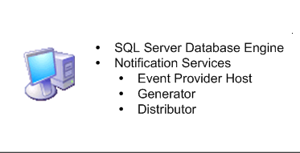
Figure 1 - Single Server Deployment Scenario
Most production environments, however, use either the remote database or scale-out deployment scenario to provide a higher notification volume capacity. In such deployment scenarios, Notification Services must be installed on each server where one or more components will reside.
For example, in a scale-out deployment scenario as shown in Figure 2, ServerA serves as the SQL Server database that stores the instance and application database, ServerB hosts the Event Provider and Generator components, and ServerC host the Distributor component.
In this deployment scenario, the Notification Services components on each of the three servers must be upgraded to SQL Server 2005 Notification Services. Failing to do so will result in a version mismatch and will result in a non-functional instance.

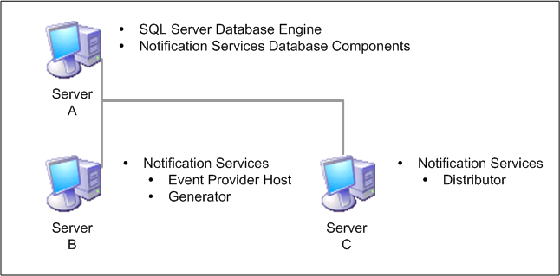
Figure 2 - Scale-Out Deployment Scenario
SQL Server 2005 Notification Services may be installed by running the SQL Server 2005 installation program and ensuring that the Notification Services option is selected.

Recompile Custom Components
As described earlier, the SQL Server 2005 Notification Services DLL is built using .NET Framework 2.0; there is no version of the DLL that is compatible with a prior version of the .NET Framework. As a result, custom components built for earlier versions of SQL Server Notification Services will not work with SQL Server 2005 Notification Services without modification.
Custom event providers, custom content formatters, and custom delivery protocols that were originally compiled using an earlier version of the .NET Framework and a previous version of the SQL Server Notification Services assembly must be updated and recompiled.
To update the custom component, remove the reference to the older version of the Notification Services assembly and replace it with a reference to the newer assembly. You can find the SQL Server 2005 Notification Services assembly in the \ProgramFiles\Microsoft SQL Server\90\NotificationServices\n.n.nnn\bin folder, where n.n.nnn is the build number.
Note: As described earlier in this section under “Upgrade Considerations,” many Notification Services 2.0 classes have been deprecated in SQL Server 2005 Notification Services. The functionality provided by these classes has been replaced by new Notification Services Management Object (NMO) classes. If any custom components rely on deprecated classes, the component should be upgraded to use the new NMO classes. For more information about the deprecated classes, see SQL Server 2005 Books Online topic “Notification Services Backward Compatibility” at ms-help://MS.SQLCC.v9/MS.SQLSVR.v9.en/instsql9/html/c4612650-eaa9-443a-a4ef-95d9feaf4976.htm.

Update the Notification Services Metadata
In SQL Server 2005 Notifications Services, metadata about each Notification Services instance is stored in the msdb database. A view, named msdb.NS90.NSInstances, is available for public consumption. You can use the view to discover information about all SQL Server 2005 Notification Services instances available on the server.
Prior versions of Notification Services did not record their existence in the msdb database. So when upgrading an instance to SQL Server 2005 from a prior version of Notification Services, you must take steps to create the appropriate metadata entries in msdb.
A new NSControl command is available for creating these entries: NSControl repair. The following command, issued from the SQL Server 2005 Notification Services command prompt, will create the appropriate metadata entries in the msdb database for the fictitious instance named ABCPress:
NSControl repair -name ABCPress -database ABCPressNSMain _
-schema dbo -server ServerName
After you run the NSControl repair command, the instance will be visible under the Notification Services folder in Management Studio, as Figure 3 shows.
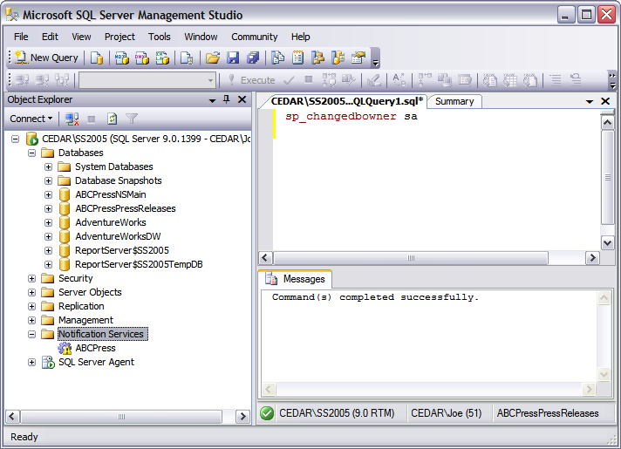
Figure 3 - A Repaired Instance in Management Studio

Update the Notification Services Instance
As noted earlier, the Notify() function is no longer supported in SQL Server 2005 Notification Services. All Generator rules that use the Notify() function to create notifications must be updated to reflect the use of the newly created notification view. Other changes may be necessary to the XML source files to reflect additional changes in the environment.
After making the necessary modifications to the Instance Configuration File and the associated Application Definition Files, the instance must be upgraded to the newer version; you can use either the NSControl upgrade command-line utility or the graphical SQL Server Management Studio interface.
The following example illustrates how to use the NSControl command-line utility to upgrade an instance called ABCPress on a database server named CEDAR\SS2005:
NSControl upgrade -name MyInstance -server MyDbServer
NSControl update –in c:\data\ns\MyInstance.xml
NSControl register –name MyInstance –server MyDbServer -server
Repeat the NSControl register command on each server in a remote database deployment or scale-out deployment scenario where components were previously registered.
If you want to use SQL Server Management Studio to upgrade the instance, you can initiate the upgrade, update the instance, and then register processes by right-clicking the instance in the Notification Services folder, as Figures 4, 5, 6, and 7 show.
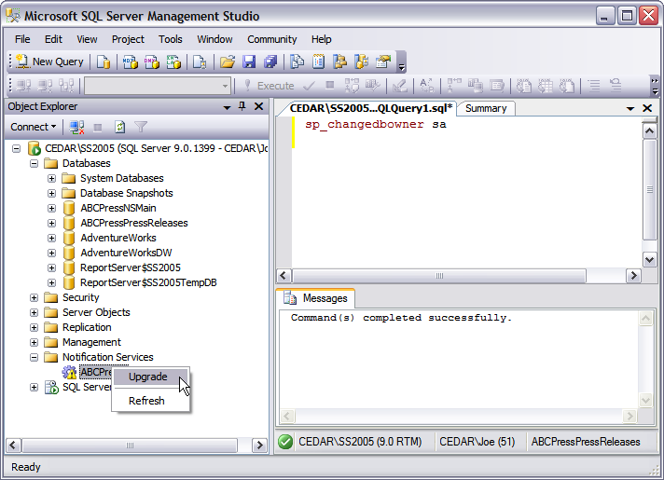
Figure 4 - Upgrading an Instance Using SQL Server Management Studio
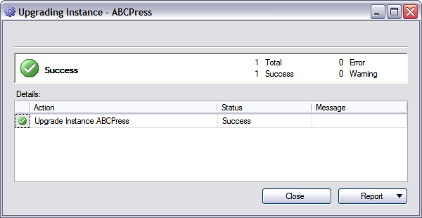
Figure 5 – Viewing the Results of the Upgrade
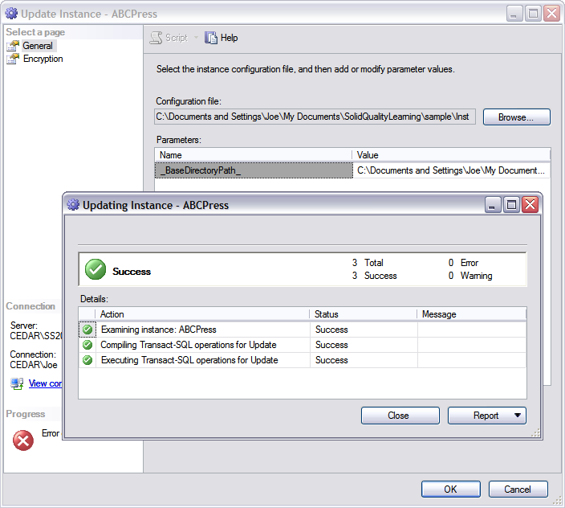
Figure 6 - Updating an Instance Using SQL Server Management Studio
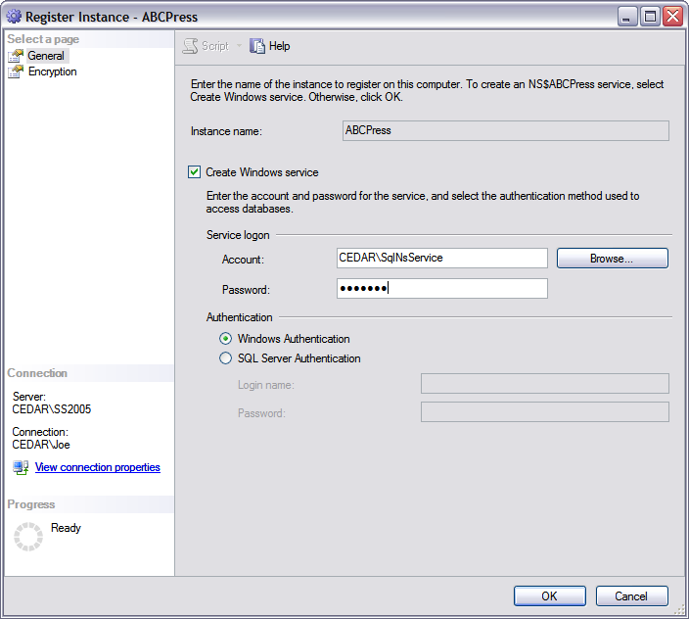
Figure 7 - Registering an Instance Using SQL Server Management Studio

Start the Notification Services Instance
The final step in upgrading a Notification Services instance to SQL Server 2005 is to enable and start the instance. The following commands illustrate this for the MyInstance instance:
NSControl enable –name MyInstance
NET START NS$MyInstance
You can also use SQL Server Management Studio to enable and start the instance by selecting the appropriate context menu options for the instance, as Figure 8 shows.
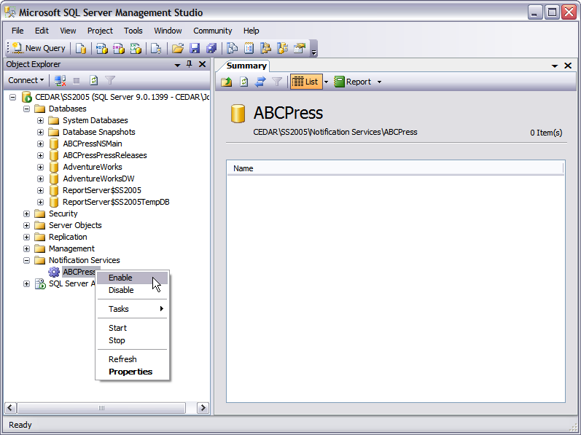
Figure 8 - Using SQL Server Management Studio to Enable and Start an Instance

Review an Upgraded Notification Services Instance
After upgrading a SQL Server Notification Services instance, it is important to ensure that the instance and application were upgraded successfully. To verify the status of a Notification Services application, review the Applications page of the Instance properties, which Figure 9 shows.
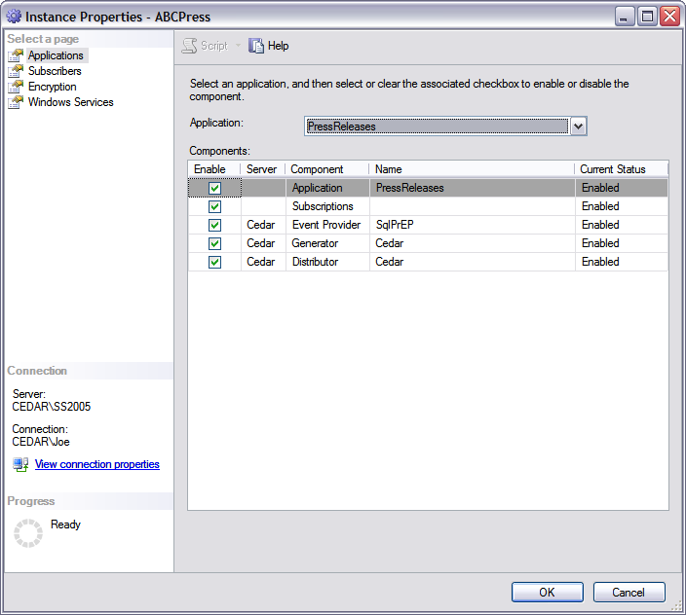
Figure 9 - Viewing the Application Properties Page
It is also important to verify that the Windows Service for the Notification Services instance has successfully started. You can do this by viewing the properties page for the Windows Services and the Associated Components, which Figure 10 shows.
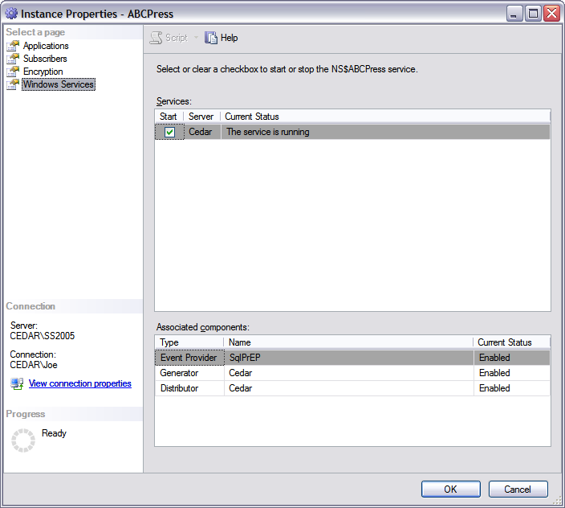
Figure 10 - Viewing the Windows Services Property Page
Finally, you need to thoroughly test the Notification Services instance and application, using a methodology similar to that used when you developed the original instance and application. In a controlled environment, submit known events to the system, and carefully review the notifications generated to ensure that you received the expected results.

Resolve Upgrade Issues
If your review of the upgraded Notification Services instance reveals an unexpected outcome, use Notification Services debugging and troubleshooting techniques to determine where the deviations occurred. These techniques include:
- Reviewing the Application Log in Event Viewer for indications of failure.
- Using the Notification Services stored procedures to review the notification and delivery information in the Notification Services tables.

Side-by-Side Upgrade
The side-by-side methodology for upgrading a SQL Server Notification Services 2.0 instance to SQL Server 2005 is very similar to the in-place upgrade methodology. The primary difference is that the SQL Server on which the upgrade is performed is separate from the original SQL Server. A parallel instance of SQL Server 2005 and Notification Services is installed and used in the upgrade process. The parallel instance may reside on the same server or another server as the instance you want to upgrade. You need to ensure that any event sources that write events directly to Notification Services are updated to write these events to the new Notification Services installation. And you also need to ensure that the flow of events is managed appropriately—that is, stopped and then restarted or migrated incrementally to the new installation. Beyond that, you need to make only minor changes to the configuration files to accommodate a different server. The following descriptions walk you through a side-by-side upgrade of Notification Services.

Stop the Notification Services Instances
Before starting the upgrade, stop and disable on the original server each SQL Server Notification Services instance to be upgraded. The following commands, issued through the Notification Services command prompt, demonstrate this process with a fictitious instance named MyInstance; be sure to run these commands on each server in a scale-out deployment scenario:
NET STOP NS$MyInstance
NSControl disable –name MyInstance

Migrate the Databases
Next, detach the instance and associated application databases from the existing instance of SQL Server 2000 by using SQL Server Enterprise Manager or the equivalent Transact-SQL code in Query Analyzer. You also must ensure that any chronicle tables are handled appropriately. Figure 11 shows how to detach a database by using SQL Server Enterprise Manager.
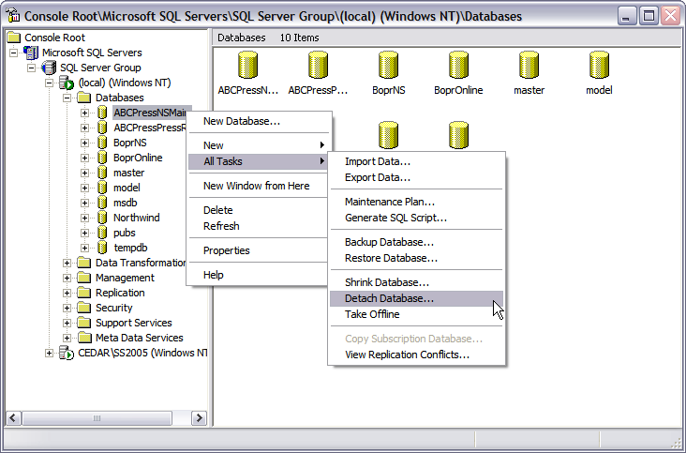
Figure 11 - Detaching a Database by Using SQL Server Enterprise Manager
Once you’ve detached the databases from the original SQL Server 2000 instance, you can copy the files to a new location and attach them to the SQL Server 2005 instance by using SQL Server Management Studio or equivalent Transact-SQL statements.
When a SQL Server 2000 database is attached to a SQL Server 2005 instance, it is automatically upgraded. As with an in-place upgrade, this process does not affect the SQL Server Notification Services instance or applications; you must manually update them.
Figures 12 and 13 illustrate how to attach a database in SQL Server 2005 by using SQL Server Management Studio.
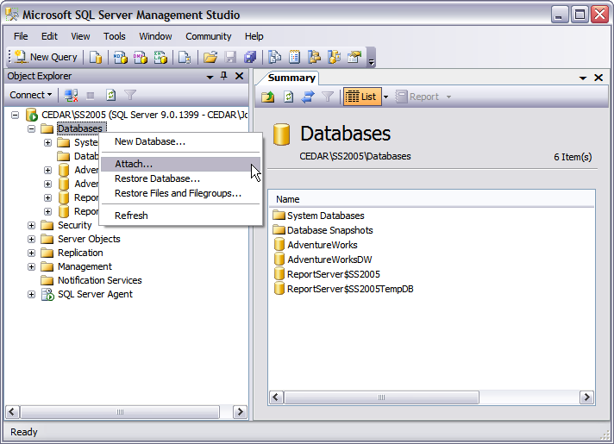
Figure 12 - Attaching a Database by Using SQL Server Management Studio

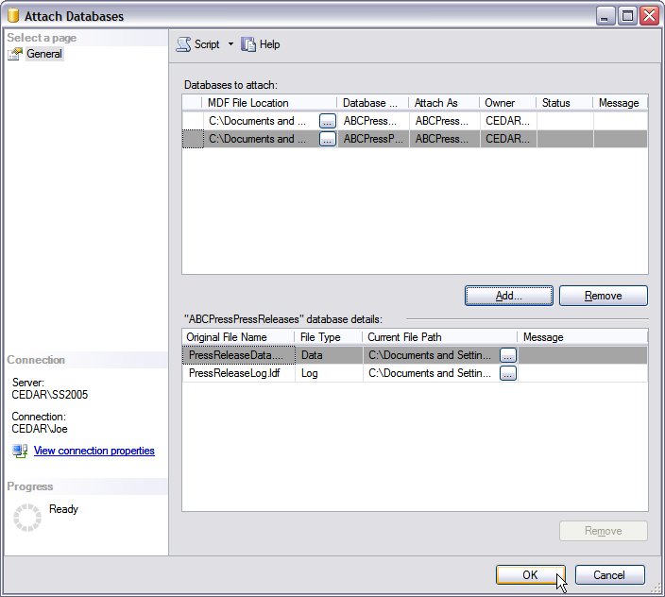
Figure 13 - Using SQL Server Management Studio to Select a Database to Attach
Note: If the location of the database files has changed, you will need to make the appropriate data modifications in the NSDatabaseFiles tables of the instance and application databases.

Completing the Upgrade
Once the SQL Server Notification Services instance and application databases have been upgraded to SQL Server 2005, the rest of the side-by-side upgrade process is identical to that of the in-place upgrade. See the “In-Place Upgrade of Notification Services Instances” discussion above for details on each of the following steps:
- Install SQL Server 2005 Notification Services.
- Recompile custom components.
- Update Notification Services metadata.
- Start the Notification Services instance.
- Review the upgraded Notification Services instance.
- Resolve upgrade issues.

Creating New Instances
The third option for converting a SQL Server 2000 Notification Services instance and application to SQL Server 2005 Notification Services is less of an upgrade and more of a re-creation scenario. For this option, the configuration files used to create the SQL Server 2000 Notification Services 2.0 instance and application are altered to reflect the new environment and then used to create a completely new Notification Services instance and application.
Alter the configuration files as described above under the “Upgrade Considerations” heading. Other changes will likely be required because the name of the SQL Server instance, the location of the database files, and other configuration file parameters will likely change under this scenario.
Once you have updated the configuration files, use the Notification Services tools to create a new SQL Server Notification Services instance and application as you normally would. After you’ve created the new instance and application, you will need to migrate data from the SQL Server 2000 Notification Services instance to the new instance and application. Use standard Transact-SQL programming techniques to migrate subscriber, subscriber device, subscription, and chronicle information to the new instance.
Once you’ve migrated the data, be sure to thoroughly test the new SQL Server Notification Services instance and application.

Section 3.07: Upgrading Management Tools

Introduction
Offering a rich, integrated, easy-to-use management toolset has been SQL Server’s hallmark. SQL Server 2005 includes many changes and enhancements, including the consolidation of some familiar management tools into a new toolset. The new release also enhances and changes the functionality of other tools, and discontinues support for some components. In the end, the new SQL Server release provides even more robust, consolidated functionality for database administrators and developers, offering intuitive graphical tools and powerful command-line utilities and scripting features.
As you plan your upgrade to SQL Server 2005, take time to look at all the tools and utilities you currently use to manage your system and identify changed functionality that may affect your processes and scripts. Make pre-upgrade modifications where needed, note revisions you need to make after the upgrade to take full advantage of new functionality, and start getting familiar with the new tools you’ll be working with.
If you work in a mixed SQL Server environment, you cannot, in general, use older tools to manage SQL Server 2005 installations (this section notes a few exceptions to this rule). However, you can use SQL Server 2005’s tools to manage most features in SQL Server 2000.

Upgrading to New Tools

SQL Server Management Studio
One of the biggest changes in SQL Server 2005 is the consolidation of SQL Server Enterprise Manager, Query Analyzer, the MDX Sample Application, and some features of Analysis Manager into a new management tool called SQL Server Management Studio. SQL Server Management Studio is an integrated environment for administering, managing, and developing all SQL Server components, including the SQL Server Database Engine, SQL Server Reporting Services, SQL Server Integration Services (SSIS), SQL Server Notification Services, and SQL Server Mobile Edition. SQL Server Management Studio uses the Visual Studio integrated development environment to give administrators a single, easy-to-use graphical tool for managing the most sophisticated systems and gives developers a consistent experience for database and application development.
Note: You cannot use SQL Server Enterprise Manager to manage SQL Server 2005 instances, but you can connect to a SQL Server 2005 instance via the SQL Server 2000 Service Pack 4 (SP4) version of Query Analyzer. However, you can use SQL Server 2005 Management Studio to manage SQL Server 2000 servers.

SQL Server Configuration Manager
After you upgrade to SQL Server 2005, you will also be working with the new SQL Server Configuration Manager. SQL Server Configuration Manager is a Microsoft Management Console (MMC) snap-in that replaces the Server Network Utility, the Client Network Utility, and the Service Manager from earlier releases of SQL Server. You can use SQL Server Configuration Manager to start, stop, pause, and resume SQL Server services, change the service properties, and configure SQL Server network protocols. The SQL Server Configuration Manager manages all SQL Server services, including those for the database engine, Analysis Services, Reporting Services, SSIS, SQL Server Agent, and SQL Server Browser.

Business Intelligence Development Studio
Business Intelligence Development Studio (BIDS) is SQL Server 2005’s new environment for developing Business Intelligence (BI) solutions that use Analysis Services, SSIS, and Reporting Services. BIDS is essentially Microsoft Visual Studio 2005 with additional project types specific to SQL Server 2005 business intelligence, giving you templates for creating objects for BI solutions as well as the designers, tools, and wizards you need to work with those objects. For more information about BIDS and other BI-specific tools in SQL Server 2005, see Section 4.01, “Upgrading to SQL Server 2005 Reporting Services,” Section 4.02, “Migrating DTS to SQL Server Integration Services,” and Section 4.03, “Upgrading to SQL Server 2005 Analysis Services.” Some functionality of the SQL Server 2000 Analysis Manager is in SQL Server Management Studio, and the rest is in BIDS.

Possible Upgrade Issues
To make sure your upgrade process goes smoothly, consider the following management tool changes and make any necessary revisions before moving to SQL Server 2005.

Database Diagrams
During your SQL Server 2005 upgrade, database diagrams created on earlier releases of SQL Server will automatically be upgraded as long as database diagramming is set up on SQL Server 2005.
The following steps describe how to set up database diagramming on SQL Server 2005 so that your current database diagrams are upgraded; database administrators wanting to set up database diagramming on a SQL Server 2005 database must be a member of the sysadmin fixed server role or the db_owner role for each database they want to configure:
- From Object Explorer in SQL Server Management Studio, expand the database you want to configure.
- Expand the Database Diagram node under the database connection.
- Select Yes when prompted to create the support objects.
- When you then open the database diagrams, SQL Server 2005 automatically upgrades them.

Reporting Services Tools
Reporting Services 2005 provides the new Reporting Services Configuration tool for you to use to configure a Reporting Services installation. You launch the tool from the Configuration Tools group within the Microsoft SQL Server 2005 Start menu group. When you upgrade Reporting Services from a previous version of SQL Server, you can use this tool to update the Report Server database to the new SQL Server 2005 format. Section 4.01, “Upgrading to SQL Server 2005 Reporting Services,” walks you through using the Reporting Services Configuration tool.
Reporting Services 2005 also comes with a new ad hoc reporting tool called Report Builder, which lets users create, edit, and deploy their own reports. A browser-based client application, Report Builder gives business users an intuitive model of their data, predefined templates, and a friendly interface for building ad hoc reports. For more information about Report Builder, see Section 4.01, “Upgrading to SQL Server 2005 Reporting Services.”
In preparation for upgrading to SQL Server 2005, database administrators working with SQL Server Reporting Services should note that the Rsactivate.exe command-line utility no longer initializes a single report server instance or multiple report server instances that are part of the same Web farm; this functionality is obsolete in SQL Server 2005.
SQL Server 2005 also does not support the Report Server Windows Management Instrumentation (WMI) Provider from SQL Server 2000; SQL Server 2005 Reporting Services includes a new version of the WMI provider.

SSIS Tools
Although you can migrate Data Transformation Services (DTS) packages to SQL Server 2005’s new SSIS component for data extraction, transformation, and movement, DTS and SSIS packages can exist independently on SQL Server 2005. Your current DTS packages will run in SQL Server 2005. However, to take advantage of the additional functionality of SSIS, you will want to migrate your DTS packages to SSIS. DTS is deprecated in SQL Server 2005, so you should plan on eventually migrating all your packages to SSIS.
Note that support for developing, managing, and executing existing DTS packages will remain untouched if an existing instance of the SQL Server 2000 or 7.0 relational engine will remain on the server after the upgrade. For example, if a new instance of the SQL Server 2005 relational engine is installed or if other components of SQL Server 2005 are installed without installing the new relational engine, then SQL Server Enterprise Manager will remain available as well as the DTS runtime and command-line tools. With these components still in place, DTS packages can be executed manually or via SQL Server Agent jobs.
However, if all instances of the SQL Server 2000 or 7.0 relational engine are removed or upgraded to SQL Server 2005’s new relational engine, then SQL Server Enterprise Manager and the ability to develop DTS packages will no longer exist. The SQL Server 2005 Setup application will install an updated DTS runtime and command-line tools, but no DTS design environment will be available. In this case, the DTS Designer Components can be installed via a Web download from the Feature Pack for SQL Server 2005. The Feature Pack is a collection of useful tools and components for working with SQL Server 2005; you can find it at: http://www.microsoft.com/downloads/details.aspx?FamilyID=d09c1d60-a13c-4479-9b91-9e8b9d835cdc&DisplayLang=en.
Once the DTS Designer Components have been installed, an additional step is required to enable package editing. Section 4.02, “Migrating DTS to SQL Server Integration Services,” describes how to enable package editing by using the DTS Designer Components from within SQL Server Management Studio.

Index Tuning Wizard
In SQL Server 2005, the Index Tuning Wizard has been replaced by the Database Engine Tuning Advisor. If you are using the tool from the command line, that means that itwiz.exe has been replaced by the dta.exe command-line utility. Database administrators should review utility scripts and replace itwize.exe calls with dta.exe calls.
Database administrators should also note the inability of dta.exe to tune workload tables on remote servers. You should use one of the following two options to modify utility scripts that call the itwiz.exe command-line utility with the –t argument:
- Use a trace file instead of a remote trace table, and modify the script to execute against a file instead of a trace table.
- Copy the remote trace table to an instance on the local server, and modify the server connection.
For a detailed look at the differences between the Index Tuning Wizard and the Database Engine Tuning Advisor, see the SQL Server 2005 Books Online article “Differences Between Database Engine Tuning Advisor and Index Tuning Wizard” at ms-help://MS.SQLCC.v9/MS.SQLSVR.v9.en/toolref9/html/206b03ea-b2f6-49b7-9611-0085d041cefd.htm.

osql Utility
SQL Server 2005 deprecates the ODBC-based osql command-line utility, which lets you run Transact-SQL statements and script files, in favor of the new OLE DB-based SQLCMD utility. Osql will not be available in the next release of SQL Server. And in its deprecated status in SQL Server 2005, osql no longer supports the ED and !! commands. Database administrators should review their administration scripts for calls to osql, and then check whether the calls use the obsolete syntax. Even better, database administrators should use the SQLCMD utility instead of osql.

bcp
The SQL Server 2000 bulk copy program (bcp) utility lets a user with INSERT and SELECT permissions on a table bulk-load data into the table by using the following command, which disables CHECK constraints and triggers on that table:
bcp <target_table> IN <datafile> -c –T
In SQL Server 2005, however, the user must also have the ALTER permission as well as INSERT and SELECT permissions on the target tables to bulk-load while disabling CHECK constraints and triggers.
If you want to maintain the older functionality, you must grant ALTER TABLE permissions to the user on all tables affected by the bcp bulk-load process. Alternatively, if you do not want users to have ALTER TABLE permissions, you can modify the bcp scripts to remove this functionality by mandating that CHECK constraints and triggers are explicitly enforced:
bcp <target_table> IN <datafile> -c –T –h “CHECK CONSTRAINTS, FIRE TRIGGERS”

isql Utility
The isql command-prompt utility is not available in SQL Server 2005. Instead, the new SQL Server release provides the SQLCMD utility. This means you need to remove all calls and references to isql or modify those calls to use the SQLCMD utility.
Note: Database administrators can still connect to SQL Server 2005 by using the isql utility, but this connection is supported only for features that are compatible with SQL Server 7.0.

Rebuild.exe
SQL Server 2005 does not support Rebuild.exe. Database administrators should review administration scripts for use of the Rebuild.exe utility and modify those scripts to use the REBUILDDATABASE option of the Setup.exe utility.

Setup.exe
The Setup.exe command-line interface has undergone a complete overhaul in SQL Server 2005. For instance, in SQL Server 2005, the Setup.exe utility does not support the TARGETCOMPUTER parameter for remote setup. Database administrators must remove this functionality from any administrative scripts they have. To set up SQL Server 2005 on a remote server, you need to use a remote connection to run Setup.exe or set up SQL Server in user-interface mode.

SQL Mail
SQL Server 2005 deprecates SQL Mail, which will not be in the next release of SQL Server, and introduces the new Database Mail. Database Mail lets you send email messages from database applications, but it doesn’t let you read email messages. Although SQL Mail will upgrade from SQL Server 2000 or 7.0 to SQL Server 2005, the SQL Server 2005 version requires Microsoft Outlook 2002 or later to serve as a mail client.
Before beginning your upgrade, be sure to review scripts using SQL Mail to determine whether the scripts are sending attachments. The SQL Server 2005 version of SQL Mail will not send mail attachments if the mail client is connected using SQL Server authentication; the authentication mode must be set to Windows authentication. For information about how to convert a stored procedure to Database Mail, see the SQL Server 2005 Books Online article “How to: Convert Stored Procedures from SQL Mail to Database Mail (Transact-SQL)” at ms-help://MS.SQLCC.v9/MS.SQLSVR.v9.en/udb9/html/68ddf917-e84d-41a7-8a25-ab90b9b442d3.htm.

Behavioral Changes That May Require Corrective Action
Consider the following changes in the way certain management tools work in SQL Server 2005 so that you can make appropriate modifications after your upgrade and maintain effective administration of your SQL Server environment.

Registered Servers
You can register servers that you access frequently so that SQL Server saves the connection information for those servers. In SQL Server 2005, you register servers by using the Registered Servers component of SQL Server Management Studio. To add SQL Server 2000 Enterprise Manager registered servers into SQL Server Management Studio, right-click the Database Engine node in the Registered Servers window, and select Previously Registered Servers.

Maintenance Plans
After upgrading to SQL Server 2005, you will find changes to the way you create maintenance plans. In earlier versions of SQL Server, you use only the Maintenance Plan Wizard to create database maintenance plans that, in turn, result in multiple SQL Server Agent jobs that perform the defined maintenance tasks. The wizard in earlier versions of SQL Server, however, did not let you define all SQL Server-related maintenance tasks, including the important task of performing differential backups.
SQL Server 2005 introduces a more functional Maintenance Plan Wizard for creating basic maintenance plans and lets you create plans for almost any SQL Server-related maintenance task while taking advantage of the new SSIS designer to define a workflow within the maintenance plan.
To gain the advantages of the new maintenance plan functionality, you need to migrate your maintenance plans to SQL Server 2005. Although an in-place upgrade will upgrade your current SQL Server maintenance plans without upgrading their functionality to SQL Server 2005, several changes will affect the functionality of those maintenance plans. For example, for maintenance plans to execute successfully, you must have SSIS installed on the same machine on which the SQL Server engine is installed. In addition, maintenance plans in SQL Server 2005 will no longer support log shipping; you’ll need to configure log shipping outside of maintenance plans. Section 3.05, “Upgrading Maintenance Plans and SQL Server Agent Jobs,” lists other important behavior changes you need to consider when upgrading and explains how to migrate your current maintenance plans to SQL Server 2005’s enhanced functionality.

Keyboard Shortcuts
Database administrators managing SQL Server 2000 environments often use keyboard shortcuts in SQL Server Enterprise Manager and Query Analyzer to increase their productivity. Database administrators upgrading to SQL Server 2005 will find that some of these shortcuts have changed.
Note: For a list of shortcut changes, see the SQL Server 2005 Books Online article “SQL Server Management Studio Keyboard Shortcuts” at ms-help://MS.SQLCC.v9/MS.SQLSVR.v9.en/toolref9/html/98baaac4-0727-4ce4-8bfe-c63793ae69b8.htm.
If you want to keep your SQL Server 2005 environment similar to your SQL Server 2000 environment, you can change the SQL Server Management Studio default standard keyboard scheme to the SQL Server 2000 keyboard scheme. To change the keyboard scheme in SQL Server Management Studio, follow these steps:
- From the Tools menu in SQL Server Management Studio, click Options.
- Expand the Environment node, and highlight the Keyboard page.
- Change the keyboard scheme by using the Keyboard Scheme drop-down box.
If you change the keyboard scheme in SQL Server Management Studio, note that the following SQL Server 2000 shortcuts are not available in SQL Server 2005:
- CTRL+O (Open a new query editor window)
- CTRL+SHIFT+P (Insert the body of the specified file into the window)
- CTRL+K (Include actual execution plan in the query output)
- CTRL+SHIFT+O (Open the Query Option dialog box)

SQL-DMO
SQL Server 2005 replaces the SQL Distributed Management Objects (SQL-DMO) object library from earlier releases of SQL Server with SQL Management Objects (SMO). Although SQL Server 2005 still supports SQL-DMO, it is now considered a legacy component, meaning that you must install the Legacy Components feature before SQL Server 2005 will support SQL-DMO.
To install Legacy Components during initial setup, click Advanced on the Components to Install page during SQL Server 2005 setup.
To install Legacy Components after setup, perform the following steps:
- In Control Panel, double-click Add or Remove Programs.
- Under Currently installed programs, click the instance of SQL Server to configure, then click Change.
- On the Component Selection - Maintenance page, select the instance or shared component to update.
- Click the Report button to view the list of SQL Server 2005 components and features installed on your computer. The report includes version, edition, update level, and language information for each installed component and feature.
- To continue, click Next.
- On the Feature Maintenance page, select a server component to update. If you selected a shared component on the previous page, this page will not be displayed.
- Click the Report button to view the list of SQL Server 2005 components and features installed on your computer. The report includes version, edition, update level, and language information for each installed component and feature.
- To continue, click Next.
- On the Change/Remove page, click Change.
- On the Feature Selection page, use the feature tree to make selection changes for your SQL Server 2005 instance. To continue, click Next.
- On the Ready to Update page, review the changes to be made by SQL Server 2005 Setup. To continue, click Next.
- On the Setup Progress page, Setup displays Setup status.
- On the Completing Setup page, click Finish to exit the Installation Wizard.

osql Utility
Although SQL Server 2005 fully supports osql, you must use the osql version that ships with SQL Server 2005 in order to perform all SQL Server 2005 functions. You can still connect to SQL Server 2005 with an older version of osql, but some of the new features in SQL Server 2005 may not be available.

Discontinued Tools
SQL Server 2005 marks the end of the road for the following tools. If you use these tools, you need to make necessary revisions to your system before upgrading.

English Query
As of SQL Server 2005, English Query—a set of tools for developing a natural-language interface to the database—has been discontinued and cannot be installed in or upgraded to SQL Server 2005. For upgrades using the in-place upgrade method against a SQL Server 2000 installation, English Query will not be affected.

Meta Data Services
SQL Server 2000’s Meta Data Services 3.0 is not available in SQL Server 2005, and database administrators upgrading to SQL Server 2005 will not be able to use the service to access repository tables. The repository tables will upgrade during the in-place upgrade process and should be manually deleted from the msdb database after the upgrade process has completed.
You can execute the following script to obtain the drop statements for the repository tables and review the script’s output to remove user tables not associated with Meta Data Services:
USE msdb
GO

SELECT 'DROP TABLE dbo.' + TABLE_NAME
FROM INFORMATION_SCHEMA.TABLES
WHERE TABLE_SCHEMA = 'dbo'
AND TABLE_NAME LIKE 'RTbl%'
GO

Additional References
To fully understand the SQL Server 2005 upgrade issues and recommended solutions regarding management tools and utilities, review the following SQL Server 2005 Books Online articles before starting your upgrade:
- “Discontinued Database Engine Functionality in SQL Server 2005”
ms-help://MS.SQLCC.v9/MS.SQLSVR.v9.en/instsql9/html/d686cdf0-d11d-4dba-9ec8-de1a5f189f25.htm
- “Breaking Changes to Database Engine Features in SQL Server 2005”
ms-help://MS.SQLCC.v9/MS.SQLSVR.v9.en/instsql9/html/47edefbd-a09b-4087-937a-453cd5c6e061.htm
- “Behavior Changes to Database Engine Features in SQL Server 2005”
ms-help://MS.SQLCC.v9/MS.SQLSVR.v9.en/instsql9/html/65eaafa1-9e06-4264-b547-cbee8013c995.htm
- “How to: Change Components in an Existing Instance of SQL Server 2005 (Setup)”
ms-help://MS.SQLCC.v9/MS.SQLSVR.v9.en/instsql9/html/954f9ef8-b979-405c-8ae1-478cdc2c0e0b.htm

Section 3.08: Upgrading MSDE to SQL Server 2005 Express
SQL Server 2005 Express Edition is a free version of SQL Server 2005. With a free graphical management tool, SQL Server Management Studio Express, SQL Server Express can be used as a local data store, embedded with an application, or act as a lightweight database server. SQL Server Express is also tightly integrated with Visual Studio 2005, which eases the design and development of database applications.
SQL Server Express is intended to replace Microsoft SQL Server 2000 Desktop Engine (MSDE) and, as such, is the appropriate edition in most circumstances to choose when upgrading MSDE to SQL Server 2005.
SQL Server Express removes the workload governor, which limited the number of concurrent operations that MSDE could perform, and has a larger maximum database size limit of 4 GB as compared to MSDE’s 2 GB. Combined with 64-bit support on WOW and new SQL Server 2005 database features, most MSDE applications can be migrated to SQL Server Express and perform more robustly.
However, MSDE and SQL Server Express have important differences that you must understand before you create your MSDE upgrade plan. For a detailed discussion of SQL Server Express, see http://msdn.microsoft.com/library/default.asp?url=/library/en-us/dnsse/html/sseoverview.asp.

Understanding MSDE Upgrade Issues
While the number of upgrade issues that the database administrator must contend with when upgrading MSDE is small, the following upgrade issues must be reviewed, understood, and accounted for in any MSDE upgrade plan:
- Number of MSDE instances
- MSDE install method
- MSDE language

Number of MSDE Instances
The computer on which you intend to perform a database upgrade from MSDE to SQL Server 2005 may have multiple instances of MSDE and may also have instances from other editions of SQL Server 2000 or 7.0. Each instance must be upgraded separately, and each instance may have a different set of upgrade requirements. For example, the different instances might use different languages or collation orders or be installed using a different installation method.
The first step in upgrading from MSDE to SQL Server 2005 is determining the instances of MSDE that are installed. Up to 50 instances of MSDE can be installed on a single system. To determine the number of installed MSDE instances on your system, review the following registry key:
HKEY_LOCAL_MACHINE\Software\Microsoft\Microsoft SQL Server\InstalledInstances

MSDE Install Method
The methodology that was used to install an MSDE instance affects the available upgrade method for the MSDE instance being upgraded.
- Setup – If an MSDE instance was installed using the MSDE setup program (such as an MSI setup or the MSDE2000A.exe setup program), the SQL Server Express installation program will detect the instance, and you will be able to perform the upgrade using the in-place upgrade method.
- Merge Modules – If an MSDE instance was installed using an MSDE legacy installation technology known as Merge Modules, the SQL Server Express installation program will not detect the instance, and you will not be able to perform the upgrade using the in-place upgrade method. When MSDE is installed using Merge Modules, MSDE is actually installed as part of another application that uses MSDE and MSDE is not installed using MSDE’s standalone installer.
To determine if an MSDE instance has been installed with an MSI setup, go to Add or Remove Programs in Control Panel. If the instance appears in the listing, it was installed with an MSI setup. If it does not appear in the listing, it was installed as part of an application and should be removed by that application’s installer program.
Important: Although an instance of MSDE installed using Merge Modules cannot be upgraded in-place, its user databases can be upgraded individually.

MSDE Language
The language of the MSDE installation determines the language of the SQL Server 2005 edition you are upgrading to. If you are performing an in-place upgrade by installing SQL Server Express Edition over the top of an existing MSDE installation, the language of the SQL Server Express Edition must be the same language of the MSDE installation or it must be set to English. SQL Server Express supports the same 12 languages that MSDE does.
Note: You can detach a user database from an MSDE instance and attach it to a SQL Server Express instance installed with any language.

Upgrading MSDE to the Different Editions of SQL Server 2005
While the core database capabilities of MSDE and SQL Server Express are similar, the features sets and limitations are different. It’s possible that either these differences or the projected requirements for features outside of the SQL Server 2005 Express feature set could cause you to select a different edition of SQL Server 2005.
Table 1 provides a feature comparison between MSDE and the SQL Server 2005 Express, Workgroup, and Standard editions.
Table 1 – Comparing MSDE to the SQL Server 2005 Express, Workgroup, and Standard Editions
Feature | MSDE | SQL Server 2005 Express Edition | SQL Server 2005 Workgroup Edition | SQL Server 2005 Standard Edition
Maximum Number of Instances | 16 | 16 | 16 | 16
Maximum # of Processors | 2 | 1 | 2 | 4
Maximum RAM | 2 GB | 1 GB | 3 GB | No Limit
Maximum Database Size | 2 GB | 4 GB | No Limit | No Limit
Workload Governor | Yes | No | No | No
XCopy Support | No | Yes | Yes | Yes
SQL Agent | Yes | No | Yes | Yes
DTS Runtime | Yes | Yes (Web download) | Yes (Web download) | Yes
Replication Publishing | Yes | No | Yes | Yes
High Availability Features  (Database Mirroring and Cluster Support) | No | No | No | Yes
BI Features  (Analysis Services, Integration Services) | No | No | No | Yes
Report Server | No | Yes | Yes | Yes
Service Broker | No | Client-only | Yes | Yes
Full-Text Search | No | Yes | Yes | Yes
While SQL Server Express would typically be the preferred choice for upgrading from MSDE to SQL Server 2005, if your environment has specific requirements for some of the features that MSDE possessed but that are not present in SQL Server 2005 Express, you may want to choose a different edition. The following discussion will help you determine if you need to upgrade to a different edition of SQL Server 2005.

Upgrading to Workgroup Edition Instead of SQL Server Express
Upgrading to SQL Server 2005 Workgroup Edition is a compelling option for the following three scenarios:
- RAM Requirements Beyond the Level Supported by SQL Server 2005 Express
MSDE supports up to 2 GB of RAM and two processors, while SQL Server Express supports only 1 GB of RAM and a single processor. While rare, some MSDE applications need more that 1 GB of RAM. If this is your case, you should consider upgrading to SQL Server 2005 Workgroup edition.
To quickly check MSDE RAM usage:
- Press Ctl-Alt-Del.
- Open Task Manager.
- Check the Mem Usage column for the sqlservr.exe process.
- Processor Requirements Beyond the Level Supported by SQL Server 2005 Express
While MSDE supports two processors compared to SQL Server Express’s single processor, it’s unlikely that this would necessitate a move to SQL Server 2005 Workgroup Edition. In most cases, it would be more cost-effective to upgrade to a higher performance processor. SQL Server Express will support multi-core processors and can be installed on any server, but each installation of SQL Server Express can access only one physical processor.
- The Requirement for SQL Server Agent or for the Instance to Act as a Replication Publisher
Application requirements for SQL Server Agent or for the instance to act as a replication Publisher might affect your decision about which edition of SQL Server 2005 to upgrade to.
- MSDE – Supplies SQL Server Agent, and an MSDE instance can act as a replication Publisher.
- SQL Server Express – Does not supply SQL Server Agent, and a SQL Server Express instance can act only as a replication Subscriber.
If your application has requirements for SQL Server Agent, you can use the Windows Task Scheduler to schedule jobs and database tasks. You may also consider upgrading to SQL Server 2005 Workgroup Edition.
If your SQL Server Express instance must act as a replication Publisher to other SQL Server Express databases, that is not supported. You would need to consider upgrading to SQL Server 2005 Workgroup Edition.

Upgrading to Standard Edition Instead of SQL Server Express
The primary reason you would consider upgrading from MSDE to SQL Server 2005 Standard Edition is that you predict your future application requirements will exceed the capabilities or feature set that’s available in SQL Server Express or Workgroup Edition. This upgrade scenario would be based on projections that your future database requirements could exceed 3 GB of RAM, that you will need a database size larger than 4 GB, or that you need the high-availability or business intelligence (BI) features found in SQL Server 2005 Standard Edition.

System Requirements for SQL Server 2005 Express
The following are the hardware and software requirements for SQL Server Express.

Hardware
SQL Server Express will run on basically the same hardware as MSDE. Microsoft’s recommended system requirements are:
- Processor – A minimum of a 600 MHz processor is required, and a 1 GHz processor is recommended.
- RAM – A minimum of 256 MB of RAM is required, and 512 MB of RAM is recommended.
- Disk Space – A minimum of 170 MB of free disk space is required, with the Microsoft .NET Framework as a prerequisite.
Note: SQL Server Express will support Windows on Windows (WOW) on x64 platforms. WOW essentially means running 32-bit Express on a 64-bit machine. SQL Server Express will not install on IA64 machines.

Software
SQL Server Express requires the installation of the .NET Framework 2.0, the presence of Internet Explorer with Service Pack 1 (SP1), and runs on:
- All editions of Microsoft Windows 2000 with SP4
- All editions of Microsoft Windows XP with SP2
- All editions of Microsoft Windows Server 2003 with SP1
- All editions of Microsoft Windows Small Business Server 2003 with SP1
Note: The .NET Framework 2.0 redistributable file is named Dotnetfx.exe, and it is a 22 MB download that’s available from the Microsoft Download Center.

Performing an In-Place Upgrade
For MSDE installations that were installed by using the MSDE setup program (which creates an MSDE entry in the Add/Remove Programs list), performing an in-place upgrade is the recommended upgrade procedure. The in-place upgrade will automatically replace all of the MSDE components and will also automatically upgrade all user databases.

Upgrade Steps
To perform an in-place upgrade from MSDE to SQL Server Express, use the following steps:
- Download and install Windows Installer 3.1. Windows Installer 3.1 is required by SQL Server Express. You can download Windows Installer 3.1 from the Microsoft Download Center. After you have downloaded Windows Installer 3.1, install it by running the WindowsInstaller-KB893803-v2-x86.exe program (if Windows Installer 3.1 is already present, the install will detect and abort). This install will require a system reboot.
- Download and install the .NET Framework 2.0. The .NET Framework 2.0 is a prerequisite to SQL Server Express, and it can be downloaded from the Microsoft Download Center. After downloading the .NET Framework 2.0, install it by running the dotnetfx.exe program.
- Start the SQL Server 2005 Setup program, and install the prerequisite software. SQL Server Express is installed by running SQLEXPR.EXE. The prerequisite Microsoft SQL Native Client and Microsoft SQL Server 2005 Setup Support files are installed, and the setup program copies and installs all supporting files on the target system.
- Perform the system configuration checks. The Setup program runs the system configuration checks before the actual setup begins to verify that the system meets the minimum criteria for installation and detects any pending reboot requirements.
If your system fails the configuration tests, click the failed link for more information, and then take the corrective action required.
- Determine if advanced configuration options should remain hidden. By default, advanced dialog boxes, such as those for setting collations and service accounts, are hidden for user simplicity. Clear the Hide Advance Configuration check box if you want to view advanced configuration dialog boxes. For example, you must view advanced options if you want to upgrade by using an instance name.
- Determine features to install on the Feature Selection page. Also by default, several features are turned off, so you must explicitly choose the components you want to install. For example, client components are not installed by default. Client components are not required for standalone databases, but they are recommended for development systems or systems that will access other database systems.
- Select the appropriate instance to upgrade on the Instance Name page.The Setup program will detect all MSDE instances installed using the MSI installation method and, by default, will select the default instance. If you want to upgrade an MSDE instance that is not the default instance, click Installed Instance and select the MSDE instance you want to upgrade, as Figure 1 shows.
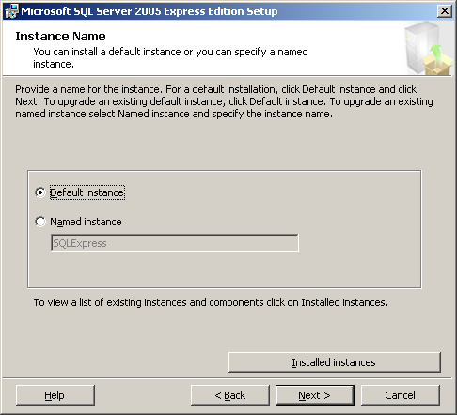
Figure 1 – The Instance Name page
On the Existing Components page, check the SQL Server Database Services 8.00.761 box, as Figure 2 shows, and then click Next.
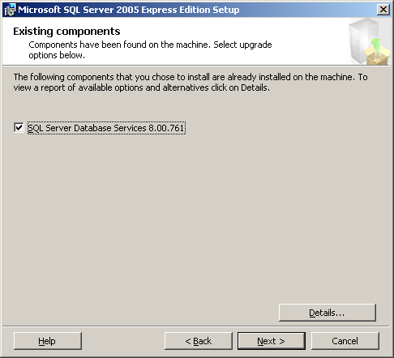
Figure 2 – The Existing Components page
- Specify the logon information for the Setup program to use to connect to the instance being upgraded. Generally, you will select the default option of Windows Authentication.
- Specify the remaining configuration options (generally accept all defaults), and then click Install on the Ready to Install dialog box. This will upgrade the specified instance of MSDE to SQL Server Express.

Verify the SQL Server 2005 Express Installation
- Use Configuration Manager to verify that the upgraded instance is running. To start Configuration Manager, double-click SQL Server Configuration Manager under Configuration Tools in the Microsoft SQL Server 2005 program group.
- Within SQL Server Configuration Manager, open the SQL Server 2005 Services node and check for an upgraded instance entry to verify that it has a status of running. If the SQL Server service is not running, you can manually attempt to start it by right-clicking the entry and selecting Start from the context menu. If the service will not start, the installation was not successful and will need to be redone.
Note: When you’re upgrading instances of MSDE that support connections from networked users, it’s important to know that SQL Server Express by default disables all remote connections. If you need to enable remote connections to SQL Server Express, open SQL Server Configuration Manager, expand the SQL Server 2005 Network Configuration node, select Protocols for MSSQLSERVER, and then enable the required protocols by right-clicking the protocol and selecting the Enable option from the context menu.

Performing a Side-by-Side Upgrade
While an in-place upgrade is the easiest method for upgrading from MSDE to SQL Server Express, there are situations where performing an in-place upgrade is not possible. You cannot perform an in-place upgrade when MSDE has been installed by using Merge Modules or if you want to change languages or collation. In these cases, upgrades must be performed either by using a side-by-side installation in which SQL Server 2005 Express is installed at the same time as MSDE or in which the MSDE databases are detached, the MSDE instance is uninstalled, a new copy of SQL Server 2005 is installed, and then the databases are re-attached to the new instance. This guide will take the second approach to show you how to move from MSDE to SQL Server Express.
Important: As discussed in Section 3.01, “Upgrading Relational Databases to SQL Server 2005,” another important reason for performing a side-by-side upgrade is to enable you to fully test the upgraded database without overwriting your working instance of the current database.
Note: In this document, we are referring to the detachment of databases, removal of the MSDE instance, and the re-attachment of its user databases to a new SQL Server Express instance as a side-by-side upgrade.

Side-by-Side Upgrade Steps
To upgrade from MSDE to SQL Server Express where you cannot or do not want to perform an in-place upgrade, use the following steps:
- Log in to the MSDE system as an administrator, and verify that the instance of MSDE that you want to upgrade is running.
Check for a green arrow on the SQL Server icon in the System tray.
- Open a command prompt, and use osql to connect to the instance you want to upgrade. To connect to the local, default instance of MSDE using Windows Authentication, use the following command:
osql -E
To connect to a named instance, use the –S switch and specify the instance name, as shown below, to connect to the desired named instance:
osql -E -S servername\instancename
- List all of the databases on the MSDE instance by using the following commands at the osql prompt:
1> SELECT name FROM master.dbo.sysdatabases WHERE DBID > 6
2> GO
This lists all of the user databases on the MSDE instance.
- Detach each of the user databases on the MSDE instance by entering the following command at the osql command prompt:
1> EXEC sp_detach_db 'database_name'
2> GO
This takes each of the user databases offline. Replace the value of database_name with the name of the databases that you want to move from MSDE to SQL Server Express. The databases will later be attached to the new SQL Server 2005 instance.
- Exit the osql utility by entering the following command at the osql command prompt:
1> exit
- Shut down MSDE by opening the SQL Server Service Manager on the System Tray, and then in the Services drop-down list, select the SQL Server service, click Stop, and then click Yes.
Note: You can also use the Services application or the NET STOP command to stop the MSDE instance.
- Repeat for the Distributed Transaction Coordinator and the SQL Server Agent services (if they are running).
- Remove MSDE by using the Add/Remove Programs applet from the system’s Control Panel, selecting the entry named Microsoft SQL Server Desktop Engine, and clicking Remove.
Note: If MSDE was installed as part of another application, there will be no entry in the Add/Remove programs list. In this case, remove MSDE using that application’s installation program.
Note: This step can be skipped until a later time if you are installing SQL Server 2005 to a different instance name than the instance of MSDE being upgraded.
- Download and install Windows Installer 3.1.
Windows Installer 3.1 is required by SQL Server Express. You can download Windows Installer 3.1 from the Microsoft Download Center. After you have downloaded Windows Installer 3.1, install it by running the WindowsInstaller-KB893803-v2-x86.exe program (if Windows Installer 3.1 is already present, the install will detect and abort). This install will require a system reboot.
- Download and install the .NET Framework 2.0.
The .NET Framework 2.0 is a prerequisite for SQL Server Express, and it can be downloaded from the Microsoft Download Center. After downloading the .NET Framework 2.0, install it by running the dotnetfx.exe program.
- Install SQL Server Express by running SQLEXPR.EXE.
Select the appropriate installation options for the new instance you are installing, including the instance name if you want to specify a name other than SQLEXPRESS, although the use of this name is recommended.
Important: The Setup program will change the name of a default instance to SQLEXPRESS, rather than the MSDE default of the host computer name. If you want the instance name to be the name of the host computer, you must specify that name as the named instance name.
- After SQL Server Express is installed, start sqlcmd by opening a command prompt, typing the following command, and then pressing Enter:
sqlcmd -E
This connects you to the local, default instance of MSDE using Windows Authentication. If you want to connect to a named instance, use the –S switch and specify the instance name, as shown below, to connect to the desired named instance:
sqlcmd -E -S servername\instancename
- Attach each of the user databases that were detached from the MSDE instance by entering the following command at the sqlcmd command prompt:
1> EXEC sp_attach_db 'database' , 'C:\Program Files\Microsoft SQL Server\MSSQL\Data\database_data_filename.mdf', 'C:\Program Files\Microsoft SQL Server\MSSQL\Data\database_log_filename.LDF'
2> go
Replace the values of database_data_filename and database_log_filename with the names of the database files from the user database that was detached from your previous MSDE installation. This example shows the default installation path that is used by MSDE. If your installation used a custom path, you can substitute the correct path value. Repeat for each detached user database.
- Exit the sqlcmd utility by typing exit and pressing Enter.
- Enable any needed protocols.
The default installation for SQL Server Express enables shared memory, which enables local access only; the named pipes and TCP/IP protocols are disabled. If your database installation requires network access, open SQL Server Configuration Manager, open the SQL Server 2005 Network Configuration node, select Protocols for MSSQLSERVER, and then enable the required protocols by right-clicking the protocol and selecting the Enable option from the context menu.

Performing Scripted Upgrades
The previous sections showed you how to upgrade MSDE to SQL Server Express by using the interactive setup program. The setup program is fine for upgrading a few systems, but using the interactive upgrade process is not the most effective means of upgrading a large MSDE installation base like you might find in an enterprise environment. To accommodate installing and upgrading large numbers of systems, the SQL Server Express setup process is entirely scriptable. You can run setup.exe from the command line, as part of a command shell script, or from another program to perform new installations of SQL Server Express or to upgrade existing MSDE installations.
You can run the SQL Server Express setup.exe program from the command script two different ways. First, you can call the setup.exe program and pass it a set of command-line parameters that govern the different setup options. Or, you can define all the required parameters within a template.ini file and pass that file as a command-line parameter to setup.exe.
To run the command-line upgrade process by using command-line parameters, you would use the following command:
Start /wait setup.exe /qb UPGRADE=SQL_Engine INSTANCENAME=InstanceName
Replace the value InstanceName with the name of the installed MSDE instance. The Start command launches the upgrade process in a new command window. The /wait parameter cause the window to remain open while the process runs. The /qb parameter allows the display of setup dialog boxes. You can display all of the available command-line options for the setup.exe program by using the /? switch as follows:
setup.exe /?
To run the command-line upgrade process by using the template.ini file, you first need to modify the content of the template.ini file and add the following line:
UPGRADE=SQL_Engine INSTANCENAME= InstanceName
Replace the value if InstanceName with the name of your installed MSDE instance. Then, execute the setup.exe program by using the /settings switch to pass in the name of the template.ini file, as shown below:
start /wait setup.exe /qb /settings c:\template.ini
Note: If you have downloaded SQL Server Express from the Microsoft Web site, you will have an installation program named SQLEXPR.EXE. To extract the setup.exe program, run the SQLEXPR.EXE program by using the /X switch, as shown below:
SQLEXPR.EXE /X
This will prompt you for a destination directory that will contain all of the extracted setup files. This directory will contain the setup.exe program as well as a sample template.ini file.

Additional Features in SQL Server 2005 Express
SQL Server Express supports all of the core database functionality that’s provided by MSDE, enabling almost all existing database applications to work without modifications. In addition, SQL Server Express also supports most of the new SQL Server 2005 features, including Common Language Runtime (CLR) support, the new XML data type, XQUERY, dynamic management views (DMVs), and user-schema separation.
In addition, SQL Server Express has a new set of management tools. SQL Server Express uses the new SQL Computer Manager for starting and stopping the database services. The new SQL Server Surface Area Configuration tool can be used to limit potential security risks by controlling network connections and shutting down unused services. In addition, SQL Server Express can be managed by using SQL Server Management Studio Express, which is a free download from Microsoft. You can use SQL Server Management Studio Express to manage all editions of SQL Server 2005, including SQL Server Express, as well as SQL Server 2000 and MSDE 2000.

Additional References
You can download SQL Server 2005 Express at: http://lab.msdn.microsoft.com/express/sql/default.aspx
You can download Windows Installer 3.1 at: http://www.microsoft.com/downloads/details.aspx?FamilyID=889482fc-5f56-4a38-b838-de776fd4138c&displaylang=en
You can download the .NET Framework 2.0 redistributable file at: http://go.microsoft.com/fwlink/?LinkId=48448
You can download the SQL Server 2005 Management Studio for Express at: http://www.microsoft.com/downloads/details.aspx?familyid=82afbd59-57a4-455e-a2d6-1d4c98d40f6e&displaylang=en
You can download SP4 for Windows 2000 at: http://www.microsoft.com/windows2000/downloads/servicepacks/sp4/default.asp
You can download SP1 for Internet Explorer at: http://www.microsoft.com/windows/ie/downloads/critical/ie6sp1/default.mspx
You can download SP1a for Windows XP at:
http://www.microsoft.com/windowsxp/downloads/updates/sp1/default.mspx
You can find full information about SQL Server 2005 Express Edition at: http://lab.msdn.microsoft.com/express/sql/
You can find a SQL Server 2005 Express Edition Overview white paper at: http://msdn.microsoft.com/library/default.asp?url=/library/en-us/dnsse/html/sseoverview.asp
You can find more information about setting up SQL Server Express from the command line at:
http://msdn2.microsoft.com/en-us/library/ms144259.aspx

Section 4.01: Upgrading to SQL Server 2005 Reporting Services

Introduction
Microsoft SQL Server 2000 Reporting Services, which shipped in January 2004, provided users with the ability to design and deploy reports within their organizations. The release of this important new component of SQL Server 2000 allowed IT departments, development groups, database administrators, and infrastructure specialists to reduce reporting TCO, development cycles, and reliance on non-Microsoft reporting technologies.
With the release of SQL Server 2005, Reporting Services has been updated to contain significant new features and ease-of-use improvements. Customers currently using Reporting Services 2000 need to determine the best approach to upgrading their existing reports and/or their existing Reporting Services 2000 environment to Reporting Services 2005. The options available for upgrading depend on how Reporting Services 2000 is currently deployed and what level of availability and upgrade testing is needed.

Reporting Services Configurations
When deploying Reporting Services 2000, many customers chose to install the components to make use of a local instance of SQL Server to house the report database. This is often referred to as a single-server installation. The diagram in Figure 1 shows this type of installation.
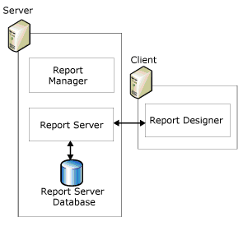
Figure 14 - Single-Server Installation of Reporting Services 2000
Reporting Services 2000 also supports a remote catalog installation in which the report catalog database is housed on a different server running SQL Server. This provides better scalability because report processing and rendering is separated from the database operations needed to manage and maintain report server content, such as reports and snapshots. The diagram in Figure 2 shows a remote catalog installation.
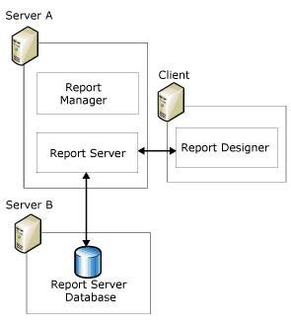
Figure 2 - Remote Catalog Installation of Reporting Services 2000
Finally, when customers require a highly scalable and available reporting environment, Reporting Services 2000 can be deployed using scale-out architecture, with or without a clustered environment for the SQL Server instance hosting the report database. Each of the report servers in the scale-out deployment share a common report database, providing an extensible architecture in which new report servers can be easily added as the user population and load increases. The diagram in Figure 3 shows a scale-out installation.
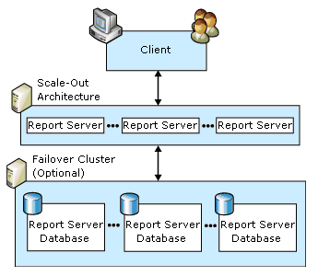
Figure 3 - Scale-Out Installation of Reporting Services 2000

Reporting Services Editions
Reporting Services 2005 comes with all editions of SQL Server 2005, with each edition meant to address specific reporting needs throughout an organization:
- Express Edition (32-bit only) – Designed for a single-server configuration with limited data source support, limited management functionality, and no support for ad hoc reporting via Report Builder.
- Workgroup Edition (32-bit only) – Designed for a single-server configuration with limited data source support, full management functionality, support for ad hoc reporting via Report Builder, and support for custom authentication extensions.
- Standard Edition (32-bit or 64-bit) – Designed for a single-server or remote database configuration with complete data source support, full management capabilities, complete report processing and storage functionality, support for ad hoc reporting via Report Builder, and full support for custom extensions (rendering, data sources, delivery, and authentication).
- Enterprise Edition (32-bit or 64-bit) – Designed to meet high-volume report processing requirements through scale-out deployment of report servers accessing a centralized (often clustered) report storage environment; Enterprise Edition includes all of the features of Standard Edition plus scale-out deployment, data-driven subscriptions, and infinite clickthrough support for Report Builder.
- Developer Edition (32-bit or 64-bit) – Designed for developers who want to integrate or extend the report server engine; Developer Edition includes all the features of Enterprise Edition but is licensed for use as a development and test system only.
- Evaluation Edition (32-bit or 64-bit) – Designed to allow organizations to evaluate and test features of Reporting Services; Evaluation Edition includes all the features of Enterprise Edition but is valid for only 120-days after installation.
A full list of features available in each edition is located at http://www.microsoft.com/sql/2005/productinfo/rsfeatures.mspx.
It is generally recommended that each edition of Reporting Services 2000 be upgraded to the same edition of Reporting Services 2005. However, certain cross-edition upgrades are supported. Specifically, the Standard Edition of Reporting Services 2000 can be upgraded to the Enterprise Edition and the Developer Edition of Reporting Services 2005 (as well as to the Standard Edition of Reporting Services 2005).
If the Standard Edition of Reporting Services 2000 is upgraded to the Enterprise Edition or the Developer Edition of Reporting Services 2005, some new features such as data-driven subscriptions, custom security extensions, and scale-out capabilities will be available. However, keep in mind that upgrading to the Developer Edition will prevent the upgraded report server from being used as a production server (until upgraded to a production version of Reporting Services 2005).
Note: This document does not discuss the integration of new features in conjunction with an upgrade of a database instance to SQL Server 2005.

Upgrade Considerations
When upgrading from Reporting Services 2000 to Reporting Services 2005, you should keep in mind the following possible issues.
- Reporting Services 2000 is always installed as a default instance. If the report server database resides within the default instance of SQL Server 2000 on the same server, the relational engine and the report server must be upgraded together (if you are performing an in-place upgrade). In this case, the setup program upgrades the relational engine first, and then upgrades the report server components. When the report server database is upgraded, the setup program modifies the table structures to reflect the schema needed for Reporting Services 2005.
- If the report server database resides within a named instance of SQL Server 2000 on the same server or resides on a remote server, the Reporting Services components can be upgraded without upgrading the relational engine. In this case, the setup program simply modifies the table structures of the report server database to reflect the schema needed for Reporting Services 2005. The report server will continue to connect to SQL Server 2000 relational engine, simply with the new database schema in place.
- Reporting Services includes client and server components. If a Reporting Services 2000 installation is upgraded to Reporting Services 2005 (i.e., the server components are upgraded), the client components used by all report developers should also be upgraded. Although it is possible to use the prior version of Report Designer with a Reporting Services 2005 server, report developers may see a disparity between report preview in Report Designer and how the report is rendered at runtime. Please note, however, that once Report Designer on a given client is upgraded, it can no longer be used to publish reports to a Reporting Services 2000 server. Report namespace differences prevent publishing to the prior version of the report server.
- If the client components of Reporting Services 2000 are installed on a report server, upgrading the server to Reporting Services 2005 will remove the previous client components. If the previous Reporting Services 2000 client components are needed, they can be reinstalled after the upgrade is complete.
- If you need to upgrade a scale-out deployment, each Reporting Services 2000 report server in the scale-out deployment must be upgraded. The servers can be upgraded in any order, but all of the report servers should be stopped until all of the upgrades are complete. To stop a report server, simply stop IIS and the Reporting Services Windows service. When the first report server is upgraded, the shared report server database will be upgraded. After finishing the upgrades, simply restart IIS and the Reporting Services Windows service on each report server.

In-Place Upgrade vs. Side-by-Side Upgrade
Reporting Services 2000 installations can be upgraded to Reporting Services 2005 in one of two ways:
- In-place upgrade: With an in-place upgrade, Reporting Services 2000 is removed and replaced by Reporting Services 2005. During the upgrade process, the Reporting Services databases are upgraded and users will not be able to access the Reporting Services 2000 reports. After the in-place upgrade is complete, only Reporting Services 2005 will remain. With an in-place upgrade, Reporting Services 2005 is tested after Reporting Services 2000 is removed. An in-place upgrade is an all-or-nothing approach; if an in-place upgrade fails, you cannot quickly roll back to the Reporting Services 2000 environment once the setup program finishes the upgrade (there is a go/no-go point within the setup program before which you can simply cancel the upgrade). To roll back to Reporting Services 2000 after an upgrade to Reporting Services 2005 is complete, you need to uninstall Reporting Services 2005, reboot, reinstall Reporting Services 2000, and restore the Reporting Services 2000 data and configuration files. Downtime in the event of upgrade problems can be significant.
- Side-by-side upgrade: With a side-by-side upgrade, an instance of Reporting Services 2005 is installed and Reporting Services 2000 remains until uninstalled. During the upgrade process, users can continue to access the Reporting Services 2000 reports (unaffected by the upgrade process). After a side-by-side upgrade is complete, Reporting Services 2000 and Reporting Services 2005 are installed. After Reporting Services 2005 is fully tested, Reporting Services 2000 can be uninstalled.
Note: With a side-by-side upgrade, you can either use a copy of the existing report server database for the new installation or redeploy reports and recreate server settings on a new server.
Important: The side-by-side upgrade option provides for greater availability during the upgrade process, simplifies rollback (should that be required), and results in simpler testing scenarios (because both versions are available at the same time).
Table 1 shows which upgrade option can be applied to each of the Reporting Services 2000 configurations mentioned above. Note that these options can be used regardless of which edition of Reporting Services 2000 is in place. See the section above for additional information related to specific editions.
Table 1 - Reporting Services 2000 Upgrade Options
Reporting Services 2000 Configuration | In-Place Upgrade? | Side-by-Side Upgrade?
Single-server installation | Yes | Yes
Remote catalog installation | Yes | Yes
Scale-out installation | Yes | Yes

Determining and Evaluating Potential Upgrade Issues
Regardless of whether you choose to perform an in-place upgrade or a side-by-side upgrade of Reporting Services 2000 to Reporting Services 2005, there is a range of potential issues you may face during an upgrade. To obtain a report that identifies many of these potential issues before you begin an upgrade, you should run Microsoft SQL Server 2005 Upgrade Advisor to analyze the Reporting Services 2000 instance that you want to upgrade. If any of these issues are reported, follow the Upgrade Advisor’s recommendations and guidance for possible mitigation options and strategies. For more information about installing and running this tool, see Section 1.0, “Upgrade Planning and Deployment.” There is also a category of issues that either cannot be detected by Upgrade Advisor or the detection of the issue would result in too many false-positive results.
The following section discusses the most important upgrade issues, whether detected by Upgrade Advisor or not. For a more complete list of backward-compatibility issues, breaking changes, and behavior changes to Reporting Services in SQL Server 2005, see “Reporting Services Backward Compatibility” at ms-help://MS.SQLCC.v9/MS.SQLSVR.v9.en/instsql9/html/675b0e0e-cfee-4790-9675-80fc3ea6d30f.htm. For a complete list of the Reporting Services upgrade issues detected by Upgrade Advisor, review the “Reporting Services Upgrade Issues” topic in the SQL Server 2005 Upgrade Advisor Help file.

Issues Preventing an In-Place Upgrade
There are certain Reporting Services 2000 configurations that may block the in-place upgrade process and prevent it from running; these configurations are discussed below. Before proceeding with an in-place upgrade, these items should be checked to ensure no problems will occur. Please note that these blockers are detected and reported by Upgrade Advisor. Use this tool to check for these situations as well as to check for other problems and issues that may impact the upgrade process.
If Reporting Services 2000 is running under IIS 6.0, the report server and Report Manager virtual directories must be running in an application pool that is configured to use the Network Service security account for its identity. If this is not the case, change the application pool to use the Network Service security account before performing an in-place upgrade. If the application pool cannot be changed, perform a side-by-side upgrade rather than an in-place upgrade.
The report server and Report Manager virtual directories must be configured using the default configuration settings. While changes to the names of the virtual directories will not block an in-place upgrade, other configuration changes will. In particular, the virtual directories should be configured with the following default settings:
- Security for the virtual directories must be set to Integrated Windows Authentication; Anonymous Access is not supported for an in-place upgrade.
- The default Application Mappings should be set as follows:
  - For the report server virtual directory, the wild card mapping must point to the v1.1 aspnet_isapi.dll executable and no other script maps should exist.
  - For the Report Manager virtual directory, the .asax and .aspx extensions must point to the v1.1 aspnet_isap.dll executable.
Reset the virtual directories to their original default configuration settings to allow an in-place upgrade to proceed. If resetting these configuration settings is not possible, perform a side-by-side upgrade rather than an in-place upgrade.
The ASP.NET account information cannot be encrypted within the registry. While encrypting the account information is considered a security best practice for some IIS installations, SQL Server 2005 cannot upgrade a Reporting Services 2000 installation configured in this manner. To proceed with an upgrade, temporarily add unencrypted account information to the Machine.config file using the following steps:
- Make a backup copy of the existing Machine.config file.
- Open Machine.config in a text editor, and find the <processModel> element.
- Find the User attribute. This attribute is created when you specify a custom domain account to run ASP.NET.
- Modify the User attribute, and specify an unencrypted user name and password.
- Upgrade Reporting Services.
- Once the upgrade is complete, modify the Machine.config file so that the User attribute within the <processModel> element specifies the encrypted values used before any changes were made.
If you have deployed custom extensions to your report server, remove references to these extensions from your report server configuration file to perform an in-place upgrade, or leave them in place and perform a side-by-side upgrade. A side-by-side upgrade is recommended in this case to ensure that reports continue to execute the way they did prior to upgrade. Custom extensions, with the exception of authentication extensions, will need to be recompiled after either an in-place or a side-by-side upgrade. Custom authentication extensions need to be updated to account for new API signatures used within Reporting Services 2005.
If you are upgrading an Evaluation Edition of Reporting Services 2000, using an in-place upgrade requires that the Evaluation Edition still be active (the evaluation period must not have expired). If the Evaluation Edition has expired, upgrade the installation by using the side-by-side upgrade process.
If any of these blocker situations exist and cannot be resolved, the installation cannot be upgraded in place; perform the upgrade using the side-by-side upgrade process.

Discontinued Reporting Services Functionality
Table 2 describes the most important functionality changes in Reporting Services 2005 that will break custom applications, scripts, or reports. It also discusses the replacement feature or functionality.
Table 2 – Discontinued Reporting Services Features/Functionality
Discontinued Feature/Functionality | Replacement Feature/Corrective Action
Rsactivate - used to initialize a single report server instance and multiple report server instances that were part of a single scale-out deployment. The Rsactivate.exe command-line utility is now obsolete. | Initialization functions are now performed by the Report Server Windows service, and configuration functions are now performed using the Reporting Services Configuration tool.
Setup – used to install and deploy an installation of Reporting Services 2000 on remote computers. In Reporting Services 2005, Setup no longer deploys a Report Server scale-out deployment installation. Batch files and setup scripts used in Reporting Services 2000 to perform these tasks will no longer work after an upgrade. | Report Server scale-out deployment configuration is now performed using the Reporting Services Configuration tool.
Data processing extensions – used to connect to a data source and retrieve data. New restrictions affect how database credentials are handled. Analysis Services data source connections, XML data source connections, and third-party .NET Framework data processing extensions can no longer be configured to use database credentials. | To configure an unattended execution account, use the Reporting Services Configuration tool.

Behavioral Changes That May Require Corrective Action
There are a number of behavior changes that may require corrective action after the upgrade is complete. Table 3 summarizes the most important of these changes.
Table 3 – Reporting Services 2005 Behavior Changes
Behavior Change | Corrective Action
Report Server Windows service –performs the initialization of a Reporting Services installation and is used for key encryption and decryption. This service is a prerequisite for most Web service operations. | Ensure that the Report Server Windows service is running. This account must be running using the account specified in the WebServiceAccount setting in the RSReportServer.config file.
WMI – the new version of WMI in Reporting Services 2005 replaces the previous version of WMO. | Update Reporting Services 2000 WMI scripts.
Action property – a Me.Value reference in the Action property will result in a compilation error when updating a Reporting Services 2000 report. | Replace each Me.Value reference with the actual value expression.

Report Projects and Definitions Must Be Updated for Use within BIDS
Reports for Reporting Services 2000 were developed in the Report Designer interface hosted within Visual Studio 2003. Reports were created within a report project, along with shared data sources and image files. Reporting Services 2005 includes an integrated development environment called Business Intelligence Development Studio (BIDS) for report design and report project management. Hosted using the Visual Studio 2005 shell, BIDS provides a much-improved report design and project management experience.
You must update existing report projects and definitions for use within BIDS so that you can make updates and changes to existing reports. When an existing report project is opened within BIDS, the project will need to be upgraded to Visual Studio 2005 format. After opening the project, the BIDS environment will launch the Visual Studio Conversion Wizard, which can be used to perform the upgrade.
After the project has been upgraded for use within the BIDS environment, each individual report must also be upgraded from Reporting Services 2000 format to Reporting Services 2005 format. This will update the report definition language (RDL) within each report to ensure it is compatible with the new version. Open each report in the project in order to launch the report converter. BIDS will display a confirmation message and update the report RDL. The updated report will then be opened in the Report Designer within BIDS; save the report to complete the upgrade process. As mentioned above, each report within a project will need to be upgraded and saved before the project can be fully deployed to Reporting Services 2005.
When reports are converted, a number of changes are made:
- The report definition namespace is upgraded to http://schemas.microsoft.com/sqlserver/reporting/2005/01/reportdefinition.
- The CustomReportItem element is modified to support data-bound controls. The element now includes child elements that describe the data that is used by the control as well as the properties and dimensions of the control in the report.
- The Custom element is replaced by a custom properties collection that contains name-value pairs. Upon upgrade, all instances of a custom element are mapped to a custom property in the CustomProperties collection.
Once a given report has been converted and saved, it can be deployed to a Reporting Services 2005 report server. If all of the reports in a given project have been converted, the entire project can be deployed.
Important: Once a report has been converted to the Reporting Services 2005 schema, it can no longer be published to a Reporting Services 2000 instance.

Preparing for an Upgrade
Before beginning an in-place upgrade, take steps to ensure that a failed upgrade can be rolled back. While the in-place upgrade process has been designed and tested to handle almost all situations, unforeseen problems may occur and result in a failed upgrade. In extreme cases, a failed upgrade may even result in an unusable Reporting Services 2000 installation. Thus, planning for a failed upgrade process is critical.
A side-by-side upgrade of an existing Reporting Services 2000 installation to Reporting Services 2005 should not encounter the same types of problems that can affect an in-place upgrade. However, the same steps should be followed because the files generated by the steps below will be needed for the upgrade process.
If a failed in-place upgrade occurs, in many cases the easiest resolution is to re-install Reporting Services 2000 and restore the installation to its state before the upgrade process was started. To ensure all of the data and configuration files needed to restore the existing installation are available, complete the following steps before the upgrade process begins.
- Verify that SQL Server 2005 hardware and software requirements are met. If you do not meet these requirements, the System Configuration Checker (SCC) portion of the SQL Server Setup program will not permit setup to continue.
- Run Upgrade Advisor to analyze the Reporting Services instance, and then review the generated report to verify that you have addressed all issues that must be resolved before the upgrade and that you understand the upgrade issues that you must resolve after setup completes.
- Back up the report server’s symmetrical encryption key using the Reporting Services 2000 rskeymgmt utility. This command-line utility is used to extract or restore the encryption key used by Reporting Services 2000 to store sensitive data within the report server database. This utility is typically found in the <SQL Install Dir>\80\Tools\binn directory. To use this utility, simply open a command line, change to this directory, and issue the following command:
rskeymgmt –e –f<File> –p<Password>
Replace the <File> parameter with a valid file specification. This file will contain the symmetric key information. Also, replace the <Password> parameter with a password, which will be used to encrypt the symmetric key before it is stored in the file.
- Back up the report server’s databases by using any supported method for backing up a SQL Server database. For a default installation of Reporting Services 2000, the two databases used are named ReportServer and ReportServerTempDB. Ensure that each of these databases has been backed up.
- Back up critical configuration files related to Reporting Services 2000, including the files that Table 4 lists.
Table 4 - Important Reporting Services 2000 Configuration Files
Configuration File | Standard Location
Rsreportserver.config | <SQL Install Dir>\MSSQL\Reporting Services\ReportServer
Rssrvpolicy.config | <SQL Install Dir>\MSSQL\Reporting Services\ReportServer
Web.config | <SQL Install Dir>\MSSQL\Reporting Services\ReportServer
Reportingservicesservice.exe.config | <SQL Install Dir>\MSSQL\Reporting Services\ReportServer\bin
Rswebapplication.config | <SQL Install Dir>\MSSQL\Reporting Services\ReportManager
Rsmgrpolicy.config | <SQL Install Dir>\MSSQL\Reporting Services\ReportManager
Web.config | <SQL Install Dir>\MSSQL\Reporting Services\ReportManager
- Back up the report server virtual directory settings. If the report server is using IIS 6.0, this can be done using the Internet Information Services (IIS) Manager application (found in the Administrative Tools folder in Control Panel). In this application, drill down under Web Sites to Default Web, then right-click the Report Server virtual directory. Select All Tasks and then Save Configuration to a File. In the resulting dialog box, provide a valid file name and path, optionally providing a password to encrypt the contents of the resulting XML file. If the report server is using IIS 5.x, document these settings manually so that the report server virtual directory can be reconfigured manually in case a failed upgrade requires a reinstallation of Reporting Services 2000.
It is recommended that all of the files generated by the above steps be placed into a single directory on a network share for safe-keeping during the upgrade process.

In-Place Upgrade of Reporting Services
As specified above, an installation of Reporting Services 2000 can be upgraded in-place to Reporting Services 2005. In this scenario, the upgrade process will handle all aspects of the upgrade, automatically updating report server content, report designs, and component configurations. Note, however, that this upgrade will not automatically handle updates to client workstations and computers that have the Report Designer or management tools installed. Those workstations and computers will have to be upgraded as well after the report server is upgraded.

Upgrading via the Setup Application
To begin the in-place upgrade process, launch the setup application for SQL Server 2005. This new integrated application can be used to install and upgrade any and all of the components that come with SQL Server 2005, including Reporting Services. After starting, the setup application will install a set of prerequisites to the installation of SQL Server 2005 components, run a system configuration check, gather system information, and prompt for typical registration information (user name, company name, and product key).
On the Components to Install page, the setup application provides options for selecting components to install. For an in-place upgrade of a Reporting Services 2000 report server, simply select the Reporting Services option. In cases where the report server previously had client components installed (such as Books Online) or where the client components need to be installed, include the Workstation Components option. Figure 4 shows the basic component selection screen, and Figure 5 shows the advanced screen, which provides fine-grained control of the components installed and their configurations.
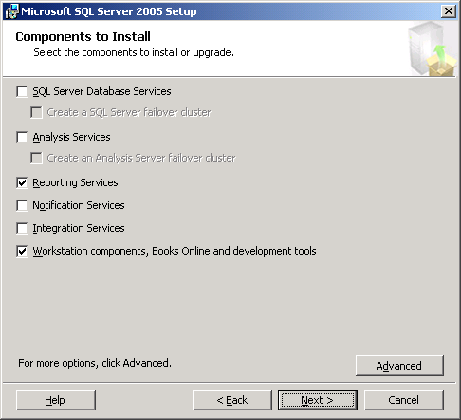
Figure 4 - Select SQL Server 2005 Components to Install
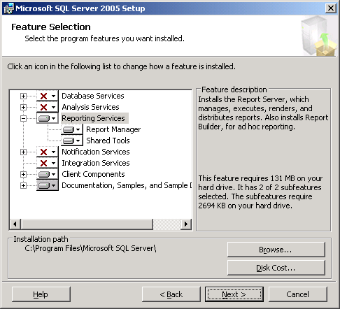
Figure 5 - Advanced Selection of SQL Server 2005 Components to Install
After you have selected the components to install, the setup application will prompt for an instance name for the selected SQL Server 2005 components. To upgrade an existing installation of Reporting Services 2000, select Default Instance and proceed. The setup application should detect any running services, depending on which components were selected for installation. Simply ensure the existing installation of Reporting Services 2000 is selected and proceed. The setup application will then analyze the existing installation to determine whether any upgrade blockers exist. Figures 6, 7, and 8 show the screens used to identify the default instance for upgrade and analyze the existing installation for upgrade blockers.
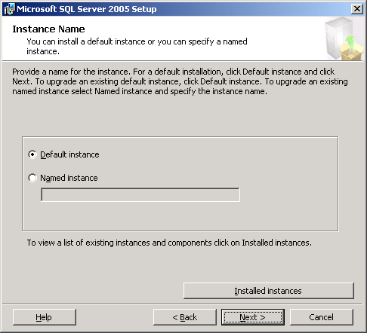
Figure 6 - Instance Name for SQL Server 2005 Installation
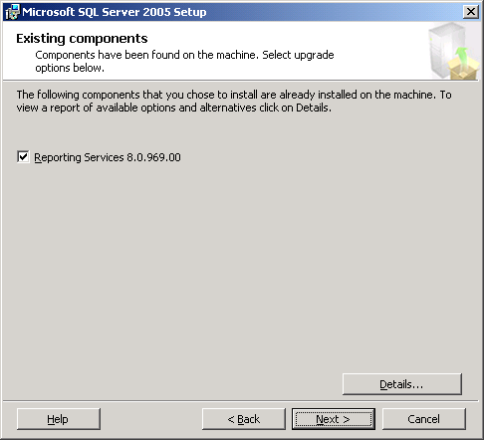
Figure 7 - Existing Components Found During SQL Server 2005 Installation
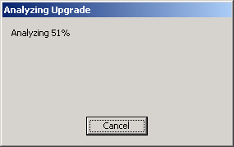
Figure 8 – Analyzing Existing Installation for Upgrade Blockers
To upgrade the report server database, the setup application must connect to the database using a login with either SQL Server administration rights or with database owner rights within the report server database. Thus, the setup application will prompt for credentials to use while upgrading the report server database. Figure 9 shows the Reporting Services Upgrade Logon screen.
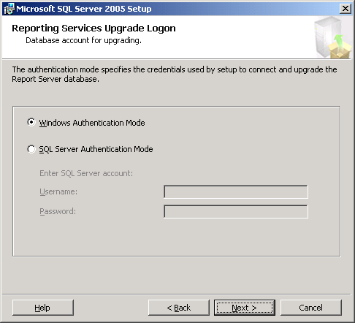
Figure 9 - Reporting Services Upgrade Logon Screen
After you review the final few screens in the setup application (used to specify error and usage reporting to Microsoft and to provide a final summary of the installation actions to be taken), the setup application should begin. A status screen will show status information regarding the various steps taken by the application and should show success for each of the components installed and upgraded when finished. A final screen will provide a summary of the installation along with any notes that are relevant to the upgrade process. Figures 10 and 11 show these two screens.
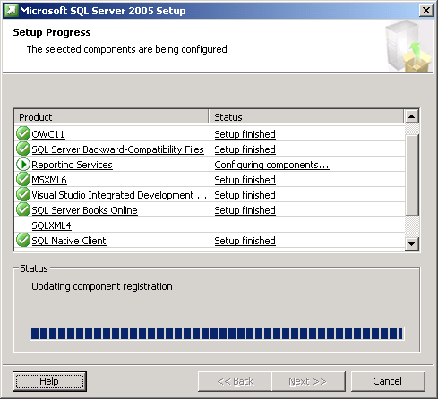
Figure 10 - Status of Installation Steps and Actions
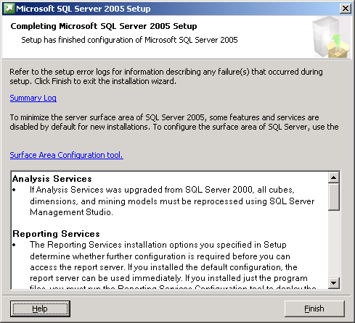
Figure 11 - Final Summary with Notes
After the upgrade process has finished, you should perform a short set of post-installation tasks to ensure the upgrade completed successfully. See the section below regarding post-installation tasks for more information.

Troubleshooting a Failed Upgrade
If the upgrade process should fail, the first course of action is to review the setup logs created by the setup application.
- Review the Summary.txt file located in the %Program Files%\Microsoft SQL Server\90\Setup Bootstrap\Log directory. If any error messages are listed, take whatever actions are required to correct the situation and try the upgrade process again.
- If no error messages are included in the summary, review the SQLSetup[xxxx]_[ComputerName]_RS.log file within the %Program Files%\Microsoft SQL Server\90\Setup Bootstrap\Log\Files directory. When reviewing the file, search for any instances of “Return Value 3” (which indicates a setup error). If any error messages are listed, take whatever actions are required to correct the situation, and try the upgrade process again.

Side-by-Side Upgrade of Reporting Services Installations
Installations of Reporting Services 2000 can be upgraded to Reporting Services 2005 using side-by-side installation. Side-by-side upgrades can be done on a single server (the existing report server) or using two servers (to take advantage of new hardware, for example).
- When you perform the upgrade on a single server, you install a new instance of Reporting Services 2005 alongside the existing Reporting Services 2000 installation, and then you manually migrate report server content, report designs, and other configuration information from Reporting Services 2000 to the new instance.
- When you perform the upgrade by using two servers, you install Reporting Services 2005 on the new server (as the default instance or as a named instance) and then perform the same manual migration of report server content, report designs, and configuration information.
Note: Regardless of the upgrade process you use, workstations and computers with the Report Designer or Reporting Services 2000 management tools will have to be upgraded after the report server is upgraded.

Installing the New Instance
The first step for a side-by-side upgrade is to install (but not configure) Reporting Services 2005. The following points should be considered when planning a single-server or a two-server upgrade process:
- If an additional server is not available, a single-server upgrade process can be used. During the upgrade process, Reporting Services 2005 must be installed as a named instance. After the upgrade (and testing) is complete, the named instance can be renamed to serve as the default instance once Reporting Services 2000 has been uninstalled.
- If an additional server is available and will serve as the new Reporting Services 2005 report server, Reporting Services 2005 can be installed as the default instance or as a named instance on the new server. After the upgrade (and testing) is complete, the old report server can be decommissioned or reused for other purposes.
To begin the upgrade process, launch the setup application for SQL Server 2005.
- After starting, the setup application will install a set of prerequisites to the installation of SQL Server 2005 components, run a system configuration check, gather system information, and prompt for typical registration information (user name, company name, and product key).
- The application will then provide options for selecting components to install. Simply select the Reporting Services option. When using a single-server upgrade, in cases where the report server previously had client components installed (such as Books Online), select the Workstation Components option as well.
- The setup application will then prompt for an instance name for the new SQL Server 2005 components. For a single-server upgrade, select Named Instance, and enter a new instance name; for a two-server upgrade, select Default Instance to install Reporting Services 2005 as a default instance, or select Named Instance and enter a new instance name.
Note: The default selection made by the setup application is Default Instance. Thus, if a new instance name needs to be used, be sure to select Named Instance and provide a new instance name.
Figure 12 shows the set application screen for entering a new instance name (for example, “RS2005”).
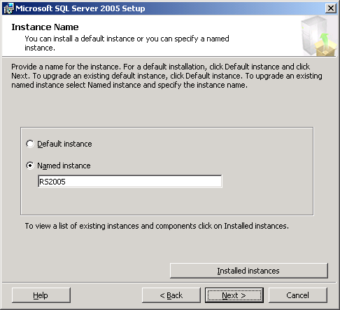
Figure 12 – New Instance Name for a Single-Server Migration
- The setup application will then prompt for service account information. Choose the credentials to use for the Windows service to be created for Reporting Services 2005 and proceed. Figure 13 shows the screen used by the setup application for gathering service account information.
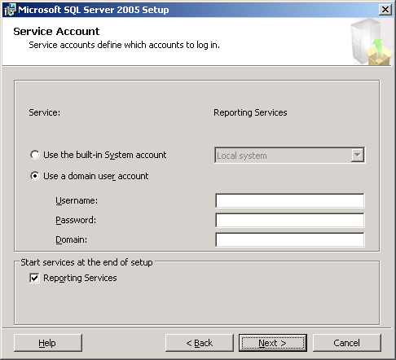
Figure 13 - Service Account Settings for New Instance
- The setup application will then display an installation options screen for specifying the type of installation to perform.
When a default instance of Reporting Services 2005 is being installed, the setup application can create and fully configure the default instance. However, when a named instance is being installed (to support a single-server side-by-side upgrade, for example), the setup application can install the report server software but cannot configure the new instance. Thus, the new named instance must be manually configured (in this case, by using specific steps to migrate the existing report server’s configuration and content to the new instance). If a two-server side-by-side upgrade is being performed and Reporting Services 2005 is being installed as the default instance on the new server, it is recommended that you select the Install but do not configure the server option. While the default instance can be configured by the setup application during installation, the configuration will have to be manually reconfigured by using the steps below in order to migrate the existing report server’s configuration and content to the new server.
Figure 14 shows the screen used by the setup application to select the type of installation to complete.
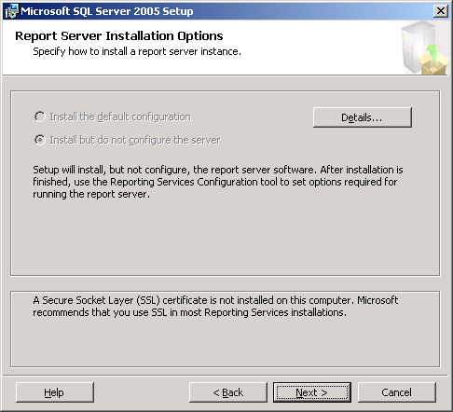
Figure 14 - Install but do not configure the server Installation Option
6. To complete the installation of the new instance, simply proceed through the remaining screens provided by the setup application. All of the required Reporting Services 2005 files will be installed, and the new instance will be ready for migration.

Configuring the New Instance
Once you have installed the new instance, you should use the new Reporting Services Configuration tool to configure the instance. Launch the tool from the Configuration Tools group within the Microsoft SQL Server 2005 Start menu group.
- When the configuration tool is first started, enter the name of the server (or “localhost”), and use the Find button to locate the newly installed Reporting Services 2005 instance. Figure 15 shows the screen used to find and connect to the new instance.
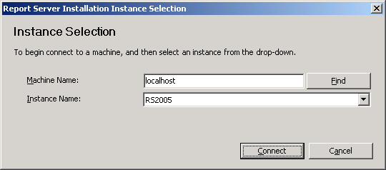
Figure 15 - Configuration Instance Selection
- Once connected to the new instance, the configuration tool will show the current status of each of the items requiring configuration for an instance of Reporting Services 2005. Figure 16 shows the state of each area before configuration is complete.
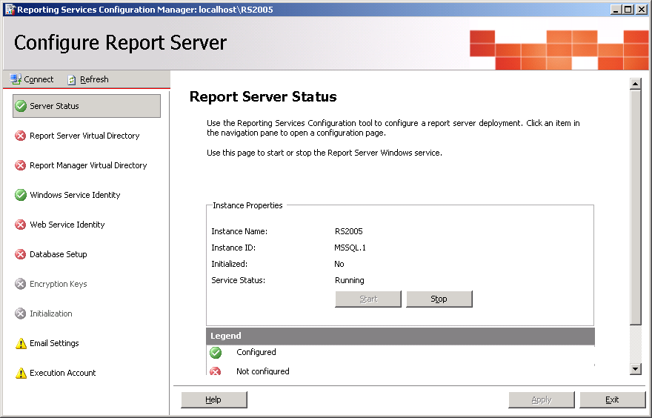
Figure 16 - Initial State of New Reporting Services 2005 Instance
Note: If the configuration tool is started right after the installation is complete, the Server Status screen may show that the server is stopped. It can be started before, during, or after the configuration steps are completed.
- To start the configuration process, use the Report Server Virtual Directory and Report Manager Virtual Directory options to create new virtual directories for the new instance. Any names can be used for these new virtual directories except virtual directory names already in use. Thus, because the original instance of Reporting Services 2000 is still installed and running, the virtual directories cannot be named ReportServer or Reports (the default names for the virtual directories created when Reporting Services 2000 is installed).
Figure 17 shows the Report Server virtual directory being created, using ReportServer2005 as the virtual directory name. And Figure 18 shows the Report Manager virtual directory being created, using the Reports2005 virtual directory name.
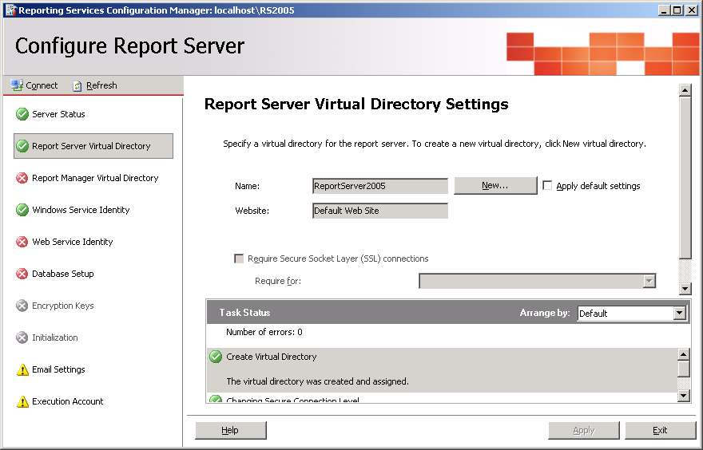
Figure 17 - Create Report Server Virtual Directory
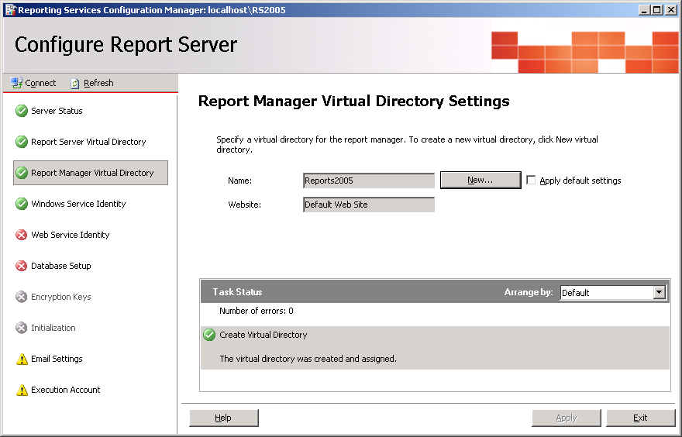
Figure 18 - Create Report Manager Virtual Directory
- After you have created the virtual directories for the new instance, use the Windows Service Identity option to confirm the security credentials for the Windows service.
The Windows service identity should reflect the choice made during installation of Reporting Services 2005. If, however, the Windows service identity is wrong or needs to be modified, the service identity can be set to any of the built-in accounts listed or can be set to a Windows account.
Figure 19 shows the screen used by the configuration tool to confirm (or set) the Windows service identity.
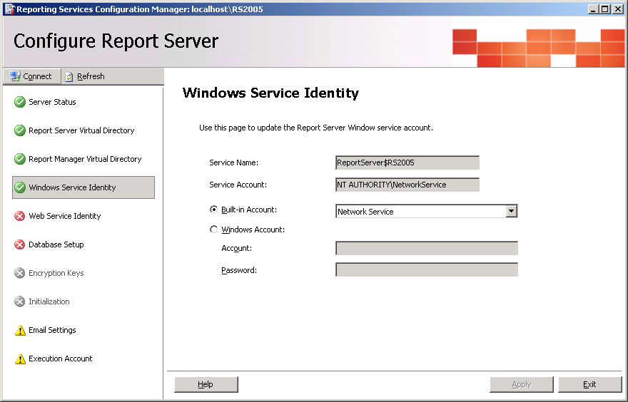
Figure 19 - Confirm Windows Service Identity
- The Web Service Identity option is used to configure the Web service identity for Reporting Services 2005. The Web service identity is configured differently based on the version of IIS being used:
- When using IIS 5 (on Windows XP, for example), the Web service runs under the security context of the ASP.NET service account. This is configured automatically and cannot be changed.
- For IIS 6 (on Windows Server 2003, for example), the Web service runs under the security context associated with a given application pool. Application pools also provide isolation of applications that require different versions of the .NET Framework. Thus, it is recommended that a new application pool be created for Reporting Services 2005. To create a new application pool and assign it a security account, use the New button on the Web Service Identity screen. After creating the new application pool, use the drop-down lists on the same screen to assign the new pool to both the Report Server and Report Manager virtual directories; then click Apply to save the changes. Figure 20 shows a new application pool named RS2005AppPool being assigned to the new virtual directories.
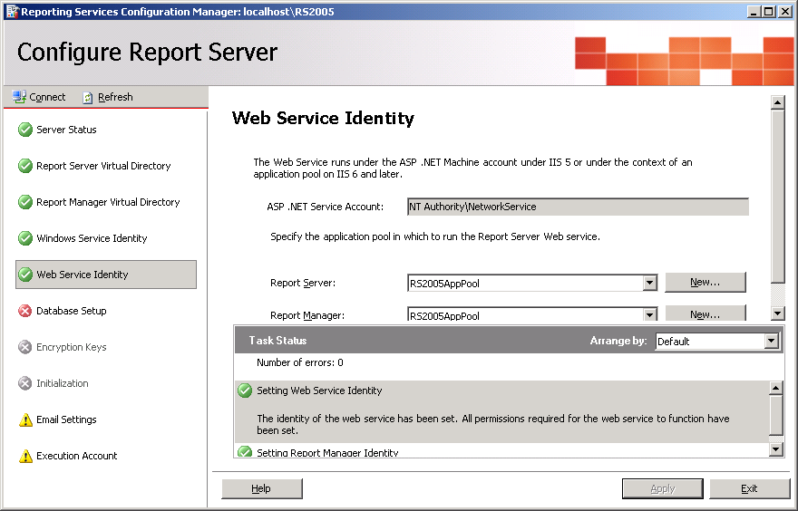
Figure 20 - Configure Web Service Identity with IIS 6
- After you have defined the security credentials and identities for both the Windows and Web services, the new instance must have its database setup defined. You use the configuration tool’s Database Setup option to define the database setup (identifying the server name, database name, and connection credentials) for the new instance.
You can also use this option to upgrade a copy of the report server database used for Reporting Services 2000 to the new format needed for Reporting Services 2005. For a migration effort, a backup copy of the report server database used for Reporting Services 2000 (named ReportServer by default) and the additional database used by Reporting Services 2000 for temporary database use (named ReportServerTempDB by default) should be restored and then upgraded for Reporting Services 2005.
- Thus, to begin the database setup process, restore a backup of the two Reporting Services 2000 report server databases. If a single-server migration is being done, the databases should be restored using new names to allow the existing instance of Reporting Services 2000 continued access to its existing databases.
- Once the databases have been restored, use the Database Setup option to connect to and upgrade the restored databases. Use the Connect button to connect to the SQL Server instance and use the drop-down list of databases to select the restored report server database (not the restored temporary database). Figure 21 shows the Database Setup screen after a connection has been established and a restored database selected.
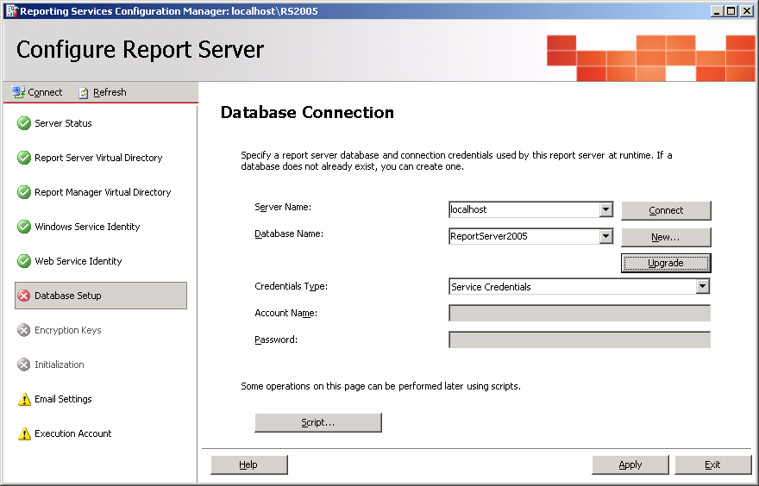
Figure 21 - Configure Database Setup
- Given that the restored databases are still in Reporting Services 2000 format, you need to use the Upgrade button to convert the format of the databases to that used by Reporting Services 2005. After you click Upgrade, the configuration tool will prompt you to verify that the upgrade should proceed. Click OK, and allow the tool to upgrade the database format. If the databases are not upgraded, the configuration of the new instance will not complete successfully.
- After the upgrade process is complete, use the Credentials Type drop-down list to specify how Reporting Services 2005 should connect to the newly upgraded databases on an on-going basis. Then click Apply to have the configuration tool update the database configuration information for the new instance of Reporting Services 2005.
- After the database connection has been established, use the Encryption Keys option to restore the symmetric encryption key extracted and saved as part of the pre-planning process. Select Restore, and provide the filename and password used with the rskeymgmt utility to extract and save the key from the Reporting Services 2000 instance. Figure 22 shows this option being used to restore a symmetric encryption key.
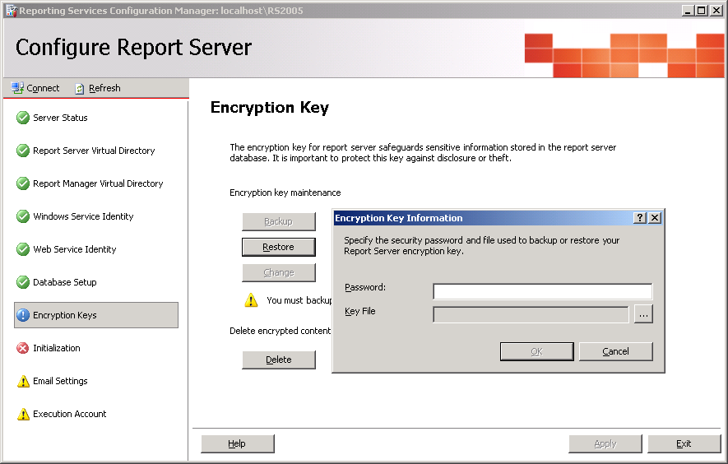
Figure 22 - Restore Symmetric Encryption Key
- You use the Initialization option within the configuration tool to initialize (and reinitialize) an instance of Reporting Services 2005. If the Initialization option still shows a red X after the encryption key has been restored and you have used the Refresh button to refresh the status of the report server’s configuration, click the Initialize button to initialize the new report server. Figure 23 shows the screen used for this option.
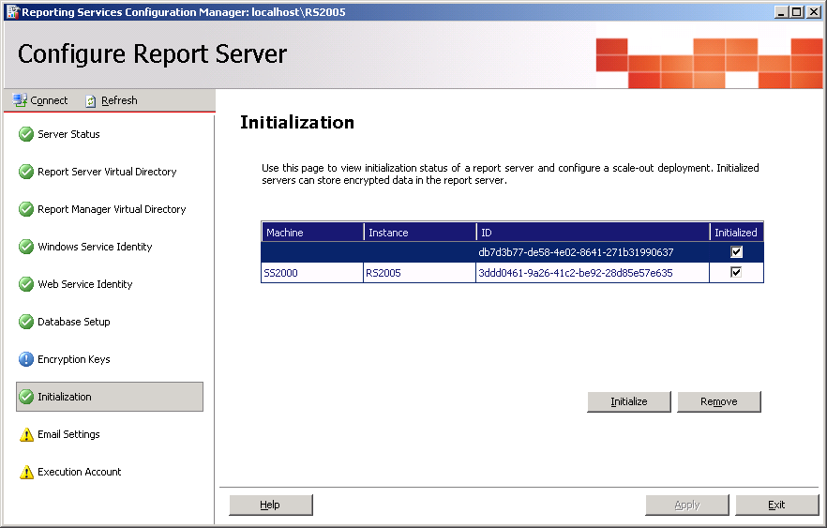
Figure 23 - Initialize New Instance
Note: If the symmetric encryption key has not yet been extracted from Reporting Services 2000, simply do so using the rskeymgmt utility (found within the <SQL Install Dir>\80\tools\binn directory) before proceeding. If the encryption key cannot be restored for some reason, the Delete option will be required to delete existing encrypted content. Note that, in this case, any encrypted content (such as existing data source credentials) will have to be recreated manually after the migration effort is complete. Once the encryption key is restored, use the Refresh button in the top left corner of the configuration tool; this should change the Initialization entry on the left from a red X to a green checkmark.
- Finally, you can use the Email Settings and Execution Account options of the configuration tool to establish other extended configuration options used by Reporting Services 2005. Use these options to set these extended options for the new instance.
- After using the configuration tool to complete the configuration of the new instance, the new instance should be ready for use. Launch the Report Manager interface using a URL referring to the newly configured virtual directory for the Report Manager application. For example, if the virtual directory was named Reports2005, then the URL http://localhost/Reports2005 can be used to launch the new version of the Report Manager application. When opened, the report folders and contents (data sources, reports, and other report item files) available within Reporting Services 2000 should now be present and available within Reporting Services 2005.

Uninstalling Reporting Services 2000
If you performed a side-by-side upgrade on a single server, the new Reporting Services 2005 instance can be used as configured alongside Reporting Services 2000. However, at some point, Reporting Services 2000 should be uninstalled. At that point, the virtual directories created for Reporting Services 2005 can then be renamed to use the names originally configured for Reporting Services 2000. When this is accomplished, end users and applications that reference the report server can continue to use original URLs and connection information as opposed to the virtual directory names assigned to Reporting Services 2005 for migration purposes.
- To accomplish this, Reporting Services 2000 can be uninstalled using the Add or Remove Programs option within Control Panel. The report server software (and other associated files installed with Reporting Services 2000) will be removed from the server. This action should not affect Reporting Services 2005 or any other installed software.
- After Reporting Services 2000 has been removed from the server, the original report server databases can be deleted from SQL Server. Ensure that you delete the databases associated with Reporting Services 2000—not those restored and upgraded for use with Reporting Services 2005.
Note: Good backups of these databases should be retained for a period of time just in case the Reporting Services 2000 implementation needs to be resurrected.
- After Reporting Services 2000 has been removed, the virtual directory names assigned to Reporting Services 2005 can be modified to use the names assigned to the virtual directories for Reporting Services 2000.
To do this, launch the Reporting Services Configuration tool (as described in the section above regarding configuring the new instance of Reporting Services 2005) and connect to the new instance.
- Use the Report Server Virtual Directory option to create a new virtual directory for the report server, using the name of the Reporting Services 2000 report server virtual directory. For example, if Reporting Services 2000 used the default name of ReportServer for the report server virtual directory, a new virtual directory for the Reporting Services 2005 report server can be created with that name.
- Use the Report Manager Virtual Directory option to create a new virtual directory for the Report Manager application. For example, if Reporting Services 2000 used the default name of Reports for the Report Manager virtual directory, a new virtual directory for the Report Manager application can be created with that name.
- Use the Web Service Identity option to assign the new application pool created when Reporting Services 2005 was configured to the new virtual directories just created.
- These steps should reconfigure Reporting Services 2005 to use the virtual directory names originally associated with Reporting Services 2000. When this is completed, you can delete the virtual directories initially created when configuring the new instance of Reporting Services 2005 by using the Internet Information Service (IIS) Manager application.

Deploying Custom Extensions and Assemblies
If any custom extensions or custom assemblies for reports were deployed and used for Reporting Services 2000, the extensions or assemblies will need to be redeployed for use with Reporting Services 2005.
- To do so, each extension or assembly will need to be recompiled using Visual Studio 2005. This will ensure each uses the Common Language Runtime (CLR) compatible with Reporting Services 2005.
- After each extension or assembly is recompiled, it will need to be deployed for use with Reporting Services 2005. This typically involves putting a copy of the compiled extension or assembly file within the correct directory under the Reporting Services 2005 installation directory and updating one or more configuration files.
Please refer to SQL Server 2005 Books Online for specific guidance and information related to deploying custom extensions and assemblies.

Verifying Configuration Files
In some cases, configuration changes made within Reporting Services 2000, particularly those made manually within the configuration files, are not created automatically by the new configuration tool for Reporting Services 2005. Thus, it is a good idea to compare each of the configuration files between the old and new instances, looking for any configuration differences that may have been made manually for Reporting Services 2000. Each of the Reporting Services 2000 configuration files saved as part of the pre-planning process should be compared to its new counterpart.
A default installation of Reporting Services 2000 will use the <SQL Install Dir>\MSSQL\Reporting Services directory, storing configuration information under the ReportServer and ReportManager subdirectories. Likewise, a default installation of Reporting Services 2005 will use the <SQL Install Dir>\MSSQL.<N>\Reporting Services directory, where <N> is a number indicating the order of installation of SQL Server 2005 components. For example, if Reporting Services 2005 is the first SQL Server 2005 component installed, the directory would be <SQL Install Dir>\MSSQL.1\Reporting Services. Configuration information is then stored under the same ReportServer and ReportManager subdirectories. The pre-planning section above lists the files to check and compare.

Post-Upgrade Tasks
After upgrading to Reporting Services 2005, it is important to ensure that the upgrade ran smoothly and to configure Reporting Services 2005.
- To begin, particularly if you performed an in-place upgrade, use the Report Server Configuration Tool to check the configuration of the report server. Once the tool is launched, connect to the upgraded instance.
- After connecting, review the configuration settings by selecting each of the items in the left pane of the tool. If any of the settings seem incorrect or are missing, update the settings and save the changes.
- Next, ensure the report server is behaving as expected by running a sample set of the reports deployed to the server. Start Report Manager using the correct URL (for example, http://locahost/Reports for an upgraded default instance or http://localhost/Reports2005 for a newly installed and configured named instance).
- Using Report Manager, open and execute various reports to ensure the report server is working correctly. At a minimum, reports should be selected and executed to verify the following report server features and capabilities (if used) are working correctly:
- Standard and custom data extensions. Reports should be executed against all defined data sources (using standard data providers or custom data extensions) to ensure each is working as expected.
- Security credentials. Run reports that rely on each of the security credential options that can be used for connecting to a data source: credentials supplied by the user running the report, credentials stored securely in the report server, and Windows integrated security.
- Subscriptions. Report subscriptions should be reviewed to ensure their settings are still applicable and each should be tested to ensure it completes successfully.
- Custom rendering and delivery extensions. Any custom rendering and delivery extensions should be fully tested to ensure each is working correctly. As mentioned above, all custom extensions created for Reporting Services 2000 must be recompiled to use the CLR provided with Visual Studio 2005.
- Custom report assemblies. If any reports include references to custom assemblies, the reports should be tested to ensure the custom assemblies continue to function as designed. As mentioned above, all custom assemblies created for reports within Reporting Services 2000 must be recompiled to use the CLR provided with Visual Studio 2005.
- Finally, Reporting Services 2005 comes with a new ad hoc reporting tool called Report Builder. If this new feature will be used, changes should be made to the existing security role definitions to provide end-user access to Report Builder. Consider updating the existing role definitions as Table 5 shows.
Table 5 - Role Updates after Reporting Services Upgrade
Existing Role Definition | Suggested Changes
Browser | Add View Models to grant permission to view published Report Builder models.
Content Manager | Add Manage Models, View Models, and Consume Reports to grant full permission over models and to provide the ability to create and modify reports in Report Builder.
Publisher | Add Manage Models to grant permission to create, view, and delete Report Builder models.
System Administrator | Add Execute Report Definitions to run reports using Report Builder.
System User | Add Execute Report Definitions to run reports using Report Builder.

Moving Reports Between SQL Server 2000 and SQL Server 2005 Installations
When a Reporting Services 2000 instance is upgraded to Reporting Services 2005 using the procedures discussed above, all of the report server content is moved to the new instance and upgraded. In some unique cases, it may be more appropriate to migrate individual reports to a new Reporting Services 2005 instance in a more controlled fashion. For example, if a single report server supports a varied group of users, with reports developed by different development groups, a staged move of reports and users to a new instance of Reporting Services 2005 may be a suitable course of action. Additionally, if a set of complex reports requires additional testing efforts, migrating each report individually may be beneficial.
After a new instance of Reporting Services 2005 is installed, reports can be migrated using one of three options:
- Existing files deployed to the Reporting Services 2000 instance can be manually moved to the new Reporting Services 2005 instance. Using the Report Manager application for Reporting Services 2000, files within a given folder can be saved to the file system on a one-by-one basis. This can be done using the Edit option when viewing the properties of a given report. This option will return an RDL file for each report, which can be saved and then uploaded to the new instance using Report Manager for Reporting Services 2005. It should be noted that data sources used by each report will need to be re-created manually within the new instance, and uploaded reports will need to be configured to use the new data sources (as the uploaded reports will not automatically see new data sources even if they are named the same as their counterparts within the Reporting Services 2000 instance). Also, other files (such as images) will also need to be manually uploaded to the new instance, placed within the same folder structure and using the same names as their counterparts within Reporting Services 2000. As RDL files are uploaded and configured, each report can be tested individually to ensure it works correctly. Any deficiencies can then be corrected within the RDL file by using the new Report Designer tools within the BIDS environment.
- Reports, data sources, and resources can be moved using the Reporting Services script host (rs.exe). By using the Web services APIs, all of the report definitions can be extracted from the Reporting Services 2000 instance to the local file system and then republished to the Reporting Services 2005 instance.
- The BIDS environment can be used to deploy existing report projects to the new instance of Reporting Services 2005. Using BIDS, report projects that were originally created using Report Designer for Reporting Services 2000 can be opened and deployed to the new Reporting Services 2005 instance. When using BIDS, data sources (as well as other files included in the report project) can be deployed along with the reports. This may provide a simpler and more efficient approach for deploying groups of reports to the new instance. As reports are deployed, each report can be tested to ensure it works as designed. Any deficiencies can be corrected within BIDS, with corrected reports redeployed as needed.
Note that deploying individual reports to a new instance of Reporting Services 2005 will not automatically migrate the metadata related to any given report. For example, report history and execution settings, parameter defaults, subscription definitions, and security settings defined for the report within Reporting Services 2000 will not be automatically re-created within Reporting Services 2005. All of these settings will need to be configured manually once the report is deployed to the new report server. Before proceeding with this approach to moving reports from Reporting Services 2000 to Reporting Services 2005, ensure that all of the additional settings for each report are well known and documented so that the settings can be recreated once each report is deployed to Reporting Services 2005.

Section 4.02: Migrating DTS to SQL Server Integration Services

Introduction
Data Transformation Services (DTS) within SQL Server 2000 has provided developers with great data extraction and manipulation capabilities for several years. Various features such as the Data Pump task, the Dynamic Properties task, and the DTS object model allowed database administrators, business intelligence developers, and data architects the ability to create complex solutions to many diverse data movement and integration problems.
With the release of SQL Server 2005 Integration Services (SSIS), Microsoft has raised the bar with regard to these types of solutions. In fact, SSIS is not an updated version of DTS—it is an entirely new product. SSIS has been architected from the ground up to provide a high-performance, scalable data movement and integration platform. Given that SSIS is a new product compared to DTS, the upgrade path is actually more of a migration path, with various options based on the exact scenario being followed.

Upgrade/Migration Considerations
When considering an upgrade or migration strategy for moving from DTS to SSIS, there are three primary considerations:
- Existing DTS packages that need to be converted or migrated to SSIS. In general, after SSIS is installed, existing DTS packages can be converted to SSIS using the Package Migration Wizard, described below, within the new development and management tools. While the existing DTS packages remain unchanged, the migration wizard uses a “best effort” strategy to generate new SSIS packages that replicate each DTS package’s functionality.
- The storage location for existing DTS packages. SQL Server 2000 provided three storage options for DTS packages: the msdb database, the Meta Data Services repository, and the Windows file system. However, SQL Server 2005 does not include support for the repository. As a result, the Package Migration Wizard cannot migrate DTS packages stored in the Meta Data Services repository. These packages are inaccessible unless you open them in the SQL Server 2000 Meta Data Services repository and then save them either as structured storage files or in the msdb database.
Note: SQL Server 7.0 DTS packages saved as structured storage files can be migrated directly, but packages saved in the msdb database can only be migrated after the SQL Server 7.0 database instance has been upgraded to SQL Server 2000 or SQL Server 2005.
- The development and management tools used for SSIS. SQL Server 2000 and 7.0 provided a single development and management tool for DTS, embedded within SQL Server Enterprise Manager. SSIS, however, uses separate tools for development and management, made available as part of SQL Server 2005’s workstation components. Business Intelligence Development Studio (BIDS) provides an integrated development environment, complete with SSIS designers, source control, and a full debugging environment. SQL Server Management Studio provides a unified tool for managing SQL Server, Reporting Services, SSIS, and more. Which tools are available on a given server depends on the role of the server and the installed client tools.
Based on the considerations described above, the upgrade path used to move from DTS to SSIS must consider:
- Existing package functionality and support
- Storage for migrated packages
- Development and management tool support

Installing SQL Server Integration Services
SSIS can be installed using the SQL Server 2005 unified Setup application. During the installation process, various components related to SSIS can be selected and installed:
- The SSIS service components can be installed by selecting Integration Services during the setup process (with or without Database Services, Analysis Services, or any other component of SQL Server 2005). Selecting Integration Services during an installation will install the runtime components for SSIS as well as the Windows service used to manage and monitor packages deployed to a server. Installing the service components alone will not affect the current DTS installation or existing development and management tools (i.e., Enterprise Manager for SQL Server 2000). Figure 1 shows the component selection screen used by the setup application, with Integration Services (as well as the workstation components) selected for installation.
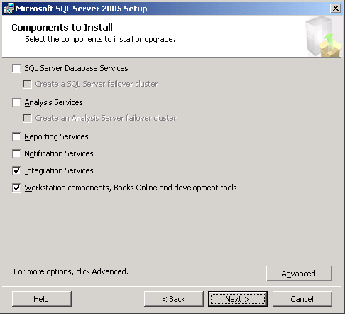
Figure 1 - Select Components During SQL Server 2005 Setup
- SQL Server 2005’s workstation components can also be installed during the setup process. This will install BIDS and SQL Server Management Studio, providing support for developing and managing SSIS packages (as well as other SQL Server 2005 solutions). A typical installation of the workstation components will include all of the components along with SQL Server 2005’s Books Online documentation. The Advanced button can be used to include or exclude optional components such as the SQL Server 2005 Software Development Toolkit (SDK). While Figure 1 shows the component selection screen with Integration Services and the workstation components selected, Figure 2 shows the screen displayed when the Advanced button is used to selectively include or exclude components.
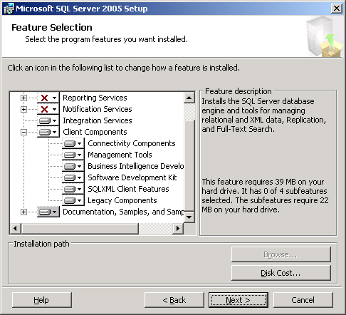
Figure 2 - Advanced Feature Selection during Setup
It is possible to install the SSIS components without installing the workstation components. This scenario would allow packages to be stored and executed on a server, but would prevent the development and management of the packages directly from that server. Another workstation or server with the workstation components would be needed to develop, deploy, and remotely manage the packages on the server.
Likewise, the workstation components can be installed without installing the SSIS components. In this scenario, SSIS packages can be developed and tested within the BIDS environment, but cannot be executed locally outside the BIDS environment.

Continued Use of DTS with SSIS
In some cases, a server storing and running DTS packages will need to be upgraded to SQL Server 2005 without an immediate effort to migrate the DTS packages to SSIS. In these cases, DTS packages can continue to be used on the upgraded server.
Support for developing, managing, and executing existing DTS packages will remain untouched if an existing instance of the SQL Server 2000 or 7.0 relational engine will remain on the server after the upgrade. For example, if a new instance of the SQL Server 2005 relational engine is installed or if other components of SQL Server 2005 are installed without installing the new relational engine, then SQL Server Enterprise Manager will remain available as well as the DTS runtime and command-line tools. With these components still in place, DTS packages can be executed manually or via SQL Server Agent jobs.
However, if all instances of the SQL Server 2000 or 7.0 relational engine are removed or upgraded to SQL Server 2005’s new relational engine, SQL Server Enterprise Manager and the ability to develop DTS packages will no longer exist. The SQL Server 2005 Setup application will install an updated DTS runtime and command-line tools, but no DTS design environment will be available. In this case, the DTS Designer Components can be installed via a Web download from the Feature Pack for SQL Server 2005. The Feature Pack is a collection of useful tools and components for working with SQL Server 2005; you can find it at: http://www.microsoft.com/downloads/details.aspx?FamilyID=d09c1d60-a13c-4479-9b91-9e8b9d835cdc&DisplayLang=en.
Once the DTS Designer Components have been installed, an additional step is required to enable package editing. During an installation of SQL Server 2005, a set of backward compatibility files are also installed. Unfortunately, the order of installation for these files along with the removal of SQL Server 2000 (or SQL Server 7.0) causes an inconsistency that disables the DTS Designer Components. To resolve the issue, use the Add or Remove Programs applet from Control Panel to repair the Microsoft SQL Server 2005 Backward Compatibility feature. Once the feature is highlighted within the Add or Remove Programs applet, select Change. This will launch a setup application that can be used to repair the installation. Once completed, the DTS Designer Components will function as intended and allow packages to be edited from within SQL Server Management Studio.
Note: Once an instance of SQL Server 2000 (or SQL Server 7.0) containing DTS packages is upgraded to SQL Server 2005 format, SQL Server Enterprise Manager on another workstation or server cannot be used to manage the DTS packages in the upgraded instance. SQL Server Enterprise Manager will not be able to connect to the upgraded instance. SQL Server Management Studio must be used, along with the DTS Designer Components, to manage and edit the DTS packages as required.

Understanding the Package Migration Wizard
As mentioned above, the Package Migration Wizard provides a mechanism for migrating DTS packages to SSIS. The wizard analyzes existing packages and attempts to create new SSIS packages with the same or similar functionality.
In some cases, the Package Migration Wizard cannot directly migrate functionality found within a DTS package into equivalent SSIS functionality. Some of the features available within DTS do not have direct equivalents within SSIS. Table 1 provides a list of DTS features and their SSIS equivalents; where SSIS equivalents do not exist, the Package Migration Wizard uses a partial-migration strategy to migrate DTS packages.
Table 1 – Comparing DTS and SSIS Features
SQL Server 2000 DTS Feature | SQL Server 2005 SSIS Equivalent
Tasks
ActiveX Script Task | ActiveX Script Task
Analysis Services Processing Task | None
Bulk Insert Task | Bulk Insert Task
Copy SQL Server Objects Task | Transfer SQL Server Objects Task
Custom Tasks | None
Data Driven Query Task | None
Data Mining Prediction Task | Data Mining Query Task
Dynamic Properties Task | None
Execute Package Task | Execute DTS 2000 Package Task
Execute Process Task | Execute Process Task
Execute SQL Task | Execute SQL Task
File Transfer Protocol Task | FTP Task
Message Queue Task | Message Queue Task
ParallelDataPump Task | None
Send Mail Task | Send Mail Task
Transfer Data (Data Pump) Task | Data Flow Task
Transfer Databases Task | Transfer Database Task
Transfer Error Messages Task | Transfer Error Messages Task
Transfer Jobs Task | Transfer Jobs Task
Transfer Logins Task | Transfer Logins Task
Transfer Master Stored Procedures Task | Transfer Master Stored Procedures Task
Other Package Features
Connection Objects | Connection Managers
Error Handling | None
Global Variables | Package Variables
Package Logging | None
Package Passwords | None
Precedent Constraints | Precedent Constraints
Text Annotations | None
The following notes apply to Table 1:
- Although SSIS includes an Analysis Services Processing Task (along with a new Analysis Services Execute DDL Task), this task is not compatible with Analysis Services 2000 or OLAP Services 7.0. Thus, the Analysis Services Processing Task within a DTS package cannot be migrated to SSIS given that the settings of the task would specify an Analysis Services 2000 or OLAP Services 7.0 database connection.
- Custom tasks designed for use within DTS cannot be migrated to SSIS. Any packages containing custom tasks will use a partial migration strategy (discussed below), which leaves the custom tasks intact within a DTS package encapsulated within the resulting SSIS package. Custom tasks should be redesigned and redeveloped using the custom task features of SSIS.
- With the exception of very simple data transformations created with the Transform Data Task, the three data pump tasks in DTS (the Data Driven Query Task, the ParallelDataPump Task, and the Transform Data Task) are generally migrated to SSIS using a partial migration strategy (discussed below). Because data movement using one of these three tasks encompasses a majority of DTS packages developed, particular attention and planning should be given to updating the migrated packages to take advantage of new data flow capabilities within SSIS.
- The Dynamic Properties Task cannot be migrated to SSIS. Similar functionality can be implemented using package configurations and expressions within SSIS, but the functionality within a Dynamic Property Task is not converted. Instead, the task is replaced by a Script Task that documents the settings within the Dynamic Property Task as comments in the resulting script.
- Error handling settings within a DTS package are not migrated to SSIS. New error handling features available within SSIS can be added after migrated packages are created, but existing error handling settings are not migrated.
- Package logging settings within a DTS package are not migrated to SSIS. New logging features available within SSIS can be added after migrated packages are created, but existing package logging settings are not migrated.
- Package passwords are not migrated to SSIS. SSIS includes new encryption features for protecting sensitive data, but package passwords are not migrated. Passwords are needed, however, during the migration process so that the Package Migration Wizard can open a password-protected package.
- Precedent constraints within a DTS package are migrated to corresponding constraints within SSIS. However, any workflow properties beyond the type of constraint, such as success, failure, or completion, are not migrated. Once a package is migrated to SSIS, new features can be used to implement more complex workflow requirements.
- Text annotations within a DTS package are not migrated to SSIS. New annotations can be added to generated SSIS packages as needed after the migration effort.
When the Package Migration Wizard migrates a given DTS package to SSIS, it converts tasks and package functionality directly whenever possible. If one or more DTS tasks do not have equivalents in SSIS, as indicated in Table 1, or will not convert cleanly, the migration wizard will encapsulate the tasks within an Execute DTS 2000 Package Task. The DTS functionality will be embedded into the task and package, which is a new capability of SSIS. This mitigates the need to deploy separate DTS packages within an SSIS package when the Execute DTS 2000 Package Task is used in this manner.
Examples of this migration behavior are provided in the next section regarding package migrations.

Migrating DTS Packages
Once the workstation components of SQL Server 2005 have been installed, the Package Migration Wizard can be started in one of several ways:
- Within BIDS, the wizard can be started within an Integration Services project. The Migrate DTS 2000 Package menu option on the Project menu within BIDS will start the wizard (as Figure 3 shows), as will the same menu option on the right-click context menu of the SSIS Packages folder within Solution Explorer (as Figure 4 shows). When started within BIDS, migrated packages are automatically added to the current Integration Services project.
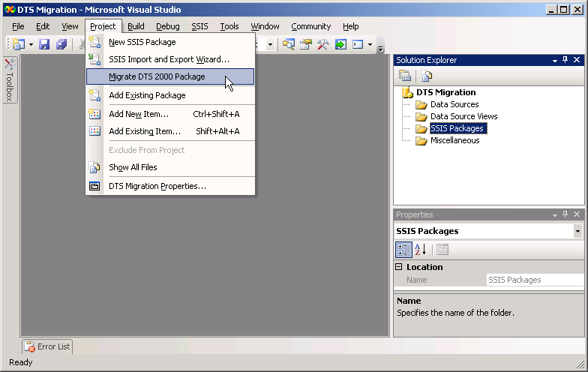
Figure 3 - Starting the Package Migration Wizard from the Project Menu in BIDS
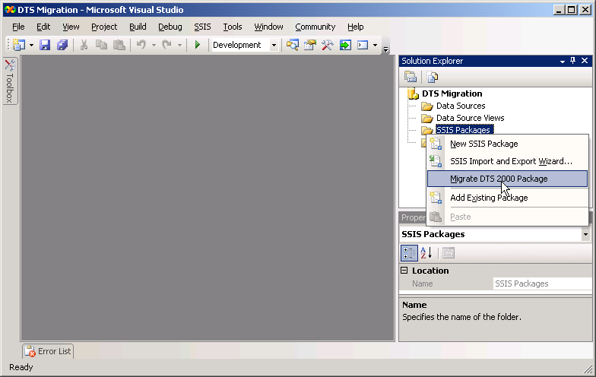
Figure 4 - Starting the Package Migration Wizard from the SSIS Packages Folder in BIDS
- The wizard can also be started from within SSMS. Once connected to a SQL Server instance, either SQL Server 2000 or SQL Server 2005, the Data Transformation Services folder, found under the Legacy folder, which is under the Management folder within the Object Explorer, provides a Migration Wizard menu item on the right-click context menu. Figure 5 shows this context menu.
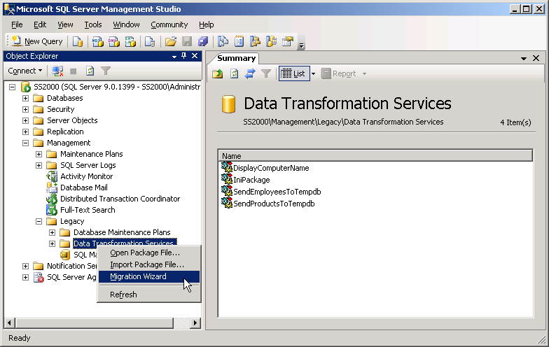
Figure 5 - Starting the Package Migration Wizard from SSMS
- Finally, the Package Migration Wizard can be started from a command prompt by typing DTSMigrationWizard from within the SQL Server 2005 installation folder, typically in the C:\Program Files\Microsoft SQL Server\90\DTS\binn subdirectory.

Running the Package Migration Wizard
When the Package Migration Wizard starts, it will initially display a welcome screen, as Figure 6 shows.
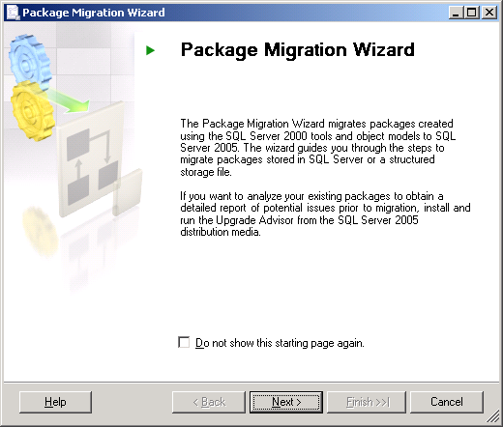
Figure 6 - Package Migration Wizard Welcome Screen
- Click Next to start the wizard.
The first step in migrating DTS packages is to specify the storage location for the packages. The wizard can migrate packages stored within SQL Server 2000 or SQL Server 2005, within the msdb database or a structured storage file. The wizard can migrate multiple packages stored within the msdb database; it can also migrate multiple packages stored in a single structured storage file. However, the wizard must be run multiple times if multiple structured storage files need to be migrated. Figure 7 shows selecting SQL Server, specifically the msdb database, as the storage location option.
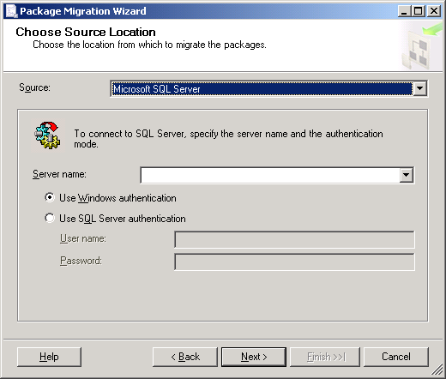
Figure 7 - Selecting a DTS Source Location
- Once a source location is defined, click Next to continue.
Once a given storage location is selected, the wizard will prompt for additional information, such as login information or the location of a structured storage file.
- The next step is to select a destination for the SSIS packages generated by the wizard. Two options exist as destination locations: SQL Server 2005, using the msdb database, and the Windows file system. When the Windows file system is selected, each package migrated by the wizard is stored in a separate SSIS file, using a .dtsx file name extension. Figure 8 shows selecting the Windows file system as a destination.
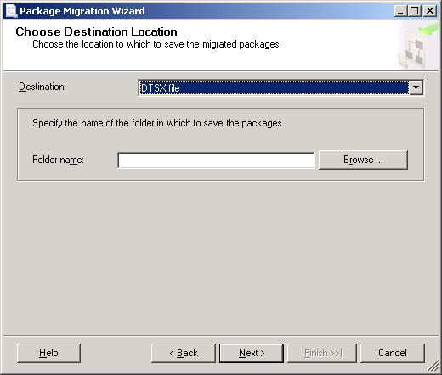
Figure 8 - Selecting an SSIS Destination Location
- Once a destination is defined, click Next to continue.
After selecting a destination location, the package enumerates a list of DTS packages found within the source location specified. By default, the most recent version of each DTS package will be migrated. However, the wizard does allow a previous version of a package to be selected for migration.
- To proceed, select which packages should be migrated and specify prior versions as needed.
In general, the SSIS package generated for each migrated DTS package will have the same name as the DTS package. However, if a prior version of a DTS package is selected for migration, the resulting SSIS package name will have the version ID appended to its name. The resulting SSIS packages can be renamed as desired after the wizard completes.
Figure 9 shows the package selection screen with multiple packages selected for migration along with a prior version of the first package selected. After selecting packages for migration, click Next to proceed.
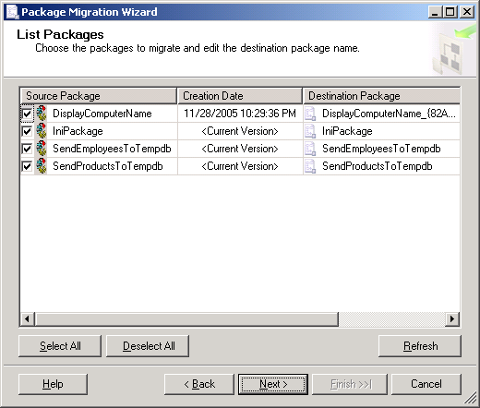
Figure 9 - Selecting DTS Packages and Versions for Migration
- Once the DTS packages are selected, if the DTS package contains passwords, the wizard will display a dialog box prompting you to enter them. Then, the wizard will prompt for a migration log file location. Simply specify a directory and log file name and click Next to proceed. Figure 10 shows the screen used to specify the log file.
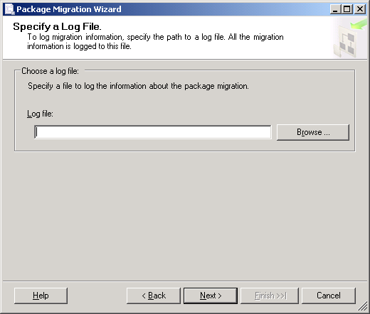
Figure 10 - Specifying a Migration Log File
- Before proceeding with the migration, the wizard will display a summary of the selections made. Review the summary to ensure all of the information is correct and then click Finish to proceed.
Figure 11 shows the summary information for a migration effort specifying SQL Server as a source location and the Windows file system as the destination location along with the set of four packages selected for migration as shown above.
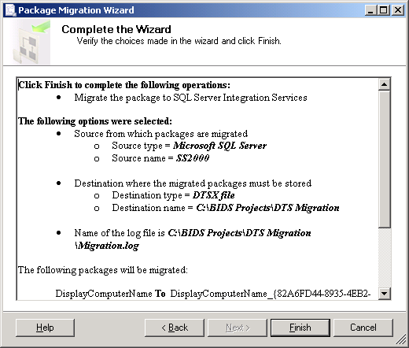
Figure 11 - Package Migration Wizard Summary
Once the wizard begins migrating packages, a progress window will be displayed showing which packages have been migrated and the status of each. Figure 12 and Figure 13 show a progress window during and after a migration process, respectively.
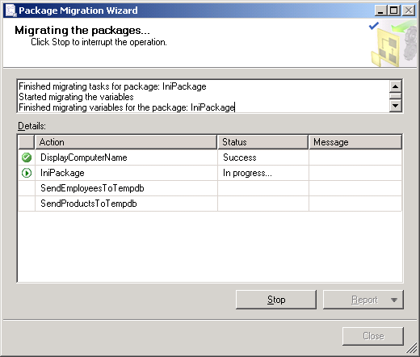
Figure 12 - Migration Process in Progress
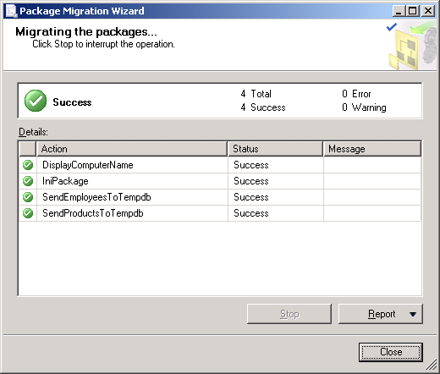
Figure 13 - Migration Process Complete
- Once the process is complete, click Close to shut down the Package Migration Wizard.
Once the migration process has completed, the generated SSIS packages should be reviewed to determine what additional work needs to be accomplished before the packages can be used. For example, ActiveX Script Tasks should be reviewed to ensure the functionality provided by the script will continue to work. Dynamic Properties Tasks, which are converted to Script Tasks, will need to be reviewed with changes made to the package to recreate the functionality provided by the Dynamic Properties Tasks.
The following three sections provide some examples of migrated packages and additional steps needed to ensure the generated SSIS packages will operate as needed.

Example 1: Simple Data Transformation
The first example concerns a DTS package that executes a simple data transformation process, moving a series of rows from a source to a destination. The data transformation is implemented using the Transform Data Task, with a simple Copy Column transformation to move the data from the source to the destination. A set of simple Execute SQL Tasks are used to drop and create the destination table used with the Transform Data Task. Figure 14 shows the DTS package, named SendProductsToTempdb.
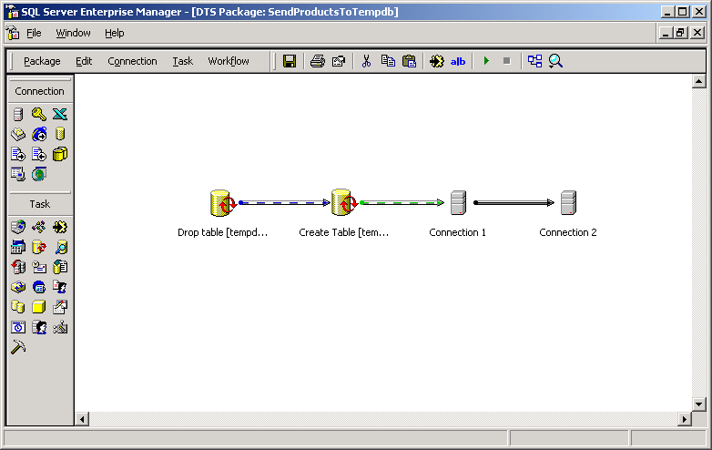
Figure 14 - SendProductsToTempdb DTS Package
Figures 15, 16, 17, 18, and 19 show the two Execute SQL Tasks, the two connection objects, and the Transformation tab of the Transform Data Task linking the two connection objects.
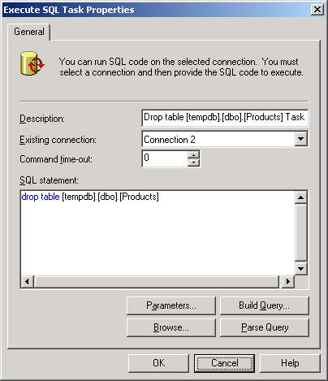
Figure 15 - Execute SQL Task to Drop Destination Table
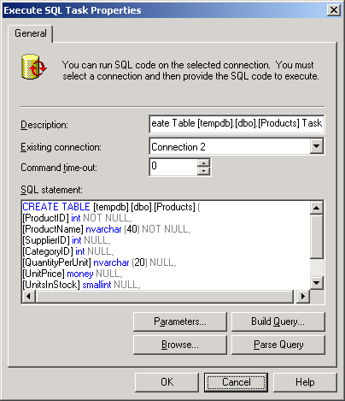
Figure 16 - Execute SQL Task to Create Destination Table
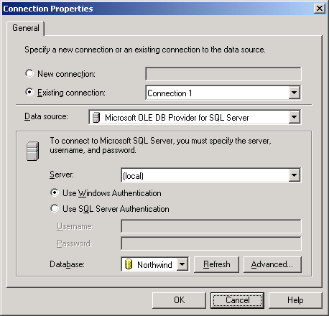
Figure 17 - Source Connection Object
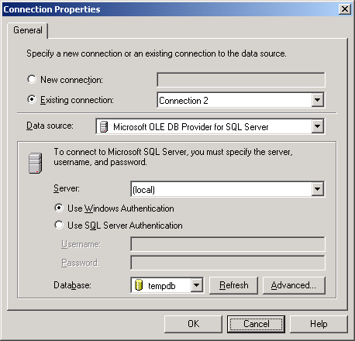
Figure 18 - Destination Connection Object
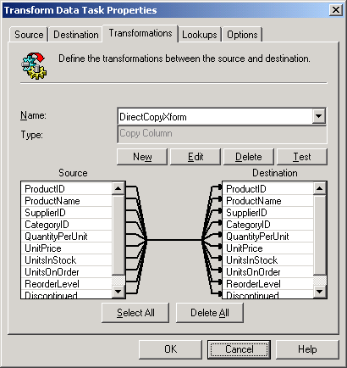
Figure 19 - Simple Copy Column Transformation
Because the package contains only Execute SQL Tasks and a simple Copy Column transform within a Transform Data Task, the Package Migration Wizard can cleanly migrate the package to SSIS. The resulting SSIS package contains two equivalent Execute SQL Tasks and a Data Flow Task. The Data Flow Task encapsulates the same functionality as that provided by the Transform Data Task.
Figure 20 shows the resulting SSIS Package, also named SendProductsToTempdb.
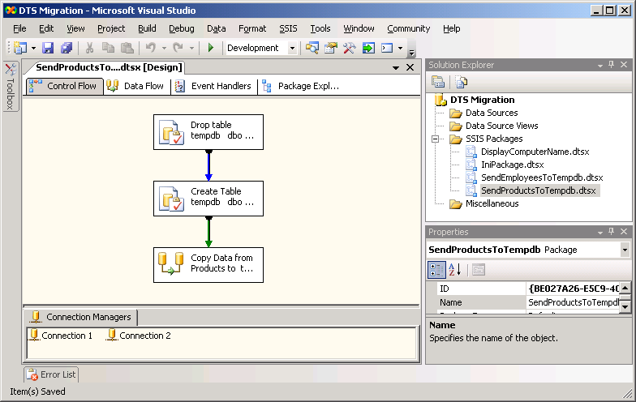
Figure 20 – New SendProductsToTempdb SSIS Package
The two Execute SQL Tasks have been converted to equivalent tasks within the new SSIS package, as Figures 21 and 22 show; notice that the text of each task’s SQLStatement property contains the same SQL code found in the original Execute SQL Tasks.
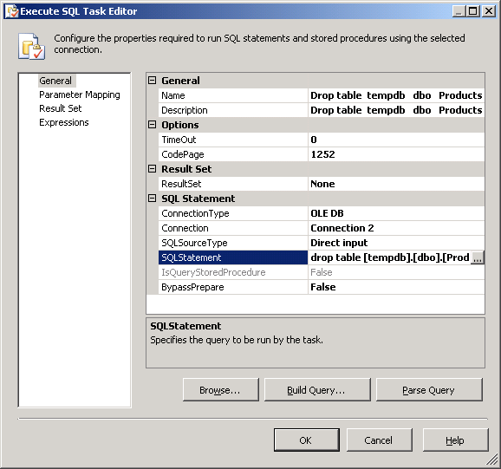
Figure 21 - New Execute SQL Task to Drop Destination Table
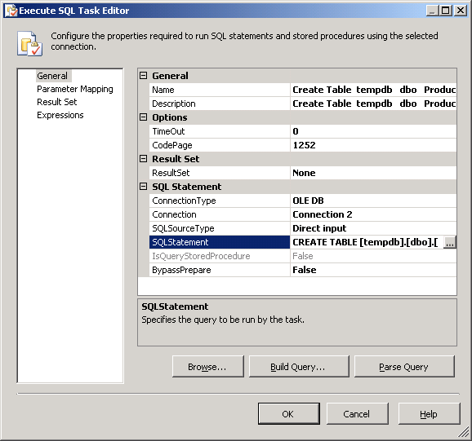
Figure 22 - New Execute SQL Task to Create Destination Table
The Data Flow task uses an OLE DB Source and OLE DB Destination to specify the source and destination for the movement of rows, much the same as the Transform Data Task uses connection objects. However, the connection information is encapsulated in Connection Managers within the SSIS package. Figures 23 and 24 show the Connection Managers created during the migration process.
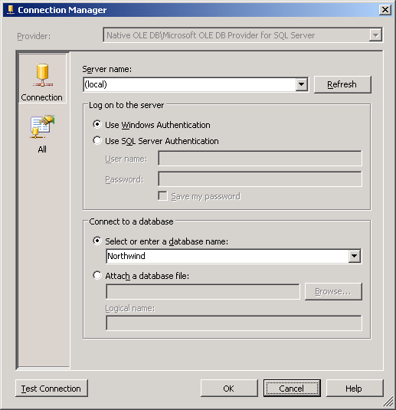
Figure 23 - New Connection Manager for Source Data
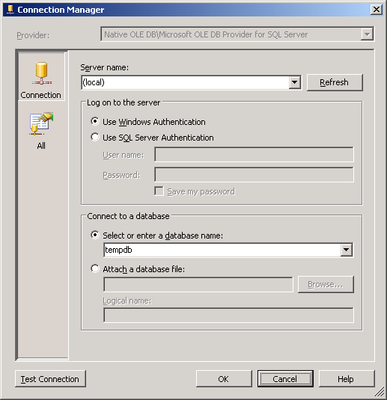
Figure 24 - New Connection Manager for Destination
The Data Flow task defines how data moves and how it is transformed between a source and a destination. In this case, columns in a table within the OLE DB Source, configured to use the source Connection Manager shown above, are simply mapped to similar columns in a similar table in the OLE DB Destination, configured to use the destination Connection Manager shown above.
Figure 25 shows the Data Flow task, and Figure 26 shows the Mappings defined for the OLE DB Destination, showing how the columns from the source table are mapped to columns in the destination table.
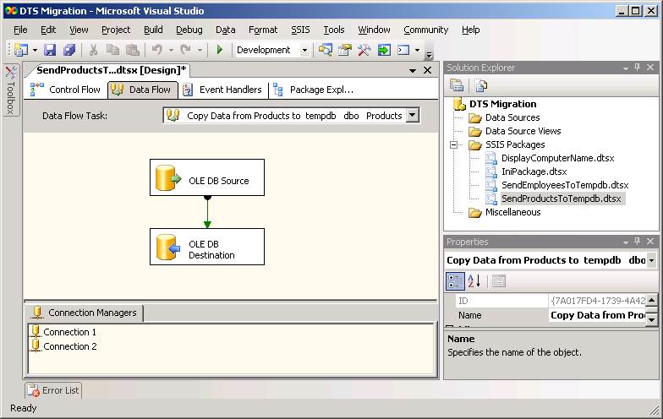
Figure 25 - New Data Flow Task
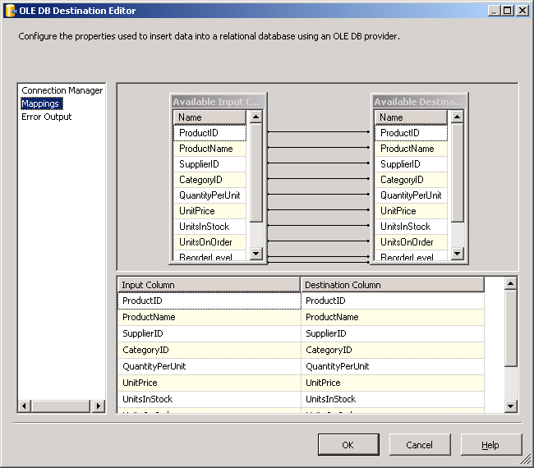
Figure 26 - Mappings Between Source and Destination Columns
The generated SSIS package can be run successfully as is. However, some additional design and development may be advised, such as renaming the generated tasks. Also, extending the new package through the use of new SSIS features such as configurations, event handlers, package logging, and checkpoints would likely increase the value of the new SSIS package.

Example 2: Complex Data Transformation
The second example involves a DTS package designed in almost the same manner as the package in the first example. The package uses a Transform Data Task to move data from a source table to a destination table. However, in this case, multiple Transforms are used on the data. Most of the transforms are simple Copy Column transforms; one, though, uses an Uppercase String transform to convert the data from a pair of columns to uppercase strings. Like the DTS package in the first example, this package also uses a set of Execute SQL Tasks to drop and create the destination table as the package executes.
Figure 27 shows the DTS package, named SendEmployeesToTempdb.
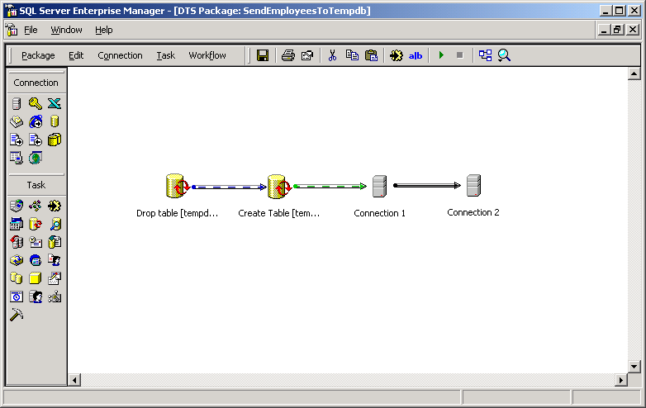
Figure 27 - SendEmployeesToTempdb DTS Package
The Execute SQL Tasks and the connection objects defined within this package are very similar to those defined for the DTS package in the first example. Thus, figures showing their details will not be repeated here. However, Figure 28 shows the Transformation tab of the Transform Data Task, highlighting the Uppercase String transform, which qualifies the package as a “complex data transformation” package.
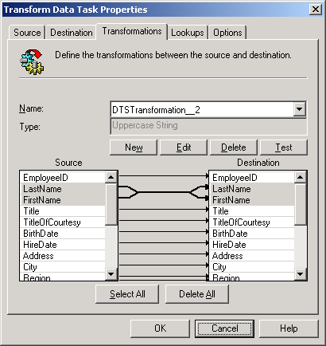
Figure 28 - Complex Uppercase String Tranformation
In general, the Package Migration Wizard can only migrate Copy Column transformations in a Transform Data Task directly to a corresponding Data Flow Task within SSIS. For any of the other transformations available within the Transform Data Task, the wizard uses a partial package migration strategy to encapsulate the tasks that will not convert directly to SSIS, in this case the Transform Data Task, within an intermediate Execute DTS 2000 Package task.
Figure 29 shows the resulting SSIS package, also named SendEmployeesToTempdb.
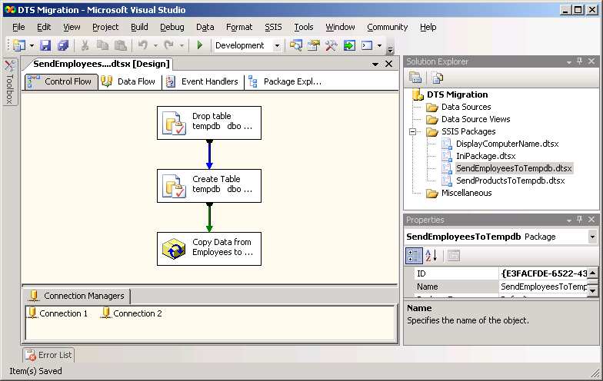
Figure 29 - New SendEmployeesToTempdb SSIS Package
Like the resulting SSIS package in the first example, this package contains Execute SQL Tasks with equivalent functionality to the corresponding tasks in the DTS package. The new package also contains two Connection Managers that define the connection information specified by the connection objects within the DTS package. Figures showing the details of these components of the new package are not shown, given their similarity to those shown for the new SSIS package generated in the first example. However, as previously mentioned, the Package Migration Wizard uses a partial migration strategy to deal with this package. Thus, the Transform Data Task has been encapsulated in an intermediate Execute DTS 2000 Package Task, not converted to a Data Flow Task.
Figure 30 shows the properties of the new Execute DTS 2000 Package Task.
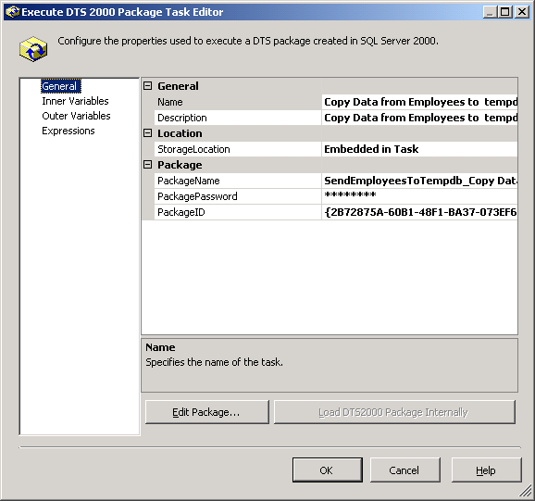
Figure 30 - New Execute DTS 2000 Package Task
Notice that the Load DTS2000 Package Internally button is grayed out. This indicates that the intermediate DTS package created by the Package Migration Wizard has already been embedded into the resulting SSIS package. Using the Edit Package button opens a version of the DTS package designer, as Figure 31 shows.
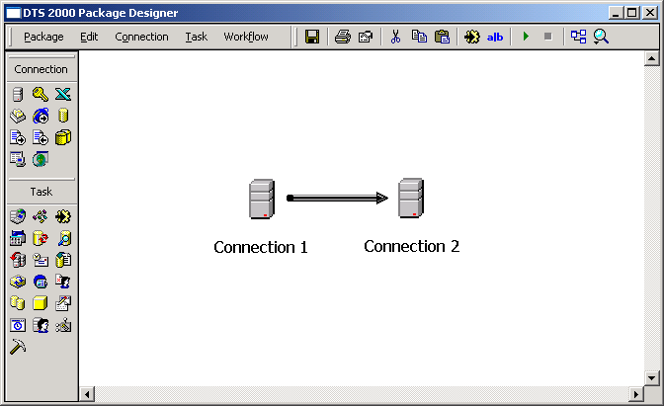
Figure 31 - DTS 2000 Package Designer Launched from BIDS
Like the generated SSIS package from the first example, the package generated by the Package Migration Wizard in this example can be successfully executed as is. The same design and development work could be applied to this package to increase its value, such as renaming the generated tasks, adding configurations and package logging, and so on. However, a more significant development effort should be pursued to replace the Execute DTS 2000 Package Task generated. In this case, the resulting Transform Data Task can be replaced with a Data Flow Task that uses a Character Map Transform to implement the needed uppercase conversion process.
Figures 32, 33, and 34 show the same SSIS package updated to include a Data Flow Task with a Character Map Transform used to handle the uppercase conversion needed within the data flow.
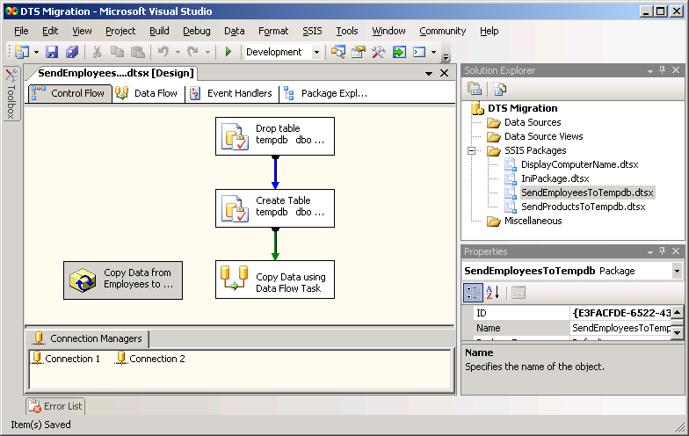
Figure 32 - Package Redesigned to Use Data Flow Task
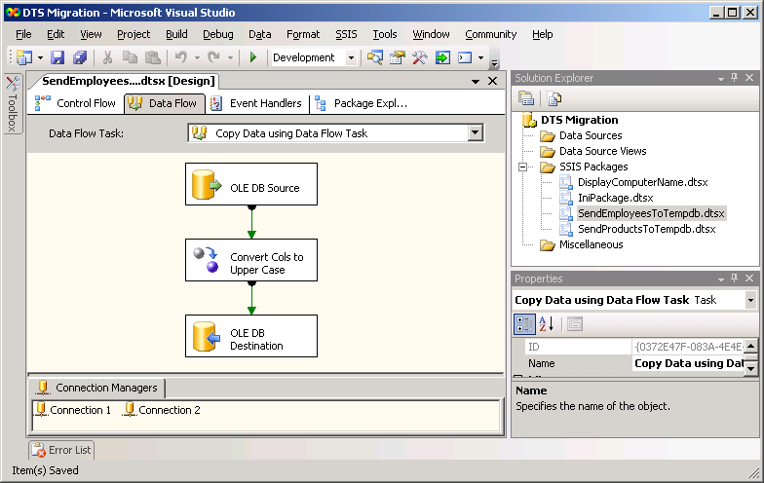
Figure 33 - Data Flow Using a Character Map Transform
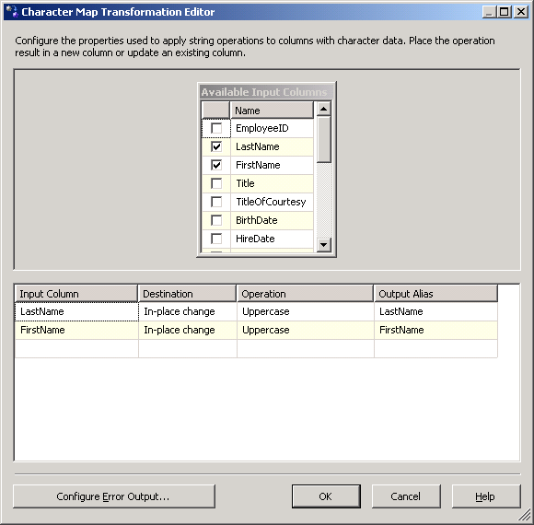
Figure 34 - Details of the Character Map Transform
While the performance of the updated SSIS package may not be significantly different for this particular example, replacing Execute DTS 2000 Package tasks with similar functionality using SSIS tasks and transforms can provide much better performance. Thus, it is recommended that all SSIS packages generated by the Package Migration Wizard be reviewed to see what additional design and development effort should be made to improve on the wizard’s results.

Example 3: Dynamic Properties Task
In some cases, the packages generated by the Package Migration Wizard will not run correctly without some additional design and development effort. As has been stated, the wizard follows a “best effort” migration process. If particular functionality is present within the original DTS package, the wizard must sometimes stop short of producing an SSIS package that can be immediately executed.
One simple example of a DTS feature that cannot be completely migrated by the Package Migration Wizard is the Dynamic Properties Task. This task provides DTS packages with self-modifying functionality whereby the task can dynamically set almost any property of other objects within the package at runtime. Thus, this task is often used to abstract properties of various objects, such as connection objects, Execute SQL Tasks, and Transform Data Tasks. This functionality allows a package to be used in different scenarios—for example, on different servers connecting to different sources and destinations. While SSIS packages can be designed with similar functionality, using features such as configurations and property expressions, the Package Migration Wizard cannot directly convert a Dynamic Properties Task into an equivalent set of features in SSIS. For the Dynamic Properties Task, the wizard generates a Script Task that documents the actions taken by the Dynamic Properties Task within a commented script. In order to use the resulting package, additional design and development efforts must be taken to replace the generated Script Task.
Figure 35 shows an example of a DTS package, named DisplayComputerName, using a Dynamic Properties Task. This package uses the task to set a Global Variable to the current value of a system environment variable named COMPUTERNAME. This Global Variable is then used by the ActiveX Script Task in the package to display the current computer name.
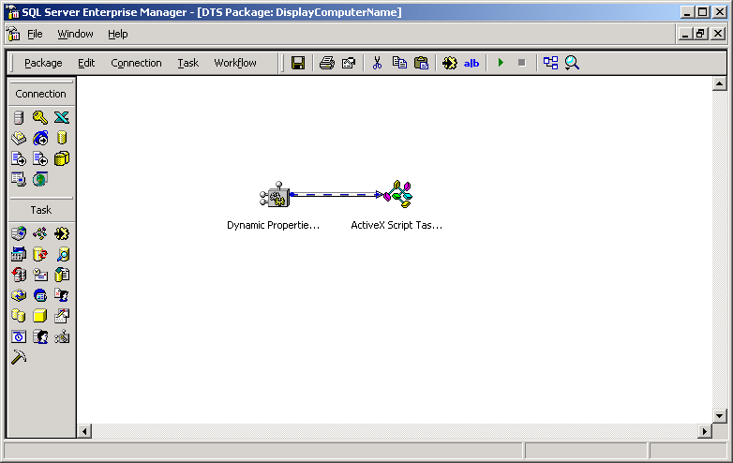
Figure 35 - DisplayComputerName DTS Package
Figures 36, 37, and 38 show the Global Variables collection for the package, the action implemented by the Dynamic Properties Task, and the script used by the ActiveX Script Task, respectively.
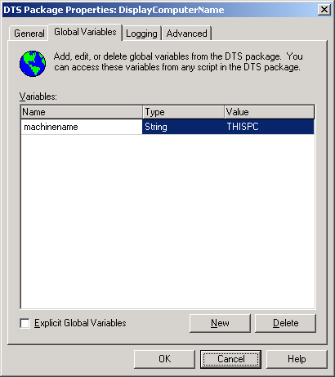
Figure 36 - Global Variables Collection
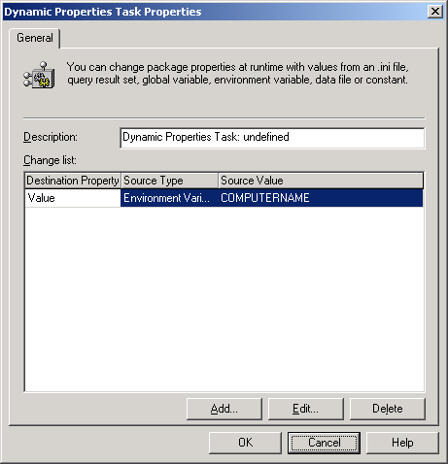
Figure 37 - Dynamic Properties Task Action
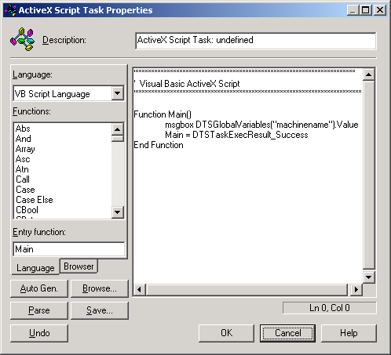
Figure 38 - ActiveX Script Used to Display Computer Name
When the Package Migration Wizard processes this package, it generates an SSIS package with two corresponding tasks.
- The first is a Script Task that simply documents the actions specified by the Dynamic Properties Task. In fact, the resulting Script Task is actually named “Dynamic Properties Task,” but do not be fooled—it is simply a Script Task with a script used to document the Dynamic Properties Task actions as comments within the script.
- The second task is an ActiveX Script Task that is equivalent to the one in the original DTS package.
Figure 39 shows the resulting SSIS package generated by the wizard.
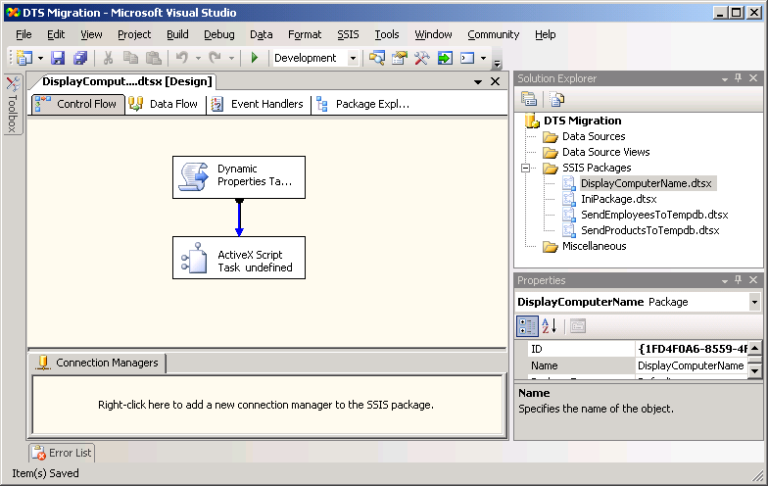
Figure 39 - New DisplayComputerName SSIS Package
Figures 40 and 41 show the Variables collection for the new package along with the ActiveX Script Task. As you can see, these are direct conversions of the Global Variables and ActiveX Script Task defined in the original DTS package.
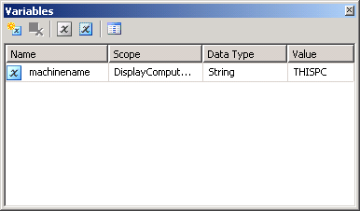
Figure 40 - New Variables Collection
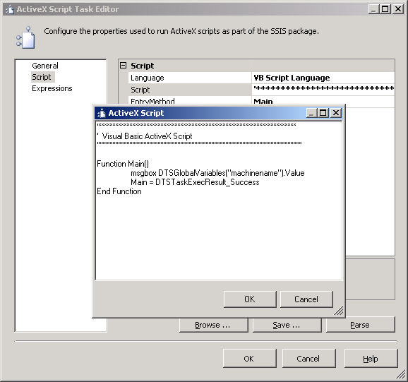
Figure 41 - New ActiveX Script Task
Figures 42 and 43 show the Script Task and the script it contains as created by the Package Migration Wizard. This new Script Task is the result of the wizard’s effort to convert the Dynamic Properties Task in the original package. Unfortunately, if the new SSIS package is executed, this script has no effect and the package displays the initial value of the variable, which is “THISPC.”
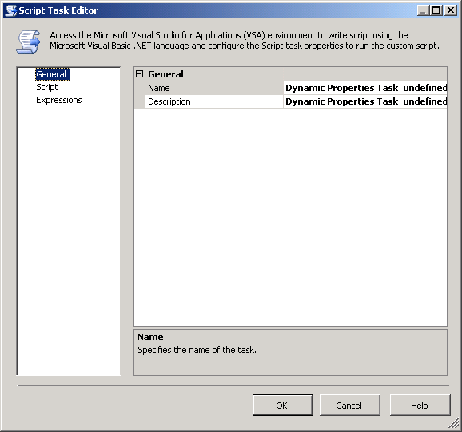
Figure 42 - New Script Task
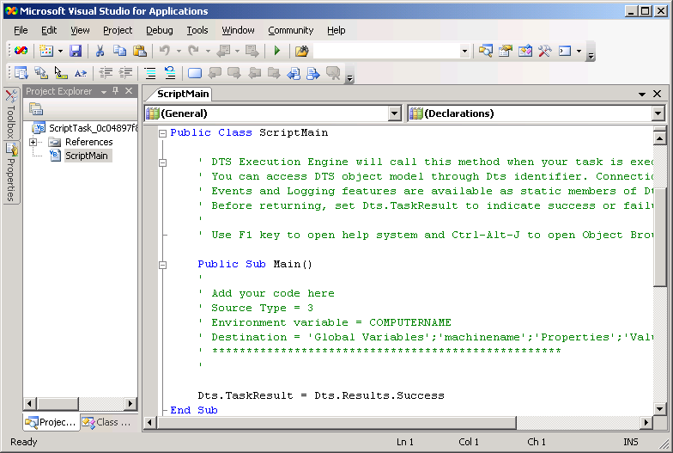
Figure 43 - Script Documenting Original Dynamic Properties Task Action
In order to correct the package so that it will execute as desired, the Script Task must be replaced with some level of SSIS functionality that will update the variable at runtime with the value of the COMPUTERNAME environment variable. One method for doing so is using package configurations in SSIS. In addition, while the ActiveX Script Task will work as designed, the task itself is included in SSIS primarily for backward compatibility. When modifying the package, you should replace the task with an equivalent Script Task.
Figure 44 shows the configuration settings for a new version of the package that implements the runtime updates to the variable.
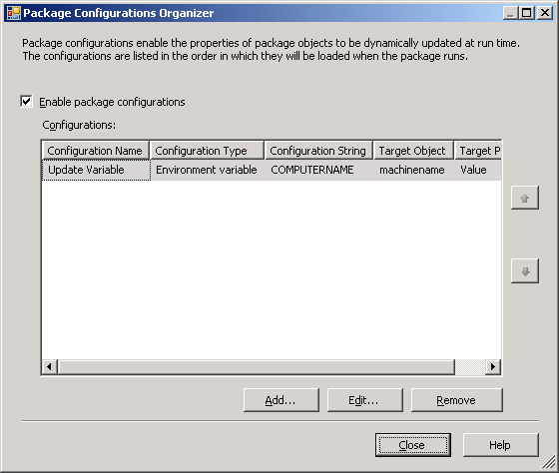
Figure 44 - Package Configuration Used to Replace Dynamic Properties Task Action
Figures 45 and 46 show the new SSIS package and the script used in the package’s new Script Task to display the value of the variable updated by the configuration settings.
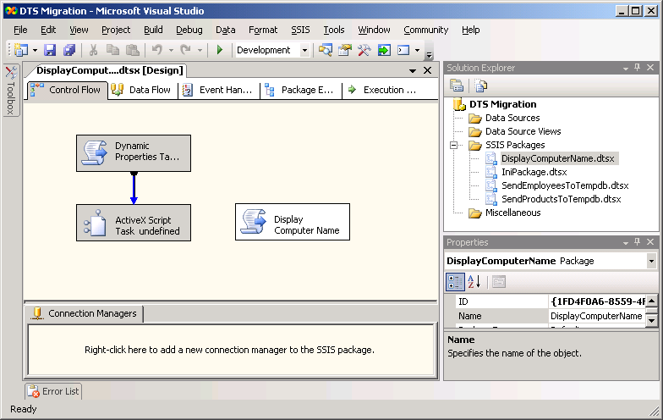
Figure 45 - Redesigned DisplayComputerName SSIS Package
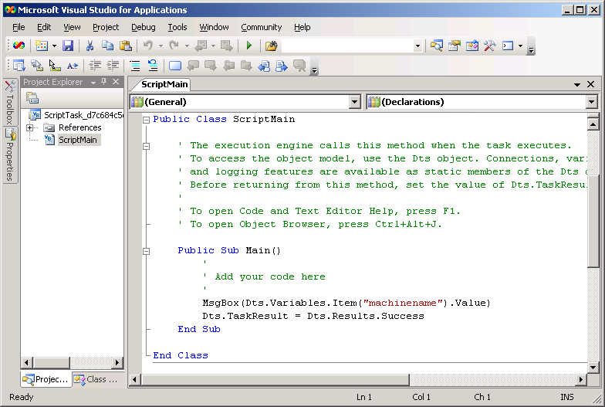
Figure 46 - New Script used in Script Task to Display Variable Value
As this example shows, the Package Migration Wizard follows a “best effort” migration strategy that can result in an SSIS package that will not correctly execute. But with a small level of design and development effort, the generated package can typically be updated and ready for use in a short amount of time.

Section 4.03: Upgrading to SQL Server 2005 Analysis Services

Introduction
SQL Server Analysis Services provides an extremely powerful multidimensional database engine for building sophisticated OLAP and data mining solutions. Its ability to handle various data warehouse designs, store and index large amounts of data efficiently, perform complex calculations quickly, and economically manage data caching structures gives it power beyond most other multidimensional solutions on the market today. Given the fact that Analysis Services is included with SQL Server and is covered by the same license, many organizations have implemented Analysis Services to solve their multidimensional and OLAP reporting challenges.
With Analysis Services 2000, Microsoft introduced many new features and capabilities to increase the functionality of its first release (OLAP Services 7.0). Features such as distinct count measures, parent-child dimensions, improved aggregation design, and data mining capabilities improved the value of Analysis Services 2000 and made its adoption rate among organizations higher than any other multidimensional database engine.
Over the past five years, Microsoft has worked extremely hard to again increase the value of Analysis Services by adding breakthrough capabilities to expand the number and types of solutions the platform can be used to develop and support. Changes in the underlying architecture of the product now provide increased scalability, a unified model for supporting OLAP and traditional reporting needs, significant improvements in the development and administration of a given solution, and new Key Performance Indicator (KPI) and data mining features.

In-Place Upgrade vs. Side-by-Side Upgrade
In general, Analysis Services 2000 can be upgraded to Analysis Services 2005 in one of two ways:
- In-place upgrade: With an in-place upgrade, the Analysis Services 2000 engine and tools are removed and replaced by Analysis Services 2005. During the upgrade process, the Analysis Services 2000 database metadata is migrated to Analysis Services 2005, and the migrated databases must be fully reprocessed to populate them with data. Due to functionality and feature changes with Analysis Services 2005, the migrated databases may require modification before users can access the business intelligence (BI) data through the migrated database. After the in-place upgrade is complete, only Analysis Services 2005 will remain. With an in-place upgrade, Analysis Services 2005 is tested after Analysis Services 2000 is removed. An in-place upgrade is an all-or-nothing approach; if an in-place upgrade fails, you cannot quickly roll back to the Analysis Services 2000 environment once the setup program finishes the upgrade (there is a go/no-go point within the Setup program before which you can simply cancel the upgrade). To roll back to Analysis Services 2000 after an upgrade to Analysis Services 2005 is complete, you need to uninstall Analysis Services 2005, reboot, reinstall Analysis Services 2000, and restore the Analysis Services 2000 databases. Downtime in the event of upgrade problems can be significant.
- Side-by-side upgrade: With a side-by-side upgrade, an instance of Analysis Services 2005 is installed, and Analysis Services 2000 remains until uninstalled. During the upgrade process, users can continue to access the Analysis Services 2000 databases (unaffected by the upgrade process). After a side-by-side upgrade is complete, Analysis Services 2000 and Analysis Services 2005 are installed. Database metadata can be migrated and tested without affecting the Analysis Services 2000 installation. After Analysis Services 2005 is fully tested, Analysis Services 2000 can be uninstalled.
Note: With a side-by-side upgrade, you can either use the existing server environment for the new installation or install Analysis Services 2005 on a new server.
Important: The side-by-side upgrade option provides for greater availability during the upgrade process, simplifies rollback (should that be required), and results in simpler testing scenarios (because both versions are available at the same time).
Both of these upgrade options will provide Analysis Services 2005 versions of the databases found within a given Analysis Services 2000 server. However, given the new features and advances that Analysis Services 2005 brings, you should also consider redesigning databases to take advantage of the new platform. Information regarding this third option is provided below along with the two options listed above.

32-bit vs. 64-bit
Analysis Services 2000 and Analysis Services 2005 are both available for 64-bit as well as 32-bit hardware platforms. An in-place upgrade should be done using the same platform edition as is already installed. Thus, the 64-bit edition of Analysis Services 2000 for the Itanium platform should be upgraded to the same edition of Analysis Services 2005. However, by using a side-by-side upgrade using two different servers, it is possible to upgrade from one hardware platform edition to another. For example, the 64-bit edition of Analysis Services 2000 for the Itanium platform can be upgraded to the 64-bit edition of Analysis Services 2005 for the x64 platform. Because a side-by-side upgrade reads metadata for the databases on a source server and creates new databases on a destination server, this type of cross-platform upgrade is possible.
If you want to upgrade from the 32-bit edition of Analysis Services 2000 to the 64-bit edition of Analysis Services 2005 for the Itanium platform, keep in mind that the Business Intelligence Development Studio (BIDS) is not available for the Itanium platform. Therefore, all development tasks related to Analysis Services 2005 for the Itanium platform must be done from another client or server with BIDS loaded.

Determining and Evaluating Potential Upgrade Issues
Regardless of whether you choose to perform an in-place upgrade or a side-by-side upgrade of Analysis Services 2000 to Analysis Services 2005, there are a range potential issues you may face during your upgrade. To obtain a report that identifies many of these potential issues before you begin an upgrade, you should run the Microsoft SQL Server 2005 Upgrade Advisor to analyze the databases on an existing Analysis Services 2000 server to determine whether any of these issues will be encountered during a given upgrade process. If any of these issues are reported, follow Upgrade Advisor’s recommendations and guidance for possible mitigation options and strategies. For more information about installing and running this tool, see Section 1.0, “Upgrade Planning and Deployment.” There is also a category of issues that either cannot be detected by Upgrade Advisor or the detection of the issue would result in too many false-positive results.
The following section discusses the most important upgrade issues, whether detected by Upgrade Advisor or not. For a more complete list of backward-compatibility issues, breaking changes, and behavior changes to Analysis Services in SQL Server 2005, see the SQL Server 2005 Books Online topic “Analysis Services Backward Compatibility” at ms-help://MS.SQLCC.v9/MS.SQLSVR.v9.en/instsql9/html/618b6c3a-e20d-47a9-b2c6-6d848dfba05a.htm. For a complete list of the Analysis Services upgrade issues detected by Upgrade Advisor, review the “Analysis Services Upgrade Issues” topic in the Upgrade Advisor Help file.

Issues Preventing an Upgrade
In general, invalid objects within a database will prevent it from being upgraded. Thus, before starting an upgrade process, ensure that all of the objects in each database on a server are valid and can be processed and queried.

Discontinued Analysis Services Functionality
Some objects and settings within an Analysis Services 2000 database cannot be directly upgraded to Analysis Services 2005. This is typically due to architectural changes or feature changes that prevent a direct mapping of objects and settings to the new version of the platform. In some cases, these objects and settings are migrated to replacement features that accomplish the same result; in other cases, replacement objects and features can be added to the resulting databases after an upgrade is complete. Before starting an upgrade process, develop a strategy for handling these types of issues.
Table 1 describes the most common objects and settings that cannot be upgraded due to discontinued or changed functionality.
Table 1 – Objects and Settings Not Upgraded
Discontinued Feature/Functionality | Explanation/Replacement Feature/Corrective Action
Command objects are not supported for cube roles. | Analysis Services 2005 does not support command objects on cube roles and will not upgrade commands from previous versions.
Command objects are not supported for database roles. | Analysis Services 2005 does not support command objects on database roles and will not upgrade commands from previous versions of Analysis Services.
Custom aggregations created in previous versions of Analysis Services are not upgraded. | Aggregations that were manually generated in previous versions of Analysis Services are not upgraded to Analysis Services 2005. Only aggregations generated by the Storage Design Wizard are upgraded.
Custom rollup formulas, custom member formulas, “All” member formulas, and custom level formulas are no longer supported as properties on dimensions or levels in Analysis Services 2005. | In previous versions of Analysis Services, the following properties are supported on dimensions and levels: custom rollup formulas, custom member formulas, “All” member formulas, and custom level formulas. In Analysis Services 2005, these properties are replaced by functionality supported in MDX scripts and are upgraded to MDX scripts.
Drillthrough settings are not upgraded. | While drillthrough exists in Analysis Services 2005, drillthrough settings are not upgraded from previous versions of Analysis Services.
Linked cubes are no longer supported and are not upgraded. In addition, any objects that depend on the linked cube are not upgraded. | Previous versions of Analysis Services supported linked cubes. In Analysis Services 2005, this feature has been replaced by linked dimensions and linked measure groups.
Objects that reference linked cubes or linked dimensions cannot be upgraded. | Linked cubes and linked dimensions are not upgraded to Analysis Services 2005. Therefore, objects that refer to a linked cube or a linked dimension cannot be upgraded because the linked object on which the object is based cannot be upgraded. For example, an OLAP mining model based on a linked cube cannot be upgraded because the linked cube on which the mining model is based cannot be upgraded.
Remote partitions cannot be automatically upgraded. | Remote partitions are supported in Analysis Services 2005, but they cannot be upgraded automatically until the remote server has been upgraded to SQL Server 2005. Any remote partitions will need to be created manually after the upgrade.
The DefaultMember property is no longer supported by dimensions. | In previous versions of Analysis Services, the default member of a dimension is specified by a MDX expression, contained in the DefaultMember property of the dimension. In Analysis Services 2005, this property is replaced by functionality supported in MDX scripts, and the property is upgraded to a MDX script during the upgrade.
The structure used for writeback tables in previous versions of Analysis Services is no longer supported. | The structure for writeback tables constructed by previous versions of Analysis Services has been updated in Analysis Services 2005. Data from writeback tables constructed by previous versions of Analysis Services cannot be upgraded into the new writeback table structure.
User-defined functions (UDFs) registered on previous versions of Analysis Services are not upgraded. | Previous versions of Analysis Services support UDFs, which are COM libraries from which functions can be incorporated into MDX expressions and statements.  In Analysis Services 2005, this functionality is replaced with assemblies, which are COM or .NET Framework libraries that can be registered and named for an Analysis Services instance or database.  UDF libraries are not converted into assemblies during the upgrade. After updating, you can manually define assembly references for COM libraries that contain UDFs in the Analysis Services instance or database. Review and validate MDX expressions that reference the affected UDFs.

Behavioral Changes That May Require Corrective Action
In some cases, upgraded databases will behave differently in Analysis Services 2005 than they did in Analysis Services 2000. This is typically due to architectural changes or feature changes in the new version of the platform. In some cases, these behavioral changes will not cause problems when querying the databases. If query problems do arise, the behavioral changes can usually be resolved by making changes to the design of the upgraded databases. Before starting an upgrade process, understand what implications, if any, these issues may have on databases involved in the upgrade. Table 2 discusses the most important of these changes.
Table 2 – Issues Affecting Upgrade Results
Behavior Change | Explanation\Corrective Action
Autoexist functionality can produce different query results when querying a dimension that contains multiple hierarchies. | When multiple hierarchies or virtual dimensions are upgraded into the same Analysis Services 2005 dimension, querying the upgraded hierarchies contained in the dimension may produce different results than querying the same hierarchies when they were in Analysis Services 2000. Autoexist functionality automatically removes tuples that do not exist in the dimension from any cross-join of sets containing members from the upgraded hierarchies.
Custom level formulas may return different results because of a change in precedence rules. | If a cube contains a dimension with custom level formulas and also contains dimensions both before and after it with custom member formulas and/or unary operators, then the cube may return different results than previous versions of Analysis Services. This occurs because calculation precedence rules have changed. Custom level formulas are also known as custom rollup expressions.
Data members can no longer be excluded from parent-child dimensions. | Previous versions of Analysis Services gave you the option of not including data members in parent-child dimensions. The DataMembers property of a dimension in previous versions of Analysis Services supported three options: None, Hidden, or Visible. The None option is no longer available in Analysis Services 2005. Data members are always included in parent attributes. The MembersWithData property for the parent attribute supports only two options: NonLeafDataHidden or NonLeafDataVisible.
Dimensions and hierarchies might be renamed during the upgrade, affecting the results of MDX expressions. | Dimension hierarchies in previous versions of Analysis Services are internally represented as separate dimensions, and a naming convention is used to identify them. Upgrading to Analysis Services 2005 might create a separate dimension, with a new name, for each dimension hierarchy instead of combining the dimension hierarchies together under the parent dimension because auto-exist results in different security rules than would apply in previous versions of Analysis Services.  Any MDX expression that directly references the dimension hierarchy might return unexpected results. This affects the following features:  - Cube calculations  - Calculated members  - Default members  - Custom member formulas  - Custom level formulas  - All member formulas  The following security features or settings might also no longer function properly:  - Dimension security  - Cell security  - Visual Totals (starting level)  - Default Member  - Lower Level  - Upper Level  In these cases, MDX expressions that refer to the prior dimension names should be updated to reflect the new names created during the upgrade process.
Discretization (bucketing) for member groups created in grouping levels may return a different set of member groups. | Automatic grouping in Analysis Services 2005 might return a different set of member groups. Calculations that rely on these member groups might return unexpected results.
Hidden or disabled levels are no longer supported. | Analysis Services 2005 no longer supports hidden or disabled levels in hierarchies. Hidden or disabled levels are upgraded as visible and enabled levels. Calculations that involve hierarchies containing such levels might return unexpected results.
Hierarchies other than parent-child hierarchies have limited support for unary operators. | Unary operators on hierarchies other than parent-child hierarchies are not supported in Analysis Services 2005 unless there is an attribute relationship between the attributes sourcing the levels in the hierarchy.
Member unique names can change during the upgrade process. | Analysis Services 2005 attempts to preserve the unique names of members during the upgrade, but there are certain circumstances in which the unique name for a member is changed. If member unique names change, client applications, MDX expressions, and other properties that depend on member unique names may produce unexpected results.
Neutral language identifiers used in previous versions of Analysis Services are upgraded to specific language identifiers in Analysis Services 2005. | Previous versions of Analysis Services used only neutral language identifiers, also known as primary language identifiers, for example LANG_ENGLISH (0x09) for English and LANG_CHINESE (0x04) for Chinese.  To support translation and collation options, Analysis Services 2005 uses specific language identifiers, which are a combination of a primary language identifier and a sublanguage identifier used for a specific culture. For example, the combination of the primary language identifier LANG_ENGLISH (0x09) and the sublanguage identifier SUBLANG_ENGLISH_AUS (0x03) describes Australian English.  Upgrading from neutral to specific language identifiers can change the expected translation and collation behavior, producing unexpected results.
ODBC data sources are no longer supported in Analysis Services 2005. | While previous versions of Analysis Services let you use ODBC data sources, this functionality is no longer supported in Analysis Services 2005. After upgrading to Analysis Services 2005, data source connection strings that refer to ODBC data sources must be changed to use OLE DB providers.
Some mining model algorithm parameters that are available in previous versions of Analysis Services are no longer supported in Analysis Services 2005. | Previous versions of Analysis Services support using the MINIMUM_LEAF_CASES parameter with the Microsoft Decision Trees algorithm, and the MINIMUM_CLUSTER_CASES parameter with the Microsoft Clustering algorithm. In Analysis Services 2005, both of these parameters have been renamed to MINIMUM_SUPPORT. If these parameters were used in mining models created using the previous version of Analysis Services, the parameters are not upgraded.
Due to enhancements and changes in the MDX language for Analysis Services 2005, certain MDX functions are either no longer supported or behave differently than in previous versions of Analysis Services. | The following MDX functions are no longer supported in Analysis Services 2005:  - Ignore  - CreateVirtualDimension  - CreatePropertySet  The following MDX functions behave differently than in previous versions of Analysis Services:  Descendants: Use of the NON_LEAVES flag in the Descendants function is not supported within calculation subcubes.  Order: When the input set has two elements for which the string or numeric expression has the same value, the input order may not be maintained.  ValidMeasure: In previous versions, the ValidMeasure function returned a null value on calculated members when used on a virtual cube. Virtual cubes are no longer supported. For more information on this change, see “Virtual cubes are not supported” in SQL Server 2005 Books Online.  For MDX expressions that contain functions that are no longer supported, the expressions that contain such functions should be modified to remove these functions before upgrading.  For MDX expressions that contain functions that behave differently than in previous versions of Analysis Services, the expressions that contain such functions should be reviewed and validated after upgrading.
The Top Level setting for dimension security is no longer supported in Analysis Services 2005. | In previous versions of Analysis Services, you could specify dimension security so that a user saw a top level different than the top level of the hierarchy. Members that are secured using the Top Level setting will be visible after the upgrade.
Virtual cubes are no longer supported. | Previous versions of Analysis Services supported virtual cubes, a combined view of a subset of measures and dimensions from one or more regular or linked cubes. In Analysis Services 2005, this feature has been replaced by linked measure groups. During upgrading, virtual cubes are upgraded to cubes using linked measure groups. After upgrading, review and verify linked measure groups generated from virtual cubes.

Preparing for an Upgrade
As with any upgrade, one of the most important steps in the process is effective preparation. Preparing for an upgrade should include two important steps: checking for possible upgrade issues and planning for a failed upgrade. The tables above list the known issues that may affect a given upgrade process. While most of the issues listed will not prevent a given upgrade from completing, some may require design changes after the upgrade to provide the same end-user experience. Before an upgrade is attempted, review the tables and determine whether any of the issues listed will affect the upgrade results. In addition, run Upgrade Advisor to analyze the Analysis Services instance, and then review the generated report to verify that you have addressed all issues that must be resolved before the upgrade and that you understand the upgrade issues that you must resolve after Setup completes.
Before beginning an in-place upgrade, take steps to ensure that a failed upgrade can be rolled back. While the in-place upgrade process has been designed and tested to handle almost all situations, unforeseen problems may occur and result in a failed upgrade. In extreme cases, a failed upgrade may even result in an unusable Analysis Services 2000 installation. Thus, planning for a failed upgrade process is critical.
Important: With an in-place upgrade, the upgrade process handles all aspects of the upgrade, automatically upgrading the metadata for each database found within Analysis Services 2000. However, the upgrade process will not automatically reprocess the upgraded databases; each database will need to be fully processed after the upgrade to ensure users can access the data contained in each database.
If a failed upgrade occurs, in many cases the easiest resolution is to re-install Analysis Services 2000 and restore the installation to its state before the upgrade process was started. To ensure all of the data and configuration information needed to restore the existing installation is available, complete the following steps before the upgrade process begins.
- Back up the registry information related to Analysis Services 2000. Using the regedit.exe utility, export the following registry key to a file:
My Computer\ HKEY_LOCAL_MACHINE\SOFTWARE\Microsoft\OLAP Server
- Back up all databases using the archive command in Analysis Manager. Open Analysis Manager, right-click each OLAP database listed, and select Archive Database from the resulting context menu. Provide a unique filename for each .cab file created.
It is recommended that all of the files generated by the above steps be placed into a single directory on a network share for safe-keeping during the upgrade process.

In-Place Upgrade of Analysis Services
To begin the upgrade process, simply launch the Setup application for SQL Server 2005. After starting, the Setup application will install a set of prerequisites to the installation of SQL Server 2005 components, run a system configuration check, gather system information, and prompt for typical registration information (user name, company name, and product key). The setup application will then provide options for selecting components to install. For upgrading an Analysis Services 2000 server, simply select the Analysis Services option. If any of the SQL Server 2005 workstation components will be needed on the server, include the Workstation Components option when selecting components. Figure 1 shows the basic component selection screen, and Figure 2 shows the advanced screen, which provides fine-grain control of the components installed and their configurations.
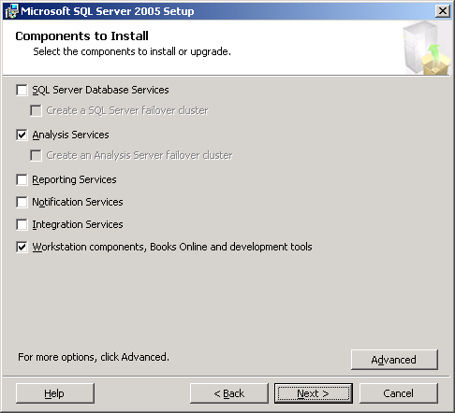
Figure 1 - Select SQL Server 2005 Components to Install

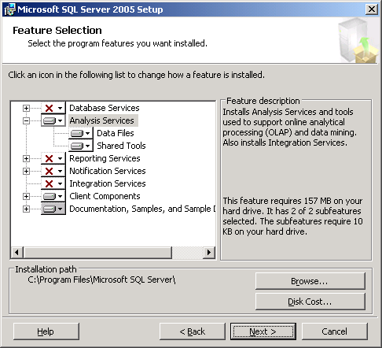
Figure 2 - Advanced Selection of SQL Server 2005 Components to Install
Once the components to install have been selected, the Setup application will prompt for an instance name for the newly installed SQL Server 2005 components. To upgrade an existing installation of Analysis Services 2000, select Default Instance, and proceed. The Setup application should detect any running services based on which components were selected for installation. Simply ensure the existing installation of Analysis Services 2000 is selected, and proceed. Figures 3 and 4 show the two screens used to identify the default instance for upgrade.
Figure 3 - Instance Name for SQL Server 2005 Installation
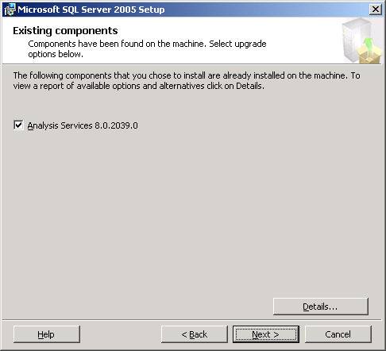
Figure 4 - Existing Components Found During SQL Server 2005 Installation
The Setup application will automatically install a new service called the SQL Browser service. The SQL Browser service listens for incoming requests for SQL Server resources and provides information about SQL Server instances installed on a server. The Setup application will prompt for what credentials to use for the newly installed service. The credentials can be specified using a built-in system account or a domain user account. The right setting should be based on what security policies have been defined for standard Windows services within an organization; if no standard security policies have been defined, the service account credentials should be set using either the Local Service built-in account or a domain user account. It should be noted that the newly installed Analysis Services 2005 service will be configured to use the same service account credentials as the existing Analysis Services 2000 service is currently using; if the credentials need to be changed, the SQL Server Configuration Manager utility can be used to do so after the upgrade process is completed. Figure 5 shows the screen used during the Setup application to specify the service account credentials for the SQL Browser service.
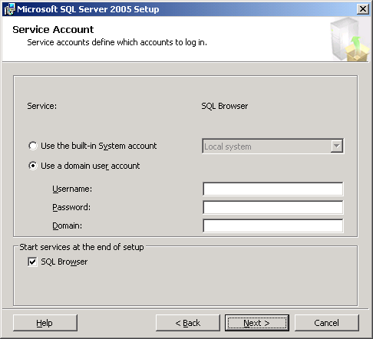
Figure 5 - Service Account Credentials for New SQL Browser Service
The Setup application will also prompt for collation settings for the new Analysis Services 2005 instance. For most installations, the default settings can be accepted because the Setup application attempts to match the collation settings to the Windows system locale setting. If Analysis Services 2005 should use different collation settings based on particular database requirements, change the settings as needed before proceeding. Figure 6 shows the screen used to specify the collation settings for the new Analysis Services 2005 instance.
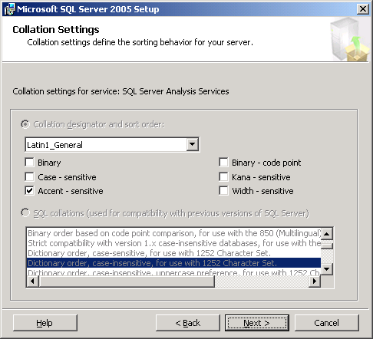
Figure 6 - Collation Settings for Analysis Services
When the Setup application is ready to proceed with the upgrade, it will display a summary of actions to be taken. Ensure that the action to be taken for Analysis Services is “upgrade,” and then proceed. Figure 7 shows this summary screen.
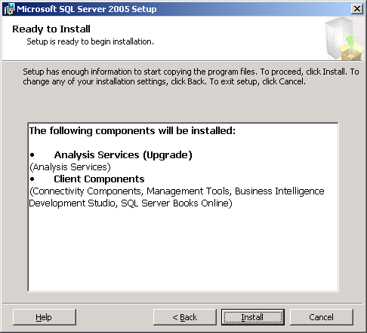
Figure 7 - Summary of SQL Server 2005 Installation Options for Upgrade
As the Setup application runs, a status screen will show status information regarding the various steps taken by the application and should show success for each of the components installed. A final screen will provide a summary of the installation along with any notes that are relevant to the upgrade process. Figures 8 and 9 show these two screens.
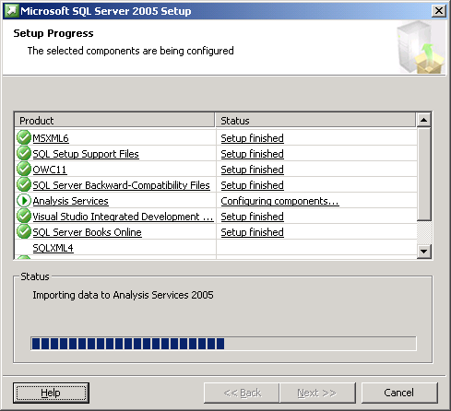
Figure 8 - Status of Installation Steps and Actions
Figure 9 - Final Summary with Notes
After the upgrade process has finished, a short set of post-installation tasks should be followed to ensure the upgrade completed successfully. See the section below regarding post-installation tasks for more information.

Troubleshooting a Failed Upgrade
Should the in-place upgrade process fail, the best course of action is to review the setup logs created by the Setup application.
- Review the Summary.txt file located in the %Program Files%\Microsoft SQL Server\90\Setup Bootstrap\Log directory. If any error messages are listed, take whatever actions are required to correct the situation, and try the upgrade process again.
- If no error messages are included in the summary, review the SQLSetup[xxxx]_[ComputerName]_AS.log file within the %Program Files%\Microsoft SQL Server\90\Setup Bootstrap\Log\Files directory. When reviewing the file, search for any instances of “Return Value 3” (which indicates a setup error). If any error messages are listed, take whatever actions are required to correct the situation, and try the upgrade process again.

Post-Upgrade Tasks
After the upgrade of a given server to Analysis Services 2005 is complete, a series of post-installation tasks must be completed before the upgraded databases will be available to end users. In addition, other post-installation tasks should be completed to ensure each database is working properly and can be modified in the future if needed.

Review Upgraded Databases
Each database upgraded by the SQL Server 2005 Setup application should be reviewed to ensure the upgrade process completed successfully. Using SQL Server Management Studio, connect to Analysis Services on the upgraded server. If the workstation components were installed as part of the upgrade, SQL Server Management Studio should be available on the upgraded server; otherwise, SQL Server Management Studio will have to be launched on another server or workstation that has had the workstation components for SQL Server 2005 installed. Figure 10 shows the connection dialog presented when SQL Server Management Studio is started.
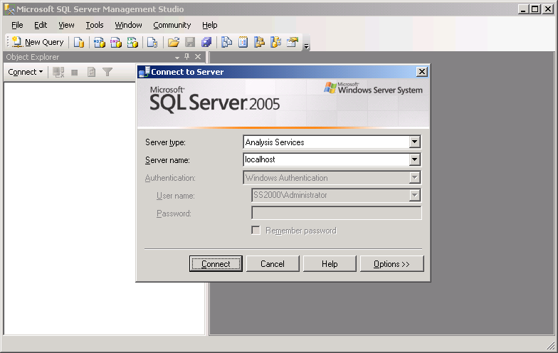
Figure 10 - Connecting with SQL Server Management Studio
Once a connection to Analysis Services on the upgraded server is established, expand the Databases folder in the Object Explorer window. If the Object Explorer window is not visible, open the View menu and select the Object Explorer menu item. Note that the Auto Hide button, represented by a pushpin in the upper right-hand corner of the Object Explorer window, can be used to “pin” the window so that it stays open.
Within the Databases folder, review the structure of each database upgraded. In particular, review the list of dimensions and cubes to see if the structure of the database is generally the same as it was before the upgrade process was completed. Note that browsing the dimensions and cubes will not be possible until the next step, processing the databases, has been completed.

Process Upgraded Databases
To browse the dimensions and cubes in each of the upgraded databases, each database will need to be processed. This can be done by using SQL Server Management Studio. Simply right-click each database listed in the Databases folder, and select Process from the resulting context menu. Figure 11 shows an upgraded server with the Foodmart 2000 database selected for processing.
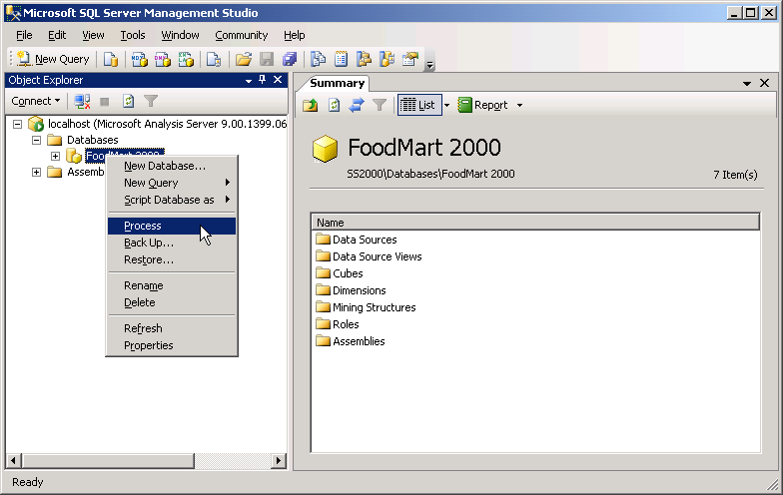
Figure 11 - Context Menu for Processing Databases
Once the Process menu option has been selected, SQL Server Management Studio will provide a Process Database dialog box. Ensure that the database selected is listed in the Object Name text box (within the Object List grid) and Process Full is listed in the Process Options text box. Click OK, and SQL Server Management Studio will begin processing the selected database. Repeat the processing action for each of the databases listed in the Databases folder. Figure 12 shows the Process Database dialog that SQL Server Management Studio provides when a database is selected for processing.
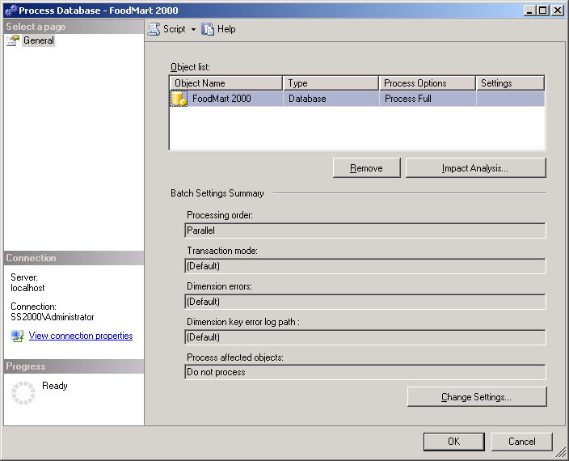
Figure 12 - Process Database Dialog
In some cases, issues with an upgraded database may prevent it from processing. Most of these issues should be reported by Upgrade Advisor. If any such issues exist, a Business Intelligence Development Studio (BIDS) project may need to be created so that changes can be made and the database redeployed for processing. See the section below regarding the creation of BIDS projects for upgraded databases for more information.

Regarding the Foodmart Sample Database
Analysis Services 2000 ships with a sample OLAP database named Foodmart. This sample database is automatically created when Analysis Services 2000 is installed. Thus, unless it has been explicitly deleted, the database will likely exist when a server is upgraded to Analysis Services 2005. In most cases, the Foodmart database is no longer needed; Analysis Services 2005 comes with two sample databases named AdventureWorks and AdventureWorksDW. These new sample databases are included with the SQL Server samples installed as part of the Workstation Components, Advanced Setup. Thus, the Foodmart database can be safely deleted from Analysis Services either before or after the upgrade is complete. However, if the Foodmart database needs to be retained (for testing or training purposes, for example), there are a few steps that must be followed before and after an in-place upgrade process is completed.
Before an in-place upgrade is performed, the Microsoft Access database that serves as the source for the Foodmart database must be saved to a backup directory. As a result of the upgrade process, the Microsoft Access database file is deleted. Thus, unless it is saved, the database file will not be available for use by the upgraded Foodmart database. By default, the Microsoft Access database file can be found at:
C:\Program Files\Microsoft Analysis Services\Samples\foodmart 2000.mdb
Once the database file has been saved to a backup directory, an in-place upgrade can be done. After an in-place upgrade has been completed, the upgraded Foodmart database must be modified in order to process cleanly. The following steps must be taken:
- Create a BIDS project reflecting the design of the upgraded Foodmart database. See the section below regarding the creation of BIDS projects for upgraded databases for more information.
- Once the BIDS project has been created and is open, the Data Source for the database must be updated. Analysis Services 2005 does not support ODBC data sources using native ODBC drivers or the OLE DB Provider for ODBC. Thus, the Data Source (named Foodmart.ds within the BIDS project) must be updated to use the Microsoft Jet 4.0 OLE DB Provider. When editing the data source, the full path and filename of the saved copy of the Microsoft Access database file should be provided.
- After updating the Data Source, the primary Data Source View (named Foodmart.dsv) should be updated. Specifically, the three calculated columns defined within the Data Source View should be updated to remove the double quotes included in the calculation, as Table 3 describes.
Table 3 – Updating Calculated Columns
Table | Calculated Column | Updated Definition
Customer | Column1 | Fname+' '+lname
sales_fact_1997 | Column1 | store_sales-store_cost
Inventory_fact_1997 | Column1 | warehouse_sales-warehouse_cost
- Finally, the Warehouse cube (named Warehouse.cube) must be updated. Specifically, the two partitions defined within the cube must be updated so that their source queries do not contain double quotes. Table 4 shows updated versions of the source queries used.
Table 4 – Updated Versions of Source Queries
Warehouse Cube Parition | Source Query
Warehouse | SELECT inventory_fact_1997.store_invoice, inventory_fact_1997.supply_time, inventory_fact_1997.warehouse_cost, inventory_fact_1997.warehouse_sales, inventory_fact_1997.units_shipped, inventory_fact_1997.units_ordered, warehouse_sales-warehouse_Cost AS Column1, inventory_fact_1997.product_id, inventory_fact_1997.warehouse_id, inventory_fact_1997.store_id, inventory_fact_1997.time_id FROM inventory_fact_1997, time_by_day WHERE inventory_fact_1997.time_id=time_by_day.time_id AND time_by_day.the_year=1997
warehouse 98 | SELECT inventory_fact_1997.store_invoice, inventory_fact_1997.supply_time, inventory_fact_1997.warehouse_cost, inventory_fact_1997.warehouse_sales, inventory_fact_1997.units_shipped, inventory_fact_1997.units_ordered, warehouse_sales-warehouse_Cost AS Column1, inventory_fact_1997.product_id, inventory_fact_1997.warehouse_id, inventory_fact_1997.store_id, inventory_fact_1997.time_id FROM inventory_fact_1997, time_by_day WHERE inventory_fact_1997.time_id=time_by_day.time_id AND time_by_day.the_year=1998
Once these changes have been made, the BIDS project can be deployed and processed successfully. The cubes within the resulting Foodmart database can then be browsed and used as expected, showing the same results as the pre-upgrade version of the database.
After a database has been processed, SQL Server Management Studio can also be used to browse its dimensions and cubes. To begin, expand a database within the Object Explorer window in SQL Server Management Studio to display a list of folders under each database. Then, expand the Dimensions and Cubes folders, right-click a given dimension or cube, and select Browse from the resulting context menu. Figures 13 and 14 show the browse windows used for browsing a dimension and a cube, respectively, within SQL Server Management Studio.
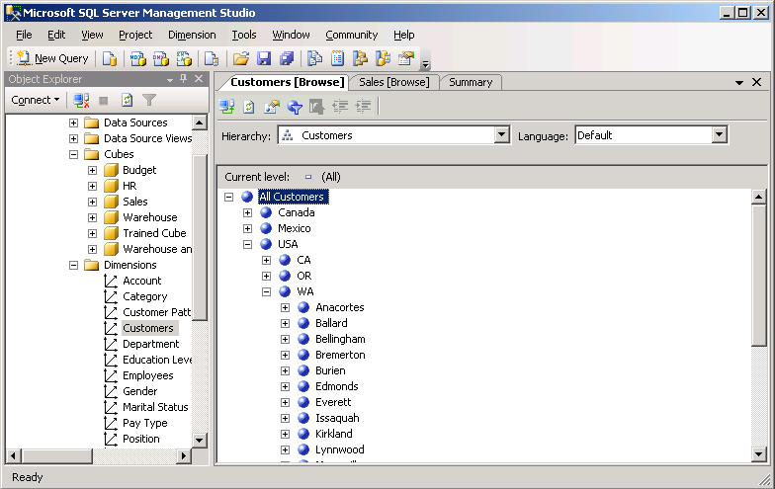
Figure 13 - Browsing Processed Dimensions
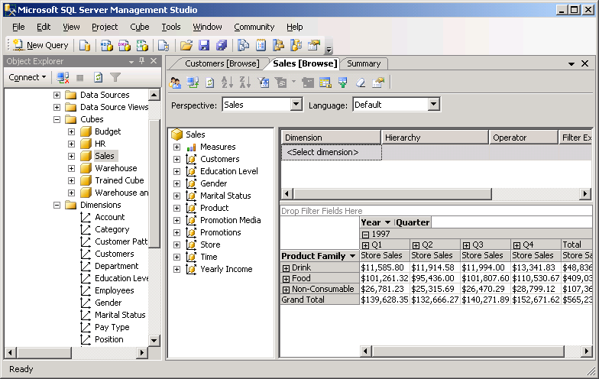
Figure 14 - Browsing Processed Cubes

Create Development Projects for Upgraded Databases
Analysis Services 2005 uses a different paradigm for developing and managing databases. While SQL Server Management Studio is used for management tasks (such as processing a database or objects, changing certain management properties for objects, and handling backup and restore operations), development tasks are now handled via the new BIDS application. BIDS takes advantage of the Visual Studio 2005 integrated development environment, using specific project and design features for Analysis Services databases. Thus, if you want to make changes to the design of a given database, a BIDS project must exist with the “source code” for the database (in the form of dimension, cube, and other object definitions).
For new Analysis Services 2005 databases, BIDS can be used to create a new project to house the database’s dimensions, cubes, and other objects. For databases created as the result of an upgrade process, BIDS can be used to “reverse engineer” a database into a BIDS project. To support future development changes to the databases involved in the upgrade, a BIDS project should be created for each database.
Within the new BIDS application, create a new project by using the File menu, selecting the New menu option, and then selecting the Project submenu option. Figure 15 shows the Project option being selected.
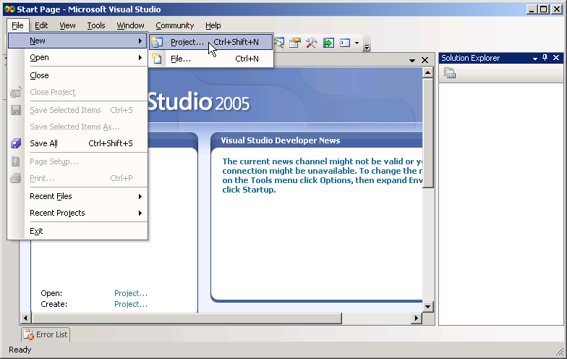
Figure 15 - Creating a New BIDS Project
BIDS will display a New Project dialog box showing the various types of projects that the Visual Studio 2005 integrated development environment can be used to create. Ensure that Business Intelligence Projects is selected as the Project Type on the left and that Import Analysis Services 9.0 Database is selected as the Template on the right. Give the project to be created a new name and location using the Name and Location options, and then select OK. Figure 16 shows the New Project dialog box.
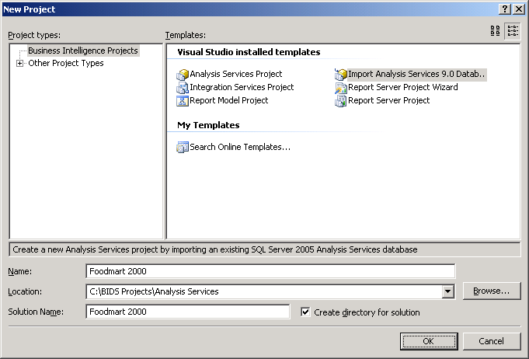
Figure 16 - New Project Dialog
To create the new project, BIDS will start the Import Analysis Services 9.0 Database Wizard. This wizard handles the import process after the database is selected. Figures 17, 18, 19, 20, and 21 show the wizard in action, along with a resulting project (based on an upgraded Foodmart database).
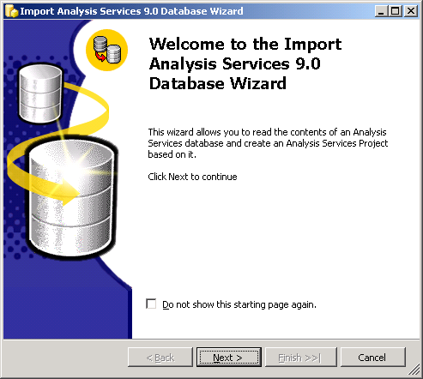
Figure 17 - Starting the Import Analysis Services 9.0 Database Wizard
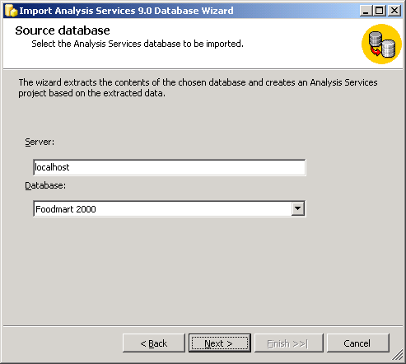
Figure 18 – Selecting a Source Database
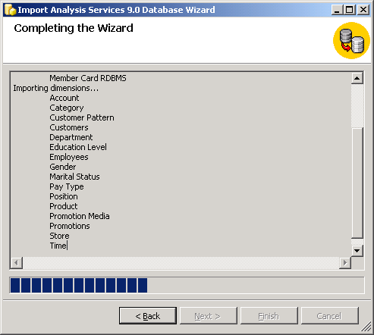
Figure 19 - Import Wizard Progress
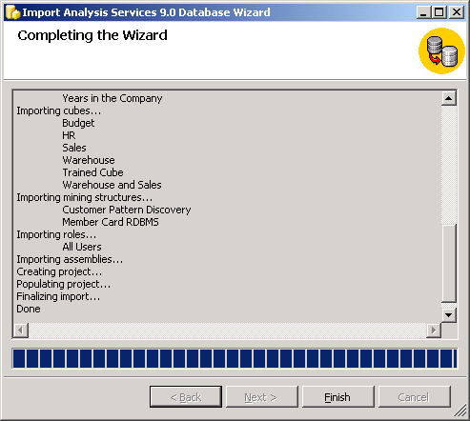
Figure 20 - Completing the Import Wizard
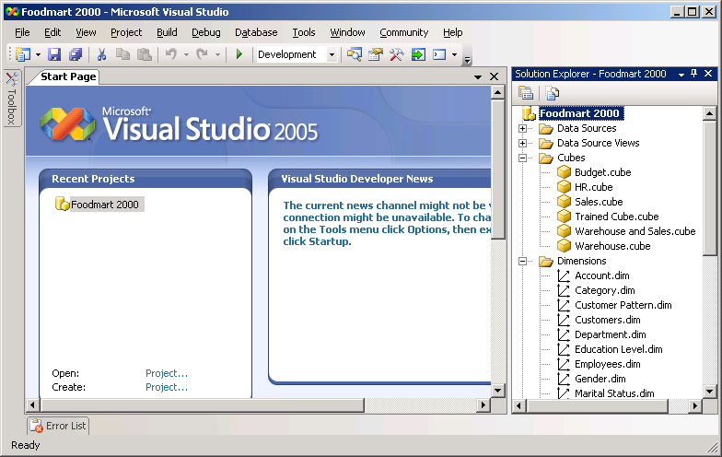
Figure 21 - Resulting Import Wizard Project
Once a given database has been imported into a BIDS project, close the project by using the File menu, selecting the Close Project menu option. Then repeat the process for each upgraded database to ensure a development project is available for any changes an upgraded project may require.

Resolve Upgrade Issues
As noted above, certain features available with Analysis Services 2000 are not upgraded and other features behave differently within Analysis Services 2005. For example, drillthrough settings within a give cube or partition will not be upgraded. Thus, it is important to thoroughly review each BIDS project created for upgraded databases to determine if any features within the original database need to be recreated or modified. If any changes are made within a given BIDS project, the database should be re-deployed and reprocessed (by using the Build menu, and selecting the Deploy menu option) to make the changes available to end users.

Review and Consolidate Data Mining Models
If an Analysis Services 2000 database includes data mining models, the mining models will be upgraded when the database is upgraded to Analysis Services 2005. In most cases, the mining models will behave as expected once upgraded; however, in a few cases, the mining models may return different results based on improvements in the data mining algorithms included with Analysis Services 2005. Thus, it is important that all of the upgraded mining models within a database be reviewed for accuracy and to ensure any behavioral differences are understood and acceptable.
Also, within an Analysis Services 2005 database, mining models based on the same relational tables or the same cube can be consolidated into a single mining structure. This capability is new within Analysis Services 2005 and provides a mechanism for comparing the mining models using a new “lift chart” feature of the mining structure. Thus, if any upgraded mining models within a given database are based on the same relational tables or the same cube, the mining models should be consolidated into a single mining structure. See SQL Server 2005 Books Online for more information regarding data mining models, mining structures, and the “lift chart.”

Side-by-Side Upgrade to Analysis Services 2005
In many cases, customers will not want to immediately upgrade all of the databases on a given server to Analysis Services 2005 in a single upgrade action and completely overwrite the Analysis Services 2000 instance before the Analysis Services 2005 installation is ready to roll. In these cases, a side-by-side upgrade process can be used to upgrade databases in a more methodical and orderly fashion. Side-by-side upgrades can be done on a single server (the existing Analysis Services 2000 server) or using two servers (to take advantage of new hardware, for example)
- When the upgrade is performed on a single server, a new instance of Analysis Services 2005 is installed alongside the existing Analysis Services 2000 databases are then upgraded to the new instance.
- If the upgrade is performed using two servers, Analysis Services 2005 is installed on the new server (as the default instance or as a named instance) and the same upgrade of databases is then performed.
Whether upgrading databases using a single server or two servers, the side-by-side upgrade process allows the databases to remain available within Analysis Services 2000 while being tested (and possibly updated to resolve issues) in Analysis Services 2005. When all of the databases have been upgraded, Analysis Services 2000 can be uninstalled. Optionally, when using a single-server for the upgrade, the new instance of Analysis Services 2005 can then be renamed as the default instance so that end users can connect to it using just the server name (as is done with Analysis Services 2000).

Preparing for a Side-by-Side Upgrade
A side-by-side upgrade to Analysis Services 2005 should not adversely affect an existing installation of Analysis Services 2000 (even if a given database upgrade effort fails). However, as with any new software installation, safeguards should be in place in case something catastrophic happens once the software is installed. Thus, even with a side-by-side upgrade on a single server, it is recommended that the same preparation steps mentioned above be followed.
- Back up the registry information related to Analysis Services 2000. Using the regedit.exe utility, export the following registry key to a file:
My Computer\ HKEY_LOCAL_MACHINE\SOFTWARE\Microsoft\OLAP Server
- Back up all existing databases using the archive command in Analysis Manager. Open Analysis Manager, right-click each database listed, and select Archive Database from the resulting context menu. Provide a unique filename for each .cab file created.
It is recommended that all of the files generated by the above steps be placed into a single directory on a network share for safe-keeping during the upgrade process.

Installing the New Instance
Once the pre-planning process is complete, the first step needed for a side-by-side upgrade is to install a new instance of Analysis Services 2005. This new instance will be created by using the Setup application for SQL Server 2005.
To begin the process, launch the Setup application for SQL Server 2005. After starting, the Setup application will install a set of prerequisites to the installation of SQL Server 2005 components, run a system configuration check, gather system information, and prompt for typical registration information (user name, company name, and product key). The application will then provide options for selecting components to install. Select the Analysis Services option. If any of the SQL Server 2005 workstation components will be needed on the server, include the Workstation Components option when selecting components. The Setup application will then prompt for an instance name for the new SQL Server 2005 components:
- For a single-server side-by-side upgrade, enter a new instance name for Analysis Services 2005 and proceed. Please note that the default selection made by the Setup application is to use the default instance name and perform an upgrade operation. Thus, be sure to select Named Instance and provide a new instance name in order to proceed.
- For a two-server side-by-side upgrade, Analysis Services 2005 can be installed as the default instance or as a named instance.
Figure 22 shows the screen used for entering a new instance name (for example, “AS2005”).
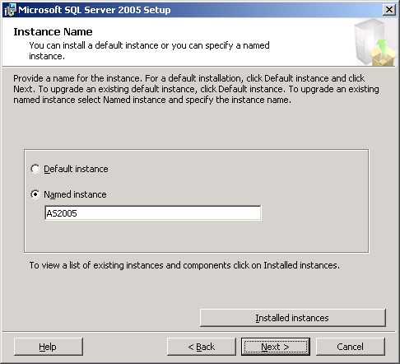
Figure 22 - New Instance Name for Side-by-Side Upgrade
The Setup application will prompt for service account information for the new instance of Analysis Services as well as for the new SQL Browser service. As mentioned above in the “In-Place Upgrade to Analysis Services 2005” section, the right settings should be based on the security policies that have been defined for standard Windows services within an organization; if no standard security policies have been defined, the service account credentials should likely be set using either the Local Service built-in account or a domain user account. Figure 23 shows the screen used during Setup to specify the service account credentials for the two new services.
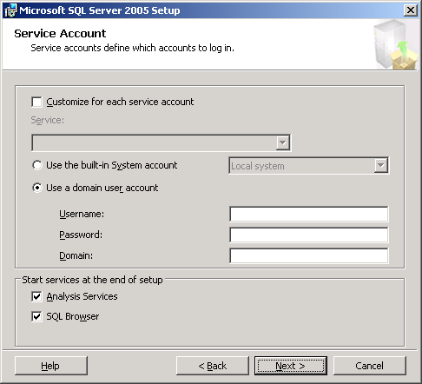
Figure 23 - Service Account Settings for New Services
As mentioned above in the “In-Place Upgrade to Analysis Services 2005” section, the Setup application will prompt for collation settings for the new instance of Analysis Services 2005. Accept the default collation designator and sort order options unless a requirement exists for other specific settings. Finally, the Setup application will show a summary of installation options before proceeding; ensure the action listed for Analysis Services is NOT “upgrade,” and then proceed. Figure 24 shows this summary screen for an installation of a new instance of Analysis Services 2005.
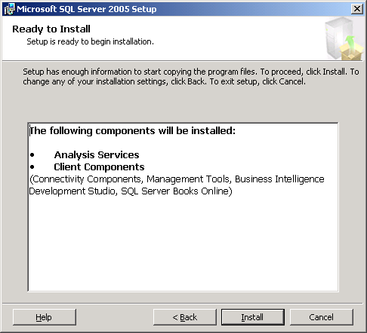
Figure 24 - Summary of SQL Server 2005 Installation Options for New Instance
To complete the installation of the new instance, simply proceed through the remaining screens provided by the Setup application. A new instance of Analysis Services 2005, ready for the upgrade effort, will be installed and then available for use.

Migrating Databases to the New Instance
After a new instance of Analysis Services 2005 has been installed, one or more databases can be migrated from Analysis Services 2000 to the new instance by using the Migration Wizard tool included with Analysis Services 2005. The Migration Wizard can be started in one of two ways:
- Open SQL Server Management Studio and connect to the new instance of Analysis Services 2005; once connected, right-click the instance name within the Object Explorer window, and select Migrate Database.
- Run the MigrationWizard.exe executable by using the Run command from the Windows Start menu or from the command-line window.
When the Migration Wizard is started, it requests the name of a source server (running Analysis Services 2000) as well as a destination server (using the server\instance format for named instances of Analysis Services 2005). To migrate databases in a side-by-side upgrade scenario, enter the name of the source server and the newly installed Analysis Services 2005 instance as the destination. The wizard will then display a list of databases found on the source server. One or more of the databases listed can be selected for migration. Figures 25 and 26 show the two screens used for specifying the source and destination for the Migration Wizard as well as the databases to be migrated.
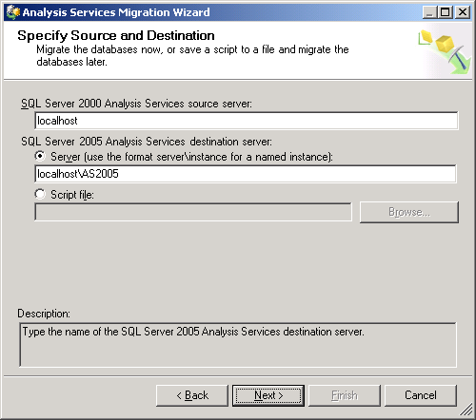
Figure 25 - Source and Destination for the Analysis Services Migration Wizard
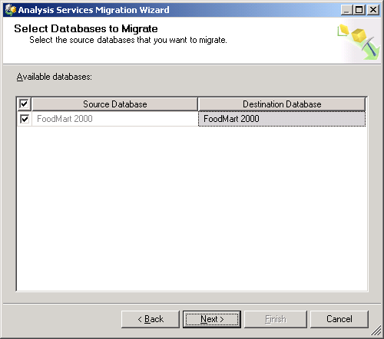
Figure 26 - Select Databases for the Migration Wizard
Once one or more databases have been selected, the Migration Wizard will validate the structure of each of the databases. The wizard will display the results of the validation effort and provide a log of the results that can be viewed or saved before the migration process is started. After validating each database, the Migration Wizard will then migrate the structure and metadata for each database to the Analysis Services 2005 instance. Figures 27, 28, 29, and 30 show the results of a validation effort, the progress of a migration effort, and the final screen displayed by the Migration Wizard.
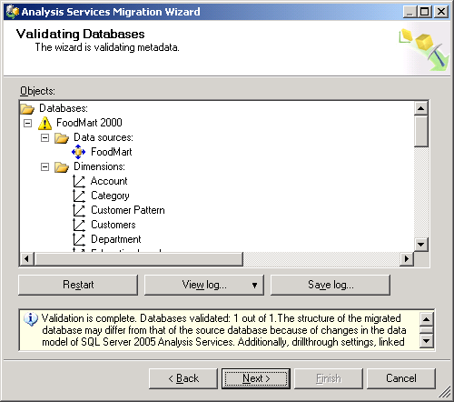
Figure 27 - Validation Results Provided by the Migration Wizard
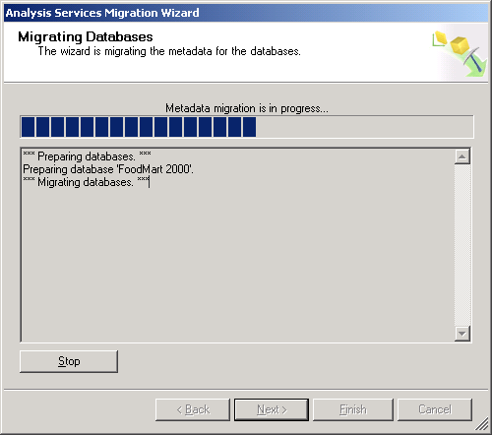
Figure 28 - Progress of the Migration Wizard
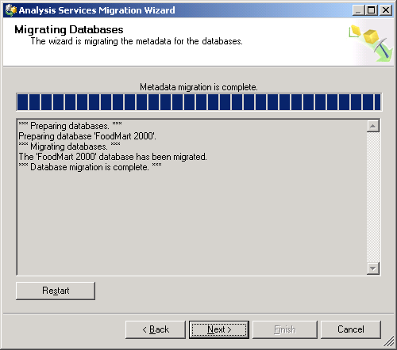
Figure 29 - Migration Completed by the Migration Wizard
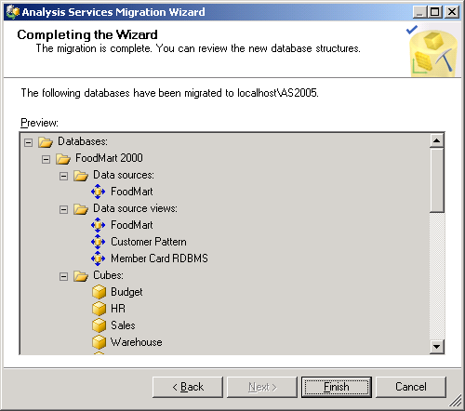
Figure 30 - Final Results Provided by the Migration Wizard
The Migration Wizard can be run as many times as needed to migrate one or more databases at different times. Thus, a methodical migrate-test-deploy cycle can be used to move databases (and end users) to the new instance of Analysis Services 2005.

Post-Migration Tasks
Once one or more databases have been migrated to the new instance of Analysis Services 2005, the same set of tasks should be completed as listed above in the “Post-Upgrade Tasks” guidance of the “In-place Upgrade to Analysis Services 2005” section. These tasks include:
- Review each migrated database by using SQL Server Management Studio to ensure its contents (specifically, dimensions and cubes) are consistent with its Analysis Services 2000 counterpart.
- Process each migrated database by using the Process command in SQL Server Management Studio.
- Browse each migrated database’s dimensions and cubes to ensure a consistent query experience compared to the database’s Analysis Services 2000 counterpart.
- Generate a new development project using BIDS for each migrated database.
- Resolve any migration issues within a given database, updating its dimension and cube designs as needed.
- Review and possibly consolidate any upgraded data mining models included in each database.
Review the details related to each of these tasks in the sections above to ensure a smooth and complete migration process.

Removing Analysis Services 2000
If all of the databases on a given server are migrated to a new instance of Analysis Services 2005, then Analysis Services 2000 may no longer be needed on the server. In this case, Analysis Services 2000 can be uninstalled by using the Add or Remove Programs applet available via the Control Panel application. Once the prior version has been removed, the new instance of Analysis Services 2005 can be renamed so that it is recognized as the default instance on the server. This can be accomplished using the new Instance Rename tool available for Analysis Services 2005. The Instance Rename tool can be started by executing asinstancerename.exe from the C:\Program Files\Microsoft SQL Server\90\Tools\Binn\VSShell\Common7\IDE directory.
When the Instance Rename tool is started, it displays a single dialog box for selecting and renaming a given instance of Analysis Services 2005. Use the Instance to rename drop-down list to select the named instance. If the instance should act as the default instance for the server, leave the New instance name text box blank and click Rename. Figure 31 shows the Instance Rename tool’s single dialog box.
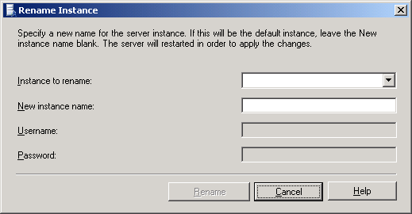
Figure 31 - Instance Rename Tool for Analysis Services 2005
The Rename Instance tool will update the Analysis Services 2005 instance and restart its service to complete the process. If an instance is renamed as the default instance, client tools can connect to Analysis Services 2005 BY using the server name without any instance name.

Redesigning Databases for Analysis Services 2005
Although upgrading Analysis Services 2005 and migrating Analysis Services databases to Analysis Services 2005 provides great options for moving databases to the new platform quickly, many customers may choose to redesign databases to take advantage of specific new features and architecture changes included in the new version. While developing new databases for Analysis Services 2005 will not be discussed in detail in this paper, some general ideas and thoughts related to redesigning the Foodmart 2000 database are included here as an example of the possibilities available.

Data Source Views
Every Analysis Services 2005 solution is based on a Data Source View (DSV) that encapsulates schema metadata based on the data sources included in the BIDS project. When a database is upgraded, the DSV generated for the database may included generically named Named Calculations, such as Column1, Column2, and so on. For example, the DSV for an upgraded Foodmart 2000 database contains a series of Named Calculations that are generically named and then used for various dimension and cube designs. While this works fine and does not affect end users (because client applications do not directly access a DSV), it is not intuitive from a development and support perspective.
A better DSV design would include properly named Named Calculations and could include other DSV options such as Named Queries and Diagrams. Figure 32 shows a partial DSV as generated during an upgrade, and Figure 33 shows a DSV as might be created during a redesign effort. Note the use of properly named Named Calculations and the use of Diagrams in Figure 33.
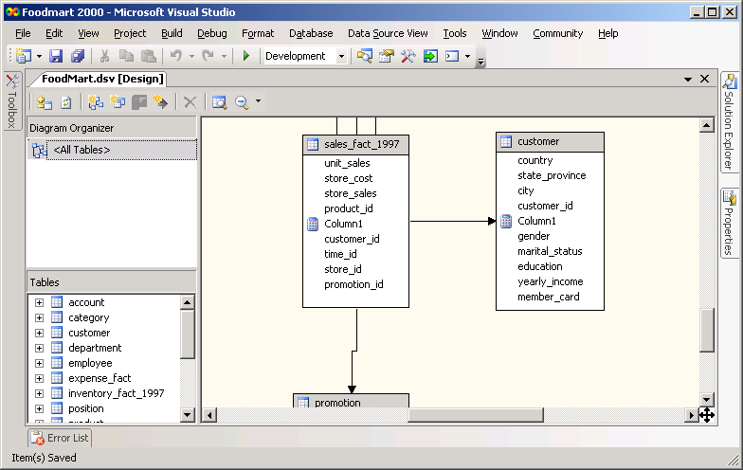
Figure 32 - Foodmart 2000 DSV Generated during Upgrade
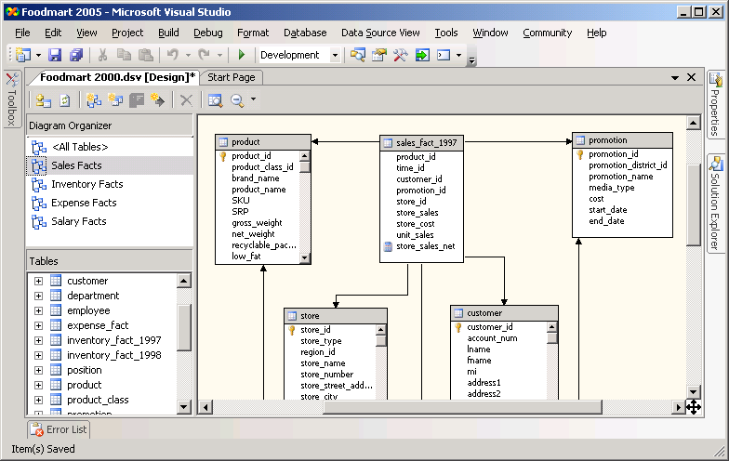
Figure 33 - Redesigned Foodmart 2000 DSV

Dimensions
Analysis Services 2005 includes many significant changes to support new features and functionality related to dimensions. Attributes and their relationships (versus levels in a dimension’s hierarchy) are now the primary design element within a dimension. Hierarchies within a dimension define navigation paths through a series of attributes, such as country, state/province, and city. A new feature of dimensions called attribute hierarchies exposes individual attributes to query applications, providing end users the ability to select any combination of attributes for reporting and analysis, above and beyond the hierarchies that may have been defined as part of the dimension.
When a database is upgraded to Analysis Services 2005, the resulting dimension designs contain only those dimension attributes required to reproduce the hierarchies defined within the dimension. In addition, no attribute hierarchies are made visible even for the attributes included in the dimension’s design. Also, in some cases, dimension attributes are renamed based on rules used during an upgrade (typically in an attempt to create attribute names that do not duplicate other objects such as dimensions or hierarchies).
For example, Figure 34 shows the design of the Foodmart 2000 Customers dimension as generated by an upgrade process; note the attribute names on the left and the other separate dimensions related to customers (Education Level, Gender, Marital Status, and Yearly Income) in the Dimensions folder on the right.
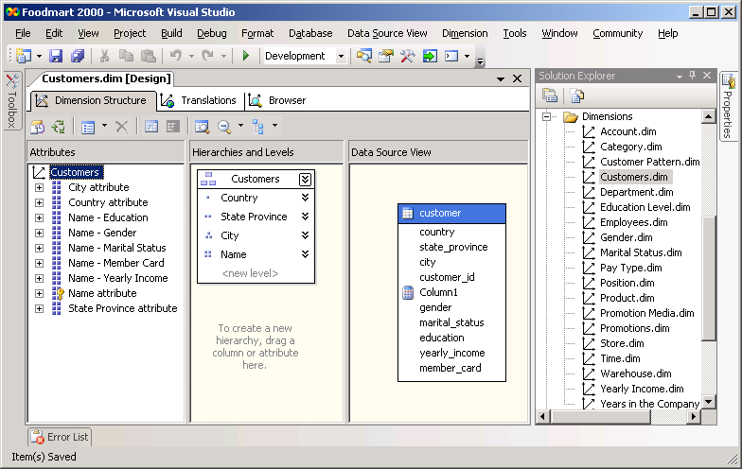
Figure 34 - Customers Dimension Generated During the Upgrade
A redesign of the Foodmart 2000 database would need to have a similar Customers dimension defined. However, the redesigned dimension would likely provide better naming for the attributes and would likely take advantage of attribute hierarchies to provide access to dimension information such as education level, gender, marital status, and yearly income. In addition, although the same structured hierarchy for the geographic information related to customers would be needed, each of the attributes in the hierarchy could also be made available as attribute hierarchies so that an end user could select any of the attributes individually (versus using the hierarchy) for reporting and analysis purposes.
Figure 35 shows a possible redesign for the Customers dimension. Note the attribute names listed on the left; also note that the separate dimensions for customer attributes such as education level and gender are not needed because these attributes are made available as attribute hierarchies.
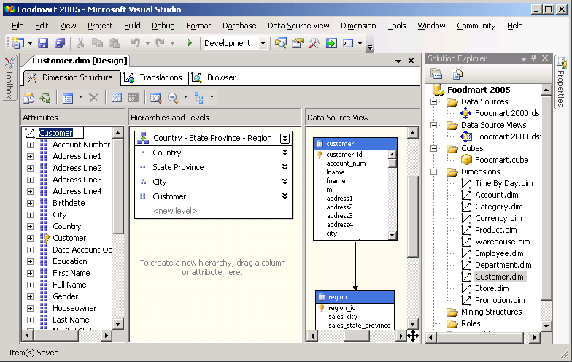
Figure 35 - Redesigned Customers Dimension

Cubes
As with dimensions, Analysis Services 2005 contains significant changes to the features and functionality related to cubes. The most significant change when comparing the new version to Analysis Services 2000 is the use of measure groups and perspectives within a cube. In Analysis Services 2000, a cube could contain only a single fact table and its related dimensions. If measures from two or more fact tables needed to be combined for reporting or analysis purposes, a virtual cube was used to join two or more cubes based on one or more common dimensions.
In Analysis Services 2005, a cube can contain measures from multiple fact tables. Measures from a given fact table are grouped together using measure groups, and the relationships between dimensions in the database and each measure group are defined as part of the cube definition. Perspectives are then used to provide subsets of a cube’s dimensions, measure groups, measures, and calculations.
When a database is upgraded to Analysis Services 2005, the database will contain a separate cube for each basic and virtual cube found in the original database. Given the new features and architecture available in Analysis Services 2005, separate cubes can often be redesigned as a single cube with multiple measure groups and perspectives. Using this design provides better flexibility and performance. For example, the Foodmart 2000 database contains six separate cubes as defined in Analysis Services 2000. Each of these becomes a separate cube within the upgraded version of the database in Analysis Services 2005. Figures 36, 37, 38, 39, 40, and 41 show the definition of the Sales and Warehouse cubes as generated by the upgrade process. Note the complete list of cubes in the Cubes folder on the right. Also note that each cube contains a single measure group, only those dimensions related to the measure group, and a single default perspective that includes everything in the cube.
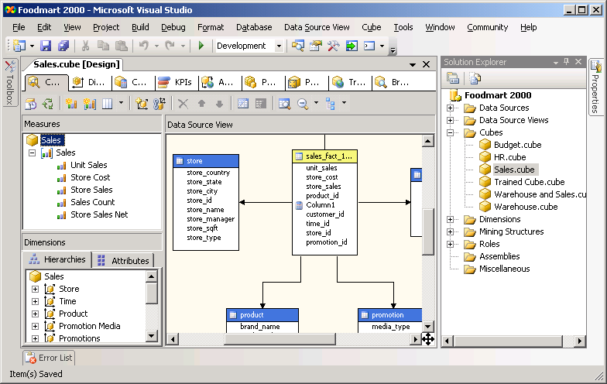
Figure 36 - Single Measure Group in the Upgraded Sales Cube
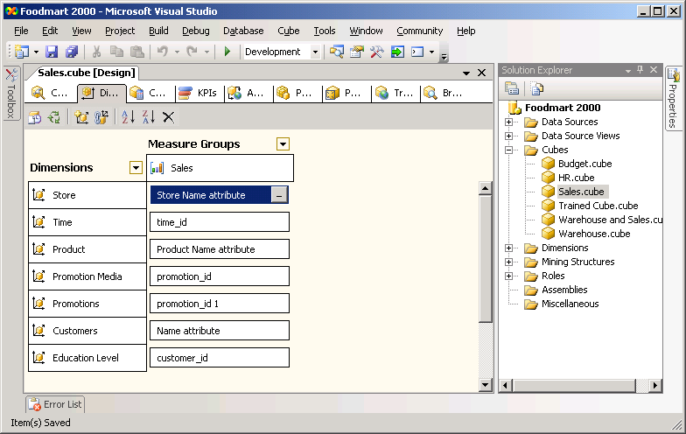
Figure 37 - Dimension Usage in the Upgraded Sales Cube
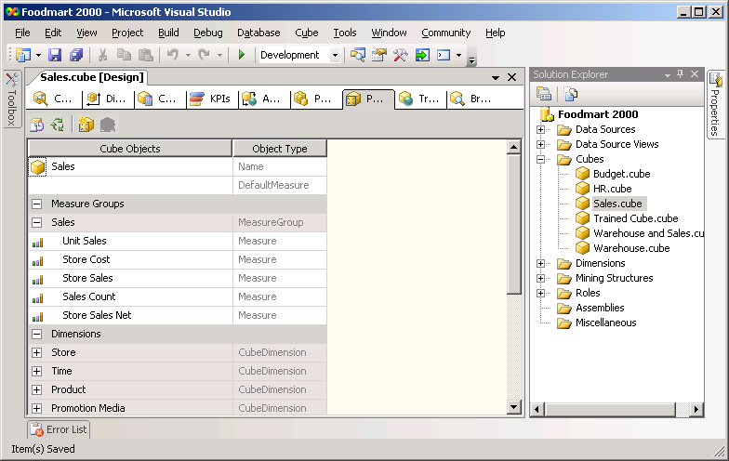
Figure 38 - Default Perspective in the Upgraded Sales Cube
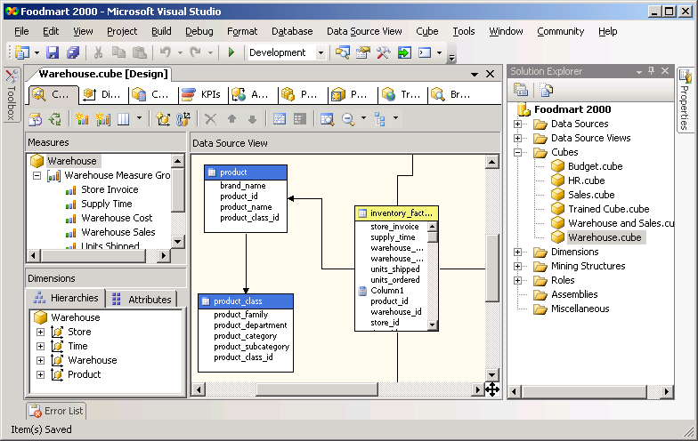
Figure 39 - Single Measure Group in the Upgraded Warehouse Cube
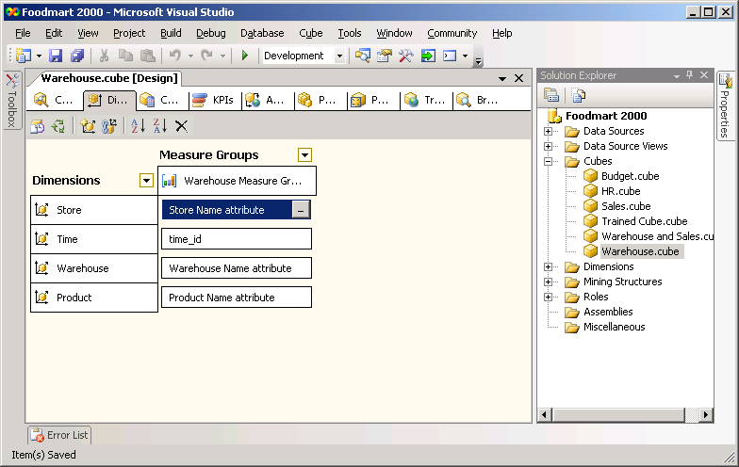
Figure 40 - Dimension Usage in the Upgraded Warehouse Cube
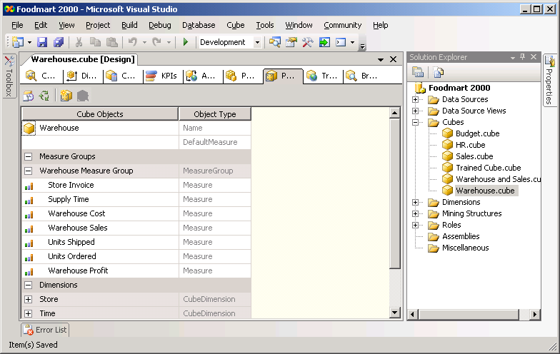
Figure 41 - Default Perspective in the Upgraded Warehouse Cube
A redesigned version of the Foodmart 2000 database would likely only include a single cube. The cube could contain measure groups that included all of the measures available in each fact table in the underlying relational database. All of the dimensions in the database could then be included in the cube, with the appropriate relationships defined between the dimensions and each measure group. Finally, a set of perspectives could be defined to subset the dimensions and cubes for individual users and applications. Figures 42, 43, and 44 show one possibility for a redesigned cube for the Foodmart 2000 database. Note that it is the only cube defined in the database; also note its multiple measure groups, dimension and cube relationships, and perspectives.
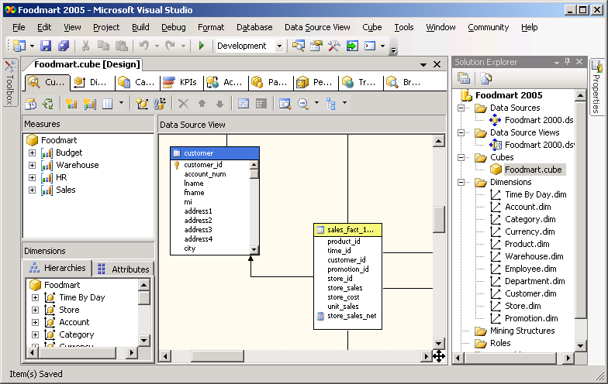
Figure 42 - Redesigned Foodmart Cube with Multiple Measure Groups
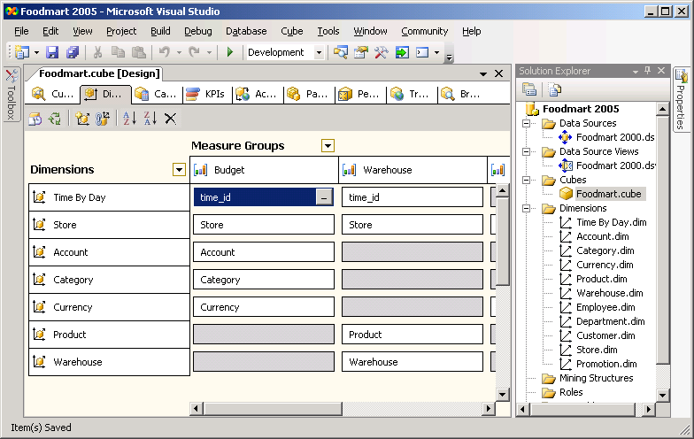
Figure 43 - Redesigned Foodmart Cube with Dimension-Measure Group Relationships
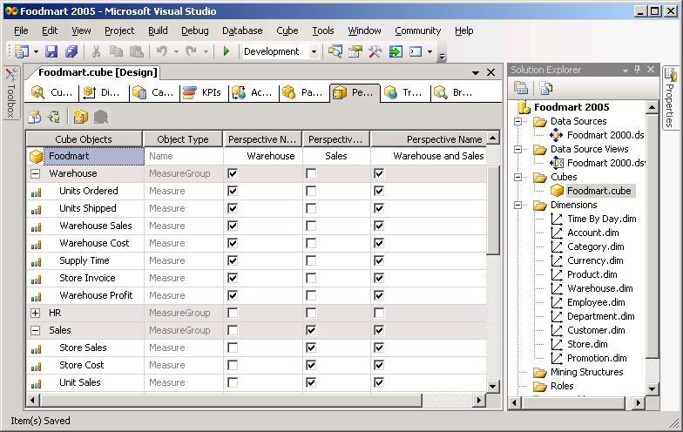
Figure 44 - Redesigned Foodmart Cube with Multiple Perspectives
In addition to the flexibility improvements provided by new cube designs, Analysis Services 2005 also provides new features such as Key Performance Indicator (KPI) definitions, Reporting Services actions, proactive caching storage mechanisms, and translation definitions. A redesigned Foodmart 2000 cube could take advantage of each of these new features (none of which are used by default within an upgraded database).
As you can see, there are potentially many reasons why a redesigned database may be better than an upgraded database. As stated before, while an upgrade process may provide a quick mechanism for moving to Analysis Services, redesigning each of the databases to take advantage of the new platform’s architecture, features, and design paradigms may prove advantageous in the long run.

Connecting Client Applications to Analysis Services 2005
Many client applications developed for Analysis Services 2000 rely on a client component known as PivotTable Services 8.0 (PTS). This component provides a level of client-side data caching and query processing to move resource usage from the server to the client. In Analysis Services 2005, the PTS component has been deprecated and is replaced by the Analysis Services 9.0 OLE DB Provider. To connect client applications to Analysis Services 2005, this new provider must be installed on client workstations.
The new provider is available as a Web download as part of the Feature Pack for SQL Server 2005; you can find the new Feature Pack at:
http://www.microsoft.com/downloads/details.aspx?FamilyID=D09C1D60-A13C-4479-9B91-9E8B9D835CDC&displaylang=en.

Section 5.0: Conclusion—Preparing for a Smooth Upgrade
As with any upgrade, the key to a smooth and successful move is effective preparation. Preparing for an upgrade should include two important steps: checking for possible upgrade issues and developing a contingency plan in case of upgrade problems.
The SQL Server 2005 Upgrade Advisor provides significant help for the first step, letting you analyze all your current SQL Server components for upgrade issues before you begin any upgrade process. Upgrade Advisor then produces detailed reports showing any upgrade issues and providing guidance about when and how to fix the problems or potential problems. Backing up all files before your upgrade is a critical part of any contingency plan.
Treat your upgrade as the major IT database project that it is by performing the following tasks:
- Begin by identifying your upgrade requirements: Determine the SQL Server 2005 edition you need to upgrade to as well as the hardware, software, and networking requirements for that edition.
- Select the appropriate upgrade strategy—in-place or side-by-side—for your environment and for each component you’re upgrading. Select the upgrade method that gives you the most uptime while providing the smoothest upgrade scenario. Allow for testing and rollback in case you experience problems.
- Run Upgrade Advisor to help identify upgrade issues. Be sure to review SQL Server 2005 Books Online to review possible issues that could break an upgrade or cause problems after the upgrade.
- Make a checklist of all issues, and then resolve all that you can before you upgrade. Note the items you need to resolve post-upgrade.
- Develop criteria and tests that you will use to determine whether the upgrade was successful.
- Formulate a rollback plan that lets you restore to original conditions in case your upgrade or validation tests do not succeed.
- Perform the upgrade for each component you are moving to SQL Server 2005, following the specific steps detailed in each section in this technical guide.
- Perform post-upgrade steps. Review logs and perform the tests you developed to validate the upgrade and configuration settings. You may need to repopulate full-text catalogs; configure log shipping, which cannot be directly upgraded from SQL Server 2000; or re-establish replication. You may need to modify stored procedures or applications to make sure your query-intensive systems work as expected. And you may need to reprocess Analysis Services databases and cubes.
- Prepare to implement new features. For example, to take advantage of new maintenance plan functionality, you will need to migrate your maintenance plans to SQL Server 2005. You will also want to migrate your DTS packages to SSIS to improve performance and use SSIS’s powerful new features. You can review your stored procedures and scripts to determine whether SQL Server 2005’s new Common Language Runtime (CLR) integration could provide better functionality.
The new release of SQL Server has a wealth of new features that you will want to explore and implement as you have need for them and time to deploy them. In the meantime, learn as much as you can about the tools you will use to perform the upgrade, including Upgrade Advisor, SQL Server 2005 Setup, the SSIS and Analysis Services Migration Wizards, and the Reporting Services Configuration tool. And get familiar with SQL Server Management Studio, BI Development Studio, and the other tools you will use to manage your upgraded SQL Server installations.

Appendix 1: Upgrade Tips and Tricks
Here are some tips and tricks highlights from each section in the SQL Server 2005 Upgrade Technical Resource Guide. For more information about a particular tip, see the relevant section in the guide.

Section 1.0: Upgrade Planning and Deployment
- If you want to upgrade just one database from a legacy SQL Server and leave the other databases alone and available, use a side-by-side upgrade method, which will result in two SQL Server instances—the legacy instance and the new SQL Server 2005 instance—either on the same server or on different servers.
- Remember that you cannot perform "cross-bit" upgrades—moving directly from a 32-bit instance of SQL Server to a 64-bit version of SQL Server 2005, or vice versa—using the in-place upgrade method. To upgrade a 32-bit version of SQL Server to a 64-bit version of SQL Server 2005 or a 64-bit version of SQL Server to a 32-bit version of SQL Server 2005, you must use the side-by-side upgrade method.
- Note that you must keep the different components of SQL Server 2005 at the same edition level when they are on the same instance. So if you are running SQL Server 2005 Enterprise Edition of the database engine on a particular instance, you must also install the Enterprise Edition of Analysis Services as part of that instance.
- Advantages of an in-place upgrade include: ease, speed, automation, minimum instance downtime, no additional hardware required, and the ability for applications to connect to the same instance name.
- Disadvantages of an in-place upgrade include: having to upgrade an entire instance or a major SQL Server component, not being able to use this method for all SQL Server components, not being able to directly upgrade just a single database, some disk use growth during the metadata upgrade process, having to inspect the entire instance for backward compatibility issues, not being able to run the upgraded version beside the legacy version for comparison, and complex rollback of upgraded data and the upgraded instance.
- Advantages of a side-by-side upgrade include: gaining more granular control over what database objects you want to upgrade; ability to run the legacy database server alongside the new server, perform a test migration, and research compatibility issues without disturbing the production system; ability to roll back to the legacy system if the migration does not pass validation and acceptance tests.
- Disadvantages of a side-by-side upgrade include: may require new or additional hardware resources; if you use just one server, you may have insufficient resources to run both instances alongside each other; having to redirect applications and users to a new instance and possibly a new server; manually transferring data, security, configuration settings, and other supporting objects to the new instance; and longer downtime in some cases if you must transfer large amounts of data.
- Because the Microsoft SQL Server 2005 Upgrade Advisor performs only read operations on the target instance, it does not cause much overhead on the target SQL Server. However, report generation and analysis is CPU intensive, so you should always try to run it remotely when working with production database servers.
- If you freshly download Upgrade Advisor, you are assured that you have the latest version. If you are working from an older version or a version you have copied from a CD or DVD, always make sure you have updated your version on disk. You can determine the version of Upgrade Advisor you are using by clicking the information button.
- When you run Upgrade Advisor, make sure your SQL Server login, whether using Windows or SQL Server authentication, has system administrator rights to the target SQL Server.
- When preparing a trace file for Upgrade Advisor, collect a representative set of queries and not a voluminous set of repeating queries. The SQLProfilerTSQL_Replay template is the preferred template to use when capturing trace information for Upgrade Advisor.
- If performance is a critical feature of your current legacy system, make sure you gather data indicating typical performance measures for important and common queries. You may need to refer to these baselines after the upgrade if you receive reports that performance has changed. You may find that users are mistaken and that the new system performs equally well or better.

Section 2.01: Minimizing Upgrade Downtime
- To reduce the upgrade impact on database availability, you can manually install the setup prerequisites (e.g., .NET Framework 2.0, SQL Server Native Client). If you are working on a clustered instance, you can apply these prerequisites beforehand to each node of the cluster.
- In an in-place upgrade, SQL Server 2005 Setup automatically upgrades logins and their passwords and permissions from the old instance the new instance.
- The automatic in-place method upgrades all databases directly, not just one. Therefore, all databases are offline until all of them are brought back online, one by one, on the SQL Server 2005 instance. The duration of database unavailability will be least for the first database brought back online, and the longest for the last one brought online.
- You do not have direct control over SQL Server 2005's Setup program timing, but through pre-upgrade QA testing, you should be able to estimate approximately how long the process will take. Before the upgrade, inform users that an upgrade will be occurring during a certain time and that they will not be able to access the databases during that time. You should take applications and users offline at the start of the automatic upgrade process.
- Remember that you may have to complete some post-upgrade tasks, such as running validation tests to make sure your applications are working as expected and running scripts to resolve issues determined by Upgrade Advisor, before you can let users and applications connect to the database.
- If the end result of the upgrade is unacceptable, rolling back an in-place upgrade can be time-consuming. You will need to stop SQL Server 2005, reinstall the legacy SQL Server instance, restore the legacy databases, and apply scripts to reconfigure the system correctly.
- For a side-by-side upgrade, if you are moving a database that has multiple filegroups and you are working with SQL Server 2005 Enterprise Edition, you can take advantage of piecemeal restore. You can back up the source server's primary filegroup and restore it to the target server, bringing the database online, and repeat the process for each filegroup. You can bring over the most important filegroups first and less important filegroups later.
- You can also reduce downtime by backing up the database on the legacy instance, leaving it online, and restoring the backup to the new SQL Server 2005 instance without recovery. Then you can take the legacy database offline, take one last transaction log backup, and restore all transaction logs to the legacy instance. With the last transaction log restore, you bring the new SQL Server 2005 database online.

Section 2.02: Upgrading Databases on Failover Clusters
- An in-place upgrade is the recommended method for upgrading a cluster instance because it minimizes the downtime of the SQL Server. But because an in-place upgrade will replace the existing SQL Server 2000 failover cluster instance, you need to thoroughly test the upgraded instance before implementing it in a production environment.
- An in-place upgrade will directly upgrade a SQL Server 2000 failover cluster instance to a SQL Server 2005 failover cluster instance. This will upgrade all registry keys, binaries, and security settings related to the SQL Server 2000 failover cluster instance.
- A side-by-side upgrade will allow the cluster to maintain partial availability. Databases within the SQL Server 2000 failover cluster instance will remain online and accessible by applications while the SQL Server 2005 failover cluster instance is built.
- To accomplish a side-by-side upgrade, you will need to perform several manual steps such as copying logins, moving jobs, and redirecting applications.
- Note that unlike in previous versions of SQL Server, an upgrade from a standalone instance to a failover cluster instance is no longer supported. You also cannot use an in-place upgrade to upgrade a SQL Server 2000 failover cluster instance to a SQL Server 2005 standalone instance. Either of these scenarios requires installation of the SQL Server 2005 instance and then migration of the databases from SQL Server 2000 using either the backup/restore or attach/detach methodologies.
- SQL Server 2000 did not support encryption when running on either a Windows 2000 or Windows 2003 cluster. But after upgrading to a SQL Server 2005 failover cluster instance on a Windows 2003 cluster, you will be able to encrypt the file system.
- Because a side-by-side upgrade leaves the SQL Server 2000 failover cluster instance intact as well as having all of the databases still available, it is possible to configure the environment to allow a rollback, either immediate or delayed, while also maintaining very high levels of availability.
- After the installation of a SQL Server 2005 failover cluster instance, a reboot may be required to complete the installation due to open file locks during the installation process. If your installation log does not contain any 3210 errors, then a reboot is not required.

Section 2.03: Upgrading Log Shipping
- Log shipping cannot be directly upgraded from SQL Server 2000 to SQL Server 2005. You will need to reconfigure log shipping by using either SQL Server Management Studio or log shipping system stored procedures.
- While a SQL Server 2000 log shipping configuration will not directly upgrade to SQL Server 2005, you do have three different methods to indirectly upgrade log shipping: highly available upgrade, partially available upgrade, and offline upgrade.
- To perform a highly available upgrade, perform the following basic steps, keeping the log-shipped databases offline during the process: 1) Upgrade the secondary instance to SQL Server 2005, 2) Fail over the log shipping to the newly upgraded secondary database, 3) Upgrade the old primary database to SQL Server 2005, 4) Reconfigure log shipping under SQL Server 2005, and 5) Manually change the roles of the databases, if desired.
- To perform a partially available upgrade, you 1) upgrade the secondary instance while the secondary database is offline, 2) upgrade the primary database (which will not be available for use during the upgrade), and 3) reconfigure log shipping between the two upgraded instances. The offline secondary database will upgrade to SQL Server 2005 once log shipping has been reconfigured.
- To do an offline upgrade, 1) remove log shipping from the SQL Server 2000 databases, 2) upgrade both databases, and 3) reconfigure SQL Server 2005 log shipping between the databases.
- You need to upgrade the monitor server, which logs error and status information as well as raises alerts, to SQL Server 2005 before reconfiguring log shipping on SQL Server 2005.
- After upgrading log-shipped databases to SQL Server 2005, you will need to perform a few cleanup tasks to remove the old log shipping tables and jobs from the upgraded instances.

Section 2.04: Upgrading Replicated Databases
- Databases participating in replication must be upgraded in the following order: Distributor, Publisher, Subscribers.
- Although there are slight variations depending on the method of replication that you are using, the Distributor must be at the same or greater version than the version of the Publisher, while the Subscriber must be at the same or a lower version than the Distributor.
- The side-by-side upgrade option is only possible for merge replication if all data changes are prevented throughout the architecture. This upgrade option is possible for transactional or snapshot replication while changes are being issued against the existing architecture.
- Due to security model changes, you should upgrade your replication scripts. If you have generated replication scripts in SQL Server 2000 or 7.0, these scripts will execute without errors only if you are executing under the security context of a sysadmin. Otherwise, you will receive errors and the scripts will not complete.
- You cannot publish from SQL Server 2000 to SQL Server 2005 if you are using merge replication. However, this is possible if you are using transactional or snapshot replication.
- In previous SQL Server versions, the Replication Wizard did not require a connection to a Subscriber during configuration. But in SQL Server 2005, all Subscribers need to be known during configuration.
- While FTP can be used to initialize subscribers, FTP initialization is now supported only for SQL Server 2000 Subscribers.
- In previous versions, Windows Synchronization Manager was used to manage synchronization and could also be used to create new subscriptions. But in SQL Server 2005, you cannot use Windows Synchronization Manager to create subscriptions. You will need to create your subscriptions using either the replication stored procedure, Replication Wizard, or Replication Management Objects (RMO).
- Previous SQL Server versions let you use the @add_to_active_directory parameter when creating a Publication to register a Publication in Active Directory. This would let you browse Active Directory to subscribe to a publication. However, adding publications to Active Directory has been eliminated, so you can no longer use Active Directory to create a new subscription. You will now need to create your subscriptions using either the replication stored procedure, Replication Wizard, or Replication Management Objects (RMO).
- The Snapshot ActiveX control has been replaced with a new managed agent. You should change your applications to use the new managed Snapshot Agent.
- SQL Server 2000 provided a feature called “offloaded agents,” which allowed the Distribution and Merge Agents to be configured on another server and activated with a DCOM call. For SQL Server 2000 Distributors, this functionality can still be used. For SQL Server 2005 Distributors, this feature has been eliminated without a replacement.
- The Jet 4.0 engine can no longer be a Subscriber within replication. For applications that used this feature, you should upgrade the database engine to SQL Server 2005 Express Edition.

Section 2.05: Upgrading Very Large Databases
- The key challenge for upgrading VLDB databases concerns the time required for backing up and potentially copying large amounts of data. If your SAN has sufficient free space for disk-based backups, you can meet these challenges with disk-based backups that use the SQL Server VDI on a SAN.
- Advantages of in-place upgrades for VLDBs include: 1) SQL Server 2005's conversion of user metadata is just as fast for a VLDB as for smaller databases with the same metadata complexity, and 2) an in-place upgrade does not transfer data, reducing the time required for the upgrade.
- Ideally you should always test an upgrade, whether in-place or side-by-side, on a true copy of the production system. It may be impossible to reproduce the size of the production VLDB in a test environment, so your upgrade testing may not give a completely reliable prediction of how much time the production upgrade will take. In a test environment that does not contain a full copy of the VLDB data, you may not encounter all the issues you might see when upgrading the production system.
- Note that for VLDBs, there may not be enough free disk space on the SAN for storing backups or additional copies of the VLDB data files. This will restrict your ability to run two systems in parallel during a side-by-side type of upgrade.
- Keep in mind that provisioning for a rollback of a VLDB upgrade can be time-consuming if you have to restore from your backups. The restore process will take at least as long as the initial backup process.

Section 3.01: Upgrading Relational Databases to SQL Server 2005
- Only instances of SQL Server 2000 Service Pack 3 (SP3) or later and instances of SQL Server 7.0 SP4 or later can be upgraded to SQL Server 2005.
- To minimize potential problems when a relational database is upgraded to SQL Server 2005, the relational database retains its existing compatibility level (other than system databases, which have a 90 compatibility level). So if a database is upgraded from SQL Server 7.0, it will have an initial compatibility level of 70, and if upgraded from SQL Server 2000, it will have an initial compatibility level of 80. Before you change the compatibility level of an upgraded relational database to 90, first use Upgrade Advisor to assess how such a change may affect your applications.
- On a server containing multiple instances of the SQL Server database engine (SQL Server 2000 and/or SQL Server 7.0), each instance must be upgraded individually; upgrading one instance has no affect on other instances on the same server. From the SQL Server 2005 point of view, instances can be upgraded in any order and at any time.
- An in-place upgrade is the quickest and simplest upgrade method for relational databases because it upgrades all system and user database objects and settings for you and client applications do not have to be updated to connect to a new instance of the relational database engine.
- However, an in-place upgrade is an all-or-nothing approach. In the unlikely event that an in-place upgrade of the relational database engine fails, you cannot quickly roll back to SQL Server 2000 or 7.0 once the setup program finishes. A relational database that has been upgraded to SQL Server 2005 cannot be migrated back to a previous version of SQL Server. You may be able to extract the data out of the SQL Server 2005 instance, but if the upgrade fails due to a persistent issue such as disk corruption, you need to have a verified backup of your original databases to retrieve data from.
- A side-by-side upgrade of the relational database engine provides for greater availability during the upgrade process, simplifies rollback (should that be required), and results in simpler testing scenarios (because both versions are available at the same time). A side-by-side upgrade, however, does not upgrade any system databases, which means the database objects in these databases (such as server logins, jobs, alerts, maintenance plans, user-defined error messages, and DTS packages) must generally be migrated separately and/or recreated manually.
- When you install a new instance of the SQL Server 2005 relational database engine and then migrate one or more user databases to this instance, the following SQL Server 2000 and 7.0 relational database features are disabled by default in new installations: ad hoc distributed queries, OLE automation, SQL Mail, Web Assistant stored procedures, named pipes, and xp_cmdshell. To enable some or all of these features, use the SQL Server Surface Area Configuration utility and select Surface Area Configuration for Features.
- If you want to use the side-by-side method of upgrading to the SQL Server 2005 relational database engine, you have several side-by-side methods to choose from: backup/restore, detach/attach, manual schema rebuild and data export/import, and the Copy Database Wizard.
- With the backup and restore upgrade method and backing up to disk, be sure to allow for the disk space needed for the original database files, the database backup file itself, and the new database files (after restoration).
- Copying a data or log file with a significant amount of empty space takes just as much time as copying a data or log file with a little empty space, which means that it will generally be faster to use the backup and restore upgrade method with a database that is utilizing data or log files that have a significant amount of empty space.
- Create a copy of the relational database file (or perform a backup) before attaching it to a new relational database instance for rollback purposes. Once you have attached a relational database file to SQL Server 2005, you cannot reattach it to an earlier version of the SQL Server relational database engine.
- After upgrading a relational database, execute DBCC UPDATEUSAGE on all attached databases’ Update usage counters to ensure that correct values exist for table and index row counts. Execute DBCC CHECKDB WITH DATA_PURITY to check the database for column values that are not valid or are out of range. Once DBCC CHECKDB WITH DATA_PURITY has been run successfully against an upgraded database, DBCC CHECKDB checks column-value integrity by default.

Section 3.02: Upgrading Database Security
- Review SQL Server 2005’s new service accounts and the security requirements of the service accounts before attempting an upgrade to SQL Server 2005. Use the principle that if a service is not needed, it should be disabled. You can also enable and disable remote connections from many of the services.
- Unlike SQL Server 2000 and 7.0, service accounts in SQL Server 2005 do not require local server administrative rights on the database server.
- You should assign domain accounts to each SQL Server service and not use the Local System or Network Service accounts. If you create the accounts ahead of time, the SQL Server 2005 Setup program will grant the minimal privileges to the accounts for the services to run properly.
- Access to catalog views and system metadata is no longer available by default to guest users or members of the public role. This restriction is also reflected in users' ability to inspect metadata using SQL Server Management Studio. You can see SQL catalog metadata for objects you own or have some permission on, and you can see information in dynamic management views if you have been granted the VIEW SERVER STATE permission.
- SQL Server 2005 does not permit a username of sys in a database. Create a new user with a different name, transfer ownership of all database objects to that new user, and drop the user sys from the database.
- SQL Server 2005 does not permit duplicate login SIDs for SQL Server authentication. You need to drop and recreate the duplicate SQL Server logins on the legacy system.
- Fixed server role names are reserved in SQL Server 2005. If you have a login name that is the same as a fixed server role, you must rename the login before starting the upgrade process.
- Database administrators creating and maintaining SQL Server logins now have the ability to apply the local Windows password policy to their SQL Server logins, if the SQL Server is running on Windows 2003. If possible, you should plan to incorporate stronger passwords and Windows-level password policies for your SQL Server logins.
- In a side-by-side upgrade, you should use the SQL Server Surface Area Configuration tool to ensure that services and configuration options are set appropriately to guarantee your successful migration. If your new installation requires any one of the services/options that are off by default, you need to enable them before upgrading by using the Surface Area Configuration for Features option in the SQL Server Surface Area Configuration tool.

Section 3.03: Upgrading Transact-SQL Queries
- Unlike other components in SQL Server, stored procedures will not automatically be upgraded to new functionality when you execute them or when the database is upgraded. Nor will the upgrade process upgrade queries embedded in your applications.
- The compatibility level of a database governs the ability of database administrators and developers to use some of the new features in SQL Server 2005 as well as their ability to retain some legacy behaviors. If you want to use all the features available in the new release of SQL Server, you should resolve any upgrade issues before changing the compatibility level of a database to 90.
- To make sure that database statistics are updated as part of your upgrade—and that your queries get optimal query plans—make sure you set the AUTO_UPDATE_STATISTICS configuration option to ON before you upgrade any databases to SQL Server 2005.
- Text pointers in UPDATETEXT statements that read or write to the same binary large object (BLOB) are no longer supported in SQL Server 2005. If you have scripts that include UPDATETEXT using text pointers to read and write to the same BLOBs, modify them to copy the BLOB to a table variable or temporary table, then reassign the value back to the original BLOB column.
- Under the 90 database compatibility mode, SQL Server 2005 has discontinued the older join syntax *= and =*. If you are running under this mode, you need to modify any stored procedures, ad hoc queries, and administrative scripts that use the old syntax to join tables so that they use the JOIN syntax of the FROM clause.
- New reserved keywords when upgrading from SQL Server 2000 to SQL Server 2005 are PIVOT, UNPIVOT, REVERT, and TABLESAMPLE. New reserved keywords when upgrading from SQL Server 7.0 to SQL Server 2005 are PIVOT, UNPIVOT, REVERT, TABLESAMPLE, COLLATE, FUNCTION, and OPENXML.
- The @@VERSION function returns additional detail in SQL Server 2005. You need to modify any scripts executing this function to account for the new format: major.minor.build.incremental-build.
- SQL Server 2005 does not support the WITH ROWS option for the CREATE STATISTICS statement. You must modify any scripts that create statistics by using the CREATE STATISTICS statement so that they specify a SAMPLE number between the WITH and ROWS keywords.
- With a few exceptions, SQL Server 2005 requires the WITH keyword when you use a table hint in the FROM clause of a query.
- Extended stored procedures that were registered without the full path for the DLL may not work after an upgrade because of changes in the directory structure of SQL Server 2005. You can use the sp_dropextendedproc and the sp_addextendedproc system stored procedures to reregister your extended stored procedures.
- In previous releases of SQL Server, trace flags set in one query session did not affect the behavior of already established sessions. However, trace flags set in SQL Server 2005 query sessions will immediately affect other concurrent sessions.
- In SQL Server 2005, the ability to use data-definition language (DDL) statements on inserted and deleted tables inside of data-manipulation language (DML) triggers has been discontinued.

Section 3.04: Upgrading Full-Text Catalogs
- In SQL Server 2000, the MSSearch service was required to run as local system, whereas in SQL Server 2005 the account (now called MSFTSQL) can run under the account of the MSSQLSERVER service or you can specify a different account. If you run this service using an account that requires a password, you must enter that account name and password during the upgrade. However, if this account does not have “Full control” permission on the directories that contain the full-text catalogs, the full-text catalogs will fail to upgrade.
- In Microsoft SQL Server 2005, Full-Text Search uses enhanced noise word files to populate full-text indexes. Any customized word noise files are replaced by these new word noise files. If you customized the noise word files in the previous version of SQL Server and you want Full-Text Search to continue using the customized files after the upgrade, you must replace the SQL Server 2005 noise files with the old customized noise files (copied to the ..mssql\binn\fteref folder).
- The sp_fulltext_catalog stored procedure has been replaced in SQL Server 2005; use the CREATE/ALTER/DROP FULLTEXT CATALOG commands instead.
- The sp_fulltext_table and sp_fulltext_column stored procedures have been replaced; instead use the CREATE/ALTER/DROP FULLTEXT CATALOG and the CREATE/ALTER/DROP FULLTEXT INDEX commands.
- The Microsoft Full-Text Engine for SQL (MSFTESQL) will not load components that are not signed by Microsoft. In SQL Server 2005, third-party filters (such as a PDF filter) that are currently installed will not be loaded by the MSFTESQL service by default after upgrade. To enable an instance of the MSFTESQL service to load a third-party filter, use the sp_fulltext_service stored procedure to set the service property, load_os_resources, to 1 and set verify_signature to 0 on that instance.
- Repopulation of the full-text catalogs commences automatically after the upgrade. It is a good practice to check the crawl log right after the upgrade and make sure the crawl is running without a problem and that the full-text population completes.
- If you are upgrading many full-text catalogs, the repopulation of each of these catalogs will happen automatically and simultaneously. This can utilize 100 percent of the CPU resources and a significant amount of memory. You may need to pause indexing and resume when SQL Server is idle or in a low-load state.

Section 3.05: Upgrading SQL Server Maintenance Plans and SQL Server Agent Jobs
- Upgrading SQL Server does not automatically upgrade your SQL Server 2005 maintenance plans to SQL Server 2005 maintenance plans. To gain the advantages of the new maintenance plan functionality, you need to migrate your maintenance plans to SQL Server 2005
- If you decide to perform a side-by-side upgrade, you will need to review your current maintenance plans so that you can manually recreate them in the new SQL Server 2005 instance.
- Maintenance plans will no longer support log shipping. You must configure log shipping outside of the maintenance plan.
- For maintenance plans to execute successfully, you must have SSIS installed on the same machine on which the SQL Server engine is installed.
- During the upgrade process, maintenance plan metadata will be migrated to SQL Server 2005’s new catalog views. You should modify any code that references the old maintenance plan system tables to reference the new catalog views.
- After upgrading from SQL Server 2000 to SQL Server 2005, the user proxy account you defined on SQL Server 2000 before the upgrade will be upgraded to a proxy account called UpgradedProxyAccount. This UpgradedProxyAccount proxy account will be granted access only to those subsystems that were explicitly used in SQL Server 2000 and will not have access to all subsystems; the same restriction applies to non-sysadmin users who in SQL Server 2000 explicitly used the proxy account to execute their job step. You will need to manually grant access to any other subsystem that this proxy account needs.
- Database administrators upgrading multi-server environments need to upgrade all target servers (TSX) before upgrading master servers (MSX). In addition, if you are upgrading target servers from SQL Server 7.0, you must manually re-enlist them with the upgraded master server.
- SQL Server Agent is available only for members of the sysadmin, SQLAgentUserRole, or MaintenanceUserRole roles.
- The SQL Server Agent service account no longer allows SQL Server authentication.
- After upgrading to SQL Server 2005, you must modify user scripts that use the xp_sqlagent_proxy_account extended stored procedure to remove references to this extended stored procedure.

Section 3.06: Upgrading to SQL Server 2005 Notification Services
- Notification Services instances must match the database engine version. SQL Server Notification Services 2.0 instances must use the Microsoft SQL Server 2000 Database Engine, and SQL Server 2005 Notification Services instances must use the SQL Server 2005 Database Engine. For remote database and distributed deployment scenarios, this requirement may be easily overlooked because the Notification Services components must be installed on multiple servers.
- To address this potential issue, you should disable and unregister each Notification Services component before upgrading the database engine, whether you are doing a single-server deployment or a distributed deployment. After the database engine has been upgraded, you need to install SQL Server 2005 Notification Services on each server where a Notification Services component resides. This will ensure that the correct version resides on each server.
- SQL Server 2005 ships with Microsoft .NET Framework 2.0, and SQL Server Notification Services requires this version of the .NET Framework. As a result, any custom components created and compiled using an earlier version of the .NET Framework will not run under the newer version of the Framework and, thus, will not work with SQL Server 2005 Notification Services.
- In SQL Server 2005 Notification Services, a new view facilitates notification creation. The new view, named for the notification class, replaces the functionality once provided by the Notify() function, which has been removed.
- When upgrading a Notification Services instance from SQL Server 2000 to SQL Server 2005, you need to modify subscription rules in each Application Definition File (ADF) to reflect the new syntax.
- During an in-place upgrade, the instance and application databases are upgraded. However, Notification Services instances and applications are not automatically upgraded; these must be manually upgraded using either the NSControl command-line utility or SQL Server Management Studio.
- SQL Server 2005 Notification Services comes with six sample instances; two of these instances share a common name with sample instances provided in SQL Server Notification Services 2.0. Before installing SQL Server 2005 Notification Services, you should remove the earlier version’s samples from the server to prevent conflict.
- In SQL Server 2005 Notifications Services, metadata about each Notification Services instance is stored in the msdb database. A view, named msdb.NS90.NSInstances, is available for public consumption. You can use the view to discover information about all SQL Server 2005 Notification Services instances available on the server.
- Prior versions of Notification Services did not record their existence in the msdb database. So when upgrading an instance to SQL Server 2005 from a prior version of Notification Services, you must take steps to create the appropriate metadata entries in msdb. A new NSControl command, NSControl repair, is available for creating these entries.
- If a review of the upgraded Notification Services instance reveals an unexpected outcome, use Notification Services debugging and troubleshooting techniques to determine where the deviations occurred: 1) Review the Application Log in Event Viewer for indications of failure, and 2) Use the Notification Services stored procedures to review the notification and delivery information in the Notification Services tables.

Section 3.07: Upgrading Management Tools
- If you work in a mixed SQL Server environment, you cannot, in general, use older tools to manage SQL Server 2005 installations (although there are a few exceptions to this rule). However, you can use SQL Server 2005’s tools to manage most features in SQL Server 2000.
- SQL Server Management Studio uses the Visual Studio integrated development environment to give administrators a single, easy-to-use graphical tool for managing the most sophisticated systems and gives developers a consistent experience for database and application development.
- SQL Server Configuration Manager is a Microsoft Management Console (MMC) snap-in that replaces the Server Network Utility, the Client Network Utility, and the Service Manager from earlier releases of SQL Server. You can use SQL Server Configuration Manager to start, stop, pause, and resume all SQL Server services, change the service properties, and configure SQL Server network protocols.
- You cannot use SQL Server Enterprise Manager to manage SQL Server 2005 instances, but you can connect to a SQL Server 2005 instance via the SQL Server 2000 Service Pack 4 (SP4) version of Query Analyzer.
- During your SQL Server 2005 upgrade, database diagrams created on earlier releases of SQL Server will automatically be upgraded as long as database diagramming is set up on SQL Server 2005. To set up database diagramming on a SQL Server 2005 database, you must be a member of the sysadmin fixed server role or the db_owner role for each database they want to configure.
- Although you can migrate Data Transformation Services (DTS) packages to SQL Server 2005’s new SQL Server Integration Services (SSIS) component for data extraction, transformation, and movement, DTS and SSIS packages can exist independently on SQL Server 2005. Your current DTS packages will run in SQL Server 2005. However, to take advantage of the additional functionality of SSIS, you will want to migrate your DTS packages to SSIS.
- SQL Server 2005 deprecates SQL Mail, which will not be in the next release of SQL Server, and introduces the new Database Mail. Database Mail lets you send email messages from database applications, but it doesn’t let you read email message. Although SQL Mail will upgrade from SQL Server 2000 or 7.0 to SQL Server 2005, the SQL Server 2005 version requires Microsoft Outlook 2002 or later to serve as a mail client.
- Database administrators managing SQL Server 2000 environments often use keyboard shortcuts in SQL Server Enterprise Manager and Query Analyzer to increase their productivity, and in SQL Server 2005, some of these shortcuts have changed. To keep your SQL Server 2005 environment similar to your SQL Server 2000 environment, you can change the SQL Server Management Studio default standard keyboard scheme to the SQL Server 2000 keyboard scheme.

Section 3.08: Upgrading MSDE to SQL Server 2005 Express
- SQL Server 2005 Express Edition, a free version of SQL Server 2005, is intended to replace Microsoft SQL Server 2000 Desktop Engine (MSDE) and, as such, is the appropriate edition in most circumstances to choose when upgrading MSDE to SQL Server 2005.
- The first step in upgrading from MSDE to SQL Server 2005 is determining the instances of MSDE that are installed. Up to 50 instances of MSDE can be installed on a single system. To determine the number of installed MSDE instances on your system, review the following registry key: HKEY_LOCAL_MACHINE\Software\Microsoft\Microsoft SQL Server\InstalledInstances
- If an MSDE instance was installed using the MSDE Setup program (such as an MSI setup or the MSDE2000A.exe setup program), the SQL Server Express installation program will detect the instance and you will be able to perform the upgrade using the in-place upgrade method.
- If an MSDE instance was installed using an MSDE legacy installation technology known as Merge Modules, the SQL Server Express installation program will not detect the instance, and you will not be able to perform the upgrade using the in-place upgrade method. However, you can upgrade MSDE’s user databases individually.
- MSDE supports up to 2 GB of RAM and two processors, while SQL Server Express only supports 1 GB of RAM and a single processor. While rare, some MSDE applications need more that 1 GB of RAM. If this is your case, you should consider upgrading to SQL Server 2005 Workgroup Edition.
- Note that SQL Server Express does not supply SQL Server Agent and a SQL Server Express instance can act only as a Subscriber in replication. So if your application has requirements for SQL Server Agent or if your SQL Server Express instance must act as a replication Publisher, you likely need to upgrade to SQL Server 2005 Workgroup Edition.
- When you’re upgrading instances of MSDE that support connections from networked users, it’s important to know that SQL Server Express by default disables all remote connections. If you need to enable remote connections to SQL Server Express open the SQL Server Configuration Manager, expand the SQL Server 2005 Network Configuration node, select Protocols for MSSQLSERVER, and then enable the required protocols by right-clicking the protocol and selecting the Enable option from the context menu.
- To accommodate installing and upgrading large numbers of systems, the SQL Server Express setup process is entirely scriptable. You can run setup.exe from the command line, as part of a command shell script, or from another program to perform new installations of SQL Server Express or to upgrade existing MSDE installations.

Section 4.01: Upgrading to SQL Server 2005 Reporting Services
- Generally, you should upgrade each edition of Reporting Services 2000 to the same edition of Reporting Services 2005. However, certain cross-edition upgrades are supported: Standard Edition of Reporting Services 2000 can be upgraded to Enterprise Edition and Developer Edition of Reporting Services 2005 (as well as to the Standard Edition of Reporting Services 2005).
- Reporting Services 2000 is always installed as a default instance. If the report server database resides within the default instance of SQL Server 2000 on the same server, the relational engine and the report server must be upgraded together (if you are performing an in-place upgrade). In this case, the setup program upgrades the relational engine first, and then upgrades the report server components. When the report server database is upgraded, the setup program modifies the table structures to reflect the schema needed for Reporting Services 2005.
- If the report server database resides within a named instance of SQL Server 2000 on the same server or resides on a remote server, the Reporting Services components can be upgraded without upgrading the relational engine. In this case, the setup program simply modifies the table structures of the report server database to reflect the schema needed for Reporting Services 2005. The report server will continue to connect to SQL Server 2000 relational engine, simply with the new database schema in place.
- Reporting Services includes client and server components. If a Reporting Services 2000 installation is upgraded to Reporting Services 2005 (i.e., the server components are upgraded), the client components used by all report developers should also be upgraded.
- Although you can use the prior version of Report Designer with a Reporting Services 2005 server, report developers may see a disparity between report preview in Report Designer and how the report is rendered at runtime. Note, however, that once Report Designer on a given client is upgraded, it can no longer be used to publish reports to a Reporting Services 2000 server. Report namespace differences prevent publishing to the prior version of the report server.
- If the client components of Reporting Services 2000 are installed on a report server, upgrading the server to Reporting Services 2005 will remove the previous client components. If you need the previous Reporting Services 2000 client components, you can reinstall them after the upgrade is complete.
- If you need to upgrade a scale-out deployment, you need to upgrade each Reporting Services 2000 report server in the scale-out deployment. You can upgrade the servers in any order, but you need to stop all of the report servers until all of the upgrades are complete. To stop a report server, simply stop IIS and the Reporting Services Windows service. When the first report server is upgraded, the shared report server database will be upgraded. After finishing the upgrades, simply restart IIS and the Reporting Services Windows service on each report server.
- If Reporting Services 2000 is running under IIS 6.0, the report server and Report Manager virtual directories must be running in an application pool that is configured to use the Network Service security account for its identity. If this is not the case, change the application pool to use the Network Service security account before performing an in-place upgrade. If the application pool cannot be changed, perform a side-by-side upgrade rather than an in-place upgrade.
- You must update existing report projects and definitions for use within Business Intelligence Development Studio (BIDS). When you open an existing report project within BIDS, you will need to upgrade the project to Visual Studio 2005 format by using the Visual Studio Conversion Wizard.
- After the project has been upgraded for use within the BIDS environment, each individual report must also be upgraded from Reporting Services 2000 format to Reporting Services 2005 format. This will update the report definition language (RDL) within each report to ensure it is compatible with the new version. Open each report in the project in order to launch the report converter.
- During an in-place upgrade of a Reporting Services 2000 installation to SQL Server 2005, the upgrade process handles all aspects of the upgrade, automatically updating report server content, report designs, and component configurations. Note, however, that this upgrade will not automatically handle updates to client workstations and computers that have the Report Designer or management tools installed. You will need to upgrade those workstations and computers as well after the report server is upgraded.
- You will need to redeploy any custom extensions or custom assemblies for reports used for Reporting Services 2000 for use with Reporting Services 2005. You do so by recompiling each extension or assembly by using Visual Studio 2005. You then need to deploy the extension or assembly for use with Reporting Services 2005 by putting a copy of the compiled extension or assembly file within the correct directory under the Reporting Services 2005 installation directory and updating one or more configuration files.
- In some cases, configuration changes made within Reporting Services 2000 are not created automatically by the new configuration tool for Reporting Services 2005. So it is a good idea to compare each of the configuration files between the old and new instances, looking for any configuration differences that may have been made manually for Reporting Services 2000.

Section 4.02: Migrating DTS to SQL Server Integration Services
- In general, after SSIS is installed, existing DTS packages can be converted to SSIS packages by using the Package Migration Wizard. While the existing DTS packages remain unchanged, the migration wizard uses a “best effort” strategy to generate new SSIS packages that replicate each DTS package’s functionality.
- SQL Server 2000 provides three storage options for DTS packages: the msdb database, the Meta Data Services repository, and the Windows file system. However, SQL Server 2005 does not support the repository, and the Package Migration Wizard cannot migrate DTS packages stored in the Meta Data Services repository. These packages are inaccessible unless you open them in the SQL Server 2000 Meta Data Services repository and then save them either as structured storage files or in the msdb database.
- Support for developing, managing, and executing existing DTS packages will remain untouched if an existing instance of the SQL Server 2000 or 7.0 relational engine will remain on the server after the upgrade. In this case, SQL Server Enterprise Manager will remain available as well as the DTS runtime and command-line tools. With these components still in place, DTS packages can be executed manually or via SQL Server Agent jobs.
- If all instances of the SQL Server 2000 or 7.0 relational engine are removed or upgraded to SQL Server 2005’s new relational engine, then SQL Server Enterprise Manager and the ability to develop DTS packages will no longer exist. You would then need to use SQL Server Management Studio, along with the DTS Designer Components, to manage and edit the DTS packages as required.
- Custom tasks designed for use within DTS cannot be migrated to SSIS. Any packages containing custom tasks will use a partial migration strategy, which leaves the custom tasks intact within a DTS package encapsulated within the resulting SSIS package. You should then redesign and redevelop custom tasks by using SSIS’s custom task features.
- With the exception of very simple data transformations created with the Transform Data Task, the Data Driven Query Task, the ParallelDataPump Task, and the Transform Data Task are generally migrated to SSIS using a partial migration strategy. Because data movement using one of these three tasks encompasses a majority of DTS packages developed, pay particular attention to updating the migrated packages to take advantage of SSIS’s new data flow capabilities.
- When the Package Migration Wizard migrates a given DTS package to SSIS, it converts tasks and package functionality directly whenever possible. If one or more DTS tasks do not have equivalents in SSIS or will not convert cleanly, the migration wizard will encapsulate the tasks within an Execute DTS 2000 Package Task.
- The Package Migration Wizard follows a “best effort” migration strategy that can result in an SSIS package that will not correctly execute. But with a small level of design and development effort, the generated package can typically be updated and ready for use in a short amount of time.

Section 4.03: Upgrading to SQL Server 2005 Analysis Services
- With an in-place upgrade, the Analysis Services 2000 engine and tools are removed and replaced by Analysis Services 2005, and the Analysis Services 2000 database metadata is migrated to Analysis Services 2005. You must fully reprocess the migrated databases to populate them with data. And because of functionality and feature changes with Analysis Services 2005, you may need to modify the migrated databases before users can access the business intelligence data through the migrated database.
- The side-by-side upgrade provides for greater availability during the Analysis Services upgrade process, simplifies rollback (should that be required), and results in simpler testing scenarios. After a side-by-side upgrade, Analysis Services 2000 and Analysis Services 2005 are both installed. You can migrate and test database metadata without affecting the Analysis Services 2000 installation. After Analysis Services 2005 is fully tested, you can uninstall Analysis Services 2000.
- Note that the Business Intelligence Development Studio (BIDS) is not available for the Itanium platform. Therefore, all development tasks related to Analysis Services 2005 for the Itanium platform must be done from another client or server with BIDS loaded.
- Custom aggregations that were manually generated in previous versions of Analysis Services are not upgraded to Analysis Services 2005. Only aggregations generated by the Storage Design Wizard are upgraded.
- Previous versions of Analysis Services support the following properties on dimensions and levels: custom rollup formulas, custom member formulas, “All” member formulas, and custom level formulas. In Analysis Services 2005, these properties are replaced by functionality supported in MDX scripts and are upgraded to MDX scripts.
- User-defined functions (UDFs) registered on previous versions of Analysis Services are not upgraded, so you need to review and validate MDX expressions that reference the affected UDFs.
- Dimensions and hierarchies might be renamed during the upgrade, affecting the results of MDX expressions. Any MDX expression that directly references the dimension hierarchy might return unexpected results, and some security features or settings might no longer function properly. In these cases, MDX expressions that refer to the prior dimension names should be updated to reflect the new names created during the upgrade process.
- With an in-place upgrade, the upgrade process handles all aspects of the upgrade, automatically upgrading the metadata for each database found within Analysis Services 2000. However, the upgrade process will not automatically reprocess the upgraded databases; you will need to fully process each database after the upgrade to ensure users can access the data contained in each database.
- To review each database upgraded by the SQL Server 2005 Setup application to ensure the upgrade process completed successfully, use SQL Server Management Studio to connect to Analysis Services on the upgraded server. If the workstation components were installed as part of the upgrade, SQL Server Management Studio should be available on the upgraded server; otherwise, it will have to be launched on another server or workstation that has had the workstation components for SQL Server 2005 installed.
- To browse the dimensions and cubes in each of the upgraded databases, each database will need to be processed. You can do this by using SQL Server Management Studio. Simply right-click on each database listed in the Databases folder, and select Process from the resulting context menu.
- Analysis Services 2000 ships with a sample OLAP database named Foodmart, which is automatically created when Analysis Services 2000 is installed. Analysis Services 2005 comes with two new sample databases named AdventureWorks and AdventureWorksDW. Thus, you probably will not need the Foodmart database and can safely delete it from Analysis Services either before or after the upgrade is complete.
- If you need to retain the Foodmart database (for testing or training purposes, for example), before performing an in-place upgrade, save to a backup directory the Microsoft Access database that serves as the source for the Foodmart database. Once you have saved the database file to a backup directory, you can do an in-place upgrade.
- For new Analysis Services 2005 databases, you can use BIDS to create a new project to house the database’s dimensions, cubes, and other objects. For databases created as the result of an upgrade process, you can use BIDS to “reverse engineer” a database into a BIDS project. To support future development changes to the databases involved in the upgrade, you should create a BIDS project for each database.
- When a database is upgraded to Analysis Services 2005, the database will contain a separate cube for each basic and virtual cube found in the original database. Given the new features and architecture available in Analysis Services 2005, you can often redesign these cubes as a single cube with multiple measure groups and perspectives to reap improved flexibility and performance.
- Many client applications developed for Analysis Services 2000 rely on a client component known as PivotTable Services 8.0 (PTS). In Analysis Services 2005, the PTS component has been deprecated and is replaced by the Analysis Services 9.0 OLE DB Provider. To connect client applications to Analysis Services 2005, this new provider must be installed on client workstations.

Appendix 2: SQL Server Feature and Edition Comparison

Appendix 3: SQL Server 2005 Feature Upgrade Matrix
 |  | SQL Server 7.0 |  |  |  | SQL Server 2000 |  |  |  |  |  | SQL Server 2005
 |  | Standard | Enterprise |  |  | Standard | Enterprise |  |  |  |  | Standard |  |  | Enterprise
 | MSDE | 32-bit | 32-bit | MSDE | Workgroup | 32-bit | 32-bit | 64-bit |  | Express | Workgroup | 32-bit | 64-bit |  | 32-bit | 64-bit |  | Notes
Scalability and Performance
# CPUs | 1 | 4 | 32 | 2 | 2 | 4 | 32 | 64 |  | 1 | 2 | 4 | 4 |  | No Limit | No Limit |  | Support for multicore  processors in  SQL Server 2005 only.
RAM | 2 GB | 2GB | 4GB* | 2 GB | 2 GB | 2 GB | 64 GB | 512 GB |  | 1GB | 3GB | No Limit | No Limit |  | No Limit | No Limit |  | RAM Limit for SQL7.0 EE  was 4GB on Intel-based  machines but > 4GB on  DEC Alpha processors.
64-bit Support | No | No | No | WOW | WOW | WOW | WOW | ✓ |  | WOW | WOW | WOW | ✓ |  | WOW | ✓ |  | WOW=Windows  on Windows
Database Size | 2 GB | 10 GB | No Limit | 2 GB | No Limit | No Limit | No Limit | No Limit |  | 4 GB | No Limit | No Limit | No Limit |  | No Limit | No Limit |  | SQL2000 MSDE included  workload governor; SQL  Express has no workload  governor.
Multiple Instances | N/A | N/A | N/A | ✓ | ✓ | ✓ | ✓ | ✓ |  | ✓ | ✓ | ✓ | ✓ |  | ✓ | ✓ |  | Multiple-instance support  in SQL2000 limited to the  relational engine, but  includes Analysis Services  in SQL2005.
Database Partitioning | N/A | N/A | N/A | N/A | N/A | N/A | N/A | N/A |  | N/A | N/A | N/A | N/A |  | ✓ | ✓
Parallel Index Operations | N/A | N/A | N/A | N/A | N/A | N/A | ✓ | ✓ |  | N/A | N/A | N/A | N/A |  | ✓ | ✓ |  | Parallel index operations  in SQL2000 limited to the  CREATE INDEX statement.  In SQL2005, index  statements can use more  processors for scan and sort  operations.
Parallel DBCC | N/A | N/A | N/A | N/A | N/A | N/A | ✓ | ✓ |  | N/A | N/A | N/A | N/A |  | ✓ | ✓
Enhanced Read-ahead and Scan | N/A | N/A | N/A | N/A | N/A | N/A | ✓ | ✓ |  | N/A | N/A | N/A | N/A |  | ✓ | ✓
Indexed Views | N/A | N/A | N/A | N/A | N/A | N/A | ✓ | ✓ |  | N/A | N/A | N/A | N/A |  | ✓ | ✓ |  | Indexed view creation is  supported in all editions.  Indexed view matching by  the query processor is  supported only in Ent. Edition.
High Availability
Failover Clustering - Relational Engine | N/A | N/A | ✓ | N/A | N/A | N/A | ✓ | ✓ |  | N/A | N/A | ✓ | ✓ |  | ✓ | ✓ |  | Standard Edition supports  only two nodes.
Log Shipping | N/A | N/A | N/A | N/A | N/A | N/A | ✓ | ✓ |  |  | ✓ | ✓ | ✓ |  | ✓ | ✓
  N/A
Online System Changes (Hot Add Memory, dedicated admin connection, and other online operations) | N/A | N/A | N/A | N/A | N/A | N/A | N/A | N/A |  | ✓ | ✓ | ✓ | ✓ |  | ✓ | ✓ |  | Requires proper hardware support.
Online Indexing | N/A | N/A | N/A | N/A | N/A | N/A | N/A | N/A |  |  | N/A | N/A | N/A |  | ✓ | ✓
  N/A
Online Page & File Restore | N/A | N/A | N/A | N/A | N/A | N/A | N/A | N/A |  | N/A | N/A | N/A | N/A |  | ✓ | ✓
Fast Redo | N/A | N/A | N/A | N/A | N/A | N/A | N/A | N/A |  |  | N/A | N/A | N/A |  | ✓ | ✓
  N/A
Manageability
SQL Server Management Studio Express | N/A | N/A | N/A | N/A | N/A | N/A | N/A | N/A |  | ✓ | ✓ | ✓ | ✓ |  | ✓ | ✓ |  | Currently requires a  separate download,  but will be added to  SQL Express at a later  date.
Enterprise Manager | N/A | ✓ | ✓ | N/A | ✓ | ✓ | ✓ | N/A |  | N/A | N/A | N/A | N/A |  | N/A | N/A |  | Replaced by  SQL Server Management  Studio.
SQL Server Management Studio | N/A | N/A | N/A | N/A | N/A | N/A | N/A | N/A |  |  | ✓ | ✓ | ✓ |  | ✓ | ✓ |  | Replaces Enterprise Manager.
  N/A
Profiler | No | ✓ | ✓ | No, but canuse  Standard or  Enerprise SKUs  for profiling | No, but can  use Standard  or Enterprise  SKUs for profiling | ✓ | ✓ | ✓ |  | No | No | ✓ | ✓ |  | ✓ | ✓
Index Tuning Wizard | N/A | ✓ | ✓ | N/A | ✓ | ✓ | ✓ | N/A |  | N/A | N/A | N/A | N/A |  | N/A | N/A |  | Replaced by Database  Engine Tuning Advisor.
Database Engine Tuning Advisor | N/A | N/A | N/A | N/A | N/A | N/A | N/A | N/A |  |  | N/A | ✓ | ✓ |  | ✓ | ✓ |  | Replaces Index  Tuning Wizard.
  N/A
Dynamic Management Views | N/A | N/A | N/A | N/A | N/A | N/A | N/A | N/A |  | ✓ | ✓ | ✓ | ✓ |  | ✓ | ✓
Management Reporting | N/A | ✓ | ✓ | N/A | ✓ | ✓ | ✓ | N/A |  | ✓ | ✓ | ✓ | ✓ |  | ✓ | ✓
Full-Text Search | N/A | ✓ | ✓ | N/A | ✓ | ✓ | ✓ | ✓ |  |  | ✓ | ✓ | ✓ |  | ✓ | ✓ |  | SQL Express does not  currently have Full-Text  Search, but this feature  will be added at later date.
  ✓
SQL Agent Job Scheduling Service | N/A | ✓ | ✓ | N/A | ✓ | ✓ | ✓ | ✓ |  | N/A | ✓ | ✓ | ✓ |  | ✓ | ✓
Auditing Tools | N/A | ✓ | ✓ | N/A | ✓ | ✓ | ✓ | N/A |  | ✓ | ✓ | ✓ | ✓ |  | ✓ | ✓ |  | No auditing tools  for SQL2000 MSDE.
Data Encryption and Key Management | N/A | N/A | N/A | N/A | N/A | N/A | N/A | N/A |  |  | ✓ | ✓ | ✓ |  | ✓ | ✓
  ✓
Integration with Microsoft Update | N/A | N/A | N/A | N/A | N/A | N/A | N/A | N/A |  | ✓ | ✓ | ✓ | ✓ |  | ✓ | ✓
Stored Procedures, Triggers & Views | ✓ | ✓ | ✓ | ✓ | ✓ | ✓ | ✓ | ✓ |  | ✓ | ✓ | ✓ | ✓ |  | ✓ | ✓ |  | SQL2000 and 2005 support  INSTEAD OF triggers.
T-SQL Enhancements (Advanced exception handling, recursive queries, and support for new data types) | N/A | N/A | N/A | N/A | N/A | N/A | N/A | N/A |  |  | ✓ | ✓ | ✓ |  | ✓ | ✓
  ✓
Common Language Runtime and .NET Integration | N/A | N/A | N/A | N/A | N/A | N/A | N/A | N/A |  |  | ✓ | ✓ | ✓ |  | ✓ | ✓
  ✓
User-defined Data Types | N/A | N/A | N/A | N/A | N/A | N/A | N/A | N/A |  |  | ✓ | ✓ | ✓ |  | ✓ | ✓ |  | SQL2000 supported  data type aliasing,  not true user-defined  data types.
  ✓
Native XML | N/A | N/A | N/A | N/A | N/A | N/A | N/A | N/A |  | ✓ | ✓ | ✓ | ✓ |  | ✓ | ✓ |  | SQL2005 supports  XML indexing and  full-text XML search.
XQuery | N/A | N/A | N/A | N/A | ✓ | ✓ | ✓ | ✓ |  | ✓ | ✓ | ✓ | ✓ |  | ✓ | ✓
Notification Services | N/A | N/A | N/A | N/A | N/A | ✓ | ✓ | ✓ |  | N/A | N/A | ✓ | ✓ |  | ✓ | ✓
Service Broker | N/A | N/A | N/A | N/A | N/A | N/A | N/A | N/A |  | ✓ | ✓ | ✓ | ✓ |  | ✓ | ✓ |  | SQL Express supports  Subscribers only.
Data Transformation Services with Basic Transforms | N/A | ✓ | ✓ | N/A | ✓ | ✓ | ✓ | N/A |  | N/A | N/A | ✓ | ✓ |  | ✓ | ✓ |  | SQL2005 supports the  execution only of existing  DTS packages; MSDE  2000 supports the  execution of DTS packages.
Integration Services with Basic Transforms | N/A | N/A | N/A | N/A | N/A | N/A | N/A | N/A |  |  | N/A | ✓ | ✓ |  | ✓ | ✓
  N/A
Integration Services Advanced Transforms (Data mining, text mining, and data cleansing transforms) | N/A | N/A | N/A | N/A | N/A | N/A | N/A | N/A |  |  | N/A | N/A | N/A |  | ✓ | ✓
  N/A
Merge Replication | ✓ | ✓ | ✓ | ✓ | ✓ | ✓ | ✓ | ✓ |  |  | ✓ | ✓ | ✓ |  | ✓ | ✓ |  | SQL2005 supports merge  replication to Subscribers  only with SQL Express and  limits publishing to 25  Subscribers with Workgroup  Edition. In SQL2005, merge  replication supports http access.
  ✓
Transactional Replication | ✓ | ✓ | ✓ | ✓ | ✓ | ✓ | ✓ | ✓ |  | ✓ | ✓ | ✓ | ✓ |  | ✓ | ✓ |  | SQL2005 supports  transactional  replication to Subscribers  only with SQL Express and limits publishing to 5 Subscribers with  Workgroup Edition.
Oracle Replication (Oracle Publisher) | N/A | N/A | N/A | N/A | N/A | N/A | N/A | N/A |  | N/A | N/A | N/A | N/A |  | ✓ | ✓
Native XML Web Services (HTTP Endpoints) | N/A | N/A | N/A | N/A | N/A | N/A | N/A | N/A |  |  | N/A | N/A | N/A |  | ✓ | ✓ |  | SQL2005 Enterprise  supports native XML Web services, WSDL, and Web  authentication.
  N/A
SQL Mail | N/A | ✓ | ✓ | N/A | ✓ | ✓ | ✓ | N/A |  | No | ✓ | ✓ | ✓ |  | ✓ | ✓ |  | Not installed by default  on SQL2005, and is a deprecated feature.
Database Mail | N/A | N/A | N/A | N/A | N/A | N/A | N/A | N/A |  | No | ✓ | ✓ | ✓ |  | ✓ | ✓ |  | Database Mail is not  active by default; you  must explicitly  enable it.
Report Server | N/A | N/A | N/A | N/A | N/A | ✓ | ✓ | ✓ |  |  | ✓ | ✓ | ✓ |  | ✓ | ✓ |  | SQL Express does not  have this feature  currently; it will be  added at a later date.
  ✓
Report Builder | N/A | N/A | N/A | N/A | N/A | N/A | N/A | N/A |  | N/A | ✓ | ✓ | ✓ |  | ✓ | ✓
Reporting Data Sources | N/A | N/A | N/A | N/A | N/A | ✓ | ✓ | ✓ |  | ✓ | ✓ | ✓ | ✓ |  | ✓ | ✓ |  | SQL2005 limits  reporting data  sources on SQL Express  and Workgroup to  relational data  sources on same  computer and  same SQL Server  edition. SQL Express  does not have this  feature currently;  it will be added  at a later date.
Scale-out Report Servers | N/A | N/A | N/A | N/A | N/A | N/A | ✓ | ✓ |  |  | N/A | N/A | N/A |  | ✓ | ✓
  N/A
Data-Driven Subscriptions | N/A | N/A | N/A | N/A | N/A | N/A | ✓ | ✓ |  | N/A | N/A | N/A | N/A |  | ✓ | ✓
Infinite Clickthrough | N/A | N/A | N/A | N/A | N/A | N/A | ✓ | ✓ |  | N/A | N/A | N/A | N/A |  | ✓ | ✓
SQL Analytical Functions | N/A | N/A | N/A | N/A | N/A | N/A | N/A | N/A |  |  | ✓ | ✓ | ✓ |  | ✓ | ✓
  ✓
BI Development Studio | N/A | N/A | N/A | N/A | N/A | N/A | N/A | N/A |  | ✓ | ✓ | ✓ | N/A |  | ✓ | N/A |  | SQL2005 supports  Report Designer  only on SQL Express  and Workgroup editions.  SQL Express does not  have this feature  currently; it will be  added at a later date.  Express feature installed  as part of a separate  Express Toolkit.
Native Support for Web Services (Services Oriented Architectures) | N/A | N/A | N/A | N/A | N/A | N/A | N/A | N/A |  | ✓ | ✓ | ✓ | ✓ |  | ✓ | ✓ |  | SQL2005 supports  Reporting Services  only on SQL Express  and Workgroup editions.
Analysis Services / OLAP Services | N/A | ✓ | ✓ | N/A | N/A | ✓ | ✓ | ✓ |  | N/A | N/A | ✓ | ✓ |  | ✓ | ✓
Failover Clustering - Analytical Engine | N/A | N/A | N/A | N/A | N/A | N/A | N/A | N/A |  |  | N/A | ✓ | ✓ |  | ✓ | ✓ |  | Standard Edition  supports only  two nodes.
  N/A
Linked Cubes | N/A | N/A | ✓ | N/A | N/A | N/A | ✓ | ✓ |  | N/A | N/A | ✓ | ✓ |  | ✓ | ✓
ROLAP dimension support | N/A | N/A | ✓ | N/A | N/A | N/A | ✓ | ✓ |  | N/A | N/A | ✓ | ✓ |  | ✓ | ✓
HTTP Internet Support | N/A | N/A | N/A | N/A | N/A | N/A | ✓ | ✓ |  | N/A | N/A | ✓ | ✓ |  | ✓ | ✓
Custom Rollups | N/A | N/A | N/A | N/A | N/A | N/A | ✓ | ✓ |  | N/A | N/A | ✓ | ✓ |  | ✓ | ✓
Calculated Cells | N/A | N/A | N/A | N/A | N/A | N/A | ✓ | ✓ |  | N/A | N/A | ✓ | ✓ |  | ✓ | ✓
Actions | N/A | N/A | N/A | N/A | N/A | N/A | ✓ | ✓ |  | N/A | N/A | ✓ | ✓ |  | ✓ | ✓
Business Analytics (MDX Scripts, MDX debugger, .NET stored procedures, time intelligence, KPI framework) | N/A | N/A | N/A | N/A | N/A | N/A | N/A | N/A |  |  | N/A | N/A | N/A |  | ✓ | ✓
  N/A
Advanced Analytics (account intelligence , metadata translation, perspective, and semi-additive measures) | N/A | N/A | N/A | N/A | N/A | N/A | N/A | N/A |  |  | N/A | N/A | N/A |  | ✓ | ✓
  N/A
Cube Partitioning | N/A | N/A | ✓ | N/A | N/A | N/A | ✓ | ✓ |  |  | N/A | N/A | N/A |  | ✓ | ✓
  N/A
Proactive Caching | N/A | N/A | N/A | N/A | N/A | N/A | N/A | N/A |  | N/A | N/A | N/A | N/A |  | ✓ | ✓
Dimension and Cell Writeback | N/A | N/A | ✓ | N/A | N/A | N/A | ✓ | ✓ |  | N/A | N/A | N/A | N/A |  | ✓ | ✓
Parallel Partition Processing | N/A | N/A | N/A | N/A | N/A | N/A | N/A | N/A |  | N/A | N/A | N/A | N/A |  | ✓ | ✓ |  | SQL2000 supports  parallel processing  only with resource  kit utility.
Server Synchronization | N/A | N/A | N/A | N/A | N/A | N/A | N/A | N/A |  | N/A | N/A | N/A | N/A |  | ✓ | ✓
Data Mining – Standard Algorithms | N/A | N/A | N/A | N/A | N/A | N/A | ✓ | ✓ |  | N/A | N/A | ✓ | ✓ |  | ✓ | ✓
Data Mining – Advanced Algorithms | N/A | N/A | N/A | N/A | N/A | N/A | N/A | N/A |  |  | N/A | N/A | N/A |  | ✓ | ✓
  N/A
SQL Server Integration Services Data Flow Integration | N/A | N/A | N/A | N/A | N/A | N/A | N/A | N/A |  | N/A | N/A | N/A | N/A |  | ✓ | ✓
Advanced Performance Tuning for Mining Models | N/A | N/A | N/A | N/A | N/A | N/A | N/A | N/A |  |  | N/A | N/A | N/A |  | ✓ | ✓
  N/A
Text Mining | N/A | N/A | N/A | N/A | N/A | N/A | N/A | N/A |  |  | N/A | N/A | N/A |  | ✓ | ✓
  N/A

Appendix 4: SQL Server Upgrade Paths by Edition

 |  | SQL Server 2005
 |  |  |  | Standard |  | Enterprise
 |  | Express | Workgroup | 32-bit | 64-bit | 32-bit | 64-bit
SQL Server 2000 SP3  or later | MSDE | ✓ | ✓ | ✓ | Not Supported | ✓ | Not Supported
 | Workgroup | Not Supported | ✓ | ✓ | ✓ | ✓ | ✓
 | Standard | Not Supported | Not Supported | ✓ | ✓ | ✓ | ✓
 | Enterprise | Not Supported | Not Supported | Not Supported | Not Supported | ✓ | ✓
 |  | SQL Server 2005
 |  |  |  | Standard |  | Enterprise
 |  | Express | Workgroup | 32-bit | 64-bit | 32-bit | 64-bit
SQL Server 7.0 SP4 | MSDE | Not Supported | Not Supported | Not Supported | Not Supported | Not Supported | Not Supported
 | Standard | Not Supported | Not Supported | ✓ | ✓ | ✓ | ✓
 | Enterprise | Not Supported | Not Supported | Not Supported | Not Supported | ✓ | ✓

