Chapter 6
Preparing for Office 2000 Distribution
Efficient, cost-effective software distribution reduces total cost of ownership (TCO). To plan for it, you have to inventory essential software and hardware, and this chapter explains how to gather that information with Microsoft Systems Management Server.
By Shelly M. Bird, Consultant, Microsoft Consulting Services, Federal

What You’ll Find in This Chapter
- How to accurately assess your workplace’s hardware and mitigating factors when creating your inventory
- How to troubleshoot data gathering so that you don’t miss hardware and software in your company—for example, skipping all of the systems that don’t shut down overnight
- How to target your inventory to gather all of the data you will need for a successful deployment
- How to maximize the capabilities of Systems Management Server to capture your inventory data
- A variety of methods for gathering inventory data
- How to best work with users to collect soft data, and what soft data will be most useful to you

What Makes a Successful Inventory
To distribute software in complex networked environments, you must have a clear picture of the current network setup, including network infrastructure, server and workstation operating systems, application environment, and user needs. You need to consider physical factors such as geographical constraints or remote-user needs. The more information you can compile, the easier it will be for you to create an effective distribution plan with an efficient workflow. Figure 6.1 shows how recommended deployment decisions are influenced by software, and Figure 6.2 illustrates the same information for hardware.
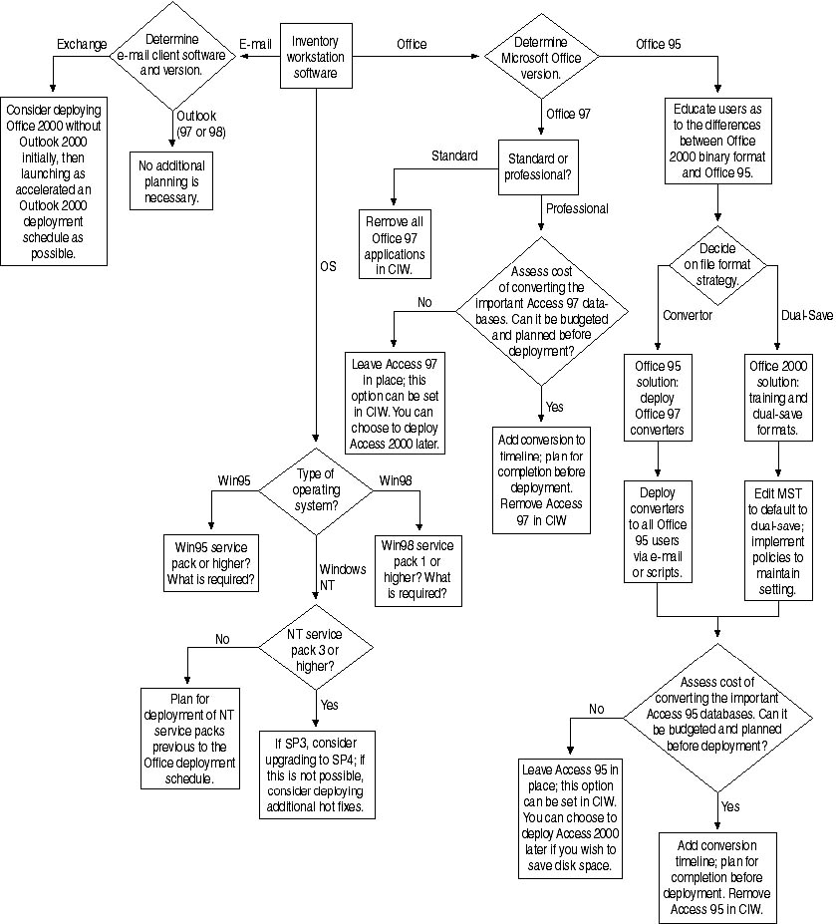
Figure 6.1 Assessing workstation software.
The software inventory should determine:
- Operating system (including service pack level). If you are using Windows NT, Service Pack 4 is considered a basic requirement for Office features such as the Office Server Extensions. You can also use Windows NT infrastructure for security and configuration.
- E-mail client type. You should migrate Exchange clients early, and you often have to perform a few more steps to take care of Personal Address Books and Schedule+ data.
- Current installed version of Office. This can drive coexistence requirements, which can in turn drive viewer and converter deployment, selection of default file save settings, and so on.

Figure 6.2 shows how recommended deployment decisions are influenced by hardware:
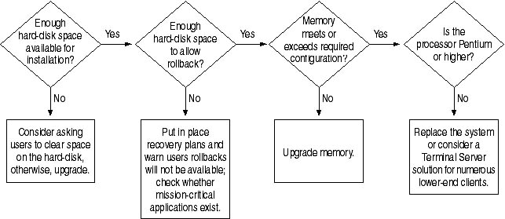
Figure 6.2 Assessing whether workstation hardware can sustain the upgrade.
The hardware inventory should determine:
- Amount of memory. This can determine which components you will install, your rollback options, and so on.
- Remaining hard disk space on the system disk. This can affect several options, including rollback, timing for removal of previous software versions, deployment of Installed on First Use option, and so on.
- Processor type. This can determine performance in several ways, especially in client-server applications.

How effectively you deal with these factors depends heavily on how accurately you inventory and understand the target system.

Inventory Planning
Inventory, analysis of the results, report creation, and testing in the laboratory form the bulk of the work performed before planning is finalized and scheduled. Typically, this pre-deployment work should take anywhere from 60 percent to 80 percent of the entire deployment schedule. If this work is done properly, then a successful deployment can be completed relatively quickly. The following sections describe the kinds of information you need to gather. Keep in mind that one purpose of the inventory is to determine which previous versions of Office will be upgraded, because upgrade prerequisites vary. In particular, keep a clear distinction between Office 95 and Office 97 installations.

Initial Preparations
During the inventory process, expect the unexpected. For example, in a recent deployment project for a company, Trey Research, MCS reviewed early reports (before visiting the site) and interviewed users to determine which operating systems were in place. Although the interviews showed that only Office 95 and Windows 95 were present, MCS’s inventory revealed a wide range of operating systems and software.
MCS had to amend the testing plan as they discovered what software was actually running. For instance, while the group deploying Office 2000 had few Macintosh machines, a significant percentage of the rest of the company used Macintoshes, Microsoft Office 98 for the Macintosh, and Eudora Pro. Consequently, MCS had to test the compatibility of new Office 2000 configurations with the Macintosh population.
In short, be flexible when you allow for preparation time, be prepared to reorganize as new information arrives, and be ready to refocus testing plans to accommodate the unanticipated.

Accurate Inventory of Hardware and Software
Deployment success greatly depends on your ability to anticipate potential problems. You have to gather accurate data on users’ software and hardware so you can prioritize time-intensive tasks such as upgrading or replacing RAM, hard disks, or CPUs for the new environment.
Unfortunately, inventory information is often unavailable and incomplete. Even when it is available, users’ systems often change too rapidly to get a reliable snapshot. You frequently have to scramble to get an accurate and timely picture.
At Trey Research, MCS used Microsoft Systems Management Server (SMS) to gather inventory data. This simplified much of the process, but did not alleviate all problems. For example, users who leave sessions running for days remain unseen by SMS, which conducts an inventory as part of a logon.
Obtaining accurate information on the wide range of installed software (and the various versions of that software) on users’ systems proved very challenging. Classic SMS software inventory required building a file, AUDIT.RUL, that compared cyclical redundancy checks (CRC) of particular files to a list that mapped the results back to particular software names and version numbers. This meant MCS had to know precisely what was being searched for—taking into account all the possible patches and upgrades to both operating systems and applications software. Given the fact that even Windows NT users had local administrator privileges, there was little hope for truly consistent configurations across the board. By creating a matrix of all possibilities, MCS decided that at least 25 variations could exist and that the actual number was probably higher. In the end, since even a relatively targeted scan of over 50 applications was known to occasionally slow down logons, administrators were reluctant to use it.
Because most companies update and patch software on a regular basis, conducting centralized software inventories is a major challenge. You need to create software inventory requests that are neither too complicated (which can slow down workstation performance) nor too narrow (which can miss slight variations to the original software you are trying to document). MCS encountered this problem at Trey Research, and it was complicated by the existence of low-grade hardware (left over 486 systems) and many different types of software.
So MCS experimented with other ways to capture critical-software information, using methods developed in previous projects and developing some on the spot. The key to this process was prioritization: identifying what was most important then narrowing down the requirements. The sections below explain how they determined which information was important and why. Any methods applicable in general situations are described. Here are their two early attempts:
- First, MCS built a custom package to obtain software inventory via relatively lightweight queries to the users’ registries—a method that also could be counted on to capture more information than the usual IDX file. The package could be sent as part of the logon script if SMS was not available for some reason—a handy capability when systems lack SMS infrastructure.
- Second, they focused on extracting the versions of the logged on e-mail clients from the Exchange server logon window. This is described more fully later in this chapter.

As this chapter was being written, the first SMS software inventory with the package that checks registry entries was underway. MCS expected this package to greatly enhance the overall picture of the environment and to extract the lists of Office 95 users.

Soft Data
In addition to hardware and software information, you need to survey the enterprise for soft data, which includes users’ reports on their experiences (past and present) with software and deployments. This is explained in detail in the section “Collecting Soft Data” on page 180.

Deciding Which Data to Capture
To inventory hardware and software (the components of the in-place system environment) and soft data (usage patterns and other factors that can affect deployment) you first have to figure out which information to capture. This section walks you through the decision processes with which you can shape an inventory plan.

Hardware
Hardware inventory data falls into two categories: workstation and server.

Workstation Hardware
Ask these questions about the workstation hardware targeted for deployment:
- New or existing? In most situations where a major deployment is planned, new workstations are purchased to provide two benefits:
- Systems targeted for replacement don’t need to be inventoried.
- Images for the new systems can be predefined and tested in the laboratory. If deployment schedules allow, you can usually provide the manufacturers with custom images suitable for your environment, eliminating the need to rebuild the workstations upon delivery.


Note If new systems are the primary platform for your deployment, they need to be taken into account as early as possible in the testing cycle. Being able to deploy out of the box saves the support staff significant time and effort. If you plan to buy new systems, purchase the same model in one block from the same manufacturer and take the first system delivered to the computer lab for testing.

- Hardware configuration? The minimum requirements for each system are:
- Size and number of hard disks. In most cases, you are concerned with the first hard disk in a chain because the operating system and applications will be loaded there. If you plan on another arrangement (such as the OS on the first hard drive, and applications on a second), you will need to know the volumes on each hard disk.
- Remaining space on hard disks. You need to know this if you plan on upgrading instead of performing an installation from scratch.
- Memory. Make sure you have enough to meet the minimum recommendation for the operating system and Office 2000. 64 MB is usually adequate, but more is better for Windows NT because it takes unusual advantage of additional memory.
- Processor type. MCS considers a Pentium 150 MHz to be the minimum. The main goal in gathering processor data is to isolate 486 systems and target them for early replacement. You could keep them and run them as Terminal Server clients. Either way, you incur additional preparation for these systems.
- Network Interface Card (NIC) manufacturer and model. This is useful for situations where Windows NT 4.0 is planned for deployment on systems built from scratch. Windows NT 4.0 is not plug and play, so you must plan to add the necessary drivers or provide an unattended installation that will preload NIC drivers. Specific Windows NT strategies to simplify this situation are addressed later in this chapter.
Note Most of the above hardware information was obtained from a standard SMS hardware inventory, which was reworked through an Excel spreadsheet and PivotTable to produce one stock report of the existing environment. “Using Excel 2000 and PivotTables to Categorize Inventory Data” on page 182 in this chapter describes this reworking process.

MCS found that the Excel 2000 PivotTable Wizard helped isolate important information in the rather long and repetitive inventory entries. Extracting the information into a PivotTable made inventory data easier to study and made it possible to obtain roll-up numbers flexibly. For more information, see “Using Excel 2000 and PivotTables to Categorize Inventory Data” on page 182 in this chapter.

Server Hardware
The main goal in this inventory is to identify potential distribution or source servers. In most cases, source servers will require only enough space to store Office 2000 files, and, if users are running the application from the network, enough processor speed and RAM to handle the higher traffic volume.
When deploying Office 2000, you must keep a source server or servers available because Office 2000 offers self-repair and Install on First Use functions via the Windows Installer service. Whenever a client chooses a module that is not preinstalled but is marked for Install on First Use, the first server in the list is accessed. This list of servers is defined in the Transform (.MST) file created by the Custom Installation Wizard. For more information, see Chapter 4, “Customizing an Office 2000 Installation.”
If you are planning a Terminal Server and Office 2000 system, follow the guidelines established in the Microsoft Office 2000 Resource Kit and in Chapter 12 of this book, “Deploying Office 2000 on Windows Terminal Server,” for minimum hardware configurations (particularly with respect to RAM). Use a dedicated server to support Terminal Server clients; it severely degrades performance to run other server applications, such as logon validation stand-alone server applications like SQL Server.
Obtain this information on the servers:
- New or existing. As with workstations, you have to plan around deployment of new servers if hardware is being delivered in the same timeframe. If at all possible, bring the new servers up before the workstation deployment launches instead of trying to coordinate server installation simultaneously. This primarily affects schedules, so it is more of a planning issue than a technical one.
- Size of hard disks, partition/volume sizes, and remaining space on partitions/volumes. Importance depends on whether you deploy Office 2000 from custom CDs or over the network.
- If you use the server strictly as a source server for self-repair and the occasional Installed on First Use, you should need less than 1 GB on one volume of an array with average access times under 10 ms. MCS sometimes sets up one server as a source and, when deployment starts, a second as a backup.
- If you plan to use the server as the primary source for brand-new installations of Office 2000 through the network, you have to consider hard disk speed and performance. RAID setups provide for speed and fault tolerance, but you also have to examine the health of the network backbone, and whether hubs and media can handle downloading 100 MB or more (depending on installation choices) to each workstation.
- Memory. More RAM boosts Windows NT-based servers response to user requests. You may have to upgrade memory on the deployment and/or source servers. Based on projected server usage, Trey Research required each server to have at least 128 MB of RAM.
- Processor type. Alpha versus I386 distinctions are important when you set up new servers and apply service packs.
- Number of processors. Evaluate servers’ power and robustness. The most powerful server should function as the Office 2000 network application server, the next in line should be used as the first source server, and the least powerful as backup source server.

When reviewing server hardware results, remember that Office 2000 allows you to define multiple source servers. The original customized transformation (.MST) file defines which server is queried first, which second, and so on. Out of the box, Office 2000 does not distribute user requests across source servers (although it does offer what amounts to a fail-over solution). The first server on the list is hit hardest. You can deal with this by placing the strongest server first in line and upgrading it as necessary to handle increased loads. You can add on other load balancing solutions such as DNS round robin.
At Trey Research, MCS ran the first network deployment (to 24 alpha users) on a single-processor Pentium II box with 128 MB RAM. No performance issues were reported during the maintenance phase, when occasional downloads of uninstalled modules were occurring. The same server was already the primary central storage for software, which was one reason for choosing it.
Software inventory data also falls into workstation and server categories.

Workstation Software
Workstation software data is important, but don’t waste energy gathering data of questionable importance. For instance, if you plan on a complete re-installation, all existing software will be overwritten and software information won’t be worth capturing. Rule of thumb: when you upgrade existing systems you need to gather information on workstation software.
If you are upgrading from Office 95 to Office 2000, a software inventory should:
- Identify the operating system, especially service pack levels. Office 2000 requires certain service pack levels.
- Isolate all non-Outlook mail clients (typically these are Exchange clients). Because of incompatibilities between Outlook and Exchange schedulers and forms designers, you need to upgrade non-Outlook clients as early as possible in the deployment. For more information, see Chapter 8, “Deploying Outlook 2000.”

Office 2000 upgrades over existing software relatively cleanly if the latest operating system service packs have been applied and users’ configurations are not cluttered with multiple loads and flawed uninstalls of older software. At Trey Research, MCS laboratory tested upgrading clean installations of Office 95 and Office 97 and found few or no significant problems or halts during installation. In the field, however, you can save time and avoid problems by researching these items before upgrading:
- Operating system type. Determine which service releases or service packs must be present for a smooth Office 2000 installation. Rule of thumb: apply the latest service packs and recommended security patches before installation. You can do this with silent, non-interactive scripts (if users have administrative rights to their workstations) so installers don’t have to go to workstations. Minimum SP requirements:
- Windows 95: Service Pack 1.
- Windows 98: no additional service packs or patches required.
- Windows NT: SP 3 or 4. For security reasons, you should have SP 4.
- Office versions. Isolating Office 95 users is the main issue. Office 97 (Service Release 1 or 2) is more compatible with Office 2000 because it handles the same binaries. Access is not completely compatible, but there usually are fewer Access users and you can identify them easily.
- Office and/or e-mail software installation source: network or local. If you plan a local Office 2000 installation, MCS recommends uninstalling Office 95 and Office 97 before the install. This applies to classic network application configurations, not to Terminal Server, which you can upgrade centrally.
- Type of e-mail client. This can be important information. Trey Research was running Scheduler on an Exchange client, which is not fully compatible with the more advanced Outlook Calendars.

At Trey Research, the functions lost between Outlook and Exchange schedulers were not terribly significant to the department being upgraded; they had to do with delegate access to manage someone else’s calendar (the administrative assistant and manager scenario) or with the ability to exchange e-mail forms. But in other departments this might have been significant. Trey Research also had a lot of Macintosh Outlook 98 clients, creating more compatibility concerns.
At Trey Research, MCS issued an SMS query and found that only one of the two locations had a significant number of Office 95 clients (about 80). It was unrealistic to expect all of these users to move to Windows NT 4.0, so MCS had to test the upgrade.
MCS found few network application-based systems, so they handled them case-by-case. If there had been more, MCS would have had to sense the network installation and handle automatic uninstalls. This can be done by adding the /u flag to the setup.exe command (setup.exe /u).

Server Software
You need to identify only the network operating system software and any client/server applications or e-mail functions.
- Network Operating System (NOS) software. This determines to client network protocol if you are going to use a customized bit-copy image installation for some or all workstations. It is not essential, but you should install Service Pack 4 for Windows NT Server, and at least Service Pack 3 for Windows NT.
- Terminal Server, version and service pack number
- Operating system: Novell, Windows NT, version and service pack numbers

At Trey Research, the servers were running Windows NT 4.0 with the latest service packs and the IT group planned to implement a Windows 2000 and/or Windows NT 4.0 Terminal Server configuration with Office 2000 for the UNIX and Macintosh clients in their areas.
- Server software. Software on the target servers that could affect performance (Exchange, SQL Server, anti-virus software distributed from the server, and so on). In Novell environments, you might find ManageWise, GroupWise, or ZenWorks.
- Network traffic analyses/profiles for key sites. Get an idea of the typical server-server and server-client communications speeds. Look at:
- Server backbone. Determine the hub, distribution, and NIC types.
- WAN link types and costs. Scattered sites and distributed traffic create special requirements for Office 2000 source servers and deployment methods.
- Typical load. Investigate loads during hours or hours during which upgrades will most likely be scheduled. If you have tools to analyze network traffic throughout the day, look for the best times for an Office 2000 network installation. Use Network Monitor (in SMS 1.2) to get snapshots of servers’ network traffic.

Soft Data
Soft data is unquantifiable but it can profoundly affect deployment planning and execution. Don’t underestimate its importance—there are cases where users resistant to change or totally unfamiliar with the new interface have stopped deployments by revolting against sudden and unwanted changes in the way they do business.
Soft data often helps you determine how much training you should plan for. It can also indicate if you should introduce users to new software in nonthreatening, informal situations such as brown bag lunches. Provide some food and some computers and let users test drive hands-on the new software in a relaxed environment.

Collecting Inventory Data with
Systems Management Server
Rule of thumb: inventory results are never perfect or even complete. At best, they are a snapshot of the existing environment at some recent time. Things large and small are missed—some users may be on vacation so that their systems are not found during the hardware and software scans.
Rather than trying to capture all information, concentrate on information on the majority of systems so that you can accurately estimate how many Office 95, Exchange, and Office 97 systems installers and scripts can expect.
Systems Management Server 2.0 extracts much more granular inventory data than SMS 1.2. If you plan to deploy to a site that can access SMS on the network, you will find it worthwhile to upgrade to SMS 2.0 before inventorying equipment.

SMS 1.2: The Audit.rul Method
Classic SMS 1.2 software surveys make use of an audit.rul file. If you plan to use this method, get the latest audit.rul file from ftp://ftp.microsoft.com/bussys
/winnt/sms-public/. Rather than trying to inventory all 5,300 products listed in this master file, narrow it down to products likely to be on your systems so that users don’t encounter long, irksome logons.
In its original form, audit.rul looks for executables or .DLLs needed to run the program, checks the sizes of the files it finds against a list of executables and .DLLs, and, if there is a match, adds the file to the workstation’s software inventory.

Below are some audit.rul extracts for Trey Research. Note that it is limited to look only for Office versions and Exchange clients, so that it can complete faster.
package 7496 “MICROSOFT OFFICE, MICROSOFT CORPORATION”
file “MSOFFICE.EXE” size 183168

package 7499 “MICROSOFT OFFICE FOR WINDOWS 95, MICROSOFT CORPORATION”
file “MSOFFICE.EXE” size 356056

package 7501 “MICROSOFT OFFICE Version?b, MICROSOFT CORPORATION”
file “MSOFFICE.EXE” size 193600

package 14370 “MICROSOFT OFFICE 97 PROFESSIONAL EDITION FOR WINDOWS 95, MICROSOFT CORPORATION”
file “MSOFFICE.EXE” size 333824

package 14394 “MICROSOFT EXCHANGE 4.00.993.4, MICROSOFT CORPORATION”
file “EXCHNG32.EXE” size 83776

package 14395 “MICROSOFT EXCHANGE 5.0.1457.3, MICROSOFT CORPORATION”
file “EXCHNG32.EXE” size 175376

package 14389 “MICROSOFT SCHEDULE+ 7.0 FOR WINDOWS 95, MICROSOFT CORPORATION”
file “SCHDPL32.EXE” size 93040

package 14390 “MICROSOFT SCHEDULE+ 7.5 FOR WINDOWS 95, MICROSOFT CORPORATION”
file “SCHDPL32.EXE” size 184080

Using CRC Checks
If there are a lot of packages and you want a good snapshot, you can survey the system faster and affect users less by checking the CRC instead of the size of the file. This method (detailed in “Package and Audit Rule File Formats” on TechNet) involves more work because you have to extract the proper CRC numbers from the original executables (detailed in “Inconsistent CRC or Checksum Values on Large Applications” on TechNet). This is an effective method if the configurations are relatively stable and you know the target applications.

Using Registry Scans: App-Reg
At Trey Research, MCS experimented with a freeware utility called app-reg, which essentially scans the registry for program listings, then produces the list of programs found under the Control Panel, Add/Remove Programs applet. You can also use it with the /E flag to convert the list to a suitable .MIF format so that the information is deposited automatically into the SMS database and examined with normal SMS queries.
MCS used app-reg at Trey Research because:
- It queried the registry at high speed
- It could be dropped into logon scripts (speeding information delivery)
- It could gather information on applications that administrators might not be aware of and thus could not include in the audit.rul file
- All the applications MCS wanted to capture appear in the Add/Remove Programs section

Automatic insertion of the information into SMS makes it possible to use SMS as the central inventory tool for future maintenance. Data doesn’t have to be concatenated, it is already available in the SMS SQL Server database.
App-reg works only for Windows 9x and Windows NT systems. Numerous other freeware utilities are available for inventory.

Pulling Data Together with SMS
MCS used Systems Management Server 1.2 to inventory hardware and software, and used queries to identify substandard computers needing immediate hard disk, memory, or processor upgrades (486 processors were marked for replacement). Here is an example of this type of query:
(
MICROSOFT|DISK|1.0:Free Storage (MByte) is less than or equal to ‘400’
AND
MICROSOFT|DISK|1.0:Disk Index is ‘C’
)
OR
MICROSOFT|X86_PC_MEMORY|1.0:Total Physical Memory (KByte) is less than or equal to ‘32000’
OR
MICROSOFT|PROCESSOR|1.0:Processor Name is like ‘486’

MCS also examined raw SMS data dumps to get an overall view of data quality, although they had to use additional steps to format key fields in the previous section.
First, MCS ran a standard SMS inventory that included these important fields: Site (the Site Server), SMSID, LogOn Name, Name, UserID, Room, Last Hardware Scan, System Type, Processor Name, Total Physical Memory, Operating System, Version, Service Pack, Free Disk, and Total Disk. They exported the results into a CSV file that could be imported into Excel.
Trey Research’s inventory showed two sites (as expected): one for the main offices and one for a second division. Some information was missing because the SMS gathers statistics on the first drive found, which is A, the floppy. So free disk and total disk were often blank (meaning users did not have a floppy in Drive A) or contained data that was old or based on the floppy drive.
MCS used another routine to derive free disk and total disk statistics for the hard disk. TechNet article Q134717, SMS: Query Results Display Only First Data Record, details a way to extract information directly from the SMS database on the SQL Server (by using an ODBC connection through Access). You can use Office 2000 to pull this information into Excel 2000 or Access 2000. TechNet article Q153534, Retrieving SMSVIEW Data Using Microsoft Access, explains.

Other Methods of Gathering Data
If you can’t use SMS or a similar distribution mechanism, here are some other ways to gather data.

Manual Checks
If you are dealing with a small site, automating inventory may take more effort than simply visiting each computer. If you do this, create an inventory form with check boxes and options to take along and simplify information gathering.

User Interviews
You can interview users through e-mail or ask them to complete forms on an intranet site. This is not the best way to gather information. Many users don’t know what hardware or software they have and therefore provide incorrect responses—especially when it comes to memory or hard disk space.

Remote Scans of the Registry and Disks
The Windows NT and Windows 9x resource kits contain utilities for remotely monitoring registry entries—a useful capability if users routinely leave their machines on. You can store the data in individual files (one per machine) on a single server share and then use a text utility to combine it. Or you can redirect the results to a concatenating file on a network share. This method saves a step and, by limiting the number of servers you have to consult, makes it much easier to gather inventory results and monitor progress.

Logon Scripts
You can insert commands into logon scripts to capture information about the size of hard disks, registry entries, and the existence of certain executables. Redirect results to a central server and share if possible, so that you reduce the number of servers you have to consult. Use this method sparingly because it can delay logon execution for users.

Collecting Soft Data
Generally speaking, you can’t extract soft data from reports. MCS often has to capture it by distributing (in e-mail or on paper) a questionnaire, or by talking to as many users, administrators, and technicians as possible. Take advantage of all contact with users: swap tips and ideas with Alpha clients while you troubleshoot problems, stay open to user comments and feedback. This effort creates good will and a sense of security in the user community, and helps you assess users’ technical sophistication and their attitude toward the new software.

Past History of Upgrades
However you approach information gathering, try to:
- Determine if people see previous upgrades as successful or unsuccessful. You’ll have to take negative feelings into account and work to allay misgivings. Use training and early adoption to overcome these obstacles.
- Identify/assess methods used in previous upgrades. Which distribution vehicles were used (SMS, Tivoli, unattended scripts, logon scripts) and how well did they work? How much user interaction was there (did users have to start the script or was it started for them on logon)? Was upgrading optional?
- What are users accustomed to seeing and doing during an upgrade? Have previous upgrades been noninteractive, or have users been offered several options? If users are experienced with one method (for example, SMS Package Command Manager or standard prompts in a logon script) use it if you can. For example, if users have always seen progress bars during installation, include them.
- Find out what didn’t work. Then figure out how to use Office 2000 upgrade tools to avoid those problems. For instance, if silent installations confused users and made them reboot before the package was complete, you can use an unattended Office 2000 installation but add foreground notices to keep users informed.

Some Trey Research users had strong opinions as to what was appropriate on their desktops and were traditionally allowed to be extremely independent in their choices. MCS realized it would have to proceed carefully when the Windows NT 4.0 and Windows 2000 portions of the rollouts required locking down desktops by implementing policies and restricting users to Domain User status.

Users’ Experience with Microsoft Office
1. Find out if requests for Office 2000 already exist. Do users need to be educated on Office 2000 benefits, or do they just want it on their desktops ASAP?
2. Determine previous issues/complaints with previous software. Users will more readily adopt Office 2000 if it will solve or mitigate existing problems.

Trey Research users complained of incompatibilities (systems and software) and of difficulties importing and exporting data. Problems recurred when users tried to color-print EPS files embedded in Office 97 PowerPoint documents. This is not something you would predict, but it was a source of serious contention at Trey Research.

Current Methods of Communicating with Users
- How are users currently alerted of IT changes? Use the most familiar method—e-mail, voice mail, bulletin boards, and so on.
- Are current methods effective? Do they provide users with timely upgrade information—what it involves, what to expect, and when it will occur. If users received alerts but were still surprised, find a better way to notify them.

At Trey Research, MCS IT technicians had good relationships with users and tended to distribute information one-on-one. They created intranet pages (including a FAQ), and used e-mail as a primary information delivery tool because they knew that users checked their e-mail daily. About six weeks before deployment was scheduled to start they held an open house where users got hands-on experience with machines running Office 2000 and could watch demonstrations.

Using Excel 2000 and PivotTables
to Categorize Inventory Data
MCS used Excel 2000 PivotTables to analyze raw data and parse it into a usable format. SMS has query tools and report-generating capabilities (including customizable Crystal Reports) but MCS found good reasons to work in Excel:
- With Excel 2000 you can review all data in one place at one time, making it easier to find anomalies and assess validity.
- You can use Excel 2000 to extract information from the overwhelming amounts of data that some sites produce. Quick replies to Where Are, Who Has, and How Many questions are now enhanced. Excel 2000 PivotTable drill-down capabilities make it allow you to get a second tier of information by double-clicking and choosing which field would show up as subdata. Excel 2000’s new wizard and its extended drag-and-drop features are easier to use than Excel 97.
- Excel tools make report creation easier than SMS Administration tools. At Trey Research, three technicians handled most of the administrative duties at both main locations. They could drop information into an Excel workbook, then examine it on their own desktops, and could use PivotTables too manipulate their view of the information.

You can apply advanced filters to eliminate data more than a month old. A range of criteria was named Criteria to make it the default for all filter criteria. Figure 6.3 shows the criteria that limit the advanced filter to data gathered in the previous month, run on a 2/19/1999 inventory list:
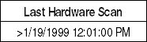
Figure 6.3 An example of criteria that determines the data gathered.
This reduced entries by about half (480 to 250). SMS can also eliminate earlier hardware scans before performing the export.
To improve readability, filtered data was copied into a fresh worksheet and then run through a PivotTable. Table 6.1 shows how you can filter a raw data sample to produce a quick view of critical information.

Table 6.1 Filtered Data That Was Run through a PivotTable.
LogOn Name | Building | Room | Last Hardware Scan | System Type | Processor Name | Operating System | Version | Service Pack
USER1 | BLDG1 | B207 | 1/19/99 12:04 | X86-based PC | INTEL PENTIUM-120 | MS DOS | 7.1
USER2 | BLDG1 | D115 | 1/19/99 15:00 | X86-based PC | 486DX-33 | MS DOS | 7.1
USER3 | BLDG1 | A112 | 1/20/99 16:22 | X86-based PC | INTEL PENTIUM-100 | MS DOS | 7.1
USER4 | BLDG1 | B104 | 1/21/99 10:45 | X86-based PC | INTEL PENTIUM-100 | MS DOS | 7.1
USER5 |  |  | 1/21/99 13:24 | X86-based PC | INTEL PENTIUM-166 | MS DOS | 7.1
USER6 | BLDG1 | B124 | 1/21/99 16:17 | X86-based PC | INTEL PENTIUM-166 | MS DOS | 7
USER7 |  |  | 1/22/99 8:20 | X86-based PC | INTEL PENTIUM II-398 | Microsoft Windows NT | 4 | Service Pack 4
USER8 | BLDG1 | B211 | 1/22/99 9:16 | X86-based PC | INTEL PENTIUM-200 | MS DOS | 7.1
USER9 | BLDG1 | D205 | 1/22/99 15:43 | X86-based PC | 486DX-75 | MS DOS | 7
USER10 | BLDG1 | C206 | 1/23/99 7:57 | X86-based PC | INTEL PENTIUM-90 | MS DOS | 7
USER11 | BLDG1 | B102 | 1/26/99 12:33 | X86-based PC | 486DX-66 | MS DOS | 7
USER12 |  |  | 1/26/99 12:39 | X86-based PC | INTEL PENTIUM-90 | MS DOS | 7.1
USER13 | BLDG1 | C217 | 1/27/99 8:20 | X86-based PC | INTEL PENTIUM-166 | MS DOS | 7

(continued)
LogOn Name | Building | Room | Last Hardware Scan | System Type | Processor Name | Operating System | Version | Service Pack
USER14 | BLDG1 | B222M | 1/27/99 9:13 | X86-based PC | INTEL PENTIUM-166 | Microsoft Windows NT | 4 | Service Pack 3
USER15 | BLDG1 |  | 1/27/99 17:51 | X86-based PC | INTEL PENTIUM II-451 | Microsoft Windows NT | 4 | Service Pack 4
USER16 |  |  | 1/28/99 8:55 | X86-based PC | INTEL PENTIUM II-266 | MS DOS | 7.1
USER17 | BLDG2 |  | 1/29/99 10:07 | X86-based PC | INTEL PENTIUM PRO-200 | Microsoft Windows NT | 4 | Service Pack 4, RC 1.43
USER18 | BLDG2 | D2 | 1/29/99 12:09 | X86-based PC | INTEL PENTIUM-90 | MS DOS | 7.1
USER19 | BLDG2 | D208 | 1/29/99 14:56 | X86-based PC | INTEL PENTIUM PRO-200 | Microsoft Windows NT | 4 | Service Pack 1
USER20 | BLDG2 | C235M | 1/29/99 15:23 | X86-based PC | 486DX-66 | MS DOS | 7
USER21 | BLDG2 | C222M | 1/30/99 12:13 | X86-based PC | 486DX-66 | MS DOS | 7
USER22 | BLDG2 | C103 | 1/31/99 10:17 | X86-based PC | INTEL PENTIUM-166 | Microsoft Windows NT | 4 | Service Pack 3
USER23 | BLDG2 |  | 1/31/99 17:31 | X86-based PC | 486DX-66 | MS DOS | 7
USER24 | BLDG2 | A120M | 2/1/99 7:09 | X86-based PC | INTEL PENTIUM II-233 | MS DOS | 7.1
USER25 | BLDG2 | C230M | 2/1/99 7:38 | X86-based PC | 486DX-66 | MS DOS | 7
USER26 | BLDG2 | B111 | 2/1/99 7:42 | X86-based PC | Internal | MS DOS | 7
USER27 | BLDG2 | C221M | 2/1/99 7:48 | X86-based PC | INTEL PENTIUM II-300 | MS DOS | 7.1

LogOn Name | Building | Room | Last Hardware Scan | System Type | Processor Name | Operating System | Version | Service Pack
USER28 | BLDG2 | D219M | 2/1/99 7:51 | X86-based PC | 486DX-66 | MS DOS | 7
USER29 | BLDG2 | A101 | 2/1/99 8:14 | X86-based PC | INTEL PENTIUM-166 | MS DOS | 7.1

Here is how to build a PivotTable on top of this data.
1. Select all the data (use ctrl+a on the keyboard, or click on the upper left corner of the worksheet).
2. Click on Data, then click PivotTable and PivotChart Report.
3. Make sure the Microsoft Excel list or database and PivotTable option buttons are selected (Figure 6.4).
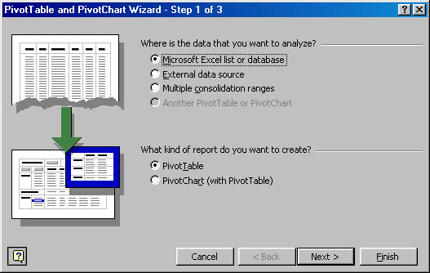
Figure 6.4 PivotTable and PivotChart Wizard.
4. Click Next and leave the current default entry since the selection has already been made (Figure 6.5):
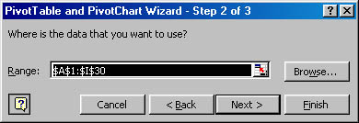
Figure 6.5 Selecting data.
5. In the next Wizard screen, leave the setting for the default PivotTable location (in a new worksheet) as is, and click the Layout button.
6. In the Layout dialog box, drag Processor Name from the right listing of buttons to the area of the dummy PivotTable labeled ROW, and then drag Count of Processor Name from the right again, this time to the area labeled DATA. Leave COLUMN blank. The layout should resemble Figure 6.6.
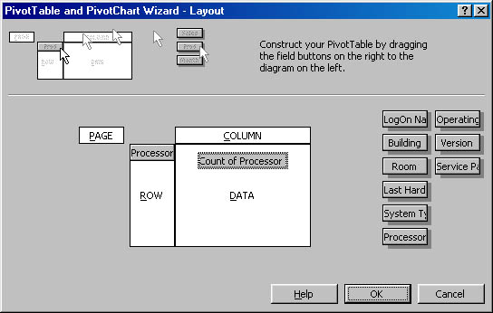
Figure 6.6 The PivotTable layout.
7. Click OK, and then click Finish to generate the PivotTable.

The PivotTable is dynamic, not static, as are most database reports. The first PivotTable created after completing the above steps would resemble that in Figure 6.7.
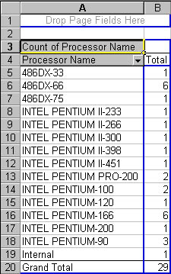
Figure 6.7 Sample PivotTable.
PivotTables help you research a particular detail, something behind the listed count. For example, if you did not expect to see the six 486DX-66 machines listed in Figure 6.7 and you want to see who logs onto those machines, you can double-click on that row to list fields you can drill down into. Clicking LogOn Name to produces this change:
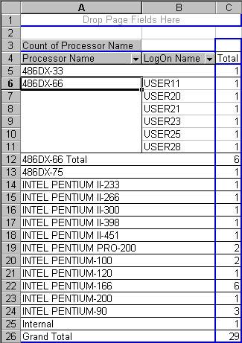
Figure 6.8 Drilling down with a PivotTable.
To the right of the PivotTable itself is a floating toolbox for the PivotTable controls. Click inside the PivotTable to expand the toolbox (Figure 6.9).
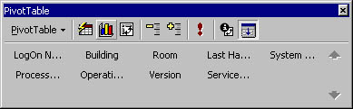
Figure 6.9 The PivotTable toolbox.
Drag the Building button to the top cell on the PivotTable where the gray text Drop Page Fields Here appears. Page fields allow dynamic changes to filter the entire table—for instance, to see where the 486DX-66 users are located. Note that the resulting Building field becomes a drop-down box, where All, Bldg1, or Bldg2 are available. You can choose Bldg2 to collapse the table to show only machines in Bldg2, which shows five users (Figure 6.10).
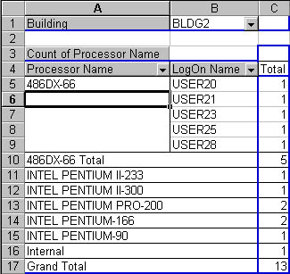
Figure 6.10 A new drop-down box.
You can also drag and drop fields such as Machine’s Name to put them next to the LogOn Name. Excel 2000 PivotTables manipulate data more flexibly than standard database reports. Trey Research used these capabilities to distribute results to administrators without sacrificing the flexibility of roll-up reports.

After-Inventory Tasks
Once you have substantial data you have to make decisions. To solidify plans you have to define this information:
- Hardware that needs complete replacement
- Hardware that requires upgrades
- Whether rollback is an option
- Which applications are mission-critical

List Hardware That Needs Complete Replacement
To some degree, hardware requirements depend on budget and on what level of performance users require. Office 2000 publishes recommended configurations, but MCS often sees lower standards applied onsite.
After lab testing, Trey Research decided they would permit users with 120 MHz or higher Pentiums and at least 64 MB RAM to upgrade to Office 2000 (installed locally).

These criteria indicated that about 25 percent of Trey Research’s computers had low-end processors (386 and 486 chips) and had to be replaced. Roughly 10 percent of these were already slated for replacement within the month, but this information helped the team decide to build a Terminal Server (for which hardware and software had already been purchased) to serve slower clients until replacement funds became available.

List Hardware That Requires Upgrades
Hardware that requires upgrades falls into two basic categories: memory and hard disks. Although 32 MB of RAM is technically sufficient, reasonable performance requires at least 64 MB. Early surveys indicated that no systems had less than 32 MB RAM but some had less than 64 MB. RAM upgrades require sending a technician to the machine, so Trey Research decided to install Office 2000 to these systems via CD-ROM so that the technician could upgrade the hardware and then install Office 2000, saving time and reducing network traffic.
Calculating necessary local client disk space is harder: it depends on decisions made in the Custom Installation Wizard and varies widely. To determine real hard-disk space requirements, run the standard installation with the custom transformation files and add up the size of the installation. Don’t forget to include all Install on Demand options to obtain the worst-case scenario for what the client could have on the local drive. If the base RAM is 64 MB and Windows NT workstations are the target, add 100 MB for paging files and storage. For systems with more RAM, add 1.5 of the RAM capacity. These operations yield a final requirement: systems without this much space will need hard disk upgrades to avoid undue fragmentation of files.
You can sometimes avoid upgrading disk space by asking users to delete older files, or offering them good removable disk alternatives or larger network shares. In most cases, though, you’ll have to upgrade.
To determine memory requirements in your environment, assess current performance metrics, then do some testing. MCS knew that some Trey Research users were happily running Windows NT 4.0 with Office 97 on 32-MB systems. Lab tests and a short alpha stage proved that Office 2000 was never slower than Office 97 and was occasionally much faster. On the basis of these tests, Trey Research kept the RAM upgrades scheduled but allowed users with 32 MB to upgrade to Office 2000 and add RAM later.

Determine If the Rollback Feature Is an Option
Office 2000 has a rollback feature that automatically restores computers to their original configuration if the installation fails. This requires enough hard-disk space to store the old configuration files and settings, which can be a challenge at sites with hard disks of 2 GB or less. If you select the rollback feature, installation will not start unless the hard disk has enough room to store the old configuration and complete the Office 2000 installation (you define this amount).
This leaves you with two alternatives: either use the rollback feature only for computers with adequate storage space, or disable it completely. If you decide not to use rollback, tell users well in advance to back up their data thoroughly, and make sure they understand that there will be no auto-recovery to a previous state should the upgrade fail. If you must be able to return to a previous configuration rapidly, make a bit copy of the hard disk before beginning the installation.

Identify Mission-Critical Applications
It is not always obvious which applications are mission critical, though it is significant when you are deciding whether to use rollback. To decide if an application is mission-critical, ask the following questions.
How much downtime for a failed installation is acceptable? Estimate the maximum allowable recovery time upon report of a problem with the installation. Users will have various tolerances for downtime on which you will need to base your approach. Here are some examples.
Example: In a 24-hour working environment, operations cannot tolerate any downtime. In this case, one solution would be to buy a small block of new machines and preconfigure them with Office 2000. Then, you would provide a new parallel system for a specific period. Once users were working purely on the new systems, claim the older machines for the upgrade and repeat the cycle.
Example: Users can tolerate only the 30 to 60 minutes of downtime estimated for installation. In this case, you must provide for rollback. This process may include upgrading hard-disk space on each machine to make sure enough is available.
Example: Users can afford to lose access to their Office applications for as long as half a day. In this case, you should set expectations by explaining that a failed installation may extend downtime beyond a half day. The additional time may be necessary because your recovery plans will center on a completely new build from scratch—as compared to trying to back out of a failed installation that is proving difficult to recover.
Example: Users can afford to lose access to their Office applications for an extended period of time if troubleshooting is necessary. For example, they are away at training for a week. Administrators should turn off the rollback option completely to save time and space.
How do users assess priority? Ask users which is more important to them—faster upgrades or better insurance against downtime. If users are willing to accept the risk of an unprotected upgrade to be able to run the new software sooner, you have an answer. Always remember that users’ answers will reflect their own points of view, and this is not necessarily the same as an application’s actual value to the organization.

