


LINQ to XSD
– Overview –
An incubation project
on typed XML programming

November 2006
Microsoft Corp.

Notice
© 2006 Microsoft Corporation. All rights reserved.
Microsoft, Windows, Visual Basic, Visual C#, and Visual C++ are either registered trademarks or trademarks of Microsoft Corporation in the U.S.A. and/or other countries/regions.
Other product and company names mentioned herein may be the trademarks of their respective owners.
The example companies, organizations, products, domain names, e-mail addresses, logos, people, places, and events depicted herein are fictitious. No association with any real company, organization, product, domain name, email address, logo, person, places, or events is intended or should be inferred.
LINQ to XSD is an incubation project on typed XML programming carried out at Microsoft. LINQ to XSD is not scheduled to ship as a product. It is important to note that this release is being exposed to customers so as to gather their feedback on the typed XML programming experience. Any future products in this space may or may not be similar to LINQ to XSD. See the license terms for details.
Important: You must accept the enclosed license terms before you can use this pre-release software. If you do not accept the License Terms, you are not authorized to use this pre-release software. The License Terms are included in the distribution of this software.

LINQ to XSD
– Overview –
Table of contents

1. Introduction 6
2. Quick start 8
2.1 Sample XML data 8
2.2 Sample untyped XML program 9
2.3 Sample XML schema 10
2.4 Sample typed XML program 11
2.5 Sample XML object types 12
2.6 Sample code to run 13
2.7 IDE integration 14
3. Design principles 20
3.1 Canonical type mapping 20
3.2 LINQ to XSD = LINQ for XML objects 21
3.3 XPath-like child axis 23
3.4 Typed data manipulation 26
3.5 Typed object construction 28
3.6 The validation contract 30
3.7 Discoverable object models 31

Introduction
What is LINQ to XSD?
The LINQ to XSD technology provides .NET developers with support for typed XML programming. LINQ to XSD contributes to the LINQ project (.NET Language Integrated Query); in particular, LINQ to XSD enhances the existing LINQ to XML technology. To get an idea, consider the following C#3.0 fragment for a LINQ to XML query that computes the total over the items in a XML tree for a purchase order:

(from item in purchaseOrder.Elements("Item")
select (double)item.Element("Price")
* (int)item.Element("Quantity")
).Sum();

Using LINQ to XSD, .NET developers may instead write `typed’ code as follows:

(from item in purchaseOrder.Item
select item.Price * item.Quantity
).Sum();

LINQ to XSD facilitates XML schemas (XSD), which are automatically mapped to object models so that XML data may be processed in typed manner within the OO paradigm. To this end, the generated classes enforce various validation constraints imposed by the input schema. In this respect, LINQ to XSD is similar to existing technologies for so-called X/O mapping or XML data binding. An important aspect of LINQ to XSD though is its foundation on ‘XML objects’ as opposed to ‘plain objects’. That is, the object models, generated from XML schemas, provide XML semantics in terms of XML fidelity and programming idioms, thereby providing a better programming environment for XML-related development tasks. To this end, the generated classes model typed views on untyped XML trees. LINQ to XSD enhances LINQ to XML. Familiar XML programming idioms of LINQ to XML are complemented by typed variations in LINQ to XSD. In particular, typed member access can be used in most cases, and untyped tree access is available as a last resort.

Roadmap
- Section 2 illustrates LINQ to XSD at work.
- Section 3 explains the design principles behind.

Further reading

- There is a manual for LINQ to XSD.
The manual mainly focuses on aspects users need to know about.
The reader only interested in the LINQ to XSD concepts can safely skip the manual.

- There is an extended sample suite for LINQ to XSD.
The suite contains all samples from the present document.

- There is a mapping documentation for LINQ to XSD.
It explains the rules of mapping XML schemas to CLR types.
The typical user of LINQ to XSD can safely skip the mapping documentation.

- Please consult the README file for release information.

- The Project LINQ website including LINQ downloads and resources.

- A series of blog posts on typed XML programming.

- “Revealing the X/O impedance mismatch”
A related research report on typed XML programming.

Quick start
The following sample is part of the LinqToXsdDemo solution; see the sample file Total.cs.

Sample XML data

Let’s look at some XML instance data on which to carry out XML programming.
The sample given below comprises a batch of purchase orders of a very simple form.

<Batch xmlns="http://www.example.com/Orders">
<PurchaseOrder>
<CustId>0815</CustId>
<Item>
<ProdId>1234</ProdId>
<Price>37</Price>
<Quantity>2</Quantity>
</Item>
<Item>
<ProdId>5678</ProdId>
<Price>1.5</Price>
<Quantity>3</Quantity>
</Item>
</PurchaseOrder>
<PurchaseOrder>
<CustId>1324</CustId>
<Item>
<ProdId>7788</ProdId>
<Price>42</Price>
<Quantity>1</Quantity>
</Item>
</PurchaseOrder>
</Batch>

Sample untyped XML program

The following LINQ to XML code totals all items of orders.

static double CalculateTotal(XElement batch)
{
XNamespace ns = "http://www.example.com/Orders";
return
(from purchaseOrder in batch.Elements(ns + "PurchaseOrder")
from item in purchaseOrder.Elements(ns + "Item")
select (double)item.Element(ns + "Price")
* (int)item.Element(ns + "Quantity")
).Sum();
}

Explanation:
- The function locally defines a namespace object, ns, which is reused in the query.
- Element names are encoded by strings as passed to Element and Elements.
- The LINQ query iterates over all orders and all their items; see the syntax from … from ….
- For each item, price and quantity values are extracted subject to some casts.
- The query result (an IEnumerable) is aggregated with the Sum function.

Sample XML schema

The following XML schema (XSD) defines the schema contract for purchase orders.

<xs:schema
xmlns:xs="http://www.w3.org/2001/XMLSchema"
targetNamespace="http://www.example.com/Orders"
xmlns="http://www.example.com/Orders"
elementFormDefault="qualified">

<xs:element name="Batch">
<xs:complexType>
<xs:sequence>
<xs:element ref="PurchaseOrder"
minOccurs="0" maxOccurs="unbounded"/>
</xs:sequence>
</xs:complexType>
</xs:element>

<xs:element name="PurchaseOrder">
<xs:complexType>
<xs:sequence>
<xs:element name="CustId" type="xs:string"/>
<xs:element ref="Item"
minOccurs="0" maxOccurs="unbounded"/>
</xs:sequence>
</xs:complexType>
</xs:element>

<xs:element name="Item">
<xs:complexType>
<xs:sequence>
<xs:element name="ProdId" type="xs:string"/>
<xs:element name="Price" type="xs:double"/>
<xs:element name="Quantity" type="xs:int"/>
</xs:sequence>
</xs:complexType>
</xs:element>

</xs:schema>

Sample typed XML program

LINQ to XSD maps the above schema readily to a CLR namespace.
The child axis can be explored in a typed fashion now.
Hence, the LINQ to XSD code for totaling all items of orders reads as follows:

using www.example.com.Orders;

static double CalculateTotal(Batch batch)
{
return
(from purchaseOrder in batch.PurchaseOrder
from item in purchaseOrder.Item
select item.Price * item.Quantity
).Sum();
}

Some observations:
- The ‘shape’ of the untyped code is preserved.
- In particular, the pattern of using LINQ carries over.
- All string-encoded access in the untyped code is eliminated in the typed code.
- All casts in the untyped code is eliminated in the typed code.
- XML namespaces are replaced by CLR namespaces.

Sample XML object types

The LINQ to XSD programmer codes against classes that are automatically generated from an XML schema.
These classes (say, XML object types) provide typed views on LINQ to XML elements.
The classes comprise members as follows:
- A default constructor.
- Properties for the typed child axis and attributes.
- Infrastructural members: Load, Save and Clone.
- Inherited members for query axes (Descendants and Co.).

There is also an explicit coercion (cast) to construct a typed wrapper from an XElement instance. Such a cast is useful when ‘untyped’ XML trees readily exist in an program scope, and a typed view should be created. Such a cast is not needed when `typed’ XML trees are readily loaded into instances of the generated classes. The API documentation discusses this subject in more detail.

The object model for the running example looks as follows:

class Batch : XTypedElement
{
 | constructor |  | Batch();

 | explicit coercion |  | Batch(XElement);

 | property |  | IList<PurchaseOrder> |  | PurchaseOrder |  | { get; set; }

}

class PurchaseOrder : XTypedElement
{
 | constructor |  | PurchaseOrder();

 | explicit coercion |  | PurchaseOrder(XElement);

 | property |  | string |  | CustId |  | { get; set; }
 | property |  | IList<Item> |  | Item |  | { get; set; }

}

class Item : XTypedElement
{
 | constructor |  | Item();

 | explicit coercion |  | Item(XElement);

 | property |  | string |  | ProdId |  | { get; set; }
 | property |  | double |  | Price |  | { get; set; }
 | property |  | int |  | Quantity |  | { get; set; }

}

Sample code to run

For the reader’s convenience, here is a self-contained sample program with a Main function.

using System;
using System.Query;
using www.example.com.Orders;

public class Program
{
static double CalculateTotal(Batch batch)
{
return
(from purchaseOrder in batch.PurchaseOrder
from item in purchaseOrder.Item
select item.Price * item.Quantity
).Sum();
}

public static void Main()
{
// Load an element with orders
var os = Batch.Load("../../XMLFile1.xml");

// Calculuate and print the total
var total = CalculateTotal(os);
Console.WriteLine(total);
}
}

IDE integration

LINQ to XSD comes with IDE support for Visual Studio 2005.
In particular, there is a build task that automates the mapping of schemas to classes.
The LINQ to XSD class generation also enables IDE tool tips for XSD constraints.

To illustrate all these issues, let us create a VS project for the running example.
(Again, the sample is part of the LinqToXsdDemo solution, but we start here from scratch.)

Step 1: Create a LINQ to XSD project.

In the “New Project” dialog, there is a template for LINQ to XSD.
For the sample at hand, we create a “LINQ to XSD Console Application”.

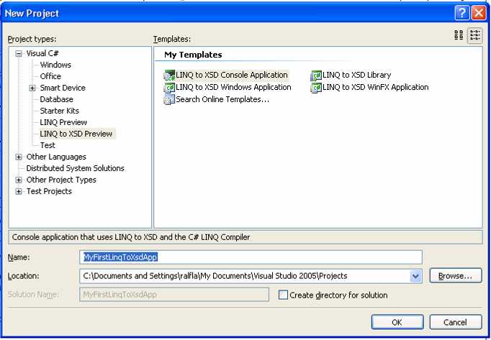

Step 2: Add new item – the XML file from Section 2.1
This step does not involve any LINQ to XSD specifics.
Once the file is created, the XML instance data from Section 2.1 should be copied and pasted to the file.

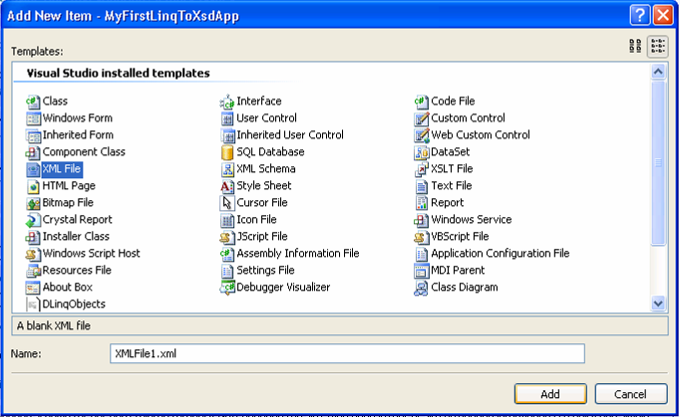

Step 3: Add new item – the XML schema from Section 2.3

Again, this step does not involve any LINQ to XSD specifics.
Once the file is created, the XML schema from Section 2.3 should be copied and pasted to the file.
Note that you need to “open” the file with the XML editor. (Use right-click on the item in the solution explorer.)

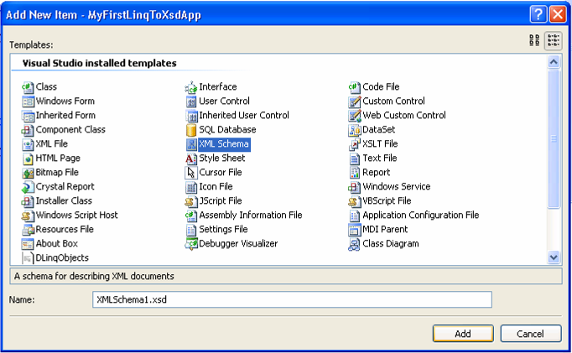

Step 4: Change build action for schema

The derivation of a LINQ to XSD object model must be explicitly requested.
To this end, the relevant schema files are to be tagged (one by one or collectively).
That is, one toggles the ‘build action’ in the ‘property window’ so that it reads as ‘LinqToXsdSchema’.
Thereby, the schema will participate in the project’s build process – as if it was source code.

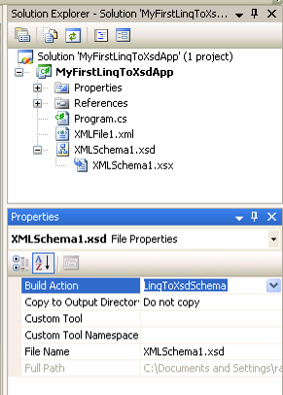

Step 5: Build solution (F6)

The object model is generated as part of the build process.
A built project is the precondition for:
- Up-to-date intellisense for the classes that are generated from XML schemas.
- Up-to-date information in the object-browser window.
That means that intellisense will not pick up schema changes w/o a prior build.
(This behavior is a limitation of the current release of LINQ to XSD.)

Step 6: Browse object model

The object model for the XML schema can be browsed like any other namespace, if this is found convenient.
(It is recommended to say no to “Show Private Members” under the browser settings.)

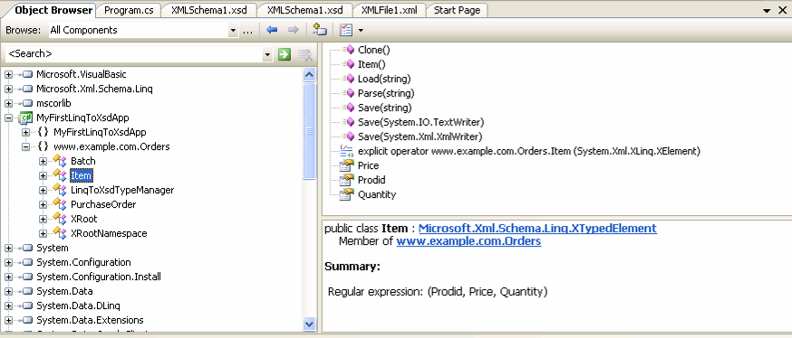

Step 7: Coding with intellisense

The main program can be worked out now.

The following screen shot shows that intellisense kicks in for namespace import.

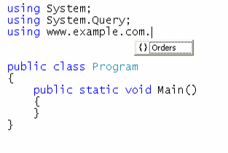

The next screen shot shows that intellisense kicks in for generated classes and their properties.

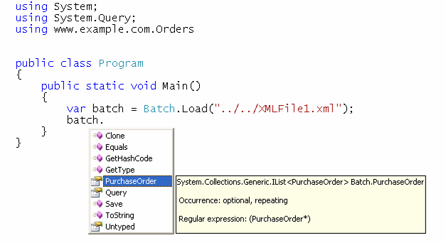

We may just copy and paste Section 2.6 to Program.cs.
Done. Run!

Design principles

Canonical type mapping

LINQ to XSD relies on a systematic mapping of schema to object types that meets the following constraints:
- The mapping covers all of XML Schema.
- The mapping is predictable and comprehensible.
- The mapping facilitates round-tripping of instance data.
- The mapping does not rely on any customization per default.
- The mapping conveys most schema intents into the object models, where possible.
- The mapping aims to derive classes that are close to the expectations of an OO programmer.
Note: The current release of LINQ to XSD only approximates these constraints. The following list of mapping rules summarizes the canonical mapping that is assumed by LINQ to XSD. There is a separate document describing the mapping in detail. There are also separate resources motivating the mapping. These documents are listed in the introduction.

Major mapping rules
- XML namespaces are mapped to CLR namespaces.
- XML names are mapped to CLR names subject to lexical conversions and clash resolution.
- Global element declarations are mapped to (top-level) classes.
- Complex-type definitions are mapped to (top-level) classes.
- Local element/attribute declarations as well as references are mapped to properties.
- Anonymous complex types for local elements are mapped to inner classes, by default.
- Named and anonymous simple types are not mapped to classes, by default.
- Complex-type derivation (by both extension and restriction) is mapped to OO subclassing.
- Substitution grouping is mapped to OO subclassing.
- Simple-type restrictions are mapped to preconditions on properties for elements of these types.
- Global attribute declarations and attribute-group definitions are inlined per reference.
- Redefinitions are carried out before mapping (according to System.Xml.Schema rules).
- Simple-type references are mapped to the use of CLR value types or string.

LINQ to XSD = LINQ for XML objects

Instances of LINQ to XSD types may be referred to as ‘XML objects’. This choice of a term is meant to emphasize that the generated classes do not facilitate ‘plain fields’. Instead, these classes model typed views on untyped XML trees. That is, the classes use properties that reach into untyped XML trees. Technically, instances of LINQ to XSD classes are wrappers around instances of the LINQ to XML class XElement. All LINQ to XSD classes have a common base: XTypedElement.

public class XTypedElement
{
private XElement xElement;
// Remainder of XTypedElement omitted
}

A global element declaration is mapped to a subclass of XTypedElement.

public class PurchaseOrder : XTypedElement
{
// API omitted
}

Objects for typed XML trees can be constructed in these ways:
- By the default constructor (followed by DML operations; to be discussed later).
- By a static method Load; here is one overload for Load:
public static PurchaseOrder Load(string xmlFile);
- By the coercion from an untyped XML tree:
public static explicit operator PurchaseOrder(XElement xe);

The full LINQ to XML API is accessible through a redirection property:

// Part of XTypedElement API
public XElement Untyped { get; set; }

For instance, one could invoke the element-name-based (and untyped) descendant axis on typed XML trees:

batch.Untyped.Descendants("Item"))

If necessary, the result could be cast back into the typed world:

(Item)batch.Untyped.Descendants("Item")).First()

Several untyped XML-programming idioms are complemented by typed variations:

- Most notably, the generated typed properties complement these untyped properties:

// Untyped services covered by generated classes
public XElement Element(XName name);
public IEnumerable<XElement> Elements(XName name);
public XAttribute Attribute(XName name);

- There are type-driven (in addition to element-name-based) descendant and ancestor axes:

// Part of XTypedElement API
public IEnumerable<T> Descendants<T>() where T : XTypedElement;
public IEnumerable<T> Ancestors<T>() where T : XTypedElement;

XPath-like child axis

The XPath notation “./foo” directly maps to OO member access “myObject.foo”.
Hence, the typed properties of LINQ to XSD facilitate an XPath-like child axis.
In particular:
- Recurrence of an element name in a content model maps to a single property.
- The element particles of a sequence and a choice can be both queried in the same way.
- There is 1:1 correspondence between element names in a content model and properties.
- There is no 1:1 correspondence between element particles and properties (in general).

This style is also called instance-oriented mapping.

The following examples demonstrate the design principle of XPath alignment.
Consider the following schema fragment for US addresses with a choice group highlighted:

<xs:complexType name="USAddress">
<xs:sequence>
<xs:choice>
<xs:element name="Street" type="xs:string"/>
<xs:element name="POBox" type="xs:int"/>
</xs:choice>
<xs:element name="City" type="xs:string"/>
<xs:element name="Zip" type="xs:int"/>
<xs:element name="State" type="xs:string"/>
</xs:sequence>
</xs:complexType>

Regardless of such a schema, XML programming may simply tests for the presence of certain elements to organize the problem logic. This will be illustrated with functionality for formatting US address, say for use in a printed letter. Here is an example instance of an US address and the corresponding rendering of the address, as we wish to compute:

<Address>  <POBox>423788</POBox>  <City>London</City>  <Zip>12345</Zip>  <State>CA</State>  </Address> | PO Box 423788  London, CA 12345

The untyped XML processing code for formatting looks as follows:

static string Format(XElement a)
{
string variablePart = null;
if (a.Element("Street") != null)
variablePart = (string)a.Element("Street");
else if (a.Element("POBox") != null)
// Prefix POBox with "PO Box"
variablePart = "PO Box " + (string)a.Element("POBox");
return
variablePart + "\n" // new line for rest
+ (string)a.Element("City") + ", "
+ (string)a.Element("State") + " "
+ (string)a.Element("Zip");
}

The corresponding LINQ to XSD code uses the same instance-oriented style and the same sort of presence tests as the LINQ to XML code. (The discoverability of choices is still supported by means of appropriate tool tips).

static string Format(USAddress a)
{
string variablePart = null;
if (a.Street != null)
variablePart = a.Street;
else if (a.POBox != null)
variablePart = "PO Box " + a.POBox;
return
variablePart + "\n"
+ a.City + ", "
+ a.State + " "
+ a.Zip;
}

Here is another schema type for addresses; this time we exercise ‘recurring element names’.
That is, a street address may have an optional second line.

<xs:complexType name="USStreetAddress">
<xs:sequence>
<xs:element name="Street" type="xs:string"/>
<xs:element name="Street" type="xs:string" minOccurs="0"/>
<xs:element name="City" type="xs:string"/>
<xs:element name="Zip" type="xs:int"/>
<xs:element name="State" type="xs:string"/>
</xs:sequence>
</xs:complexType>

The generated class comprises a single property Street only.

public IList<string> Street { get; set; }

Typed data manipulation

Per redirection to the untyped tree, all DML capabilities of LINQ to XML are available.
In addition, LINQ to XSD classes provide typed DML as follows:
- All typed properties provide setters.
- All list-typed properties use mutable lists (i.e., IList as opposed to IEnumerable).

Example (Setters for non-repeating elements)
Given is an element e which is supposed to carry a child of name Salary.
The content of the Salary node shall be updated such that it is increased by a factor.

The stated DML problem is modeled in LINQ to XML as follows:
var s = e.Element(ns + "Salary");
s.ReplaceContent((double)s * factor);

The stated DML problem is modeled in LINQ to XSD as follows:
e.Salary *= factor;

Example (Setters for repeating elements)

Given is a PurchaseOrder element o.
Another Item i shall be added to o.
The DML problem is modeled in LINQ to XSD as follows:

var o = PurchaseOrder.Load(...);
Item i = new Item { ... };
o.Item.Add(i);

Semantics of setters
The following rules apply to setters whose property type is not a list type.
All setters provide either ‘insert’ or ‘append’ mode. These modes cover the case where the value to be set is not null, and where the relevant element is not yet present in the tree to be modified. The actual choice depends on the underlying content model.
The ‘insert’ semantics models that the new element is inserted into the actual content in a ‘valid’ position with regard to order. Insert semantics is restricted to simpler content models such as content models without recurrent element names and without nested compositors.
The ‘append’ semantics is the general fall-back. The relevant element is simply appended to the end of the current content. Clearly, different orders of invoking a number of append setters may have an impact on validity. To this end, tool tips highlight setters with append semantics and list the regular expression for the content model.

Note: the current release of LINQ to XSD is not yet aggressive in providing the more attractive ‘insert’ semantics for all possible content models and properties. The intention is that the ‘append’ semantics is eventually only left for those content models and properties that are intrinsically ambiguous when using an instance-oriented mapping.

All setters provide two additional modes:
- ‘delete’ – for value == null, and the relevant element is already present.
- ‘update’ – for value != null, and the relevant element is already present.

The dichotomy of ‘insert’ and ‘append’ semantics also applies to properties of a list type.
In this case, these two different semantics are concerned with the IList operations Add and Insert.

Typed object construction

LINQ to XML facilitates functional constructors for the construction of untyped XML trees.
That is, all attributes and child elements are listed as arguments of the XElement constructor.
VB 9.0 also provides XML literals as a more language-embedded approach to construction.
By contrast, LINQ to XSD facilitates default constructors and DML for the construction of XML objects.
To this end, the C# 3.0 / VB 9.0 expression-oriented object-initializer syntax can be used.

Consider the following XML fragment:

<PurchaseOrder xmlns="http://www.example.com/Orders">
<CustId>0815</CustId>
<Item>
<ProdId>1234</ProdId>
<Price>37</Price>
<Quantity>2</Quantity>
</Item>
<Item>
<ProdId>5678</ProdId>
<Price>1.5</Price>
<Quantity>3</Quantity>
</Item>
</PurchaseOrder>

LINQ to XML style of construction

XNamespace ns = "http://www.example.com/Orders";
XElement o = new XElement(ns + "PurchaseOrder",
new XElement(ns + "CustId", "0815"),
new XElement(ns + "Item",
new XElement(ns + "ProdId", "1234"),
new XElement(ns + "Price", "37"),
new XElement(ns + "Quantity", "2")
),
new XElement(ns + "Item",
new XElement(ns + "ProdId", "5678"),
new XElement(ns + "Price", "1.5"),
new XElement(ns + "Quantity", "3")
)
);

LINQ to XSD style of construction

var o = new PurchaseOrder {
CustId = "0815",
Item = new Item[] {
new Item {
ProdId = "1234",
Price = 37,
Quantity = 2 },
new Item {
ProdId = "5678",
Price = 1.5,
Quantity = 3 }}};

Object initialization syntax should only be used on object types with ‘insert semantics’; see Section 3.4.
As a fall-back, statement-oriented (as opposed to expression-oriented) initialization can always be used.

Alternative imperative style

var o = new PurchaseOrder();
o.CustId = "0815";
var i = new Item();
i.ProdId = "1234";
i.Price = 37;
i.Quantity = 2;
o.Item.Add(i);
i = new Item();
i.ProdId = "5678";
i.Price = 1.5;
i.Quantity = 3;
o.Item.Add(i);

The validation contract

The generated classes rule out several programming mistakes statically (when compared to the basic LINQ to XML style of programming) because several XSD constraints are readily captured by leveraging the CLR type system. Most obviously, misspelling of element and attribute names is ruled out. However, it is important to note that (the current release of) LINQ to XSD does not support any sort of ‘full validation’ or ‘valid at all times’ contract. Separate validation of the input and the output of LINQ to XSD functionality should be considered. In the following, the validation contract for the various operations in typed XML programming is explained.

Cast-time validation – Given an XElement instance, e, we can attempt to cast e to a specific subclass of XTypedElement. The validation contract varies depending on the fact whether the subclass corresponds to a global element declaration or a complex-type definition. In the case of a class corresponding to a global element declaration, the tag of e is checked to agree with the element name that is associated with the class. Subtyping (in the sense of substitution groups) is taken into account in this context. In the case of a class corresponding to a complex-type definition, e must be a subtree in a readily typed XML tree such that the subtree position is known (per XSD) to be of the relevant. Again, subtyping is taken into account. For instance, assume that the file XMLFile1.xml contains an invoice. Then, the following statement sequence throws due to infeasible cast to a purchase order:

var element = XElement.Load("XMLFile1.xml");
var order = (PurchaseOrder)untypedOrder;

Load-time validation – Executing load on a specific type, say PurchaseOrder, actually can be seen as a composition of untyped load followed by cast; hence, see cast-time validation. Consider the following sample code. This code throws, if we assume that the file XMLFile1.xml contains an invoice.

var order = PurchaseOrder.Load("XMLFile1.xml");

Getter-time validation – Constraints for required particles are enforced. That is, a getter for a required element throws if the relevant element is not present in the queried tree. However, it is important to notice that this check is tied to the specific getter; the absence of a missing element is not uncovered by any other operation. Data-type constraints are enforced similarly. For instance, the getter for a local element declaration with xs:int as element type throws if the inner text of the relevant element cannot be parsed to the CLR counterpart for xs:int.

Update-time validation – Data-type constraints are enforced.
Insert-time validation – Data-type constraints are enforced.
Delete-time validation – No validation is performed.
Save-time validation – No validation is performed.

Note: the current release of LINQ to XSD does not fully comply with the above contract. Also, extra forms of validation are desirable. In particular, complex-type restrictions may be checked, and minOccurs/maxOccurs constraints may be checked more precisely.

Discoverable object models

Recurrent challenges in dealing with programming against complex schemas are these:
- What are the possible rooting types for complete XML trees in the input?
- When constructing valid instances, again, what are the rooting types to start with?
- For any given content model, is there any additional schema-level documentation available?
- When constructing and querying complex content models, what is its structure anyhow?

LINQ to XSD addresses these challenges by deriving discoverable object models:
- A LINQ to XSD project provides a special helper class, XRoot to be discussed below.
- Similarly, each namespace provides a special helper class, XRootNamespace.
- Tool tips for types comprise schema-level documentation where available.
- Likewise, tool tips for properties leverage element-particle documentation, if available.
- The regular expressions for content models are integrated into tool tips.
- Append semantics is pointed out per tool tip.

Tool tips for classes
The underlying content model is quickly summarized in the tool tip for a class.
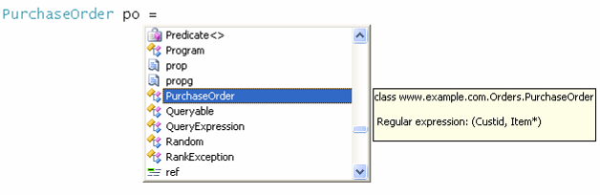

Tool tips for properties
Tool tips for typed properties describe XSD constraints and recall the hosting content model.

The XRoot class
Semantically, the XRoot class is the typed variation on LINQ to XML’s XDocument class. The class is generated from the XML-schema set of a LINQ to XSD project. The class adds some typed services for exploring the schemas in the project. Per mapped CLR namespace, there is also an XRootNamespace class, which provides exactly the same services as XRoot, but limited to the scope of a namespace.

Note: the XRoot class and the overall support for discoverable object models are in a relatively experimental state in the current release of LINQ to XSD. In particular, more guidance on object construction is desirable.

The XRoot class provides constructors and getters (per root element declaration of the original XML schema). These services help in creating and observing global element declarations. We recall that complete XML trees are necessarily of the type of a global element declaration (which is therefore also called root-element declaration). Hence, the XRoot class makes it easier to construct and explore complete XML trees without the need to ‘guess on class names’, without confusing auxiliary classes for complex-type definitions with the more essential classes for root-element declarations.

Here is the interface of the XRoot class for the project of Section 2.

public class XRoot {

// Load/Parse/Save methods; only one overload shown
public static XRoot Load(string xmlFile);
public static XRoot Parse(string xmlFile);
public virtual void Save(string fileName);

// Constructors per root element
public XRoot(Batch root);
public XRoot(PurchaseOrder root);
public XRoot(Item root);

// Getters per root element
public Batch Batch { get; }
public PurchaseOrder PurchaseOrder { get; }
public Item Item { get; }

// Handle on document
public XDocument XDocument { get; }
}

The use of the XRoot services is illustrated below.

‘Blind’ query
You have got a document and you wish to start querying into it. Rather than guessing what the type at hand could be, you go through the member list of the XRoot class so as to get suggestions for possible roots that are admitted by the schema(s) in the project. The getters of the XRoot class serve this purpose. Of course, your choice (batch vs. purchase order vs. item) should better be backed up by an inspection of a concrete XML instance, where available. You can also check on the null value returned by the getter, and thereby dispatch on all possible root-element declarations.

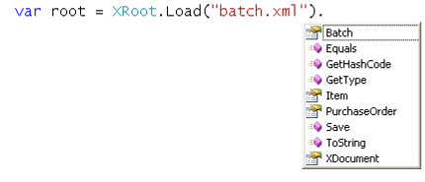

‘Blind’ construction
You want to quickly get started with the construction of an instance for the XML schema(s) in the project. There is an easy way of doing this by going through the constructors of the XRoot class. In the screen shot below, you decide to go for a purchase order.
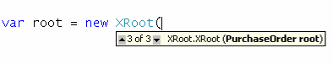
From here on, standard intellisense may take over:

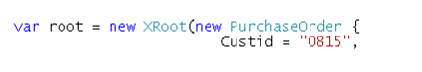

Note: the current release of LINQ to XSD layers on top of the May 2006 LINQ CTP. This implies that intellisense is generally limited for new C# 3.0 constructs. This also applies to the object initializer syntax that is exercised above.

