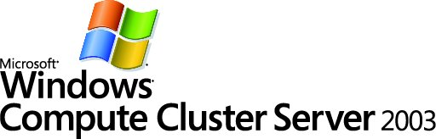

Migrating Parallel Applications
White Paper
Charlie Russel
Microsoft MVP for Windows Server
Author of Microsoft Windows Server 2003 Administrator’s Companion
(Microsoft Press, 2003)

Published: November 2005
For the latest version of this document, please see http://go.microsoft.com/fwlink/?LinkId=55931



Contents

Contributors and Acknowledgements 1
Introduction 2
Two Migration Choices 2
Migrating MPI Code 3
Migrating Applications to Native Windows 4
MPICH2 Migration 5
Migrating to Subsystem for UNIX-based Applications 6
The Subsystem for UNIX-based Applications Architecture 6
Conclusion 7
References 8

Contributors and Acknowledgements
Ryan Waite, Microsoft
Jason Zions, Microsoft
Larry Mead, Microsoft
Peter Larson, Microsoft
Kyril Faenov, Microsoft
Sreeraman Vaidyanathan, Microsoft
Eric Lantz, Microsoft
Kang Su Gatlin, Microsoft
Ryan Rands, Microsoft
Anand Krishnan, Microsoft
Maria Adams, Microsoft
Elsa Rosenberg, Studio B
Carolyn Mader, Studio B
Kathie Werner, Studio B
David Talbott, Studio B
Introduction
Microsoft® Windows® Compute Cluster Server 2003 (CCS) brings personal high-performance computing (HPC) to readily available and affordable x64-based computers. CCS is available in a 2-CD package that includes Microsoft® Windows Server™ 2003 operating system, Compute Cluster Edition on the first CD and Microsoft® Compute Cluster Pack on the second CD. They can be purchased separately. The Compute Cluster Pack is a collection of tools for high performance computing, which enable deployment, management, job scheduling, and parallel programming. The Compute Cluster Pack can be installed on any server running Windows Server 2003 x64 Editions.
CCS is based on Microsoft® Windows Server™ 2003 operating system, Standard x64 Edition. The Compute Cluster Pack requires a 64-bit machine and cannot be installed on the 32-bit versions of the Microsoft® Windows Server™ 2003 R2 operating systems. For R2 functionality, including the Subsystem for UNIX-based Applications, you can install the Compute Cluster Pack on servers running 64-bit versions of the Microsoft® Windows Server™ 2003 R2 operating systems.
This paper provides an overview of the effort and steps required in migrating UNIX HPC applications to CCS. In particular, it discusses the two migration paths available to the UNIX programmer.

Two Migration Choices
When migrating UNIX- and Linux-based HPC applications to Windows, the programmer has two choices:
- Migrating to native Windows
- Migrating to Subsystem for UNIX-based Applications (SUA)
Migrating as a native Windows application provides the most complete performance solution for your HPC application. The UNIX and Windows operating systems were designed differently. Although SUA presents a UNIX-like interface to applications, the underlying mechanisms are unlike UNIX. As a result, some computational resources are expended in providing that interface, which would not be required if the native Windows approach were used. Some examples:
- Asynchronous notification (signals vs. events)
- Asynchronous I/O (select vs. I/O completion ports)
- Process creation (fork/exec vs. CreateProcess)
Migrating as a SUA application leaves the original application code little changed. SUA provides a fully portable operating system interface-compliant (POSIX-compliant) subsystem. Code migration is fairly straightforward and requires the same level of effort as when moving to a different version of UNIX. However, some advanced capabilities of the Windows environment are unsupported. Communication between the SUA subsystem and the Windows subsystem is limited.
Because of these differences, a Windows-based application optimized for these platform differences will usually get better performance than an application written for UNIX but running under SUA. However, because the SUA subsystem resides just above the kernel (see Figure 1), UNIX APIs exposed by SUA experience the same level of performance as native Windows APIs.
Most HPC applications require top performance. The Windows system architecture is different from UNIX and Linux. As a result, your application may require modifications in threading, memory management, or I/O to achieve similar or better performance on Windows.

Migrating MPI Code
CCS and the Compute Cluster Pack include the Microsoft ® Message Passing Interface (MPI) software (called MS MPI), which is the Microsoft implementation of the MPI2 specification. MS MPI is based on, and compatible with, the MPICH2 open-source implementation created by the Argonne National Laboratory. MS MPI is completely compatible with the 160+ application programming interfaces (APIs) of MPICH2, but also provides additional functionality in scheduling and job management that helps improve security in a Windows environment.
Current MPI code that works with MPICH2 will migrate without problem. The goal of MS MPI is complete compatibility with the MPICH2 APIs: if an application works with MPICH2 and doesn’t work with Microsoft MPI, then it’s a Microsoft MPI bug.
Security features are important reasons to choose MS MPI over MPICH2. MS MPI jobs run with the credentials of the user, not the root or super-user. The user is authenticated by Microsoft® Active Directory® directory service, and credentials are only present while the job is being executed. When the job completes or is cancelled, credentials are erased. Individual processes only have access to a logon token for their process, and do not have access to the job credentials or to the credentials used by other processes.

Migrating Applications to Native Windows
Before migrating a UNIX HPC application to native Windows, you need to understand the differences between the Windows APIs and UNIX APIs and some of the inherent differences between Windows and UNIX. Detailed guidance on migration of UNIX applications is available from the Microsoft Web site. The References section at the end of this white paper lists several useful papers.
Because of its roots as a multitasking and multiuser operating system, UNIX is very efficient at creating processes. In the Windows operating system, which comes from very different roots, process creation is a relatively expensive operation. Creating threads in Windows is relatively inexpensive.
UNIX employs a synchronization mechanism that handles some synchronization primitives differently from the way that Windows handles them. Threaded applications written to take advantage of pthreads and condition variables in UNIX will need to be modified to work with Windows threads, because there is no Windows API equivalent to the condition variable. Other pthread applications that do not use condition variables will convert more easily.
Data types also differ between UNIX and Windows. They may require conversion. Windows uses the LLP64 data model, which is essentially a 32-bit model with 64-bit addresses. In the LLP64 model, int and long are 32-bit types and pointers are 64-bit. In the LP64 data model that UNIX uses, long and pointers are both 64-bit. Table 1 shows the differences between the two sets of data types.
Table 1. Data Type Differences Between UNIX and Windows
Data Type | LLP64 (Windows) | LP64 (UNIX)
Char | 8 | 8
Short | 16 | 16
Int | 32 | 32
Long | 32 | 64
longlong (int64) | 64
Pointer | 64 | 64
UNIX and Windows also differ significantly in how they implement processes and threads. Table 2 gives a quick summary of these differences.
Table 2. Process and Thread Differences Between UNIX and Windows
Feature | Windows | UNIX
Primary mechanism | Threads | Processes
Processes | Yes | Yes
Threads | Yes | Yes, but different implementations
Performance | Very good at creating threads | Very good at creating processes
Process hierarchy | No, but the information can be collected and acted on by the application itself. | Yes
Security groups | Unlimited | Limited number per user
Security inherited | Yes | Yes (except setuid)
Programmers need to consider the different security models that UNIX and Windows use. By default, UNIX uses a relatively simple security model that provides read, write and execute permissions on a file or directory for one of three types of user: the owner, the group, or the world. An application or script is executable based on the execute privilege of the particular user. Windows has a more granular set of permissions, which are controlled by discretionary access control lists (DACLs). Files are considered executable based on the file extension. If the extension of a file is in the PATHEXT environment variable, then the file is considered executable.
Applications that use shared files will need to have file name paths converted since the Windows subsystem doesn’t employ the same single-rooted file system that UNIX uses, and Windows uses different delimiters. Also, UNIX files are case sensitive and UNIX treats “file” as a different file from “File”. Windows is case preserving, but not case sensitive. Table 3 summarizes the file system and security differences.
Table 3. Summary of File System and Security Differences
Feature | Windows | UNIX
Overall structure | Hierarchical, multiple trees | Hierarchical, single tree
Drive names | Yes (for example C, D) | No
Mounting partitions | Yes | Yes
Path separator | \ | /
Case-sensitive names | Yes, but not normally exposed to Windows APIs | Yes
Hard links | Yes | Yes
Symbolic links | No | Yes
Shortcuts | Yes | No
Network file system | SMB | NFS
Device files | No | Yes
Set user ID | No | Yes
Security | access control lists (ACLs) | Simple bit permissions

MPICH2 Migration
When migrating HPC applications to CCS, programmatic calls to MPI should need essentially no changes. Most UNIX HPC applications use MPICH2 as their MPI implementation. MS MPI implementation is compatible with the MPICH2 implementation. Where there are differences, they are found in the job management and job scheduling side of MPI, not in the APIs.
An important difference between MPICH2 and MS MPI is in the security model. MPICH2 supports delegate, impersonate and localroot, for example. MS MPI uses the submitting user’s credentials for all MPI jobs.

Migrating to Subsystem for UNIX-based Applications
The Microsoft Windows Subsystem for UNIX-based Applications (SUA) provides a full-featured, POSIX-compliant, UNIX application environment with more than 2000+ UNIX APIs. The SUA shells and applications run as a full subsystem on the Windows kernel. SUA supports standard UNIX shell programs and applications.
The SUA environment provides a familiar environment for the UNIX programmer or user. A single-rooted file system ensures that file locations are where they’re expected; for example, /etc, /usr/bin, /usr/local/bin. SUA supports symbolic and hard links that are transparent to the UNIX user. SUA can also support full-case sensitivity and SUID behavior if required.
SUA ships as part of Microsoft® Windows Server™ 2003 R2 operating systems. But to use SUA with your HPC application, you must install the Compute Cluster Pack on servers running 64-bit versions of the Microsoft® Windows Server™ 2003 R2 operating systems.

The Subsystem for UNIX-based Applications Architecture
SUA is an integral part of the Windows Server environment beginning with the R2 release of Windows Server 2003. The architecture, shown in Figure 1, provides a highly compatible environment for UNIX applications.
SUA supports both multiprocess and multithreaded applications. Applications can use fork to spawn new processes, but note that fork is not supported across the SUA/Win32 boundary. SUA also supports POSIX threads that use the pthread APIs.
Microsoft Visual Studio® 2005 Professional Edition and Visual Studio 2005 Team System support remote debugging of SUA applications, which simplifies parallel debugging.
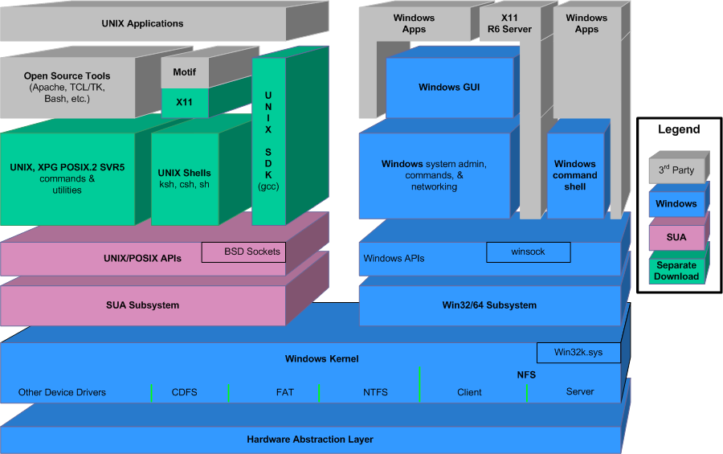

Figure 1. SUA Architecture

Conclusion
Microsoft Windows Compute Cluster Server 2003 provides a complete solution for the HPC developer who is migrating HPC applications to the Windows platform. The developer can choose a migration path to native Windows or to the Subsystem for UNIX-based Applications (SUA). Although not providing full access to the rich Windows application execution environment, SUA can provide a relatively easy migration of UNIX applications with little code change required.
The migration of the core MPI code of an HPC application is greatly simplified by the inclusion of MS MPI as part of Windows Compute Cluster Server 2003. MS MPI is based on and compatible with MPICH2, the most widely used MPI implementation, while providing improved security and job management capabilities.

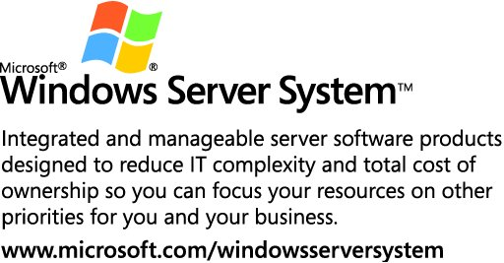

This is a preliminary document and may be changed substantially prior to final commercial release of the software described herein.
The information contained in this document represents the current view of Microsoft Corporation on the issues discussed as of the date of publication. Because Microsoft must respond to changing market conditions, it should not be interpreted to be a commitment on the part of Microsoft, and Microsoft cannot guarantee the accuracy of any information presented after the date of publication.
This white paper is for informational purposes only. MICROSOFT MAKES NO WARRANTIES, EXPRESS OR IMPLIED, IN THIS
DOCUMENT.
Complying with all applicable copyright laws is the responsibility of the user. Without limiting the rights under copyright, no part of this document may be reproduced, stored in, or introduced into a retrieval system, or transmitted in any form or by any means (electronic, mechanical, photocopying, recording, or otherwise), or for any purpose, without the express written permission of Microsoft Corporation.
Microsoft may have patents, patent applications, trademarks, copyrights, or other intellectual property rights covering subject matter in this document. Except as expressly provided in any written license agreement from Microsoft, the furnishing of this document does not give you any license to these patents, trademarks, copyrights, or other intellectual property.
© 2005 Microsoft Corporation. All rights reserved.
Microsoft, are either registered trademarks or trademarks of Microsoft Corporation in the United States and/or other countries.
1105

References
UNIX Application Migration Guide
(http://go.microsoft.com/fwlink/?LinkId=56094)
UNIX Migration Project Guide
http://go.microsoft.com/fwlink/?LinkId=56093
Solution Guide for Migrating HPC Applications
(http://go.microsoft.com/fwlink/?LinkId=56092)
Pthread support in Windows Services for UNIX
(http://go.microsoft.com/fwlink/?LinkId=56091)
Deploying & Managing Compute Cluster Server 2003
(http://go.microsoft.com/fwlink/?LinkId=55927)

Using the Compute Cluster Server 2003 Job Scheduler
(http://go.microsoft.com/fwlink/?LinkId=55929)

Debugging Parallel Applications Using Visual Studio 2005
(http://go.microsoft.com/fwlink/?LinkId=55932)

Using Microsoft Message Passing Interface
(http://go.microsoft.com/fwlink/?LinkId=55930)

