# Sharepoint_logoCover.png­

Executive Summary

Records Management with Microsoft Office SharePoint Server 2007

Records management is the practice of identifying, classifying, archiving, preserving, and destroying records according to a set of pre-defined standards. The primary driver behind records management solutions is to reduce risk through improved regulatory and corporate compliance.

In recent years, enterprises and government agencies have experienced increasing pressure to manage risk more effectively through improved compliance with regulatory and corporate policies. While strict compliance concerns have historically been associated with highly regulated industries, recent scandals and new federal regulations have extended the need for records management solutions to all organizations. Because the risk of noncompliance has very large legal and financial ramifications, the records management discipline has transitioned from being considered an administrative task to a set mission-critical business activities at the core of corporate operations.

One of the main challenges facing organizations implementing records management solution is driving adoption of the solution by a broad audience. Traditional records management applications have been focused on enabling highly specialized roles—legal department, compliance officers—in the records management process. As a result, organizations that try to extend these solutions to typical employees are having a difficult time changing behaviors and enforcing compliance standards.

Microsoft has responded to these industry challenges by delivering a records management platform that can be extended to every information worker. By viewing retention and records management as a component of the overall document lifecycle, organizations can reduce risk and improve compliance with increased adoption of records management practices.

The information contained in this document represents the current view of Microsoft Corporation on the issues discussed as of the date of publication. Because Microsoft must respond to changing market conditions, it should not be interpreted to be a commitment on the part of Microsoft, and Microsoft cannot guarantee the accuracy of any information presented after the date of publication.

This white paper is for informational purposes only. MICROSOFT MAKES NO WARRANTIES, EXPRESS, IMPLIED OR STATUTORY, AS TO THE INFORMATION IN THIS DOCUMENT.

Complying with all applicable copyright laws is the responsibility of the user. Without limiting the rights under copyright, no part of this document may be reproduced, stored in or introduced into a retrieval system, or transmitted in any form or by any means (electronic, mechanical, photocopying, recording, or otherwise), or for any purpose, without the express written permission of Microsoft Corporation.

Microsoft may have patents, patent applications, trademarks, copyrights, or other intellectual property rights covering subject matter in this document. Except as expressly provided in any written license agreement from Microsoft, the furnishing of this document does not give you any license to these patents, trademarks, copyrights, or other intellectual property.

© 2007 Microsoft Corporation. All rights reserved.

Microsoft, Active Directory, BizTalk, Excel, InfoPath, Outlook, PowerPoint, SharePoint, SQL Server, Visio, Windows, and Windows Server are either registered trademarks or trademarks of Microsoft Corporation in the United States and/or other countries.

The names of actual companies and products mentioned herein may be the trademarks of their respective owners.

[Executive Summary 2](#_Toc174169362)

[Microsoft Office SharePoint Server 2007 Records Management Solution 5](#_Toc174169363)

[Why Records Management? 5](#_Toc174169364)

[Records Management Challenges 6](#_Toc174169365)

[Reduced Risk and Improved Regulatory Compliance 6](#_Toc174169366)

[Protect the Integrity of Enterprise Records 7](#_Toc174169367)

[Establish a Secure Enterprise Records Repository 7](#_Toc174169368)

[Reduce Risk Through Policies 8](#_Toc174169369)

[Seamlessly Integrate Records Management into the Document Lifecycle 11](#_Toc174169370)

[Increase IT Manageability and Efficiency 12](#_Toc174169371)

[Reduce Reliance on IT 12](#_Toc174169372)

[Efficient Administration 13](#_Toc174169373)

[Audit User Activity 14](#_Toc174169374)

[Improve Compliance through Usability and Simplicity 15](#_Toc174169375)

[Simplify Collection of Enterprise Records 15](#_Toc174169376)

[Simplify Management of Enterprise Records 17](#_Toc174169377)

[Simplify Access to Enterprise Records 19](#_Toc174169378)

[Integrate and Extend Records Management Solutions 19](#_Toc174169379)

[Extend Your Records Management Capabilities 19](#_Toc174169380)

[Leverage Additional Microsoft Capabilities 20](#_Toc174169381)

[Enable Interoperability with Third-Party Applications 21](#_Toc174169382)

[Conclusion 22](#_Toc174169383)

Microsoft Office SharePoint Server 2007 Records Management Solution

Microsoft® Office SharePoint® Server 2007 is the foundation of an optimized business productivity infrastructure—the first comprehensive approach to solving the problems that people encounter in the unstructured world of work. Rather than treating information management and access, collaboration, and people-driven processes as isolated challenges, Office SharePoint Server 2007 encompasses the whole continuum of unstructured work as a single set of related issues that demand a single, strategic approach. This offers the following significant benefits:

* **Simplicity** for end users, who can leverage their familiarity with Office-based applications and the browser environment for all their information-work activities, regardless of their role or task.
* **Value and governance** for IT, which only needs to support a single set of technologies to enable comprehensive capabilities across the enterprise.
* **Speed and flexibility** for the business, which can customize and extend the platform quickly and easily at a variety of levels from personalization to enterprise application development.
* The **security and scalability** of a platform built for the enterprise.

The Office SharePoint Server 2007 records management solution helps organizations easily protect the integrity of enterprise records and improve overall compliance with enterprise standards. By integrating records management capabilities into the daily activities of employees, the Office SharePoint Server 2007 records management solution can enable seamless and ubiquitous adoption of records management policies across the enterprise.

Why Records Management?

Traditionally, records management solutions have been a mainstay of highly regulated industries that have significant government compliance and reporting considerations. However, recent changes in legal statutes and requirements have significantly broadened the need for records management solutions for every enterprise.

Notable industry drivers include:

* **Changes in government and industry regulations.** Industry and government regulations have been early drivers for records management adoption. Due to compliance regulations and legal risks (for example, SOX, SEC 17-a/b, DOD 5015.2, MoReq, ISO, and HIPAA) organizations need retention and disposition policies, and failure to comply with these policies can result in fines or imprisonment.
* **Legal eDiscovery.** U.S. Federal Rules of Civil Procedure will have an impact on companies across the board as they realize the need to implement records management to address new electronic discovery requirements. This ruling may be the most significant to affect records management adoption since the U.S. Sarbanes-Oxley Act.

With these regulatory and legal changes comes increased attention to records management as a driver for corporate compliance. For most organizations, a lack of defined policies and enormous volumes of documents make initiating a records management solution seem daunting and cost-prohibitive.

Records Management Challenges

* **Difficulty applying retention policies to content.** Organizations are struggling to apply retention policies to a wide range of content types in order to comply with regulations and business policies.
* **High costs of complying with new laws and regulations.** Newlaws and regulations are forcing organizations to quickly implement records management solutions, and the burden of funding these initiatives can be high. Most companies are struggling to find a cost-effective solution for addressing new compliance requirements and minimizing corporate risk.
* **Difficulty providing access to controlled records.** While protecting the integrity of enterprise records is critical, it is not reasonable to expect that all corporate records are made inaccessible. The needs to continue standard business practices are sometimes at odds with the need to protect work product. Organizations are struggling to balance the need to provide accessibility to critical corporate information with the need to protect the integrity of corporate records.
* **Heavy reliance on IT.** Complying with and reporting on the records management process has traditionally placed a large burden on IT to perform administrative tasks.
* **Poor user adoption of records management solutions.** Many companies have experienced difficulty getting a wide range of users to adopt records management solutions across the enterprise.

Reduced Risk and Improved Regulatory Compliance

The Office SharePoint Server 2007 records management solution helps organizations reduce litigation risk and improve compliance with industry and government regulations. Office SharePoint Server 2007 records management is designed to achieve a balance between the richness of records management features and functionality and the simplicity necessary to drive user adoption. This approach enables the broad participation in records management required to reduce risk enterprise wide while protecting enterprise record integrity resulting in overall improvement in corporate compliance. More specifically, to deliver on this vision, Office SharePoint Server 2007:

* Protects the integrity of enterprise records
* Increases IT manageability and efficiency
* Improves compliance through usability and simplicity

Additional Information about Protecting the Integrity of Enterprise Records

[Records Management Team Blog: Information Management Policies](http://go.microsoft.com/fwlink/?LinkId=95963&clcid=0x409)

[Records Management Team Blog: Hold Orders](http://go.microsoft.com/fwlink/?LinkId=95964&clcid=0x409)

[TechNet: Plan information management policies](http://go.microsoft.com/fwlink/?LinkID=95828&clcid=0x409)

[MSDN Blog: What Are Content Types, Anyway?](http://go.microsoft.com/fwlink/?LinkId=95965&clcid=0x409)

[TechNet: Plan Content Types](http://go.microsoft.com/fwlink/?LinkId=95966&clcid=0x409)

[TechNet: Plan physical records retention](http://go.microsoft.com/fwlink/?LinkId=95967&clcid=0x409)

[TechNet: Design the Records Center site](http://go.microsoft.com/fwlink/?LinkId=95968&clcid=0x409)

[MSDN: Document Information Panel and Document Properties](http://go.microsoft.com/fwlink/?LinkId=95969&clcid=0x409)

* Integrates and extends records management solutions

Protect the Integrity of Enterprise Records

The primary purpose of a records management solution is to protect the integrity of enterprise records. Whether documents are needed for regulatory compliance or become evidence in a legal proceeding, it is imperative that companies can illustrate that their records have not been altered or amended in any way. Additionally, companies must make sure all applicable records have been collected and categorized correctly. This is accomplished through a combination of clear policies and user adoption. By protecting the integrity of these records, organizations are able to reduce their overall risk in a cost effective way.

Establish a Secure Enterprise Records Repository

The Records Center within Office SharePoint Server 2007 is intended to serve as a central repository in which an organization can store and manage all of its records. The Records Center supports the entire records management process, from collection and management to disposition. Additionally, Records Center capabilities ensure that companies increase compliance and reduce risk by locking records to prevent tampering, enable easy litigation hold, and accurately track any necessary changes to records. Typically, a Records Center site is designed and configured by an organization's records management professionals and IT staff to support their records management policies.

**Records Center capabilities ensure that records are locked.** The Records Centerensures that records are not automatically modified by the system. For example, a document is in danger of being modified by the system during role transitions. Typically, all documents referencing a particular role would be updated with the information of any new role owner; however, to ensure compliance, a record would need to reflect the name of the former employee. This ensures that records that are uploaded to a Records Center site and then referenced again later are always identical. Site administrators can easily configure the Records Center with settings that prevent the direct tampering with records by versioning any changes that are made to document contents and by auditing specific types of changes.

**Hold capabilities allow one or more holds that suspend policies on items to support Legal eDiscovery**. The ability to designate and secure records that are evidence in legal proceedings is an important component of protecting enterprise records. The Records Center enables organizations to take records that are under legal discovery or relevant to an audit or investigation and place them on a Holds list. When records are placed on hold, they are suspended from any expiration policies that may be in effect, and they are thus protected from destruction. For example, if an organization facing litigation places relevant records that it may be required to produce on hold, these records are available until the litigation is complete. Records can be placed on more than one hold at a time. Records managers can also search the Records Center for records that need to be placed on hold, automating the process of protecting these records.

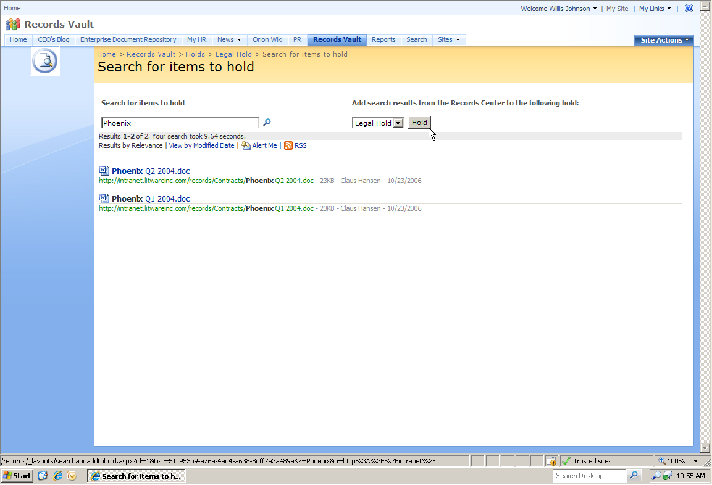

ms_masthead_ltr  
Streamlining Records Management Using SharePoint Server 2007 Workflow

The Microsoft Legal and Corporate Affairs (LCA) Records Management team created an efficient inventory tracking solution that gives Microsoft employees easy access to physical records information and eliminates the need to handle inventory searches manually. Building on Microsoft® Office SharePoint® Server 2007 and Microsoft® Office InfoPath® 2007, the new solution uses forms and workflows to automate the collection and management of inventory data. This results in an enforced inventory through team-established business rules, increased accuracy of inventory data, and easy access to inventory information. Thus, the LCA Corporate Records Management team can more effectively manage document records.

[More Information…](http://go.microsoft.com/fwlink/?LinkId=95970&clcid=0x409)

Figure : Placing a record on hold

**Maintain metadata on items separately from records’ metadata.** There are instances in which a document may need to be modified after it has been sent to the Record Center. For example, the document may have been categorized incorrectly and need to be fixed. In this case, two sets of metadata would need to be captured in order to accomplish the compliance goal of illustrating records have never been modified. One set of metadata would contain information about the record’s state when added to the Record Center, and the other set would need to reflect the corrected metadata. Office SharePoint Server 2007 has the ability to track changes to metadata much in the same way that changes to a document are tracked, which increases compliance by establishing a clear record of modifications.

Reduce Risk Through Policies

In addition to establishing a secure repository for enterprise records, it is critical that organizations have a way to easily apply their corporate policies to a wide range of content across the enterprise. The Office SharePoint Server 2007 records management solution streamlines the process of applying policies to both physical and electronic content and documents through Information Management Policies. Policies can be assigned on either an individual basis or driven by content types, providing a balance between automation and flexibility for the business.

**Use content types for describing properties, policies, and workflows for a specific type of content.** Over the course of a single project, a business might produce several different types of content, for example, proposals, legal contracts, statements of work, and product design specifications. Although these documents might be stored together because they are related to a single project, they can be created, used, shared, and retained in different ways. A content type is a scalable tool that IT can use to enforce governance overall and defines how people can interact with the type of content. For example, a business might want to collect and maintain different kinds of metadata about each content type, including information needed for records compliance, or it might want to apply an information management policy to a content type. Content types could also define a template that must be used when a document is created, available workflows, and the associated document information panel. Content types can be defined for any type of item in Office SharePoint Server 2007, including documents, list items, and folders, and can be reused throughout a company’s Office SharePoint Server 2007 solution in conjunction with its records management solution.

**Easily apply information management policies to business records.** An information management policy is a set of rules for a type of content. Information management policies enable organizations to control and track things like how long content is retained or what actions users can take with that content. Information management policies can help organizations comply with legal or governmental regulations, or they can simply enforce internal business processes. For example, an organization that must follow government regulations requiring that they demonstrate "adequate controls" of their financial statements might create one or more information management policies that audit specific actions in the authoring and approval process for all documents related to financial filings.

**Maintain information on items using the Document Information Panel.** The Document Information Panel helps ensure that documents which eventually may be declared as records are tagged with the appropriate metadata to make them easy to find, discover, and manage over their entire lifecycle. The Document Information Panel helps enforce information management policies by being the interface in which people enter information about the document. The Document Information Panel can have required metadata fields and will give an error if the information is incorrectly filled out, which in turn increases compliance and reduces risk. In the 2007 Office system, the Document Information Panel feature is used to capture metadata for Microsoft® Office Word 2007, Microsoft® Office Excel® 2007, and Microsoft® Office PowerPoint® 2007documents from the moment of creation. Integration with the 2007 Office system ensures that it is easy for users to capture document metadata in a familiar interface, without having to learn a separate system. It also increases the relevance and quality of metadata capture because users can enter the information in documents as they are created and used, rather than when they are submitted to the records center, which occurs after the document has been finalized and people are ready to stop working on it.

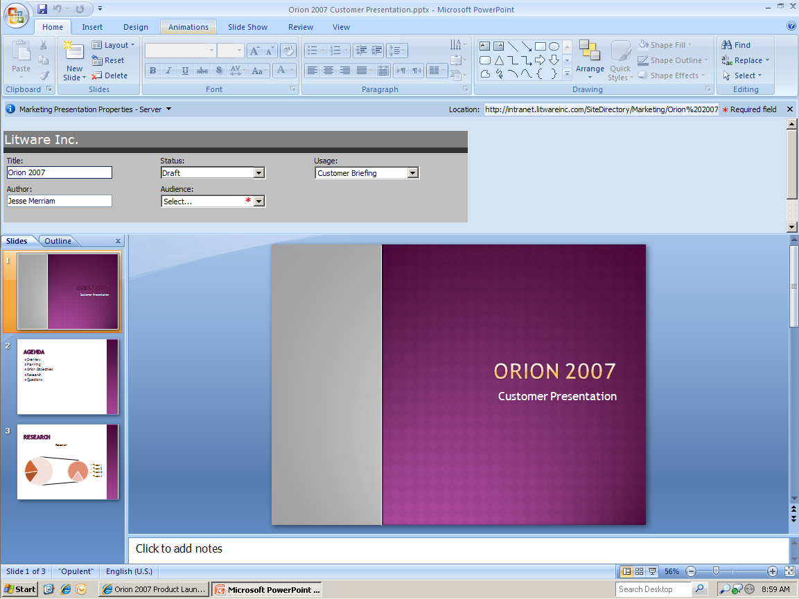

Figure : Document Information Panel

**Use barcodes, labeling, and tracking capabilities to manage physical records.** Barcodes provide each record with a unique image and numeric value. The value of the barcode is stored and indexed along with the electronic version of the record. In the context of records management, barcodes are useful for retaining and tracking physical records. When the records in a library have physical versions, barcodes provide a way to correlate the physical versions with their electronic counterparts.

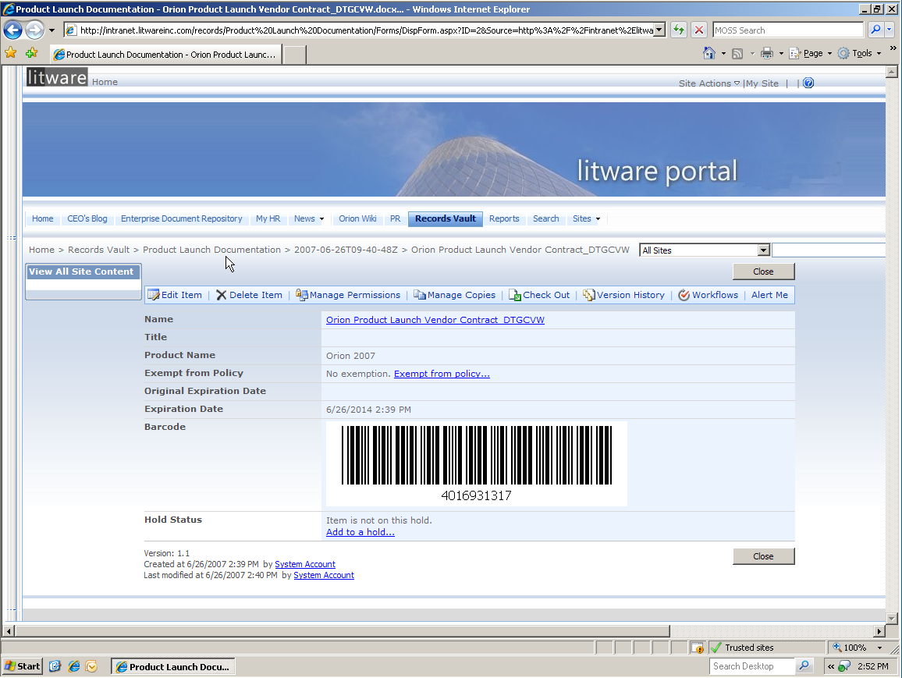

Figure : Document barcode

The Labels policy feature enables organizations to track physical copies of documents or list items that have been printed from a site. The Labels policy feature automatically generates text labels based on document properties and metadata that a site administrator or list manager specifies. For example, legally required metadata can be printed strategically within the document using the label feature in a policy. When users insert labels into Microsoft Office documents, the labels are updated automatically with the information from the document's properties.

Seamlessly Integrate Records Management into the Document Lifecycle

Office SharePoint Server 2007 provides an end-to-end solution for managing the full lifecycle of enterprise documents from creation through retention. Traditionally, records management solutions have focused on applying corporate policies and managing the document once it has been designated a record, usually at the end of the document lifecycle. Office SharePoint Server 2007 helps organizations ensure that their policies are being adopted and enforced across the company because it embeds records management policies into the full document lifecycle through tight integration with the 2007 Office system, document management capabilities, and Windows Workflow Foundation. This integration is essential to enabling employees to actively and passively participate in records management without changing behavior.



Figure : Typical document lifecycle stages

**Manage the full lifecycle of enterprise records from creation through expiration, including integrated deletion workflow.** Office SharePoint Server 2007 records management is simple for users to adopt, which enables broad participation in records management across the organization. This is accomplished using workflows to enable integration between document management and records management. Workflows can be triggered to start whenever a document of a certain content type is created, or can be manually started from within Office SharePoint Server 2007 or a 2007 Office document. They can enforce the collection of metadata during the document management cycle that will be used to organize documents in a record repository later, or can route a document to a list of approvers. When a document expires according to the document’s information management policy, the disposition portion of a workflow can automatically begin. Because of the automation and common tools, employees participate in records management by performing work in the same way as they always have, with only a few minor changes around collecting metadata and workflow task completion.

**Record routing that enables automated routing of content to its proper location.** The Records Center includes a Record Routing list that automatically routes incoming records, whether submitted automatically or manually, to their proper location based on their content type. This reduces the time a records manger spends organizing records by automating many of their tasks and allowing them to audit record routing to ensure compliance. Record routing can be automatically initiated as a part of a workflow or can be manually started by a user.

**Content-type and policy-based document retention and expiration schedules.** Retention and expirations schedules dictate how long a record should be retained and what action should occur when the retention period ends. They are defined by information management policies and enforced by content types. For example, when a record reaches the end of its retention period, a Disposition Approval workflow could be automatically initiated. These workflow enforced policies ensure that records are never accidentally deleted.

Increase IT Manageability and Efficiency

Ensuring corporate compliance can prove to be taxing and time-consuming for IT resources. In organizations without records management solutions, the process of collecting, storing, and accessing critical documents is labor-intensive and typically falls onto the shoulders of IT. For companies that do have records management solutions, many IT resources are overly burdened by activities required to develop, maintain, and support these applications on disparate platforms. The Office SharePoint Server 2007 records management solution is designed to decrease the IT burden for complying with corporate policies while streamlining the deployment and maintenance of records management solutions.

Reduce Reliance on IT

The most significant IT benefit of a successful records management solution is that it reduces the reliance on IT to perform critical activities in the records management process. By empowering business users to maintain and access records, and by providing automated tools to facilitate the records management process, IT organizations are able to reduce the inefficiencies associated with traditionally manual compliance activities.

**Empower end-users to categorize, organize, administer and audit records.** Office SharePoint Server 2007 records management provides business users with the tools to easily administer, organize, and manage enterprise records, which in turn reduces reliance on IT. Some of these tools include information management policies, content types, metadata, and auditing capabilities. Allowing users to assist with these tasks helps companies become more rigorous in their records management compliance because the people closest to the information are dictating its organization. For example, if a purchase order for office supplies is started by an employee in the finance department it could be automatically tagged with metadata stating it is related to finance operations. If this purchase order also contains supplies that will be used by the accounting department, it is important that an employee can easily modify the metadata to reflect this case. In order to further ensure compliance, auditing tasks can be performed by a user, such as the department head, to ensure records have been organized correctly. By providing easy to use management, categorization and auditing tools, IT resources can delegate the management of records to business users and remain confident that the right policies are being enforced.

**Enable legal and business resources to find enterprise records in a self-service model**. Increased rigor in record metadata and organization increases search relevancy which allows users to easily find relevant records in a self-service model, without help from IT. The quality of search is increased through metadata collection, because the record has been categorized by end users familiar with the record’s content. The more metadata that is collected using the Document Information Panel and Content Types, the more accurate search results will be.

Additional Information about Increasing IT Manageability and Efficiency:

[MSDN Blog: MOSS Architecture and Shared Services](http://go.microsoft.com/fwlink/?LinkID=95843&clcid=0x409)

[TechNet: Plan Shared Services Providers](http://go.microsoft.com/fwlink/?LinkID=95845&clcid=0x409)

[Records Management Team Blog: Auditing](http://go.microsoft.com/fwlink/?LinkId=95971&clcid=0x409)

[TechNet: Analyze document usage](http://go.microsoft.com/fwlink/?LinkId=95972&clcid=0x409)

[MSDN: Item-Level Auditing with SharePoint Server 2007](http://go.microsoft.com/fwlink/?LinkID=95829&clcid=0x409)

[MSDN Webcast: Get the Facts on Reporting in SharePoint Server 2007](http://go.microsoft.com/fwlink/?LinkID=95831&clcid=0x409)

[MSDN: Workflows in Office SharePoint Server 2007](http://go.microsoft.com/fwlink/?LinkID=95863&clcid=0x409)

**Utilize workflow for document modification.** Most documents will not be modified after being submitted to the records center; however, exceptions do occur. When this happens, a workflow can be automatically initiated that approves the change through the proper channels, or collects additional metadata to capture the reason for the change. Once the modification workflow has been completed the records can be resubmitted automatically to the records center.This reduces the reliance on IT to manage required changes to enterprise records.

Efficient Administration

The administration of business applications and technology platforms has become a significant drain on IT resources over the last decade. Past technology trends have led to a proliferation of point solutions that require IT administrators to learn and support multiple technologies. Office SharePoint Server 2007 is designed to lessen the burden on these resources by providing a unified platform with consistent tools for managing administrative tasks.

**Consistent UI for all Enterprise Content Management and Office SharePoint Server 2007 administrative tasks.** Office SharePoint Server 2007 provides a familiar interface for conducting such administrative tasks as collaboration, all enterprise content management capabilities, and search.

**Delegate management tasks without granting central administrator access.** Not every administrative task needs to be performed by central IT. With Office SharePoint Server 2007, many tasks can be completed by departmental IT staff without granting them permission to conduct central administration tasks. For example, a business unit IT person can create a search content source for their department and manage department information, such as records management workflows and forms.

**Manage single set of shared services for multiple farms.** Server administrators can package custom modifications to Office SharePoint Server 2007, such as applications or features, and consistently deploy them as a solution to a farm or single site. The administrator UI displays where solutions have been deployed. A solution can be rolled out to a farm, rather than having to be installed on every server individually.

**Use audience targeting to manage record permissions.** Permissions enable an organization to determine who can access records stored in a record center site and what they can do with the information in them. For example, you can set up permissions to allow record center managers to add or modify records to the site but only allow people outside the team to view content without changing it. Configuration of these permissions can be delegated to department IT staff so it does not need to be managed by central IT.

Audit User Activity

One of the most labor-intensive components of records management is developing reports on how well an organization is complying with corporate policies. In the past, IT organizations have spent considerable time manually collecting data on the compliance process, and that data was frequently inaccurate and incomplete. By automating data collection and reporting activities, Office SharePoint Server 2007 provides IT resources with tools to streamline the compliance reporting process.

**Audit enterprise-wide policy compliance.** Auditing enables administrators to keep a reliable log of what is happening with important content on a site collection. This log is used to ensure compliance with information management policies and therefore reduce risk for an organization. Administrators are able to retrieve the entire history of actions taken by a particular user and can also retrieve the entire history of actions taken during a particular date range. Knowing who has done what with which information is critical for many business requirements such as regulatory compliance and records management.Site administrators can also use auditing to track how documents and items are used throughout a site collection. Auditing information is stored in an audit log and can contain the following information:

* Item name and location
* Site from which an event originated
* Item type (for example, list or document)
* User ID associated with the event
* Event date and time
* Action taken on the item

Although there is no way to modify events once they are logged, site administrators can delete items from the audit log report.

**View reports on Policy Compliance.** All of the events that an administrator selects to be audited are captured in audit logs that can be viewed in Office Excel 2007 and are available from the Auditing Reports page. Administrators can view the contents of audit logs and sort, filter, and manipulate the data in them to analyze activity across a site collection. Audit reports enable organizations to use the raw data in audit logs to construct a meaningful picture of what actions have or have not occurred in a site collection. The reports can be readily saved in a useful format for review, including being displayed in an Office SharePoint Server 2007 Web Part.

Auditing reports enable you to determine:

* Items that have been added to a list or library
* Documents and files that have been viewed and read
* Changes to permissions
* Changes to columns and content types
* Items that have been deleted or restored
* Items that have been copied, moved, checked in, and checked out
* Search queries
* Changes to auditing

Improve Compliance through Usability and Simplicity

Many of the early adopters of records management solutions have identified user adoption as the primary barrier to success for their initiatives. Difficult interfaces, complex processes, and disparate tool sets make it difficult for users to participate in the records management process. As a result, too many documents are never subjected to enterprise policies, resulting in widespread noncompliance.

The Office SharePoint Server 2007 records management solution has been designed to demystify the process of collecting, managing accessing enterprise records. By making the solution simple, it can be easily adopted by a broad audience, resulting in improved compliance across the organization.

Simplify Collection of Enterprise Records

Once adocument’s lifecycle evolves to records status, it should be moved to the Records Center site.There are two different ways in which an organization can arrange for content to be submitted to a Records Center site:

* Develop a workflow solution that automatically routes the content into a Records Center site using a Web service or e-mail.
* Configure a connection between an Office SharePoint Server 2007 site and a Records Center site, so that individual users can manually submit documents to the Records Center site.

Both options provide simple interfaces and streamline the collection of records.

**Automate the collection of enterprise records through policy-based workflows**. User adoption can be enhanced by allowing users to passively participate in records management through workflow and integration of the familiar 2007 Office system interface. If an organization defines an information management policy for a content type, list or library, it can be configured to be automatically enforced through workflow thereafter. This means that the document can be automatically sent to a records center using the related record routing table, retained or expired by the system using a workflow. Users can exempt specific items or documents from an information management policy if they don't want that policy to apply to a particular item, or if there is a business need to exempt the item from the policy.

**Manually send records to Record Center.** If an organization has configured a connection between a Records Center site and the Office SharePoint Server 2007 site that is used for document creation and collaboration, documents can be submitted to the Records Center site that should be stored as official business records. The content type for the document that the organization wants to send to the Records Center must match a record type stored on the Records Center site. For example, if the organization retains copies of contracts as official business records on a Records Center site, employees can send documents that belong to a contract content type to the Records Center. Additionally, the file menu in 2007 Office system programs such as Word and Excel can be customized so that documents can be submitted to a Record Center directly from within the 2007 Office system.

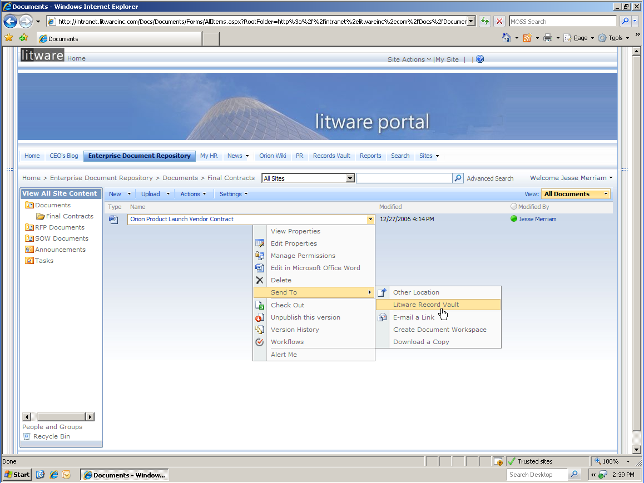

Figure : Manually sending a record to the Records Center

**Use Exchange Managed Mail Folders and Managed Mail Policies**.  An increasing amount of important information related to contracts, accounts, customer service, and other business-critical areas is now contained in email.  Office SharePoint Server 2007 provides a policy-based solution for managing e-mail content across Microsoft Office Outlook 2007, Microsoft Exchange Server 2007, and Office SharePoint Server 2007. This is accomplished through two new features: Managed Mail Folders and Mail Management Policies.

* **Managed Mail Folders** help records managers and compliance officers manage the e-mail in individual mailboxes more effectively by defining a set of standard folders, each with an explicit business purpose, in which individual employees can file their e-mail. These folders can be deployed to individual information workers based on their roles within the organization so that people who fill equivalent roles across a company can have similar top-level filing structures in their mailboxes.  To contribute email to a MOSS Record Center, an individual only has to click and drag the email to the correct managed folder.  MOSS and Exchange automatically adds the email to the correct place in the Records Center.
* **Mail Management Policies** are the rules behind each managed mail folder.  These policies define expiration / retention policies, record routing, etc (same as content types).  Policies can be applied to any e-mail folder—such as Inbox, Drafts, and Sent Items.  Policy statements appear at the top of each folder view in Office Outlook 2007 and Microsoft Outlook Web Access. These statements help records managers, compliance officers, and IT workers to communicate the policies associated with folders in a way that makes sense to employees and that no one can claim they never saw.

## Simplify Management of Enterprise Records

Traditionally, managing records required learning new interfaces and processes completely disconnected from other document management solutions. As a result, there is no consistent way for users to apply retention and management policies throughout the document lifecycle. By providing an end-to-end solution, Office SharePoint Server 2007 enables users to leverage the same rich management features throughout the full lifecycle of enterprise documents and records.

**Manage the lifecycle of enterprise records.** Office SharePoint Server 2007 provides an end-to-end solution for managing the full lifecycle of enterprise documents from creation through retention that is easy for people to use. Managing a full enterprise document necessitates document management capabilities, which focus on applying document management policies and managing the lifecycle during content’s published state, that is, from Approval through Expiration. For example, users can:

* Categorize documents using metadata, which ensures that when documents become records they are routed correctly and increases search relevancy.
* Manage documents using workflow, which includes tight 2007 Office system integration that allows users to complete workflow tasks from the familiar 2007 Office system interface.
* Audit documents to ensure information management policies are being followed.

By enabling the management of the full document lifecycle, Office SharePoint Server 2007 records management helps organizations ensure that their policies are being adopted and enforced across the organization.

**Rich document versioning capabilities**. When versions of a document are tracked for lists or libraries, revisions to the files and their properties are stored. This enables a company to better manage content as it is revised and even to restore a previous version after the document has been made a record. Versioning is especially helpful when several people work together on projects, or when information goes through several stages of development and review. Versioning is maintained through the check-in/check-out process. When you check out a file, a version is created only when you check the file back in. When check-out is not required, a version is created when you first save a file, and then this version is updated when you close it.

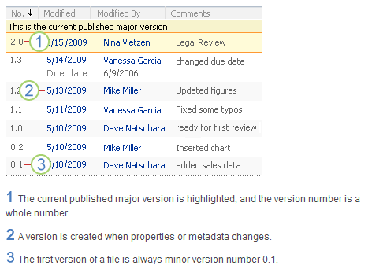

Figure : Version History

Simplify Access to Enterprise Records

Traditionally, organizations have focused heavily on the collection and protection of enterprise records rather than on enabling access to those records once they are stored and retained. New legal and regulatory requirements, specifically around eDiscovery, make the process of accessing records in a cost-effective manner a primary consideration for records management solutions. Office SharePoint Server 2007 provides business users with a simplified process for quickly and efficiently accessing records needed for legal proceedings and compliance reporting.

**Robust search can be leveraged to find and access records** Users can access and retrieve records that are stored in the Records Center using a self service model. By using the Advanced Search page, a user can refine their search to find records that have a specific property or that contain a specific word. Any combination of these search criteria can be used. For example, you can search for only documents that contain the metadata tag “contract” and are authored by a specific employee.

**Use information rights management to enable broader user access to records.** A problem for many companies is managing security and document usage on files that are taken offline. Information Rights Management (IRM) enables a company to limit the actions that users can take on documents that have been downloaded from Office SharePoint Server 2007. IRM can be defined at the document or list level, and limits the set of users who are allowed to read files as well as actions they can take such as printing, copying, or forwarding.

Additional Information about Integrating and Extending Records Management Solutions:

[TechNet Presentation: Coding Compliance Components: Writing Custom Policies for Auditing, Expiration and More](http://go.microsoft.com/fwlink/?LinkId=95980&clcid=0x409)

[Video: Extending the Document and Records Management Features of SharePoint Server 2007](http://go.microsoft.com/fwlink/?LinkId=95979&clcid=0x409)

[TechNet Presentation: Designing, Deploying and Managing Workflow in SharePoint Sites](http://go.microsoft.com/fwlink/?LinkID=95861&clcid=0x409)

[Interoperability TechCenter](http://go.microsoft.com/fwlink/?LinkID=95865&clcid=0x409)

Integrate and Extend Records Management Solutions

For organizations that have more complex records management needs, the ability to integrate, customize, and extend their records management solutions is critical to their success. For example, highly regulated industries may have specialized legacy applications for strictly controlled and targeted records management. In these cases, Office SharePoint Server 2007 provides a solution that integrates with existing systems but extends those capabilities to a broader audience. In other cases, companies may need to tailor Office SharePoint Server 2007 records management capabilities to meet the specific challenges of their business. The Office SharePoint Server 2007 platform provides extensive flexibility for customizing, integrating, and extending records management solutions to meet your company’s unique requirements.

Extend Your Records Management Capabilities

Office SharePoint Server 2007 provides an extensible platform for building out additional records management capabilities for optimal flexibility and agility. For example, the Records Center's programmable interface enables organizations to configure both document management and e-mail systems to automatically submit files to the Records Center site. Content can be submitted to the Records Center through a Web service by using the SOAP protocol or through e-mail by using the SMTP protocol.

**Build custom workflows for more complex information lifecycle management.** An organization may choose to design and develop workflows that are unique to the business processes in that company. Developers can create workflows that are started by people who use a site, or they can create workflows that start automatically based on an event, such as when a list item is created or changed. There are two ways in which custom workflows can be created for Office SharePoint Server 2007:

* **Microsoft Office SharePoint Designer 2007** is for power users to create no-code workflows for use in a specific list or library. These workflows are created from a list of available workflow activities, and can be deployed directly to the list or library without assistance from IT.
* **Visual Studio 2005 Extensions for Windows Workflow Foundation** is for professional software developers. These workflows contain custom code and workflow activities. After a custom workflow is created, a server administrator can deploy them across multiple sites.

**Create custom content types and metadata fields for enhanced manageability.** Organizations can also create and deploy custom policy features to meet specific needs. For example, a manufacturing organization might want to define an information management policy for all draft product design specification documents that prohibits users from printing copies of these documents on non-secure printers. To define this kind of information management policy, the organization can create and deploy a Printing Restriction policy feature that can be added to the relevant information management policy for the product design specification content type.

Leverage Additional Microsoft Capabilities

Organizations can take advantage of specialized capabilities provided by other products and technologies from Microsoft. The unified Office SharePoint Server 2007 platform streamlines the process of integrating and extending records management by leveraging additional Microsoft functionality. Whether an organization needs to continue to collaborate on documents while maintaining integrity, or if they need advanced reporting options for measuring corporate compliance, the Microsoft suite provides seamless integration for addressing these specialized requirements.

**Manage collaboration separately from records while maintaining consistency with policies**. An organization's information infrastructure consists of two different types of spaces:

* Collaborative spaces where knowledge workers do their work and create documents that may eventually become records.
* Records spaces where records managers administer the records that must be retained.

While organizations need to provide some control over content created in collaborative spaces, if the collaborative space is too tightly managed, information workers will be slowed down or won't use the collaboration tools. Some of this information constitutes business records, such as documents and other information that need to be kept in order to preserve the "corporate memory" of company activity. However, most of the information created in these collaborative spaces is of short-term value and will have different retention policies than official business records. .

Office SharePoint Server 2007 provides a unified platform for managing both types of content, while enables easy differentiation between records and disposable documents using information management policies and content types.

**Harness Business Intelligence capabilities to build custom reports to analyze records.** Many organizations need tocreate reports for corporate stakeholders or government entities to illustrate compliance with key regulatory statutes. Traditionally, the process of collecting this data and building reports has been time consuming and prone to inaccuracies due to manual processing. For companies with extensive or complex reporting requirements, Microsoft business intelligence capabilities can be leveraged to automate the creation of comprehensive reports that can be modified for different communities.

Enable Interoperability with Third-Party Applications

Because records management can be highly complex and requirements vary dramatically across industries and corporate cultures, specific retention and compliance needs will vary considerably from one company to another. In order to address varying levels of depth, some companies need to integrated records management solutions with third-party applications. Office SharePoint Server 2007 provides an open, standards-based platform that enables interoperability with a wide range of specialized tools and repositories.

**Integrate with third-party repositories and archiving solutions.** For companies that have been early adopters of records management solutions, Office SharePoint Server 2007 can provide a way to extend their existing capabilities to a broader range of employees and document types. In these cases, Office SharePoint Server 2007 can integrate with these systems to provide a full end-to-end records management solution while preserving historical investments in other technologies.

**Integrate with specialized Legal eDiscovery applications for managing the litigation process.** For complex legal and litigation situations, specialized Legal eDiscovery solutions may be required to manage the collection and organization of documents for depositions, evidentiary hearings, and trials. In many cases, external counsel will have proprietary systems for managing the discovery process during the course of litigation. In other cases, companies may make their own investments in specialized tools. In either case, the Office SharePoint Server 2007 records management solution provides full interoperability with these systems to streamline the legal eDiscovery process.

Conclusion

In summary, the Office SharePoint Server 2007 records management solution helps organizations reduce litigation risk and improve compliance with industry and government regulations. Office SharePoint Server 2007 records management is designed to achieve a balance between richness of records management features and functionality, and the simplicity necessary to drive user adoption. This approach enables the broad participation in records management required to reduce risk enterprise wide while protecting enterprise record integrity resulting in overall improvement in corporate compliance. In addition, records management from Microsoft:

* Includes a secure records vault that enables hold capabilities and captures metadata on records to ensure they are categorized correctly, and has the ability to define and enforce clear records management policies and records routing.
* Reduces reliance on IT by empowering a broad population to utilize records management functionality on a unified SharePoint technology-based foundation with common management tools.
* Can be easily adopted by every information worker, due to integration with familiar and easy-to-use Microsoft Office programs.
* Ability to customize their records management solution to meet an organization’s unique business needs.