Microsoft Exchange Server
Intelligent Message Filter Overview

Microsoft Corporation
Published: March 2004

Abstract
The Microsoft® Exchange Server Intelligent Message Filter is an advanced, server-side filtering technology that intelligently determines whether e-mail is junk or legitimate. This tool integrates with the Microsoft Exchange Server 2003 feature set and administration to provide additional spam filtering.



This is a preliminary document and may be changed substantially prior to final commercial release of the software described herein.
The information contained in this document represents the current view of Microsoft Corporation on the issues discussed as of the date of publication. Because Microsoft must respond to changing market conditions, it should not be interpreted to be a commitment on the part of Microsoft, and Microsoft cannot guarantee the accuracy of any information presented after the date of publication.
This White Paper is for informational purposes only. MICROSOFT MAKES NO WARRANTIES, EXPRESS, IMPLIED OR STATUTORY, AS TO THE INFORMATION IN THIS DOCUMENT.
Complying with all applicable copyright laws is the responsibility of the user. Without limiting the rights under copyright, no part of this document may be reproduced, stored in or introduced into a retrieval system, or transmitted in any form or by any means (electronic, mechanical, photocopying, recording, or otherwise), or for any purpose, without the express written permission of Microsoft Corporation.
Microsoft may have patents, patent applications, trademarks, copyrights, or other intellectual property rights covering subject matter in this document. Except as expressly provided in any written license agreement from Microsoft, the furnishing of this document does not give you any license to these patents, trademarks, copyrights, or other intellectual property.
© 2004 Microsoft Corporation. All rights reserved.
Microsoft, Outlook, and SmartScreen are either registered trademarks or trademarks of Microsoft Corporation in the United States and/or other countries.
The names of actual companies and products mentioned herein may be the trademarks of their respective owners.
.
Contents
Introduction 1
Exchange Server Intelligent Message Filter Features 2
Comprehensive Antispam Features in Exchange Server 4
Integration with Outlook 2003 5
Summary 7

Introduction
Recent industry estimates indicate that more than half of e-mail sent today is unsolicited commercial e-mail (UCE)—also known as “spam” or “junk e-mail”—straining networks and wasting time, money, and resources for organizations around the world. Ferris Research estimates the total cost of UCE to U.S. corporations in 2002 to be $8.9 billion. This figure includes end-user productivity loss, consumption of network resources, and Help desk costs.
Microsoft Exchange Intelligent Message Filter provides advanced server-side message filtering that combats the influx of UCE from a variety of senders and sources. Working with Microsoft Office Outlook® 2003 and Exchange 2003 it helps correctly filter messages, strengthening the end-to-end hygiene solution. When used with Outlook, it significantly reduces the volume of UCE that e-mail users receive. Intelligent Message Filter requires Exchange Server 2003 and works in conjunction with its existing antispam features, such as connection filtering, sender filtering, and recipient filtering.
Intelligent Message Filter reduces costs by cutting the time that information workers spend reading, sorting, and deleting UCE and the time that administrators spend maintaining the health and integrity of their networks.

Exchange Server Intelligent Message Filter Features
Intelligent Message Filter is based on Microsoft SmartScreen™ technology from Microsoft Research. SmartScreen is a patented technology that enables Intelligent Message Filter to distinguish between legitimate e-mail messages and UCE.
Designed for Exchange Server administrators who want to add server-based UCE filtering to their messaging environment, the heuristics-based filter of Intelligence Message Filter analyzes each message to determine whether it is UCE. A spam confidence level (SCL) rating is then attached to the message that Exchange Server or Outlook then uses to determine whether to deliver the message to the UCE folder.
Note: Only Exchange Server 2003 and Outlook 2003 use the SCL rating.
Intelligence Message Filter features include:
- Heuristics-based analysis of messages determines whether they are legitimate or UCE.
- Server-side filtering with integrated Exchange Server administration decreases administrative time and cost as well as user productivity loss.
- Support for per-message SCL allows thresholds to be set both at the server gateway running Intelligent Message Filter and at the user mailbox using Outlook

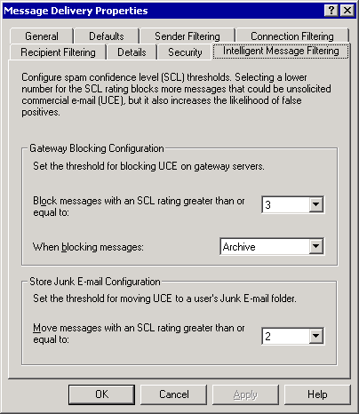
Figure 1. The Intelligent Message Filtering tab in the Message Delivery Properties dialog box
Intelligent Message Filter is installed on the Exchange Server gateway servers to filter incoming Internet e-mail messages before they are sent to a user's Inbox. In a typical Exchange Server topology, e-mail servers that are configured to send and receive Internet-based e-mail are usually deployed at or near the Internet inside data centers. These gateway servers forward incoming Internet e-mail messages to the appropriate mailbox server, as Figure 1 shows.
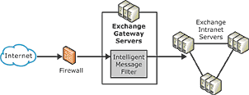
Figure 2. Diagram of a typical Exchange Server topology with Intelligent Message Filter
Note: If you use a non-Microsoft e-mail server as your Internet gateway server, you can install Intelligent Message Filter on a server running Exchange Server that is configured as a bridgehead server, accepting incoming Internet e-mail messages from your gateway servers.
When Exchange Server using Exchange Server Intelligent Message Filter receives an external message, the filter evaluates the content of the messages for recognizable patterns and assigns the message a rating based on the probability that the message is UCE. This rating is stored with the message as an SCL and persists with the message when it is sent to other servers running Exchange Server and even to other user Inboxes.
An administrator sets two thresholds that determine how Intelligent Message Filter handles e-mail messages with various SCL ratings:
- A gateway threshold above which the server running Exchange Server performs an associated action
- A mailbox store threshold
If a message has a rating equal to or higher than the gateway threshold, Intelligent Message Filter takes the action specified at the Exchange Server gateway server level. If the message has a rating below the gateway threshold, the message is sent to the Exchange Server mailbox store of the recipient. At the Exchange Server mailbox store, if the message has a higher rating than the mailbox store threshold, the mailbox store delivers the message to the user's UCE folder rather than to the Inbox. Using two different thresholds gives organizations using the Intelligent Message Filter flexibility in their fight against UCE.
- For more information about Intelligent Message Filter, see “Exchange Server Intelligent Message Filter Overview,” at http://www.microsoft.com/exchange/imf. For more information about deploying the Intelligent Message Filter, see “Exchange Server Intelligent Message Filter Deployment Guide,” at http://www.microsoft.com/exchange/library.
For the latest information about Exchange Server, see the Exchange Server Web site at http://www.microsoft.com/exchange.

Comprehensive Antispam Features in Exchange Server
While Exchange Server Intelligent Message Filter provides server-side filtering based on message characteristics, other features provide connection, recipient, and sender filtering. These Exchange Server features include:
- Support for global deny and accept lists: Exchange Server supports connection filtering based on a list of IP addresses that are always accepted or denied. This feature enables organizations to define trusted partner and customer IP addresses on the “accept” list and known offenders on the “deny” list.
- Support for Domain Name System (DNS) blocked sender lists: Exchange Server further filters connections by integrating with DNS blocked sender lists. Exchange Server forwards the IP address of each incoming message to one or more blocked sender list providers, which maintain lists of known UCE sources. The service provider returns a status code for each incoming message to Exchange Server, which uses this code to determine whether it will accept or reject the incoming message and return an error code to the sender.
- Inbound recipient filtering: Administrators can configure Exchange Server to block incoming messages destined for invalid recipients or restricted internal addresses. When recipient filtering is applied, Exchange Server simply rejects messages for nonexistent or blocked recipients during the Simple Mail Transfer Protocol (SMTP) session rather than sending a non-delivery report (NDR) back to the sender. Without this feature, Exchange Server would likely return an NDR to the sender, which, because UCE typically originates from false addresses, could waste server resources.
- Sender filtering: The sender filter in Exchange Server can be configured to examine each incoming message and compare the sender’s e-mail address (not the IP address) against a list of blocked e-mail addresses. If there is a match, Exchange Server can either drop the incoming message or archive it, depending on your settings.
For more information about antispam features in Exchange Server, see “Antispam Capabilities in Exchange Server 2003,” at http://www.microsoft.com/exchange/techinfo/security/antispam.asp.

Integration with Outlook 2003
Like Intelligent Message Filter, Outlook uses SmartScreen technology, which evaluates factors such as the time and content of the message, to determine whether to treat a message as UCE or legitimate e-mail. If either Exchange Server Intelligent Message Filter or Outlook determines a message to be UCE, the message is delivered to the UCE folder so that no user interaction is required. Users can set their filter settings to No Protection, Low, or High or use a highly restricted mode that permits only people on their contact lists to send them e-mail. In addition, users can add senders to either safe sender or junk sender lists so that Outlook correctly routes incoming messages.
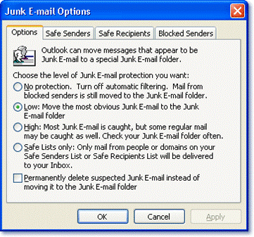
Figure 3. The Junk E-mail Options dialog box in Outlook
As highlighted in the scenario above, Outlook helps protect against UCE by combining list-based approaches with machine learning technology. The combination of these technologies provides the most intelligent and flexible filtering available. The antispam features of Outlook include:
- Safe senders list: E-mail addresses and domain names on the safe senders list are never treated as UCE, regardless of the message content. This feature is extended to mailing lists as well, with the safe recipients list.
- Contacts list: Contacts also are trusted by default, and e-mail from them is never treated as UCE. Similarly, in combination with Exchange Server, no e-mail from within the user’s organization is treated as junk, regardless of the message content.
- Blocked senders list: The blocked senders list ensures that certain e-mail addresses or domain names are automatically blocked. E-mail messages from people or domain names on this list are always treated as UCE, regardless of the message content.
- Outlook UCE filter: The UCE filter powered by SmartScreen enables users to block external content in e-mail messages. This feature disables the viewing of images downloaded from a Web server, thus protecting users against inappropriate or offensive content. Also, messages formatted in HTML often contain pictures that are not included in the message itself but are instead downloaded from a Web server when the e-mail message is opened. Spammers have used this capability to their advantage by including a Web beacon in these messages. A Web beacon notifies the Web server when a user reads the junk message, validating the e-mail address. This often results in the user becoming a target for more UCE. The external content blocking feature does not block content from anyone on a user’s safe senders or safe recipients list.
These Office and Exchange Server features integrate with the Intelligent Message Filter to create a powerful and comprehensive set of antispam tools, as Figure 4 shows.
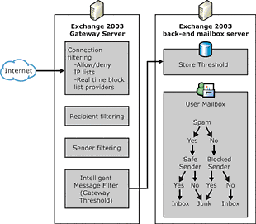
Figure 4. Intelligent Message Filter integration with Exchange Server and Outlook UCE features
Intelligent Message Filter must be installed on a server running Exchange Server 2003 Standard or Enterprise Edition. For more information about installing and configuring Intelligent Message Filter, see “Exchange Server Intelligent Message Filter Overview,” at http://www.microsoft.com/exchange/imf. For more information about antispam features in Outlook, see “Help Prevent Junk E-Mail Messages with Outlook 2003,” at http://www.microsoft.com/office/editions/prodinfo/junkmail.mspx

Summary
Intelligent Message Filter can reduce the amount of UCE by using advanced, server-side message filtering to determine junk and legitimate e-mails. Combined with Outlook 2003 and Exchange Server 2003, Intelligent Message Filter adds to and strengthens the end-to-end hygiene solution by virtue of the server-side and client-side technologies working together to reduce the influx of unsolicited commercial or UCE in Inboxes. Intelligent Message Filter also helps to reduce the costs associated with preventing junk e-mail messages and helps increase end-user productivity by reducing the amount of junk e-mail messages in users’ mailboxes.

Ferris Research, “Spam Control: Problems and Opportunities,” January 2003

