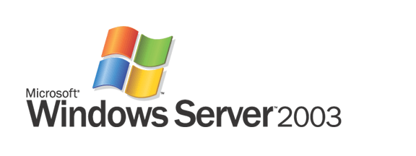

Windows Server 2003 Scalability

Microsoft Corporation
Published: July 2005

Abstract
Your business demands reliable applications that can scale to grow with the company. Significant changes have been in the architecture of Windows Server 2003 to deliver scalability of applications up with 64-processor support and out using a variety of technologies. This white paper examines performance- and scalability-related changes in the Windows Server 2003 operating system. It begins with the core operating system enhancements that affect all major server workloads, followed by an examination of workload-specific changes and throughput gains for several common server workloads: database, Web, file, Active Directory, Terminal Services, and Windows Media Services.



The information contained in this document represents the current view of Microsoft Corporation on the issues discussed as of the date of publication. Because Microsoft must respond to changing market conditions, it should not be interpreted to be a commitment on the part of Microsoft, and Microsoft cannot guarantee the accuracy of any information presented after the date of publication.
This White Paper is for informational purposes only. MICROSOFT MAKES NO WARRANTIES, EXPRESS, IMPLIED, OR STATUTORY, AS TO THE INFORMATION IN THIS DOCUMENT.
Complying with all applicable copyright laws is the responsibility of the user. Without limiting the rights under copyright, no part of this document may be reproduced, stored in or introduced into a retrieval system, or transmitted in any form or by any means (electronic, mechanical, photocopying, recording, or otherwise), or for any purpose, without the express written permission of Microsoft Corporation.
Microsoft may have patents, patent applications, trademarks, copyrights, or other intellectual property rights covering subject matter in this document. Except as expressly provided in any written license agreement from Microsoft, the furnishing of this document does not give you any license to these patents, trademarks, copyrights, or other intellectual property.
© 2005 Microsoft Corporation. All rights reserved.
Microsoft, Microsoft, Windows, Windows NT, Windows Server, the Windows logo, and Active Directory are either registered trademarks or trademarks of Microsoft Corporation in the United States and/or other countries.
All other trademarks are property of their respective owners.
Contents
Executive Summary 1
Windows Server 2003 1
Database Server Workloads 1
Other Enterprise Workloads 3
Server Performance Diagnostics 3
Benefits of Upgrading to Windows Server 2003 3
Introduction 4
Key Concepts and Definitions 4
System Resources 4
Performance 5
Scalability 5
Factors Limiting Server Throughput 5
Microsoft’s Approach to Performance and Scalability 5
Overview of Enhancements in Windows Server 2003 6
Kernel and Kernel-Mode Enhancements 6
Disk I/O and Network I/O 6
NUMA Support 7
64-bit Support 7
Workload-specific Changes and Overall Performance/Scalability Gains 7
Server Performance Diagnostics 7
Kernel-mode Enhancements 8
Multiprocessor Synchronization 8
Optimization of System Locks 8
Queued Spinlocks 9
In-stack Queued Spinlocks 9
Interlocked Operations 9
Non-blocking Queues 10
Pushlocks 10
Other Synchronization-Related Improvements 10
Scheduling 10
Optimization of Scheduler-Related System Locks 11
Reduced Contention for Dispatch Spinlock 11
Elimination of Context Swap Spinlock 11
Improved Hyperthreading Support 11
Other Scheduling-Related Improvements 12
Memory Management 13
System Lock Optimization 14
Page Frame (PFN) lock 14
System Space Lock 14
Commitment Lock 14
Non-paged Pool lock 15
AWE Lock 15
Zero Pages 15
User Mode Large Pages 15
Heap Improvements 15
Other Memory Management-Related Improvements 16
Miscellaneous Kernel-mode Enhancements 17
NUMA Support 18
64-bit Support 19
Disk I/O 21
Storport Driver 21
Increased Queuing Efficiency. 21
More Outstanding Requests 22
Full-duplex Mode 22
Reduced Device Lock Contention 22
DPC-level Hooks 22
Performance and Scalability Improvements 22
Network I/O 24
Auto-tuning support 24
TCP Window Size 24
TCP Offload Support 24
Performance and Scalability Improvements 25
Database 26
Changes that Improve Database Performance and Scalability 26
Database Throughput Benchmarks 27
TPC-C Nonclustered Benchmark 27
Web 28
Changes that Improve Web Server Performance and Scalability 28
Fault-tolerant Process Model and Kernel-mode Web Driver 28
Persisted ASP Template Cache 29
ASP.NET Output Caching 29
Other IIS 6.0 Features and Benefits 30
Web Server Throughput Benchmarks 30
WebBench 30
WebBench: Static Mix 30
WebBench: Dynamic (ISAPI) Mix 31
WebBench: Dynamic (CGI) Mix 32
WebBench: E-Commerce (SSL/ISAPI) Mix 33
WebBench: E-Commerce (SSL/CGI) Mix 34
Nile 35
TPC-W 36
ASP and ASP.NET Scripting 36
Web Hosting 37
File 39
Changes that Improve File Server Performance and Scalability 39
Related Improvements 39
File Server Throughput Benchmarks 40
File Server Consolidation 41
Active Directory 42
Changes that Improve Active Directory Performance and Scalability 42
Larger Directory Database Cache 42
More Efficient Object Storage 42
New Fast Bind Mechanism 42
Improved Query Optimizer 42
Improved Database Replication 42
Active Directory Throughput Benchmarks 43
DirectoryMark 43
Messaging Mix 43
Addressing Mix 44
LDAP Primitives 45
Terminal Server 48
Changes that Improve Terminal Server Performance and Scalability 48
Performance Improvements 48
Other Benefits 49
64-bit Considerations 49
Streaming Media 50
Performance Improvements 50
Server Performance Diagnostics 52
Conclusion 57

Executive Summary
Server scalability is a key requirement to meet changing business needs. Not only must today’s IT solutions deliver adequate levels of throughput to meet current peak processing requirements, but they must also offer a cost-effective path for scaling to support greater workloads in the future. Growth in customer transactions, supporting new sales channels, keeping in compliance with regulatory issues, integrating with new partners, and mining volumes of information to turn raw data into actionable business intelligence are just a few of the business requirements that can drive the need for additional processing power.
Historically, companies were forced to adopt expensive, proprietary solutions to meet their growing throughput needs. Introduction of the Microsoft Windows NT Server operating system in the early 1990s marked the start of a trend that continues to accelerate today: offering a comprehensive migration path from proprietary platforms to a reliable, scalable and secure, cost effective operating system running on industry-standard servers. At the time, the Pentium Pro processor—a desktop-class device—was the most powerful processor available for Intel-based servers.
Introduction of Windows 2000 close to a decade later further accelerated the adoption of Windows in the enterprise. When running on eight-way systems based on Xeon processors, Intel’s first true server-class chip, Windows 2000 Advanced Server delivered enough throughput to support all but the heaviest enterprise workloads. A few months later, Microsoft’s release of Windows 2000 Datacenter Server enabled another step function in throughput for Intel-based servers by supporting up to 32 processors and 64 gigabytes (GB) of RAM. Many companies began building enterprise solutions onto the Windows platform for one simple reason: it met their performance and scalability requirements with far lower development, deployment, and long-term management costs.

Windows Server 2003
With Windows Server 2003, Microsoft has once again raised the bar on server scalability and performance. Optimizations at all levels of the operating system deliver increased throughput for all common server workloads, especially on systems with more than eight processors.
When compared to Windows 2000 Server, the maximum transactions per minute on Windows Server 2003 is ten times greater and throughput is more than doubled in many scenarios, along with greater reliability and manageability. Throughput improvements are far higher when Windows Server 2003 is compared to Windows NT Server 4.0, as are the corresponding differences in reliability and manageability. With support for 64-bit processors, Windows Server 2003 can scale meet the needs of any organization and match the throughput of high-end UNIX-based servers in real world scenarios—at far more attractive price-performance ratios.

Database Server Workloads
Figure 1 shows the history of throughput improvements for the Windows platform when running the TPC-C Nonclustered Benchmark. Between 1996 and 2005, throughput for this widely accepted measure of online transaction processing (OLTP) performance has increased by a factor of 160. During the same time period, cost per transaction decreased by more than 90 percent.
Figure 1: Seven-year history of throughput and price-performance for the TPC-C Nonclustered online transaction processing benchmark. (Source: www.tpc.org as of 9/30/2003)*
Windows Server 2003 marks the latest iteration of this progression. In February 2005, Windows Server 2003 was benchmarked by the Transaction Processing Performance Council (TPC) as the best nonclustered server for price/performance at $1.40/tpmC. In addition to leading in price-performance ratio, Windows Server 2003 boasts powerful performance: TPC has benchmarked a server running Windows Server 2003 with a tmpC—the measure of transaction per minute—of 1,082,203, which works out to 1,558,372,320 transactions per day. To put this figure in perspective, there are approximately 1 billion cash transactions per day worldwide; put another way, this is more than six times the number of daily transactions that would be handled by a large credit card company. Windows Server 2003 can scale to meet the needs of any enterprise.

Other Enterprise Workloads
Microsoft commissioned VeriTest to conduct a series of benchmark tests comparing the performance of Windows Server 2003, Enterprise Edition, Windows 2000 Advanced Server, and Windows NT Server 4.0 Enterprise Edition. Windows Server 2003 delivered significant performance and scalability improvements under all scenarios.
Some highlights of those tests in an eight-processor configuration include:
- Web Server. On static Web content, Windows Server 2003 delivered 487 percent better performance than Windows NT 4.0 and 355 percent better performance than Windows 2000.
- File Server. In a file server scenario, Windows Server 2003 delivered 184 percent better performance than Windows NT 4.0 and 84 percent better performance than Windows 2000.
- Directory Server. On a messaging mix workload, Windows Server 2003 delivered 439 percent better performance than Windows 2000 Advanced Server. Performance on an addressing mix workload was 1,786 percent better on Windows Server 2003 than on Windows 2000.
Windows Server 2003 also delivers large performance and scalability gains for other common server workloads: up to 540 percent greater throughput for streaming media (Windows Media Services), and up 140 percent more users per server for Windows Terminal Server.

Server Performance Diagnostics
In addition to enterprise-class levels of performance and scalability, Windows Server 2003 provides new capabilities that let system administrators examine the behavior of their systems on a request-by-request basis, in response to real-life workloads. This feature is complemented by new reporting tools that help to turn the raw data collected on system behavior into actionable information, which IT professionals can use to identify and resolve application bottlenecks that may be limiting server throughput. In addition to providing raw data, the Server Performance Advisor tool can generate detailed reports, pinpointing problems and pointing to solutions.

Benefits of Upgrading to Windows Server 2003
By taking advantage of the performance and scalability improvements provided by Windows Server 2003, companies with existing Windows-based infrastructures can:
- Get more out of existing hardware investments—as required to support continually increasing workloads or new business applications
- Reduce administrative costs by consolidating onto fewer, more powerful servers
In either case, companies that upgrade to Windows Server 2003 also will benefit from improvements in the areas of security and manageability.
Windows Server 2003 also provides a compelling proposition for companies that today rely on proprietary UNIX-based solutions: a way to meet throughput requirements for mission-critical applications while realizing far greater business agility and future growth coupled with a significantly lower total cost of ownership.

Introduction
High server throughput—that is, the amount of useful work a server can do—is a critical business requirement for many organizations. Getting more work out of a server enables companies to:
- Reduce hardware and software costs when deploying new information technology (IT) solutions
- Increase the capacity of existing systems to meet growing workloads
- Meet capacity requirements or improve system responsiveness for mission-critical applications
- Decrease system administration costs (fewer servers can generally be managed with fewer resources)
Compared to the Windows 2000 Server family of operating systems, the Windows Server 2003 family delivers significant improvements in server scalability and throughput for all major workloads—up to 200 percent in many scenarios. By taking advantage of these improvements, companies can meet increasing IT needs with minimal time and expense. As Terry Treder, Principal Architect for Citrix Systems, reports, "Windows Server 2003 gives us better scalability and stability. Our customers get more users per server and don't have to do as much maintenance."
The remainder of this paper examines those factors that influence server throughput, how those challenges are addressed in Windows Server 2003, and the resultant throughput improvements for several common Windows-based server workloads: database, Web, file, Active Directory, Terminal Services, and Windows Media Services.

Key Concepts and Definitions
The following concepts and definitions will be helpful in understanding the challenges faced in optimizing server throughput and the approaches that Microsoft used to deliver the performance and scalability gains provided in Windows Server 2003.

System Resources
System resources are those internal and input/output (I/O) resources that are required for a server and operating system to run its workload. System resources can be broken down into four areas:
- Processors
- Memory
- Disk I/O
- Network I/O
Every server workload uses some combination of these resources—all require processors and memory, and most also require some amount of network I/O and disk I/O. Processors and memory are typically under full control of the operating system, whereas disk I/O and network I/O throughput for a given server may be affected by other computers that share the same disk storage device or network segment.

Performance
In this document, the term performance refers to the maximum workload that a given server configuration—that is, one with a fixed amount of each system resource—can support. Unlike with desktop computers, for which performance is often measured by application response times in a single-user scenario, performance for most server-based workloads is measured by the maximum throughput (defined as amount of work per unit time) that can be sustained while maintaining acceptable response times.
Units of measurement for server performance are often workload-specific—for example, database transactions per second or Web pages served per second. Measures of maximum server throughput frequently are divided by the average workload generated by one user to obtain an estimate of the number of simultaneous users that the server can support—a useful metric in planning server deployments.

Scalability
At a technical level, a server’s scalability is a measure of the additional throughput that it can deliver as more system resources are added. The term also may be used to describe the maximum system resource configuration for a server—hard limits that are a function of the server’s hardware design and operating system. For example, one could say “Microsoft Windows 2000 Datacenter Server is highly scalable; it can support up to 32 processors and 64 gigabytes of RAM,” or “We’ll need a server and operating system platform that can scale to support twice as many users within the next 18 months.”

Factors Limiting Server Throughput
Each unit of work that a server does—such as serving a request for a Web page or supporting a database transaction—requires some amount of system resources. Because a server has a fixed amount of each resource, its peak performance for any given workload is limited by:
- The maximum system resources that are available
- The efficiency with which those resources are used
Hardware design, operating system design, application architecture, network speed and topology, and storage subsystem performance can all influence a server’s ultimate performance and scalability, with bottlenecks at any level or in any location limiting its overall throughput.
In almost all desktop computer benchmarks, performance is limited by disk I/O. In many server scenarios, however, where the main goal is to maximize overall system throughput while maintaining acceptable response times, CPU cycles are most often the limiting resource. But this is not always the case, and just because a server has spare CPU cycles does not mean that it has spare throughput. System resource usage can vary widely according to workload, resulting in bottlenecks that are caused by a lack of memory, disk I/O, or network I/O.

Microsoft’s Approach to Performance and Scalability
At the time that Microsoft released Windows NT Server version 3.5, its first server operating system, the company formed a dedicated team of engineers to focus on maximizing server operating system performance and scalability. This group works closely with the core Windows software development team, using a four-step methodology to continually improve the performance and scalability of Windows for common customer workloads:
- Workload Definition. Improving performance and scalability begins with an accurate workload definition—one that most closely represents those scenarios in which customers are using Windows. To achieve this, the performance and scalability team combines accepted industry standard benchmarks with internally developed benchmarks that represent real server workloads at customer sites and across Microsoft’s internal IT infrastructure.
- Performance Characterization. After workloads are characterized and benchmark tests are defined, they are run on a broad range of system configurations to characterize performance and scalability with varying amounts of resources. Goals for improvements are set based on previous versions, customer feedback, and the competitive landscape.
- Bottleneck Analysis. In a dedicated performance and scalability lab, the team uses sophisticated tools to examine low-level system behavior and identify bottlenecks. Analysis methods that are employed include the use of bus analyzers, sampling and call trace profilers, built-in Windows instrumentation, and custom tools that are developed by the performance and scalability team or by Microsoft Research. Many of the custom tools are later made available to customers through the Windows resource kit.
- Design and Architecture Improvements. With workloads broken down into low-level operating system primitives, the performance and scalability team works closely with the core Windows development team to identify bottlenecks and influence design improvements. Improvements can range from low-level design changes like alignment of system data structures across processor cache lines to redesigning an entire subsystem, as was done with Internet Information Services 6.0 in Windows Server 2003.
In addition to its internal focus on optimizing operating system performance and scalability, Microsoft works closely with server OEMs to optimize server architectures and reduce hardware bottlenecks.

Overview of Enhancements in Windows Server 2003
The remainder of this paper describes some of the key changes that were made in Windows Server 2003 to improve operating system performance and scalability for common customer workloads. This information is broken down as follows, with each topic discussed in greater detail in the remaining sections of this document:

Kernel and Kernel-Mode Enhancements
Windows Server 2003 includes many enhancements to those core operating system functions that are used to manipulate and manage system resources. Because the efficiency with which system resources are managed affects all server workloads, the benefits resulting from these changes are not limited to any one workload but instead have a broad, positive effect on performance and scalability.

Disk I/O and Network I/O
Most server workloads have some component of disk I/O and/or network I/O. Both types of I/O require processor cycles and memory, so the optimizations in Windows Server 2003 that improve the efficiency with which disk I/O and network I/O is processed leave more system resources available to support other components of a workload.

NUMA Support
Windows Server 2003 contains several enhancements that help to improve performance and scalability on servers that employ a Non-Uniform Memory Architecture (NUMA). This is achieved by optimizing scheduling and memory management to minimize the percentage of time that threads running on one NUMA node have to access “far” memory residing on another NUMA node. Windows Server 2003 also includes NUMA-specific application programming interfaces (APIs) that can be used to optimize application performance.

64-bit Support
Selected editions of Windows Server 2003 include support for servers with new 64-bit CPUs. In addition to processing twice as much data per clock cycle and providing more on-chip computing resources (such as registers) than their 32-bit counterparts, 64-bit CPUs eliminate many of the inherent resource management limitations of 32-bit architectures. By enabling more system resources to be added and to be used more efficiently, 64-bit servers deliver significantly greater levels of performance and scalability.

Workload-specific Changes and Overall Performance/Scalability Gains
In addition to the preceding low-level changes, which contribute to higher levels of throughput for all server workloads, Windows Server 2003 includes many higher-level enhancements that help to increase performance and scalability for specific workloads:
- Database
- Web server
- File System
- Active Directory
- Windows Media Services
- Terminal Services
Each workload is discussed separately in later sections of this document, including a description of any workload-specific changes in Windows Server 2003 and the overall performance and scalability benefits that are realized.

Server Performance Diagnostics
Windows Server 2003 includes significant enhancements to Event Tracing for Windows (ETW), which is high-performance trace instrumentation that captures the paths and resource usage of system requests (such as an HTTP request for a Web page) as they pass through the operating system. Raw trace logs generated by ETW are processed using Server Performance Advisor, a comprehensive reporting and analysis tool that turns the low-level trace data captured by ETW into valuable insights into server behavior. Using ETW together with Server Performance Advisor, system administrators can easily characterize the behavior of real-life workloads toward identifying any resolving any bottlenecks that may be limiting server throughput.

Kernel-mode Enhancements
The kernel-mode components of Windows Server 2003 provide low-level system services such as multiprocessor synchronization, thread scheduling, and memory management, as well as many others. Hardware device drivers, file system, and network adapter drivers also run in kernel mode, as do the windowing and graphics subsystem and hardware abstraction layer (HAL), which isolates the rest of the kernel-mode components from server-specific hardware differences.
Because of their low-level nature, kernel-mode components play a role in all major workloads. Database server, Web server, file server, and most other server workloads all require some combination of processor cycles, memory, disk I/O, and network I/O to get the job done. As such, optimizations made in these areas have a positive effect on the performance and scalability of all major workloads.
A large part of the performance and scalability improvements provided by Windows Server 2003 were realized through optimization of kernel-mode components. At a high level, these changes are grouped into the following areas:
- Multiprocessor Synchronization
- Scheduling
- Memory Management
- Miscellaneous kernel-mode enhancements

Multiprocessor Synchronization
On single processor multithreaded systems, hardware IRQ (interrupt) levels provide an effective means of ensuring that only one thread can operate on critical kernel data structures at any given time. In Windows, this is done by raising the processor's IRQ level to the highest level used by any potential interrupt source that accesses the global data. On symmetric multiprocessor Windows systems, the kernel has the added responsibility of ensuring that only one processor can operate on a critical kernel data structure at any given time, which manipulation of IRQ levels alone cannot achieve.
Mutually exclusive access to shared kernel data structures—such as those that support thread scheduling and memory management—is coordinated using system locks. Before entering a critical code section, a processor must acquire the proper system lock, which is done using an atomic test-and-set operation on a dedicated flag in global memory. If the flag is clear, the lock is immediately set, the data structure is modified, and the flag is cleared. While one processor has the lock, other processors that need to access the same code section are forced to wait. Higher-level synchronization mechanisms such as mutexes and semaphores usually have some sort of low-level system lock (or locks) at their core.

Optimization of System Locks
While system locks provide an effective way for multiple processors to share resources, this comes at the cost of limiting scalability. For example, while one processor has a spinlock, all other processors that are waiting for the same lock are simply “spinning”—constantly testing the lock to see if it has become available and, as a result, not doing any real productive work. This state is called lock contention, and is a key reason why a two, four, or eight processor system cannot deliver two, four, or eight times the throughput of a single-processor system. Lock contention increases with the number of processors, so optimization of “hot” system locks is critical to delivering continued scalability as additional processors are added to a server.
In developing Windows Server 2003, sophisticated hardware and software tools were used to identify hot system locks. Software developers then used this information to make changes that improve operating system scalability by:
- Eliminating the need for some system locks in their entirety
- Decreasing the number of cases where a system lock must be acquired
- Decreasing the length of time that a lock is held
Changes for specific system locks are described in the following sections of this document. These changes play a large role in the scalability improvements that are delivered by Windows Server 2003, especially on systems with a large number of processors.
Queued Spinlocks
In Windows 2000, queued spinlocks were introduced and applied to several global hot locks. Use of queued spinlocks was increased in Windows Server 2003, with several more spinlocks being converted to this type. Compared to regular spinlocks, use of queued spinlocks improves overall kernel efficiency in synchronizing access to shared data structures by:
- Implementing First In First Out (FIFO) queuing for processors that are waiting for the spinlock
- Removing the race condition that occurs when a lock is released and more than one processor is waiting for it
- Reducing bus usage (because of removal of the race condition) and providing a per-processor indicator for the status of the spinlock
Although queued spinlocks were introduced in Windows 2000, their use was limited primarily to the core development team working on the kernel itself. Other developers could not take advantage of the reduced bus utilization and balanced FIFO ordering provided by queued spinlocks because they were limited to the global static type, requiring preallocation of both the lock itself and of an entry in the queue for each processor.
In-stack Queued Spinlocks
Windows Server 2003 extends the performance and scalability benefits of queued spinlocks by providing a new type of queued spinlock, called an in-stack queued spinlock, which developers of kernel-mode code can create an on the fly. Unlike regular queued spinlocks, in-stack queued spinlocks are nonglobal and do not require preallocation of the queue area, which enables them to be shared between threads and allows more than one queued entry per processor. The only restriction is that the activation record that exists when the lock was acquired must still exist when the lock is released.

Interlocked Operations
Interlocked operations are instructions supported by Intel processors (such as compare/exchange) that facilitate atomic updates to memory. In Windows Server 2003, several data structures that used to be protected by spinlocks are now modified using interlocked operations.

Non-blocking Queues
Non-blocking queues are a new primitive in Windows Server 2003, and were used to replace many queues that were protected by spinlocks in Windows 2000. They facilitate the insertion and removal of queue entries in one atomic (non-interruptible) action by taking advantage of interlocked operations.

Pushlocks
Pushlocks are a new locking primitive in Windows Server 2003 and are used instead of spinlocks to protect key kernel data structures. Unlike spinlocks, which must be acquired exclusively for all operations on a data structure, pushlocks can be shared by multiple “readers” and need only be acquired exclusively when a thread needs to modify the data structure.
If a spinlock is held by one or more readers, threads that want to modify the data structure are queued for exclusive access. This queuing mechanism provides some of the same benefits of queued spinlocks—for example, FIFO ordering, elimination of race conditions, and reduced cache thrashing when more than one thread is waiting for the pushlock.

Other Synchronization-Related Improvements
In addition to low-level system locks, several higher-level synchronization primitives were optimized in Windows Server 2003:
- Mutexes. Mutexes are used to gain exclusive access to a resource (at most, one thread at a time can hold a mutex.) In Windows Server 2003, many routines that perform operations on mutexes are inlined by the compiler for increased performance.
- Executive Resources. Executive resources, which are another type of synchronization object, provide both exclusive access and shared read-only access. In Windows Server 2003, routines for operating on executive resources were optimized to avoid use of system locks under certain code paths, such as when there are no waiters in a queue.

Scheduling
Windows Server 2003 is a multithreaded operating system, which means that multiple threads of execution can share a single processor. Although each nonhyperthreaded processor in a system can only run one thread at any given time (hyperthreaded processors can run two), limiting each processor to only one thread over any significant period of time would waste valuable CPU cycles as the system waited for (asynchronous?) events such as disk I/O to complete.
Within the kernel, the scheduler is responsible for determining and tracking which threads run on which processors. Conditions that may cause scheduling events to occur include starting a new process, synchronization with another thread, processing an I/O completion, or a thread running out of its quantum. The code that manages scheduling is distributed throughout the kernel and is very complex, using a complex mix of primitives, queues, system locks, and other data structures to distribute threads of varying priority across multiple processors while ensuring that the system as a whole remains as busy as possible doing productive work.
Windows Server 2003 contains many enhancements to scheduler-related data structures, algorithms, and code paths. Some of those changes that contribute to the significant performance and scalability improvements that are provided by Windows Server 2003 include:

Optimization of Scheduler-Related System Locks
Windows 2000 exhibited high levels of contention for key scheduler-related system locks, especially in systems with more than eight processors. In Windows Server 2003, those system locks were either optimized to reduce contention or removed in their entirety.
Reduced Contention for Dispatch Spinlock
The dispatch spinlock is used to synchronize access to several scheduling-related data structures, including those used to manage processes, threads, ready queues, wait lists, events, kernel queues, mutexes, fast mutexes, and semaphores. Contention for the dispatch spinlock is significantly reduced in Windows Server 2003. This was accomplished by:
- Reducing the frequency of lock acquires for many code paths
  - Replacement of global wait lists and ready queues with per-processor wait lists and ready queues.
  - New per-queue locks eliminate the need to acquire the dispatch spinlock when inserting a thread into an empty scheduling queue
  - Addition of per-thread data structures reduce involvement of the dispatch lock during a context swap (see the “Elimination of Context Swap Spinlock” section that follows)
  - Acquisition of the dispatch lock is no longer required during thread rundown and when flushing an Asynchronous Procedure Call (APC) queue
- Reducing the average and maximum lengths of time that the lock is held
  - Ranking of the dispatch and per-thread Asynchronous Procedure Call (APC) locks was reversed, which reduces hold times for the dispatch lock
  - Priority boosting and quantum adjustment code now resides outside of the dispatch lock—per-thread locks are used instead
  - Code for WAIT routines now resides outside of the dispatch lock
Elimination of Context Swap Spinlock
Context swaps are closely associated with thread dispatch activity. When a thread is dispatched, the context of the previous thread is saved, the context of the new thread is loaded, and the thread is started.
In Windows 2000, the context swap and dispatcher locks both were acquired when performing a context swap or invalidating a translation lookaside buffer (TLB). In Windows Server 2003, the context swap spinlock was replaced with per-thread data structures.
Improved Hyperthreading Support
The first Intel processors to support hyperthreading were the Intel Xeon MP family of processors, which became available in the first half of 2002. With hyperthreading, two separate architectural states (called logical processors) are available on each physical processor. Each architectural state executes a single thread of execution, meaning that two concurrent threads can coexist on a single physical processor.
(Note: On 32-bit versions of Windows, hyperthreading is disabled on systems with more than 16 physical processors. This is because the operating system can handle a maximum of 32 logical processors.)
A key difference between a hyperthreaded processor and two traditional single-threaded processors is that the logical processors on a hyperthreaded processor must share certain physical resources such as the processor’s execution engine, onboard cache set, and system bus interface. As a result, a single hyperthreaded processor cannot deliver the same performance of two similarly equipped single-threaded processors. However, it can deliver significant performance gains over a single nonhyperthreaded processor.
Although the Windows 2000 Server family will run without error on systems with hyperthreaded processors, it was released before the new technology became commercially available. As such, it treats each logical processor as a separate physical processor, ignoring the pairing of logical processors on the same chip and their need to share the same set of processor resources.
Windows Server 2003 recognizes the presence of hyperthreaded processors and is optimized for them. Changes that were made to improve performance and scalability when hyperthreaded processors are present include:
- Scheduling Optimizations. Windows Server 2003 recognizes the pairing of logical processors that share the same on-chip resources and uses this information to optimize thread scheduling. For example, it might schedule a thread on a physical processor with two idle logical processors instead of on a logical processor whose counterpart on the same chip is already busy—to avoid the two logical processors competing for shared on-chip resources. In other cases, the scheduler may optimize performance by ensuring that two threads are dispatched to the same physical processor and will share the same on-chip resources.
- Aggressive HALT of Idle Processors. An idle logical processor can still compete for shared resources with its on-chip counterpart. Compared to Windows 2000, Windows Server 2003 minimizes competition for shared resources by making more aggressive use of the HALT instruction.
- Use of YIELD Instruction. When one logical processor on a chip is spinning (and therefore constantly testing a lock), it uses resources that the other logical processor could possibly put to a more productive use. To alleviate this problem in Windows Server 2003, a YIELD instruction is executed within the code that tests for and acquires a spinlock, allowing the other processor to better use the shared resources for a brief period.

Other Scheduling-Related Improvements
In addition to optimization of scheduler-related system locks, several other scheduler-related changes that help to improve performance and scalability were made in Windows Server 2003. Those changes include:
- Improved anti-convoy features minimize backups in scheduling queues that may occur under certain circumstances (Lock convoys are caused by handing off ownership of a lock without expediting the scheduling of the new owner. If several threads of the same priority repeatedly compete for a lock that is held for a small fraction of total processing time, they run with minimal context switches until a collision occurs by chance. After that, the threads get into a steady state of collision-and-context-switch on every lock acquire thereafter. Because every acquire is a collision when a convoy forms, the rate at which the application can do lock acquires is limited to the rate the system can context switch. This also results in greater contention for the dispatch lock.)
- Improved timer processing, which limits the maximum length of time that the dispatch lock is held during this activity
- Improved support for NUMA systems—for example, scheduling threads on processors with data in near memory (see NUMA section for more details)
- Improved handling of multicast inter-processor interrupts (IPIs) to reduce cache thrashing. (Instead of constantly testing a bit mask, the processor that initiated the IPI now spins on a flag that is set by the last processor to respond to the IPI and adjust the bit mask. This reduces cache thrashing by approximately 50 percent.)
- Reductions in the number of potential IRQL raise and lower operations for scheduling operations

Memory Management
The memory manager in Windows Server 2003 implements a page-based virtual memory management scheme. Systems with 32-bit processors allow the operating system to manipulate at most 4 gigabytes (2³² bytes) of virtual memory, which the memory manager maps to physical memory. Within that limited virtual address space, any single process can access a maximum of 2 GB—an area of memory that is called the user space. The other 2 GB is reserved for system use and is called the system space.
Virtual addresses are not mapped directly to physical memory. Instead, the memory manager uses a two-level scheme by default. A page directory, of which each process has its own, contains a list of 1024 (2¹⁰) page directory entries (PDEs) that each describe the location of a single page table for the process. Each page table, in turn, has 1024 page table entries (PTEs) that store two types of information: a page frame number (PFN) that specifies how a 4 KB (2¹² bytes) range of virtual address space maps to physical memory, and some flags that describe the page frame’s current state and protection levels.
When the memory manager maps a virtual address to physical memory, the first 10 bits of the 32-bit virtual address determine the PDE, the second 10 bits determine the PTE, and the remaining 12 bits determine the offset in bytes within the page frame. Through this mechanism, Windows provides virtual memory that is unique to each process and relatively independent of available physical resources.
Although this method of mapping virtual to physical memory provides good flexibility, it requires the overhead of accessing three memory locations to look up a single PFN. To accelerate PFN lookup, Windows takes advantage of a dedicated on-chip cache called the translation lookaside buffer (TLB). When a PFN lookup is done as described previously, the result is stored in the TLB, which, because it is implemented in hardware, can be searched extremely quickly. However, TLB entries are very valuable because the TLB is small and can only store 32 PFN entries.
In addition to mapping between virtual and physical addresses, the memory manager pages the contents of physical memory to disk when the memory is required for another purpose—and back into physical memory when the data is again needed. Virtual address ranges that may be swapped out to disk are allocated from the paged pool and those that must remain present in physical memory are allocated from the nonpaged pool. A soft page fault occurs when the required data exists in physical memory but not in virtual memory, and a hard page fault occurs when the required data is not in physical memory and must be retrieved from disk.

System Lock Optimization
As with scheduling-related system locks, reduced contention for memory management-related system locks plays a key role in the performance and scalability gains that are provided by Windows Server 2003. Improvements in synchronizing access to system memory across multiple processors include:
Page Frame (PFN) lock
Valid PTEs point to entries in the PFN database, which stores the status of each page physical memory in a system and a pointer back to the page table that is using it. The PFN spinlock is used to ensure that only one processor can modify the PFN database at a time. As such, use of this lock affects all virtual and user address mapping, page faults, and page lockdown for direct memory access (DMA) I/O.
PFN spinlock contention is significantly reduced in Windows Server 2003 through the following changes:
- Reduction in the frequency of lock acquires on many paths, including disk I/O page lock/unlock and soft page faults
- Use of interlocked operations instead of the PFN lock in many cases—for example, AWE locking and unlocking operations
- Bypass of the PFN spinlock for disk I/O to AWE and large pages (AWE and large pages are discussed in more detail later in this section)
- Reduction in hold times when the lock is acquired
- Batching of updates to the PFN database when possible
Reduced PFN lock contention plays a large role the improved performance and scalability of Windows Server 2003, especially on systems with large numbers of processors. In fact, the number of PFN lock acquires is reduced by a factor of 20 on a 32-processor system running the industry-standard TPC-C benchmark.
System Space Lock
In Windows 2000, a system space lock was used to synchronize mapping into system space for I/O operations. This lock is completely eliminated in Windows Server 2003. Instead, nonblocking queues are used to protect those data structures that are used when mapping into system space.
Commitment Lock
Memory pages can have one of three states: free, reserved, or committed. In Windows 2000, a spinlock was used to synchronize access to data structures that are used in committing memory. In Windows Server 2003, those data structures are protected using interlocked operations.
Non-paged Pool lock
Activity of device drivers and other system components that use nonpaged pool can result in high levels of contention for the nonpaged pool lock. Contention for the nonpaged pool lock was reduced in Windows Server 2003 through code path optimization and by implementing per-processor lookaside lists for resources like I/O request packets (IRPs).
AWE Lock
By default, a user process running on a 32-bit version of Windows is limited to 2 GB of private address space. Address Windowing Extensions (AWE), which were introduced in Windows 2000, provide a way to overcome this limitation by taking advantage of 32-bit Intel processor feature called Physical Address Extension (PAE). When booted with the /PAE switch, the memory manager uses another layer of address translation together with 64-bit wide PDEs and PTEs to support up to 64 GB of physical memory. However, this benefit is not without overhead; an additional layer of address translation is required and special AWE operations must be used to manipulate a 32-bit window into the larger physical memory space.
In Windows 2000, a per-process spinlock was used to synchronize access and modifications to AWE-related data structures—a technique that forced the serialization of all allocating, freeing, mapping, and unmapping of AWE pages. In Windows Server 2003, a per-process pushlock is used instead. Mapping and unmapping operations can acquire the pushlock in a shared manner, allowing those operations to be performed in parallel and improving the scalability of AWE page map and unmap operations. When allocating and freeing AWE pages, the pushlock must be acquired exclusively.

Zero Pages
Pages of physical memory are zeroed—that is, any existing data contained in that memory is wiped clean—proactively and on-demand to help ensure security. In Windows 2000, page zeroing upon boot-up was done with a single thread. In Windows Server 2003, page zeroing during boot-up is done with one thread per processor, which makes this process much faster on multiprocessor systems.
Page zeroing also is faster after a server is up and running. For example, when restarting SQL Server 2000 on a server running Windows 2000, one thread would zero the memory allocated to SQL Server. Windows Server 2003 makes available a pool of worker threads for this operation, which decreases the time required to zero the pages.

User Mode Large Pages
By default, Windows uses a 4 KB page size. Support for larger page sizes was available in Windows 2000, but large pages were limited to system use. Windows Server 2003 adds support for user mode large pages, which are 4 megabytes (MB) in size on 32-bit systems. Using large pages, large amounts of physical memory can be managed with far fewer PTEs, which improves the TLB hit ratio and therefore delivers better performance and scalability.

Heap Improvements
A heap is a region of reserved memory within which variables and other data structures can be dynamically allocated and deallocated. Major heap-related changes in Windows Server 2003 include:
- Faster heap creation. Per-process heaps are now created faster, which improves performance and scalability be reducing process creation time.
- Monitoring heap usage. Heap usage now can be monitored with the performance monitoring utility (this capability is enabled in the registry).
- Low fragmentation heap. Windows Server 2003 provides a new type of heap called the Low Fragmentation Heap (LFH). Based on work done at Microsoft Research, the LFH is accessed through a new API and reduces the amount of time that it takes to find a properly sized block of memory.

Other Memory Management-Related Improvements
In addition to the key improvements described previously, Windows Server 2003 contains several other memory management-related enhancements. Some of those include:
- Improved I/O float count. Per-processor pools of available I/O request packets (IRPs) are kept to reduce the number of allocations and frees to the nonpaged pool. In Windows Server 2003, cross-processor balancing heuristics for IRPs were reworked to dramatically reduce the number of IRP allocations that fall through to the global nonpaged pool allocator.
- Improved lookaside list autotuning. Lookaside lists are relatively small data structures that cache a limited number of look-up entries to improve performance for commonly used routines. In Windows 2000, all lookaside lists were tuned—that is, had their maximum sizes adjusted—whenever the autotuning routine ran. In Windows Server 2003, that same routine was modified to only address a subset of all lookaside lists on any given pass. This improves scalability by decreasing the maximum amount of time that the routine is active.
- Improved working set trimming. Claims-based working set trimming is now used for multiprocessor as well as uniprocessor systems (Windows 2000-based multiprocessor systems used page fault-based trimming—a reactive method that adjusts working sets based on page faults.) Claims-based working set trimming improves server performance and scalability by monitoring memory usage and proactively planning where and how to trim working sets (that is, making “claims” ahead of time.) This helps reduce page faults and enables systems to scale from light or moderate to heavy workloads more gracefully.
- Larger maximum sizes for critical system resources. Compared to Windows 2000, Windows Server 2003 can provide larger maximum sizes for paged pool, nonpaged pool, the page frame database, and the file system cache. In addition, Windows Server 2003 can better balance the allocations of those resources against each other—necessary because they all reside in system space.
- Reduced working set mutex hold times. In Windows Server 2003, those routines that operate on working set mutexes were optimized to reduce the maximum amount of time that the mutex is held. This was done by optimizing code paths and moving nonessential operations outside of the mutex.
- Balanced VAD tree. The virtual address descriptor (VAD) tree was changed from a binary splay search tree to an AVL balanced tree. In addition, the tree now is bitmapped for faster allocations and searches.
- Fewer IRQL operations. The number of potential interrupt request level (IRQL) raise and lower operations is reduced for all memory management operations—for example, pool and AWE mappings.

Miscellaneous Kernel-mode Enhancements
In addition to the previously described changes, many other enhancements were made in Windows Server 2003 to improve performance and scalability:
- Data structure alignment. Many global and per-processor kernel data structures were realigned to reduce false sharing and cache thrashing, which can occur when two or more independent variables are located in memory such that they share the same cache line. In addition, variables that are frequently used together now are prefetched in many cases.
- Inlining of hot functions. Small, frequently used routines—often leaf functions—are inlined at compile time to reduce path length. Selective inlining of “hot” routines eliminates the cost of function calls and returns with a minimal impact on code space and therefore cache hit ratios.
- Processes, threads, handles, objects, and named pipes. Windows Server 2003 includes changes to many other low-level operating system primitives and functions. Some of those changes include:
  - Reduction in the time required for handle table inheritance and rundown, which improves process creation times—especially when handles are inherited
  - Reduction in lock usage and contention for the handle table
  - Reduction in the number of registry touches when a process is created
  - Reduction in process lock usage
  - Use of a pushlock for a fast read/write lock
  - Finer granularity locking for the object manager
  - Reduction in lock contention on named pipes

NUMA Support
As processor clock rates and memory access speeds continue to increase, it becomes increasingly difficult to support large amounts of processors and memory using a single system bus without the bus becoming a bottleneck. A technique that is frequently used to overcome this limitation on large, high-end servers is Non-Uniform Memory Architecture (NUMA).
As Figure 2 illustrates, NUMA uses a building-block technique where two or more nodes are connected using a cache-coherent interconnect. Each node contains processors (usually four), memory, and, in some cases, an I/O subsystem. Processors access memory within their own node—called near memory—using a direct path through the node’s memory controller. Memory in a different node—called far memory—is accessed using a path that goes through the first node’s memory controller, over the system interconnect, and through the second node’s memory controller. As a result, accessing data in far memory requires significantly more time than retrieving information that is stored in near memory.
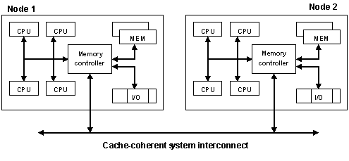
Figure 2: Architecture of an eight-processor server utilizing two NUMA nodes.
To achieve the best performance when running a single operating-system image on a NUMA-based system, the percentage of time that processors need to access far memory over the system interconnect must be kept to a minimum. Windows Server 2003 does this in several ways:
- Scheduling. During boot, processes are assigned to NUMA nodes using a round-robin algorithm. New threads inherit the process’s node affinity—that is, they are assigned to a processor in the same node to which the original process was assigned. This ensures that, wherever possible, the threads for any given process run within the same NUMA node. Similarly, threads are rescheduled on the same node to which they were originally assigned.
- Memory Management. The memory manager creates paged and nonpaged pools for each NUMA node. When a thread requests memory, the memory manager tries to allocate physical memory from the same node on which the thread is running. Memory requested AWE also is allocated on the same node whenever possible.
- NUMA APIs. To assist developers in optimizing application performance, optimize performance, the topology of a NUMA system is made available to application software through a set of Windows APIs. Developers can use this information to ensure that threads with dependencies on shared memory structures and data caches have their affinities set to processors within the same node, and that data caches and control structures are optimally partitioned across NUMA nodes.

64-bit Support
Windows 2000 Datacenter Server, the most scalable version of the Windows 2000 Server family, provided support for up to 32 32-bit processors and up to 64 GB of RAM. Windows Server 2003 includes two editions (Enterprise Edition and Datacenter Edition) that support 64-bit processors, with the latter capable of supporting up to 64 processors and up to 512 GB of RAM.
In addition, Windows Server 2003 x64 is a version of Windows Server 2003 explicitly extended to the 64-bit environment, available in a Standard Edition, an Enterprise Edition, and a Datacenter Edition. Standard Edition supports up to 4 processors and 512 MB of RAM; Enterprise Edition supports up to eight processors and 1 terabyte of RAM; Datacenter Edition supports up to 64 processors and 1 terabyte of RAM.
Compared to 32-bit processors, 64-bit processors offer several advantages in themselves:
- They can do twice as much work per processor cycle—that is, they can manipulate 64 bits of data per clock cycle instead of 32 bits.
- They typically have more on-chip resources such as memory cache and registers, as well as new execution architectures.
However, for many workloads, a larger benefit provided by 64-bit processors is that they natively support 64-bit memory addressing. This eliminates the 4GB virtual address space barrier that is inherent in 32-bit systems, providing one that is 4 billion times larger. An almost unlimited virtual address space provides several advantages:
- System address space. With 64-bit systems, the operating system is no longer limited to 2GB of system space. As a result, system data structures that reside within this virtual address space are no longer limited in size. A few examples of the benefits this provides in scaling the operating system include:
  - 64-bit Windows systems can support up to one million concurrent network connections, which is ten times the 100,000-connection capacity of a 32-bit system
  - The maximum number of processes that can be created on a 64-bit Windows system is 550,000, a number 22 times larger than the 22,000-process limit for a 32-bit Windows system
  - User-mode large page size is increased from 4 MB to 16 MB, which enables four times as much memory to be supported with the same number of PTEs
- User space. In 64-bit systems, far more physical memory can be installed and efficiently used. Applications that may benefit from large amounts of physical memory are no longer limited to 64 GB, nor must they endure the additional address translation overhead imposed by AWE to access more than 2GB of user space per process. For example, performance of SQL Server is significantly better on 64-bit systems because of a far larger virtual address space.
Performance and scalability of disk and network I/O also is improved on 64-bit servers with more than 4 GB of memory. Network adapters that are 64-bit capable can perform direct memory access (DMA) operations into physical memory locations above 4 GB. This capability eliminates the need for double buffering—that is, when data residing in memory locations above 4 GB must be temporarily moved into a locations below 4 GB before it can be accessed by a 32-bit network adapter. The same holds true for disk I/O.

Disk I/O
Many of the previously described synchronization, scheduling, and memory management enhancements in Windows Server 2003 play a role in disk I/O processing. The optimizations in those areas help to increase the efficiency with which disk I/O is processed, which results in higher disk I/O throughput. Those previously described changes that make the largest contributions to improved disk I/O processing include:
- Reduced contention for the Dispatcher, PFN, and Nonpaged Pool system locks
- Elimination of the Context Swap, AWE, and System Space locks
- Changing scheduler data structures from a global basis to a per-CPU basis
- Improved per-CPU IRP heuristics
- Realignment of global and per-CPU system data structures to reduce false sharing and cache thrashing
- Inlining of hot functions
- Use of in-stack queued spinlocks
- Use of nonblocking queues
- Improvements in the handling of inter-processor interrupts
- Reduction in the frequency of IRQL raise and lower operations for scheduling and memory management

Storport Driver
Windows 2000 provided a SCSI port driver (scsiport.sys) as a component of its disk I/O subsystem. Windows Server 2003 introduces a new port driver called Storport (storport.sys), which delivers significantly greater disk I/O processing efficiency and throughput—especially when used with high-performance devices such as host-based RAID and fiber-channel adapters.
There are several advantages to using the Storport driver, including reduced system resource usage and better performance (it should perform at least as well as a monolithic port driver). Some of the primary reasons for the Storport driver’s better performance and resource usage include:
Increased Queuing Efficiency.
The SCSI port driver uses two levels of queuing: at the logical device level, with one queue per device, and at the adapter level, with one queue per adapter. All disk I/O must pass through a queue at each level, with each queue using locking mechanisms to maintain integrity and thus posing a point of lock contention. In contrast, the Storport driver only queues at the logical device level—queuing information for the adapter level also is tracked but does not reside in a second level of queue. Avoiding this second level of queuing provides significant throughput benefits.
More Outstanding Requests
With the SCSI port driver, a maximum of 255 outstanding I/O requests are allowed per adapter. The Storport driver allows up to 255 requests per logical device, with no per-adapter limits (however, the adapter itself still may have a limit.) Because there are typically many logical devices connected to any one physical adapter, Storport facilitates a far greater number of outstanding I/O requests at any one time.
Full-duplex Mode
Unlike the SCSI port driver, the Storport driver is capable of processing disk input and disk output at the same time. With the SCSI driver, access to the miniport driver is completely synchronous—that is, an interrupt spinlock is acquired, held, and released whenever data is passed between the SCSI port driver and the miniport driver. A similar locking mechanism is used as data passes between the miniport driver and the hardware adapter. As a result, the SCSI driver can process either an initiation or a completion, but not both at the same time.
Because of its design, the Storport driver does not require raising IRQ levels when generating an I/O request. This enables it to simultaneously receive interrupts, resulting in an ability to process initiations and completions at the same time.
Reduced Device Lock Contention
With the SCSI port driver, a “common” lock is acquired and held when initiating I/O and receiving interrupts. The Storport driver uses more granular locking, enabling multiple I/Os to pass through the port driver and into the miniport driver—and in the other direction—at the same time. This granular locking is the reason for the Storport driver’s full-duplex capabilities.
DPC-level Hooks
When writing device drivers, a common design goal is to perform as much work as possible at the dispatch level instead of at the interrupt level—the latter preventing other devices from doing their work. Storport includes hooks that allow miniport drivers to do work later—that it, at the Deferred Procedure Call (DPC) level.

Performance and Scalability Improvements
Figure 3 illustrates the disk I/O throughput and processing efficiency gains provided by Windows Server 2003 (Datacenter Edition). Data presented is for 8 KB random concurrent reads—representative of an OLTP environment with large numbers of small, random I/Os. Some highlights include:
On a 2-processor server, Windows Server 2003 delivers 136 percent greater disk throughput than Windows 2000. In this scenario, CPU usage—not the physical disk subsystem—is the limiting system resource. CPU usage is roughly 100 percent for both configurations, yet the server running Windows Server 2003 processes more than twice as many I/Os with the same number of processor cycles.
On a 32-processor server, Windows Server 2003 delivers 12 percent greater I/O throughput at 30 percent lower processor utilization. In this scenario, the physical disk subsystem—not CPU usage—is the limiting system resource. Note that Windows 2000 requires 16 processors to reach this point, whereas Windows Server 2003 requires only four.
Figure 3: Disk I/O throughput for Windows Server 2003 Datacenter Edition and Windows 2000 Datacenter Server (SP1). (Test hardware: Unisys ES7000 server with 32 Xeon MP 2.8 GHz Intel Xeon processors, Unisys external disk storage system with 480 18GB 15,000 RPM disk drives (220 used in testing), and an Emulex LP8000 Fiber Channel host adapter.)

Network I/O
In Windows Server 2003, many of the low-level enhancements that improve disk I/O processing also contribute to increased throughput and processing efficiency for network I/O. In addition, many the techniques that were used to optimize synchronization, scheduling, and memory management also were applied to networking-specific routines and data structures:
- Improved I/O code paths. Algorithms that operate on networking data structures were reworked to reduce code paths and minimize processor usage.
- Synchronization. Networking data structures and default configurations were reworked to facilitate improved sharing across multiple processors.
- Data Structure Alignment. Networking data structures were realigned across memory boundaries to reduce false sharing and cache-thrashing.
Enhancements also were made at higher levels, including optimizations to the networking stack and to higher-level network services.

Auto-tuning support
Windows Server 2003 provides improved support for network adapters with autotuning features. Adapters with this capability monitor themselves and adjust their behavior in an adaptive manner—for example, adjusting the frequency with which they generate interrupts to indicate network activity or its completion. Some network adapters also are capable of adjusting their behavior based on factors such as processor utilization.

TCP Window Size
In Windows Server 2003, TCP window size is automatically adjusted based on network media speed to optimize networking throughput. (TCP window size determines the maximum number of bytes that can be sent before an acknowledgement is required. As such, its value can affect the throughput with which data is sent.)

TCP Offload Support
Windows Server 2003 provides support for network adapters with TCP offload support, in which tasks that are normally performed by the TCP/IP transport are offloaded to the network card. By freeing a server from performing those tasks, more system resources remain available to do other work.
Examples of tasks that can be offloaded to a NIC with TCP offload support include:
- Checksums. The TCP/IP transport can offload the calculation and validation of IP and/or TCP checksums.
- Internet Protocol Security (IP-SEC). The TCP/IP transport can offload the calculation and validation of encrypted checksums for authentication headers and/or encapsulating security payloads (ESP). The transport also can offload the encryption and decryption of ESP and UDP-encapsulated ESP data packets.
- Segmentation of large packets. The TCP/IP transport supports Large Send Offload (LSO), in which the segmentation of large TCP packets is performed by the network card.

Performance and Scalability Improvements
When their individual contributions are combined together, the networking-related changes in Windows Server 2003 contribute to substantial gains in throughput and processing efficiency for network I/O—helping to improve performance and scalability for all major workloads. Some specific results include:
- More concurrent connections. Up to 1 million concurrent network connections can be supported before running out of virtual address space—a significant improvement over Windows 2000. This is especially beneficial for servers that support chat or online gaming.
- Improved networking throughput. Compared to Windows 2000, Windows Server 2003 delivers improved throughput for many common networking protocols:
  - Up to 25 percent higher TCP/IP send throughput
  - Up to 20 percent higher UDP/IP send throughput
  - Up to 20 percent higher virtual private network (VPN) tunneling throughput
- Higher throughput for network services. Compared to Windows 2000, Windows Server 2003 delivers substantial improvements in throughput for common network services:
  - Up to 500 percent higher throughput for streaming media (see the Windows Media section later in this document for additional information)
  - Up to 120 percent higher throughput for domain name service (DNS) queries
  - Up to 125 percent higher throughput for file transfer protocol (FTP) workloads

Database
Databases are at the heart of most business systems. Performance and scalability are critical for database servers because of the added complexity involved in partitioning data across multiple systems—if possible at all.
Database throughput depends heavily on scheduling, memory management, and disk I/O. In addition, synchronization becomes increasingly important as the number of processors in a database server increases. In fact, database management systems (DBMS) such as Microsoft SQL Server are extremely sophisticated systems themselves, often with their own internal mechanisms for synchronization, scheduling, and memory management. Because of this, the ultimate efficiency with which a database server uses system resources is heavily dependent on the level of integration between the DBMS and its underlying operating system.
Databases rely on several previously discussed kernel-mode mechanisms:
- Scheduling. Database systems like SQL Server typically rely on a fairly large pool of worker threads to support multiple simultaneous database transactions.
- Memory Management. SQL Server manages its own memory using the capabilities provided by the memory manager, windowing into the proper section of physical memory in support of transactions.
- Disk I/O. Databases often are many times the size of a system’s installed physical memory, so data is frequently paged between memory and disk.
- Network I/O. Although network I/O is required to send requests to the database server and to return the appropriate results, it typically is not a resource bottleneck.

Changes that Improve Database Performance and Scalability
Because database servers rely heavily on processor cycles, memory, and disk I/O, changes in those areas all contribute to better throughput. Some of the previously discussed changes that have the largest impact on database server performance and scalability include:
- Support for more physical memory (with 64-bit systems)
- Optimization of system locks for scheduling and memory management
- Optimization of kernel data structures to take advantage of new hardware features (such as larger cache sizes, bigger buses, and so on)
- Improved Hyper-threading support
- Improved NUMA support
- Improved I/O path lengths and scalability
- Improved disk I/O Performance

Database Throughput Benchmarks
Windows Server 2003 delivers significant improvements in performance and scalability for all major database benchmarks, especially on systems with more than eight processors (on 32-processor Windows systems, the throughput gains provided by Windows Server 2003 are often greater than 200 percent).

TPC-C Nonclustered Benchmark
Published by the Transaction Processing Performance Council (TPC), the TPC-C benchmark is a widely used standard for measuring the performance of database systems in online transaction processing (OLTP) applications. It simulates a large number of end users executing transactions against one database. The database performs a large number of small transactions, which generates a fairly large number of small, random disk I/Os.
Figure 4 shows the results of TPC-C Nonclustered benchmark tests for various servers running Windows Server 2003 and SQL Server 2000. You can find more information on the TPC-C benchmark at http://www.tpc.org/tpcc/detail.asp.
Figure 4: Performance of Windows Server 2003 on the TPC-C Nonclustered benchmark.

Web
Continually increasing demand for new types of Web-based applications and Web services raises the importance of performance and scalability for Web servers. The speed and efficiency with which Web requests are processed directly affects the workload that a Web server can support or the number of Web sites that can run on a single server.

Changes that Improve Web Server Performance and Scalability
Microsoft Internet Information Services (IIS) 6.0, the Web server in Windows Server 2003, was redesigned from the ground up. It combines a cache-enabled, kernel-mode Web driver with a new fault-tolerant process model to deliver significantly better performance, scalability, manageability, and security for Web-based applications and Web services.

Fault-tolerant Process Model and Kernel-mode Web Driver
Figure 5 illustrates the major differences between IIS 5.0 and IIS 6.0. In IIS 5.0, requests came in through TCP/IP to AFD.SYS (the kernel-mode part of WinSock 2.0), were passed across the kernel/user mode boundary to the user-mode component of WinSock 2.0, and then passed to INETINFO.EXE. When using the IIS 5.0 out-of-process model, requests for dynamic content would then be passed to a separate ISAPI or ASP process.
Figure 5: Architectures of IIS 5.0 and IIS 6.0.
In IIS 6.0, requests are passed directly from the network stack to a kernel-mode Web driver, HTTP.SYS—the AFD.SYS driver and Winsock 2.0 layer no longer play a role (although they can still be used if desired). HTTP.SYS then examines the request, determining if it can be satisfied from the driver’s own cache (see Figure 6). If so, the requested content is immediately returned without a context switch from kernel mode to user mode.
Figure 6: HTTP.SYS can satisfy requests for static content directly from its cache.
When the kernel-mode Web driver cannot satisfy a request from its cache, HTTP.SYS passes the request across the kernel/user boundary directly to a worker process for servicing. In addition to delivering significantly better Web server throughput, the new architecture of IIS 6.0 significantly improves Web server stability because a single faulty application running on the Web server can no longer bring down other applications on the same server. The worker process that is servicing the faulty application can simply be recycled without affecting other worker processes.

Persisted ASP Template Cache
With IIS 5.0, before ASP code was ran, it was compiled into a template that was stored in process memory. Because this cache was limited in size, older templates were flushed from the cache to make room for newer templates. If the older template was again required, it had to be recompiled, which carried a significant cost in terms of system resources.
To avoid this additional use of system resources, IIS 6.0 persists compiled ASP templates to disk. If the template is required later, it is loaded from disk instead of loading the ASP code and dedicating additional system resources to recompiling it.

ASP.NET Output Caching
ASP.NET enables the caching of dynamically generated content. Called ASP.NET output caching, this feature allows subsequent requests for the same content to be satisfied a cache so that the code that is used to initially create the content does not need to be run again. Using ASP.NET output caching to cache frequently accessed content can significantly improve a Web site’s overall throughput.

Other IIS 6.0 Features and Benefits
IIS 6.0 includes many other new features that help to improve Web server performance and scalability. For more information on those features as well as the improvements that IIS 6.0 provides in the areas of security and manageability, go to http://www.microsoft.com/windowsserver2003/evaluation/overview/technologies/iis.mspx.

Web Server Throughput Benchmarks
Because of the preceding changes, Windows Server 2003 delivers significant improvements in Web server performance and scalability—in some cases approaching 500 percent. The following benchmark test results confirm those improvements over a broad range of workloads: static Web content, dynamic Web content, and several e-commerce scenarios.

WebBench
Microsoft commissioned VeriTest to compare the performance of Windows Server 2003 (Enterprise Edition), Windows 2000 Server (Enterprise Edition), and Windows NT Server 4.0 (Enterprise Edition) across a number of Web server configurations and workloads. Tests were performed using Ziff Davis Media’s WebBench 4.1 benchmarking software, which uses a large number of client PCs to generate an HTTP-based workload for different combinations of static and dynamic Web content.
WebBench results are measured in terms of total bytes and requests per second. All requests are nonkeepalive; each request requires establishing a connection between the client and the Web server, transmitting a request, processing the request, transmitting a response, and closing the connection. As such, WebBench results also are affected by the efficiency with which a network stack can establish and tear down a large number of connections.

WebBench: Static Mix
This benchmark measures a Web server’s ability to serve Web content that does not change, such as straight HTML files and graphics. As illustrated in Figure 7, Windows Server 2003 delivers large improvements in performance and scalability across all tested configurations.
Some highlights include:
- On a one-processor server, Windows Server 2003 delivered 80 percent better performance than Windows 2000 and 162 percent better performance than Windows NT Server 4.0.
- On a two-processor server, Windows Server 2003 delivered 117 percent better performance than Windows 2000 and 197 percent better performance than Windows NT 4.0.
- On a four-processor server, Windows Server 2003 delivered 217 percent better performance than Windows 2000 and 297 percent better performance than Windows NT 4.0.
- On an eight-processor server, Windows Server 2003 delivered 355 percent better performance than Windows 2000 and 487 percent better performance than Windows NT Server 4.0.
Figure 7: WebBench static benchmark.

WebBench: Dynamic (ISAPI) Mix
This part of the WebBench benchmark measures a Web server’s ability to service a workload where 80 percent of requests are for static content and the remaining 20 percent invoke a simple ISAPI-based module. As illustrated in Figure 8, Windows Server 2003 delivers significant improvements in performance and scalability across all tested configurations.
Some highlights include:
- On a one-processor server, Windows Server 2003 delivered 64 percent better performance than Windows 2000 and 109 percent better performance than Windows NT Server 4.0.
- On a two-processor server, Windows Server 2003 delivered 98 percent better performance than Windows 2000 and 134 percent better performance than Windows NT 4.0.
- On a four-processor server, Windows Server 2003 delivered 110 percent better performance than Windows 2000 and 176 percent better performance than Windows NT 4.0.
- On an eight-processor server, Windows Server 2003 delivered 333 percent better performance than Windows 2000 and 368 percent better performance than Windows NT Server 4.0.
Figure 8: WebBench dynamic (static + ISAPI) benchmark.

WebBench: Dynamic (CGI) Mix
This test is similar to the previously described dynamic benchmark (static + ISAPI) except that 80 percent of requests are for static content and the remaining 20 percent invoke CGI scripts. As illustrated in Figure 9, Windows Server 2003 delivers significantly improved performance and scalability across all tested configurations.
Some highlights include:
- On a one-processor server, Windows Server 2003 delivered 21 percent better performance than Windows 2000 and 39 percent better performance than Windows NT Server 4.0.
- On a two-processor server, Windows Server 2003 delivered 78 percent better performance than Windows 2000 and 84 percent better performance than Windows NT 4.0.
- On a four-processor server, Windows Server 2003 delivered 91 percent better performance than Windows 2000 and 175 percent better performance than Windows NT 4.0.
- On an eight-processor server, Windows Server 2003 delivered 159 percent better performance than Windows 2000 and 263 percent better performance than Windows NT Server 4.0.
Figure 9: WebBench dynamic (static + CGI) benchmark.

WebBench: E-Commerce (SSL/ISAPI) Mix
This benchmark uses a workload where 76 percent of requests are for static content, 20 percent invoke a simple ISAPI-based module, and the remaining 8 percent require encryption using Secure Sockets Layer (SSL) 3.0. As illustrated in Figure 10, Windows Server 2003 delivers improvements in scalability and performance for this workload across all tested configurations.
Some highlights include:
- On a one-processor server, Windows Server 2003 delivered 34 percent better performance than Windows 2000 and 74 percent better performance than Windows NT Server 4.0.
- On a two-processor server, Windows Server 2003 delivered 61 percent better performance than Windows 2000 and 110 percent better performance than Windows NT 4.0.
- On a four-processor server, Windows Server 2003 delivered 81 percent better performance than Windows 2000 and 158 percent better performance than Windows NT 4.0.
- On an eight-processor server, Windows Server 2003 delivered 333 percent better performance than Windows 2000 (Windows NT Server 4.0 was not tested with eight processors).
Figure 10: WebBench E-commerce (static + ISAPI + SSL) benchmark.

WebBench: E-Commerce (SSL/CGI) Mix
This test is similar to the SSL/ISAPI e-commerce benchmark just described except that the 16 percent of requests that call ISAPI modules are replaced by requests that execute CGI scripts. As illustrated in Figure 11, Windows Server 2003 delivers improvements in scalability and performance for this workload across all tested configurations.
Some highlights include:
- On a one-processor server, Windows Server 2003 delivered 28 percent better performance than Windows 2000 and 50 percent better performance than Windows NT Server 4.0.
- On a two-processor server, Windows Server 2003 delivered 97 percent better performance than Windows 2000 and 85 percent better performance than Windows NT 4.0.
- On a four-processor server, Windows Server 2003 delivered 150 percent better performance than Windows 2000 and 349 percent better performance than Windows NT 4.0.
- On an eight-processor server, Windows Server 2003 delivered 587 percent better performance than Windows 2000 and 330 percent better performance than Windows NT 4.0.
Figure 11: WebBench E-commerce (static + CGI + SSL) benchmark.

Nile
The Nile benchmark, published by Doculabs, uses a mix of 72.4 percent static requests and 27.6 percent dynamic requests to simulate a typical e-commerce workload. Operations include logon, browsing items, searches, shopping cart operations, and check-out—many of which involve database transactions. As illustrated in Figure 12, Windows Server 2003 delivers significant performance and scalability improvements for all configurations.
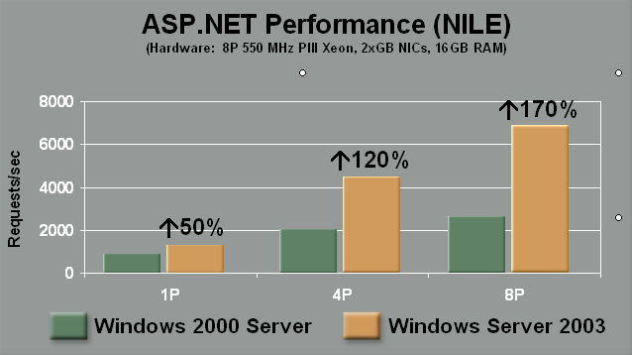
Figure 12: Nile benchmark.

TPC-W
TPC-W is a benchmark published by the Transaction Processing Council. It measures Web interactions per second (WIPS) using a mix of static, ISAPI, and SSL requests. Like the Nile benchmark, it requires significant database access. Figure 13 shows the performance and scalability gains provided by Windows Server 2003 for the TPC-W benchmark.
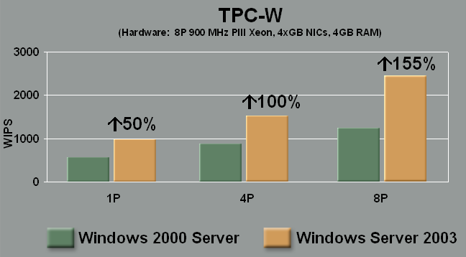
Figure 13: TPC-W benchmark.

ASP and ASP.NET Scripting
Figures 14 and 15 show the performance of ASP and ASP.NET scripting on both Windows Server and Windows Server 2003. The tests uses a “large corporate workload” representative of Microsoft’s own Web site architecture: 14,000 ASP or ASP.NET scripts, where 60 percent of all requests are for a small hot-set of 160 scripts and with some scripts that use ADO or ADO.NET to access a data store. As illustrated, Windows Server 2003 delivers greater levels of performance and scalability for both ASP and ASP.NET scripting.
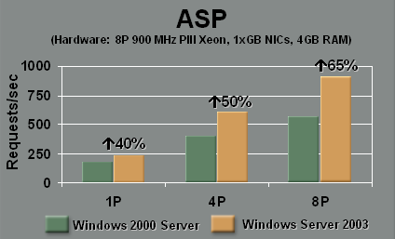
Figure 14: ASP scripting performance.
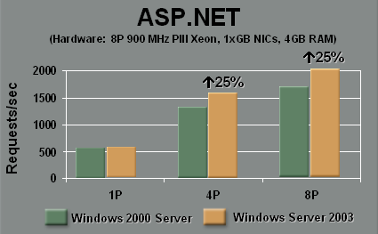
Figure 15: ASP.NET scripting performance.

Web Hosting
The performance and scalability improvements provided by Windows Server 2003 make it far more efficient and economical for Web hosting, where large numbers of Web sites are hosted on each server. In fact, one server running Windows Server 2003 can host up to 50,000 Web sites.
Figure 16 shows the maximum requests per second for large numbers of Web sites on a two-processor server. Figure 17 shows the startup times for the same scenarios. As illustrated in the test results, Windows Server 2003 can service 245 percent more requests per second and restarts up 8 times faster than Windows 2000 when hosting 10,000 Web sites.
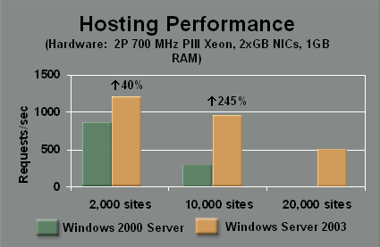
Figure 16: Web site hosting on Windows 2000 and Windows Server 2003.
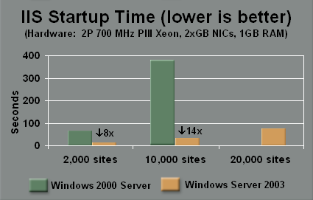
Figure 17: Web server startup times when hosting a large number of sites.

File
The Windows operating is widely used for file server applications. However, many companies still run Windows NT Server 4.0 for this purpose. By taking advantage of the improvements in file server performance and scalability that are provided by Windows Server 2003, companies can reduce administrative costs by consolidating existing file server workloads onto fewer servers.

Changes that Improve File Server Performance and Scalability
When a Windows-based desktop client accesses a file on a Windows-based file server, it uses the Server Message Block (SMB) protocol—a Windows implementation of the Common Internet File System (CIFS). Both ends of the connection—client and server—run software components that work together to provide users with access to remote files.
Windows Server 2003 includes several changes that improve file server performance and scalability. Client and server file system components work together, so peak file server throughput for Windows Server 2003 is achieved when running Windows XP on client PCs. However, significant improvements in file server throughput can still achieved by upgrading only the file server to Windows Server 2003.
Some of the key file system improvements in Windows Server 2003 include:
- Improved handle and file metadata caching, which minimizes the number of round-trips and data that is transmitted between the client and server.
- The cache scavenger thread now runs at a tunable interval instead of a fixed 10-second interval.
- Improved processor affinity, which provides increased scalability on multiprocessor systems.
- Zero-copy reads are used when serving the same file to multiple clients.
File server throughput also benefits from the synchronization, scheduling, memory management, disk I/O, and network I/O improvements in Windows Server 2003. Use of TCP-offload enabled (TOE) network cards together with Windows Server 2003 for file servers delivers incremental throughput gains because the workload is networking-intensive and processor-intensive.

Related Improvements
In addition to the preceding changes, which directly affect file server throughput, Windows Server 2003 includes several file system-related improvements:
- Improved CHKDSK Performance. Testing by VeriTest shows that CHKDSK running on Windows Server 2003 is between 140 and 1200 percent faster that on Windows NT Server 4.0, and between 20 and 38 percent faster than Windows 2000 Server. You can find detailed test results at http://www.veritest.com/clients/reports/microsoft/mschkdsk.pdf.
- Multiple DFS Roots. Windows Server 2003 (Enterprise Edition and Datacenter Edition) can support multiple Distributed File System (DFS) root directories on a single server (Windows 2000 is limited to a single DFS root per server).

File Server Throughput Benchmarks
VeriTest measured the file server performance and scalability improvements provided by Windows Server 2003 using the Ziff Davis Media’s NetBench benchmark, version 7.02. NetBench is similar to WebBench in that it uses a large number of desktop clients to generate a server workload. VeriTest also measured the additional throughput improvements that are realized by using TOE network adapters. As illustrated in Figure 18, Windows Server 2003 delivered substantial improvements in performance and scalability across all tested configurations.
Some highlights include:
- On a one-processor server, Windows Server 2003 delivered 35 percent better performance than Windows 2000 and 64 percent better performance than Windows NT Server 4.0.
- On a two-processor server, Windows Server 2003 delivered 48 percent better performance than Windows 2000 and 59 percent better performance than Windows NT 4.0.
- On a four-processor server, Windows Server 2003 delivered 69 percent better performance than Windows 2000 and 102 percent better performance than Windows NT 4.0.
- On an eight-processor server, Windows Server 2003 delivered 84 percent better performance than Windows 2000 and 148 percent better performance than Windows NT Server 4.0.
- Replacing the Intel PRO/1000 MF Server Adapters on the eight pro.
Figure 18: NetBench benchmark.

File Server Consolidation
The improved file server performance and scalability provided by Windows Server 2003 make it a strong enabler for file server consolidation—that is, consolidating an enterprise’s file server workload onto fewer servers. Figure 19 shows how 100 older file servers running Windows NT Server 4.0 can be consolidated onto eight newer, more powerful servers running Windows Server 2003—resulting in significantly lower system management costs.
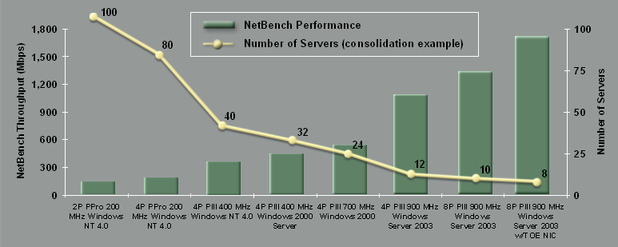

Figure 19: Historical increase in file server performance and scalability.

Active Directory
The Microsoft Active Directory service is a core component of the Windows platform. First introduced in Windows 2000, it provides the means to manage those identities and relationships that make up network environments. Active Directory stores information about network objects in a structured data store and organizes this information in a logical, hierarchical manner, making the information easy for administrators and users to find and manipulate.

Changes that Improve Active Directory Performance and Scalability
Like all other workloads, the efficiency with which Active Directory operates is increased by many of the previously discussed low-level changes. Windows Server 2003 also includes several Active Directory-specific changes that help to improve directory server throughput.

Larger Directory Database Cache
Active Directory implements an in-memory cache that resides in user space and stores directory objects for faster access than if they had to be retrieved from disk. In Windows 2000, this cache was limited to 512 megabytes (MB) under typical conditions and 1024 MB when the /3GB switch was used. In Windows Server 2003, this cache is allowed to grow more freely, although it is still limited by the amount of virtual address space (approximate maximum sizes are 2.2 GB with the /3GB switch and 1.5 GB without the switch. With the cache able to store more objects, cache hit ratios are higher and performance is improved.

More Efficient Object Storage
In addition to larger directory cache sizes, the amount of information stored in the Active Directory database is reduced. With Windows 2000, each directory object that was stored in the database had its own access control list (ACL). With Windows Server 2003, similar objects share the same copy of an ACL. This further increases the number of objects that can reside in cache, thus delivering even greater hit ratios and directory performance.

New Fast Bind Mechanism
In Windows Server 2003, a new fast-bind authentication mechanism is available. Unlike a simple bind, the fast-bind authenticates a user name and password without occurring the overhead required to generate credentials. This can be useful for applications that need to do authentication only, and results in a 400 percent performance improvement as compared to a simple bind.

Improved Query Optimizer
In Windows Server 2003, the query optimizer in Active Directory was tuned to deliver better performance.

Improved Database Replication
Active Directory uses replication to synchronize geographically distributed copies of the directory database. Several replication-related improvements were made in Windows Server 2003:
- More Intelligent Replication. In Windows 2000, default behavior was for a changes made in one location to be replicated to all other locations. In Windows Server 2003, those routines that manage replication are more intelligent—they determine how changes are to be replicated based on an intelligent analysis of network topology. Because of this, the maximum recommended number of sites that can be supported without having to manually set up replication is significantly greater when using Windows Server 2003 than when using Windows 2000.
- More Efficient Replication. In Windows Server 2003, a new algorithm is used when compressing data to be replicated. Compared to Windows 2000, Windows Server 2003 uses one-sixth the processor cycles when compressing data to be replicated.
- Improved Replication of Multivalued Attributes. With Windows 2000, entire groups were replicated when an item in the group was changed, resulting in a recommendation that groups be kept to 5,000 items or less. Windows Server 2003 only replicates those changes within the group, effectively eliminating the 5,000-item recommended limit.

Active Directory Throughput Benchmarks

DirectoryMark
VeriTest benchmarked the improved performance Active Directory running on Windows Server 2003 using DirectoryMark 1.2, a benchmark published by Mindcraft that measures the throughput of Lightweight Directory Access Protocol (LDAP) implementations like active directory. Two workloads were tested: an addressing mix and messaging mix. Results for both tests are measured in searches per second.
Messaging Mix
The messaging mix workload simulates the workload that an e-mail server such as one running Microsoft Exchange might place on a directory server. As illustrated in Figure 20, Windows Server 2003 delivered substantial performance and scalability improvements across all tested configurations.
Some highlights include:
- On a one-processor server, Windows Server 2003 delivered 102 percent greater throughput than Windows 2000.
- On a two-processor server, Windows Server 2003 delivered 116 percent greater throughput than Windows 2000.
- On a four-processor server, Windows Server 2003 delivered 149 greater throughput than Windows 2000.
- On an eight-processor server, Windows 2000 delivered 439 percent greater throughput than Windows 2000.
Figure 20: DirectoryMark messaging mix.
Addressing Mix
The addressing mix workload simulates users looking up a specific person or group of persons in an address book—a workload that requires the directory server to sort through significantly more data than the messaging workload. As illustrated in Figure 21, Windows Server 2003 delivered significantly greater throughput than Windows 2000 for all tested configurations.
Some highlights include:
- On a one-processor server, Windows Server 2003 delivered 926 percent greater throughput than Windows 2000.
- On a two-processor server, Windows Server 2003 delivered 1,190 percent greater throughput than Windows 2000.
- On a four-processor server, Windows Server 2003 delivered 1,569 greater throughput than Windows 2000.
- On an eight-processor server, Windows 2000 delivered 1,786 percent greater throughput than Windows 2000.
Figure 21: DirectoryMark addressing mix.

LDAP Primitives
In its internal labs, Microsoft used ADTEST (a freeware tool) to measure the performance of Active Directory in servicing various LDAP protocol calls:
- Base search (searches by user name and returns five attributes).
- Subtree search (multilevel search filtered by user, returns one attribute).
- Simple and fast bind (simple bind returns a security token, fast bind is authentication-only).
- Updates (updates five attributes for a single user).
All tests were performed against an Active Directory database with 2 million users. Test results are illustrated in Figures 22, 23, 24, and 25.
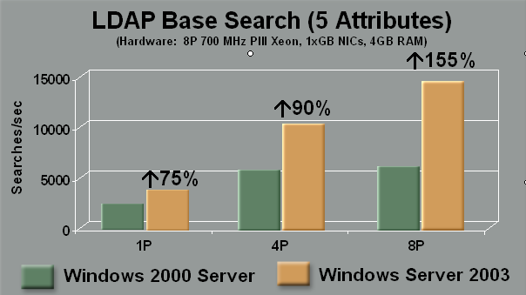
Figure 22: Base search.
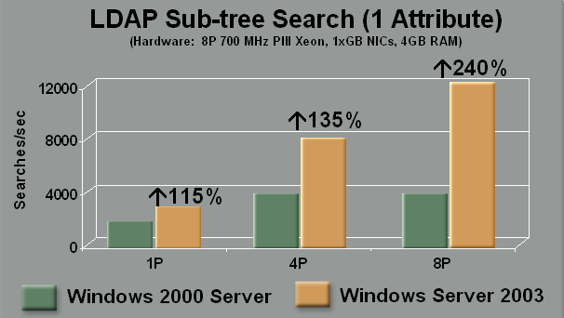
Figure 23: Subtree search.
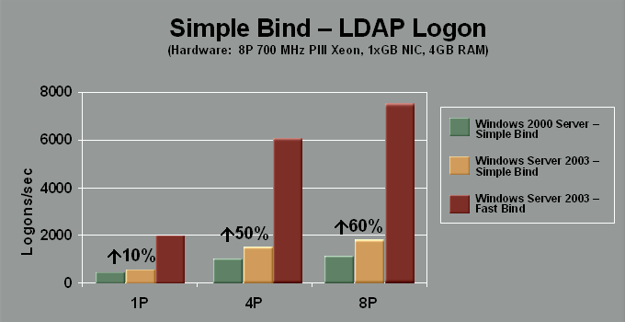
Figure 24: Simple and fast bind.
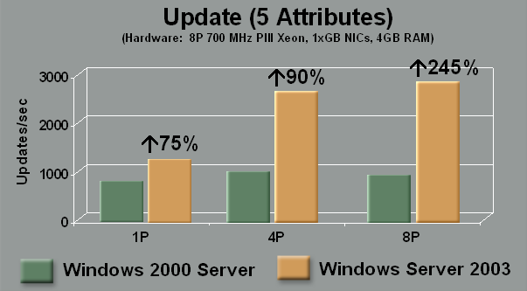
Figure 25: Update.

Terminal Server
Windows Terminal Server, which is included with both Windows 2000 and Windows Server 2003, lets multiple users run Windows-based applications on a remote server. All application execution and data processing occur on the server—only the user interface (display, user input, and so on) is remoted to the client desktop. Benefits of this approach can include lower desktop hardware costs along with centralized application management and deployment.
In most Terminal Server scenarios, the goal is to support as many users as possible per server while maintaining an acceptable level of responsiveness for end-user applications. As such, the maximum number of users that can be supported is a function of the amount of system resources in the server and the system resource consumption of those applications running in the Terminal Server environment.
Memory, not processor cycles, is typically the limiting system resource when attempting to maximize the number of users per server in a Terminal Server environment. More specifically, Terminal Server scalability is typically limited by two memory-related system resources: paged pool and page table entries (PTEs), both of which reside within a limited 2 GB system space and have roughly the same maximum sizes regardless of the number of processors installed in a server. Most customers running Terminal Services found that two-or four processor systems with 4 GB of installed memory was enough—beyond this point, adding more processors or memory would not increase the number of users that a server could support.

Changes that Improve Terminal Server Performance and Scalability
In Windows Server 2003, two key changes were made that significantly increase Terminal Server scalability:
- Maximum sizes for both paged pool and system PTEs are larger, which enables a system with adequate installed memory (for example, 4 GB) to support more users.
- The default ratio of paged pool size to system PTE size was adjusted. (Testing showed that under Windows 2000, paged pool was depleted before system PTEs).
In addition, several lower-level memory management-related changes were made that also contribute to improved Terminal Server performance:
- Images now always share pages, regardless of frequent rebase collisions (this reduces physical memory footprint and memory commitment and increases the cache hit ratio).
- Many specify locks were eliminated.
- Lookaside list usage is increased for frequent terminal server nonpaged and paged pool allocations.
For more information on Terminal Server scalability, go to http://www.microsoft.com/windowsserver2003/techinfo/overview/tsscaling.mspx.

Performance Improvements
In Terminal Server installations where virtual memory is the limiting resource, significant improvements in per-server capacity can be realized by upgrading from Windows 2000 to Windows Server 2003. In many cases, the maximum number of users that can be supported is improved by 80 to 140 percent. On the other hand, little capacity increase will be realized when processor cycles or installed physical memory are limiting factors.

Other Benefits
Terminal Services in Windows Server 2003 delivers more than just improved capacity in terms of the number of end users that can be supported. Other benefits include:
- Reduced Network Bandwidth Usage. In Windows Server 2003, the Remote Desktop Protocol that Terminal Services uses to remote each application’s end-user interface to the client computer is optimized to reduce bandwidth utilization by 50 to 60 percent. As such, upgrading an existing Terminal Services environment from Windows 2000 to Windows Server 2003 could result in an ability to support twice as many users with little increase in network usage.
- Smoother Application Responsiveness. Application responsiveness for end users is far smoother when running Windows Server 2003 than with Windows 2000.

64-bit Considerations
The 64-bit environment eliminates the 4 GB virtual address space limitation of the 32-bit systems. However, while 64-bit servers are currently available, most applications that users would want to run under Terminal Server are still 32-bit.
AMD’s Opteron chip poses interesting possibilities here because it facilitates a flat 64-bit address space while retaining the ability to run 32-bit desktop applications. Informal tests performed by Microsoft indicate that a server with four 1.6 GHz Opteron processors and 16 GB RAM can support up to 400 knowledge workers before the server reaches CPU saturation (as compared to 280 knowledge workers on a 32-bit server with four fast processors and 4 GB of RAM—remember that any more memory is often wasted).

Streaming Media
Microsoft® Windows Media™ Services 9 Series (an optional component in Microsoft Windows Server 2003, Standard Edition, Enterprise Edition, and Datacenter Edition) is the server component of the Windows Media 9 Series platform. The service works together with Windows Media Encoder and Windows Media Player to deliver audio and video content to clients over the Internet or an intranet.
Changes that Improve Streaming Media Performance and Scalability
For Windows Server 2003, Windows Media Services was rearchitected to deliver better reliability, performance, and scalability. Some of the changes that were made include:
- More Efficient Disk I/O. Testing with the previous version of Windows Media Services found that it was using excessive disk I/O. Redundant disk reads were eliminated by fetching larger blocks of data at a time.
- New Edge Delivery Capabilities. Several new and enhanced features are provided that facilitate the building of scalable, high-performance content delivery solutions:
  - New cache/proxy support enables developers to customize and extend native cache and proxy policies. Cache/proxy solutions can conserve network bandwidth, decrease network-imposed latency, and decrease the load on Windows Media origin servers.
  - Addition of User Datagram Protocol (UDP) and multicast distribution between servers using Transmission Control Protocol (TCP).

Performance Improvements
The extensive redesign of Windows Media Services in Windows Server 2003 delivers significant performance and scalability improvements—between 70 and 540 percent better throughput on a two-processor server. Figure 26 illustrates the increase in the number of simultaneous streams that can be supported by Windows Server 2003 for various stream speeds, delivery methods (for example, broadcast versus on-demand), and disk configurations.
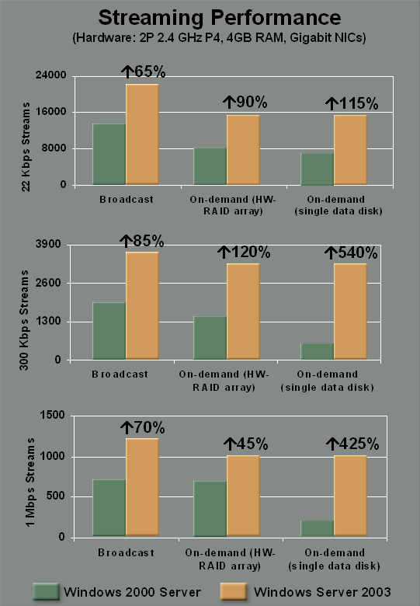
Figure 26: Streaming media throughput.

Server Performance Diagnostics
To ensure consistency and make the data meaningful, performance and scalability measurements for server workloads must be measured in highly controlled environments, with a consistent set of requests used to drive a server to its peak throughput. Customer environments can vary broadly from those used for these controlled tests, with actual throughput levels influenced heavily by network design, solution architecture, I/O constraints, and many other factors.
Event Tracing for Windows
To help customers optimize their solutions and maximize server throughput, Windows Server 2003 includes Event Tracing for Windows (ETW), which is high-performance trace instrumentation that captures the low-level behavior of systems on a request-by-request basis. For example, using ETW and its supporting utilities, an HTTP request for a Web page is traced from initial receipt to final reply, with the data captured including response times, the request’s path through various Windows subsystems, and system resource consumption in processing the request. Figure 27 illustrates the raw output of such a trace.
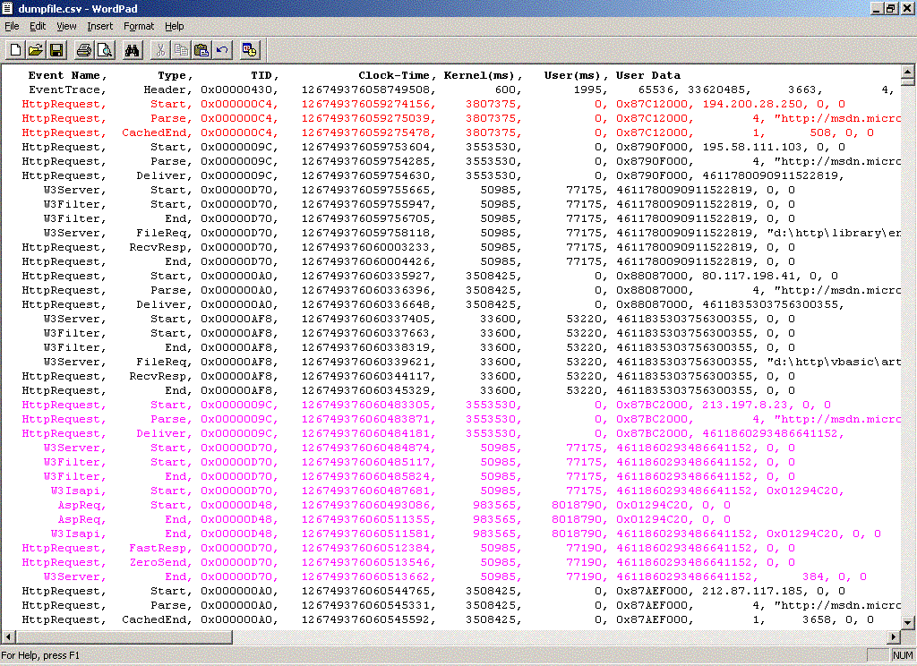
HTTP request served from HTTP Cache
ASP request going through HTTP driver, W3 Server, Filters, ISAPI, and ASP
Figure 27: Raw ETW trace output.
ETW instrumentation is built into Windows Server 2003 for the following workloads and system services, allowing the processing of most common server workloads to be correlated from the lowest system levels all the way up to the application level:
- Web server (tracks HTTP requests from receipt to response)
- Active Directory (tracks directory operations such as search and logon)
- File and Print (tracks SMB and print spooler requests)
- Core Operating System (tracks processes, threads, disk and network I/O, page faults, heap activity, context switching, and so on)
Future enhancements to ETW will include a high-performance trace class for the Microsoft .NET Framework. With all ETW APIs wrapped into a managed class, developers will be able to instrument their own applications with only a few lines of code.
More Information on ETW can be found by searching for “event tracing” at http://msdn.microsoft.com.
Server Performance Advisor
The ETW framework also includes Server Performance Advisor, a trace log processing and reporting utility that turns the raw data generated by ETW into valuable insights into solution behavior, performance, and scalability—a sort of “business intelligence for IT.” With Server Performance Advisor, IT professionals can more easily understand system behavior in response to real-life workloads and use this information to optimize server throughput.
For example, in a Web server scenario, an IT administrator can generate a predefined report that shows total CPU usage for each target URL—data that can be used to identify which Web pages are consuming excessive system resources. In processing an ETW Web server trace, some of the information that Server Performance Advisor provides in its predefined report includes:
- Most requested URLs
- Slowest URLs
- URLs with the most CPU usage
- URLs with the most bytes sent
- URLs generating the most HTTP errors
- Clients with the most requests
- Clients with the slowest responses
- Sites with the most requests
- Sites with the slowest responses
- Sites with the most CPU time usage
- Sites with the most bytes sent
The next two illustrations show some of the information that is provided by Server Performance Advisor. Figure 28 provides an example of a summary report on Web server behavior.
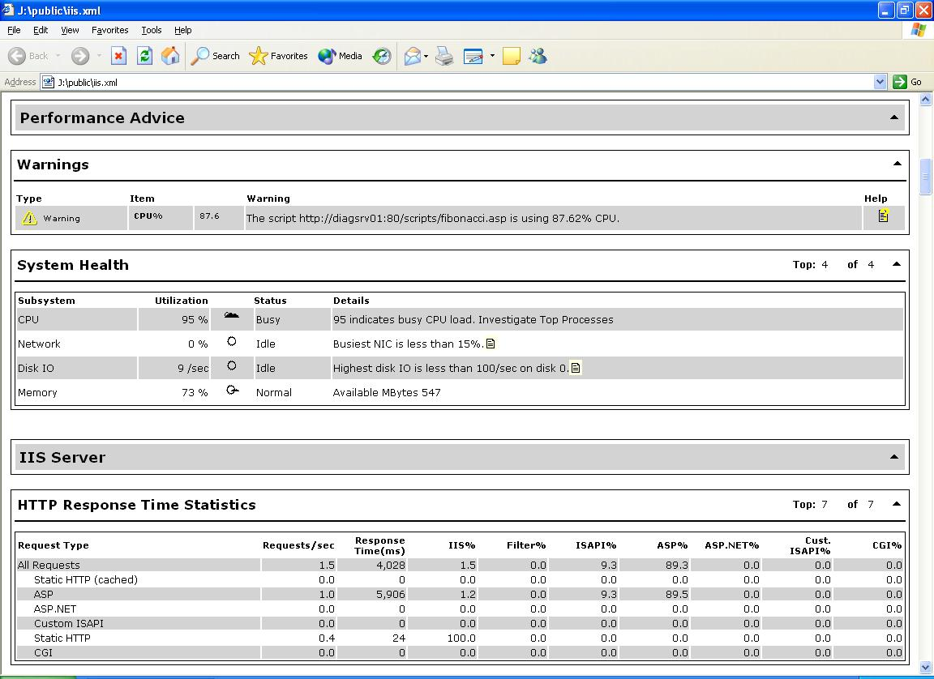
Figure 28: Server Performance Advisor summary report.
Figure 29 provides an example of a more detailed report. Drilling down into detailed data is achieved by simply clicking a link in a summary report.

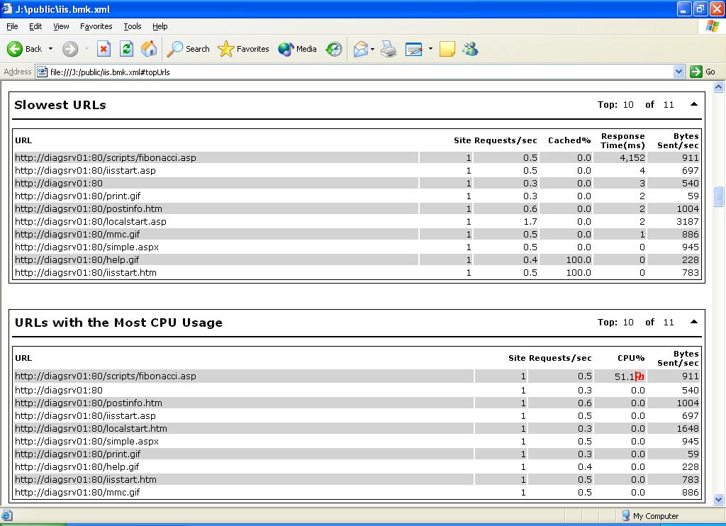
Figure 29: Server Performance Advisor detailed report.
Server Performance Advisor also contains built-in diagnostics that are based on Microsoft’s experience with thousands of customer environments as well as its own IT infrastructure. When Server Performance Advisor generates a report, it intelligently analyzes the metrics that are displayed and flags values that may warrant further investigation—such as a single client that is using an abnormally high percentage of a directory server’s processor cycles, as illustrated in Figure 30. (Note the red flag next to the client name in the illustration.)
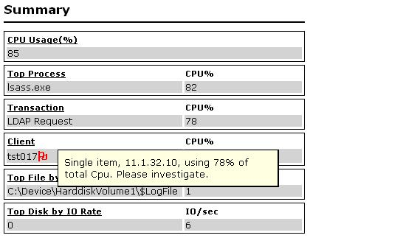
Figure 30: Server Performance Advisor flags suspect system behavior for further investigation.

Conclusion
Windows Server 2003 delivers significant improvements in performance and scalability for major server workloads: database, Web, file, streaming media, directory, Terminal Server, and more. Those improvements are the result of low-level optimizations in multiprocessor synchronization, scheduling, and memory management—changes that affect all workloads—as well as many higher-level enhancements that improve throughput for specific workloads.
With the performance and scalability improvements provided by Windows Server 2003, businesses can:
- Get more out of existing hardware investments—as required to support continually increasing workloads to improve system responsiveness for mission-critical applications.
- Reduce hardware and software costs when deploying new information technology (IT) solutions.
- Decrease system administrative costs by consolidating onto fewer, more powerful servers.
- Meet throughput requirements for mission-critical solutions while realizing greater business agility and a lower cost of ownership than proprietary UNIX-based solutions.
This trend is encapsulated in the August 2004 report, "Migrating Unix ERP Installations to a Windows Server Environment," by the META Group: “Windows is now a mainstream option for the vast majority of [Enterprise Resource Planning (ERP)] projects. Moreover, despite the fact that major new ERP software releases generally require more processing resources, and the average number of users has increased, the number of servers required with existing production Unix-based systems was actually reduced with the Windows-based server configurations.”

What can Windows Server 2003 do for your business applications? Start your evaluation of Windows Server today.

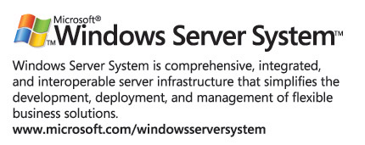

* The goal of this chart is to demonstrate the maximum performance that Window Server is capable of achieving in each timeframe using the TPC-C benchmark methodology. No TPC-C peak benchmark for 2004 was included in this chart, due to the fact that no 64P results were delivered in 2004.
The price/performance and performance benchmarks were recorded on 02/24/05 and 06/07/05, respectively, and are available at http://www.tpc.org
A /3GB switch in boot.ini can be used to increase user space to 3 GB, leaving 1 GB for system space. Address Windowing Extensions (AWE) provide another method that can be used to provide a single process with access to more than 2 GB of memory.
An AVL (Adelson-Velskii and Landis) balanced tree is a binary search tree where the height of the two children of any node on the tree differs by at most one.
In all cases, the maximum amount of processors and memory in a server may be limited by OEM hardware configurations.
Note: Tests were performed on Windows .NET Server Beta 3.

