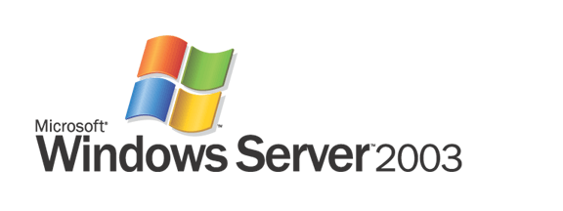

Reliability with Windows Server 2003, Enterprise Edition

Microsoft Corporation
Published: June 2005

Abstract
Windows Server 2003, Enterprise Edition is the most productive server operating system for powering applications that require the utmost in performance, scalability and high availability. Microsoft is dedicated to achieving highest level of server operating system reliability through developing a coherent strategy to provide mission-critical services that address the most common causes of downtime. As a result, customers using Windows Server 2003 Enterprise Edition have proven that it sets world-class standards of as the premier platform to host the applications that are critical to the success of their businesses.

The information contained in this document represents the current view of Microsoft Corporation on the issues discussed as of the date of publication. Because Microsoft must respond to changing market conditions, it should not be interpreted to be a commitment on the part of Microsoft, and Microsoft cannot guarantee the accuracy of any information presented after the date of publication.
This White Paper is for informational purposes only. MICROSOFT MAKES NO WARRANTIES, EXPRESS, IMPLIED OR STATUTORY, AS TO THE INFORMATION IN THIS DOCUMENT.
Complying with all applicable copyright laws is the responsibility of the user. Without limiting the rights under copyright, no part of this document may be reproduced, stored in or introduced into a retrieval system, or transmitted in any form or by any means (electronic, mechanical, photocopying, recording, or otherwise), or for any purpose, without the express written permission of Microsoft Corporation.
Microsoft may have patents, patent applications, trademarks, copyrights, or other intellectual property rights covering subject matter in this document. Except as expressly provided in any written license agreement from Microsoft, the furnishing of this document does not give you any license to these patents, trademarks, copyrights, or other intellectual property.
© 2005 Microsoft Corporation. All rights reserved.
Microsoft Windows, Exchange and SQL Server are either registered trademarks or trademarks of Microsoft Corporation in the United States and/or other countries.
All other trademarks are property of their respective owners.

Contents
Introduction 1
Microsoft and Reliability 1
Reliability Analysis 2
Built-in Measurement and Feedback Mechanisms 3
Microsoft Reliability Service 3
How MRS Works 3
MRS Reporting Capabilities 3
Reliability Strategy 4
Providing Reliability to Enterprise Customers 4
Providing Mission-Critical Services 4
Eliminating Common Causes of Downtime 4
Reliability Engineering 5
Component-level Testing and Validation 5
System-level Testing and Validation 5
Post-release reliability testing 6
Reliability Features and Results 6
Mission-Critical Capabilities 6
Failover Clustering 6
Fault-Tolerant Servers 7
Improved Reliability for Business Applications 8
Minimizing Causes of Downtime 9
Planned Downtime 9
Unplanned Downtime 9
Server Recovery 11
Additional Features to Combat Downtime 11
Exceeding Competitors in Reliability 12
Reliability Best Practices 13
Microsoft Solutions Framework 13
Microsoft Systems Architecture 13
Microsoft Operations Framework 13
Conclusion 14
Related Links 15
Windows Server 2003 15
Features of Windows Server 2003, Enterprise Edition 15
Microsoft Training and Knowledge Base 15

Introduction
Today’s enterprise is more and more reliant on technology, and this reliance will continue to grow. With the growth of the Internet as the primary source of connection between an enterprise and its vendors, customers, clients and even employees, IT systems must be available at all times to keep an enterprise in business. Inconsistencies and failures with such systems can cause difficulties and increase costs.
First, the cost of application failure is often too high. For example, clients whose service is somehow interrupted by unexpected technical failure may seek to do business elsewhere, resulting in lost revenue and reduced future sales. Additionally, the expense of repairing corrupted data can further increase the cost of application failure.
Second, unreliable systems are difficult to maintain or improve because the failure points are typically hidden throughout the system. The downtime caused by an error can dramatically increase if the error is unknown, given the difficulty of isolating such errors.
Finally, and perhaps most importantly, an unreliable system has an adverse effect on your enterprise’s most important resource: people. An unreliable system can cause frustration in both your employees and clients, undermining their confidence in your enterprise. In fact, a recent study has shown that showed a third of employees become frustrated with only five minutes of e-mail downtime, and a full 82 percent become frustrated with an hour of downtime.
Given the potential for damage to your bottom line, and damage to your reputation with both clients and employees, addressing the reliability of IT systems ought to be a priority for any enterprise, as it is for Microsoft.

Microsoft and Reliability
The term reliability refers to the frequency an application is available for fully functional use. A more reliable application is one that has less downtime, either planned or unplanned. Benefiting from the Trustworthy Computing Initiative, Windows Server 2003 is the most reliable operating system that Microsoft has ever produced. Because some applications are critical to the operation and success of your business, Microsoft recommends Windows Server 2003, Enterprise Edition as the most secure and reliable platform for your company’s mission-critical applications.
For Microsoft, reliability is a critical component of the company’s long-term commitment to trustworthy computing. Microsoft began a strategic focus in this area more than ten years ago. At that time, the company formed a core team dedicated to making the Windows operating system the most reliable and available environment for running applications in all customer scenarios. Perceiving that reliability was a key concern to customers, Microsoft worked hard to improve reliability with its new generation operating systems. Grounded in the Windows software development organization, the Windows reliability team has grown to more than 10 times its initial size over the past several years and today touches all corners of the organization: program management, product development, quality assurance, product support services, Microsoft Consulting Services and the company’s internal IT services organization. As a result, your enterprise can now benefit from the reliability provided by Windows Server 2003, Enterprise Edition.
This paper discusses the strategies employed by Microsoft to maximize the reliability of Windows–based solutions, particular Windows Server 2003, Enterprise Edition.

Reliability Analysis
To determine which changes or new software features need to be added to increase application availability, Microsoft has made an effort to gather information about performance in terms of reliability. To do this, monitoring tools and feedback loops are used to provide an accurate understanding of the behavior and reliability of Windows in mission-critical environments and to illustrate the challenges that are faced.
Microsoft collects detailed system information—including the specific causes of downtime—from hundreds of servers throughout the company’s internal IT infrastructure and thousands of customers systems. This information is combined with similar data collected from customer environments and is used to generate a data-driven assessment of the operating system’s performance. Requirements are determined based on the leading causes of downtime and are fed back to the Windows development organization for the necessary product improvements.
The following chart shows common causes of server downtime with Windows 2000 Server.
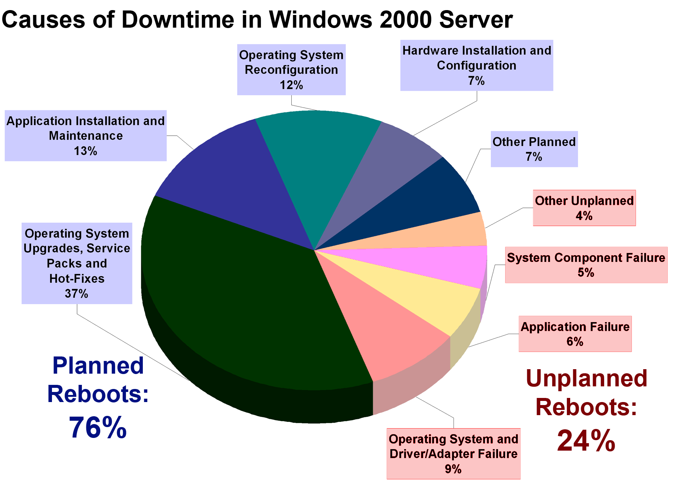
Figure 1: Breakdown of planned and unplanned reboots for more than 500 Microsoft production servers running Windows 2000 over a period of six months.
By breaking down the causes of downtime, Microsoft has been able to address these causes specifically in its effort to eliminate downtime entirely.

Built-in Measurement and Feedback Mechanisms
The Windows operating system includes several built-in features designed to help customers measure server reliability and better understand the causes of downtime:
- Windows Error Reporting is a configurable feature in Windows that transmits information about operating system and application crashes to Microsoft, where it is used to drive further product improvement.
- The Shutdown Event Tracker (SET) provides a way to consistently track why a server is shut down or rebooted. System administrators can choose to have the information forwarded to Microsoft so that it can be used to further understand customer environments and their causes of downtime.

Microsoft Reliability Service
Microsoft Reliability Service (MRS) can be thought of as a hosted business intelligence service for the IT community. Nonintrusive techniques are used to collect reliability data from target servers in custom environments; this information is then sent to Microsoft for analysis (an option also will be provided for customers to run the entire service within their environments). Results are presented through an intuitive, secure, Web-based interface that enables users to view reliability trends over groups of servers and drill down on individual servers for a more detailed view. With these capabilities, IT professionals can better understand the unique causes of downtime in their environments and identify the proper corrective actions.

How MRS Works
Users of the service install the MRS client on a single workstation or server in their environment. No agent is required on the servers for which availability data is to be collected. The MRS client collects reliability data from the event logs on a customer-defined set of servers at regular intervals and transmits the data to Microsoft over the Internet. Servers at Microsoft store and analyze the data, presenting the results through an intuitive, Web-based interface. MRS data also is used by Microsoft to gain a deeper and broader understanding of customer issues, leading to new innovations that will further improve the customer’s ability to maximize the reliability of their Windows-based solutions.

MRS Reporting Capabilities
MRS provides powerful reporting capabilities that enable IT professionals to understand overall server availability trends, identify problem areas and analyze the causes of downtime. Graphical reports show server availability over user-specified intervals. Results can be grouped by a broad variety of criteria, including server characteristics, user-specified groups and reason for reboot. In addition, for Windows Server 2003 systems that enable Shutdown Event Tracker data, this information can be used to group report results. When issues are identified, IT professionals can use MRS to focus on specific servers to better understand the causes of downtime—including SET System State Data.

Reliability Strategy
The Windows reliability advances made to date are the result of a continuous process of improvement that began with the release of Windows NT Server and have been most notable in Windows Server 2003, Enterprise Edition. Specific processes have been adjusted and refined over time. These processes are far more extensive and robust today than in the past but are still based on a simple premise: Identify the causes of planned and unplanned downtime in customer environments and use this knowledge to drive process, product and service improvements that help to increase the reliability of Windows–based solutions.

Providing Reliability to Enterprise Customers
Windows Server 2003, Enterprise Edition has been developed to provide the highest level reliability to the Enterprise customer. Microsoft delivers increased reliability through the following developments:

Providing Mission-Critical Services
Essential applications, such as e-mail, databases, Enterprise Resource Planning (ERP) systems and other business applications, must be available to your customers, clients and employees all the time. Windows Server 2003, Enterprise Edition is the best platform to run such applications. Mission-critical services, such as Failover Clustering and fault-tolerant services, have been developed with your Enterprise’s mission-critical needs in mind, to ensure that your most essential applications remain available as often as possible.

Eliminating Common Causes of Downtime
Technologies imbedded in Windows Server 2003, Enterprise Edition have been designed by Microsoft to address the most common causes of downtime. Specifically, they decrease planned downtime, unplanned downtime and recovery time. By studying the causes of downtime that users experienced in prior iterations of the Windows Server system, Microsoft has been able to address the most common problems to maximize the availability of your applications hosted on the Microsoft platform.

Reliability Engineering
The reliability of any software solution starts with a stable operating system. To ensure that Windows Server 2003, Enterprise Edition delivers on this requirement, Microsoft proactively validates its reliability at all key stages in the Windows engineering process. It performs such validation at multiple levels, including on a component-by-component basis and against the operating system as a whole. Many of the tools that Microsoft uses internally also are made available to the software vendors writing applications for Windows and to the customers running them.

Component-level Testing and Validation
Microsoft has strived to guarantee that the code underlying its server systems have the integrity to ensure proper operation. Component-level testing and validation tools built into the engineering process include:
Static code-defect detection tools | These tools use sophisticated heuristic pattern matching to identify subtle code defects, such as buffer overruns and double-free pointers.
Dynamic code-defect detection tools | These tools simulate the passing of parameters between routines to check for mismatches and invalid parameters.
Code coverage tools | These tools analyze the components of the operating system that are dependent on changes in another component and the portions of code that are executed in a test pass.
Driver verification tools | These tools analyze kernel-mode and graphics drivers to verify that they do not make illegal function calls or cause system corruption.

System-level Testing and Validation
After a Microsoft product has been designed, it is rigorously tested to ensure it meets reliability standards. Prerelease testing includes:
Internal build tests | Internal testing of new builds on more than 150 production servers and thousands of focused test systems ensure that new builds are of sufficient quality to release to the next phase of testing.
Release criteria | Formal reliability-specific release criteria ensure that predefined, percentage improvements in reliability are achieved for each new build that is released.
Beta and release candidate tests | External beta and release candidate testing includes broad programs encompassing thousands of customers, as well as focused programs in which Microsoft works one-on-one with key enterprise customers to proactively identify and resolve potential reliability issues.

Post-release reliability testing
Even after release, Microsoft continues to monitor its server system software to ensure it continues to operate with as high reliability as possible. The following mechanisms keep reliability up to speed post-release:
Quality Fix Engineering (QFE) | Windows Server 2003 additions are tested for new QFE deliveries that continually increase test coverage as new issues are discovered.
Backward and forward porting | Through this mechanism, Microsoft ensures that errors discovered in one version of Windows are corrected in other versions that may exhibit the same behavior.

Reliability Features and Results
This analysis, strategy and engineering process has led Microsoft to its most reliable platform ever: Windows Server 2003, Enterprise Edition. The features of this product address the reliability needs that Microsoft has discovered, and the product has delivered proven results that a make it the best product for your most important applications.

Mission-Critical Capabilities
Instead of directly noticing the effects of an operating system, most users evaluate an IT system by the performance of software on that operating system. A mission-critical application serves as a cornerstone to an overall IT configuration in that an enterprise relies on such an application to continue functioning. Common mission-critical applications include e-mail, databases and business applications.
When it comes right down to it, the job most people want to see an IT system do is function when needed. If you are an employee, you want to be able to check your e-mail and respond to customers or other members of your enterprise. If you are a customer, you want to be able to make purchases or otherwise interact with the business. If these vital functions are not working, whether you are an employee or a customer, you will most likely become frustrated—and that can lead to decreased productivity or even the loss of a client.
Microsoft Windows Server 2003, Enterprise Edition has several features aimed directly at increasing the reliability of mission-critical systems.

Failover Clustering
In Windows Server 2003, Enterprise Edition, failover clustering allows you to add additional levels of availability to critical services. When configured for failover, a group of servers offers services as a single virtual server. If one of the physical servers fails, the others continue to provide that service until you bring it back online.
The purpose of this feature is to enhance reliability by preventing downtime. Instead of a server failure causing complete shutdown of your vital systems such as e-mail, databases, and business applications, the other server or servers will pick up the workload for the failed server while repairs or other corrections can be made.
Windows Server 2003, Enterprise Edition clustering consists of two different technologies: Server Clusters and Network Load Balancing (NLB). Each of these technologies can be used to provide high availability for different types of services.
Server Clusters are primarily used to provide availability for mission-critical applications through failover. Database, ERP or CRM, OLTP, file and print, e-mail and custom application services are typically clustered using Server Clusters. In addition, server clusters facilitate the process of scaling, both up and out. You can more easily scale up because you can shut down a server without interrupting service. When that server is shut down, you can add hardware as necessary. You can easily scale out because you can add additional servers to your cluster.
NLB is used to provide high availability for applications that scale out horizontally, such as Web servers, proxy servers and other services that need client requests distributed across nodes in a cluster.
The following features of clustering enhance the reliability of mission-critical applications:
Integrated clustering | Microsoft Cluster Service is an integral part of the Windows Server 2003, Enterprise Edition operating system and no longer an optional component. This integration enables the configuration of cluster nodes without distribution media.
Cluster setup and management | Cluster configuration and setup is made easier through an enhanced wizard, which enables clusters of any size to be created with a simple two-step process.
Eight-node clustering | Windows Server 2003, Enterprise Edition, supports clusters of up to eight nodes. Eight-node clustering is not available in Standard Edition.
Client-side caching | The failure of a clustered file share node—and the subsequent failover of the file share service—can be hidden from the client.
Scripting support | A Generic Script resource type allows existing applications to be made cluster-aware using Microsoft Visual Basic script or JavaScript. This resource replaces the need to write resource DLLs in C or C++.
Geographically Disbursed Clusters | With geographically dispersed clusters, you can ensure that if servers at one location go down, the operation at large will remain viable.

Fault-Tolerant Servers
As operating systems, applications, drivers and other software-based solution components become more reliable, hardware-related issues and failures play a larger relative role in determining a solution’s total downtime. One approach to minimizing these causes of downtime is through the use of fault-tolerant servers, combined with software that supports them. According to Stratus Technologies, the average availability level of all Windows–based Stratus Server systems monitored through its network is 99.9998 percent.
Unlike many other fault-tolerant platforms, which may require “check pointing” at the application level, support for fault tolerance in Windows Server 2003, Enterprise Edition is handled completely at the kernel and hardware abstraction layer levels. Windows–based fault-tolerant servers must pass the same rigorous Windows Hardware Compatibility Tests as other servers, ensuring that the applications running on them will behave no differently.
Enhancements in Windows Server 2003, Enterprise Edition that apply to fault-tolerant servers include the following:
Memory mirroring | Enhanced support for memory mirroring enables fault-tolerant server OEMs to implement this capability more easily.
Multipath I/O | More than one physical path can be used to access storage devices, providing improved system reliability and availability through a redundant path for I/O traffic.
Load balancing and failover for miniport drivers | Miniport drivers can be configured to switch to a secondary network adapter if a primary adapter fails.
Hot-plug PCI support | System administrators can install and remove Peripheral Component Interconnect (PCI) devices while the server is running, eliminating maintenance downtime associated with this commonly used device type.
Hot-add memory support | Memory can be added to a server and made available to the operating system and applications while a server is running. Hot-add memory is not available on the Standard Edition of Windows Server 2003, but is on Enterprise Edition.

Improved Reliability for Business Applications
Enterprises often find the need to create customized IT solutions to meet their own particular needs. Such applications must be reliable if they are to be effective. Windows Server 2003, Enterprise Edition has been designed to increase the reliability of such applications. This increase reliability can ultimately drop your total cost of operation.
In August 2004, a Meta Group study referenced Window Server’s improvements in scalability, reliability, and manageability over the past five years, which coupled with the strong performance increases with Intel-based server systems, have made Windows Server 2003 “a mainstream option for the vast majority of ERP projects.”

Minimizing Causes of Downtime
By carefully examining the cause of downtime, Microsoft has engineered Windows Server 2003, Enterprise Edition to be down as infrequently as possible. The Microsoft strategy involves addressing the most common causes of downtime, both planned and unplanned, and decreasing the recovery time after experiencing a shutdown.

Planned Downtime
On Windows 2000, planned downtime accounted for 76 percent of total downtime.
Windows Server 2003, Enterprise Edition includes the following improvements that decrease planned downtime by reducing or eliminating the number of reboots that are required for common maintenance system tasks:
QFE chaining | Multiple operating system updates can be installed with a single reboot.
No-reboot QFEs | An estimated 40 percent of all critical updates now can be installed without a reboot.
Operating system reconfiguration | Reboots are no longer required for common reconfiguration tasks, such as adding or removing a server from a Network Load Balancing (NLB) cluster or a Microsoft Cluster Services (MSCS) cluster. The number of reboots is reduced for other operations, such as renaming a domain controller.
Side-by-side assembly and DLL installation | With the Microsoft .NET Framework, applications that have common system components can each use the version of the component that they were written and tested with. The .NET Framework also enables components to be updated on the fly, making it possible to deploy application updates without having to bring down a server.
Idle time shell extension unloads | In Windows Server 2003, shell extensions are unloaded and removed from memory after they are not used for a specified time period—without requiring a server reboot.
Hot-plug PCI support and Hot-add memory support (mentioned previously) also decrease planned downtime.

Unplanned Downtime
Unplanned downtime accounted for only 24 percent of all Windows 2000 reboots across the servers that were analyzed. However, its unpredictability can make unplanned downtime far more costly than planned downtime. Windows Server 2003, Enterprise Edition includes several enhancements and new features that are designed to help reduce unplanned downtime.

Faulty Device Drivers
Faulty device drivers are the single largest cause of unplanned downtime for Windows–based servers. Windows Server 2003, Enterprise Edition includes several new and improved features that help mitigate the effects that bad drivers can have on server reliability:
Driver verifier | Driver verifier tests kernel-mode and graphics drivers for illegal function calls and other behaviors that may cause corruption. The new version of Driver Verifier includes enhanced tests for asynchronous I/O errors, surrogate IRP errors, user mode buffer overwrite errors and potential deadlock behaviors.
Windows driver protection | Drivers with known problems are prevented from getting installed. This feature integrates with the Help and Support Center in Windows Server 2003, Enterprise Edition to point customers to upgraded driver versions.
Device driver rollback | Drivers can be rolled back to a previous version when a newly-installed driver version negatively affects performance or stability of the server.
Driver signing | All drivers are checked for digital signatures before installation, and drivers with improper or missing signatures can be prevented from being installed.
Enhanced software tracing | More natively instrumented components make it easier for developers to write debug messages to a log file.
Pool tagging enhancements | Kernel-mode device driver developers can test their code by making memory allocations to selected device drivers out of a special pool instead of a shared system pool.

Application or System Component Failure
Windows Server 2003, Enterprise Edition also contains the following enhancements and new features that are designed to mitigate application or system component failure, thus preventing a poorly behaved program, Web site or service from bringing down an entire server:
COM+ application recycling | To protect against applications whose performance or stability may degrade over time, system administrators can configure processes to automatically shut down and restart based on memory utilization, method calls processed, activation count or time in use.
Application verifier | System administrators can test for commonly encountered compatibility issues, as well as potentially dangerous behaviors, such as heap corruption, improper lock usage, invalid handle usage, allocation of adequate stack space, improper version handling, or writing data to incorrect locations within the registry or the file system.
Windows resource management | Individual applications or pools of applications can be prevented from negatively affecting reliability by limiting the amount of memory or share of total CPU cycles that an application or pool of applications is allowed to consume.
IIS 6.0 worker process isolation | Internet Information Services (IIS) 6.0, the built-in Web server in Windows Server 2003, Enterprise Edition has been completely rebuilt with a new, fault-tolerant process model that greatly increases the reliability of servers running Web sites and Web-based applications.
IIS 6.0 out-of-process application recycling | Individual IIS 6.0 worker processes can be recycled automatically based on elapsed time, virtual memory usage, number of requests served, scheduled times during a 24-hour period, a “liveness” ping, or on demand.
Service.exe decomposition | Many system services are now hosted in a Service Host process that is not system-critical.

Server Recovery
When downtime does occur, minimizing the time required to get servers back up and running is critical to restoring service availability. Windows Server 2003, Enterprise Edition includes several features and improvements that are designed to streamline the process of restoring servers to operational status:
Automated system recovery | A one-step process can be used to restore the operating system, system state and hardware configuration in disaster recovery situations.
Volume Shadow Copy Service | Point-in-time copies of application data can be captured without shutting down applications.
Faster CHKDSK utility | Although running the CHKDSK utility is rarely required, the utility performs faster than it did in Windows 2000.

Additional Features to Combat Downtime
Along with enhancements designed specifically to protect against the common causes of downtime, Windows Server 2003, Enterprise Edition contains many subtle changes that help to make it the most reliable operating system that Microsoft has ever produced. Changes include:
Increased overall robustness | Algorithmic changes in memory, cache, scheduler, file system and I/O routines improve the robustness of Windows Server 2003, Enterprise Edition at “exhaustion” boundaries.
System-wide locked pages limit | Windows Server 2003, Enterprise Edition tracks all locked pages, preventing applications or drivers from pushing the system beyond a kernel-controlled limit.
Memory “pressure” signals | Memory pressure signals are used by various components to prevent exhaustion of limited kernel resources.
Graceful recovery of timed-out services | Critical sections time out and force applications and services to recover gracefully instead of hanging the application, service or system.
Reduced application and service hanging | Troublesome applications and services can be paused, stopped or killed more easily because the operating system now has the ability to control the window used to manipulate the service or application.
Memory mirroring, Multipath I/O, and load balancing and failover for miniport drivers (mentioned previously) also decrease downtime.

Exceeding Competitors in Reliability
The fruit of Microsoft’s efforts to increase reliability can be seen by comparing the downtime of the Windows server operating systems. Windows NT Server achieved 99.84 percent uptime, or 14 hours, 9 minutes, and 57.6 seconds of downtime per year; Windows 2000 Server achieved 99.92 percent uptime, or 7 hours, 28.8 seconds of downtime per year; Windows Server 2003, Enterprise Edition, in a testing environment, achieves 100 percent uptime, 0 seconds of downtime per year.
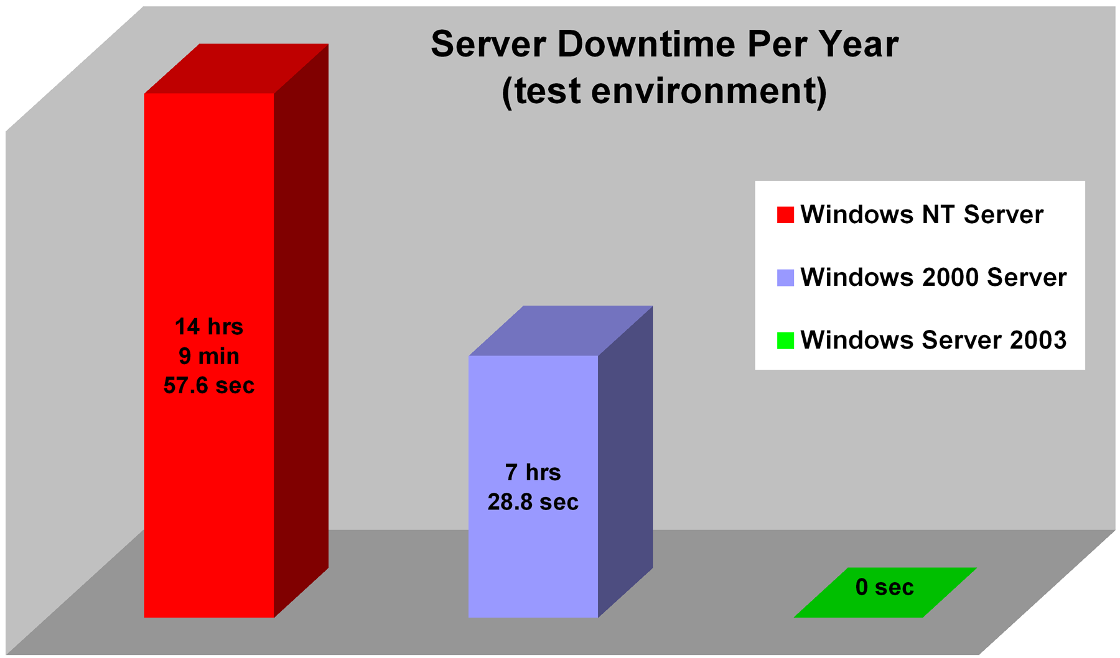

Figure 2: Average downtime for Windows NT Server, Windows 2000 and Windows Server 2003. Measurements were taken in a testing environment and include both planned and unplanned downtime.
The improvements in reliability have propelled Microsoft beyond its competitors. An April 2005 Veritest report concluded that Microsoft Windows Server is more reliable that Red Hat Linux. Here are some of the report’s conclusions:
“In our tests, the Windows Server 2003 environment had 4:20:19 of average end-user service loss time compared to 4:59:44 of average service loss time for the Red Hat Enterprise Linux AS 3.0 environment on measured service loss events. Lower results are better.”
“In our tests, more work was completed in the Windows Server 2003 environment (280 completed tasks and events) than in the Red Hat Enterprise Linux AS 3.0 environment (248 completed tasks and events) in less average elapsed time (18:44:14 versus 27:48:05).”
Microsoft Windows 2003, Enterprise Edition is the clear choice to ensure the reliable operation of your enterprise’s IT systems.

Reliability Best Practices
Many companies today are achieving mission-critical levels of availability by combining the reliability of Windows with robust system architectures, proper training and operational best practices. To help its broad customer base reach this goal, Microsoft offers a comprehensive collection of architectural guidance and best practices that are intended to help customers maximize the availability of their Windows–based solutions. Available materials span all phases of the solution life cycle, from solution architecture and application development to time-proven techniques for the deployment and operation of Windows–based solutions.
Some of the key resources that customers and partners can use to maximize the availability of their Windows-based solutions include:

Microsoft Solutions Framework
The Microsoft Solutions Framework (MSF) covers the “plan and build” phases of implementing Windows–based solutions. Microsoft collects best practices from its product developers—as well as its worldwide network of consultants, customers and partners—analyzes them for repeatable success factors and integrates these success factors into MSF principles and practices for use by Microsoft Consulting Services, partners and customers.

Microsoft Systems Architecture
The Microsoft Systems Architecture (MSA) program provides standardized architectures for enterprise-class, Windows–based solutions. Tested in Microsoft technology labs and optimized for Windows–based solutions, MSA configurations scale from the department level to enterprise and Internet data centers, enabling companies building solutions of all sizes to benefit from rapid implementations, predictable costs, reduced risk and faster time to benefit.

Microsoft Operations Framework
Designed to help companies operate, manage and optimize Windows–based solutions, the Microsoft Operations Framework (MOF) is based on the IT Infrastructure Library (ITIL) from Britain’s Central Computer and Telecommunications Agency, an agency chartered with development of IT-related best practices. MOF combines the collaborative industry standards and best practices identified by ITIL with specific guidelines for using Microsoft products and technologies.
By following Microsoft suggestions for best practices, your enterprise can maximize reliability. For example, one of the Netherlands’ leading Internet hosting companies, IS Interned Services, recently used Microsoft best practices when migrating from Windows 2000 Server to Windows Server 2003. As a result, they were able to migrate rapidly, and the end result was high reliability. "Windows Server 2003 performs very well," says founder and Managing Director Arjan Steevels. "The number of ‘management incidents' has fallen from an average of seven per week to practically none. It has also greatly improved facilities for centralized management, load balancing, and security."
Another success story involves County Durham and Darlington Acute Hospitals NHS Trust. Primarily seeking increased reliability while merging with another trust, the Trust worked with Microsoft Certified Partner Sx3 to migrate from Microsoft Windows NT Server 4.0 to Microsoft Windows Server 2003 with Active Directory. Sx3 made the effective suggestion to the Trust that they migrate directly from NT to Server 2003, bypassing Windows 2000 entirely. As a result, the Trust achieved a successful migration and increased reliability. “The migration from NT 4.0 to Windows Server 2003 went very smoothly. In fact I would say that it is one of the most straightforward implementations that we have worked on. The ease of migration is thanks to the platform itself and the fact that Sx3 already knew our infrastructure very well. We spent the bulk of our time planning the move to see how we could do it with minimum disruption. Our clinical systems are effectively in use 24 hours a day, seven days a week so we needed to keep downtime to an absolute minimum," says Steven Dodd, Assistant Head of Information Management and Technology (IM&T) at County Durham and Darlington Acute Hospitals NHS Trust.

Conclusion
For more than a decade, Microsoft has made the reliability of its server operating systems a top priority, realizing that enterprise customers require high reliability to ensure the healthy function of their businesses. An unreliable IT system causes many problems, including frustrated customers and employees and, ultimately, a higher total cost of operation.
With these problems in mind, Microsoft has analyzed the causes of downtime and developed a coherent strategy to address problems with reliability. Windows Server 2003, Enterprise Edition has been engineered from the ground up to be the ideal platform for mission-critical applications and to combat the most common causes of downtime, both planned and unplanned.
The result: Windows Server 2003, Enterprise Edition is the best enterprise-level server platform on the market. Last year, Computer Business Review Online reported that Unisys, a server technology consulting firm (www.unisys.com), chose Windows Server 2003 over UNIX based on reliability considerations. "There is no reason anymore for customers to go with proprietary RISC/UNIX platforms," says Mark Feverston, Unisys Vice President of Platform Marketing for Enterprise Servers. "[Windows Server 2003] numbers are right up there with the best of any machine in the data center."
Your customers, clients and employees deserve to get the highest reliability from your enterprises IT systems; and you deserve to run your systems on the premier enterprise platform: Windows Server 2003, Enterprise Edition.

Related Links
See the following resources for further information:

Windows Server 2003
- Windows Server 2003 at http://www.microsoft.com/windowsserver2003
- Overview of Windows Server 2003, Enterprise Edition at http://www.microsoft.com/windowsserver2003/evaluation/overview/enterprise.mspx
- 64-bit Version of Windows Server, Enterprise Edition at http://www.microsoft.com/windowsserver2003/64bit/default.mspx
- Windows Server 2003, Service Pack 1 at http://www.microsoft.com/windowsserver2003/downloads/servicepacks/sp1/default.mspx

Features of Windows Server 2003, Enterprise Edition
- Failover Clustering at http://download.microsoft.com/download/4/d/e/4de815ef-2904-420a-b726-e57de31ae63a/ClusteringOverview.doc
- Volume Shadow Copy and Virtual Disk Service at http://download.microsoft.com/download/9/3/0/9304593c-e16b-4e3b-aecc-4cdee9677a51/W2K3ActDirFastRecov.doc
- Geographically Disbursed Clusters at http://download.microsoft.com/download/7/6/f/76f3db2f-6f43-4624-bfde-ff731e3c1f96/GDClusters.doc

Microsoft Training and Knowledge Base
- Microsoft Training and Certification at http://www.microsoft.com/traincert/
- The Microsoft Operations Framework on TechNet at http://www.microsoft.com/mof/
- The Microsoft Solutions Framework on TechNet at http://www.microsoft.com/msf/
- Microsoft Systems Architecture (MSA) on the Microsoft Solutions Web site at http://www.microsoft.com/solutions/msa/

For the latest information about Windows Server 2003, see the Windows Server 2003 Web site at http://www.microsoft.com/windowsserver2003.

http://news.zdnet.com/2100-3513_22-1013611.html
http://www.codix.gr/downloads/STRATUS20030804.pdf
http://download.microsoft.com/download/f/5/f/f5fcd06a-dafd-4f45-ab4d-bdd2da2b2e86/METAGroup.pdf
http://download.microsoft.com/download/b/3/b/b3bbc822-8252-465e-b4cd-14c04c0e3a16/Veritest_reliability.pdf
http://www.microsoft.com/resources/casestudies/CaseStudy.asp?CaseStudyID=15148
http://www.microsoft.com/resources/casestudies/CaseStudy.asp?CaseStudyID=14861
http://www.cbronline.com/article_news.asp?guid=040D01B7-ADED-436D-BD1B-4B4140413C46

