MSlogo_rev_1118

September 2006

Microsoft Office   
Accounting Professional 2007

Table of Contents

Cover is for   
position only

[Introducing Microsoft Office Accounting Professional 2007 1](#_Toc147215073)

[Small Business Challenges 1](#_Toc147215074)

[The Microsoft Office Accounting Professional 2007 Solution 2](#_Toc147215075)

[Save Time and Work More Efficiently 5](#_Toc147215076)

[Get Started Quickly and Easily 6](#_Toc147215077)

[Get Up and Running in Minutes 6](#_Toc147215078)

[Import Data from QuickBooks and Other Sources 7](#_Toc147215079)

[Work in a Familiar Interface 8](#_Toc147215080)

[Save Time Managing Everyday Tasks 10](#_Toc147215081)

[Enter Information Once 10](#_Toc147215082)

[Easily Create Quotes, Invoices, and More 10](#_Toc147215083)

[Track Expenses and Transactions Automatically 12](#_Toc147215084)

[Create, Modify, and Export Documents in Office Word 13](#_Toc147215085)

[Automate Bank Accounts 15](#_Toc147215086)

[Automate Customer Payments 16](#_Toc147215087)

[Track Employee Time and Costs 16](#_Toc147215088)

[Manage Payroll and Taxes 17](#_Toc147215089)

[Track and Forecast Inventory 18](#_Toc147215090)

[Sell and Buy in Multiple Currencies 18](#_Toc147215091)

[Get a Complete View of Your Business 19](#_Toc147215092)

[View Your Financial Information in One Place 19](#_Toc147215093)

[Store and Organize Data Centrally 19](#_Toc147215094)

[Work with Microsoft Point of Sale 20](#_Toc147215095)

[Get a Snapshot of Important Information 20](#_Toc147215096)

[Share Account Information with Office Outlook 2007 with Business Contact Manager 22](#_Toc147215097)

[Work the Way You Want 24](#_Toc147215098)

[Create a Personalized Company Home Page 24](#_Toc147215099)

[Customize Forms 25](#_Toc147215100)

[Provide Employee Access and Customize Security Roles 26](#_Toc147215101)

[Find and Organize Information Quickly 28](#_Toc147215102)

[Gain Insight into Your Business Finances 28](#_Toc147215103)

[Understand Your Business with Comprehensive Reports 28](#_Toc147215104)

[Understand Your Customers 30](#_Toc147215105)

[Monitor and Forecast Cash Flow 32](#_Toc147215106)

[Analyze Data with Office Excel and Office Access Integration 33](#_Toc147215107)

[Share Data with Your Accounting Professional 33](#_Toc147215108)

[Manage and Grow Your Business More Effectively 35](#_Toc147215109)

[Sell Online More Effectively 35](#_Toc147215110)

[Sell on eBay 35](#_Toc147215111)

[Do Business with Confidence 37](#_Toc147215112)

[Get Paid Faster Through PayPal 37](#_Toc147215113)

[Credit Profile with Equifax 38](#_Toc147215114)

[Resources 39](#_Toc147215115)

[System Requirements 40](#_Toc147215116)

# Introducing Microsoft Office Accounting Professional 2007

Welcome to Microsoft® Office Accounting Professional 2007, the complete accounting solution for Microsoft Office users. Office Accounting Professional 2007 provides a comprehensive set of accounting tools that helps you save time, get organized, and grow your business online.

## Small Business Challenges

Running a small business today is more challenging than ever. With limited resources, the business owner is often responsible for managing most of the day-to-day tasks of running the business, including handling the finances. Most business owners recognize that accounting is a vital task, yet the complexity of managing cash flow, payroll, taxes, invoicing, and expenses can be overwhelming. And the daily challenges of simply running a business make it difficult for owners to find the time to get a complete view of the financial health of the business.

Most business owners do not have ready access to the financial data they need to assess their business. Essential information is often held by different people and spread across several places in the business such as paper files in file cabinets, e-mail messages, Microsoft Office Word documents, or Microsoft Office Excel® spreadsheets. General accounting software can help perform key financial tasks, but still does not provide all the answers. Even if the business owner hires an accountant or bookkeeper, gaining relevant information to make business decisions can be costly and time-consuming.

The key to managing finances in a small business successfully is to simplify the process and make it easier for the owner and employees to get work done. The owner and employees need a way to collect day-to-day customer and financial data easily from Microsoft Office documents and other sources. They also need a way to organize and view the critical accounting information so that they can effectively perform everyday financial tasks like quoting, invoicing, or tracking billable time, without having to enter the information multiple times. Employees should be able to enter the information in the programs they use most commonly, and this information should flow into the accounting system automatically. Finally, the owner needs a way to get a complete view of the business to make the right decisions and help the business grow.

## The Microsoft Office Accounting Professional 2007 Solution

Microsoft Office Accounting Professional 2007 is a complete accounting solution designed for business owners, bookkeepers, and office managers in any company with up to 50 employees.

Office Accounting Professional 2007 requires no accounting experience to use and works smoothly with the Microsoft Office programs you use every day. By organizing financial information in one place, you will get a complete view of your business and obtain valuable information for your interaction with customers. Office Accounting Professional 2007 includes comprehensive tools for managing your business finances more effectively so you can spend more time developing your business.

This guide provides an overview of the key features and functionality in Office Accounting Professional 2007. It also provides a close look at the program in action, providing guidance on specific details that demonstrate the capabilities for businesses like yours.

Office Accounting Professional 2007 includes new features to help you get started quickly, save time, sell online, and work more effectively with the Microsoft Office system. Key enhancements include:

**New!** **Upgrade Company Data Wizard** helps you easily upgradefrom Microsoft Office Small Business Accounting 2006.

**New! Online Sales integration** gives you the ability to sell inventory, track activity, and download orders in online marketplaces such as eBay directly from Office Accounting Professional 2007.[[1]](#endnote-2)

**New! Use Credit Profile service** powered by Equifax to order credit reports and monitor credit for your business, customers, or vendors.[[2]](#endnote-3)

**New! Microsoft Office Live integration** helps you smoothly exchange Office Accounting Professional 2007 data with your accounting professional.[[3]](#endnote-4)

**New! Accept new payment types** including credit cards and PayPal[[4]](#endnote-5) to streamline transactions.

**New! Accountant Transfer Export Wizard** helps you share data with an accounting professional while you continue using Office Accounting Professional 2007. When the accounting professional is finished updating the accounts, the data synchronizes easily.

**New! Accountant View** provides a centralized location from which accountants can manage Office Accounting Professional data for multiple clients independently.

**Improved! Data import** enables you to import accounting and financial data from additional programs and versions, including Microsoft Money, Microsoft Excel, and Intuit QuickBooks.

**Improved! Journal entry** is now expanded so that you can enter multiple accounts, customers, and vendors in the same journal entry. Be more productive by creating numerous journal entries posting on different dates and with different accounts.

**Improved!** **Microsoft Office Outlook® 2007 with Business Contact Manager** provides a way to track customer and financial information with Office Accounting Professional 2007. The new Account and Customer Integration Wizard enables synchronized data sharing. Make updates to a customer’s record in either program, and quickly see the results in the other program.

**Improved! Combine Microsoft Point of Sale** with Office Accounting Professional 2007 to create an integrated retail solution.

**Improved! Forms customization** enables you to modify and save the layouts of most Office Accounting Professional 2007 forms. Fully customize the data elements in a form by adding fields, moving fields, creating custom fields, renaming fields, and hiding unnecessary fields.

**Improved! Use customizable security roles** to add and remove permissions for different roles in the organization for flexibility regarding access to accounting data.

**Improved! Microsoft Office integration** helpsyou work with programs more efficiently. Export all reports and lists to Excel with formatting and formulas intact. Easily export documents to Word. Use the Write Letters Wizard for customers, vendors, and employees. Use Outlook to send documents by e-mail. Use the optional Analysis Tools to generate Microsoft Office Excel PivotTable® views and Microsoft Office Access database reports.

**Improved! Achieve faster database performance** by compressing historical data. Using the Compress Data feature, you can roll up past fiscal year data in a separate company database to make the active database faster than ever. Data for all years remains available if needed.

# Save Time and Work More Efficiently

During a typical day, small business owners and employees rely on a variety of documents to get their jobs done. Essential financial and customer information can be stored in diverse places such as paper files, Excel spreadsheets, Word forms, and other documents. In such a situation, accomplishing simple accounting tasks such as creating customer quotes, invoices, and sales reports can be time-consuming. Yet, for many small business owners and employees, the prospect of switching to a new accounting solution, even if that solution would save them time and resources, may be intimidating.

If your business is currently using any other accounting solution, Office Accounting Professional 2007 provides an easy and fast way to switch to a solution that will help you save time with everyday financial tasks. Office Accounting Professional 2007 tools are easy to use and have the familiar look and feel of the Microsoft Office system.

Office Accounting Professional 2007 in Action: Contoso Landscape Design

Contoso Landscape Design is a small residential and commercial landscape design firm. Aaron Con founded the company as a sole proprietor 20 years ago and now employs 10 people, including several designers. Aaron spends most of his time involved in the company’s sales efforts and finances.

Aaron and his staff rely heavily on Microsoft Office system programs during a typical day for job tracking, customer quotes, invoices, financial reporting, cash flow analysis, and other accounting needs. Aaron feels his current accounting solution of Excel spreadsheets and other Office programs takes too much time out of the day, so he has decided to switch to Office Accounting Professional 2007 to manage his firm’s business finances.

## Get Started Quickly and Easily

Most small businesses do not have the time or IT staff to install and configure complicated business software. Office Accounting Professional 2007 is easy to set up and learn, so you can get started in just a few minutes. Because Office Accounting Professional 2007 looks and feels like familiar Microsoft Office programs, you can be productive right away with minimal effort and training.

### Get Up and Running in Minutes

The Startup Wizard imports your existing accounting data from sources such as Microsoft Office Excel, Intuit QuickBooks, and Microsoft Money. The Startup Wizard gets your company’s financial processes set up, connected, and working right away so that you can be writing your first invoice within minutes. Office Accounting Professional 2007 is intuitive and easy to use, and it doesn’t require extensive training to become proficient. Best of all, Office Accounting Professional 2007 looks and works just like other familiar Microsoft Office system programs.

If you are starting a new business, the Startup Wizard makes it easy to select a list of your accounts and enter information about customers, vendors, and items. Your accountant or CPA can also use the Startup Wizard to set up accounts, taxes, and other accounting information.

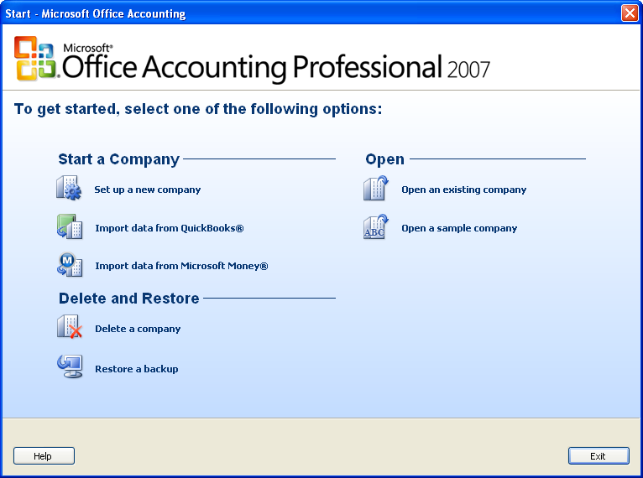

Figure 1: The Startup Wizard gets Office Accounting Professional 2007 running quickly and easily.

### Import Data from QuickBooks and Other Sources

Office Accounting Professional 2007 is designed to import data from many sources. You can easily use existing financial information and not be concerned about starting from scratch or losing valuable data. Import data from Microsoft Office system programs such as Excel and other accounting software such as Intuit QuickBooks and Microsoft Money.

QuickBooks users can easily import their data by using the Convert from QuickBooks Wizard. You can import all your QuickBooks data including master records such as chart of accounts, customers, vendors, items, employees, and supporting tables as well as beginning balances and transactions. If you are using a previous version of Office Accounting Professional 2007, such as Microsoft Office Small Business Accounting 2006, it is very easy to upgrade to Office Accounting Professional 2007.

Office Accounting Professional 2007 in Action: Get Started Quickly

For several years, Aaron has considered using an accounting package for his growing business. However, with no formal accounting training or experience, Aaron was apprehensive about switching from his basic but trusted accounting solution of Excel spreadsheets, Word documents, and other programs. Aaron understands that his company’s methods are inefficient, but installing an accounting package seems like a complicated endeavor.

Using the Startup Wizard, Aaron was able to get his company’s accounts set up in Office Accounting Professional 2007 in an afternoon. There was no need to retype existing accounting data because he could import data directly from the company’s existing Excel spreadsheets, such as his customer lists. After he imported his files, Aaron could get to work right away.

### Work in a Familiar Interface

Most small businesses rely on Microsoft Office programs to get work done. The familiar Microsoft Office interface and functionality help people communicate more effectively and be more productive. Office Accounting Professional 2007 helps extend that ease of use and productivity to managing your company’s finances.

A Navigation Pane provides centralized navigation and easy access to home pages to start commonly performed tasks. Office Accounting Professional 2007 is so easy to use that you can be productive right away, whether you are new to accounting software or an advanced user. Furthermore, Office Accounting Professional 2007 works smoothly with Office Outlook 2007 with Business Contact Manager to provide customer information in one place.

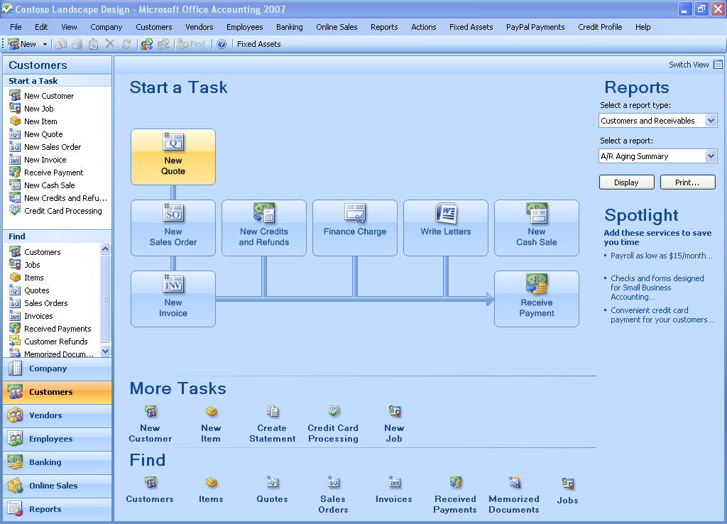**Figure 2: Office Accounting Professional 2007 provides a familiar, intuitive interface.**

Office Accounting Professional 2007 in Action: Easy to Learn with a Familiar Interface

Aaron and his staff rely on Microsoft Office programs, such as Office Outlook, throughout the day. Because Office Accounting Professional 2007 looks and works like his familiar Microsoft Office programs, it was easy for Aaron and his team to get up to speed quickly with little training. For example, clicking the Customer button in the Navigation Pane opens the Customers home page, where Aaron can perform routine tasks such as creating a new customer invoice. Because Office Accounting Professional 2007 is easy to learn, training new employees to create quotes and invoices or track project time can be accomplished much faster than before.

## Save Time Managing Everyday Tasks

Time is money, and routine but necessary accounting tasks such as tracking expenses and managing payroll can take up hours that could be spent growing your business. Even simple tasks such as paying bills and invoicing customers may require that information be written down or entered multiple times, which not only is time-consuming but can lead to errors. Office Accounting Professional 2007 streamlines those financial processes to help you manage everyday accounting tasks more efficiently.

### Enter Information Once

Office Accounting Professional 2007 simplifies everyday tasks because you can share and reuse common data across different forms rather than retyping the information. To make entering recurring transactions easier and faster, Office Accounting Professional 2007 tracks your transactions and stores the information for future use. You can easily share accounting data across other Microsoft Office programs you use. For example, within Office Accounting Professional 2007 you can easily export a quote to Office Word to create a professional-looking proposal customized for your business.

### Easily Create Quotes, Invoices, and More

With Office Accounting Professional 2007, you can easily create common documents such as quotes, invoices, purchase orders, and more. For example, quickly convert information such as a customer quote into an invoice without tedious data reentry. You can also easily customize each form to suit your business’s specific needs. Office Accounting Professional 2007 works smoothly with Office Outlook 2007 with Business Contact Manager to put customer information and financial data in one place. From within Office Outlook 2007 with Business Contact Manager, employees can view financial information about customers and create quotes, orders, and invoices in Office Accounting Professional 2007—without having to transfer data from one program to another.

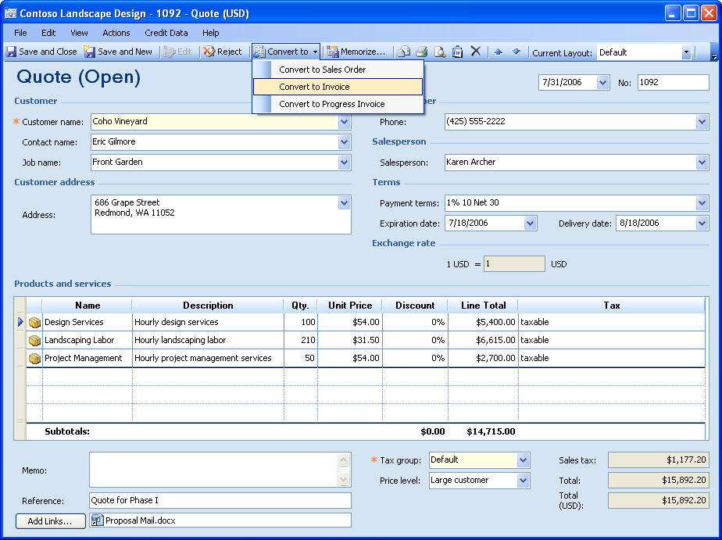

Figure 3: Easily create new documents, such as invoices, from existing information.

Office Accounting Professional 2007 in Action: Save Time by Eliminating Repetitive Tasks

For years, employees at Contoso Landscape Design would retype information as it was needed for different purposes, spending valuable time and occasionally introducing errors. For example, after a customer consultation, a landscape designer used an Excel spreadsheet to create a detailed list of materials and labor costs. Some details were then copied to a Word document that became the customer proposal. If the firm won the proposal, some of the information was added to a contract. As the project was completed, Aaron then used some of the information to generate invoices. Payments were then recorded and receipts generated.

With Office Accounting Professional 2007, Aaron and his designers spend less time accomplishing everyday financial tasks. With a single click, a customer proposal becomes an invoice or purchase order. For his corporate customers, Aaron can assign items to a particular landscaping job and track billable time and expenses as the job is completed. Even if proposal information was originally contained in an Excel spreadsheet, Aaron can easily import it into Office Accounting Professional 2007 to become an invoice. As a result, Aaron and his employees can now focus on tasks that generate more sales and help the company grow.

### Track Expenses and Transactions Automatically

The process of paying bills and recording expenses is often inefficient. Writing down information to be entered later can be time-consuming and is prone to errors. Office Accounting Professional 2007 automatically tracks all transactions, including expenses, as you enter information. You can easily categorize income and expenses for tracking and reporting.

You can see detailed views of each transaction and audit transactions to understand changes made to records. To save time, advanced users can enter multiple transactions by creating numerous journal entries posting on different dates and relating to different accounts in one journal form.

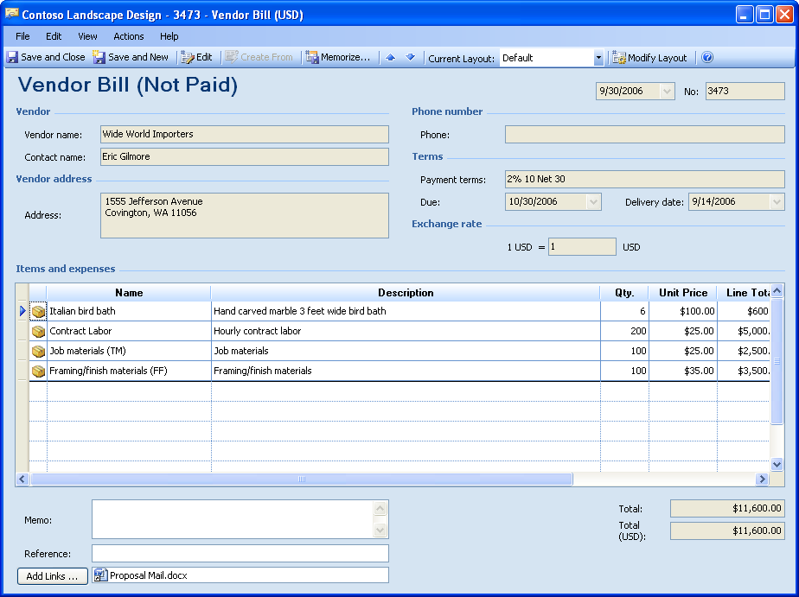

Figure 4: Easily track expenses and other transactions.

### Create, Modify, and Export Documents in Office Word

Because Office Accounting Professional 2007 works smoothly with Office Word, you can easily export quotes, sales orders, packing slips, invoices, and other information to Word with a click. If your business has already created personalized Word documents, you can reuse existing templates and documents. You can also customize templates that come with Office Accounting Professional 2007 to create professional-looking materials and documents. The Write Letters Wizard is an easy way to create and modify letters from Word templates for your customers, vendors, and employees.

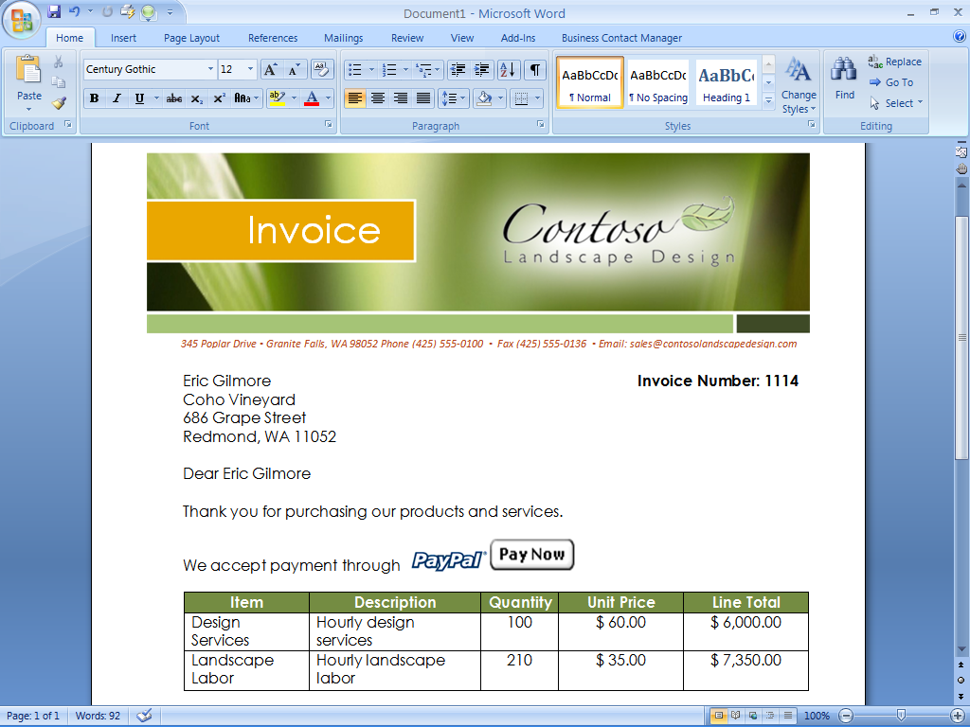

Figure 5: Create professional-looking documents with Microsoft Office programs.

Office Accounting Professional 2007 in Action: Work with Office Word

Employees at Contoso can continue working with familiar programs such as Office Word, knowing that the programs work smoothly with Office Accounting Professional 2007. For example, when viewing a quote within Office Accounting Professional 2007, Aaron can export the information as a Word document for editing and submitting to the customer. Through this integration, Aaron can create professional-looking proposals, invoices, and other customer mailings.

### Automate Bank Accounts

Businesses must track banking activities to keep tight control on the flow of funds into and out of the company. If your business has an online banking account, you can download your records from the bank or other financial institution directly into Office Accounting Professional 2007. The Online Banking Wizard helps you easily set up and use the online banking feature.

Office Accounting Professional 2007 helps you manage multiple company bank accounts and maintain a consolidated view of the various accounts. The Banking home page summarizes your company’s banking activities. From the Banking home page, you can easily write and print checks, make deposits, reconcile your bank accounts, and perform other banking tasks.

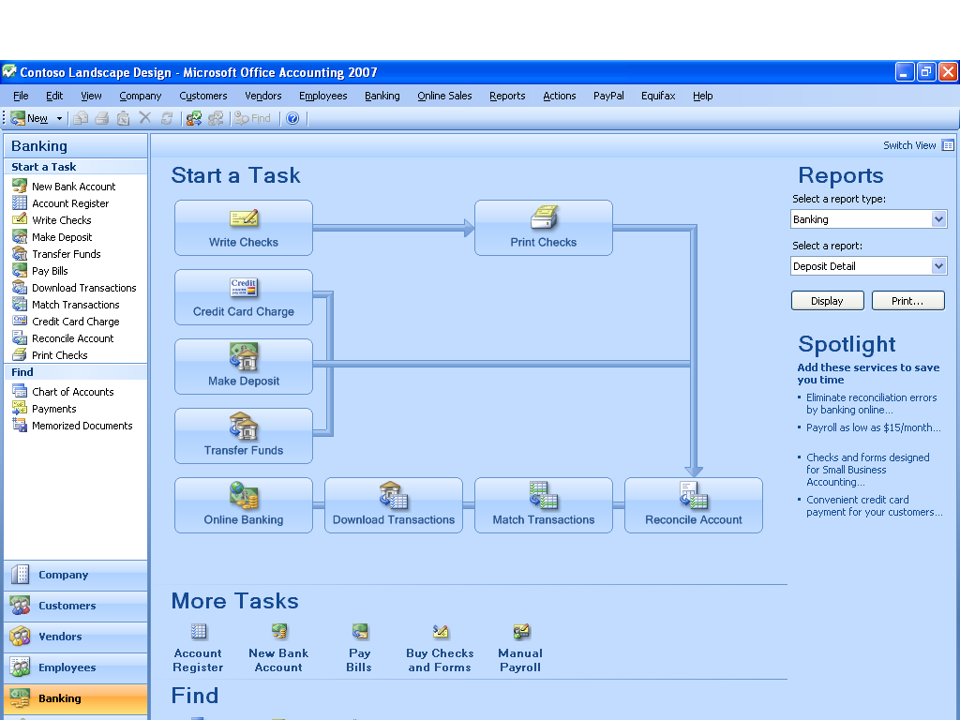

Figure 6: The Banking home page summarizes banking activities.

### Automate Customer Payments

You can customize and organize customer payments with Office Accounting Professional 2007. With the credit card processing option, accept credit and debit card payments to better serve your customers and reduce transaction costs. For credit card purchases, you can print receipts and create customer credit memo templates for future transactions.

### Track Employee Time and Costs

Billable time is the livelihood of service businesses. You can track and manage employees’ billable time directly in Office Accounting Professional 2007 through the Time Entry form. Office Accounting Professional 2007 can then use the billable hours to create customer invoices.

Many companies, such as consulting firms and contractors, organize their businesses around specific customer jobs. Office Accounting Professional 2007 helps you track revenues and expenses by job, and monitor and compare total job profitability. You can also track estimated versus actual job costs and compare invoices versus quotes. This data becomes useful for business planning such as increasing the accuracy of future job estimates.

Working with Office Outlook 2007 with Business Contact Manager helps you achieve more accurate and timely billing. Employees can mark appointments in their Outlook calendars as billable time, and then transfer that information to Office Accounting Professional 2007 with a single click.

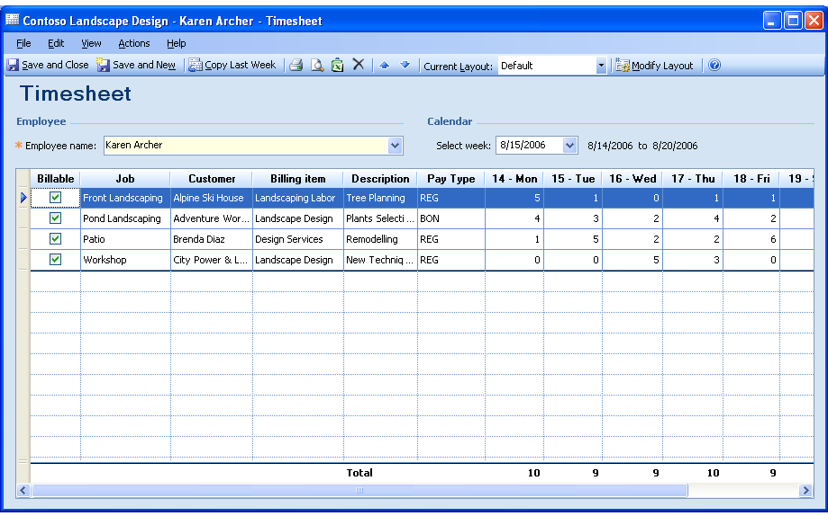

Figure 7: Easily track billable time by job in Office Accounting Professional 2007.

### Manage Payroll and Taxes

Managing payroll and calculating government taxes can be one of the most difficult financial tasks for any business. With Office Accounting Professional 2007, you can subscribe to online-based payroll functionality powered by payroll-industry leader ADP for an additional fee. The Payroll tool in Office Accounting Professional 2007 provides a full-featured, easy-to-use payroll and tax processing program for calculating federal, state, and local taxes. ADP offers multiple payroll options so you can select a service that meets your business needs. In addition, with the integration between Office Accounting Professional 2007 and ADP, you can import timesheet data directly into the payroll application, and export payroll and tax information to the general ledger.

Office Accounting Professional 2007 in Action: Manage Payroll with ADP Services

Using the optional ADP payroll services, Aaron easily calculates payroll, prints checks, and files taxes. Working with ADP eliminates a significant amount of paperwork and makes it easy for Aaron to pay employees. Because ADP services work smoothly with Office Accounting Professional 2007, Aaron can automate tasks such as employee timesheets. Every two weeks, he exports timesheet data directly into the ADP payroll application for automated payroll processing, saving hours of tedious work. ADP can even automatically supply the latest tax forms and calculate state and local taxes.

### Track and Forecast Inventory

For small businesses that sell products, effective inventory management is key to minimizing costs and maximizing profits. Office Accounting Professional 2007 provides an inventory system that automatically updates quantities when you create invoices or take returns. You can track and adjust overall inventory quantities in the system in real time, and you can use the physical inventory worksheet to perform a physical count. An inventory form contains inventory information for each item, including the quantity on hand, the reorder point, and total value.

### Sell and Buy in Multiple Currencies

For businesses that work with customers or vendors outside the United States, Office Accounting Professional 2007 handles the complexity of currency conversion and reconciliation, helping you do business with international vendors and customers in their own currencies.

# Get a Complete View of Your Business

In many small businesses, customer and financial information resides in different places—file folders, e-mail messages, spreadsheets, documents, and even sticky notes. Many small business owners do not have adequate time to truly understand and make use of their financial data, and often no easy way to share or organize the information exists to enable faster decision-making and provide better service to customers. Comprehensive business information is difficult to compile and understand, so getting the big picture of the business’s financial health is challenging.

Office Accounting Professional 2007 gives you a single, always up-to-date view of your business by helping you manage financial information in one place. You can get organized and work the way you want by customizing the information you would like to see at a glance. Furthermore, you can track customer and financial information together by sharing customer account information using Office Outlook 2007 with Business Contact Manager.

## View Your Financial Information in One Place

Office Accounting Professional 2007 puts financial data and business information in one place, giving you a comprehensive look at your business to enable better-informed decisions. By sharing and synchronizing customer account information using Office Outlook 2007 with Business Contact Manager, you can provide your employees with better financial information to serve customers, improve productivity, and reduce errors.

### Store and Organize Data Centrally

Office Accounting Professional 2007 gives businesses a central place to collect, organize, and manage financial information so they don’t have to use multiple methods and tools. Easily work with information about your customers, employees, and vendors in one place.

Because Office Accounting Professional 2007 and Office Outlook 2007 for Business Contact Manager share a single database, information related to customers, vendors, prospects, and employees can be easily shared in real time between the two programs. The ability to bill, track transactions, and query financial history can be used by salespeople as well as office managers and business owners.

### Work with Microsoft Point of Sale

If you are a single-store retailer, Microsoft Point of Sale provides an easy-to-use program that helps track sales, inventory, and customer information. Combining Microsoft Point of Sale with Office Accounting Professional 2007 creates an integrated retail solution that connects the point of sale to accounting. You can send all the sales details of the day from Microsoft Point of Sale to Office Accounting Professional 2007 without retyping data, thus saving time and reducing errors. You can then use Office Accounting Professional 2007 to run financial reports that help you manage cash flow and improve profitability.

### Get a Snapshot of Important Information

When accounting data is available in one place, you can quickly get a look at the fiscal health of the company. The company home page provides a snapshot of important information, critical tasks, and reminders on one screen. By capturing this information in one location, you can stay on top of your business and quickly get an overall sense of its performance.

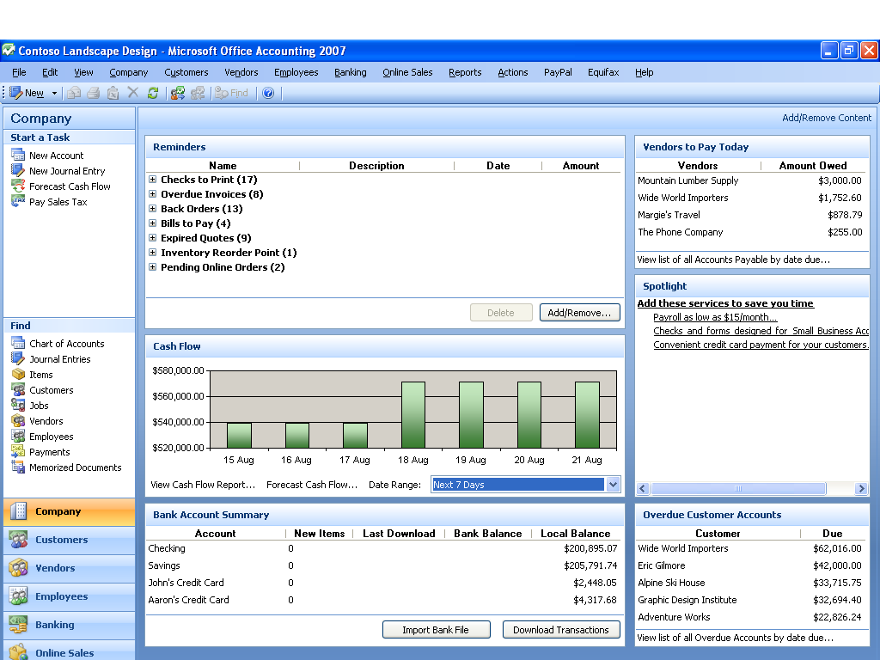

Figure 8: The company home page provides a centralized view of critical business information.

Office Accounting Professional 2007 in Action: Get a Complete View of the Business

At Contoso Landscape Design, the company’s financial information used to be located in different documents and spreadsheets throughout the office. Now Office Accounting Professional 2007 provides Aaron with the tools he needs to manage his company’s business finances in one place: core accounting functions, invoicing and billing, inventory and landscape job tracking, account reconciling, and reporting. Aaron can now replace his company’s different accounting documents and forms, and he and his employees can continue using familiar Microsoft Office system programs.

Through the company home page in Office Accounting Professional 2007, Aaron gets reminders of daily tasks as well as key information such as cash flow, sales to a new client, subcontractors to pay, and overdue client payments. With a single click, Aaron can invoice or pay bills. Items that were previously in separate spreadsheets, such as price lists, accounts receivable, accounts payable, and employee payroll, are now all in one location.

### Share Account Information with Office Outlook 2007 with Business Contact Manager

When you combine Office Accounting Professional 2007 with Office Outlook 2007 with Business Contact Manager, you get a complete business and financial picture of your customers in one place. From within Office Outlook 2007 with Business Contact Manager, employees can turn opportunities into quotes, orders, and invoices in Office Accounting Professional 2007—without having to reenter information in another program. Employees can mark their Outlook calendar appointments, projects, tasks, and phone logs as billable and automatically send that information to Office Accounting Professional 2007 to create customer invoices.

An integration wizard helps you link your Office Outlook 2007 with Business Contact Manager accounts and contacts with your customers in Office Accounting Professional 2007. Because the programs share a database, data entered in either program automatically flows to the other so information is always synchronized. This keeps you informed of account and customer changes and provides a central location for critical information, which can also be shared with employees selectively, based on their roles.

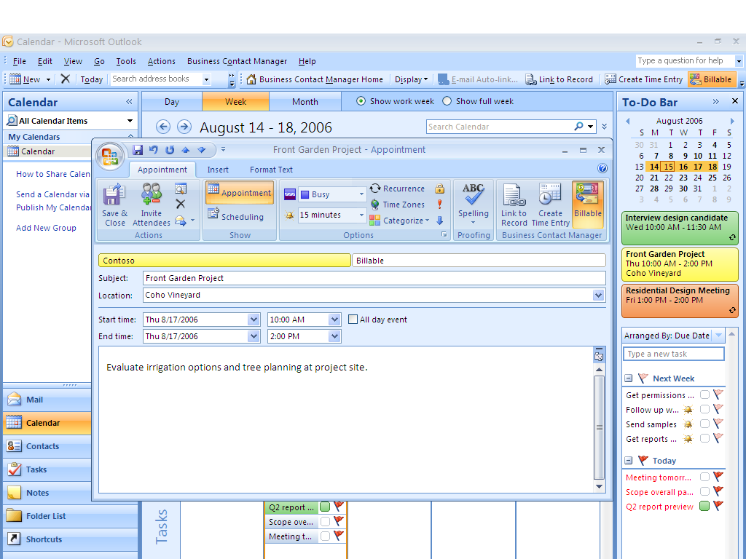

Figure 9: Use Office Outlook 2007 with Business Contact Manager to work smoothly with Office Accounting Professional 2007.

Office Accounting Professional 2007 in Action: A Consolidated View Using Office Outlook 2007 with Business Contact Manager

Contoso customer information residing in Office Outlook 2007 with Business Contact Manager is shared smoothly with Office Accounting Professional 2007. For example, as the landscape designers meet with customers, they can mark their Outlook calendar appointments as billable and automatically transfer the time to Office Accounting Professional 2007 for customer invoicing, eliminating the tedious task of copying information from Outlook or handwritten notes to generate an invoice.

Through the combination of Office Accounting Professional 2007 and Office Outlook 2007 with Business Contact Manager, all employees now have a clearer picture of the customer. When a customer calls, a designer or other employee can quickly see the customer’s status, including financial information such as quotes and invoices. Employees can now more easily track customer communications by using Outlook because everyone working with a particular account can attach the latest notes, e-mail messages, and scanned documents.

## Work the Way You Want

Every business is different. That’s why tailoring your accounting solution to suit your business’s needs and style is so important. Office Accounting Professional 2007 makes it easy to customize and personalize the information you need.

### Create a Personalized Company Home Page

The company home page provides a snapshot of your business’s overall financial condition as well as your day-to-day accounts payable and accounts receivable information. You can personalize this information by easily adding and removing dashboard content such as reminders, recent cash flow forecasts, bank account information, vendors, customers, and more.

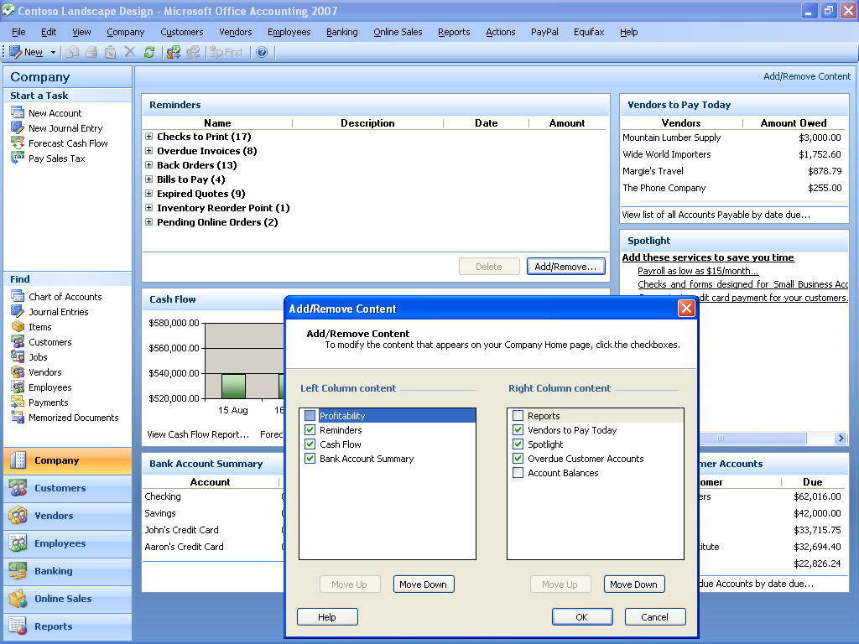

Figure 10: Easily customize the company home page to personalize snapshot information.

### Customize Forms

Using Office Accounting Professional 2007, you can easily customize quotes, sales orders, invoices, purchase orders, reports, and more. You can fully customize the data elements used in most forms by moving fields, creating custom fields, renaming fields, and hiding unneeded fields. These customized forms and letters can be exported to Word templates to sharpen the professional appearance of marketing materials and financial documents.

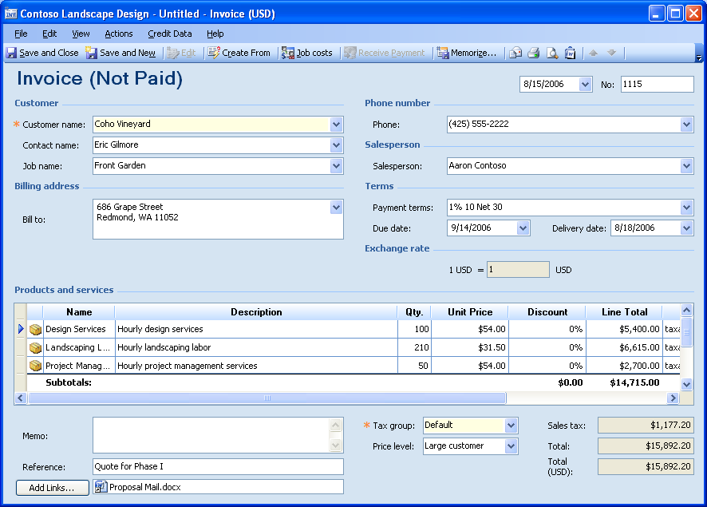

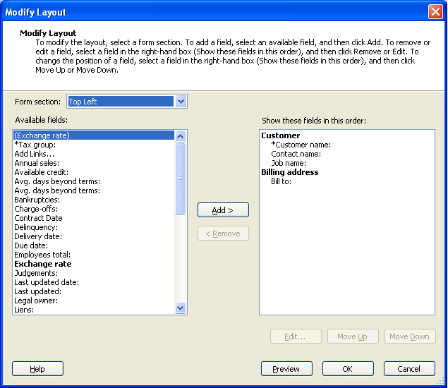

Figure 11: Customize forms to suit your business needs.

### Provide Employee Access and Customize Security Roles

Having better insight into financial and customer information can help employees be more effective workers. Yet, because some employees may not need access to all the company’s accounting data, providing even basic information to the right employees can be challenging.

With Office Accounting Professional 2007, owners and managers can control access to sensitive information based on an employee’s role. You can add and remove permissions from different roles such as Owner, Office Manager, Accountant, and Salesperson, as well as add new customized roles. That gives you ultimate flexibility over who has access to your business’s accounting data.

Multiple users can also work with Office Accounting Professional 2007 from different computers at the same time.

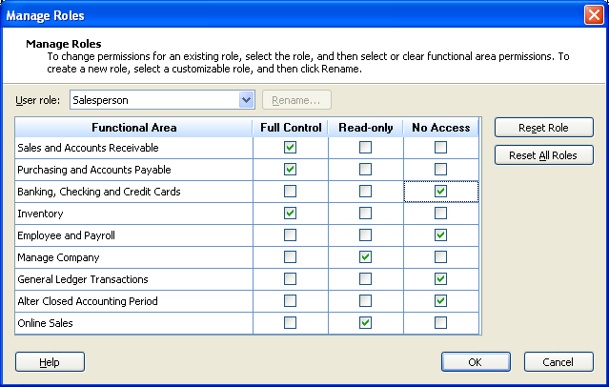

Figure 12: Manage which employees can access accounting information by customizing roles.

### Find and Organize Information Quickly

Even when a business is small, finding financial and customer information is sometimes more work than it needs to be. It is essential to make financial and customer data accessible and usable to everyone in the company who needs it. Office Accounting Professional 2007 includes features to help you quickly find mission-critical data, whether it is related to customers, vendors, jobs, or other information.

To improve database performance, the Compress Data feature compresses historical data in a separate company database, making the active database faster than ever. Data for all years remains available if needed for year-by-year comparisons.

## Gain Insight into Your Business Finances

Business owners are often caught up in the day-to-day tasks of running the business. It can be challenging to gather financial information to gain insights for making short-term and long-term decisions about the direction of the business. Office Accounting Professional 2007 provides the features and reports to give you the information you need, at a glance, to make more informed business decisions. You can further analyze the data by exporting accounting data to other Microsoft Office system programs such as Office Excel or Office Access.

### Understand Your Business with Comprehensive Reports

Office Accounting Professional 2007 offers more than 60 predefined reports that help you get insights into all aspects of your business. Easy-to-use reporting empowers you with many kinds of financial information across the company, such as the sales pipeline, cash flow, item profitability, and customer transactions. In addition, you can easily customize the reports by setting filters, changing fonts and formatting, and more. If you need to further analyze or format the data, you can export these reports to Office Excel.

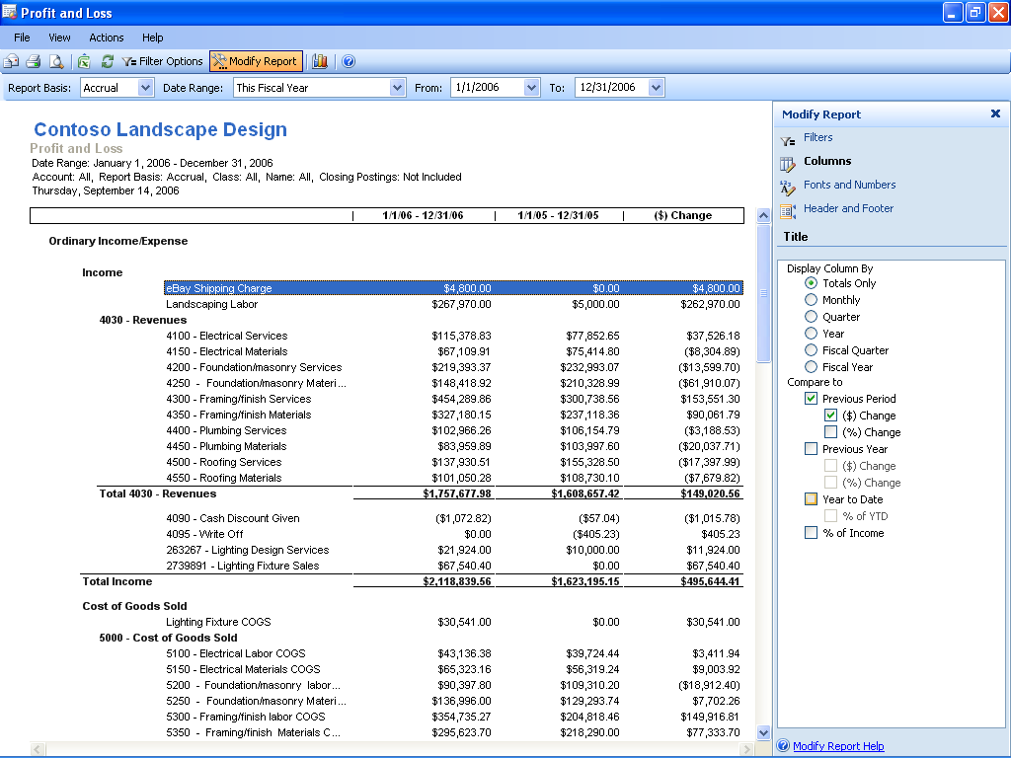

Figure 13: Gain insight into your business with more than 60 predefined, customizable reports.

Office Accounting Professional 2007 in Action: Gain Insight into the Business

Running the business every day takes up most of Aaron’s time, but he wants to gain better insight into his business that could help him make critical decisions about the direction of the company. For example, Aaron is interested in his designers’ billable hours, but the day-to-day tasks of running his business always take priority over generating this information.

By running some of the predefined reports in Office Accounting Professional 2007, Aaron can better understand the health of his business. In addition to easily generating essential reports such as a company balance sheet, Aaron creates a time report to better understand how his employees account for billable hours that are submitted to customers.

### Understand Your Customers

Using the customers home page in Office Accounting Professional 2007, you can perform all the tasks related to customers and receivables and get a quick view of the state of each account. You can stay up-to-date on the latest customer needs through a financial summary that includes outstanding payments and balance information.

If more information is required to manage sales and predict sales activity, you can run detailed reports. For example, you can run reports that show sales status, order information, and probability of closing. Salespeople can filter data to view the status of accounts they are working on or to display customers they have not contacted recently.

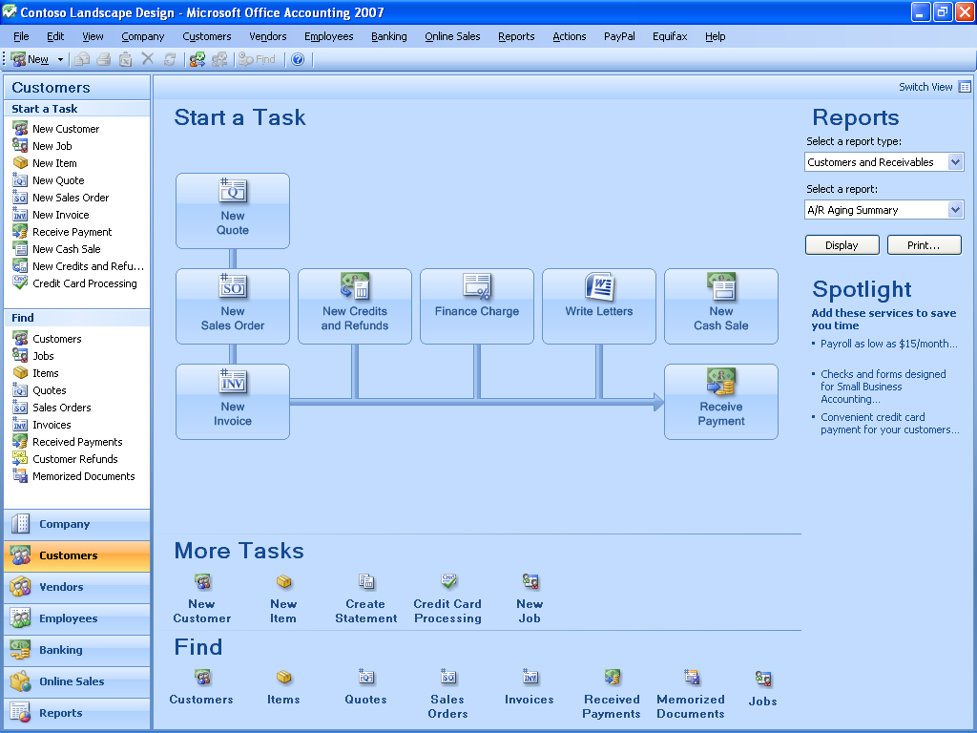

Figure 14: The customers home page is the starting point for managing customer sales.

### Monitor and Forecast Cash Flow

Analyzing cash flow—the difference between income and expenses—is an essential task for business owners. Office Accounting Professional 2007 includes cash flow tools that help you conduct a complete and accurate analysis of history and trend data for cash coming in and going out of the business.

The Cash Flow Forecast tool keeps track of sales, purchases, and payments to help you manage and predict cash flow easily. You can model different scenarios to help forecast future cash flows and make decisions about which customers to contact or which bills to pay. For further cash flow analysis, Office Accounting Professional 2007 reports such as the Cash Flow Statement can show cash inflows and outflows of the business over a period of time.

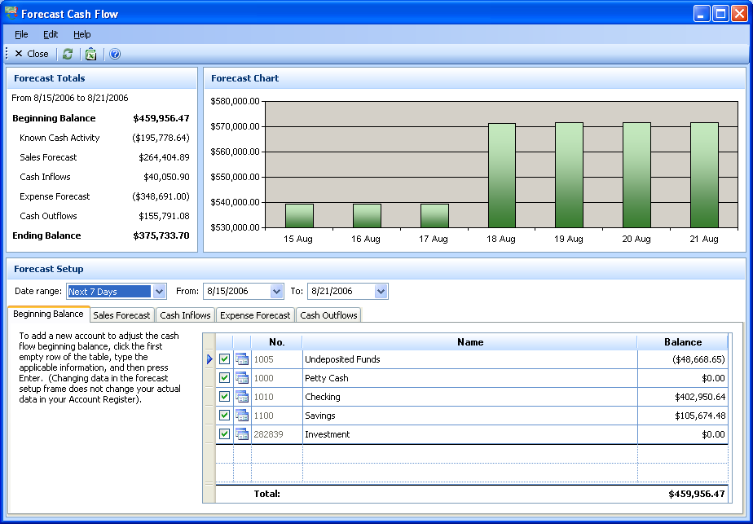

Figure 15: The Cash Flow Forecast tool helps businesses easily manage and predict cash flow.

Office Accounting Professional 2007 in Action: Forecast Cash Flow

Aaron wants to get a better handle on the cash flow of Contoso Landscape Design. He feels uneasy that he does not know whether he’ll have enough cash for some landscaping equipment he plans to purchase in 90 days. Aaron can use the Cash Flow Forecast tool to model different scenarios and predict how potential sales and expenses will change the inflow and outflow of cash. By entering his expected sales and ongoing expenses, Aaron feels more confident in his decision to purchase the equipment.

### Analyze Data with Office Excel and Office Access Integration

Microsoft Office integration helps you work with Office Excel and Office Access more efficiently. Excel makes it possible to view Office Accounting Professional 2007 data in reports and lists to facilitate analysis or create financial forecasts. You can easily import accounting data from Excel or export reports while maintaining rich formatting and formulas. With Office Accounting Professional 2007, you can also export data to Access.

With the Office Accounting Professional 2007 Analysis Tools, you can extend your accounting system by connecting to your Office Accounting Professional database and generating Excel PivotTable views and Access database reports. With these PivotTable views and Access reports, the extracted information can help you make better sense of your company transactions.

## Share Data with Your Accounting Professional

Many small businesses regularly work with an accountant or bookkeeper, whether for payroll, tax preparation, or other tasks. Office Accounting Professional 2007 includes unique features to make it easier to share your business’s financial data with an accounting professional.

Using the Accountant Transfer Export Wizard, you can send your business’s accounting data to your accountant and continue using Office Accounting Professional 2007. When the accountant is done updating the books, he or she can send the data back to you to synchronize the changes. Alternatively, your accountant can remotely connect to your copy of Office Accounting Professional 2007 and update it.

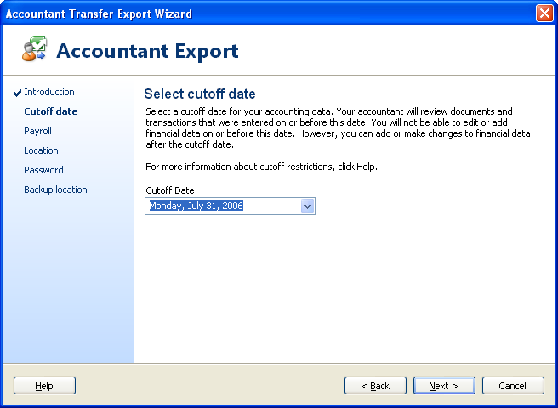

Figure 16: Easily send financial data to your accountant with the Accountant Transfer Export Wizard.

Microsoft Office Live helps businesses create a fully featured online presence. With Office Live and Office Accounting Professional 2007, you can easily and more securely transfer financial data to and from your accounting professional. If an accountant works with multiple clients who use Office Accounting Professional 2007, the Accountant View page provides a centralized dashboard from which the accountant can independently manage client accounts and payroll, import and export client data, and manage journal entries for each client.

# Manage and Grow Your Business More Effectively

In a competitive world, small business owners are looking for better ways to manage and develop their businesses. More small businesses are selling online because the Internet gives them the ability to reach millions of potential customers. Office Accounting Professional 2007 works smoothly with online marketplaces to help you sell more effectively and receive customer orders and payments with confidence.

## Sell Online More Effectively

With the Microsoft Small Business Online Sales option, you can easily and cost-effectively sell on Internet marketplaces such as eBay. Whether you’re selling online for the first time or already have an eBay business, working through Office Accounting Professional 2007 can save you time and help you sell more.

### Sell on eBay

Office Small Business Accounting 2007 helps you reach out to millions of potential customers with its full-featured eBay integration. From the online sales home page, you can easily list inventory items, check the status of your listing, download and process orders, and track activity in real time from within Office Accounting Professional 2007. A single listing screen helps you manage all inventory items in real time, including quantity, reserve prices, and images. You can easily upload multiple listings simultaneously. After an item sells, the order information including commissions and fees is downloaded directly into Office Accounting Professional 2007. The online orders can be processed in Office Accounting Professional 2007, and payments can be received by using the integrated credit card services or PayPal.

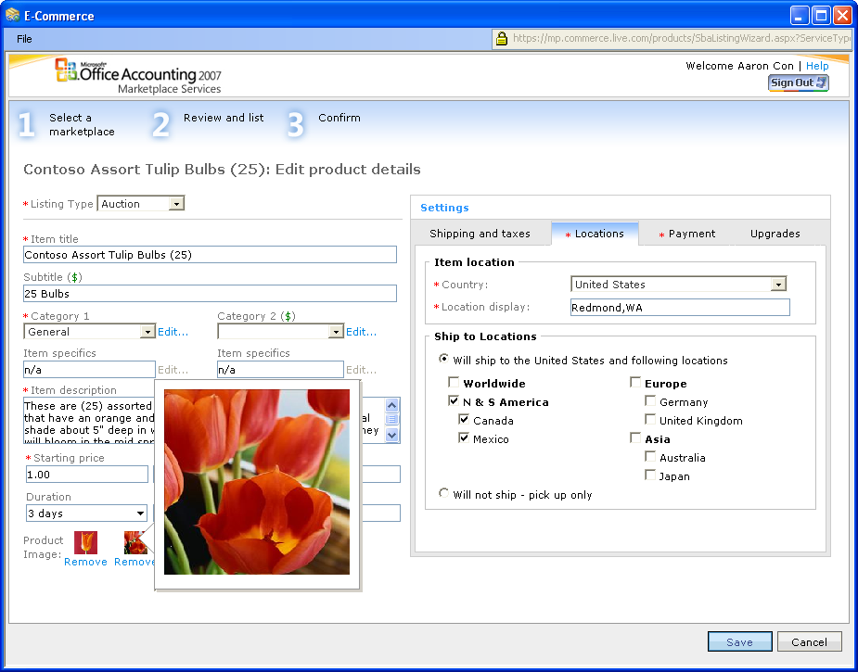

Figure 17: List inventory items, upload images, and sell on eBay.

Office Accounting Professional 2007 in Action: Easily Sell Online

Contoso Landscape Design offers landscape lighting equipment as part of its landscape design service. Selling lighting equipment and replacement parts is currently a small part of Contoso’s sales, but owner Aaron Con believes he can expand the business further by offering landscape lighting products online.

Through the online sales home page in Office Accounting Professional 2007, Aaron can easily start selling items on eBay. A single listing screen helps him manage all of his listing data and images in one place. Because everything can be managed and tracked through Office Accounting Professional 2007, Aaron can easily manage the sales without needing to reenter information. After an item sells, the transactions are automatically downloaded into Office Accounting Professional 2007, further saving time.

## Do Business with Confidence

Managing customer transactions can be a constant challenge for small businesses. Office Accounting Professional 2007 provides integration with services to help you check the financial health of your customers and provide them with more payment options so that you can receive payment more quickly.

### Get Paid Faster Through PayPal

Smart businesses offer customers a variety of payment methods. Office Accounting Professional 2007 gives you the ability to offer customers a PayPal payment option to help you get paid faster. Using Microsoft Office Outlook, you can easily generate an e-mail message with an invoice that includes an integrated PayPal option. Customers click an automatically generated link and use the PayPal service to enter payment. All transactions are tracked in Office Accounting Professional 2007, dramatically simplifying the payment process.

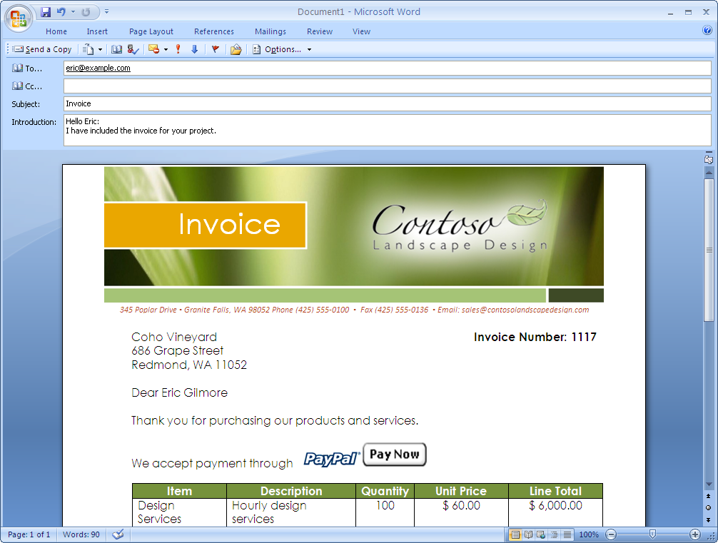

Figure 18: Get paid through e-mail by using Office Outlook and PayPal.

### Credit Profile with Equifax

Office Accounting Professional 2007 provides easy access to Equifax credit report services. Obtain one-time credit reports or ongoing credit monitoring of customers and prospects to help you evaluate business risk and make decisions about customer sales with more confidence. You can also order a credit report for your business to keep track of your own credit history.

# Resources

For more information about Microsoft Office Accounting Professional 2007, please refer to the following resource:

<http://www.microsoft.com/office/accounting>

# System Requirements

For complete system requirements, see <http://www.microsoft.com/office/accounting>.

This document is developed prior to the product’s release to manufacturing, and as such, we cannot guarantee that all details included herein will be exactly as what is found in the shipping product. The information contained in this document represents the current view of Microsoft Corporation on the issues discussed as of the date of publication. Because Microsoft must respond to changing market conditions, this document should not be interpreted to be a commitment on the part of Microsoft, and Microsoft cannot guarantee the accuracy of any information presented after the date of publication. The information represents the product at the time this document was printed and should be used for planning purposes only. Information is subject to change at any time without prior notice.

This document is for informational purposes only. MICROSOFT MAKES NO WARRANTIES, EXPRESS OR IMPLIED, IN THIS DOCUMENT.

© 2006 Microsoft Corporation. All rights reserved.

Microsoft, Excel, the Office logo, Outlook, and PivotTable are either registered trademarks or trademarks of Microsoft Corporation in the United States and/or other countries. All other trademarks are property of their respective owners.

1. Requires purchase of an additional third-party service. [↑](#endnote-ref-2)
2. Subscription and additional fees may apply. [↑](#endnote-ref-3)
3. Subscription and additional fees may apply for Office Live. [↑](#endnote-ref-4)
4. Requires purchase of an additional third-party service. [↑](#endnote-ref-5)