

Microsoft Office 2003 Editions
Product Guide
September 2003
Table of Contents
1 Overview 5
Introduction 5
Design Goals 5
Connect people 5
Connect information 6
Connect business processes 7
System Recommendations 8
Additional Items or Services 9
2 Connect People 11
Introduction 11
Collaboration challenges 11
Providing a platform for effective teamwork 11
New feature highlights 11
Key functionality 12
Shared Workspace Task Pane 13
Document Workspaces 14
Integrated Web discussions 19
Meeting Workspaces 19
File Menu integration 23
Version tracking 24
Document Check-in and Check-out 25
Windows SharePoint Services integration with Office 2003 Editions programs 26
Windows SharePoint Services and Outlook 2003 26
Shared Lists 28
Windows SharePoint Services and Excel 2003 and Access 2003 28
Manage team time 30
Instant messaging integration and presence integration 30
Team calendar views 30
Helping to Protect Sensitive Documents 33
Information Rights Management in Office 2003 Editions 33
Permission options 35
Additional server requirements 36
Regional Permissions 36
Structured Editing in Word 2003 37
Summary 38
3 Connect Information 38
Introduction 39
Organizational and design enhancements 39
New feature highlights 39
A new look for Outlook 2003 40
Working with new e-mail views 40
Navigation Pane 44
Key functionality 52
Streamline e-mail creation 52
Organize and prioritize e-mail 54
Prevent unwanted e-mail 64
Filter Junk e-mail 66
Enable worker mobility and productivity 69
More effective contact management 73
Bringing relevant information to people’s fingertips 74
Flexible information management technologies 78
Picture Manager 82
Summary 83
4 Connect Business Processes 83
Introduction 84
Business process management challenges 84
Business value of XML in Office Professional Edition 2003 84
New feature highlights 85
Key functions that are enabled by XML in Office Professional Edition 2003 87
Freeing up critical business information 87
XML in Word 2003 94
XML in Excel 2003 98
XML in Access 2003 101
Summary 103
5 Help and Office Online Services 103
Online help and training 104
Help 104
Assistance 104
Training on Office Online 105
Downloads 105
Accessibility features 106
Clip Art and Media Web site 106
Templates on Office Online 108
6 Conclusion 109
7 Program Features 110
Index of new functionality 111
Microsoft Office 2003 Editions 112
Creating a Document Workspace 112
Information Rights Management (IRM) 114
XML 115
Outlook 2003 117
Reading Pane 117
Multi-line message view with smart dates and grouping 118
Arrange by conversation 121
Go menu 122
Quick flags 123
For Follow Up folder 123
Search Folders 125
New mail Desktop Alert 126
Junk e-mail settings 127
Block external content 129
Shared calendar 130
Contact picture 130
Cached Exchange Mode 132
Remote Procedure Calls (RPC) over Hypertext Transport Protocols (HTTP) 133
Internet faxing 133
Word 2003 134
ClearType 135
Reading Layout view 136
Merge enhancements 137
Track changes enhancements 138
Ink support 139
Formatting Restrictions 141
Editing Restrictions 142
Excel 2003 144
List data integration with Windows SharePoint Services 144
Using Improved Standard Deviation computation 145
Smart tag integration 145
PowerPoint 2003 147
Smart tag integration 147
Thesaurus integration 149
Ink support 150
Annotations in Slide Show view 151
Expanded playlist formats 152
Full-screen playback 153
PowerPoint Viewer and Package for CD 154
Access 2003 155
List data integration with Windows SharePoint Services 155
Smart tag integration 157
Back up a database 159
AutoCorrect option 160
Dependent Objects 160
Font Control for the SQL Window 162
Error checking 163
Making a local table 165
Propagating field properties 166
XML Glossary 167

The information contained in this document represents the current view of Microsoft Corporation on the issues discussed as of the date of publication. Because Microsoft must respond to changing market conditions, it should not be interpreted to be a commitment on the part of Microsoft, and Microsoft cannot guarantee the accuracy of any information presented after the date of publication.
This White Paper is for informational purposes only. MICROSOFT MAKES NO WARRANTIES, EXPRESS, IMPLIED OR STATUTORY, AS TO THE INFORMATION IN THIS DOCUMENT.
Complying with all applicable copyright laws is the responsibility of the user. Without limiting the rights under copyright, no part of this document may be reproduced, stored in or introduced into a retrieval system, or transmitted in any form or by any means (electronic, mechanical, photocopying, recording, or otherwise), or for any purpose, without the express written permission of Microsoft Corporation.
Microsoft may have patents, patent applications, trademarks, copyrights, or other intellectual property rights covering subject matter in this document. Except as expressly provided in any written license agreement from Microsoft, the furnishing of this document does not give you any license to these patents, trademarks, copyrights, or other intellectual property.
Unless otherwise noted, the example companies, organizations, products, domain names, e-mail addresses, logos, people, places, and events depicted herein are fictitious, and no association with any real company, organization, product, domain name, email address, logo, person, place, or event is intended or should be inferred.
 2003 Microsoft Corporation. All rights reserved.
Microsoft, ClearType, Encarta, InfoPath, MSDN, MSN, OneNote, Outlook, PivotTable, PivotChart, PowerPoint, SharePoint, Visual Basic, Visual C#, Visual C++, Visual Studio, Windows, Windows Media, and Windows Server are either registered trademarks or trademarks of Microsoft Corporation in the United States and/or other countries.
The names of actual companies and products mentioned herein may be the trademarks of their respective owners.

Introduction
Welcome to Microsoft® Office 2003 Editions, the easiest way to help more people use information to make a positive impact on business. The Office 2003 Editions offer new technologies and features while improving upon existing and familiar tools to facilitate effective and efficient collaboration and information sharing.
Through integration with Microsoft Windows® SharePoint™ Service, the Office 2003 Editions offer advances in intranet collaboration to help users gain access to and share information both internally and externally. Support for Information Rights Management (IRM), and industry-standard Extensible Markup Language (XML) provides a platform on which to build cost-effective solutions that can have an immediate, positive impact. In addition, the Office 2003 Editions offer new ways to organize and manage e-mail and make more use out of the workday.
Design Goals
With a focus on connecting people, information, and business processes, the design goals integrate collaboration, usability, and information management.
Connect people
Designed to integrate with intranet technologies such as Microsoft Windows® SharePoint Services, the Office 2003 Editions provide new ways to connect individuals, teams, and organizations. By incorporating the new tools with familiar Microsoft Office menus, functions, and interfaces, training and implementation time is minimized. Workers can collaborate from any location by using shared information and simplified review processes, including the following features:
- New! Shared Workspace Task Pane facilitates and simplifies efficient collaboration and document sharing.
- New! Shared Attachment Option offers an automatic way of creating Document Workspaces through e-mail messages, when sending attachments for review. Document Workspaces then provide a forum for managing collaborative review and projects, with features such as automatic updates to the most current version, and the ability to share documents and other relevant information in real time.
- New! Meeting Workspace Option automatically creates workspaces through Outlook invitations. Meeting Workspaces help enhance the productivity of meetings by providing a place to coordinate schedules, disseminate materials, and store notes and minutes.
- New! Instant messaging (IM) and alerts technology is integrated throughout the Office 2003 Editions collaboration tools, providing instant information and the ability to initiate IM conversations quickly from within documents, Shared Workspaces, or Microsoft Office Outlook 2003.
- Improved! Contacts and calendars can be shared easily among team members and viewed side-by-side to facilitate meeting coordination and scheduling.
- New! Information Rights Management (IRM) functionality protects sensitive information from unauthorized distribution or alteration, and allows companies to set and enforce policies that help control how their data is used.
- New! Word 2003 Formatting and Editing Restrictions maintain formatting structure and document integrity.
Connect information
The Office 2003 Editions are designed to make it easier for people to manage an ever-increasing volume of business information. Improvements and new features in Outlook 2003 enable users to organize and prioritize e-mail messages quickly and easily, and new security settings offer increased support for junk e-mail filtering. Support for remote and mobile workers includes improvements to connectivity performance, such as better caching, and shared calendars. Obtaining information from a variety of locations is made easier with organizational tools, such as the Research Task Pane. The following are new and improved features for connecting information:
- New! New Mail View, Reading Pane, and Navigation Pane in Outlook 2003 work together to give users a more comprehensive, organized view of their e-mail messages, with more efficient use of screen space.
- New! Outlook 2003 Search Folders provide an easy, automated way to organize e-mail messages without physically moving them. Users can create customized Search Folders based on their business needs.
- New! Outlook 2003 Quick Flags provide one-click marking of e-mail messages that require action.
- Improved! Remote and mobile access includes improved Outlook 2003 connectivity and better caching.
- Improved! Enhanced Rules and Alerts provide automated organization of incoming e-mail messages, in addition to automatic notifications so that users can stay current with incoming e-mail messages without spending extra time doing so. Alerts can also be integrated with Document Workspaces to notify users about important project developments.
- Improved! Accessing needed information is more efficient with the Research Task Pane.
- Improved! E-mail security enhancements help stop incoming messages that contain viruses, improve junk e-mail filtering, and block unsolicited attachments from communicating back to the originating servers.
- Improved! Enhanced ink support provides a better experience overall when using Tablet PCs, offering support for handwritten e-mail messages and the ability to write directly in Word 2003, Microsoft Office PowerPoint® 2003, and Microsoft Office Excel 2003 documents.
Connect business processes
Often critical business information is kept separate from the programs that workers know and use. With its extensive support for industry-standard XML, the Office 2003 Editions help bring business processes and information together on the desktop. To facilitate greater efficiency, features such as Smart Documents and Programmable Task Panes help users to share customizable, task-specific information easily. New and improved tools for connecting business processes include the following features:
- New! Customer-defined XML schema support is available in Word 2003 and Excel 2003.
- New! Smart Documents bring relevant information directly to the task at hand through a new Programmable Task Pane user interface. With Smart Documents, XML solutions can be created to enable business processes, help users complete forms and other documents, and then link that information to back-end systems that support XML. As the user clicks through the document, the program is modified to present the appropriate functions to complete the task.
- New! Extensible Smart Tag support is now offered in all the Office programs including PowerPoint 2003, Outlook 2003, and Microsoft Office Access 2003. Support includes automatic configuration capabilities such as formatting and populating an index at the end of an article.
- New! XML support for Word 2003 includes content management options, data reporting, content repurposing, and data mining.
- Improved! XML support for Excel 2003 and Access 2003 offers increased flexibility for importing XML files of any schema.
System Recommendations
To use the Office 2003 Editions, you need to meet the following system requirements:
  - Personal computer with an Intel Pentium 233-megahertz (MHz) or faster processor (Pentium III recommended)
  - Microsoft Windows® 2000 with Service Pack 3 (SP3) or later; or Windows XP or later
  - Super VGA (800 × 600) or a higher-resolution monitor
  - 128 megabytes (MB) of RAM or more
Hard disk usage will vary depending on configuration; custom installation choices may require more or less hard disk space. The following are the hard disk requirements for individual Office 2003 Editions.
Microsoft Office Professional Edition 2003
- 400 MB of available hard disk space; 190 MB of hard disk space for Microsoft Office Outlook® 2003 with Business Contact Manager
- Optional installation files cache (recommended) requires an additional 290 MB of available hard disk space
Microsoft Office Small Business Edition 2003
- 380 MB of available hard disk space; 190 MB of additional hard disk space to use the optional installation of Outlook 2003 with Business Contact Manager
- Optional installation files cache (recommended) requires an additional 280 MB of available hard disk space
Microsoft Office Standard Edition 2003
- 260 MB of available hard disk space
- Optional installation files cache (recommended) requires an additional 250 MB of available hard disk space
Microsoft Office Student and Teacher Edition 2003
- 260 MB of available hard disk space
Optional installation files cache (recommended) requires an additional 250 MB of available hard disk space
Additional Items or Services
Some features or advanced functionality have additional requirements.
Microsoft Office Professional Edition 2003
To use the optional installation of Outlook 2003 with Business Contact Manager, you need to meet the following system requirements:
- A PC with a Pentium 450-MHz or faster processor
- 260 MB of RAM or more recommended
- 190 MB of additional hard disk space
- For speech recognition:
  - Pentium II 400-MHz or faster processor.
  - Close-talk microphone and audio-output device.
- Microsoft Exchange Server is required for certain advanced functionality in Outlook 2003.
- Microsoft Windows Server™ 2003 running Windows SharePoint™ Services is required for certain advanced collaboration functionality.
- Internet functionality requires dial-up or broadband Internet access provided separately; local or long-distance charges may apply.
- Certain inking features require running Microsoft Office on the Microsoft Windows XP Tablet PC Edition.
- Information Rights Management features require access to a Microsoft Windows 2003 Sever running Windows Rights Management Services.
Note Business Contact Manager will be disabled in the presence of an Exchange-technologies-based e-mail system.
Microsoft Office Small Business Edition 2003
- To use the optional installation of Outlook 2003 with Business Contact Manager you need to meet the following system requirements:
  - A PC with a Pentium 450-MHz or faster processor.
  - 260 MB of RAM or more recommended.
  - 190 MB of additional hard disk space.
- For speech recognition:
  - Pentium II 400-MHz or higher processor.
  - Close-talk microphone and audio output device.
- Exchange is required for certain advanced functionality in Outlook 2003.
Note Business Contact Manager will be disabled in the presence of an Exchange-technologies-based e-mail system.
- Windows Server 2003 running Windows SharePoint™ Services is required for certain advanced collaboration functionality.
- Internet functionality requires dial-up or broadband Internet access provided separately; local or long-distance charges may apply.
Office Standard Edition 2003
- For speech recognition:
  - Pentium II 400-MHz or faster processor.
  - Close-talk microphone and audio-output device.
- Microsoft Exchange Server is required for certain advanced functionality in Outlook 2003.
- Microsoft Windows Server™ 2003 running Windows SharePoint™ Services is required for certain advanced collaboration functionality.
- Internet functionality requires dial-up or broadband Internet access provided separately; local or long-distance charges may apply.
- Certain inking features require running Microsoft Office on the Microsoft Windows XP Tablet PC Edition.

Introduction
Every employee faces challenges when a project requires team collaboration.
The Microsoft® Office 2003 Editions and the integration with Microsoft Windows® SharePoint™ Services (WSS) provides a platform that includes programs employees use daily to work with other team members in a centralized location, making the team’s work more effective and efficient.
The Office 2003 Editions allow for closer teamwork experience. New task panes from within the documents and e-mail messages provide information about other team members and also offer access to resources. Team members can use instant messenger (IM) integration to see when other team members are online or offline. New calendar features in Microsoft Outlook® 2003 make scheduling meetings with other team members quicker and more effective. The Office 2003 Editions also offer content protection rights to authors, ensuring that authors have complete access to and control over their documents.
Collaboration challenges
Scheduling and communication typically require a great deal of back-and-forth interaction, and employees in different locations often have difficulty contacting each other. Until now, collaboration technology has been difficult to use without introducing a lot of infrastructure.
Providing a platform for effective teamwork
With WSS, the Office 2003 Editions gain new and enhanced tools for working on a shared document, communicating the status of a project, finding a teammate online, or adding comments or results to a shared worksite. This collaborative workspace environment is available wherever the Microsoft Office System of programs or a simple Web browser is installed.
New feature highlights
The Office 2003 Editions and WSS integrations facilitate collaborative work on projects, and make these projects efficient and effective. Task panes, such as the Shared Workspace task pane, show lists of the collaborating team members, their online status, collaborative lists of tasks, and relevant documents about and hyperlinks to the SharePoint site to the author—giving the author multiple information sources within the immediate work area.
While working with a Shared Workspace or Document Workspace, the author can use the new instant messaging integration to determine whether other team members are online or offline, which makes the availability of contacts obvious. Outlook 2003 also allows teams to share calendars and contacts, giving all team members access to important scheduling and information resources. Through these team-oriented features, collaborative work becomes more efficient.
New content protection features include Information Rights Management (IRM) and Formatting and Editing Restrictions. IRM is a new policy enforcement technology in the Microsoft Office 2003 Editions that helps persistently protect sensitive documents and e-mail messages from unauthorized use. IRM helps reduce the risk of having confidential e-mail messages and documents fall into the wrong hands, whether by accident, carelessness, or some degree of malicious intent. In the Professional version of Office 2003 Editions, document owners can identify authorized recipients and set allowable actions. In all of the Editions, authors can also use the Formatting Restriction in Microsoft Office Word 2003 to define specific styles for a document, which reduces the amount of time that might be needed to reformat a document that has been created collaboratively. In addition to determining specific styles for a document, authors can protect individual parts of a document. By using the Editing Restriction feature in Word 2003, authors can assign specific sections to specific team members. The team members can only change content within their assigned regions, which decreases the author’s time when the various parts of a document are integrated.

Key functionality
Team projects are becoming more common and depend on seamless communication among team members. When a new team forms, the team members need to focus on the project’s tasks rather than worrying about the tools that they should use to accomplish those tasks. The Office 2003 Editions and WSS integrations employ easy-to-use tools and offer powerful functionality that helps enhance the success of a team’s collaboration efforts.
The Shared Workspace task pane, which is available in Word 2003, Microsoft Office Excel 2003, and Microsoft Office PowerPoint® 2003, allows users to view other authors’ online status. It also provides a central location for several lists that each team member can contribute to, keeping the entire team up-to-date and informed.
Document Workspaces bring all of a user’s resources, in addition to the team-collaboration context that is established in the Shared Workspace task pane, into the user's specific Office 2003 program. The user can view the progress of a document without having to resort to long e-mail chains, and can view the latest copies of the document while other team members continue their own work.
Integrated Web discussions allow reviewers, authors, and editors to work together more efficiently by providing inline discussion tools and by storing inline discussion comments on a SharePoint site. Comments are directly added to a document that is stored and managed centrally so each team member has access to the most accurate version.
Meeting Workspaces provide a secure and centralized online site for all meeting-related communication, documents, and logistics. They create organized meetings where each team member can capture up-to-date information about a project, regardless of his or her proximity to the physical meeting space.
The File menu in most Office 2003 Edition programs has been updated to include commands for shared documents on a SharePoint site. The File menu allows the user to open or save documents in a document library and add or update metadata in a document.
Version tracking is also a key functionality of WSS. Users can view previous versions of Office 2003 Edition and Office documents that are stored on a SharePoint site to find information that was deleted from the documents.
Document check-in and checkout methods have also been improved. WSS allows a user to check out Office 2003 Edition or other Office documents that are stored in a document library; however, other users are prohibited from making any changes to the checked out document. After the user checks in the document, other users can resume work on the document.
Shared Workspace Task Pane
When a user opens a document that is located on a WSS site, whether it is an Internet Web site, a Document Workspace site, or a Meetings Workspace site, the Office 2003 program that opens the document provides a special task pane that shows relevant information about that site. This pane displays information such as the list of people that are collaborating in the workspace and their online status, a list of tasks, other documents in the Shared Workspace library, relevant hyperlinks, and other information.
Opening the Shared Workspace task pane
Word 2003, Microsoft Office Excel 2003, and Microsoft Office PowerPoint® 2003 will display the Shared Workspace task pane when the user opens a document that resides on a SharePoint site.
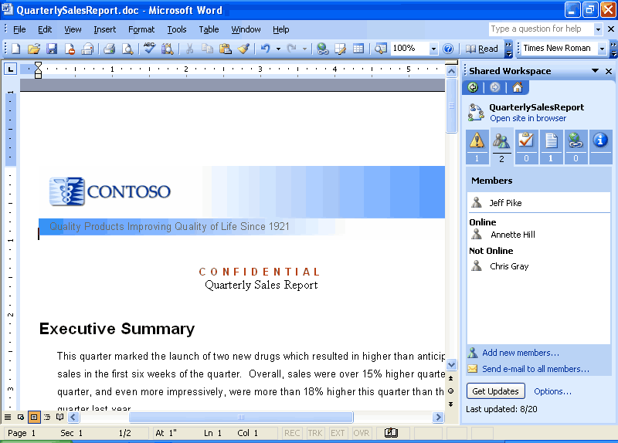
A document showing the Shared Workspace task pane that includes the list of people who are collaborating on the document.
Aggregating key collaboration tools
The Shared Workspace task pane is not just view-only; it allows a user to invite new contributors to the workspace; create or assign tasks, or mark them as completed; upload additional documents; view other documents in the library; and add or follow hyperlinks that relate to the document. Also, integration of the task pane with instant messaging technology allows the user to see who is online through the familiar “pawn” icon and to send instant messages or e-mail to team members. This pane brings the collaboration of tools right into the user’s document environment.
Document Workspaces
When working with others on a document, users often start by sending the document to their co-workers through e-mail. When the document is in a single server location, users often need to have an offline or local copy of the file as well, because they are off the network occasionally or because the server copy is locked for editing by another user.
Using e-mail and having offline copies always results in documents getting out of sync, or “forked” into multiple incarnations. The various versions that result often require lengthy reconciliation. When using e-mail, it is also difficult to track the other contributors' progress. This situation becomes exponentially more difficult as the number of contributors increases.
Document workspace sites make ad hoc, everyday document collaborations and team projects easier in several ways. As with any SharePoint site, they centralize all of the “artifacts” of collaboration: task lists, deadlines, related documents, hyperlinks, and contacts for participants. They also integrate with Office 2003 Editions programs through the Shared Workspace task pane that is directly next to the document itself in the program, allowing for easy access to all of these resources and bringing the team-collaboration context into each worker’s personal productivity tools. Unlike e-mail, where the original authors have no way of knowing whether the people who they have been asked to contribute have even started working, the Shared Workspace task pane and Document Workspace sites allow each user to view the incremental progress of task completion.
Actions that the Document Workspace supports include the following:
- Collaborating with other team members while increasing productivity time
- Safeguarding against multiple versions of a document by creating a master copy and subsequent versions
- Tracking a document’s progress through other team member’s productivity without setting up a server
- Synchronizing a document stored locally with the master copy
- Creating a new Document Workspace
- Manipulating other team members' work

Creating a Document Workspace through an Office program
Users can create a Document Workspace in one of two ways. On the Tools menu, the user can select the Shared Workspace menu item, or the user can open the Shared Workspace task pane directly to create a Document Workspace site for any Office document on the hard drive. This document then becomes a connected local copy of the document, with a master copy on the server. Users can solicit other contributors, add links, and more without ever leaving the program in which they are working.
Creating a Document Workspace for a document in a SharePoint site
Sometimes SharePoint sites can grow quite large with many documents and members. In such cases, some users may want to take a specific document to a semi-private space to work on it further, without disrupting the current, “public” version. Users can create a Document Workspace site for the document to work on it alone or with a few others until it is finished, and then republish it to the main SharePoint site.
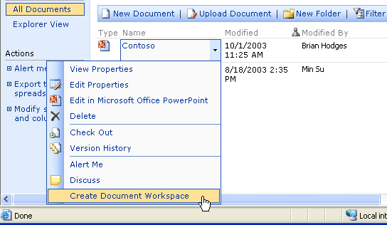
Any document in a SharePoint site can reside in a Document Workspace site that has been created for it and that has limited membership. When changes to the document are complete, the author can “publish back” to the original location and update the original document so that everyone can see the changes.
Working in a Document Workspace
In Outlook 2003, when users attach an Office document to an e-mail message, they see the Attachment Options task pane. By default, the attachments are sent as they were in the past. However, if the users select the “Shared Attachment” option, the sent document is stored on a Document Workspace site that is created automatically on an available server running WSS. If they want to, the users can specify the SharePoint site on which to create the Document Workspace, or can accept the default choice.
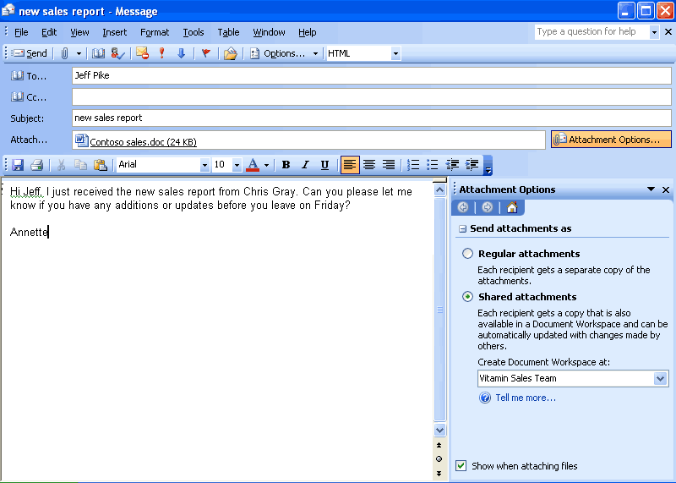
An e-mail message in Outlook with the Attachment Options task pane visible and shared attachments selected. Simply sending the attachment through e-mail brings up the Attachment Options task pane.
Whether initiated through e-mail messages or Office 2003 programs, sharing attachments automatically provides all of the collaborative workflow and information functionality of the Document Workspace. This information also appears in context, directly in the Shared Workspace task pane and next to the document when any teammate opens it on a PC. Anyone who receives the e-mail is automatically added to the workspace. By sending a simple e-mail and an attachment, the users have initiated a powerful collaboration tool for their team of co-workers, wherever the individual team members might be.
Every recipient of the original e-mail receives both the soft copy of the attachment and a link pointing to the Document Workspace site where the latest copies of the document can be found. Each recipient also receives other information that is related to the collaboration. Recipients who do not have an Office 2003 Edition can either work on the out-of-date attachments as they would typically, or use the included link to the Document Workspace site to see the most up-to-date information.
Users can work directly off the server while online. Recipients who have an Office 2003 Edition see an added benefit: any Office documents that were attached to the e-mail are automatically connected to the master copies in the Document Workspace site. When those documents are opened, the program offers to check for an updated version on the server. The out-of-date e-mail attachment remains attached to the e-mail and is simply ignored by the program when it opens the updated version.
When a recipient opens the attached document, the Shared Workspace task pane appears, providing information about the Document Workspace. Because the shared attachment is on the user’s local machine, it can be edited offline or online, even if other users are working on the server copy or on their own connected local copies. The Office 2003 Editions user can work on the most current version and cannot be inadvertently locked out by others who might be using the server copy of the document. From this point onward, Office 2003 Editions users no longer have to distribute e-mail copies of the document with incremental revisions, which helps to eliminate confusion and saves network storage space and bandwidth.
When an attachment is shared in a Document Workspace site, each co-author is prompted when others have made changes to the document and is given the opportunity to review the changes or to contribute additional changes in real time. Using SharePoint Tasks and Alerts, teammates can also track other contributors' progress.
When working online in a Document Workspace site, instant messaging integration also makes it easy to see when other authors are online and to initiate conversations with them. Instant messaging is enabled even if the user chooses to work offline.
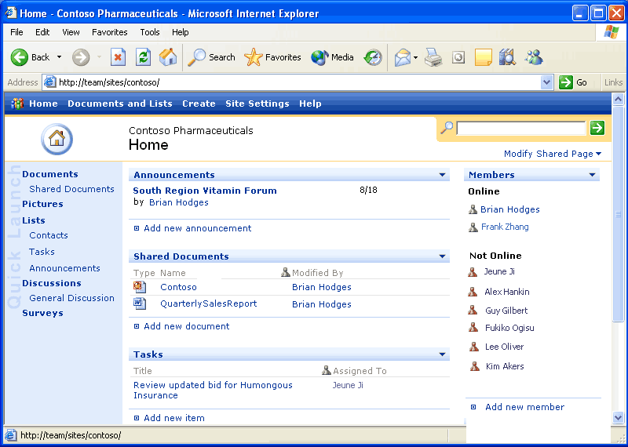
Users can also use these functions from the SharePoint Web site that hosts the Shared Workspace, either directly from the Shared Workspace task pane or by navigating to it from a Web browser
Integrated Web discussions
WSS enhances the existing shared editing features in Office 2003 Editions by providing inline discussion tools and by storing inline discussion comments on the SharePoint site. This means that reviewers can add their comments directly to the document and that reviewer comments are stored and managed centrally, so they are available whenever an editor or reviewer opens a document from the SharePoint site. To make changes to a document in a SharePoint library, the user must be a member of a site group with the Edit Items right for that SharePoint site.
Meeting Workspaces
Meetings Workspaces are for anyone who invests time in preparing for, conducting, and following-up on meetings. The workspace provides a secure online site to centralize all meeting-related communication, documents, and logistics, making it the perfect location for everything that is related to the meeting and that needs to be organized, shared, and archived. The Meetings Workspace is designed to make the meeting process more intuitive, streamlined, and effective, saving customers time and improving meeting productivity.
Because it has been built using WSS and Web Parts, the Meetings Workspace is essentially a customized site that provides simple, intuitive tools that help bring together employees for one-time, recurring or related meetings.
With Meetings Workspaces, meeting coordinators can easily plan the meeting; coordinate attendees; provide any necessary documents or collateral in the meeting area; loop in remote employees; capture the information, tasks, and follow up items that are generated during the meeting; and disseminate meeting notes and action items.
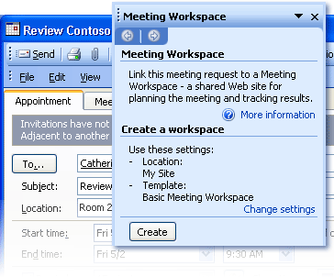
By creating a Meetings Workspace, meeting coordinators can easily plan and conduct meetings, and keep track of follow-up items.
Actions that the Meetings Workspace supports include the following:
- Disseminating pre-planned agenda items and materials
- Sharing visuals, content, meeting minutes, action items
- Facilitating recurring meetings
- Reporting problems with a current meeting’s time or location
- Updating collateral without having to resend the meeting request
- Taking simple notes during the meeting or capturing more complex notes from OneNote, for example
- Connecting mobile or remote users to the meeting
- Integrating meetings calendar views in a SharePoint list
- Creating, provisioning, and managing a Workspace site
- Integrating Workspace with any SharePoint site
- Relating Workspace information through program task panes
- Editing Workspace data by using Excel 2003, PowerPoint 2003, and Word 2003
Creating and customizing a Meeting Workspace
Before a Meeting Workspace site can be created, a meeting request must be opened. This meeting request can either be a new or an existing request. If the meeting request is new, the meeting attendees must be chosen before a Meeting Workspace can be created.
Use the Meeting Workspace task pane in Outlook 2003 to set up a Workspace. After opening a new or existing meeting request, the user clicks the Meeting Workspace button to open the Meeting Workspace task pane. In the Meeting Workspace task pane, the user can link an existing Meeting Workspace to the open meeting request, customize the settings for the existing Meeting Workspace, or create a new Meeting Workspace. The user can customize the Meeting Workspace settings quickly and easily by making selections in the task pane.
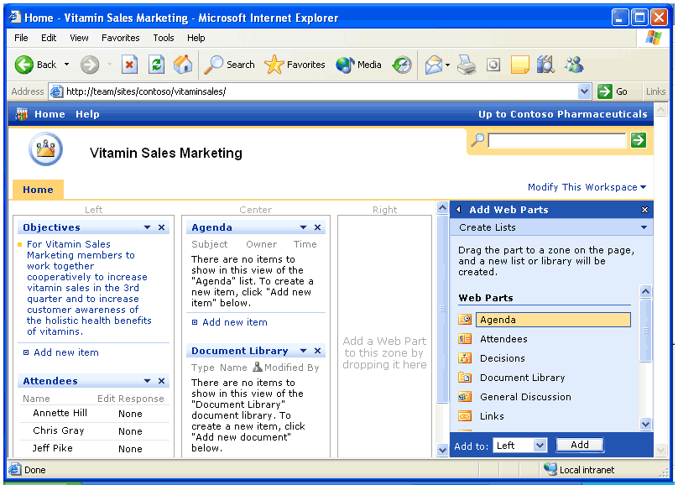
The Meetings Workspace provides a consolidated area for scheduling, disseminating to participants, and keeping track of results. Web Parts can be added easily to provide other streams of information.
File Menu integration
Document sharing is fully integrated into the File menu in most Office 2003 Edition programs. Using the File menu to open or save documents in a document library, a document repository on a SharePoint site. When you save a document in a document library, Office 2003 Edition programs also store metadata for the document in the library. When you close the document, you may be prompted to add or update metadata.
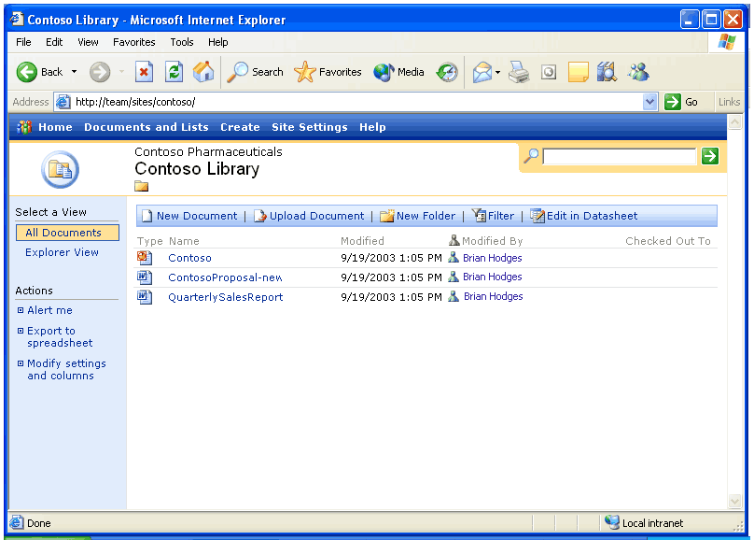
Saving a document in the document library allows for efficient document sharing.

Version tracking
WSS also handles version tracking for Office 2003 Editions and other Office documents stored on a SharePoint site. WSS keeps copies of previous versions of each document. Users can go back and view the changes that were made to a document at any time. This is particularly useful when rolling back a document to a previous version or when retrieving data that was deleted from an earlier version of a document. To turn version tracking on or off, a user must be a member of a site group with the Manage Lists right for that SharePoint site.
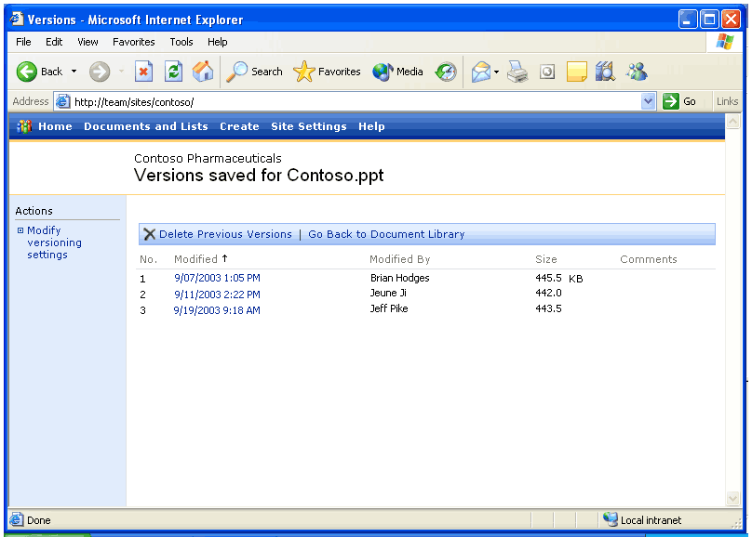
The document library shows the versions of a document saved. Users can view or retrieve information from any of these versions.

Document Check-in and Check-out
Most traditional document sharing methods use e-mail or file shares for documents that have multiple authors or editors. The problem with these methods is that they can quickly become confusing. Identifying the latest version of a document is difficult, and multiple users may edit a document at the same time, resulting in conflicting versions. Trying to track changes can lead to confusion and lost productivity, especially if a document must be rolled back to an earlier version.
To prevent these problems, WSS provides an intuitive, easy-to-use method for tracking the version history of a document. First, an Office 2003 Editions or other Office document that is stored in a document library can be checked out. When this is done, other users cannot make changes to the document. This helps prevent the confusion that can occur when multiple users make simultaneous changes to the same document. Documents can then be checked in so other users can work on them. To check out a document, the user must be a member of a site group with the Edit Items right for that SharePoint site.
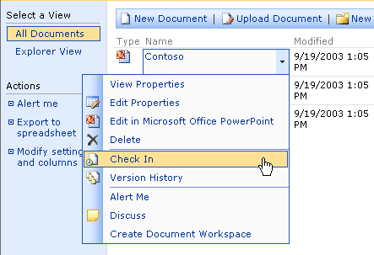
Documents can be checked into the document library so other users can work on them.
Windows SharePoint Services integration with Office 2003 Editions programs
The integration of Office 2003 Editions programs and WSS offers users tools that are powerful and easy to use and that make collaboration easier. A WSS site provides a virtual community for team collaboration—making it easy for users to work together on documents, projects, events, and other activities where information sharing is essential.
In addition to the new Workspaces, Outlook 2003 offers a workgroup server, offline availability, and multiple calendar views and lists. Microsoft Office Access 2003 has features that allow users to link tables to other SharePoint Web sites and preserve full read/write capabilities. Because Excel 2003 and the various SharePoint lists are integrated more closely, a user can import or export a list to or from Excel and share it with other team members. The Office 2003 Editions program and WSS integration gives users more opportunities for increased accessibility to view, edit, read, or write information within Outlook, Access, and Excel.
Windows SharePoint Services and Outlook 2003
With Office 2003 Editions, data from WSS can be used from directly within Outlook, allowing users to make better use of team information by integrating it with their own. Outlook 2003 provides users with team calendars to centralize team-specific appointments, specialized alerts to notify team members about any changes made to shared documents, and other benefits, such as workgroup servers, offline availability, and SharePoint capabilities.
Team calendars
Team calendars allow teams to post their schedules of product reviews on a SharePoint site for the whole team to reference. Team members can check that schedule against their own by opening up the live calendar view of a SharePoint list side-by-side with their individual Outlook calendars. Events from a SharePoint list look and act just like Outlook appointments and can be dragged and dropped from the SharePoint calendar into each user’s Outlook calendar.
Specialized alerts
Specialized alerts can help workers to be more effective by providing relevant information that keeps them up to date. Users can view alerts by clicking Alert Me links in any SharePoint Web site, or by selecting Rules and Alerts from the Tools menu in Outlook, and then clicking the Manage Alerts tab.
Alerts can be used to notify users of changes to documents, list items, document libraries, lists, surveys, or even search results by sending e-mail notifications. In addition, users can easily set up rules to move alert e-mails to folders and can view all active alerts in Outlook by using the Rules and Alerts dialog box. From there, users can delete the alert, jump directly to the Web site, create rules to act on the alerts, and more.
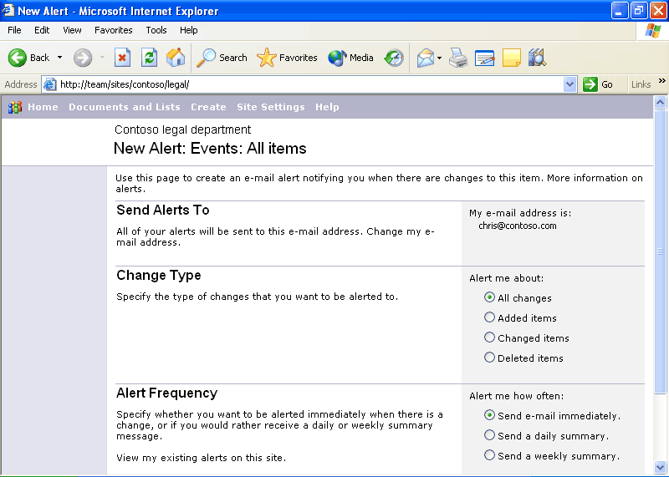
By selecting the options that best meet their needs, users can customize the alerts they receive and stay up-to-date on the status of a shared document.
Other benefits
Other benefits of tight integration between WSS and Outlook 2003 include the following:
- Workgroup server. Small businesses can use WSS as a small workgroup server that enables shared contacts and calendars without having an Exchange server.
- Offline availability. Data from WSS is cached on the local computer so that it can be taken offline. These calendar and contact lists can be viewed even when the SharePoint site is unavailable, such as when the user is on an airplane.
- SharePoint in Outlook 2003. Outlook users can open calendar lists, event lists, and contact lists within the Outlook user interface as a read-only source of data. The data from WSS looks and acts just like native Outlook calendars and contact lists, and calendars can be opened side-by-side.
Shared Lists
Users of WSS benefit from the enhanced ability of Office 2003 Editions to work with SharePoint lists. Each enhancement to the list experience in WSS enables a range of scenarios not previously available. The enhancements also provide the ability to combine SharePoint lists with the rich functionality of core Office programs, opening new possibilities for collaboration, data collection, and analysis.
- New! Grid view. This new view style is similar to the grid display style in Excel 2003, and brings Excel-like functionality to WSS with functions such as calculation formulas, AutoFill, AutoComplete, Sorting, and Filtering.
- New! Multiple-user list collaboration. Multiple users can now edit the same list at the same time. WSS detects any conflicts, and then presents conflict-resolution options.
- Improved! Easy editing. Users can drag and drop to rearrange rows and columns or move data inside a list.
- Improved! Office program integration. Users can now have the best of both worlds, using Office programs to work with SharePoint lists. By using Excel 2003, for example, users can print lists, take lists offline, and create tables or charts with list data.
- New lists. New lists include Photo Library, which offers options for storing and viewing pictures, and Business Document Libraries, which enable XML solution authoring, editing, and storage in the team site.
- Improved lists. Improvements to the existing lists include options for scheduling reoccurring meetings in event lists, and new security settings that allow delegation of permissions to a per-list level.
Windows SharePoint Services and Excel 2003 and Access 2003
WSS provides Office 2003 Editions users multiple ways to manipulate data in lists and tables created in Excel 2003 and Access 2003. Lists that reside on SharePoint sites can be synchronized using Excel 2003 and Access 2003. Both programs have individual benefits for users as well. Users can easily update WSS lists in Excel 2003. Users can now create a table in Access 2003 and link it to lists that reside on a SharePoint Web site while maintaining full read/write capabilities.
List synchronization
Microsoft Office Excel 2003 and Microsoft Office Access 2003 can now be used to view and edit data stored in lists on SharePoint sites. This is an excellent way to share information with other users, make use of information that is already published, and provide standardized lists of information (for example, product names or company departments) that can be used throughout the company.
Updating Windows SharePoint Services lists in Excel 2003
Office 2003 Editions make it easy for users to view, edit, and update WSS lists in Excel. Excel 2003 now offers the ability to share ranges that are designated as lists by exporting them as a SharePoint list. Users can also import SharePoint lists into Excel, or link to them so that changes to the list are shared between the server and the Excel client.
The SharePoint Datasheet List Control, which is similar to the grid display style in Excel, makes an Excel-like editing experience available in a browser so that content can be edited in WSS through Datasheet Control.
Conflict resolution is also provided when lists are updated from Excel 2003, and lists can be modified offline by using Binary File Format (BIFF). XML tags that map to items on existing Excel business forms can also be created, such as “employee name,” “amount,” or “quantity,” making those forms another easy-to-use data warehouse.
The new Spreadsheet Web Component in WSS can consume any Excel spreadsheet that is mapped to an XML schema, and can provide that data to both SharePoint and non-SharePoint data sources. The component displays data according to a mapping of XML elements.
Linked tables between Access 2003 and Windows SharePoint Services
Users can now link tables that were created in Access 2003 to lists on SharePoint Web sites and maintain full read/write capabilities. Users specify that they want to use SharePoint as the type, and then they select the Web site and the list name.
This means that WSS can act as a new type of database server for Access 2003 users who want to collaborate with others across the Web and use the familiar desktop program interface, or who want to incorporate SharePoint data into other tracking projects that they already perform.
The following table shows WSS integration features for each program in Office 2003 Editions:
Windows SharePoint Site Feature | Office 2003 Edition Programs
Open and Save from File menu | Excel, Outlook, PowerPoint, Publisher, Word
Shared Workspace task pane | Excel, PowerPoint, Word
Create shared attachment | Outlook
Synchronize calendar and contact list sites | Outlook
Document updates for shared attachments | Excel, PowerPoint, Word
Automatically collect metadata | Word, Excel, PowerPoint
Check-in / check-out | Word, Excel, PowerPoint
Version Tracking | Word, Excel, PowerPoint
Store inline discussions on the server | Word, Excel, PowerPoint
Import SharePoint list as data | Excel, Access
Export data as SharePoint list | Excel, Access
Manage team time
One of the ways to make a project successful is to ensure that all team members stay current with personal and team schedules. The Office 2003 programs and WSS integration offer users instant messaging capabilities while working within Outlook 2003 or with a document. Team members can also view personal and team calendars and contacts side-by-side, so scheduling meetings and tracking down references is more efficient.
Instant messaging integration and presence integration
Instant Messaging (IM) technology is integrated with Office 2003 programs to provide instantaneous presence information and the ability to initiate conversations quickly from within documents or Outlook.
Team calendar views
When a user is viewing multiple calendars, correlations between appointments can be difficult to understand. Outlook 2003 offers color-coded team appointments within each team member’s calendar so that the user can distinguish between team appointments and other appointments.
Accessing the side-by-side calendars in Outlook 2003
Outlook 2003 makes it possible to view multiple calendars—including local calendars, public-folder calendars, other users’ calendars, and calendar views—side-by-side in the Outlook window. The color-coded calendars scroll together, making them useful for comparing schedules or finding a teammate. Users can drag appointments between calendars or onto their own calendar, or use the New Meeting With feature to set up a meeting quickly with the owners of some or all of the open calendars.
After a user has opened a calendar, it appears in the Calendar module of the Navigation Pane. To turn these calendars on side-by-side, the user simply selects the box next to the appropriate calendars. To turn a calendar off, the user simply clears the box.
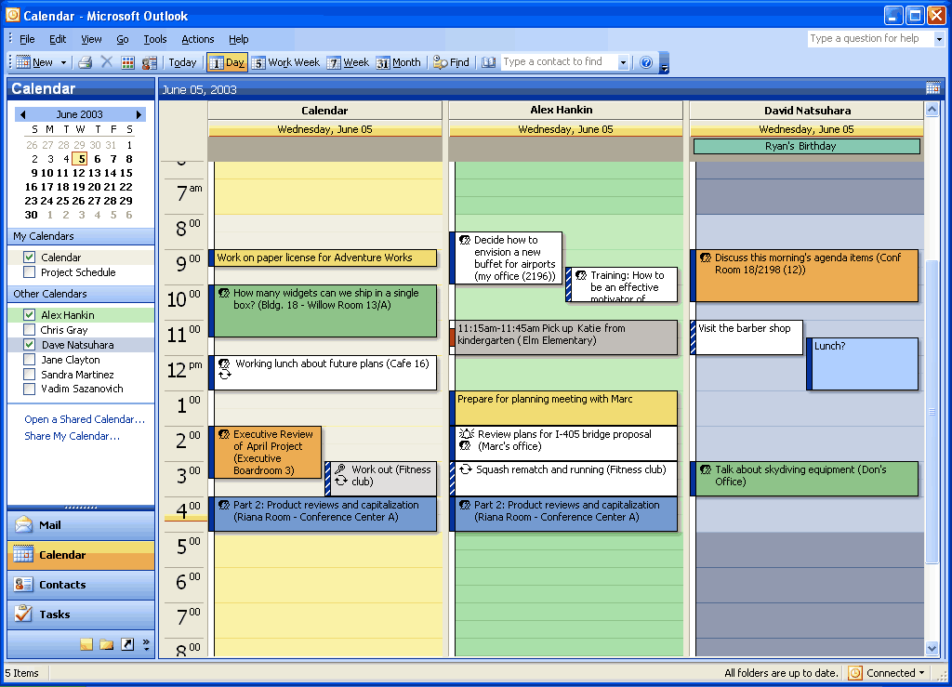
The side-by-side calendars view in Outlook. At left the Navigation Pane shows the calendars that the user has access to. To use the New Meeting With function, open several calendars side-by-side. Right-click the calendar and highlight “New Meeting With.”
Accessing integrated contacts and calendar information from Windows SharePoint Services in Outlook
Contacts and Calendars are common lists that store both personal and group information. Outlook 2003 and WSS now allow users to view team and personal calendars side by side. The user can select to view the team calendar and the team contacts directly in Outlook, making the information always available.

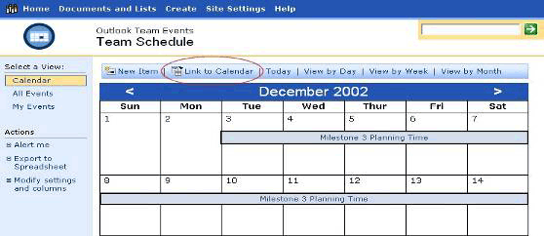
To view a calendar list from WSS in Outlook, navigate to that calendar by using the Web browser. Click the “Link to Calendar” button in the toolbar. Outlook will ask you to confirm that you want to add the calendar: Click “Yes.”

After a calendar from WSS has been added, it can be opened in Outlook 2003 and compared with the user’s default calendar that appears in Outlook.

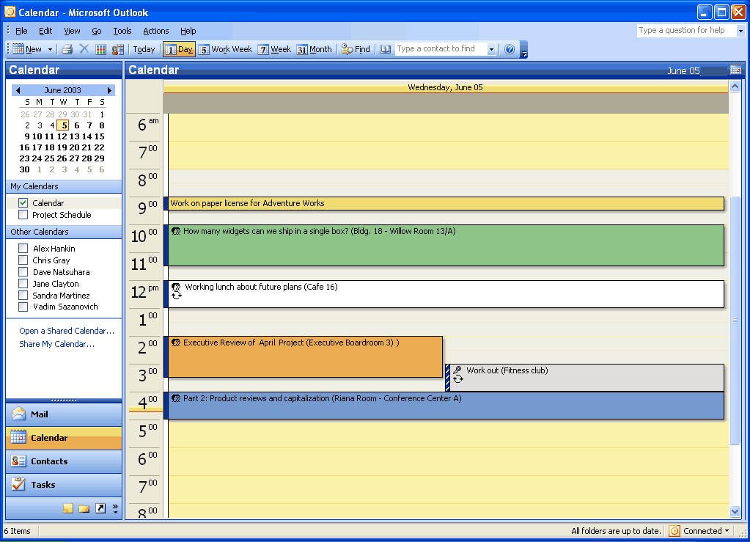
If you are opening a calendar, the calendar list is opened up side-by-side with your default calendar and added to the “Other Calendars” list. Contacts lists can be viewed in Outlook in the same way.
Helping to Protect Sensitive Documents
New technologies in Microsoft Office 2003 Editions help protect digital intellectual property. Information Rights Management (IRM) in Office 2003 Professional allows functions such as cut, copy, paste, print, and e-mail forwarding to be restricted for specific documents and e-mails, giving users and organizations more control over their valuable information assets. With Word 2003, in-document editing rights and style protection allow document owners to specify who is allowed to make changes.
Information Rights Management in Office 2003 Editions
IRM is a new policy enforcement technology in Office 2003 Editions that helps protect documents and e-mails from unauthorized access and use. IRM is a persistent, file-level protection technology that allows the owner to specify who can access a document or e-mail and control whether those users are allowed to edit, copy, forward, or print the contents. IRM is an extension of Windows Rights Management Services (RMS) into Microsoft Office 2003 programs. IRM in Office Professional 2003 Edition requires RMS on Windows Server 2003, either within the organization or via a service such as Microsoft Passport. Windows Rights Management Services for Windows Server 2003 is a new premium service that requires a separate Client Access License (CAL).
IRM is a policy enforcement technology, not a security technology, allowing documents and e-mails to be distributed while helping to maintain control over who can access content and how they can use it. Once a document or e-mail is protected with this technology, the access and usage restrictions are enforced no matter where the file or e-mail goes.
IRM support in Microsoft Office 2003 Editions helps corporations and knowledge workers address two fundamental needs:
- Helping to protecting digital intellectual property. Most corporations today rely on firewalls, login security, and other network technologies to protect their digital intellectual property. The fundamental limitation of these technologies is that, after legitimate users have access to the information, the information can be intentionally or accidentally shared with unauthorized people, creating a potential breach in security policies. IRM helps protect the information itself from unauthorized access and reuse.
- Helping to ensure information privacy, control, and integrity Knowledge workers often deal with confidential or sensitive information, relying on the discretion of others to keep sensitive materials in-house. IRM helps eliminate the risk of accidental leaks by disabling the forward, paste, or print functions in IRM-protected documents and e-mails. In addition, IRM can enforce expiration dates to help ensure that knowledge workers only see and use up-to-date content.
For IT managers, IRM helps enforce enterprise policies regarding document confidentiality, workflow, and e-mail retention. For CEOs and security officers, it helps reduce the risk of having key company information get into the hands of the wrong people, whether by accident, thoughtlessness, or malicious intent.
When enabled by the organization, users of Office 2003 Editions will be able to easily take advantage of this technology. To create and protect documents and e-mails with IRM, Microsoft Office Professional Edition or the full stand-alone products are required. A simple user interface based on customizable “rights templates” available in the standard toolbar makes IRM convenient and easy to use. Other Microsoft Office 2003 Editions will give users the ability to read and edit IRM-protected content, but not create. Integration with Active Directory® provides a level of convenience not seen on today’s document-specific passwords.
Finally, IRM-protected documents and e-mail can be shared across organizations and with users that do not have Office 2003 Editions. Microsoft is offering, for a limited time, an IRM service for customers who do not host their own Windows Rights Management Services Server. The Rights Management Add-on for Internet Explorer allows any Microsoft Windows user to consume IRM-protected documents whether or not they have Office 2003 Editions. This service will use Microsoft Passport as the authentication mechanism instead of Active Directory. Users of this service will not be able to create custom rights templates, such as the “Company Confidential” template described earlier, but they will be able to share and access IRM-protected documents and e-mails.

How and when to enable IRM in Outlook 2003
IRM in Outlook 2003 helps prevent unauthorized forwarding, copying, or printing of sensitive e-mails. It also helps to protect messages that are automatically encrypted during transit, and when the sender applies usage restrictions, Outlook 2003 disables the necessary commands. Office documents that are attached to protected messages are automatically protected as well and these policies persist with the document.
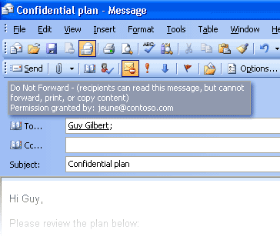
Users can apply usage restrictions to limit who can read and change e-mail messages and attachments.
Leveraging IRM in Excel 2003, Word 2003, and PowerPoint 2003
IRM in Microsoft Office Professional Edition 2003 allows the document owner to assign permissions to individual users and groups (groups based on Active Directory). In Excel 2003, Word 2003, and PowerPoint 2003, each user or group can be given a set of permissions according to the following roles: read, change, and full control. Depending on the recipient’s role, IRM disables certain commands to enforce the rights that are assigned. The document owner can also prevent printing and can set expiration dates. After expiration, documents cannot be opened.
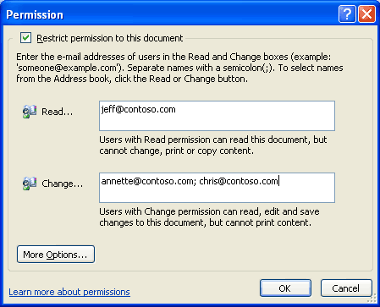
Users can apply usage restrictions to limit who can read, change, or control Excel 2003, Word 2003, and PowerPoint 2003 files.
Permission options
If a protected document is forwarded to an unauthorized recipient, the document cannot be opened and an error message that contains the document owner’s e-mail appears so that the recipient can request additional rights. If the document owner decides not to include an e-mail address, unauthorized recipients simply get an error message.
Organizational policies and template options
On the Windows Rights Management Server, organizations can create “rights templates” that will appear in Office Professional Edition 2003 programs. For example, a company might define a template called “Company Confidential,” which specifies that a document or e-mail in that template can only be opened by users inside the company domain. These templates can reflect the policies of the organization, and the number of templates that can be created is unlimited.
Rights Management Add-on for Internet Explorer
Because enforcement of rights is done at the application level, Office files protected with IRM technology can only be opened and edited by Office 2003 Editions. However, Rights Management Add-on for Internet Explorer allows users without Office 2003 Editions to read IRM-protected materials. The Rights Management Add-on for Internet Explorer is available for download free of charge at www.microsoft.com (connect-time charges may apply).
The Rights Management Add-on for Internet Explorer will play an important role in communication between business units and with business partners, as companies may choose to migrate to Office 2003 Editions on their own timeframes. Companies can use IRM in Office 2003 Editions knowing that authorized users will be able to access and consume protected content, even if they do not have Office 2003 Editions.
Additional server requirements
Microsoft Windows Server™ 2003 with Rights Management Services and Active Directory are required to enable IRM fully in Office Professional Edition 2003. The Rights Management Services feature requires a premium Client Access License (CAL). Microsoft is also hosting, for a limited time, an IRM service through Passport for customers who do not have the Windows Server 2003. This service will enable users to share protected documents and e-mail by using Microsoft Passport as the authentication mechanism.
Note that users of Office Standard Edition 2003, Office Small Business Edition 2003 and Office Student and Teacher Edition 2003 cannot create new IRM-protected documents or e-mail messages, or modify the permissions on existing IRM-protected files. However, they can open, edit, save, and print IRM-protected documents and e-mail messages with the appropriate permissions.
Regional Permissions
When teams collaborate on very large documents, some users may be assigned certain portions of the document to work on. In the past there was no way to ensure that each user only modified the assigned portion of the document. When it came time to reconcile the edits and merge changes into a master document, large numbers of conflicting edits often caused problems.
Document owners can set permissions to certain regions or specific portions of a document from being editing by some or all users. Using the Protect Document task pane (by selecting the “Tools” menu, and then “Protect Document”), a document owner can first protect the whole document against any edits (optionally allowing only comments), and then assign permissions to individual portions of the document by selecting them and specifying the users who should be able to edit that selected region. Later, when reconciling the changes of different individuals, the document owner is assured that no two people edited the same area, and no conflicts will exist.
After the permissions have been set up, the task pane switches focus from helping the creator set up the permissions and manage the list of users to helping users find the parts of a document that they can edit.
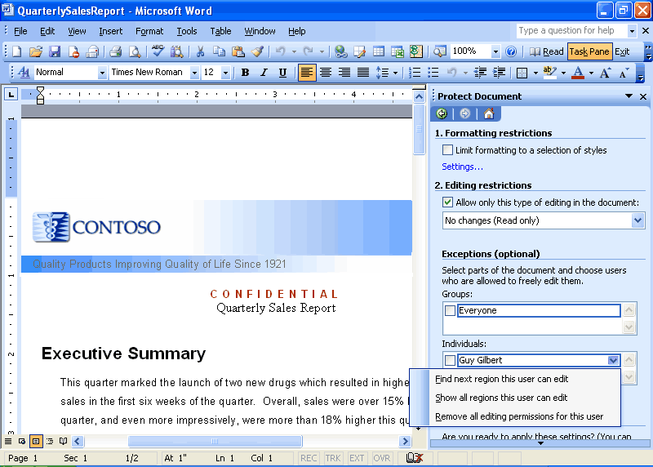
User view of the Protect Document task pane
Structured Editing in Word 2003
Word 2003 includes additional features to allow a large number of users to collaborate on a large, sophisticated document in a structured way.
Formatting Restrictions
Many large organizations need to produce documents that show a consistent style or appearance. Although this can be accomplished with Word styles, many users are not familiar with how styles function, and so they resort to formatting the document directly. Over time, large documents that include direct formatting become a burden to maintain because updating the styles does not change the appearance of the document, and moving portions of a document to another document does not produce the expected result.
With Word 2003, users can set up a template or a document that uses a set of specific styles. By using the Formatting Restrictions feature of Word 2003, the user can enforce the use of only those specified styles. All direct formatting is disabled. This allows many people to edit the same complex document and still retain structured formatting.
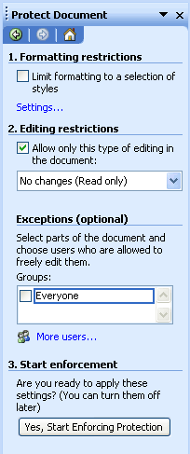
Creator View of the Protect Document task pane

Summary
The Office 2003 Editions and WSS integration make it easier and more efficient for users to connect with other team members and the information that they need. By enhancing the desktop programs that employees are already familiar with, the Office 2003 Editions help users spend their time making progress on their projects instead of learning a new set of features and commands. The Professional version of Office 2003 Editions also allows authors to create documents and e-mail messages that are better protected from unauthorized use by offering IRM technology. This improved functionality in the Office 2003 Editions assists users when working on projects that require team efforts.

Introduction
Often, too much information exists, in too many places, for workers to keep track of it. Tasks such as organizing and managing e-mail can often take much of the workday; the process of accessing e-mail slows the process further for remote and mobile users. Junk e-mail has become increasingly problematic because it can consume valuable space and prevents efficient processing of important e-mail.
Given this influx of e-mail and other data, locating information often requires going to multiple locations. Microsoft® Office 2003 Editions provide new ways to help workers stay organized and manage the details that accompany information overload.

Organizational and design enhancements
The redesigned look and feel of the Office 2003 Editions helps users manage and prioritize large volumes of information. The simplified interface of Microsoft Office Outlook® 2003, ink support for the Microsoft Tablet PC, and more make it easier to read, organize, and work with information. Some new design enhancements to Outlook 2003 include allowing users to read e-mail more quickly by using the new Reading Pane, to find important messages by using Search Folders, and to view tasks at-a-glance by using Quick Flags.

New feature highlights
With the improvements and new features of Outlook 2003, users can manage large volumes of information quickly and easily. The new screen layout optimizes screen space while giving users a comprehensive look at their Inbox, and users can organize messages virtually in Search Folders—by using the built in search folders or creating their own. Quick Flags let users mark e-mail messages that require follow-up action and these messages are easily found in the new For Follow Up search folder.
New security settings offer increased support for junk e-mail filtering and blocking of external content. Remote and mobile users can take advantage of improvements to connectivity performance with better caching. Along with a new look, Office 2003 Editions users can draw information from a variety of locations quickly by using the Research task pane.

A new look for Outlook 2003
Microsoft Office Outlook 2003 provides innovative features that help users manage and organize e-mail messages, contacts, calendar tasks, notes, and other critical information. The new look for Outlook 2003 helps users organize information to increase productivity and get the information they need. Outlook 2003 also helps users block the information they don’t need and protect against the misuse and unwanted distribution of key company information.

Working with new e-mail views
Studies of Outlook users show overwhelmingly that the sender’s name or address is the most important criteria that is considered when deciding whether to open e-mail messages. The Multi-line view puts the sender’s name in dark text in the upper-left corner, making it easy to scan down the list for important names. Secondary information is rendered in lighter shades of text to draw the eye towards the more important information. This Multi-line view also provides a taller region, which makes messages easier to select with the pen on a Tablet PC.
Microsoft has listened how customers interact with their e-mail. In the Office 2003 Editions, Outlook 2003 features a new interface that breaks from the traditional mold.
The new interface uses the Reading Pane (described below) to create a very efficient and easy-to-use layout of messages on the screen. The vertical column orientation of the new layout makes it possible to see nearly twice as much data on the screen at once. The new e-mail view is also optimized to help users easily find items and navigate through t e-mail. This efficient layout means less time spent scrolling and more time accomplishing work.
Reading Pane
The Reading Pane helps reduce eyestrain and makes time spent reading e-mail more efficient by showing more of the message on the screen. This reduces scrolling and often eliminates the need to open and manage many separate windows for different messages.
Replacing the Preview Pane from previous versions of Outlook, the vertical layout of the Reading Pane presents messages in a manner that is more consistent with the way newspapers have been formatting text for hundreds of years. This simple redesign, in addition to the new multi-line mail list, frees up nearly twice as much monitor space for text as the previous horizontal view Preview Pane, and makes for a more comfortable reading experience overall.
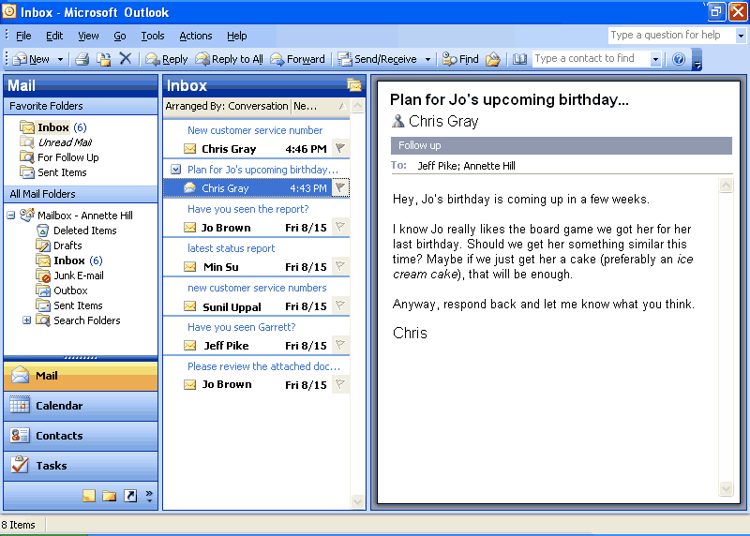
The Reading Pane is on by default in Outlook 2003. The Reading Pane accommodates more than three paragraphs of text and 14 e-mail messages, whereas the Preview Pane in earlier versions of Outlook showed only two paragraphs of text and 11 e-mail messages.
Intelligent grouping
When creating lists, users naturally group similar items together, such as a to-do list under the headings “Today,” “Tomorrow,” and “Next Week.” The new e-mail view automatically applies intelligent groupings to help users sort messages.
For example, when users arrange mail by the date it was received, Outlook 2003 splits the communications into simple groups—“Today,” “Yesterday,” “Last Week,” “Last Month,” and so on. When users rearrange by size, Outlook 2003 again splits the communications into user-friendly groups—“Large,” “Small,” “Very Large,” and so on. These groups make it easier for users to scan through a list and find what they need, because the groupings reflect the way most humans work.
Advanced users can treat these groups as objects, choosing to move, delete, copy, forward, or perform other actions on all items in the group at the same time. For example, e-mail messages could be grouped by date, and then all messages from “Last Month” could be dragged to another folder and filed away with one click.
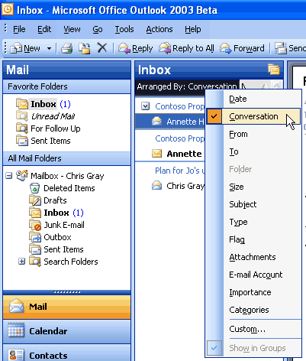
Clicking the Arrange By button shows the list of possible arrangements, such as by Date, From, Subject, Size, Flag, and so on. This menu is also available by clicking View -> Arrange By.
Smart Dates
To use space more efficiently in the Multi-line view, Smart Dates change the date format on the fly based on how long ago the message was received. For example, an e-mail message that was received today will only display a time: 3:40 p.m. Messages that were received during the current week display a day of the week and time: Wed 1:24 a.m. For e-mail that was received many months ago, the exact time is less important, so Outlook 2003 displays only the date: 1/12/2003. This makes it easier for the user to sort, find, file, and manage e-mail quickly and efficiently.
Arrange by Conversation
Arrange by Conversation helps with the most common task that is performed in Outlook: reading mail. It was designed to help users quickly catch up on their e-mail, without embarrassing themselves by replying to items that have already been resolved.
Arrange by Conversation displays e-mail messages in a conversation-oriented or “threaded” view, by default showing only e-mail that is unread or marked for follow-up, so the user doesn’t need to skip over dozens of read messages to find the new ones. Similar messages are grouped together, and indentation shows clearly who responded to whom throughout the conversation.
Each conversation can be expanded to show all related messages, so users can easily view the entire conversation at once, instead of reading pieces here and there. A user can use Arrange by Conversation just as easily as sorting mail and by using the same interface, which means that the feature can be used right away by anyone who is familiar with Outlook. And because multiple messages in a conversation share the same subject, the subject line only needs to be shown on the screen once per conversation, allowing for as many as twice the number of messages to fit on the screen. As with any group in Outlook, the conversation can be treated as an object, meaning that users can delete, copy, file, or forward the entire conversation at once.
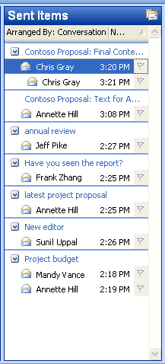
In the Arranged by Conversation view, messages about the same conversation are grouped together and indentation shows who replied to whom. Only unread and Quick Flagged messages are shown by default, so the screen remains uncluttered while the user catches up on e-mail.
To arrange new messages by conversation, click Arranged By over the new mail view, and then click Conversation. Or, click Arrange By on the View menu, and then click Conversation.

Navigation Pane
The Navigation Pane builds more efficiency into Outlook 2003 by combining the main navigation and sharing aspects of the program into one easy-to-use pane. With the Navigation Pane, users experience more relevant and context-sensitive navigation through Outlook 2003, rather than a simple, static list of folders.
In Calendar, for example, users see the date navigator and other users’ shared calendars. In Contacts, users get a list of all contacts folders they can open, both local and shared, in addition to different ways to view the contacts. The Navigation Pane is on by default. To turn it off and on, click View, and then click Navigation Pane.
The Navigation Pane improves Outlook 2003 in several ways:
- Efficient use of screen space The best of the Outlook Bar and the Folder List are brought together into a smaller, more efficient space. All navigation options, not just folder navigation, are in one place, giving users dramatically increased space to view their data. For example, users can view up to twice as much of their Calendar in Outlook 2003 compared to Outlook 2002.
- Context sensitivity. Simplified, context-sensitive navigation shows the most relevant information for each type area of Outlook. For instance, in the Mail pane, users view the list of e-mail folders and search folders. In Calendar, they see a date picker and a list of calendars that are available to them.
- Shared data. Sharing information is simplified by presenting shared data next to a user’s own data. For example, users can view other calendars to which they have access, placing them side-by-side with their own calendar.
- View settings. View settings appear in the Navigation Pane, making it easy to change how something is displayed.
- Quick Launch. Advanced users appreciate the ability to shrink the module buttons into a Quick Launch bar to save space.
- Go menu. The Go menu and associated keyboard shortcuts make the Navigation Pane more accessible.
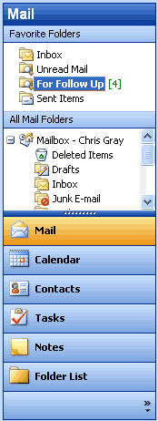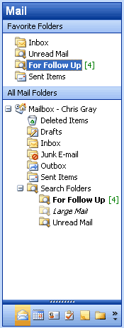
Navigation Pane with large buttons Navigation Pane with smaller buttons
The Navigation Pane. The splitter between the big buttons at the bottom and the content pane can be moved up and down to create larger or smaller buttons. The large buttons are great for easy clicking with Tablet PC or other pen-based computers, or users may choose to shrink all the buttons to a single Quick Launch bar in order to save space.
Navigation Pane modules
Each of the eight Navigation Pane modules has a unique but consistent user interface that presents the most relevant information in an efficient space. The following eight Navigation Pane modules are available.
Mail view
The Mail pane displays e-mail folders and Search Folders, and also includes a Favorite Folders section at the top for quick access. To create favorites, users simply drag an e-mail folder or Search Folder to the Favorite Folders area.
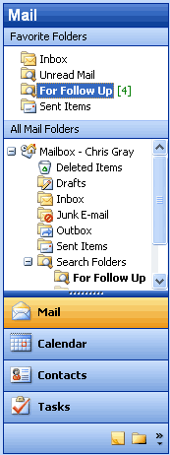
The Navigation Pane in Mail view. By default, four large buttons appear at the bottom, with three buttons minimized to the “Quick Launch” state. The section at the top, Favorite Folders, can include any folders that you want to keep handy for quick reference—just drag them to the Favorites section.
Calendar view
The Calendar pane shows the date navigator at the top, and under that the list of all calendars to which the user has access, including local calendars, Microsoft Windows® SharePoint Services™ calendars, public folder calendars, and other users’ calendars—all in one simple list. Calendars can be individually turned on or off to view them side-by-side in the Outlook window. Links are also available to open shared calendars and to share the user’s own calendar (or modify permissions).
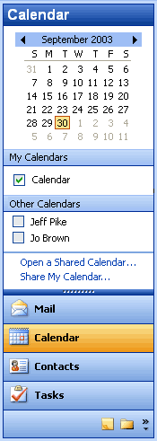
Through the Calendar view, all local, shared, and team calendars are simplified to a single list, regardless of location.
Contacts view
Like the Calendar pane, the Contacts pane displays all contacts to which the user has access—including local contacts, Windows SharePoint Services contacts, public folder contacts, and other users’ contacts. Users can opt to view contacts in different ways, such as “By Company” or “Address Cards,” in addition to any custom views they have created. Links are also available to open shared contacts, share contact information, modify permissions, or modify the options of the Current View.
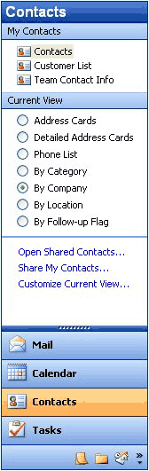
In the Contacts view, all contacts folders that the user can open, including local, public and shared, are presented in a simple list. The Current View section provides an easy way for users to arrange contacts.
Tasks view
The Tasks pane shows a list of all tasks folders that the user can open, including local tasks, public folder tasks, and other users’ tasks. The viewing options for Tasks include built-in views such as “Overdue Tasks” and “Next Seven Days,” in addition to any views that a user has created. Users can also select links that open shared tasks, share task information, modify permissions, or modify the options of the Current View.
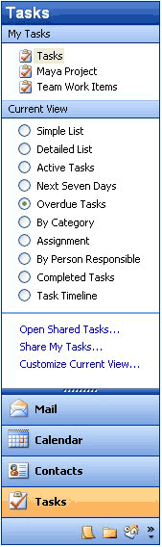
In the Tasks view, all tasks folders that the user can open, including local, public, and shared, are presented in a simple list. The Current View section provides an easy way for users to organize their tasks into logical groups.
Notes view
The Notes pane shows a list of the user’s notes, including shared notes. Viewing options for Notes include built-in views such as “By Category” and “Last Seven Days,” in addition to any views a user has created. Links are also available to open shared notes, share the user’s own notes, modify permissions, or modify the options of the Current View.
Folder List
The Folder List is designed to help with data-file management activities such as archiving and copying between mailboxes. All local folders of all types are shown in the Folder List, just like the Folder List in previous versions of Outlook. Convenient links are available to help manage folder sizes and Outlook Data Files.
Shortcuts
The Shortcuts pane is a location for shortcuts to nearly anything: Outlook folders, programs, documents on the hard drive, files on a network, shared folders, Web pages, and more. The user can create groups to organize these shortcuts, and can collapse and expand these groups to use the space more efficiently. To add a shortcut, users can employ the provided link, or just drag and drop items onto the list.
Journal
The Journal pane shows a list of all Journal folders that are available to the user, including public and shared Journal folders. As with the Contacts, Tasks, and Notes panes, all available Journal views are shown in this pane and can be customized. Links to share or open shared Journal data are also provided. The Journal pane is off by default, but users can turn it on by using the Navigation Pane Options menu, or by selecting Journal from the Go menu to use it without adding to the Navigation Pane.
Note Each Outlook pane displays six options. By using the Navigation Pane Options menu, users can show, hide, or rearrange the panes.
Go menu
The Go menu is back! The Go menu makes it easy to navigate through Outlook 2003 by using the keyboard. Users can also change their view of the Navigation Pane by using the Go menu.
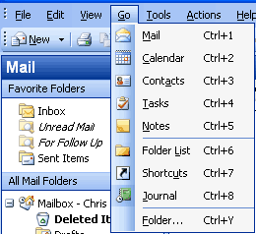
Users can take advantage of the Go menu or the integrated keyboard shortcuts for each of the modules of the Navigation Pane.
To move quickly between Navigation Pane modules, use the keyboard shortcuts documented on the Go menu:
  - Mail CTRL+1
  - Calendar CTRL+2
  - Contacts CTRL+3
  - Tasks CTRL+4
  - Notes CTRL+5

Key functionality
Several customer-requested improvements have been made to the process of addressing, composing, and sending e-mail messages in Outlook 2003. These features are designed to help all users be more productive with their e-mail.

Streamline e-mail creation
Simplified e-mail creation helps with overall efficiency and productivity. Outlook 2003 now offers a simplified “Word Mail” user interface (using Microsoft Office Word 2003 as the e-mail editor), which is easier to use, is less confusing, and requires less training. Additional new features that help streamline e-mail creation include expandable distribution lists, improved AutoComplete, Unicode support, and Internet faxing.
Expandable distribution lists
Distribution lists can now be expanded to display the names of the people on the list, making it easy to add or remove a few names before sending the message. This eliminates the need to modify the distribution list or start from scratch when addressing an e-mail message to a distribution list.
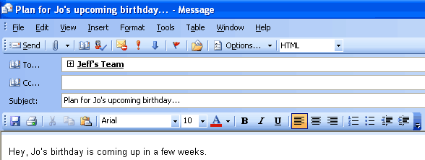
Click the plus sign next to a distribution list to expand it and list all members.

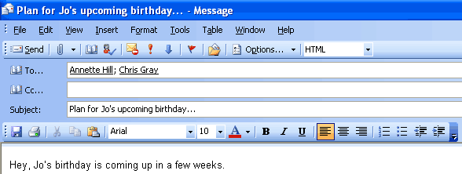
Members of the distribution list appear after clicking the plus sign.
Improved AutoComplete
AutoComplete now matches on just one letter instead of three, and the AutoComplete list is sorted by the most frequently used e-mail addresses instead of alphabetically. In many cases the user can address e-mail simply by pressing the first letter in that person’s name. Tablet PC users need only to place their cursor into the address line and to their most commonly-used e-mail addresses and choose the one they want. Users spend less time searching for the correct e-mail addresses and significantly reduce the required number of keystrokes overall.
Simplified e-mail editor in Word 2003
The experience of creating a new e-mail message has been vastly simplified. Commands have been consolidated into a single toolbar called “E-mail,” which is positioned directly above the text of the message. As a result, the number of buttons on the screen has been reduced by more than half, making it easier for users to find what they need, and leaving more room for the message.
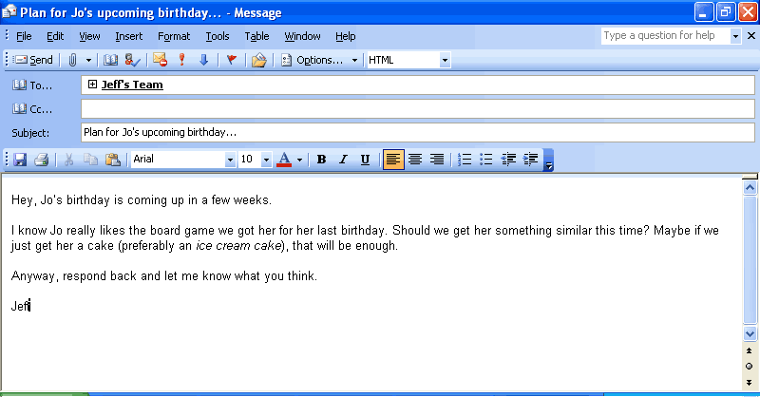
The Word e-mail editor has been redesigned with simplicity in mind.
Unicode support
Outlook 2003 supports Unicode for Contacts, Mail, Calendar, Tasks, and Notes. Users can view and edit text within Outlook 2003 in any language and any script that is installed and is supported by the operating system. Unlimited support for Multilingual User Interface enables IT administrators to switch the user interface and Help files to different languages based on the users' individual needs.
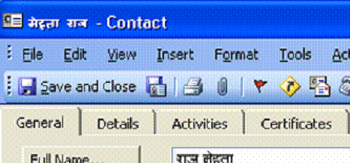
Support for Unicode allows Outlook to appear in the user’s native language–in this case a Contact in Hindi.
Internet faxing
With Internet faxing, faxes can be sent and received directly from a desktop computer, eliminating the challenges that can accompany using a fax modem, such as tying up the telephone line, incurring long-distance charges, and having to redial or manually confirm that the fax arrived.
Office 2003 Editions integrate Internet faxing with its programs, including Outlook 2003. Some new faxing features include fax numbers made available in Contacts, a rich preview tool, the ability to calculate the cost of the fax before sending it, cover pages that are editable in Word 2003, and even the ability to sign your name by using a Tablet PC.
Internet faxing in the Office 2003 Editions require users to sign up with one of the faxing services that partner with Microsoft Office (For a list of Microsoft Office fax partners, see Office Online at http://office.microsoft.com).

Organize and prioritize e-mail
Users are now faced with an increasing volume of incoming e-mail messages. This influx of messages requires more intuitive and efficient organizational tools.
Quick Flags
Studies of customers using Outlook found that most people do one of three things with nearly every e-mail message:
1. Respond to it immediately.
2. Delete or file it immediately.
3. Save the message in some way as to indicate that a follow-up action is required. Because they lack the time or information that is required to take action right away, they decide to follow up on it later.
There are almost as many approaches to the third option as there are users—mark the message as unread, move it to an e-mail folder named “To Do,” make a task out of it, delete or file all messages that don’t require a response, and so on. While these strategies may work for a particular individual, they are makeshift responses to an ever-increasing volume of e-mail for which earlier versions of Outlook were not designed.
Outlook 2003 offers Quick Flags as a simple solution to this problem. Activated by a single click, Quick Flags provide a means for users to “flag” messages for follow-up action or later reference.
To assign a Quick Flag to a particular message, a user simply clicks the flag icon on an e-mail message from any folder in Outlook 2003. Each marked or "flagged" message has one of several colored flags (as chosen by the user) visible next to it so that it is easy to find at-a-glance. Users can choose colors that work best for them, such as red for high priority or blue for personal to-do items.
Items marked with a Quick Flag are automatically stored in the For Follow Up folder, which becomes an automated, virtual to-do list in Outlook. The For Follow Up folder shows all flagged items at-a-glance, and enables users to work with and organize items by color. For more information about the For Follow Up folder, see the following section.
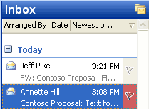
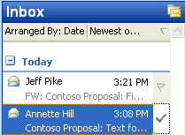
Click the gray flag icon to Quick Flag an e-mail item. Click the icon again to mark it complete. The “Insert” key can also be used to add or complete a Quick Flag.
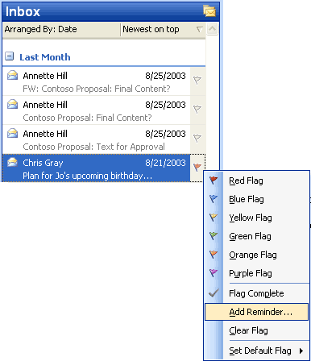
Users can also select one of six different colors from a right-click menu to categorize their follow-up items easily.
Using the For Follow Up folder
To make finding messages even easier, a special Search Folder called “For Follow Up” exists. This folder always contains an up-to-date list of all messages that have been marked with a Quick Flag for every folder in the Inbox. A user who is ready to take action on these messages can open the For Follow Up folder and find every message that has been marked. When finished with a message, the user simply single-clicks again to mark it as Complete, and the message is stamped with the date/time it was completed. The For Follow Up folder is a default folder that is located in the Favorite Folders section.
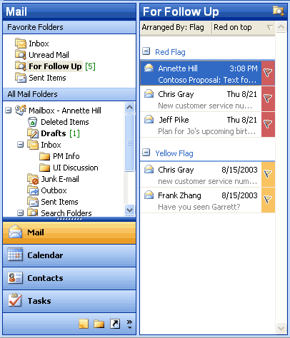
The “For Follow Up” folder collects a to-do list of every item that has been Quick Flagged in every folder in a mailbox. By default, it is arranged by Quick Flag color so that users can easily see what goes with what. Also, users can drag a message between groups to reclassify it. For example, to turn a yellow quick flagged item into a red quick flagged item, a user could just drag the message from the yellow group to the red group.
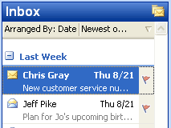
Quick Flagged messages can also be arranged by date.

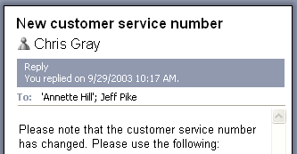
Outlook records the date and time the task was completed, and displays it in the InfoBar on the top of the message.
Search Folders
Search Folders help users spend less time filing and finding e-mail messages. Search Folders are actually live search results that look like traditional e-mail folders, but differ because they do not store e-mail messages. They are virtual folders that contain views of all e-mail items matching specific search criteria. Search Folders display the results of previously defined search queries, but all e-mail messages remain in their original Outlook folder. By using Search Folders, users can easily group and browse through all items relating to a subject, person, task or other criteria, without physically moving messages or folders.

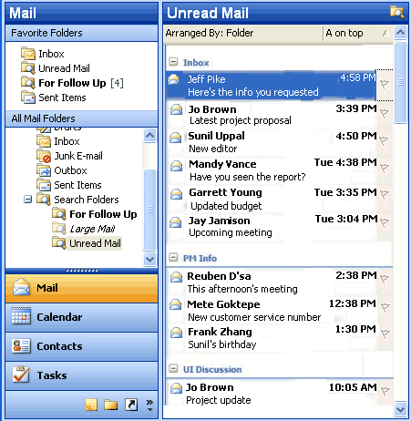
Search Folders work just like folders, except that they can reference e-mail messages from multiple folders.

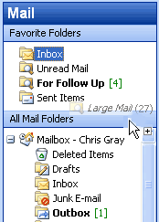
Users can drag frequently used folders or Search Folders to the Favorite Folders section of the Mail pane to keep them handy. This reduces the need to navigate through a deep hierarchy.
Using default Search Folders
Three Search Folders are created for users by default, so even beginners can take advantage of this new tool:
Unread Mail. All unread e-mail messages, regardless of their folder location, are shown in the Unread Mail search folder.
For Follow Up. This folder provides a virtual to-do list of all messages that have a Quick Flag applied.
Large Mail. This folder assists with mailbox cleanup by showing the largest e-mail messages from the entire Inbox.
Creating customized Search Folders
After using the default Search Folders, intermediate users will want to create their own folders for customized searches. To make this as easy as possible, Outlook 2003 offers a template gallery that includes 13 ready-made templates for common Search Folders. These templates make it possible to create a wide range of Search Folders in just a few clicks. The following are some key Search Folders that can be created from templates:
- Important Mail. This provides a central location for all e-mail messages that are marked as having high importance.
- Mail from and to a specific person. This helps users to stay current with customer and personal relationships. For example, it can help answer questions such as “Do I owe Janet a message?” or “Where is that e-mail conversation I had with Marc?”
- Old Mail. This is helpful in locating old messages for archiving.

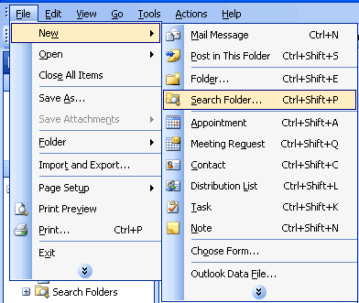
To create a new Search Folder with the template gallery, from the File menu, click New and select Search Folder.
Users can also create a custom Search Folder by choosing the last template, “Create a custom Search Folder.” Under "Customize Search Folder," users simply click "Choose," and type a name for their customized Search Folder. After selecting the search criteria for the customized folder, the user can select and search the folders they want to browse.
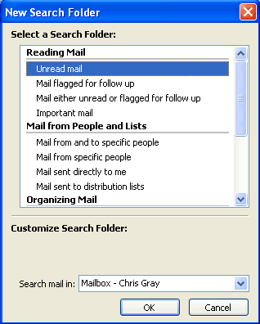
Users can create Search Folders by modifying existing templates.

Saving searches from Find or Advanced Find as Search Folders
By using Find or Advanced Find, users can save any search that was created with Outlook 2003 as a Search Folder or use any of the templates that are provided to create a customized search folder. In both cases, the user can specify not only the search criteria, but also which folders Outlook 2003 searches to create the Search Folder. Search Folders can be easily customized at any time. Users can even perform another search within the contents of a Search Folder to refine their results further.
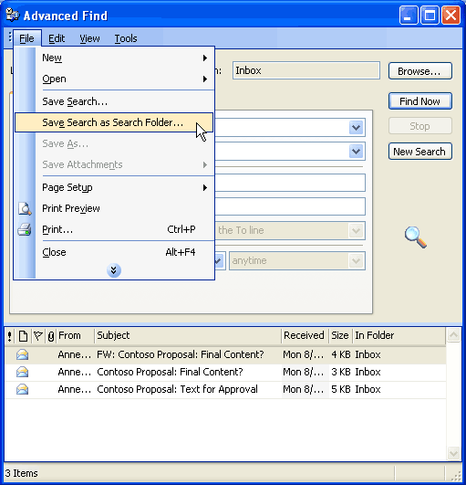
Users can also save search results from Find or Advanced Find as a Search Folder. To save the results of Find as a Search Folder, on the Find bar, click Options and select Save as Search Folder. To save the results of Advanced Find as a Search Folder, from the File menu in the Advanced Find dialog box, click Save as Search Folder.
New Mail Desktop Alert
Outlook 2003 offers a new desktop alert to replace the previous new e-mail message alert. The New Mail Desktop Alert fades in subtly with the name, subject, and a short text preview. It appears just long enough that users can immediately see whether the new message is urgent, should be marked for follow-up, or can be safely ignored without interrupting the current task. The alert contains quick buttons to open, flag, or delete the e-mail message, and if ignored, fades out just as subtly as it appeared. This is completely configurable by the user.
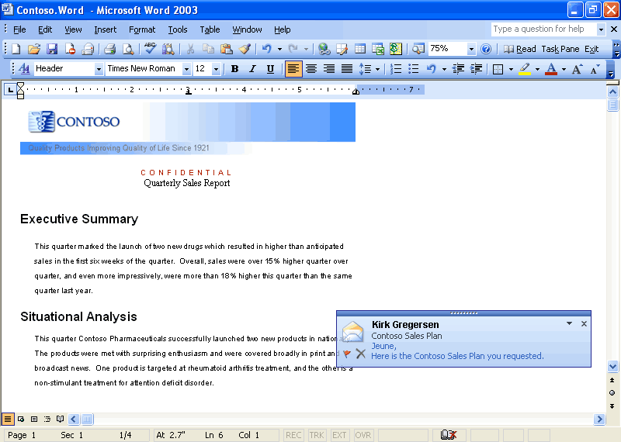
The New Mail Desktop Alert appears while users are working in programs other than Outlook.

Bigger Personal Folders file
The improved Personal Folders file (*.pst) stores up to 20 GB of data by default (administrators can specify a larger folder if they choose) and supports multilingual Unicode data. The new Outlook Personal Folders File will not work with earlier versions of Outlook. Outlook 2003 still supports Outlook 97-2002 Personal Folders files, which are limited to about 2 GB of data. These improvements are also leveraged for the Offline Folders files (*.ost).
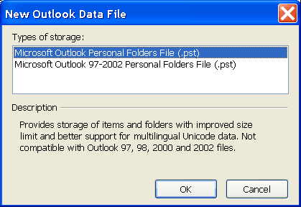
When creating a new Personal Folders file, the new format Microsoft Outlook Personal Folders File is used by default. On the File menu, use the New Outlook Data File entry to create new Microsoft Outlook Personal Folders and also backwards-compatible Microsoft Outlook 97-2002 Personal Folders Files, so users who have older versions of Outlook on a home computer can still create compatible personal folders.

Prevent unwanted e-mail
Unfortunately, in addition to an increasing volume of e-mail, users are being inundated with junk e-mail. These e-mail messages can be bothersome and distracting, but they can also have a more serious impact by taking up valuable storage space.
Block external content
By default, Outlook 2003 helps protect the privacy of its users, and provides them with more control over the information in their Inbox. This protection is enabled through a new feature called Block External Content.
HTML-formatted messages often contain pictures that are not included in the actual e-mail message, but are instead downloaded from a Web server when the e-mail message is opened. Junk e-mail senders have used this capability to their advantage by including something called a “Web beacon” in these messages. A Web beacon notifies the Web server when a user reads the junk message, validating the e-mail address. If an e-mail message tries to connect automatically to a Web server on the Internet, Outlook 2003 blocks that connection until the user decides to view the content, which takes only one click. The user can also turn off this feature.
Giving users control over external content has several advantages:
- Automatic connections to arbitrary Web servers on the Internet are no longer allowed, cutting off the unwanted flow of information to e-mail solicitors.
- Because pictures are not shown unless requested, offensive messages can be deleted without the user being subjected to its images.
- Users on a low bandwidth connection can choose whether an image is valuable enough to warrant the time and bandwidth to download it.
It is important to note that Outlook 2003 retains all of its rich functionality for viewing and sharing pictures. Outlook 2003 will block all pictures by default if they are sent with the message and not on a Web server.
- Content creators who want to send richly formatted HTML e-mail to their customers can still do so by including the pictures in the body of the e-mail message.
- Pictures that are inserted into e-mail by using Outlook or Outlook Express already use the MHTML standard by default and include the pictures in the message, so they are not affected.
- Any e-mail that includes references to images or content on the Intranet or on Trusted sites (defined by the Intranet and Trusted zones of Internet Explorer) will not be affected.
- Any e-mail messages that were sent from someone on a defined list of trusted senders will not be affected. Users can easily add e-mail addresses to this list (which includes the corporate directory and the user's local contact folder by default).
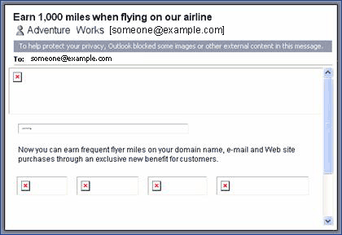
Mail messages that attempt to download content from the Internet are not allowed to make the connection without the user’s permission. The colored InfoBar strip at the top of the message lets users know that the content was blocked.
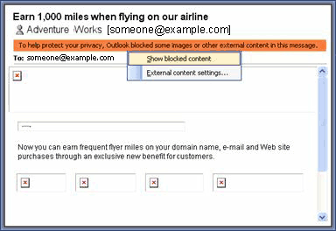
Clicking the InfoBar brings up a context-sensitive menu. Users can turn on images for a specific message using this menu. Users can also add individual e-mail addresses to a “Trusted Senders” list, to disable content blocking for all mail from that address.
Working with Outlook 2003 Rules and Alerts improvements
The experience for creating new rules to handle e-mail messages has been streamlined and made easier for common rules and to view and change rules once they have been created.
Common rule actions can be viewed graphically and modified quickly. In addition, users can associate alerts with their rules to stay abreast of current information.
To view the new Rules and Alerts functionality, do one of the following:
- Go to the Tools menu and click Rules and Alerts, or
- In the Rules and Alerts dialog box, click New Rule, or
- Right-click on any e-mail message and click Create Rule

Filter Junk e-mail
Outlook 2003 includes functionality that has been designed to help eliminate much of the unwanted e-mail that users get every day. These features give users control over the kinds of messages they receive, and from whom.
Features
Outlook 2003 provides a set of features that are designed to work together to help protect users from unsolicited e-mail messages:
- Trusted Senders list. If an e-mail message is mistakenly marked as junk by the filter, the user can add the sender of that message to the Trusted Senders List. E-mail addresses and domain names on the Trusted Senders List are never treated as junk e-mail, regardless of the content of the message. Contacts are automatically trusted by default, and mail from them will never be treated as junk. With Microsoft Exchange Server, mail from within the organization will never be treated as junk, regardless of the content of the message. Users can configure Outlook 2003 to accept mail only from the Trusted Senders List, giving users total control over which messages reach their Inbox.
- Junk Senders list. E-mail from a certain e-mail address or domain name can easily be blocked by adding the sender to the Junk Senders List. Mail from people or domain names on this list are always treated as junk, regardless of the content of the message.
- Junk e-mail filter. Outlook 2003 uses state-of-the-art technology developed by Microsoft Research to evaluate whether a message should be treated as junk e-mail based on several factors, such as the time it was sent and the content of the message. The filter does not single out any particular sender or type of e-mail; it is based on the content of the message in general and uses advanced analysis of the structure of the message to determine how likely it is to be thought of by the user as junk.
By default, this filter is set to a low setting which is designed to catch the most obvious junk e-mail. Any message that is caught by the filter is moved to a special “Junk E-mail” folder, where a user can retrieve it at a later time. The user can choose to make the filter more aggressive (perhaps mistakenly catching more legitimate messages), or even set Outlook 2003 to permanently delete junk e-mail as it arrives.

- AutoUpdate. Microsoft is committed to providing periodic updates of the Junk E-mail Filter so that it continues to be effective.
- Trusted Recipients list. A mailing list can also be added to the user’s Trusted Recipients List. Any e-mail that is sent to e-mail addresses or domain names on this list will not be treated as junk, regardless of the content of the message.
The Junk E-mail Filter is turned on by default. The first time Outlook 2003 moves an e-mail to the Junk E-mail folder, it will notify the user by way of a dialog box.
How to customize
Users can customize junk e-mail settings to meet their needs. To change Junk E-mail settings, select Options from the Tools menu and click on Junk E-mail. To add people to the Trusted Senders, Trusted Recipients, or Junk Senders lists, right-click the message and click Junk E-mail, or click Junk E-mail on the Actions menu. For versions of Microsoft Exchange Server without Cached Exchange Mode (see Cached Exchange Mode), the junk e-mail filtering must be installed and configured on the computer running Microsoft Exchange Server.

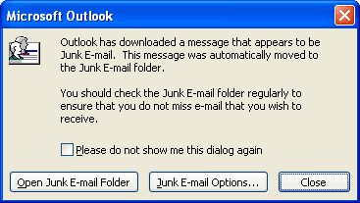
The first time Outlook 2003 downloads an e-mail message that appears to be junk e-mail, a dialog box appears to inform the user. By default, this dialog box comes up each time a suspected e-mail message is downloaded—however, it can be easily turned off by clicking “Please do not show me this dialog again.”

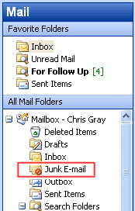

Suspect messages are moved to the “Junk E-mail” folder by default.

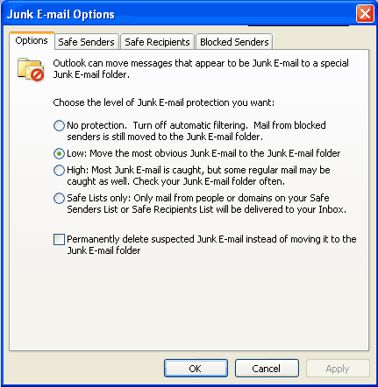
The Junk E-mail Options can be opened from the Tools menu, under Options-> Junk E-mail. The user can choose the appropriate level of protection, ranging from no protection to trusted lists only. The user can also choose to permanently delete mail instead of moving it to the Junk E-mail Folder.

Enable worker mobility and productivity
Outlook 2003 provides many technical advances that help users connect to information and use it more effectively without having to worry about issues such as network performance.
Cached Exchange Mode
The new Cached Exchange Mode in Outlook 2003 delivers a reliable and responsive user experience independent of network performance by loading all necessary data up front rather than as e-mail is read. Cached Exchange Mode insulates the user from network issues, ensuring that the user is able to remain productive at all times. As such, the feature provides advantages for IT directors, reducing support calls, making server site consolidation possible, and enabling a new set of mobile scenarios. On a new installation of Outlook 2003, Cached Exchange Mode is on by default. With an upgrade, the user can enable Cached Exchange Mode.
For several releases, Outlook 2003 has had the ability to synchronize data between the Exchange server and its local store. Users can presently use Send/Receive groups to synchronize their data. Office 2003 Editions offer the ability to use the new Cached Exchange mode in Outlook 2003 to synchronize data continuously.
When working with Exchange Server 2003, synchronization is more efficient and robust because the server and client communicate in a way designed to reduce the amount of data that is transferred between the client and server during synchronization. These improvements are especially important for mobile scenarios in which the connection from Outlook to the Exchange server is over a network that has limited bandwidth and variable latency. This efficiency results in cost savings on “pay-by-the-byte” networks, and generally reduces the amount of time that is required to complete any synchronization, making the benefits automatic.
Intelligent connectivity
The intelligent connectivity feature introduces network “awareness” to Outlook 2003, so that the program is more responsive over low-speed or unreliable network connections, or when a user is moving from one wireless network connection to another. This enables Outlook 2003 to remain usable, and when combined with the Cached Exchange Mode, actually hides the network reliability from the user almost entirely—no more connection-error messages.
The synchronization modes of Cached Exchange Mode include Download Headers and then Full Items, Download Full Items, Download Headers, or On Slow Connections Download Headers Only (the default mode for a slow connection, which can be overridden). Users can change the Cached Exchange Mode connection setting by selecting "Cached Exchange Mode" from the File menu, and then selecting one of the following synchronization modes:
Download Headers and then Full Items – Downloads all headers, and then complete items including attachments. Users can click a header and the full item is downloaded immediately.
Download Full Items – Downloads the header, body, and any attachments simultaneously. This mode is effective with a network connection or a continuous dial-up connection.
Download Headers – Downloads headers only. The full item including attachments is available when the user previews or opens the item. This mode is useful to keep the amount of data transferred between Outlook and the computer running Microsoft Exchange as small as possible.
On Slow Connections Download Headers Only – This is the default setting for a slow connection. The body, including any attachments, is downloaded only at the user's request, or as needed for synchronization or auto-archiving. The Offline Address Book is not downloaded. This mode is effective when using dial-up connections, or cellular wireless with General Packet Radio Service (GPRS) connections.
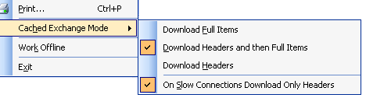
The Cached Exchange Mode menu shows the options that are available when connecting to slow or unreliable networks.
Connectivity to Exchange via HTTP
Gaining access to a Microsoft Exchange server by using Outlook has traditionally required direct access to the server, either through a local area network (LAN) connection or by connecting remotely through a virtual private network (VPN) connection. With Outlook 2003 and Exchange Server 2003 running on Microsoft Windows Server 2003, users can open their Exchange server computer directly by way of HTTP over an Internet connection. By using Outlook 2003, if a user can browse the Web, the user can open his or her Exchange mailbox.
After the feature is operational, Outlook 2003 automatically connects by way of HTTP when a direct connection to the Exchange server is unavailable, eliminating the need to have corporate VPN servers set up for e-mail access.
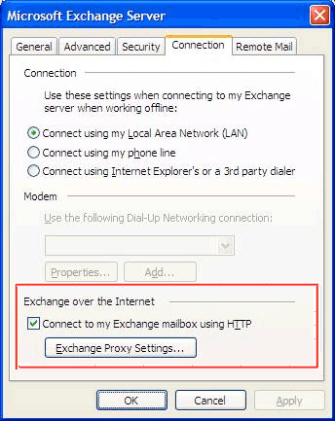
Office administrators can now easily configure Outlook 2003 to communicate with an Exchange server over the Internet.
Notification Area icon
Most people keep their e-mail program running all the time. The new Notification Area icon in Outlook 2003 makes it possible for users to stay on top of their e-mail messages even when working in another program. The Notification Area icon shows the status of Outlook 2003, even when the program is hidden, minimized, or in the background.
The Notification Area icon displays different types of information in new ways:
- Informational messages. Outlook 2003 provides alert and reminder information to the user in a less intrusive manner. Notification “pop-up balloons” now notify the user of status changes and other information in a subtle manner, allowing the user to continue working. In previous versions of Outlook, message boxes indicating status would appear and block the screen. With Outlook 2003, users can read the message if they choose, but do not have to respond. Users can also choose to opt-out of groups of messages that they do not want to receive in the future.
Note Opting out of receiving messages does not affect any error logs that might be created.
- Synchronization status. This icon shows when Outlook 2003 is downloading and sending e-mail. This is useful when a user wants to work in another program until Outlook 2003 is finished sending or receiving e-mail.
- Network problems. If Outlook 2003 has a problem with the network or with the e-mail server, it notifies the user by changing to a “trouble” icon. In most cases, configuration data is still available, but no new messages are received until the trouble is resolved. Users can cancel the network operation by clicking the icon and selecting “Cancel Request.”

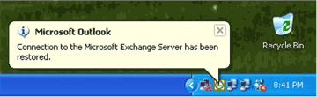
The Notification Area icon can show informational messages in pop-up balloons. The Notification Area icon is always available in the notification area of the Windows taskbar. Click or right-click the icon to bring up the menu. Double-click to bring up Outlook (even when Outlook is totally hidden).
Kerberos authentication
Besides NTLM, Outlook 2003 supports Kerberos authentication when running Exchange Server 2003, giving corporations more options for meeting their authentication needs.

More effective contact management
Users can now take advantage of enhancements to the Address Book, including an updated interface and the option to insert a picture.
Improved Address Book interface
The Select Names dialog box in Outlook has been redesigned to help users view more information on the screen at one time. The dialog boxes are completely resizable based on user preferences, making it possible to take advantage of today’s larger monitors, and common commands have been made more prominent in the user interface.
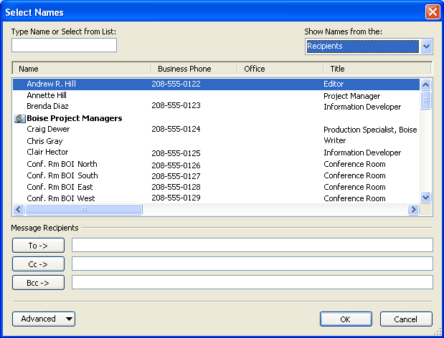
The new Address Book Chooser is resizable and has been redesigned to be more intuitive.
Contact picture
The ability to add a picture to Contacts is one of the most frequently requested features from customers. With Outlook 2003, pictures can be added directly to the contact information, giving users the ability to associate a face with the name and other available information.
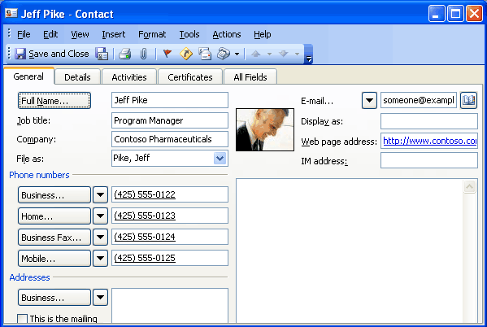
The contact with a picture added.

Bringing relevant information to people’s fingertips
The Office 2003 Editions have created two new panes to bring relevant information to its users: the Document Recovery pane and the Research task pane. The Document Recovery pane safeguards users against the loss of data, while the Research task pane allows users to browse the Web for information within the program that they are working from.
Document Recovery pane
The Document Recovery pane in Microsoft Office PowerPoint® 2003, Word 2003, and Microsoft Office Excel 2003 helps prevent the loss of work when one of the programs encounters a problem and stops responding. The files that are listed in the Document Recovery pane can be opened, their repairs can be viewed, the files themselves can be compared, and one or all of the files can be saved. The listed files are clearly labeled as “original” and “recovered.” The Document Recovery pane allows users to connect with the temporarily lost information quickly and easily.
Research task pane
Each Microsoft Office program and Microsoft Internet Explorer (through an Office add-on) now includes a Research task pane that allows users to search for information through the Web or a corporate data source from directly within the program. Now users can access corporate data and work with their research information right alongside their reports, charts, and other documents.
Search results can be pulled into the document without switching programs, and through the use of smart tags, the data source can provide a variety of actions beyond the typical copy-and-paste of HTML that a Web search would accomplish. For example, a search against a corporate data source could provide the option to refine the search with additional parameters, insert the results as structured XML data into Excel, or present the information as a linked, refreshable XML document fragment from a content database.
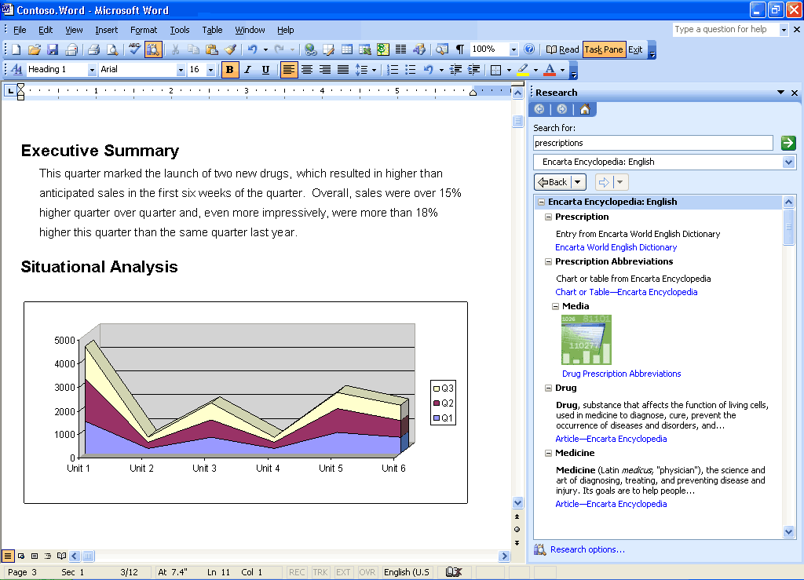
Through the Research Library task pane, users can research the Web or corporate resources right alongside their documents.

Research task pane vs. ordinary Web searches
A Web search searches only publicly available information, and returns only formatted text or, occasionally, documents as the results. The results are viewable only in a browser, not in any Office programs.
The Research task pane searches the Web as well, but it also searches numerous other sources that are not available to Web searches, including the following sources:
- Subscription services such as Factiva, e-library, or Gale company profiles (you or your company must be a subscriber)
- Microsoft services such as dictionaries, thesauri, or the Microsoft Encarta® encyclopedia
- Translation services through Microsoft partners
- SharePoint Portal server computers inside of a company's firewall
- Corporate databases inside of a company’s firewall that have been provided with a Research Library front-end (either on the server or on the client), such as customer databases, sales data, product catalogues, or support databases
Most powerfully, the Research task pane is not limited to returning only formatted text as a result. It can return XML data from Web services or databases. Using smart tags linked to the data types returned, a service can provide the user with options to insert the data into programs or take special actions. For example, if sales data is returned from a search in Excel, the service can provide an action to insert the data as a refreshable Web query or to create a PivotTable or PivotChart. Likewise, the same service might offer different actions in Word 2003 or PowerPoint 2003.
An SDK is available to developers to help them build their own research services, or to put a research front-end on an existing data source. Many partner vendors are already preparing research front-ends for their server products and services.
Research Library closes the XML data loop by letting end-users access all the data inside or outside of an organization and reuse it within Office programs.
Research task pane tools
The Research task pane also includes basic resources such as a thesaurus and dictionaries in multiple languages (available even offline), as well as automated translation and an encyclopedia on the Internet. If the user or corporation has signed up with third-party data service partners such as Factiva, eLibrary, and others, these are also searched and the results are presented in the Research Library.
Looking up information by using the Research task pane is simple: simply hold the Alt key and click on a word in your document. Users can also right-click or use the menu or toolbar to open the Research task pane. It will appear with results even if it was not open when the search was initiated.
In Microsoft Outlook 2003, the Research pane makes it easier to read foreign-language e-mail messages, because a single click will provide a translation of a word, or the entire e-mail message, to the user’s native language. This is especially useful in multinational corporations where many users do not natively speak the predominant language.
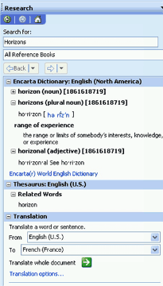
The Research Library task pane provides a variety of tools and resources.

Flexible information management technologies
Ink integration in Office 2003 Editions programs
In Office XP, Tablet PC users were able to download the Microsoft Office XP for Tablet PC (Tablet Pack) add-in to create ink e-mail messages and to draw in Word (comment bubbles only), Excel, and PowerPoint; and annotate presentations. In Office 2003 Editions, ink is integrated directly into the programs, allowing ink users to use more functions and use ink more effectively for annotating and drawing within their documents. Support for ink has also been improved throughout the Office suite.
The following are some of the benefits of tighter ink integration with Office 2003 Editions:
- Handwriting within 2003 Editions programs. Users can treat their Word documents, Excel worksheets, and PowerPoint slides as a piece of paper, making notes directly on top of the document or in the margins, sketching out ideas and saving them for later, without having to worry about supplemental software to accomplish the notation.
- Show and hide ink markup. Integration of ink annotations with the Reviewing toolbar in Word 2003, Excel 2003, and PowerPoint 2003 allows users to show and hide their ink mark-ups in the same way as other comments and revisions.
- Write inside of Word comments. Word 2003 provides an ink comment bubble feature, which allows users to ink inside of Word comments with all of the same features, such as the ability to filter by author. Using Comment bubbles ensures that the annotations will remain anchored to the text that was commented, even as the document is edited later.
- Comment “anchoring.” Office 2003 Editions also take the first step toward true integration between ink annotations and words on the page, with limited support for document reflow and anchoring. In Excel, annotations will move as columns are inserted, so ink comments remain over the relevant item. In Word, annotations are linked to paragraphs, so edits elsewhere in the document leave ink annotations in the correct place. Changes to annotated paragraphs on the word or line level are not yet supported in Word—such edits might cause the ink annotations to drift from the words to which they should be connected. Users are notified that annotations may shift when switching between Reading Layout and Print Layout views for printing. Annotating in Print Layout view is still a better choice for those who want to print their annotations.
- Two ink modes. In addition to annotating directly on the document surface, users can insert hand-drawings in Word 2003 through the same interface as pictures or text boxes. The user is given a “canvas” inside the document, which acts like an ink picture. Double-clicking on the ink image produces a “format ink” dialog box, in the same way as a text box or picture, with options to wrap text around the ink, resize the canvas, and so on.
- Two ink toolbars. An ink toolbar is available for drawing and writing, and another for annotations. Each provides a set of ballpoint pens, felt tip pens, and highlighters, enabling users to change the color and width.
- Familiar interface. Other ink features in the Office 2003 Editions use the same familiar interface that is found in the previous Tablet Pack.
- Copy and Paste. Users can copy and paste ink objects between programs.
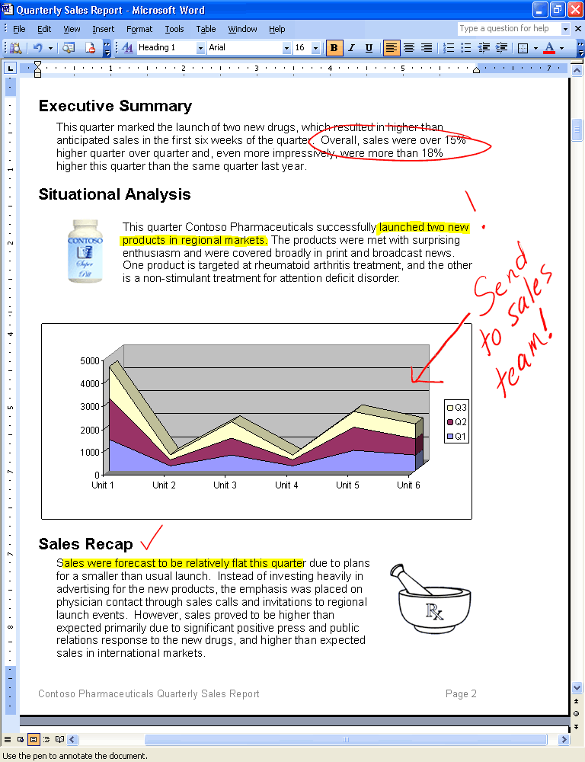

Users can now write notes directly in documents in Word 2003.

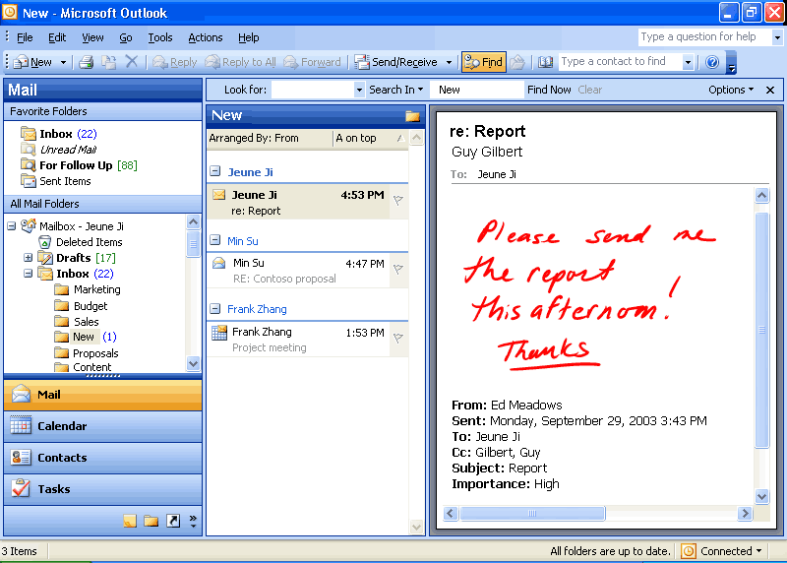
Support for ink is enhanced throughout the Office 2003 Editions. Here, a user adds handwritten notes to an Outlook e-mail message.

Word 2003 Reading Layout view
The new Reading Layout view in Word 2003 makes it easier to read documents on-screen, rather than printing them out. Outlook attachments and documents opened read-only from SharePoint server computers will automatically open in Reading Layout view. The following are some advantages of this mode:
- Optimized experience for on-screen reading. The document is laid out in virtual pages that are optimized in size for the particular display that is in use. The text is displayed with clean margins, shorter lines, a larger font and, space permitting, two pages per screen to make on-screen documents easier to read. Text is displayed by using an improved form of ClearType for smooth display and reduced eyestrain.
- Useful aids to reading. Toolbars are simplified to show only the tools that are useful for reading and review. These include the new the Research task pane (see Research), where simply clicking on a word in the document will show definitions, translations, encyclopedia articles, and other related content from the Internet and corporate intranet; commenting tools (typed, spoken, and even handwritten if on a Tablet PC); the Find feature; and buttons to increase or decrease font size temporarily for reading purposes.
- Easier navigation. Rather than scrolling, pages are flipped one or two at a time to simulate the experience of reading a book, which reduces eyestrain by making it easier for a user’s eyes to track the text. Users can browse a document by using the new thumbnail view, which lets them jump to a particular page by clicking on an image of that page, or by using the document map, which displays the structure of the document similar to a table of contents. Users can also navigate by using the mouse wheel, or any of several different keystrokes (for example, SPACEBAR, PAGE DOWN, DOWN ARROW, ENTER to move to the next page, and UP ARROW, PAGE UP to move to the previous page).
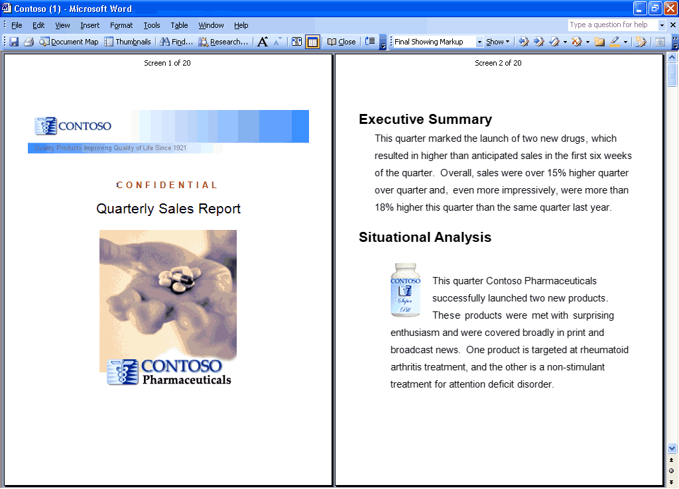

A document displayed in the Reading Layout view
Not every document can be displayed well in Reading Layout view. For the most complex documents, a button called Actual Page can be used to display the document as it would be printed. This button is also useful to switch temporarily to the original print version of the document to view a particular layout.
Office document imaging
Document imaging in Outlook 2003 enables users to scan paper documents and convert them to digital images that can be stored on a hard disk, network server, CD, or DVD. Digital images can be saved in TIFF or MDI file formats.
Two components make up Document Imaging—the Scan component and the Imaging component. On the Office Start menu, these appear as Microsoft Office Document Scanning and Microsoft Office Document Imaging.
- Office Document Scanning—Use the Scan component to make scanned documents available on the user's computer by using any installed scanner. The presets that control the scanner are optimized for specific purposes. Black and White produces the best results when scanning text; Color produces the best results when scanning pictures or artwork.
- Optical character recognition—Optical Character Recognition (OCR) translates images of text into actual text character. By using OCR, users can manipulate text, search, or copy text to another program. For best results, use the Black and White preset for OCR.
- Develop image-based custom programs—Users can insert images from the scanner into a Word document by using Office Document Scanning, or by using the software that came with the scanner.
- Annotate images—Users can annotate images easily for document sharing.
- Office Document Image Writer—By using the Document Image Writer, users can view scanned documents on-screen, rearrange multiple-page documents with ease, select and work with OCR text, and annotate or send fax documents.

Picture Manager
Microsoft Office Picture Manager provides a flexible way to manage, edit, and share pictures. Users can view all pictures, regardless of where they are stored, and the Locate Pictures features assists with searching. Office Picture Manager can automatically perform corrections to pictures, or users can make specific adjustments by using the individual picture-editing tools. Sharing pictures is easier and more powerful; pictures can be sent in e-mail messages or users can create a Microsoft SharePoint Picture Library on a corporate intranet.
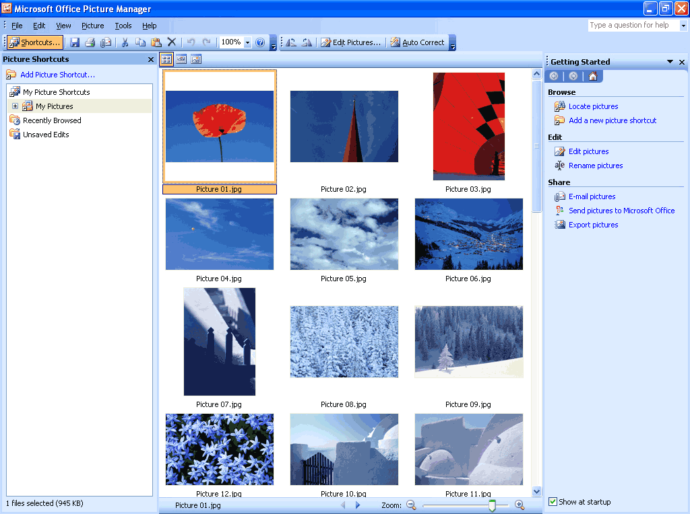
Use the Picture Manager to sort and find pictures.

Managing pictures
To avoid navigating between locations and long lists of folders to locate pictures, users can now add shortcuts to all the locations that contain pictures. Office Picture Manager works with the current folder hierarchy and does not require the user to create new categories or import pictures. After a shortcut has been added, users can work with pictures from any location as if working directly from the file system.
Editing pictures
Users can change how pictures look by adjusting these settings and tools: brightness and contrast, color, crop, rotate and flip, red eye removal, and resize. After editing is complete, users can save the edits to the current file or keep the original file by exporting the changed picture to another file name or to another location.
Sharing pictures
After editing is complete, users might want to share them with a workgroup. Pictures can be sent in e-mail messages, or users can create a SharePoint Picture Library for a rich collaboration experience. The SharePoint Picture Library offers simplified administration and role-based permission settings, in addition to a unique picture-management model that enables users to download picture versions at any size or resolution, while efficiently storing the original pictures.
Shared pictures can be compressed to a file size that is the most efficient for the sharing medium. Smaller file sizes appear more quickly on Web pages, and take up less disk space. If the user is sharing pictures in e-mail messages, smaller file sizes are sent more quickly.
Summary
With Microsoft® Office 2003 Editions, users have new ways to stay organized and manage the details that accompany information overload. New design enhancements to Outlook 2003, including the new Reading Pane, Search Folders, and Quick Flags help users save time and manage information more effectively.

Introduction
The Microsoft® Office 2003 Editions integrate support for Extensible Markup Language (XML) in a way that can help companies create new, simple, and efficient processes for everyday business functions, such as invoices, contracts, press releases, reports, presentations, customer-facing e-mails, and more. The new processes combined with the power of XML can bring all departments together and save time by eliminating the need to pass documents back and forth among departments and people.
Business process management challenges
Because different departments in an organization have varying needs for consuming and reporting the same data, sharing information between departments can be difficult. Often, data output from one department is in the wrong form or file type to be opened or used by others. This means that departments must spend extra time reworking data to fit their needs and then verifying that it remains accurate.
Business value of XML in Office Professional Edition 2003
A surprising amount of business information stored today is already in XML format, or can be easily converted to XML as it is used. All major database tools on the market today—from any vendor—support access to stored information by using XML format. A solution developer can simply request information as XML by using the correct interface, and the database server automatically generates the XML.
Support for customer-defined schemas in Office Professional Edition 2003 means that the data coming from these databases can be used directly in the Office programs. Likewise, data collected or created in Office Professional Edition 2003 can be submitted to existing databases without reworking the data.
With Office 2003 Editions, there is no need to wait for existing business information to be converted to XML—most of it is already available to power users and solution developers who are trying to make business processes more efficient. Although XML is implemented in all of the Microsoft® Office 2003 Editions, this chapter focuses on XML implementation in Office Professional Edition 2003.
In Office Professional Edition 2003, the broad implementation of industry-standard XML, integrated task panes for research and communication, and expanded Smart tag capabilities help bring relevant and current business data to the user from within Office system programs. The task panes also provide a platform for business process solutions to be built on top of the familiar Office interface.
The following are some of the benefits of XML:
- Easy exchange of data. XML allows data to be retrieved and used from disparate and otherwise incompatible systems.
- Simple reuse of data. Reuse of information through XML eliminates the need to re-key or recode, and thereby reduces the time required and errors generated in repurposing information.
- Easily searchable information. XML helps give structure and meaning to electronic information, so that information becomes much easier to search and organize.
- Different views of the same data. Because XML separates content from its presentation, the same information can be used in different environments, formats, programs, and devices, depending on the user's needs.
- Rapid solution development. Because more structured information uses the industry-standard XML data tags, business applications can be written from the ground up by developers, or even generated by experienced users, more quickly and easily.
New feature highlights
The new support for XML in Office Professional Edition 2003 is broad and deep across several products—in ways that are groundbreaking for desktop software.
Structuring data and creating solutions
Office Professional Edition 2003 provides support for customer-defined XML Schema Definitions (XSDs), meaning power users and developers can structure their data in a way that makes the most sense for them, and companies can create integrated business solutions inside of documents that interact with other valuable XML-based Web services that any user can take advantage of, even without knowing anything about XML.
Retaining rich formatting in documents
Microsoft Office Word 2003 can open and save files in any XML schema. When saving as XML, users also have the option to include, in addition to their own XML data, XML that describes the document formatting by using the WordML schema. Including WordML lets users retain all of the rich Word formatting when saving in XML format, so users can open the file and continue editing later with no loss of fidelity. The XML file can also be opened later in another program for searching or reuse of document fragments. A developer can build a document template that contains embedded XML, and anyone who uses that template will then produce valid XML output without knowing anything about XML. A collection of XML documents can be searched as readily as a database, enabling businesses to unlock the information that is stored in documents across the organization. All of this turns Word into a powerful tool for managing, modifying, and formatting business data.
Manipulating XML-based data
Microsoft Office Excel 2003 can now read data within any customer-defined XML schema without the data having to be reformatted. Manipulating XML-based data in Excel for reuse and analysis is now as easy as selecting from a field chooser. Excel can also use XML to update charts, tables, and graphs as changes are made to the underlying XML data store, providing dynamic, real-time information for analysis in any Excel format.
Defining XSDs for exporting data
Microsoft recognizes that each customer has an individualized approach to business, and uses specific types of documents and data. For example, a purchase order document for an automotive parts supplier is a very different document from a legal contract written in a law firm.
Accordingly, the XML support in Office Professional Edition 2003 is not merely a way to save the formatting of a document. Instead, the Office programs allow a solution developer or power user to incorporate the actual structure of business data that is used by a particular customer into that customer's documents. This is done by creating or using an existing XML schema that identifies the parts of a document. In the case of the purchase order, these parts might include the customer name, ID#, item description, item ID, quantity, price, and so on.
After these parts of a document are identified in a template, anyone using that template or solution—even someone without any knowledge of XML—will be processing and creating XML data in the format that best suits the particular business needs. The data can then flow directly into business systems and processes.
In contrast to this, the “native schema” for Word or other programs is simply the schema that is used to contain the formatting for the document so it can be saved and re-opened in Word without loss of fidelity. To make this most accessible for customers who may want to use this formatting information, the schema (or file format) is fully documented in the Office 2003 developer tool kit.
For users who want to extract data from one or more tables in a database, Microsoft Access is the most appropriate Office tool. With Microsoft Office Access 2003, users can browse through related tables in a database and choose how to export data by defining the structure of a customer-defined XSD.

Key functions that are enabled by XML in Office Professional Edition 2003
Support for XML in Office Professional Edition 2003 helps to seamlessly integrate data into related documents, spreadsheets, and databases, streamlining business processes. Along with providing full access to standard XML features, new XML-based tools in Word 2003, Excel 2003, and Microsoft Office Access 2003 help users to interact with data and documents more easily.
Freeing up critical business information
Time and again, businesses have expressed the need to capture important business information in a way that allows them to reuse it in other documents or business processes, regardless of servers, programs, or platforms. To fulfill this need, Microsoft has built XML into the heart of Office Professional Edition 2003 programs by creating and enhancing the following features:
- XSDs. Support for standard and user-defined XSDs better enables data to fit needs.
- Research task pane. Efficient access to relevant data increases productivity.
- Smart documents. Enabling custom solution development and deployment streamlines business processes.
- Programmable task panes. Displays of relevant tasks and information help to automate daily work.
- Real-time data. Real-time updates to data that is inserted from other sources helps reduce valuable time spent on research.
- Smart tags. Information and action options that function while data is being entered help automate work.
Support for XSDs
XML markup can be used to create "semi-structured" documents with regions of meaning, in addition to presentation and formatting. By creating or using specific XML schemas that define the structure of the document and the type of content that each data element contains, businesses can customize data presentation for their own use, making it easier to manipulate, search, and reuse information. XML bridges the gap between unstructured documents and rigidly structured data.
The World Wide Web Consortium (W3C) has created a standard for generating and describing XML schemas that is known as the XML Schema Definition Language, or XSD. Because each company knows best what type of data it needs to capture, it can define for itself the XSDs that are most relevant to its own business. This is called a “customer-defined schema,” as compared to one that Microsoft or another vendor has defined. Being able to define schemas is a critical business advantage.
By making it possible for businesses to capture the kind of information they need in a richer, more semantic, and structured way, Office 2003 Editions enable businesses to work with information in whatever way makes sense to their organization. For example, with Office 2003 Editions, a Human Resources system may have Word document resumes that are marked up with XML tags such as “name,” “address,” “career goals,” or “qualifications.” Once the Word documents are submitted to the system, a Human Resources director can run queries as rich as a database against the collection of XML resume files: Who has an MBA? Who speaks Polish? The Human Resources director can also use Excel to build charts, summary reports, and more from the data that is contained in those documents.
These schemas can and often will be totally internal and unique to a company, such as an order-processing schema or a research report schema. But in some industries, it makes sense to create schemas for use among multiple companies or organizations. One example is XBRL, which stands for eXtensible Business Reporting Language, which is an open specification that uses XML schema to describe financial information. Another example is HL7, which is used in the healthcare industry. Having these standard schemas in place allows different organizations to easily share information, even if they are using completely different technologies from different vendors on different platforms. The standard schemas also create other communication and business efficiencies.
Research task pane
The Research task pane uses XML to provide a way for organizations to expose relevant internal business information and processes, and information from other relevant sources, directly in the context of each Office 2003 program.
Developers within an organization can create and deploy services by using XML that plugs directly into the Research task pane on computers that are running Office 2003 Editions. Services can include anything from data accessibility to interactive forms. An organization can also subscribe to vendor Web services that give personnel access to even more information in the Research pane.
Developers can make services available to users over the Internet, through a corporate intranet, or by installing the services directly on a user's computer. Services that are available over a network, Internet, or intranet are better for information that may change frequently or is used by a large audience.
Services can be deployed manually, be discovered automatically by a user's computer, or pre-registered when an Office 2003 Edition is installed on a computer. With manual deployment, a user navigates to a URL and registers for the service. With discovery, the user is prompted to register for a new service automatically. When a service is pre-registered, no user intervention is required.
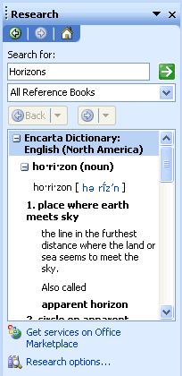
The Research task pane in Office 2003 Editions.
Smart documents
Smart documents are XML-based solution development and deployment platforms that are available in Word 2003 and Excel 2003. Smart documents help developers to tackle business-process problems by quickly building document-based solutions that combine the advantages of the Word and Excel desktop programs with the advantages of Web services. Benefits of these solutions include easier deployment and updating of the solution, and a larger selection of tools for solution development.
Smart documents bring relevant information directly to the task at hand through a new “Programmable task pane” user interface. With smart documents, XML solutions can be created to enable business processes and help users complete forms and other documents, and then link that information to back-end systems that support XML. As the user clicks through the document, the program modifies itself to present the appropriate functions and help to complete a task.
Smart documents can easily be incorporated into business processes such as expense reporting, contracts, or anything else that might pass through multiple hands or systems while being authored, or that require information from back-end sources. A Smart Document solution can also include custom Smart Tags that are designed specifically to run only in that solution, or any other code that the developer would like.
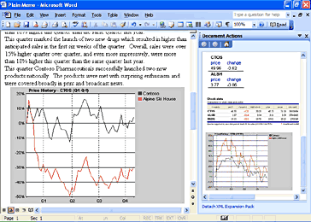
Smart documents use the new “Programmable task pane” shown on the right to bring relevant information directly to the user.
Using smart documents makes solution deployment much more flexible. Solution code can now be deployed once to a central server location, and Word and Excel will securely download and cache it locally when the smart document is opened. Updates to the solution code and even the document template itself can be delivered the same way, as a single update to the server location for the smart document solution, without having to deploy directly to hundreds or thousands of clients, just as with Web-based solutions. But unlike Web-based programs, the Smart Document solutions can operate even when the computer is offline, because they use the Office programs rather than a browser. In addition to solutions based on the Component Object Model, smart documents also accept solutions that are written in Microsoft Visual Basic® 6.0, Microsoft Visual C#®, Microsoft Visual C++®, and Microsoft .NET managed code for additional security and ease of development.
Smart documents are new, and their use is virtually unlimited. The following are a few example scenarios.
- A purchase order solution using Excel might be linked to a business rule in a back-end server that takes the User ID and applies the user's current signing limit to the order directly in Excel, while the user is completing the form.
- A social services solution could be created that translates forms into different languages or assists applicants in completing the form, with context-sensitive help.
- Depending on the user type or ID, or on input from the user, a Word document could reconfigure itself to include the necessary sections that the user needs to complete—for example, a performance review form that has different sections for management and employees.
Programmable task panes
Developers can create custom actions for each section of a document based on the XML elements of the particular document and then make the actions available to users in a programmable task pane. The task pane ties different controls to different parts of the document, revealing the most relevant services for each part while the document is being developed. For example, developers can build actions that display help text, ask for input (using standard Microsoft Windows® controls like check boxes and text fields), or retrieve data from other programs or back-end servers. After the user enters the data that is necessary for a task, the smart document can perform actions such as looking up data, formatting it according to the document’s template, and placing it in the document.
As the user moves from section to section in the document, tasks and information that are relevant to a document or spreadsheet appear in the task pane, helping to streamline and automate what may currently be lengthy day-to-day business processes. The task pane gives the user control over which actions are invoked and when, such as manipulating data in the document, making database queries, or interacting with line-of-business systems.
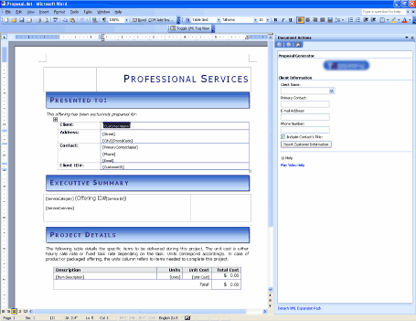
A sample smart document for writing proposals. The Programmable task pane on the right is built to aid with the task of writing a proposal.
Real-time data
In a smart document, experienced users or template and solution creators can easily keep their documents current by creating dynamic charts and graphs that draw on up-to-date, real-time data from back-end systems to display business information as it changes, or they can create reports with up-to-the-minute information. Users can insert and manually refresh this data from the Research pane or from a custom solution that is created for the purpose.
For example, a financial analyst writing a report can use the Research pane to locate all of the latest financial information about a particular organization and insert it into the report. Later, he or she can easily update the data to reflect any changes that occurred after the report was written.
Smart tag capabilities
As in Microsoft Office XP, smart tags in Office Professional Edition 2003 recognize certain words or strings as they are entered (such as a name, address, or a stock ticker) and allow users to choose information and actions to associate with that entry. For example, a user can select an action, such as turning part numbers into hyperlinks in a sales database, adding properly formatted citations to the end of a research paper, or automatically populating an index with every person, company, or product that is mentioned in an article.
In Office Professional Edition 2003, smart tag support has been increased to include Access, PowerPoint, and Outlook. In addition, smart tag support is included in new features such as the Research task pane and Shared Workspaces, which are discussed in another chapter.
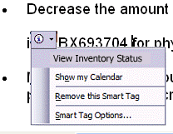
A smart tag is indicated by a series of purple dots under the text. Clicking the Smart tag provides context-sensitive options.

In Word 2003 and Excel 2003, smart tags integrate with XML support, and smart tag actions can be linked to XML elements in documents or spreadsheets. Word also extends the functionality of smart tags to apply to XML elements directly, so actions can be provided for entire sections of documents rather than just a few words, and actions can work on “types” or collections of data rather than relying on text recognition. For example, a custom smart tag can be written that appears on fields that require the user to enter data and then offers to pre-populate the data. A smart tag action can also be provided that applies different transforms or views on XML data that the Research task pane retrieves.
Access 2003 developers can easily embed smart tags into any Access field without extra programming steps. Any control on a form, report, or data page has a property for specifying smart tags. Any field or column on a table also has this property. The columns in a query inherit this property from the table that the query is based on. By embedding smart tags into fields, Access developers can create solutions in Access that have the look and feel of other Office programs.
Users of Microsoft Office PowerPoint 2003 now can have the rich information and association functionality of smart tags. For example, a user could use a smart tag to add product details to a slide that is used during a presentation or to offer additional information about a new HR evaluation program or benefits package in a published slideshow.
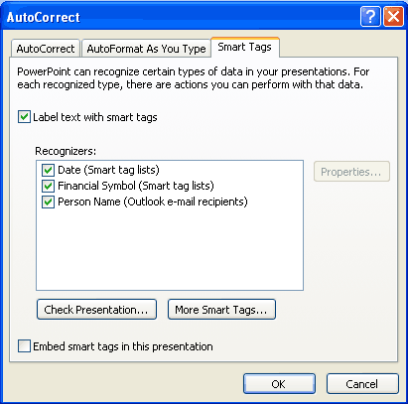
Smart tags are off by default in PowerPoint 2003, but can easily be enabled by the user or a solution. Select AutoCorrect from the Tools menu to bring up this dialog box.

Using smart tags in Office XP, independent software vendors (ISVs) and users have extended smart tags in ways that are specific to certain industries, such as facilitating the ability of a medical facility to look up patient records from a database by using names or ID numbers. Companies have also developed specialized capabilities using smart tags, such as the ability to display customer data based on customer ID, or show inventory and sell-through for a particular stock-keeping unit number. Office Professional Edition 2003 extends the capabilities of smart tags even further and brings that functionality to more programs, for the benefit of both users and developers.
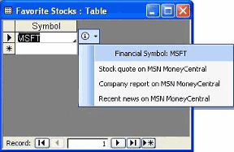
With the new Office Professional Edition 2003, smart tags can be attached to fields on tables, queries, forms, and data access pages in Access.
XML in Word 2003
The deep support for XML in Word 2003 creates a new metaphor for documents: bridging the gap between documents and data. XML in Word provides the basis for building solutions for a wide variety of business problems, such as consistent forms and reports, data reporting, content aggregation, publishing, data mining, and data submittal to business processes.
Benefits for structured documents and content authoring
An efficient method of streamlining business processes is the implementation of standard tools across departments, including forms and reports. To support this goal, Word 2003 includes the ability to limit the formatting that can be used in a document, and to limit the parts of a document a user or users can edit. In this way, Word can be used as a data input tool for XML-based business processes.
For example, with a financial services template, the creator of the template can lock the parts of the document that explain how to fill it out, and can even limit the kinds of formatting the user can apply. After the customer completes the rich Word document within these enforced guidelines, it can be submitted to a Web service or internal server tool that collates the information the user submitted, because the data is pure, valid, well formed XML, which means that other business systems can use it easily.
Capabilities and benefits
Much of an organization’s knowledge lies in documents that are created by individuals in the organization, and those documents are generally stored where access is relatively difficult for anyone other than the creator of the document. Predictions about exactly which bits of information are going to be valuable in the future are also difficult. When documents are stored as XML files, this information can be “mined” at a later date as appropriate. For example, a user could pull all of the graduation dates out of a collection of resumes in a particular XML schema with a simple query. Doing this with HTML or normal word processing documents (in binary or native XML without customer-defined schemas) would be difficult if not impossible.
In addition to the support for customer-defined schemas in the professional edition, all editions of Word 2003 provide a native XML file format—a valid, well-formed XML file that fully represents a Word document. With Word 2003, users can save resumes, reports, or other documents as XML files and retain all of Word’s rich formatting when the file is opened again. No features or formatting are lost when saving a Word document as XML, and only a single file is created. This makes it much easier to share or work with the document than with the HTML format, where images and other files are stored separately.
To maximize the usefulness of a document, one document often appears in different contexts or on different devices. For example, a company’s annual report might go out to shareholders in a rich printed form, be available from their Web site in a simpler form that works with all Web browsers, and even be available for display on devices with small screens, such as Pocket PCs.
Word 2003 defaults to saving in the *.doc binary format, which can be read by over 300 million Word users worldwide. Word can be configured to default to any of several other formats, either through corporate policy or by end-user choices. An option that exists in Tools/Options/Save forces Word to always save in XML, for example. Further, a solution builder can control Word so that it always saves as XML to a content repository, but allows the end user to save as *.doc locally, if that is what the user prefers.
The Word XML file format is useful in itself as a way to enable access to the content of documents without requiring Word (such as when WordML documents are stored on a server and the server needs to query the document content). In addition, a significant part of its value is to act as a container for the customer-defined schema data. When using a customer-defined schema, the Word XML acts as a transparent “envelope” that carries the more valuable customer data, providing information about how it should be presented (for example, formatted in a table). When used with customer-defined XML data, Word XML also adds the capability to execute complex operations on customer data, such as merging two XML documents and storing the differences, or tracking changes on XML data as it is modified by multiple users–capabilities that are simply not available today in other products.
Using Word 2003, users can open a pre-existing, customer-defined XML file while retaining the file’s own schema, or can create a new file by applying an XML schema to an existing Word document or template. Word also allows users to see the XML elements that have been applied to a document, along with a list of elements that can be applied to the current selection. This list is taken from the schema that has been applied to the document. By default, it shows only those elements that are valid according to the schema in the selected context.
Word’s support for customer-defined schemas allows the customer’s data to remain in the document while it is edited, and to be extracted later on. This is much more powerful than a method where the customer data is transformed into formatting or styles in a document. Word 2003 also supports the use of XSL Transforms (XSLTs) for converting files.
Users can employ XSLTs to produce multiple formats from one master XML copy of the document. The advantage of this approach is that users do not need to make edits in multiple copies of the document. Instead, a Web server can use different transforms on the master XML document depending on the viewing device, so the user simply edits the master and lets the transform take care of the appropriate presentation. Similarly, the XSLT can be changed in order to change the appearance of the document without having to worry about introducing errors into the original. The user can also manually create the different versions by simply doing a Save As “through” the different XSLTs.
A document that uses a customer-defined schema (from an XSD) can be saved in one of the following ways:
- In XML using only that schema (no Word XML included) this is considered “pure data.”
- A WordML file with the customer-defined XML interspersed, yet clearly separated by using XML namespaces. The WordML can be easily removed through a transform or programmatically at any time, leaving only the XML in the original schema for easy manipulation by outside processes, such as a server mining the document for data.
- XML markup also conveniently persists in the binary *.doc and *.dot formats for easy transport and storage, as well as to provide a document that can be opened, viewed, and edited in older versions of Word (although the customer-defined XML will be lost if the document is changed and saved).
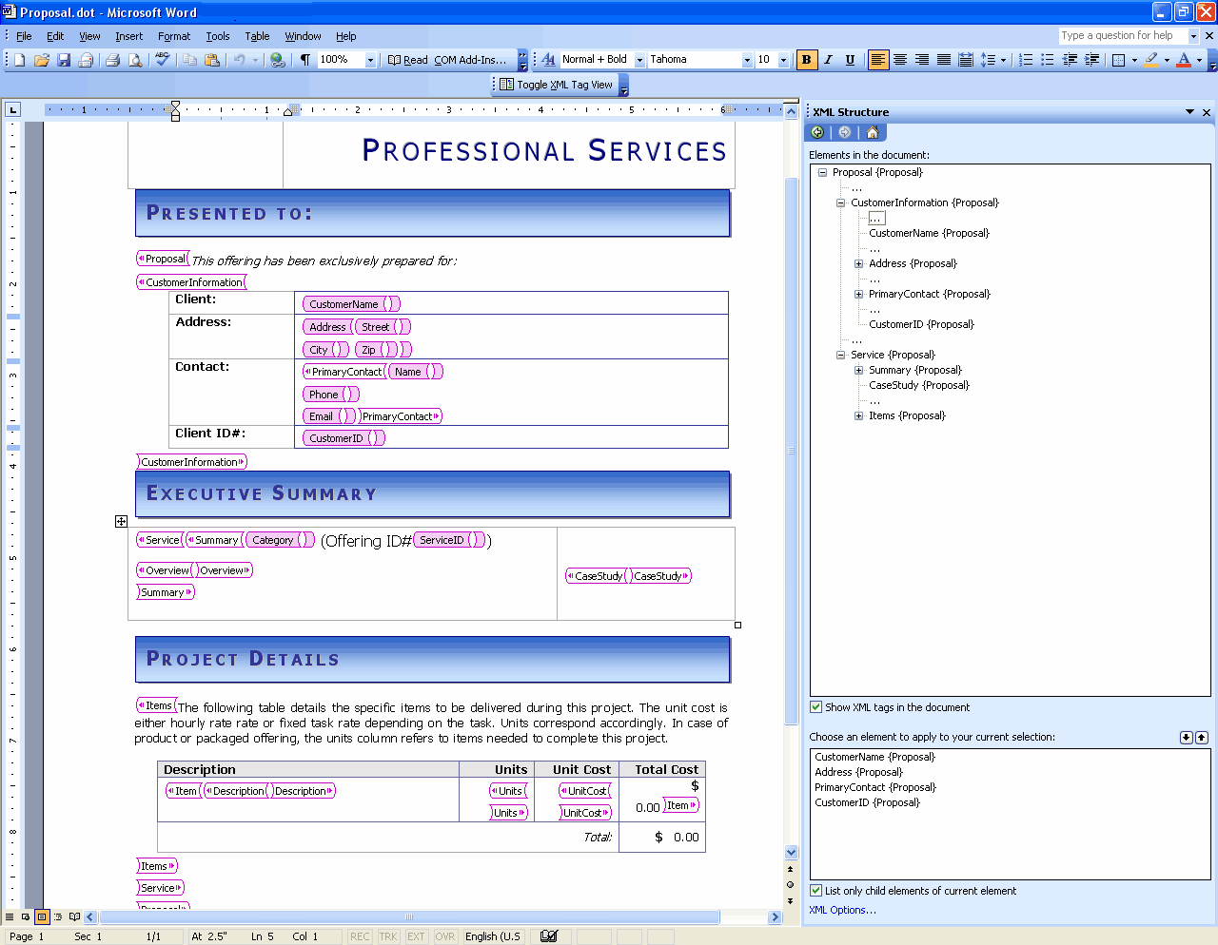
An advanced Word user marking up a template with the user's own XML schema. The tag view is turned on and the XML structure pane is visible. Later on, a consumer of this template would not see any tags or the XML structure pane, but would simply fill out the template normally and see the appropriate markup on the content.

In addition, Word 2003 will automatically detect associations among XML files and schema files (XSDs), and give users the option to attach the appropriate XSDs or use applicable XSLTs when it encounters XML files that belong to categories that are registered with Word, such as news articles or resumes. With this feature, a user can simply open an XML file, and Word will automatically apply an XSL Transform to display it in an organization’s standard format if an association has already been made.
For reporting data, Word 2003 supports refreshable XML web queries. The results of the queries can be passed through an XSL Transform for display in Word using its rich formatting capabilities. Users can take advantage of this capability to present, inside a weekly report or other document data such as server-side SharePoint data (available as XML from SharePoint), other XML data from any Web service or database, ASP/ASPX pages, or other sources. For example, a user can include a table in a document that shows the current status of the document on a SharePoint site, the author, priority, due date, and more, and this information can be updated automatically to keep it in sync with any changes on the server.
By making it so easy to work with XML files, Word 2003 can now become an integral part of an organization’s content-management solution. Users can create XML content by using the familiar Word program. Word’s task pane can also show fragments of XML documents that can be recombined or inserted into the current document to simplify the reuse of content across the organization. Developers can easily create solutions to manipulate, distribute and repurpose this content as needed by using tools such as Visual Basic for Applications (VBA) or even Visual Studio .NET Tools for Office and the robust Word XML object model.
XML in Excel 2003
In the previous version of Excel (Excel 2002), users who wanted to work with XML had a great tool using the XML Spreadsheet (XMLSS) format. Excel 2003 has built on that initial XML experience and is now able to consume and generate XML data files expressed in customer-defined XML schemas (XSDs), not just in the XML Spreadsheet format. Excel is now an efficient XML data analyzer, editor, and viewer; expanding the ability to analyze, display, and insert up-to-the-second business information.
Advantages for sharing business data
The support for XML in Excel 2003 opens a wide range of possibilities for processing data from an Excel file in other programs. For example, an expense report solution could be created that consists of an Excel spreadsheet template mapped to an organization’s XML schema for expense reports. After entering data in Excel and producing an XML file matching the expense report schema, that data could easily be consumed by the company’s SAP accounting system—or any other back-end system or platform that supports XML—for processing. The XML capabilities of Excel unlock this information so that it can be used across multiple disparate systems within heterogeneous environments.
Capabilities and benefits
To simplify the process of sharing data across programs from within an Excel file, support for customer-defined XSDs make it easier for users to add structure to their data and to map data easily from external XML sources into an Excel workbook.
Excel now allows users to add structure around data that they track in spreadsheets. The List feature and its XML overlay provide a data entry row at the bottom of the list that automatically expands the list region as new items are entered. The Toggle Total Row feature turns on a total row where the user can specify average, count, count numbers, maximum, minimum, summation, standard deviation, or variance for the values in any of the list's columns. In addition, when data is in an Excel list, operations such as printing, charting, or creating a PivotTable are easier to perform.
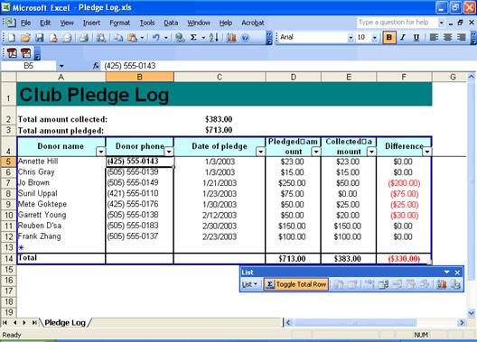
New List features in Excel help users arrange and analyze listed data.

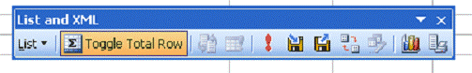
To import XML data, use the refresh and import buttons on the List and XML toolbar.

For importing data from other XML sources, Excel 2003 provides a user-friendly visual mapping tool that works much like a field chooser. With it, Office solution developers and even power users can do the following tasks, without writing any code:
- Easily map existing Excel spreadsheets to XML data structures such as databases for import
- Create dynamic Excel documents that load XML data, display it and write it back out in the same XML vocabulary with up-to-the-minute information
- Create new XML-enabled information repositories from existing Excel spreadsheets
Using the mapping tool to pull from data sources such as a back-end XML-enabled server, a Web service, or any XML data file, users can arrange information on the Excel grid and display it in any format they want. Simply clicking Refresh updates the spreadsheet, so up-to-date information is available for even the fastest-moving data.
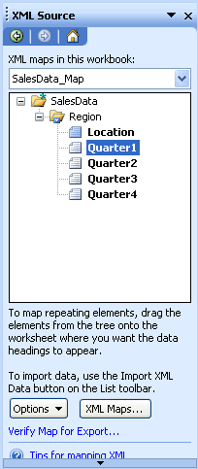
The new visual mapping tool for XML in Excel 2003 works much like a field chooser. With it, Office solution developers and even power users can now build a dynamic information structure into an existing spreadsheet, graph, or chart, using XML data as calculation inputs to the document. The tool makes this possible without writing any code.
XML in Access 2003
XML support in Access 2003 has been dramatically improved, offering a powerful tool for exchanging data between Access 2003 databases and between Access 2003 and external sources. The Access 2003 XML enhancements include exporting several related tables at once, importing or exporting the published 2001 XSD namespace, applying an XSLT on export or import, exporting presentation XSLs, and enabling all of these enhancements programmatically.
Benefits for reporting and storing numerical or textual data
XML support in Access 2003 makes it an ideal solution for reporting and storing data. This is enabled by enhanced XML export and import options.
The basic export options allow data to be exported as pure XML, the schema of that data to be exported as XSD, and/or an HTML presentation of the data to be exported as an XSLT. Additional export options provide detailed control of the export, including how much data to export, which records to export, transform options, and schema options.
The new import options make Access 2003 an ideal storage location for vital business information. During import, the structure of the XML data is presented in the Import dialog box. A registered custom XSLT can be applied to restructure data to fit the database, and new XML data from external sources can now be appended to existing tables.
Capabilities and benefits
Importing and exporting XML files is far more flexible with Access 2003 than with previous versions of the program. With Access 2003, users can work with XML files of any schema and import them into the existing structure of an Access 2003 database by applying an XSL Transform (XSLT) that they or another developer created.
In previous versions of Access, data had to be restructured for a database before it could be imported; in Access 2003 a user can apply a custom registered XSLT during import so that the data is restructured during the import process. When a transform has been specified, it is added to a list of transforms that Access remembers so that they can easily be applied in the future.
When importing an XML file from an external source or another Access 2003 database, the user can choose to create new tables or append existing tables. Basic import options are to import structure only, structure and data, or append data.
The export options enable users to apply an XSLT during export, and as a result convert the Access generated XML into any file format that the XSLT whishes to generate. For example, a user can export data and use an XSLT that generates a Word 2003 file, including images, proper word wrapping, and any other Word feature.
The ability to apply transforms on import and export allow users within an organization or different organizations to easily share information. XML files can easily be converted to and from other XML schemas via transforms.
Additional new export options allow users to select how much of a database to export, to decide whether or not to apply an existing sort, and which records to export. For example, a user can choose to export a single record from a database with or without related data, or all of the data in a database. The user can also choose to apply existing filters or sorts to the exported data.
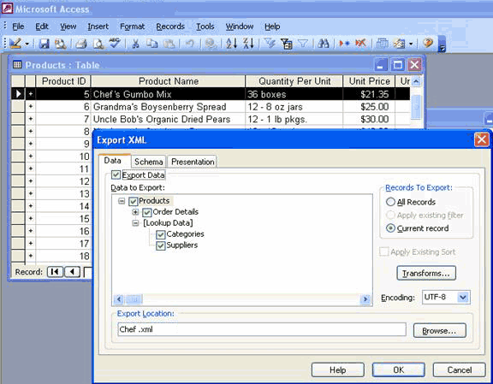
The Export feature in Access 2003 can be used to output just the XML data that is associated with the current record, all records, or filtered data—if a filter is applied—in a table. The Lookup Data options allow Access to export the related lookup data for the records as well, for a complete representation of the information.
Access 2003 also provides improved support for exporting data for an HTML presentation, making data easier to publish to the Web. Furthermore, XSLTs are generated, sorting and grouping have been improved, and running sums, hyperlinks, and expressions in sorting and grouping are available.
In addition to the user interface capabilities that are bolstered by improved XML support, all of the following XML features are available to developers through the Access object model:
- Application.ExportXML
- AcExportXMLOtherFlags
- Application.CreateAdditionalData
- AdditionalData Object
- Application.ImportXML
- Application.TransformXML

Summary
Support for XML in Office Professional Edition 2003 simplifies business processes by making information accessible in multiple formats and in multiple programs. By enabling user-defined XSDs and XSLTs, organizations can also customize data output to meet their specific needs. With the added benefits and features of XML, Office Professional Edition 2003 can be the premier choice for businesses.

Online help and training
Office 2003 Editions offer new and improved integration with Microsoft Office Online Web services. More powerful, better integrated, and with an improved online interface, these services are seamlessly available from within Office 2003 programs. The website, also available through a browser at www.microsoft.com/office, offers a resource page for each Office 2003 Editions program. The resources pages have assistance, columns, training, and templates.
Help
The Help system of Microsoft® Office 2003 Editions has been extended beyond individual workstations. If a user is connected to the Internet when choosing a Help topic or entering a word in the Ask-A-Question box, the Help system displays not only the help information from the local system, but also brings to the Help window information from the Microsoft Web site (www.microsoft.com). This provides the most current information on the topic that the user needs help with, in addition to links to other resources.
Assistance
The Assistance Web page provides up-to-date information with How To articles, conceptual topics, columns, and helpful tips for common tasks. Users can find answers to common questions, read articles on features in Office 2003 Editions, look for specific help in newsgroups, or suggest a topic for a future article.
Training on Office Online
The Training site offers Web-based interactive training courses and self-paced exercises. Users can develop deeper knowledge of tasks and application features, such as creating an outline in Microsoft Office Word 2003 or using motion paths in Microsoft Office PowerPoint® 2003 slides. Courses include practice sessions where users can give things a try in the actual program, and short tests to assess comprehension. Courses cover a variety of topics, and are available for any Office 2003 Editions program.
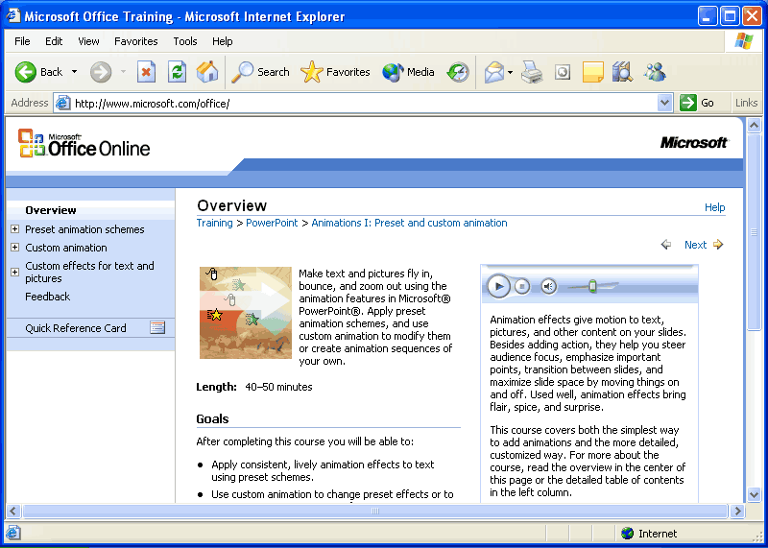
Use Office Online to find training opportunities for Office programs.
Downloads
On the Downloads site (formerly known as Office Update), users can check for free updates that improve the stability and security of Office 2003 Editions. On the Downloads home page, users can click the "Check for Updates" button to start the automatic detection tool, which scans the computer and then returns a list of new downloads that are available and compatible with the user's version of Office. In addition to security and performance updates, viewers, converters, add-ins, stationery, and other useful downloads are also available. The most popular downloads are listed in the Popular Office Downloads section.
Accessibility features
Office 2003 Editions provide new and improved features for accessibility. The following are some of the new accessibility features:
  - Keyboard shortcuts for using the Help task pane and Help window
  - Keyboard shortcuts for using the "Ask a Question" box
  - Options to change the appearance of a Help topic by altering the background or color
Specific to Word 2003 are keyboard shortcuts for customization options, and tips for working more efficiently. For Microsoft Office Access 2003, developers and users who create and edit Microsoft SQL Server™ queries can control the font size of the text in the SQL Server window. This feature is one that users have been requesting since the first version of Access was released.
For more information about accessibility, go to www.microsoft.com/enable.
Clip Art and Media Web site
The new Clip Art and Media Web site offers thousands of Clip Art pieces and media selections to brighten up documents. Users can now perform multiple word searches by using the improved Clip Art Search function. In addition, all clips and media are arranged in a variety of categories for quick and easy browsing. Some examples of categories include Arts, Business, Food, Leisure, and Technology. The Featured Collections section of the Web site offers specially selected categories.
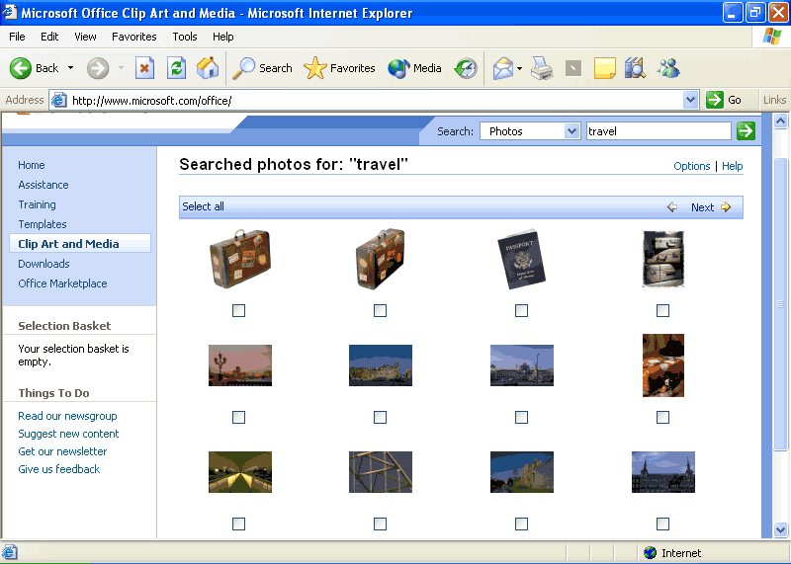
Perform searches for clipart and media by keyword or category.

To select a file for download, users can add it to the basket. Similar to an online shopping basket, all of the Clip Art selections are displayed in the basket and users can view its contents at any time. The basket displays the total number of clips accumulated, file size, and approximate download time for each clip. Users can download all of the clips in the shopping basket at one time by clicking the "Download Now" button.
As an alternative to using the basket, users can click the "Download the clip of the day" link to download the featured clip. Users can also drag the clip of the day, or any clip, directly onto an Office document. In addition, Popular Collections are categorized for easy navigation in the side pane. Some sample collections include Business Photos, Travel Photos, Birthday Clips, and Office Sounds.
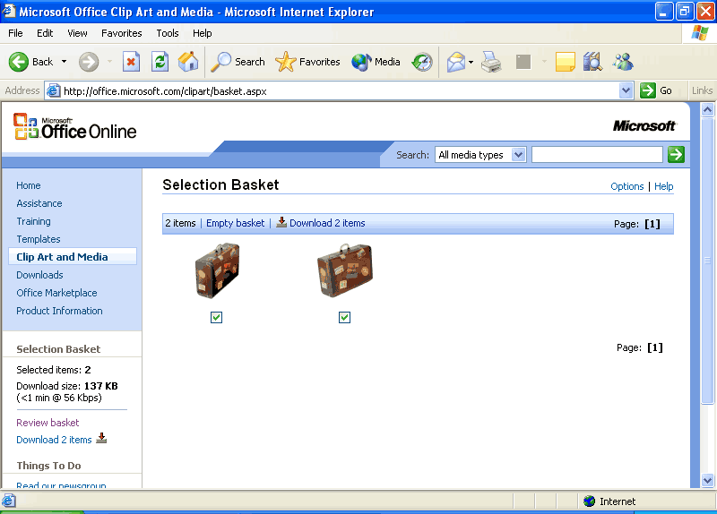
Use the shopping basket to sort clipart and media and download only those you really want.
Templates on Office Online
Templates help to optimize productivity by providing timesaving documents that are useful for simple and complex tasks. The improved Templates site (formerly known as the "Template Gallery") offers hundreds of templates to choose from, for business use and for fun. The new design of the Templates site includes a simplified user interface organized into clear-cut categories that users can easily navigate.
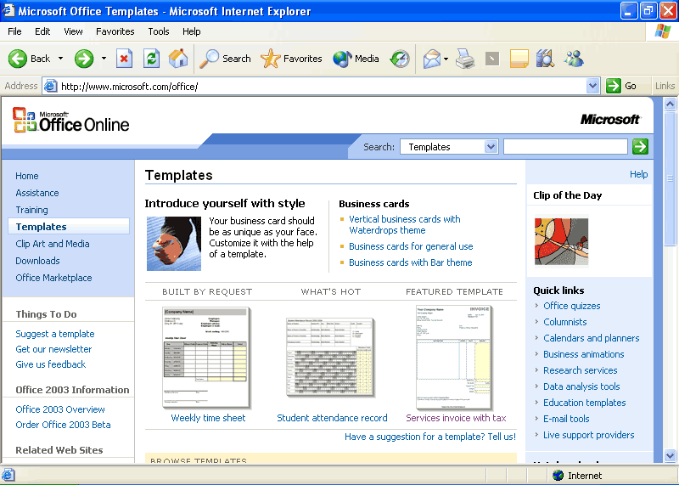
Find the best template quickly and easily with the improved organization of the Templates site.

The available templates are organized into logical categories for easy browsing. Categories include Calendars and Planners, Finance and Accounting, Travel and Maps, Meetings and Projects, and many more.
When users select a template to view, they can see the size of the template, approximate download time, and any additional system requirements that are necessary (if applicable). With one simple click, a user can download and open the template in the appropriate Office 2003 Editions program.
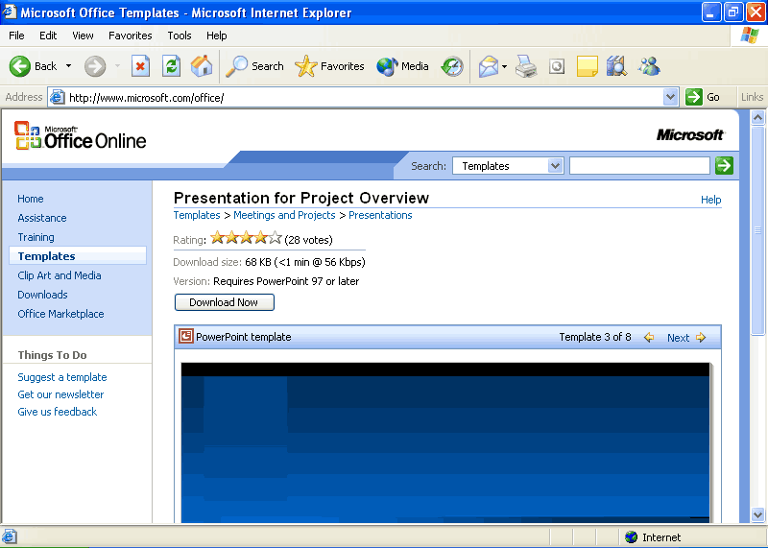
See file size and download time before making a decision to download templates.

Similar in format to the Clip Art and Media Web site, the Templates site includes a place where users can provide feedback, make suggestions for a template style, or opt to get the newsletter. The list of Quick Links is also the same across the Office Online sites—Calendars and Planners, Business Animation, Data Analysis Tools, Live Support Providers, and more.

Whether you're a student, small business owner, or a volume-license business customer, Microsoft has an Office 2003 Edition that's right for you. Use the following table to learn what Microsoft Office System products and technologies will be included in each edition.

 | Student  and Teacher Edition*  (retail only) | Standard Edition | Small Business Edition | Professional Edition | Professional Edition  (volume licensing only)
Create professional and effective documents by using Word | ✓ | ✓ | ✓ | ✓ | ✓
Access, analyze, and display data with Excel spreadsheets | ✓ | ✓ | ✓ | ✓ | ✓
Deliver your ideas powerfully with PowerPoint presentations | ✓ | ✓ | ✓ | ✓ | ✓
Manage your e-mail, calendar, and tasks effectively by using Outlook | ✓ | ✓ | ✓ | ✓ | ✓
Manage customer relationships with Business Contact Manager for Outlook |  |  | ✓ | ✓ | ✓
Create impressive sales and marketing materials with Publisher |  |  | ✓ | ✓ | ✓
Build powerful, customizable database solutions with Access |  |  |  | ✓ | ✓
Exchange data with other systems using enhanced support for XML technology |  |  |  | ✓ | ✓
Create IRM protected documents and e-mails that help reduce unintentional sharing of sensitive information. |  |  |  | ✓ | ✓
Create easy-to-use forms, gather information more effectively, and collaborate with InfoPath |  |  |  |  | ✓
* You must be a “Qualified Education User” to license this software. Please review the qualifying criteria at www.microsoft.com/office/eula
For more information on how to purchase, please go to http://www.microsoft.com/office

Index of new functionality
Microsoft Office 2003 Editions
Creating a Document Workspace
Information Rights Management (IRM)
XML
Outlook 2003
Reading Pane
Multi-line message view with smart dates and grouping
Arrange by conversation
Go menu
Quick flags
For Follow Up folder
Search Folders
New mail Desktop Alert
Junk e-mail settings
Block external content
Shared calendar
Contact picture
Cached Exchange Mode
Remote Procedure Calls (RPC) over Hypertext Transport Protocols (HTTP)
Internet faxing
Word 2003
ClearType
Reading Layout view
Merge enhancements
Track changes enhancements
Ink support
Formatting Restrictions
Editing Restrictions
Excel 2003
List data integration with Windows SharePoint Services
Using Improved Standard Deviation computation
Smart tag integration
PowerPoint 2003
Smart tag integration
Thesaurus integration
Ink support
Annotations in Slide Show view
Expanded playlist formats
Full-screen playback
PowerPoint Viewer and Package for CD
Access 2003
List data integration with Windows SharePoint Services
Smart tag integration
Back up a database
AutoCorrect option
Dependent Objects
Font Control for the SQL Window
Error checking
Making a local table
Propagating field properties
XML Glossary

Microsoft Office 2003 Editions
Microsoft® Office 2003 Editions offers several new features to its users. These new features are individually described within the following sections.
Creating a Document Workspace
Document Workspace sites make everyday document collaboration easier in several ways. By using a Microsoft Windows® SharePoint™ Services site, all of the task lists, deadlines, related documents, hyperlinks, and contacts for project participants are centralized. The sites also integrate with Office 2003 Editions programs through the Shared Workspace task pane in the program. Each user can see the incremental progress in task completion.
Users can create a Document Workspace site for any Office document on a workstation. This document becomes a connected local copy of the document, and a master copy is kept on the server. Users can then invite other contributors to work in the Document Workspace, add links, and more.
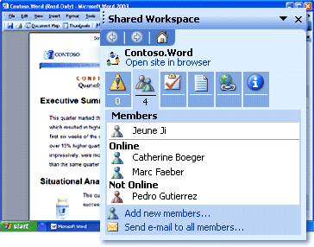
Facilitate collaboration by creating a document workspace.
How to create a Document Workspace
- On the Tools menu, click Shared Workspace.
- In the Shared Workspace task pane, click or type the Web address (URL) of a Windows SharePoint Services Web site where the Document Workspace will be located.
- Click Create.
In Microsoft Office Outlook 2003®, when an Office document is attached to an e-mail message, the Attachment Options task pane appears. By default, the attachment is sent in the same way as in the past, but the user also has the option to store the document in a Document Workspace. Users can specify the SharePoint site on which to create the Document Workspace, or use the default choice.
Store a document in a Document Workspace by saving the attachment as a shared attachment.

How to create a document workspace when you send a shared attachment
In Outlook 2003, start a new e-mail message and attach a document to the message.
-or-
- Open the attached document, click File, click Send to, and click Mail Recipient (as Attachment).
- If the Attachment Options task pane is not visible, click Attachment Options.
- Click Shared attachments.
- In the Create Document Workspace at box, click or type the Web address (URL) of a Windows SharePoint Services Web site where the Document Workspace site will be located.
Information Rights Management (IRM)
IRM is a new policy-enforcement technology that continually helps to protect sensitive documents and e-mail messages from unauthorized use. Because the access and usage restrictions are enforced no matter where the information is, a user can protect a document or e-mail and then share it or send it in e-mail while maintaining more control over who can use it and what they use it for.
IRM can also help to prevent e-mail forwarding, copying, or printing. Protected messages are automatically encrypted during transit. When the sender applies restrictions, Outlook 2003 disables the reuse commands when the message is received. Office documents that are attached to protected messages are also automatically protected.
In Microsoft Office Word 2003, Microsoft Office Excel 2003, and Microsoft Office PowerPoint® 2003, users can help protect documents on a per-user or per-group basis. Each user or group has a set of permissions according to the defined roles: Viewer, Reviewer, or Editor. Users can also prevent printing and set expiration dates. After expiration, documents cannot be opened.
With IRM, users control who can view, review, or edit documents.

How to send an e-mail message with restricted permission in Outlook 2003
- Open a new mail message and fill in the To, Cc, Bcc, and Subject fields.
- Type your message.
- On the E-mail toolbar, click Permission .

How to set IRM in Word 2003, Excel 2003, and PowerPoint 2003
- On the File menu, point to Permission, and then click Do Not Distribute.
- In the Permission dialog box, select the Restrict permission to this <file type> check box.
- In the Read and Change boxes, type the names or e-mail addresses of people you want have permissions.
XML
Office 2003 Editions enhance XML support in existing Office programs and introduces new XML programs. When creating reports, spreadsheets, and forms with an attendant XML schema, users build documents that recognize the structure and meaning of the content within those documents and respond intelligently (for example, by validating information as it is input and avoiding errors). The following are examples of XML use in Office 2003 Editions:
- With Microsoft Office Access 2003, users can work with XML files of any schema and import them into the existing structure of an Access database, or continue to use an XSL Transform (XSLT).
- In Excel 2003, users can map existing Excel spreadsheets to XML data structures such as databases for import, create dynamic Excel documents that load XML data and write it back out in any format, and create new XML-enabled information repositories from existing Excel spreadsheets.
- Word 2003 provides a native XML file format—a valid, well-formed XML file that fully represents a Word document. With Word 2003, users can create XML using the XML Structure pane, and then save resumes, reports, or other documents as XML files while retaining the rich formatting of Word when the file is opened again.
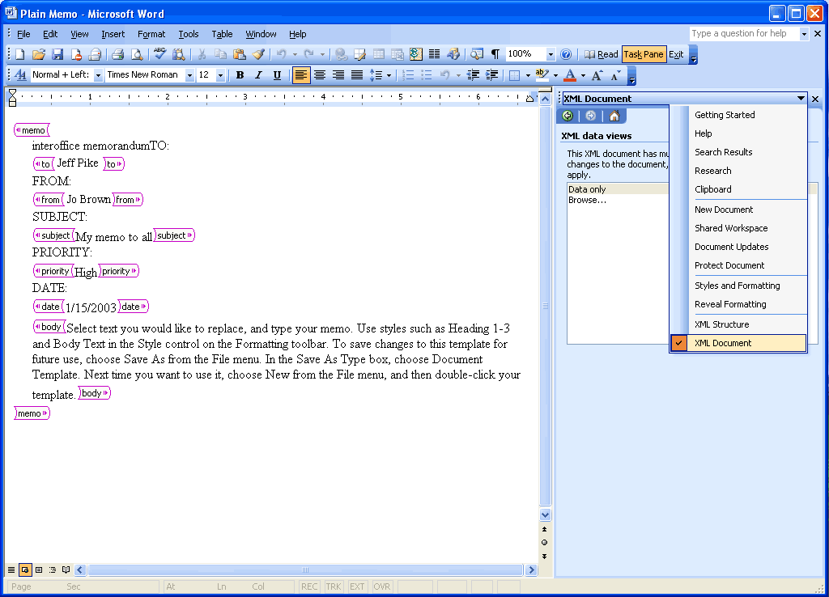
Word 2003 provides a native XML file format that fully represents a Word document.

How to view XML tags in a Word document
Press CTRL+SHIFT+X.
Outlook 2003
Outlook 2003 offers several new features to its users. These new features are individually described within the following sections.
Reading Pane
Using the Reading Pane reduces eyestrain and makes time spent reading e-mail messages more efficient by showing more of the message on the screen. The Reading Pane reduces scrolling and minimizes the need to open and manage many separate windows for different e-mail messages.
More of the message is visible with the Reading Pane.
How to use the Reading Pane
To change the Reading Pane options:
- On the Tools menu, click Options,
- Click the Other tab.
- Click Reading Pane.

To change the location of the Reading Pane:
- On the View menu, point to Reading Pane.
- Click Right or Bottom.

To hide the message header:
- On the View menu, point to Arrange By, click Custom, and then click Other Settings.
- Under Reading Pane, select the Hide header information check box.

Multi-line message view with smart dates and grouping
Organizing messages is easier with Outlook 2003. The Multi-line view puts the sender’s name in dark text in the upper-left corner, making it easy to scan down the list for important names. Secondary information is rendered in lighter shades of text to draw the eye towards the more important information. This view also makes messages easier to select with the pen on a Tablet PC.
To use space more efficiently, Smart Dates change the date format on the fly based on how long ago the message was received. For example, an e-mail message that was received today will only display a time: 3:40 p.m. Messages that were received during the current week display a day of the week and time: Wed 1:24 a.m. For e-mail that was received many months ago, the exact time is less important, so Outlook 2003 displays only the date: 1/12/2003. This makes it easier for the user to sort, find, file, and manage e-mail quickly and efficiently.
The new e-mail view automatically applies intelligent groupings to help sort messages. For example, when messages are arranged by date received, Outlook 2003 splits them into simple groups (“Today,” “Yesterday,” “Last Week,” “Last Month,” and so on). When messages are arranged by size, Outlook 2003 again divides messages into user-friendly groups (“Large,” “Small,” “Very Large,” and so on). These groups make it easier to scan through a list of several messages.
Users can treat these groups as objects, choosing to move, delete, copy, forward, or perform other actions on all items in the group at one time. For example, messages can be grouped by date, and then the user can drag all of the messages from “Last Month” to another folder, filing them away with one click.

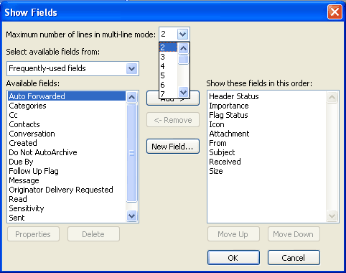
Users can specify the number of lines that display in multi-line view.

How to change multi-line view settings
To change the number of characters displayed before multi-line layout switches to single-line layout:
- On the View menu, point to Arrange By, and then click Custom.
- Click Other Settings.
- Under Other Options, select the Use multi-line layout in widths smaller than n characters check box, and type the number you want for n.

To specify the number of lines that display in multi-line view:
- On the View menu, point to Arrange By, and then click Custom.
- Click Fields.
- In the Maximum number of lines in multi-line mode box, select the number you want.

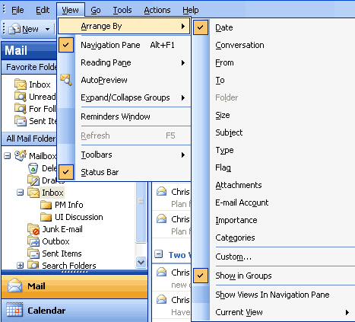
When users rearrange e-mail messages, Outlook 2003 groups them into logical units.

How to apply intelligent grouping
- On the View menu, point to Arrange By, and then select the appropriate arrangement.
- To customize the arrangement that has been applied, on the View menu, point to Arrange By, click Custom, and then select the appropriate options.
Arrange by conversation
This feature groups messages by message subject or “thread.” The sorting order of items in the “threads” is based on who replied to whom, and the sorting order of the groups is by date. When a new message is received, the entire conversation to which it pertains moves to the top of the message list. By default, only unread and flagged messages appear. Users can see all messages in the conversation by clicking the arrow that appears next to the conversation heading. Messages are indented to show who replied to whom and when the reply was sent.

Arrange e-mail messages by conversation to sort by subject or thread.

How to arrange by conversation
- On the View menu, point to Arrange By, and then click Conversation.
- To customize the arrangement, on the View menu, point to Arrange By, click Custom, and then select the appropriate options.
Go menu
To move between the different Navigation Pane module views quickly, users can use the Go menu or the integrated keyboard shortcuts. The following are keyboard shortcuts:
- Mail CTRL+1
- Calendar CTRL+2
- Contacts CTRL+3
- Tasks CTRL+4
- Notes CTRL+5
- Folder List CTRL+6
- Shortcuts CTRL+7
- Folder CTRL+Y

Navigate between the different modules by using the Go menu or keyboard shortcuts.

How to navigate using the Go menu
On the Go menu, click the appropriate Navigation Pane module or view.
Quick flags
Use this feature to mark messages with a flag for follow-up action or later reference. Flagging a message, meeting request, or contact adds a flag icon to the item. Use the six colored message flags to manage incoming e-mail items by flagging the items for different kinds of follow-up action.
When users add a message flag, the background color of the Flag Status column changes color, making it easy for users to find items in the message list while scrolling. Items to which a message flag is added automatically appear in the For Follow Up Search Folder.
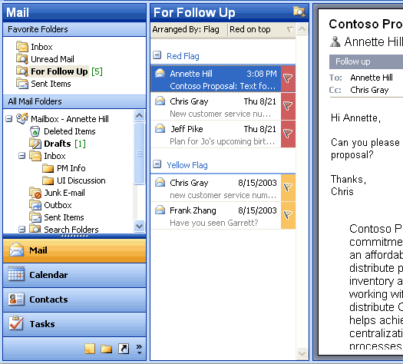
Use the colored message flags to flag items for different kinds of follow-up action.

How to flag an e-mail message
- Click the flag icon on an e-mail message to flag it with the default flag.
- To flag the message with a different colored flag, or to change the default flag color, right-click the flag icon, and then click the appropriate option.
For Follow Up folder
Any message, meeting request, or contact that has been flagged is visible in the For Follow Up Search Folder. Because it is a Search Folder, the items remain in their original Outlook locations. Items are grouped by the type of follow-up action they require, which is indicated by the color of the message flag. Use this folder to group and browse items that are intended for follow-up action or further reference.

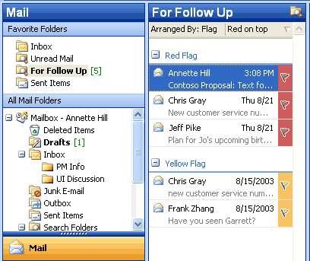
The For Follow Up Search folder contains a view of all items that have been flagged.

How to view the For Follow Up Search folder
- Make sure that at least one message, meeting request, or contact has been flagged.
- In Mail, in the Favorite Folders area, click For Follow Up.
Search Folders
Search Folders are virtual folders that contain views of all e-mail items matching specific search criteria. Search Folders contain the results of previously defined search queries, but all e-mail items remain in their original Outlook folder. With Search Folders, users can easily group and browse through all items relating to a subject, person, task, or other criteria, without physically moving messages or folders.
Three Search Folders are created for users by default:
- Unread Mail. All unread e-mail items appear in the Unread Mail Search Folder.
- For Follow Up. Any e-mail message that includes a flag appears in the “For Follow Up” Search Folder.
- Large Mail. E-mail items that are larger than 100 kilobytes (KB) appear in the Large Mail Search Folder.
These three default Search Folders can be modified or deleted.
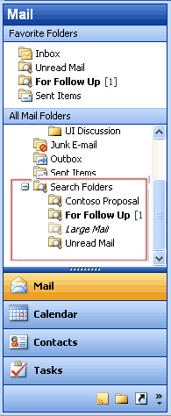
Use Search Folders to group and browse through all items that relate to a subject.

How to create a new Search Folder
- In Mail, on the File menu, point to New, and then click Search Folder.
- Use a predefined Search Folder or click Create a custom Search Folder.
New mail Desktop Alert
In Outlook 2003, the new mail Desktop Alert fades into view with the name, subject, and a short text preview of the new e-mail message. When a Desktop Alert appears, users can set a flag on a message, delete it, or mark it as read—all without opening the Inbox. If the Desktop Alert is ignored, it soon fades from view.
Users can customize the appearance of the Desktop Alerts. The alerts can remain visible for as briefly as three seconds or for as long as 30 seconds. Users can also adjust the transparency to make the alerts more noticeable or to keep them from blocking the view of documents and other items on the desktop. Users can also change where the Desktop Alerts appear by dragging an alert to a more preferable location on the desktop.
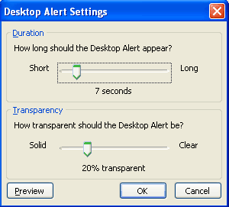
Customize the transparency and duration of the Desktop Alerts.

How to customize Desktop Alerts
- On the Tools menu, click Options.
- On the Preferences tab, click E-Mail Options, click Advanced E-mail Options, and then click Desktop Alert Settings.
Junk e-mail settings
Outlook 2003 includes features that are designed to help prevent much of the unwanted e-mail that arrives every day, and to give the user control over the kinds of messages that can be received. The features include the following options:
- Junk E-mail Filter. The Junk E-mail Filter feature is on by default, and the protection level is set to Low, which is designed to catch the most obvious junk e-mail messages. Any message that Junk E-mail Filter catches is moved to a special Junk E-mail folder, where users can retrieve or review it at a later time. Outlook 2003 can also be set to delete junk e-mail messages permanently.
- Safe Senders List. If an e-mail message is mistakenly marked as junk by the filter, the user can add the sender of that message to the Safe Senders List.
E-mail addresses and domain names on the Safe Senders List are never treated as junk e-mail, regardless of the content of the message.
- Blocked Senders List. E-mail messages from certain e-mail addresses or domain names can easily be blocked by simply adding the sender to the Blocked Senders List. Mail from people or domain names on this list are always treated as junk, regardless of the content of the message.
- Safe Recipients List. A mailing list can also be added to the Safe Recipients List. Any e-mail that is sent to e-mail addresses or domain names on this list will not be treated as junk, regardless of the content of the message.
- AutoUpdate. Microsoft is committed to providing periodic updates of the Junk E-mail Filter so that it continues to be effective.
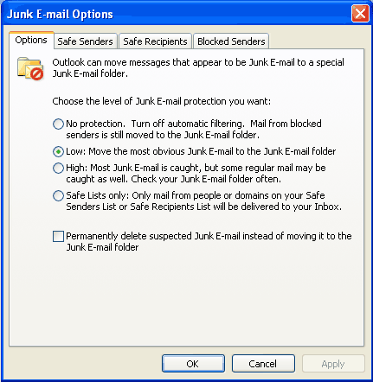
Use the junk e-mail settings to set the appropriate level of protection, and to add to the Safe Senders, Safe Recipients, and Blocked Senders lists.

How to change the junk e-mail settings
- On the Tools menu, click Options.
- On the Preferences tab, click Junk E-mail.
- Click the Options, Safe Senders, Safe Recipients, or Blocked Senders tab to modify the desired settings.
Block external content
Messages that are formatted in HTML often contain images that are not included in the message itself, but are instead downloaded from a Web server when the e-mail message is opened. These unannounced connections to Web servers can now be blocked.
If an e-mail message tries to connect unannounced to a Web server on the Internet, Outlook 2003 blocks that connection until the user decides to view the content. However, e-mail messages from or to e-mail addresses or domain names on the Safe Senders and Safe Recipients Lists are treated as exceptions, and the blocked content will be downloaded. Users can download pictures and other content on a per-message basis by clicking the InfoBar or by right-clicking a blocked image, or can change the settings about automatic picture download for all HTML messages.
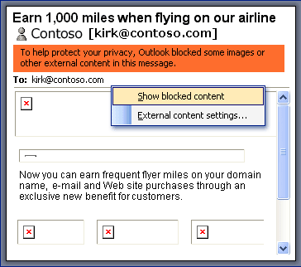
When an e-mail message attempts to download pictures from a Web server, the pictures are blocked. Users can download them on a per-message basis, or change the settings.

How to change the Block External Content settings
- On the Tools menu, click Options, and then click the Security tab.
- In the Download Pictures area, click Change Download Settings.
Shared calendar
Users can quickly view another person's calendar, contacts, and tasks from the Navigation Pane. After the first time a user gains access to another person's folder, the shared folder is added to the Navigation Pane. The next time the user wants to view the other person's folder, the user can select it in the Navigation Pane. Likewise, users can share their own calendar with anyone or with only a specified group. In either case, the details of any item that is marked Private are not displayed to other people.
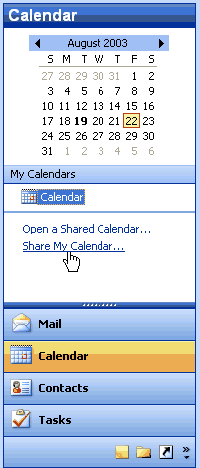
Users can specify if they want to share their calendars.
How to share a calendar
In Calendar, click Share My Calendar.
How to view another person’s shared calendar
- In Calendar, click Open a Shared Calendar.
- To select another person's name from the address book, click Name or type the name in the Name box. The new calendar will appear to the side of any calendar already in the view.
Contact picture
With Outlook 2003, pictures can be added directly into a contact, which means that users can associate a face with the name and other information in the contact.
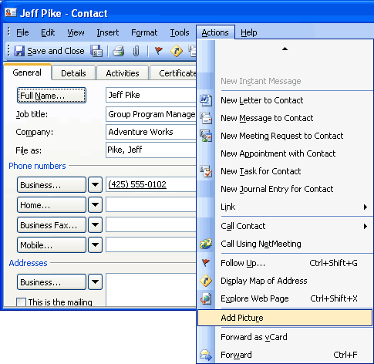
When a picture is added to a contact, a name is associated with a face.

How to add a picture to a contact
- In Contacts, create or open a contact.
- On the Actions menu, click Add Picture.
Cached Exchange Mode
In Cached Exchange Mode, a copy of a mailbox is stored on the computer, and the mail server updates the data frequently. If the user is working offline, whether by choice or as a result of a connection problem, the data is still available instantly.
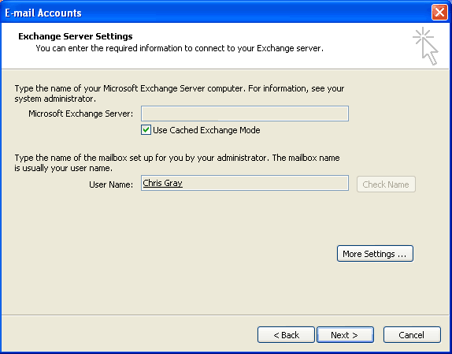
Cached Exchange Mode stores a copy of the user's mailbox for offline availability.

How to turn Cached Exchange Mode on or off
- On the Tools menu, click E-Mail Accounts,
- Click View or change existing e-mail accounts, and then click Next.
- In the Outlook processes e-mail for these accounts in the following order list, click Microsoft Exchange Server, and then click Change.
- Under Microsoft Exchange Server, select or clear the Use Cached Exchange Mode check box.
Remote Procedure Calls (RPC) over Hypertext Transport Protocols (HTTP)
With Outlook 2003 and Microsoft Exchange Server 2003 running on Microsoft Windows Server 2003, users can gain access to the Exchange Server-based computer directly by way of HTTP over an Internet connection. With Outlook 2003, if users can browse the Web, they can use the Exchange mailbox.
Outlook 2003 automatically connects by way of HTTP when a direct connection to the Exchange Server-based computer is unavailable, eliminating the need to have corporate VPN servers set up for e-mail access.
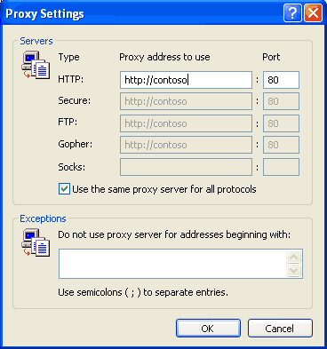
Office administrators can configure Outlook 2003 to communicate with an Exchange server over the Internet.

How to connect to the Exchange server by using HTTP
- On the Tools menu, click E-mail accounts, and then select View or change existing e-mail accounts.
- Click Next.
- Select the Microsoft Exchange e-mail account, and then click Change.
- Click More Settings, and then click the Connection tab.
- Select the connection you use when working offline.
Internet faxing
Outlook 2003 integrates Internet faxing. This integration allows the users to send faxes by using features that a typical fax machine does not offer. For example, users can use the fax numbers in Contacts, use the preview tool to view a fax before sending it, calculate the cost of the fax before sending it, add cover pages that are fully editable in Word 2003, and even sign their names on their fax if they use a Tablet PC. Users can not only send faxes with Outlook 2003, but also receive faxes in their Outlook Inboxes.
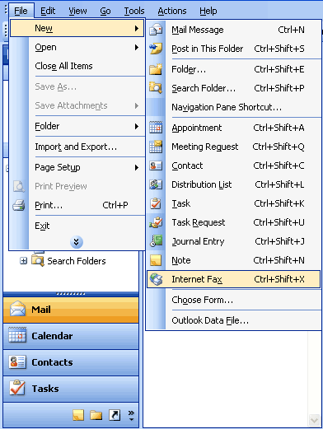
With Internet faxing, users save on long-distance phone bills and keep phone lines free.

How to send a fax
On the File menu, point to New, and then click Internet Fax.
An e-mail message opens in Outlook 2003 with the document attached as a .TIF (image) file, or a file can be attached to the message.
Word 2003
Word 2003 offers several new features to its users. These new features are individually described within the following sections.
ClearType
Reading Layout view and Print Layout view use Microsoft ClearType® to display type in Word 2003. ClearType is a typographical technology that is ideal for portable computer monitors and other flat-screen monitors. With ClearType, text may appear slightly blurry on older desktop-computer monitors. If users are working with a flat-screen monitor, they will need to ensure that ClearType is enabled in Windows.
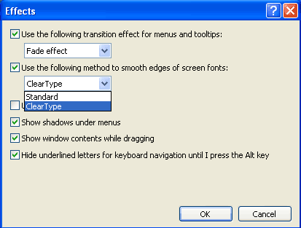
The clarity and sharpness of ClearType is ideal for portable computer monitors and other flat-screen monitors.

How to enable ClearType in Windows XP
- In Windows Control Panel, click Appearance and Themes, and then click Display.
- Click the Appearance tab, and then click Effects.
- Select the Use the following method to smooth edges of screen fonts check box, and then click ClearType.
Reading Layout view
If users are opening a document primarily for reading, Reading Layout view optimizes the reading experience. Reading Layout view hides all of the toolbars except for the Reading Layout and Reviewing toolbars. Because the goal of Reading Layout view is to increase legibility, pages that are represented in this view are designed to fit well on the screen, and the text is automatically displayed by using Microsoft ClearType technology. Users can easily increase or decrease the size in which text is shown without affecting the size of the font in the document.
If users want to modify the document, they can simply edit text while reading without switching out of Reading Layout view. The Reviewing toolbar is automatically displayed in this view, so users can easily use change tracking and comments to mark up a document.
To improve the reading experience, the pages in Reading Layout view fit well on-screen, and the text is displayed by using Microsoft ClearType technology.
How to switch to the Reading Layout view
- Click the Read button on the Standard toolbar.
- To stop using the Reading Layout view, click the Close button on the Reading Layout toolbar, or press ESC, or press ALT+C.
-or-
- Press ALT+R in any view in Word.
- To stop using the Reading Layout view, click the Close button on the Reading Layout toolbar, or press ESC, or press ALT+C.
Merge enhancements
The Mail Merge task pane helps users create form letters, mailing labels, envelopes, directories, mass e-mail, and fax distributions. The Mail Merge Wizard is easy to use and provides step-by-step instructions, but users can also take advantage of the Mail Merge toolbar. In either case, users can follow the process by looking at the numbered steps at the bottom of the Mail Merge task pane.
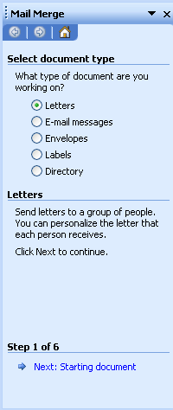
Use the Mail Merge task pane to create mass e-mails or mailing labels.

How to open the Mail Merge task pane
- On the Tools menu, point to Letters and Mailings, and then click Mail Merge.
Track changes enhancements
To make online review easier, Word 2003 allows users to make and view tracked changes and comments in a document. To preserve the layout of a document, Word 2003 shows some markup elements in the text of the document while others are contained in balloons that appear in the margin. The Reviewing Pane shows an outline of all the edits in a list format at the bottom of the screen.
With the Track Changes feature turned on, each insertion, deletion, or formatting change that a reviewer makes is tracked. As tracked changes are reviewed, users can accept or reject each change. Users can also use the Display for Review drop-down box to view the document during various stages of the review process.
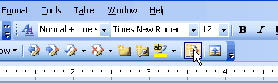
Turn on Track Changes when reviewing a document.

How to track changes
On the Tools menu, click Track changes to open the Reviewing toolbar.
-or-
Click the Track Changes button.

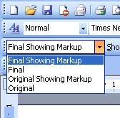
Select the desired review setting for a document.
How to view the document during various stages of the review process
On the Reviewing toolbar, select the desired setting from the Display for Review drop-down list.
Ink support
If users are working on a Microsoft Tablet PC, they can use a tablet pen to add drawings or handwritten notes to Word 2003 documents—in comments, in the content of a document, or as annotations about content that already exists in the document.
With a Tablet PC, handwritten comments can be added to a Word document.

How to use ink
To write directly in a document:
- On the Insert menu, point to Picture.
- Tap Ink Drawing and Writing.

To insert an ink comment:
On the Insert menu, tap Ink Comment.

Use one of these methods to make ink annotations:
- From the Print Layout view, go to the Insert menu.
- Tap Insert Ink Annotation.
- Mark up the document similar to how you would do so on paper. When you are finished, tap Stop Inking on the Ink Annotations toolbar.
-or-
- From the Reading Layout view, go to the Reading Layout toolbar.
- Tap Actual Page.
- On the Reviewing toolbar, tap Insert Ink Annotations.
- Mark up the document similar to how you would do so on paper. When you are finished, tap Stop Inking on the Ink Annotations toolbar.
Formatting Restrictions
In Word 2003, users can specify and enforce template or document styles by using the Formatting Restrictions feature. All direct formatting will be disabled. Complex documents can be edited by many people and still retain structured formatting.
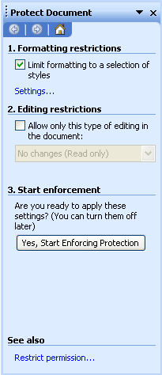
Use the Protect Document task pane to specify the styles that a template or document uses.

How to restrict formatting
- On the Tools menu, click Protect Document.
- In the Protect Document task pane, under Formatting restrictions, select the Limit formatting to a selection of styles check box, and then click Settings.
Editing Restrictions
With editing restrictions in Word 2003, users can protect portions of a document against editing by some or all users. Editing restrictions options include protecting the entire document against any edits, allowing only comments, and assigning permissions to individual portions of the document by selecting them and choosing which users can edit a designated area. Later, when reconciling the changes of different individuals, users are assured that no two people edited the same area and that no conflicts exist.
After the restrictions have been set up, the Protect Document task pane helps users find the sections that they can edit.
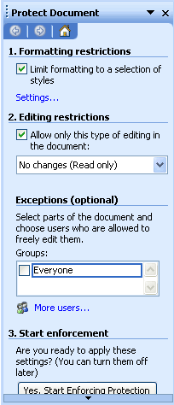
Set the restrictions on all or portions of a document.

How to restrict editing
- On the Tools menu, click Protect Document.
- In the Protect Document task pane, select the Editing restrictions check box, and then click one of the following:
No changes (read only) (if you want to prevent users from changing the document)
-or-
Comments (if you want to allow users to insert comments into the document but not change the content of the document)
-or-
Track Changes (if you want to allow users to insert comments into the document and add tracked changes)
-or-
Filling in forms (if you want to allow users to fill in a form but not make changes to the form)
- If you select No changes (read only) or Comments, go to the Exceptions area and assign permissions to individual portions of the document by selecting those portions and then choosing which users can edit them.
- If you select Filling in forms, you can remove protection from sections of the form by clicking Select sections and clearing the checkboxes for those sections you do not want to protect. To protect only parts of a form, those parts must be in separate sections.
- Click Yes, Start Enforcing Protection.
Excel 2003
Excel 2003 offers several new features to its users. These new features are individually described within the following sections.
List data integration with Windows SharePoint Services
Through integration with Windows SharePoint Services, Excel 2003 lists make it easy to share data with other users. If the user has the Web address and authoring rights on a SharePoint site, the list can be shared so that other people can view, edit, and update it. If the user opts to link the list in Excel 2003 to a list on a SharePoint site, users can edit that list offline and synchronize changes with the SharePoint site at a later time so that other users can see updated data.
To manage the synchronization between the local Excel list and the SharePoint list, the List toolbar provides two buttons that allow users to choose how they want to handle updates to the list.
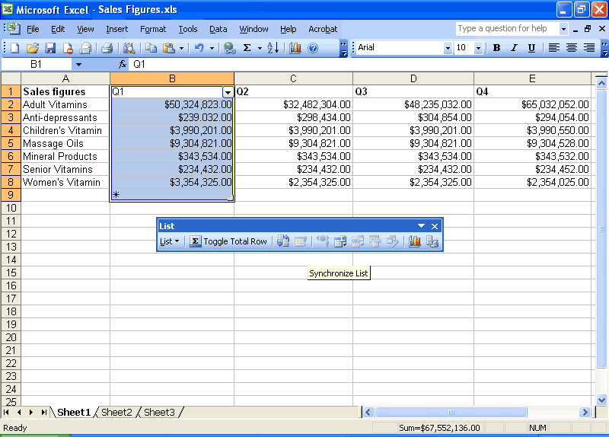Synchronize Excel lists and SharePoint lists using the List toolbar.

Synchronizing lists
To publish any local changes to the SharePoint list, and transfer any changes that were made to the SharePoint list to the local Excel list, complete the following step:
On the List toolbar, click Synchronize List .
To discard local changes to the list, and download the current copy of the list from the Microsoft Windows SharePoint Services Web site, complete the following step:
On List toolbar, click Discard Changes and Refresh
Using Improved Standard Deviation computation
Standard Deviation functionality in Excel estimates standard deviation based on a sample. The standard deviation is a measure of how widely values are dispersed from the average value (the mean).
The procedure used in Excel 2003 uses a two-pass process through the data. First, the sum and count of the data values are computed and from these the sample mean (average) can be computed. Then, on the second pass, the squared difference between each data point and the sample mean is found and these squared differences are summed.
- Prior versions of Excel Standard Deviation Syntax = STDEV(number 1, number 2, etc)
- Excel 2003 Standard Deviation Syntax = SQRT(DEVSQ(values)/(COUNT(values) – 1))
Smart tag integration
Users can save time by using smart tags to perform actions in Excel 2003 that used to require other programs. Smart tags recognize certain types of text and then offer related functions and commands.
A smart tag can help users take advantage of external resources. For example, when a U.S. financial symbol such as "MSFT" is typed in a cell, the Smart Tag Actions button provides a list of available smart tag actions. Users can click the smart tag (the purple triangle in the corner of a worksheet cell), and then select the action "Recent news on MSN Money Central." The browser opens to a Web page that contains news and information about the company. When finished, the user can close the browser and continue to work in Excel 2003.
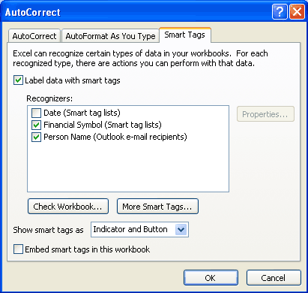
Select the types of smart tags to recognize and specify their appearance.

How to use smart tags
To turn on smart tags:
- On the Tools menu, click AutoCorrect Options.
- Click the Smart Tags tab, and then select the Label data with smart tags check box.

To select a smart tag action:
- Cells with smart tags are indicated by a purple triangle in the lower-right corner of the cell. Move the cursor over the purple triangle in a cell until Smart Tag Actions appears.
- Click the arrow. The actions that can be performed appear in a list.
- Select an action.

To find more smart tags, complete the following step:
- On the Tools menu, click AutoCorrect Options.
- Click the Smart Tags tab.
- Click More Smart Tags to go to Web sites to find new smart tags and actions.
PowerPoint 2003
PowerPoint 2003 offers several new features to its users. These new features are individually described within the following sections.
Smart tag integration
Users can save time by using smart tags to perform actions in PowerPoint 2003 that used to require other programs. Smart tags recognize certain types of text and then offer related functions and commands. With PowerPoint 2003, users can embed smart tags so that they are available to anyone who opens the presentation.
Users might find additional smart tags created by Microsoft, by third-party companies, or by Information Technology (IT) professionals who design smart tags and actions for the specific products or services that are relevant to their activities.
Select the types of smart tags to recognize and specify their appearance.

How to use smart tags
To turn on smart tags:
- On the Tools menu, click AutoCorrect Options.
- Click the Smart Tags tab, and then select the Label text with smart tags check box.
To select a smart tag action:
- Move the insertion point over text that is underlined with a purple dotted line until Smart Tag Actions appears.
- Click the arrow. The actions that can be performed appear in a list.
- Select an action.

To find more smart tags, complete the following step:
- On the Tools menu, click AutoCorrect Options.
- Click the Smart Tags tab.
- Click More Smart Tags to go to Web sites to find new smart tags and actions.
Thesaurus integration
PowerPoint 2003 now includes a thesaurus that is integrated into the Research task pane. When the integrated thesaurus is opened, a list of suggested synonyms appears. If users select a word from the list, that word replaces the selected term in the text. If the list does not contain an appropriate synonym, the user can select Thesaurus from the list to open the full thesaurus and continue the search.
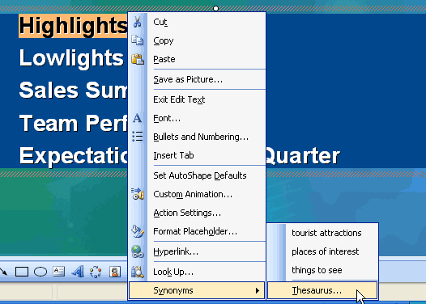
Use the integrated thesaurus to find just the right word.

How to open the integrated thesaurus
Right-click on a word, select Synonyms, and then select Thesaurus.
-or-
Click Tools, and then click Thesaurus.
-or-
Hold down ALT, and then click on a word.
Ink support
For users working with a Tablet PC, ink support is available with the tablet pen. Users can add ink while delivering a presentation, or while editing slides. If users are creating or editing slides, they can add ink drawing and writing to emphasize certain portions of a slide, or use handwriting or hand-drawn pictures to design the overall layout of the information. Ink can be inserted in the following PowerPoint views:
- Normal view
- Notes Page view
- Slide Master view
- Handout Master view
- Notes Master view
- Slide Show view
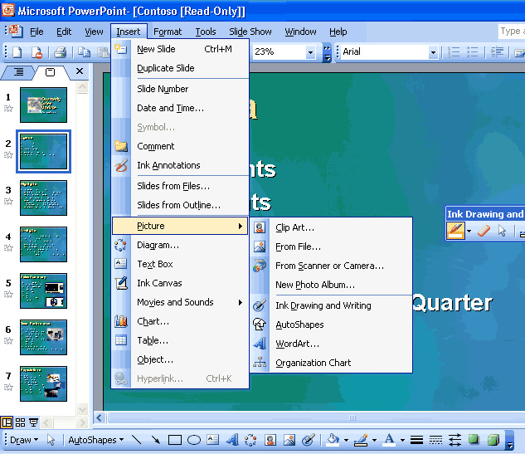
Add ink to PowerPoint slides.
How to use ink to edit slides
On the Insert menu, tap Ink Drawing and Writing.
Annotations in Slide Show view
PowerPoint 2003 has improved annotation support. Tablet PC users can mark slides with ink while in Slide Show view. Users can make comments or answer questions that are asked during the presentation by adding them directly to the slides. Users can also take notes on slides, and save the ink on the slides for later use.
PowerPoint 2003 has also updated the pen tools in slide show with more colors and types of pens to choose from, in addition to giving the user the ability to highlight parts of the presentation by using a new highlighter tool.
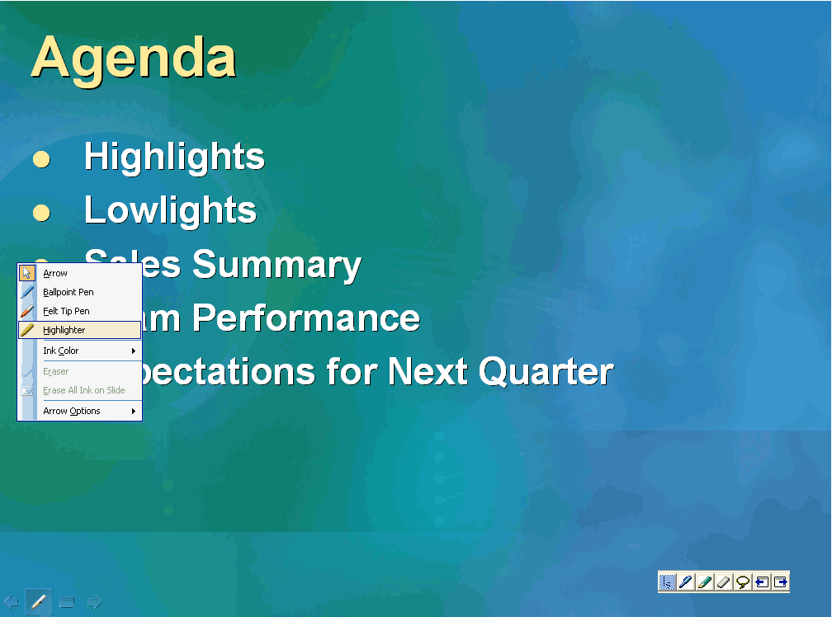
Make comments directly in a slide using Ink.

How to make annotations while in Slide Show view
- Place the tablet pen or mouse over the pen icon on the lower right of the slide.
- Tap or click the arrow on the slide show toolbar, and then tap or click Ballpoint Pen, Felt Tip Pen, or Highlighter.
- To cancel the selection of ink, click or tap away from the selected ink.
Expanded playlist formats
PowerPoint 2003 now supports the following audio playlist formats: ASX, WMX, M3U, WVX, WAX, and WMA. Also, if a media codec (software that is necessary to play the selected files) is not available, PowerPoint 2003 tries to download it from the Web by using Microsoft Windows Media® Player technology.
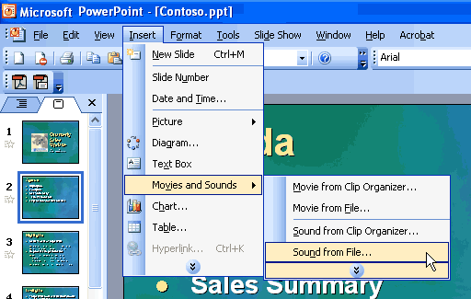
Insert a supported playlist into a presentation.

How to insert a playlist in a slide
- On the Insert menu, point to Movies and Sounds.
- Click Sound from File.
- Find the folder that contains the playlist to be inserted, and then double-click the playlist.

How to find more sounds, movies, and clip art
- On the Insert menu, point to Movies and Sounds.
- Click Sound from Clip Organizer or Movie from Clip Organizer.
- In the Clip Art task pane, click Clip art on Office Online.
Full-screen playback
Movies that are embedded in a slide can now play across the entire screen during a slide show. To enable this feature, users select the check box in the Movie Options dialog box. Alternatively, users can leave the check box cleared if they want the movie to play in a rectangle within the slide.
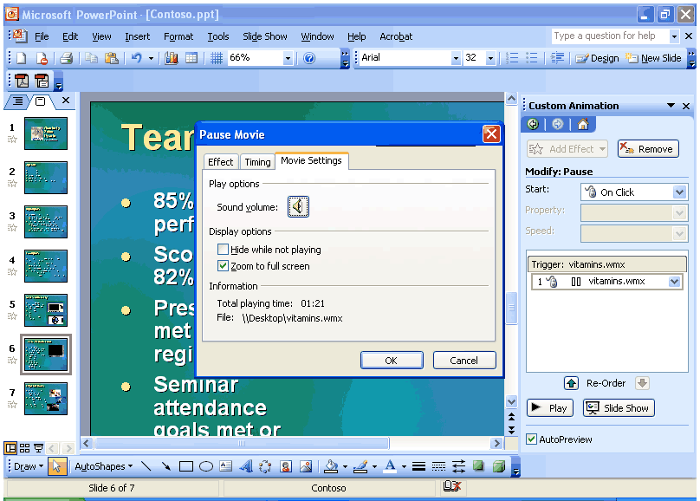
Use the new setting in the Movie Options dialog box for full-screen playback in a slide show.

How to select full-screen playback
Use either of these methods to select full-screen playback:
- Right-click on the movie.
- Select Edit movie object from the context menu.
- Select the Zoom to full screen check box.
-or-
- In the Custom Animation task pane, click the Play effect.
- On the Gallery menu, select Effect Options.
- Click the Movie Settings tab, and then select the Zoom to full screen check box.
PowerPoint Viewer and Package for CD
The PowerPoint Viewer displays presentations exactly as the author created them, even on systems that do not have PowerPoint 2003 installed. By using PowerPoint Viewer, users can open protected presentations by using a password, and can print presentations. The new PowerPoint Viewer is an improved version of the Microsoft PowerPoint Viewer 97.
PowerPoint Viewer is, by default, part of the “Package for CD” feature. With this feature, users can package presentations onto a CD, and distribute PowerPoint presentations without worrying if the recipients have the correct version of PowerPoint for viewing. Users can also choose to have the CD play presentations automatically when the CD is inserted into a computer.
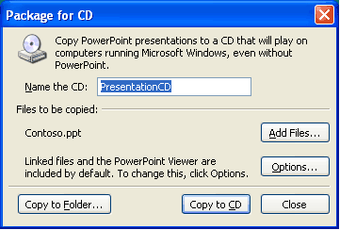
When a presentation is packaged on a CD, even computers that do not have PowerPoint installed can view it.

How to package a presentation for CD
On the File menu, click Package for CD.
Access 2003
Access 2003 offers several new features to its users. These new features are individually described within the following sections.
List data integration with Windows SharePoint Services
If Windows SharePoint Services is configured and available, integration with Access 2003 requires no special setup, customization, or other actions. Access 2003 integration with Windows SharePoint Services makes the following tasks possible:
- Export the contents of a table from Access 2003 to a list in Windows SharePoint Services.
- Import the contents of a list in Windows SharePoint Services into a table in Access 2003.
- Create a linked table in Access 2003 that gets live data from a list in Windows SharePoint Services.
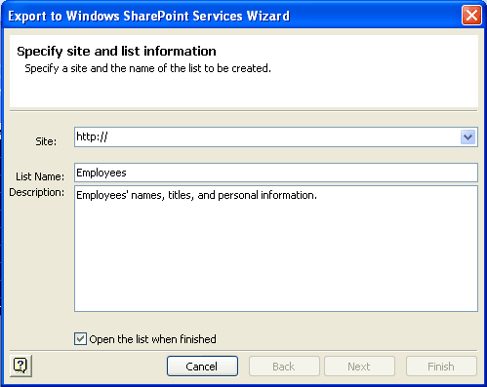
Export Access 2003 data to a SharePoint site.

How to work with lists
To export tables or queries to lists in Windows SharePoint Services, complete the following steps:
- Start Access 2003.
- Open the database to export from.
- In the database windows, select the table or query to export, click File on the Access toolbar, and then click Export.
- Select Windows SharePoint Services from the Save as Type dropdown menu.
- Use the Export to Windows SharePoint Services Wizard to complete the operation.

To import data from lists or views of a list in Windows SharePoint Services, complete the following steps:
- In the database window, click File on the Access toolbar.
- Click Get external data, then Import.
- Select Windows SharePoint Services from the Files of Type dropdown menu.
- Use the Import from Windows SharePoint Services Wizard to complete the operation.

To link to data from lists or views of a list in Windows SharePoint Services, complete the following steps:
- In the database window, click File on the Access toolbar.
- Click Get external data, then Link Tables.
- Select Windows SharePoint Services from the Files of Type dropdown menu.
- Use the Link to Windows SharePoint Services Wizard to complete the operation.
Smart tag integration
Users can save time by using smart tags to perform actions in Access 2003 that are typically completed by other programs. Smart tags can be attached to a field in a table or query, or to controls in a form.

Microsoft provides a set of ready-to-use smart tags with Access 2003. Users can also create their own smart tags. Visit the Office Developer Center on the Microsoft Developer Network (MSDN®) Web site for more information about creating smart tags for use with Access 2003.
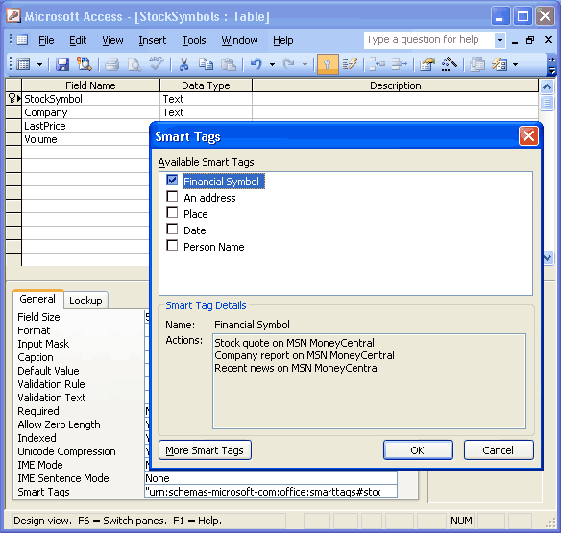
Add smart tags to any database field.

How to use smart tags
To add smart tags to a form:
- Open a form in Design View.
- Select a text box, list box, combo box, or label.
- Click Properties on the toolbar, select the Smart Tags property on the Data tab, and then click the Build button .

To add smart tags to a table:
- Open a table in Design View.
- Select the field that you would like to add a Smart Tag to.
- Select the Smart Tags property on the General tab, and then click the Build button .

To select a smart tag action:
- After a smart tag has been added to a field or control, the Smart Tag Actions button appears when a cell in the field or the control is activated.
- Click the button to see the menu of actions that are possible with the smart tag.
To get more smart tags, complete the following step:
- Create a new form in Design View.
- Add a Text Box to the form and then click Properties on the toolbar.
- Click the Build button for the Smart Tags property, and then click More Smart Tags.
Back up a database
Users can back up critical Access database files from within Access 2003. These database files are saved to a consistent location on a local system or shared network. The name of the backup file is based on the current date. As part of the backup operation, the Compact and Repair action is performed to make sure that the database is internally consistent.
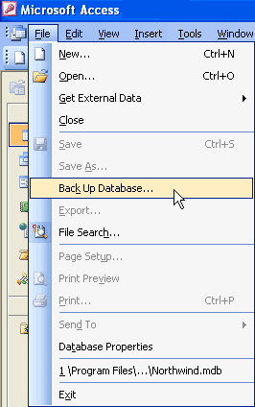

Use this simple menu selection to back up critical Access database files.

How to back up an Access database
- Save and close all objects in the database.
- On the File menu, click Back Up Database.
AutoCorrect option
In Access 2003, the AutoCorrect Smart Tag appears whenever AutoCorrect occurs. AutoCorrect works for the Text Box and the Combo Box controls when in Form View, and for all fields when in Datasheet View.
Users have extensive control of the functions of AutoCorrect. To reject the changes of AutoCorrect, users can work with the Undo, Stop, and Control AutoCorrect Options for each of the scenarios.
The AutoCorrect scenarios are:
- Correct TWo INitial Capitals
- Capitalize the first letter of sentences
- Capitalize the names of days
- Correct accidental use of cAPS LOCK key
- Replace text as you type
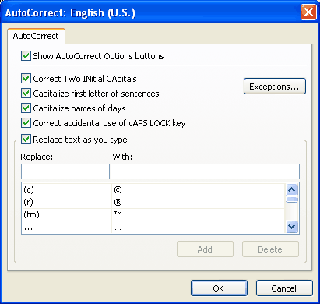
All of the checked options are automatically corrected while the user types.

How to set AutoCorrect options
On the Tools menu, click AutoCorrect Options.

Dependent Objects
Using this feature, users can keep track of which database objects depend on the database object that is being modified. Tracking name AutoCorrect information must be turned on to view dependency information, and this information is generated only for tables, queries, forms, and reports in an Access database. The new Dependent Objects feature makes it easy to determine the dependents of any object in an Access database, which reduces the troubleshooting time that is needed to make a modification to an existing Access application. This feature is only available in a Microsoft Access database (*.mdb).
When users open the Dependency pane, a list of objects that use the selected object appears. To view the list of objects that are being used by the selected object, users can click "Objects that I depend on" at the top of the pane. To view dependency information for an object listed in the pane, simply click on the expand icon (+) that appears next to the object.
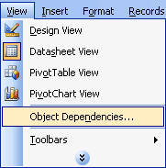
Use the Dependent Objects feature to determine the dependents of any object in an Access database.

How to view Dependent Objects
- Right-click a Table, Query, Form, or Report.
- Click Object Dependencies.
-or-
Click View, and then click Object Dependencies.
Font Control for the SQL Window
In an Access database, the font can be changed in SQL and Query Design view. These font settings apply to Access 2003 as a whole.
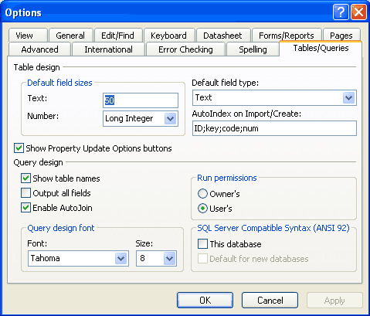
Select the appropriate font in the Query design font area.

How to change the font in SQL and Query Design view
- On the Tools menu, click Options.
- Click the Tables/Queries tab.
Error checking
In Access 2003, automatic error checking points out errors in a form or report, and provides options for correcting them. For example, when two controls use the same keyboard shortcut, or when the width of a report is greater than the page on which it will be printed, the error-checking feature automatically highlights the error. The error appears as a smart tag. The following are some of the error-checking smart tags:
- Unassociated Label
- New Unassociated Label
- Unassociated Label with Accelerator (Form Only)
- Duplicate Accelerator (Form Only)
- Invalid Accelerator (Form Only)
- Invalid Control Source
- Circular Reference
- Duplicate Option Value
- Invalid Sorting and Grouping (Report Only)
- The report width is greater than the page width
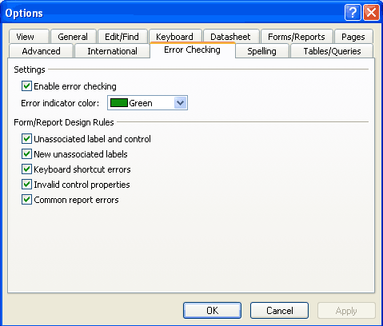
Select the types of errors that Access should look for in a form or report.
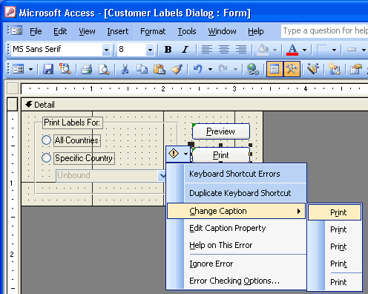
Correct an error by selecting an option from the menu.

How to use error checking
To turn on error checking:
- On the Tools menu, click Options.
- Click the Error Checking tab.
- Under Settings, select the Enable error checking check box.

To correct an error:
- Select the control that has an error indicator.
- Rest the pointer on the Error Checking Options button.
- Click the arrow in the button.
- Select an option from the menu that appears.
Making a local table
Copying a linked table into the local database is a common technique for optimizing performance for slow-running reports that use linked tables or queries. In previous versions of Access, users had to create a complex Make Table query to perform this task. Now, users can simply copy the linked table to the clipboard and paste it back into the database, or find this action in the task pane as a common task for Linked Tables.
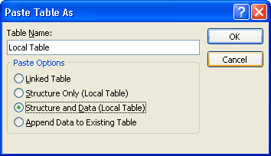
Copy a linked table and paste it into a database to create a local table.

How to make a local table
- In the Database window, select the linked table to convert to a local table.
- Copy the table, and then paste it.
- Type the name for the new table in the Table Name box, and then select whether to create a Linked Table, an empty table (click Structure Only), or to keep the data from the linked table also (click Structure and Data).
Propagating field properties
In Access 2003, when an inherited field property in the Table Design view is modified, users now have the option to update the property of all or some controls that are bound to that field.
In the past, developers had to go through each related object and set the property manually. This new feature means that a property is modified in only one place, saving time and reducing the risk of forgetting to update an object.
Whenever an inherited field property is modified in the Table Design view, the Property Update Options smart tag appears, and the user has the option to update that property everywhere that field is used.
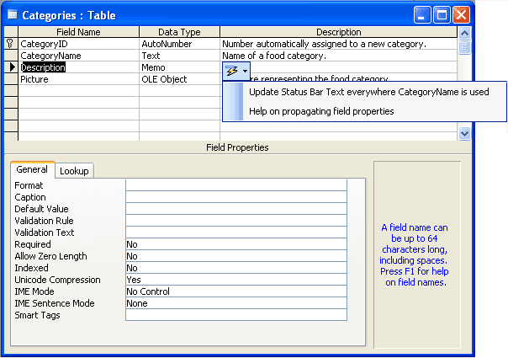
Propagate the property of all or some controls that are bound to an inherited field.

How to propagate inherited properties
- If the value of an inherited property is changed, the Property Update Options button appears next to the property name.
- Click the Property Update Options button.
- Click the Update command.

XML Glossary
XML — Extensible Markup Language is a metadata definition language that is used to describe data in a structured open format.
XML Schema — Valid XML files that is used to define the structure for other XML Files.
XPATH — An XML Query language that is used to extract elements and data easily from complex XML documents.
XSD — The XML Schema Definition file.
XSL — Extensible Stylesheet Language.
XSLT — Extensible Stylesheet Transform files are used to transform the format or content of existing XML files.
Namespace — An XML namespace is a collection of element type and attribute names that are identified by the name of the unique XML namespace of which they are a part.
Smart document — A Word 2003 or Excel 2003-based solution that combines an underlying XML structure with custom code to enable special actions within the document. Actions are based on where the cursor is placed within the document and can include context-sensitive help information, data retrieval, formatting actions, and others.
Smart tags — User-interface icons that dynamically recognize data and present information workers with actions that are based on that data.
Solution Manifest — An XML file that describes the locations and behaviors of a particular solution's component files.
Valid XML — An XML document with elements and attributes that match the logical structure and data types that are defined in a particular schema.
Well-formed XML — XML that has accurate beginning and ending tags, and containment relationships; that is, the XML conforms to the Worldwide Web Consortium (W3C) XML specification.

