
Order to Purchase

Microsoft Dynamics™ SL

Accurately promise customers the goods they want, when they want
them. Microsoft Dynamics SL Order to Purchase helps balance inventory carrying costs with customer service levels so your representatives can fulfill customers’ request for goods, even when stock is short.

Benefits
- Avoid delays
View updated lead times and prices,
as well as averages over time and
stock substitutes, so you can give your customers more options and better service. Gain visibility into how your vendors are performing to help you pick the right vendor to fulfill your customer’s needs.

- Speed fulfillment
Take a customer order and place a purchase order to fulfill stock needs —
all in one step. Streamline the fulfillment process and provide sales people with the tools they need to satisfy customers while protecting the bottom line.

- Automate purchasing
Automate purchasing to efficiently
source inventory when stock levels are low, cutting the manual effort required to fulfill commitments to customers. When goods aren’t on hand to satisfy incoming orders, Microsoft Dynamics SL Order to Purchase provides automated drop-ship processing between vendors and customers.

- Manage drop shipments better
Take the guesswork out of fulfillment so your sales representatives can focus on providing great customer service. Efficiently identify inventory that is shipped from the warehouse when in stock and drop ship when out of stock.

- Fine-tune your processes
Configure Microsoft Dynamics SL Order
to Purchase to meet your organization’s
unique and complex requirements.
This flexible module provides efficient processes that can be fine-tuned for the maximum competitive edge.

Gain insight
into vendor performance and select the best vendor to fulfill your customers’ needs

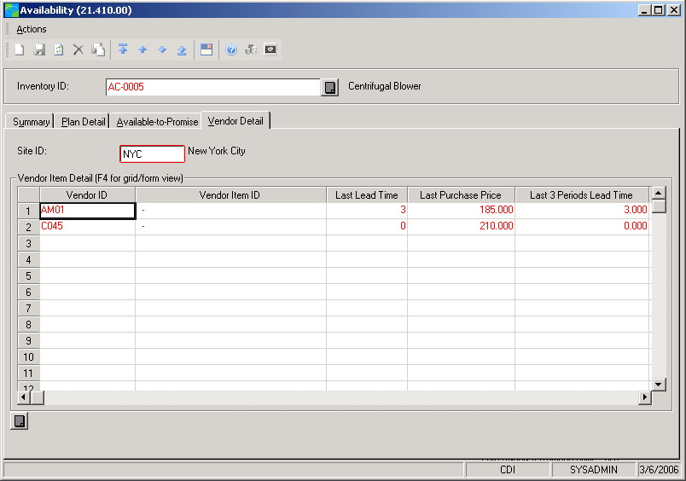

View
the latest lead times
and prices, as well as averages over time and substitutions



Vendor Selection  features  BENEFITS | Manage vendor choice to achieve the best pricing and delivery terms. With Order  to Purchase, you have the final say on how goods are purchased and from whom.
Performance Monitoring | Identify preferred vendors based on past performance. With the availability  screen, sales representatives can make fast, informed decisions about suppliers.
Faster Fulfillment | Place drop-ship orders for replacement stock quickly and easily. Access the lead times, prices charged, and returned goods history of each vendor to confidently provide great customer service while fulfilling demand.
Automated Processes | Create purchase orders from sales orders automatically. Drop-shipment processing is automated through to invoicing so no manual confirmations are needed.
Multiple Auto PO Policies | Choose from three Auto PO Policies at the item and site level: Auto PO Always  (always generate a Purchase Order for this Inventory Site); Auto PO If No  Inventory (generate a Purchase Order if not enough Inventory is available); or,  None (the Auto Create PO flag will be cleared by default).
Flexible Ordering | Order to Purchase works with special order items, drop shipments, and regular inventory.
Powerful Controls | Override default selections easily, such as which vendor to use, in automatic purchase orders. Or, set fields to display-only with Microsoft Dynamics SL Customization Manager so that users cannot make changes.
Increased Efficiency | Eliminate duplicate or overlooked purchase orders, delays in delivery time, and  duplicate shipments. An Auto Create PO flag will create a new purchase order  and bind it to the sales order.
Lot/Serial Matching | Automatically assign any lot and serial number from the purchase order receipt  to the shipper to make sure the information from the vendor matches the invoice  sent to the customer.
Freight Charge Assignment | Automatically assign any freight charges entered on the purchase order receipt to the Shipper Premium Freight for drop shipments based on the Sales Order Freight Terms.
Shipper Confirmation | Shippers for drop shipments are automatically confirmed after the purchase order receipt is processed to minimize data entry.
Integrated Workflow | Order to Purchase works seamlessly with Microsoft Dynamics SL e-Commerce Gateway–EDI Edition to enhance your drop-shipment work flow.

For more information about Microsoft Dynamics™ SL, visit: http://www.microsoft.com/dynamics/sl

This document is for information purposes only.
MICROSOFT MAKES NO WARRANTIES, EXPRESS, IMPLIED, OR STATUTORY, AS TO THE INFORMATION IN THIS DOCUMENT.

© 2005 Microsoft Corporation. All rights reserved.
Microsoft, The Microsoft Dynamics Logo, are either registered trademarks or trademarks of Microsoft Corporation or Microsoft Business Solutions ApS in the United States and/or other countries. Microsoft Business Solutions ApS is a subsidiary of Microsoft Corporation.

