Overview  Country or Region: Global  Industry: Information Technology  Partner Profile  Microsoft® Gold Certified Partner Infosys Technologies defines, designs, and delivers IT-enabled business solutions for Global 2000 companies.  Business Needs  Banking and Financial Services companies often struggle to integrate financial and CRM data from disparate sources to provide client relationship managers with a clear view of the data they need to server their clients most effectively.  Solution  Infosys developed its solution for wealth management and private banking on the Microsoft Dynamics™ CRM platform to provide a 360-degree view of each customer and a single role-based dashboard view for each user.  Benefits  - Faster time to market compared to custom solutions  - Faster Implementation at each customer  - Multiplied power and reach for application |  |  | “With the Infosys Wealth Management and Private Banking solution built on Microsoft Dynamics CRM 4.0, we can focus entirely on meeting client needs without having to worry about platform capabilities.”  Dinesh Mohan, Lead, Industry Solutions, Microsoft Dynamics Practice
 |  |  | Wealth management and private banking solutions require customer relationship management (CRM) that can integrate financial and CRM data from disparate applications and systems, and empower role-based access to the most relevant, timely, accurate information. To meet this need, Microsoft® Gold Certified Partner Infosys Technologies leveraged the sophisticated capabilities and open architecture of Microsoft Dynamics™ CRM to create its Wealth Management and Private Banking solution. The application can integrate data from sources across an enterprise and present dashboard views of data most relevant for each role. By building the solution on Dynamics CRM 4.0, Infosys was able to quickly deliver a highly customized, industry-specific, flexible application that provides the multilingual and multicurrency capabilities required by international financial services firms.
 |  |  | 

Business Needs
Businesses that provide wealth management and private banking services in the Banking and Financial Services industry require sophisticated customer relationship management (CRM) applications to effectively evaluate and sell financial products and services, manage and support customers, and increase business. This is further complicated by the need to meet highly-regulated compliance standards established by both local and international laws.
"Thanks to the power of the SDK and the flexibility of the platform, we can modify most entities, fields, layouts, forms, and properties on the fly without extensive coding. This means we have a solution that is easy to support, maintain, and upgrade.”
Dinesh Mohan, Lead, Industry Solutions, Microsoft Dynamics Practice

Because these businesses often have multiple, disparate applications and systems to manage both financial and CRM data, there can be gaps between the applications and systems, between the technology and the end users, and between end users across divisions. In addition, these multiple sources of data along with the multiple roles within a company can make it difficult for end users to find and access the right information at the right time, which can result in lost business.

Therefore, there is a strong need for a single, unifying CRM application that can integrate all the data from the disparate sources to provide each relationship manager with the most relevant, timely, accurate information for his role, while simultaneously tracking sales processes and required workflow activities.

This need is especially vital since this sector is both fast-paced and prone to high turnover. With such an application, rather than requiring a new employee to spend days trying to find, access, view, and organize all the data for the new role, the user could, with one click, go right to the dashboard for that role and have access to everything required to be immediately productive.

Solution
Microsoft® Gold Certified Partner Infosys Technologies identified the gaps that hinder effective customer relationship management in a Wealth Management and Private Banking domain and, in response, developed Microsoft Dynamics CRM for Wealth Management and Private Banking. It chose to build its solution on the Microsoft Dynamics CRM platform because it offers:

- A sophisticated set of building blocks for sales, marketing, and service;
- Flexible workflow that cuts across and ties the modules together;
- Role-based security across business entities; and
- A highly customizable platform.

All this allowed Infosys to create a solution to meet the complex needs of the Banking and Financial Services Industry.

Custom Wealth Management and Private Banking Solution
Infosys’ Wealth Management and Private Banking solution is pre-configured and customized to empower wealth management divisions in banks to not only better manage their current customer relations, but retain those with better service and expand business through more effective cross-selling and up-selling. The solution caters to the needs of different stakeholders in the bank, including the Relationship Managers, Financial Planning Analysts, Financial Product Managers, and Back Office Personnel.

The solution provides a 360-degree view of each customer (referred to as Know Your Customer) while giving each user a single dashboard with a role-based view. By combining this with the extensive functionality of the Dynamics CRM platform, the data across the application can be quickly, seamlessly, and effectively leveraged into the entire relationship management process.

Streamlined Integration
According to Dinesh Mohan, Lead, Industry Solutions, Microsoft Dynamics Practice, “One key reason we chose to build our Wealth Management and Private Banking solution on the Dynamics CRM platform is its tight integration with Microsoft SQL Server®, [Office] SharePoint® Server 2007, PerformancePoint™ Server, and Office applications. This integration brought efficiency to our development and provides a familiar interface for our customers.” He adds, “Microsoft Office Outlook is a ubiquitous tool for relationship managers and back-office workers, so providing them the ability to fully leverage our application through the Outlook interface was vital.”
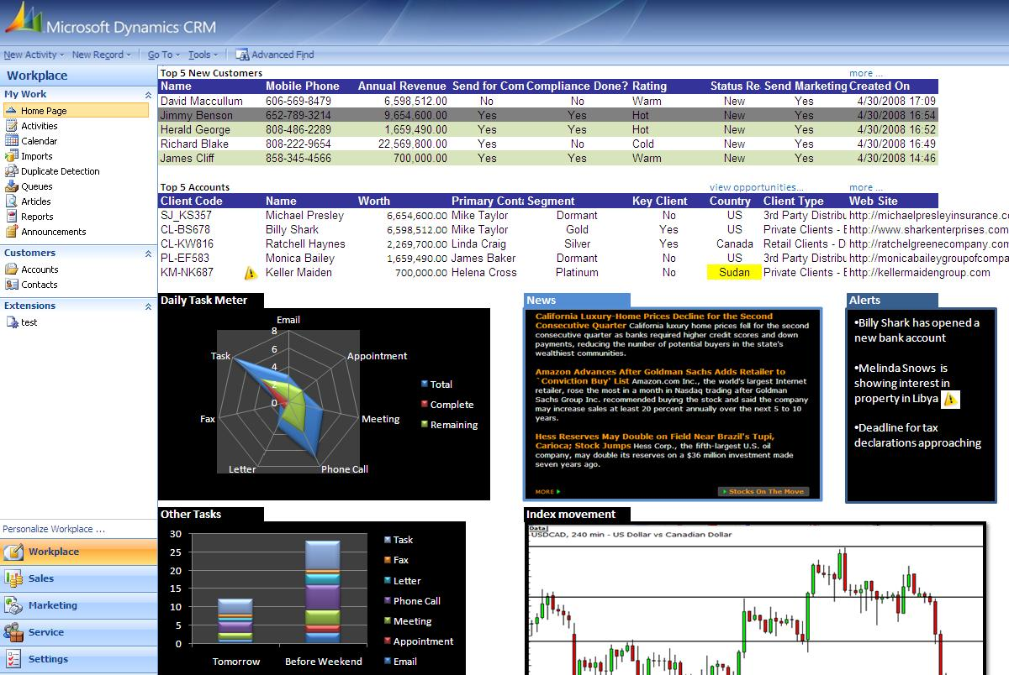

Industry-Specific Customizability
Another reason Infosys chose to build its Wealth Management and Private Banking solution on the Dynamics CRM platform is its customizability. Dinesh states, “The Dynamics CRM 4.0 platform is incredibly flexible. Its comprehensive SDK makes it easy for us to extend product functionality and integrate multiple capabilities to meet any industry or company-specific requirements.” He adds, “Because the platform is extensible using the .NET Framework, we didn’t have to train or find developers with specific Dynamics CRM development skills either. Instead, we were able to easily leverage the developers we needed from our existing base of over 20,000 .NET professionals.”

Company-Specific Flexibility
In addition to its customizability in development, Infosys also wanted a platform that was highly flexible for implementation. Dinesh states, “With other technology solutions, we would first have to go to the customer to collect requirements. Then, we would have to come back and write the code and configure the application to meet their needs. Finally, we would go back to the customer to implement the application. Now, thanks to the power of the SDK and the flexibility of the platform, we can modify most entities, fields, layouts, forms, and properties on the fly without extensive coding. This means we have a solution that is easy to support, maintain, and upgrade.”
Figure 1 - Relationship Manager Dashboard, including Top 5 New Customers, Top 5 Accounts, Daily Task Meter, Other Tasks, News, Alerts, and Financial Index movements

Dynamics CRM 4.0 provides greater customizability and flexibility than ever before. Dinesh states, “With the many-to-many relationships available in Dynamics CRM 4.0 out of the box, we can truly and more easily meet and support all the sophisticated business relationship needs of our customers.”

Role-Based Dashboards
The Infosys Wealth Management and Private Banking solution provides customized dashboards to present the massive amounts of financial and customer-related data from disparate sources in a single view (see Figure 1). Each dashboard is a custom collection of data that is fed by various entities to provide each user with a clear view of all related requirements, tasks, workflow, and required actions. Within the dashboard, each user can also drill down into the data behind the dashboard as needed.

Custom, Flexible Reporting
By leveraging SQL Server Reporting Services, end-users are also empowered to create and view various standard and customized reports. For example, now, instead of browsing multiple spreadsheets to extract data to be configured for each report, an end user can simply create the report which then pulls the required data as needed. The reports can be as simple as a detailed view of a client portfolio or as complex as a report that maps financial products across a client’s current portfolio, arming the relationship manager with appropriate and compelling cross-selling and up-selling opportunities.
“[With Dynamics CRM 4.0], we can easily develop the sophisticated multi-branching workflows required by this industry, implement custom workflows for each client, and additionally provide customers with the ability to create and modify workflows without technical expertise.”
Dinesh Mohan, Lead, Industry Solutions, Microsoft Dynamics Practice

Ability to Expose Data Outside Dynamics CRM
The tight integration with SharePoint Server also allows Infosys to expose much of the functionality of their Wealth Management and Private Banking solution through SharePoint Server 2007. Dashboards are available in SharePoint Server 2007 to view and update data without requiring end users to log into Dynamics CRM. This gives users—who don’t need full access to Dynamics CRM—the ability to view and update data in the Wealth Management and Private Banking application without requiring the additional product training or licensing for their limited use.

Improved Workflow Development and Implementation
Creating and managing effective workflow can be challenging for any business. In the Banking and Financial Services industry, this is further complicated by the extensive compliance and reporting requirements at every level of the customer relationship. According to Dinesh, “We previously had to configure and code complex workflows to provide the required escalations, multiple branching, approvals, reporting, etc. However, with Dynamics CRM 4.0, Windows® Workflow Foundation provides for all the complexities we previously had to code. So now, we can easily develop the sophisticated multi-branching workflows required by this industry, implement custom workflows for each client, and additionally provide customers with the ability to create and modify workflow without technical expertise or intervention.”

He adds, “Windows Workflow Foundation also integrates with SharePoint Server 2007, so the workflow within Dynamics CRM can reach and be accessed by those whose access to the application is only through SharePoint.”

Expanded Security and Compliance Capabilities
The banking and financial services industry has extremely stringent requirements for security. According to Dinesh, “Dynamics CRM 4.0 provides a great foundation for a comprehensive security infrastructure. However, just as important, it also allows us to easily extend security for additional custom entities by configuration.”

He adds, “Another feature that provides additional security for our application is the multi-tenancy capability of Dynamics CRM 4.0. This allows us to ‘bucket’ data into various non-permeable layers in order to separate data between countries, and business divisions. Then, using SharePoint Server 2007, we can provide views of the aggregated data from across the buckets for those who require consolidated information.”

To meet compliance requirements, Infosys also added an audit log to their Wealth Management and Private Banking solution. Through a custom form, the fields that require auditing can be selected. Then, when any data is changed in that field, the date, time, content that was changed, along with the user who made the change are recorded. This feature has helped to harden the security available in Microsoft Dynamics CRM.

Benefits
Faster Time to Market for Industry-Specific Application
According to Dinesh, “By leveraging the power and flexibility of the Dynamics CRM 4.0 platform, we were able to develop a deeply customized, flexible CRM solution to meet the complex needs of the Banking and Financial Services industry and get it to market in rapid time. From our client point of view, a preconfigured solution helps to lower total cost of ownership (TCO) while providing a rapid return on investment (ROI).”
“By leveraging the power and flexibility of the Dynamics CRM 4.0 platform, we were able to develop a deeply customized, flexible CRM solution to meet the complex needs of the Banking and Financial Services industry and get it to market in rapid time.”
Dinesh Mohan, Lead, Industry Solutions, Microsoft Dynamics Practice

Faster Implementation Saves Time for ISV and Customers
Thanks to the improved flexibility of Dynamics CRM 4.0, Infosys can now provide a one-step implementation process. Because Infosys can now configure the application to meet exact customer specifications during implementation, the ISV saves the significant time and expense of extra time to gather requirements while the customer gets to implement the application sooner.

Multiplied Power and Reach for Application
New features in Dynamics CRM 4.0 have vastly improved Infosys’ Wealth Management and Private Banking solution. These capabilities include:

- Multicurrency: Multicurrency capability is a vital need for any Banking or Financial Services solution and thus, the multicurrency capabilities of Dynamics CRM 4.0 vastly improve the value of the Infosys solution.
- Multilingual: The ability in Dynamics CRM 4.0 to handle multiple languages in a single instance also expands the power of the solution to meet the needs of larger, international customers.
- Multi-tenancy: The multi-tenancy capability of Dynamics CRM 4.0 improves the solution in two key ways. According to Dinesh, “Multi-tenancy has been a big boon for us, allowing us to support multiple organizations with a single instance and to provide data privacy needs through non-permeable layers within the same organization.”

Dinesh concludes, “With the Infosys Wealth Management and Private Banking solution built on Microsoft Dynamics CRM 4.0, we can focus entirely on meeting client needs without having to worry about platform capabilities.”
Microsoft Dynamics
For More Information
For more information about Microsoft products and services, call the Microsoft Sales Information Center at (800) 426-9400. In Canada, call the Microsoft Canada Information Centre at (877) 568-2495. Customers who are deaf or hard-of-hearing can reach Microsoft text telephone (TTY/TDD) services at (800) 892-5234 in the United States or (905) 568-9641 in Canada. Outside the 50 United States and Canada, please contact your local Microsoft subsidiary. To access information using the World Wide Web, go to:
www.microsoft.com

For more information about Infosys Technologies products and services, call (080) 28520261 or visit the Web site at: www.infosys.com

This case study is for informational purposes only. MICROSOFT MAKES NO WARRANTIES, EXPRESS OR IMPLIED, IN THIS SUMMARY.

Document published May 2008

Software and Services  - Products  - Microsoft Dynamics CRM  - Microsoft Office Outlook 2007  - Microsoft Office SharePoint Server 2007 | - Microsoft Office PerformancePoint Server  - SQL Server 2008 Reporting Services  - Technologies  - Microsoft .NET Framework

Microsoft Dynamics is a line of integrated, adaptable business management solutions that enables you and your people to make business decisions with greater confidence. Microsoft Dynamics works like familiar Microsoft software such as Microsoft Office, which means less of a learning curve for your people, so they can get up and running quickly and focus on what’s most important. And because it is from Microsoft, it easily works with the systems that your company already has implemented. By automating and streamlining financial, customer relationship, and supply chain processes, Microsoft Dynamics brings together people, processes, and technologies, increasing the productivity and effectiveness of your business, and helping you drive business success.

For more information about Microsoft Dynamics, go to:
www.microsoft.com/dynamics

