

Exchange Server 2003
Anti-Spam Framework Overview
Microsoft Corporation
Published: January 2006

Abstract
Microsoft® Exchange Server 2003 with Service Pack 2 (SP2) uses several methods for reducing unsolicited commercial e-mail, also known as spam. It is important that Exchange administrators and implementers understand how each of these methods works and how they work together. This paper presents a brief overview of each anti-spam method deployed by Exchange Server 2003 SP2 and describes how they work together to reduce the total amount of spam that arrives in a user’s inbox.

This is a preliminary document and may be changed substantially prior to final commercial release of the software described herein.
The information contained in this document represents the current view of Microsoft Corporation on the issues discussed as of the date of publication. Because Microsoft must respond to changing market conditions, it should not be interpreted to be a commitment on the part of Microsoft, and Microsoft cannot guarantee the accuracy of any information presented after the date of publication.
This White Paper is for informational purposes only. MICROSOFT MAKES NO WARRANTIES; EXPRESS, IMPLIED, OR STATUTORY; AS TO THE INFORMATION IN THIS DOCUMENT.
Complying with all applicable copyright laws is the responsibility of the user. Without limiting the rights under copyright, no part of this document may be reproduced, stored in or introduced into a retrieval system, or transmitted in any form or by any means (electronic, mechanical, photocopying, recording, or otherwise), or for any purpose without the express written permission of Microsoft Corporation.
Microsoft may have patents, patent applications, trademarks, copyrights, or other intellectual property rights covering subject matter in this document. Except as expressly provided in any written license agreement from Microsoft, the furnishing of this document does not give you any license to these patents, trademarks, copyrights, or other intellectual property.
 2006 Microsoft Corporation. All rights reserved.
Microsoft, MSN, Hotmail, Outlook, and SmartScreen are either registered trademarks or trademarks of Microsoft Corporation in the United States and/or other countries.
The names of actual companies and products mentioned herein may be the trademarks of their respective owners.
Contents
Introduction 1
Exchange Server 2003 Anti-Spam Framework 2
Connection-Level Protection 3
IP Connection Filtering 3
Real-Time Block Lists 3
Protocol-Level Protection 4
Recipient and Sender Blocking 4
Sender ID 5
Content-Level Protection 7
Exchange Intelligent Message Filter 7
Outlook 2003 and Outlook Web Access Junk E-Mail 8
Summary 10
Resources 11
Glossary 12

Introduction
Unsolicited commercial e-mail (UCE), widely known as spam, makes up an estimated 70 percent of e-mail traffic sent worldwide each day. However, the burden placed on organizations by spam is difficult to calculate. The 2004 National Technology Readiness Survey estimates that time wasted deleting spam amounts to around $21.6 billion per year in the United States alone. This figure only accounts for end-user productivity and does not include consumption of network resources, help desk costs, or additional hardware and/or software needed to manage spam.
Internet e-mail offers unscrupulous individuals and companies a pathway through an organization’s unprotected network to its users. Spam messages sent by malicious parties consume computer and network resources, along with the valuable time of your users. Spam messages can also carry a dangerous payload–viruses that can infect your network or misleading messages that deceive users into disclosing personal information such as credit card numbers and passwords.
The fight against spam can be won by attacking it on multiple fronts. Effective legislation and law enforcement, innovative technologies, industry cooperation and collaboration, and user education can all be effective in turning the tide against a practice that can potentially render e-mail communication impractical.
Companies and organizations can contribute to this effort by being proactive rather than reactive; for example, by implementing Simple Mail Transfer Protocol (SMTP) best practices that do not allow spam to propagate, as well as deploying services and solutions that reduce or prevent spam from entering the organization.
Software manufacturers such as Microsoft will continue to create innovative technologies that adapt to evolving spam techniques. For example, the release of Exchange Server 2003 SP2 has significantly strengthened the Microsoft Exchange anti-spam framework with the inclusion of Sender ID filtering. This e-mail authentication technology, free to Exchange customers and based on industry standards, enables receiving SMTP hosts to verify that the messages are from the domain they purport to be from. Another example is hosted anti-spam solutions. FrontBridge, a Microsoft subsidiary, uses multiple virus-scanning engines and dynamic spam-filtering techniques to keep spam out of your organization. However, without industry cooperation and collaboration, technologies such as Sender ID will have limited effect, and the problem will continue to grow.

Exchange Server 2003 Anti-Spam Framework
The focus of this paper is to describe the anti-spam framework provided by Microsoft® Exchange Server 2003 with Service Pack 2 (SP2) to reduce the amount of spam that arrives in a user’s inbox. This framework is a collection of several methods, and it is important that Exchange administrators and implementers understand how each of these methods work and how they work together.
Exchange Server 2003 applies spam protection at three different levels–the connection level, the protocol level, and the content level–as shown in the following example.
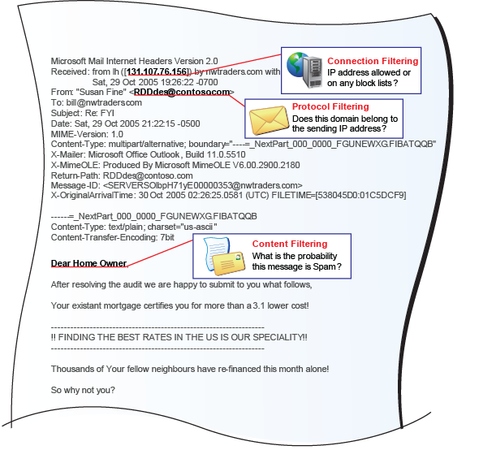
As indicated in this example, connection-level protection analyzes the connecting SMTP host, protocol-level protection analyzes the message’s sender and recipient, and content-level protection evaluates the message content. Each of these types of anti-spam protection will now be described in greater detail.

Connection-Level Protection
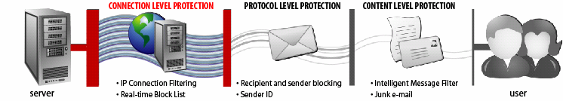
Connection-level protection is among the most beneficial layers of defense against spam, because with this level of protection, the spam message never enters the organization. Connection-level protection works by evaluating each incoming SMTP connection for the probability that it is a source of spam. If the connecting SMTP host is identified as a host that sends spam or a host that would not normally send SMTP messages, the connection can be refused, thus eliminating costly cycles spent determining if the inbound message is spam. To this end, there are two types of connection-level filtering available with Exchange Server 2003 outlined below.

IP Connection Filtering
With Exchange Server 2003, you can explicitly choose to deny SMTP connections based on IP address. This is the most rudimentary method of protecting an Exchange server because the connection-filtering lists are manually administered. If you want to deny inbound SMTP connections from a specific host for a given reason (including the probability that it is a source of spam), the connections are denied at this level.
You can also explicitly allow SMTP connections. If you want to receive mail from a blocked SMTP host that has been identified as a source of spam, you can choose to allow messages from the specified SMTP host that otherwise would be denied.

Real-Time Block Lists
A more dynamic means of providing connection-level protection is through use of Real-time Block Lists. Block lists are lists of IP addresses that are either known sources of spam, open relays, or part of an IP scope that should not include an SMTP host, such as an IP address from the Microsoft MSN® dial-up pool.
Third-party block list providers collect IP addresses that fit each profile. When a sending host initiates an SMTP session with a subscriber to the block list service, the subscriber issues a Domain Name System (DNS)-type query to the block list provider with the connecting host’s IP address. The block list provider then replies with a code indicating whether the connecting host is on a list. The code can also indicate which list the connecting SMTP host is on.
The Real-time Block List filtering process is as follows:

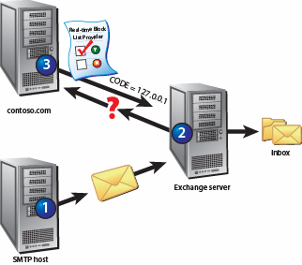
- An SMTP host connects to the Exchange Server 2003 server over Transmission Control Protocol (TCP) port 25.
- The Exchange Server 2003 server queries the configured block list provider, contoso.com, to verify that the connecting SMTP host is not on the block list.
- If the connecting SMTP host is not on the block list, the connection is allowed. If the host is on the block list, the connection is dropped.

Prior to Exchange Server 2003 SP2, connection filtering functionality was not available if firewalls or intermediary SMTP hosts existed between Exchange and the sending identity (Exchange is positioned behind the parameter network). This is because connection filtering prior to Exchange Server 2003 SP2 considered only the connecting host. When an intermediary host (like a firewall or other SMTP appliance) is between the sending host and Exchange, only the intermediary host is considered.
With the release of Exchange Server 2003 SP2, the Exchange server can be positioned anywhere in the organization and still get connection filtering working correctly. This is achieved by providing perimeter IP lists and an internal IP range configuration in Exchange System Manager. That way, Sender ID and Real Time Block List will analyze the IP address that connects to your intermediary SMTP host, such as a firewall.
For Microsoft.com, 25 percent of inbound messages are blocked by using connection-level filtering.

Protocol-Level Protection
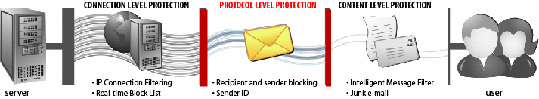
After the SMTP message has advanced beyond the connection-level protection, the next layer of defense is at the SMTP protocol level. The SMTP dialog between the sending SMTP host and the receiving SMTP host is analyzed to verify that the sender and recipients are allowed, and to determine the sender’s SMTP domain name.

Recipient and Sender Blocking
Another way to manually reduce spam is to define individual senders or domains from which you do not want to accept messages. Sender blocking allows you to specify individual SMTP addresses or domains to block. With Exchange Server 2003, you can also disallow messages that have a blank sender address, as well as archive filtered messages.
Recipient filtering allows you to filter messages sent to a specific recipient. You can also filter recipients who are not listed in the directory. However, enabling the filtering of recipients who are not in the directory can make your organization vulnerable to an SMTP e-mail address harvest attack, known as directory harvesting attack (DHA). In this situation, the Exchange server responses to RFC2821 RCPT TO: commands are parsed in search of valid SMTP addresses. The SMTP protocol acknowledges acceptable recipients during an SMTP session by responding with a 250 2.1.5 response. When e-mail is sent to a non-existent recipient, the Exchange server returns a 550 5.1.1 User unknown error. Therefore, a spammer can write an automated program that uses common names or dictionary terms to construct e-mail addresses to a specific domain. The program can then collect all e-mail addresses that return 250 2.1.5 to RCPT TO: SMTP and discard all e-mail address that cause 550 5.1.1 User unknown errors. The spammer can then sell the valid e-mail addresses or use them as recipients for unsolicited mail.
This threat can be mitigated by using a method known as tarpitting. The Microsoft Windows Server™ 2003 SP1 SMTP tarpit feature allows an administrator to insert a configurable delay before returning some SMTP protocol responses. The attacking host does not wait long enough for the response. More information about tarpitting can be found in the Resources section below.

Sender ID
One of the most recent additions to the Exchange Server 2003 anti-spam defenses is Sender ID filtering. Supported in Exchange Server 2003 SP2, Sender ID is a feature that attempts to verify that the sending SMTP host is approved to send messages from the domain specified in the sending e-mail address. Many spam messages are spoofed so that the message appears to come from a legitimate e-mail address. By deceiving the e-mail recipient into thinking the e-mail is from a legitimate authority (bank representative, customer service, etc.), users may be tricked into disclosing valuable information that can lead to identity theft or larceny. Sender ID attempts to reduce or eliminate spoofed messages.
There are two parts to Sender ID that are required for the system to work. The first part is a Domain Naming System (DNS) record known as a sender policy framework (SPF) record. The SPF record defines which servers are authorized to send SMTP addresses for your domain. You do not need to have Sender ID configured to have an SPF record. The second part is an SMTP host, such as Exchange Server 2003 SP2, which supports Sender ID.
The SPF record is added to your DNS zone so that other organizations with Sender ID can verify that messages they receive that purport to be from your domain are sent by the servers you authorized in your SPF record. The process is as follows:

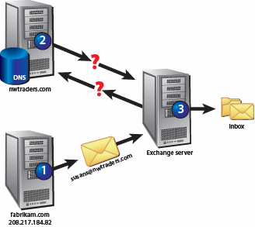
- A message is sent to the Exchange Server 2003 server from the spamming SMTP host fabrikam.com with sender ID enabled. The sender address is susanf@nwtraders.com.
- The Exchange server queries DNS for the SPF record for nwtraders.com.
- Because nwtraders.com does not have an SPF record, the message is allowed past Sender ID.

Northwind Traders then adds an SPF record to the nwtraders.com DNS zone as follows:

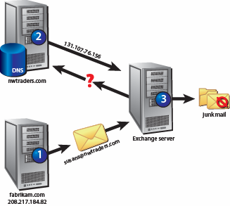
- A message is sent to the Exchange Server 2003 server from the spamming SMTP host fabrikam.com with Sender ID enabled. The sender address is susanf@nwtraders.com.
- The Exchange server queries DNS for the SPF record for nwtraders.com.
- Because the sending IP address (208.217.184.82) is not in the list of IP addresses allowed to send e-mail for nwtraders.com as defined in the SPF (131.107.76.156), the message is acted upon by Sender ID.

By implementing Sender ID, you can greatly reduce spam addressed (spoofed) from domains that have an SPF record. Keep in mind that Sender ID protection is only as good as the number of organizations that have SPF records.
For Microsoft.com, 59 percent of inbound messages that get past connection-level filtering are blocked by protocol-level filtering.

Content-Level Protection
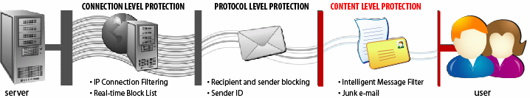
After connection-level and protocol-level filtering have been applied to determine if an inbound message is spam, the next line of defense is to analyze the message content, looking for common clues that may indicate unsolicited e-mail. Spammers have exerted a constant effort to come up with new and inventive ways to avoid detection so that their messages get past content filters and enter the users’ inboxes.

Exchange Intelligent Message Filter
Intelligent Message Filter (IMF) is a content filter designed specifically for Exchange. It is based on patented machine-learning technology from Microsoft Research known as Microsoft SmartScreen® technology. SmartScreen is currently used by MSN, Microsoft Hotmail®, Microsoft Office Outlook® 2003, and Exchange. IMF was designed to distinguish between characteristics of legitimate e-mail messages and spam, based on millions of messages. IMF can make an accurate assessment of the probability that an incoming e-mail message is either a legitimate message or spam. Unlike many other filtering technologies, IMF uses characteristics from a statistically sound sample of e-mail messages. In addition to spam, the inclusion of legitimate messages in this sample reduces the likelihood of mistakes. Because IMF recognizes characteristics of both legitimate and UCE messages, the accuracy of IMF is increased.
Intelligent Message Filter is installed on Exchange servers that accept inbound SMTP messages from the Internet. When an external user sends e-mail messages to an Exchange server with IMF installed, the IMF evaluates the textual content of the messages and assigns each message a rating based on the probability that the message is spam. This rating ranges from 1 to 9 and is stored as a message property known as the spam confidence level (SCL) rating. This rating is persisted with the message when the message is sent to other Exchange servers.
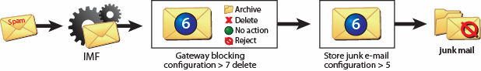
After Intelligent Message Filter has assigned an SCL to the message, it is evaluated against two thresholds configured by the administrator as follows:
- Gateway blocking configuration: Block messages with an SCL rating greater than or equal to. If the SCL of a message is greater than or equal to the value set here, one of the following actions can be performed on the message :
  - Archive
  - Delete
  - No action
  - Reject
- Store junk e-mail configuration: Move messages with an SCL rating greater than. If the message is greater than the value set here, the message will be delivered to the junk e-mail folder of the user’s inbox, unless the user has the sender on their safe senders list.

Anti-Phishing
Phishing is a type of deception designed to steal your identity. In phishing scams, scam artists try to get you to disclose valuable personal data, such as credit card numbers, passwords, account data, or other information, by convincing you to provide it under false pretenses; for example, an e-mail message asking you to verify account information.
Exchange Server 2003 SP2 adds anti-phishing technology to the IMF so that the phishing messages are assigned an appropriate SCL and dealt with accordingly.

Custom Weighting
Exchange Server 2003 SP2 also provides a custom weighting feature that lets administrators customize the behavior of Intelligent Message Filter, based on phrases found within the body of an e-mail message, the subject line, or both.
The custom weighting feature is implemented by inserting an Extensible Markup Language (XML) file named MSExchange.UceContentFilter.xml into the same directory as the MSExchange.UceContentFilter.dll and .dat files on the server with Intelligent Message Filter installed. When the SMTP virtual server is started and Intelligent Message Filter initialized, the XML file is loaded.
The XML file defines phrases that can be given more or less emphasis by Intelligent Message Filter. This allows you to customize Intelligent Message Filter if you have business requirements to accept, or deny messages based on phrases that would otherwise be given a different SCL rating by Intelligent Message Filter.
For Microsoft.com, 38 percent of inbound messages that pass connection-level and protocol-level filtering are blocked by Intelligent Message Filter.

Outlook 2003 and Outlook Web Access Junk E-Mail
After a message makes it past server-based anti-spam defenses, the Outlook 2003 client can act on messages that have an SCL value greater than or equal to the store junk e-mail configuration setting in Intelligent Message Filter. Messages that exceed this server setting are sent to the junk e-mail folder in the Outlook 2003 inbox.
Outlook 2003 and Outlook Web Access for Exchange Server 2003 also allow users to create a list of safe senders from whom users always want to accept e-mail messages, as well as a list of blocked senders from whom users always want to reject e-mail messages. At the mailbox store, regardless of the SCL rating assigned to the message, Exchange delivers all messages from safe senders to the user's inbox and all messages from blocked senders to the user's junk e-mail folder. However, if the e-mail message has been blocked by the gateway threshold, it is not delivered to the user's inbox because the message is never delivered to the mailbox store.
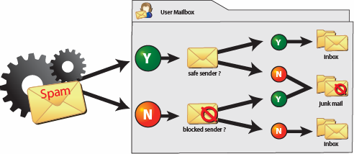
If a user is running an earlier version of Outlook, the safe senders and blocked senders lists are not available. Any message marked as spam is delivered directly to the user's inbox. Users with earlier versions of Outlook can use Outlook Web Access to define safe and blocked sender lists.

Summary
The Microsoft anti-spam framework has evolved over the years to meet the threat of unsolicited commercial e-mail. Implementing the anti-spam features of Exchange Server 2003 SP2 reduces the amount of spam entering your organization by using advanced, server-side and client-side filtering to identify junk and legitimate e-mails. The combination of connection-level protection, protocol-level protection, and content-level protection provides an end-to-end mail hygiene solution that reduces the productivity and network costs associated with junk e-mail messages, while reducing the risk associated with spam for your network and users.

Resources
Microsoft Safety
http://www.microsoft.com/mscorp/safety/default.mspx
How to configure connection filtering to use Real-time Block Lists (RBLs) and how to configure recipient filtering in Exchange 2003
http://support.microsoft.com/default.aspx?scid=kb;en-us;823866
Introduction to the Microsoft Exchange Intelligent Message Filter Deployment Guide
http://www.microsoft.com/technet/prodtechnol/exchange/guides/IMFDeploy/dbb65d96-b763-46a3-9942-41d5a23c2676.mspx
FrontBridge, a Microsoft subsidiary
http://www.microsoft.com/exchange/evaluation/fbridge
http://www.frontbridge.com
Exchange Intelligent Message Filter
http://www.microsoft.com/downloads/details.aspx?FamilyID=c1b08f7b-8caf-4147-b074-8c9c8f277071&DisplayLang=en
Exchange Server 2003 SP2 Overview
http://www.microsoft.com/exchange/downloads/2003/sp2/overview.mspx
Anti-Phishing Technologies
http://www.microsoft.com/mscorp/safety/technologies/antiphishing/default.mspx
Sender ID
http://www.microsoft.com/mscorp/safety/technologies/senderid/default.mspx
SMTP tar pit feature for Microsoft Windows Server 2003
http://go.microsoft.com/fwlink/?LinkId=3052&kbid=842851
Help Prevent Junk E-Mail Message with Outlook 2003
http://www.microsoft.com/office/editions/prodinfo/junkmail.mspx

Glossary
IP Internet Protocol is the basis for communication on the Internet. Defined by RFC 791, IP specifies addressing and format of packets, also called datagrams. Most networks and the Internet combine IP with Transmission Control Protocol (TCP). TCP establishes a virtual connection between two hosts.
Host is computer system connected to a network.
DNS Domain Name System is a network of hosts that translate domain names into IP addresses. For example, smtp.nwtraders.com is translated to 208.217.184.82 by the DNS server(s) responsible for nwtraders.com.
SMTP Simple Mail Transfer Protocol is used to transfer messages between SMTP hosts or between an Internet client and an SMTP host. SMTP is defined in RFC 821.
Open Relay (also called a third-party relay or insecure relay) is an SMTP host that relays messages addressed to unknown recipients to other SMTP hosts.
SPF Sender Policy Framework is an extension to SMTP that specifies which hosts can send SMTP messages for a given domain. This makes it difficult for spammers to send messages from one domain while claiming they are from another domain.
RBL Real-time Block Lists are lists of IP addresses of SMTP hosts that originate or relay spam. RBL providers offer a service that allows subscribers to query the RBL to verify the message is not coming from an SMTP host on the list.
Spoofing is the practice of spammers of sending messages from one domain while claiming to be from a legitimate domain, thereby spoofing the From address to mislead the recipient.
Phishing is the practice of malicious spammers of sending e-mail to a recipient, falsely claiming to be a legitimate enterprise in an attempt to trick the user into providing private information that will be used for identity theft or larceny



Rockbridge Associates, Inc. “2004 National Technology Readiness Survey”, February 3rd, 2005 sponsored by The Center for Excellence in Service, R.H. Smith School of Business, University of Maryland.
FrontBridge Technologies, a Microsoft subsidiary, offers managed messaging services for enforcing e-mail compliance, providing e-mail availability, and improving protection from viruses and spam. For more information about FrontBridge, go to http://www.frontbridge.com or reference the links in the Resources section of this paper.

