*Proactive IT management designed for midsize businesses*

**Together, Microsoft® System Center Essentials 2007 and Microsoft System Center Virtual Machine Manager 2007 Workgroup Edition provide a comprehensive, unified IT Management solution for midsize businesses that helps enable proactive and efficient management of IT resources, increases physical server utilization through virtualization, helps IT staff simplify complex management tasks, and improves business continuity for increased IT efficiency.**

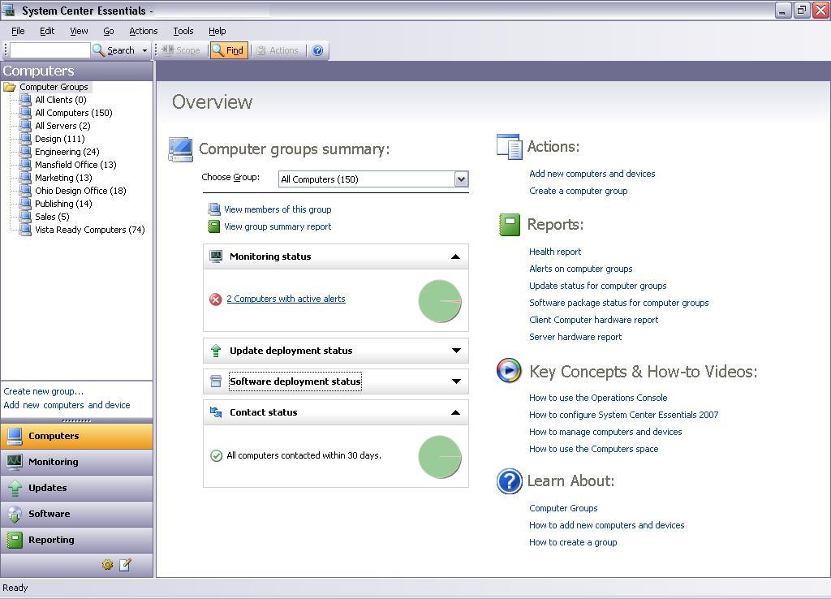

Overview screen in Essentials 2007.

**Key Features**

* **Comprehensive Monitoring**
* **Updates & Software Deployment**
* **Physical to Virtual Migration**
* **Rapid New Virtual Machine Creation**
* **Integrated Reporting**
* **Software and Hardware Inventory**

**Key Benefits**

**Unified Experience**

System Center Virtual Machine Manager 2007 Workgroup Edition (VMM WGE 2007) and System Center Essentials 2007 (Essentials 2007) provide a single solution for managing both physical and virtual server infrastructure servers as well as clients, software, and IT services for a unified experience.

**Single Solution**

* Utilizing similar and intuitively familiar user interfaces, Essentials 2007 and VMM 2007 WGE enable administrators to become quickly proficient and spend less time in training and skills upgrading. Further utilizing an IT department’s existing investments and knowledge, Essentials 2007 and VMM 2007 WGE use many of the foundational Windows Server® technologies such as Active Directory ® and IIS, to name just a few.
* The user experience has been optimized so administrators can easily perform the broad set of tasks that midsize businesses need to do on a daily basis.

**Consistent Interface**

* Through Essentials 2007, with the Virtualization Management Packs installed, administrators not only see virtual machines alongside physical ones, they also can manage them side-by-side with the same suite of controls, operations, and easy-to-use wizards.
* The VMM 2007 WGE and Essentials 2007 suite provides comprehensive IT management with a single view of servers, clients, hardware, software, and IT services. Whether virtualized or not, these resources are managed from a single console and administrators have visibility down to the in-guest workload level within a virtual machine.
* Overview pages provide summary information, common tasks, alerts and reports, allowing administrators to quickly see all the aspects of the health and ongoing performance of the IT environment. From these pages, an administrator can quickly drill down to get information to fix issues.

**Integrated Virtualization**

Essentials 2007 with VMM 2007 WGE allows organizations to take full advantage of virtualization benefits, including the consolidation of servers and rapid provisioning of new virtual machines on up to five virtual hosts.

**Fast, Reliable Machine Conversions**

* VMM 2007 WGE with Essentials 2007 enables administrators to convert physical machines into virtual (P2V) without having to interrupt the source machine.
* VMM 2007 WGE with Essentials 2007 can also easily convert existing VMware virtual machines to deployable Microsoft virtual machines.

**Rapid New Machine Provisioning**

* With VMM WGE 2007 and Essentials 2007, administrators can respond to new machine requests at a fraction of the time it would take to deploy a new physical machine.

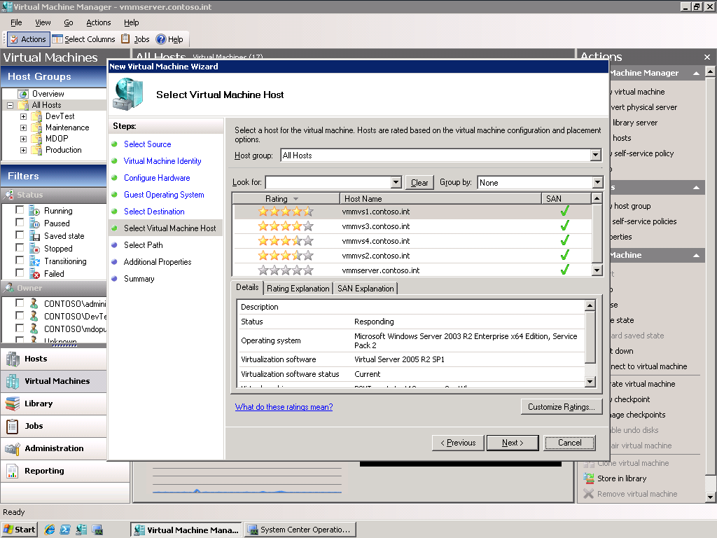

Intelligent Placement screen from VMM WGE.

**Rapid New Machine Provisioning**

* With VMM WGE 2007 and Essentials 2007, administrators can respond to new machine requests at a fraction of the time it would take to deploy a new physical machine. A centralized “library” of virtual machine “building blocks” – such as templates, ISO images, offline machines, and scripts – makes this process straightforward and easy.
* A sophisticated assessment algorithm within VMM 2007 WGE and Essentials 2007 -- “Intelligent Placement” – takes the guesswork out of deciding which virtual host is best suited to support a new virtual machine. Relying on performance data, virtual machine profile, pre-set business rules and other factors, Intelligent Placement makes a deployment recommendation targeted to produce maximized results.

**Proactive Management**

Essentials 2007 and VMM 2007 WGE helps enable proactive management of an organization’s IT environment, keeping systems up-to-date with tools that help accelerate problem resolution and enable automation of system updates and data.

**Accelerates troubleshooting, automates system updates**

* Essentials 2007 with VMM 2007 WGE actively alerts administrators to performance problems or other maintenance issues.
* Solve problems using integrated troubleshooting and resolution tools for clients, servers, applications and services.
* The suite of Essentials 2007 and VMM 2007 WGE provides a simple and powerful way to manually or automatically deploy updates for Microsoft operating systems, hardware updates, drivers, and software applications, both Microsoft and non-Microsoft, to help ensure the security of the network.
* Essentials 2007 with VMM 2007 WGE checks for availability of new updates and also allows administrators to assess, configure, and patch IT resources without interrupting users or network service.
* Essentials 2007 automates the collection of software and hardware inventory so assets can be reviewed to help achieve optimum configuration and compliance.

**Increased Efficiency**

System Center Essentials 2007 and VMM 2007 WGE are easy to deploy and maintain, helping simplify complex management tasks for increased efficiency.

**Simple to Use**

* A simple wizard quickly walks administrators through the process of deploying software to clients and servers on the network. Various types of applications (i.e., MSI and non-MSI applications) and drivers can be deployed accurately by targeting software installations by grouped computers and defining command line configurations.
* With Essentials 2007 and VMM 2007 WGE, administrators can add monitoring without being an expert by using provided templates. For example, a provided wizard creates monitoring for a specific website, a database or file share.

**Simple to Deploy and Maintain**

* Using an intuitive installation wizard to install all System Center Essentials product components and prerequisites, administrators can get up and running quickly with Essentials 2007 and VMM 2007 WGE.
* The initial discovery wizard identifies and selects existing computers and devices on the network to be managed. When new devices are added, they are also automatically discovered using a simple, universal protocol.
* The provided update configuration wizard allows administrators to easily set the update behavior for clients and servers on the network. With Essentials 2007 and VMM 2007 WGE, administrators can define update parameters such as installation deadlines, which products to patch and types of updates to push out, or can simply install immediately “on demand.”