

Working with Clients in Windows Small Business Server 2008

Lab Manual

Information in this document is subject to change without notice. The example companies, organizations, products, people, and events depicted herein are fictitious. No association with any real company, organization, product, person, or event is intended or should be inferred. Complying with all applicable copyright laws is the responsibility of the user. Without limiting the rights under copyright, no part of this document may be reproduced, stored in or introduced into a retrieval system, or transmitted in any form or by any means (electronic, mechanical, photocopying, recording, or otherwise), or for any purpose, without the express written permission of Microsoft Corporation.

Microsoft may have patents, patent applications, trademarked, copyrights, or other intellectual property rights covering subject matter in this document. Except as expressly provided in any written license agreement from Microsoft, the furnishing of this document does not give you any license to these patents, trademarks, copyrights, or other intellectual property.

2009 Microsoft Corporation. All rights reserved.

The example companies, organizations, products, domain names, e-mail addresses, logos, people, places, and events depicted herein are fictitious. No association with any real company, organization, product, domain name, e-mail address, logo, person, place, or event is intended or should be inferred.

Microsoft, Hyper-V, Internet Explorer, OneCare, Outlook, Windows, Windows Live, the Windows logo, and Windows Vista are either registered trademarks or trademarks of Microsoft Corporation in the U.S.A. and/or other countries.

Other product and company names herein may be the trademarks of their respective owners.

Working with Clients in Windows Small Business Server 2008
Scenario
Contoso, a small business of approximately 25 users/devices, is planning and executing their deployment of Windows® Small Business Server (SBS) 2008. Like many organizations this size, Contoso has a partner, Roland Winkler, who performs most of the IT duties. Stan Orme, the owner of Contoso, also has some technical skills and sometimes performs some of the day-to-day tasks.
As Contoso grows, they are adding more and more PCs and portable computers to their Windows SBS 2008 environment. These computers are not always in the office. Roland, the administrator, decides to configure the Remote Web Workplace for Contoso employees to use.
Objectives
After completing this lab, you will be able to:
- Deploy client computers.
- Manage client computers.
- Manage SBS Remote Web Workplace.
- Install Certificate Packs.
- Navigate Remote Web Workplace.

Architecture
Two virtual machines (VMs) are used in this lab—one representing Windows Small Business Server (SBS) 2008 and one Windows Vista® client.
Estimated time to complete this lab:
60 minutes

Exercise 0:
Lab Setup, Prepare the Environment
In this exercise, you prepare the host server to run the lab.
You need to be running Windows Server® 2008 with the Hyper-V™ role enabled. For information on getting started with Hyper-V, click here.

- Task 1: Add Internal Only network adapter to Hyper-V server
    - On the host server, click Start > Administrative Tools > Hyper-V Manager.
    - In the right column, click Virtual Network Manager.
    - Select Private, then click Add.
    - Name the new virtual network SBS Network.
    - Ensure that Private is selected.
    - Click OK.

- Task 2: Import virtual machines
    - Under the right column, click Import Virtual Machine.
    - Click Browse.
    - Locate your SBS2008 HOL content folder.
    - Double-click the Administration folder.
    - Select the contoso.com-Server folder, click Select Folder.
    - Click Import.
    - Repeat steps 1–6 for the Vista-Client folder.
    - You will see a warning when the Vista-Client VM is imported. That is expected, and the following steps will correct the issue.
    - In the Server Manager console, right-click the Vista-Client virtual machine and select Settings.
    - Click the Legacy Network Adapter in the hardware list
    - In the details pane, change the Network to SBS Network.
    - Click OK.

- Task 3: Start virtual machines
    - Select contoso.com-Server virtual machine.
    - In the right column, click Start.
    - Once the SBS 2008 virtual machine has started to the log on screen, repeat steps 1 and 2 for Vista-Client.
    - Select Vista-Client and click Connect in the right column.
    - Switch back to the Hyper-V Manager window.
    - Select the contoso.com-Server virtual machine and click Connect in the right column.
    - Log on using the following credentials:
User name: Contoso\RolandW
Password: pass@word1
    - Open Internet Explorer and click Tools, Internet Options.
    - Click the Connections tab and the LAN Settings button
    - Uncheck Use a proxy server and click OK twice and close Internet Explorer.

Exercise 1:
Deploy Client Computers
Overview
In this exercise, you deploy client computers to the Small Business Server 2008 domain. This exercise involves the following tasks:
- Add a client computer to the network.
- Assign a user account to the client computer.
- Migrate existing user data from workgroup to domain.

- Task 1: Add client computer to the network
    - On the host server, switch to the Vista-Client on localhost – Virtual Machine Connection window.
    - In the Set Network Location dialog, select Work. At the user account control message click Continue and then click Close.
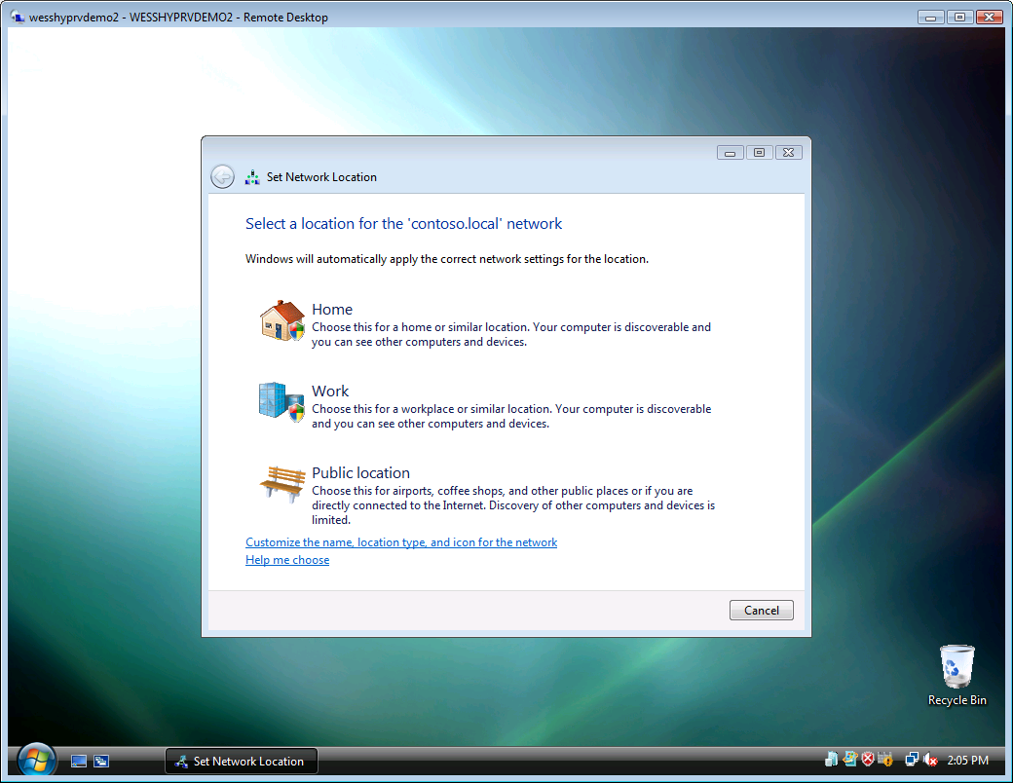
Figure 1 Set Network Location
    - From the Windows task bar, select Start > Internet.
    - In the URL field, type http://connect. At the Information Bar prompt, click Close. At the Microsoft Phishing Filter prompt, select Turn on and click OK. Click the Information Bar and select Enable Intranet Settings, and then click Yes.
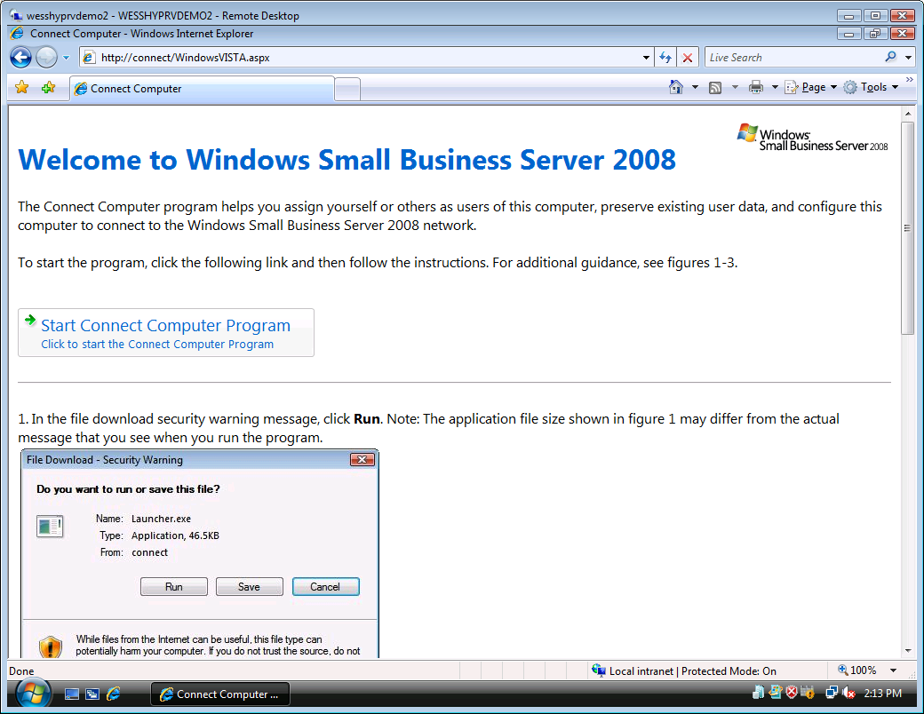
Figure 2 http://connect/
    - Click Start Connect Computer Program.
    - In the Security Warning dialog box, click Run.
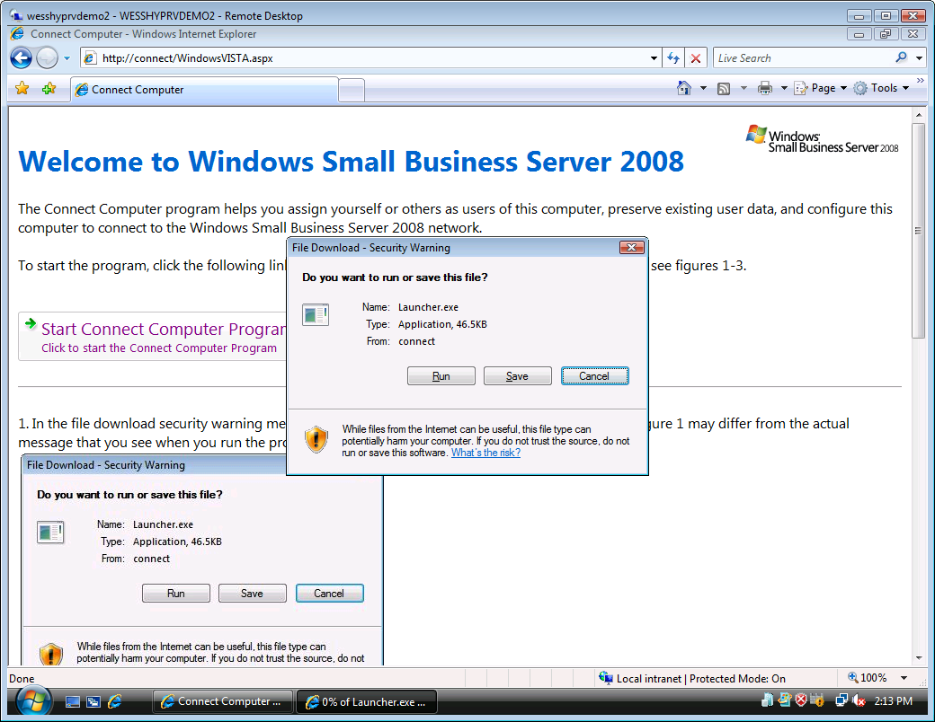
Figure 3 Security Warning dialog box
    - In the User Account Control dialog box, click Continue.

- Task 3: Assign user account to client computer
    - Select Set up this computer for myself.
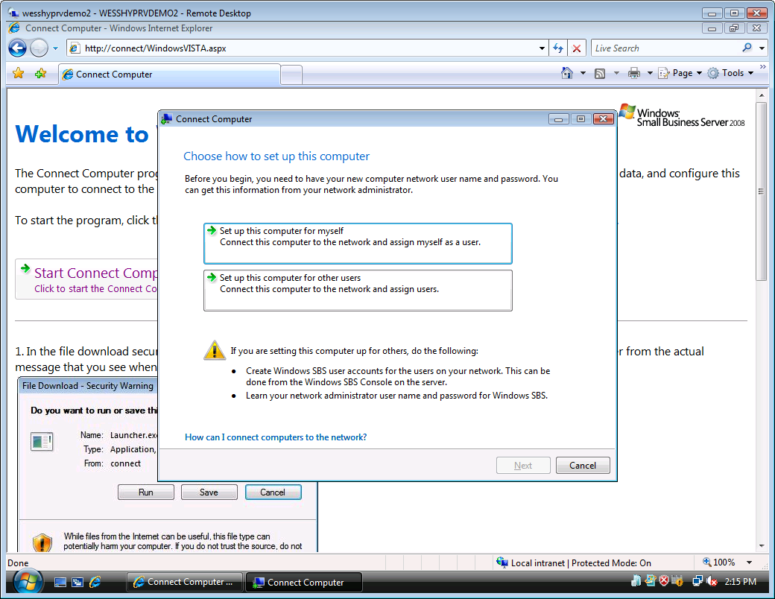
Figure 4 Connect Computer dialog box
    - Wait for the wizard to verify requirements that are necessary to connect to the network. After verification is complete, click Next in the Connect Computer dialog box.
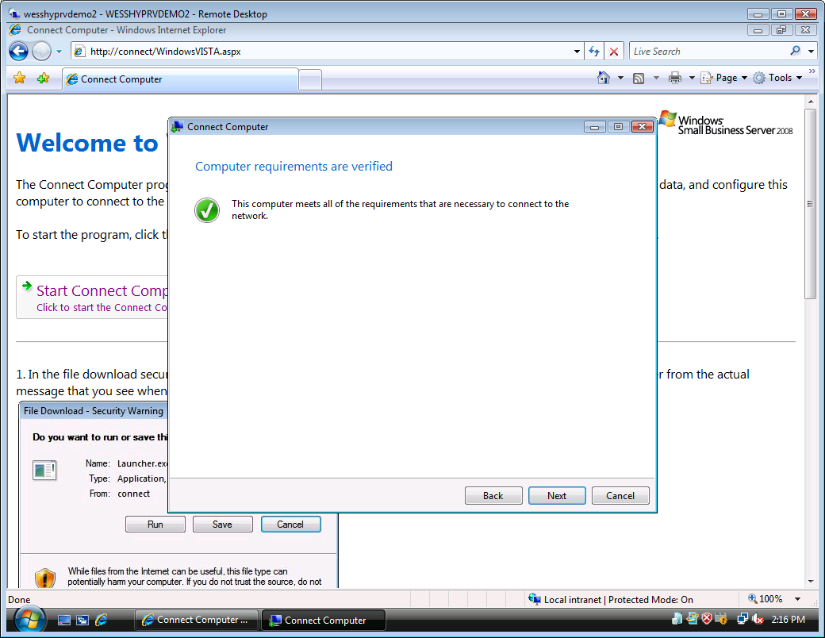
Figure 5 Connect Computer dialog box
    - Type the new user name and password:
User name: LisaM
Password: pass@word1
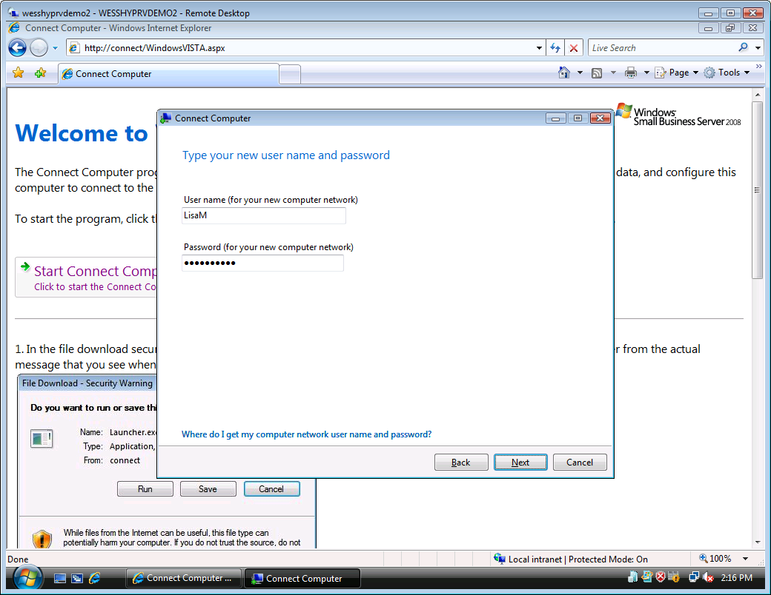
Figure 6 Type your user name and password page
    - Click Next.
    - Change the name of the computer to LISAM-PC and leave the description blank, and then click Next.
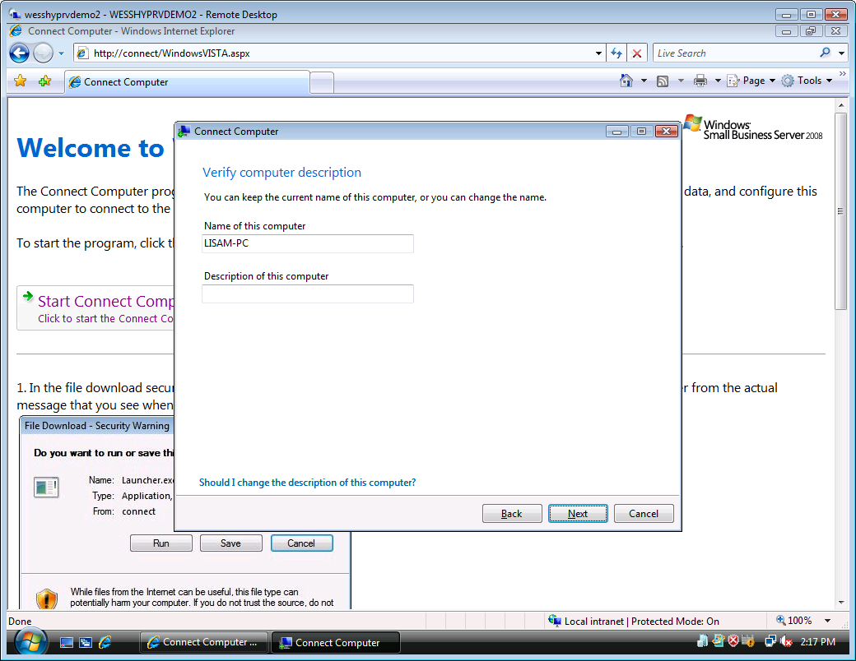
Figure 7 Verify computer description page
- Task 4: Migrate existing user data from workgroup to domain
    - In the Move existing user data and settings drop-down menu, select User.
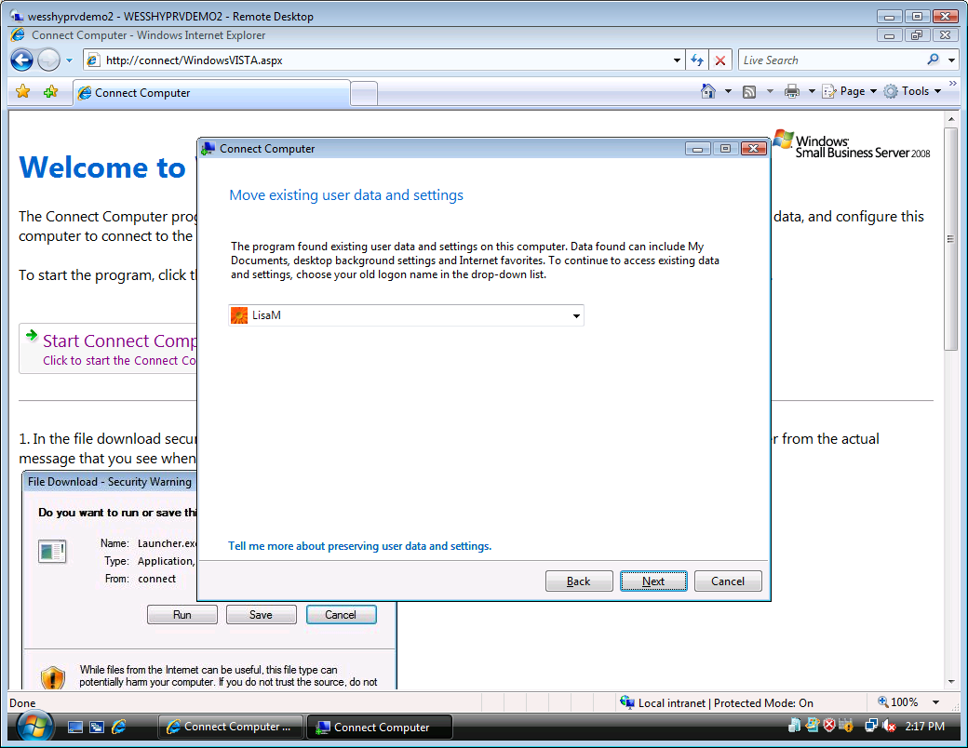
Figure 8 Move existing user data and settings page
    - Click Next.
    - Confirm your user data and settings selection, and then click Next.
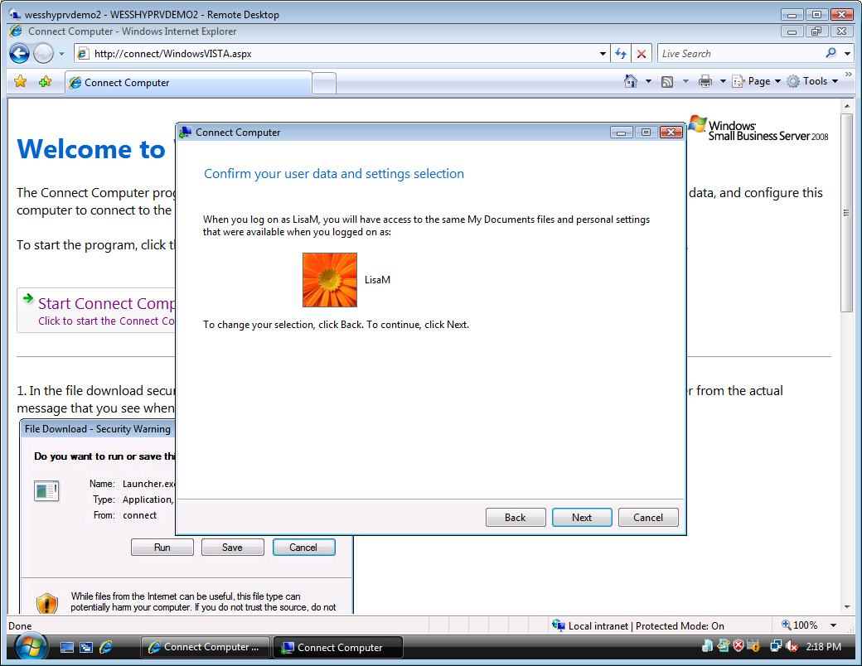
Figure 9 Confirm your user data and setting selection page

    - On the Restart the computer page, click Restart.
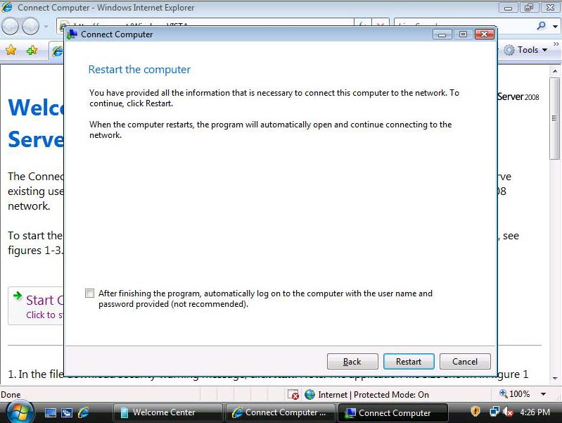
Figure 10 Restart the computer page
    - The client PC now performs the tasks required to join the network, and then restarts.
    - The client VM restarts twice to complete the domain membership join task. After this is complete, log on with the following information:
User name: Contoso\LisaM
Password: pass@word1
    - You receive a prompt informing you that the connect computer task is complete. Click Finish.

Exercise 2:
Manage Client Computers
Overview
In this exercise, you manage client computers. This exercise includes the following tasks:
- Assign user access.
- Change access level of users on client computers.
- Offer Remote Assistance
- Remove client computer from the SBS domain.
- Task 1: Assign user access
- On the ribbon at the top of the Windows SBS 2008 console, click Network.
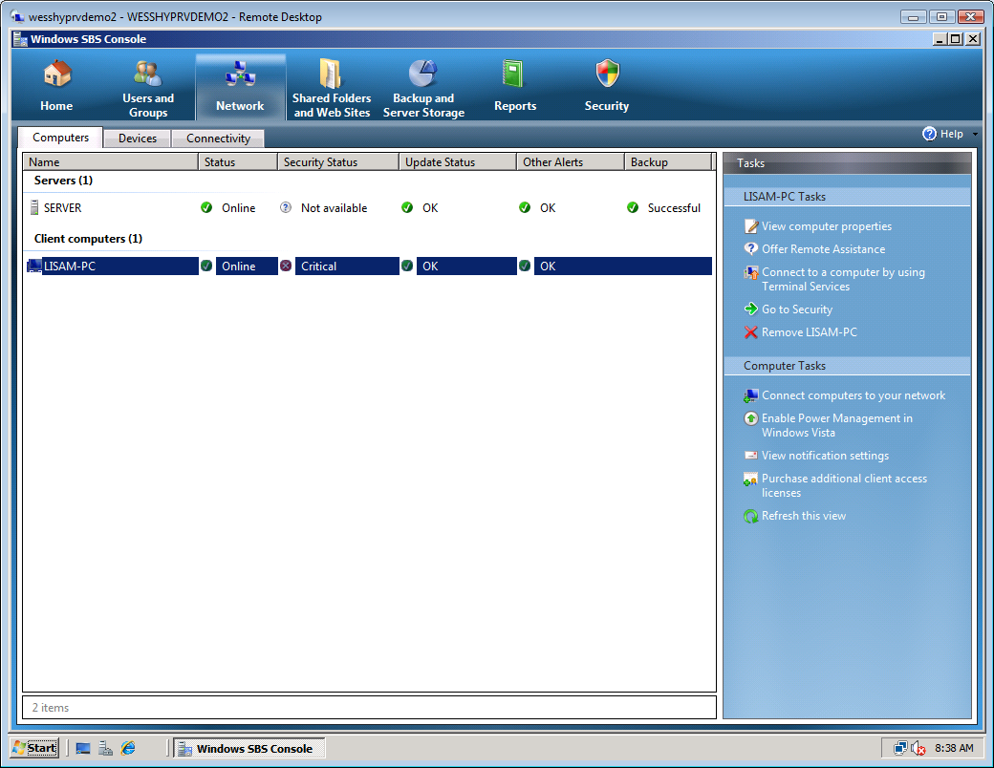
Figure 11 Windows SBS 2008 Console - Network
- Select LisaM-PC. If the client computer is not listed, click Refresh this view.
- In the Tasks pane to the right, click View computer properties.
Note: If Status of Vista-Client is “Offline,” wait a moment for the Windows Vista VM to restart. You can click Refresh this view to update the status.
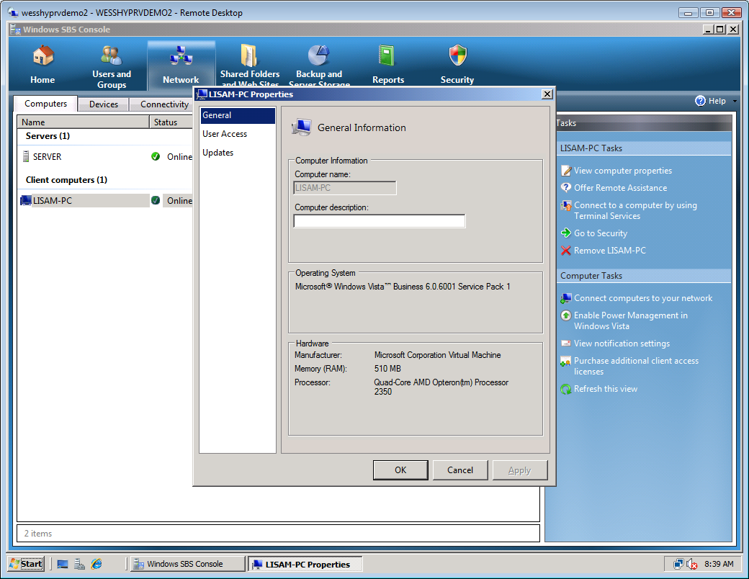
Figure 12 LisaM-PC properties page
- In the dialog box that appears in the left column, select User Access.
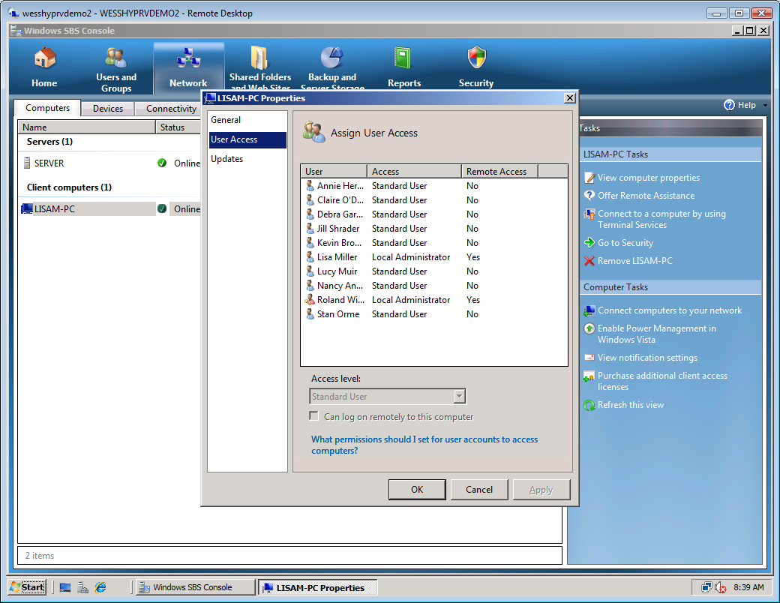
Figure 13 User Access page

- Select Stan Orme.
- Select the Can log on remotely to this computer check box.
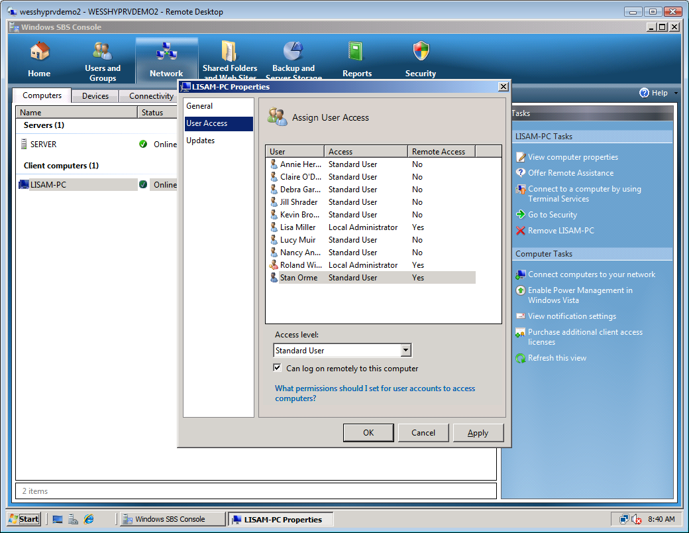
Figure 14 Can log on remotely enabled
- Click Apply.

- Task 2: Change access level of users on client computers
The LisaM-PC Properties window should still be open from the previous task.
    - Select Roland Winkler.
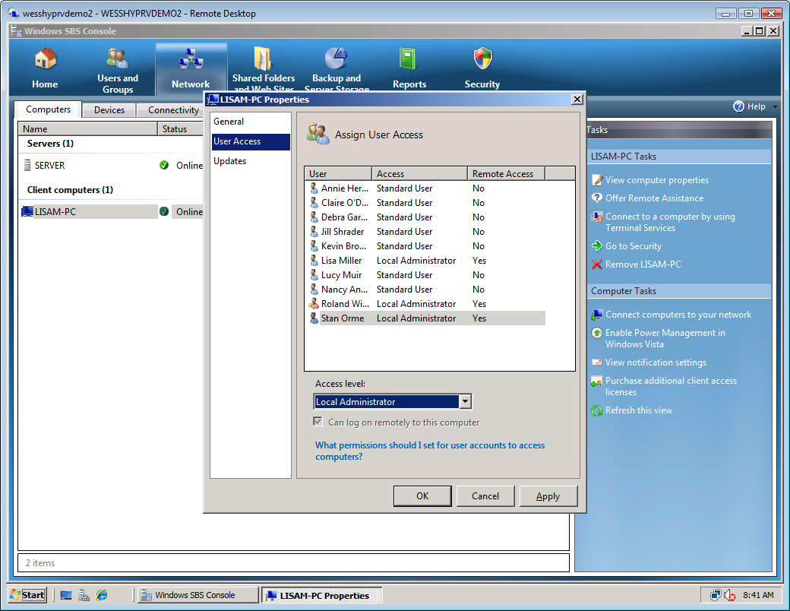
Figure 15 Access level local administrator
    - Note that as a domain administrator, Roland always has the ability to log on remotely.
    - Click OK.

- Task 3: Offer Remote Assistance
- Select Vista-Client.
- In the Tasks panel, click Offer Remote Assistance.
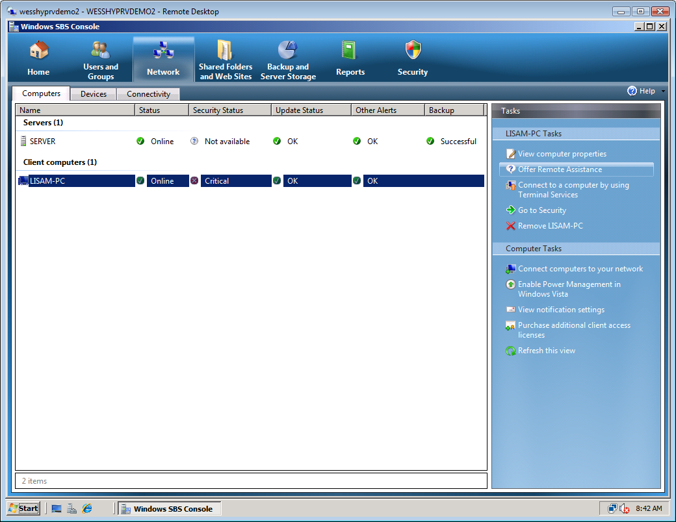
Figure 16 Offer Remote Assistance
- When prompted to verify, click Yes.
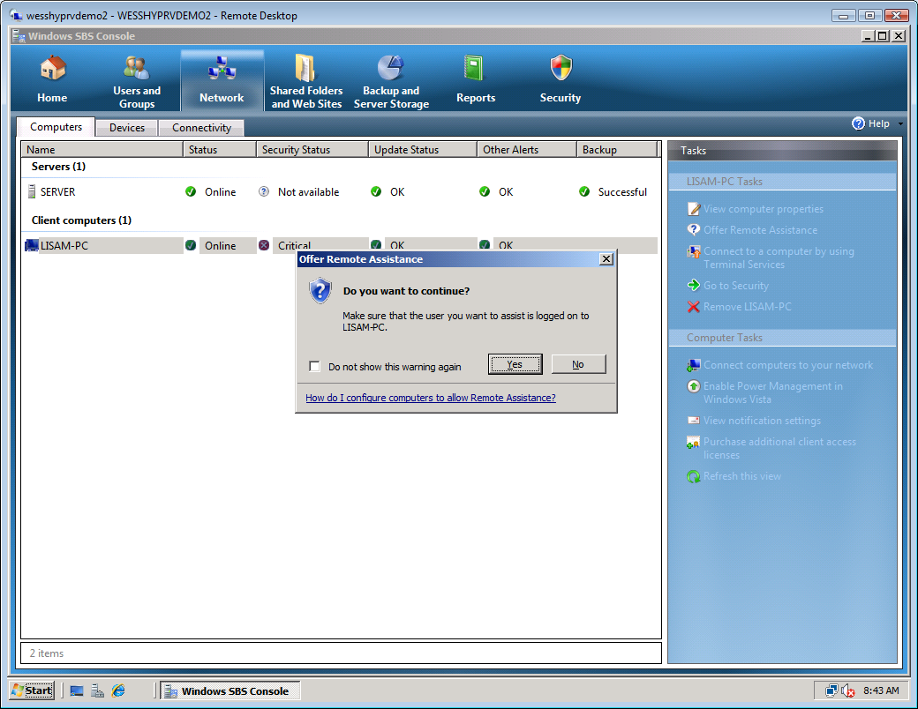
Figure 17 Confirm Remote Assistance
- Switch to the Vista-Client virtual machine.
- You should see a prompt asking to allow remote assistance from Roland Winkler. This may take a couple of minutes. Click Yes.
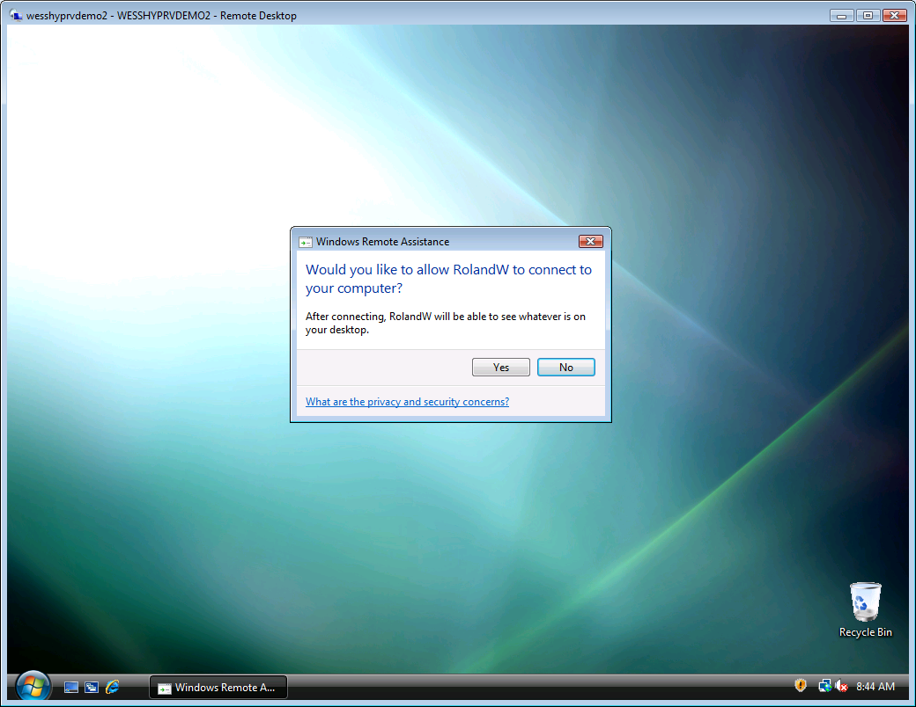
Figure 18 Allow Remote Assistance prompt
- The Remote Assistance task bar appears.
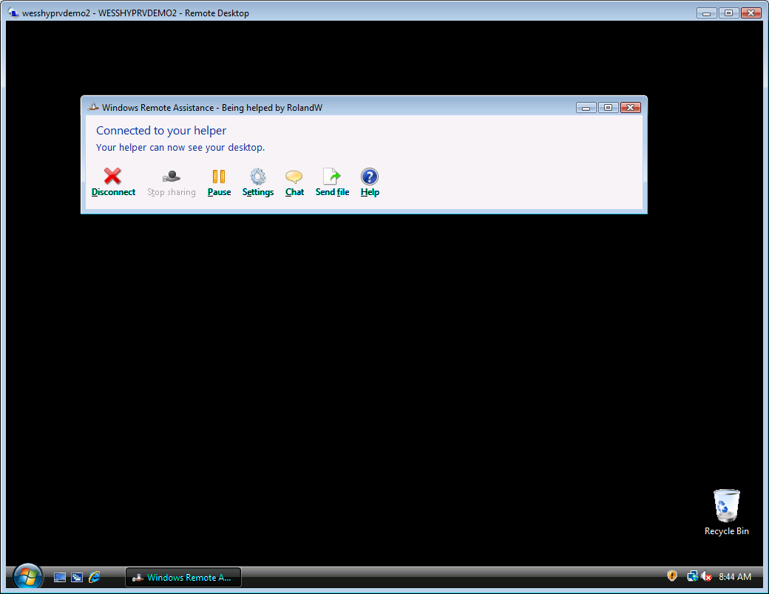
Figure 19 Remote Assistance on client
- Switch back to the SERVER VM.
- Here you see the Remote Assistance interface. From here you can control the desktop of the remote client, and send/receive chat messages and files.
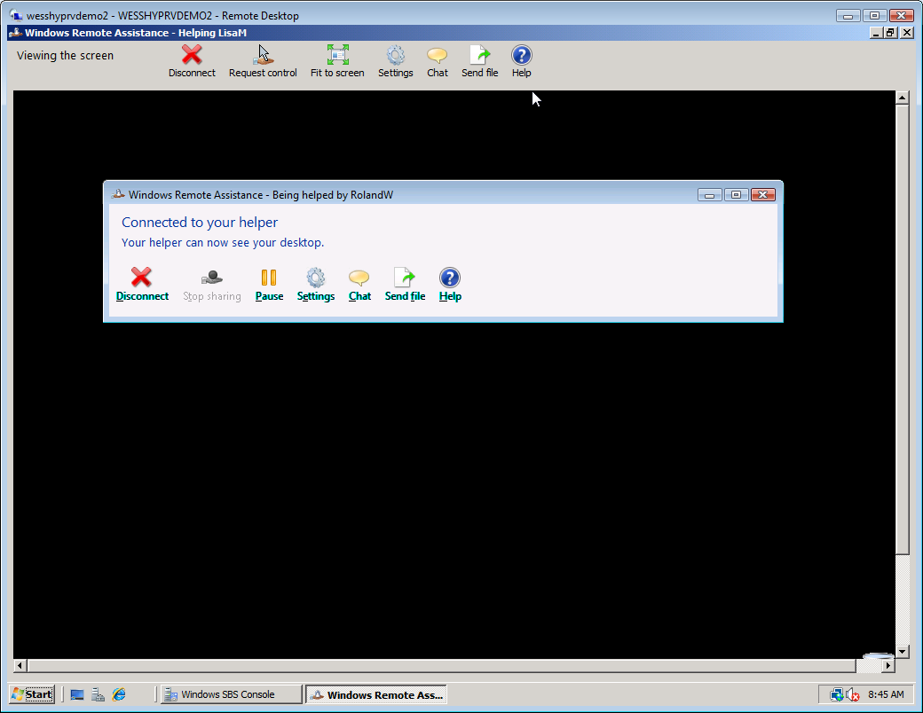
Figure 20 Remote Assistance connected
- Click Disconnect in the upper toolbar to end the Remote Assistance session (do not click the remote PC desktop, but on the toolbar at the top of the window).
- Click Yes to confirm.
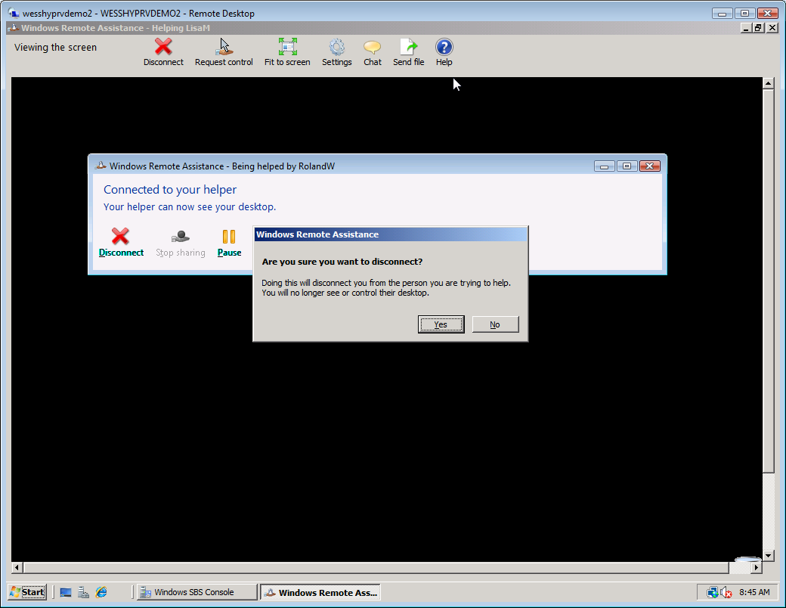
Figure 21 Remote Assistance disconnected
- Click Cancel to close the Windows Remote Assistance window.
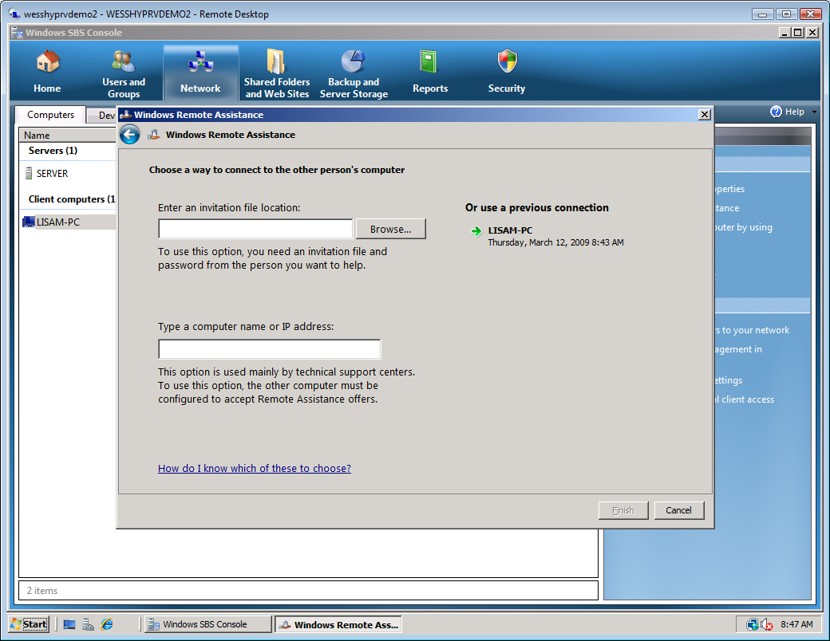
Figure 22 Windows Remote Assistance

- Task 4: Remove client from domain
- Select LisaM-PC.
- In the Tasks panel, click Remove LisaM-PC.
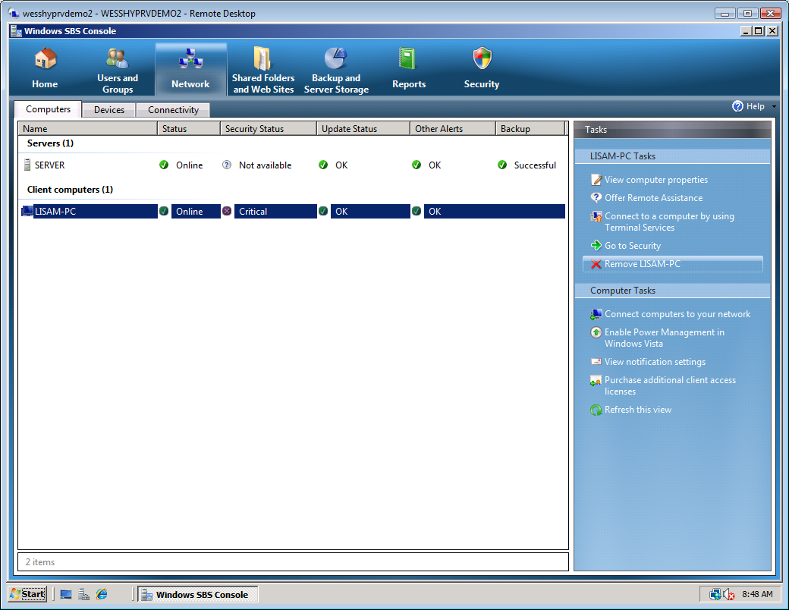
Figure 23 Remove Vista-Client
- For purposes of this lab do not remove the client from the domain.
- On the Remove LISAM-PC message, click No.
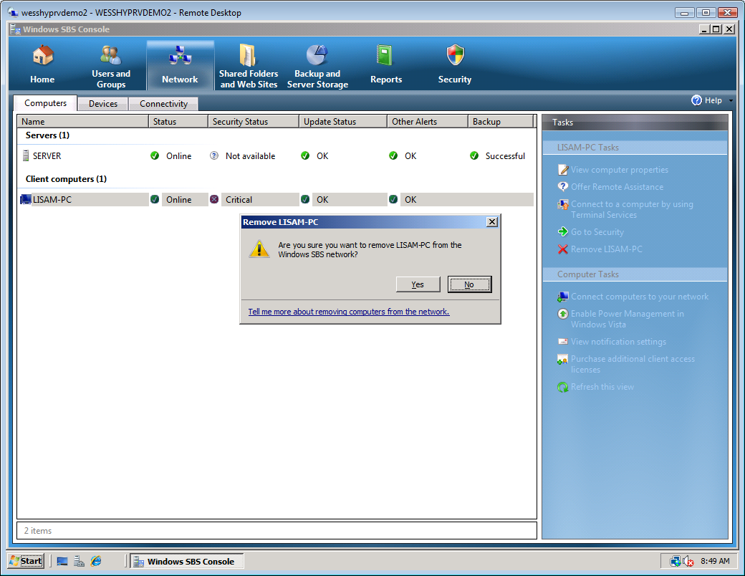
Figure 24 Remove Vista-Client prompt

Exercise 3:
Manage SBS Remote Web Workplace
Overview
In this exercise, you manage SBS 2008 Remote Web Workplace. You will learn how to complete the following tasks:
- Enable/Disable Remote Web Workplace.
- Manage user access to the Remote Web Workplace.
- Configure, enable, and disable home page links.
- Add/Remove custom links for standard users and administrators.
- Assign user access and permissions to Remote Web Workplace link lists.

- Task 1: Enable/Disable Remote Web Workplace
    - From the desktop of the SERVER VM, open the Windows SBS Console.
    - On the ribbon at the top of the Windows SBS 2008 console, click Shared Folders and Web Sites and click the Web Sites tab.
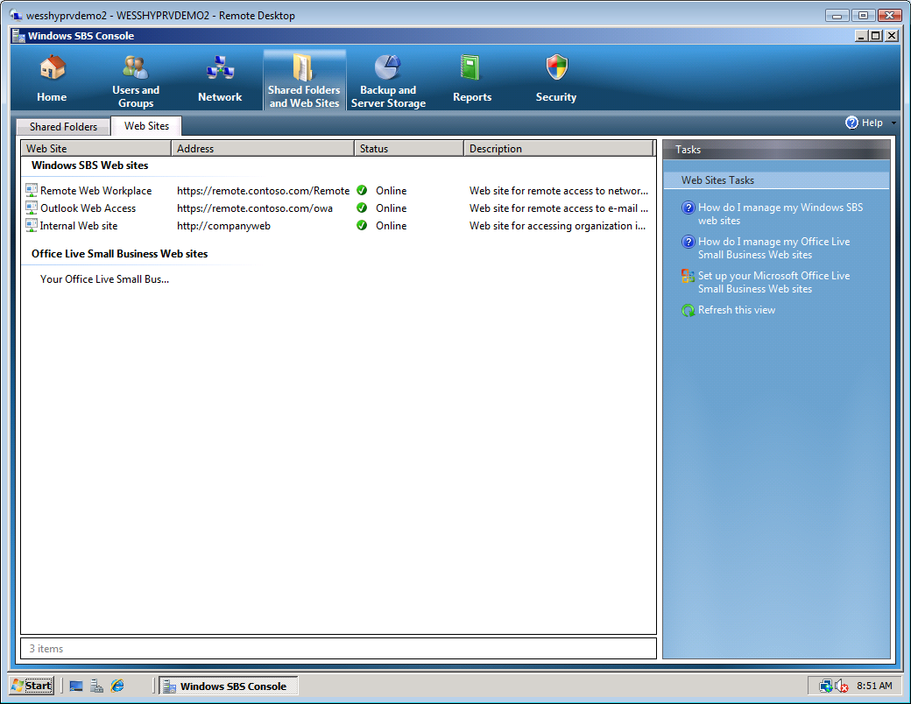
Figure 25 Shared Folders and Web Sites
    - Select Remote Web Workplace.
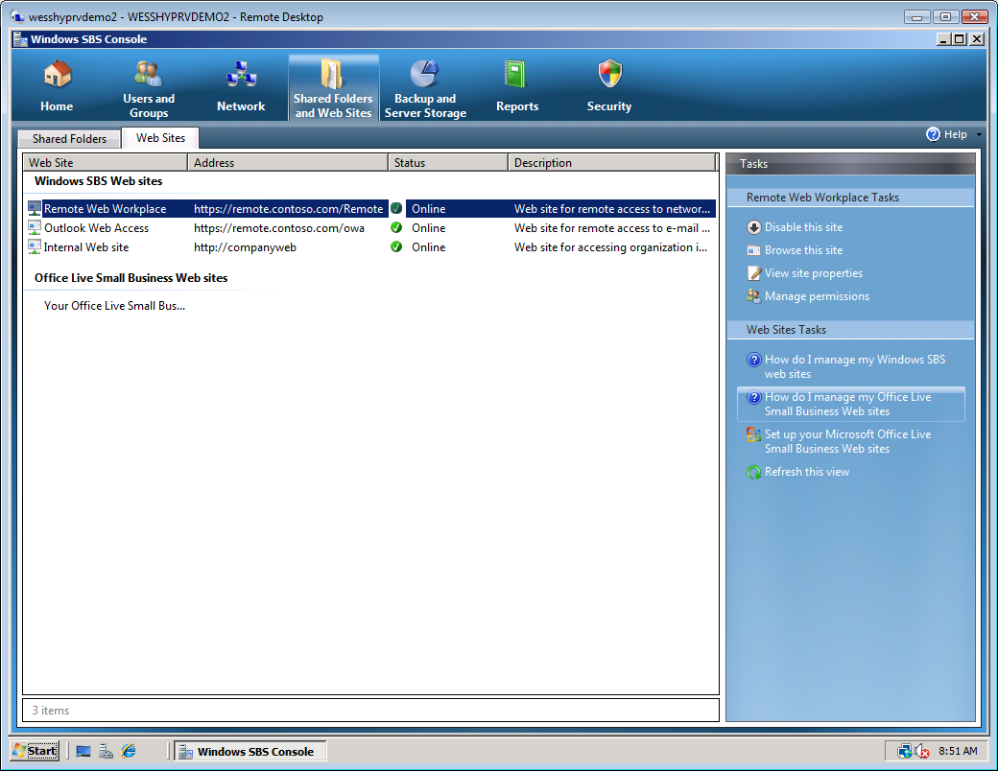
Figure 26 Remote Web Workplace

    - In the Tasks pane to the right, click Disable this site.
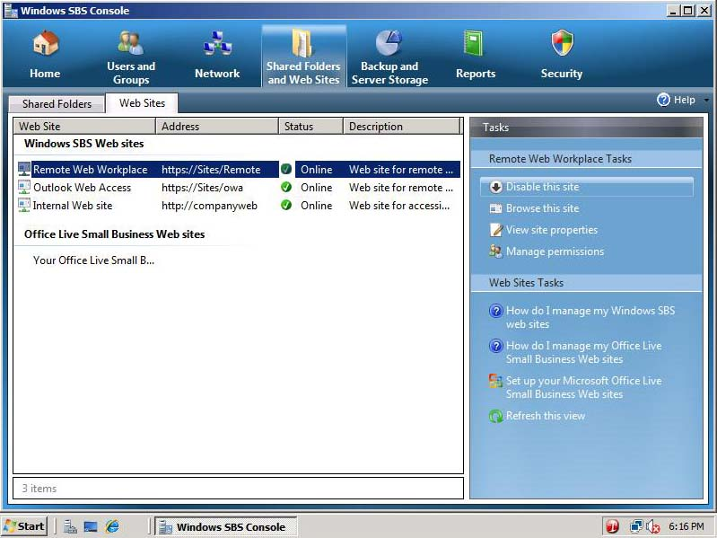
Figure 27 Disable this site
    - The Remote Web Workplace Web site is now disabled.
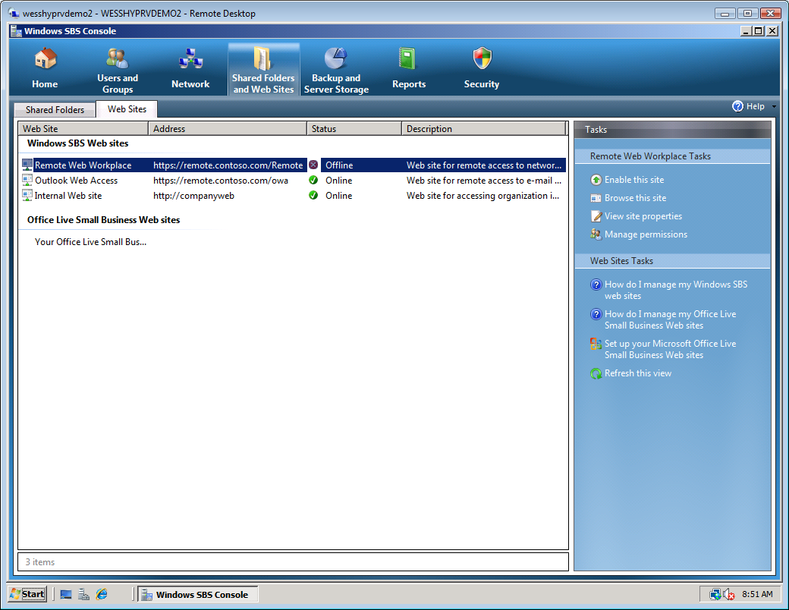
Figure 28 Enable this site
    - In the Tasks pane to the right, click Enable this site.
    - The Remote Web Workplace Web site is now enabled.

- Task 2: Manage user access to the Remote Web Workplace
    - On the ribbon at the top of the Windows SBS 2008 console, click Shared Folders and Web Sites.
    - Click the Web Sites tab and select Remote Web Workplace.
    - In the Tasks pane to the right, click Manage Permissions.
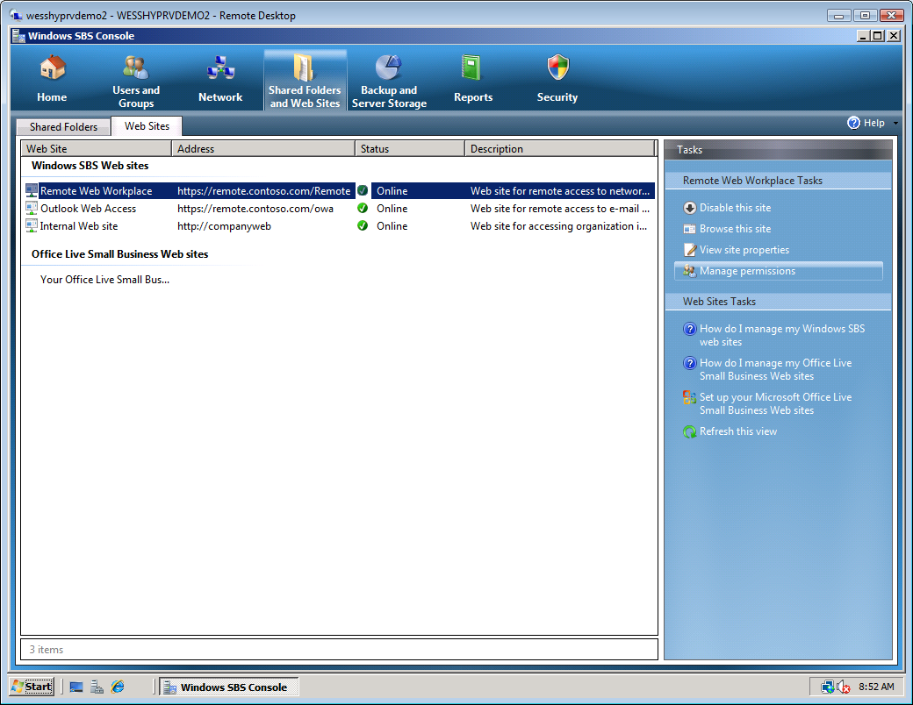
Figure 29 Manage permissions
    - In the Remote Web Workplace Properties dialog box, click Modify.
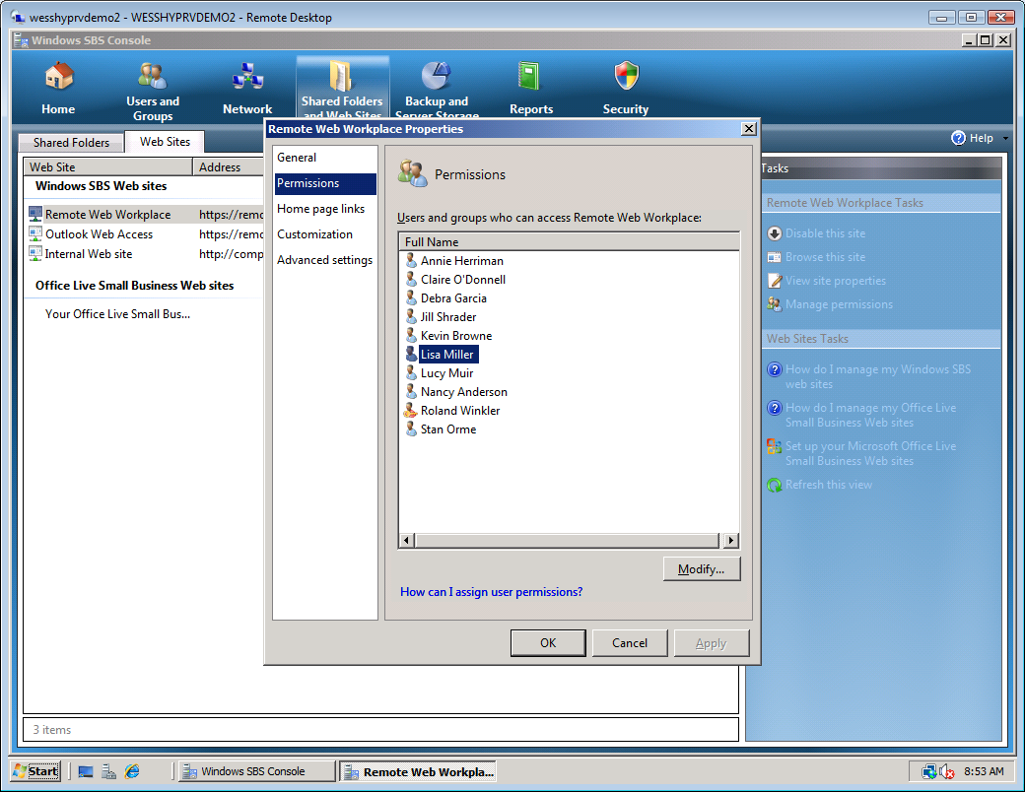
Figure 30 Remote Web Workplace permissions
    - In the Change Group Membership dialog box that appears, select Lisa Miller from the list of Group Members on the right.
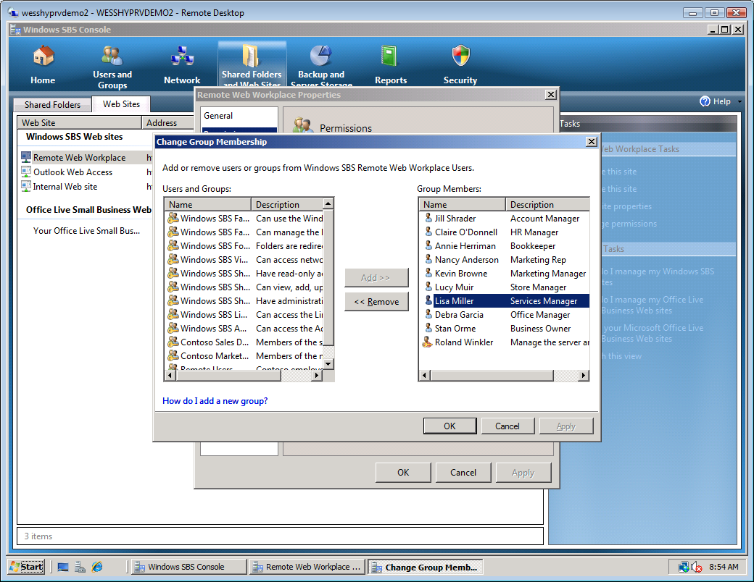
Figure 31 Change group membership page

    - Click Remove. Lisa Miller’s name is moved to the list of unassigned Users and Groups to the left.
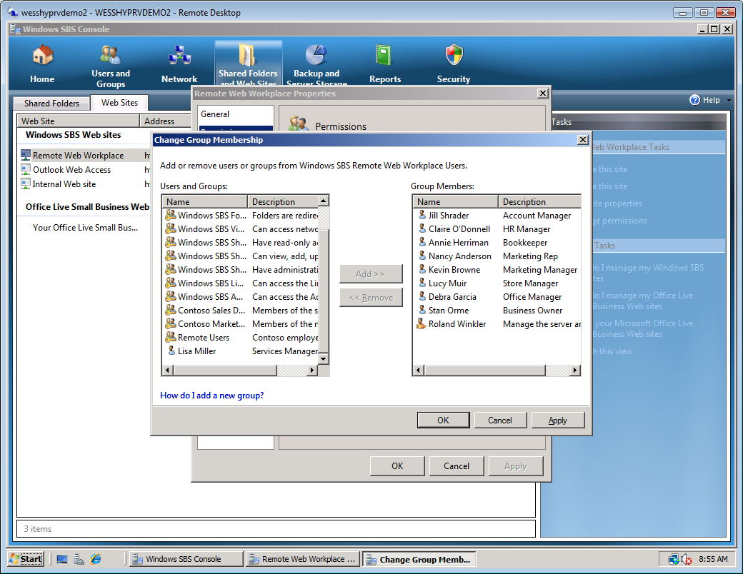
Figure 32 Change group membership page
    - Click Apply. Lisa Miller is no longer a member of the Remote Web Workplace group.
    - In the Users and Groups section on the left, select Lisa Miller.
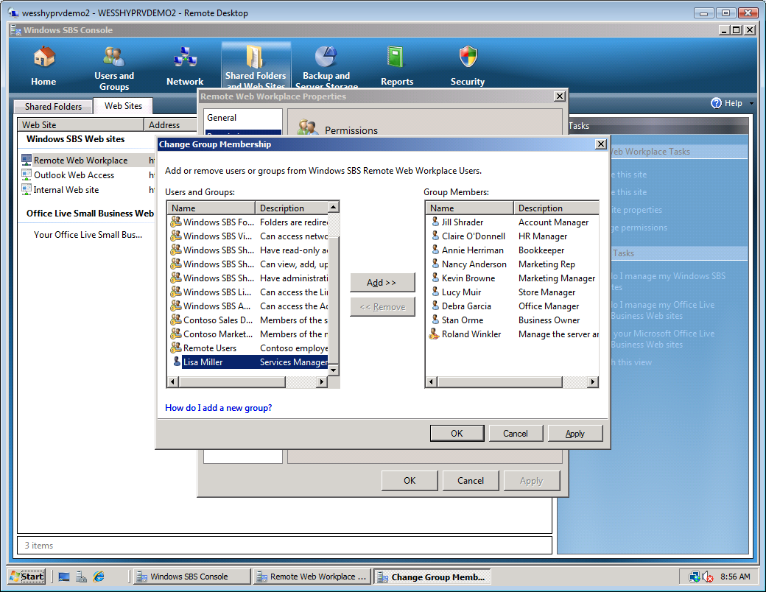
Figure 33 Change group membership page

    - Click Add. Lisa Miller’s name is moved to the list of Group Members to the right.
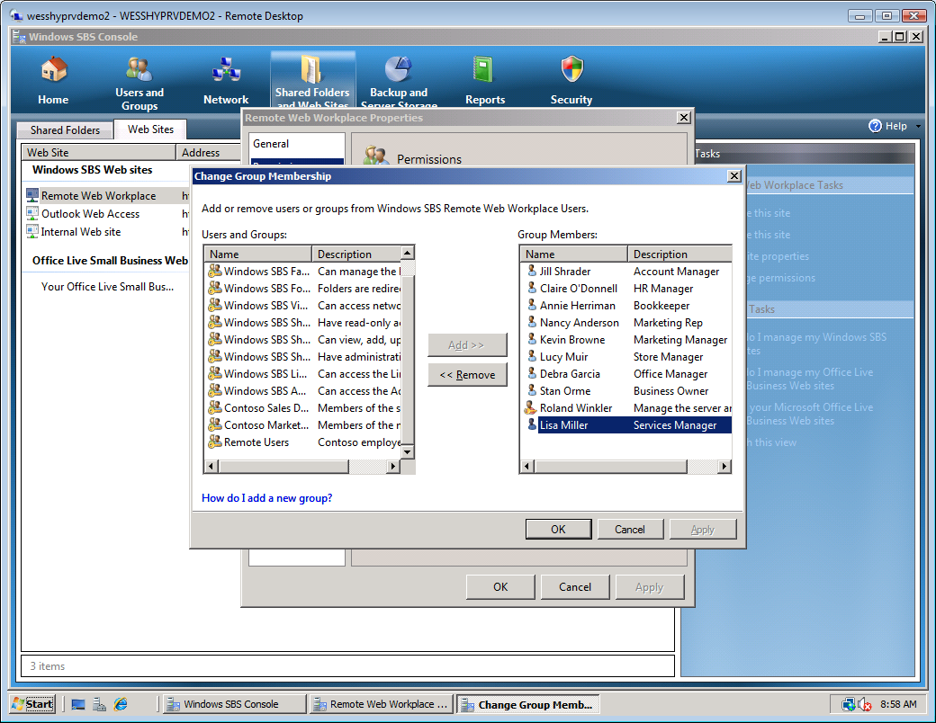
Figure 34 Change group membership page
    - Click Apply. Lisa Miller is now a member of the Remote Web Workplace group. Note that in this dialog you can select security groups, individual users, and multiple objects at a time.
    - Click OK.
    - Click OK.

- Task 3: Configure, enable, and disable home page links
The Windows SBS 2008 console should still be open from the previous task.
    - From the Web Sites tab, select Remote Web Workplace.
    - In the Tasks pane to the right, click View site properties.
    - In the Remote Web Workplace Properties dialog box, in the left column, click Home page links.
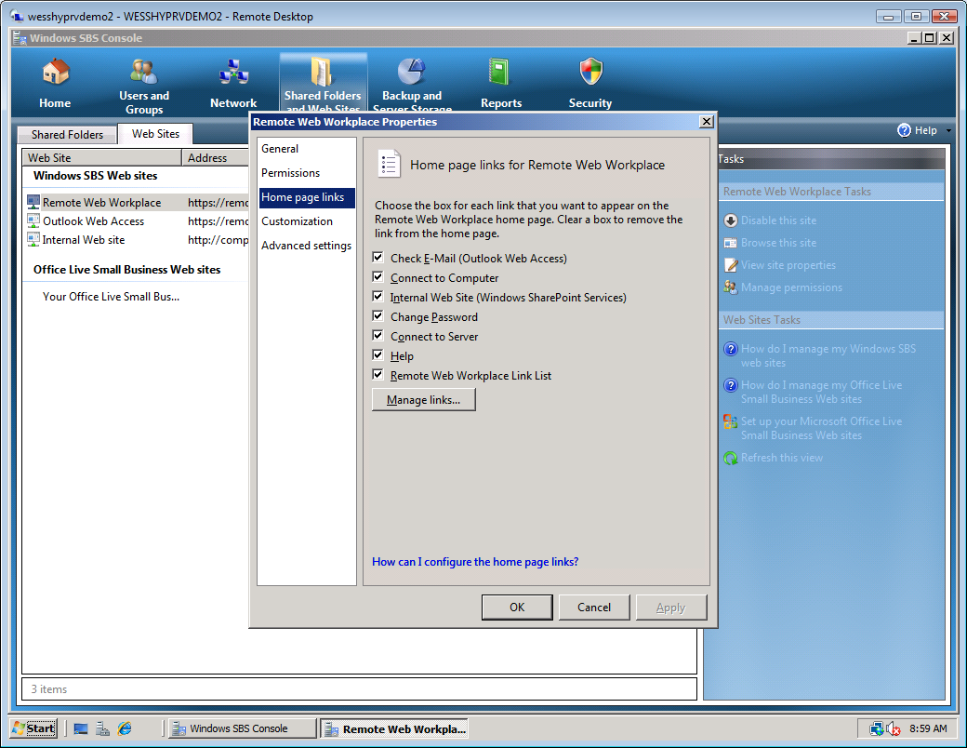
Figure 35 Home page links
    - Open Windows® Internet Explorer® and navigate to remote.contoso.com.
    - Log on with the following information:
User name: RolandW
Password: pass@word1
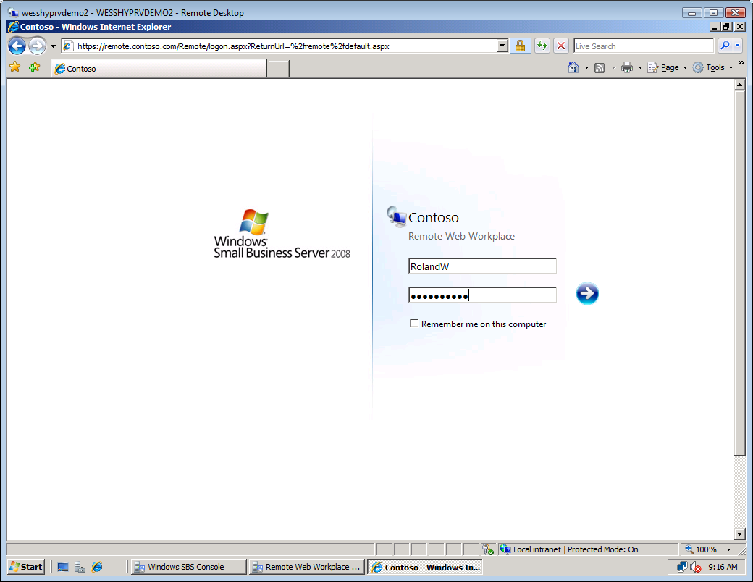
Figure 36 Remote Web Workplace log on page
    - Note the View Help link on the right side of the window.
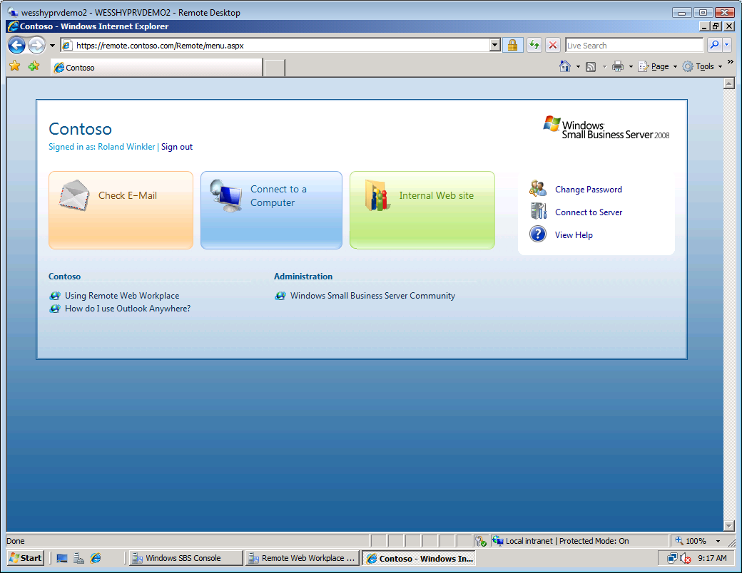
Figure 37 Remote Web Workplace home page
    - Switch back to the Remote Web Workplace Properties page.
    - Review the available Remote Web Workplace home page links. Clear the Help check box. Click Apply.
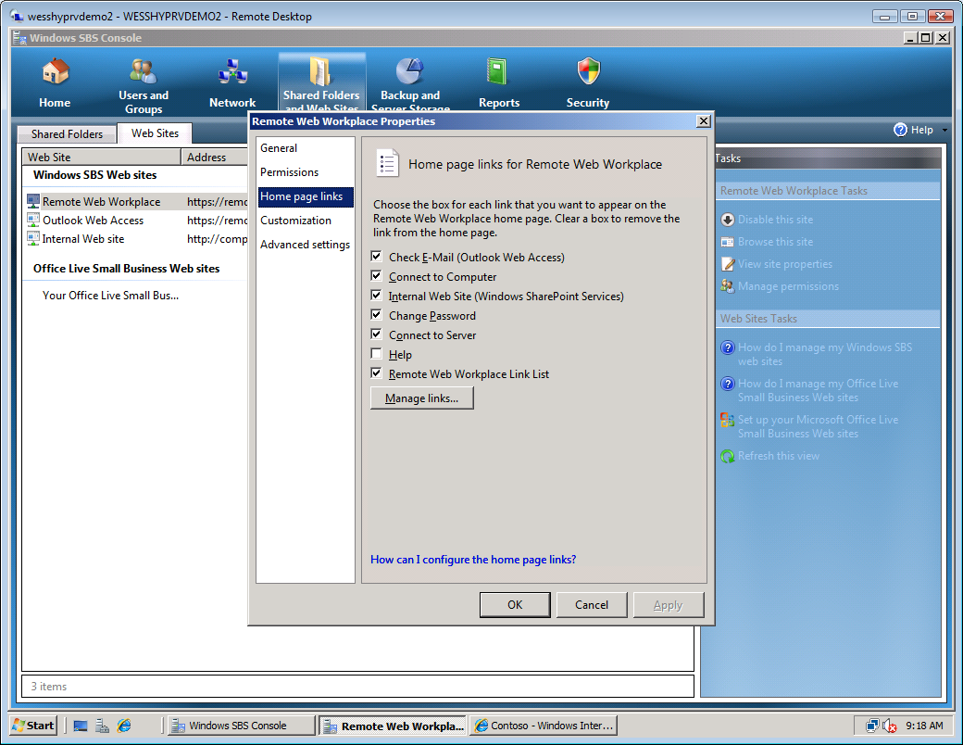
Figure 38 Remote Web Workplace Properties page
    - Switch to Internet Explorer and click Sign out.
    - Click Sign in.
    - Log on with the following information:
User name: RolandW
Password: pass@word1
    - Notice that the Help Web site link is no longer present on the Remote Web Workplace Home Page.
    - Switch back to the Remote Web Workplace Properties window and re-check the Help link. Click Apply.

- Task 4: Add/Remove custom links for standard users and administrators
    - From the Remote Web Workplace Properties dialog box, click Home Page links in the column to the left.
    - Click the Manage links button.
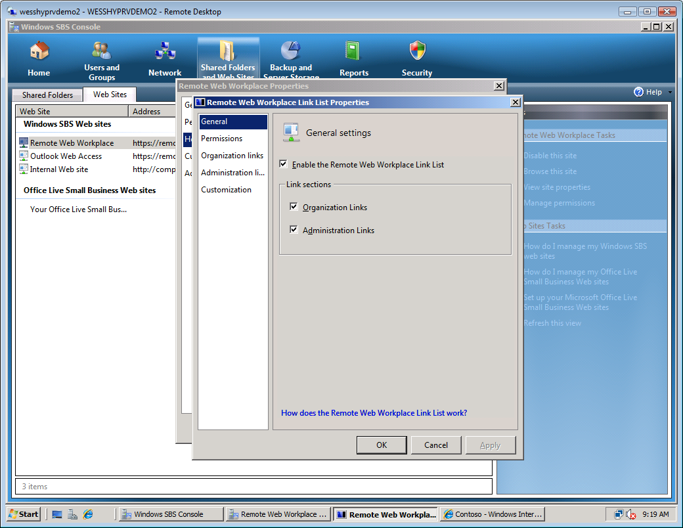
Figure 39 Remote Web Workplace Link List Properties page
    - In the column to the left, select Organization Links.
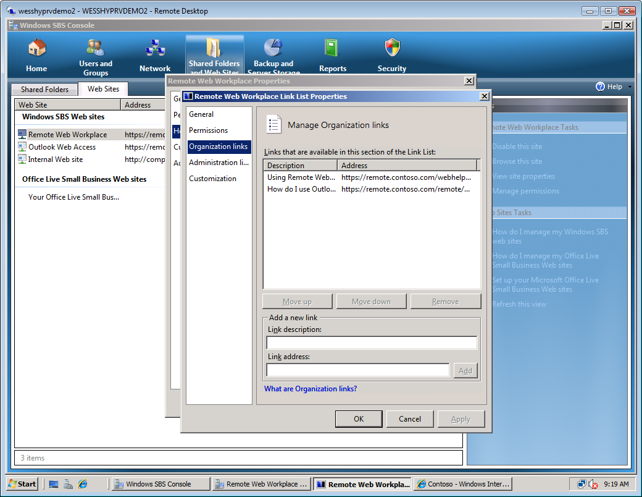
Figure 40 Manage Organization links
    - Enter the following information in the Add a new link section:
Link description: Contoso Web Site
Link address: http://www.contoso.com
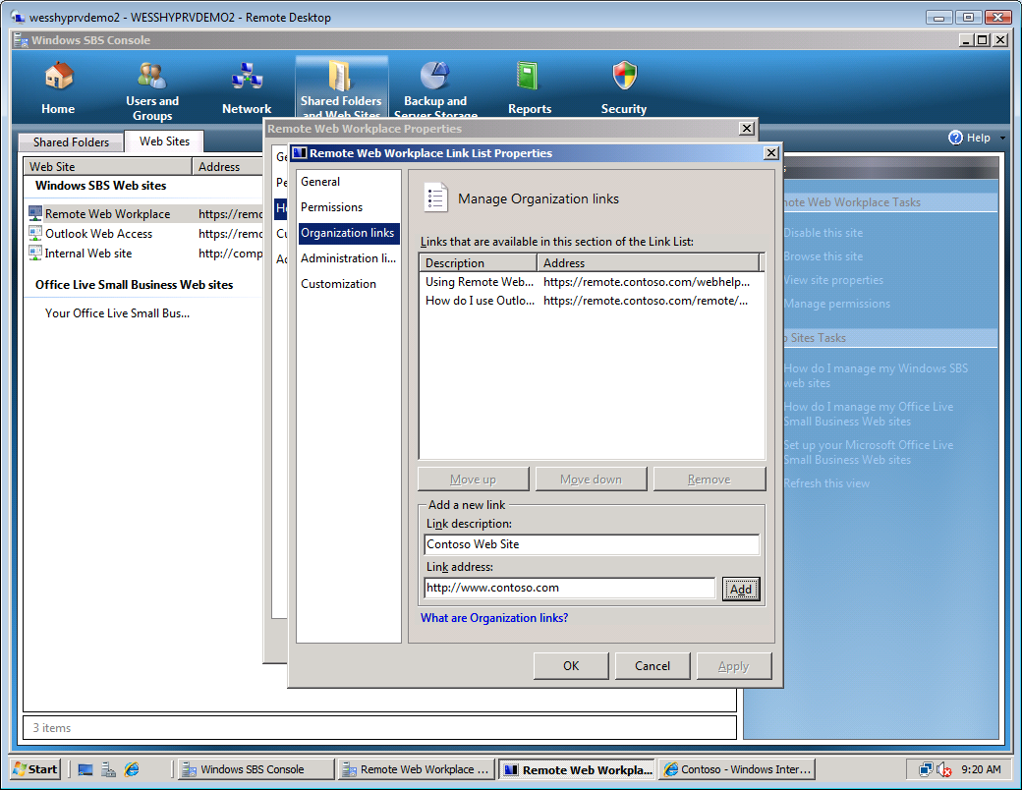
Figure 41 Add a new link section
    - Click Add.
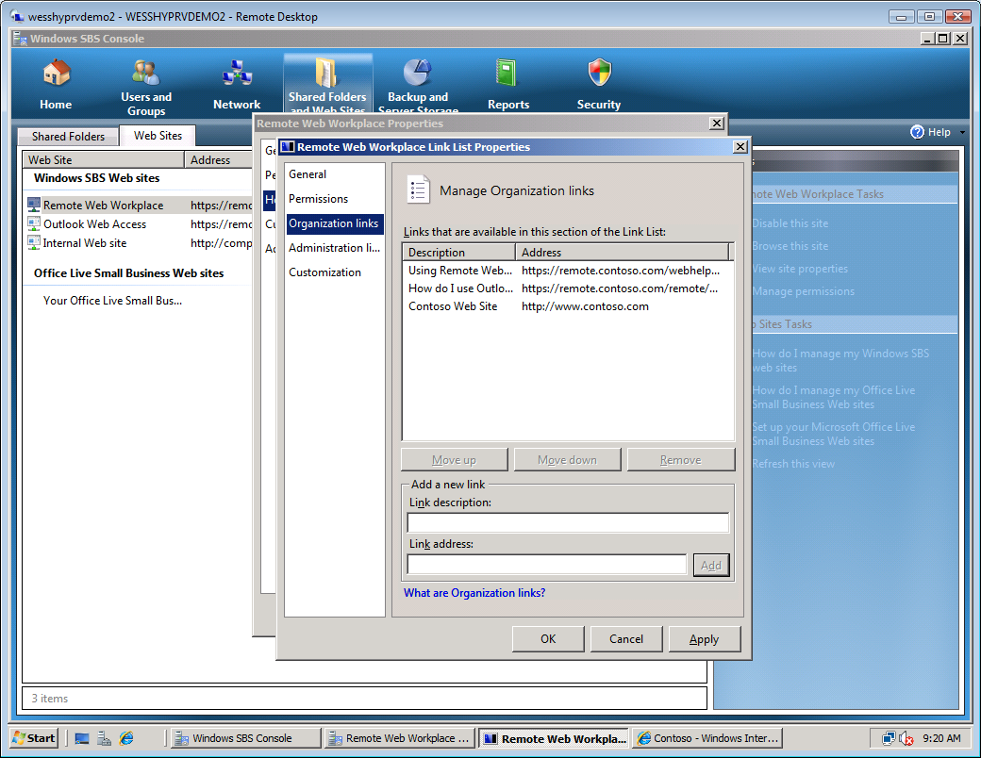
Figure 42 New link added
    - Click Apply.
    - Switch back to Internet Explorer and click Sign Out.
    - Click Sign in.
    - Log on with the following information:
User name: RolandW
Password: pass@word1
    - Notice that the Contoso Home Page link you just created is now listed on the lower left corner of the Remote Web Workplace Web site.
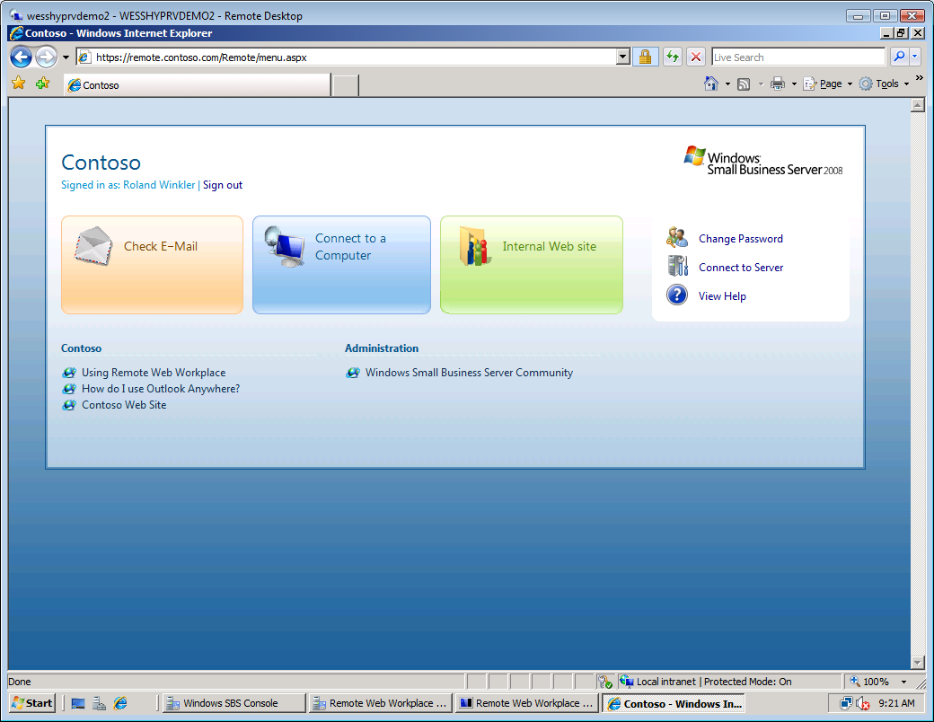
Figure 43 Remote Web Workplace home page

- Task 5: Assign user access and permissions to Remote Web Workplace link lists
The Remote Web Workplace Properties dialog box should still be open from the previous task.
    - In the column to the left, select Permissions.
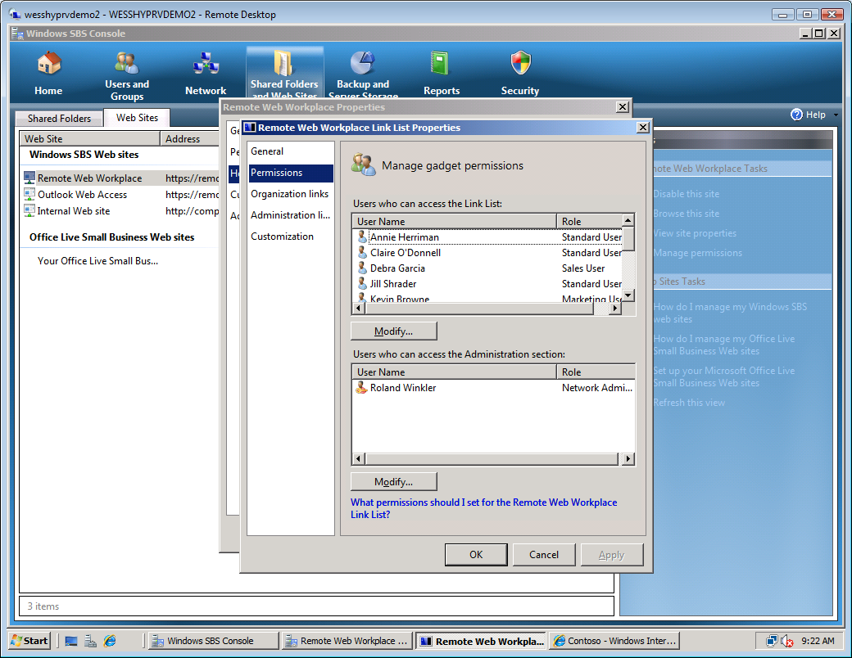
Figure 44 Remote Web Workplace Permissions page
    - Under Users who can access the Administration section, click Modify...
    - Under Users and Groups, select Stan Orme.
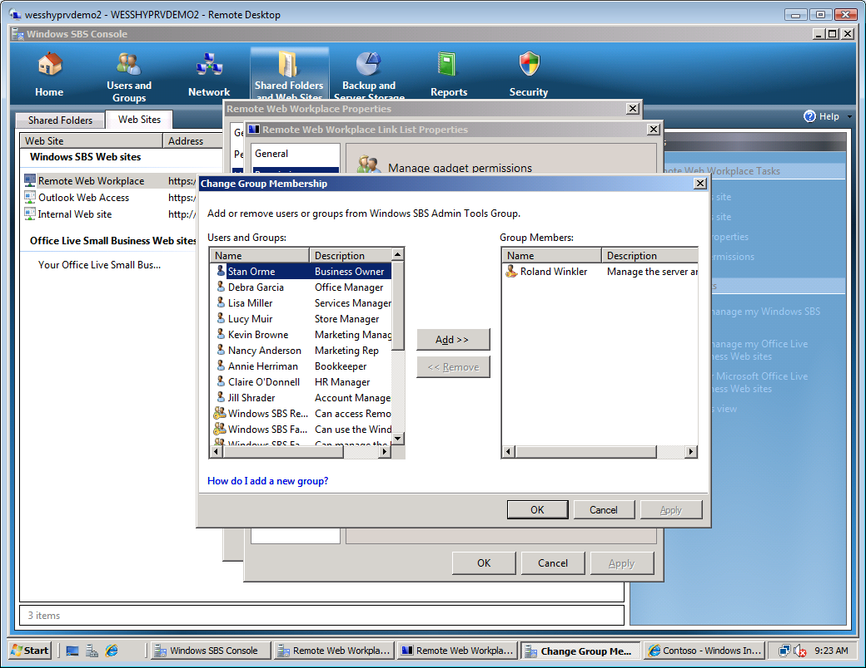
Figure 45 Change Group Membership page
    - Click Add.
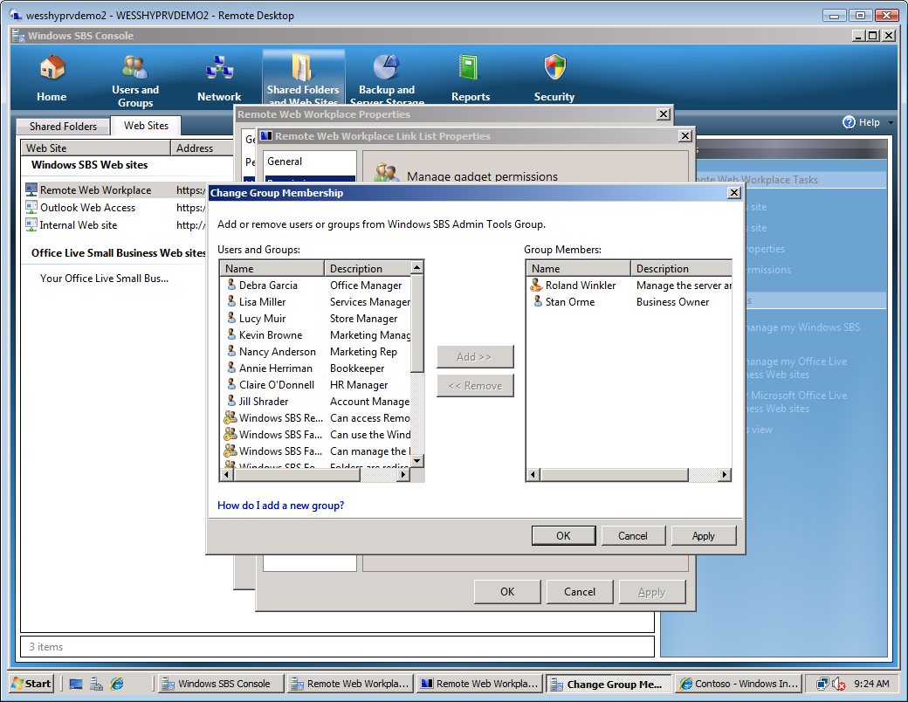
Figure 46 User added to Windows SBS Admin Tools group
    - Click OK. Stan Orme now has access to the administration section of links in the Remote Web Workplace.

Exercise 4:
Deploying Certificate to Clients
Overview
In this exercise, you deploy a certificate pack to a client. This is not required with a domain-joined client. Typically, the Install Certificate Package.zip would be distributed via e-mail, USB, or floppy disk. In this exercise, the client is on the local network and can download the package directly.
- Install certificate pack on a client PC
- Install certificate pack on a mobile device
- Task 1: Install certificate pack on a client PC
    - From the host server, switch to the Vista-Client on localhost – Virtual Machine Connection window.
    - Log on with the following information
User name: Contoso\LisaM
Password: pass@word1
    - Click Start and in the Start Search box type \\sites\public\downloads and press Enter.
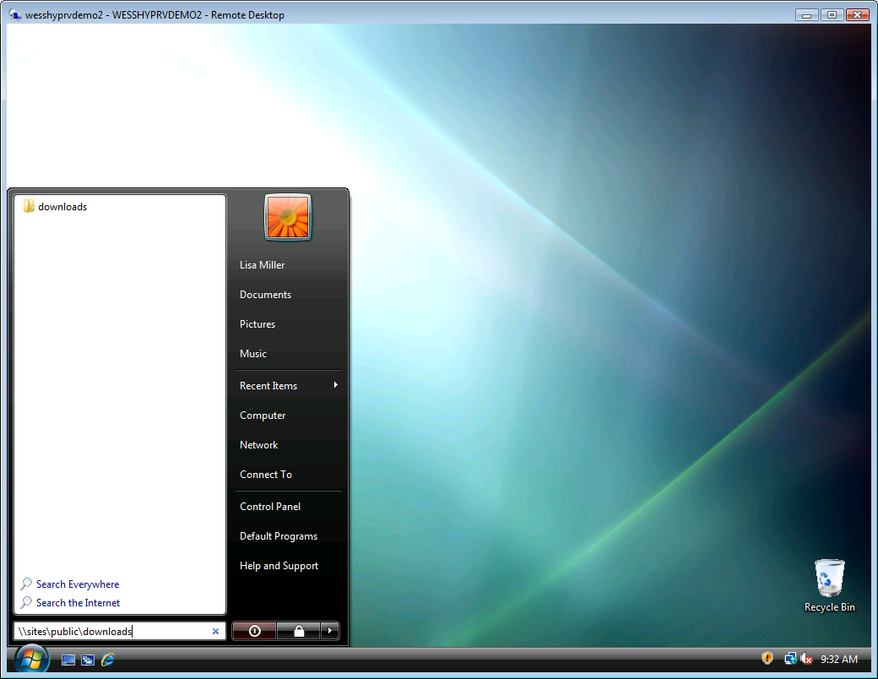
Figure 47 UNC to Certificate distribution package
    - Double-click Certificate Distribution Package folder.
    - Double-click InstallCertificate.
    - Select Install the certificate on my computer, and then click Cancel.
Note: For purposes of this lab you will not complete installation of the certificates at this time. This client already has the proper certificates installed.
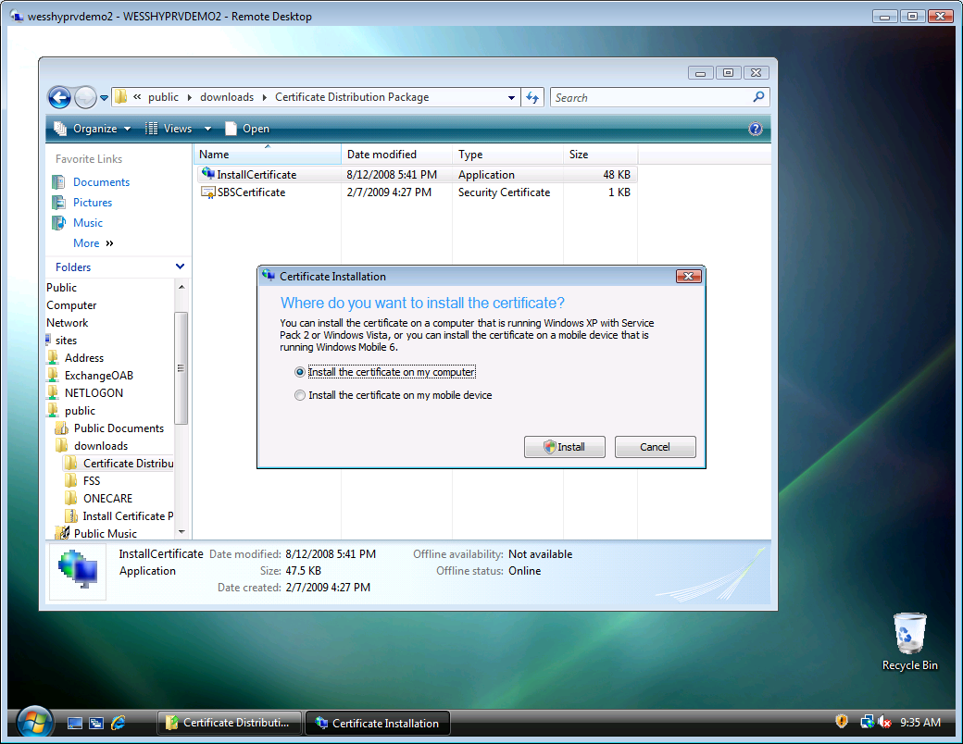
Figure 48 Certificate Installation dialog box

- Task 2: Install certificate pack on a mobile device
    - Double-click InstallCertificate.
    - Select Install the certificate on my mobile device.
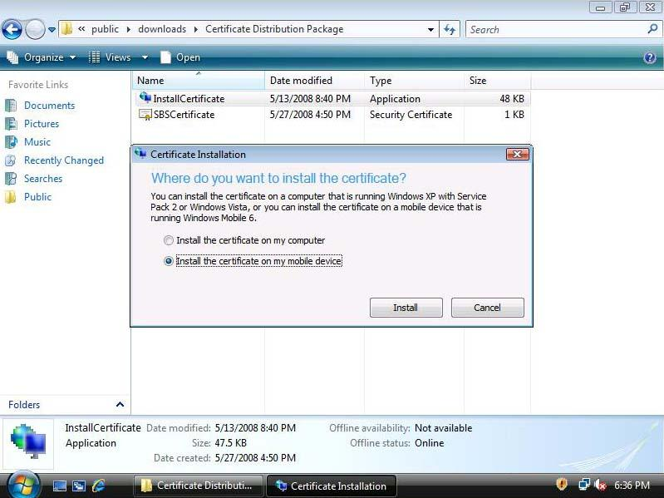
Figure 49 Certificate Installation dialog box
    - At this point you would connect your mobile device to your computer and click Install. Due to limitations on this lab, this task will not be fully completed. Click Cancel.
    - Click Start, and then pause over the arrow next to the lock. Click Log Off.

Exercise 5:
Using Remote Web Workplace
Overview
In this exercise, you explore the Remote Web Workplace interface.
- Navigate the Remote Web Workplace
- Task 1: Open Remote Web Workplace
    - From the SERVER virtual machine, browse to remote.contoso.com using Internet Explorer.
    - Log on with the following information:
User name: RolandW
Password: pass@word1
Figure 50 Remote Web Workplace log on page
    - Click Check E-mail.
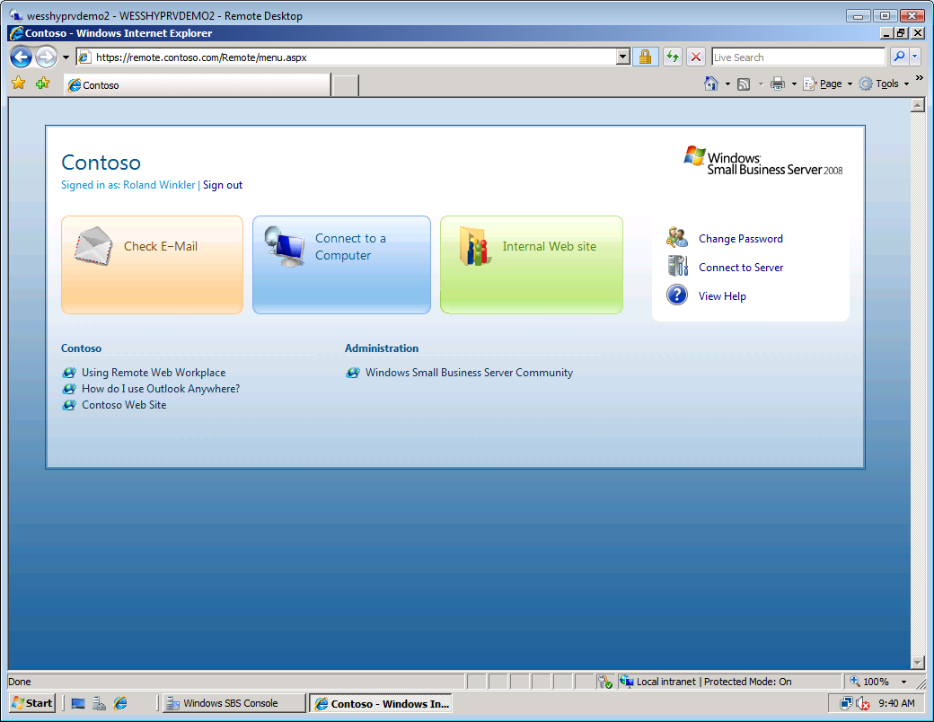
Figure 51 Check E-Mail from main RWW portal page

    - If prompted for language and time zone options, accept defaults and click OK.
    - Microsoft® Office Outlook® Web Access (OWA) is now displayed. The user is able to access e-mail from here as they would with any OWA session.
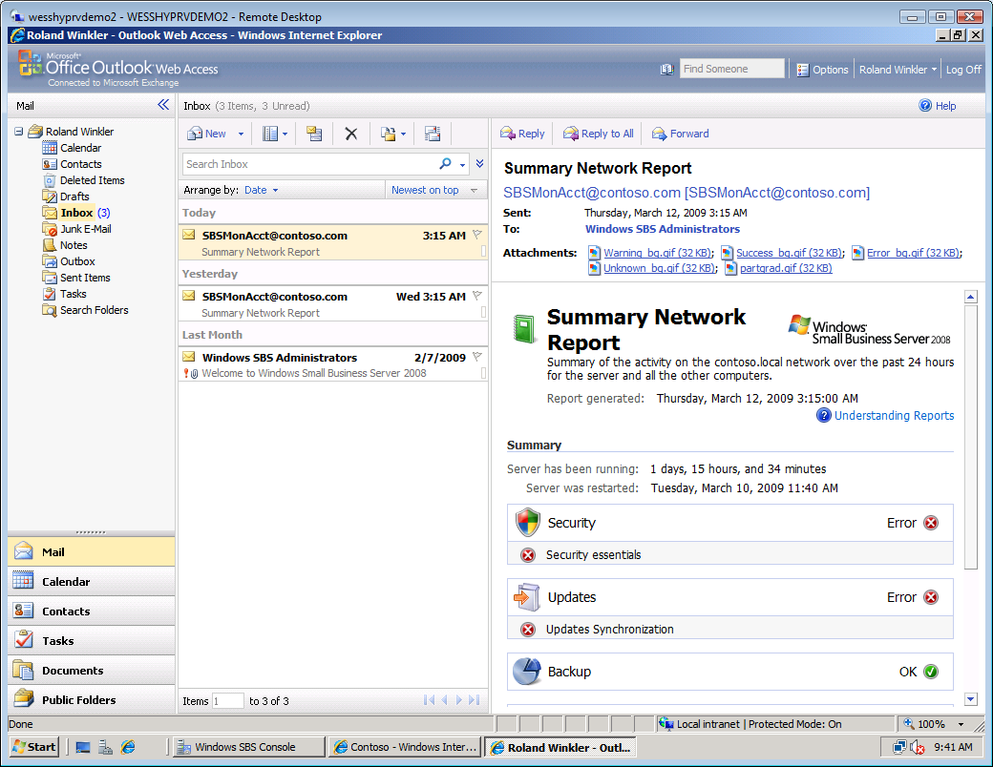
Figure 52 Outlook Web Access (OWA)
    - Close the Outlook Web Access window, or click Log Off, and then close the Outlook Web Access window.
    - Click Connect to a computer.
    - If prompted, select your client PC that you want to connect to: LisaM-PC.
Note: Normally there would be a list of computers, but for this lab there is only one PC to connect to.
    - On the Remote Desktop Connection warning dialog box, click Connect.
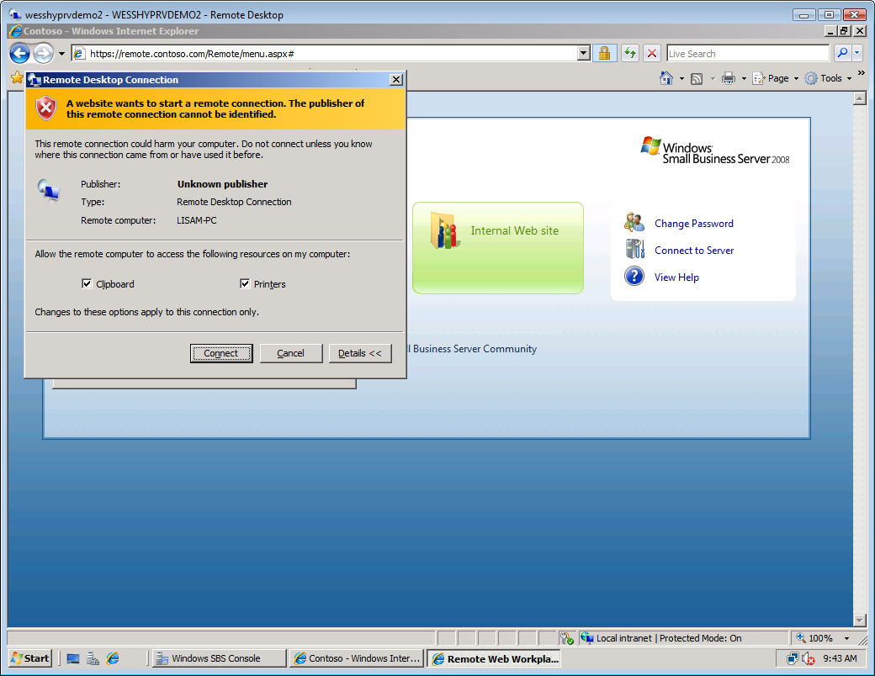
Figure 53 Remote desktop connection prompt
    - Log on to Vista-Client as CONTOSO \RolandW, password pass@word1.
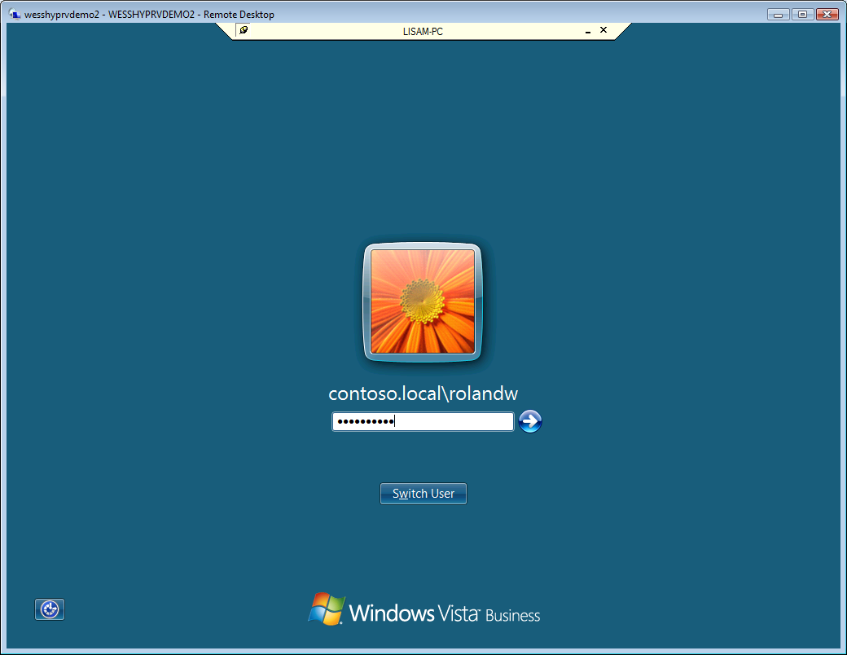
Figure 54 Remote desktop connection log on
    - Now you can access your client desktop remotely through Remote Web Workplace.
    - Click Start, pause over the right arrow, and then select Log Off .
    - Click Internal Web Site. A new window opens, displaying the internal Companyweb Web site.
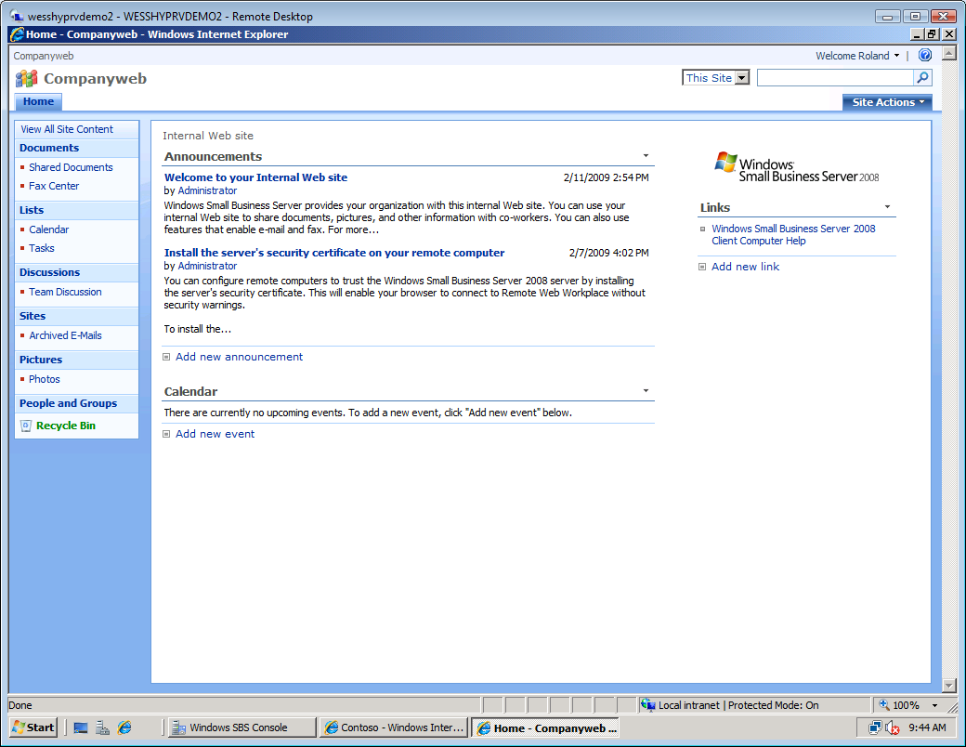
Figure 55 CompanyWeb
    - Close the CompanyWeb window.
    - Click Change Password. Here you can update your domain password.
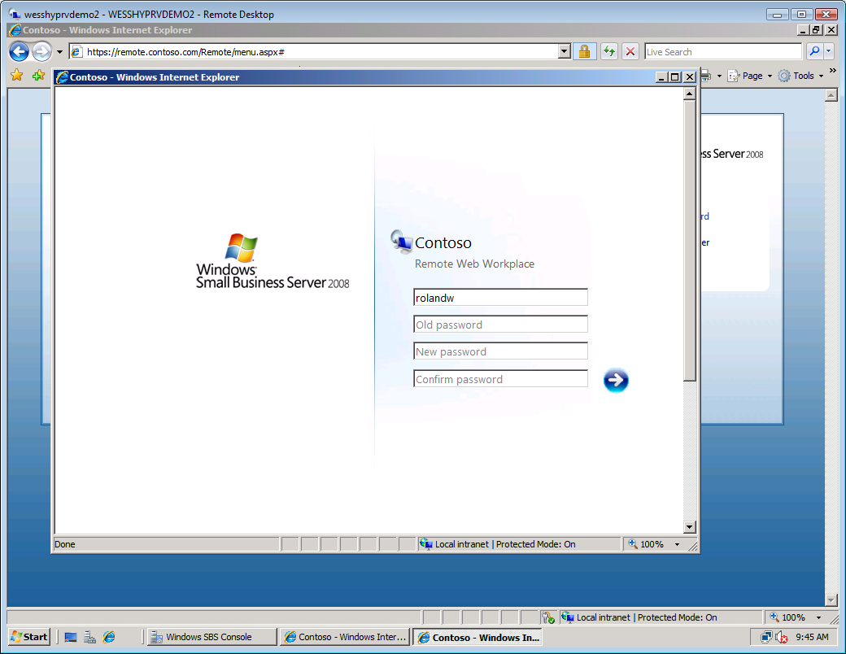
Figure 56 Remote Web Workplace change password page
    - Close the Change Password window.

End of Lab

