

Virtualization for Windows:
A Technology Overview

 David Chappell, Chappell & Associates
July 2007

© Copyright Microsoft Corporation 2007. All rights reserved.

Contents
Understanding Virtualization 3
Virtualization Technologies 3
Hardware Virtualization 4
Presentation Virtualization 5
Application Virtualization 7
Other Virtualization Technologies 8
Managing a Virtualized World 9
Microsoft Virtualization Technologies 10
Hardware Virtualization 10
Virtual Server 2005 R2 10
Virtual PC 2007 11
Looking Ahead: Windows Server Virtualization 12
Presentation Virtualization 13
Windows Server 2003 Terminal Services 13
Looking Ahead: Windows Server 2008 Terminal Services 15
Application Virtualization: SoftGrid Application Virtualization 16
Managing a Virtualized Windows Environment 18
System Center Operations Manager 2007 18
System Center Configuration Manager 2007 20
System Center Virtual Machine Manager 2007 21
Combining Virtualization Technologies 23
Conclusion 25
About the Author 25

Understanding Virtualization
Virtualization is unquestionably one of the hottest trends in information technology today. This is no accident. While a variety of technologies fall under the virtualization umbrella, all of them are changing the IT world in significant ways.
This overview introduces Microsoft’s virtualization technologies, focusing on three areas: hardware virtualization, presentation virtualization, and application virtualization. Since every technology, virtual or otherwise, must be effectively managed, this discussion also looks at Microsoft’s management products for a virtual world. The goal is to make clear what these offerings do, describe a bit about how they do it, and show how they work together.

Virtualization Technologies
To understand modern virtualization technologies, think first about a system without them. Imagine, for example, an application such as Microsoft Word running on a standalone desktop computer. Figure 1 shows how this looks.
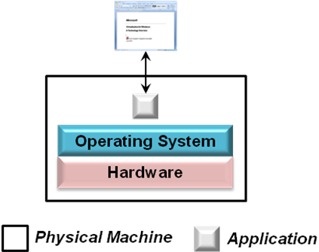
Figure 1: A system without virtualization
The application is installed and runs directly on the operating system, which in turn runs directly on the computer’s hardware. The application’s user interface is presented via a display that’s directly attached to this machine. This simple scenario is familiar to anybody who’s ever used Windows.
But it’s not the only choice. In fact, it’s often not the best choice. Rather than locking these various parts together—the operating system to the hardware, the application to the operating system, and the user interface to the local machine—it’s possible to loosen the direct reliance these parts have on each other.
Doing this means virtualizing aspects of this environment, something that can be done in various ways. The operating system can be decoupled from the physical hardware it runs on using hardware virtualization, for example, while application virtualization allows an analogous decoupling between the operating system and the applications that use it. Similarly, presentation virtualization allows separating an application’s user interface from the physical machine the application runs on. All of these approaches to virtualization help make the links between components less rigid. This lets hardware and software be used in more diverse ways, and it also makes both easier to change. Given that most IT professionals spend most of their time working with what’s already installed rather than rolling out new deployments, making their world more malleable is a good thing.
Each type of virtualization also brings other benefits specific to the problem it addresses. Understanding what these are requires knowing more about the technologies themselves. Accordingly, the next sections take a closer look at each one.

Hardware Virtualization
For most IT people today, the word “virtualization” conjures up thoughts of running multiple operating systems on a single physical machine. This is hardware virtualization, and while it’s not the only important kind of virtualization, it is unquestionably the most visible today.
The core idea of hardware virtualization is simple: Use software to create a virtual machine (VM) that emulates a physical computer. By providing multiple VMs at once, this approach allows running several operating systems simultaneously on a single physical machine. Figure 2 shows how this looks.
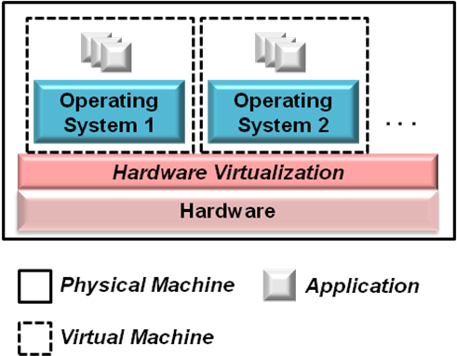
Figure 2: Illustrating hardware virtualization
When used on client machines, this approach is often called desktop virtualization, while using it on server systems is known as server virtualization. Desktop virtualization can be useful in a variety of situations. One of the most common is to deal with incompatibility between applications and desktop operating systems. For example, suppose a user running Windows Vista needs to use an application that runs only on Windows XP with Service Pack 2. By creating a VM that runs this older operating system, then installing the application in that VM, this problem can be solved.
Still, while desktop virtualization is useful, the real excitement around hardware virtualization is focused on servers. The primary reason for this is economic: Rather than paying for many under-utilized server machines, each dedicated to a specific workload, server virtualization allows consolidating those workloads onto a smaller number of more fully used machines. This implies fewer people to manage those computers, less space to house them, and fewer kilowatt hours of power to run them, all of which saves money.
Server virtualization also makes restoring failed systems easier. VMs are stored as files, and so restoring a failed system can be as simple as copying its file onto a new machine. Since VMs can have different hardware configurations from the physical machine on which they’re running, this approach also allows restoring a failed system onto any available machine. There’s no requirement to use a physically identical system.
Hardware virtualization can be accomplished in various ways, and so Microsoft offers three different technologies that address this area:
- Virtual Server 2005 R2: This technology provides hardware virtualization on top of Windows via add-on software. As its name suggests, Virtual Server provides server virtualization, targeting scalable multi-user scenarios.
- Virtual PC 2007: Like Virtual Server, this technology also provides hardware virtualization on top of Windows via add-on software. Virtual PC provides desktop virtualization, however, and so it’s designed to support multiple operating systems on a single-user computer.
- Windows Server virtualization: Like Virtual Server, Windows Server virtualization provides server virtualization. Rather than relying on an add-on, however, support for hardware virtualization is built directly into Windows itself. Windows Server virtualization is part of Windows Server 2008, and it’s scheduled to ship shortly after the release of this new operating system.
All of these technologies are useful in different situations, and all are described in more detail later in this overview.

Presentation Virtualization
Many of the applications people use most are designed to both run and present their user interface on the same machine. Microsoft Office is one common example, but there are plenty of others. While accepting this default is fine much of the time, it’s not without some downside. For example, organizations that manage many desktop machines must make sure that any sensitive data on those desktops is kept secure. They’re also obliged to spend significant amounts of time and money managing the applications resident on those machines. Letting an application execute on a remote server, yet display its user interface locally—presentation virtualization—can help. Figure 3 shows how this looks.
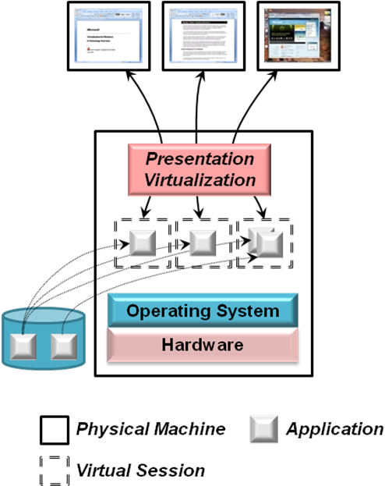
Figure 3: Illustrating presentation virtualization
As the figure shows, this approach allows creating virtual sessions, each interacting with a remote desktop system. The applications executing in those sessions rely on presentation virtualization to project their user interfaces remotely. Each session might run only a single application, or it might present its user with a complete desktop offering multiple applications. In either case, several virtual sessions can use the same installed copy of an application.
Running applications on a shared server like this offers several benefits, including the following:
- Data can be centralized, storing it safely on a central server rather than on multiple desktop machines. This improves security, since information isn’t spread across many different systems.
- The cost of managing applications can be significantly reduced. Instead of updating each application on each individual desktop, for example, only the single shared copy on the server needs to be changed. Presentation virtualization also allows using simpler desktop operating system images or specialized desktop devices, commonly called thin clients, both of which can lower management costs.
- Organizations need no longer worry about incompatibilities between an application and a desktop operating system. While desktop virtualization can also solve this problem, as described earlier, it’s sometimes simpler to run the application on a central server, then use presentation virtualization to make the application accessible to clients running any operating system.
- In some cases, presentation virtualization can improve performance. For example, think about a client/server application that pulls large amounts of data from a central database down to the client. If the network link between the client and the server is slow or congested, this application will also be slow. One way to improve its performance is to run the entire application—both client and server—on a machine with a high-bandwidth connection to the database, then use presentation virtualization to make the application available to its users.
Microsoft’s presentation virtualization technology is Windows Terminal Services. First released for Windows NT 4, it’s now a standard part of Windows Server 2003. Terminal Services lets an ordinary Windows desktop application run on a shared server machine yet present its user interface on a remote system, such as a desktop computer or thin client. While remote interfaces haven’t always been viewed through the lens of virtualization, this perspective can provide a useful way to think about this widely used technology.

Application Virtualization
Virtualization provides an abstracted view of some computing resource. Rather than run directly on a physical computer, for example, hardware virtualization lets an operating system run on a software abstraction of a machine. Similarly, presentation virtualization lets an application’s user interface be abstracted to a remote device. In both cases, virtualization loosens an otherwise tight bond between components.
Another bond that can benefit from more abstraction is the connection between an application and the operating system it runs on. Every application depends on its operating system for a range of services, including memory allocation, device drivers, and much more. Incompatibilities between an application and its operating system can be addressed by either hardware virtualization or presentation virtualization, as described earlier. But what about incompatibilities between two applications installed on the same instance of an operating system? Applications commonly share various things with other applications on their system, yet this sharing can be problematic. For example, one application might require a specific version of a dynamic link library (DLL) to function, while another application on that system might require a different version of the same DLL. Installing both applications leads to what’s commonly known as DLL hell, where one of them overwrites the version required by the other. To avoid this, organizations often perform extensive testing before installing a new application, an approach that’s workable but time-consuming and expensive.
Application virtualization solves this problem by creating application-specific copies of all shared resources, as Figure 4 illustrates. The problematic things an application might share with other applications on its system—registry entries, specific DLLs, and more—are instead packaged with it, creating a virtual application. When a virtual application is deployed, it uses its own copy of these shared resources.

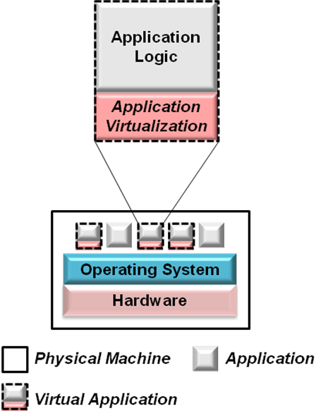
Figure 4: Illustrating application virtualization
Application virtualization makes deployment significantly easier. Since applications no longer compete for DLL versions or other shared aspects of their environment, there’s no need to test new applications for conflicts with existing applications before they’re rolled out. And as Figure 4 suggests, these virtual applications can run alongside ordinary applications—not everything needs to be virtualized.
SoftGrid Application Virtualization is Microsoft’s technology for this area. A SoftGrid administrator can create virtual applications, then deploy those applications as needed. By providing an abstracted view of key parts of the system, application virtualization reduces the time and expense required to deploy and update applications.

Other Virtualization Technologies
This overview looks at three kinds of virtualization: hardware, presentation, and application. Similar kinds of abstraction are also used in other contexts, however. Among the most important are network virtualization and storage virtualization.
The term network virtualization is used to describe a number of different things. Perhaps the most common is the idea of a virtual private network (VPN). VPNs abstract the notion of a network connection, allowing a remote user to access an organization’s internal network just as if she were physically attached to that network. VPNs are a widely implemented idea, and they can use various technologies. In the Microsoft world, the primary VPN technologies today are Internet Security and Acceleration (ISA) Server 2006 and Internet Application Gateway 2007.
The term storage virtualization is also used quite broadly. In a general sense, it means providing a logical, abstracted view of physical storage devices, and so anything other than a locally attached disk drive might be viewed in this light. A simple example is folder redirection in Windows, which lets the information in a folder be stored on any network-accessible drive. Much more powerful (and more complex) approaches also fit into this category, including storage area networks (SANs) and others. However it’s done, the benefits of storage virtualization are analogous to those of every other kind of virtualization: more abstraction and less direct coupling between components.

Managing a Virtualized World
Virtualization technologies provide a range of benefits. Yet as an organization’s computing environment gets more virtualized, it also gets more abstract. Increasing abstraction can increase complexity, making it harder for IT staff to control their world. The corollary is clear: If a virtualized world isn’t managed well, its benefits can be elusive.
For example, think about what happens when the workloads of several existing server machines are moved into virtual machines running on a single server. That one physical computer is now as important to the organization as were all of the machines it replaced. If it fails, havoc will ensue. A virtualized world that isn’t well-managed can be less reliable and perhaps even more expensive than its non-virtualized counterpart.
To address this, Microsoft provides a family of tools for systems management. To a large degree, the specifics of managing a virtualized world are the same as those of managing a physical world, and so the same tools can be used. This is a good thing, since it lets the people who manage the environment use the same skills and knowledge for both. Still, there are cases where a tool focused explicitly on virtualization makes sense. With System Center Operations Manager 2007, System Center Configuration Manager 2007, and System Center Virtual Machine Manager 2007, Microsoft provides products addressing both situations.
A fundamental concern in systems management is monitoring and managing the hardware and software in a distributed environment. System Center Operations Manager 2007 is Microsoft’s flagship product for addressing this concern. By allowing operations staff to monitor both the software running on physical machines and the physical machines themselves, Operations Manager lets them know what’s happening in their environment. It also lets these people respond appropriately, running tasks and taking other actions to fix problems that occur. Given the strong similarities between physical and virtual environments, Operations Manager can also be used to monitor and manage virtual machines and other aspects of a virtualized world.
Another unavoidable concern for people who manage a distributed environment is installing software and managing how that software is configured. While it’s possible to perform these tasks by hand, automated solutions are a much better approach in all but the smallest environments. To allow this, Microsoft provides System Center Configuration Manager 2007. Like Operations Manager, Configuration Manager handles virtual environments in much the same way as physical environments. Once again, the same tool can be used for both situations.
Both Operations Manager and Configuration Manager are intended for larger organizations with more specialized IT staffs. What about mid-size companies? While using these two products together is certainly possible, Microsoft also provides a simpler tool for less complex environments. This tool, System Center Essentials 2007, implements the most important functions of both Operations Manager and Configuration Manager. Like its big brothers, it views virtual technologies much like physical systems, and so it can also be used to manage both.
Tools that work in both the physical and virtual worlds are attractive. Yet think about an environment that has dozens or even hundreds of VMs installed. How are these machines created? How are they destroyed? And how are other VM-specific management functions performed? Addressing these questions requires a tool that’s focused specifically on managing hardware virtualization. For VMs running on Virtual Server 2005, that tool is System Center Virtual Machine Manager 2007. Among other things, this tool helps operations staff choose workloads for virtualization, create the VMs that will run those workloads, and transfer the applications to their new homes.
Understanding the big picture of virtualization requires seeing how a virtualized environment can be managed. It also requires understanding the virtualization technologies themselves, however. To help with this, the next section takes a closer look at each of Microsoft’s virtualization offerings.

Microsoft Virtualization Technologies
Every virtualization technology abstracts a computing resource in some way to make it more useful. Whether the thing being abstracted is a computer, an application’s user interface, or the environment that application runs in, virtualization boils down to this core idea. And while all of these technologies are important, it’s fair to say that hardware virtualization gets the most attention today. Accordingly, it’s the place to begin this technology tour.

Hardware Virtualization
Most trends in computing depend on an underlying megatrend: the exponential growth in processing power described by Moore’s Law. One way to think of this growth is to realize that in the next two years, processor capability will increase by as much as it has since the dawn of computing. Given this rate of increase, keeping machines busy gets harder and harder. Combine this with the difficulty of running different workloads provided by different applications on a single operating system, and the result is lots of under-utilized servers. Each one of these server machines costs money to buy, house, and operate, and so a technology for increasing server utilization would be very attractive.
Hardware virtualization is that technology, and it is unquestionably very attractive. While hardware virtualization is a 40-year-old idea, it’s just now becoming a major part of mainstream computing environments. In the not-too-distant future, expect to see the majority of applications deployed on virtualized servers rather than dedicated physical machines. The benefits are too great to ignore.
To let Windows customers reap these benefits, Microsoft today provides two hardware virtualization technologies: Virtual Server 2005 R2 for servers and Virtual PC 2007 for desktops. After the release of Windows Server 2008, Microsoft will also provide Windows Server virtualization for that system. The following sections provide a brief description of each of these technologies.

Virtual Server 2005 R2
One way to support multiple virtual machines on a single physical machine is to run virtualization software largely on top of the operating system. Writing this software is challenging, especially for older processors that don’t provide built-in support for hardware virtualization. Yet it’s a viable solution, one that’s proven quite successful in practice. One example of this success is Virtual Server 2005 R2, a freely available technology for Windows Server 2003. Figure 5 illustrates how Virtual Server supports multiple virtual machines on a single physical machine.
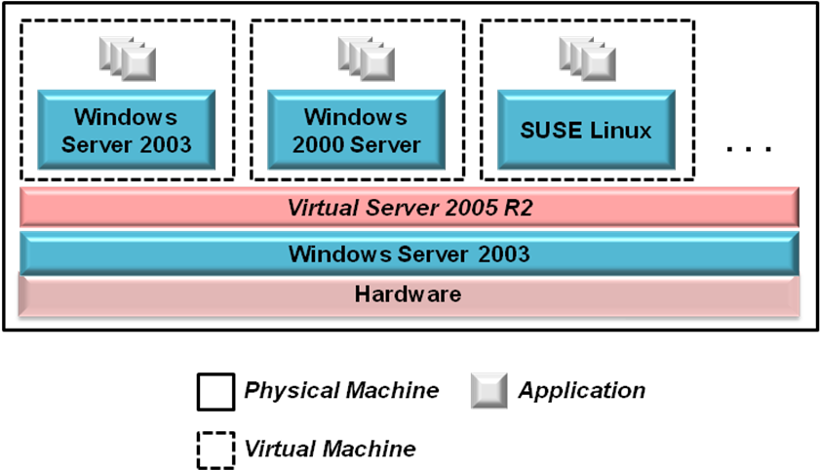
Figure 5: Illustrating Virtual Server 2005 R2
As the figure shows, Virtual Server runs on Windows Server 2003. It provides virtual machines, each of which supports its own guest operating system. Every VM is completely isolated from its fellows, allowing the workload on each one to execute as if it were running on its own physical server. Virtual Server also provides a browser-based tool to manage its VMs.
Virtual Server can host several different x86 operating systems. The list of supported guests includes Windows Server 2003, Windows Server 2000, Windows NT 4.0, and other Windows versions. It also includes SUSE Linux and Red Hat Linux, reflecting the realities of customer data centers.
Whatever guest operating systems are running, all of them require storage. To allow this, Microsoft has defined a virtual hard disk (VHD) format. A VHD is really just a file, but to a virtual machine, it appears to be an attached disk drive. Guest operating systems and their applications rely on one or more VHDs for storage. In fact, all of Microsoft’s hardware virtualization technologies use the same VHD format, making it easier to move information among them. To encourage industry adoption, Microsoft has included the VHD specification under its Open Specification Promise (OSP), making this format freely available for others to implement.

Virtual PC 2007
The most commercially important aspect of hardware virtualization today is the ability to consolidate workloads from multiple physical servers onto one machine. Yet it can also be useful to run guest operating systems on a desktop machine. Virtual PC 2007 is designed for this situation.
Virtual PC is architecturally much like Virtual Server. Both are available as free downloads, both run largely on top of another operating system, and both can host a variety of x86 operating systems. Both also use the same VHD format for storage. Yet the products have important differences, as well. Because it’s intended for servers, Virtual Server is significantly more scalable than Virtual PC, and it supports a wider array of storage options. Virtual Server also includes administrative tools that target professional IT staff, while Virtual PC is designed to be managed by users. While Virtual PC does provide a few things that are lacking in Virtual Server, such as sound card support, it’s fair to think of it as offering a simpler approach to hardware virtualization for desktop users.

Looking Ahead: Windows Server Virtualization
Virtual Server 2005 R2 is used successfully today in a range of organizations. Yet as with most technologies, experience leads to better approaches. Windows Server virtualization, the built-in technology for hardware virtualization in Windows Server 2008, is a good example of this kind of progress. As Figure 6 shows, this new approach differs from Virtual Server in some important ways.
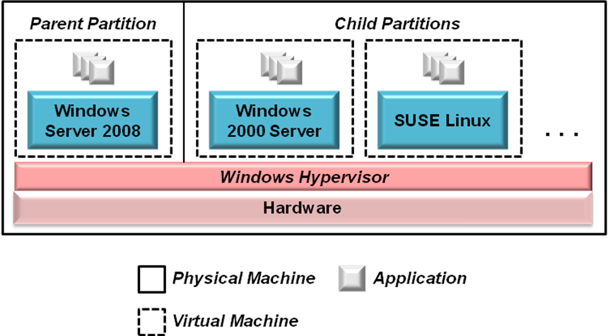
Figure 6: Illustrating Windows Server virtualization
Rather than adding virtualization code largely on top of Windows, as Virtual Server does, Windows Server virtualization makes supporting virtual machines part of Windows itself. This new approach provides a hypervisor that runs directly on the hardware. One or more partitions can then be created on top of the hypervisor, each providing a VM. One of these, the parent partition, must run Windows Server 2008. Child partitions (which are really just virtual machines) can run any other supported operating system, including various Windows versions and Linux distributions such as SUSE Linux. To create and manage new partitions, an administrator can use an MMC snap-in running in the parent partition.
This approach is fundamentally different from Microsoft’s earlier technologies for hardware virtualization. One important difference is that the low-level support provided by the Windows hypervisor lets virtualization be done in a more efficient way, providing better performance. Windows Server virtualization also improves over Virtual Server in other ways, including the following:
- Because Windows Server virtualization is a native 64-bit technology, it supports a much larger physical memory space than the 32-bit Virtual Server. This is a useful thing when many virtual machines are running on a single physical server. Windows Server virtualization also allows the VMs themselves to have more memory, with an upper limit greater than 32 gigabytes per virtual machine.
- While Virtual Server supports only 32-bit virtual machines, Windows Server virtualization supports both 32-bit and 64- bit VMs. VMs of both types can run simultaneously on a single Windows Server 2008 machine.
- Rather than supporting a single CPU per virtual machine, as does Virtual Server, Windows Server virtualization allows assigning multiple CPUs to a single VM.
Windows Server 2008 has an installation option called Server Core, in which only a limited subset of the system’s functions is installed. This reduces both the management effort and the possible security threats for this system, and it’s the recommended choice for servers that deploy Windows Server virtualization. Systems that use this option have no graphical user interface support, however, and so they can’t run the Windows Server virtualization management snap-in locally. Instead, VM management can be done remotely using Virtual Machine Manager. It’s also possible to deploy Windows Server 2008 in a traditional non-virtualized configuration. If this is done, the Windows hypervisor isn’t installed, and the operating system runs directly on the hardware.
Windows Server virtualization is scheduled to ship within 180 days after the release of Windows Server 2008. This technology will be available for all three 64-bit editions of this new operating system: Standard, Enterprise, and Data Center. And because Windows Server virtualization uses the same VHD format as Virtual Server 2005 R2, migrating workloads from this earlier technology is relatively straightforward.
Hardware virtualization is a mainstream technology today. Microsoft’s decision to make it a fundamental part of Windows only underscores its importance. After perhaps the longest adolescence in computing history, this useful idea has at last reached maturity.

Presentation Virtualization
Windows Terminal Services has been available for several years, and it’s not always been seen as a virtualization technology. Yet viewing it in this light is useful, if only because this perspective helps clarify what’s really happening: A resource is being abstracted, offering only what’s needed to its user. Just as hardware virtualization offers an operating system only what it needs—the illusion of real hardware—presentation virtualization offers a user what she really needs: a user interface. This section provides a brief description of Windows Terminal Services, looking at both the 2003 and 2008 versions of the technology.

Windows Server 2003 Terminal Services
Software today typically interacts with people through a screen, keyboard, and mouse. To accomplish this, an application can provide a graphical user interface for a local user. Yet there are plenty of situations where letting the user access a remote application as if it were local is a better approach. Making the application’s user interface available remotely—presentation virtualization—is an effective way to do this. As Figure 7 shows, the purpose of Windows Server 2003 Terminal Services is to make this possible.
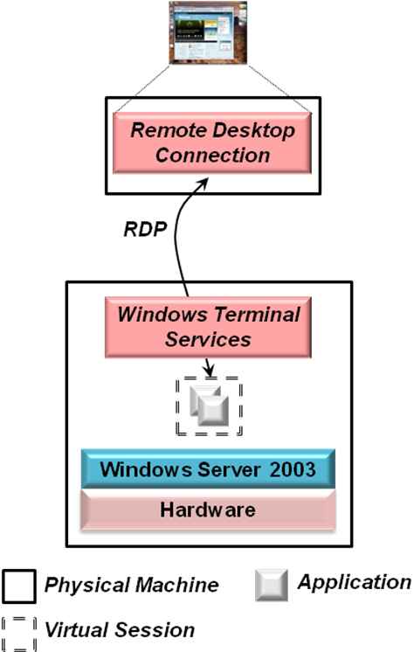
Figure 7: Illustrating Windows Server 2003 Terminal Services
Terminal Services works with standard Windows applications—no changes are required. Instead, an entire desktop, complete with all application user interfaces, is presented across a network by the Remote Desktop Connection. Running on a client machine, this software communicates with Terminal Services using the Remote Desktop Protocol (RDP), sending only key presses, mouse movements, and screen data. This minimalist approach lets RDP work over low-bandwidth connections such as dial-up lines. RDP also encrypts traffic, allowing more secure access to applications.
The Remote Desktop Connection runs on Windows XP and Windows Vista, and earlier versions of Windows also provide Terminal Services clients. Other client options are possible as well, including Pocket PCs and the Apple Macintosh. And for browser access, a client supporting RDP is available as an ActiveX control, allowing Web-based access to applications.
Presentation virtualization moves most of the work an application does from a user’s desktop to a shared server. Giving users the responsiveness they expect can require significant processing resources, especially in a large environment. To help make this possible, Terminal Services allows creating server farms that spread the processing load across multiple machines. Terminal Services can also keep track of where a user is connected, then let him reconnect to that same system if the user disconnects or the connection is unexpectedly lost.

Looking Ahead: Windows Server 2008 Terminal Services
Along with Windows Server virtualization and more, Windows Server 2008 includes a new version of Windows Terminal Services. This next release adds several useful capabilities to this technology. Figure 8 shows perhaps the most important of these, a facility known as Terminal Servers (TS) RemoteApp.
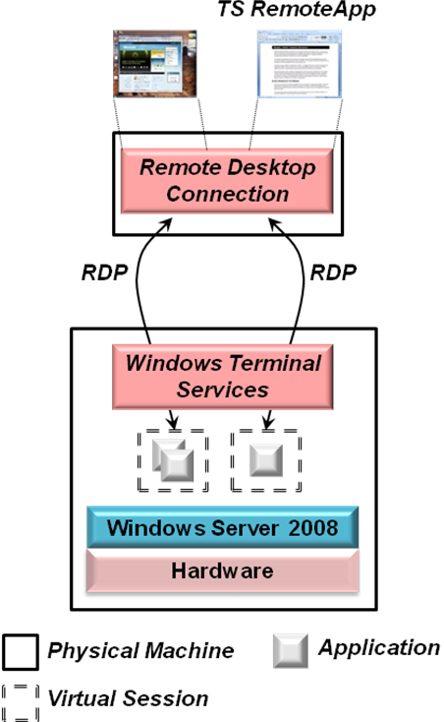
Figure 8: Illustrating TS RemoteApp in Windows Server 2008 Terminal Services
As in Windows Server 2003, a user of Windows Server 2008 Terminal Services can create a virtual session with a complete desktop. While this is the only choice in the 2003 release, the new TS RemoteApp capability also lets a 2008 user create a virtual session containing just a single remote application, as the figure shows. If a Windows user creates a virtual session with a complete desktop, that desktop and all of its applications appear in a window on top of her local desktop. With TS RemoteApp, however, the application’s user interface appears on her local desktop just as if the application were running locally. In fact, an application accessed via TS RemoteApp appears in the Task Bar like a local application, and it can also be launched like one: from the Start menu, through a shortcut, or in some other way.
The next version of Windows Terminal Services also provides better support for using applications via the Web. Rather than requiring the full Remote Desktop Connection client, for example, a new Terminal Services Web Access capability allows single applications (via TS RemoteApp) and complete desktops to be accessed from a Web browser. This new release also includes a Terminal Services Gateway that encapsulates RDP traffic in HTTPS. This gives users outside an organization’s firewall more secure access to internal applications without using a VPN.

Application Virtualization: SoftGrid Application Virtualization
Both hardware virtualization and presentation virtualization are familiar ideas to many people. Application virtualization is a more recent notion, but it’s not hard to understand. As described earlier, the primary goal of this technology is to avoid conflicts between applications running on the same machine. To do this, application-specific copies of potentially shared resources are included in each virtual application. Figure 9 illustrates how Microsoft’s SoftGrid Application Virtualization does this.
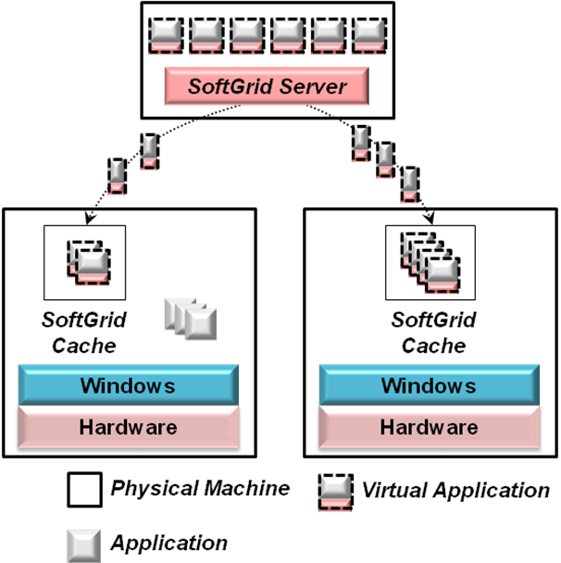
Figure 9: Illustrating SoftGrid Application Virtualization and Streaming
Virtual applications are stored on a SoftGrid server running on a central machine. The first time a user starts a virtual application, this server sends the application’s code to the user’s system via a process called streaming. The virtual application then begins executing, perhaps running alongside other non-virtual applications on the same machine. After this initial download, applications are stored in a local SoftGrid cache on the machine, Future uses of the application rely on this cached code, and so streaming is required only for the first access to an application.
From the user’s perspective, a virtual application looks just like any other application. It may have been started from the Windows Start menu, from an icon on the desktop, or in some other way. The application appears in Task Manager, and it can use printers, network connections, and other resources on the machine. This makes sense, since the application really is running locally on the machine. Yet all of the resources it uses that might conflict with other applications on this system have been made part of the virtual application itself. If the application writes a registry entry, for example, that change is actually made to a registry entry stored within the virtual application; the machine’s registry isn’t affected.
For this to work, applications must be packaged using a process called sequencing before they are downloaded by the SoftGrid Server. Using SoftGrid’s wizard-based Sequencer tool, an administrator creates a virtual application from its ordinary counterpart. The Sequencer doesn’t modify an application’s source code, but instead looks at how the application functions to see what shared configuration information it uses. It then packages the application into the SoftGrid format, including application-specific copies of this information.
Storing virtual applications centrally, then downloading them to a user’s system on demand makes management easier. Yet if a user were required to wait for the entire virtual application to be downloaded before it started, her first access to this application might be very slow. To avoid this, SoftGrid’s streaming process brings down only the code required to get the application up and running. (Determining exactly which parts those are is part of the sequencing process.) The rest of the application can then be downloaded in the background as needed.
Because downloaded virtual applications are stored in a SoftGrid-provided cache, they can be executed multiple times without being downloaded again. When a user starts a cached virtual application, SoftGrid automatically checks this application with the version currently stored on the central SoftGrid server. If a new version is available on the server, any changed parts of that application are streamed to the user’s machine. This lets patches and other updates be applied to the copy of the virtual application stored on the central server, then be automatically distributed to all cached copies of the application.
SoftGrid also allows disconnected use of virtual applications. Suppose, for example, that the client is a laptop machine. The user can access the applications he’ll need, causing them to be downloaded into the SoftGrid cache. Once this is done, the laptop can be disconnected from the network and used as usual. Virtual applications will be run from the machine’s cache.
Whether the system they’re copied to is a desktop machine or a laptop, virtual applications have a license attached to them. The SoftGrid Server keeps track of which applications are used by which machines, providing a central point for license management. Each application will eventually time out, so a user with applications downloaded onto his laptop will eventually need to contact the central SoftGrid server to reacquire the licenses for those applications.
Another challenge faced by SoftGrid’s creators was determining which virtual applications should be visible to each user. To address this, virtual applications are assigned to users based on the Active Directory groups those users belong to. If a new user is added to a group, for example, he can access his SoftGrid applications from any machine in this domain.
The benefits of using virtual applications with desktop and laptop computers are obvious. There’s also another important use of this technology, however, that might be less obvious. Just as applications conflict with one another on a single-user machine, applications used with Windows Terminal Services can also conflict. Suppose, for example, that an organization installs two applications on the same Terminal Services server machine (commonly called just a terminal server) that require different versions of the same DLL. This conflict will be even more problematic then it would be on a user’s desktop, since it now affects all of the Terminal Services clients that rely on this server. If both applications must be made available, the typical solution has been to deploy them on separate terminal servers. While this works, it also tends to leave those servers under-utilized.
Application virtualization can help. If the applications are virtualized before they’re loaded onto a terminal server, they can avoid the typical conflicts that require using different servers. Rather than creating separate server silos, then seeing those servers underutilized, virtual applications can be run on any terminal server. This lets organizations use fewer server machines, reducing both hardware and administrative costs.
In effect, a SoftGrid virtual application is managed less like ordinary installed software and more like a Web page. A virtual application can be brought down from a server on demand, like a Web page, and just as there’s no need to test Web pages for potential conflicts before they’re accessed, there’s no need to test virtual applications before they’re deployed. Once again, the underlying idea is abstraction: providing a virtual view of an application’s configuration information. As with other kinds of virtualization, the benefits stem from increasing the separation between different elements of the computing environment.

Managing a Virtualized Windows Environment
The biggest cost in most IT organizations is salaries. If virtualization reduced other costs but led to increased management effort, it would likely be a net loss—people cost more than machines. Given this fact, managing virtualization technologies effectively is essential. This section describes how Microsoft’s System Center tools—Operations Manager, Configuration Manager, and Virtual Machine Manager—can be used to manage a virtualized Windows environment.

System Center Operations Manager 2007
For all but the smallest organizations, tools for monitoring and managing the systems in a distributed world are an inescapable requirement. Microsoft provides Operations Manager to address this challenge for Windows-oriented environments. Focused on managing hardware and software on desktops, servers, and other devices, the product supports a broad approach to systems management.
Computing environments contain many different components: client and server machines, operating systems, databases, mail servers, and much more. To deal with this diversity, Operations Manager relies on management packs (MPs). Each MP encapsulates knowledge and more about how to manage a particular component, and each one is created by people with extensive experience in that area. For example, Microsoft provides MPs for managing Windows, SQL Server, Exchange Server, and nearly all of its other enterprise products. HP and Dell each provide MPs for managing their server machines, while several other vendors also provide MPs for their products. By installing the appropriate MPs, an organization can exploit the knowledge of their creators to manage its environment more effectively. This includes managing an environment using virtualization, as Figure 10 shows.
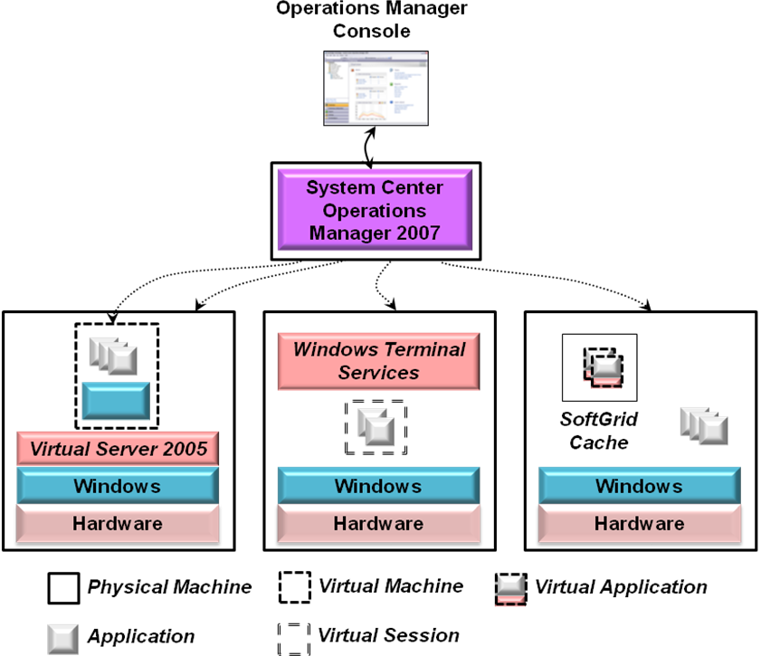
Figure 10: Operations Manager in a virtualized environment
As the system on the left shows, Operations Manager can manage virtual machines as well as physical machines. In fact, the product works in the same way in both cases. Operations Manager relies on an agent that runs on each machine it manages, and so every machine—physical or virtual—has one. In the diagram above, for example, the system on the left would have two agents: one for the physical machine and one for the VM provided by Virtual Server. From the perspective of an operator at the Operations Manager console, both look like ordinary Windows machines, and both are managed in the same way. Rather than deploying different tools for managing physical and virtual environments, Operations Manager applies the same user interface and the same MPs, to both worlds.
While managing physical and virtual machines is done with the same MPs, there are also specific MPs for managing virtualization technologies. The MP for Virtual Server, for example, allows an operator to enumerate the VMs that are running on a particular physical machine, monitor the state of those VMs, and more. Similarly the MP for Windows Terminal Services lets an operator track the performance and availability of this presentation virtualization technology. A forthcoming MP for SoftGrid will support similar types of management operations. By applying the same technology to physical and virtual environments, Operations Manager provides a consistent approach to managing these two worlds.

System Center Configuration Manager 2007
Deploying the right software onto the right machines, then keeping that software up to date can be a herculean task. Add the challenge of maintaining a current record of software assets, and the value of an automated tool becomes clear. To address these challenges, Microsoft provides Configuration Manager, another member of the System Center family.
Challenging as it is in the physical world, managing software configurations can become even more challenging once virtualization is on the scene. Creating more virtual machines, for example, means more machines whose software must be updated. Effective configuration management becomes even more important in this environment.
Like Operations Manager, Configuration Manager approaches the physical and virtual worlds in the same way. Rather than requiring separate tools for managing software configuration in these separate environments, Configuration Manager applies the same technology to both. Figure 11 shows how this looks.
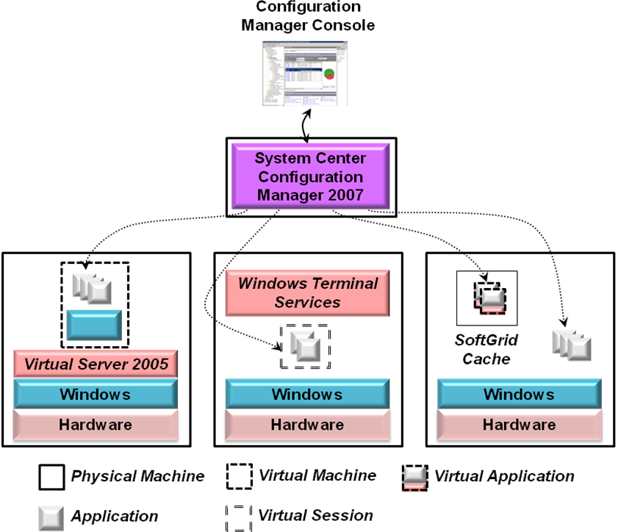
Figure 11: Configuration Manager in a virtualized environment
As the leftmost system in this figure illustrates, Configuration Manager treats a VM provided by Virtual Server as if it were a physical machine. Software can be installed on this machine, updated as needed, and appear as part of the asset inventory maintained by Configuration Manager. Similarly, this tool works with applications running on a terminal server just like any others.
Configuration Manager also works with SoftGrid, as the system on the right above illustrates. SoftGrid provides its own distribution mechanism for virtual applications, however, so the relationship between these two technologies requires a bit more explanation. One option is to use Configuration Manager to deploy SoftGrid virtual applications. This approach places applications into the SoftGrid cache, as usual, and it relies on SoftGrid’s SMS Connector. (Configuration Manager is the successor to Systems Management Server 2003, commonly referred to as SMS.). The Connector allows Configuration Manager to access virtual applications stored on a SoftGrid server, then deploy them like ordinary applications. While this approach doesn’t let virtual applications be streamed on demand to the system on which they’ll run, it does allow using Configuration Manager to deploy both virtual applications and their non-virtual counterparts.
Another option is to use SoftGrid’s SMS Connector to make virtual applications visible to Configuration Manager while still allowing them to be streamed from the SoftGrid server. This approach lets Configuration Manager provide a single console for working with all applications, while still preserving the benefits of streaming. The Connector also makes virtual applications visible to Configuration Manager’s asset tracking functions, something that’s not otherwise possible.
Managing software configurations is important in every organization. As the virtualization wave continues to roll across the IT world, managing virtualized software matters more and more. The goal of Configuration Manager is to provide a common solution to this problem for both physical and virtual environments.

System Center Virtual Machine Manager 2007
Many of the requirements for managing a virtualized environment are identical to those of a purely physical world. Operations Manager and Configuration Manager both exploit this fact, viewing both environments in much the same way. But virtualization also brings its own unique management challenges. The most important example of this stems from hardware virtualization and the plethora of virtual machines it allows. As more virtual machines are created and used, the need for a tool focused solely on managing them also grows.
Virtual Machine Manager is Microsoft’s response to this need. As its name suggests, the tool is designed entirely for managing VMs. In its first release, Virtual Machine Manager works only with VMs supported by Virtual Server. Once Windows Server virtualization is available, the tool will be expanded to work with VMs created with this new technology. Figure 12 gives a simple illustration of how Virtual Machine Manager can be used.
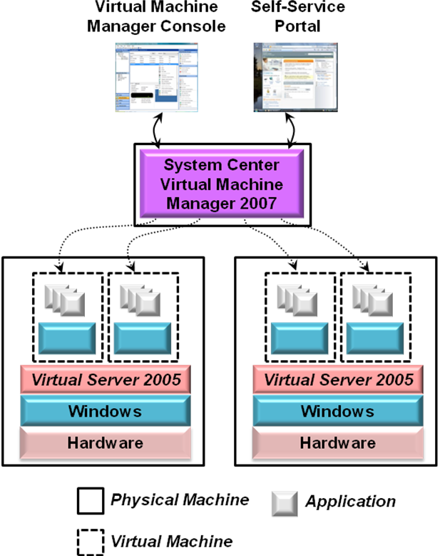
Figure 12: Illustrating Virtual Machine Manager
While both Virtual Server and Windows Server virtualization provide tools for managing their VMs, these tools work on only a single physical machine. Once an organization has more than a handful of VMs spread across different physical machines, a centralized console for managing them is likely to be attractive. As the figure shows, Virtual Machine Manager provides this central console, allowing many VMs to be managed from a single point. An administrator can use this console to check the status of a VM, see exactly what’s running in that virtual machine, move VMs from one physical machine to another, and perform other management tasks. And although the console provides a graphical interface, this interface is built entirely on Microsoft’s PowerShell scripting tool. Anything that can be done graphically can also be done from the command line using this language
To help administrators create VMs, Virtual Machine Manager provides the New Virtual Machine Wizard. This tool provides a number of options for defining a new VM, including the following:
- Creating a new VM from scratch, specifying its CPU type, memory size, and more.
- Converting a physical machine’s environment into a new VM, a process known as P2V.
- Creating a new VM from an existing VM.
- Converting an existing VM created using VMware into Microsoft’s VHD format.
- Using a template. Each template is a virtual machine containing a deployment-ready version of Windows that can be customized by the administrator.
Whatever choice is made, the wizard can examine performance data to help determine which physical machine should host this new VM, a process known as intelligent placement. Based on their available capacity and other criteria, the wizard ranks candidate servers from one to five stars. Once the administrator chooses a server, the tool then helps her install the new virtual machine on that system.
To make life easier for administrators, Virtual Machine Manager maintains a library of templates, VHDs, and other information. Along with creating new VMs using the contents of this library, an administrator can take an existing VM offline, store it in the library, then restore it later. Users can also create VMs themselves from the templates in this library through Virtual Machine Manager’s self-service portal. To help administrators remain in control, Virtual Machine Manager allows defining per-user policies, specifying things such as a quota limiting the number of VMs a user can create.
Hardware virtualization, especially on servers, is fast becoming the norm. While single-machine tools for managing VMs are fine in simple scenarios, they’re not sufficient for the kind of widespread virtualization that’s appearing today. By providing a centralized console, a library to draw from, and other tools, Virtual Machine Manager aims at providing a single point for managing Windows VMs across an organization.

Combining Virtualization Technologies
Looking at each virtualization technology in isolation is useful, since it’s the simplest way to understand each one. Yet using these technologies together is useful, too. Figure 13 shows an example scenario that combines hardware virtualization, presentation virtualization, and application virtualization.
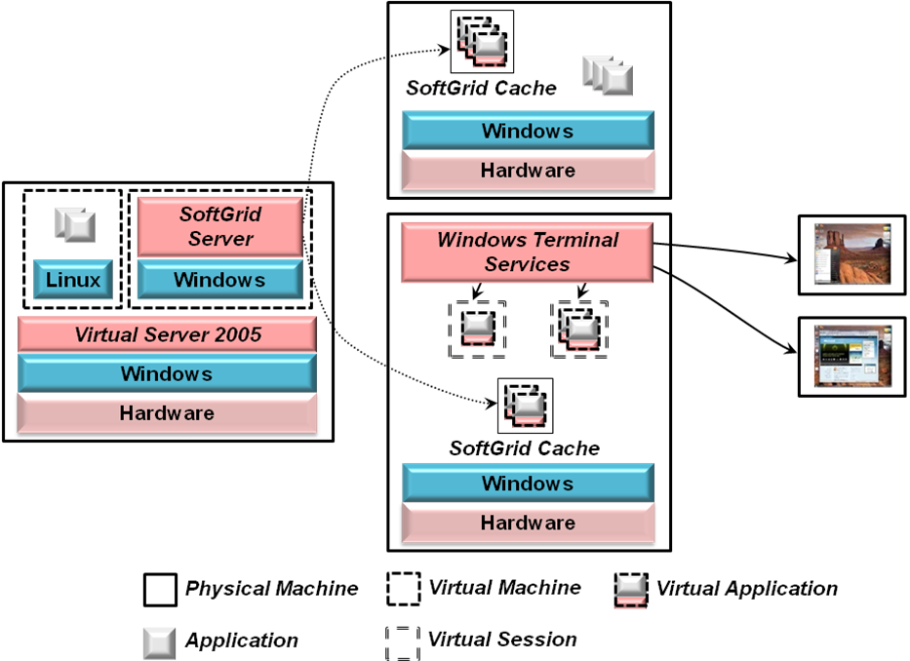
Figure 13: Using different virtualization technologies together
In this example, the system on the left uses hardware virtualization provided by Virtual Server. One VM is running a workload on Linux, while the other is running the SoftGrid Server on Windows. This server provides virtual applications to other systems in this organization. The machine at the top of the figure, for example, might be a desktop, laptop, or server machine, and some of its applications are SoftGrid virtual applications streamed on demand. The system at the bottom is providing presentation virtualization using Terminal Services, and all of the applications it runs are packaged as virtual applications.
As all kinds of virtualization continue to spread, multi-technology scenarios like this will become increasingly common. Plenty of other approaches are possible, too. For example, Windows Vista has built in support for the RDP protocol. This lets Vista provide presentation virtualization without deploying Terminal Services—all that’s needed is a machine to run Vista and clients to display the user interface. Using hardware virtualization, it’s possible to run many copies of Vista on a single server, each in its own VM and each used remotely by one user. When those users go home at the end of their work day, an administrator could use Virtual Machine Manager to store these VMs, then load other VMs running some other workload, such as overnight batch processing. When the next workday starts, each user’s desktop can then be restored. This hosted desktop approach can allow using hardware more efficiently, and it can also help simplify management of a distributed environment.
One important issue that isn’t described in this paper is the impact of virtualization technologies on licensing. Traditional licenses are often wedded to hardware, a marriage of convenience that breaks down in a virtualized world. A different approach is needed, and so understanding the licensing requirements for these technologies is unavoidable. The hosted desktop scenario just described requires the Vista Enterprise Centralized Desktop product license, for example, and other situations also have their own unique licensing requirements.

Conclusion
The pull of virtualization is strong—the economics are too attractive to resist. And for most organizations, there’s no reason to fight against this pull. Well-managed virtualization technologies can make their world better.
Microsoft takes a broad view of this area, providing hardware virtualization, presentation virtualization, application virtualization, and more. The company also takes a broad view of management, with virtualized technologies given equal weight to their physical counterparts. As the popularity of virtualization continues to grow, expect to see these technologies become a bedrock part of modern computing.

About the Author
David Chappell is Principal of Chappell & Associates (www.davidchappell.com) in San Francisco, California. Through his speaking, writing, and consulting, he helps technology professionals around the world understand, use, and make better decisions about enterprise software.

