Microsoft Business Solutions−Axapta
Product Builder
Microsoft® Business Solutions–Axapta® Product Builder simplifies and streamlines the process of ordering, planning and producing customized products, helping you to win more orders and increase customer loyalty.

Key Benefits:
- Your customers, vendors and employees can easily configure customized products

- Deliver customized products faster and more cost effectively by reducing the manual work involved in designing, planning and producing them

- An easy to use system that adapts to the needs of your customers and employees
Microsoft Axapta Product Builder enables your employees, as well as your customers, to configure complex products via a Microsoft Windows® client or over the Web.
Microsoft Axapta is an all-in-one solution that gives you real-time connectivity across your business. The Product Builder is designed to work with other key functional areas in Microsoft Axapta, including the Enterprise Portal, Master Planning, Production, Sales and Purchasing to shorten delivery cycles and optimize product design and production planning.

Efficient configuration of customized products
Both your customers and your employees can use the Product Builder to configure customized products and quickly obtain accurate pricing and delivery dates. Your employees can configure products using the Product Builder within the Microsoft Axapta client. In combination with Microsoft Axapta Enterprise Portal, your customers can configure products through your company Web site to match their unique needs. With Microsoft Axapta Product Builder, your business is open to your customers 24/7.
The Product Builder enables you to create flexible product models which define each product’s configurable options according to variables such as color, size and materials. Products can then be configured which match your customers’ individual requirements based on the options provided in the product models.
When the product has been configured, your customers receive up-to-date pricing and delivery information based on their choices. Because Product Builder links to other modules within Microsoft Axapta, updates to products, prices and lead times are automatically reflected throughout the solution and on your company Web site. Your customers will always be kept up-to-date on the status of the products they want.

Deliver customized products faster and more cost effectively
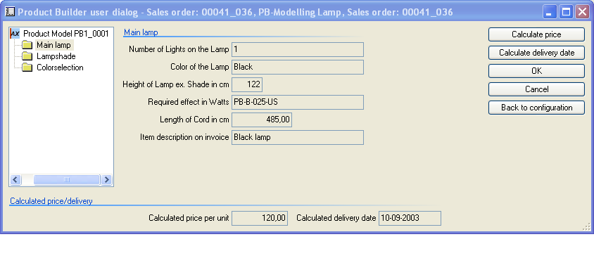
The Product Builder provides information on the price and delivery date for configured products
Setting up the product models in Microsoft Axapta Product Builder is fast and efficient and reduces the potential for error. Through a series of menus and options, you define the criteria for the product models that are then used to configure products for individual orders.
When products are configured, the bills of material (BOM) and production routes are automatically generated for each sales order line. This results in less manual work required in production planning and scheduling and faster delivery of customized products to your customers. Pricing is also automatically calculated for each item on the configured BOM. And, as the Product Builder is connected in real time to the Master Planning module, delivery dates are calculated immediately with consideration of on-hand inventory and capacity availability.
Changes to product specifications are easily managed within the Product Builder. As BOMs are not pre-defined but are defined as products are configured, changes made to product models are reflected in BOMs created from that point on. This avoids the need to manually change hundreds of BOMs when changes to a product specification are made; you make the change once in the product model and that is all.

Microsoft Business Solutions–Axapta
Microsoft Axapta Product Builder is part of Microsoft Business Solutions–Axapta, a customizable, scalable and global Enterprise Resource Planning (ERP) solution that supports connectivity with your business community and provides you with a fast and powerful way to gain competitive advantage.

For more information about Microsoft Axapta
To learn more about Microsoft Axapta, contact your local Microsoft Business Solutions office, a Microsoft Certified Business Solutions reselling Partner and/or visit www.microsoft.com/BusinessSolutions

About Microsoft Business Solutions
Microsoft Business Solutions, a division of Microsoft, offers a wide range of integrated, end-to-end business applications and services designed to help small, midmarket and corporate businesses become more connected with customers, employees, partners and suppliers. Microsoft Business Solutions' applications optimize strategic business processes across financial management, analytics, human resources management, project management, customer relationship management, field service management, supply chain management, e-commerce, manufacturing and retail management. The applications are designed to provide insight to help customers achieve business success. More information about Microsoft Business Solutions can be found at www.microsoft.com/BusinessSolutions.

Address:
Microsoft Business Solutions
Frydenlunds Allé 6
2950 Vedbaek
Denmark
Tel +45 45 67 80 00
Fax +45 45 67 80 01
www.microsoft.com/BusinessSolutions
Key Features | Description

Product Builder I
Product configuration | - Integrated with Microsoft Axapta sales orders, purchase orders and production  - User dialog automatically generated from variable setup on product model  - Immediate item configuration based on customer input  - Generates production of specific bills of material for each configured item  - Can model all complex products  - Default values for variables depending on customers and/or inventory items  - User profiles on variables to only allow specific users to specify this variable  - Reuse of data from previous configurations if needed  - Generation of item numbers based on the model variables  - Configuration details can be printed on order documents using the standard Axapta document handling feature  - Price calculations based on customers’ choice of variables from product models  - Price calculations can be fixed amount, percentage or even programmed per variable  - Language texts offering user dialogs in preferred languages  - Export/import of product models  - Possibility of using sub models with inheritance of variables from top to bottom and visa versa

Product Builder II
Routing integration | - Allows the creation of production specific routes and job cards for each configured item  - Default routes, as templates for the routes created in the product model  - Inserts complete default route in product model

Product Builder III
Validation Rules | - Create validation rules for variables, groups of variables and a complete configuration  - Create rules that govern the allowed content of variables  - Add or remove values from enumerated text variables  - Assign values to specific variables based on the content of other variables  - Validate values and display an error message build from the condition  - Add or remove variables from the user interface based on customer choices  - Enable product models to deal with divergent national standards  - Validation rules can be made in X++ code  - Create rules that govern the allowed content of variables (each variable, for a group of variables, or for all variables in a complete product model)  - Assign values to specific variables based on the content of other variables  - Add or remove variables from the user interface based on customer choices

Product Builder IV
Advanced Configurations | - Provides access to all of the tables and classes in your Microsoft Axapta installation  - Makes it possible to create complex formulas for tasks such as the calculation of raw material consumption  - Incorporates facts from any Microsoft Axapta table into your product models  - Enables product models to deal with divergent national standards  - Allows you to create advanced calculations using X++ programming language. Variables can be declared as any table, class or data type in Microsoft Axapta.  - Unlimited calculations

Product Builder for Enterprise Portal
Product Builder for Enterprise Portal | - Enables configuration of products via the Internet using existing product models  - Available as an add-on to the Microsoft Business Solutions–Axapta Enterprise Portal – Customer Role.  - Same user-dialog as when configuring the item via the sales order line from the Windows version of Microsoft Axapta

System Requirements
To obtain all of the features mentioned in this fact sheet,  the following modules and technologies are required: | - Microsoft Business Solutions− Axapta 3.0  - Microsoft Business Solutions− Axapta Logistics Series  - Microsoft Business Solutions− Axapta Production I and II  - Microsoft Business Solutions− Axapta Product Builder I, II, III and IV  - Microsoft Business Solutions− Axapta X++ Source Code  - Microsoft Business Solutions− Axapta Enterprise Portal Framework  - Microsoft Business Solutions− Axapta Enterprise Portal – Customer Role  - Microsoft Business Solutions− Axapta Product Builder for Enterprise Portal
20 April, 2004
The information contained in this document represents the current view of Microsoft Corporation on the issues discussed as of the date of publication. Because Microsoft must respond to changing market conditions, it should not be interpreted to be a commitment on the part of Microsoft, and Microsoft cannot guarantee the accuracy of any information presented after the date of publication.

This document is for informational purposes only. MICROSOFT MAKES NO WARRANTIES, EXPRESS, IMPLIED OR STATUTORY, AS TO THE INFORMATION IN THIS DOCUMENT.

Complying with all applicable copyright laws is the responsibility of the user. Without limiting the rights under copyright, no part of this document may be reproduced, stored in or introduced into a retrieval system, or transmitted in any form or by any means (electronic, mechanical, photocopying, recording, or otherwise), or for any purpose, without the express written permission of Microsoft Corporation.

Microsoft may have patents, patent applications, trademarks, copyrights, or other intellectual property rights covering subject matter in this document. Except as expressly provided in any written license agreement from Microsoft, the furnishing of this document does not give you any license to these patents, trademarks, copyrights, or other intellectual property.

© 2003 Microsoft Business Solutions ApS, Denmark. All rights reserved. Microsoft and Axapta are either registered trademarks or trademarks of Microsoft Corporation, Great Plains Software, Inc., FRx Software Corporation, or Microsoft Business Solutions ApS or their affiliates in the United States and/or other countries. Great Plains Software, Inc., FRx Software Corporation, and Microsoft Business Solutions ApS are subsidiaries of Microsoft Corporation. The names of actual companies and products mentioned herein may be the trademarks of their respective owners. The example companies, organizations, products, domain names, email addresses, logos, people and events depicted herein are fictitious. No association with any real company, organization, product, domain name, e-mail address, logo, person, or event is intended or should be inferred.

