

Configuring Print Sharing for Branch Offices
Microsoft Corporation
Published: May 2006

Abstract
The print management technologies in Microsoft® Windows Server™ 2003 R2—particularly the Print Management Console—allow you to easily administer and manage printers and print jobs in branch offices while avoiding many of the traditional challenges of doing so. This article provides specific prescriptive guidance to configure your Windows Server 2003 R2 servers to take advantage of powerful print management functionality.

This is a preliminary document and may be changed substantially prior to final commercial release of the software described herein.
The information contained in this document represents the current view of Microsoft Corporation on the issues discussed as of the date of publication. Because Microsoft must respond to changing market conditions, it should not be interpreted to be a commitment on the part of Microsoft, and Microsoft cannot guarantee the accuracy of any information presented after the date of publication.
This White Paper is for informational purposes only. MICROSOFT MAKES NO WARRANTIES, EXPRESS, IMPLIED OR STATUTORY, AS TO THE INFORMATION IN THIS DOCUMENT.
Complying with all applicable copyright laws is the responsibility of the user. Without limiting the rights under copyright, no part of this document may be reproduced, stored in or introduced into a retrieval system, or transmitted in any form or by any means (electronic, mechanical, photocopying, recording, or otherwise), or for any purpose, without the express written permission of Microsoft Corporation.
Microsoft may have patents, patent applications, trademarks, copyrights, or other intellectual property rights covering subject matter in this document. Except as expressly provided in any written license agreement from Microsoft, the furnishing of this document does not give you any license to these patents, trademarks, copyrights, or other intellectual property.
© 2006 Microsoft Corporation. All rights reserved.
Microsoft, Active Directory, Windows, the Windows logo, and Windows Server are either registered trademarks or trademarks of Microsoft Corporation in the United States and/or other countries.
The names of actual companies and products mentioned herein may be the trademarks of their respective owners.

Contents
Configuring Print Sharing for Branch Offices 1
Abstract 1
Contents 3
Configuring File and Print Sharing for Branch Offices 5
Terminology 6
Assumptions 7
Skills Needed 7
Infrastructure 7
Before You Begin 7
Good Solution: Printer Attached to a Local Computer in a Branch Office 8
Better Solution: Print Server in a Branch Office 9
Best Solution: Print Server in a Branch Office Managed via the Print Management Console in Windows Server 2003 R2 10
Print Management Console 11
Install the Print Management Console 11
Adding Print Servers 13
Add a Local Print Server 13
Add a Network Print Server 15
Manage Printers 17
Automatically Add Network Printers 18
Manage Multiple Printers 19
Administer and Monitor Multiple Printers 20
Summary 21
Related Links 22

Configuring File and Print Sharing for Branch Offices
Microsoft® Windows Server™ 2003 R2 allows you to maintain the productivity benefits of local branch office printers while you avoid the IT resource allocation issues typically associated with managing printers in branch offices.
Through the Print Management Console (PMC), you have a central interface for managing all of the printers connected to all of the print servers within your organization. With PMC, you can monitor printer errors, deploy printer connections to clients, automatically find and install printers on a local branch office subnet, and run configuration scripts. PMC allows branch servers to perform as print servers because they are remotely manageable on a one-to-many basis.
PMC is an MMC snap-in that enables you to view and manage all of the printers on every print server in your organization from any computer on the network running Windows Server 2003 R2. PMC provides up-to-the-minute details such as the queue status, printer name, number of jobs, driver name, and server name. By using the PMC filtering capability, you can set custom views. For example, you could view only those printers in a particular error state or only printers in a specific location that have more than one job in the queue.
The automatic-detect feature finds and installs printers from the local subnet to the local print server. You can log on to a branch location's local server by using Remote Desktop and use this feature to easily install printers remotely.
In cases where a printer has a printer Web page, PMC may display rich troubleshooting details such as exactly where a paper jam is happening or the printer’s toner level. Some printer Web pages give the Administrator options for remote control functions that can help resolve problems at branch locations. By using the PMC, you may have a clearer picture of the problem before assistance is needed.
PMC is available only with Windows Server 2003 R2 and Windows Storage Server 2003 R2. To use PMC, you must install the print server role on the computer where you want to use PMC. PMC allows you to view printers that are running on print servers running Windows 2000 Server, Windows Server 2003, and Windows Server 2003 R2.
You should move the server into a computer group in the domain that you have specified for member print servers. For more information about how to create and help secure print servers in your domain see the Windows Server 2003 Security Guide on the Microsoft Web site at the following location: http://go.microsoft.com/fwlink/?linkid=14846
To take full advantage of PMC, you must be assigned use rights as a member of the local Administrators group or the Domain Administrators group when you log on to the print servers you want to manage. As a security best practice you should create two groups for print administrators: one for administrative tasks and one for non-administrative tasks.
It is wise from a security perspective for administrators to use an account with limited permissions to perform routine, non-administrative tasks and to use an account with broader permissions only when they perform specific administrative tasks.
You can open PMC and monitor any print server and printer without administrative privileges. However, you will be unable to perform certain functions such as addition and deletion of printers and printer drivers.
This article will examine three printer deployment and management scenarios for branch offices with varying print needs: a printer attached to a client computer in the branch office, a printer attached to a server in the branch office, and a server-attached branch office printer managed and administered via PMC. This document will also lead you through the following actions:
- Installing the Print Management Console
- Adding Print Servers
- Managing Printers
- Troubleshooting Printers

Terminology
Here is a brief overview of the terms and acronyms used in this article.
Local-Area Network (LAN)
A communications network connecting a group of computers, printers, and other devices located within a relatively limited area (for example, a building). A LAN enables any connected device to interact with others on the network.
Virtual private network (VPN)
The extension of a private network that encompasses encapsulated, encrypted, and authenticated links across shared or public networks. VPN connections typically provide remote access and router-to-router connections to private networks over the Internet.
Wide-area network (WAN)
A communications network connecting geographically separated locations that uses long-distance links of third-party telecommunications vendors.

Assumptions

Skills Needed
In order to complete all of the steps contained in this article, you should able to confidently:
• Install Microsoft Windows® components from installation media (such as a CD, for example).
• Install and use snap-ins to the Microsoft Management Console.
• Add and manage users and groups in Active Directory Users and Computers.
Note
All the step-by step instructions included in this document were developed from the Start menu that appears by default when you install your operating system. If you have modified your Start menu, the steps might differ slightly.

Infrastructure
The steps in this article assume that you have met the following requirements:
- A VPN connection exists between the central file server and all branch file servers
- Windows Server 2003 R2 is installed on your servers
- You have sufficient WAN bandwidth as determined by you or your IT staff

Before You Begin
To complete all tasks in this article, you will need:
• Your Windows Server 2003 R2 installation CDs
• A Domain Controller running Active Directory; you must also be able to log in to the Domain Controller as a Domain Administrator
Note
Screenshots in this document reflect a test environment. The domain and server names in your environment might differ slightly from the ones shown in this article.

Good Solution: Printer Attached to a Local Computer in a Branch Office
In this scenario, client computers in a branch office send print jobs to a printer attached to one of the client computers in the branch office. This arrangement has a large price advantage: aside from the printer itself, there can be little to no additional cost, particularly if all of the client computers are running Windows XP.
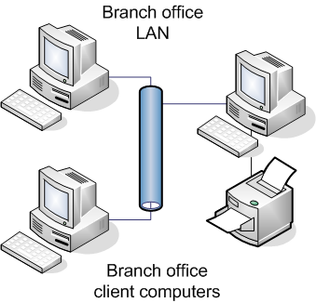
There is a disadvantage to this configuration, though, and it is a large one: management. Each of the branch office computers must be configured (and troubleshot) for connection to the printer individually. Because your branch offices may not have dedicated IT personnel in them, central IT staff will have to travel to the site to do this (or, worse still, rely upon the branch office employees to do this for themselves). A heterogeneous client computer environment in the branch office only complicates this situation.
Because attaching a printer to a client computer or adding a network printer to a client computer requires only basic IT administration skills, no prescriptive guidance on these subjects is given in this document. For basic information on attaching printers to Windows XP clients, see Windows XP Professional Product Documentation at http://go.microsoft.com/fwlink/?LinkId=67386

Better Solution: Print Server in a Branch Office
Organizations with a server in a branch office may choose to co-locate the print server workload on the branch server. (Branch print workloads are generally not heavy enough to justify a unique print server.) This can significantly ease printer management: administrators need only administer and troubleshoot one computer in dealing with the printer. It is also easier to administer printer permissions for various users. Moreover, if the server is running Windows Server 2003, it can automatically load the necessary printer drivers on to Windows-based client computers connecting to it over the network.
While certainly a better branch office print management solution than a printer attached to a client computer, this arrangement has some limitations. Depending on the operating system on the branch office server, printer management options for administrators at the central office site may be limited: administrators using this configuration may only be able to see and manage printers attached to the server they have remotely connected to, for example.
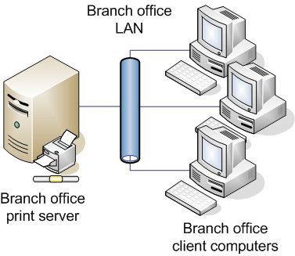
If the branch server hosting print services runs Windows 2000 Server, Windows 2000 Professional, Windows XP, or Windows Server 2003, with Internet Information Services (IIS) installed (by default on Windows 2000 Server), administrators can use the built-in Web-based printer management functionality in these operating systems enabled by the Internet Print Protocol specification introduced in Windows 2000.
Note
Both Windows XP and Windows 2000 Professional have a 10-connection limit for Web-based printer management.
Third-party printer management solutions are also a possibility in this print server configuration. However, there are costs to such schemes on top of the cost of the additional software, such as training IT staff in the use of another interface.
For more information on setting up network printers in a Windows environment and IPP, see the following:
- Printer Connectivity Technical Overview at http://go.microsoft.com/fwlink/?LinkId=67387
- Effectively Using IPP Printing at http://go.microsoft.com/fwlink/?LinkId=67388

Best Solution: Print Server in a Branch Office Managed via the Print Management Console in Windows Server 2003 R2
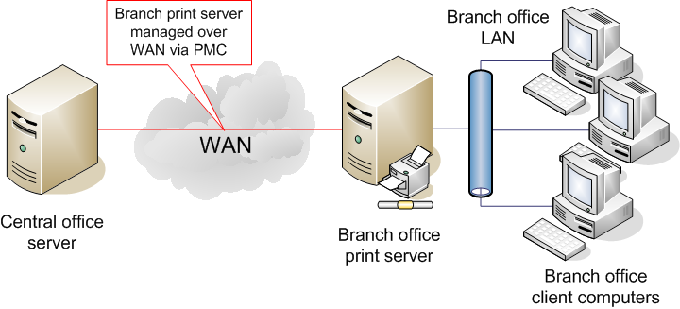
This solution is similar to the ‘good’ solution above, except that the operating system on the branch server and on a central office server is Windows Server 2003 R2, which provides the Print Management Console (PMC). The PMC is a Microsoft Management Console interface that consolidates views of printer and provides a single interface to manage the many printer devices throughout your organization. The PMC can also automatically discover and install printers on the branch office subnet to the branch office print servers and provide rich troubleshooting details on individual branch office printers. These features and others allow administrators to take full advantage of the out-of-the-box print management functionality in Windows Server 2003 R2, providing the benefits listed in the introduction to this article. This maximizes both administrator and user productivity, and it results in fewer software solutions for an organization to buy.

Print Management Console

Install the Print Management Console
To use the Print Management Console, you must first update the schema to install the Active Directory components of PMC. You will update the schema in the following task.
Note
To perform the following task, you must be a member of the Domain Administrators group or you must have been delegated the appropriate authority. You must perform this step on your domain controller.
To upgrade the schema to install the Active Directory Components of DFS Replication:
1. Insert the Windows Server 2003 R2 CD2 into your CD drive.
2. From the Windows Server 2003 R2 desktop, click Start and select Run.
3. In the Open box, type D:\CMPNENTS\R2\adprep\adprep.exe /forestprep where D:\ is the CD drive on the server on which this document was prepared.
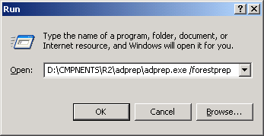
4. On the ADPREP WARNING command-line prompt screen, type C then press ENTER. Because you are using Windows Server 2003 R2, you can disregard the warning that appears.
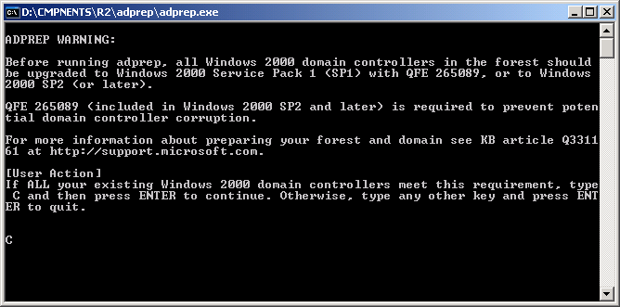
Note
For more information on extending Active Directory schema, see “Extending Your Active Directory Schema in Windows Server 2003 R2” on the TechNet Web site at http://go.microsoft.com/fwlink/?LinkId=67423
To install the Print Management Console:
- Click Start, select All Programs, then Administrative Tools, and then click Manage Your Server.
- On the Manage Your Server page, click Add or remove a role.
- The Configure Your Server Wizard will open. On the Preliminary Steps page, click Next.
- After your settings have been detected, the Server Role page will appear. Select Print Server then click Next.
- On the Summary of Selections page, click Next.
- The installation will now begin. When prompted, inset the Windows 2003 R2 CD 2 into your CD drive. (Note that you can also copy these files from an alternate location, such as a floppy disk or a network drive.)
- On the This Server Is Now a Print Server page, click Finish.

Adding Print Servers
You can add both a local print server and network print servers to the Print Management Console.
Note
The computer on which you install the Print Management Console does not have to be a print server.

Add a Local Print Server
To add a local print server:
- In the left console pane, in the Print Management tree, right-click Print Management (Root Node) and select Properties.
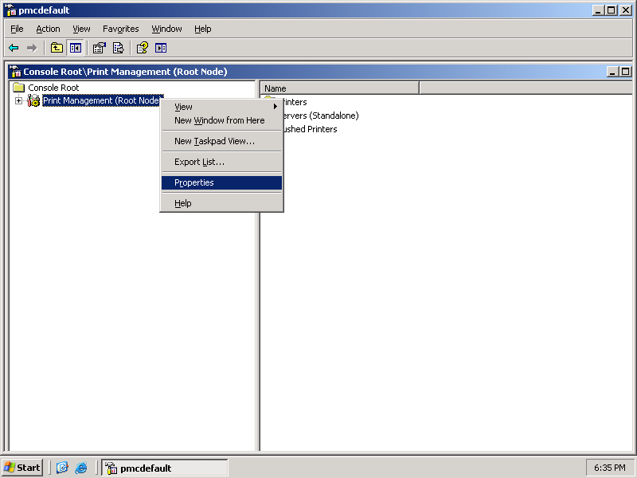
- In the Print Management (Root Node) Properties window, type in the name of the local print server (browse if necessary), and click Add Local Server.
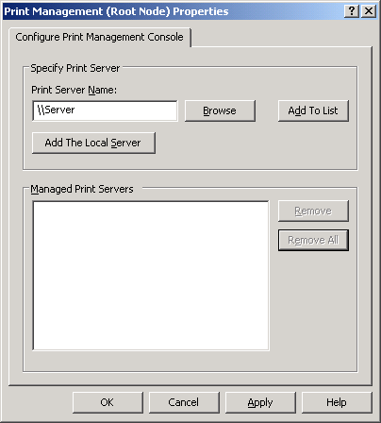
- Click OK.
To verify that you successfully added a local print server:
- In the Print Management tree in the left Print Management console window, expand Print Management (Root Node) and Servers (Standalone) to see the Local Print Server.
- This is your verification that you successfully added the local print server.

Add a Network Print Server
To add a network print server:
- Right-click Print Management (Root Node) in the Print Management tree in the left Print Management console and select Properties.
- In the Print Server Name box, enter the name of the network print server (browse if necessary). Click Add To List and then click OK.
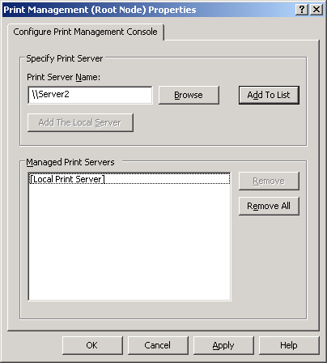
To verify that you successfully added the network print server:
- Back at the Print Management console tree, note the newly installed network print server.
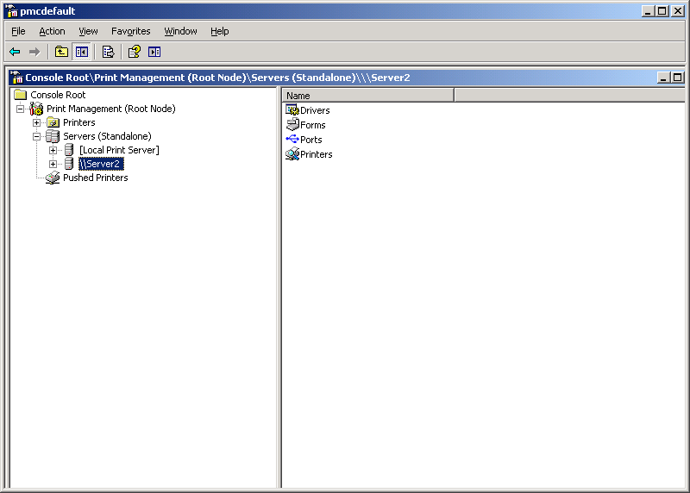
- This is your verification that you successfully added the network print server.

Manage Printers
You can use Print Management to manage all of the printers in your organization, including printers in branch offices. You can use the same interface to control how you share printers, update drivers, and control print queues. It is unnecessary to navigate to the individual folders for each printer on each printer server. Print Management creates a centralized location that even allows you to add and remove printers from Active Directory.
Administrators can use Print Management in conjunction with the Configure Your Server Wizard and Terminal Services to automatically search for and install network printers on a local print server in branch offices. This is helpful when branch office personnel cannot perform such administrative duties. You can use Group Policy to deploy a printer to an entire group of people or make a printer available to every computer in a particular room. The Print Management administration features direct control of branch office printers to corporate IT administrators, which decreases security risks because it eliminates excessive delegation of printer administration tasks.

Automatically Add Network Printers
To automatically add network printers:
- In the Print Management console tree, expand the Servers (Standalone) node, right-click [Local Print Server] and then select Automatically add network printers.
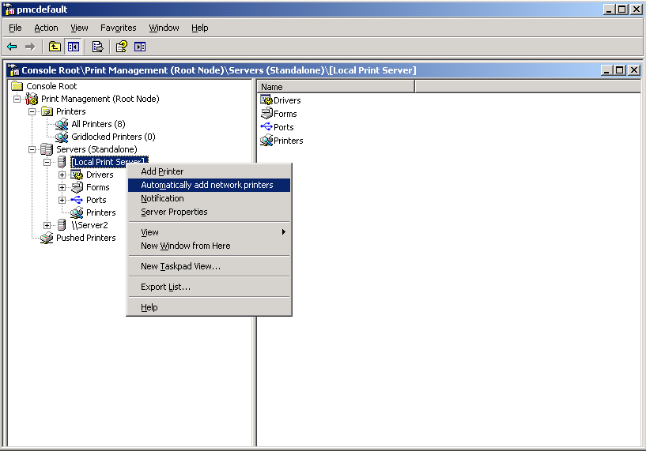
- The scan process will begin. Click Close when the process is complete.
- In the Search for Printers dialog box, click Start.
Note
Windows Server 2003 R2 might prompt you to specify which driver you want to install for a printer, but otherwise, the process is automatic.

Manage Multiple Printers
To pause, cancel, or resume all print jobs on a printer:
- In the Print Management console tree, select All Printers (#).
- In the right Print Management console pane, right-click the printer you wish to manage and select the appropriate option.
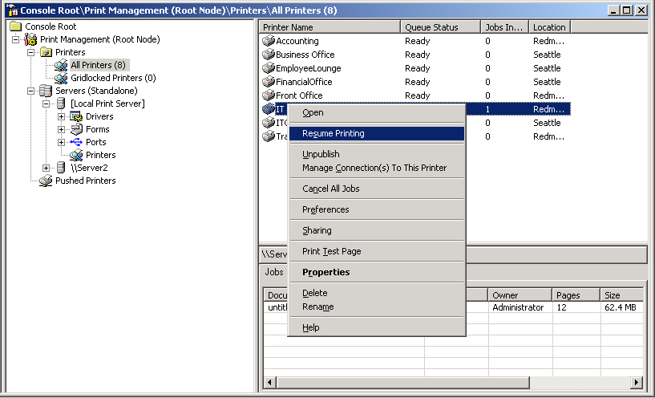

Administer and Monitor Multiple Printers
To manage device drivers:
- In the Print Management console tree, under the appropriate print server, right-click Drivers and select Manage Drivers.
- From the Print Server Properties dialog box, you can add, remove, reinstall or view the properties of drivers. Click OK to close this window.
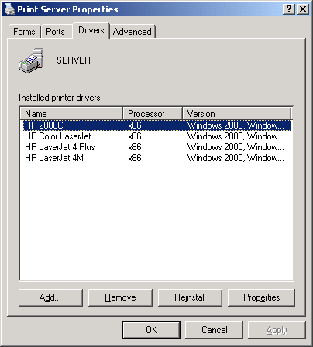
To publish or unpublish printers in Active Directory:
- In the Print Management console tree, expand the Printers node and select All Printers (#).
- Right-click the printer to publish or unpublish and select Publish or Unpublish.
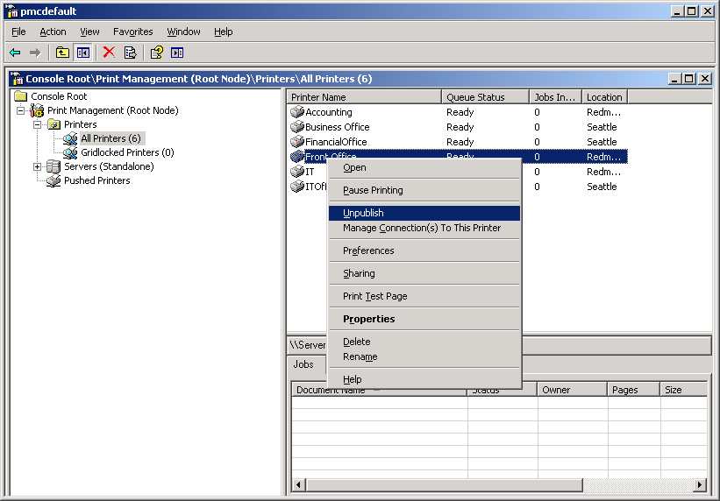

Summary
There are many ways to meet print needs in branch offices. Where these needs are very modest and management concerns are limited, this solution may something as simple as sharing a printer attached to a branch office client computer for use by other computers in the office. Greater print needs can me met with co-locating a print server workload on a server in the branch office. However, greater print complexity in the branch can significantly increase administrative and management costs in both the branch and central offices.
Print Management Console (PMC) significantly centralizes printer administration, because it removes the administrative burden from the branch office. As a best practice, organizations can create two security groups for print management to allow non-administrative users to monitor printers; these users can then escalate issues to printer administrators for resolution.
The more intuitive, centralized administration of PMC creates an opportunity to limit access and better control permissions to the IT assets in the branch office setting, which increases wide area network security while it uses network resources more efficiently.

Related Links
For more information about Windows Server 2003 R2 and the Windows Server System, see:
- the Windows Server 2003 R2 Print Services page on the Microsoft Web site at http://www.microsoft.com/windowsserver2003/technologies/print/default.mspx
- the “Print Management Step-by-Step Guide” on the Microsoft Web site at http://www.microsoft.com/downloads/details.aspx?FamilyID=83066ddc-bc96-4418-a629-48c8abd2c7a0&displaylang=en
- the Windows Server 2003 R2 home page on the Microsoft Web site at http://go.microsoft.com/fwlink/?LinkId=51540
- the Windows Server System home page on the Microsoft Web site at http://go.microsoft.com/fwlink/?LinkId=49867

