SharePoint 2010 Communities: An Integrated Collaboration Platform
Microsoft® SharePoint® 2010 Communities gives your people the tools they need to share ideas, find colleagues and expertise, and create social content. Plus, because SharePoint 2010 provides a single, business-ready platform, you can manage these tools from one place, helping to cut costs and reduce IT risk.  Work Together the Way You Want  Collaborate with flexibility  Give your people the ability to work together in ways that are most effective for them. SharePoint provides a full set of familiar, easy-to-use collaboration tools, including wikis, blogs, newsfeeds, team sites, personal profiles, and much more.  Support unstructured work  Work isn’t only about producing a deliverable—it’s also about creating relationships and sharing ideas and knowledge. SharePoint can help you capture what your people know through a comprehensive tagging taxonomy system, automatic colleague and expertise suggestions, and an enterprise wiki solution.  Work with familiar tools  The familiar Microsoft Office productivity applications and an Internet browser are all you need to take advantage of the powerful SharePoint collaboration capabilities. SharePoint provides deep connections to Microsoft Office and Unified Communications, with features like the contact card, simultaneous multiuser co-authoring, and offline access with Microsoft SharePoint® Workspace.  Help your people work better together  SharePoint 2010 Communities helps your people work better together by providing a broad range of collaboration tools to share ideas, find colleagues and expertise, and locate business information.  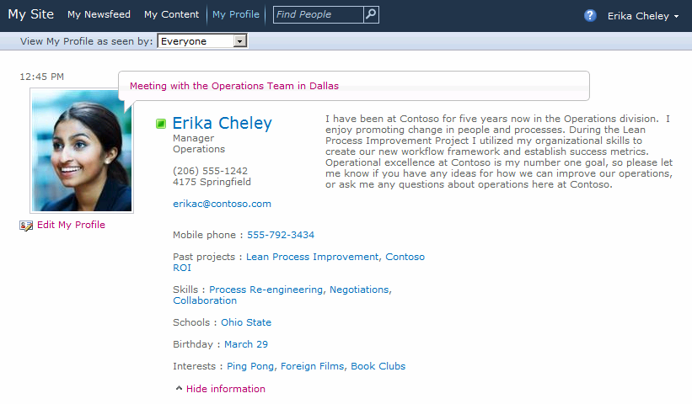  You can customize your My Site Profile page to share your experience, interests, and skills with your colleagues. |  | 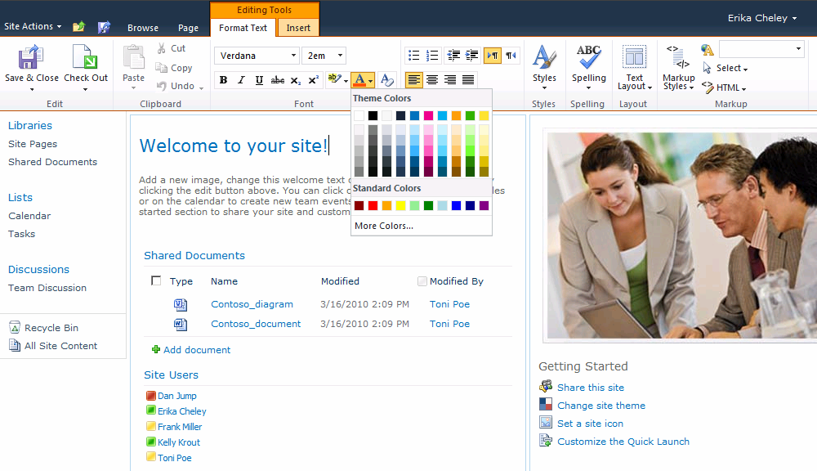  SharePoint site pages combine the ease of wiki editing with the deep functionality of Web Parts.  Rely on a Secure Collaboration Platform  Secure your infrastructure  SharePoint 2010 is ready to handle your company’s specific platform security needs. It provides robust security settings and supports fine-grained policy management, centralized configuration options, and individual privacy options.  Rapidly respond to challenges and opportunities  Your IT staff will be able to rapidly respond to challenges and make the most of opportunities, because it’s easier to share ideas, consolidate information, analyze data, and make dynamic changes.  Balance user and administrator control  With SharePoint 2010, anyone can create and provision specific business solutions through team sites, document libraries, colleague networks, and more. For IT, this means a better balance between allowing users to be more self-sufficient and maintaining centralized control of the platform.  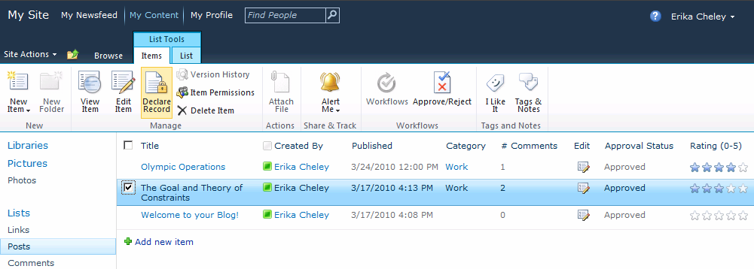  Blog posts and wiki pages support in-place records management.

Simplify control and management  With SharePoint 2010, you can centrally administer, manage, and monitor your collaboration infrastructure, giving you more control and the freedom to focus on higher business priorities. Using the Central Administration dashboard, you can manage accounts, set policies and compliance rules at the company or department level, and take advantage of flexible reporting and analysis capabilities.  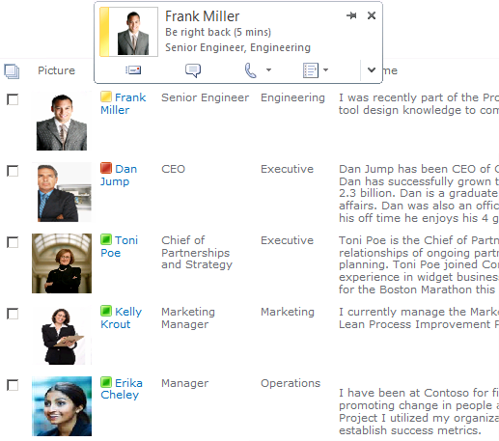  With photos and presence, it’s easy to  identify and connect with colleagues.  Extend the Value of your Community Solutions  Invest in a platform solution  Your company is different from any other, so it needs more than a “one-size-fits-all” collaboration solution. SharePoint was designed to be a platform that provides a standard, extensible framework to support custom solutions for specific business needs.  Reduce developers’ workload  SharePoint provides a full set of familiar tools that anyone can use to create custom business solutions. From simple sites to complex applications, your people can build solutions to specific business needs using Microsoft Visual Studio® and Microsoft SharePoint® Designer.  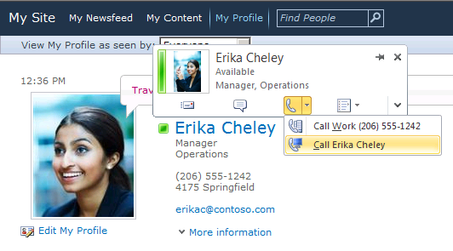  Connections to Exchange Server and Office Communications Server enable one-click communications from SharePoint. |  | Drive innovation from the ground up  Using SharePoint 2010 Communities, all your people can help to grow the business. Now it’s a snap to capture and exchange information, so everyone can offer their ideas for innovation.  Be more efficient with connected solutions  The SharePoint platform easily connects to the rest of the Microsoft stack, including the Microsoft Office applications, Microsoft Exchange Server, Microsoft Office Communications Server, Microsoft SQL Server®, Microsoft BizTalk®, Microsoft Visual Studio, and Microsoft Dynamics®. SharePoint also provides deep connections to line-of-business applications through Business Connectivity Services.  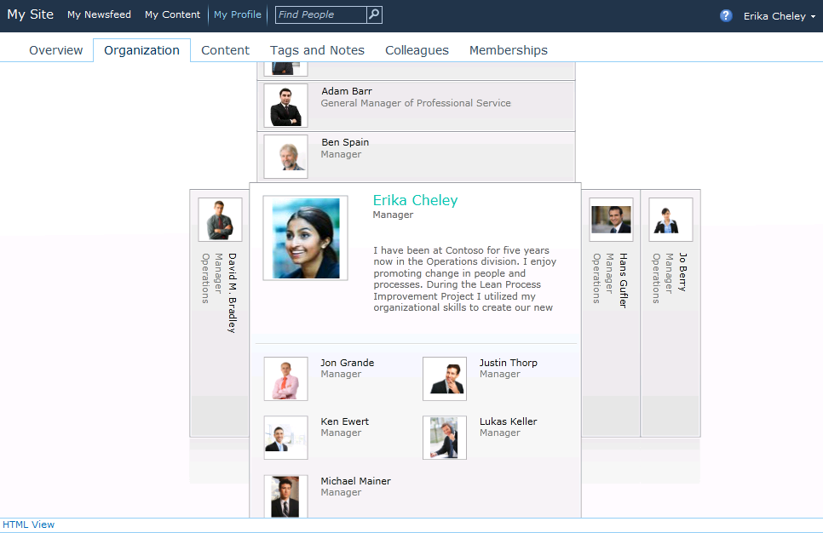  The Organization Browser provides a fun, visual  browsing experience.  For More Information  Learn more about SharePoint 2010 Communities at http://www.microsoft.com/sharepoint.  Find out how SharePoint has helped other companies at http://www.microsoft.com/casestudies.  This document is for informational purposes only. MICROSOFT MAKES NO WARRANTIES, EXPRESS OR IMPLIED, IN THIS SUMMARY.  The example companies, organizations, products, domain names, e-mail addresses, logos, people, places, and events depicted herein are fictitious. No association with any real company, organization, product, domain name, e-mail address, logo, person, place, or event is intended or should be inferred.    © 2010 Microsoft Corporation. All rights reserved. Microsoft, BizTalk, Dynamics, SharePoint, SQL Server, and Visual Studio are either registered trademarks or trademarks of the Microsoft group of companies in the United States and/or other countries. All other trademarks are property of their respective owners.

