
The Microsoft® Office diagramming program for IT professionals

Microsoft® Office Visio® Professional 2003 is a diagramming program that helps IT professionals effectively document, design, and communicate ideas, processes, and systems. Through integration with other Microsoft Office System programs and services, Visio Professional 2003 makes it easy to reuse and share information contained in diagrams.

With Visio Professional 2003, IT professionals can increase productivity when working with new or existing data and create powerful diagrams to communicate ideas and processes more effectively.

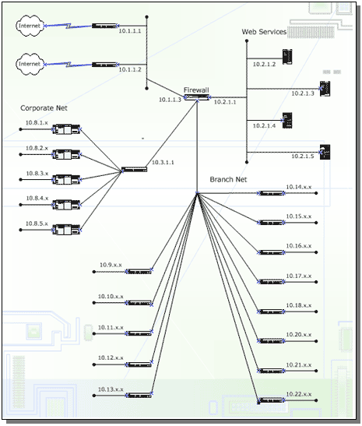
A flexible productivity tool
Visio Professional 2003 facilitates improved productivity and effective communication by helping you:
- Document process and data flow
Record the logical flow of data and business processes using the new business process diagram templates. You can include external data sources and destinations, activities that transform the data, and stores or collections for holding data.
- Comprehend information structure
Using Visio Professional 2003’s predefined shapes with drag-and-drop functionality and wizards you can quickly and easily grasp information and create diagrams.
- Develop network resource diagrams
Create simple and detailed network diagrams to represent the impact of deploying new software on existing network resources.
- Communicate project milestones
Keep your projects on track by documenting timelines in Visio Professional 2003. You can also import tasks and milestones from Microsoft Project to create or enhance your Visio Professional 2003 diagrams.
- Plan with Visio 2003, build once
Visio Professional 2003’s extensive planning capabilities help you avoid any miscalculations when building your Web site, database, or software project.
Document existing networks
Improved templates for logical and physical network diagrams help you to work more efficiently and concisely.
- Create visually appealing network diagrams
Use Visio Professional 2003 to create a rich visual representation of your network. New shapes and improved templates for logical and physical network diagrams help you to work more efficiently and concisely.
- Use intelligent shapes
With Visio Professional 2003 you don’t need artistic skills to create diagrams. Use intelligent, predefined SmartShapes® symbols that snap together and the Custom Properties window to add detailed information or hyperlinks to additional resources.
- Add objects to directory diagrams
Using the ready-made network shapes for directory objects in Visio Professional 2003 you can quickly add objects to represent where servers and other resources are listed in the directory.
- View your existing directory structure
You can review the properties for each object in the diagram showing the existing structure to inform decisions about where to add new servers and other components.


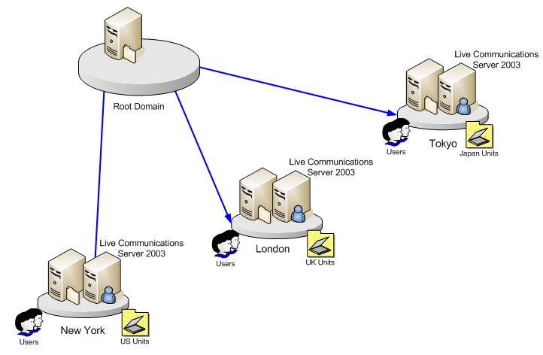

Above: Proposed directory structure created with the Active Directory template in Visio 2003.
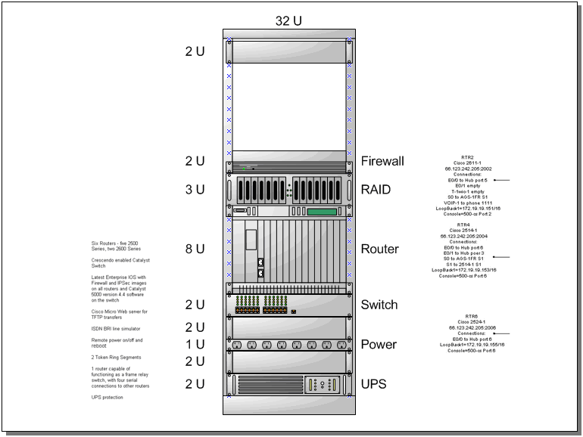
Above: The new Rack Diagram template and shapes provide rack component and cabinet shapes for creating accurate representations of server room configurations.
Conceptualize new resources
Use Visio Professional 2003 to create and refine your plans and diagrams before implementing.
- Plan to build networks accurately
Visio Professional 2003’s extensive planning capabilities help you avoid expensive miscalculations when building or adding to your network.
- Build detailed guides
Use the Microsoft® Active Directory®, NDS, and LDAP templates in Visio Professional 2003 to create detailed guides.

Below: Improved network shapes have a consistent visual design and custom properties that make it easier to create intelligent designs.

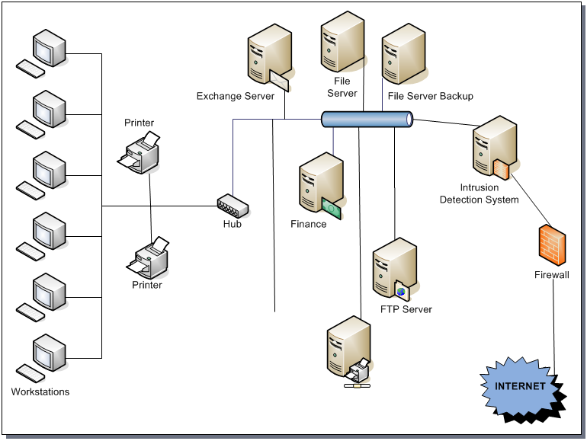

- Design rack space for network equipment
Using the new Rack Diagram Template in Visio Professional 2003 you can easily design rack space for new and existing equipment by dragging server shapes to the page where they snap into place.
- Create custom reports
The diagrams created with Visio Professional 2003 store a wealth of data below the surface and are readily available for purposes such as tracking assets, developing purchasing lists, or providing information to help coworkers install devices directly from your drawings.
- Export custom properties
Properties that are embedded in shapes can be exported to file formats such as XML, for integration with additional business processes and systems.
Communicate and collaborate more effectively
Visio Professional 2003 enhances the work you do by helping you communicate and collaborate flexibly with team members and other project stakeholders.
- Share and review diagrams
The Shared Workspace functionality in Visio Professional 2003 promotes collaboration through Microsoft® Windows® SharePoint™ Services sites, so you can readily publish diagrams to your team site. Team members can open Visio Professional 2003 diagrams directly from the Shared Workspace and review them using new annotation tools that make each reviewer’s contributions identifiable to others.
- Export data to generate reports
Use Visio Professional 2003 to export the information contained in diagrams to reports in Excel 2003, XML, and HTML formats.
- Save diagrams as Web pages
With Visio Professional 2003 you can save your diagrams as Web pages complete with navigation controls, a custom property viewer, reports, choice of image format, and style sheet options.
- Print to large format printers
Set custom page sizes to accommodate your specific needs, including large printouts for reference purposes.

For complete system requirements, please visit http://microsoft.com/office/visio

©2003 Microsoft Corporation. All rights reserved.
This document is for informational purposes only. MICROSOFT MAKES NO WARRANTIES, EXPRESS OR IMPLIED, IN THIS SUMMARY.
Microsoft® Office Visio® Professional 2003, Microsoft® Office 2003, Microsoft® Office Excel 2003, Microsoft® Active Directory®, Microsoft® SmartShapes®, Microsoft® Windows® SharePoint™ Services are either registered trademarks or trademarks of Microsoft Corporation in the United States and/or other countries.
0603 Part No.xxx-xxxxx

