


Implementing Visio 2003 Solutions in Healthcare
White Paper
October 2003

Abstract
This paper discusses how Microsoft® Office Visio® 2003 can be incorporated into solutions that address the needs of the healthcare sector. Widely known as an easy-to-use business and technical diagramming tool, Visio has evolved into a powerful and extensible application that enables continuous process improvement and unlocks the potential of data from disparate systems. Visio 2003 can address a wide range of issues facing healthcare entities and represents a potential new revenue stream for system integrators, independent software vendors, and consultants.

Table of Contents

Introduction 3
Visio 2003: More Than a Diagramming Tool 3
Partner Opportunity 4
Visio 2003 Applications in Healthcare 4
Situation: Inefficient Billing and Collections 5
Solution Scenario: Billing and Collections Monitoring 5
Implementation and Deployment 6
Solution Architecture 6
“Connect and Parse” Component 7
Development Time 7
Other Visio 2003 Solutions in Healthcare 8
Optimizing Patient Handling 8
Facilities Tracking 8
Staff Planning 8
Getting Started 8

Introduction
When people in an organization can quickly access and understand business information, they can make better decisions and the whole organization benefits. By presenting information graphically, Microsoft® Office Visio® 2003 can help people see and use information in a whole new way. Visio 2003 also presents a potential new revenue stream for system integrators, independent software vendors and consultants.
Historically, organizations have tackled business problems by deploying discrete solutions or complex line-of-business applications such as enterprise resource planning (ERP) systems. Organizations have tried to maximize the benefits of these systems by streamlining processes that, over time, grow stale in a rapidly changing marketplace.
These systems capture an enormous amount of transaction, customer, and other data. Significant human capital and tools have been employed to consolidate, report and analyze this data. Despite these efforts, organizations still do not fully capitalize on the potential of their data. Because enterprise-wide deployment can be costly, access to these systems has typically been limited to a scant few employees—which reduces the value of these systems to the organization.
To address these problems, organizations need a cost-effective way to give employees access to the right information, in a format that is easy to interpret and use, so they can make more effective decisions. Microsoft Office Visio 2003 answers this need.

Visio 2003: More Than a Diagramming Tool
While Visio is known as a flexible business and technical diagramming application, with the most recent release it has evolved into a powerful solution enabler. The diagramming capabilities of Visio 2003, in combination with technologies such as Extensible Markup Language (XML) and XML Web services, can be integrated with disparate business applications and databases to transform static diagrams into dynamic graphical reporting and monitoring tools. By doing so, Visio 2003 can help address a wide range of business problems.
The fundamental building blocks of Visio 2003 diagrams, SmartShapes® symbols (shapes), are defined by an extensive set of customizable parameters that control the geometry, connection points, color, page position, and custom properties of each shape. These parameters can be changed through the Visio 2003 user interface or programmatically manipulated to respond to user interaction or changes in associated data. Data can be entered into a Visio 2003 diagram either manually or automatically using a connection to a database or enterprise system. Visio 2003 can also generate diagrams automatically, based on business rules and underlying data. The result is a visually rich Visio diagram that presents business information in an easy-to-understand, easy-to-navigate graphical format.
Visio 2003 has a lower total cost of ownership compared with alternative solutions. Visio-based solutions can replace what would otherwise be a myriad of applications, each with its own license fee, maintenance agreement, and training requirements. Because Visio is part of the Microsoft Office System, users are already familiar with the user interface and many of the common features, so training is less time consuming and costly. In addition, the cost of Visio 2003 is significantly lower per license than most ERP and other enterprise systems.
Visio 2003 presents a powerful way of viewing data that is easily understood, retained and used—giving more people better visibility to critical business information. By using Visio 2003, organizations can benefit from cost-effective and flexible solutions that enable improved decision making and more effective design, monitoring and automation of business processes.

Partner Opportunity
While many organizations use Visio to create static business process flowcharts, network diagrams, office layouts, and other business and technical diagrams, the true power of Visio 2003 is realized when it is connected to enterprise business systems. That’s where you come in as a system integrator, independent software vendor, or consultant.
Incorporating Visio 2003 into your existing solutions or developing new commercial software applications with Visio 2003 can help you reach new customers and deliver more value to existing ones. The more customers you help, the more you can replicate these solutions—which lowers your average development cost and increases your margins.
In short, Visio 2003 gives you the opportunity to provide cost-effective solutions that meet the unique needs of your customers, while providing you with a new and profitable revenue stream.

Visio 2003 Applications in Healthcare
The healthcare industry is composed of a complex network of healthcare providers, such as hospitals and medical practices, payors, such as healthcare insurance companies, as well employers and government entities. A number of dynamic market trends impact the healthcare market—including increased competition among payors and providers, regulatory pressures, rising costs, and a move toward consolidation and collaboration. In addition, customers and employers are demanding more say in the way their healthcare dollars are spent.
While the healthcare industry has an abundance of medical technology, it is just now beginning to look towards information technology (IT) to help reduce costs and improve the quality of patient care.
Healthcare organizations can address many of their business issues by:
- Using Visio 2003 process flowcharts to design, document and improve operational processes to reduce bottlenecks, redundancies and inefficiencies
- Leveraging the ability of Visio 2003 to represent scaled diagrams for capacity planning, restructuring and emergency preparedness
- Using Visio 2003 dynamic visual reports to understand and share complex financial and operational information across the organization
By far, the biggest challenge in the healthcare industry today is to contain costs in the face of rapidly escalating medical expenses. While there are a variety of ways that Visio can help healthcare organizations manage costs, the following discussion focuses on the issue of inefficient billing and collections and how creating a streamlined solution can result in ongoing cost savings—while complying with government regulations such as HIPAA.

Situation: Inefficient Billing and Collections
The financial relationships among healthcare payors, providers and patients can be extremely complex. Contracts between providers and payors may cover thousands of medical offerings, typically with a 15% to 50% discount. Depending on the level of service the patient has with the insurance company, the patient’s responsibility will vary—including co-pay and type and percentage of services covered. These complex relationships and contracts often result in confusion as to how much is owed for a particular service and which party is responsible for payment. This confusion results in long delays in the billing and collections process, avoidable administrative costs, and patient dissatisfaction.
To help solve this problem, payors and providers need to identify the bottlenecks and inefficiencies in their billing and collection processes. They also need to understand the leading causes of process delays, such as contract types, procedures, or ineffective communication between payors and providers. However, billing and collection managers typically do not have access to this data or the tools to analyze and comprehend it.

Solution Scenario: Billing and Collections Monitoring
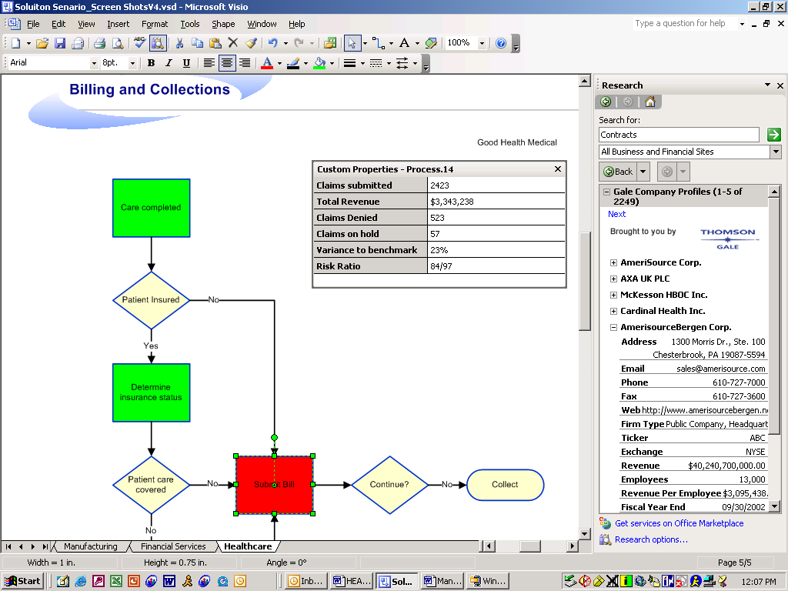
Healthcare organizations can use Visio 2003 to improve their billing and collections processes through collaborative design of an efficient standard process. Once the processes are defined, Visio 2003 can be connected to enterprise systems to monitor the efficiency of each process and help billing and collections managers identify possible problems. By visually monitoring claim status metrics, past due account receivables, denied claims, and other related metrics against a Visio 2003 process diagram, healthcare organizations can proactively manage and continually improve their billing and collections processes.
By leveraging the collaboration and review functionality in Visio 2003, organizations can bring together all process constituents—contract administration, materials management, and billing and collections. Working together, they can design an efficient process that meets the needs of each group, complies with regulatory constraints, and provides the framework for a Visio 2003 process monitoring tool. Large-scale payors and providers may even collaboratively develop a joint process covering the specific interactions between the two organizations. Furthermore, they can ensure that their billing and collections process are in compliance with HIPAA regulations by building in process steps to protect patient confidentiality.
Visio 2003 can consolidate data from multiple sources, such as finance, contract management, or materials management, into a dynamic and easy-to-understand process flow diagram. This data can be displayed at a summary level within each process step and with more detail in the custom properties window. If a primary metric—such as a number or monetary value of past due accounts, transaction volume, or denied claims—exceeds an out-of-tolerance threshold, the process step shape can be configured to change color. This provides a visual indication that there may be a problem. When this occurs, any stakeholder in the process can view the associated metrics and drill down from a high level process to a sub-process to view the details about the potential problem. Sub-process detail may show, for example, that the problem is associated with a particular payor, contract type, or medical facility. If further granularity is needed, the process owner can link directly into the source system to view additional information.
For example, let’s say that a healthcare provider is receiving a higher than normal number of claims rejections for a specific procedure. The Visio-based process monitoring tool indicates this condition by changing the color of the relevant process step or steps. By drilling down into the process and viewing the out-of-tolerance metrics, the billing and collections manager can quickly determine that the problem is specific to a particular payor. With this information, they can work with the payor to identify the root cause of the problem. The problem may be that a new payor policy requires additional information to be attached to the claim. If this were the case, the billing and collections manager can update the payor sub-process to include this step and, if needed, inform the medical facilities that new information must be collected from the doctor or patient. If this were to go unnoticed, claims would continue to go though a time-consuming reject and resubmit process cycle.
Because the process is continually measured within the process flow, systemic process inefficiencies can be identified, the process adapted, and thresholds changed. Thus, the process is continuously improved with small incremental changes, streamlining the process as the business changes—without large-scale process improvement efforts. Visio 2003 can also help healthcare organizations address large-scale process initiatives, such as those mandated by new regulations.
In short, Visio 2003 gives healthcare companies the ability to see at a glance potential problems in the billing and collections process. This allows them to quickly resolve day-to-day problems before they become major issues, and adjust the process continuously to maintain a streamlined and efficient process in an ever-changing environment.

Implementation and Deployment
Building a Visio billing and collections monitoring solution for your customers means working with XML and XML Web services and writing client-side and server-side solutions in Component Object Model (COM)-compliant development languages such as Microsoft Visual Basic®, Microsoft Visual C++®, and Microsoft Visual C#®. The effort required to develop and deploy a Visio 2003-based billing and collections monitoring solution will vary depending on the complexity of the reporting required, the quality and integrity of the data, the technical environment of the healthcare organization, and the number of data sources that contain relevant data. Following is a discussion of the solution architecture, steps and estimated efforts to deploy a billing and collections monitoring in a healthcare organization.

Solution Architecture
Connecting Visio 2003 to enterprise systems requires either a direct connection with an Open Database Connectivity (ODBC) data source or an indirect connection through a data access and security tier. This tier streamlines integration between Visio 2003 and multiple data sources and is the most effective and extensible architecture for a billing and collections monitoring solution.
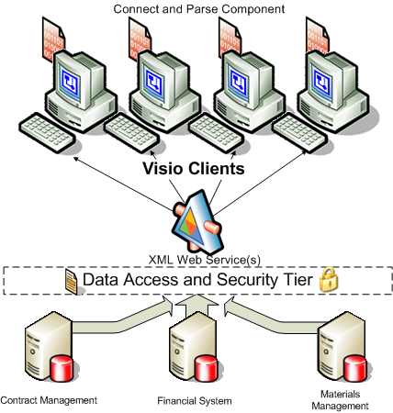
Another advantage of a multiple-tier architecture is that if the underlying systems that contain the data change, the Visio add-in component running on employee desktops can likely remain unchanged. With this architecture, you can connect Visio 2003 to virtually any data source. The data access and security tier can also be used in solutions developed with other smart client applications that consume XML Web services, such as Microsoft Office Word 2003 and Microsoft Office Excel 2003.
The data access and security tier, if it does not already exist, may require significant effort to develop and is beyond the scope of this paper.

“Connect and Parse” Component
For Visio 2003 to send the correct request to the data access and security tier, and to interpret and render the results in a process monitoring solution, a “connect and parse” add-in component is required. The connect and parse component, developed in a COM-compliant language such as Visual Basic or C#, will need to be developed for and deployed on Visio 2003 client desktops. This component will connect the data access and security tier to the Visio 2003 smart client by submitting a query requesting the billing and collections metrics. It will receive the returned XML, parse it, and pass the results to the correct step within the process flow. The component can also provide custom tools for navigating the diagram and changing the view of metrics displayed. Logic must be built into the Visio 2003 shapes to display the updated data returned from the Web service and modify the color based on the out-of-tolerance thresholds.

Development Time
To make a billing and collection monitoring solution ready for deployment would take an estimated 120 to 240 hours of development time. This solution would allow the user to monitor up to 90 process steps. Development time includes writing the Visio 2003 client code to request billing and collections metrics and populating the correct step with the data and customizing SmartShapes with out-of-tolerance threshold logic to change color based on the associated data. These steps complete the “develop” and “stabilize” stages within the Microsoft Solutions Framework (envision, plan, develop, stabilize and deploy).
The effort required to develop and deploy a Visio 2003–based billing and collections monitoring solution will vary depending on the complexity of the reporting required, the quality and integrity of the data, the technical environment of the healthcare organization, and the number of data sources that contain relevant data. Once developed, you will be able to reuse much of the code with other clients interested in deploying similar solutions.

Other Visio 2003 Solutions in Healthcare
In addition to improving the billing and collection process, Visio 2003 can help the healthcare industry streamline other processes, track and monitor assets, and improve staff planning. The following examples illustrate just a few additional ways that Visio 2003 can be applied in healthcare.

Optimizing Patient Handling
Patient handling includes collection of patient information from admission through discharge. Visio 2003 can help streamline the patient management process by integrating human interaction, system touch points, and form processing to reduce duplication. By ensuring that the right patient information is captured at the right time, healthcare providers can more effectively provide health services and support the providers’ administrative services.

Facilities Tracking
In order to maximize the use of their facilities, hospitals need a tool that enables effective capacity planning. Hospitals can use Visio 2003 to track the organization’s physical assets—including beds, treatment rooms, and location of medical equipment and supplies. By improving their facilities tracking process, they maximize the profitability of their space and can help increase patient safety.

Staff Planning
Given the national nursing shortage, effective staff management is critical to the success of healthcare providers. With Visio 2003, real-time employee data—including work shifts, availability, work location, skill sets and specialties, performance, and safety metrics—can be graphically viewed to assist in staff planning. Visio 2003 can also help organizations effectively manage capacity and match patients to facilities for optimum patient treatment.

Getting Started
Microsoft offers a number of technical resources to help you gain the skills needed to build solutions with Visio 2003, as well as the sales and marketing programs to help you market and sell your solutions.
For more information about solution opportunities with Visio 2003 and the rest of the Microsoft Office System, visit the Microsoft Office Solutions Directory Web site at iwsolve.partners.extranet.microsoft.com
By registering in the Microsoft Office Solutions Directory, you can access additional information and resources to help you develop and market your solution. This includes invitations to technical briefings, early access to new product releases, special support offerings, the opportunity to be included in events and marketing programs. It also provides access to more than 400 Microsoft Business Productivity Advisors (BPAs) who can help introduce you to enterprise business decision makers looking to adopt technology to address their business needs.
The Microsoft Certified Partner program provides additional technical and marketing resources to help you maximize your investment in Microsoft technology and grow your business. For more information, visit http://www.microsoft.com/partners.
For additional information about developing solutions with Visio 2003, visit the Visio Developer Center on the MSDN® at msdn.microsoft.com/visio.
For more information about Visio 2003, please visit http://www.microsoft.com/office/visio.

This is a preliminary document and may be changed substantially prior to final commercial release of the software described herein.
The information contained in this document represents the current view of Microsoft Corporation on the issues discussed as of the date of publication. Because Microsoft must respond to changing market conditions, it should not be interpreted to be a commitment on the part of Microsoft, and Microsoft cannot guarantee the accuracy of any information presented after the date of publication.
This white paper is for informational purposes only. MICROSOFT MAKES NO WARRANTIES, EXPRESS OR IMPLIED, IN THIS SUMMARY.
Complying with all applicable copyright laws is the responsibility of the user. Without limiting the rights under copyright, no part of this document may be reproduced, stored in, or introduced into a retrieval system, or transmitted in any form, by any means (electronic, mechanical, photocopying, recording, or otherwise), or for any purpose, without the express written permission of Microsoft Corporation.
Microsoft may have patents, patent applications, trademarks, copyrights, or other intellectual property rights covering subject matter in this document. Except as expressly provided in any written license agreement from Microsoft, the furnishing of this document does not give you any license to these patents, trademarks, copyrights, or other intellectual property.
© 2003 Microsoft Corporation. All rights reserved.
Microsoft, BizTalk, InfoPath, MSDN, the Office logo, SharePoint, SmartShapes, Visio, Visual Basic, Visual C++, and Visual C# are either registered trademarks or trademarks of Microsoft Corporation in the United States and/or other countries. The names of actual companies and products mentioned herein may be the trademarks of their respective owners.
1003 Part No. xxx-xxxxx [Include the part number if required.]

