
The Microsoft® Office diagramming program for software developers and application architects

Microsoft® Office Visio® Professional 2003 is a diagramming program that helps software developers and application architects effectively document, design, and communicate ideas, processes, and systems. Through integration with other Microsoft Office System programs and services, Visio Professional 2003 makes it easy to reuse and share information contained in diagrams.
With Visio Professional 2003, software developers and application architects can increase productivity when working with new or existing data and create powerful diagrams to communicate ideas and processes more effectively.

A flexible productivity tool
Visio 2003 facilitates improved productivity and effective communication by helping you:
- Comprehend information structures
Using Visio Professional 2003’s predefined shapes with drag-and-drop functionality and wizards you can quickly and easily grasp information and create diagrams.
- Document process and data flow
Record the logical flow of data and business processes using the new business process diagram templates. You can include external data sources and destinations, activities that transform the data, and stores or collections for holding data.
- Prototype application interfaces
Use the Microsoft® Windows® XP User Interface template to create mock-ups of user interfaces with shapes designed according to Windows XP guidelines.
- Develop network resource diagrams
Create simple and detailed network diagrams to represent the impact of deploying new software on existing network resources.
- Communicate project milestones
Keep your software projects on track by documenting timelines in Visio Professional 2003. You can also import tasks and milestones from Microsoft® Office Project 2003 to create or enhance your Visio 2003 diagrams.
Document existing software projects
With the Unified Modeling Language (UML) Model Diagram template you can create UML static structure diagrams by dragging shapes to the diagram or reverse engineering all or part of the schema of an existing project.
- Visio 2003 Reverse Engineer Wizard
Extract all or part of the schema from an existing Microsoft® Visual Studio® project by following a few simple steps. The Reverse Engineer Wizard in Visual Studio extracts the schema into a UML model diagram in Visio Professional 2003 that you can review and modify.
- Utilize UML model diagram features
The UML model diagram templates include custom functionality around the UML Model Explorer such as predefined intelligent shapes with UML notation, code- and error- checking utilities, easy-access property dialog boxes, reverse engineering projects, and UML static structure reports.
- Create Web site maps
Visio 2003 documents the structure of existing Web sites for you in seconds to assist in the development, implementation or integration of Web-based applications.


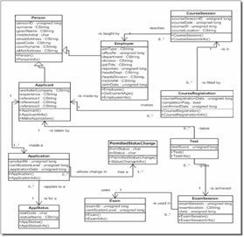

Above: UML static structure diagram created with UML Model Diagram template
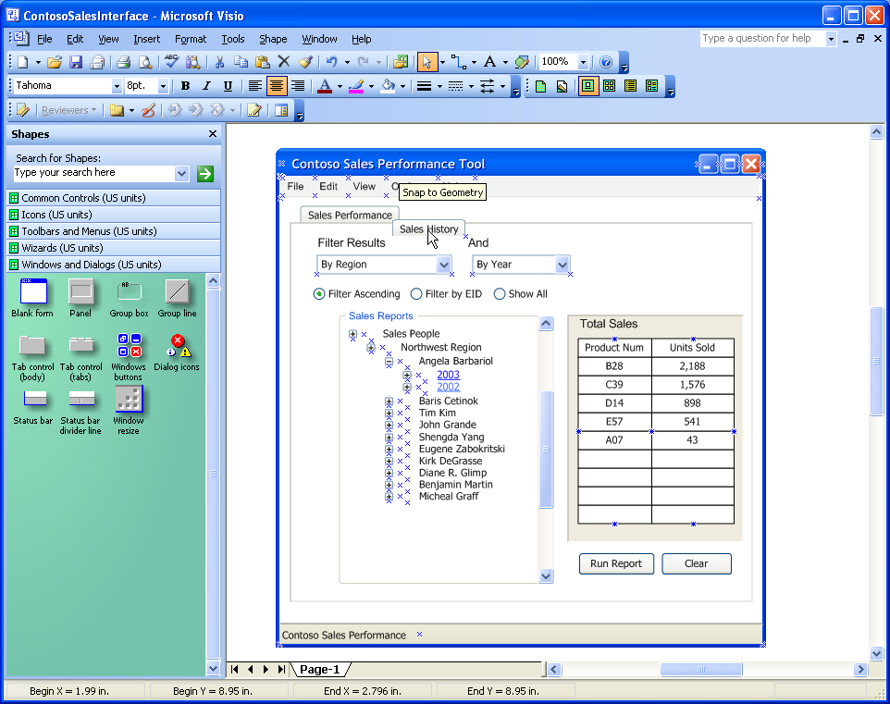
Above: User interface diagram created with Windows XP User Interface template

Conceptualize new projects
Visio Professional 2003 simplifies the planning process of Web sites, software projects, and databases.
- Plan with Visio 2003, build once
Visio Professional 2003’s extensive planning capabilities help you avoid miscalculations when building your Web site, database, or software project.

Below: Hierarchical map of a Web site created with the Web Site Map template

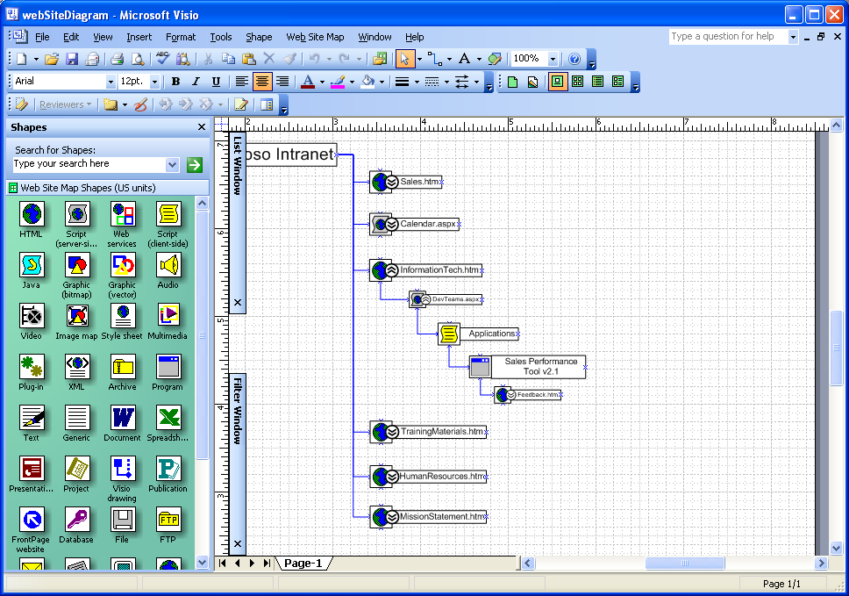

- Design and document new databases
Quickly document relational views between tables to generate a plan that is easy to follow and understand.
- Reveal detailed database information
Visio Professional 2003 features anchored windows for displaying model explorer, properties and class-specific documentation in UML diagrams.
- Support many development languages
With Visio Professional 2003 you can reverse engineer projects written in Microsoft® Visual Basic® 6, Visual Basic® .NET®, Microsoft Visual C++® (managed and unmanaged), and Microsoft Visual C#® to automatically create UML static structure diagrams.
Communicate and collaborate more effectively
Visio Professional 2003 enhances the work you do by helping you communicate and collaborate flexibly with team members and other project stakeholders.
- Share and review diagrams
The Shared Workspace functionality in Visio Professional 2003 promotes collaboration through Microsoft® Windows® SharePoint™ Services sites, so you can readily publish diagrams to your team site. Team members can open Visio Professional 2003 diagrams directly from the Shared Workspace and review them using new annotation tools that make each reviewer’s contributions identifiable to others.
- Export data to generate reports
Use Visio Professional 2003 to export the information contained in diagrams to reports in Microsoft® Office Excel 2003, XML, and HTML formats.
- Save diagrams as Web pages
With Visio Professional 2003 you can save your diagrams as Web pages complete with navigation controls, a custom property viewer, reports, choice of image format, and style sheet options.
- Print to large format printers
Set custom page sizes to accommodate your specific needs, including large printouts for reference purposes.

For complete system requirements, please visit http://microsoft.com/office/visio

©2003 Microsoft Corporation. All rights reserved.
This document is for informational purposes only. MICROSOFT MAKES NO WARRANTIES, EXPRESS OR IMPLIED, IN THIS SUMMARY.
Microsoft, Microsoft Office, Microsoft Office Visio Professional 2003, Microsoft Visual Basic 6, Microsoft Visual Basic .NET, Microsoft Visual C++, Microsoft Visual C#, Microsoft Visual Studio, Microsoft Windows SharePoint Services, Microsoft Office Excel, are either registered trademarks or trademarks of Microsoft Corporation in the United States and/or other countries.
0603 Part No.xxx-xxxxx

