
The Microsoft® Office diagramming program for database administrators

Microsoft® Office Visio® Professional 2003 is a diagramming program that helps database administrators effectively document, design, and communicate ideas, processes, and systems. Through integration with other Microsoft Office System programs and services, Visio Professional 2003 makes it easy to reuse and share information contained in diagrams.
With Visio Professional 2003, database administrators can increase productivity when working with new or existing data and create powerful diagrams to communicate ideas and processes more effectively.

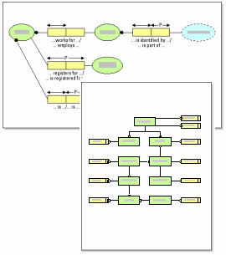
A flexible productivity tool
Visio Professional 2003 facilitates improved productivity and effective communication by helping you:
- Comprehend information structures
Using Visio Professional 2003’s predefined shapes with drag-and-drop functionality and wizards you can quickly and easily grasp information and create diagrams.
- Document process and data flow
Record the logical flow of data and business processes using the new business process diagram templates. You can include external data sources and destinations, activities that transform the data, and stores or collections for holding data.
- Develop network resource diagrams
Create simple and detailed network diagrams to represent the impact of deploying new software on existing network resources.
- Communicate project milestones
Keep your projects on track by documenting timelines in Visio Professional 2003. You can also import tasks and milestones from Microsoft Project to create or enhance your Visio 2003 diagrams.
- Prototype application interfaces
Use the Microsoft® Windows XP User Interface template to create

mock-ups of user interfaces with shapes designed according to Microsoft Windows XP guidelines.
Document existing databases
Reverse engineer all or part of the schema of an existing database using the Database Model template in Visio Professional 2003.
- Reverse engineer projects and databases
Extract all or part of the schema from existing databases by following a few simple steps. The Reverse Engineer Wizard connects to the target database management systems, specifies the platform-specific database objects, and extracts the schema into a database model diagram that you can review and modify.
- Incorporate data from multiple databases
Visio Professional 2003 works with many database systems such as ODBC, Microsoft SQL Server, Microsoft Access, Oracle, Sybase, and IBM DB2.
- Synchronize diagrams with databases
With the Refresh Model Wizard you can refresh your database model diagram to synchronize with the database if it has changed due to reverse engineering.


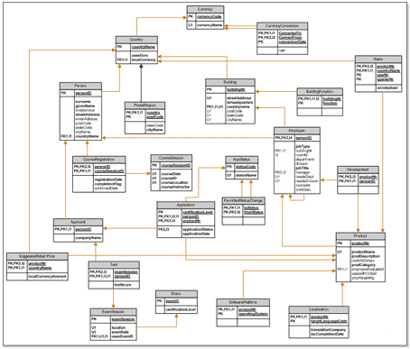

Above: Diagram of database schema created with Database Model template
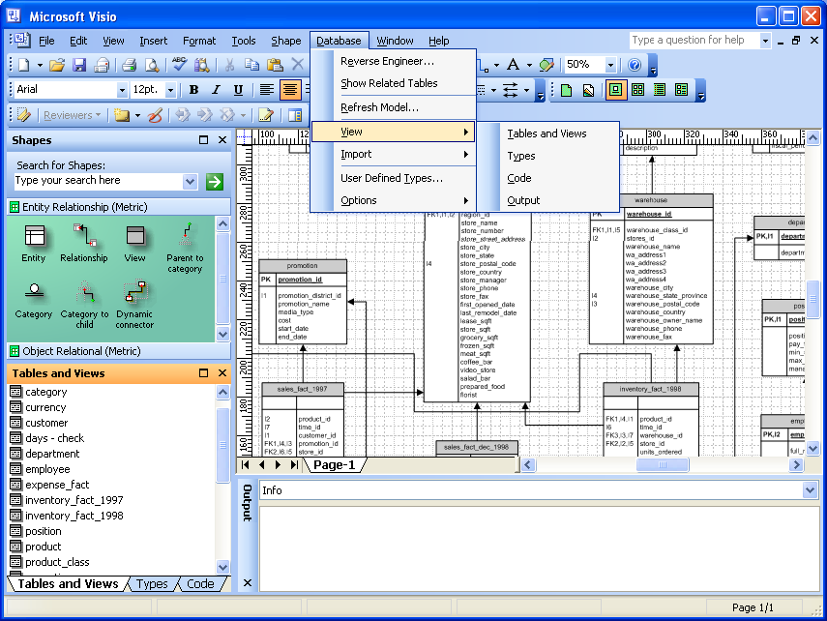
Above: Anchored windows display additional details about the columns in your database tables

- Reveal detailed database information
Visio Professional 2003 uses anchored windows to display, edit, and review relationships between tables in databases.
- Utilize the database menu
When working with the Database Model Diagram template, Visio Professional 2003 makes it easy to access unique database-mode commands with the database menu.

Below: The Reverse Engineer Wizard supports a variety of database drivers to simplify documentation

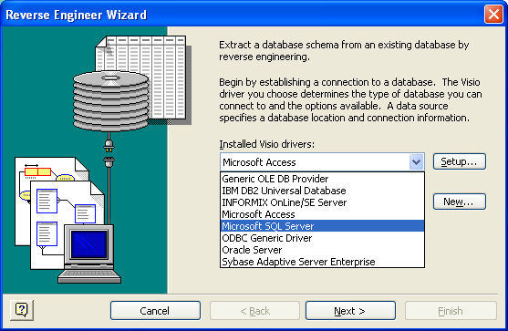
Conceptualize database projects
Planning the design and functionality of a database can be time consuming and inefficient. Visio Professional 2003 makes it easy to design and document logical model diagrams for rational and object-relational databases.
- Design and document new databases
Quickly document relational views between tables to give developers a plan that is easy to understand
- Get going quickly with stencils
The database templates include stencils containing hundreds of shapes for effectively documenting entity relationship and object-relational models.
- Create custom reports
Generate custom database reports on tables, views, foreign key relationships, and categories, and export them into widely accepted file formats such as Microsoft® Office Excel 2003 and XML.

Communicate and collaborate more effectively
Visio Professional 2003 enhances the work you do by helping you communicate and collaborate flexibly with team members and other project stakeholders.
- Share and review diagrams
The Shared Workspace functionality in Visio Professional 2003 promotes collaboration through Microsoft® Windows® SharePoint™ Services sites, so you can readily publish diagrams to your team site. Team members can open Visio Professional 2003 diagrams directly from the Shared Workspace and review them using new annotation tools that make each reviewer’s contributions identifiable to others.
- Export data to generate reports
Use Visio Professional 2003 to export the information contained in diagrams to reports in Microsoft® Office Excel 2003, XML, and HTML formats.
- Save diagrams as Web pages
With Visio Professional 2003 you can save your diagrams as Web pages complete with navigation controls, a custom property viewer, reports, choice of image format, and style sheet options.
- Print to large format printers
Set custom page sizes to accommodate your specific needs, including large printouts for reference purposes.

For complete system requirements, please visit http://microsoft.com/office/visio

©2003 Microsoft Corporation. All rights reserved.
This document is for informational purposes only MICROSOFT MAKES NO WARRANTIES, EXPRESS OR IMPLIED, IN THIS SUMMARY.
Microsoft, [list other trademarks referenced] are either registered trademarks or trademarks of Microsoft Corporation in the United States and/or other countries.
The names of actual companies and products mentioned herein may be the trademarks of their respective owners.
0603 Part No.xxx-xxxxx

