Messaging Operations at Microsoft
White Paper
Published: August 2003
Contents
Executive Summary 3
Introduction 4
Microsoft Operations Framework and Service Management Function Terminology 4
The Microsoft IT group 4
Background 5
Microsoft IT Organization and Structure 5
Messaging Infrastructure 7
Datacenter Operations 10
Best Practice Recommendations 14
Migration 14
Plan for Server Consolidation 14
Administration Best Practices 26
Capacity Management 28
Availability Management 30
Business Continuity Management 33
Problem Management and Support 36
Security Best Practices 38
Conclusion 42
People 42
Processes 42
Technology 42
For More Information 43

Executive Summary
This white paper describes the best practices from the daily operations of Microsoft® Exchange Server 2003 based on experiences of an early adopter—the Microsoft internal IT organization, part of the Microsoft IT group. This paper highlights new interdependencies with Windows® Server 2003 and the Microsoft Office 2003 Editions. Microsoft IT’s “early adopter” experiences that can help customers plan their upgrade from Exchange 2000 Server to Exchange Server 2003 are detailed.
Best practices that also apply to earlier versions of Exchange are noted. Desktop deployment of the Microsoft Office 2003 Editions, upgrading from Microsoft Exchange Server 5.5, or client-side only issues such as Microsoft Outlook® 2003 Exchange cache mode deployment are not covered.
This paper is written for enterprise technical decision makers and operations personnel who want to take advantage of the improvements offered in Exchange Server 2003. Advanced understanding of Exchange design, deployment and operations is assumed.
Microsoft is sharing this information to assist its customers in operating Exchange Server 2003 in their own environments. Microsoft IT’s recommendations and design details are based on its early adopter experience and the Microsoft IT environment. This paper is not intended to serve as a procedural guide. Each enterprise environment is composed of unique circumstances; therefore, each organization should adapt the procedures and lessons learned to meet its specific needs.
Note: For security reasons, the sample names of forests, domains, internal resources, and organizations used in this paper do not represent real resource names used within Microsoft and are for illustration purposes only.
Introduction
Customers frequently ask the Microsoft IT group about the methods employed and lessons learned when Microsoft software is deployed and operated internally at Microsoft. This document provides Microsoft customers with an inside look at how Microsoft IT operates Microsoft Exchange Server 2003 at Microsoft.
The following pages describe the internal Microsoft IT environment, with specific focus on messaging. The best practice recommendations and lessons learned in the second part of this paper are based on the interplay of Microsoft business needs and this environment. To understand how closely the recommendations might apply to you, it is useful to read the Background section before reading the rest of the paper.
Microsoft Operations Framework and Service Management Function Terminology
To assist enterprise professionals in efficiently managing IT operations, Microsoft developed the Microsoft Operations Framework (MOF). The framework is a collection of documentation on best practices, principles, and models, providing technical guidance. Following MOF guidelines can help you achieve mission-critical production system reliability, availability, supportability, and manageability using Microsoft products. For more information, see http://www.microsoft.com/mof.
Not all companies use the same terms for IT operations tasks. One organization’s “antivirus and spam management” SMF is another’s “capacity and availability management”. This paper uses MOF Service Management Function (SMF) terminology.
The Microsoft IT group
Microsoft IT holds the broad responsibility of running the company's internal networks, telecommunication systems, corporate servers, and line-of-business applications. Microsoft IT provides an IT environment comprising services, applications, and infrastructure that helps provide availability, privacy, and security to approximately 57,000 employees, contractors, vendors, and interns in more than 400 locations worldwide.
In addition to running the global IT service internally, Microsoft IT is also committed to testing Microsoft enterprise products in production before they are released to customers to ensure that products will scale to meet the business challenges of other large enterprises. This process is known internally as “eating our own dogfood.” Microsoft IT’s customer service mission extends to sharing its early adopter experiences, best practices, and lessons learned through papers such as this one.
Like other enterprise IT organizations, Microsoft IT’s operational goals focus on striking the right balance of availability, performance, flexibility, and cost. Unique is Microsoft IT’s commitment to use Microsoft solutions wherever possible, often before they are released to the public.
To achieve these goals the Model Enterprise strategy is based on:
- Maximizing the number of management tasks performed centrally (not at the device).
- Reducing the number of data centers and the number of infrastructure and application servers.
- Standardizing infrastructure and devices worldwide.
Background
Microsoft IT Organization and Structure
In the past, the Microsoft IT group of around 2,500 staff members has oscillated between a centralized system and a decentralized, federated model for the company's IT infrastructure. To create a more stable infrastructure, as of this writing, Microsoft IT has combined the most effective aspects of each system.
Centralization is essential for efficiently managing key elements of the infrastructure that must operate seamlessly across organizational and geographic boundaries. Systems that must operate across organizational and geographical boundaries include the network, telephony, messaging and collaboration services, backup and restore services, network operations, and the command center. Running these systems centrally also reduces their cost. Hardware and software standardization on servers and desktops is key to controlling support costs in this model.
Strategic initiatives, such as regional IT issues, early adopter efforts, and deployment scenarios supporting product development and test, are decentralized.
Desktop Support Model (Helpdesk)
The Microsoft internal support organization is a centralized organization based on a call-center model. The cost per incident in the call centers is roughly 33 percent of the costs of a field technician making an on-site visit. Approximately 200 staff operate three regional call centers, and another 300 field technicians cover the worldwide user base of more than 57,000 employees, contractors, and vendors. Helpdesk fields around 50,000 non-dogfood calls per month worldwide. At the time of this writing, more than 10 percent of those calls are resolved using Remote Assistance in Windows XP, avoiding the cost of an on-site visit. At the time of this writing, about 75 percent of the incident tickets are “first contact” resolutions.
Network Infrastructure
The Microsoft internal network, known as corpnet, follows a logical design similar to that recommended in the Microsoft Systems Architecture (MSA) Enterprise Data Center. The MSA prescriptive architecture guides provide both the blueprints and the guidance to create geographically distributed Enterprise Data Center infrastructures using Microsoft and partner technologies. You can find further information about the MSA at http://www.microsoft.com/solutions/msa/evaluation/overview/edc/default.asp.
Although a variety of network protocols are run for development and testing purposes on the Microsoft corporate network, the environment is primarily Transmission Control Protocol/Internet Protocol (TCP/IP)–based. The Exchange Server 2003 mailbox server traffic and the Outlook 2003 messaging and collaboration client to server traffic examined in this paper is Remote Procedure Call (RPC) only. Exchange Server 2003 also offers alternate methods of accessing the mailbox server, such as “Outlook over the Internet” (which requires Windows Server 2003, Exchange Server 2003, Windows XP Professional SP1, and Outlook 2003), as well as HTTPs for Outlook Mobile Access (OMA) and HTTPs used by the Exchange Server 2003 version of Outlook Web Access. All incoming messaging connections at Microsoft are HTTPs. The daily operation issues for these protocols are beyond the scope of this white paper.
For increased security, remote users accessing the corpnet (RAS/VPN) must use Smart Card two factor authentication.
The high-level conceptual design is shown in Figure 1.
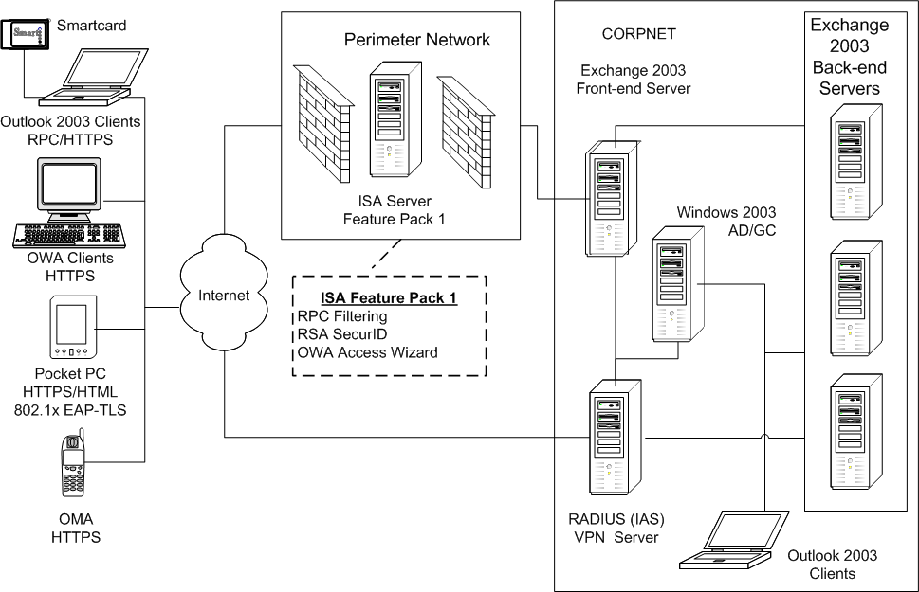
Figure 1. Corpnet Logical Design
The network is designed on a multi-domain routing model. It is divided into four regional networks, with each network functioning as a single Open Shortest Path First routing and addressing domain. Each regional network consists of a backbone area and multiple areas to ensure scalability of each regional network. External Border Gateway Protocol is used to exchange routes between the regional networks to ensure the scalability of the network as a whole.
The Puget Sound Metropolitan Area Network (MAN) supports the bulk of data traffic on the global enterprise network, providing gigabit rate connectivity between buildings and the main data centers located in the area. The headquarters campus is comprised of 70 separate buildings and two data centers with a network infrastructure providing access to corporate resources, developer lab networks, and Internet connectivity.
This network relies on Gigabit Ethernet and Packet over a Synchronous Optical Network. In the MAN, efficient use of limited fiber resources is realized by leveraging Wave Division Multiplexing technologies to provision multiple circuits across a single physical link.
The available network bandwidth is significant for applications such as Exchange Server 2003 and site-to-site connectivity. As of June 2003, the network had grown to encompass:
- More than 2,000 routers and over 275 ATM switches
- More than 2,600 network layer 2 switches
- More than 3,300 IP subnets
- More than 10,000 worldwide servers
- More than 350,000 LAN ports
- The largest wireless LAN (802.1x EAP-TLS) in the world
- Over 4,000 wireless access points
- More than 24,000 wireless devices
- Three enterprise data centers and nineteen regional data centers worldwide
- More than 8,000 servers
- All parts of the physical network are monitored from a single physical space that co-houses the Microsoft IT monitoring teams:
- Network Operations (NOC)
- Data Center Operations (OPS)
- Global Telecom Operations (GTO)
- Support (Helpdesk)
Forest and Domain Structure
Like most organizations that migrated to Windows 2000 Active Directory®, Microsoft IT initially deployed an Active Directory design that could both coexist with and easily migrate from the existing Windows NT 4.0 domain architecture. This design, which did not change substantially during the Windows Server 2003 upgrade, is based on a single Active Directory production forest (corpnet.microsoft.com).
The corpnet Windows 2003 forest is the primary container of Microsoft IT -controlled corporate domain user accounts, groups, and corporate resources. The root of the forest is the corpnet.microsoft.com domain. This domain is a top-level placeholder that contains a limited number of corporate-wide resources and administrative accounts only. The prefix (DC=corpnet) was added to microsoft.com in order to differentiate the corpnet from the Internet namespace.
The operational best practices detailed in this paper refer to the primary corporate production forest. Three additional production-level forests are supported for product development purposes and for staging new features prior to deployment in the corporate forest. In addition, there is one forest, the extranet, that is used for partner access to corporate resources. Multiple forests in this design enable Microsoft IT to centrally manage product development forest users and groups and other corporate network resources, yet isolate the production environment from changes in the Active Directory schema that are necessary in the product development environments. No significant changes to this structure were required or made for the migration to Windows Server 2003 Forest mode.
Messaging Infrastructure
Microsoft IT is responsible for maintaining more than 150,000 computers worldwide. At the time of this writing, the messaging environment at Microsoft consists of more than 200 servers, including 190 Exchange 2003 servers (113 of which are active mailbox servers) in 75 locations worldwide, including servers in additional cross-forest test environments. This environment supports:
- Global mail flow of 6,000,000 messages per day on average, with an average of 2,500,000 Internet e-mail messages per day.
- 200 megabytes (MB) per user mailbox limits, supported by twenty databases per server, with 50 gigabyte (GB) maximum database size on new clustered deployments.
- Global service availability of 99.9 percent with a target to achieve 99.99 percent on clustered servers.
- Worldwide mail delivery in less than ninety seconds, 95 percent of the time.
- Backup and restore operation service level agreement (SLA) of less than one hour per database.
Daily operations tasks are tied to and determined by the choices made in the design phase. For example, with the rollout of each version of Exchange, beginning with version 5.5, Microsoft IT has improved daily messaging operations by increasing the number of mailboxes per server while decreasing the number of sites or locations. Figures 2 and 3 show the historical trends, including the forecast (FC) figures for next fiscal year (FY).
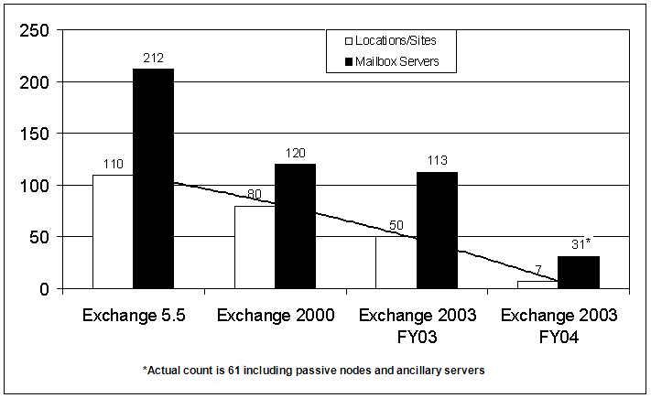
Figure 2. Historical trend–Active mailbox servers/Locations
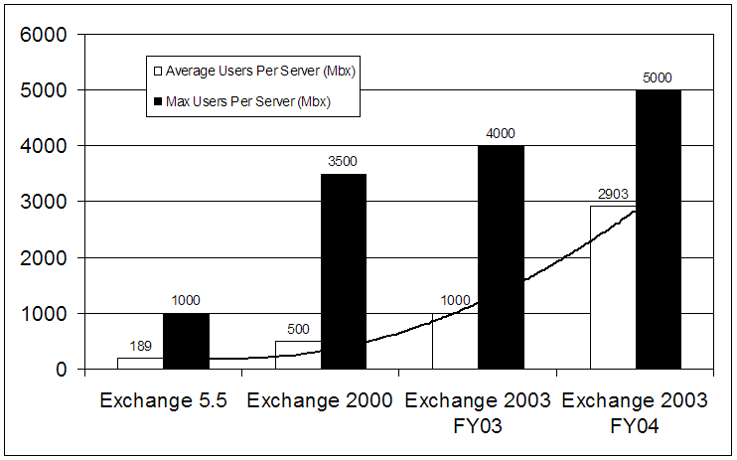
Figure 3. Historical trend–Maximum/Average mailboxes per server
Single-Server Roles for Manageability
Microsoft IT’s strategy is to deploy infrastructure servers, such as messaging servers, in dedicated roles for efficient administration. Table 1 shows how messaging servers are distributed.
Table 1. Messaging Server Role Distribution
Server Role | Number of servers running  Exchange Server 2003
Mailbox | 113
Public Folder | 20
Messaging Hub | 12
Internet Gateway | 22
Outbound Fax | 3
Voice Mail | 2
* Front-end servers were consolidated with the deployment of Exchange Server 2003 because the technology formerly included in Mobile Information Server 2002 was added to Exchange Server 2003. To increase system availability, each Exchange Server 2003 front-end server deployment site was configured with a pair of load-balanced servers.

Business Continuance and Disaster Recovery Constraints
The mailbox servers at Microsoft are designed and managed based on business continuance constraints. Because Exchange 5.5 was limited to a single information store, practical limitations of restore from backup tape forced each mailbox server to be limited to 1,000 mailboxes.
Beginning with Exchange 2000 Server, support for multiple storage groups and databases (up to 20 databases per server) enabled Microsoft IT to deploy many more mailboxes per server while still maintaining targeted recovery SLAs.
By combining software advances in Exchange Server 2003 and Windows Server 2003 with advanced server hardware capabilities (such as SANs and hyperthreading CPUs), Microsoft IT was able to implement larger servers hosting 5,000 mailboxes per server at 200 MB per mailbox. In addition, hardware improvements (such as faster bus speeds) and software advances (such as the Recovery Storage Group feature new to Exchange Server 2003) enable Microsoft IT to meet or beat the one hour SLA requirement.

Client Profile
It is important to understand the usage pattern in your environment to design, build and test your Exchange infrastructure.
The “average” Microsoft employee uses three computers synchronized with Exchange. In addition, a significant portion of that population also carries Pocket PC and Smartphone devices that also synchronize with Exchange. At the time of this writing the Microsoft IT corporate standard messaging client is Outlook 2003 running in Exchange cache mode on Windows XP Professional Service Pack 1.
Instead of using an “average” user profile to plan server designs, Microsoft IT now studies actual usage patterns. For example, Microsoft IT has measured server concurrency at about 80 percent over time, meaning that for the majority of the day 80 percent of the total possible users of the server are using the server. However, the usage pattern is fairly evenly spread. About 25 percent of the users spend less than one hour a day checking e-mail, and about 29 percent spend more than 8 hours, as shown in Table 2.
Table 2. Microsoft Corporate User Messaging Profile–Exchange 2003
Messages Sent Per Day | Percent of Users
1–10 | 72.15%
26–50 | 18.01%
50–100 | 8.58%
About 90 percent of Microsoft users send 50 or fewer e-mails a day, to an average of 5 recipients. About 25 percent of users receive more than 100 non-spam e-mails a day (spam filtering removes a large number of incoming mail–as high as 75 percent on some days). Table 3 shows the distribution.
Table 3. Microsoft Corporate User Messaging Profile–Exchange 2003
Messages Received Per Day | Percent of Users
1–10 | 25%
26–50 | 18%
51–75 | 17%
76–100 | 14%
101–500 | 26%

Routing Group and Administrative Group Structures
In all Exchange deployments prior to Exchange 2000 Server, Microsoft IT grouped Exchange servers into sites based on the network topology. The deployment of Exchange 2000 on Windows 2000 gave Microsoft IT the ability to place servers in routing groups independent of their administration group membership and to optimize the routing topology without losing the advantages of large administrative groups.
Directory replication is now a function of Active Directory and is an operating system-level issue that is no longer a key concern of the Exchange deployment. Because routing groups and administrative groups need not be the same (as was the case in Exchange 5.5 and earlier versions), the Microsoft IT messaging operations staff is free to place Exchange 2003 servers into groups that match their administrative and operational structure, and into routing groups that match the WAN topology. This arrangement leaves directory replication concerns to another Microsoft IT team specifically focused on that area. As of this writing, to accommodate testing, production, and the product development group requirements, Microsoft IT maintains 31 Exchange Server 2003 routing groups and 11 administration groups.
Datacenter Operations
IT Environment
The three main enterprise data centers for Microsoft are located in Redmond, Washington; Dublin, Ireland; and Chofu, Japan. In addition, there are 16 regional data centers and approximately 400 worldwide business locations. The data center operations (OPS) group offers three levels of service to the owners of managed servers in a Microsoft data center. Table 4 describes the service levels.
Table 4. Service Level Offerings
Service Level | Servers | Description
One | ~700 | Power, cooling, and network taps.
Two | ~2,000 | Power, cooling, and network taps.  Data backup support.  Reactive support. The server owner calls Help Desk when the server is not operating properly, and then OPS is notified and takes action.
Three (fully managed)  Business Critical | ~6,000 | Power, cooling, and network taps.  Data backup support.  Proactive support of the server hardware and the operating system, including full proactive monitoring through MOM and full monitoring for patch compliance.
Full management is critical for efficient daily operations of the core infrastructure, such as file and print servers; proxy servers; remote access servers; and servers that run Active Directory, DNS, and WINS. Service level two is often chosen for lab servers. Regardless of the service level chosen, each server owner is responsible for managing and maintaining servers at the application level and higher. For example, server owners are responsible for managing user rights.
At Microsoft, the server owners must use approved versions of server software and the latest patches. The server owners must also use hardware that is manufactured by approved vendors according to corporate standard specifications. This standardization ensures that OPS can control costs by managing these servers centrally.
Escalation Hierarchy
When a problem with a fully managed server is identified at Microsoft, the problem is escalated as follows:
Tier 1, Helpdesk. Most mailbox server issues are detected at Tier 2. However, if the server owner or an application user identifies the problem, he or she contacts Helpdesk. Smaller regional mailbox servers are centrally monitored, and operating systems and Exchange service items are centrally managed. Hardware issues for regional mailbox servers are handled locally. Regional helpdesk technicians perform any needed hands-on server operations and provide first-line support to the user community in their native language.
Tier 2, Data Center Operations (OPS). OPS uses Microsoft Operations Manager (MOM) alerts to proactively monitor servers for problems so that many problems circumvent Helpdesk. However, if the server owner identifies the problem and contacts Helpdesk, Helpdesk then contacts the data center OPS or messaging operations teams for further action. Once alerted OPS handles the initial response, spending a defined amount of time, such as fifteen minutes, on the issue using an internally developed Troubleshooting Guide (TSG). OPS also initiate the trouble-ticket in internally-developed Microsoft ticketing system. This system integrates the ticket tracking application with several knowledge management functions, such as the product group knowledge base, TSGs, and other internal resources. The ticketing system is used to manage the incident life cycle from detection and recording to investigation, diagnosis, and resolution.
TSGs are created when an issue is common and the resolution is known and easily implemented. If OPS cannot resolve the issue, then they escalate per instructions in each TSG for investigation and root cause resolution. TSGs are linked to alerts in the custom ticketing application.
Note: For more information see the technical brief “Monitoring Messaging at Microsoft” at http://www.microsoft.com/technet/itsolutions/msit/deploy/monitTSB.asp
See also the white paper “Monitoring Enterprise Servers at Microsoft” at http://www.microsoft.com/technet/treeview/default.asp?url=/technet/itsolutions/msit/deploy/entserv.asp
Tier 3, Infrastructure Support (IS) and Advanced Diagnostics and Debug (ADD) teams. Depending on the nature of the problem, OPS can contact either IS or ADD. IS provides end-to-end measurement and management of core infrastructure services. ADD specializes in debugging Windows operating system issues and communicates directly with the product development groups.
Tier 4, Engineering. IS contacts infrastructure engineering if resolving the problem involves modifying the IT architecture, hardware standards, or software standards.
Multi-homed MOM Infrastructure
The MOM infrastructure for monitoring Exchange Server 2003 at Microsoft is multi-homed. This enables different teams to use the data. For example, the messaging operations team is interested in Exchange-specific events, performance data, and threshold alerts such as high RPC average latencies. The OPS team is interested in different information: potential problems with the hardware, operating system, or disk subsystem.
Each team has its own set of rules and configuration group. If a monitored condition occurs, an event is generated, and then MOM sends an alert, which automatically tickets the relevant team.
A custom Data Transformation Services job runs daily to archive Exchange key performance data for long-term trend analysis. For example, all sampled data is retained for eight days before archival. Events are also retained for eight days. Resolved alerts are retained for four days. Six months of Exchange server availability data is retained in a SQL Server 2000 database for long-term trend analysis. This multi-homed architecture is shown in Figure 4.
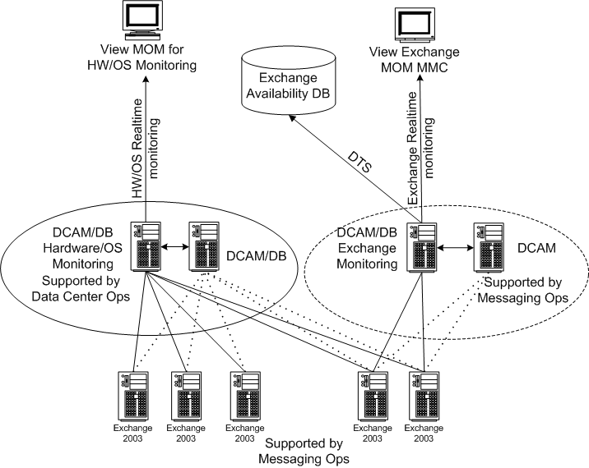
Figure 4. Exchange Server 2003 Monitoring Architecture
Across the 190 Exchange servers that Microsoft IT manages, MOM averages 200 alerts a day, filtered from around 42,000 events and 6 million samples of performance data. These 200 alerts on average generate about 66 trouble tickets. The alert to ticket ratio has dropped from 35:1 to 3:1 since standardizing on the MOM infrastructure.
Best Practice Recommendations
The Microsoft Operations Framework (MOF) identifies service management functions (SMFs) common to most service solutions. Each SMF provides consistent policies, procedures, standards, and best practices that can be applied across the entire suite of service solutions found in an IT environment. The following pages are grouped into specific SMF headings for ease of navigation, but all the SMFs are related and dependent on each other.
Migration
Exchange 2000 and Exchange 2003 handle directory services very differently from Exchange 5.5. Microsoft fully migrated from Exchange Server 5.5 to Exchange 2000 Server in 1999. The best practices in this white paper, based on Microsoft internal experience, cover migration from Exchange 2000 Server, but not migration from Exchange Server 5.5.
Plan for Server Consolidation
If you plan a server consolidation project simultaneously with your deployments, Microsoft IT recommends a nine-step process for the consolidation plan.
1. Assess current infrastructure
- Determine the capacity and usage of servers. What is the range of CPU utilization? How many user mailboxes per server? What concurrency?
- Document the existing support and management processes.
- Take inventory of your server infrastructure.
- Determine the cost of managing and maintaining your infrastructure.
2. Identify goals
- Determine your top business and technology priorities for the project.
- Make trade-offs among priorities, including high availability, cost reduction, and infrastructure flexibility.
- Identify the projected capacity goals of the new environment.
- Determine the cost goals for managing and maintaining a consolidated infrastructure.
- Plot the schedule and budget for the consolidation project.
3. Design a new environment
- Research your hardware and software options.
- Select an infrastructure based on your capacity and growth requirements.
- Design for failover and redundancy.
4. Plan for the migration
- Assess the business impact of each of the consolidation alternatives.
- Identify the organizational roles and responsibilities during and after the consolidation.
- Fully assess plan, risks, budget, and desired results prior to implementing.
5. Build, test, and implement a new pilot environment
- Identify and purchase the needed hardware and software.
- Document your network and infrastructure design.
- Plan around any technical limitations and risks.
- Build and test your consolidated environment.
6. Document and test your plan for migrating users and data
- Write procedures for moving users and data to the new environment.
- Build a detailed deployment schedule, including contingency plans.
- Set the criteria for proceeding. For example:
- User moves take no longer than 24 hours
- Backup and restore SLA is improved N%
- N days of operation at N% availability
- Other business measurements
7. Implement the new production environment
- Deploy applications, utilities, and tools in the new, consolidated production environment.
- Develop and document post-consolidation maintenance and management procedures.
8. Migrate users and data to the consolidated environment
- Ensure that appropriate backups and contingency plans are in place prior to migration.
- Complete migration according to a detailed schedule.
- Test consolidated environment, including users and data.
- Transition to the new production environment.
9. Evaluate and review
- Evaluate the results of your consolidation project, including costs and maintenance procedures.
- Reevaluate the consolidation on a regular basis.
- Optimize your environment.
For more information on consolidation best practices, see http://www.microsoft.com/servers/consolidation/.
Figure 5 shows an example high-level decision tree to guide decisions regarding mailbox server consolidation.
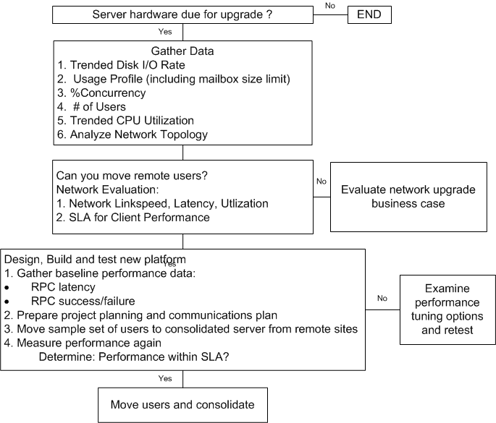
Figure 5. Consolidation Decision Tree
Design for Server Consolidation
Your server design should take three primary factors into account to support ongoing server and location consolidation: network speed (LAN/WAN), cost, and your backup and restore SLA.
Network Considerations
The network performance between clients and servers should drive your decisions about whether the existing network is sufficient to consolidate users. After analysis you may decide to budget network improvements to support consolidation of users. Where network improvement costs are prohibitive, you may decide to retain local servers in remote sites.
Consider Network Topology and Performance
Consolidation may put additional strain on your network, so you should consider your network topology, bandwidth, latency, and performance.
A key consideration for planning your messaging system is the total amount of data that can be transmitted over the network in a given amount of time. This quantity is determined by a combination of bandwidth and latency. Both of these factors combine to determine the amount of data that can be transmitted in a certain amount of time over the network. The product of these two facts directly affects user perception of how long it takes to process a transaction.
When evaluating your network links, evaluate both bandwidth and latency, recognizing that although some types of network connections can maximize bandwidth, they may increase latency. For example, a satellite link may offer high bandwidth, but latency may suffer when compared to ground links such as frame relay service or dial-up ISDN service.
For Exchange Server 2003, the minimum recommended bandwidth for connections to remote offices is 56 Kbps. When mapping site locations and connections, determine the type and speed of network connectivity, and factor in the amount of latency introduced due to distances between sites. You may need to recommend network upgrades as part of the project.
Disable Auto-Negotiation on Network Adapters
Ensure there is no auto-negotiation on any network adapters. Force the link speed and link type on the server as well as the switch. By default, most network cards will auto-negotiate their link speed and link type on installation. This can cause some performance degradation. Instead, to use the maximum capability of the link, force the link speed and link type to 100 Mb full duplex on the server system.
Before you put the system in production evaluate how the network card performs by measuring bytes on the wire, and output queue length. A 100 Mb adapter is capable of sustained throughput of about 7 MB a second, and a 1 GB adapter supports 30 to 40 Mb per second. If you are reaching those limits and the output queue length starts to greatly increase, you must address this problem.
Evaluate Gigabit versus 100 Mb Ethernet
Gigabit Ethernet was used in the Microsoft IT Exchange 2000 Server design to maximize network throughput on stand-alone Exchange servers during the backup process. These servers typically contained 200 to 300 GB of data each. After Microsoft IT started using clusters, it was no longer solely dependent upon network throughput capabilities to process the disk-to-tape backup. Instead, Microsoft IT now uses alternate passive nodes in each cluster to push the backup data through to the tape libraries by means of direct fiber connections.
After the dependency upon extremely fast network throughput was eliminated by the use of clusters with fiber attached libraries, Microsoft IT simplified the server maintenance effort and saved costs by replacing the gigabit Ethernet network adapters with 100 Mbps Ethernet network adapters. These adapters still provided more than enough network performance capacity for the Exchange server requirements and require a much lower level of maintenance overhead.
Cost Considerations
Performance improvements in Exchange Server 2003, Windows Server 2003, and the Outlook 2003 client, along with improved hardware (processors, SANS) allows Microsoft IT to host many more users per server than before.
- Hyperthreading CPUs can reduce CPU licensing costs.
- A SAN storage solution can reduce long-term total cost of ownership compared to the cost of operating and maintaining many smaller mailbox servers and storage arrays.
- In Exchange, transaction logs are accessed sequentially, and databases are accessed randomly. In accordance with general storage best practice, you should separate the transaction logs (sequential I/O) from databases (random I/O) to maximize performance and increase fault tolerance. Specifically, you should move each set of transaction logs to its own array, separate from databases and other Exchange data such as SMTP queues. Following these practices will affect the total number of disks for your solution, and drive deployment costs.
Disk I/O Considerations
Disk problems are a common bottleneck for large Exchange deployments. Successful storage performance for messaging is dependent on key indicators: response time, throughput, and predictable behavior. Your Exchange client usage profile is the primary factor in designing your appropriate disk subsystem so that behavior is predictable. If predictable, managing storage operations can become more focused on capacity management than break/fix tasks.
You can use the Microsoft Exchange Performance Calculator to help determine the disk subsystem performance required for a given user base/profile. You can find the calculator at: HTTP://www.microsoft.com/Exchange/techinfo/planning/2000/ExchangeCalculator.asp
If the user profile is unknown, then you can use some general rules of thumb that are based on trends regarding the number of random Exchange database I/O’s per second (IOps) per user during peak load observed by the product development group over time. These rules of thumb only apply to the number of I/O’s being generated on the database drives (all other Exchange specific I/O’s, including log drives are not included):
Heavy Knowledge Worker Profile= .5 IOps
- A 3000 user “Heavy Knowledge Worker” server may see average peak random disk I/O to the database drives in the 1500/sec range.
Average Knowledge Worker Profile= .25 IOps
- A 3000 user “Average Knowledge Worker” server may see average peak random disk I/O to the database drives in the 750/sec range.
**Note: “Average Peak” is used in the preceding examples to depict the average database I/O during the peak hours of the day, for example between 08:00h and 10:00h. This is the random disk I/O load the database drives must be able to handle over a matter of hours. Do not confuse “Average Peak” with peak disk I/O.
From long-term trending, Microsoft IT knows its read/write profile is around three reads for every write. A disk read happens when a user sorts an inbox, looks through e-mail, or opens e-mail. A disk write happens when a user composes and sends an e-mail. For example, sending an e-mail with a 5 MB attachment would be a 5 MB write to the store. The disk read is inherently more efficient than the disk write because of the RAID configuration.
Make sure that the database disk subsystem is capable of sustaining the required level of I/O. This is a key factor determining how many mailboxes you can put on a server. Observe and trend peak server processor utilization. For example, consider a server that supports 1500 mailboxes but is designed to support 2700 mailboxes. You should view the processor utilization over a period of time, such as 24 hours. You should see backup happening, perhaps an RPC spike you need to investigate, and then a steady-state period, followed by maintenance functions. If the server trend shows 10 percent processor utilization during the business day, the server can clearly handle double the load.
Remember that as you increase the size of the mailboxes, the required disk transfers (4K random read/write activity) also increases. For example, in the Microsoft IT group the legacy server configurations supporting 100–MB mailbox limits sustained peak averages between 0.6 and 0.8 transfers per second per mailbox. Testing on the new clustered platform supporting 200 MB limits showed a noticeable increase toward 1.0 to 1.2 transfers per second at peak periods (historically trended as Monday mornings). To meet this requirement Microsoft IT designed the new platform supporting 4,000 200–MB mailboxes to sustain peaks of up to 6000 4K random transfers per second with minimum read and write latencies.
Availability/SLA Considerations
If your business risks large revenue losses if e-mail is unavailable, new clustering features in Windows Server 2003 and Exchange Server 2003 can help to provide high availability. Microsoft IT’s design goal was to support 8,000 mailboxes per SAN, with 200–MB mailbox limits, 99.99 percent cluster server availability, and less than one hour per database backup and restore time. Microsoft IT runs clustered SAN implementations of 16,000 mailboxes with greater than 99.9 percent service availability.
Your SLA for Exchange should specify the maximum time to restore a database. This can limit the number of users per server. You can use the following formula to roughly estimate number of users per database:
Mailbox quota MB per user × Number of users = 35,000 MB/hour × Maximum hours to restore
or
Number of users = (35,000 MB/hour × Maximum time to restore) / Mailbox quota MB per user
Note: Increasing the capacity of servers also increases the number of transaction logs per server. The time it takes to replay transaction logs significantly impacts the time it takes to restore a server. Calculate the time to replay the logs, monitor the average number of logs per day, and then adjust recovery plans accordingly.
The choices you make as you plan and implement your storage solution affect the cost associated with administration and maintenance of your Exchange Server 2003 environment. As you plan your storage strategy for Exchange Server 2003, you should balance three criteria: capacity, performance, and availability.
- Capacity. In Exchange Server 2003, your total mailbox capacity should roughly equal to the number of mailboxes multiplied by the amount of storage allocated to each mailbox, plus around 40 percent extra space for growth and deleted file retention. If your organization is supporting public folders, you must add the appropriate amount of disk space to accommodate public folder storage.
- Performance. Measure storage performance in terms of throughput as measured by how many reads and writes per second a storage device can perform.
- Availability. The level of e-mail availability required of your messaging system depends on your company needs. Overall availability is increased by redundancy. Cluster servers or implement a redundant array of independent disks (RAID) solution to provide data redundancy.
When considering consolidation, determine which type of RAID level should be used for the volumes hosting Exchange. The current industry best practice is to use as many spindles as possible and configure them using RAID 0+1 for optimal performance. RAID 0+1 should be used for database volumes, but should also be considered for the transaction log volumes. This design provides optimal performance when accessing the transaction logs for disaster recovery.
Design the System for Growth and Optimization
Move sequential and random I/O onto separate Logical Unit Number (LUN) assignments or disk assignments. For best performance, data that is randomly stored should be kept separate from your log drive, which is sequentially stored.
Monitor free space on log drives and database drives. Do not allow free space to drop below 40 percent for an extended period of time. Watch the database log files and do not allow them to grow above a defined limit.
Put Backup Disk LUNs in a Separate Cluster Resource Group
Backup disks are maintained in a separate cluster resource group to enable independent LUN movement between cluster nodes between the first stage, disk-to-disk backup, and the second stage, disk-to-tape backup.
Note: Windows Server 2000 and Windows Server 2003 clusters organize resources into functional units, called resource groups, which are assigned to individual nodes. If a node fails, the Cluster service transfers the groups that were being hosted by the node to other nodes in the cluster. This transfer process is called failover. The reverse process, failback, occurs when the failed node becomes active again, and the resource groups that were failed over to other nodes are transferred back to the original node.
Baseline the Peak Period Traffic Rate
Microsoft IT needed to understand what its peak I/O requirements were for its existing Exchange implementations before designing the new SAN implementation. The best way for Microsoft IT to gather this data was to log the messaging infrastructure activity on a series of Monday mornings, the peak period for user messaging activity at Microsoft. Microsoft IT collected information about peak period traffic, looked for trends, then added 20 percent, and used this figure as a baseline to plan for future growth. Microsoft IT recommends using the peak usage counters from the busiest server as the baseline for planning for load expansion or server consolidation.
Use Volume Mount Points in Clusters
Microsoft IT’s clustered server configurations used SANs to maximize storage capacity and improve backup and restore performance. Support for mount points in clustered implementations is new in Windows Server 2003. Microsoft IT used mount points to eliminate drive letter limitations for supporting the log, SMTP, and backup drives in the large clustered mailbox server design.
Microsoft IT Cluster Design Specifications
Microsoft IT implemented the same type of infrastructure design as it had with Exchange 2000 Server. However, each server now consumed only three drive letters instead of 10, enabling the association of the full four storage groups per server and allowing for many more servers within a cluster. The use of volume mount points on Microsoft IT’s Exchange servers means that four drive letters can effectively support 20 databases rather than using 10 drive letters to support 15 databases.
The server specification for the smaller regional cluster implementation consists of one Enterprise Virtual Array (EVA), three active nodes, one primary passive node, and one alternate passive node (AAAPp).
The larger headquarters clustered implementation is similar in design. It consists of two EVAs per cluster, with four active nodes, one primary passive node, and two alternate passive nodes for streaming backups from disk to tape (AAAAPpp). These configurations are shown in Table 6.
Table 6. Cluster Design Specifications
Specification | Regional | Headquarters
4 CPU Active Nodes | 3 | 4
4 CPU Passive Nodes | 1 | 1
2 CPU Alternate Passive Nodes | 1 | 2
EVA | 1 | 2
Mailboxes per cluster | 8,000 | 16,000
The passive nodes provide two benefits—as a failover solution and an independent resource for the backup process. The primary passive node supports peak period failover. The alternate passive node(s) are primarily used to transfer disk-based backups to tape, which enables the active nodes to focus solely on serving users. The alternate passive nodes also provide off-peak failover support to speed up the process for rolling upgrades or patch application. The 16,000 mailbox headquarters implementation design is shown in Figure 6.
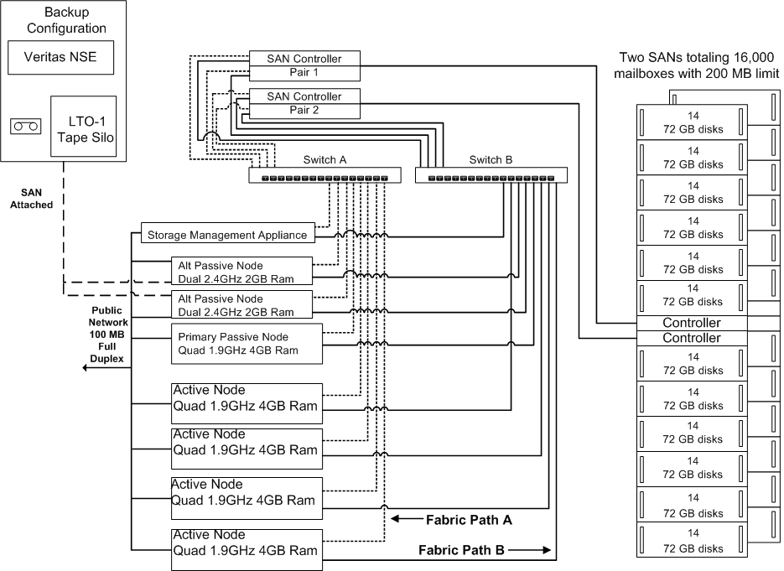
Figure 6: Clustered Exchange 2003 design
Microsoft IT’s multi-node cluster design is based on active and primary alternate servers with four hyperthreading 1.9 gigahertz (GHz) processors and 4 GB of RAM. These servers run Windows Server 2003 Enterprise Edition and Exchange Server 2003 with the following modifications:
- /3GB switch set in the Boot.ini file
- /USERVA=3030 parameter set in the Boot.ini file.
- Mount Points are used to mitigate drive letter limitations for supporting the log and backup drives.
- Backup disks are maintained in a separate cluster resource group to enable independent LUN movement between cluster nodes.
Each Exchange Virtual Server (EVS) hosts four storage groups for a total of twenty databases of about 50 GB each per EVS. Each database is configured with a 200–MB mailbox limit. This design means a maximum of 200 mailboxes per database, which equals 4,000 per EVS, or 16,000 mailboxes total.
The alternate passive node configuration is a less expensive server with dual 2.4 GHz CPUs, and 2 GB RAM. These nodes are used to transfer the disk-based backup files from a disk-based backup to a fiber-connected LTO-1 Tape Silo. This second part of the two-step backup process is managed with Veritas Network Storage Executive.
These configurations are based on the internal messaging system requirements at Microsoft. Although these configurations (both server and storage) were selected for Microsoft deployment, they may not meet your deployment needs. As always, careful analysis, planning, testing, and piloting should precede any Exchange deployment design decision. Ensure that you apply Microsoft and hardware vendor best practices and recommendations when making your own design decisions.
Test Disk Performance with Jetstress
Exchange Server 2003 is a disk-intensive program that requires a fast, reliable disk subsystem for best performance. You should use Jetstress to test and verify disk subsystem performance and stability before production deployment, according to your specified performance criteria for the user count and user profiles you have established.
Jetstress helps verify disk performance by simulating Exchange disk I/O load. Specifically, Jetstress simulates the Exchange database and log file loads produced by a specific number of users. You can use Performance Monitor, Event Viewer, and ESEUTIL in conjunction with Jetstress, to verify that your disk subsystem meets or exceeds the performance criteria you establish.
Note: You can find Jetstress at: http://www.microsoft.com/exchange/tools/2003.asp
With Jetstress, you can perform two types of tests: the Jetstress Disk Performance Test and the Jetstress Disk Subsystem Stress Test. The Disk Performance Test runs for two hours, and enables you to verify the performance and sizing of your storage solution. The Disk Subsystem Stress Test runs for 24 hours and enable you to test the storage reliability over a significant amount of time. Microsoft IT recommends running both tests to verify the integrity and performance of your disk subsystem.
Configure your disk subsystem before running the tests. Use the following checklist to help prepare:
- Verify all aspects of the storage are on the windows hardware compatibility list (WHCL) at http://www.microsoft.com/whdc/hcl/default.mspx .
- Jetstress should only be run against storage that is Windows certified.
- If the server is a cluster, verify that the server/storage configuration is Cluster Certified.
- If multiple clusters will be sharing any aspect of the disk subsystem, ensure the server/storage configuration is Cluster/Multi-Cluster Certified.
- Ensure drivers/firmware are up to date These include, but are not limited to:
- Server Bios/firmware
- SCSI/Array Controller firmware and driver
- Fiber Host Bus Adapter (HBA) firmware and driver
- Fiber Switch/Hub firmware
- SAN enclosure Operating System/Microcode/Firmware
- Hard Disk firmware
- Verify HBA/SAN specific configuration is set correctly. Many HBA’s use registry keys to tailor the configuration to a specific SAN.
- Configure the storage LUNs (Exchange Log devices and Database devices).
- Format the LUNs within Windows with NTFS (default Allocation size).
You should create Jetstress databases that are matched appropriately to the expected database sizes. For example, Microsoft employees usually access only a portion of their data on a day to day basis. Most users probably do not access all of the data in a 200–MB limit mailbox in a given week. However, Jetstress will access 100 percent of the storage group. Assuming a 100 MB mailbox, and that a user accesses20 percent of the production storage group, build a Jetstress databases of at least 20 GB to represent the usage pattern for a 100 GB storage group.
For more information about Jetstress and other tools that can be used to test Exchange Server 2003 performance and scalability, see “Planning an Exchange 2003 Messaging System” at: http://microsoft.com/downloads/details.aspx?FamilyId=9FC3260F-787C-4567-BB71-908B8F2B980D&displaylang=en
Note: Jetstress is only supported when running with Exchange 2000 Server or Exchange Server 2003 or newer versions of ESE.DLL. Also, due to this support limitation, Jetstress is only supported on Windows 2000 Server, Windows Server 2003, Advanced Server, Datacenter and newer Windows operating system platforms (Windows NT 4.0 and earlier versions are not supported).
Exchange makes extensive use of the disk subsystem, but its utilization varies depending on the disk’s intended function:
- Temp Disk
- Database Disks
- Transaction Log Disks
- SMTP queue
- Page File Disk
Because each disk that is dedicated to one of these functions will show see distinct I/O utilization, no disk should be used for more than one function for ease of performance analysis.
Temp Disk
The operating system temporary drive is where all the format conversions take place, such as from RTF to HTML. It is also the home for all temporary files created and accessed during Content Indexing crawls.
When first installed, the operating system sets the temporary files to be created and used in the same disk as the operating system itself. This means that any I/O for the temp disk will compete with I/Os for running programs from that drive and page file operations, which can impact performance. Microsoft IT recommends setting the temp disk to its own disk. This can be done by changing the global environment setting “TEMP” to point to another disk.
To monitor temp disk contentions, monitor:
PhysicalDisk\Average Disk sec/Read. Average Disk sec/Read is the average time in seconds of a read of data from the disk. The average for this value should be below 10 ms. There should not be spikes (maximum values) higher than 50 ms.
PhysicalDisk\Average Disk sec/Write. Average Disk sec/Write is the average time in seconds of a write of data to the disk. The average for this value should be below 10 ms. There should not be spikes (maximum values) higher than 50 ms.
PhysicalDisk\Average Disk Queue Length. Average Disk Queue Length is the average number of both read and write requests that were queued for the selected disk during the sample interval. The average should be less than the number of spindles of the disk (1 if it is really a physical disk).
Database Disks
An Exchange database consists of an EDB file (MAPI content) an STM file (non-MAPI content). The EDB file stores all of the MAPI messages, tables used by the store process to locate all messages, checksums of both the EDB and STM files, and MAPI messages. The STM file contains messages that are transmitted with their native Internet content. Because access to these files is generally random, they can be placed on the same disk volume. To monitor database disk contentions, monitor:
PhysicalDisk\Average Disk sec/Read. Average Disk sec/Read is the average time in seconds of a read of data from the disk. The average for this value should be below 40 ms. There should not be spikes (maximum values) higher than 100 ms.
PhysicalDisk\Average Disk sec/Write. Average Disk sec/Write is the average time in seconds of a write of data to the disk. The average for this value should be below 40 ms. There should not be spikes (maximum values) higher than 100 ms.
PhysicalDisk\Average Disk Queue Length. Average Disk Queue Length is the average number of both read and write requests that were queued for the selected disk during the sample interval. The average should be less than the number of spindles of the disk.
Transaction Log Disks
The transaction log files maintain the state and integrity of your EDB and STM files; this means that the log files really represent the data. There is a transaction log file set for each storage group. To monitor log disk contentions, monitor:
PhysicalDisk\Average Disk sec/Read. Average Disk sec/Read is the average time in seconds of a read of data from the disk. The average for this value should be below 5 ms. There should not be spikes (maximum values) higher than 50 ms.
PhysicalDisk\Average Disk sec/Write. Average Disk sec/Write is the average time in seconds of a write of data to the disk. The average for this value should be below 10 ms. There should not be spikes (maximum values) higher than 50 ms.
PhysicalDisk\Average Disk Queue Length. Average Disk Queue Length is the average number of both read and write requests that were queued for the selected disk during the sample interval. The average should be less than the number of spindles of the disk.
Database\Log Record Stalls/sec. Log Record Stalls/sec is the number of log records that cannot be added to the log buffers per second because they are full. The average for this value should be below 25. There should not be spikes (maximum values) higher then 250.
Database\Log Threads Waiting. Log Threads Waiting is the number of threads waiting for their data to be written to the log in order to complete an update of the database. If this number is too high, the log may be a bottleneck. The average for this value should be below 10.
SMTP Queues
The SMTP queue stores SMTP messages until they are written to a database (private or public), or sent to another server or connector. SMTP queues generally experience random small I/Os. To monitor SMTP queue disk contentions, monitor:
PhysicalDisk\Average Disk sec/Read. Average Disk sec/Read is the average time in seconds of a read of data from the disk. The average for this value should be below 10 ms. There should not be spikes (maximum values) higher than 50 ms.
PhysicalDisk\Average Disk sec/Write. Average Disk sec/Write is the average time in seconds of a write of data to the disk. The average for this value should be below 10 ms. There should not be spikes (maximum values) higher than 50 ms.
PhysicalDisk\Average Disk Queue Length. Average Disk Queue Length is the average number of both read and write requests that were queued for the selected disk during the sample interval. The average should be less than the number of spindles of the disk.
Page File Disk
The page file will always see some utilization, even in computers with a good amount of free memory: the operating system tries to keep in memory only needed pages and enough free space for operations. In servers where the physical memory is being heavily utilized, it is important to ensure that all access to the page file is as fast as possible. It is common for servers to start seeing errors in memory operations long before the page file is full, so observing its utilization patterns is more important than how full it is. To monitor page file disk contentions, monitor:
PhysicalDisk\Average Disk sec/Read. Average Disk sec/Read is the average time in seconds of a read of data from the disk. This value should be below 10 ms at all times.
PhysicalDisk\Average Disk sec/Write. Average Disk sec/Write is the average time in seconds of a write of data to the disk. This value should be below 10 ms at all times.
PhysicalDisk\Average Disk Queue Length. Average Disk Queue Length is the average number of both read and write requests that were queued for the selected disk during the sample interval. The average should be less than the number of spindles of the disk.
Paging File\% Usage. % Usage indicates the amount of the paging file that is in use during the sample interval, as a percentage. A high value indicates that you may need to increase the size of your Pagefile.sys file or add more RAM. This value should remain below 50 percent.
Administration Best Practices
Microsoft IT uses centralized management, based on the MOM infrastructure for worldwide data center monitoring. Microsoft IT 's monitoring infrastructure is comprised of multiple groups that enable different Microsoft teams to capture the data they need. For example the OPS team uses the hardware and operating system event stream, Corporate Security uses and archives the security event stream, and the messaging operations group uses the stream of Exchange alerts and performance information. Microsoft IT links MOM data with the incident management ticketing system, as well as the TSGs and other internal information.
Use the MOM Management Pack to Monitor Exchange 2003
Exchange Server 2003 comes with a new MOM management pack that enables MOM to offer additional end-to-end monitoring of servers. The Exchange Server 2003 management pack for MOM provides about 200 new out-of-the-box rules, as well as a built-in Microsoft Knowledge Base, to monitor and preemptively alert on the performance, availability, and security of Exchange Server 2003. Better information facilitates rapid failure detection, reduces time to resolution, and reduces management complexity. The management pack also includes support for monitoring viruses, and mobility services such as Exchange ActiveSync and Outlook Mobile Access, and enables Microsoft IT to monitor the Outlook 2003 client experience in addition to server performance.
Out-of-the-Box Rules
A useful out-of-the-box rule is an Exchange transaction log aging script titled Exchange 2003 Verify Log Files Are Being Truncated. This rule detects log files that are over 24 hours old, indicating that a server did not successfully complete its daily backup. The rule sends an alert to the messaging operations group, which can then direct the IT staff in a regional server location to investigate and backup the server if necessary.
Another useful rule for Microsoft IT is Check Local Free Disk Space which now supports clustered mount point disks. Mount point support on clusters is new in Windows Server 2003 and necessary for Microsoft IT to scale the number of virtual servers per cluster in the large (16,000 mailbox) clustered servers.
Rules in the management pack also monitor for disk latencies on the system. If a disk subsystem is unable to efficiently process the I/O required for the system, an alert occurs based on disk latency threshold.
Custom Rules
A standard MOM processing rule sends an alert if a transaction log is older than 24 hours, indicating a possible backup failure. However, to support high availability and business continuance requirements Microsoft IT operators run a custom processing rule that checks application event logs each evening between 20:00h and 20:10h local time (when backups are scheduled) for missing events. If the event is not present, backups may not have started, and operators are immediately notified. Microsoft IT also has a custom consolidation rule to detect a successful number of backups over a given period of time. If the number is lower than expected, an alert is issued to the operator to investigate.
Custom Reports
Custom reports supplement management pack out-of-the-box reports. For example Microsoft IT monitors trended metrics from a long-term trending database that contains such data as server availability, white-space calculations, and total number of messages sent and received. Figure 7 is an example of a custom report that Microsoft IT derives from a database query.
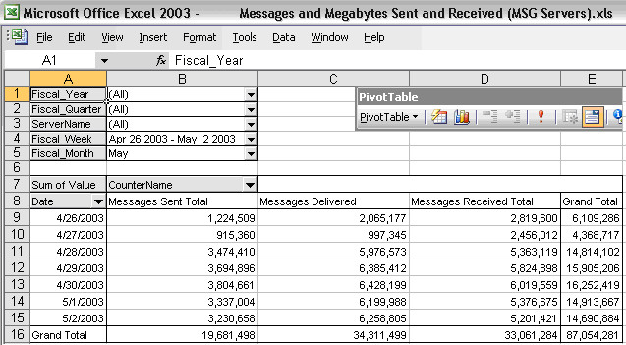
Figure 7. Example Custom Report
The example report contains three performance counters that Microsoft IT captures for all internal mailbox servers at Microsoft:
- Messages Sent Total. Total messages sent through one of the transport protocols, SMTP, since service startup.
- Messages Delivered. Messages successfully delivered to the information store.
- Messages Received Total. Messages received by the server or store, but not yet delivered.
The pivot table enables Microsoft IT to view how many messages were sent, delivered, and received by date, fiscal week, and fiscal month, as well as by individual server. The example shows messages sent, delivered, and received for the fiscal week of April 26 to May 2.
Support for Exchange in the Application Management Pack for MOM has been extended to cover all 1,800 Exchange 2000 Server events for clustered and non-clustered Exchange servers and to provide advanced mailbox and Outlook client performance testing.
You can find the Exchange 2003 Management Pack at http://www.microsoft.com/downloads/details.aspx?FamilyID=56d036bf-8dd3-4993-bf07-07f99f1d5cc4&DisplayLang=en
For more information about the Exchange 2003 Management Pack for Microsoft Operations Manager, see: http://www.microsoft.com/mom. Also see the white paper “Monitoring Enterprise Servers at Microsoft” at http://www.microsoft.com/technet/treeview/default.asp?url=/technet/itsolutions/msit/deploy/entserv.asp
Customize Threshold Levels
The threshold definitions provided in the management pack are associated with servers of all sizes. Because Microsoft IT operates servers in single service roles, the level of mail flow is dramatically different for each server. You should treat Internet gateway servers—which may handle thousands of e-mail messages every hour—as a separate entity for queue management. Adjust the threshold rules as appropriate for your business.
For example, Microsoft IT has one gateway server that handles nondelivery traffic. Microsoft IT specified a heavily adjusted set of threshold rules associated with that server. Lower threshold definitions are set on the gateway servers that do not handle nondelivery traffic. For example, Microsoft IT established threshold rules on Internet gateway server queues in the range of 10,000 of 15,000 messages, but for mailbox servers Microsoft IT established a threshold rule of only 500 messages.
If you modify the out-of-the-box rules, you should first disable the rule, and then copy it to a custom processing rule group, and finally adjust the threshold definition in the custom rule group. This way you have the original rules intact and can manage updates more efficiently.
In addition, you should establish long-term performance trend characteristics for your servers (for example, processor utilization, disk I/O, and RPC latencies), and then set thresholds that define an abnormal condition in your environment. After you adjust thresholds, be prepared to follow up and investigate changes in your environment. For example, if processor utilization is normally 40 percent and spikes to 80 percent for a sustained period, a problem may exist.
Capacity Management
Capacity management is the process of planning, sizing, and controlling a service solution to meet or exceed the defined service level agreement performance levels. Server and network capacity are key components to overall capacity. IT operations staff can set predetermined thresholds in the MOM management pack that will indicate when additional capacity is required.
Based on Microsoft IT 's experience with monitoring key capacity indicators, you should monitor:
- RPC latencies for mailbox servers
- Disk latencies for mailbox servers
In addition, an often overlooked element of capacity planning is the operational processes themselves. Many times the processes deployed to deliver a service solution are not revisited with increases in user volume until response times somewhere in the process become problematic. In Microsoft IT 's experience, further analysis often discovers that a process that was adequate for a small number of users, or a test environment, may not scale to support the increased loads. Process scale should be reviewed on a regular basis along with traditional messaging system parameters.
Trend Average RPC Latencies
If the value for RPC average latency is high over time, it could impact client performance. High RPC requests outstanding and operations per second are indicated by the RPC Requests and RPC Operations per second counters
The figures given here are examples based on Microsoft IT 's early adopter experience, not general recommendations. Microsoft IT routinely monitors the following counters on the MSExchangeIS object for capacity management purposes:
RPC Operations/sec. This counter alone does not clearly indicate how busy the server is, because processor utilization may be impacted by other aspects of the server besides routine e-mail processing. Each operation puts a different load on the server; some are expensive and some are inexpensive. If you have a high number of operations that are expensive, the server could be overloaded. If RPC Operations/sec is low and the outstanding requests counter (MSExchangeIS\RPC Requests) is zero then the problem is before Exchange—all other combinations indicate that the problem is with Exchange or something after Exchange.
RPC Averaged Latency. Sustained RPC averaged latencies above 50ms is an indication of poor client performance.
RPC Requests. Twenty to 25 RPC requests indicate that the store process is backlogging.
Monitor Disk Read and Write Latency
Disk read latency and disk write latency indicate how well the disks are performing. Every I/O disk transfer is a 4 KB block. 5000 I/Os per second times 4 KB per I/O block is a total transfer rate of 20 MB of data per second. This is indicated by the Disk Transfers/sec counter.
On the PhysicalDisk object, Microsoft IT monitors:
- Avg. Disk sec/Read. The normal range for average latency on the disk read operations is below 16ms.
- Avg. Disk sec/Write. Averages of 2 to 4ms are acceptable.
- Disk Transfers/sec. This is the total transfers per second. Any value is acceptable here after latencies have been minimized. Microsoft IT typically observes 5000 peaks with 66 percent read and 33 percent write activity with 2ms to 4ms write latencies.
SAN Disk Management
You should set free disk space monitoring thresholds to alert you if free disk group space falls below 10 percent. If you determine that additional disks must be added to the EVA, always add them in numbers divisible by two.
Always add the disks evenly across all shelves—maintain an equal number of disks per shelf. Wait at least 60 seconds after each disk insertion for the controller software to complete device recognition.
Monitor PF/FB performance
When using Exchange cache mode, 90 percent of normal Outlook 2003 user tasks are performed in the background. However, there are still specific tasks that require real-time access, including:
- Accessing a Public Folder
- Delegating mailbox access (used by people who have permissions to work in another person’s mailbox, such as an administrative assistant who schedules appointments for a manager)
- Free/Busy checking of other users (used to check the schedule availability of a prospective meeting request recipient)
The ongoing consolidation of Exchange servers into major regional sites during the Exchange Server 2003 deployment required that Microsoft IT employ higher capacity Public Folder servers to maintain the same consistent level of performance to all users. Microsoft IT forecasted somewhat higher usage of these servers because more people per server used free/busy publishing, retrieved Outlook 2003 security settings, and accessed general Public Folders then pre-consolidation. Each consolidated site employs two non-clustered, Public Folder servers for redundancy and load sharing.
Availability Management
The goal of the availability management SMF is ensuring the service user has access to a given IT service according to the terms of the SLA. For example, with goals of three to five 9s of availability, this translates to somewhere between 525 and 5 minutes of unplanned downtime on a yearly basis for a 7x24x365 operation.
Availability is related to, but different from, reliability. Reliability measures how frequently the system fails, whereas availability measures the percentage of time the system is in its operational state. A common method for calculating availability is to subtract downtime from total time and divide by total time. For example, if your data center experiences a failure on average every six months and it takes twenty minutes, on average, to return the data center to its operational state, the data center’s availability is:
Availability = (6 months - 20 minutes)/ 6 months = 99.992%
However, measuring server uptime is not sufficient. An Exchange outage could occur because a store went offline, without a corresponding server outage. The Microsoft IT messaging team computes the service availability metric based on the duration between a stop event and the corresponding start event for a given server, multiplied times the number of databases, to help prioritize response. For example, a one minute outage for 15 databases users is reported as 15 minutes of downtime.
Microsoft IT uses MOM to collect all the stop events and start events in a database. An intranet Web site extracts the event stream from the event log. The site then performs a query that looks at each stop event and looks for the corresponding subsequent start event and tallies the outage durations (referred to as “data base minutes,” or “DB Mins”), as shown in Figure 8. Showing outages in terms of the effect on users helps the messaging operations group target its response.
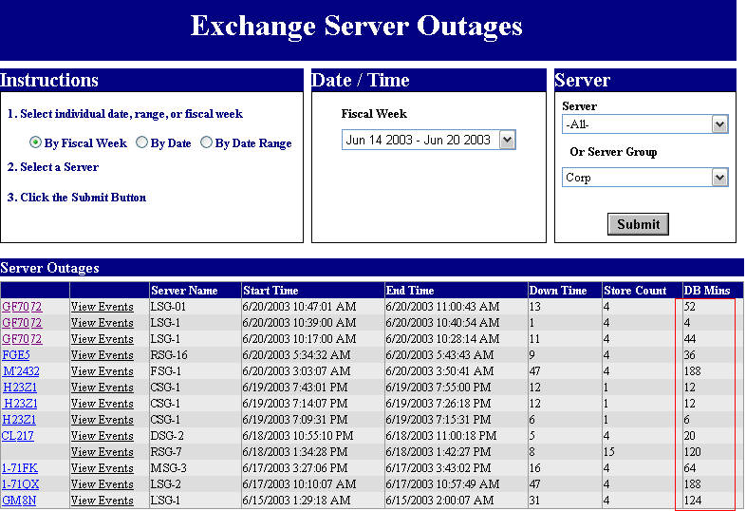
Figure 8. Example Custom Report
Virus and Spam Management
You should filter e-mail viruses and most of your spam at the gateway. Long-term trending shows 40 to 70 percent of inbound e-mail at Microsoft is spam. Rather than transport it, Microsoft IT intercepts it at the gateway to save network and hardware resources.
Antivirus servers are gateway servers that filter e-mail at the network perimeter before it reaches the store. Use MOM to check the availability of your antivirus service. For example, Microsoft IT runs a Service Verification script every few minutes on every antivirus server to make sure that the antivirus service is running. If the service is not running, MOM issues an alert. For additional security, Microsoft IT requires additional antivirus software on every corporate standard desktop.
Adjust threshold definition rules by examining the number of viruses being removed from messages. For example, every few minutes, Microsoft IT samples the counter of the number of viruses being removed. If the virus queue exceeds 100 over five sampling periods, an alert occurs. Measuring rules help Microsoft IT understand the trend in the environment for infected incoming messages, outgoing messages, outgoing viruses, and the total number of infected messages being processed. This measurement helps serve as an early alert in the case of certain kinds of denial-of-service attacks.
For general information about antivirus measures in Exchange Server, see the “Protection” chapter in the Exchange 2000 Server Operations Guide.
Force OWA Server Proximity
Microsoft IT 's early adopter experience showed that for best performance you should encourage users to select the OWA front-end servers physically located closest to their mailbox server, not the OWA servers closest to their present location. For example, when an employee from Australia traveled to the United States, her online OWA experience was optimized if the WAN link was between her and the OWA server rather than between the OWA server and her mailbox server. To make this easy for users, Microsoft IT modified the OWA sign-in screen to include links to all available OWA servers and included instructions on which one to use, as shown in Figure 9.
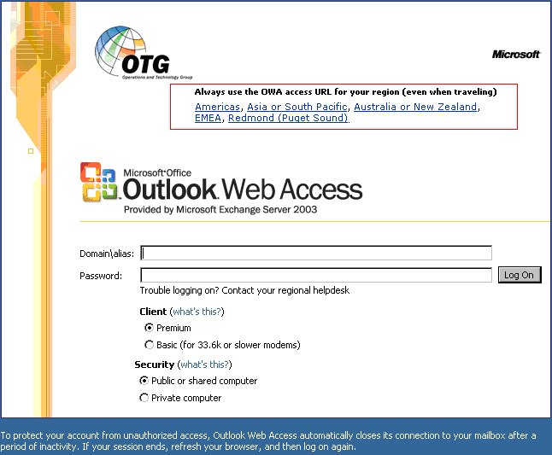
Figure 9. Example OWA Logon Screen
The new logon page for Outlook Web Access stores the user's name and password in a cookie instead of in the browser. When a user closes his or her browser, the cookie is cleared. This logon page also allows users to select the security options that best fits their needs. The Public or shared computer option (selected by default) provides a short default timeout option of fifteen minutes. Alternatively, OWA users who are using computers in their offices or homes where they are the sole operators, can select the Private computer option. When selected, the Private computer option provides a much longer period of inactivity before automatically ending the session, 24 hours by default. To match enterprise security needs, an Exchange Server 2003 administrator can customize the inactivity timeout values for both option settings. To enable the Outlook Web Access logon page, you must enable forms-based authentication on the server.
Plan Exchange Link Names Carefully
The same Exchange front-end servers used for OWA are also used by Outlook Mobile Access (OMA) clients in the Microsoft IT configuration. Consider that entering a normal URL on a Smartphone device can be time-consuming. A long and complex OMA URL will likely prevent most users from regularly using the service.
SMTP Queue Directory Management
Exchange Server 2003 supports a new GUI method for moving the SMTP BadMail and Queue directories. This makes it practical to have a dedicated disk or disks for SMTP queues on “multi-purpose” Exchange servers. For example, Microsoft IT dedicates disk spindles for the SMTP Queue and BadMail directories on servers that are a combination Hub and Public Folder server, instead of using the default Exchange installation drive. Having dedicated disks improves server performance, drive space management, and makes moving the directories for troubleshooting purposes much easier than before in Exchange 2000 Server. The changes in the GUI are shown in Figure 10.
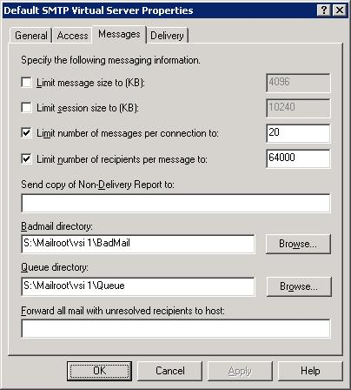
Figure 10. SMTP BadMail Properties
Business Continuity Management
Closely related to availability management, and previously known as contingency management, the Business Continuity SMF focuses on minimizing the business disruption of mission-critical systems by planning response and recovery from an IT disaster.
An IT disaster is defined as a loss of service for protracted periods, which requires that work be moved to an alternative system in a nonroutine way. It also provides guidance on safeguarding the existing systems by the development and introduction of proactive and reactive countermeasures. IT service continuity management also considers what activities need to be performed in the event of a service outage not attributed to a full-blown disaster.
The key to business continuance management is producing (and maintaining) an effective service continuity (contingency) plan that includes:
- Alternate operations sites and/or backup facilities capable of running business-critical systems
- Manual backup or alternate business processes that can be performed in the event of major service disruptions
- High-availability best practices for business-critical systems (redundancy, hot/warm/cold standby systems, mirroring, and so on)
- Clear procedures and communication channels for coordination of activity during execution of a contingency plan; establishment of command central
- Staff training in critical recovery plans
Reliable and efficient daily backups are critical to the success of the business continuity plan. An example disaster recovery flowchart for Exchange 2000 Server is shown in Figure 11.
Figure 11. Example of Exchange 2000 Server Disaster Recovery Flowchart
Use a Two-Step Backup Process
Microsoft IT uses a two-step backup process—disk-to-disk and disk-to-tape—in its clustered environment. In the past, both steps were managed by the mailbox server running Exchange, which impacted server performance. Because of the impact, Microsoft IT had a limited window to do its daily backups. Now, using clustering improvements in Exchange and Windows, Microsoft IT is able to perform step two of the process (disk-to-tape) on an alternate passive node, which minimizes user impact. This setup also gives Microsoft IT more flexibility to run backups at different times as necessary.
For more detailed information on the Microsoft IT two-step backup process see the technical case study “Messaging Backup and Restore at Microsoft” at: http://www.microsoft.com/technet/treeview/default.asp?url=/technet/itsolutions/msit/deploy/msgbrtcs.asp
Use MOM to Monitor Backup and Restore
Each night Microsoft IT performs backup of a total of 15 to 20 (average 20 GB to 50 GB) databases depending on the server. The databases are represented as a specific BKF file into a predefined directory, which enables multiple concurrent backup jobs to complete during the second stage backup.
A standard MOM rule sends an alert if a transaction log is older than 24 hours, indicating a possible backup failure. However, Microsoft IT also runs a custom MOM processing rule that checks the application event logs each evening between 20:00h and 20:10h local time for missing events that indicate scheduled backups have started. If the event is not present, operators are immediately alerted. Microsoft IT also has a consolidation rule to detect a successful number of backups over a given period of time. If the number is lower than expected, an alert is issued to the operator to investigate.
When using the MOM management pack to monitor the cluster, you should disable event log replication so that you can prevent duplicate alerts from the physical cluster nodes.
Use Recovery Storage Groups
Use the Exchange Server 2003 Recovery Storage Groups for disaster recovery restores as well as for single mailbox restores. If there is a hardware failure and you lose databases, you can bring the storage group up, empty, while recovering user’s old data. This restores service quickly, and minimizes user downtime, at the cost of access to their old data for the time the restoration operation takes.
Problem Management and Support
You should set up alerts that are based on new types of error conditions when they are discovered in your environment. Implement an alerting and notification process around each new condition. To enable the operations staff to quickly respond to the issue, document the alert and notification process by writing a TSG. At Microsoft, all common alerts have an associated TSG, a 5 to 10 page Microsoft Word document for the technician that includes instructions on solving the issue, and a clear escalation path if the fix is unsuccessful, or the allotted time (fifteen minutes for example) has expired without resolution. For example:
- If the alert is Exchange-specific, the alert is escalated to someone in the messaging operations group.
- If the alert is hardware-related, the alert is escalated to someone in the Operations group.
- If the alert is an OS issue, the alert is escalated to someone in the IS Tier 3 Support group.
Microsoft IT maintains the TSGs on an intranet site based on Windows SharePoint Service and SharePoint Portal Server™, as shown in Figure 12.
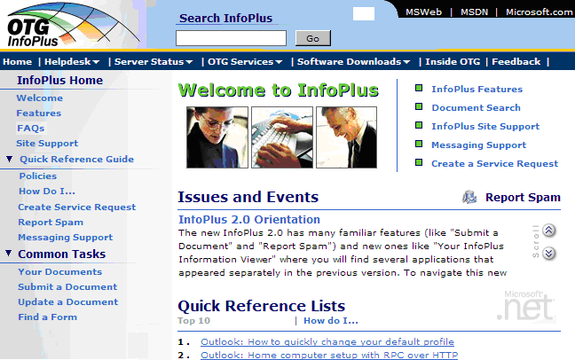
Figure 12. Infoplus
Target Troubleshooting with Counters
One translation of the medical profession’s guiding principle is "First, do no harm." Before trying to fix a problem, make sure you have the right information. In a complicated IT environment fixing the wrong thing can be as disruptive as not fixing the right thing fast enough. Be sure to look at the relevant real-time performance characteristics.
For example, monitor the counters MSExchangeIS\RPC Averaged Latency and MSExchangeIS\RPC Requests, which provide a view of Exchange client performance. When you receive an alert, investigate by manually looking at real time performance characteristics on the server. Look at the processor utilization, physical disk counters, SMTP counters, network interface counters, and MSExchangeIS object counters. Also look at threads (process counters) to see if a particular process is causing problems.
On the MSExchangeIS object, the RPC Operations/sec counter indicates the rate at which RPC requests are being processed. If RPC Operations/sec is low and the outstanding requests counter (MSExchangeIS\RPC Requests) is zero, then the problem occurs before the request reaches Exchange Server—all other combinations means the problem is with Exchange or occurs after Exchange Server processes the request.
Use an Issue Tracking Intranet Portal
Set up an intranet Web site to view open trouble tickets. Data Center Operations (OPS) views MOM alerts using an internal tool called EEMS (Enterprise Event Management System). Figure 13 shows an EEMS screen showing controlled and uncontrolled outages, their durations, and links to the associated incident ticket and TSG.
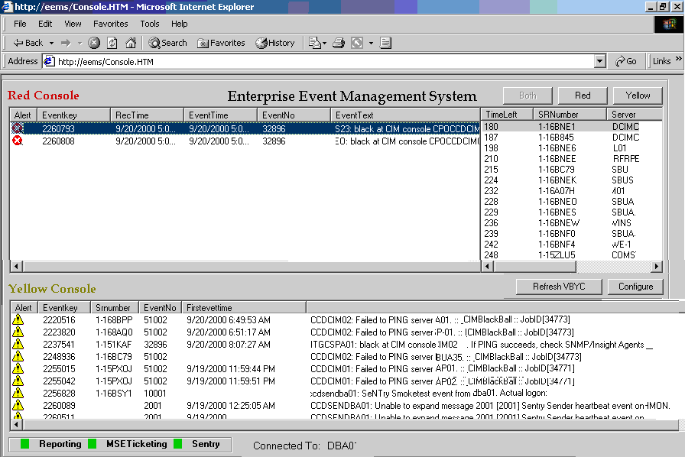
Figure 13. EEMS
Isolate the Issue
Be sure to disable, turn off, or otherwise suspend online maintenance, anti-spam, backup, monitoring, mailbox moves and remote access tools when attempting to troubleshoot or diagnose an issue.
Security Best Practices
For general information about security best practices in Exchange Server, see the “Protection” chapter in the Exchange 2000 Server Operations Guide. The best practice advice there also applies to Exchange Server 2003.
Use Clients with Improved Security
Outlook 2003 and OWA 2003 provide antivirus enhancements, including attachment blocking, and automatic script and Web beacon removal. With these clients, you can allow users to maintain Trusted and Junk Senders lists and optionally store Trusted/Junk lists on the server.
For increased security, and to simplify support, you can block access to the server by earlier versions of Outlook. This operation requires Exchange 2000 Server Service Pack 1 or later. For more information, see the article “Security Tip: Place Server-Side Restrictions on Clients Used to Access Exchange 2000 Mailboxes” at http://www.microsoft.com/exchange/techinfo/tips/SecTip01.asp
Enable Forms-Based Authentication
To improve security you can enable the new logon page for Outlook Web Access that stores the user's name and password in a cookie that expires when a user closes his or her browser or after a predefined period of browser inactivity. The new logon page requires users to enter their domain, user name, and password, or their full user principal name (UPN) e-mail address and password. To enable the Outlook Web Access logon page, you must enable forms-based authentication on the server.
Use RPC over HTTP
As an alternative to VPN access with the Outlook client or OWA, you can provide users with a more secure method to receive their mail with Outlook 2003 using RPC/HTTP. Windows 2003, Exchange Server 2003, Outlook 2003, and Windows XP Service Pack1 are all required for RPC/HTTP. The recommended method for deploying RPC over HTTP is to install ISA Server with Feature Pack 1 in the perimeter network and position your RPC proxy server within the corporate network. Your RPC proxy server can be either your Exchange front-end server or another Web server that you allow users to connect to from the Internet. With RPC/HTTP users get full Outlook 2003 functionality, including new mail notification, public folder access, free/busy information, and more, without Microsoft IT having to open any new ports in the network perimeter.
Filter High-Profile Senders
Block specific internal senders that you are sure will never send messages from the Internet. For example, block your CIO address (someone@example.com) as a sender for inbound Internet e-mail, if the CIO never sends e-mail messages from the Internet to the internal corporate messaging system. You should also block internal distribution group names that consist of easily guessed acronyms, such as ops@example.com. This prevents any malicious code or sender from attempting to impersonate the sender for inbound e-mail.
Block the sender using the Exchange ESM by selecting the Drop connection if address matches filter check box on the Sender Filtering tab of the Message Delivery Properties dialog box, as shown in Figure 14.
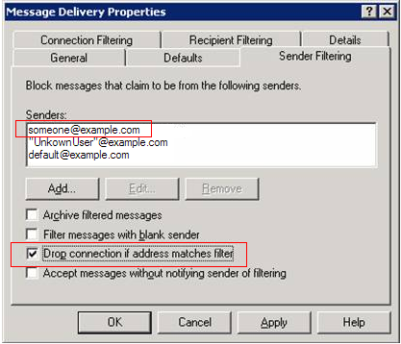
Figure 14. Block High Profile Senders
Use Authenticated-Only Distribution Groups
New in Exchange Server 2003 is support for restricting sensitive distribution groups to accept only senders who have been authenticated. If you can determine that a distribution group need never receive e-mail from anonymous senders, then you should restrict all such distribution groups to accept e-mail only from authenticated senders. This practice will reduce unsolicited commercial e-mail from the Internet being delivered to the distribution group recipients.
This feature is implemented as a check box on the Exchange General tab of the All Employees Properties dialog box when looking at e-mail-enabled group objects in Active Directory Users and Computers. To see this option, you must have the Exchange 2003 Management Components installed. Figure 15 shows the setting for an example distribution group (DG) labeled “All Employees."
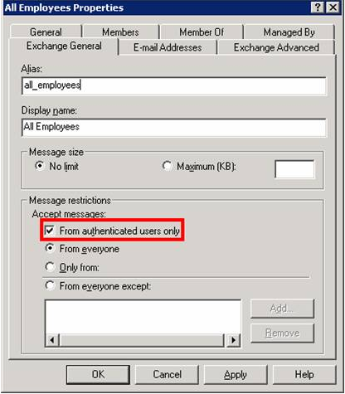
Figure 15. Authenticated-Only DG Example
Disable P2 Sender Address Resolution to Prevent Spoofing
In Exchange 2000 Server, the ResolveP2 registry setting contains information that Exchange 2000 can use to “resolve” specified addresses in an e-mail message body (referred to as “P2”), if those users exist in the Exchange 2000 directory.
Spoofing is the act of using a fake sending address that disguises the origin of a message. Spoofing may be done legitimately to redirect responses to an account other than the one actually sending the message, but it can also be done with the intent of impersonating another sender, maliciously redirecting a response to spam e-mail or gaining illegal entry into a secure system.
If you double-click a resolved address in the client, the Exchange 2000 or Exchange 2003 directory information is displayed. An unresolved address simply displays the SMTP address. Because this is the resolution behavior for internal addresses, an external resolved address can lead an unobservant e-mail user to believe that an e-mail message originated from within the local domain or organization. If you enable the ResolveP2 setting, educated users can tell the difference between internal and external e-mail, as shown in Figure 16.
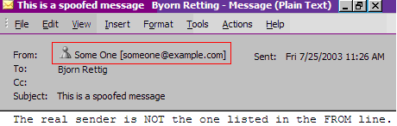
Figure 16. Example of Spoofed E-Mail Message
The Resolve anonymous (P2) e-mail setting is unchecked (disabled) by default in Exchange Server 2003. You can enable anonymous resolution in the Exchange System Manger, in the SMTP Virtual Server Properties, under the Access tab–on the Authentication tab, as shown in Figure 17.
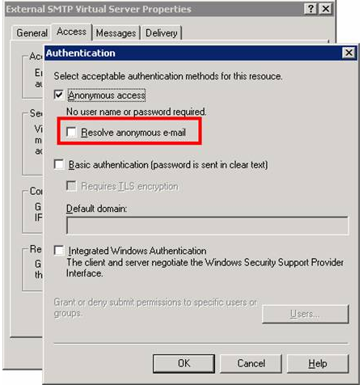
Figure 17. ResolveP2 Setting Tab
You set the ResolveP2 key on the server that receives e-mail from the Internet. Instructions for setting the registry key for Exchange 2000 Server can be found in Microsoft Knowledge Base Article 288635 at http://support.microsoft.com/default.aspx?scid=kb;en-us;288635.
Conclusion
Like other enterprise IT organizations, Microsoft IT’s operational goals focus on striking the right balance of availability, performance, flexibility, and cost. Unique is Microsoft IT’s commitment to use Microsoft solutions wherever possible, often before they are released to the public. Achieving operational excellence involves people, processes, and technology.
People
The operations teams in Microsoft IT responsible for the messaging environment focus on key aspects for achieving their goals:
A–Agreeing on monitoring requirements
D–Deploying the process and technology
O–Optimizing the process and technology
P–Performing continuous monitoring
T–Turning monitoring off and on
S–Showcasing best practices and lessons learned to customers
Processes
A single monitoring infrastructure on Microsoft Operations Manager, a ticket system, and a configuration management database support Microsoft IT processes. Proactive monitoring and notification of potential service breaches, along with quick resolution of incidents, wherever possible using automated corrective actions, is the key to achieving the Microsoft IT model enterprise initiative goals. Standardized process models, such as the Microsoft Operations Framework, can help enterprise operations sustain improvements.
Technology
Improvements in Windows Server 2003, Exchange Server 2003, the Microsoft Office 2003 Editions, and solutions such as the Microsoft Solutions for Management and Microsoft Operations Manager enable Microsoft IT to continuously improve daily messaging operations. Even in a very changeable environment Microsoft IT maintains:
- Global mail flow of 6,000,000 messages per day on average, with 2,500,000 average Internet e-mail messages per day.
- Global service availability of better than 99.9 percent.
- Worldwide mail delivery in less than ninety seconds, 95 percent of the time.
- Backup and restore operation SLA of less than one hour per database, even on servers of more than five thousand 200–MB mailboxes, and clustered implementations of 16,000 mailboxes.
Microsoft IT has many unique aspects to its environment, and a commitment to using Microsoft software before it is released to the public. However, many of the early adopter lessons learned and best practices may also apply to other enterprise customers. Microsoft IT will continue to share its experiences and advice as part of its customer service mission.
For More Information
To view additional IT Showcase material please visit http://www.microsoft.com/technet/showcase
This paper builds on the Exchange 2000 Server Operations Guide located at: http://www.microsoft.com/technet/prodtechnol/exchange/exchange2000/maintain/operate/opsguide
Exchange Server 2003 Security Enhancements http://www.microsoft.com/exchange/evaluation/03SecEnh.doc
Planning an Exchange 2003 Messaging System http://microsoft.com/downloads/details.aspx?FamilyId=9FC3260F-787C-4567-BB71-908B8F2B980D&displaylang=en
Exchange 2003 Deployment Guide
http://microsoft.com/downloads/details.aspx?FamilyId=77B6D819-C7B3-42D1-8FBB-FE6339FFA1ED&displaylang=en
Deploying and Supporting Windows Server 2003: Experiences of Early Adoption at Microsoft
http://www.microsoft.com/technet/treeview/default.asp?url=/technet/itsolutions/msit/deploy/win2003.asp
Microsoft Systems Architecture Enterprise Data Center http://www.microsoft.com/solutions/msa/evaluation/overview/EDC/default.asp
MOF Process Model for Operations http://www.microsoft.com/technet/itsolutions/tandp/opex/mofrl/MOFPM.asp
MOF Risk Model for Operations http://www.microsoft.com/technet/treeview/default.asp?url=/technet/itsolutions/tandp/opex/mofrl/mofrisk.asp.
MOM Management Pack for Exchange Server 2003
http://www.microsoft.com/downloads/details.aspx?FamilyID=56d036bf-8dd3-4993-bf07-07f99f1d5cc4&DisplayLang=en
Messaging Backup and Restore at Microsoft Case Study
http://www.microsoft.com/technet/treeview/default.asp?url=/technet/itsolutions/msit/deploy/msgbrtcs.asp
Monitoring Enterprise Servers at Microsoft
http://www.microsoft.com/technet/treeview/default.asp?url=/technet/itsolutions/msit/deploy/entserv.asp
Exchange 2000 Capacity Planning and Topology Calculator
http://www.microsoft.com/downloads/details.aspx?displaylang=en&familyid=342035d0-53f8-4ccd-9028-35b993713f5f
Exchange 2000 Front-End Server and SMTP Gateway Hardware Scalability Guide
http://www.microsoft.com/downloads/details.aspx?displaylang=en&familyid=155a7de2-c08d-4570-9242-fff4c7933453
Exchange 2000 Server Back End Mailbox Scalability
http://www.microsoft.com/downloads/details.aspx?displaylang=en&familyid=90ef65fa-6c81-4b82-8278-747d22a2646f
For any questions, comments, or suggestions on this document, or to obtain additional information about Microsoft IT Showcase, please send e-mail to
showcase@microsoft.com.
For more information about Microsoft products or services, call the Microsoft Sales Information Center at (800) 426-9400. In Canada, call the Microsoft Canada information Centre at (800) 563-9048. Outside the 50 United States and Canada, please contact your local Microsoft subsidiary. To access information via the World Wide Web, go to: http://www.microsoft.com/.

The information contained in this document represents the current view of Microsoft Corporation on the issues discussed as of the date of publication. Because Microsoft must respond to changing market conditions, it should not be interpreted to be a commitment on the part of Microsoft, and Microsoft cannot guarantee the accuracy of any information presented after the date of publication.
This White Paper is for informational purposes only. MICROSOFT MAKES NO WARRANTIES, EXPRESS, IMPLIED OR STATUTORY, AS TO THE INFORMATION IN THIS DOCUMENT.
Complying with all applicable copyright laws is the responsibility of the user. Microsoft grants you the right to reproduce this White Paper, in whole or in part, specifically and solely for the purpose of personal education.
Microsoft may have patents, patent applications, trademarks, copyrights, or other intellectual property rights covering subject matter in this document. Except as expressly provided in any written license agreement from Microsoft, the furnishing of this document does not give you any license to these patents, trademarks, copyrights, or other intellectual property.
Unless otherwise noted, the example companies, organizations, products, domain names, e-mail addresses, logos, people, places and events depicted herein are fictitious, and no association with any real company, organization, product, domain name, email address, logo, person, place or event is intended or should be inferred.
© 2003 Microsoft Corporation. All rights reserved.
Microsoft, Active Directory, Outlook and Windows are either registered trademarks or trademarks of Microsoft Corporation in the United States and/or other countries.

