

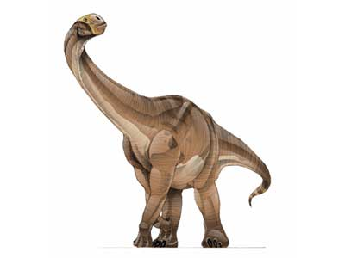

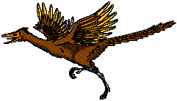

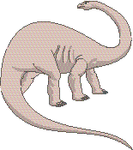
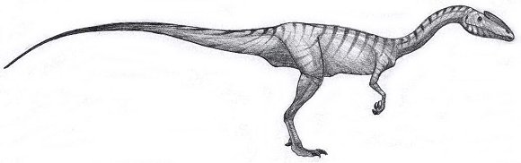

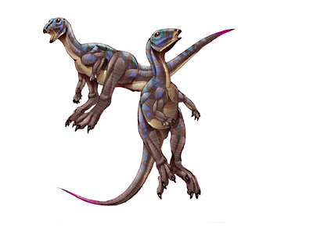
Archaeopteryx
Cetiosaurus

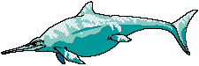
Syntarsus

Middle – Dogger
180 – 154
One Million Years Ago
Early - Lias
206 – 180
One Million Years Ago
Late – Malm
154 – 144
Million Years Ago
Ichthyosaurus
Brachiosaurus
Xiaosaurus

