MICROSOFT Belgium and Luxembourg

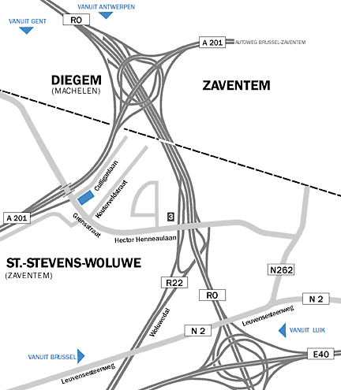

Coming from Antwerp:
Take the E19 motorway towards Brussels/Zaventem.
You remain on exit Zaventem and should follow directions Brussels/Evere. Take exit 2 Diegem/Industrie. At the traffic lights, turn left passing underneath the bridge. When you passed the bridge, take the first road at your left hand side. Turn immediate to the right onto the parking of the Microsoft Building. Welcome to Microsoft!

Coming from Ghent:
Take the E40 motorway towards Brussels Zaventem. Take exit Zaventem. You remain on exit Zaventem and should follow directions Brussels/Evere. Take exit 2 Diegem/Industrie. At the traffic lights, turn left passing under the bridge. When you passed the bridge, take the first road at your left hand side. Turn immediate to the right onto the parking of the Microsoft Building. Welcome to Microsoft!

Coming from Liège:
Take the E40 motorway towards Brussels, follow R0, directions Antwerp/Ghent.
On the R0, take exit Zaventem – Diegem. At the traffic lights, turn left. You are now on the Avenue Hector Henneau. Follow this road as far as the bridge. The Avenue Culligan is just before the bridge, on your right hand side. Welcome to Microsoft!

Coming from Brussels:
From Place Meyser, take the Chaussée de Louvain as far as the Boulevard de la Woluwe.
Turn left on the Boulevard de la Woluwe, towards Diegem. Keep to your left. You are now on the Avenue Hector Henneau. Follow this road as far as the bridge. The Avenue Culligan is just before the bridge, on your right hand side. Welcome to Microsoft!

Coming from Brussels National Airport:
Follow directions Brussels Centre - A201. When on the A201, take the exit 2, ‘Diegem Industrie’. At the traffic lights, turn left passing underneath the bridge. When you passed the bridge, take the first road at your left hand side. Turn immediate to the right onto the parking of the Microsoft Building. Welcome to Microsoft!

