“With tighter SAM standards, we have fewer system problems and help-desk calls, reducing both costs and labor. The whole department runs more smoothly and efficiently.”
Customer: Interactive Network for Continuing Education (INCE)
Web Site: www.ince.com
Customer Size: 100
Country or Region: United States
Industry: Continuing education
Partner: Softchoice

Customer Profile
The Interactive Network for Continuing Education provides educational programs, collateral materials, and support services that help professionals, especially medical workers, with their ongoing training needs.

Software and Services
- Microsoft Server Product Portfolio
- Windows Server® 2003 Enterprise Edition
- Windows® XP
- AssetMetrix Business Intelligence Services
- Softchoice TechCheck Services

Hardware
- Dell personal computers
- HP ProLiant server computers
For more information about other Microsoft customer successes, please visit: www.microsoft.com/casestudies

Anwer Abbas, IT Manager, Interactive Network for Continuing Education
In 2005, the Interactive Network for Continuing Education (INCE) wanted to automate its process for tracking software and licenses and keeping licenses up to date. INCE turned to Microsoft® Gold Certified Partner Softchoice for advice. Softchoice helped INCE deploy AssetMetrix and TechCheck services as a first step in a comprehensive Software Asset Management (SAM) program. The new solution streamlines IT management, thereby reducing help-desk calls and saving 15 percent on IT costs.

Business Needs
 |  |  | 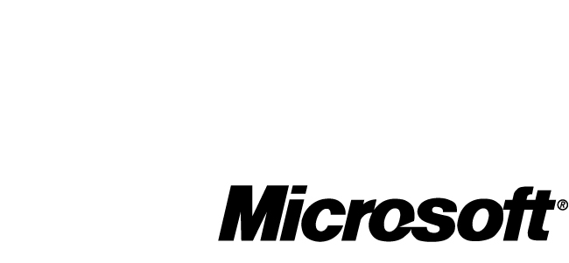

Located in Cranbury, New Jersey, and founded in 1991, INCE develops continuing professional, vocational, medical, and nursing education programs. It also provides related collateral materials and support services. The experience of the company’s 100 employees spans many therapeutic categories, and INCE presentations are available in a variety of media and formats, including audio, video, CD-ROM, live and recorded webcasts, and print.

In October 2005, INCE was using a manually updated spreadsheet to track its software and licenses. INCE wanted to automate this process and make sure that all the company’s licenses were up to date. The company sought advice from Softchoice, a Microsoft Gold Certified Partner.

Founded in 1989 and with offices in more than 35 cities in the United States and Canada, Softchoice is a leading provider of technology products and services to North American businesses. The company helps organizations of all sizes to select, acquire, and manage their software and hardware technology resources.

Solution
As a first step, Softchoice recommended that INCE use the subscription-based business intelligence service AssetMetrix to comprehensively inventory INCE systems. AssetMetrix gathers information about a customer’s IT environment and uploads it to a hosted database. From there, through the Softchoice TechCheck services, Softchoice analyzes the data, compiles it into summary reports, and delivers the analysis to the customer.

INCE agreed to use AssetMetrix to conduct a one-time inventory of its hardware and software assets. “It really impressed us,” says Anwer Abbas, IT Manager at INCE. “AssetMetrix gave us not only licensing information but also information about applications, operating systems, BIOS versions, and asset ID numbers. The level of detail impressed us so much that we purchased a subscription right away.”

Through its Policy TechCheck and Licensing TechCheck services, Softchoice also helped INCE assess its current software licensing situation and implement a more formalized SAM program. The new program would complement existing INCE policies and procedures through tighter standards and would more closely track the company’s software assets. Components of the new program include the following steps:

- Implement policies for software usage and for infrastructure and security management.
- Standardize the IT environment on the Windows Server® 2003 and Windows® XP Professional operating systems.
- Tighten standards for employee computers by creating lists of authorized software and allowing only the IT department to set up and maintain these computers.
- Remove nonstandard and unauthorized programs from employee computers.
- Replace aging hardware with new models.
- Centralize the software budgeting and purchasing authority in the IT department.
- Participate in a Microsoft Enterprise Agreement for volume licensing.
- Join the Microsoft Software Assurance maintenance program to qualify for new software version rights, more-flexible payment options, additional training, and expanded support.

Like many companies, INCE had already taken some of these steps, such as standardizing its operating systems and publishing a software usage policy. The remaining steps were implemented over the next few months.

Benefits
The new SAM program provides a comprehensive solution for managing software and licenses, simplifies IT management, and reduces related IT labor costs. Better visibility into the IT environment also helps managers make better-informed purchasing and maintenance decisions.

More-Efficient IT Administration, Lower Costs
With the new solution in place, IT management is simplified and requires less time and labor. “The SAM program streamlined everything, especially the distribution and control over software and upgrades,” Abbas says. “With tighter SAM standards, we have about half as many system problems and help-desk calls, reducing both costs and labor. The whole IT department runs more smoothly and efficiently. We were able to repurpose a full-time IT resource.” As a result, INCE estimates that it is saving about 15 percent on its annual IT budget.

Cost-Effective Balancing of Licenses
The initial inventory revealed that several software titles were either overlicensed or underlicensed. “Before, I think we didn’t have the proper understanding of how the licensing works in particular circumstances. But the TechCheck report helped us decide which software licenses we needed and which ones could be repurposed, and Softchoice handled ordering any new licenses. We had an easy go of it. The process worked out pretty well.”

Additionally, INCE realizes the importance of managing its software assets as part of an overall strategy to promote good corporate governance. “Our managers value the fact that we’re in compliance with license agreements,” says Abbas. “Now that I know our license management has been improved, it’s a big relief for me.”

Comprehensive Asset Information
The new solution provides high visibility into INCE systems. “The TechCheck gave us a complete picture of what is inside each computer,” Abbas says. “For example, in one case, Softchoice reported that equipment was outdated, which helped us decide which systems should be replaced first. An even more-impressive example occurred when it identified a Dell printer and reported that this particular model had been recalled for a safety issue.”

“Having this kind of information is absolutely invaluable for an IT department, especially one that’s understaffed or overworked,” adds Chip Snider, Services Consultant at Softchoice. “When you can get up-do-date IT information from reporting tools that are deployed directly in the environment, then you always have the data to justify important IT decisions—real, hard numbers to convince managers to invest in new systems and solutions, for example. I think that benefit is something valuable that we were able to give INCE through AssetMetrix and the TechCheck services.”

