Microsoft Office Project Standard 2007

**Microsoft****® Office Project Standard 2007 gives you robust project management tools with the right blend of usability, power, and flexibility so you can manage projects efficiently and effectively. You can stay informed and control project work, schedules, and finances; keep project teams aligned; and be more productive through integration with familiar Microsoft Office system programs, powerful reporting, guided planning, and flexible tools.**

Understand and Control Project-Related Schedules and Finances

Better organize your projects and people with the scheduling power of Office Project 2007.

Trace the source of issues.

Using the Task Drivers feature, you can determine prerequisites and resource constraints that drive the start date of a selected task. With Task Drivers, you can easily trace critical paths in project plans to find the root cause of a particular delay.

**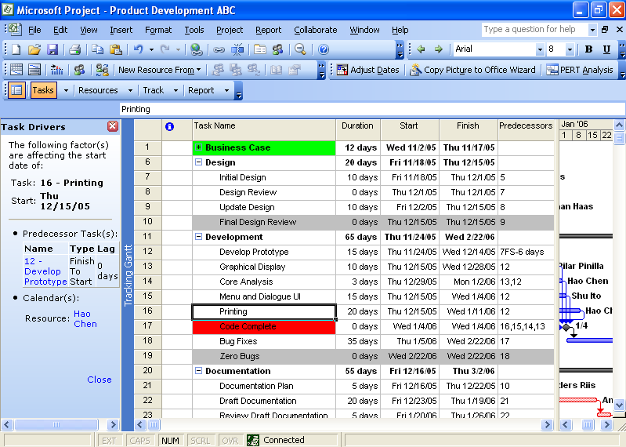**

Example of the Task Drivers pane.

Reverse changes.

Experiment with what-if scenarios by using Multiple Level Undo. This enables you to undo and redo changes to views, data, and options. You can undo actions or sets of actions from macros or compliant, third-party customizations to fully understand the implications of each change.

See the effects of a change.

Determine the impact of a change on all other dependent tasks with Change Highlights. Project automatically highlights all items that shift as a result of the most recent change you make.

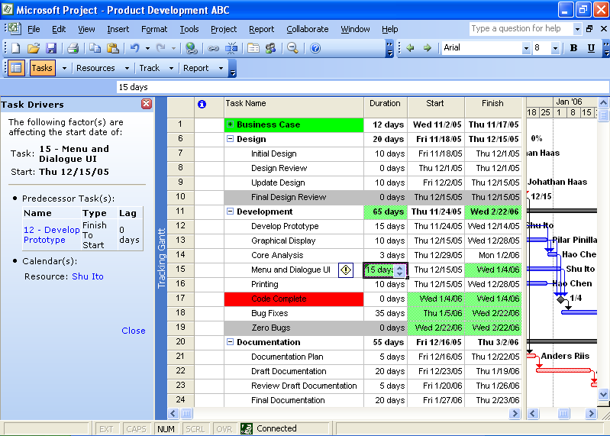

Green highlights indicate effects of edits.

Control project finances.

Assign budgets to projects and programs to allocate funds and track costs.

Assign costs to tasks.

Assign multiple arbitrary costs (not based on work time) with the new Cost resource type. Also, new fields for cost information enable better project accounting. You can more accurately monitor project financials and keep your project in sync with data in your accounting system.

Effectively Communicate   
Project-Related Information

Communicate your progress and issues effectively with Office Project 2007.

Use predefined reports.

Select, preview, and print the most frequently used information needed to manage projects, track resources, maintain costs, and communicate progress to your team. You can also adapt these reports to present the specific information you want to display.

Use Project views to convey information.

Updated views and visual capabilities allow for better reports. The Background Cell Highlighting feature enables you to change the color of a cell or row to convey additional meaning.

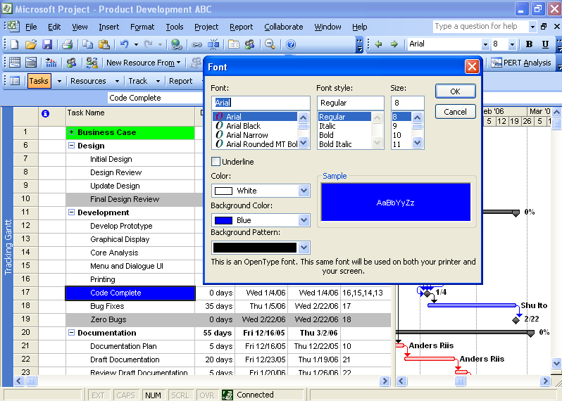

Example of Background Cell Highlighting.

Capitalize on charts and diagrams.

Easily create charts in Microsoft Office Excel® 2007 or 2003 and diagrams in Microsoft Office Visio® Professional 2007 of your project data with the Visual Reports feature. This feature creates report templates that may be reused with different projects. These reports support PivotTable® views versus the static snapshots of Project information that the Copy Picture to Office Wizard creates in Excel, Microsoft Office Word, or Microsoft Office PowerPoint®.

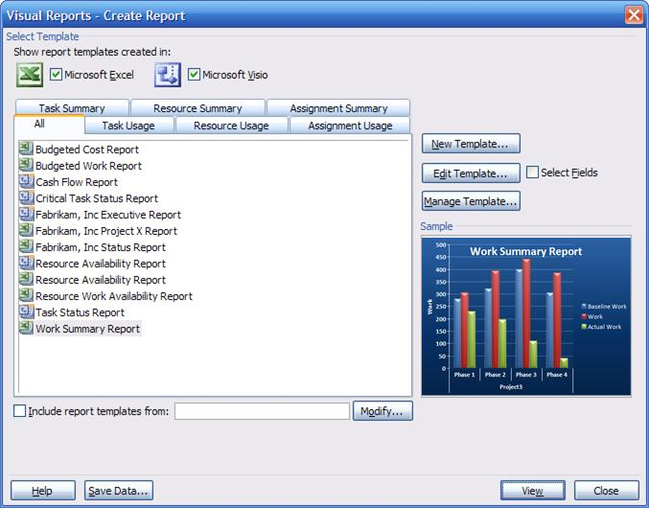

The Visual Reports window with an Excel report.

Get Productive Quickly

Easily assign resources, control finances, and help improve cost estimation.

Follow the Project Guide.

Learn to use Project by following the Project Guide, an interactive step-by-step planning aid that helps you quickly master the project management process.

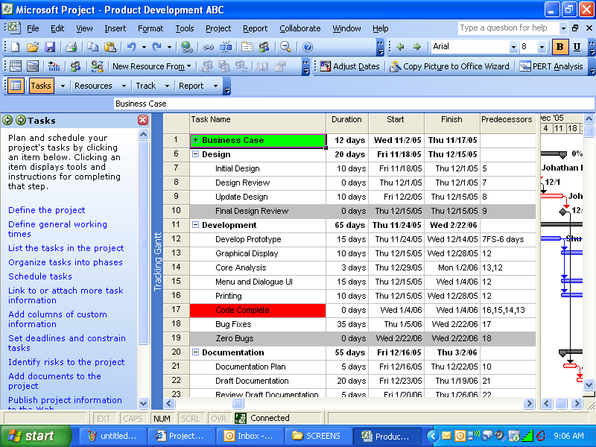

The Gantt view with the Project Guide task pane.

Save time with project templates.

Project provides many out-of-the-box templates to help speed the project creation process. A Project template prepopulates task and resource information, formatting, macros, and other project-specific settings. You can send templates to other users via e-mail to share best practices and create consistency. You can also download additional templates from the evolving Microsoft Office Online gallery.

Create your own template.

Take advantage of your own best practices by creating your own custom templates. This enables you to reuse an existing project as the basis for future projects.

Tap Office Online Help and training.

Get Help quickly while you work. Project provides a wealth of assistance, from a robust Help search engine and wizards to online access to training courses, templates, and more (requires Internet connection).

Choose the Office Project 2007 Edition   
to Meet Your Needs

Office Project Standard 2007 gives you the core tools you need to manage schedules and resources independently.

Office Project Professional 2007 includes all of the features of Office Project Standard 2007, but can also be used with Microsoft Office Project Server 2007, which provides you with enterprise project management capabilities such as centrally tracking resource availability and skills across projects and communicating and collaborating across the enterprise.

For More Information

Learn more about Office Project Standard 2007 and the Microsoft Office system at <www.microsoft.com/office/project>.

For complete system requirements, visit <www.microsoft.com/office/project>.

This document is for informational purposes only. MICROSOFT MAKES NO WARRANTIES, EXPRESS OR IMPLIED, IN THIS SUMMARY.

The example companies, organizations, products, domain names, e-mail addresses, logos, people, places, and events depicted herein are fictitious. No association with any real company, organization, product, domain name, e-mail address, logo, person, place, or event is intended or should be inferred.

MSlogo_k_1118© 2006 Microsoft Corporation. All rights reserved. Microsoft, Excel, the Office logo, PivotTable, PowerPoint, Visio, and the Windows logo are either registered trademarks or trademarks of Microsoft Corporation in the United States and/or other countries. All other trademarks are property of their respective owners.