General Ledger

Microsoft Business Solutions–Solomon General Ledger is the highly flexible core of all Solomon business and financial accounting applications. Using this module, you establish your chart of accounts according to the way your business operates. Then you can post accounting transactions, process, summarize, report, and close your books smoothly each month, quarter, and year. A record is kept of all your financial data, providing you with timely business information and the assurance that a complete audit trail is beneath your business transactions.
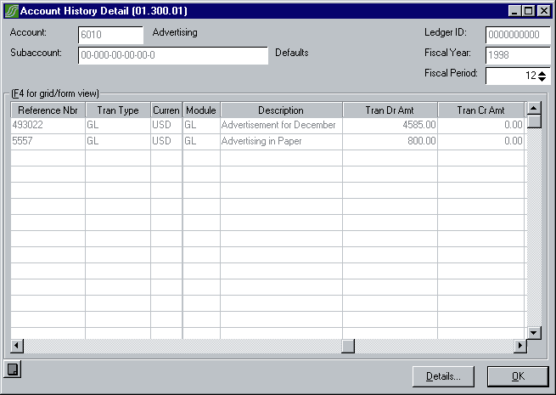
Easy data lookup allows you to review posted transactions, with the ability to drill down to originating documents.
Flexible to Fit Your Business
Easily configurable, you can set up accounts and subaccounts to your operating structure, and select from various user-definable options that help you better manage your time and business. Reference numbering can be set to automatic, manual, or optional at the time of data entry. Multiple sets of books can be maintained in a single database allowing for budgets, forecasts, and statistical information to be compared in context to your actual operating results. And, you can configure the appropriate number of periods to keep a detailed audit trail in the General Ledger and integrated subsidiary Solomon modules.
Powerful Data Entry and Inquiry
You can tailor data entry to your business, with the option of using several types of transaction batches, including non-recurring, recurring, manual, and adjustment (one-sided). System defaults accelerate data entry by populating the data fields ahead of time with user-definable default values, allowing you to focus on the task at hand — without needing to search for the proper account, subaccount, or currency code. Valid account/subaccount combinations are defined during General Ledger setup and verified during data entry, helping to reduce erroneous postings.
And inquiry and lookup capabilities get you the information you need quickly, without the hassle of navigating through complicated interfaces and unnecessary information. You can instantly drill down from a balance to the supporting source documents for detailed account information. From top to bottom or anywhere in-between — you get the information you need!
Efficient Processes
With Solomon General Ledger, you can streamline the monthly, quarterly, and year-end closing processes by automating routine activities, allocations, and reports. You can have multiple sessions open simultaneously, even to execute multiple tasks while others are processing. Consolidating information from other ledgers, companies, currencies, and databases is accomplished through a simple export/import process, giving you the complete picture of your organization whether it is a single office or multi-national business.
Reliable Controls
You can post by period, account, and subaccount, allowing for flexible control of your financial data flow. You can also enter transactions for any prior fiscal period or year, as well as for future periods. This allows installments and prepayments to be managed at a single time — not month after month. For convenient closing control, you can choose to close or keep subsidiary modules open for activity until the General Ledger module is closed. The application creates a complete audit trail without the need for additional reports or controls outside the system.
Comprehensive Financial Reporting
Financial reporting is at the heart of the General Ledger, allowing you to communicate financial results by using a built-in version of FRx®. FRx integrates with Solomon to summarize and present financial data generated from all modules and subsidiary ledgers. Within FRx, users can run a report that shows summarized balances and drills down to general ledger transaction detail.
To save you the effort of creating your own report formats, predefined financial statements are included, all chosen and defined by experts to meet the needs of most businesses. You can also modify any of the standard financial statement formats, or create your own using FRx Report Designer. And with FRx, you can e-mail reports directly from the DrillDown Viewer menu, launch reports, export formulas into Excel and Lotus 1-2-3, rearrange report units easily, and report on account types. You can also password protect rows, columns, and trees to prevent unwanted changes.
Business Issues | How This Flexible Product Can Help
Flexibility is essential in setting up your account/subaccount structure, for optimum reporting. | You can define up to 30 characters in meaningful segments for your GL account/subaccount ID structure. The main account number can be up to 10 characters, and the subaccount number can be up to 20 characters, which can include up to eight segments. You can control what account/subaccount combinations can be entered and easily maintain combinations, especially when adding new accounts and subaccounts.
You’re planning for company growth through acquisition and need the ability to report on all companies within your organization. | You can indicate if an installation is to operate in Multi-Company processing mode. With multiple companies, you can create inter-company transactions, have centralized cash control, and make multi-company allocations. See the Multi-Company data sheet for more information.
Your company tracks statistical information and several different budget revisions. | You can maintain information for multiple sets of books in a single database by setting up multiple ledgers. A ledger can be a company’s statistical information, budgets, financial books, tax books, or a translated set of financials.
Monthly financial statements must report on all cost centers within your company. | With Multi-Entity Consolidation, you can consolidate information from different databases with similar and differing periods, calendar years, and chart of account structures.
General Ledger delivers these additional features:
- Comprehensive allocation — from any ledger to multiple accounts
- Automatic batch reports to strengthen the audit trail
- Flexible reversing batch entries
- Flexible posting by batch, module, or company
- Journal entries for posting to future or prior periods with the ability to exclude for current-period reporting
- Detail or summary posting to General Ledger by account
- Automatic posting for GL only or for all modules
- Report generation before closing the period
- Convenient budgeting for any account/subaccount combination or range of accounts
- History retention of up to 99 years
- Easy account history inquiry
- Active/inactive account status

© 2003 Microsoft Corporation. All rights reserved.
Microsoft and Solomon are either registered trademarks or trademarks of Microsoft Corporation or Great Plains in the United States and/or other countries. Great Plains Software, Inc. is a wholly-owned subsidiary of Microsoft Corporation.
Microsoft, Windows, Solomon IV, Microsoft Business Solutions Retail Management System, Microsoft Office, Microsoft Office XP, Microsoft Office XP Smart Tag Manager, Microsoft Word, Microsoft Excel, Microsoft Outlook, FRx Financial Reporter, or FRx Forecaster either registered trademarks or trademarks of Microsoft Corporation, or Great Plains Software, Inc., FRx Software Corporation or their affiliates in the United States and/or other countries. The names of actual companies and products mentioned herein may be trademarks of their respective owners.

Contents subject to change without notice. This document does not constitute an agreement of any kind between Microsoft Corporation or Microsoft Business Solutions and any other party. For complete details on all defect corrections, please refer to the Solomon 5.5 Summary of Changes document.

