Microsoft® Internet Explorer 5 Deployment Guide for Internet Service Providers

© 1999 Microsoft Corp. All rights reserved.
The information contained in this document represents the current view of Microsoft Corporation on the issues discussed as of the date of publication. Because Microsoft must respond to changing market conditions, it should not be interpreted to be a commitment on the part of Microsoft, and Microsoft cannot guarantee the accuracy of any information presented after the date of publication.
This document is for information purposes only. MICROSOFT MAKES NO WARRANTIES, EXPRESS OR IMPLIED, IN THIS DOCUMENT.
Microsoft, Windows, the Windows logo, Windows NT, Active Desktop, Active Channel, Outlook, NetMeeting, and ActiveX are either registered trademarks or trademarks of Microsoft Corporation in the United and/or other countries.
Other product and company names mentioned herein may be the trademarks of their respective owners.
Microsoft Corp. • One Microsoft Way • Redmond, WA 98052-6399 • USA
March, 1999
Abstract
This document provides Internet Service Providers (ISPs) with a step-by-step guide for deploying custom packages of Microsoft® Internet Explorer 5 using the Microsoft Internet Explorer Administration Kit 5 (IEAK 5). Using this guide, ISPs can create custom packages of Internet Explorer 5, including customized versions of all the installation tools, browser code and additional components necessary for fast and easy deployment. The guide will help ISP administrators understand the following key steps.
- How to prepare for a deployment, including creating a pilot rollout
- How to create custom packages using the IEAK 5, including “best practices” advice
- How to deploy the browser and sign-up packages
- How to use the tools that are available to manage Internet Explorer 5 after initial deployment
Microsoft Internet Explorer 5 is the next major update to the award-winning Internet Explorer Web browsing technologies, optimized to save users time on the things they do most often on the Web. This document focuses on many of the new capabilities included in Internet Explorer 5 and provides an overview of how these capabilities will benefit customers.
For the latest information on Microsoft Internet Explorer, visit http://www.microsoft.com/ie.
Contents
Part 1: Introduction 1
Save Time Distributing Your Custom Browser 3
Get More Users to the Web 3
Reduce Your Support Costs 3
Increase Your Revenues Per User 4
Part 2: Planning Your Internet Explorer 5 Deployment 5
Chapter 1: Internet Explorer 5 New Feature Overview 7
Chapter 2: Components of the IEAK 5 13
Chapter 3: Capabilities of the IEAK 5 15
Internet Explorer 5 Setup Options 15
Browser Customization Options 16
Other Key Capabilities 17
Chapter 4: Getting Started 19
Installation and Sign-up Procedure for Internet Service Providers 19
Logo Customization 20
Internet Explorer 5 Deployment Checklist 20
Welcome Page 26
Part 3: Running the IEAK Customization Wizard 29
Chapter 5: Gathering Information 31
Gathering Information 32
Company Name and Customization Code 32
Platform Options 33
File Locations 33
Advanced Options 34
Language Selection 35
Media Selection 35
Feature Selection 36
Chapter 6: Specifying Setup Parameters 39
Microsoft Download Site 40
Automatic Version Synchronization 40
Add Custom Components 41
Chapter 7: Customizing Setup 43
CD Autorun Customizations 44
More CD Options 45
Customize Setup 45
Installation Options 46
Component Download Site 47
Advanced Installation Options 49
Components on Media 49
Connection Manager Customization 50
Digital Signatures 51
Chapter 8: Customizing the Browser 53
Browser Title 54
Browser Toolbar Buttons 55
Animated Logo 57
Static Logo 58
Important URLs 58
Favorites and Links 59
Channels 60
Welcome Page 61
User Agent String 62
Connection Settings 62
Proxy Settings 63
Add a Root Certificate 64
Sign-up 65
Chapter 9: Customizing Components 67
Programs 68
Outlook Express Accounts 68
Outlook Express Custom Content 69
Outlook Express Custom Settings 70
Outlook Express View Settings 71
Address Book Directory Service 72
System Policies and Restrictions 73
Wizard Complete 73
Chapter 10: Browser Distribution 77
Web Distribution 77
CD Distribution 78
Multiple Floppy Distribution 79
Single Disk Branding Distribution 79
Appendix A: Sample Customization Screens 81
Appendix B: ISP Signup Options 85
Appendix C: The Connection Manager Administration Kit 99
Appendix D: Creating a Pilot Program 123
Appendix E: Internet Explorer 5 Quick CD-ROM Deployment Guide 125
Glossary 143

Part 1: Introduction
- Save Time Distributing Your Custom Browser
- Get More Users to the Web
- Reduce Your Support Costs
- Increase Your Revenues Per User

Part 1: Introduction
This document provides Internet Service Providers (ISPs) with a step-by-step guide to deploying custom packages of Microsoft® Internet Explorer 5 using the Microsoft Internet Explorer Administration Kit 5 (IEAK 5).
Although you can download most Web browsers, including Internet Explorer 5, directly from the Web, custom packages offer ISPs and customers many advantages, including the following.

Save Time Distributing Your Custom Browser
- IEAK 5 provides an improved Customization wizard that lets you customize the features and components of Internet Explorer 5. In addition, your subscribers will be able to install additional components using the original distribution media via the Install on Demand feature.
- IEAK 5 lets you distribute your custom browser via Web download, CD and floppy disk. In additional to a multiple-floppy installation, you can customize an existing Internet Explorer 4 or Internet Explorer 5 browser using the single-disk-branding feature. This new option allows you to create connections and branding for Windows® 98 users without reinstalling the browser. Single disk branding can be distributed via a floppy disk or a small download executable.
- IEAK 5 allows you to configure an Update Check Page, so that Internet Explorer 5 users can be redirected at startup and regular intervals to a Web page where you can offer the latest software and support information.
- Take advantage of Microsoft tools and support. In addition to the IEAK 5, which is designed specifically for ISPs, you can get the Internet Explorer 5 Deployment Guide for ISPs and get free IEAK 5 online support and FAQs at http://www.microsoft.com/windows/ieak

Get More Users to the Web
- Internet Explorer 5 makes it easier to attract new users to the Web because it saves users time on the things they do most often on the Web and provides a stable platform on which to run Web applications.
- IEAK 5 also includes sample code so that you can create your own new user sign-up Web pages that can be integrated into your existing user management system. Sign-up pages can be HTML-based or integrated with the Microsoft Internet Connection Wizard.
- You can reach all of your users across multiple platforms with Microsoft Internet Explorer. Internet Explorer 5 is available for your Windows 98, Windows 95, Windows NT® 4.0 and Windows 3.1 users. For Macintosh users, you can distribute the new Internet Explorer 4.5 browser using the Mac IEAK 4.5 Customization wizard.

Reduce Your Support Costs
- Internet Explorer 5 provides new features to simplify the user experience with a Search Assistant, easier organization of Favorites, History search and views, AutoCorrect URLs in the address bar and AutoComplete of Web-based forms.
- Internet Explorer 5 addresses most of the top 15 technical support issues with Internet Explorer 4 and provides several features aimed at improving supportability for ISPs, such as friendly HTML-based error messages, hidden script errors, no shell updates, per-connection settings, importing and exporting of Cookies/Favorites, and the ability for the end user to self-repair Internet Explorer 5.
- Using the Connection Manager Administration Kit (CMAK) you can ensure that your Windows customers configure their systems correctly and that they always have the latest dial-up phone numbers. In addition, through customized Help files and wizards you can make your consumer and business customers more self-sufficient, ensuring both lower support costs and a better access experience.

Increase Your Revenues per User
- You can use Internet Explorer 5 extensibility features like Explorer Bars or additional Toolbar buttons to increase the frequency and duration that your users spend in your Web site or custom portal and thus increase your advertising-based revenues or sponsorships. You can also make it easier for your users to use Web-hosting services by encouraging them to use FTP Folders.
- In addition to the simplified browser features like Search, History and Favorites, your Internet Explorer 5 users will be able to save complete Web pages locally and will have the best fidelity viewing Microsoft® Office-generated HTML files. Internet Explorer 5 will automatically recognize the Office 2000 application that generated the document and will show the appropriate icon in the Toolbar Edit button. This feature allows the users to switch back and forth between viewing with the browser and editing with the productivity application.
- Using the CMAK included in IEAK 5, you can create a custom, branded dialup profile and distribute it with your custom package. Connection Manager provides a reliable and customizable dialer with desktop visibility that enables roaming services and business services like outsourcing of business modem pools and Virtual Private Networking.
- With Connection Manager you can provide dynamic phone book updates for your customers by using Connection Point Services on a Windows NT Server 4.0. Using the service type specification in the Connection Manager interface you can segment your service offerings to maximize market penetration and revenues. This flexibility in the interface also provides a means of easily up-selling value-added services from a base service offering.

Part 2: Planning Your Internet Explorer 5 Deployment

- Chapter 1: Internet Explorer 5 New Feature Overview
- Chapter 2: Components of the IEAK 5
- Chapter 3: Capabilities of the IEAK 5
- Chapter 4: Getting Started

Chapter 1: Internet Explorer 5 New Feature Overview
The table below shows some of the key features and enhancements to Internet Explorer for the Windows 32-bit operating systems, organized by design goals.
Feature | Benefits

Using the Web Has Never Been Simpler
Go button | Users now have the choice of clicking “Enter” or clicking the new Go button next to the address bar after typing in the URL to go to the site.
User interface consistency across browser and applications | Users enjoy enhanced consistency in user interface and commands across Internet Explorer and productivity applications, like Microsoft Office.
Home Page Object Model | Users can more easily change their home page by simply clicking a link on a Web page that includes some simple scripting.
Search Assistant | Helps users to quickly get more accurate results in their searches by: 1) taking advantage of search engines optimized for the information they are looking for (e.g., Web sites, people, companies, maps); and 2) easily redirecting searches from one search provider to another of their choice.
Active HTTP error messages | Intercepts standard HTTP errors and replaces them with more friendly error messages that include recommendations of what the user can do to find the desired site.
Active script errors | When confronted with a script error, users can choose to not see script errors in the future or to be prompted if they want to see specific script errors.
Explorer Bars | Offers more familiar scrollbars and background color to Explorer Bars. Also offers persistence so that users who want to browse with an Explorer Bar open at all times can close their browser and open it with the same Explorer Bar open. New command buttons for each Explorer Bar give users easy access to the most popular features.
Add Favorites | Improved dialog reduces complexity in naming, filing and designating that a Favorite be made available for offline use.
Smart Frameset Favorites | When adding a Favorite Web site that includes frames, Internet Explorer 5 now recognizes the frameset arrangement and saves accordingly rather than always defaulting to the URL of the outermost frame, which is often not the appropriate site.
Organize Favorites | Improved dialog simplifies organizing Favorites (e.g., creating new folders, renaming Favorites) and provides easy access to additional information about the Favorite, such as URL, times visited and date last visited.
Import/Export Wizard | New wizard enables easy importing/exporting of Favorites and Cookies to or from Netscape Navigator.
History | Users can more easily locate recently viewed sites via: 1) multiple views of History (e.g., by order visited); 2) smart sorting of sites within each view by first letter in domain name (e.g., www.Microsoft.com) rather than first letter in URL (e.g., Www.microsoft.com); and 3) searching history by words or by URLs from within the History Explorer Bar.
Windows Synchronization Manager | The Windows Synchronization Manager provides easy synchronization of Web pages on the Internet/intranet, mail, folders, etc. for offline use through a single click. Users have extensive customization of what is synchronized when (including on logon or logoff), maximum hard-disk space on a per-page basis, etc.
Save Complete Web Page | Users can now by default save entire Web pages, including images, for offline use or sharing with others via e-mail.
Rich File Transfer Protocol (FTP) Folders | FTP folders on the Internet now appear with the same look and feel and richness of folders on a user’s hard drive.
Web Distributed Authoring and Versioning (WebDAV) support | Enables users to access, work with and share documents on HTTP Web servers that support the WebDAV protocol.
Content Advisor | Gives parents enhanced control over content their children can view through: 1) support for W3C standard PICSRules architecture, which simplifies the process for parents to set up PICS settings for their children’s browser; and 2) new Approved/Disapproved Sites List support, which lets parents specify approved and disapproved sites for their children, independent of whether the sites rate themselves using PICS.

Built-in Intelligence Automates Common Web Tasks
AutoCorrect | Typing mistakes in common URL conventions like “http://” are automatically corrected so that users are not slowed down unnecessarily.
AutoComplete (address bar) | While typing a URL into the address bar, a list of previously visited sites and Favorites that match what has been typed in are automatically displayed in a drop-down list to enable easier selection.
AutoComplete (Web forms) | While typing in a form on a Web site (e.g., Address field, e-mail address and user name and password), a list of previous entries typed in the browser that match the current entry are automatically displayed in a drop-down list to enable quick selection.
AutoSearch | Users who type searches directly into the address bar (e.g., “Microsoft,” “? Microsoft,” or “Go Microsoft”) now receive both a typical Web search as well as a specific suggestion on a matching site if one exists, all within one easy-to-understand page.
AutoInstall | If a user encounters a page that requires an Internet Explorer component not currently on their system (e.g., Microsoft Virtual Machine for Java), the browser can automatically install the component.

AutoDetect Offline | Better detection of network state at launch and on an ongoing basis helps users avoid long timeouts. This feature also enables Internet Explorer to intelligently gray out items in Favorites and History that are unavailable while offline so that users have a simple visual cue of what is and is not available.
AutoConfiguration of proxy settings | When connecting to a new network, Internet Explorer will automatically locate the appropriate proxy server based on IETF Web Proxy AutoDiscovery (WPAD) protocol so that users do not have to know or type their proxy server.
Smart Edit | When a user views an HTML document that was created in an application the user has on his or her PC (e.g., Microsoft Word 2000), the Edit button icon will automatically change to the icon used by the creating application. When users click the Edit button, the document will automatically be opened in that application to present users with full editing richness.

Provides Maximum Flexibility To Use the Web the Way You Want
Integrate productivity applications of choice | Users can easily set the default mail, calendar, contacts, Internet call, newsgroup and now HTML editors of their choice to use with their browser.
Web-based mail integration | Users can now designate Web-based mail providers as their default mail program. When they then click a sendto: link or want to compose a new message, read mail, send a link or send a page from within Internet Explorer, the browser can automatically use the Web-based provider.
Web accessories | Enhancements to the open Internet Explorer platform enable software vendors, portals, news sites, etc. to develop customized Web accessories for the browser. For example, a vertical or horizontal Explorer Bar that provides easy access to a wider range of information while browsing.
Per-connection proxy settings | Users can now switch from one connection (e.g., LAN) to another (e.g., ISP dial-up) without requiring manual changes to advanced settings like proxy servers (or conducting an AutoConfiguration).

Easy and Cost-effective Deployment with Internet Explorer Administration Kit (IEAK) 5
Customization wizard user interface | Easier-to-use and better-organized user interface makes customization and deployment much more straightforward and less time-consuming.
Flexible wizard | Administrators can more quickly get to the portion of the Customization wizard that includes the set of features they are interested in and all non-mandatory screens can be hidden.
Enhanced deployment options | Administrators enjoy a variety of new and enhanced options for how they would like to distribute the browser, from single disk branding, which enables configuration of browser settings without installing client code, to customization of AutoInstall.
Flexible customization and branding options | Virtually every setting in the browser can be customized and locked down to ensure the browser is appropriate for the organization’s needs and that settings can be standardized for all users to reduce support costs. For example, administrators can add new toolbar buttons that launch applications or scripts of the administrator’s choice.
Integration with Connection Manager Administration Kit (CMAK) | The IEAK5 includes CMAK, which helps lower dial-up support costs by creating customized connection information tailored for specific employees or ISP subscribers.

Enables Value-Added Services
Enhanced Support for Dynamic HTML Standards | Enhanced support for standards such as HTML 4.0, Cascading Style Sheets (CSS) 1.0 and 2.0, Document Object Model (DOM), and ECMA-262-compliant scripting provides developers the richest standards-based platform for authoring rich content for users.
eXtensible Markup Language (XML) | XML provides developers a standard data-interchange format that is separated from content, enabling richer data-based applications. Enhancements to XML support in Internet Explorer include: 1) Full support for XML 1.0 and the W3C Namespace working draft; 2) XML tags can now be intermixed within an HTML document, in which CSS properties can be directly applied to them to control their appearance; 3) Native XML support enables XML to be viewed like a regular document within the browser; 4) eXtensible Style Language (XSL) support enables developers to apply style sheets to native XML documents and display the data dynamically with extensive customization abilities; and 5) Full support for the W3C XML DOM offers developers extensive programmatic control of XML document content, structure, formats, and so on.
Performance improvements | Developers and users enjoy dramatically improved performance with large documents and tables, and Internet Explorer renders more often and efficiently from the cache.
Dynamic properties | Instead of creating long, complicated scripts to perform relatively simple activities, now any property on a page can be defined as a function of any other property.
Full drag-and-drop object model support | Developers can now build applications that allow users to drag content between frames as well as to other applications.
Dynamic Relative/Absolute Positioning support | Authors can enable actions like drag-and-drop functionality in their applications much more easily, as elements can be placed on a page with Relative Positioning, but can revert to an Absolute Position “on the fly.”
Persistence | Via rich XML, any element on a page, such as a collapsible outline, can remain in its current state, even when users leave that page and return later. This enables developers to avoid the 4K Cookie limit.
Client Capabilities | Through scripting, authors can query which features of the browser are available or not (e.g., perhaps Java or ActiveX has been disabled), so that they can serve up the right content, and the pages appear exactly as they intended them to on the client’s platform.
CurrentStyle Object | The CurrentStyle object exposes the exact value that each element on a page is using for all of its CSS properties, not just the ones that have been explicitly placed on that object.
Multiple CSS class support | Any element can take a list of CSS classes, making it much simpler to write script when different actions are to occur on a single element.
<HTMLAREA> | New intrinsic control similar to text boxes or drop-down boxes allows developers to insert a separate HTML-enabled area into their pages where users can insert richer content.
Browser-less applications (.hta) | Developers can easily create an application (e.g., a 401k tool) based on Web technologies without confusing users with a browser user interface.
Developer mode | Developers who wish to debug any script errors encountered with Internet Explorer now receive error messages improved with more detailed info about scripting errors, HTML structure errors and other useful information for diagnosing application errors (turned off for end users by default).
Compatibility mode | This special mode of Internet Explorer enables developers to test their sites against Internet Explorer 4 and 5-level browsers on the same PC.
Dynamic HTML Behaviors | Dynamic HTML Behaviors are lightweight components that provide easy separation of script from content and bring the benefits of encapsulation and code reuse to Dynamic HTML. Developers can now build reusable scripts and custom XML tags that Web pages can simply reference. For example, a developer can write a script that tells text or pictures to fly in from the right side of the page. This script can be referenced from any page simply by calling whatever name the developer gave it and pointing to it. Behaviors allow writers to focus on content, graphic designers to focus on format, and developers to focus on engineering, resulting in better applications created more quickly.

Chapter 2: Components of the IEAK 5
The Internet Explorer Administration Kit (IEAK) 5 consists of the following components.
- Customization Wizard. The Customization wizard provides a simple, step-by-step process administrators follow to generate customized versions of Internet Explorer 5. It guides administrators through the creation of customized self-installing versions of Internet Explorer 5 and any add-on products, such as Microsoft NetMeeting™. Administrators can customize the Installation wizard that end users see and the look and feel of the Internet Explorer 5 browser. Using the Customization wizard, administrators can easily produce ready-to-deploy customized Internet Explorer 5 packages for different distribution methods, including CD, floppy disk or Web install.
- IEAK Profile Manager. The IEAK Profile Manager is a program included for corporate administrators that provides single-click access to all previously set options, enabling administrators to make dynamic updates to a browser package, including changes in system policies and restrictions. The IEAK Profile Manager is generally used only by corporate administrators.
- IEAK online documentation. The IEAK documentation uses HTML-based Help, providing administrators with full-text searching, a better-organized help resource and advanced printing capabilities. In addition, context-sensitive Help topics are included in every screen of the Customization wizard and Profile Manager, so administrators can easily find answers as issues arise.
- Connection Manager Admin Kit (CMAK). CMAK enables administrators to configure automatic connection profiles for users’ machines. Connection Profiles can be configured with Point of Presence phone books, which can be administered remotely using Microsoft Connection Services. This ability to dynamically administer multiple dial-in phone numbers is particularly useful for ISPs and other administrators with multiple remote access numbers or remote users.

Chapter 3: Capabilities of the IEAK 5
The IEAK 5 provides many enhanced and new capabilities over previous versions of the IEAK. Following are some of the highlights and key capabilities.

Internet Explorer 5 Setup Options
- Sign-up – A key setup feature in Internet Explorer 5 is the ability to provide a completely automated process for browser configuration, customer account creation and connection profile generation. After browser installation, sign-up can be accomplished with locally installed HTML files, an existing Web-based solution, or by using the Internet Connection Wizard.
- Cross-Platform Distribution – Administrators can distribute the same customizations to clients running Windows NT (3.51 or greater), Windows 95, Windows 98, Windows 3.11 and Windows for Workgroups.
- Distribution Media Options – Multiple distribution methods (e.g., Web download, CD-ROM, multiple floppy disk, single disk branding or LAN deployment) enable administrators to choose the most appropriate approach for their site. Single disk branding, a new feature in Internet Explorer 5, enables configuration of Internet Explorer settings without installing code on the client machine. (Single disk branding will be available only for Windows 98.)
- Custom Components – Up to 10 custom components, self-extracting executables (.exe) or cabinet files (.cab), can be installed along with Internet Explorer 5. Custom components can include in-house applications, shareware, or any other program administrators want to distribute at the same time as Internet Explorer 5.
- Pre-Install Components – Custom components can be installed before installing the Internet Explorer 5 browser. This is particularly useful for utilities that prepare machines for a browser installation. For example, a registry-cleaning utility could be run first, ensuring that no registry keys the browser creates are deleted.
- CD Autorun Customization – The CD Installation wizard can be branded with an ISP’s title bar text, a custom bitmap, an information file and a startup screen. Package branding helps improve brand awareness for corporations, both internally and externally.
- Installation Options – Each installation package can be customized with up to 10 installation types, each of which includes a specific set of components. The IEAK 5 includes minimum, typical and full installation types, which administrators can keep, remove or customize. Installation types allow an administrator to create and distribute a single package that can be tailored for different types of customers.
- Improved Web Deployment – Web installations can be configured to use up to 10 download sites, and can switch between sites on the fly in the event of a connectivity problem. Internet Explorer 5 setup can also resume an interrupted download. This helps ensure that users experience as smooth an installation process as possible.
- Versioning – The IEAK 5 automatically versions every package, and it can be configured to allow or prevent overwriting of older versions onto newer versions. Individual Internet Explorer 5 components are also versioned and can be individually updated with an installation package without having to reinstall all components.
- Optimize for Web Download – Internet Explorer 5 setup can detect whether a compatible version of an Internet Explorer component is already available on a user’s system. If the component already exists, it will not be downloaded again. For example, if Microsoft®
Outlook™ Express is already installed on a user’s system; it won’t be reinstalled even if it is part of the installation package. Because of the savings of valuable bandwidth and time, this is a key feature for users downloading across slow links. This feature can also be disabled to ensure that all components are installed with a supported version.
- Install on Demand (IOD) –IOD lets administrators include components in a distribution that won’t be installed until the user requires them. For example, if Internet Explorer 5 detects that Microsoft Wallet is required for something a user is attempting to do, Internet Explorer will automatically find the distribution point (a Web share, for example) and install the necessary components. With IOD, administrators minimize the time and disk space wasted by installing components a user never needs.
- Connection Manager Administration Kit (CMAK) Profile – Internet Explorer 5 installation packages can include a custom CMAK Profile, which enables all of the settings necessary for remote access to a network. These profiles can be integrated with Microsoft Connection Services if they are already in use. CMAK integration is provided for compatibility with existing Connection Manager services.
- Automatic Digital Signing – Internet Explorer 5 packages can be automatically digitally signed for distribution during package creation. By including a digital signature, administrators can assure customers that the package hasn’t been changed and the source is known.

Browser Customization Options
- Browser Title – The title bar of the browser can be appended to read "Microsoft Internet Explorer provided by CompanyX.” This promotes company or brand awareness every time Internet Explorer 5 is used.
- Browser Toolbar Buttons – Custom browser toolbar buttons can be added to launch applications or run scripts. The default toolbar buttons can each be disabled as well. Additional toolbar buttons can be added to run custom components that the ISP has included in the custom package.
- Browser Logos – The static and animated bitmaps in the top right-hand corner of the browser window can be customized. This is one of the most visible areas of Internet Explorer for branding with a custom logo.
- Favorites / Channels – Channels are now better integrated with Favorites, and both sets can be pre-populated by the administrator. The Favorites list, which can be populated and organized with up to 200 links, can be ordered, and Favorites can be placed either at the top or bottom of the list. Administrators can use the list to provide a standard set of useful links to new customers, as well as links to support sites, advertisers or sponsors.
- Welcome Page –A special page with introductory information can be displayed the first time the browser is started. This URL can be either the Microsoft default or a customized page, or administrators can opt for no start page. (The “Welcome to Internet Explorer” dialog box that ran automatically in version 4 has been removed.) ISPs can use this welcome page to communicate key information about Internet Explorer 5, including new customer information, support services information and other company-specific messages.
- Connection Settings – Internet Explorer 5 includes improved logic for determining connection status. Connection settings, such as proxy address, can be edited on a per-connection basis. Internet Explorer 5 will detect which connection is being used, and apply appropriate connection settings automatically. Administrators can import these connection settings from an existing machine, or create the connections using a sign-up process. This greatly simplifies creation of auto-dial settings for administrators and minimizes proxy-setting problems for users.
- Proxy – Proxy servers and proxy exceptions can be pre-populated. These settings can be configured on a per-connection basis, and they can be imported during package creation. This makes it easier for administrators to create packages, and makes connecting much easier for users with multiple connection settings.
- Toolbar Background Bitmap – The browser toolbar background bitmap, or "watermark," can be customized. This is another component of browser branding, offering the benefits of higher visibility for a company or brand, both internally and externally.

Other Key Capabilities
- CMAK Ships with IEAK – CMAK is shipped with and installed at the same time as the IEAK (all part of IEAK 5.exe). The CMAK is also included in the Customization wizard and can automatically integrate a Connection Manager profile into the Internet Explorer package. This makes it easier to use the CMAK, which simplifies the use of Internet Explorer 5 with existing connection settings.
- Feature Selection – The Internet Explorer Customization wizard can be customized to show only the sets of features necessary for that particular package. For example, if an administrator only wants to customize Favorites, then all other non-mandatory screens can be hidden to save time and reduce complexity.
- Single Disk Branding – For Windows 98 systems that are already running Internet Explorer 5, administrators can use the Customization wizard to create a single floppy disk that simply brands the system with custom text and logo information, and then sets up connections if necessary. This provides a simple way to add branding information and set up settings for existing Internet Explorer 5 users.
- Outlook Express – Outlook Express is included in Internet Explorer 5, and IEAK 5 can be used to pre-populate mail and news server settings, as well as a welcome e-mail message and customized Infopane. Additional Outlook Express customizations include newsgroup pre-population, message rules and views options.
- HTML Help – All of the IEAK 5 documentation uses the HTML Help engine, which is the same Help engine used in Internet Explorer 5 and Windows 98. HTML Help is referenced and hyperlinked to improve access to technical information in the Help file.
- Improved UI – The IEAK 5 Customization wizard has an easier-to-use, more attractive and better-organized user interface, making deployment much more straightforward and less time-consuming for administrators.

Chapter 4: Getting Started
To create and deploy custom Internet Explorer 5 packages, administrators follow the same general process as with any application or operating system upgrade. Microsoft recommends the following steps in a properly planned deployment:
- Gather information and make decisions. Use the Custom Build Checklist to gather necessary information and files. This checklist also helps administrators make decisions about deployment, such as distribution type and components to include.
- Learn how to use the IEAK. Build a pilot deployment package using the IEAK. Complete instructions and information on the IEAK are in Step #2, “Configuring Custom Packages with the IEAK Customization Wizard.”
- Trial Deployment #1. First, test the pilot deployment in a lab on non-production machines. Instructions and guidelines on how to conduct a test lab are included in Appendix D, “Creating a Pilot Program.” The installation process and browser configuration should be tested for all platforms and installation media types.
- Trial Deployment #2. After initial deployment, update and version the deployment package with any changes incorporated from the test lab. Test the final deployment in a lab on non-production machines. It is not safe to assume that changes, no matter how small, will have no effect on the deployment. Two hours of testing in the lab can save two weeks of trying to fix a bad deployment.
- Final Deployment. Once the final version of the package is tested and approved, it is ready for distribution to customers.
The creation and deployment of this (and any other) software package is iterative; this Plan→Develop→Test procedure could go through a single cycle⎯or many cycles⎯before the package is ready for deployment.

Installation and Sign-up Procedure for Internet Service Providers
An ISP deployment typically contains the following elements:
- Installation Code. This is the package that is generated by the IEAK. The package contains all of the necessary files to install, configure, and run Internet Explorer. The IEAK will generate a package for each type of installation media desired. The package will generally be configured with at least the following options:
- Company branding, such as custom logos, title bar, Favorites and start page.
- Automatic Connection – The package will generate a Dial-up Networking or Connection Manager entry on the user’s machine that is configured for the ISP’s dial-up phone number, proxy settings, etc. Automatic connection information, including phone number, account and password, are typically generated by using a sign-up process. For more information, see Appendix B, “Automatic Connections” and “Sign-up.”
- Optional Components – Components such as Outlook Express for mail and news, Macromedia Shockwave and Microsoft Chat can be added and configured.
- Installation Media. The Installation Media are the physical methods used to deliver the package. The media can consist of a CD master, Web download site or floppy disk masters. This deployment guide contains instructions for preparing the installation media in the “Stage 6: Browser Deployment” section below.
- Sign-up Information. Sign-up is the process of collecting user account and billing information, and using it to customize the browser and connection information. The IEAK will include all necessary sign-up files with the browser package, but some server-based sign-up files may need to be deployed onto a Web server by the ISP. Examples of sign-up files are included with the IEAK.
Once these items are created and tested, the ISP is ready to deploy Internet Explorer 5 to existing and potential customers. Bulk mailings can be sent out with a complete CD, a single floppy disk that starts the Web download process, or multiple floppy disks. Links to the IE5setup.exe file can be sent via e-mail or linked to existing distribution Web pages.

Logo Customization
Create a folder on your hard disk or network drive for the custom bitmaps you will use. If you are going to use custom bitmaps for the wizard setup screens, Autorun screens, etc., then you should have the bitmaps ready to use before running the IEAK. The following bitmaps and images can be customized in Internet Explorer 5. They should be prepared and copied to the IEAK workstation before beginning the Configuration wizard. All bitmaps will need to be 256 color bitmaps. See Appendix A for examples of how some of the more commonly customized bitmaps might appear.
- Left Setup wizard bitmap path (first page): 162 X 312 pixels
- Setup wizard top banner path (all pages except first): 496 X 96 pixels
- CD Autorun custom bitmap path: 540 X 347 pixels
- CMAK logon bitmap path: 330 X 141 pixels
- CMAK phonebook bitmap path: 114 X 304 pixels
- Program icon path: 256 color .ico (icon) file: 32 X 32 pixels
- Title bar icon path: 256 color .ico (icon) file: 16 X 16 pixels
- Status area icon path: 256 color .ico (icon) file: 16 X 16 pixels
- Large animated browser logo: 38 X 38 pixels
- Small animated browser logo: 22 X 22 pixels
- Large static browser logo: 38 X 38 pixels
- Small static browser logo: 22 X 22 pixels
The custom backgrounds and buttons are displayed only on computers with 256-color (8-bit) display capabilities. On computers with 16-color (4-bit) display capabilities, a standard low-resolution background bitmap and button set is displayed. For more information about all the graphics you can customize in the IEAK, see “Creating Customized Graphics” in the IEAK Help.

Internet Explorer 5 Deployment Checklist
Use the following checklist to gather the necessary information before using the IEAK 5. An asterisk (*) denotes required information. More information about specific components can be found in the Glossary.

Important Decisions
* Company Name: * Product Keycode:
* Platform: Win9x/NT Win3.x UNIX
* Type of Distribution: Download CD-ROM Flat (LAN) Multiple Floppy

Branding Customizations

Title Bar Customizations
Information is used to customize installation screens and how the browser is presented to users.
CD Autorun screen title bar text:
Setup wizard title bar text:
Browser title bar text:
(i.e., Microsoft Internet Explorer provided by “ACME”)

Files to Collect
Setup wizard top banner: 496 X 96 pixels
Setup wizard left bitmap: 162 X 312 pixels
Browser toolbar background bitmap
Large animated browser logo: 38 X 38 pixels
Small animated browser logo: 22 X 22 pixels
Large static browser logo: 38 X 38 pixels
Small static browser logo: 22 X 22 pixels
CD Autorun custom bitmap path: 540 X 347 pixels
CD Autorun “More Information” text file
CD Autorun kiosk mode startup HTML file

URLs to Collect
These URLs will become part of a user’s desktop.
Home page URL:
Search pane URL:
Online support page URL:
Favorite URLs: (1)
(Up to 200) (2)
(3)
(4)
Product update page:
Custom welcome page:

Configuration Information

Automatic Connection
Pre-configuring dial-up settings will help users connect more easily.
Name of dial-up entry:
Phone number
Use Proxy Server? Yes No
If Yes, proxy settings: Address: Port:

Sign-up
See Appendix B for a complete discussion of sign-up and steps for preparing sign-up files.
Internet sign-up server Serverless sign-up No sign-up

Internet Sign-up Server
Sign-up server method: Kiosk mode Internet Connection wizard
Kiosk (full-screen) mode sign-up is included for compatibility with existing procedures.
Path to Signup.htm file:
Internet settings (.ins) files:
(One per location)

Web path of sign-up HTML files:
File path of sign-up HTML files:

Serverless Sign-up – kiosk mode only
Path to Signup.htm file:
Internet settings (.ins) files:
(One per location)

Outlook Express
Outlook Express is an integrated component of Internet Explorer 5.
Incoming mail server address:
Outgoing mail server address:
News server address:
Infopane: (URL or local file)
URL path:
Local file HTML path:
Local file image path:
Custom HTML welcome message:
HTML path:
Sender address:
Reply-to address:

LDAP Address Server
Service name:
Server name:
Service Web site:
Search base: c=
Service bitmap path:

Custom Components
You can add up to 10 custom components, which your customers may install along with Microsoft Internet Explorer and the other Microsoft components you have selected. These components may be provided in the form of a compressed cabinet (.cab) file or a self-extracting executable (.exe) if applicable. If you specify a .cab file, you must also specify the command to run.
Component:
Location:
Command:
Parameter:
Uninstall key:
GUID:
Version:

Deployment Information

*Web Distribution
Download site name: (i.e., Primary Download Site)
Download site URL: (i.e., http://www.domain.com/ie5)
Site region: (i.e., North America)
Local path for download files: (i.e., c:\wwwroot\ie5)

Digital Signatures
Certification Authorities (CAs) issue digital certificates verifying the electronic identity of individuals and organizations. If you have a publisher certificate from one of the CAs, you can have your custom package automatically signed.
Company name on certificate:
Software publishing certificates (.spc) file:
Private key (.pvk) file:
Description text:
More information URL:

Other Information

Certificate Customization
You can add a root certificate to your customized IEAK package by typing the URL into the new root certificate path box. This provides a level of trust that certificates lower in the hierarchy can inherit. Each certificate is inspected for a parent certificate until it reaches the root certificate.
New root certificate path:

Channels
You can customize the channels in your package. Fill out the following items for each channel that you wish to add:
Channel title:
Channel definition file on Web server URL:
Channel definition file path:
Narrow channel image path:
Channel icon path:

User Agent String
Some companies track site statistics, such as how many times their content is accessed and by which types of Web browsers. User Agent Strings help identify the browser type.
User Agent String:

Welcome Page
The IEAK Customization wizard is used to create custom packages that install customized versions of Internet Explorer for end users. The IEAK Customization wizard is a step-by-step process organized into five stages. Each stage requires completion of at least four wizard pages.
Administrators should allow one hour to configure the first package from start to finish. It’s best to do this in one session, otherwise some options may have to be respecified. Once a package is configured, each subsequent package will require less time because some of the values specified for a previous package can be reused.
The following sections display all of the wizard pages. Each page is followed by a table that describes the features and options available on that wizard page.
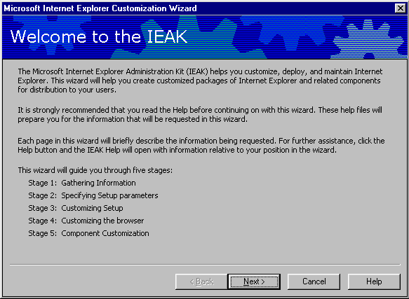
Action | Click
Accept the values on the current page and move to next page. | Next
Display any previous page. May have to retype some of the values you’ve entered. | Back
Exit this package. | Cancel
Need more information about using a page or specific feature. | Help

Part 3: Running the IEAK Customization Wizard

- Chapter 5: Gathering Information
- Chapter 6: Specifying Setup Parameters
- Chapter 7: Customizing Setup
- Chapter 8: Customizing the Browser
- Chapter 9: Customizing Components
- Chapter 10: Browser Distribution

Chapter 5: Gathering Information
The IEAK Customization wizard pages in Stage 1 are:
- Gathering information
- Company name and customization code
- Platform options
- File locations
- Advanced options
- Select media to distribute your browser
- Language selection
- Media selection
- Feature selection
In this section, the wizard simply prompts the administrator for this information.

Gathering Information

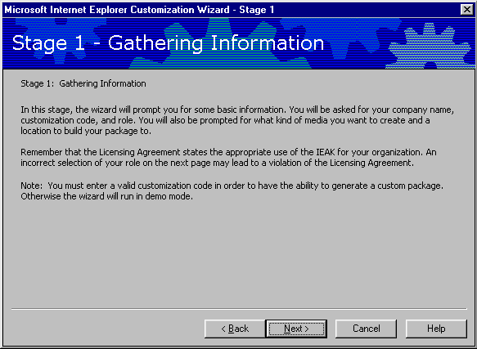

Company Name and Customization Code
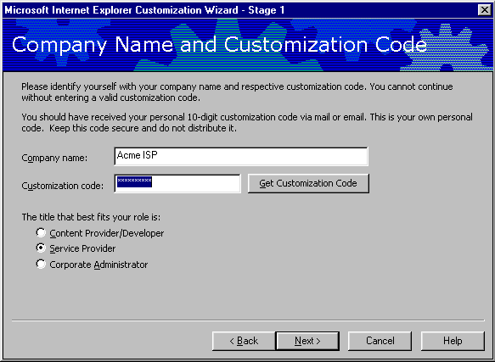
Option | Explanation
Company name | Type the name of your company. This information is put in the Registry for identification.
Customization code | Type the code you received from Microsoft at the IEAK Web site.
Get Customization Code | If you do not already have a customization code, then this button will take you to the Microsoft Web page where you can register for a customization code.
The title that best fits your role is | Because the customization code is specific for your role, the wizard automatically selects Content Provider. Be sure to select Service Provider Option to receive all of the necessary wizard options for Internet Service Providers.

Platform Options
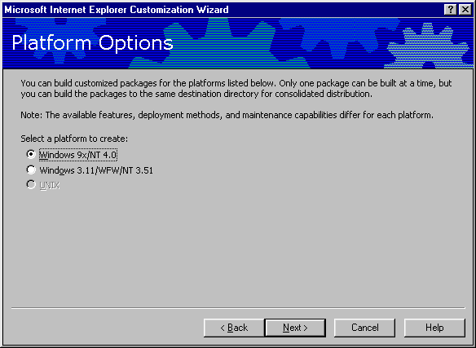
This screen allows administrators to select the platform version of Internet Explorer 5.

File Locations
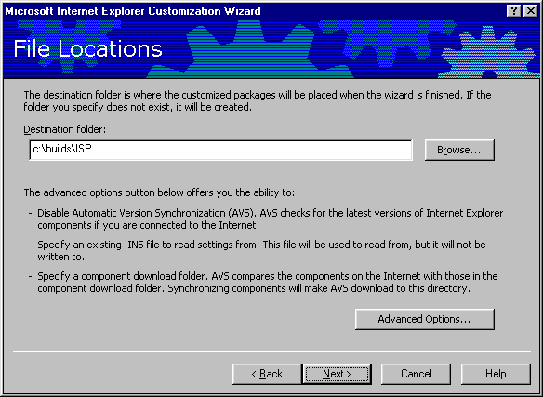  Option | Explanation
Destination folder | This is the location that the packages will be placed in after the wizard is finished.

Advanced Options
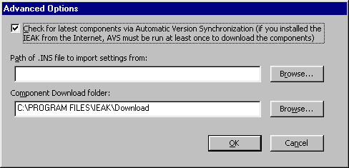
Option | Explanation
Check for latest components via AVS | AVS will check for the latest versions of all AVS components. AVS must be run at least once if the IEAK was installed from the Internet.
Path of .ins files to import settings from | The IEAK retains the most recently used settings of each separately saved build in the .ins subdirectory. Administrators can recover the settings from a previous .ins file by entering the path here.
Component download folder | Checking this box will allow administrators to specify a location for the downloaded components. If this location is changed, then the IEAK will need to resynchronize all components.

It is important that administrators understand versioning and version synchronization when setting a browser policy for an organization. Microsoft may periodically release a later version of the Internet Explorer 5 browser or its components, and the IEAK can synchronize its downloaded components with the latest versions. However, once these components have been synchronized, there is no way to roll back to an earlier version when creating new packages. There are two ways for administrators to access older versions of updated components:
- Administrators should check the “Change Component Download Folder” button when synchronizing components, and specify a new location for components. Selecting this option will require a complete resynchronization of all components because the IEAK will not see any downloaded components in the new folder. This may be desirable if the integrity of an up-to-date component is unknown and a separate and newly downloaded version is desired.
- After downloading and synchronizing the production set of components, make a copy of the c:\program files\IEAK\download folder. This will keep a copy of older components that can be copied back to the \downloads location if an updated component needs to be rolled back. When synchronizing, only the new versions of components will be updated.
Because Internet Explorer components are not installed during IEAK setup, administrators will be required to synchronize at least the Internet Explorer Web browser the first time the IEAK is run.

Language Selection
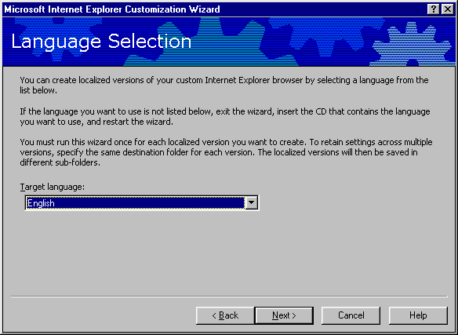
Localized versions of the Internet Explorer package can be created by selecting a language from the pull-down box. The wizard must be run once for each localized version that is created.

Media Selection
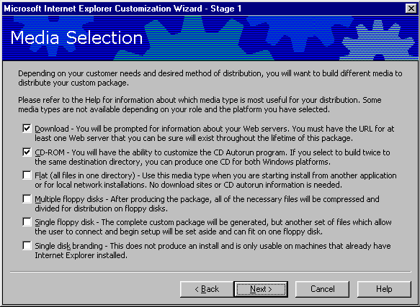
This screen allows administrators to select the media used for installation. Almost every package created will require 20-60 MB of storage in the location specified in the previous screen.
The Customization wizard creates a number of files, including all necessary .cab files, configuration files and a small IE5setup.exe file that can be quickly downloaded, distributed via e-mail or put on a floppy disk. The IE5setup.exe program will contain download and distribution information that is specified during the IEAK setup. The CD-ROM installation will also create the CD Autorun program in addition to the Internet Explorer 5 installation files. A complete set of installation files will be generated for each option except for the single disk branding option. Single disk branding will generate only the files necessary to customize an existing Internet Explorer 4 or Internet Explorer 5 installation.
The recommended installation types for ISPs are CD-ROM, Web download and single disk branding.
Note: The Internet Explorer 5 Connection Wizard (ICW) component is not included in a single disk branding package. Although single disk branding will brand an Internet Explorer 4.x browser, server-based signup using the ICW will not work for Internet Explorer 4 browsers. If a single disk branding package is going to be used on Windows 98 computers, then kiosk-mode server-based sign-up should be used.

Feature Selection
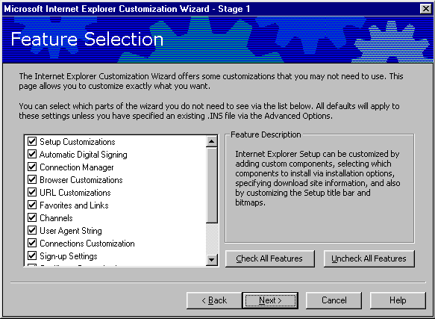
You can determine which remaining screens of the Customization wizard are displayed by selecting or clearing the check boxes in this screen. For instance, if you only planned to customize links and URLs, you could clear the other check boxes so that other screens aren't displayed. This will make it faster and easier to complete the Customization wizard. Checking or clearing these boxes will not affect functionality; rather, these boxes will determine which items in the IEAK Customization Wizard you can customize.

Chapter 6: Specifying Setup Parameters
The Internet Explorer 5 setup engine provides some distinct advantages over previous installation methods. Specifically, IE5setup.exe is a small, Web-based setup package that lets users install the latest Internet Explorer components directly from a Web site. It is small (about 400K) so it can be run from a single floppy disk, distributed via e-mail or downloaded quickly over the Internet. Internet Explorer Setup not only manages the entire installation process, but it can also search to see what components are already installed, and alert users or administrators when there are newer versions available. When Internet Explorer 5 setup downloads Internet Explorer 5, it breaks it up into several small segments. In the event of a failure or dropped connection, this makes it possible to restart an installation from where it was interrupted, instead of having to start over from the beginning.
The IEAK Customization Wizard pages in Stage 2:
- Specifying Setup Parameters
- Select a Microsoft Download Site
- Automatic Version Synchronization (AVS)
- Add Custom Components
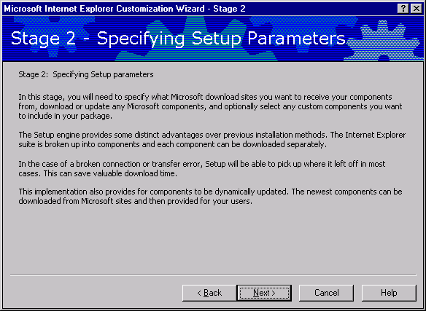
In this stage, the Microsoft download sites are specified. The IEAK does not check the validity or availability of any Web servers specified. A package created with an incorrect URL must be re-created to correct the error. Internet Explorer components must also be downloaded or updated and any custom components must be selected for inclusion in the package.
Note: The “Stage 6: Browser Deployment” section of this paper provides assistance with planning a Web server configuration using the Checklist – it is important to do this before proceeding with Step 2.

Microsoft Download Site
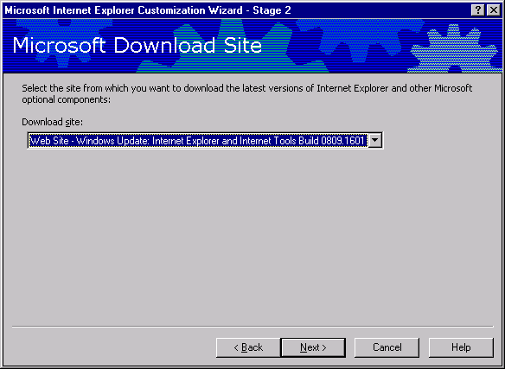
The IEAK automatically loads the list of sites from which to choose. Pull down the Web site from which the latest versions of Internet Explorer and other Internet Explorer components will be downloaded. The IEAK requires that at least the Internet Explorer 5 Web Browser components be synchronized the first time a package is created, as well as whenever the component download folder is changed.

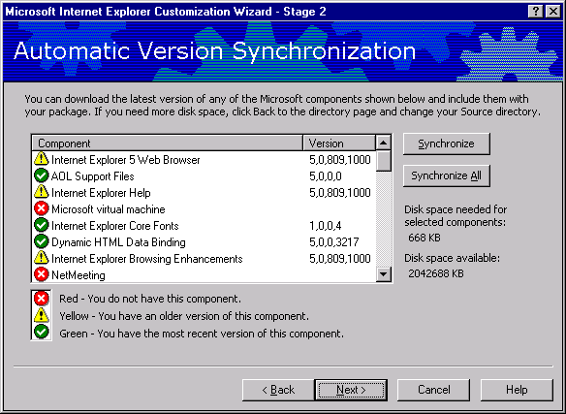Automatic Version Synchronization

Option | Explanation
Synchronize | Click here to synchronize only the specific Internet Explorer components that you have highlighted.  The wizard downloads the latest version(s) of the component(s) that you selected.
Synchronize All | Use this button to synchronize all Internet Explorer components.  The wizard downloads the latest version of each Internet Explorer component without any version checking.

This wizard page shows quickly whether any updates have been posted for the Internet Explorer 5 components. A red signal means that no component has been downloaded; a yellow signal means that a newer version is available and a green signal indicates that the administrator already has the latest version. Although it is recommended that an organization use the latest possible version of Internet Explorer 5, administrators may wish to generate new packages using older versions of a component to ensure version continuity across the enterprise. It is important to remember that there is no rollback option to earlier versions of these components. Newer versions will overwrite older versions as they are downloaded. To keep the older versions of these components, specify a different download location for the newly synchronized components.
In addition, Internet Explorer 5 browser and components can be rolled back to earlier versions only by uninstalling Internet Explorer and reinstalling an earlier package. For this reason, each package generated should be created into a separate subdirectory with enough versioning documentation to help determine what it contains throughout the life of the product.

Add Custom Components
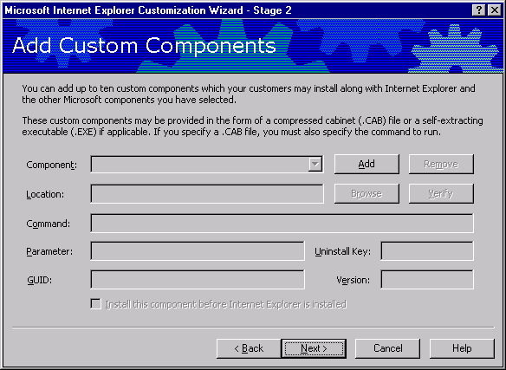
Here administrators can choose to add any custom components to include with a package. These components can be self-extracting executable (.exe) files or compressed cabinet (.cab) files. Up
to 10 custom components can be added, which users can install either before or during browser installation. It is recommended that administrators sign any custom code. Code-signing lets users know they can trust code before downloading it to their computers. The default settings in Internet Explorer will reject unsigned code. Switches for unattended installations can be entered in the Parameters dialog box.

Option | Explanation
Component | Enter the name of your component in this box. This name will appear in the setup screen when users install your software.
Location | Click Browse, or type the path to the self-extracting .exe file or the .cab file for the component.
Command | For .cab files only. Type the command needed to run the .cab file.
Parameter | For .exe files only. Type the switch(es) you want to run with the .exe file. Switches can be used for network or unattended installation. See the component’s help documentation for more information.
GUID (Globally Unique Identifier) | If your program already has a GUID, type it in the box. A GUID will otherwise be automatically generated. A GUID establishes a unique identity for programs, objects and other items. For more information on GUIDs, please see “What is a Globally Unique Identifier?” in the IEAK online Help.
Uninstall Key | To allow end users to uninstall this component, administrators should type the registry entry including both the DISPLAYNAME and UNINSTALLSTRING values in HKEY_LOCAL_MACHINE/Software/Microsoft/Windows/CurrentVersion/Uninstall/. More information on Uninstall Keys can be found in the IEAK Help.
Version | Type a version number to help track versions of your program and ensure that the latest version is installed.
Install this package before Internet Explorer | Select this option to have the component install before Internet Explorer.

Chapter 7: Customizing Setup
The IEAK Customization Wizard pages in Stage 3:
- CD Autorun Customizations
- More CD Options
- Customize Setup
- Installation Options
- Component Download Site
- Component Download
- Advanced Installation Options
- Components on Media
- Digital Signatures

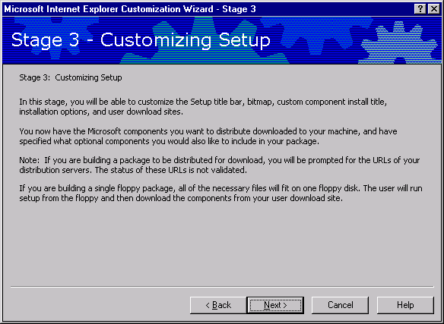

CD Autorun Customizations
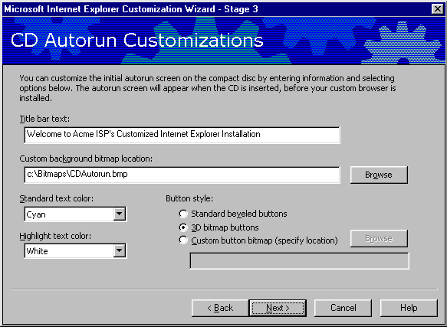

(CD installation only)
Option | Explanation
Title bar text | This is the text that goes in the CD Autorun title bar.
Custom background bitmap location | You can provide a bitmap that appears behind the text. Make sure the background color doesn't conflict with the text color. This bitmap must be 540 X 347 pixels.
Standard text color | This setting determines the color of any text that isn't part of a link.
Highlight text color | This setting determines the color of the links on the page.
Button style | You can determine the appearance of the buttons that users click to install Internet Explorer and to get more information. See the Help file for more information on button requirements.

More CD Options
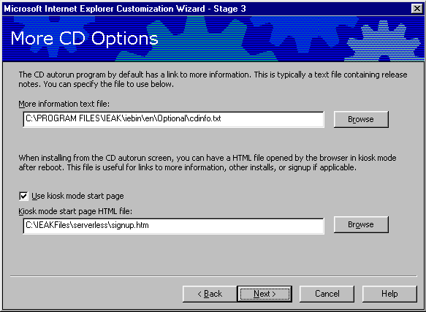
This screen allows you to specify a “more information” text file, as well as the initial start file that is seen when Internet Explorer first runs.
Note: If you are using Serverless Signup features, then you should enter the path to your Signup.htm file as the kiosk mode start page. For more information on sign-up, see Appendix B, “Automated Connections” and “Sign-up.”
Internet sign-up server pages that do not use the Microsoft Internet Connection Wizard also need to be run as a kiosk mode start page. If you are going to use the ICW for signup, then clear the kiosk mode check box.

Customize Setup
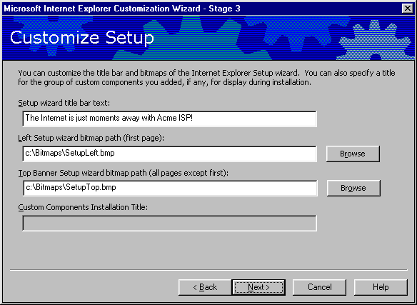
Option | Explanation
Setup wizard title bar text | Type the text you want to appear in the title bar of the end user’s Setup wizard page.
Left Setup wizard bitmap path | Type the path to a bitmap or click Browse to locate the path to the image. The bitmap must be 162 X 312 pixels.
Top Banner Setup wizard bitmap path | Type the path to a bitmap or click Browse to locate the path to the image. The bitmap must be 496 X 96 pixels.

Installation Options
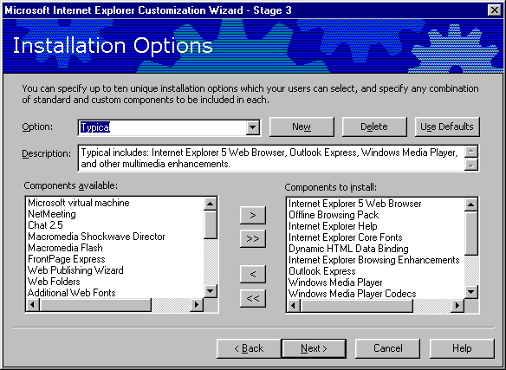
This page is used to customize the Minimal, Typical and Full Installation packages and components. The arrow keys are used to move components back and forth to create customized packages. Administrators are not limited to these two types of installations: Up to 10 installation options can be created per package, each of which includes a specified configuration, the option name and descriptions of those options.
Option | Explanation
Option | Select the option you prefer, or click New to add a custom option.
Description | Enter a description of this custom package that end users will see when installing Internet Explorer. Provide enough information so that users can make a decision about which software to install.
Components available | The wizard lists the components that you made available on the AVS page. To add additional components, click Back until you reach that page.
Components to install | The wizard lists the components to be included in this installation option.

Component Download Site
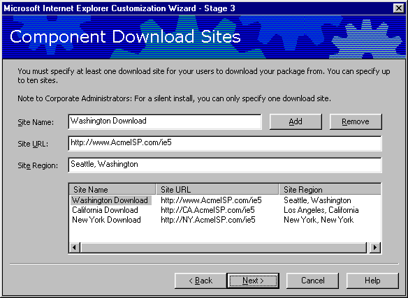
This wizard page must be completed for each download URL.
Option | Explanation
Site Name | Click Add to designate a download site. If you wish, you can modify the name created by the wizard.  Note: Do not use commas in the name.
Site URL | Type the URL for your HTTP or FTP server. This is the location for the file IE5sites.dat. See below.
Site Region | Type the location of the site, such as the city, state, region or country.
Custom download sites | The wizard lists all of the downloaded sites.

See the “Stage 6: Browser Deployment” section below for more information on Web server configuration and file locations.
Note: The IEAK will not check the validity of the listed Web server, nor will it copy the installation files to the Web server unless the Web share location was specified as the package creation location at the beginning of this wizard.
Component Download
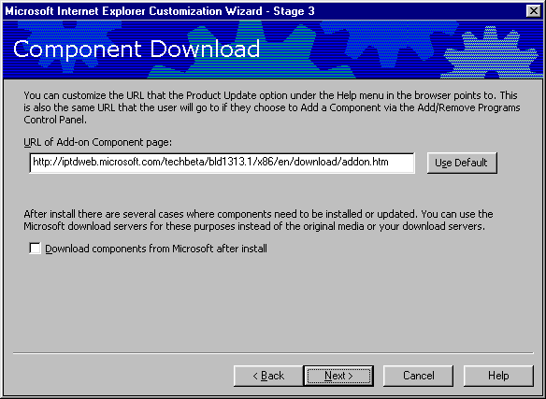
Option | Explanation
URL of Add-on Component page | The Add-on Component Page is the page that is viewed when the user selects the Product Update option within Internet Explorer, or when the user chooses to add a component in Windows Update.
Download components from Microsoft after install | You can also enable users to download components directly from Microsoft, rather than from the original distribution servers or media. Selecting this check box can reduce administrative overhead because the ISP will not need to maintain an updated list of components.

Examples of a custom add-on page are included in the IEAK Toolkit in the \Program Files\IEAK\Toolkit\Addons\HTML folder.

Advanced Installation Options
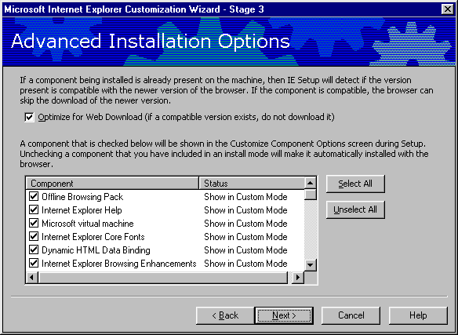
Option | Explanation
Optimize for Web Download | Internet Explorer Setup can detect whether the same version of a component is already installed on a user's computer. If the same component is already installed, then Internet Explorer will not download it.
Optional component window | If users are allowed to customize an installation, the administrator can still prevent specific components from being removed. The administrator simply selects the components that users cannot customize.

Components on Media
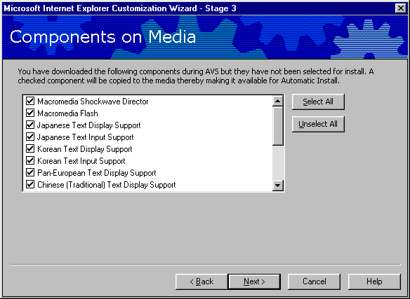
The components in this list have been downloaded to the IEAK computer but have not been included in a Setup option. The components selected can be made available for installation if users attempt to use a feature that requires these components; this feature is called Install on Demand.

Connection Manager Customization
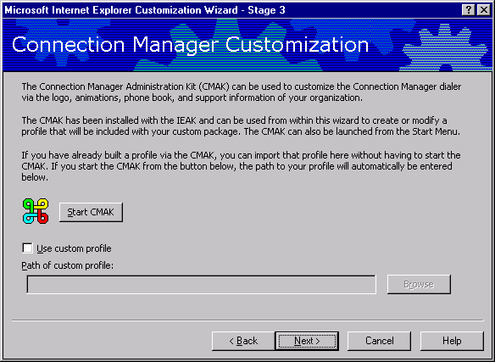
The Connection Manager Administration Kit (CMAK) can be used to create a customized and branded connection profile for users. A connection profile is useful when an administrator wishes to automatically distribute, configure and manage dial-up connections for users. The CMAK is a separate program that is included with the IEAK. A CMAK profile can be generated during the Customization wizard by selecting the Start CMAK option, or an existing profile can be used by selecting the Use Custom Profile check box and then entering the path to the custom profile.
Note: The CMAK does not create Dial-up Networking entries. The recommended way to create an automatic dial-up connection is by importing connection settings, or using a sign-up page.
See Appendix C for more information on how to create a custom connection profile by using the CMAK.
See Appendix B for a discussion about automatic connections and sign-up.

Digital Signatures
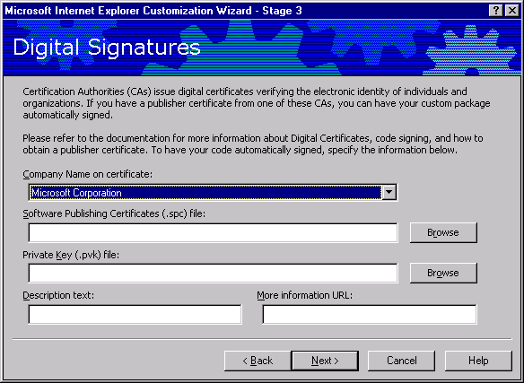
With a publisher certificate from a recognized Certification Authority, administrators can have custom packages automatically signed. Digital signatures show where programs come from and verify that they haven't been altered. Customized browser packages and any custom programs should be digitally signed to ensure that users don't receive warnings when installing the custom browser. Users may be prevented from installing ActiveX controls and Java packages that aren't signed. Information about the digital certificate must be specified when using the Internet Explorer Customization wizard.
Option | Explanation
Company name on certificate | If a publisher certificate is on your computer, its company name will appear in this list.
Software publishing .spc file | Enter the name of the .spc file associated with the certificate, or click Browse to locate it.
Private key .pvk file | Enter the name of the .pvk file associated with the certificate, or click Browse to locate it.
Description text | Enter the text that will appear on the dialog box that appears when users download programs that are signed with this certificate.
More information URL | Enter the URL that will appear in this dialog box so that users can obtain more information about the certificate and your company.

Chapter 8: Customizing the Browser
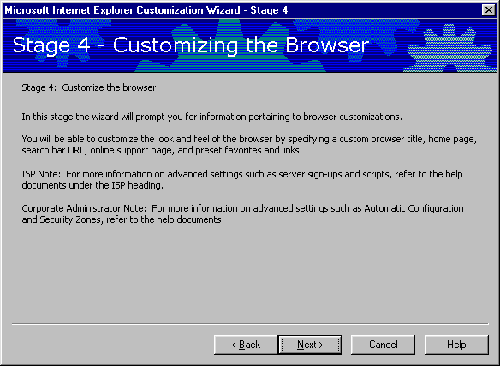
The IEAK Customization Wizard pages in Stage 4:
- Customize the Browser Title and Toolbar Background
- Customize the Toolbar Buttons
- Specify Animated and Static Logos
- Customize Important URLs
- Favorites and Links
- Channels
- Welcome Page
- User Agent String
- Connection Settings
- Proxy Settings
- Add a Root Certificate
- Specify the Sign-up Method

Browser Title
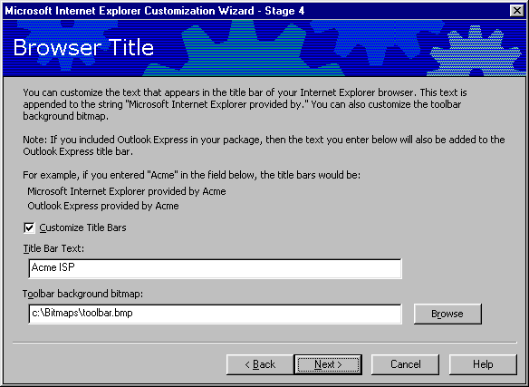
Option | Explanation
Customize Title Bars | Select this check box to customize the browser title bars (and Outlook Express if included in the package).
Title Bar Text | Type the text that you want to follow the phrase “Microsoft Internet Explorer provided by.”
Toolbar background bitmap | Type the path to the bitmap (or “watermark”) to be displayed in the background behind the Internet Explorer toolbar buttons, or click Browse to locate it.

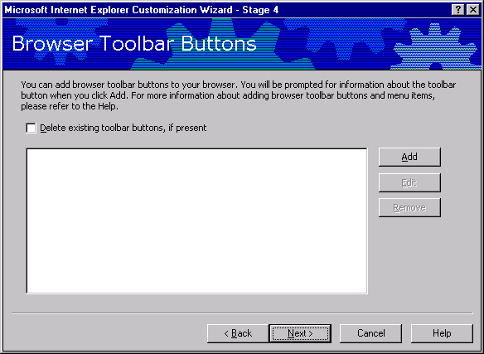
Browser Toolbar Buttons

Browser toolbar buttons can be added to the browser. By selecting Add, the following options will be displayed:
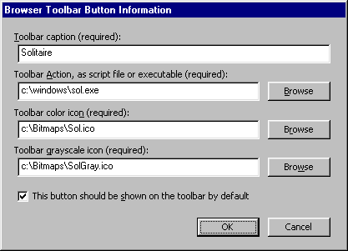

Option | Explanation
Toolbar caption | This is the name of the toolbar button.
Toolbar Action | Browse to the executable that you want this toolbar button to run.
Toolbar color icon | An .ico icon file is required for your toolbar. Browse to it by selecting the Browse button, or type in the path.
Toolbar grayscale icon | An .ico icon file that is rendered in shades of gray. This icon will display correctly on black-and-white monitors.

Animated Logo
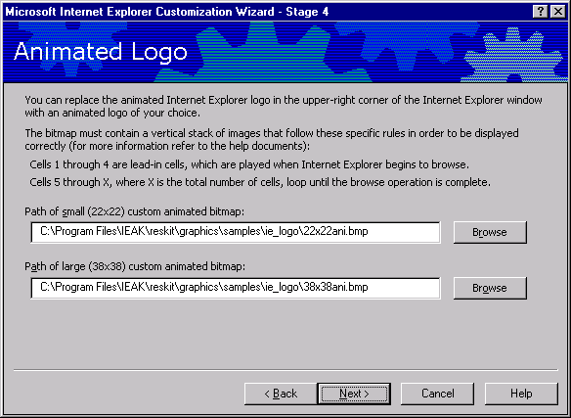
With Internet Explorer 5, all Internet Explorer administrators have the ability to customize the animated logo that appears in the upper-right corner of the Internet Explorer window. In Internet Explorer 4 this ability was limited to customers with special licensing agreements.
With an animated bitmap, the first frame appears as static when no action is taking place in the browser; the remaining frames appear as animated when the browser is in use. Two animated bitmaps are required for a custom animated logo: one at 22 X 22 pixels and the other at 38 X 38 pixels. The paths of the small and large custom animated bitmaps need to be typed in the boxes provided. Sample animated bitmaps are available in the IEAK Toolkit, which is installed in the \Ieak\Toolkit folder on the hard disk when the IEAK is installed.
Two tools are included with the IEAK to help administrators create customized animated bitmaps for the browser. One is used to stack bitmaps in the format described above, and the other previews the animation. Information about how to use these tools is included in “Animated Bitmap Tools” in the IEAK Help section.

Static Logo
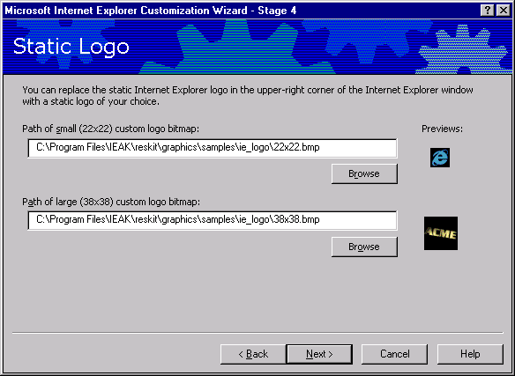
The Internet Explorer logo in the upper-right corner of the browser appears in two states: animated when the browser is in use, and static when no action is taking place. The small and large bitmaps must be 22 X 22 and 38 X 38 pixels, respectively.

Important URLs
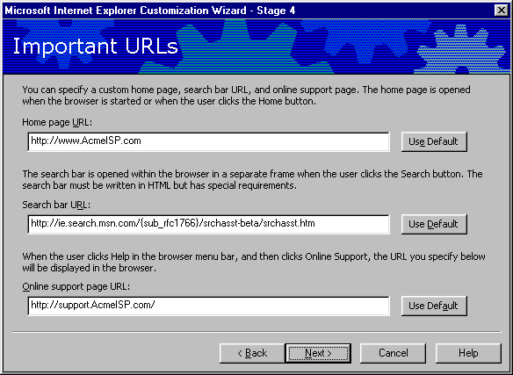
Option | Explanation
Home page URL | To use the default Internet Explorer home page, click Use Default. To use another home page, type the URL of the home page.
Search bar URL | To use the default Internet Explorer Search Pane, click Use Default. To use another search bar, type the URL of the search bar.
Online support page URL | To use the default Online Support Page, click Use Default. To use another support page, type the URL of the support page.

In Internet Explorer 5, search results are written so that the results of the search appear in the main browser window, rather than in the search pane.
Note: The Test URL button has been removed from the IEAK in Internet Explorer 5. Administrators should be sure to verify that the URLs are typed in correctly before distributing the package to users.

Favorites and Links
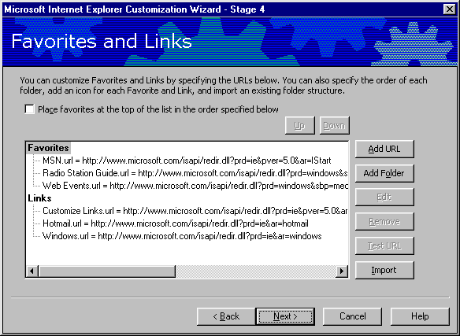
Option | Explanation
Favorites | Type a name for the Favorite or link.
Links | Type a URL for the Favorite or link.  You can click Test URL to ensure that the URL is correct.
Add Folder | To insert a hierarchical directory into the Favorites list, which can include more Favorites, click Add Folder.
Add URL | Select Favorites or Links or a folder, then click Add URL to add its URL.
Import | Select Import to point the IEAK to a link or a folder of links that you would like to import into the package.

Channels
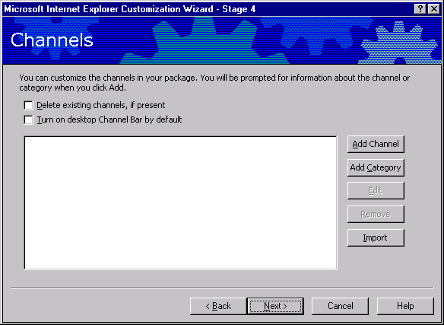
Option | Explanation
Delete existing channels, if present | The IEAK includes the channels that are configured on the IEAK workstation, as well as any custom channels that you add. The existing channels can be removed and a customized list used instead.
Turn on desktop Channel Bar by default | The Desktop Channel bar can be selectively enabled or disabled with this option.
Add Channel | Adds a channel to the Channel Bar. See the next screen shot for information on channel setup.
Add Category | Adds a category to the Channel bar for channel organization and customization.

Channels can be used by including the Internet Explorer Browsing Enhancements in the custom browser package. Channels are an Internet Explorer feature that allows a user to be notified when content on a particular Web site has been changed. The easiest way to set up channels is to configure the IEAK workstation with the desired corporate channels and then import those settings. Information on manually configuring channel information can be found in the Internet Explorer 5 Help file and on the Microsoft Site Builder network.

Welcome Page
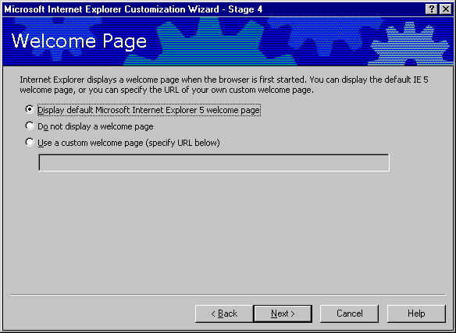
Option | Explanation
Welcome page | Select the welcome page you want to display. The default is the Microsoft Internet Explorer 5 welcome page.
Do not display a welcome page | Select this option if you don’t want to display a welcome page. The first page displayed will then be the home page.
Use a custom welcome page | Type the URL for your custom welcome page.

Internet Explorer displays a welcome page the first time the browser is launched. You can display the default Internet Explorer welcome page, or you can specify the URL of your own custom welcome page. The welcome page is not the same as the home page, which is the page that opens each time you start your browser (after the first time), and when the user clicks the Home button. The welcome page is also not the same as the kiosk mode start page, which runs once before both the welcome page and home page.
Note: The “Welcome to Internet Explorer” startup dialog that you had to run twice in Internet Explorer 4.0 is not displayed in Internet Explorer 5.

User Agent String
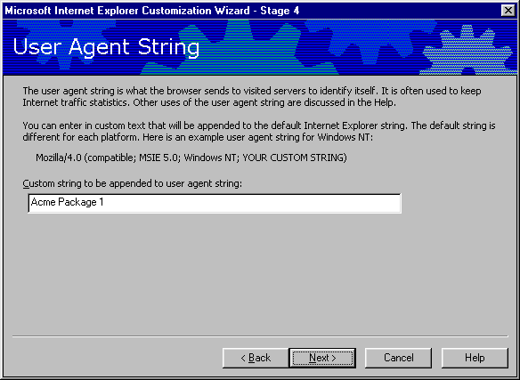
The string entered in this box is appended to the user agent string for the customized browser. The user agent string does not need to be customized unless the administrator wants to track the usage of a custom browser and gather browser statistics from other Internet sites. Administrators should be aware that other companies that track site statistics will see the customized string.
An example of how this would appear is:
Mozilla/4.0 (compatible : MSIE 5.0;WindowsNT) ; Acme Package1

Connection Settings
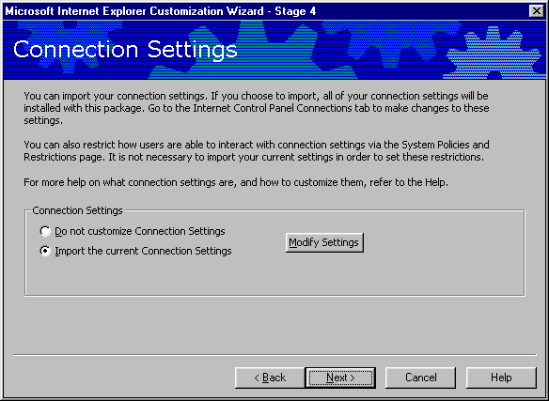
This dialog box will allow administrators to import all of the connection setting from the current installation of Internet Explorer 5 on the IEAK workstation. This option will import all of the settings on the Connection tab of the Internet Options screen.
Select the Modify Settings button to adjust the local connections before importing them into the package. Individual settings such as proxy server and configuration scripts can be specified for each Dial-up Networking connection.
Importing a connection setting will also import the connection itself. This is a very easy way to create customized Dial-Up Networking entries on the user’s workstation.
Connection settings can also be created by using a sign-up process, and this is the preferred method for dynamically creating automatic connections for ISPs. For more information on automatic connections, see Appendix B: “Automatic Connections” and “Sign-up.” Do not import settings if you are going to be using a sign-up process, whether server-based or serverless. Sign-up connections will be created later in the Internet Explorer Customization Wizard.

Proxy Settings
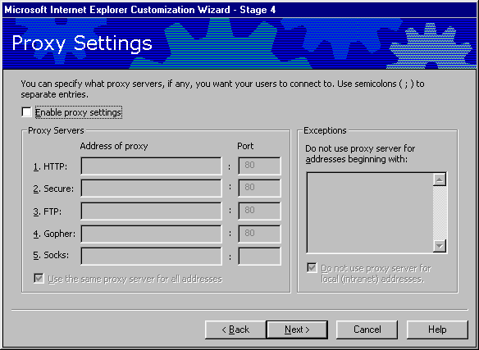
This dialog box specifies the standard proxy server for this package installation, and is displayed only if connection settings are not imported. If an organization has more than one proxy server, or needs to specify different proxy settings for a user based on location, organization, etc., then different approaches can be taken to specify different proxy setting for different users:
- Create individual packages for each group that requires a different proxy setting, and then distribute these packages separately to each group. Specify a different .ins file for each package. This approach is best when distributing Internet Explorer 5 to users in different WAN sites, and when other configuration options will need to be specified for these sites. The individual .ins files can be used to update site-specific browser options and security policies for each group.
- Create a .pac, .js, or .jvs file for advanced proxy configuration and specify it in a general package distributed to all users. Advanced proxy configuration can assign proxy servers using rules and group identifiers. The IEAK Help file contains 10 examples of proxy scripting files that can be used for advanced proxy configuration. Using .pac, .js, or .jvs files for proxy configuration is a good idea when different proxy servers need to be dynamically specified for different users or groups in the same organization.
Option | Explanation
Enable Proxy Settings | If you do not use proxy servers, clear this check box.
HTTP | Type the URL of the proxy server for HTTP and its port number.
Secure | Type the URL of the secure proxy server and its port number.
FTP | Type the URL of the proxy server for FTP and its port number.
Gopher | Type the URL of the proxy server for Gopher and its port number.
Socks | Type the URL of the sock proxy and its port number.
Use the same proxy server | To use different proxy servers for different services, clear this check box.
Exceptions | Type the path(s) or domain(s) that do not require the use of proxy servers.
Do not use proxy server for local | To use proxy servers for all URLs, clear this check box.

Add a Root Certificate
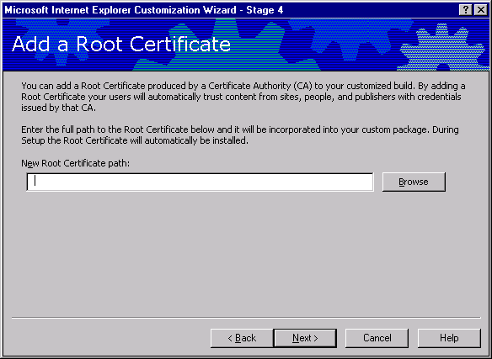
Administrators can add a root certificate to your customized IEAK package by typing the URL into the New root certificate path box. This provides a level of trust that certificates lower in the hierarchy can inherit. Each certificate is inspected for a parent certificate until it reaches the root certificate. Check the IEAK Help file for more information on root certificates.

Sign-up
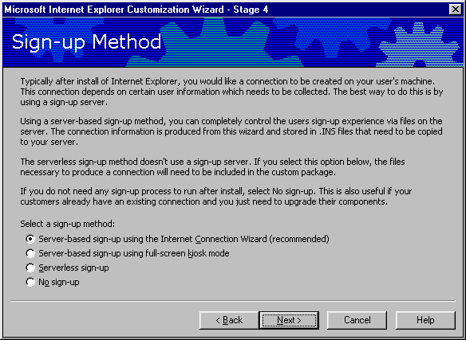
ISPs can specify how users sign up with their service and connect to the Internet:
Internet Sign-up Server. This method provides full flexibility and dynamically adapts to various sign-up options. The examples included with the IEAK Toolkit will collect user account, billing and password information, save this information to a Microsoft Access database, and then configure the browser and Dial-up Networking with all of the information necessary to automatically connect through the ISP to the Internet. Internet sign-up can be used in two different ways:
- A consistent installation look-and-feel can be achieved by using the Internet Connection Wizard (ICW). The ICW will act as a shell to customized sign-up files that reside on the ISP’s sign-up server.
- An existing Web-based sign-up process can be integrated by selecting kiosk mode sign-up server. This method is appropriate if the ISP already has an HTML-based sign-up process that they do not wish to alter. The sign-up page must be specified at the beginning of the Customization wizard as the kiosk mode start page.
Serverless Sign-up. This method doesn't require a sign-up server. If you select the serverless method, the Internet Explorer Customization wizard will prompt you to provide the necessary information to control the sign-up process.
No Sign-up. Specify this if you don't want users to go through a sign-up procedure when they install their custom browser.
A complete description of how to use the sign-up features is included in Appendix B, “Automatic Connection” and “Sign-up.” It is highly recommended that administrators review this section before attempting to integrate sign-up of any sort. Using sign-up features changes the way that Internet Explorer starts, and these changes are difficult to bypass or alter if the sign-up settings are not correctly configured.

Chapter 9: Customizing Components
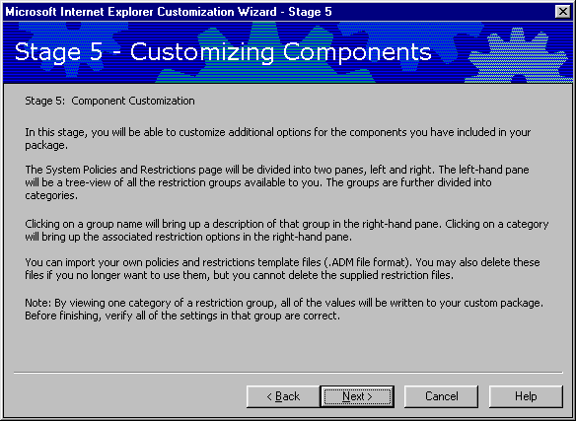
The IEAK Customization wizard pages in Stage 5:
- Specify Internet Mail Servers, Domain and News Server
- Configure Outlook Express Accounts
- Configure Outlook Express Custom Content
- Configure Outlook Express View Settings
- Specify Lightweight Directory Access Protocol (LDAP) Server Settings
- System Policies and Restrictions
Stage 5 of the Customization wizard allows administrators to configure any components included in a package. If a component shown in this section was not included in a package, the configuration screen for it will not be displayed.

Programs
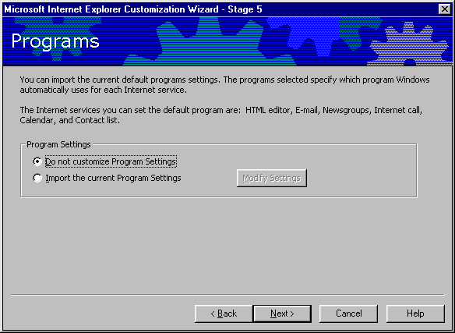
This screen allows the administrator to specify which programs are the default HTML editor, e-mail client, newsgroup reader, Calendar and Contact list. Because many of these clients contain ISP-specific settings, they should not be customized in the package.

Outlook Express Accounts
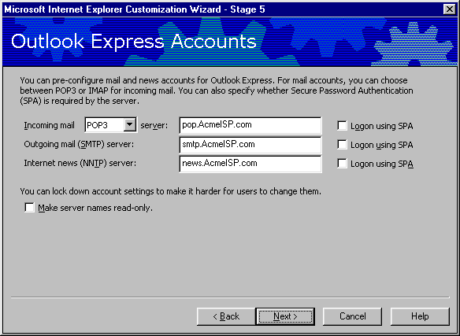
This wizard page appears only when Outlook Express is chosen as an Internet Explorer component. It’s optional because end users can provide this information when they run Outlook Express, but this is a good way for ISPs to pre-configure server settings for their customers.

Option | Explanation
Incoming mail (POP or IMAP) server | Type the server name for handling incoming mail, i.e., mail.mydomain.com. Select the server type from the Server Type box.
Outgoing mail (SMTP) server | Type the server name of the outgoing mail server. This may be the same as the incoming mail server.
Internet news (NNTP) server | Type the server name of the Network News Transfer Protocol (NNTP) server to use.
Logon Using SPA (Secure Password Authentication) | If you want SPA to authenticate users when they log on, select this check box.
Make server names read-only | This check box prevents the user from making any changes to their Outlook Express account settings. This is not recommended for ISPs.

Outlook Express Custom Content
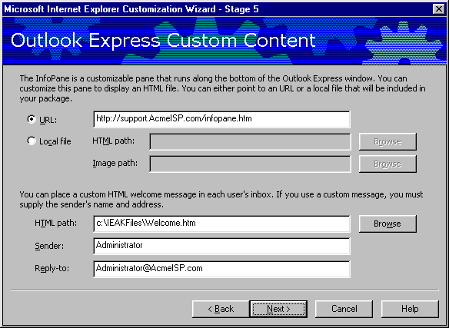
Option | Explanation
URL | Click to specify a URL for the Outlook Express Infopane.
Local file | Click to use an HTML file for Outlook Express Infopane.
HTML path (Infopane) | Type the path to the Infopane file or click Browse to locate it.
HTML path (custom welcome message) | Type the path to the custom welcome message file or click Browse to locate it.
Sender | Type the user’s name.
Reply-to | Type the user’s e-mail address.

Administrators can give Outlook Express a custom look, and welcome new users with an e-mail message.
The Outlook Express Infopane contains helpful information and links. This pane can be customized with support numbers, Frequently Asked Questions (FAQ), and information about the company.
The Infopane appears as a window at the bottom of Outlook Express when the program is started. The Infopane can be customized with an HTML file that is either a local file or at an Internet address (URL).

Outlook Express Custom Settings
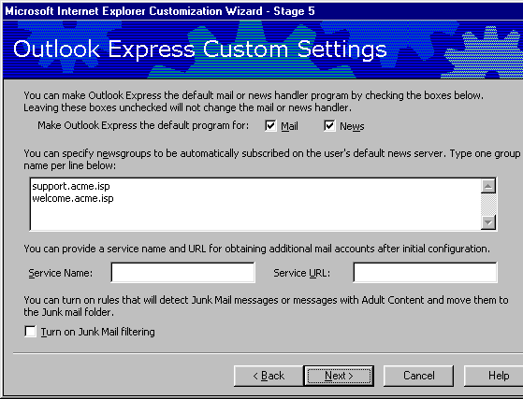

Option | Explanation
Make Outlook Express the default program for Mail, News | This setting will open Outlook Express automatically whenever a Mail or News item is opened by the Operating System.
News Group Window | Users can be presubscribed to newsgroups, such as public or private support newsgroups. In order to subscribe a user to a newsgroup, that newsgroup must be available from the news server specified as the default server in the previous screen.
Service Name | This is the name of the mail service that will provide additional mail accounts after initial configuration.
Service URL | This is the Web location of the account server that will configure Outlook Express with additional mail accounts.
Turn on Junk Mail Filtering | Outlook Express 5 contains a junk mail filter that screens junk mail and e-mail with adult content into a separate folder from the Inbox.
Note: The junk mail filter may relegate legitimate e-mail messages, such as electronic greeting cards from family or friends, to the junk mail folder, and dispose of them according to the user’s preferences. The Junk Mail filter is not recommended as a default setting for ISPs.

Outlook Express View Settings
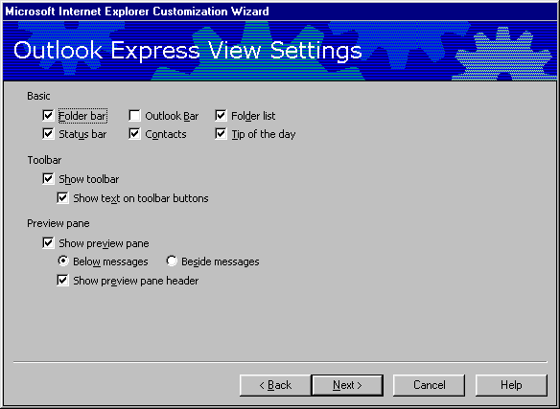
This wizard screen allows administrators to customize the basic appearance of Outlook Explorer. Check the IEAK Help files for more information on specific items.

Address Book Directory Service
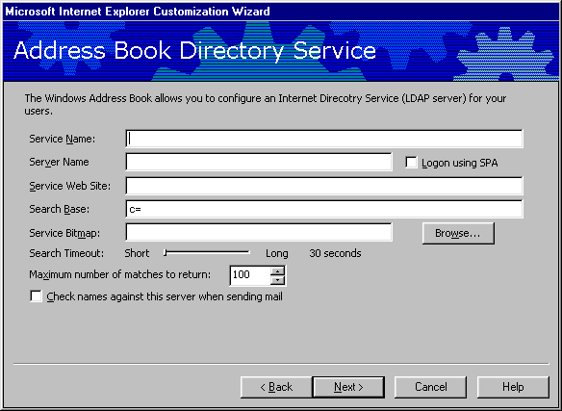
Directory services are powerful search tools that help users find people and businesses around the world. The Address Book supports LDAP (Lightweight Directory Access Protocol) for accessing directory services, and it comes with built-in access to several popular directory services. Administrators can specify the LDAP services for users.
Option | Explanation
Server name | Type the name of the LDAP server.
Service name | Type the directory service.
Service Web site | Type the URL of the home page that Internet Explorer displays when the end user requests the LDAP Web site.
Search base | Type the root or scope for the hierarchical level at which to search the LDAP server: base, one or sub.
Service bitmap | Type the path to the location of the bitmap or click Browse to locate it.
Check names against this server when sending mail | If you want Outlook Express to check names before sending mail, select this check box.

System Policies and Restrictions
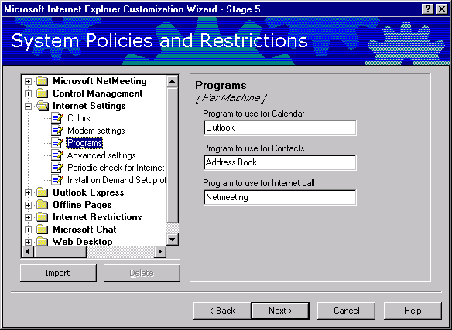  Option | Explanation
Left Pane | Select the subject you want to change policies and restrictions for.
Right Pane | Specify the policies and restrictions you want for the subject.
The administrator has the ability to set system policies and restrictions on the customer’s workstation. This is an advanced feature that is recommended for corporate administrators only.

Wizard Complete
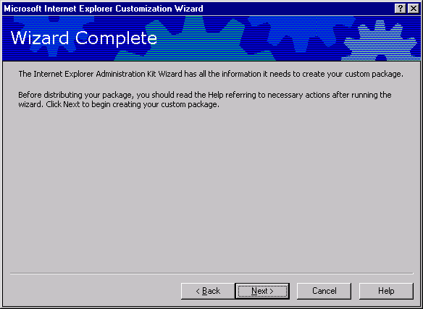
After finishing Stage 5, the IEAK Customization wizard creates the package for each type of distribution media specified in the wizard.

Chapter 10: Browser Distribution
The IEAK generates several installation subdirectories in the c:\builds folder. The Windows Explorer view of your generated packages should be similar to this:
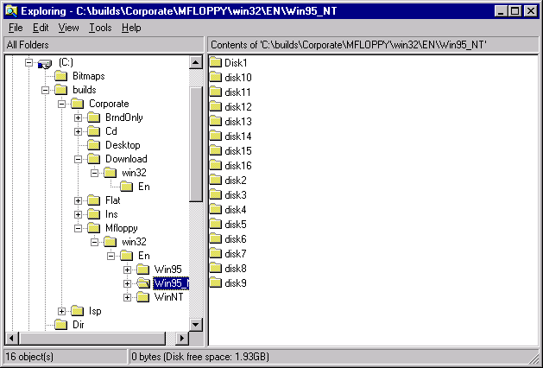

Web Distribution
The following outlines how Internet Explorer 5 Setup works for the end user:
- Ie5setup.exe extracts the setup files into a temporary directory.
- Ie5setup looks at the [String] section of Ie5setup.inf for the URL location of the IE5sites.dat file.
- Setup goes to the file IE5site.dat for the URLs for the download sites and then displays the download sites to the end user.
- Setup downloads .cab files, which are placed in the directory the end user specifies.
- Setup extracts the .cab files.
- Setup installs Internet Explorer and each component the administrator specified.
- If necessary, Setup prompts the end user to restart the computer.
The important files for a Web distribution of Internet Explorer 5 is the file iesetup.exe, the contents of the download subdirectory, and the file IE5sites.dat. The file IE5setup.exe locates the URL path to IE5sites.dat. IE5sites.dat is a text file that lists all of the download location information and the path to the .cab files in each location. For the purposes of this guide, it is assumed that administrators are running a Microsoft Internet Information Server (IIS) or Personal Web Server, and that the default Web share location is c:\inetpub\wwwroot. If a different server or path is being used, some of the following locations may need to be changed.

IE5Setup.exe
The IE5Setup.exe file is a small (400K) file that can be distributed by e-mail or floppy disk. IE5Setup.exe is created in the following path: c:\builds\<Build_Number>\Download\Win32\En.

Download Subdirectory
The download subdirectory needs to be copied onto the Web server in the location specified during the Customization wizard. Administrators should make a note of the location that was specified as the download path for each download location in the IEAK package. In the Customization wizard walkthrough in this guide, this path was specified as http:\\www.AcmeISP.com\ie5\. The Download folder needs to be copied to a location specified during the Customization wizard. Assuming a standard Microsoft IIS installation, the file path in this example needs to be c:\inetpub\wwwroot\ie5. This folder structure can be created simply by copying the entire Download folder created under c:\builds\<build_number> to the file path.
Note: The c:\builds\<build_number> path may also contain the CD and floppy installation packages if these were created in the IEAK; they do not need to be copied to the Web Server.

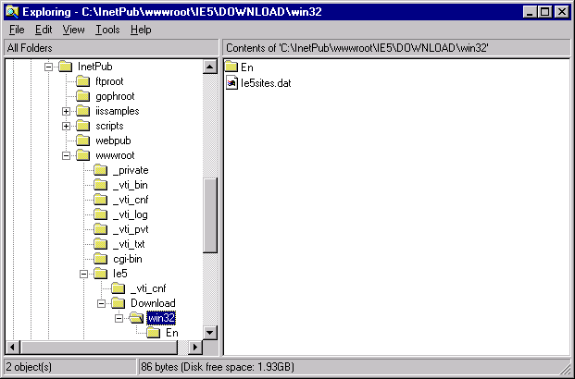
Windows Explorer view of the Web download folder copied to the Web share location.

The IE5sites.dat File
The IE5sites.dat file will be put in the correct place simply by creating or copying the Downloads subdirectory to the Web path specified in the customization wizard.

CD Distribution
Copy everything from within the c:\builds\<build_number>\CD subdirectory onto the root of the CD. Unlike with a Web distribution, the CD subdirectory itself is not copied. The root of the CD-ROM will contain the Win32 subdirectory, Autorun.inf and a setup file.

Multiple Floppy Distribution
The IEAK will create a subdirectory called \mfloppy. Within this subdirectory are version-specific package folders, and within these are individual disk folders. Copy the files within each folder to the root of each disk.

Single Disk Branding Distribution
Single disk branding differs from other distribution methods in that only configuration settings files are generated. Single disk branding can be used to customize both Internet Explorer 4.x and Internet Explorer 5 browsers, although sign-up using the ICW will only work with Internet Explorer 5. The single disk branding option will create two subdirectories in the \builds directory, BrndOnly and INS.
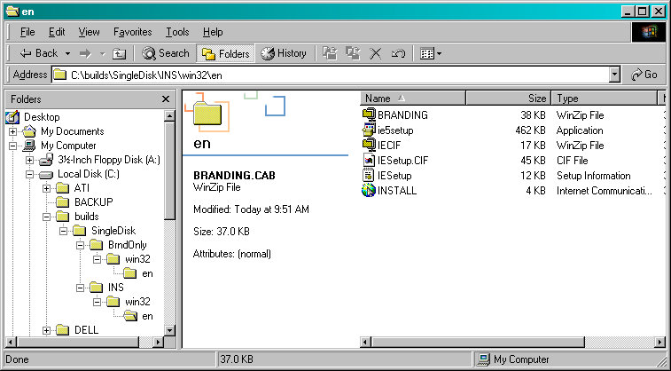
BrndOnly will contain a single setup.exe file that contains all of the branding information from the Internet Explorer Customization wizard, but no customization files such as custom logos or additional dial-up networking connections. The BrndOnly setup option is used to create a customization file that is guaranteed to fit on a single floppy disk.
INS will contain an IE5setup.exe file, customized connection settings and all of the additional customization files that were included in the Internet Explorer Customization Wizard. All of the additional files will be stored in a file called Branding.zip. Although it is unlikely, it is technically possible for the package created in the INS subdirectory to be too large to fit on a single floppy disk. Verify the size of the package before investing time in pilot testing and distribution.

Appendix A: Sample Customization Screens
Figure 1: CD Autorun Screen showing custom CD Autorun bitmap and title bar text.
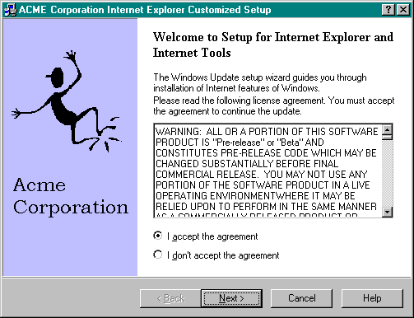
Figure 2: CD Autorun Screen showing title bar text and left setup bitmap.

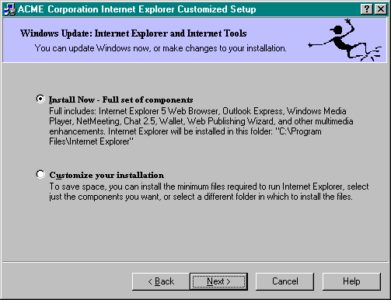
Figure 3: CD Installation wizard showing top banner bitmap and component choices.

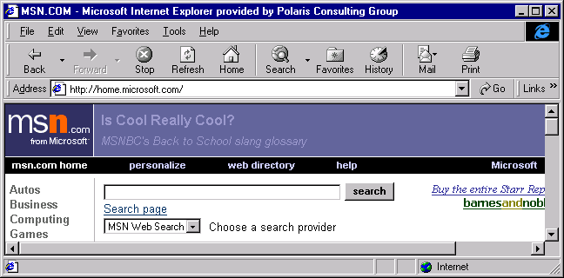
Figure 4: Customized browser showing title bar text, animated and static logo area in top-right corner. Custom toolbar buttons and background watermark are not shown, but would appear here.

Appendix B: ISP Sign-up Options

Automatic Connections
Automatic Connections can be configured on a user’s workstation to automate the remote connection process. The ability to include a pre-configured dial-up connection to your RAS server significantly reduces the administrative overhead associated with supporting these connections. There are two different ways to create an automatic dial-up connection with your Internet Explorer 5 package: Creating Dial-up Networking (DUN) entries, or using the Connection Manager Admin Kit (CMAK). The trade-off between these two approaches is between simplicity and features. Creating or importing an existing DUN connection is a very easy way to set up an automatic connection, but it does not offer all of the customization options available from the CMAK. This Appendix is intended as a discussion of the merits and ramifications of each approach; technical specifics can be found in the IEAK Help file, Appendix C and the Customization wizard walkthrough.

Importing a Connection
The easiest way to set up an automatic connection is to create your DUN RAS settings on the IEAK workstation, and then import these connection settings during the Customization wizard. For ISPs, DUN connections can also be created during the sign-up process, and this is the recommended method. Importing a connection will create a DUN entry on each user workstation to match those on the IEAK workstation. Dial-up, protocol and proxy settings for each connection will also be imported. If more than one DUN entry is imported, the default connection will also be made the default on the user workstation. The primary advantage of this approach is that it is very easy. DUN entries are usually familiar to both users and support technicians, which helps to reduce both the learning curve and administrative overhead. Imported DUN entries can be used in conjunction with a user’s existing DUN entries, such as a business RAS dialup.
The sign-up process can be used to create new DUN entries on the user’s workstation. Both serverless and server-based sign-up deliver a customized Internet Settings (.ins) file that can contain the information necessary to create a DUN profile. Server-based sign-up using the Internet Connection Wizard (ICW) can also preconfigure the user name and password.
DUN entries are the recommended connection method for ISPs. By using a sign-up server, the customer can select a local dialup number, which is then used for day-to-day access. The DUN entry will become the default for Internet Explorer and Outlook Express, and will dial automatically when these applications are run.

The Connection Manager Administration Kit
The CMAK is the tool used to create and administer Connection Profiles for Microsoft Connection Manager. Connection Manager is a client application similar to DUN that supports multiple phone numbers per Connection Manager profile; the ability to run applications automatically before, during and after a connection takes place; and Virtual Private Network support. Connection Manager is part of Internet Connection Services for RAS, which is in the Windows NT® Server 4.0 Option Pack. Connection Manager can be integrated with Connection Point Services for Windows NT. Connection Point Services consists of a phonebook administrator and a phonebook service that can be used to automatically configure, administer and dynamically update connection numbers to a client Connection Manager profile.
The advantages of creating automatic connections by using the CMAK are support for multiple phone numbers per connection profile, and the ability to configure connection actions and auto-applications. This option would be desirable for organizations that have numerous RAS sites that
their users need to connect to, or for organizations that need to constantly update a pool of dial-up numbers. A Connection Manager profile can be configured with custom bitmaps and license agreements, auto-applications, connect actions, Help files, user documentation and command-line parameters.
The primary disadvantage of using the CMAK is the added complexity of correctly configuring a Connection Manager Profile. Although static phonebook entries can be used, Microsoft Connection Services are required to administer multiple phone book entries. Connection Manager profiles are different from DUN entries, and will require both users and administrators to learn how to use them. The use of auto-applications and connect actions can be useful to an organization, but can increase the occurrence of tech support calls if they don’t work as the user expects, or cause a software conflict (such as having both Outlook Express and Microsoft Outlook running at the same time). If, however, an organization is already using both Connection Manager and Connection Point Services, then a CMAK profile can be integrated into an Internet Explorer package with a minimum of administrative overhead. Detailed information on the CMAK can be found in Appendix C, and in the CMAK documentation.

Sign-up
ISPs can specify how users sign up with their service and connect to the Internet. Sign-up is the process of collecting information from the user and then using that information to customize browser and connection options. Sign-up can be handled in four different ways:
The server-based sign-up server using the Internet Connection Wizard (ICW) is the recommended method for signing up users. The ICW acts as a shell, displaying a series of customized active server pages that accept user information, billing data and location information, and then customize a DUN connection for the user. Examples of ICW-based sign-up files are included in the IEAK Toolkit.
The server-based sign-up server using a kiosk mode start page option dials a default (usually toll-free) number, then displays a series of Web pages that collect account and billing information from the user. This information can be integrated into an existing user database by using CGI or ActiveX scripts. Once this information has been collected, the sign-up server returns a customized Internet Setting (.ins) file that configures the browser settings and creates a DUN connection profile automatically. Once sign-up is complete, the browser will be configured with a local dial-up number as well as account and password information for that user. A server-based sign-up page that does not use the ICW must be run in kiosk mode. This is a good option for ISPs that already have a sign-up page that they do not want to change.
The serverless sign-up option configures account and connection information, but doesn't require a sign-up server. If you select the serverless method, the Internet Explorer Customization Wizard prompts you to provide the necessary information to control all aspects of the sign-up process. If you choose this option, you'll be prompted for connection information. A separate configuration file will be generated for each set of connection settings, and these configuration files are included locally with the browser installation package. When users start the browser for the first time, they are shown a local HTML sign-up page that prompts them to choose between connection options, and then configures the browser and connection settings.
The serverless sign-up option is appropriate if the ISP has only a few dial-up locations for the user to choose from, and does not want to automate the collection of new customer information by the browser by setting up a sign-up server.
The no sign-up method is used if an ISP doesn’t want users to go through a sign-up procedure when they install their custom browser. This option works for ISPs that have a single dial-up location and will be manually providing account and password information to users. An automatic dial-up connection profile can be created by importing connection settings from the IEAK workstation. This is also a good option if the ISP has a sign-up process in place that does not integrate with the IEAK.

Internet Sign-up Using the Internet Connection Wizard
The ICW uses a series of eight .asp pages to collect user information. During the ICW, the user enters account and billing information, chooses an account name and password, and selects billing information. The ICW writes this information to a database, then returns an Internet Settings (.ins) file to the browser. This .ins file configures the browser with configuration information and branding information, and creates a DUN profile configured with a local dialup, account information and a password.
The sign-up process happens in three steps:
- The new customer connects to your sign-up server. A file called ICWsign.htm is included in the Internet Explorer package, as well as a connection settings file called signup.isp. The ICWsign.htm file is used to select a local dial-up connection so that the ICW can connect to the server-based sign-up files. The signup.isp file contains the settings for this initial connection. The purpose of using the ICWSign.htm start page is to allow the browser to connect to the sign-up server without having to make a toll call. ICWsign.htm could give the user the choice of local call numbers, or use a single toll-free number.
- Once a connection has been made to the sign-up server, the ICW runs eight sign-up HTML files and collects information from the user and adds the customer information to your customer database. The location for these files is specified during the Customization wizard.
- Your server creates and passes an .ins configuration file back to the customer's computer. This file includes information about configuration and branding. It also includes a local phone number so the customer can access the ISP.

Note that if the user's Security options are set to High, the sign-up server will not work, because the necessary files will not be downloaded.

Samples of ICWsign.htm and the eight HTML files that are used by the ICW are included in the \IEAK\toolkit\isp\Server\ICW subdirectories. Specific directions on how to customize each page of the ICW are available in the Internet Explorer HTML Help by searching for “Internet Connection Wizard.”

Sign-up Files
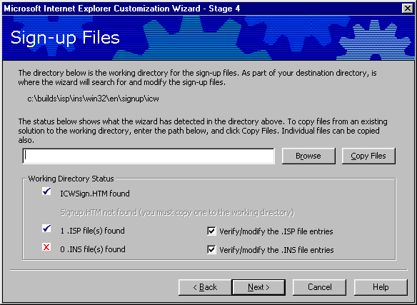
This wizard page imports the ICWsign.htm file into the Internet Explorer package. ICWsign.htm provides the user with a series of connection options for the initial, temporary connection to the ISP’s sign-up server. ICWsign.htm prompts the user to select a connection option, and then uses an .isp file to create the temporary connection. The .isp files can be imported in this page, or they can be created and/or modified by selecting the .isp check box. The .isp connection files also contain a reference to the Signup01.htm file that is to be used by the ICW.

Sign-up Server Information
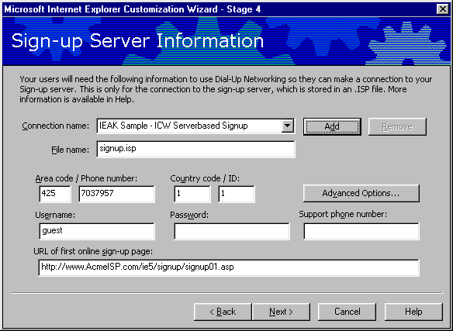
This page is used to create new .isp connection pages, or to edit pages that were imported in the previous wizard screen. These are temporary connections that are used solely to connect to the sign-up server. Permanent DUN connections are created as .ins files by the ICW based on information gathered during sign-up.
Each .isp file contains a reference to the URL location of the signupX.asp files that the ICW will use to collect user information, set up billing information and configure the browser. Examples of these files are in the \IEAK\toolkit\isp\server\icw\asp subdirectory. PERL-based sign-up files are also available. The ICW acts as a shell for these sign-up files.
Information on the configuration and deployment of the ICW signup.asp pages is in the IEAK Help.
The Advanced button can specify advanced connection configuration information, such as DNS, Compression and Encryption settings.
A support phone number can be entered that will be available during the ICW process.

Internet Settings Files
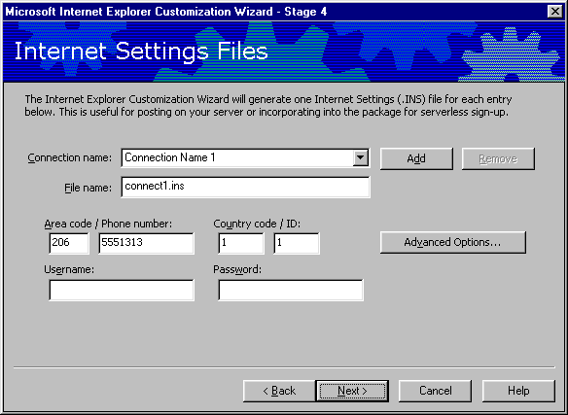
Permanent Settings files can be created and integrated with the ICW. Specific instructions on how to create and reference these files within the ICW signup.asp pages is available in the Internet Explorer HTML Help.

Internet Connection Wizard
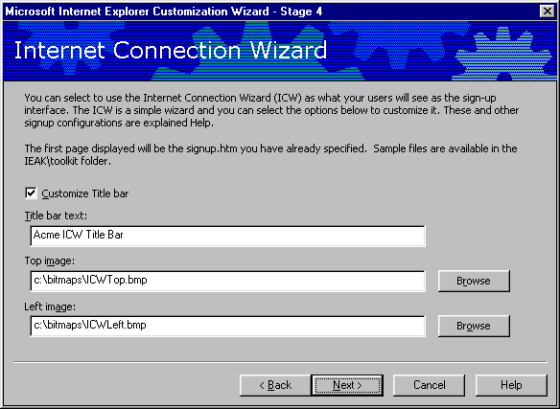
Just like the CD Autorun customizations, the ICW can be branded with a custom title bar, top logo and left logo.
Action | Click
Title bar Text | Enter the text that will appear in the ICW title bar.
Top image | The Top Image size must be 49 X 49 pixels.
Left image | The Left Image size must be 164 X 458 pixels.

Internet Sign-up Server Using Kiosk Mode
The server-based sign-up process is a Web browser-based mechanism that automates the task of adding new customers to your customer database. The sign-up process happens in three steps:
- The new customer connects to your sign-up server.
- An HTML/HTTP-based dialog box collects information from the user and adds the customer information to your customer database.
- Your server passes an .ins configuration file back to the customer's computer. This file includes information about configuration and branding. It also includes the local phone number so the customer can access the ISP.
Note that if the user's Security options are set to High, the sign-up server will not work, because the necessary files will not be downloaded.
After the customer has provided you with the information you need, you must return the following information to the customer:
- Data for configuring Internet connections
- Capabilities of the customer's account (including e-mail and newsreaders)
- Branding information
This information must be passed back to the computer in an IEAK profile, or .ins file. The IEAK can create an .ins file for each specified dial-up location during the Customization wizard, and these settings can be edited manually as appropriate. Some settings, such as Entry, User, Phone, Device, Server and TCP/IP, cannot be specified in the wizard, but can be customized by using HTML scripts.
If you want to provide a variety of custom "private branded" versions of Internet Explorer (containing such items as custom logos, title bar, Favorites, Search bar, start page, special links on the Links bar and the location for online assistance) to different customer groups, you should maintain a variety of sets of branding information on the server for downloading in the .ins file. This means that all of the compact discs you send out will be the same, but they will be branded differently when the user signs up. This eliminates the potential for a large inventory problem.
The Server-based sign-up process is an extremely versatile tool that can be customized far beyond the examples included in the \toolkit\isp\server subdirectory. More information on how to customize and deploy an Internet Sign-up Server is included in the IEAK Help file and the \toolkit\isp\server subdirectory.

Custom Sign-up Files
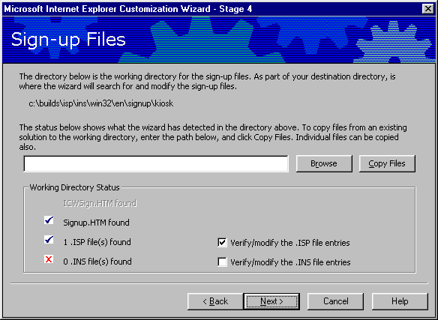
This is the first page in the “Server-based sign-up using kiosk mode” track.
This page imports the Signup.htm file into the Internet Explorer package. Signup.htm is run in kiosk mode the first time that Internet Explorer is started after installation. The Signup.htm file gives the user the option to connect to the ISP and includes a link to the .isp connection file. The connection (.isp) file contains two main sections: all of the connection information necessary to dial the sign-up server, and the URL of the actual sign-up home page. Signup.isp will be created by the next Customization wizard screen.
Signup.htm and Signup.isp are used for a one-time connection to the ISP, and then are used to run a kiosk-mode sign-up page. The kiosk-mode sign-up page is specified toward the beginning of the Customization wizard.

Sign-up Server Information
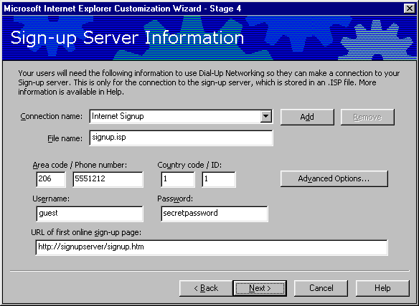
This page creates the signup.isp file that is referenced by the Signup.htm file specified in the previous page. Signup.isp contains the connection information necessary to dial the sign-up server, a guest username and password, and the URL of the sign-up pages. There are two ways to specify sign-up locations so that users will not have to make a toll call to connect to the sign-up server:
- The administrator can create multiple .isp files, and reference each of them in Signup.htm by area code.
- The administrator can use a toll-free number for sign-up.
The customer will not permanently use the phone number specified in this screen. The permanent dial-up number will be created in the next Customization wizard screen, and will be passed to the user in a customized .ins file at the end of the sign-up process.
The Advanced Options button allows the administrator to specify advanced dial-up options, such as DNS, Compression and Encryption settings.
Once the temporary connection is established, the .isp file will run the URL specified here. This is the first page of the ISP’s HTML-based sign-up process.

Internet Settings File
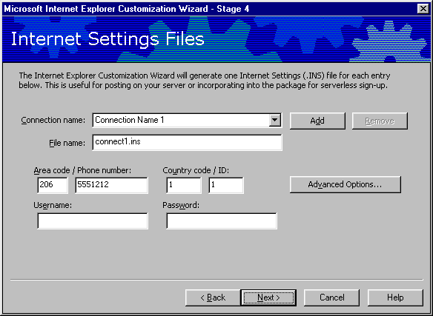
The Internet Settings files (.ins files) created in this page contain the permanent dial-up connection settings that will be passed to the users. This page creates an .ins file (specified in the file name entry) that contains all of the branding and configuration information from the Customization wizard, as well as the connection information specified here. This .ins file is passed to the browser at the end of the sign-up process and can be configured with user-specific information such as account name, password and connection location.
This page is used to pre-build location-specific customized .ins files for the administrator’s convenience. Further user-specific customizations from information in the sign-up pages can be added by CGI or ActiveX scripts. Examples of how to do this are included in the \toolkit\isp\server subdirectory.

Serverless Sign-up
The serverless sign-up process presents a user with several pre-created configurations in an HTML sign-up page that is automatically displayed after package installation. These sets of configurations are stored in a .ins file that is created during the IEAK wizard. Internet Explorer takes the settings in the .ins file and uses them to configure options from the Customization wizard, including browser branding and options, policies and dial-up connection settings. The serverless sign-up process enables ISPs that will not be using a sign-up server to provide customized connection options to customers.
Note: No information from the serverless sign-up process is returned to the ISP. The ISP will need to give the user a dial-up account name and password, as will also have to collect all necessary billing and account information from the customer by other means.
In the serverless version, the configuration file is created by the IEAK before the package is shipped, and it is included in the installation package. Therefore, the configuration file contains no user-specific configuration information. A sign-up HTML file, Signup.htm, is run automatically by the browser in kiosk mode the first time that Internet Explorer is run. The sign-up page gives the user the option to select one or several configuration options. These options are linked to .ins installation files that can configure the installation and create a Dial-Up Networking entry based on that configuration option. The \toolkit\isp\servless subdirectory contains examples of single and multiple installation options that can be customized and then included in the sign-up package.
If you are creating multiple customized versions of Internet Explorer and have many settings that stay the same across several or all versions, you can simplify the process. For more information, see “Creating Multiple Versions of the Browser” in the IEAK Help.
Serverless sign-up runs only in kiosk mode, and works only for CD distributions. Web distributions should use a server-based sign-up page. The kiosk mode start page, signup.htm, must be specified at the beginning of the IEAK Customization wizard.

Serverless Sign-up Files
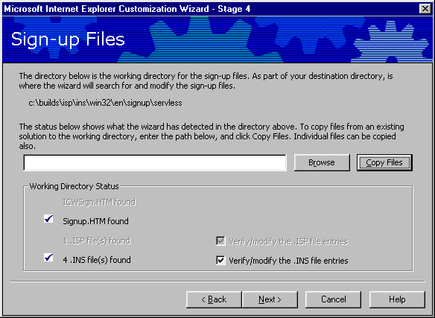
This imports the Signup.htm file into the Internet Explorer package. Signup.htm is the HTML page that will run in kiosk mode the first time that Internet Explorer is started. Check the c:\program files\IEAK\toolkit\isp\servless subdirectory for examples of Signup.htm. Signup.htm will contain one or several links to Internet Settings files (.ins). These .ins files will either be created by the IEAK in the next Customization wizard page, or created in advance and copied to the folder specified here. .Ins files are text files that contain all of the branding information from the Customization wizard, as well as entries for creating a Dial-Up Networking entry. Specific examples on how to customize the Signup.htm and .ins files are at the bottom of the “Serverless Sign-up” section.
The Customization wizard will create a new .ins file for every dial-up connection that the administrator configures. The need for different configuration options based on dial-up location is the most common use of serverless sign-up, but the .ins files can be used to separately configure other installation options as well. For instance, the Signup.htm file could let users choose from different branding options, color options or sets of Favorites.

Sign-Up Server Information
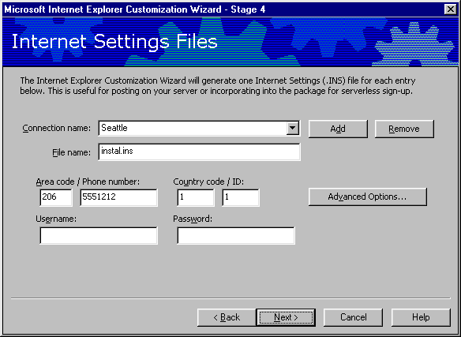
This is the wizard screen that is used to generate the customized .ins files that are linked in the Signup.htm file. These .ins files are created automatically by the IEAK and included with the Internet Explorer package along with any .ins files that were in the Signup.htm path specified in the previous wizard page. The .ins file will configure the Internet Explorer installation, and create a Dial-Up Networking entry with the settings specified here. Multiple .ins files can be created by selecting the Add button.

Serverless Signup.htm Screen Example
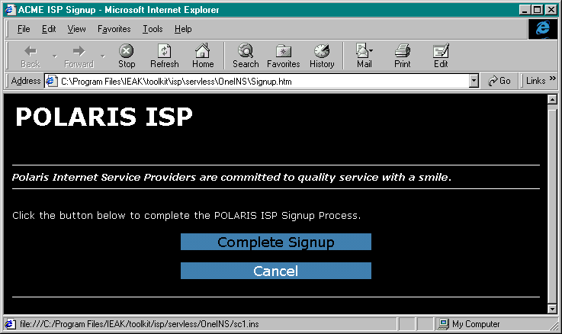
This screen is an example of the Signup.htm file that is run automatically in kiosk mode the first time that Internet Explorer is run. This page contains a single button that links to the .ins file created in the IEAK wizard. This screen is a customized example of the demo files included in the \toolkit\isp\servless\oneINS subdirectory. Multiple connection locations can be specified by creating multiple .ins entries in the Customization wizard, and then configuring the example in the \toolkit\isp\servless\multiINS subdirectory to refer to these .ins files.

Serverless Signup.htm Text Example
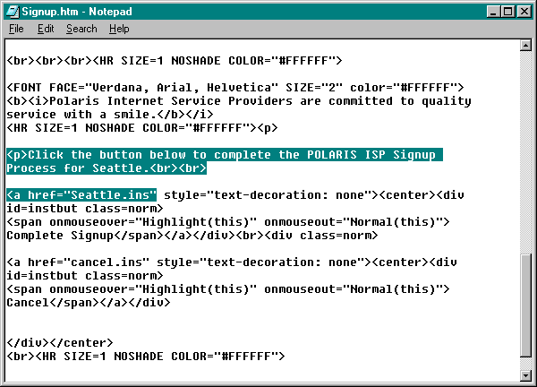
This screen shows an example of the text references used to customize the Signup.htm file. This example is a customized copy of the example included in the \toolkit\isp\servless\oneINS subdirectory. Note that in the highlighted section the Seattle.ins file created in the IEAK Customization wizard is the referenced as the action for the “Click the button” entry. A user could choose from multiple .ins files, as shown in the \toolkit\isp\servless\multiINS subdirectory.

No Sign-up
The No Sign-up option is a flexible option that can be used under several circumstances. This option can be used if the ISP is using a sign-up method that cannot be integrated with the IEAK Sign-up process, or if no sign-up is to be used.

Appendix C: The Connection Manager Administration Kit
Connection Manager provides a graphical interface so that a user can connect to their service using connection features that the administrator defines. These features are defined using the Connection Manager Administration Kit (CMAK), which supports the creation and updating of multiple versions of Connection Manager, each of which the administrator should define to meet the needs of a specific target audience. The CMAK can be used to create a Connection Manager profile on a user’s desktop. A Connection Manager profile is similar to, but not the same as, a Dial-up Networking connection. See Appendix B for more discussion on Automatic Connections.

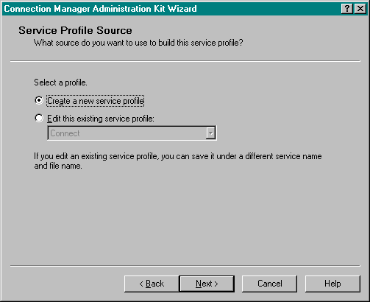
This screen allows the administrator to create a new profile or edit a previously created profile. For the profile to be visible to the CMAK, it must be located in the Profiles subdirectory in the C:\program files\cmak directory.

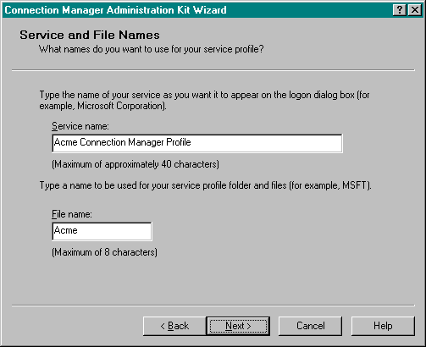
Each profile has a friendly service name and a profile file name. The files are limited to 40 and 8 characters, respectively.

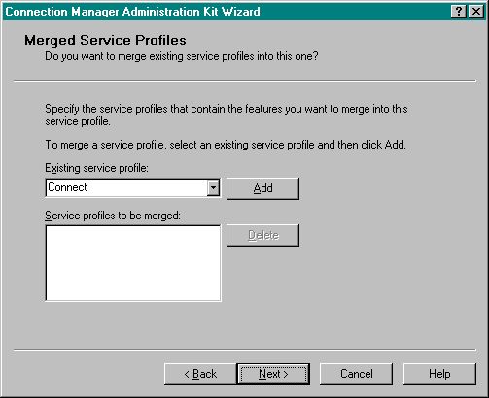
If an administrator has existing service profiles that already contain information needed in the service, that information can be included by merging those service profiles with the service. .Each time the CMAK wizard is run, administrators must specify whether they want to create a new service profile or edit an existing one. Merging a profile is useful if there is an existing phone book or configuration information to add to a new profile, without editing the old one.

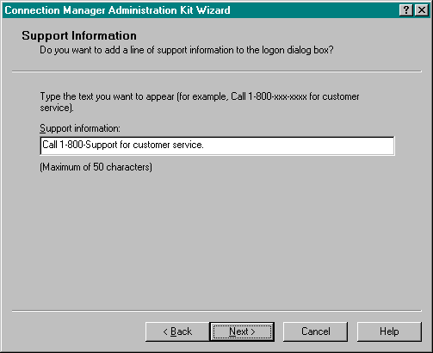
The support information entered here is displayed every time the Connection Manager is run.

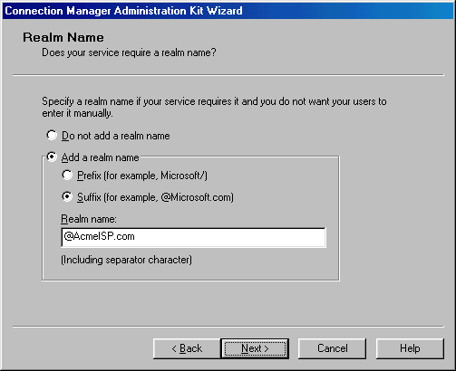
Administrators can specify a realm name prefix (such as AcmeISP/) or suffix (such as @acmeisp.com) to be added to the user name that a user enters when connecting to the service. The realm name includes any separator characters, such as @ or /. If the realm is specified, users do not have to type it.
Note: Realm names are typically not used by ISPs.

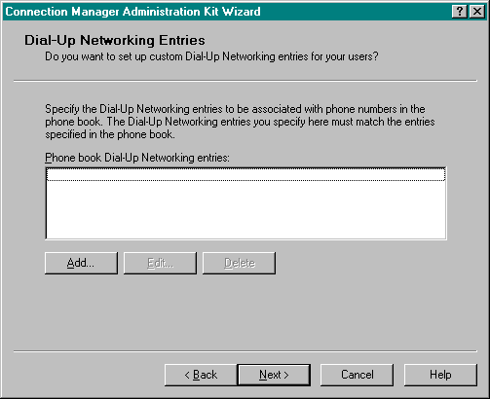
The administrator can create Dial-up Networking (DUN) entries that match certain phone numbers in the Connection Manager phone book. This is a separate feature from importing or creating DUN connections in the IEAK. To set up custom DUN entries for a particular POP, administrators associate DUN entries set up in the phonebook file (.pbk) with the DUN entries set up in the service profile. Before running the CMAK wizard, administrators must define the entries to set up with custom DUN, and the options to use for each. The following information must be specified for each entry that will be customized:
- The name of the phonebook DUN entries to customize. This entry must match the phonebook DUN entries in the phonebook. If a phonebook is not being used, the DUN entries name must be the same as the service name. For example, to create a custom DUN entry for a service profile name ACME ISP that has no phonebook, administrators would specify “ACME ISP” as the Phonebook DUN entry on the worksheet and in the CMAK wizard.
- Whether or not to use the server-assigned address or to use specific Domain Name System (DNS) and Windows Internet Name Service (WINS) addresses. To assign specific addresses to the DUN, administrators can specify both primary and secondary DNS and WINS IP addresses.
To use server-assigned addresses, end-point servers running Windows NT Server must be configured to use the Dynamic Host Configuration Protocol (DHCP) to automatically assign remote TCP/IP client IP addresses.

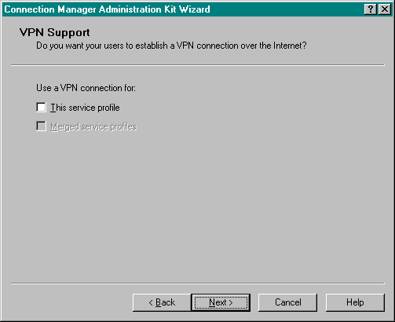
The secure connection feature uses Point-to-Point Tunneling Protocol (PPTP) with Microsoft Point-to-Point Compression (MPPC) and Microsoft Point-to-Point Encryption (MPPE). To use secure connections, there must be a PPTP server on the network side.

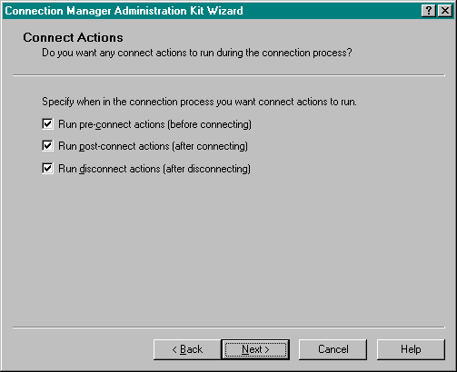
To set up the service profile to automatically start programs or install software when a user connects to the service, administrators must correctly specify the connect-action programs when running the CMAK wizard. These actions, especially post-connect actions, should not be confused with auto-applications. A separate wizard screen is provided for running applications automatically after connection.
Pre-connect actions run immediately after the user selects connect, but before any connection actually takes place.
Post-connect actions run after establishing the DUN connection. Some post-connect actions, such as automatically updating phonebook entries and using MCIS logon information, have been pre-configured into the post-connect dialog box that follows.
Disconnect actions run immediately after disconnecting.

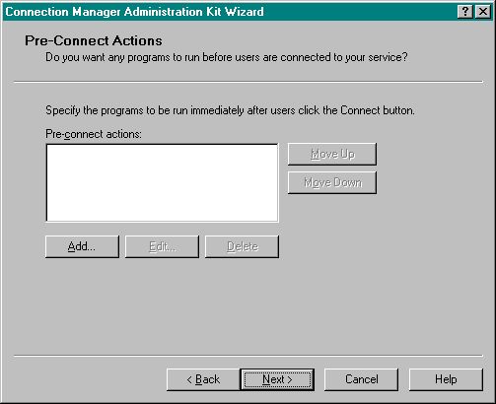
Pre-connect actions run immediately after the user selects connect, but before any connection actually takes place.

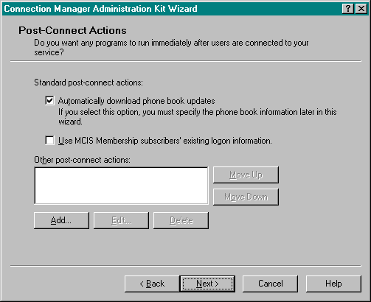
Post-connect actions run after establishing the DUN connection. Some post-connect actions, such as automatically updating phonebook entries and using MCIS logon information, have been pre-configured into the post-connect dialog box.

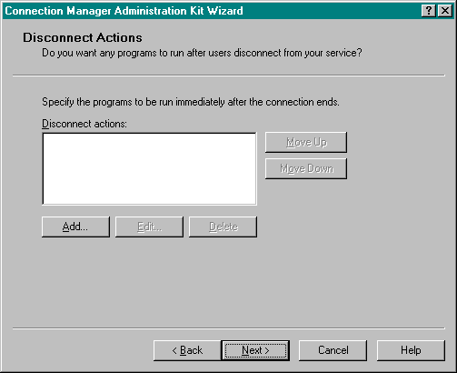
Disconnect Actions take place after a service has been disconnected.

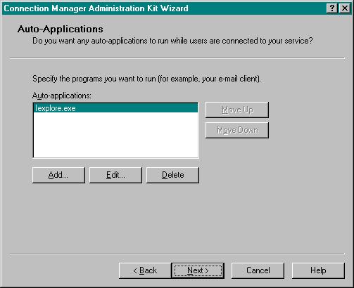
The Auto-Applications screen is used to run applications automatically when a user connects to the service. Auto-Applications are different from Connect Actions in that when an Auto-Application is closed, so is the connection. Each application can be run with parameters specified during the Add and Edit dialog boxes:

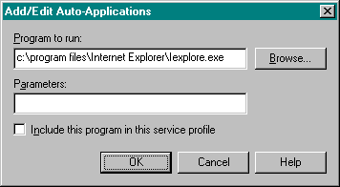
Administrators can include the program in the service profile, but the only program included will be the executable itself. Any additional files needed to run the program will need to be in place on the user’s machine for the program to work. If the Include box is not checked, then the Connection Manager will attempt to run the program from the same location as on the IEAK workstation.

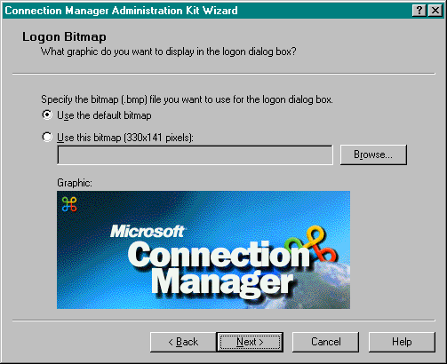
This screen allows administrators to use the default logon bitmap or to specify one. The bitmap must be 256 colors, 330 X 131 pixels.

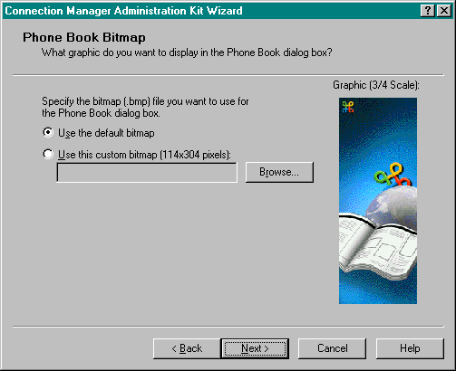
The Phonebook Bitmap is a 114 X 304-pixel bitmap that appears on the left side of the Phone Book dialog box. If no bitmap is specified, then the default bitmap will be used.

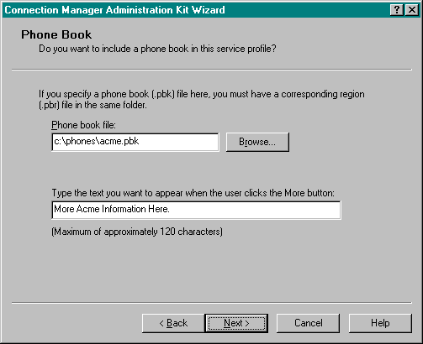
In addition to the CMAK, the Microsoft Windows NT Server 4.0 Option Pack contains Connection Point Services. Connection Point Services provides support for creating, maintaining and updating Phone Books. Administrators can also create Phone Books, but the complexity of the format and requirements makes this difficult if there is more than a single POP. Search the CMAK Help file for the words “phone book” for detailed instructions on creating and configuring Phone Books, either manually or with Connection Point Services.

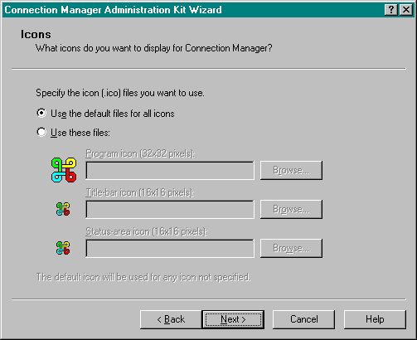
The administrator must specify the .ico files to use for the Program, Title bar and Status-area icons.
Note: These files are icon (.ico) files and not bitmap (.bmp) files. If no custom icons are specified, then the default icons will be used.

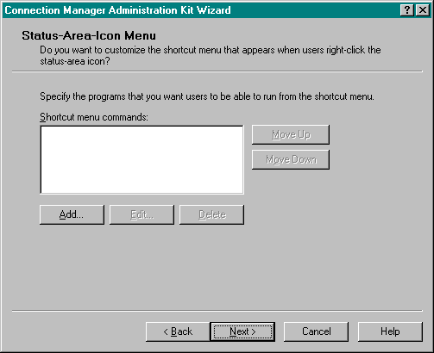
Administrators can customize the pop-up shortcut menu that users receive when they right-click on the Connection Manager status-area icon. This dialog box allows the administrator to add additional programs to the shortcut menu. Possible uses for this feature could be a virus-checking program, traffic analysis tool or shortcuts to Internet Explorer and Outlook Express.

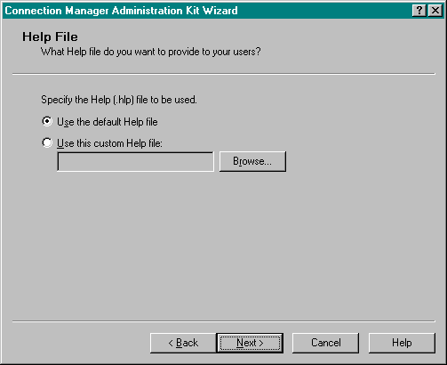
The administrator can specify a custom Help file or use the default Connection Manager Help file.

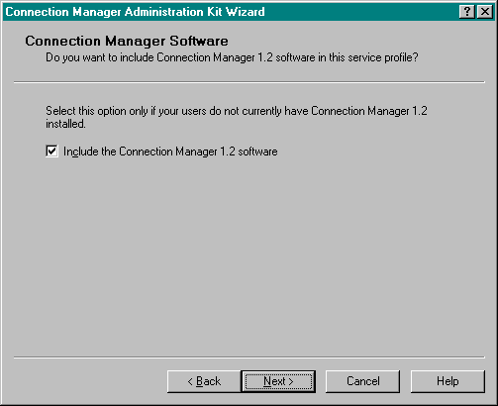
This dialog box allows the administrator to specify whether the Connection Manager software is included in the profile. The Connection Manager software adds about 400K to the size of the profile, for a total of 500K. Including the software is a good idea because it ensures that users have the latest version and are using a consistent version of the Connection Manager software.

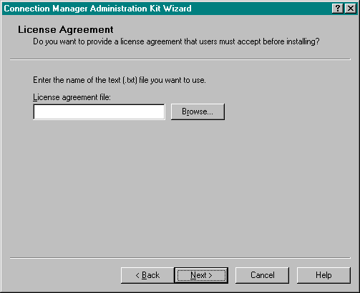
The administrator can include a customized license agreement in the connection manager profile. The license agreement must be saved as a text (.txt) file.

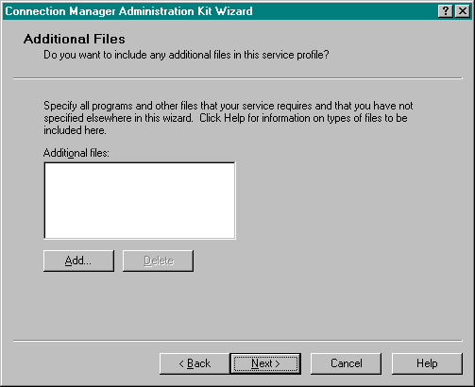
The administrator can add to the service profile other files that users should have, such as supporting files for connect actions. When these additional files are specified in the CMAK wizard, the service profile copies the files to the Connection Manager folder. Some advanced customization techniques require administrators to include files in the service profile. When administrators make advanced customization decisions, they should add any files required by those decisions to this list of additional files. For example, all the files required to provide any user documentation or customized error handlers should be included as additional files. For more information on advanced customization techniques, see the CMAK Help file.

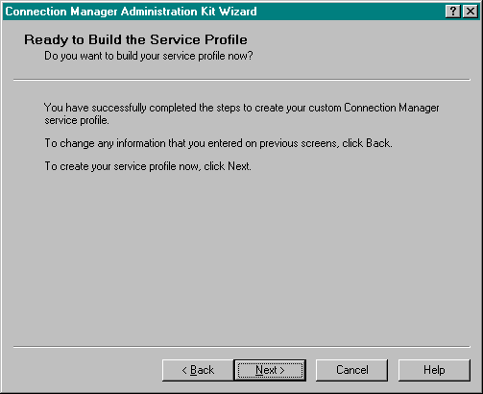
Once the package has been generated, it will be automatically added to the Internet Explorer custom package. The package will be saved to c:\program files\cmak\profiles\<profile name>.

Appendix D: Creating a Pilot Program
The following outlines steps ISPs follow to create an abbreviated pilot program. These steps are a subset of the steps that a corporate organization would use to set up a production-level pilot for a line-of-business application deployment.
It makes good practice to prepare a test plan and checklists for lab tests, and then use the checklists to record satisfactory completion of tasks and note all problems with the process. Also, prepare a checklist to test each deployment and distribution strategy.

ISP Lab Deployment Steps:

Prepare custom packages for deployment:
- Install and run the IEAK Configuration Wizard.
- Build custom packages containing the distribution files.
- Configure browser automatic configuration (.ins, .js, .pac) files.
- Configure download sites and install the distribution files.
- Copy distribution files to compact discs and floppy disks.

Deploy custom package to lab clients:
- Run Internet Explorer 5 Setup to install the custom package on each client.
- Install using each available user install option.

Operate lab client software after custom package is installed:
- Test sign-up procedure, if used.
- Run Internet Explorer to test all add-ins and features.
- Run business applications to check for satisfactory operation.

Restore lab clients to their original state:
- Uninstall Internet Explorer 5 and add-ins.
- Verify that Internet Explorer components have been removed.
- Test the desktop and business applications.
Administrators should prepare a test lab and then test the proposed deployment strategies on lab computers that represent typical client configurations for the ISP. If an ISP has customers with vastly different computing environments or needs, administrators may need to prepare multiple test labs and conduct tests at several different sites.

Appendix E: Internet Explorer 5 Quick CD-ROM Deployment Guide

Introduction
This guide will produce a package for deployment on CD-ROM. A typical customer installation would go as follows:
- The user inserts the CD-ROM into the PC, and the Installation wizard walks the user through the license agreement and other installation options.
- A branded and customized Internet Explorer package will be installed on the user’s PC. After the Installation wizard is completed, the user is prompted to reboot the PC.
- The first time that Internet Explorer is run, a sign-up page will automatically run in kiosk (full-screen) mode. This sign-up page will give the user the option to choose a local dial-up connection number. Once this option is chosen, Internet Explorer will configure itself and create a default dial-up networking connection.
- Internet Explorer is now installed and configured on the user’s PC. The installed code will include:
- Internet Explorer and any additional components specified by the administrator.
- Outlook Express, pre-configured with necessary e-mail and Usenet settings.
- An automated dial-up networking connection, configured as the default for the browser.
Including the sign-up page with the browser code is known as “serverless” sign-up. The IEAK also supports “Internet Signup Server” customization, which allows the ISP to collect account and billing information, integrate this information into an existing customer management system, and then customize Internet Explorer with branding and connection information. More information on deploying an Internet sign-up server can be found in the IEAK Help file, the full IEAK deployment guide, and the sign-up examples included in the IEAK \toolkit subdirectory.

Checklist
The following checklist can be used to gather the necessary information before using the IEAK 5. An asterisk (*) denotes required information. More information about specific components can be found in the Glossary.

Important Decisions
* Company Name: * Product Keycode:
* Platform: Win9x/NT
* Type of Distribution: CD-ROM
* Installation Type: Minimum Typical Full
Select one or all of these installation types.

Title Bar Customizations
Information is used to customize installation screens and how the browser is presented to users.
CD Autorun Screen Title Bar Text:
Setup Wizard Title Bar Text:
Browser Title Bar Text:
(i.e. Microsoft Internet Explorer provided by “ACME”.)

Files to Collect
The IEAK allows the administrator to customize most Internet Explorer bitmaps. These items are optional.
Setup wizard left bitmap (162 X 312 pixels)
CD Autorun custom bitmap path (540 X 347 pixels)
CD Autorun more information text file

URLs to Collect
These URLs will become part of a user’s desktop.
Home page URL:
On-line support page URL:
Favorite URLs: (1)
(Up to 200) (2)
(3)
(4)
Custom Welcome Page:
The Welcome Page is run the first time that Internet Explorer is run, after sign-up.

Automatic Connection
Pre-configuring dial-up settings will help users connect more easily. Fill out this section once for each dial-up location that you wish the user to be able to choose from.
Name of dial-up entry (friendly name):
File name of dial-up entry (8 characters): .ins
Phone number
Use proxy server? Yes No
If Yes, proxy settings: Address: Port:

Outlook Express
Outlook Express is an integrated component of Internet Explorer 5.
Incoming mail server address:
Outgoing mail server address:
News server address:

Sign-up
Instructions on how to create a signup page are included in Appendix B, “Automatic Connections” and “Sign-up.” Read this Appendix before filling in the following items:
Signup.htm file location:
Dial-up location (.ins) files specified in Signup.htm (one per location, these files are created during the IEAK:

How To Deploy a CD-ROM Distribution Package
The IEAK generates a CD subdirectory in the c:\builds folder. The Windows Explorer view of your generated packages should be similar to this:
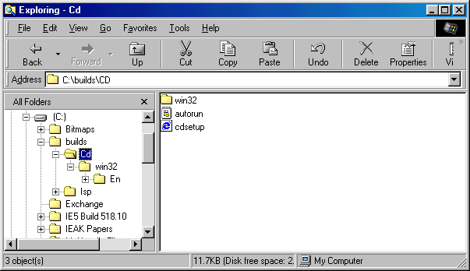
Copy everything from within the c:\builds\<build_number>\CD subdirectory onto the root of the master CD. The root of the CD-ROM will contain the Win32 subdirectory, Autorun.inf, and a setup file. All necessary sign-up and configuration files are contained within the installation .cab files.

The 10-Minute Walkthrough
The IEAK Customization wizard can be easily completed in 10 minutes by following this walkthrough. Accept the default for any screen that is not shown here, or does not require information that was gathered in the checklist.

Welcome Page
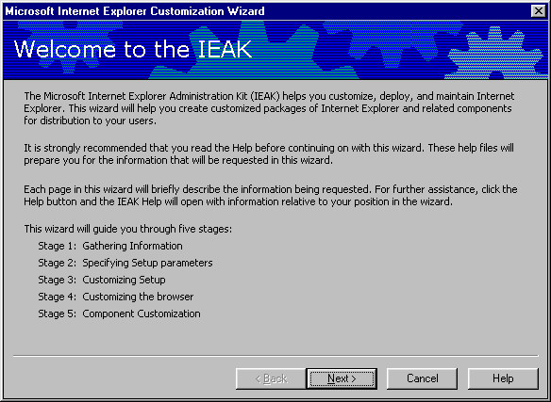
Action | Click
Accept the values on the current page and move to next page. | Next
Display any previous page. May have to retype some of the values you’ve entered. | Back
Exit this package. | Cancel
Need more information about using a page or specific feature. | Help

Company Name and Customization Code
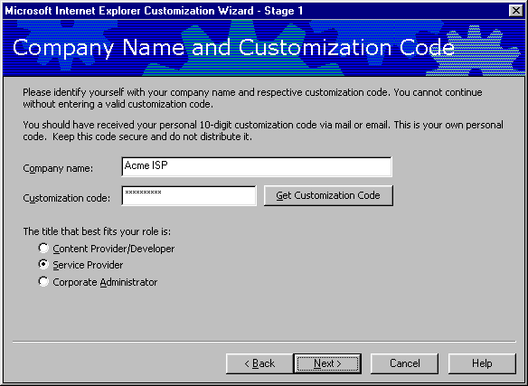
Option | Explanation
Company name | Type the name of your company. This information is put in the Registry for identification.
Customization Code | Type the code you received from Microsoft at the IEAK Web site.
Get Customization Code | Selecting this option will take you to the Microsoft IEAK registration Web page. At this page you will be able to register your copy of the IEAK and receive a customization code.
The title that best fits your role is: | Because the customization code is specific for your role, the wizard automatically selects Content Provider. Be sure to select Service Provider option to receive all of the necessary wizard options for Service Providers.

Platform Options
The next screen allows administrators to select the platform version of Internet Explorer 5.

File Locations
Option | Explanation
Destination folder | This is the location that the packages will be placed in after the wizard is finished.

Language Selection
Localized versions of the Internet Explorer package can be created by selecting a language from the pull-down box. The wizard must be run once for each localized version that is created.

Media Selection
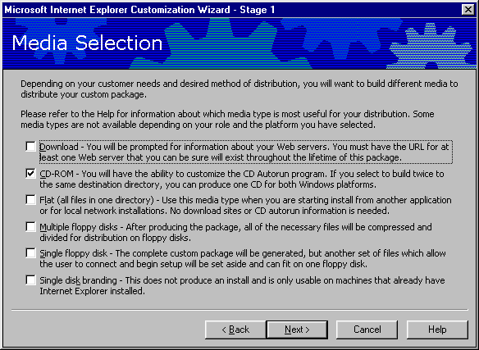
Select the CD-ROM media type only. Distributions via other media types are covered in the full IEAK Deployment Guide.

Feature Selection
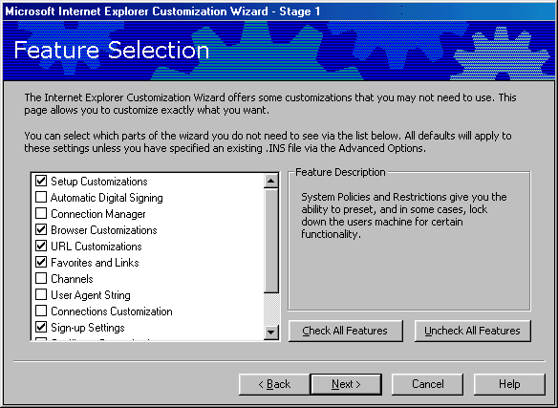
You can determine which remaining screens of the Customization wizard are displayed by selecting or clearing the check boxes in this screen. This will make it faster and easier to complete the Customization wizard. Checking or clearing these boxes will not affect functionality; rather, these boxes will determine which items in the IEAK Customization Wizard you can customize. Clear all boxes except the following:
- Setup Customizations
- Browser Customizations
- URL Customizations
- Favorites and Links
- Sign-up Settings
- Outlook Express Customization

Automatic Version Synchronization
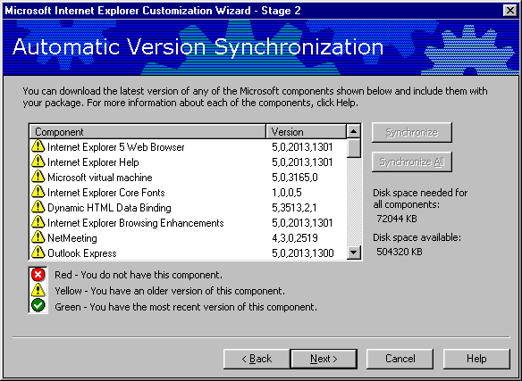
Use this screen to synchronize the individual Internet Explorer components to the latest versions. It is recommended that all components be synchronized before continuing the wizard, but this is not required.
Note: Synchronization time will depend on the type of connection available and number of components that are synchronized. Synchronization time for 70 MB of Internet Explorer components over a modem is not included in the 10-minute completion goal for this paper.

CD Autorun Customization
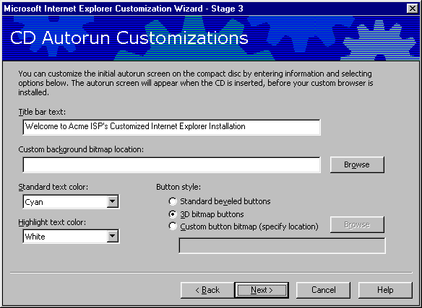
This screen can be used to customize several different CD Autorun items, but the two that are most easily customized are the CD Autorun title bar text and custom background bitmap. These two items are used to identify the ISP before the Installation wizard actually begins.

Option | Explanation
Title bar Text | This is the text that goes in the CD Autorun title bar.
Custom background bitmap location | You can provide a bitmap that appears behind the text. Make sure the background color doesn't conflict with the text color. This bitmap must be 540 X 347 pixels.

More CD Options
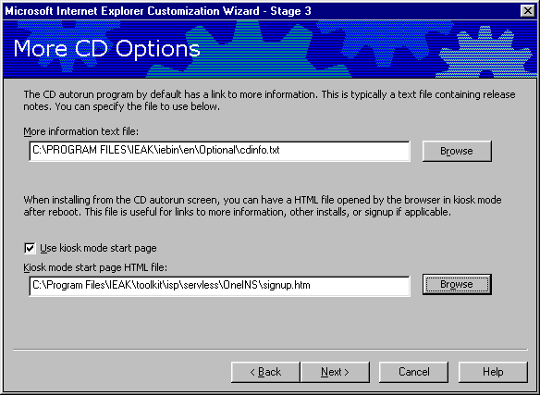
This screen allows you to specify a “more information” text file, as well as the kiosk mode sign-up page that is seen when Internet Explorer first runs. The path to the serverless sign-up page, signup.htm, is specified in here.

Customize Setup
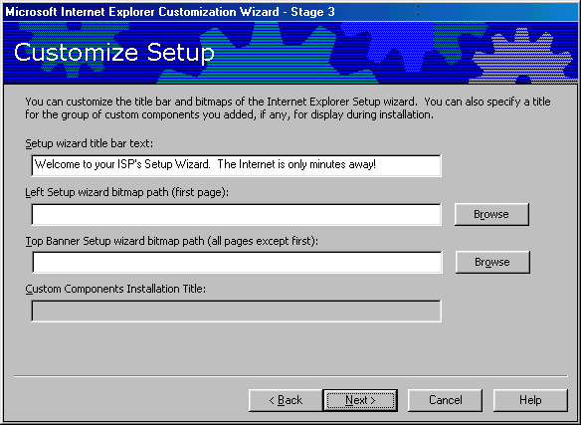
Add the Setup wizard title bar text that was collected in the IEAK Checklist.

Installation Type
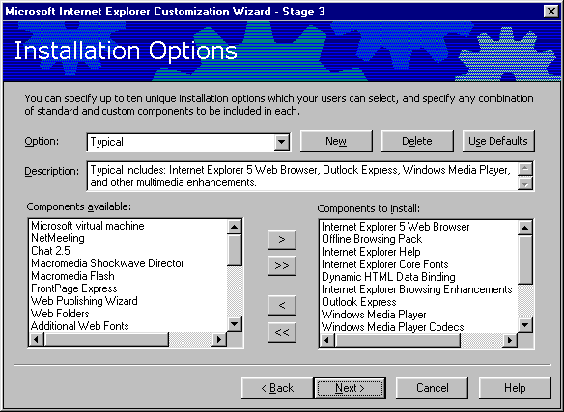
These installation types will be available to the user when installing Internet Explorer. Remove undesired options by selecting the option, then the Delete key. Some organizations may wish their customers to have the ability to choose an installation type; others may wish to only support a specific set of features. The ability of the user to add or remove components from an installation type is determined later in the Customization wizard.

Browser Title
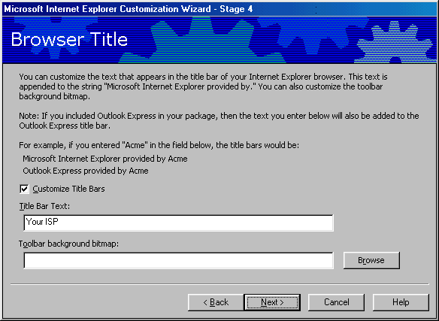
Check the Customize Title Bars button, and add your company name. The browser title bar will read “Microsoft Internet Explorer provided by Your ISP” in this example.

Important URLs
The two items that can be most easily customized in this page are the Home Page and Support page URL. These items were collected in the Checklist and should be entered here.

Note: The IEAK does not check the validity of these sites. Double-check the entries to make sure that they are typed correctly.

Favorites and Links
There are two ways to pre-populate a set of Favorites in Internet Explorer. The first is to select the Add URL button and manually enter a name and address for each Favorite. An easier and more reliable way is to edit the Internet Explorer Favorites on the IEAK workstation, and then import these Favorites by selecting the Import button.

Sign-up Method
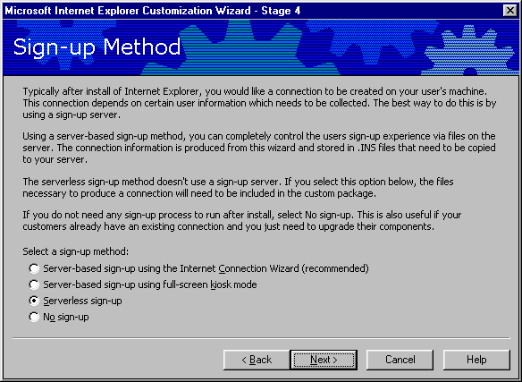
Select serverless sign-up as the sign-up method. Serverless sign-up will include an HTML page, signup.htm, in the browser package. Signup.htm will give the user a choice of dial-up locations. Once the user selects a local dial-up, signup.htm will return an Internet Settings (.ins) file to the browser that will configure the browser and create a dial-up networking connection.
You can also select the No sign-up option at this point. Selecting No sign-up will configure the browser with the settings specified during the customization wizard. This option would be appropriate for an organization that already has a sign-up procedure in place, or one that is providing a browser to clients with pre-existing Internet connections.
An example of the Signup.htm file is included in the \IEAK\toolkit\isp\servless subdirectory, and should be customized before proceeding past this point. Complete instructions on how to customize signup.htm are included in Appendix B, “Automatic Connections” and “Sign-up.”

Serverless Sign-up Files
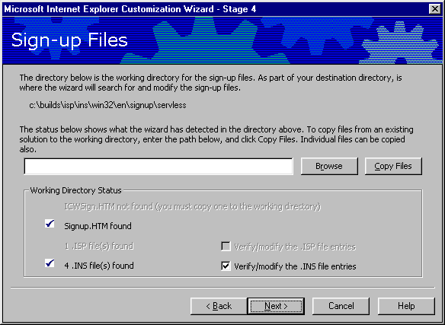
This screen imports the Signup.HTM file into the Internet Explorer package. Signup.htm is the HTML page that will run in kiosk mode the first time that Internet Explorer is started. Check the c:\program files\toolkit\isp\servless subdirectory for examples of Signup.htm. Signup.htm will contain one or several links to Internet Settings files (.ins). These .ins files will be created by the IEAK in the next Customization wizard page. .Ins files are text files that contain all of the branding information from the Customization wizard, as well as entries for creating a Dial-Up Networking entry. Specific examples on how to customize the Signup.htm and .ins files are in Appendix B, “Automatic Connections” and “Sign-up.”

Sign-up Server Information
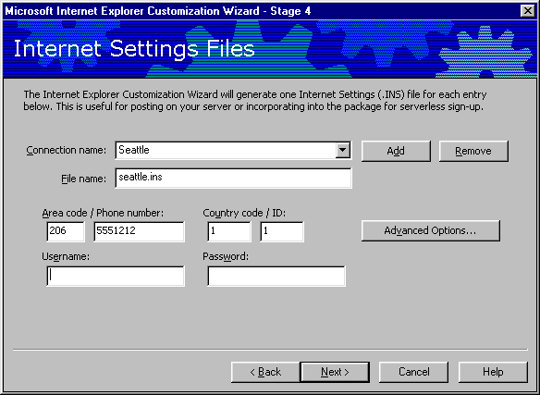
This is the wizard screen that is used to generate the customized .ins files that are linked to in the Signup.htm file. These .ins files are created automatically by the IEAK and included with the Internet Explorer package along with any .ins files that were in the Signup.htm path specified in the previous wizard page. The .ins file will configure the Internet Explorer installation, and create a Dial-Up Networking entry with the settings specified here. Selecting the Add button can create additional .ins files. Users use the signup.htm page to choose between these multiple .ins files.
The Advanced Options page allows the administrator to specify advanced connection settings, such as DNS, Compression and Encryption settings.

Outlook Express Accounts
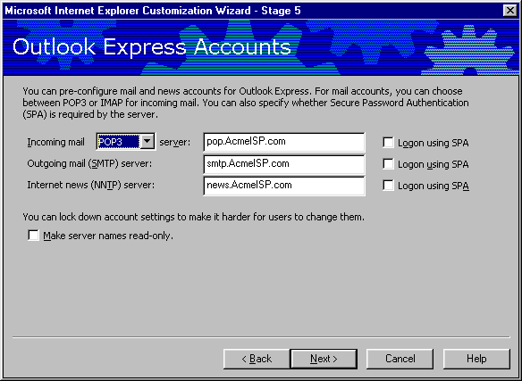
Enter the DNS names for the mail and news servers in this page. These entries will configure Outlook Express for the user.

Wizard Complete
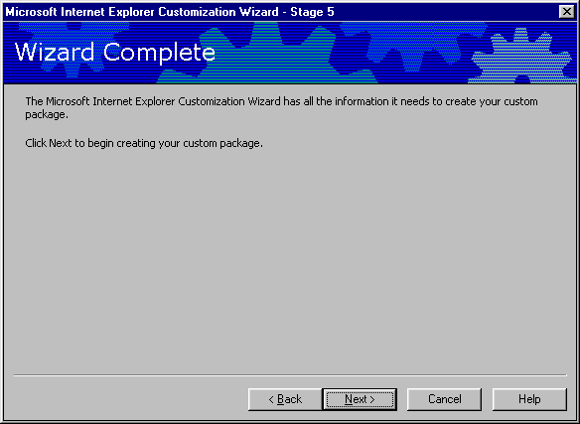
Congratulations! You have completed the IEAK Customization Wizard. The Customization wizard will now generate all of the code necessary for a CD-ROM-based installation, using the files and settings that you have specified. Before deploying this installation to your customers, it should be tested on a few typical client machines to ensure that sign-up works correctly, and all of the files and logos are correctly formatted.

Glossary
Active Desktop – Active Desktop is one of the two components installed with Windows Desktop Update. Active Desktop allows the user to add active content, such as a stock ticker, to their desktop, taskbar or folders. Users can also single-click files to run and open them. Active Desktop can be disabled in the IEAK, even if Windows Desktop Update is installed.
Authenticode – Authenticode lets a corporate administrator preconfigure security zones, preset ratings and customize certification authorities. The administrator can also set system policies and restrictions to control whether users can modify their security settings.
Automatic Configuration – Automatic Configuration is a feature of Internet Explorer that allows the administrator to dynamically configure settings from the IEAK, as well as system policies and restrictions.
AVS – Automatic Version Synchronization automatically checks for updated versions of each Internet Explorer Component every time the IEAK is run. Updated components can be downloaded from Microsoft and included in subsequent IEAK packages.
Bitmap – Bitmaps (.bmp files) are the format used for updating the graphics in an IEAK package. Most common graphic formats can be simply saved as bitmaps by using the “save as” command in Microsoft Paint.
Branding – Branding is the customization of the Internet Explorer browser and components, the installation wizard and CD Autorun screen with an organization’s artwork, text messages, welcome pages, etc. Branding an installation differentiates a customized package from a generic Internet Explorer installation.
CD Autorun Screen – The CD Autorun screen is automatically displayed when an Internet Explorer installation CD is inserted into a workstation. The CD Autorun screen typically consists of an “Install Internet Explorer 5” button, a “Cancel” button and a customizable graphic.
Certification Authorities – Certification Authorities are companies such as VeriSign or GTE that issue digital certificates, which provide a trusted source to verify the authenticity of a certificate.
Certificates – See Digital Certificates
Channels and Categories – A Channel is a Web site that has been enabled for information-receiving programs. The mechanism that makes this possible is the Channel Definition Format (.cdf) file. Channels can be organized into Categories and placed on the user’s desktop.
CMAK – The Connection Manager Administration Kit is a tool for creating, editing and managing Connection Manager Profiles. The CMAK is included with the IEAK.
Code Signing – Code signing is the process of signing a completed Internet Explorer package with a digital certificate. Signing the package requires two steps: obtaining a digital certificate and signing the code. You do not need to sign files that you plan to install on the UNIX or Windows 3.x platforms.
Component – Examples of components are Outlook Express, Microsoft NetMeeting, and the VDOLive player. You can include many Internet components from Microsoft and other companies with the Internet Explorer browser.
Configuration Identifier – The Configuration Identifier is a string of text that a Web site can retrieve to identify the types and versions of browsers that visit it.
Connection Manager Profile – Connection Manager Profiles are objects similar (but not the same as) Dial-up Networking entries. Connection Manager profiles are one way of automating a dial-up connection.
Connection Settings – Connection Settings are the settings that Internet Explorer uses to connect to the Internet. Connection Settings are typically collections of settings for dial-up networking entries, such as proxy settings, account and passwords, and modem configurations.
Content Ratings – Content ratings in Internet Explorer provide a way to help you control the types of content that your computer can access on the Internet. You can adjust the settings to reflect what you think is appropriate content in four areas: language, nudity, sex and violence.
Customization Wizard – The Customization wizard is one of the main components of the IEAK. The Customization wizard is used to generate a customized version of Internet Explorer for installation in a specific organization.
Deployment – Deployment is the actual process of installing Internet Explorer to an entire organization. Contrast with a “pilot,” which is the installation of Internet Explorer on a group of test users.
Digital Certificates –Digital Certificates are issued by Certification Authorities, show where a program comes from, and prove that a package hasn’t been altered. ISPs that plan to distribute an Internet Explorer package over the Internet should sign their code with a Digital Certificate.
Favorites – Favorites are predefined links to Web sites. Favorites are also known as bookmarks. Favorites in Internet Explorer can be configured to automatically notify the user when content changes.
File Path – The file path, in the context of a Web deployment, is the actual local path to the distribution files on a Web server. A typical example might be “c:\inetpub\wwwroot\ie5\download”.
Folder Webviews – You can customize how My Computer and Control Panel appear on your company's computers by customizing the HTTP files that serve as templates for them. Folder Webviews require Windows Desktop Update to be installed.
GUID – A globally unique identifier (GUID) is an identifier that distinguishes one program or object from another. When using the IEAK, you can generate a GUID for each custom component that you add.
Home Page – The Home Page is displayed every time Internet Explorer is started.
IEAK – The Internet Explorer Administrator Kit (IEAK) is the tool used to create, distribute and manage customized Internet Explorer packages across an organization.
Infopane – See Outlook Express Infopane.
Keycode – The Keycode is a license code that is issued to an organization when it downloads the IEAK. The Keycode is not required to install the IEAK, but it is required to generate IEAK packages.
Kiosk Mode Start Page – A kiosk mode start page can be specified for CD Installation. This page will appear in kiosk (full-screen) mode, in which the browser toolbar and menu bar are not displayed.
Lab – A lab is a collection of non-production machines that are used to test an Internet Explorer Package. The lab is not the same as a pilot group.
LDAP – The Windows Address Book supports LDAP (Lightweight Directory Access Protocol) for accessing directory services, and it comes with built-in access to several popular directory services. ISPs can specify an additional service for their users.
Media – Media refers to the physical methods used for browser package distribution. Typical media choices are CD-ROM, Web download or floppy disk.
Newsgroups – See Usenet.
Outlook Express Infopane – The Outlook Express Infopane is an area for content providers to place helpful information and links. You can customize this pane with support numbers, frequently asked questions (FAQ) and information about your company.
Package – A package is a set of customized installation code for Internet Explorer. A package contains all necessary code and files to install, configure and run Internet Explorer. The IEAK can configure packages for several different types of installation media.
Pilot Group – A pilot group is a representative sample of production machines that are used to test an Internet Explorer package before a full deployment to the entire organization. A pilot group is different from a lab in that it uses production machines and users.
Platform – A platform is a type of client; for instance, Windows 95, Windows 3.x, Macintosh or UNIX.
Profile Manager – The Profile Manager is one of the major components of the IEAK. The Profile Manager is used to create and dynamically manage browser and desktop automatic configuration settings.
Proxy – A proxy server provides network address translation and Web content caching services for Web browsers. Proxy settings can be configured automatically as part of an IEAK package.
Realms – Realms are a feature of the CMAK that provide a prefix (such as company\) or suffix (such as @company.com) to a user name when connecting to a Connection Manager service.
Security Zones – The new Internet Explorer 5 security options enable you to assign specific Web sites to various security zones, depending on how much you trust the content of the Web site. Security Zones allow an administrator to restrict user access to certain Web sites.
Server-based Sign-up – See Sign-up.
Serverless Sign-up – See Sign-up.
Shell Integration – Shell Integration is one of the two components of Windows Desktop Update. Shell Integration lets users browse their computers just as they browse the Web. Users will find the Go and Favorites menus everywhere.
Sign-up – Once Internet Explorer is installed, sign-up features can be used to complete the customer registration process. Server-based sign-up provides full flexibility and dynamically adapts to various sign-up options, but requires the use of CGI or ActiveX scripts on a Web Server. Serverless sign-up doesn't require a sign-up server. If you select the serverless method, the Internet Explorer Customization wizard prompts you to provide the necessary information to control the sign-up process.
Title Bar Text – Title bar text is the text at the very top of program windows. The title bar text can be branded for several windows in an Internet Explorer package, including the CD Autorun screen, the Browser itself and Outlook Express.
URL – Uniform Resource Locator. A URL is a Web address, such as “http://www.microsoft.com”
Usenet – Usenet groups are also called Newsgroups. They are text based newsgroups that serve as bulletin boards that any user can post to.
Versioning – There are two types of Internet Explorer versioning: Each Internet Explorer package will be assigned a version number, and versioning can be enforced so that older packages are not allowed to overwrite newer versions of the same package. Individual components in Internet Explorer are also versioned, and configured not to download or install if a compatible version of the component already exists on the client machine.
Watermark – The watermark is a bitmap that is displayed behind the Internet Explorer toolbar. The color of the watermark should not obscure the text or graphics of toolbar buttons.
Web Path – In the context of a Web deployment, the Web path is the path used to connect a browser to the Internet Explorer installation files. A typical Web path for browser deployment might be “www.mycompany.com/ie5”
Welcome Page – The Welcome Page is only displayed the first time that Internet Explorer is run. Subsequently, the Home Page is the page that is automatically displayed when Internet Explorer is started.

Mandatory information only if distributing Internet Explorer 5 over the Internet.
The user will need to provide account and password information to the dial-up networking profile.

