Windows 7
Customer TCO Case Study
 |  |  |   City of Miami Uses Windows 7 to Improve City Services With Less Budget

Overview  Country or Region: United States  Industry: City government  Customer Profile  Incorporated in 1896, Miami is the major city of the state of Florida. With 424,662 residents, Miami is the center of a metropolitan area with a population of more than 3.5 million people.  Business Situation  Delivery of efficient, cost-effective city services was constrained by manual procedures, low network bandwidth at remote offices throughout the city, and strict security policies.  Solution  Windows® 7 capabilities enabled city officials to support more efficient, security-enhanced, and lower-cost city services than previously, and help PC users work more productively.  Benefits  - Windows 7 deployment cost savings: U.S.$28/PC/year  - Desktop management savings: $25/PC/year  - Service desk cost savings of IT labor: $36/PC/year  - PC power savings: $45/PC/year  - Avoid branch office network bandwidth costs: $14/PC/year |  |  | “Now, when every budget dollar counts, we can deliver higher levels of service at lower costs. Doing more with less is a compelling way to assure citizens that tax revenue is being spent wisely.”  Peter W. Korinis, Chief Information Officer, City of Miami
Like many city governments, the City of Miami faces mounting pressures to deliver more city services with less budget. After piloting the new Windows® 7 operating system, the city decided to upgrade to Windows 7 city-wide to take advantage of the software’s capabilities. City IT managers saw in Windows 7 the opportunity to deliver significant benefits, even in an environment of scarce staff and increasing demand for IT services.
The city expects an estimated return on investment (ROI) of 151 percent and internal rate of return (IRR) of 78 percent with payback in less than 15 months based on direct IT labor savings alone. Benefits include direct IT labor-cost savings estimated at U.S.$89 per PC per year, made possible by automated deployment, enhanced security, and desktop management tools. When power savings are included, the business case is even more compelling, with an estimated net present value (NPV) of $250 per PC during a 3-year cash-flow period and a payback period of approximately 9 months.
In addition to the direct cost savings, Windows 7 is estimated to save city PC users approximately 18 hours per user per year by helping them access data more quickly and securely from any location, and avoid self-help tasks.
 |  |  | 

Situation
“We’re faced with growing expectations for services yet we have less money to fund them. Modernizing our IT infrastructure has become our top priority. We want to use the latest software to make our IT operations more efficient and serve citizens less effort and cost. Windows 7 can help us do this.”
James E. Osteen Jr., Assistant Director of Technical Services, City of Miami

City of Miami officials are addressing a problem that is all too familiar to all levels of government: although citizens continue to expect a wide variety of efficient, responsive city services, the budgets required to cover the costs of these services are shrinking. The city’s IT challenges were the result of dated operating system software, limited network bandwidth at facilities throughout the city, and scarce IT staff manually performing desktop management procedures.

This ongoing dilemma and the current economic downturn have prompted city officials to seek improvements to their IT infrastructure to help them deliver a solution to these challenges. As a result, city IT managers focused on a software solution that would:

- Maintain IT services without adding to the budget. The challenge was to continue providing all the services and support— which citizens and other city agencies have come to expect—with a proposed IT budget reduction of 18 percent.
- Improve PC user productivity and satisfaction. High network traffic on low-bandwidth connections frustrated City of Miami PC users and made it difficult for them to work as efficiently as they wanted.
- Support a more secure PC environment. City IT managers wanted an IT infrastructure that minimized the likelihood of loss of service due to security breaches.

James E. Osteen Jr., Assistant Director of Technical Services at the City of Miami comments, “We’re faced with growing expectations for services, yet we have less money to fund them. Modernizing our IT infrastructure has become our top priority. We want to use the latest software to make our IT operations more efficient and serve citizens with less effort and cost. Windows 7 can help us do this.”

Solution
The City of Miami IT staff undertook a project to evaluate Windows® 7 as a possible solution to their do-more-with-less dilemma. What they found was that features of Windows 7 help address their immediate needs, and that the advanced desktop operating system provided a foundation for process improvement. Windows 7 capabilities would enable them to take advantage of new technology to improve best practices and move their scarce IT resources from manual, reactive tasks to a more proactive automated desktop management model.

The Windows 7 solution enables city IT staff to streamline deployment processes, deliver desktop services more efficiently, and significantly reduce the cost of supporting PC users. These capabilities are enabled by a broad array of new and improved Windows 7 features. For example, the city expects to use Windows 7 power management capabilities to significantly reduce the electrical power consumed by City PCs.

Lower deployment costs drive change in deployment strategy. The city had been on a four- to five-year hardware refresh cycle, replacing approximately 20 percent of its PCs each year; most PCs were not upgraded in place. Of the city’s nearly 3,900 employees, 2,500 use PCs. About 70 percent of these PCs are desktop computers, and the remaining 30 percent are mobile computers. About two-thirds of PC users used computers running Windows XP; the other computers run the Windows Vista® operating system.
“We’ve seen the light. We’re continuously finding new benefits; Windows 7 has already exceeded our expectations.”
James E. Osteen Jr., Assistant Director of Technical Services, City of Miami

After reviewing Windows 7 capabilities, city IT managers recognized that low Windows 7 deployment costs made a convincing business case for an accelerated deployment. Combining an in-place upgrade of most PCs with upgrades of the remaining PCs as part of the normal refresh cycle will enable the city to gain operational and financial benefits more quickly. Among the benefits:

- Less image management effort. The city IT staff must currently maintain a number of different images to support a number of disparate hardware and software configurations. Windows 7 features such as Dynamic Driver Provisioning and the Deployment Image Servicing and Management tool (DISM) will help the IT staff move towards a single image for their entire organization. As a result, image management time is estimated to be reduced by more than 50 percent.
- Faster installations. An image is currently deployed to a machine using external drives and IT labor. The current process takes approximately three hours per machine. When used with the Microsoft® System Center Configuration Manager and the User State Migration Tool (USMT) 4.0, the Microsoft Deployment Toolkit radically simplifies and automates the deployment process for Windows 7 and enables city IT technicians to significantly decrease IT labor.
- Less manual deployment effort. In addition, new Windows 7 features such as data hard-linking will further enable the IT staff to deploy an image with less manual effort. By automating the deployment process, the IT staff will spend 1.3 fewer hours installing each instance of Windows 7, a 50 percent decrease in IT labor and an average savings of at least U.S.$28 for each PC deployed or reimaged.
- Fewer post-deployment support calls. The City also noted that by improving its deployment process, it could expect a decrease in post-deployment support calls. In addition, IT staff noted that the new compatibility modes built into Windows 7 will help mitigate application issues as they migrate users from existing Windows XP configurations to Windows 7.

James E. Osteen Jr. notes, “With new [Windows 7 deployment] tools, we can automate our deployment process. This enables us to upgrade multiple machines throughout the network and walk away while the process is underway. This is a huge improvement in efficiency.”

The deployment efficiencies alone provide sufficient financial value that the City of Miami has decided to change its current PC refresh policy to accelerate deployment of Windows 7. As a result, the city will have deployed Windows 7 on 10 percent of its PCs by the end of October 2009 and all 2,500 city PCs within two years through a combination of compressed refresh and in-place upgrades.

“We’ve seen the light,” says Jim Osteen. “We’re continuously finding new benefits; Windows 7 has already exceeded our expectations.”

- Effective management drives improved services. Management features such as AppLocker™, a new capability in Windows 7, enable city IT staff to proactively manage application installations, which helps to increase standardization throughout their environment. Standardization has long been recognized as a means to reduce IT labor and cost because a more standardized environment is easier to manage, maintain, and support.
“Our Windows 7 deployment provides more efficient IT services, more satisfied, productive PC users, and improved security and performance—most everything we need to improve, not just maintain our services.”
Derrick Arias, Assistant Director of Telecommunications, City of Miami

- Flexibility with control. At present, nearly 10 percent of the PC users within the City of Miami organization require administrator rights for their machines, for a variety of reasons. As a result of improvements in Windows 7, including greater granularity in User Account Control (UAC), the city IT staff estimates that they will be able to reduce the number of users with local administrator rights to approximately 5 percent without constraining user flexibility.
- Simplified desktop management. System Center Configuration Manager 2007 simplifies desktop management by providing a single console from which IT professionals can manage and change operating system settings and other configuration parameters. Group Policy Preferences also give the IT staff more flexibility in managing policies and settings from a central location. Reducing manual effort involved in desktop administration and configuration management is expected to reduce IT costs by approximately $25 per PC per year.
Jim Osteen notes, “We recognize that being able to manage a capability takes us a long way toward getting value from that capability,”
- Improved user experience. In addition to IT efficiencies, the city IT staff indicated that the improvements in UAC will also lead to a much improved PC user experience by providing users with more administrative freedom without creating additional work for the IT staff. This is, in their opinion, an example of how Windows 7 helps them deliver better services while controlling costs.
- Better support by design. The city’s IT infrastructure supports 2,500 users at more than 100 locations, including elected officials, fire chiefs, building inspectors, and office workers. Capabilities built into Windows 7 directly affect the way that the IT staff can address a wide range of support challenges and improve IT processes along the way.
- Improved reliability. Microsoft has delivered significant reliability improvements in Windows 7. The operating system has improved fault tolerance, which enables the software to handle application issues without crashing. The Windows Troubleshooting Platform and the addition of the Action Center help PC users identify and resolve issues without having to call the service desk. The IT staff estimates that Windows 7 will result in 20 percent less operating system-related downtime and proportionately fewer support calls with an associated reduction in service desk costs, These improvements should also result in a reduction of up to 25 percent in the amount of time users spend trying to resolve issues through self-support or peer-support tasks.
- Better self healing. If an operating system operations issue does occur, Windows 7 provides a number of ways in which full functionality may be automatically restored. Startup Repair automatically attempts to make repairs after a failure; improved System Restore functionality can restore a PC to a known, good configuration. And, if the operating system itself does need repair, the WIM image format enables the IT staff to reinstall the operating system in place. Together, these capabilities are expected to reduce by 25 percent the number of PCs that must be re-imaged each year.
“With new [Windows 7 deployment] tools, we can automate our deployment process. This enables us to upgrade multiple machines throughout the network and walk away while the process is underway. This is a huge improvement in efficiency.”
James E. Osteen Jr., Assistant Director of Technical Services, City of Miami

- Reduced desk side support. At present, the city IT staff must physically travel to the PC user’s location to resolve many types of support issues. Windows 7 has advanced capabilities, which will now help the IT staff resolve issues remotely, saving both travel time and PC user downtime. Improvements in Remote Desktop, for example, will help the service desk staff diagnose and resolve issues remotely. Built-in features such as the Windows Troubleshooting Platform and the Problem Steps Recorder have been described as “nuggets of gold in the operating system” for helping users to clearly and accurately communicate problems to the service desk. The IT staff estimates that these capabilities will reduce the need to dispatch technicians to user locations by as much as 90 percent.

The support functionality built into Windows 7 is estimated to reduce overall support costs by $36 per PC per year, a reduction of more than 10 percent. In keeping with the city IT staff’s goals, this delivers measurable improvements in service at a reduced cost and helps the city re-invest its IT staff resources in more proactive tasks. This and similar Windows 7 benefits enable city IT managers to move scarce staff resources from time-consuming, manual support tasks and reassign those resources to higher-value tasks, which are expected to drive even greater benefits.

Jim Osteen comments, “In the current economic climate, we have to be more efficient. Our focus is to improve efficiencies in our core IT processes, so that we can free up staff and invest them in further process improvements.”

Security enhanced and extended without incremental cost. The City of Miami, as with any modern organization, is very conscious of the need for information security. The IT staff constantly searches for ways to improve security within the city’s budget constraints. With Windows 7 security capabilities, they have found means to do so.

- Enhanced security coverage. The Windows Firewall Client, improved in Windows 7, together with AppLocker and Group Policy improvements, extends a layer of security beyond current practice. As part of Windows 7, the city will be able to add a layer of security to all city PCs, without incremental cost.
William Mendez, Desktop Security Lead for the City of Miami, says, “Windows 7 Firewall, through a combination of filtering rules for inbound/outbound, IPSec integration, and GPO management mechanisms, adds a security layer that will increase the resilience of our desktops to potential network based attacks.”
- Encryption where needed. A third-party data encryption tool is currently deployed but only to about 75 of the city’s PCs because of budget constraints. By using BitLocker® and BitLocker To Go™, built-in features of Windows 7, the IT staff can deploy data encryption to all appropriate machines—approximately 900 PCs—without incurring additional costs.
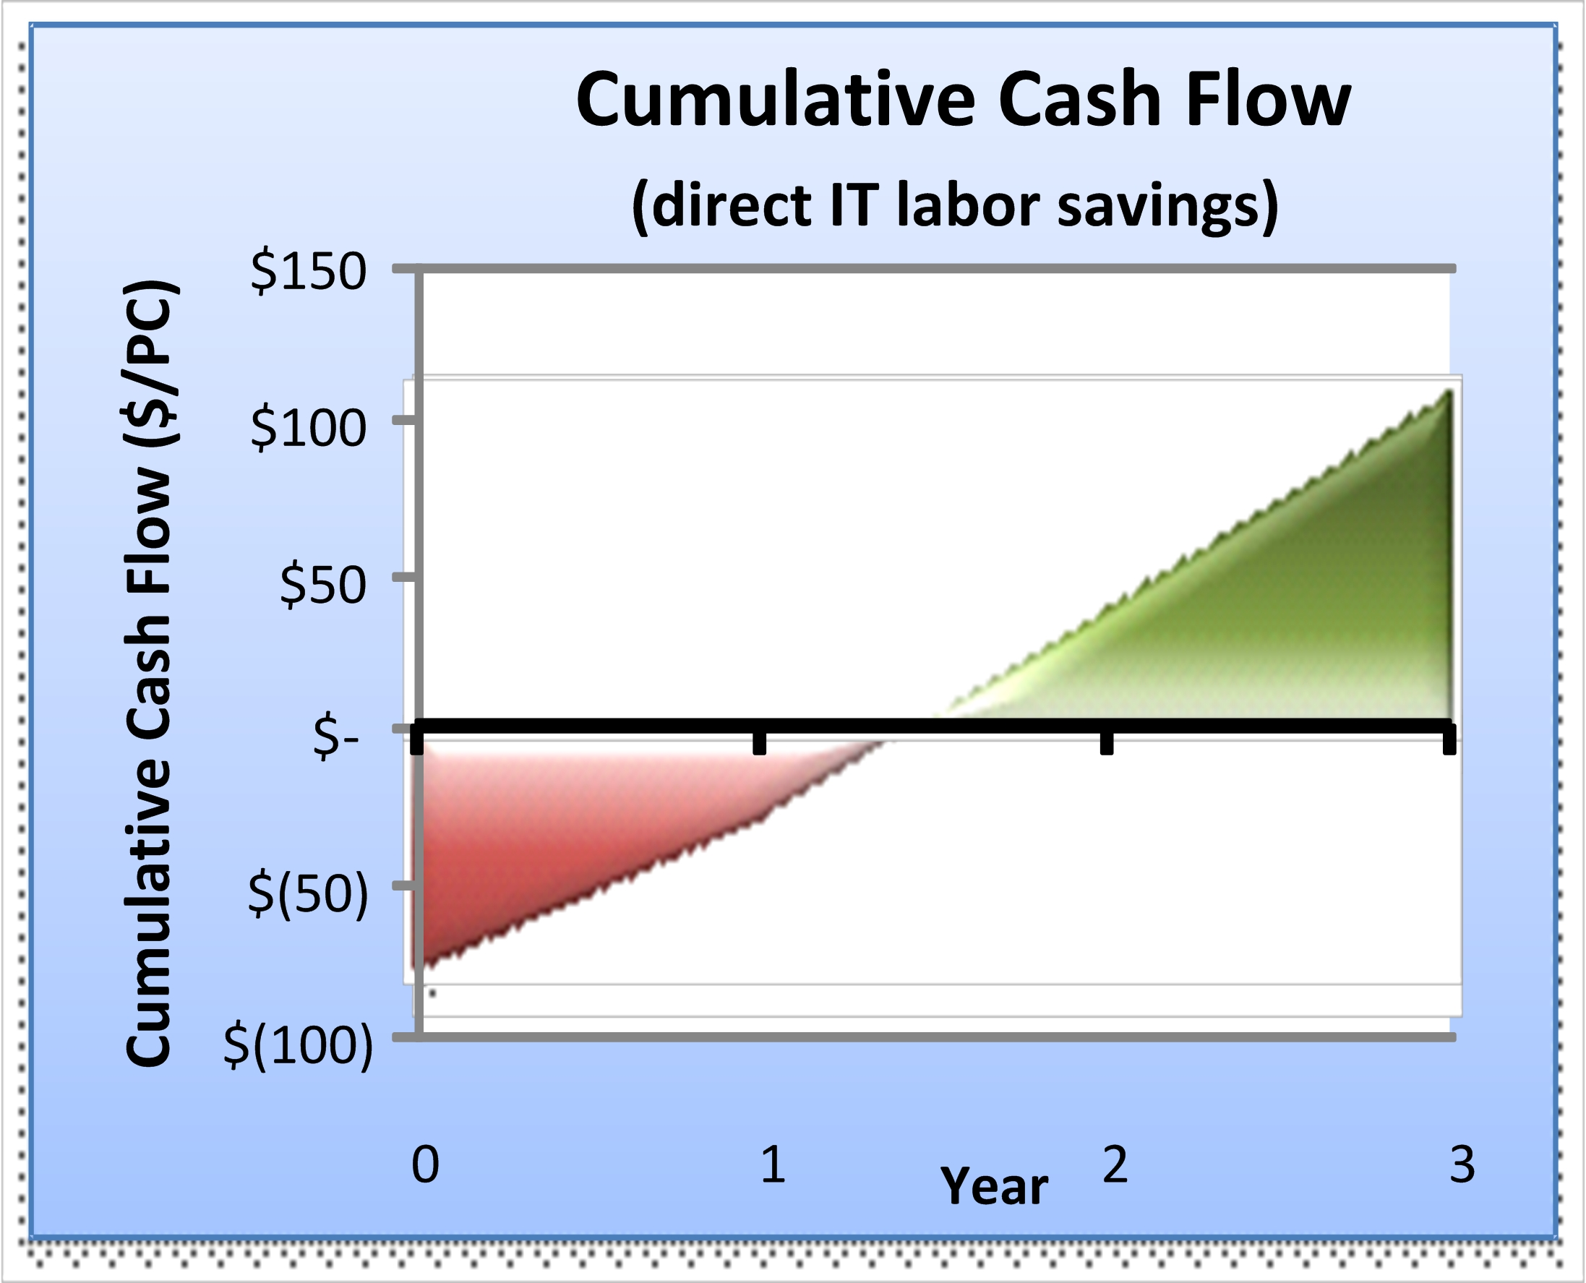
- Additional layers of defense. City IT staff noted that AppLocker, by enabling rules-based control over application installs, also serves as an additional layer of defense against malware.
Mendez adds, “The flexibility to create rules with GPO integration makes it a very attractive and straightforward tool to use”.

It is difficult to calculate the monetary value of enhanced security. It is clear, though, that extending greater security capabilities across a wider portion of the city’s IT environment without increasing cost, is exactly the kind of “do more with less” solution the City needs—and gets—with Windows 7.

Derrick Arias, City Assistant Director of Telecommunications, comments, “When the economy is difficult and budgets are tight, just maintaining IT services can be challenging. Our Windows 7 deployment provides more efficient IT services, more satisfied, productive PC users, and improved network security and performance—most everything we need to improve, not just maintain our services.”

New IT capabilities deliver business benefits. Windows 7 capabilities also enable the IT staff to provide new and more efficient services, which help reduce rather than add to the IT budget.
- Seamless enablement of remote and mobile users. City of Miami PC users include mobile and remote PC users, many of whom work at sites with low-bandwidth connectivity. New Windows 7 capabilities not only help the city IT staff meet the diverse needs of those workers without increasing costs but might help avoid planned future costs as well.
- Seamless access to offline data. Windows 7 includes improvements which enable office, mobile, and remote workers to keep a local copy (offline cache) of centralized data and synchronize it smoothly. Windows 7 Folder Redirection and Offline Files seamlessly synchronizes files and folders for PC users throughout city facilities, ensuring that PC users have access to offline data without having to wait for the server every time they log on or off. Files are synchronized in the background, and synchronization parameters can be centrally managed through Group Policy. This approach minimizes network impact, eliminates user impact when data servers go down, and helps boost PC user efficiency. The city estimates that users can reduce the amount of time they spend configuring offline data by as much as approximately 30 percent.
- Faster access through local caching. BranchCache™, a new feature of Windows 7 and Windows Server 2008 R2, enables PC users to take advantage of locally cached data rather than going out across the network each time they need it. By using BranchCache, users can cache data on a local PC or server even over a low-bandwidth connection, where it is then seamlessly accessible to other users at that location. This approach, combined with the more efficient Server Message Block (SMB) protocol, can improve application response time and reduce Wide Area Network (WAN) traffic. In this way, BranchCache enables the IT staff to deliver better service to remote users and help the city forestall planned investments in network bandwidth to as many as 20 remote city locations. The city estimates it can avoid $36,000 in planned bandwidth costs per year.
IT Cost Savings
($ per PC per year)
Direct Benefits  (IT Labor) | Value US$
Deployment | $28
Service desk | $36
Desktop management | $25
TOTAL IT-LABOR BENEFITS | $89
Direct Benefits
(Non-Labor)
Power savings | $45
Branch office network bandwidth costs | $14
TOTAL NON-LABOR BENEFITS | $59
Total Savings per PC | $148

- Power savings drive compelling savings. Many City of Miami computers, including most desktop PCs and as many of a third of the laptops, are left powered-on 24x7. Windows 7 provides new power options, which can be centrally managed by Group Policy. Now, the IT staff can take a more proactive role in managing the electricity consumed by city PCs. The IT staff estimates that being able to use Group Policies to power-down machines—and still be able to wake them remotely for management tasks—will reduce power consumption by nearly 70 percent and directly drive bottom-line savings of more than $51 per desktop computer per year, and a blended average of more than $45 per computer in power.

Jim Osteen notes, “Deploying a Windows 7 workstation shows benefit to the bottom line, from day one. It costs us $30 to $40 of tech-time to upgrade a machine, and over the next year we’ll save more than that just through power management. That’s a strong justification for Windows 7 all by itself.”

Users spend 18 hours less per year tending their PCs and are now free to focus on productivity. Preliminary results from the City of Miami deployment program showed that Windows 7 helped city employees avoid time-consuming PC self-support and self-help tasks, access data more quickly and securely, and avoid delays caused by slow network performance. These and other Windows 7 capabilities enabled each PC user to save (on average) an estimated 18.3 hours per year maintaining his or her PC. In addition to spending less time doing IT-like related tasks, PC users use Windows 7 capabilities to work more effectively. Of particular note:

- Enhanced user interface. User Interface (UI) enhancements and performance improvements in Windows 7 help users seamlessly move between tasks. For example, improvements in the Windows Aero® desktop experience can significantly improve user productivity. In particular, the Windows Aero “peek” functionality provides preview thumbnails which help PC users view desktop contents more readily by displaying Windows Taskbar thumbnail images. Also, the Jump List enhancement to Taskbar functionality helps users rapidly jump to recently used files and tasks, decreasing time spent on routine tasks of file identification, access, and opening.
- Better tools for all. Due to budget constraints, only a small subset of city PC users currently have a third-party tool that enables them to capture images of selected areas or images on their PC screen. The Snipping Tool, built into Windows 7, delivers this capability to all users within the organization at no additional cost, providing new, needed functionality.
Indirect benefits such as user productivity improvements are often not considered a viable part of a business case for technology investments. However, even without quantifying the potential impacts on PC user productivity, it is clear that Windows 7 helps the City of Miami deliver better IT services to its users, without increasing IT costs.

Benefits
Results of the deployment program show that Windows 7 capabilities enable the city IT staff to support more efficient, security-enhanced, and lower-cost city services than previously and help PC users work more productively.

A business value analysis was conducted with the city for the three-year Windows 7 deployment project. Using only direct cost benefits, the results included a net present value (NPV) of $119 per PC, a return on investment (ROI) of 151 percent, and an internal rate of return (IRR) of 78 percent with a payback period of less than 15 months.

The cumulative cash flow chart shows the project’s estimated break-even point based only on direct IT labor savings.
When power savings are included the business case is even more compelling, with an estimated NPV of $250 per PC during a three-year cash-flow period and a payback period of less than nine months.

The business case for Windows 7 deployment was influenced by a number of factors, which reduced the city’s cost baseline.

First, the city had an existing Microsoft Enterprise Agreement with Software Assurance. Therefore, the city has no incremental costs for the operating system license. Second, the IT staff previously conducted application compatibility testing as part of their Windows Vista deployment, so only minimal testing was required to validate applications on Windows 7. Equally important, the city has found that all PC hardware purchased during the Windows Vista timeframe runs Windows 7 quite well, so the IT staff doesn’t need to perform in-place hardware upgrades.

Windows 7 Capabilities Reduce Direct IT Labor Costs by $89 per PC per Year
Windows 7 features and capabilities provide the city IT staff with direct cost savings.

- Deployment labor efficiencies. Capabilities delivered with Windows 7 and associated deployment tools enable the city IT staff to reduce deployment tasks by up to 50 percent, resulting in a direct savings of at least $28 per PC per year.
- Desktop management. Reducing manual effort involved in configuration management is estimated to reduce IT labor costs by an estimated $25 per PC per year.
- Service desk costs. By reducing the number and complexity of service desk calls and the need to travel to user locations, Windows 7 capabilities are expected to reduce IT support costs by $36 per PC per year.
Quantifiable Non-Labor Benefits Valued at $59 per PC Annually
Windows 7 capabilities also provided substantial non-labor benefits to the City of Miami IT staff and PC users.

- Branch office cost avoidance. By enabling the seamless caching of data at remote city facilities, BranchCache enables the IT staff to forestall planned network investments, resulting in a projected savings of more than $14 per PC per year.
- Power cost avoidance. The ability to centrally manage power consumption on city PCs will result in dramatic reduction in electricity bills and also tangibly support the city’s “green” initiatives. Power management Group Policies and lower power consumption as a result of using Windows 7 is expected to reduce power consumption by 70 percent, resulting in an average annual IT cost saving of $45 per PC per year.

Extended Security and Greater User Satisfaction
Windows 7 also provided other difficult to quantify benefits to city IT staff and PC users.
- Extend security without increasing cost. Security features built into Windows 7 means the IT staff can bolster the security for each PC user without incremental cost.
- Improved PC user satisfaction. The number of PC users who reported high levels of satisfaction with their PC environment increased by 15 percentage points due to Windows 7, and other related improvements. For example, faster access to information at branch offices, less restrictive security policies, and improved self-help capabilities made their desktop experience more efficient and less frustrating.

In addition to direct cost savings, Windows 7 is estimated to save approximately 18 hours per PC user per year by helping them access data more quickly and securely from any location, and avoid self-help tasks.

Providing more services with less cost has been the goal of the City of Miami’s IT department for a long time. Now, with new capabilities of Windows 7, this goal has become a reality.

Peter W. Korinis, City of Miami Chief Information Officer comments, “Our Windows 7 deployment could not have happened at a better time. Now, when every budget dollar counts, we can deliver higher levels of service at lower costs. Doing more with less is a compelling way to assure citizens that tax revenue is being spent wisely.”

Windows 7
For More Information
For more information about Microsoft products and services, call the Microsoft Sales Information Center at (800) 426-9400. In Canada, call the Microsoft Canada Information Centre at (877) 568-2495. Customers who are deaf or hard-of-hearing can reach Microsoft text telephone (TTY/TDD) services at (800) 892-5234 in the United States or (905) 568-9641 in Canada. Outside the 50 United States and Canada, please contact your local Microsoft subsidiary. To access information using the World Wide Web, go to:
www.microsoft.com

For more information about the City of Miami, visit the Web site at: www.miamigov.com/cms

This case study is for informational purposes only. MICROSOFT MAKES NO WARRANTIES, EXPRESS OR IMPLIED, IN THIS SUMMARY.

Document published September 2009

Software and Services
- Windows 7
- Microsoft Server Product Portfolio
- Windows Server 2008 R2
- System Center Configuration Manager 2007 R2

Works the Way you Want: Windows 7 will help your organization use information technology to gain a competitive advantage in today’s new world of work. Your people will be able to be more productive anyway. You will be able to support your mobile work force with better access to shared data and collaboration tools. And your IT staff will have better tools and technologies to enhance corporate IT security, data protection, and more efficient deployment and management.

For more information about Windows 7, go to:
www.microsoft.com/windows/windows-7

