Accessible Technology in Computing ⎯
Examining Awareness, Use, and
Future Potential

Study Commissioned by Microsoft Corporation and
Conducted by Forrester Research, Inc., in 2004

 |  | 

Forrester Oval program, Forrester Wave, WholeView, Technographics, TechStrategy, and TechRankings are trademarks of Forrester Research, Inc.
Forrester Research, Inc., 400 Technology Square, Cambridge, MA 02139 USA +1 617/613-6000 Fax: +1 617/613-5000
Amsterdam • Austin • Frankfurt • London • San Francisco • Sydney • Tokyo
www.forrester.com Email: forrester@forrester.com

Abstract
This report examines awareness and use of accessible technology today and identifies areas for potential growth and predictions about future use. The study surveyed individuals with a broad range of difficulties or impairments, including those who experience mild impairments or occasional difficulty performing daily tasks and those with severe difficulties/impairments who are typically considered the most likely users of accessible technology. The study's extensive approach to identifying potential users of accessible technology provides a deeper understanding of the complete market for accessible technology than previously available. Findings show that nearly three-quarters of people who experience some type of difficulty or impairment use computers today and more than two-thirds of them use some form of accessible technology. Computer users approach accessible technology quite differently than the IT industry presents accessible technology. Those who currently use accessible technology are most often motivated to use accessible technology because it makes their computer more comfortable and easier to use. Today’s use of accessible technology is influenced more by an individual's computer experience and confidence than by the presence or severity of difficulties or impairments. Users of accessible technology have often stumbled upon accessible technology in their quest to improve their computing experience.
If accessibility options and assistive technology products were presented as part of a computer's functionality rather than as aids for people with disabilities, more computer users would be able to find and use accessible technology. Making accessible technology easier to find and discover, and easier to use for all computer users, will benefit both the diverse set of computer users and the IT industry.

Contents
Overview 7

Executive Summary 9

Background 11
Identifying Who Is Likely and Very Likely to Benefit from the Use of Accessible Technology 11
Majority of Computer Users Likely to Benefit from the Use of Accessible Technology 12

Findings About the Use of Computers 13
Computer Use Rates Lower Across All Types of Mild or Severe Difficulties/Impairments 13
Computer Use Rates Lowest Among Individuals with Multiple or Severe Difficulties/Impairments 14
Computer Use Rates at Work, Home, and School Lower Among Individuals with Difficulties/Impairments 15

Factors that Influence the Use of Computers 18
Education and Household Income Influence the Use of Computers 18
Age Influences the Use of Computers 20

Findings About the Awareness and Use of Accessible Technology 22
Widespread Awareness and Modest Use of Accessible Technology 22
Accessibility Options and Utilities Awareness and Use 24
Assistive Technology Product Awareness and Use 25
Why Individuals Use Accessible Technology 27

Factors that Influence the Use of Accessible Technology 30
Computer Experience Influences the Use of Accessible Technology 30
Computer Confidence Influences the Use of Accessible Technology 33
Computer Experience and Confidence Are Independent Factors that Influence the
Use of Accessible Technology 34
How Individuals Learn About Accessible Technology 36
Purchase Considerations and Process When Selecting Assistive Technology Products 37

Opportunities and Forecast 41
Growth in the Accessible Technology Market 41
Expanding the Use Among Current Users of Accessible Technology 42
Expanding the Use of Accessible Technology to a Wider Audience of Computer Users 43
Increasing Number of Computer Users Likely to Benefit from the Use of Accessible Technology 44
Conclusion 45
Appendix A: Accessible Technology Studied 47
Appendix B: Methodology 49
Appendix C: Defining Who Is Likely to Benefit from the Use of Accessible Technology 53
Appendix D: Accessible Technology Awareness and Use amongst All Computer Users 55
Appendix E: About Forrester Research, Inc. 57

Overview
In early 2003, Microsoft Corporation commissioned Forrester Research, Inc., to conduct a comprehensive, two-part study (Phase I and Phase II) to measure the current and potential market of accessible technology in the United States and understand how accessible technology is being used today. This study focused on working-age adults (defined to be individuals who range from 18 to 64 years old) and computer users among them. Accessible technology enables individuals to adjust a computer to meet their visual, hearing, dexterity, cognitive, and speech needs. Types of accessible technology studied include both accessibility options built into products (such as options that change font size and color) and assistive technology products (specialty hardware and software products such as a screen reader or voice recognition product).

Phase I identified the wide range of working-age adults and computer users who are likely and very likely to benefit from the use of accessible technology due to having mild or severe difficulties/impairments.
It consisted of a survey that assessed a variety of difficulties and impairments and their degrees of severity to determine how they may affect an individual's use of computers. This study identified individuals with disabilities as well as a broader group of individuals who experience occasional or mild difficulties performing daily tasks. Individuals with severe difficulties/impairments represent the group traditionally considered as having disabilities and comprising the market for accessible technology.
The broader group of individuals with mild or occasional difficulties and impairments are not commonly identified in studies about disabilities but are likely to benefit from the use of accessible technology. Phase I involved a nationwide survey conducted by phone and mail in spring 2003 and completed by 15,477 participants, a sample selected to be representative of the US adult population. Results from Phase I are reported in The Wide Range of Abilities and Its Impact on Computer Use (January 2004)
at www.microsoft.com/enable/research/.

Phase II examined the use of computers and accessible technology among those who were identified in Phase I as being likely or very likely to benefit from accessible technology. It involved a follow-up survey with computer users who currently use accessible technology and with computer users who were identified in Phase I as being likely or very likely to benefit from the use of accessible technology due to experiencing mild or severe visual, dexterity, hearing, cognitive, and speech difficulties and impairments. The survey was conducted by phone and mail in fall 2003 and was completed by 3,428 computer users.
It included in-depth questions about the use of computers and the awareness and use of accessible technology.

This report summarizes findings from Phase I and presents new findings from Phase II about the use of computers among individuals with difficulties/impairments. It also discusses factors that influence the use of computers and accessible technology and includes data about the current awareness and use of accessible technology. This report concludes with a forecast of growth in the demand for accessible technology and an overview of the opportunities for the IT industry to make accessible technology easier to discover and use.

Executive Summary
This report provides a comprehensive look at computer use among individuals with mild or severe difficulties/impairments and the market for accessible technology—including the use of computers, awareness and use of accessible technology, and factors that influence the use of computers and accessible technology.

This study identified the wide range of individuals who can benefit from the use of accessible technology by examining both individuals who are traditionally considered as comprising the market for accessible technology (people with disabilities) and a broader category of individuals who experience slight or occasional difficulties and impairments (which are defined as “mild difficulties/impairments” in this report). Within this broader category, the majority of people across all ranges of difficulties/impairments use computers today and many of them use some form of accessible technology. This study provides a more complete understanding of the market for accessible technology and reveals that 57% of computer users are likely or very likely to benefit from the use of accessible technology due to experiencing a mild or severe difficulty/impairment.

Computer use is widespread among individuals with, and without, difficulties and impairments. However, the rate of computer use is lower among those with difficulties/impairments. Among individuals with mild or severe difficulties/impairments, 74% use computers compared with 84% of individuals without difficulties/impairments who use computers. Given the demographic factors that influence the use of computers, such as household income and education, it is clear that these factors contribute to lower rates of computer use among individuals across all types of difficulties/impairments just as they do in the general population. However, having a severe difficulty/impairment reduces computer use among people from all demographic backgrounds.

Most computer users (69%) with mild or severe difficulties/impairments are currently using some form of accessible technology, but many of these users could benefit from using additional accessibility options or assistive technology products. There are opportunities to expand the use of accessible technology among current users and increase use among the remaining 30% of computer users with mild or severe difficulties/impairments who are not yet using accessible technology. Furthermore, the rapidly aging population and the increasing use of computers in older generations will lead to growth in the population of computer users who are likely to benefit from accessible technology.

The two factors that primarily influence the use of accessible technology are an individual's level of computer experience and confidence using a computer. Although having a difficulty/impairment impacts whether a computer user is likely to benefit from the use of accessible technology, its use is ultimately determined by an individual's level of experience and confidence using computers. Computer users with more experience and confidence are more likely to use accessible technology and alternately, computer users with less experience and confidence are not as likely to use accessible technology.

The IT industry focuses on helping individuals with specific severe disabilities find the accessible technology they need to use computers. However, the majority of people who are currently using accessible technology, and those who are likely to use accessible technology in the future, do not use this technology because they do not consider themselves as having an impairment or disability but rather look for ways to make computing easier. There is an opportunity for the IT industry to realize growth in the accessible technology market and improve computers by making accessible technology easier to find and use by all computer users. Specifically, presenting accessibility options and assistive technology products as part of a computer's functionality rather than as an aid for people with disabilities will reach more computer users and will increase the reach of accessible technology.

Ultimately, today’s users of accessible technology find that accessible technology makes computers easier, more convenient, and more comfortable to use. Therefore, making accessible technology easier to discover and use will result in computers that are easier, more convenient, and more comfortable for computer users with diverse needs and backgrounds⎯resulting in growth in the accessible technology market that will benefit computer users and the IT industry alike.

Background
The following section provides background information about how the Phase I survey identified individuals as being likely or very likely to benefit from the use of accessible technology and reviews findings presented in the Phase I report, The Wide Range of Abilities and Its Impact on Computer Use (www.microsoft.com/enable/research).

Identifying Who Is Likely and Very Likely to Benefit from the Use of Accessible Technology
The Phase I study was designed to identify the range of individuals who are likely or very likely to benefit from the use of accessible technology. It consisted of survey questions that were written to identify individuals with disabilities or impairments as well as a broader group of individuals who experience occasional, intermittent, or mild difficulties performing daily tasks. Individuals with severe difficulties/impairments represent the group generally considered to comprise the market for accessible technology.

This study was able to measure and understand the current and potential use of accessible technology by studying the broader group of individuals. Specifically, the survey included questions to identify:
- Individuals who have difficulty with a variety of daily tasks. These questions had a gradient of answers (“None,” “Some,” or “Most of the time”) that allowed participants to be specific about the severity of difficulty with a daily task.
- Individuals who have a visual, dexterity, hearing, speech, or cognitive difficulty or impairment. These questions also had a gradient of answers that allowed participants to specify the severity of an impairment.
- Individuals who have a difficulty or impairment that impacts their employment.

Based on their responses, participants were placed into one of the following three groups according to the likelihood of benefiting from the use of accessible technology:
- Not likely to benefit from the use of accessible technology due to no (or very minimal) difficulties or impairments.
- Likely to benefit from the use of accessible technology due to experiencing mild difficulties or impairments.
- Very likely to benefit from the use of accessible technology due to experiencing severe difficulties or impairments.

Because participants were able to respond to questions using a gradient of answers, they were able to report experiencing mild and intermittent difficulties and impairments in addition to the more severe and long-term difficulties and impairments that are typically defined as "disabilities" in other studies. This approach enabled the study to identify a wider range of individuals with difficulties and impairments and more accurately measure and understand the current and potential accessible technology market than other studies have been able to do.

Majority of Computer Users Likely to Benefit from the Use of Accessible Technology
This study identified a larger potential market for accessible technology than other studies because it measured individuals with mild or severe difficulties/impairments and identified them as being likely to benefit from the use of accessible technology. Figure 1 shows that 57% (74.2 million) of computer users are likely or very likely to benefit from the use of accessible technology due to having mild or severe difficulties/impairments. Specifically:
- 40% (51.6 million) of computer users are likely to benefit from the use of accessible technology due to mild difficulties/impairments.
- 17% (22.6 million) of computer users are very likely to benefit from the use of accessible technology due to severe difficulties/impairments.

The remaining 43% (56.2 million) of computer users are not likely to benefit from the use of accessible technology because they have no difficulties/impairments.
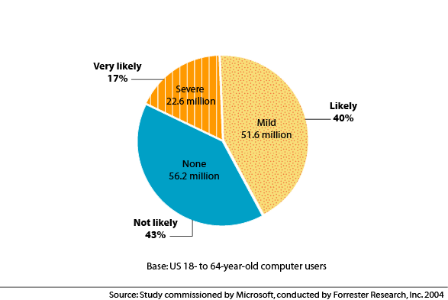
Figure 1: Majority of Computer Users Likely to Benefit from the Use of Accessible Technology
Note about multiple difficulties/impairments: Figure 1 shows the total number of computer users who have one or more type of difficulty/impairment. Many individuals have multiple types of difficulties/impairments. Specifically, 42% of computer users with difficulties/impairments have more than one type.
The following section provides details about the use of computers among individuals with mild or severe difficulties and impairments.

Findings About the Use of Computers
Most people with difficulties and impairments use computers today. However, despite the high rate of computer use, individuals with mild or severe difficulties/impairments are less likely to use computers than are individuals no difficulties/impairments. The following section discusses rates of computer use at home, work, and school among individuals with mild or severe difficulties/impairments and compares them with computer use rates among those no difficulties/impairments.

Computer Use Rates Lower Across All Types of Mild or Severe Difficulties/Impairments
Computer use is widespread, but individuals with mild or severe difficulties/impairments are less likely to use computers than are those without difficulties/impairments. Among working-age adults, a total of 78% use computers⎯68% use a computer at home and 45% use a computer at work. Computer use rates are lower among those with mild or severe difficulty/impairment, particularly among those with severe difficulties/impairments.

Figure 2 shows computer use rates among individuals with no, mild, or severe difficulties/impairments. Compared to those with no difficulties/impairments, computer use rates are slightly lower among working-age adults with mild difficulties/impairments. Computer use rates are much lower among working-age adults with severe difficulties/impairments. Specifically:
- 85% of working-age adults with no difficulties/impairments use computers.
- 80% of working-age adults with mild difficulties/impairments use computers.
- 63% of working-age adults with severe difficulties/impairment use computers.

Figure 2: Computer Use Rates Among Working-Age Adults with No, Mild, or Severe Difficulties/Impairments
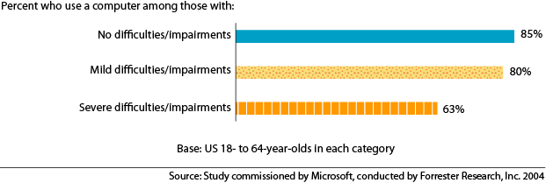
While the rate of computer use is slightly lower among individuals with mild impairments/difficulties, the decrease among those with severe difficulties/impairments is much greater, reflecting the more significant
barriers that these individuals face when trying to use computers. Moreover, lower rates of computer use among individuals with mild difficulties/impairments largely reflect differences in levels of education and income between those with no and mild impairments.

Compared with working-age adults with no difficulties/impairments, computer use rates are lower among working-age adults across all types of difficulties and impairments. Figure 3 shows computer use rates among the range of individuals with mild or severe visual, dexterity, hearing, cognitive, and speech difficulties and impairments.
Figure 3: Comparison of Rate of Computer Use by Type and Severity of Difficulty/Impairment

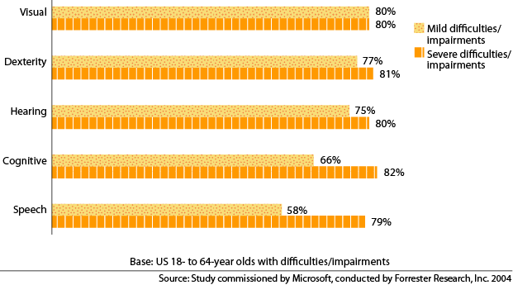
Computer Use Rates Lowest Among Individuals with Multiple or Severe Difficulties/Impairments
Working-age adults with severe difficulties are less likely to use computers than are working-age adults with mild difficulties/impairments. It is likely that this difference stems from the significant challenges working-age adults with severe difficulties/impairments face when trying to use computers. Those with more than one difficulty/impairment, particularly when one is severe, are even less likely to use computers than are individuals with only one type of mild difficulty/impairment. This relationship is important to
understand because a large percentage of individuals with difficulties/impairments have multiple types of difficulties/impairments. Specifically:
- 35% of individuals with mild difficulties/impairments have multiple types of difficulties/impairments.
- 63% of individuals with severe difficulties/impairments have multiple types of difficulties/impairments.
Figure 4 compares the rates of computer use among individuals with only one difficulty/impairment and those with multiple types. Computer use rates are lowest among individuals with multiple types of difficulties/impairments or severe difficulties/impairments. Specifically:
- 82% of working-age adults with one mild difficulty/impairment use computers.
- 70% of working-age adults with one severe difficulty/impairment use computers.
- 78% of working-age adults with multiple types of mild difficulties/impairments use computers.
- 59% of working-age adults with multiple types of severe difficulties/impairments use computers.

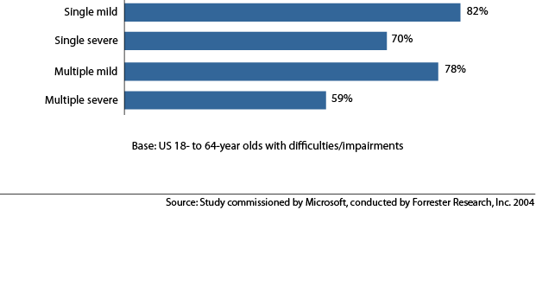
Figure 4: Comparison of Computer Use Rates Among Individuals with Single Versus Multiple
Mild or Severe Difficulties/Impairments

Computer Use Rates at Work, Home, and School Lower Among Individuals with Difficulties/Impairments
The relationship between using a computer and having a difficulty/impairment differs among the general population of working-age adults, employed working-age adults, and working-age students.

Figure 5 compares computer use rates of working-age adults with no, mild, and severe difficulties/impairments. Computer use is compared among: all working-age adults who use computers
at home; working-age students who use computer at school; and, employed working-age adults who use computers at work.

Figure 5: Comparison of Computer Use Rates Among Working-Age Adults with Mild or Severe Difficulties/Impairments at Home, Work, and School
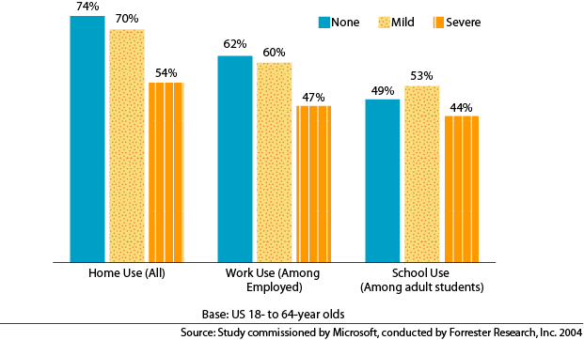
Figure 5 shows that working-age adults with severe difficulties/impairments are less likely to use computers at home, work, or school than are those with no or mild difficulties/impairments.

For computer use among all working-age adults at home:
- 74% of working-age adults with no difficulties/impairments use a computer at home.
- 70% of working-age adults with mild difficulties/impairments use a computer at home.
- 54% of working-age adults with severe difficulties/impairments use a computer at home.

For computer use among employed working-age adults at work:
- 62% of working-age adults with no difficulties/impairments use a computer at work.
- 60% of working-age adults with mild difficulties/impairments use a computer at work.
- 47% of working-age adults with severe difficulties/impairments use a computer at work.

For computer use among part-time or full-time adult students at school:
- 49% of working-age adult students with no difficulties/impairments use a computer at school.
- 53% of working-age adult students with mild difficulties/impairments use a computer at school.
- 44% of working-age adult students with severe difficulties/impairments who use a computer at school.

The biggest difference in computer use is noticed when examining computer use at home (among all working-age adults). Working-age adults with severe difficulties/impairments are far less likely to use computers at home than are those with no or mild difficulties/impairments. The differences in computer use by those with no, mild, or severe difficulties/impairments are not as distinct when examining computer use at work (among employed working-age adults) and at school (among adult students).

Employed working-age adults and adult students with severe difficulties/impairments are less likely to use computers at work and school. However, computer use is similar among those with mild and no difficulties/impairments at work (among employed working-age adults) and school (among working-age adult students). Indeed, among adult students, the likelihood of using computers at school is slightly higher among those with mild difficulties/impairments, which might reflect the uniqueness of adult students as a group or the success of adult educational institutions to increase access to all students.

Working-age adults who use a computer at work or school are more likely to use a computer at home as well; this is particularly true among individuals with mild or severe difficulties/impairments. Conversely, working-age adults who do not use a computer at work or school are less likely to use a computer at home.

Computer use rates among the different groups of working-age adults illustrate the extent of the "digital divide" for those with difficulties/impairments who are not employed or do not have access to a computer at work. Comparing the rates of computer use among working-age adults who do not use a computer at work shows that:
- Those with no difficulties/impairments are 25% less likely to use a computer at home than are working-age adults who use a computer at work.
- Those with mild difficulties/impairments are 33% less likely to use a computer at home than are working-age adults who use a computer at work.
- Those with severe difficulties/impairments are 46% less likely to use a computer at home than are working-age adults who use a computer at work.

This data shows the additional significance having a difficulty/impairment has on the use of computers among employed working-age adults.

Having a mild or severe difficulty/impairment is a factor that reduces computer use among working-age adults. The following findings examine additional factors that influence the use of computers, the current awareness and use of accessible technology, and factors that influence the use of accessible technology.

Factors that Influence the Use of Computers
Household income, education, employment status, age, gender, family size, and attitudes toward technology are all important determinants of computer use among working-age adults. The relationships between household income, education, and age and the use of computers among working-age adults are discussed in this section. These relationships are important to consider because they often indirectly contribute to lower rates of computer use among individuals with difficulties/impairments. For example, individuals with mild or severe difficulties/impairments have lower levels of education and household income on average than do those without difficulties/impairments. Therefore, it is important to consider the relationship between computer use and levels of education and household income in order to understand how difficulties/impairments influence computer use.

Education and Household Income Influence the Use of Computers
Working-age adults with lower levels of education and household income are less likely to use computers at both home and work than are those with higher levels of education and household income.

Figure 6 shows the relationship between household income and computer use among individuals with no, mild, and severe difficulties/impairments. Computer use rates are higher among individuals with higher levels of household income.

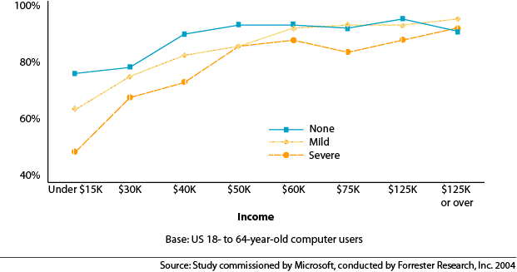
Figure 6: Computer Use Rates Increase with Household Income

The relationship between household income and the use of computers differs among those with no, mild, and severe difficulties/impairments. For individuals with no difficulties/impairments, computer use rates rise among individuals with household incomes below $40,000 and levels off with a little over 90% using computers for all incomes over $40,000. However, individuals with mild or severe difficulties/impairments face a steeper relationship between household income and computer use. For individuals with mild or severe difficulties/impairments with household incomes over $40,000, higher household incomes are still associated with higher rates of computer use. Those with the highest incomes are clearly most able to overcome barriers to using computers. Computer use by those with incomes over $125,000 is similar for those with and without impairments.

Figure 7 shows that working-age adults with higher levels of education are more likely to use computers. Those with mild difficulties/impairments are just as likely as those with no difficulties/impairments to use computers in each of the education categories. However, individuals with severe impairments/difficulties use computers less than those with either no or mild impairments/difficulties at each education level.

Figure 7: Computer Use Increases with Education
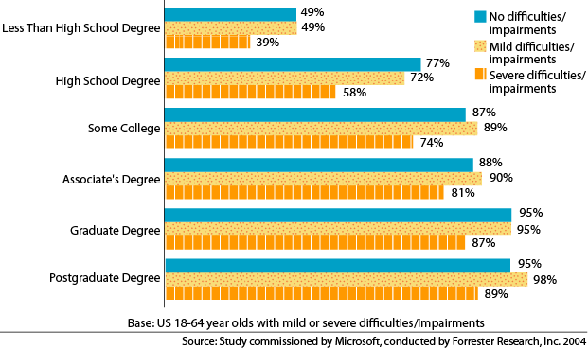
Figures 6 and 7 illustrate that computer use rates are lower among working-age adults with difficulties/impairments, particularly among those with severe difficulties/impairments. Reduced computer use rates among working-age adults with difficulties/impairments can partly be attributed to lower levels of education and household income. However, after education and household income are considered, computer use rates among working-age adults with mild difficulties/impairments are similar to rates of those with no difficulties/impairments. Yet computer use among working-age adults with severe difficulties/impairments is still 8% lower than computer use among those with no difficulties/impairments after income and education are taken into account.

Age Influences the Use of Computers
Because the US population is rapidly aging and the occurrence of difficulties and impairments increases with age, the relationships among age, having a difficulty/impairment, and computer use are important to consider.

Figure 8 shows the relationship between computer use and age for individuals with no, mild, and severe difficulties/impairments. This figure shows that computer use rates are highest for individuals age 18-25 and lowest for individuals over age 60 for both those with and without difficulties/impairments.

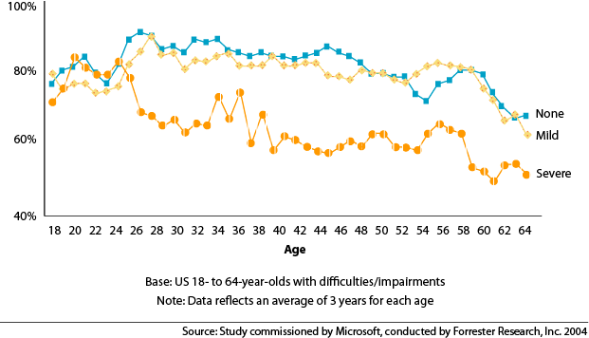
Figure 8: Computer Use by Age and Severity of Difficulties/Impairments

Individuals with no or mild difficulties/impairments show similar computers use patterns through various ages. However, the decline in computer use with age is most pronounced for individuals with severe difficulties/impairments. In the early to mid 20s, there is very little difference in computer use among those with no, mild, or severe difficulties/impairments. For those with no or mild difficulties/impairments, computer use is highest for those in their late 20s and early 30s. In contrast, individuals with severe difficulties/impairments have lower rates of computer use starting in the late 20s and in all older age groups.

There are many factors that influence the use of computers⎯household income, education, employment status, age, gender, family size, and attitudes toward technology⎯all have a significant impact.
The following section provides details about awareness and use of accessible technology, followed by factors that influence the use of accessible technology in particular. A computer user’s experiences and attitudes about technology are also important determinants of who uses accessible technology. Surprisingly, these experiences and attitudes are the primary determinants of who uses accessible technology.

Findings About the Awareness and Use of Accessible Technology
A primary goal of this study was to understand the current awareness and use of accessible technology among computer users. In this section, details about awareness and use of built-in accessibility options and utilities and assistive technology products are examined separately.

Accessible technology enables individuals to adjust a computer to meet their visual, hearing, dexterity, cognitive, and speech needs. The accessible technology examined in this study included accessibility options built into products (such as the option that changes font size and colors) and assistive technology products (specialty hardware and software products such as a screen reader or voice recognition product).

Widespread Awareness and Modest Use of Accessible Technology
Although most accessible technology was originally intended and designed for individuals with severe difficulties/impairments, accessible technology is widely used by computer users of all abilities today.

The majority of computer users (54%) are aware of some form of accessible technology but fewer are using it. Some form of accessible technology is used by 44% (or approximately 57 million) of computer users.
- 40% (approximately 52 million) computer users use built-in accessibility options/utilities.
- 17% (approximately 22 million) computer users use assistive technology products.

Note: The remainder of this report focuses on computer users with mild or severe difficulties/impairments. Appendix D provides data about awareness and use of accessible technology scaled to reflect percentages among all working-age computer users.

Most computer users who have mild or severe difficulties/impairments are aware of some form of accessible technology. Specifically:
- 95% of computer users with mild or severe difficulties/impairments are aware of accessible technology.
- 97% of computer users with mild difficulties/impairments are aware of accessible technology.
- 93% of computer users with severe difficulties/impairments are aware of accessible technology.

The rate of use of accessible technology is the same among computer users with mild or severe difficulties/impairments. Specifically:
- 69% of computer users with mild difficulties/impairments use some form of accessible technology.
- 69% of computer users with severe difficulties/impairments use some form of accessible technology.
Figure 9 provides additional data about the awareness and use of accessible technology among individuals with mild or severe visual, dexterity, hearing, cognitive, and speech difficulties/impairments.

Figure 9: Awareness and Use of All Accessible Technology Among Types of Difficulties
and Impairments

 | Awareness |  | Use
 | Mild | Severe | Mild | Severe
Any | 96% | 93% | 69% | 69%
Visual | 95% | 94% | 69% | 70%
Dexterity | 96% | 92% | 73% | 74%
Hearing | 95% | 87% | 70% | 64%
Cognitive | 91% | 90% | 67% | 71%
Speech | 95% | 87% | 68% | 56%
Base: US 18- to 64- year-old computer users with difficulties/impairments

Awareness is fairly uniform across all types of difficulties/impairments with the exception of cognitive difficulties/impairments for which awareness is slightly lower. Awareness is lower among computer users with severe hearing, speech, and cognitive difficulties/impairments compared to those with severe visual and dexterity difficulties/impairments.

Among types of mild difficulties/impairments, computer users with mild visual, dexterity, and hearing impairments/difficulties use accessible technology more than those with mild cognitive and speech impairments/difficulties, however the differences are minor. Among those with severe difficulties/impairments, the use of accessible technology is substantially lower among computer users with severe speech difficulties/impairments than among those with other severe difficulties/impairments.

While awareness and use of accessible technology is widespread, it differs greatly by type of accessibility option or assistive technology product. In the following sections, awareness and use of built-in accessibility options and utilities and assistive technology products are presented in detail.

Accessibility Options and Utilities Awareness and Use
The most commonly used forms of accessible technology are accessibility options and utilities that are built into most current operating systems. This section presents details about current awareness and use of these built-in features.

Awareness of Accessibility Options and Utilities
Awareness of accessibility options in general is quite high; however, variation exists among the specific options. Among computer users with mild or severe difficulties/impairments, 88% are aware of built-in accessibility options. Specifically:
- 77% are aware of display options.
- 64% are aware of mouse options.
- 65% are aware of keyboard options.
- 38% are aware of sound options.

Awareness of built-in accessibility utilities is notably lower. Among computer users with mild or severe difficulties/impairments, 38% are aware of built-in accessibility utilities. Specifically:
- 33% are aware of a built-in screen magnification utility in the operating system.
- 17% are aware of a built-in on-screen keyboard in the operating system.
- 17% are aware of a built-in screen reader in the operating system.

Use of Accessibility Options and Utilities
The use of accessibility options is also quite high and variation of use matches awareness. Among computer users with mild or severe difficulties/impairments, 71% report using built-in accessibility options. Specifically:
- 48% use display options.
- 32% use mouse options.
- 33% use keyboard options.
- 14% use sound options.

The use of built-in accessibility utilities is lower than that for accessibility options, which is expected given that awareness is notably lower. Among computer users with mild or severe difficulties/impairments, 14% report using built-in accessibility utilities. Specifically:
- 10% use a screen magnification utility that is built into their operating system.
- 2% use an on-screen keyboard that is built into their operating system.
- 2% use a screen reader that is built into their operating system.

Figure 10 shows awareness and use of built-in accessibility options and utilities among computer users with mild or severe difficulties/impairments. While awareness varies among types of built-in accessibility options and utilities, there is very little variation in either awareness or usage by form of difficulty/impairment. This is partially explained by looking at the reasons why individuals report using accessibility options and utilities, which is discussed in the next section.
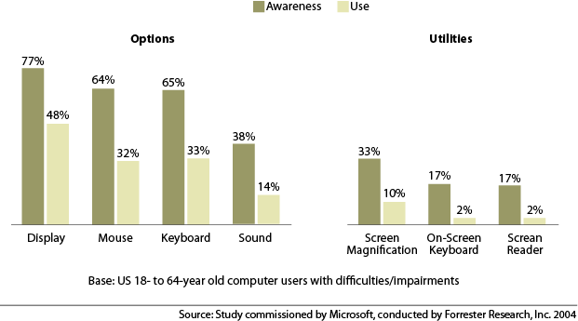
Figure 10: Awareness and Use of Built-in Accessibility Options/Utilities Among Computer Users with Mild or Severe Difficulties/Impairments

Assistive Technology Product Awareness and Use
This section provides data about the awareness and use of assistive technology products. Assistive technology products are specially designed hardware and software products that are chosen specifically to accommodate individuals with visual, dexterity, hearing, speech, and cognitive difficulties and impairments. Many individuals who need these products cannot effectively use a computer without their assistive technology product because of a difficulty or impairment.

Assistive technology products are not as commonly used as built-in accessibility options/utilities because they tend to fulfill the needs for a narrower group of people and require a separate purchase and installation.

Awareness of Assistive Technology Products
Awareness of assistive technology products is lower than awareness of built-in accessibility options and utilities and tremendous variation in awareness exists among the different categories of assistive technology products.

Among computer users with mild or severe difficulties/impairments, 80% are aware of assistive technology products. Assistive technology products with the highest awareness rates are:
- 64% are aware of touch screen/monitors.
- 56% are aware of voice recognition products.
- 46% are aware of trackballs.
- 36% are aware of screen magnifiers.

Additional data about the awareness of assistive technology products is provided below in Figure 11.
Assistive technology products that are more specialized and critical for individuals with particular difficulties/impairments but do not aid general computer users (such as a Braille embossers and refreshable Braille displays, which are only useful for those who can read Braille) have much lower awareness rates than products with a wider potential audience such as voice recognition software and alternative keyboards.

Use of Assistive Technology
Similar to awareness, assistive technology product usage is highest among products that are more widely used by the general population and lower among more specialty products designed for specific difficulties/impairments. Assistive technology products are not as commonly used as built-in accessibility options/utilities because assistive technology products require a separate purchase and installation.

Among computer users with mild or severe difficulties/impairments, a total of 22% report using assistive technology products. Computer users with severe difficulties/impairments often have a greater need for assistive technology products, especially for individuals with a severe difficulty/impairment such as those who are blind or do not have the use of their arms for which assistive technology is required. Therefore, it is logical to assume that assistive technology use is higher among individuals with severe difficulties/impairments than among those with mild difficulties/impairments. However:
- 21% of individuals with mild difficulties/impairments use assistive technology products.
- 24% of individuals with severe difficulties/impairments use assistive technology products.

Assistive technology use differs at home versus work. Specifically, of individuals with mild or severe difficulties/impairments:
- 16% use assistive technology products at home.
- 12% use assistive technology products at work.

Figure 11 also provides detailed data about the total use of assistive technology products as well as use at home and work. In most cases, the use of assistive technology products is slightly higher at home than at work.

Figure 11: Awareness and Use of Assistive Technology Products Among Computer Users with Mild or Severe Difficulties/Impairments
 | Awareness | Home Use | Work Use | Total Use
Alternative keyboards | 31% | 2% | 1% | 3%
Augmentative communication devices | 14% | <1% | <1% | 1%
Braille embosser/printer | 13% | <1% | <1% | <1%
Electronic pointing devices | 32% | 1% | 1% | 2%
On-screen keyboards | 21% | 2% | 1% | 2%
Reading tools | 17% | 1% | <1% | 1%
Refreshable Braille display | 8% | <1% | <1% | <1%
Screen magnifier | 36% | 4% | 3% | 5%
Screen readers | 16% | 1% | 1% | 1%
Sip-and-puff switches | 10% | <1% | <1% | <1%
Speech-training software | 16% | 1% | 1% | 1%
Talking word processor | 24% | 1% | 1% | 1%
Touch screen/monitor | 64% | 1% | 4% | 4%
Trackball | 46% | 7% | 4% | 9%
TTY/TTD modem | 24% | <1% | <1% | <1%
Voice recognition products | 56% | 3% | 1% | 4%
Word prediction programs | 11% | 1% | 1% | 2%
Base: US 18- to 64-year old computer users with mild or severe difficulties/impairments

Why Individuals Use Accessible Technology
It is commonly assumed that individuals choose to use accessible technology because they have a difficulty or impairment. However, this study challenges this assumption by asking individuals who use accessible technology why they use accessibility options/utilities or assistive technology products. This study reveals that computer users use accessible technology because it makes the computer easier, more convenient, and more comfortable to use. Reasons why individuals report using accessible technology are presented below.

Why Individuals Use Accessibility Options and Utilities
Computer users who reported using built-in accessibility options and utilities were asked why they chose to use these options/utilities. The main three reasons reported for using accessibility options/utilities are that it makes the computer easier, more convenient, and more comfortable to use.

Individuals with and without difficulties/impairments are turning to accessibility options/utilities to improve their overall computing experience. Among computer users who use built-in accessibility options and utilities:
- 32% have no difficulty/impairment.
- 68% have a mild or severe difficulty/impairment.
Figure 12 provides the reasons why computer users report using accessibility options among computer users with no, mild, or severe difficulties/impairments. The primary reason all types of individuals gave for using accessibility options/utilities is that they make the computer easier to use, followed by convenience and comfort.

Computer users who use accessibility options/utilities were asked directly if they use these accessibility options/utilities to avoid a health problem or because of an existing health or physical issue. While individuals with severe difficulties/impairments often need accessible technology in order to be able to use a computer, a health issue was rarely reported as the primary reason for choosing to use accessible technology. Health reasons play a larger role for those with mild or severe difficulties/impairments (as show in Figure 12), but more individuals choose to use accessibility options/utilities because they make the computer easier, more convenient, and more comfortable to use.

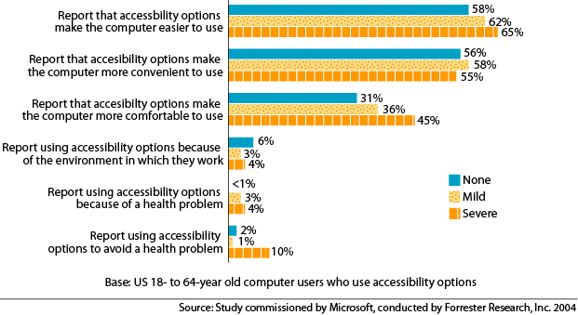
Figure 12: Reasons Computer Users Report for Using Accessibility Options

Why Individuals Use Assistive Technology Products
Reasons why computer users use assistive technology products were also studied. Assistive technology products differ from built-in accessibility options/utilities in that they are specialty products focused on meeting specific needs for individuals, often those with severe difficulties/impairments. These products are often essential for an individual with a severe difficulty/impairment to be able to effectively use a computer. Therefore, it is not surprising that health reasons are more frequently cited as reasons for using assistive technology products than for using built-in accessibility options/utilities.

However, individuals also choose to use assistive technology products for reasons other than health issues and many feel that these products enhance their computing experience. From trackballs to screen magnifiers, participants frequently reported that these products make computers “easier to use,” “more comfortable,” and “convenient.”

Figure 13 shows the reasons assistive technology users report for using assistive technology products.
Participants who use assistive technology were asked to report if their use of assistive technology was due to an ongoing health issue, a health issue they had recovered from, avoiding a health issue, or assisting someone in their household with an ongoing health issue. The majority, 65%, of assistive technology users did not report any of these health issues as reasons for using assistive technology products. The second most likely reason assistive technology users report using assistive technology products is to avoid a health issue.

Figure 13: Reasons Assistive Technology Users Report for Using Assistive Technology Products
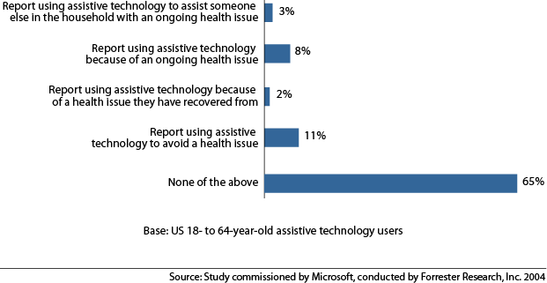
Furthermore, some individuals with a difficulty/impairment ameliorated by assistive technology products do not always associate the purchase and usage of their assistive technology product directly with their difficulty/impairment, but instead report that assistive technology products make it easier to use a computer. This study identified a trend among some participants with severe difficulties/impairments who discussed the use of their assistive technology products. For example, one participant with a severe dexterity difficulty/impairment commented that her voice recognition software allowed her “to not have to type” and another participant with a severe visual difficulty/impairment reported using a screen magnifier “to make it easier to see.” Neither participant reported using assistive technology products for health reasons when asked. In other words, someone with arthritis may be more likely to find that voice recognition software enhances their computing experience but does not directly associate the use of voice recognition software with the arthritis.

Factors that Influence the Use of Accessible Technology
The reasons why individuals use accessible technology (as discussed in the previous section) confirm that accessible technology is useful and beneficial to a wide range of computer users, with and without difficulties and impairments. The reasons that all types of computer users gave for using accessible technology are that it makes the computer easier to use, more convenient, and more comfortable to use. To further understand why some individuals use accessible technology and others do not, it is important to understand the factors that influence the use of accessible technology.

Computer experience and confidence using a computer are two key factors that influence the use of accessible technology, both of which are lower among individuals with difficulties/impairments who need accessible technology the most. The following section discusses computer experience and confidence and provides details about how computer users learn about accessible technology

Computer Experience Influences the Use of Accessible Technology
Participants were asked about their experience performing various computer tasks that ranged in difficulty (examples of tasks include installing new software and transferring files over a network) as well as their self-assessed experience rating. Responses to these questions were used to develop low, medium, and high computer experience levels. This computer experience level was then examined to see how an individual’s computer experience influences their use of accessible technology.

Computer experience plays an important role in determining whether an individual uses accessible technology. Among those with difficulties and impairments, computer users with higher computer experience are more likely to use accessible technology. Of computer users with mild or severe difficulties/impairments:
- 46% have a low level of computer experience and use accessible technology.
- 70% have a medium level of computer experience and use accessible technology.
- 88% have a high level of computer experience and use accessible technology.

Figure 14 presents two charts that compare computer experience among individuals with mild difficulties/impairments to that of computer users with severe difficulties/impairments. Computer users with severe difficulties/impairments have lower levels of computer experience on average than computer users with mild difficulties/impairments. Specifically:
- Of computer users with mild difficulties/impairments:
    - 25% have a low level of computer experience
    - 40% have a medium level of computer experience
    - 35% have a high level of computer experience
- Of computer users with severe difficulties/impairments:
    - 31% have a low level computer experience
    - 41% have a medium level computer experience
    - 28% have a high level computer experience
Figure 14: Computer Experience among Computer Users with Difficulties/Impairments

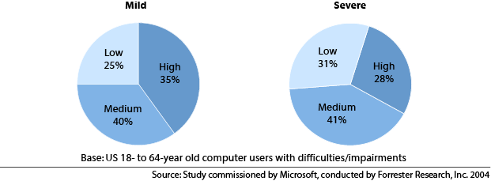
Figure 15 shows the influence of low, medium, and high levels of computer experience has on the rate of use of accessible technology among computer users with mild or severe difficulties/impairments. The use of accessible technology is higher among individuals with severe difficulties/impairments who have low or medium levels of computer experience than among individuals with mild difficulties/impairments who also have low or medium levels of computer experience. However, the use of accessible technology among those with mild difficulties/impairment and a high level of computer experience (89%) is slightly higher than among those with severe difficulties/impairments and a high level of computer experience (87%).

Figure 15: Computer Experience and the Use of Accessible Technology Among Computer Users with Difficulties/Impairments
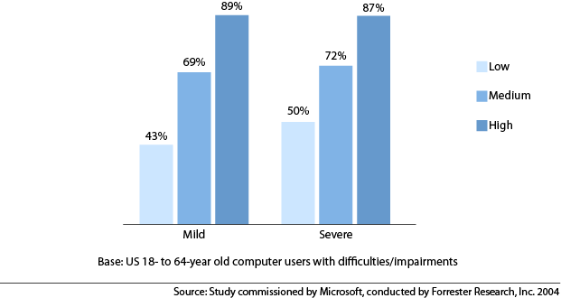
Individuals with mild difficulties/impairments are slightly more likely to use accessible technology than are those with severe difficulties/impairments. Low levels of computer experience dramatically reduce the use of accessible technology.

While individuals with severe difficulties/impairments are more likely to overcome a low level of computer experience in order to use accessible technology, they are also much more likely to have a low level of computer experience. This higher use of accessible technology among those with a low level of computer experience and severe difficulties/impairments most likely reflects the fact that the use of accessible technology is often essential for this segment of computer users to be able to use a computer.

Computer experience has a significant influence on whether an individual uses accessible technology. When comparing the use of accessible technology among computer users with low, medium, and high computer experience, the differences are much more significant than the differences in the use of accessible technology when comparing computer users with mild or severe difficulties/impairments.

Having higher level of computer experience appears to be a more important motivating factor for using accessible technology than does the existence or severity of the difficulties or impairments they are intended assist. This finding highlights how influential computer experience is in determining accessible technology use.

Computer Confidence Influences the Use of Accessible Technology
The second most important determinant for using accessible technology is an individual's level of confidence in using a computer. Computer confidence is determined by assessing respondents’ answers to a range of attitudinal questions about technology and questions about knowledge and understanding of computers and comfort level changing computer settings. Participants were classified as having low, medium, or high levels of computer confidence.

Figure 16 shows computer confidence levels for computer users with mild or severe difficulties/impairments. Specifically:
- Of computer users with mild difficulties/impairments:
    - 25% have a low level of computer confidence.
    - 37% have a medium level of computer confidence.
    - 38% have a high level of computer confidence.
- Of computer users with severe difficulties/impairments:
    - 29% have a low level of computer confidence.
    - 36% have a medium level of computer confidence.
    - 35% have a high level of computer confidence.

Figure 16: Computer Confidence Among Computer Users with Difficulties/Impairments

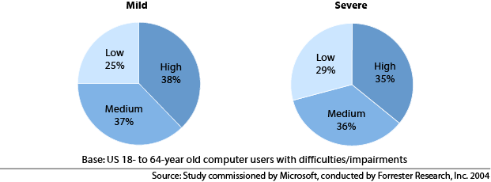
While the differences between computer confidence levels of computer users with mild difficulties/impairments and those with severe ones are not as large as they are for computer experience, computer users with severe difficulties/impairments are likely to have lower levels of computer confidence.

Figure 17 shows how higher levels of computer confidence increase the rate of use of accessible technology for computer users with mild or severe difficulties/impairments. Higher computer confidence levels are associated with higher rates of use of accessible technology.

Figure 17: Computer Confidence and the Use of Accessible Technology Among Computer Users with Difficulties/Impairments
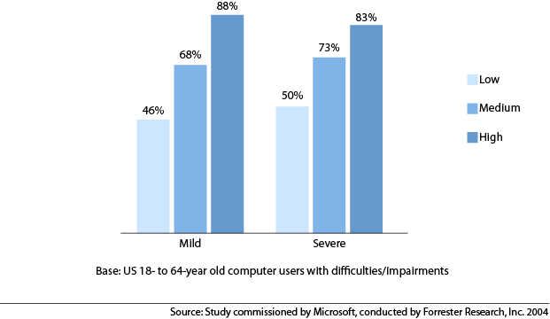

Computer Experience and Confidence Are Independent Factors that Influence the Use of Accessible Technology
Among all adults, attitudes toward technology influence computer use—those who are the most interested in technology, who think that technology is important, and who are less likely to be intimidated by technology are most likely to use computers. As technology has diffused throughout our society, individuals who are less comfortable or less optimistic about technology have had to overcome their hesitation and become computer users. However, when asked their views toward technology, these individuals continue to express their overall discomfort, lack of confidence when using computers, and pessimism toward technology.

In this study, many individuals reported a lack of confidence in using computers yet also reported a high level of computer experience. Computer experience and continued computer use often lead individuals to become more confident about using a computer, but this varies among each individual. Previous studies indicate that a person’s tolerance for risk, background, and comfort level all impact how confident they feel about using technology.

To further understand this dynamic, consider an individual who has used a computer for over 20 years and therefore has a high level of computer experience but is still not confident when changing their computer options and prefers to leave their computer as-is. This individual might feel very uncomfortable if someone else uses their computer and changes the fonts, for example, and will likely feel very apprehensive about changing their settings because of a concern of something going wrong with their computer. In contrast, an adolescent with little computer experience may be extremely confident making changes to computer settings due to having high levels of risk tolerance and self-confidence and feeling at ease with technology in general.

This dynamic between computer experience and computer confidence is important to examine because both computer experience and computer confidence independently influence the use of accessible technology. Figure 18 illustrates this dynamic by providing a table that shows the percent using accessible technology among nine different segments of computer users. The table shows that the percentage using accessible technology increases with high levels of confidence and experience⎯higher levels of computer experience or higher levels of computer confidence result in higher use of accessible technology whereas lower levels of computer experience or lower levels of computer confidence result in lower use of accessible technology.

Figure 18: High Levels of Computer Experience and Confidence Increase Use of
Accessible Technology
 |  | Percent of population* | Percent using  accessible technology
Low confidence/ | Low experience | 16% | 38%
Low confidence/ | Medium experience | 10% | 62%
Low confidence/ | High experience | 1% | 61%
Medium confidence/ | Low experience | 9% | 56%
Medium confidence/ | Medium experience | 20% | 69%
Medium confidence/ | High experience | 8% | 84%
High confidence/ | Low experience | 2% | 63%
High confidence/ | Medium experience | 11% | 81%
High confidence/ | High experience | 23% | 91%
*Base: US 18- to 64-year old computer users with mild or severe difficulties/impairments

However, levels of computer experience and computer confidence are lower among individuals with difficulties/impairments who need accessible technology the most. This presents a challenge for the industry because the individuals who need accessible technology the most are currently less likely to be able to use it.

Accessible technology is a relatively new technology and is lower on the adoption curve than is overall computer use, so it is not surprising that computer experience and confidence, which limited the use of computers a decade ago, are limiting accessible technology use today.

How Individuals Learn About Accessible Technology
Because computer experience and confidence are key influential factors for using accessible technology, it is important to understand how computer users learn about the accessible technology they use. Awareness of accessible technology does not indicate knowledge of how to find, purchase, install, or use accessible technology. In general, the use of accessible technology requires that an individual seek it out.

This section discusses how individuals learn about both accessibility options/utilities and assistive technology products and describes the purchase considerations and process for assistive technology products.

How Individuals Learn About Accessibility Options and Utilities
Participants in the study were asked to select the sources from which they learned about the accessible technology they use (and were allowed to select more than one source).

Among computer users who currently use built-in accessibility options and utilities, individuals report learning about accessibility options and utilities most frequently through:
- Discovering them on their own (58%)
- Documentation (40%)
- Friends and family members (38%)

More than half of computer users with difficulties/impairments report learning about accessibility options and utilities by discovering them on their own. Given how influential an individual’s computer experience and confidence are on the use of accessible technology, it is not surprising that a prevalent way individuals learn about accessible technology is through discovering it on their own.

Although the discoverability of accessibility options/utilities seems relatively high being that 58% of users of accessibility options discover it on their own, a significant gap exists between awareness and use of accessibility options/options among computer users with difficulties/impairments who most need this technology. For example, 79% of computer users with visual difficulties/impairments are aware of display options that would make their computer screen easier to see and read, but only 57% use display options. Even though computer users with mild and/or severe difficulties/impairments are likely to benefit from the use of these options, usage remains lower than awareness because computer users do not recognize that accessibility options/utilities will benefit them or they do not know how to find and/or use them.

How Individuals Learn About Assistive Technology Products
Computer users who use assistive technology products learn about these products from a wider variety of sources. Individuals learn about the assistive technology products they use most frequently through:
- Friends and family members (33%)
- Discovering them on their own (24%)
- Information online (16%)

These top three sources account for only 73% of the individuals who use assistive technology, unlike the top three sources for built-in accessibility options and utilities which amounts to 136%. Because survey respondents were able to select all of the ways in which they learn about assistive technology products, the lower total for the top three sources reflects both the diversity of ways in which people learn about assistive technology products and the fact that they tend to have less sources through which they learn about them. The other sources from which people learn about assistive technology include their employers, product documentation, a sales clerk at a computer store, or publications such as newsletters and magazines.

In general, the use of accessible technology⎯particularly accessibility options/utilities⎯depends far too greatly on an individual seeking it out or discovering it on their own, which is more likely among computer users with higher levels of computer experience and confidence.

Purchase Considerations and Process When Selecting Assistive Technology Products
Most computer users with difficulties/impairments (80%) are aware that assistive technology products are available; however, their awareness seems to stop with name recognition. Only 54% report they know where to buy assistive technology products.

A large segment of the target market for assistive technology products do not even know if these products will enhance their computing experience. When users of assistive technology products were asked if additional assistive technology products would enhance their computing experience, only 21% of computer users with severe difficulties/impairments and 17% of computer users with mild difficulties/impairments believe that additional assistive technology products could enhance their computing experience. Perhaps more striking is that many do not know if other assistive technology products would enhance their computing experience—35% of computer users with mild difficulties/impairments, and 39% of computers with severe difficulties/impairments, report they did not know if additional assistive technology products would enhance their computing experience.

Many assistive technology owners receive assistance from friends, family members, or their employer when deciding what to purchase and when setting up the product. Among assistive technology owners, more than half (51%) had a friend or family member purchase the product and 40% had a friend or family member install the product; 12% report their employer purchased the product and 14% said that their employer installed the product. This is consistent with the data reported previously that most individuals who use assistive technology products learn about them through friends, family members, or by discovering assistive technology products on their own.

Whether an individual purchases and installs an assistive technology product depends on how an individual learns about the products. Those who discovered the products on their own are more than twice as likely to have bought the products themselves (60% versus 30%) than those who do not discover the products on their own. Similarly, those who learned about the product through a friend or family member are nearly 3 times as likely to have had a family member or friend purchase the product for them. Among assistive technology owners, 42% who heard about the product through their employer had their employer purchase the product, compared with only 7% of those who discovered them on their own.

Assistive technology owners on average are satisfied with the products they own and do not report price as a concern. When asked to rate the price of assistive technology products on a scale from 1 to 5 with
1 meaning “Too inexpensive” and 5 meaning “Too expensive,” most participants rated price at a 3 or lower. However, price sensitivity is greater for those computer users who do not currently own assistive technology products. Among computer users with difficulties/impairments, 28% with mild difficulties/impairments and 32% with severe difficulties/impairments report there is an assistive technology product that they do not own now but would purchase if it became more affordable. Additionally, 17% of computer users with mild difficulties/impairments and 28% of computers with severe difficulties/impairments report they considered purchasing some assistive technology products but decided not to make the purchase because it was too expensive.

Opportunities and Forecast
The level of awareness of accessible technology is high, and 44% of computer users use some form of accessible technology today; however many of them are not using the full array of accessibility options/utilities or assistive technology products that would benefit them. Computer users do not recognize that accessible technology will benefit their computing experience and the use of accessible technology relies too much on computer users seeking it out.

The two primary factors that influence the use of accessible technology—computer experience and confidence—point to the need to make accessible technology easier to find and use. Computer users
with and without difficulties/impairments approach their computers with the same goals⎯to be able to comfortably, efficiently, and successfully use their computers. When faced with barriers, such as difficulty typing or seeing the screen, computer users look for solutions that make it easier to type or read the computer screen.

Making accessible technology easier to find and use will result in computers that are easier, more convenient, and more comfortable for computer users with diverse needs and preferences to use.
This will result in a growth in the accessible technology market.

This section presents three potential areas for growth in the accessible technology market and includes
a forecast of growth in the market for accessible technology from 2003 to 2010.

Growth in the Accessible Technology Market
Growth in the overall use of accessible technology is likely to come from three areas:
- Expanding use of accessible technology among current users of accessible technology (both accessibility options/utilities and assistive technology products).
- Expanding use of accessible technology to a wider audience of computer users.
- Increasing numbers of computer users likely to benefit from the use of accessible technology due to an increase in the general US population and an increase in computer use among individuals over the age of 65.

Figure 19 presents the total predicted growth in accessible technology users between 2003 and 2010. Currently, 57 million use some form of accessible technology. By 2010, the number of accessible technology users is expected to rise to 70 million.

However, for growth in the accessible technology market to be realized, considerable efforts need to be made to overcome the barriers currently faced by computer users who need accessible technology. Addressing these barriers will unlock the potential benefits of accessible technology to a wider audience of computer users. The three potential growth areas are discussed below.
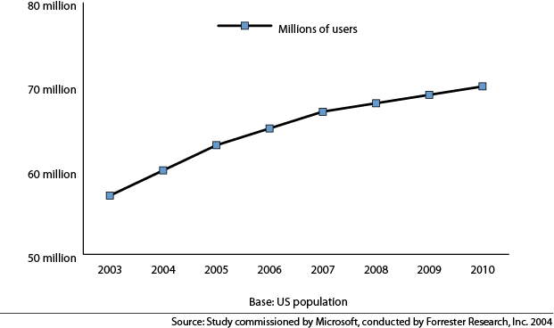
Figure 19: Predicted Growth in Number of Accessible Technology Users from 2003 to 2010

Expanding the Use Among Current Users of Accessible Technology
Many computer users who are using accessibility options/utilities are not using the full selection of accessibility options/utilities that would benefit them. Individuals often stumble across one option while missing others. While most of the expansion in use will come from built-in accessibility options/utilities, this group of users may also buy assistive technology products.

Expanding the Use of Accessibility Options/Utilities Among Current Users of Accessible Technology
Expanding the use of accessibility options/utilities will not result in growth in the number of people using accessible technology, but it has the potential to dramatically increase the number of people using each type of built-in accessibility options/utilities. Consider what would happen if half of the 57 million users (28.5 million) began using additional accessibility options/utilities. In this scenario, the market measured by product use would grow more than if the remaining 22 million computer users who have mild or severe difficulties/impairments who are not yet using accessible technology started using accessible technology.
Additionally, expanding use of accessibility options among current users could indirectly contribute to grassroots growth in the use of accessibility options/utilities because most people learn about accessibility options/utilities from friends or family. Expanding the amount and types of accessibility options/utilities a person uses increases the probability that they will influence someone else to start using accessible technology.

Expanding the Use of Assistive Technology Products Among Current Users of Accessible Technology
Most computer users who use assistive technology products also use accessibility options/utilities; therefore most of the growth in the number of people using accessible technology will occur for accessibility options/utilities. It is difficult to calculate growth in the assistive technology market in particular because growth in the use of accessibility options/utilities is much larger and masks any growth in the use of assistive technology products. However, while difficulty to measure, there are opportunities to expand use of assistive technology products among individuals with severe difficulties/impairments who are not using them yet as well as for some assistive technology products to be used by a wider audience.

Only 24% of computer users with severe difficulties/impairments currently use assistive technology products. Assistive technology products are often critical for many individuals, particularly for those with severe difficulties/impairments, to be able to use computers effectively. However, assistive technology products are under utilized. Individuals with severe difficulties/impairments need to be able to easily find an assistive technology product that will benefit them the most. A large number of users with severe difficulties/impairments (39%) do not even know that additional assistive technology products would enhance their computing experience. While assistive technology owners rely heavily on their friends and family when considering products, those who discovered their assistive technology products on their own are more than twice as likely to have bought the products themselves (60% versus 30%).

Many assistive technology users don’t perceive their difficulty/impairment as a reason for using these products but rather are looking for solutions to make their computer easier and more comfortable to use. Potential users of assistive technology products are searching for products that will enhance their computing experience and functionality⎯products that will make it easier to type, use a mouse, or see the screen, for example. These potential users of assistive technology products are likely to overlook many products with these functions because the industry often markets these products toward people with disabilities and highlights the disability the products is designed to assist, rather than the functionality of the product.

There is also a potential for some assistive technology products (such as voice recognition software, screen magnifiers, and trackballs) to reach a wider audience beyond those with difficulties/impairments.
If more computer users were made aware of the benefits assistive technology products offer and if assistive technology products were easier to find, these products could reach a larger market. However, very specialized products such as refreshable Braille displays and screen readers (for computer users who are blind) or sip-and-puff switches (for computer users with paralysis) are not likely to reach a wider audience. The following section discusses more about expanding the use of all forms of accessible technology to a wider audience of computer users.

Expanding the Use of Accessible Technology to a Wider Audience of Computer Users
Currently, only 44% (57million) of computer users use accessible technology even though a wider audience of computer users can benefit from using accessible technology. Unfortunately, most computer users without difficulties/impairments do not yet recognize that accessible technology can be beneficial
to their computing experience and are not likely to look for options and products that are categorized as products for people with disabilities. Accessibility options/utilities are often associated with and labeled
for people with disabilities. Furthermore, lack of computer experience and confidence prevent many individuals from using accessible technology. These issues need to be addressed by the IT industry
in order for the use of accessibility options/utilities to expand to a wider audience.

Specifically, built-in accessibility options/utilities need better labeling and placement in the product so they are not overlooked by the wide audience of computer users (57%) who are likely benefit from using them. Built-in accessibility options/utilities today rely on individuals identifying their impairment and seeking a solution for that impairment. Because most people with mild, occasional, and intermittent difficulties and impairments⎯and even many with severe difficulties and impairment⎯do not self-identify as having an impairment, many people who will likely benefit from accessible technology may not click on an option that calls out an impairment.

Increasing Number of Computer Users Likely to Benefit from the Use of Accessible Technology
The total number of computer users who are likely or very likely to benefit from the use of accessible technology will increase over the next few years due to an increase in the US population and an increase in computer use among individuals over the age of 65.

The US population is both expanding and changing its demographic profile⎯both of which will contribute to an increase in the total number of people using accessible technology. The population is expected to grow 1.1% per year over the next 6 years. Population dynamics are also changing over this time period, resulting in more people over the age of 65 relative to those under 65. In addition, computer use among people over the age of 65 will increase. This is noteworthy because a large percentage of people over the age of 65 have difficulties/impairments that make them likely to benefit from the use of accessible technology.

Many individuals over the age of 65 today did not begin to use computers during their working-age years and many of those who were exposed to computers at work did not see the personal benefit of using a computer at home until recently. In contrast, the majority of individuals under age 65 use computers at home and rely on them for day-to-day tasks. People who range from 55 to 64 years old today currently use computers in the workplace at a higher rate than people in their 60s and 70s did at earlier ages. They will continue to rely on computers as they age. People who currently range from 55 to 64 years old will continue to use computers in their 60s and 70s, and at the same time will develop new difficulties/impairments as part of the natural aging process. In 10 years, 2.5 times more adults who range from 65 to 74 will be using computers as there are today. This is a new trend for this generation. As Baby Boomers enter retirement, they will continue to use computers actively and will demand that the technology work around the difficulties/impairments that they will experience as they age. The growth in computer use by this demographic will play a particularly pivotal role in extending the reach of accessible technology.

Conclusion
Accessible technology has the potential to improve computer use for a wider audience because it makes computers easier to use. Targeting a wider market for accessible technology will benefit computer users and is critical to expanding the use of accessible technology. A key component of encouraging the use of accessible technology is to make it easier to find and highlight the functionality and benefits rather than the impairments they seek to ameliorate.

Making accessible technology easier to find and use is also essential to helping individuals with low levels of computer experience or confidence overcome these barriers. Currently, the use of accessible technology is concentrated among those with high levels of computer experience and confidence. Accessible technology must be made easier to find and use so that computer users with lower levels of computer experience and confidence will be encouraged to use it.

Computer experience and confidence will continue to spread naturally through the population as technology becomes further integrated into people’s lives, but the IT industry can speed the process along by helping individuals recognize the ways in which accessible technology—both built-in accessibility options/utilities and assistive technology products—can enhance their computing experience.

Making accessible technology both easier to find and use is an opportunity for the IT industry to benefit and reach a wider audience and realize growth in the use of accessible technology.

Appendix A: Accessible Technology Studied
The following provides detailed information about the forms of accessible technology studied in this research.

Accessibility Options and Utilities Studied
Many newer operating systems have built-in accessibility options and utilities provided for computer users. Accessibility options allow computer users to adjust and customize their computers for their vision, dexterity, hearing, speech, and cognitive needs and preferences. Accessibility utilities provide basic access to the computer for individuals with more severe difficulties and impairments. Accessibility utilities built into operating systems are not full-featured assistive technology products (which are discussed in the next section). These utilities provide basic access for individuals to set-up their computer and install a full-featured assistive technology product or provide an individual with temporary use of a computer other than their own.

In this study, the following built-in accessibility options and utilities were studied:
- Keyboard options
- Mouse options
- Sound options
- Display options
- On-screen keyboard utilities
- Screen magnification utilities
- Screen reader utilities

Assistive Technology Studied
Assistive technology products are specially designed hardware and software products that are chosen specifically to accommodate those with visual, dexterity, hearing, speech, and cognitive difficulties and impairments.

Many individuals who need these products can not effectively use a computer without their assistive technology product because of a difficulty/impairment. However, individuals with no difficulties/impairments may also choose to use assistive technology products as an alternative to traditional computing, such as those who want to use voice recognition products or touch screen monitors.

In this study, the following assistive technology products were studied:
- Alternative keyboards
(for example, keyboards for use with one hand, alternative key configurations)
- Augmentative communication aids
(for example, software that speaks text aloud for someone through their computer)
- Augmentative communication devices
(for example, a hand-held device that speaks aloud for someone who has difficulty speaking or being understood by others)
- Braille embosser/printer
- Electronic pointing devices
(such as those used to control the cursor on the screen using ultrasound, an infrared beam, eye movements, nerve signals, or brain waves)
- On-screen keyboard programs
- Refreshable Braille displays
- Reading tools for learning disabilities programs
(such as text highlighting and text tracking)
- Screen magnifiers
- Screen readers
- Sip-and-puff switches
- Speech training software
- Talking word processors
- Touch screens or monitors
- Trackball
- TTY/TDD modems
- Voice recognition products
- Word prediction programs

Appendix B: Methodology

Phase I
Forrester conducted a nationwide survey from May to July 2003 to assess the incidence rates and
the degree of severity of difficulties and impairments among US working-age adults and computer users. The survey was conducted by phone and mail, yielding a total of 15,477 respondents. Respondents were asked a range of questions about difficulties, impairments, computer use, and attitudes toward technology. Resulting data is representative of the adult US population. Forrester created an initial survey, in conjunction with Microsoft’s team, to be fielded to a representative selection of households within the US to assess incidence rates and the degree of severity for several difficulty/impairment types. The following types of difficulty/impairment were studied: visual, dexterity, hearing, speech, and cognition.

Survey questions
The survey was designed to identify individuals who self-identify as having a difficulty or impairment, as well as those who do not consider themselves to have an impairment but do report difficulty with tasks.
To measure a range of potential demand for accessible technology, a three-pronged approach was used to ask questions to identify those most likely to benefit from accessible technology.

The survey included the following three types of questions:

- Task-based questions: Designed to understand difficulty with ordinary daily tasks in each of the difficulty/impairment types. The types of questions asked include: “Please indicate how often, if ever, you have difficulty seeing the words and letters in ordinary newspaper print because of your eyesight. If you usually wear glasses or contacts, please indicate whether you have difficulty while wearing glasses or contacts,” and “Please indicate how often, if ever, you have difficulty using a keypad on a phone/dialing the phone because of physical difficulties with your arms, hands, wrists or fingers.”
- Direct questions about impairments: Designed to assess the proportion of the population who believe that they have an impairment. Individuals were also asked to assess the degree of severity of their impairment. The purpose of asking them for their own assessment was to understand the role of self-identification in seeking out solutions to difficulties with computer tasks. These questions were more direct, for example: “Do you have a visual impairment?”
- Direct questions about impact on employment: Designed to allow individuals to communicate their assessment of the limitations imposed by their impairment. For example, people who identified themselves as having a visual difficulty/impairment were asked directly: “Do you have a visual impairment that limits the kind or amount of work you can do?”

In addition to a rigorous assessment of respondents’ ability within a difficulty/impairment type, the survey assessed overall computer usage; technology, health, and life attitudes; employment; accessible technology use; and a range of demographic characteristics.

Sample size
A target sample size of over 15,000 completed responses ensured that the study would capture a large sample of computer users with various impairments. Additionally, this ensured that some low-incidence difficulty/impairment types (such as severe hearing impairment) would be sufficiently represented.

Phone and mail surveys
Respondents were contacted by either mail or phone from May to July 2003; 10,464 respondents are members of the mail panel managed by National Family Opinion (NFO); the remaining 5,013 respondents were contacted by phone through random digital dial (RDD).

Fielding the surveys by phone and mail allowed the research team to take advantage of the benefits of each method, accurately capturing a representative sample of the US population while minimizing bias against specific difficulties/impairments that would have challenged answering phone or mail surveys alone. The benefits of the mail survey include that it was more accessible for people with hearing difficulties and impairments and that the panelists know the source of the questionnaire, making them feel more secure revealing private information. Additionally, the mail survey was supplemented with rich background data on panelists (this background data also allows consistency checks on answers like income, age, and gender). The benefits of the phone survey include that the RDD method is more likely to include less traditional household structures, it is more accessible for people with visual difficulties/impairments, and the survey is guided by an interviewer, which reduces errors in the answers.

Weighting the data
Forrester Research uses weights to ensure that the final group of survey respondents gathered through each method is representative of the general US population. Mail surveys were sent to a representative group of households, but the final data was weighted due to differing response rates. Similarly, phone surveying, while providing a random selection of households, creates a self-selected bias in the sample that requires weighting to correct. Weights were created by identifying target characteristics of US households from the June 2003 Current Population Statistics. Sampling was done at the household level, so the weights are designed to ensure that the data is representative of US households and the individuals within them, rather than all individuals.

Although phone-based and mail-based data was weighted along similar grounds and attributes, weights were developed separately to ensure representation across both groups. Each survey was weighted so that, when combined, it represented 50% of respondents. While the mail survey actually captured twice as many respondents as the phone survey, mail survey respondents were more likely to identify limitations/disabilities in many cases. As such, the decision to weight them equally provided more conservative estimates of difficulty/impairment rates.

Phase II
Phase II, conducted in the fall of 2003, involved a follow-up survey sent to a sample of computer users who currently use accessible technology as well as computer users with mild or severe difficulties/impairments who were identified in Phase I as likely or very likely to benefit from the use of accessible technology due to mild or severe visual, dexterity, hearing, cognitive, and speech difficulties and impairments.

Survey questions
The Phase II survey asked participants a wide variety of questions about their current computer and Internet use as well as their own awareness and use of computers and accessible technology, computer comfort level, computer knowledge, computer experience completing eight different computer tasks, attitudes about accessible technology, and demographic questions.

The survey contained the following questions in the following categories:

- General computer use at home and work: These questions asked people about ownership and use of computers including the number of hours using computers per day, years of using computers, and number and type of computers used. Participants were asked to identify from the following list which operating systems they use: Macintosh OS X or higher; Macintosh OS 8.0, 8.1, 8.5, 8.6, 9.0, or 9.1; Macintosh OS 7.X or lower; Windows XP; Windows 2000/NT/ME; Windows 95/98 or earlier; Unix; Linux/Lindows; Other (write-in) or Don’t Know.
- Accessibility options awareness and use: These questions asked specifically about built-in accessibility options and utilities including display, mouse, keyboard, sound options as well as built-in screen magnification utilities, on-screen keyboards, and screen readers included in the operating system. See Appendix A for a complete list.
- Assistive Technology awareness and use: These questions asked about specialty hardware and software products. See Appendix A for a complete list.
- Demographic and household questions: The survey assessed health and life attitudes, employment status, the use of accessible technology, and a range of demographic characteristics.

Sample selection and size: The Phase II survey involved re-contacting a random sample of computer users identified in Phase I who experience mild or severe difficulties/impairments. Phase II survey was conducted by phone and mail from October through November 2003 and was completed by 3,428 qualified computer users (2,555 by mail and 873 by phone). (Note: The survey was completed by a total of 4,072 respondents but only 3,428 qualified). Respondents were asked a range of questions about computer use, accessible technology, and attitudes toward technology. Resulting data is representative of the adult US population.

General Information
US focus. Both Phase I and Phase II surveys had a US focus. Difficulties/impairments identified will likely affect people similarly in other countries and our findings will be noteworthy outside of the United States. As such, Microsoft made the decision to focus the survey in the US because of the extremely high cost of a multi-country survey and because the surveys could not be easily translated to other languages and cultures. This study could be leveraged by other countries but the survey questions would need to be reconsidered to field the survey outside of the US, rather than directly translated into other languages, because of the sensitive nature of the research topic. Forrester Research believes that the survey design, and to some extent the research methodology, would need to be customized for each country. A key benefit of a US-only study is that the lessons from this experience can help ensure better execution of non-US versions, if Microsoft decides to invest in research on this topic in other countries.

Accuracy of results
For results based on a randomly chosen sample of this size (N=15,477), there is 95% confidence that the results have a statistical precision of plus or minus 1% of what they would be if the entire adult population of US households had been polled. The phone survey is randomly sampled, but the mail sample is not a random sample; while individuals have been randomly sampled from NFO’s panel for this survey, they have previously chosen to take part in the NFO mail panel.

Appendix C: Defining Who Is Likely to Benefit from the Use of Accessible Technology
Note: The following is excerpted from The Wide Range of Abilities and Its Impact on Computer Use, www.microsoft.com/enable/research/.

Based on answers to the survey questions in the first survey, survey respondents were placed into one of the following three groups according to the likelihood of benefiting from the use of accessible technology:

Not likely to benefit from the use of accessible technology due to no (or very minimal) difficulties or impairments.
This group includes:
- Individuals who had trouble performing two or fewer daily tasks in a difficulty/impairment type only some of the time or who never had trouble with any assessed task.
- Individuals who did not self-identify as having any type of impairment or report having a difficulty or impairment that impacts employment.
Likely to benefit from the use of accessible technology due to mild difficulties or impairments.
This group includes:
- Individuals who self-identified as having a difficulty/impairment that did not limit their employment and daily life.
- Individuals who reported difficulty with more than one daily task within a particular difficulty/impairment type some or most of the time.
Examples of mild difficulties and impairments include being slightly hard of hearing or having difficulty hearing conversation some, but not most, of the time and experiencing pain in hands, arms, or wrists that limits activities some, but not most, of the time. These individuals are likely to benefit from the ability to customize accessibility options built into software such as increasing font size, turning up volume on computers, and using keyboard shortcuts instead of a mouse.
Very likely to benefit from the use of accessible technology due to severe difficulties or impairments.
This group includes:
- Individuals who reported having an impairment that limits employment.
- Individuals who reported difficulty with all of the tasks within a difficulty/impairment type some of the time and report having an impairment.
- Individuals who reported difficulty with most of the tasks within a difficulty/impairment type most of the time.
Examples of severe difficulties and impairments include being blind or deaf, experiencing pain in the hands, arms, or wrists that limits activities most of the time, and having non-correctable visual problems that cause difficulty performing many visual-related tasks. These individuals are likely to benefit both from using the accessibility options built into software (as described above) as well as specialty assistive technology software and hardware designed for specific difficulties and impairments (such as screen readers and voice recognition software).

Appendix D: Accessible Technology Awareness and Use amongst All Computer Users
This report focuses on presenting data about awareness and use of accessible technology among the 74.2 million working-age computer users (those age 18 to 64 years old) in the US with mild or severe difficulties/impairments. This appendix provides data about awareness and use of accessible technology scaled to reflect percentages among all (130.4 million) working-age computer users (those age 18 to 64 years old) in the US. The table below compares awareness and usage rates of specific types of accessible technology among all computer users to those among computer users with mild or severe difficulties and impairments.

 | All working-age  computer users | Computer users with mild or severe difficulties/impairments
Total awareness and use of accessible technology | 54% are aware of accessible technology.  44% use some form of accessible technology. | 95% are aware of accessible technology.  69% use some form of accessible technology.
Awareness of built-in  accessibility options | 50% are aware of built-in accessibility options.  Awareness of specific option types:  43% - Display options  37% - Keyboard options  36% - Mouse options  21% - Sound options | 88% are aware of built-in accessibility options.  Awareness of specific option types:  77% - Display options  65% - Keyboard options  64% - Mouse options  38% - Sound options
Use of built-in  accessibility options | 40% use built-in accessibility options.  Usage of specific option types:  27% - Display options  19% - Keyboard options  18% - Mouse options  7% - Sound options | 71% use built-in accessibility options.  Usage of specific option types:  48% - Display options  33% - Keyboard options  32% - Mouse options  14% - Sound options
Awareness of built-in accessibility utilities | 22% are aware of built-in accessibility utilities in the operating system.  Awareness by specific utility type:  19% - Screen magnification  10% - On-screen keyboard  10% - Screen reader | 38% are aware of built-in accessibility utilities in the operating system.  Awareness by specific utility type:  33% - Screen magnification  17% - On-screen keyboard  17% - Screen reader
Use of built-in  accessibility utilities | 8% use built-in accessibility utilities in the operating system.  Usage by specific utility type:  6% - Screen magnification  1% - On-screen keyboard  1% - Screen reader | 14% use built-in accessibility utilities in the operating system.  Usage by specific utility type:  10% - Screen magnification  2% - On-screen keyboard  2% - Screen reader
Base: US 18- to 64-year old computer users

Appendix E: About Forrester Research, Inc.
Forrester Research identifies and analyzes trends in technology and their impact on business. It provides companies with practical ideas, rigorous research, and objective guidance to help them thrive on technology change. In February 2003, Giga Information Group became a wholly owned subsidiary of Forrester Research, Inc. Giga provides objective research, pragmatic advice, and personalized consulting to global IT professionals. Together, Forrester and Giga enable companies to make better strategic decisions that maximize technology investments and achieve identifiable business results.

The Forrester Project Team
Forrester’s Custom Consumer Research team helps companies make strategic business decisions by providing analysis of consumer attitudes and behavior and helping to formulate market strategies. To gain a thorough understanding of consumers, the CCR designs, implements, and analyzes proprietary consumer surveys. Furthermore, the CCR may work with data proprietary to clients to provide the best possible assessment of current customer demand issues. In addition to data analysis and consumer research, senior research staff at Forrester combines the consumer analysis with relevant industry analysis. Senior research staff works together to find the best solution for clients’ business problems.

The Forrester project team included:

Betsey Stevenson, Ph.D. Custom Consumer Research Advisor, who was the lead researcher. Betsey leads Forrester’s Custom Consumer Research team, helping clients make strategic business decisions by designing, implementing, and analyzing proprietary consumer surveys. She has served as an analyst in Consumer Technographics®, covering a wide range of industries. Before coming to Forrester, Betsey taught and conducted research in economics at Harvard University. Her work there focused on statistical analysis of individuals to predict behavior in a wide range of consumer, health, and family areas. Betsey also taught courses in applied econometrics at Harvard University. Her writings have appeared in a variety of publications, including The Wall Street Journal. Prior to her work at Harvard, Betsey was part of the International Finance group of the Federal Reserve Board, analyzing the financial situation of developing countries and debt restructuring packages. Betsey graduated from Wellesley College and received an M.A. and Ph.D. in economics at Harvard University with an emphasis on econometric analysis and quantitative research design.

Jed Kolko, Ph.D. Vice President, who supervised the execution of the study. As the leader of Consumer Technographics® in North America, Jed directs a team of analysts and associates who track and analyze consumer use of technology products and services. His team conducts original research—surveying hundreds of thousands of households each year—on topics ranging from the spread of broadband to the adoption of wireless devices. This primary research is the largest and longest-running technology research effort in the world and provides Forrester and its clients with the most accurate view of emerging as well as established technologies. Prior to this position, Jed, was a principal analyst researching consumer devices, access, and services using Forrester’s Technographics® consumer surveys. He covers devices such as PCs and peripherals, consumer electronics, and telecom products; Internet access, including broadband and wireless; and social implications of new technologies. Prior to coming to Forrester, Jed consulted to public and nonprofit agencies on telecommunications policy and urban development, including the Citizens Budget Commission in New York and the Initiative for a Competitive Inner City in Boston. He worked at the World Bank and for the Progressive Policy Institute in Washington. He also taught economics courses at Harvard University. Jed holds a Ph.D. in economics and an A.B. summa cum laude from Harvard. His doctoral dissertation examined the impact of information technology on urban development. His research has been widely cited in the academic and popular press.

Findings presented in this report are for the United States only.
Throughout this report the terms working-age adults and computer users refers to those ages 18 to 64.
See Appendix A for details about the type of accessible technology studied.
See Appendix B and C for details about the methodology and definitions of mild or severe difficulties and impairments.
Data from Phase I and II was used to compare computer use among working-age adults with and without difficulties/impairments.
For more on the rate of computer use among working-age adults with difficulties and impairments, see Factors that Influence Computer Use.
For more information on aging trends, computer use, and difficulties/impairments, see The Wide Range of Abilities and Its Impact on Computer Technology (www.microsoft.com/enable/research/).
See Appendix A for details about the types of accessible technology studied.
See Appendix B for a list of the operating systems and versions studied.
This data was determined by the initial Phase I survey.
This section on Factors that Influence the Use of Accessible Technology is based on Phase II survey data.
Forrester Research’s 2003 Benchmark report shows the relationship between technology optimism and technology adoption. Technology optimists are more likely than technology pessimists to adopt most technologies; as adoption progresses, the percent of adopters who are pessimists increases.
Current Population Report: Projections of the Numbers of Households and Families in the United States: 1995-2010. (www.census.gov/prod/1/pop/p25-1129.pdf).
See The Wide Range of Abilities and Its Impact on Computer Technology (www.microsoft.com/enable/).
See Appendix B for a list of the operating systems and versions studied.
To ensure a conservative estimate, those who only reported some difficulty with one daily task in an impairment type were not included.

