11

Visual Studio Integration Program
In the previous few chapters, we’ve outlined various ways you can extend, customize and automate the VS.NET environment. Macros provide a powerful way to automate routine tasks. Add-ins gives you the power to interact with the environment from a compiled language, which gives you even more power to interact with VS.NET. There is one more way you can integrate your code into VS.NET, and it involves becoming a Visual Studio Integration Partner (VSIP). Once you become a VSIP licensee, you get the documentation and samples to integrate your code as a VS.NET Package. This chapter will give you an overview of what is possible once you have joined the VSIP program. Since you need a VSIP license to get to the SDK and use VSIP (i.e., for the necessary interface definitions, etc.), I can’t show you any sample code. What I will do is use the samples provided with the VSIP SDK to show you can example of what can be done (and if you join the VSIP program, you will then have the same samples).
Applying for VSIP
For the latest information about how to join the Visual Studio.NET Integration Program, see http://msdn.microsoft.com/vstudio/vsip/vsi/default.asp.

Why VSIP?
Since you can automate tasks with a macro or Add-In, and even create custom commands and wizards using an Add-In, why would you ever need to use the VSIP extensibility model? Because creating a VSIP package will give you the tightest integration into the VS.NET environment and the most power to affect the state of the environment. A macro can automate tasks in the environment. An Add-In can hook into the UI and add command and toolbars, but there are many tasks that can only be accomplished by creating a VSIP package. The downside of building a package is that the development complexity (and therefore time) is much greater than an Add-In (which of course is more complex than building a macro). Also, because Add-Ins are configurable by the end user, building a package ensures that once installed, your product cannot be turned off.
These actions can be done only with a package:
- Create a new project system
- Be part of the build, debug and deploy of a project
- Create a debugger for a new language
- Create a text editor for a new language
- Create a designer for a new or existing language
- Add a new type of Data Source for use in the Server Explorer
- Add a command line switch to devenv.exe
- Add IntelliSense, syntax coloration and method tips to an editor
- Integrate an existing developer product into VS.NET
- Gain brand identity by adding your product to VS.NET’s splash screen and/or about box
Looking at this list, you might see that many of these things are already built into VS.NET for languages like C#. If you are guessing that all of the project types and editors built into VS.NET are built using packages, you’d be correct. If you build your own custom package, you will be using the same extensibility paradigm that runs the majority of the functionality in VS.NET.
Table 11-1: Features of Macros, Add-Ins and Packages
Feature | Can Implement w/ Macro | Can Implement w/ Add-In | Can Implement w/ Package
Manipulate the IDE Object Model (i.e. automate a task) | Yes | Yes | Yes
Insert a menu command | No | Yes | Yes
Add a New Project Type | No | No | Yes
Be part of a build | No | No | Yes
Appear on the splash screen and/or about box | No | Yes | Yes
Create a debugger | No | No | Yes
Create an editor | No | No | Yes
Create a designer | No | No | Yes
Add a command line switch to devnenv.exe | No | No | Yes
Add IntelliSense or syntax coloring to an editor | No | No | Yes
Write using a managed language | Yes (VB.NET only) | Yes | No
Create custom property pages on the options dialog | No | Yes | Yes
Create Tool windows | Yes | Yes | Yes
A package is a COM component that is loaded by the environment based upon a demand for the services it advertises (through various registry entries). Although each package implements the same IVsPackage interface, each package can expose different services to the environment. A package then is like a factory object, which provides objects that implement services to be exposed to the environment. At this time it isn’t feasible (although it is technically possible) to implement a package in a managed language, so if you choose to write a package you will be writing unmanaged code (versus an Add-in which you can easily write in managed code).
Here are the packages installed by VS.NET Enterprise Edition organized by the kind of service that they provide:
Table 11-2. Visual Studio .NET Enterprise Edition packages.
Project | Visual Basic.NET Project System  Visual C++ Package  Solution Build Package  ATL Package  Visual Studio Analyzer Package  ACT Project Package  CSharp Project Package  Enterprise Templates Package  Visual Studio Project Persistence Package  Visual C++ Project System
Language | Babel Language Package  Visual Basic Common Compatibility Wrapper Package  CPP Language Manager
Compiler | Microsoft Visual Basic Compiler
Debugging | Visual Studio Debugger
UI | Class Outline Package  Task List Package
Editor/Designer | HtmlEditorPackage  Undo Package  Visual Studio Deployment Editors  Component Enumerator Package  Visual Database Tools Package  Binary Editor Package  Visual Studio XML DataSet Designer  VSDesignerPackage  VsRptDesigner Package  Text Management Package  Crystal Reports Tools Package  DesignerPackage  Resource Editor Package  VS7 CSS Editing Package
Help | Help Package
Utility | Commands Definition Package  Visual Studio Team Core Package  DirListPackage  Visual Studio Deployment Package  Visual Basic Deploy Deployment Package  DBServicesPackage Class
Shell | MS Environment Menu Package  MS Help Package  vsmacros  Source Code Control Package  WebBrowser Package  MS Environment Package  Complus Library Manager Package
The VS.NET environment is built around the idea of services. Obviously packages expose interesting services to the environment. Packages do most of the heavy lifting in terms of persistence, editing, building and debugging. The shell environment also exposes a number of interesting services as well. The shell and packages work together to provide all the services that we use in VS.NET. It is a bi-directional architecture, where the shell loads the appropriate package needed, and the package exposes its services back to the shell, potentially to be used by the shell or other packages. When a package needs a service, either from the shell or from another package, it asks the shell for that service. So in a way the shell is just a coordinator, taking in services from packages, and handing them back out again to packages that request them. You can see this relationship in Figure 11-1.
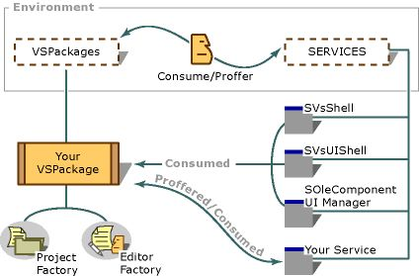
Figure 11-1: Package/service architecture
Here are some of the services that the shell is responsible for:
- Drawing and maintaining the main UI windows.
- Loading packages when needed (packages are not loaded until they are needed).
- Routing of commands to the appropriate package
- Managing the solution files.
- Maintaining a list of all the currently running documents in a running document table (RDT)
Packages often need the help of other parts of the environment to accomplish their tasks. To enable this, the shell has bidirectional communication with a package, so that if a package needs a service, it can ask the shell. Some of these useful services (some of which may be ultimately implemented by other packages), include:
- Retrieving interface pointers to services or packages
- Registering a package’s services with the environment
- Creating, hosting, and modifying windows in the UI
Local Registry
Instead of using the normal parts of the registry related to COM, VS.NET uses its own registry hive to hold information about the package coclasses. The reason for this is so you can have multiple COM servers that correspond to one GUID (which wouldn’t be possible under the COM runtime). Having this separate hive allows you to override any of the built in services with your own versions, and still have the original installation intact. Figure 11-2 shows a VS.NET hive with three different paths, the root, exp, and foo.
It is also interesting to note that when you install the VSIP SDK it makes a copy of the VS.NET hive in the registry is created with an extra string on the end (7.0Exp). When you run VS.NET with a command line switch (devenv.exe /rootsuffix exp) you get only those packages that are in the 7.0Exp hive. This enables you to have a set of packages that get loaded for testing, and not when you are developing those packages (or otherwise don’t want them to load). You can have multiple hives. So you could create multiple hives for different configurations of VS.NET, for example changing the default editor of .aspx files to the text editor versus the WebForm designer, while still leaving the original hive in place, allowing you to choose based upon the /rootsuffix switch which version you’d like to use at runtime.
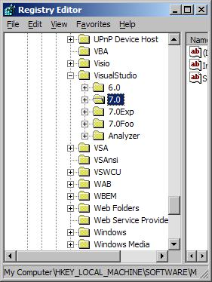
Figure 11-2: The VS.NET multi-hive registry

Typical Package Execution Path
Since the basic VS.NET architecture is built around packages, it is interesting to look at a typical usage scenario to examine all the packages that come into play when creating, building, debugging, and persisting a project. When you launch VS.NET the devenv.exe loads a number of base packages, including the MS Environment Package and the MS Environment Menu Package, which are responsible for creating the base UI of the environment. Here is how packages are used as you work with a project in VS.NET:
Creating a new project
If you create a new project, such as a C# Windows Application project, the environment loads the package which is registered to handle that particular kind of project. The environment looks at the project GUID and loads the appropriate package from its Projects registry hive. For a C# project the GUID is {FAE04EC0-301F-11d3-BF4B-00C04F79EFBC}, which corresponds to the CSharp Project Package. Once the project package is loaded, the shell and the package exchange interface pointers, so the package can obtain services from the shell, and the shell can call the appropriate interfaces on objects exposed by the package. Once the project package is loaded, it is then responsible for creating all the files and directories for the new project.
Putting the project under source control
Once created, if the project is added to source control, the project package gets the source control service from the shell (which is provided by the Visual Studio Team Core Package), and uses that service to check files in and out of the source control database.
Editing the main file in Design view
In a C# Windows Application there is a main .cs file (usually named Form1.cs) which has the definitions for the main entry point function as well as the Form control that is the main window of the application. When you go to edit this file, the default view is the Design editor view. When this file is opened, the shell goes to the Editors hive in its registry hive and finds the appropriate Editor Package for this file extension. It loads that Editor Package (in this case the editor for .cs files is exposed by the CSharp Project Package), and uses IVSPackage (exposed by the package object) for the Editor Factory class. The shell then asks the Editor Factory which view should be opened, and the Editor Factory returns the correct view. In the case of the CSharp editor, it actually looks at the .cs file to see if the base class in that file has a Designer class associated with it; this determines whether the editor should show a Design view at all (see Chapter 8 for more information about designers). This editor object is also responsible for deciding which (if any) ToolBox windows should be available during editing. If the editor uses one of the built in ToolBoxes, it can ask the shell for that service.
Switching to Code view
If you are in Design view and decide to switch to Code view, the Editor Factory is called and it returns an interface pointer to another object (generally this object is the VS.NET default text editor). When editing the .cs file, the shell looks in its registry hive and tries to find a Language Service (see the section later in this chapter for detailed information about Language Services) package for this file extension. If it finds one (it does for .cs files), it loads that Language Service Package, and sets up a bidirectional communication between the language service and the editor. The Language Service can then provide syntax highlighting, statement completion, and method tips (the CSharp Language Service uses a language parser to provide highlighting, and uses CLR metadata to provide statement completion and method tips).
Building and debugging
Once you add all the code you want, you are going to want to build and debug. When you build, the CSharp Project Package is responsible for loading and executing the CSharp compiler. If there is a syntax error during the build, the Language Service Package can highlight the lines in the editor where the syntax error appears.
After a successful build, you can debug your program. Loading the correct debugger is also the responsibility of the Project Package. In this case, because the project is outputting IL, the CSharp Project Package can ask the shell for the IL debugger package (i.e. the Visual Studio Debugger package).
Saving your project
When you want to save your project, persistence is the job of the project package, but the shell provides services to aid that persistence. The shell is responsible for persistence of the solution files. You can see that most of the code that ends up executing inside of VS.NET lives in a package.

Creating Custom Packages
It is interesting to see how VS.NET uses packages, but since we can’t change those packages, the most interesting thing we can do is create our own. In the SDK sample (the Figures Sample), there are packages to create a design editor, a project package, and a language service. Once you obtain the VSIP license, this sample is a good example of the code you will need to write if you decide to create your own packages.

Editing/Designer
A view is a window that gives the user a different way of looking at and editing a source code document (i.e. the visual form designer for Windows Forms). In VS.NET a document can have N views (although most only have two: Design and Code). For each view there is an object that is responsible for drawing the proper representation of the document. This object is known as the DocView. A DocData object (one per document) is responsible for persistence and keeps common information about the document.
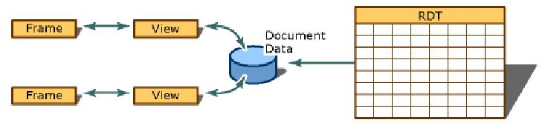
Figure 11-3: The DocView/DocData architecture
One type of view you may be responsible for is the Design view, for which you’d build a visual editor. The most common scenario for building such an editor is where you’d like to have a custom designer for some particular source file to allow visual editing (a la the ASP.NET or Windows Forms designers) and dragging and dropping of objects from the Toolbox. There are two types of visual editors that the environment will load:
Simple Embedded Editor
This type implements some VSIP-specific interfaces to coordinate the interaction between the editor and the shell (and the other UI elements such as menus, toolbars, etc).
In-Place Activation Editor
This type has a DocView object that implements set of standard OLE interfaces. This type of editor is really just an ActiveX control that can host other ActiveX controls. If you already have a visual editor that exposes the standard OLE interfaces for controls, this is probably the preferable option.
The other view you have to be responsible for is the Code view or the simple text editor view. In most cases, the default VS.NET text editor (which is implemented as a package as well) will work fine for this view of the source file. Because this is typical (since there aren’t a lot of reasons to reinvent a text editor) when implementing your “design” DocView, you can use the existing “code” DocView rather than having to build your own text editor DocView object.
Remember, even if you use the existing code editor, if you implement a new language you still can have total control over keyword highlighting and IntelliSense by implementing a language service package.
The environment keeps a table of documents that are currently open (the running document table or RDT). When a file is opened, the environment first checks the RDT to see if another editor already has the document open. If the file is not open, the environment asks the Project Package to open it. The Editor Package exposes an object known as the Editor Factory. The Editor Factory is called by the environment to open the correct DocView for the document being opened, based upon the default view. Once the document is opened, the user can request a different view to edit. The Editor Package controls the commands for switching between views, adding the commands necessary to support the exposed views. These may appear on the context menu or as tabs at the bottom of the editor pane, as they do in the HTML designer that you can see in Figure 11-4.
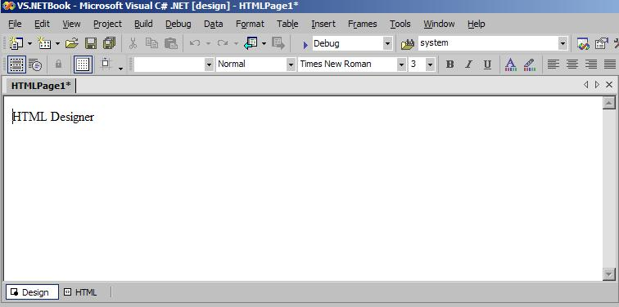
Figure 11-4: HTML Designer commands
When the Factory gets a request to open a DocView, it is passed a string that tells it which DocView is being requested. It is then responsible for creating the correct object that will act as the editor for this view, which could mean returning the current editor (if the document is already open in the RDT) which will be passed to it by the environment. The Factory might also return a custom editor object (in the case of a custom designer), or it might ask the environment to create (or return a current instance) of the default text editor object. After the Factory returns an interface pointer to the correct object, it is then out of the way and the editor object talks directly to the environment.
Once you have your package built you need to add the necessary registry entries. There are two entries that come into play for an editor. The first is HKLM\Software\Microsoft\Visual Studio\7.0\Packages\PackageGUID. This entry is needed for all packages regardless of the services they provide. The GUID is the CLASSID for the coclass that implements the IVsPackage interface, which is the environment’s entry point into the package for obtaining the necessary services.
The other registry entry needed is under HKLM\Software\Microsoft\Visual Studio\7.0\Editors. Under this hive you need to add the necessary entries to tell VS.NET what file extensions you want to be an editor for, and what views you support (as well as a pointer to your package GUID).
Once you have the registry entries taken care of you can add a file to your project with the appropriate extension and VS.NET will load the editor package. During the initialization of the package, the package object needs to register the editor(s) with the environment. Once this is done, you can design and edit.
In the VSIP SDK Figures sample, the designer is for visually designing shapes that will appear on a Windows Forms application. See Figure 11-5. This sample uses a file with a .fig extension to persist the type and coordinates of different shapes. A separate .cs file is created by the project package when the project is built. This file is the source file that will be compiled by the C# compiler and will end up drawing the shapes on the Form.

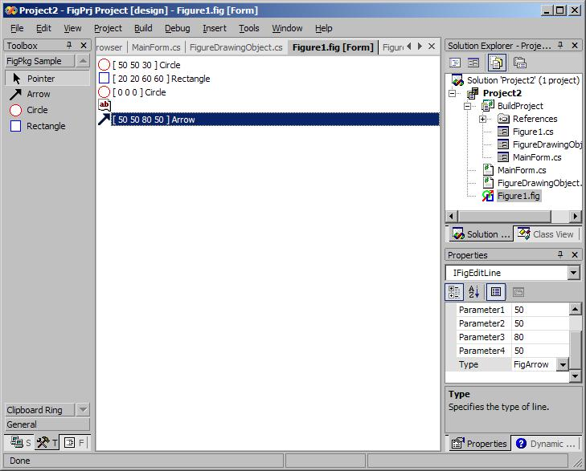
Figure 11-5: The Figure Project Screen
There are few things to notice about this project screen that help emphasize the depth of the integration you get when you build a package. You can see that the Figure Edit package has added a new tab to the Toolbox (“FigPkg Sample”) from which you can drag and drop the different figure objects onto the form designer. With a package you can also add command items to the context menu that appears when right-clicking on the form view. You can also see that the property window has specialized information about the .fig file.

Language Service
If you switch to the code view of the .fig file you will see that there is both syntax coloring and IntelliSense. See Figure 11-6.

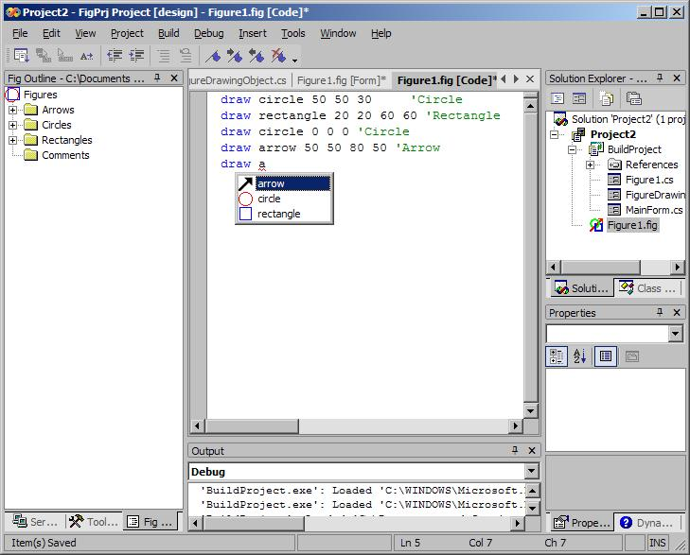
Figure 11-6: Code View Enhancements
As with most designer editors, the figure editor package relies on the VS.NET default text editor for the code DocView. In order to enhance this editor to provide all the cool stuff we expect when editing code files in VS.NET (e.g., syntax coloring, IntelliSense, statement completion, method tips, error markers) with a new language, you must provide a Language Service package.
Under the HKLM\SOFTWARE\Microsoft\VisualStudio\7.0\Languages\File Extensions key is a list of file extensions, each with a package GUID listed as the default value. This is the GUID to the package that acts as the Language Service for that particular file extension.
The Language Service works with the appropriate editor and coordinates with it to give the editor all of the information needed to implement some or all of these text editing enhancements. As you type in the text editor, the editor and the Language Service have a constant bi-directional communication going on. So as you type in the editor, the editor passes the text you are typing to the service, and if the word you are typing needs to be colorized, the service will tell the editor. If you press Ctrl-Space to invoke statement completion, the editor calls the service and the service gives the editor a list of items appropriate for the current context.
Each different type of enhancement is implemented by creating an object that implements certain interfaces. When the document is being edited, the environment calls the appropriate interface for each enhancement, the interface pointers having been passed to the environment by the Language Service during initialization.
For example, as text is typed into the .fig file, the text is being passed to an object that is responsible for colorization. As each token is passed into that object, it returns a flag attached to each token that should be colorized (so the colorization object is really a lexical parser that tells the editor which words are language keywords).

New Project Type
Editing the file with all the “extras” is nice, but in the end the file is useless if it cannot be compiled as part of the build process. The .fig file has to be converted into a .cs file, so that when the project is compiled the correct shapes are drawn on the form. In order to be involved when the project is compiled, you need to create a Project package (although in this case the .fig file could just have a Custom Tool associated with it – see Chapter 3). A Project Package is an object that implements a certain set of interfaces which allows it to interact with the IDE to coordinate project creation, project persistence and project compilation. Unlike adding a new project wizard (which only allows you to create a custom set of project items for an existing project type), creating a new project type with a VSIP Package give you total control over the whole project lifecycle.
Reasons why you might need to create a project type package:
- Be involved in building, debugging, file persistence, or source control
- Have control over items in the solution explorer
- Support project nesting (i.e. nesting one project below another)
If you need custom project items, but don’t need this type of control, you are much better off creating a new project wizard (see Chapter 10). In the case of the Figures project, the most interesting thing it does differently than any other of the project types is to take the .fig file and use an internal parser generate a separate .cs file from the .fig file syntax. It adds this file to the project, and compiles it when the project runs the C# compiler.
The project package architecture works much the same as other packages. The environment creates the package object, and passes in its interface pointer for the package to obtain services. The package object then registers its project factory interface with the environment. When a project is opened (or created) that belongs to this package, the environment asks the factory to create (or hand back) an object that represents the project itself.
If the configuration of the project changes, the project object is called and is responsible for persisting that information. If a build command is issued, the project object must do whatever is appropriate to build the solution. When a new file is added, the project object is responsible for persisting that file, and putting it in the appropriate place. When the project is added to source control, the project object is responsible for checking items in and out through the source control services exposed by the environment.
When a debug command is issued, the project object must work with a debugging package to start and manage the debugging process. If your compile outputs assembly (generally x86) and you also output a .PDB file, there is a DE (Debugging Engine) for Windows code (that has an expression evaluator for C++), so you don’t need to create any additional packages. If a project implements a new language that doesn’t compile into IL or x86 assembly, you need to create a new debugging engine package. In the case of the Figures project, since it is using C#, the project object can just use the existing DE built into VS.NET for IL, and all you need to build is an expression evaluator (EE) to work with the DE.

Debugging Engines and Expression Evaluators
If you implement a new language that does not emit either windows native code or the corresponding debug format files (PDB), you will need to write a DE. The VSIP SDK includes information and a sample to show you how to build a DE.
A DE is a component that implements the services necessary to debug a particular architecture (there are DE’s for Windows code, IL, TSQL, and script built into VS.NET). A DE works with an IDE (or the operating system) to provide execution control services (e.g. breakpoints and statement stepping). So if your language targets IL, you also do not need to write a DE.
If your compiler does output native Windows files with PDB files you probably will not need to build either a DE or an EE since both are available for these formats (the EE targets the C++ language – so if your language is significantly different you may need to write an EE).
An EE is a VS.NET package that coordinates with the IDE to evaluate language expressions at runtime. This can happen in both the intermediate and watch windows while a program is being debugged.
When the VS.NET debugger loads, and execution stops on a breakpoint, the DE in question creates an instance of the EE engine for the particular language and gives the EE a list of variables that needs to be displayed in the locals window. The EE is responsible for parsing those variable (symbol) names and giving back to VS.NET the memory location to find them.
A similar process happens when a symbol is requested from the watch window. When a statement is typed into the intermediate window however, the EE must both parse the symbols, and possibly return a result (i.e. of a valid language operation such as “4+5”). The SDK comes with a sample called MyCEE. This EE will evaluate locals and expressions in the watch window for the MyCEE language (which is a language whose compiler is also supplied as an example in the SDK of how to implement a language that compiles to IL).

