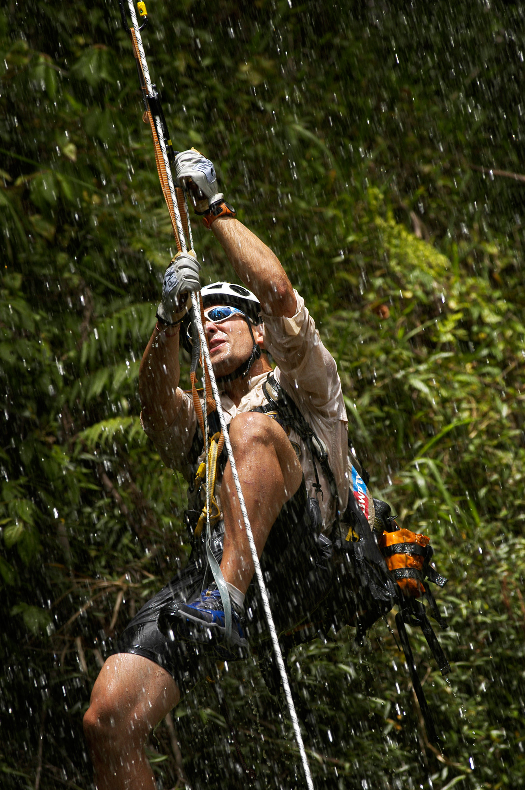

Achieving a Better Digital Workflow:
Copyright 2004, Reed Hoffmann, Blue Pixel


Best practices for digital photographers using Microsoft Windows XP


Why the computer matters in your workflow
At Blue Pixel we spend thousands of hours each year training organizations and individuals on how to achieve the most from digital photography. Even experienced photographers must learn seemingly countless new things when making the transition to digital. At each step along the way technology can help—or hinder
—your results. One thing is certain: today the computer is an essential part of any digital
imaging workflow.
We work daily with photographers using both Windows and Macintosh computer systems. There was a time when consensus was that just one platform was suitable for high-end professional results. That time is no more. Today’s computers running the Microsoft® Windows® XP operating system deliver high performance, an end-to-end color-managed workflow, and solid choices in professional hardware and software tools. No computer is yet perfect, but Microsoft and its partners seem to be working hard to
deliver better solutions for photographers who prefer the PC platform.
We know from experience that achieving the best results requires a correct digital workflow. In this paper we will provide practical “best
practices” tips and advice gleaned from years of shooting digital around the world, so that you too can design a Windows-based “workflow that works.”
Eco-Challenge: A history
lesson
The conventional wisdom is that film is easier to shoot than digital when working in remote locations. Not necessarily! In 1997 Blue Pixel took on the assignment of photographing the Eco-Challenge adventure race. Teams of four rely on their outdoor skills and endurance to spend a dozen days racing across some of the most scenic and harsh terrain in the world.
Our job was to provide all the photos needed for the race organizers—Eco-Challenge—as well as the race sponsor—Discovery Channel. We were the sole photographers responsible for delivering images on deadline for newspapers and magazines, as well as images for promoting the television program that would air months later.
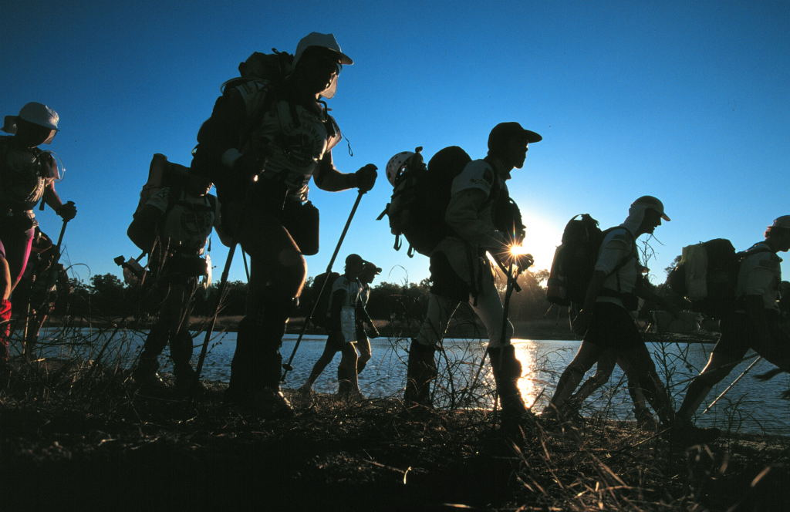
Teams start Eco-Challenge Australia at dusk with a 60-kilometer trek through the outback.

At that point, all of the photographers were shooting digital, yet the clients for Eco-Challenge wanted us to provide chromes. For the first three years that Blue Pixel provided images for Eco-Challenge, our photographers would shoot digital for all their other assignments and then switch back to film for Eco-Challenge. In Australia shooting E6 film and getting it processed was no problem, but in
Morocco we had to shoot color negative since there were no labs that processed E6. In 1999 in Argentina, we’d found one lab in Bariloche that could handle slide film. At least they said they could.
From the first day, the lab couldn't keep up with the volume of film we were delivering. By the second day it was obvious they’d never catch up. We had to start setting aside the most important film and try to get it processed first. On the third day I was on top of the mountains
covering teams fighting their way through 100-kilometer winds. It made for great pictures. That afternoon I gave my three best rolls to a helicopter that was able to land briefly. That was a mistake. That night the lab ruined the film.
Now we had a crisis. We still needed to release photos every day, but we could no longer trust our lab. That’s when we started sending film to a lab in Buenos Aires that had agreed to stay open overnight to process the film. The next morning the film was couriered to the airport for a return flight to Bariloche. It was an expensive solution, and it put us a day behind on deadlines, but it was the only choice we had. By the finish of that race, we knew the time had come to cover Eco-Challenge digitally.
In 2000 Eco-Challenge took place in the state of Sabah, Malaysia, more commonly known as Borneo, a rainforest-covered island surrounded by ocean. With difficult logistics, transportation and communications, it turned out that digital would be the only way to fulfill all of our clients’ needs. Fortunately, the end of 1999 saw the introduction of the Nikon D1, a camera that
produced a high-quality image and was tough enough for the job.
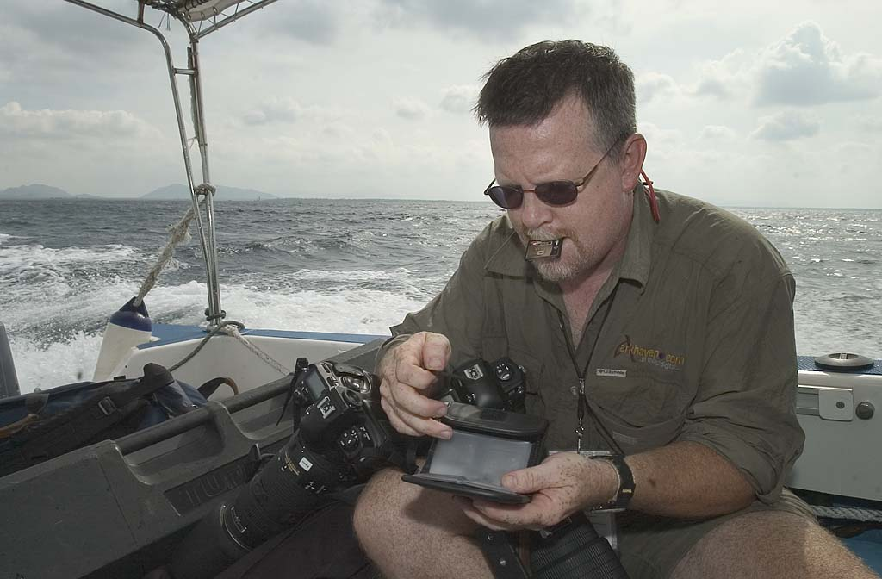
Kevin Gilbert changes cards in his Nikon D1’s in the back of a boat off Borneo.

Eco-Challenge goes digital
There was no question that the Nikon D1 was capable of high enough output for newspaper and magazine work—we all used them everyday in that capacity. But the Eco-Challenge images would also be used in promotion of the television show, in sizes ranging from posters and bus-wraps to six-story-tall billboards. Could the images hold up?
The answer was “yes,” but it was no small job to convince our wary clients. Because digital images are composed of pixels, rather than grains of chemicals, they look different when enlarged. We knew the files would be up to the task, but the best way to convince the Eco-Challenge clients would be to show them hard copy prints.
We created samples for them and made the commitment to shooting the entire event in the RAW format, to ensure the highest quality image through the entire job. (RAW, the camera’s native image format, contains data taken
directly off the sensor without processing for color, tone, noise, sharpening, etc. RAW images are like “digital negatives” which are later “developed” or processed using software on a
personal computer.)
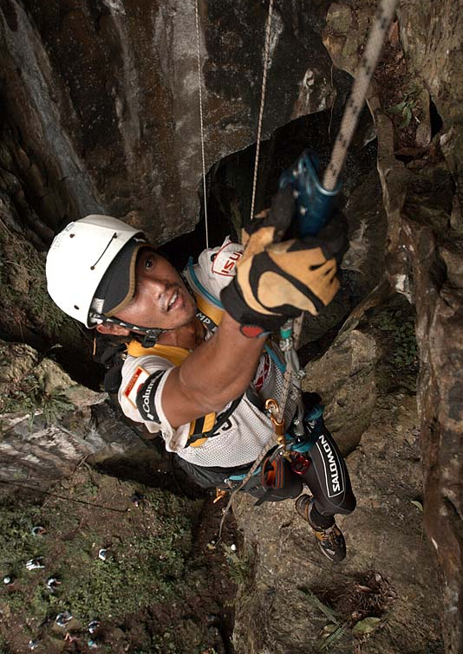
If the heat in Borneo didn’t get you, the climbs might.

As anyone who’s photographed a big event will tell you, planning is half the battle. Sometimes it’s more than half. The race in Borneo promised to be hot and wet, something that’s no small concern to a photographer. Our time would be split between ocean and jungle.
We arrived with everything from dry bags to snorkeling gear. Four photographers would work this race, each of whom would be equipped with three Nikon D1 cameras, a variety of lenses (ranging from 17mm to 500mm), two SB-28DX strobes, six camera battery packs, fourteen Lexar CompactFlash cards, and more.
More important than the camera equipment was the computer gear we carried. We each had a laptop loaded with Photo Mechanic from
CameraBits for browsing, re-naming and captioning and Adobe Photoshop for editing. Each also carried a small external drive for daily backup of images. We had inverters so we could charge and power all this digital equipment from a car if we had to (and we often did). Finally, everything needed to be as portable as possible, as we’d be going quickly from jeeps to helicopters to small boats at a moment’s notice.
The biggest and most immediate difference in covering Eco-Challenge digitally was that we instantly could tell if we had the shot. Using the camera’s flashing highlight feature (where the preview image blinks anywhere the image is overexposed) and histogram told us if were getting the exposure right. Backing up images every day to the external drive let us be confident our images would make it back to the client intact. And the cameras survived being beaten about in small boats, splashed with saltwater, banged into rocks and rained on. We didn’t have a single failure.
Making deadlines was much easier with our digital system since we removed the middleman of the film lab. The image quality was top-notch, and the clients were happy. We only had one real problem: we suffered from a poorly executed workflow.
The key to making any digital photo project run smoothly is a well-planned workflow. Going into Borneo we all were aware of the importance of a good system. We had talked about naming conventions and batch captioning and archiving, but we failed to have every piece in place before the start of the race. The more people involved, the more things can go wrong, and usually do.
We weren’t able to bring all the images together until the race was totally finished. I spent the last four days in Borneo locked in my hotel room, re-organizing the entire 15,000-plus image shoot and then burning all of it to CD. It was a waste of time, and could have been avoided with a better workflow. I swore that would never happen again.
As we prepared for our fourth Eco-Challenge—New Zealand in 2001—we had some new toys to play with. The Nikon D1X, with its much greater 5-megapixel resolution, had just come on the scene and would be the camera we’d use. We also had several external high-capacity Digital Camera Batteries (www.digtitalcamerabattery.com) along. These portable 30-watt power packs would provide power not only to cameras, but strobes and laptops as well. We also had added several photographers, bringing our number to seven.
But most importantly, we’d learned from Borneo and built a much better workflow, taking advantage of new software and hardware available. Photographers would download their images daily to their laptops and also to external drives, then rename each file using a specific naming convention and then batch caption the day’s photos. They’d then make copies of their best images and place them in a separate folder.
This had to happen whether they were sitting in a hotel or camped on top of a mountain. The disk drives would be delivered every day or two to an on-course photo editor working out of a small camper with two laptops and a RAID array of two 120GB drives. After downloading, the small drives would then immediately go back to the photographer. The editor also had a DVD burner in his camper, and was able to start compiling and burning the first days of the race to DVD even before the race finished.
By the time we left New Zealand, all of the 20,000 images had been burned to two sets of DVDs, and all images had been cataloged and indexed.
2002 saw us in Fiji, which offered the usual challenges we’d come to expect from the races by now (not the least of which being where on the island to find the best margarita!). The biggest change we made for this race though was adding keywording to the daily captioning of images. We also decided to streamline delivery of images to our clients. Each received a 120GB portable drive with all of the images they’d contracted for, indexed and cataloged, by the time we left the island. The total take at the end of this race was 26,000 images.
What did we learn? Good workflow can make digital easy, bad workflow can make you miserable, and even worse can cost you clients and money.
Digital workflow — the
overview
After working with digital for more than nine years, we’ve encountered the same problems time and time again. Here are the key things we’ve learned from Eco-Challenge and our other digital projects of the past decade:
Make the most of the camera
Digital images are like slide film. Overexpose highlights and you’ve ruined the image. Get the exposure right and you’ll be amazed at how good digital can be.
Stay low. Every digital camera creates its highest quality when shot at the lowest ISO it was designed for. Don’t raise the ISO without good reason.
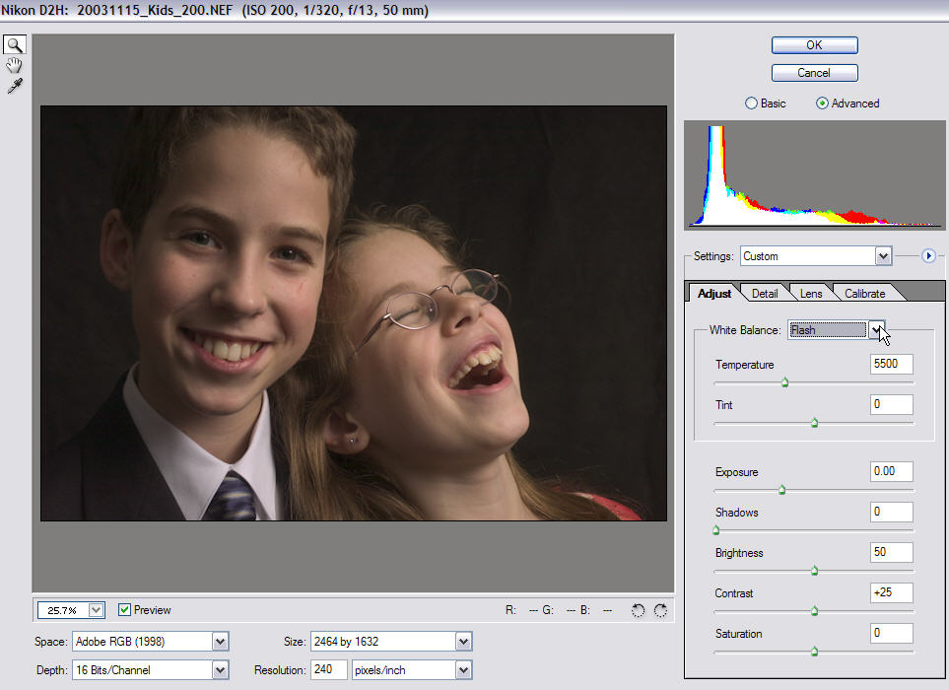
Think white balance, white balance, white
balance. Then think white balance again.
Photographers who take the time to set their white balance properly (which almost always means setting a white balance preset in artificial light) spend little time correcting color. Photographers who don't pay attention to white balance complain about "poor digital color" and spend far too much time in Photoshop.

Adobe Photoshop CS has a built-in RAW image editor.
If you shoot JPEG, shoot best quality JPEG. It will mean larger files, but better quality. JPEG is compression, and if you compress image information too much you’ll start seeing a noticeable loss in image quality. If you care about the photos, stay at best quality. Or better yet…
Consider shooting RAW. I’m not suggesting you run around taking pictures naked (unless you’re at a nudist camp). Every high-end digital camera, and even many of the compact “point-and-shoot” cameras, offers the ability to record information in a RAW format, and every manufacturer has their own version.
Think of RAW as a digital negative. A RAW file contains information directly from the sensor, and hasn’t been processed for things like color, tonal curve, sharpening, noise reduction and other variables. That means you’ll do that work later at the computer, which adds time to your post-processing but gives you much greater control over the finished photo. Some RAW files may be compressed (Canon and Kodak, for example), but that compression doesn’t result in a poorer image, using what’s called a “lossless” compression. The files are smaller, but no data has been lost.
In fact, with the ability to shoot RAW format, my choice comes down to shooting JPEG or RAW. I see no real use for the TIFF format in the cameras. TIFF has the same processing as a JPEG, just not compressed, meaning a MUCH larger file written to the card. Some photographers (mainly studio or commercial) choose to shoot TIFF due to client demands, and thus skip the compression without the additional step of processing RAW files. My preference would be to shoot in RAW format, which is actually smaller than a TIFF due to the fact it hasn’t been processed yet, and I can change my mind about the processing I want later. If I want the absolute best quality, I shoot RAW. For speed and efficiency, I shoot JPEG. If I’m comfortable with my white balance choice and exposure, I’ll shoot best quality JPEG and have a short and fast workflow, and a high-quality image. If I have any concerns at all about color or exposure problems, I’ll shoot RAW.
Some of the latest digital SLRs now provide the ability to capture both RAW and JPEG in the same file, which provides additional flexibility once you get the images into the computer.
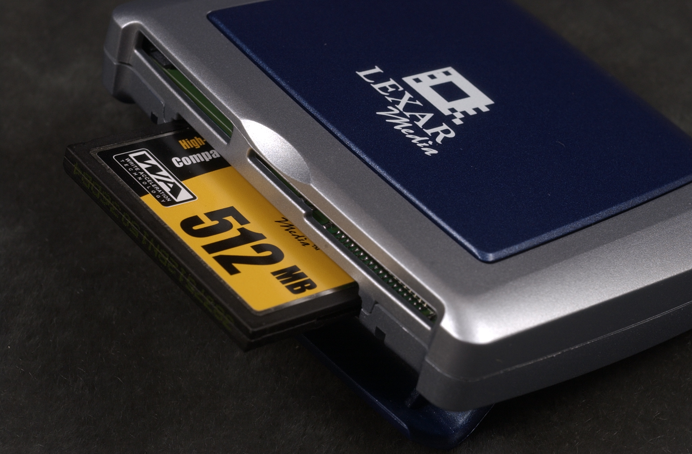
For RAW files, choose the software that works best for you. With more and more software
coming on the market that allows processing of RAW images, you have more choices on the “look” of the color that a RAW image can be processed for.

Fast downloads require high-speed readers like this Lexar USB 2.0 reader or a FireWire equivalent.

Use fast card readers
You can have the fastest processor on the block, but it will do you no good if you’re using a slow method to download your images. Make sure you’re using a card reader that supports either USB 2.0 or FireWire connections to get your photos into the computer quickly. Windows XP supports plug-and-play installation of both USB 2.0 and FireWire (IEEE 1394) devices.
Make the most of your computer and operating system
Power equals speed. A fast computer with a lot of RAM will mean less time staring at the screen waiting for things to happen. We recommend 1Gb as a baseline memory configuration; 2Gb is even better. If you are still using an older version of Windows, consider an upgrade: a modern, stable operating system like Windows XP means fewer problems. (The good news is that Windows systems are fast. In a recent report published by www.robgalbraith.com, Windows XP workstations outperformed Macintosh G5 systems in 58 of 77 tests of digital workflow.) A big hard drive means you’ll spend less time pouring data back and forth to other devices. A second drive will give you additional backup capabilities and allow you to place your Adobe Photoshop scratch disk on a separate drive from the Windows XP swap file, improving performance for image editing sessions. Finally, follow Microsoft’s recommendations for keeping your system up to date and secure: use Windows Update, appropriate antivirus software, and the Windows XP Internet Connection Firewall.
Use color management
Unless you use color management properly, you’ll never know what your camera is truly doing to color, whether you’re helping or hurting that, or have any confidence in what you deliver to clients. Windows XP provides the ability to assign ICC-standard color profiles to devices, display and preview JPEG images in color-managed space, and take advantage of applications such as Photoshop that support a fully color-managed workflow.

Color management means investing in a good calibration/profiling package.
Not all software is equal
With more and more software coming on the market that allows processing of RAW images, you have more choices in the “look” of the color that a RAW image can be processed for. Choose the software that gives you the look you prefer, and meets your requirements for processing speed and efficiency. The best tools support efficient batch-processing of RAW images in the background using the native multi-threading and multi-processing features of Windows XP.
Make the software do the work for you
Workflow is all about making the process all flow and less work. Use software that will help you download images, rename them and batch caption them, and do all of this quickly. An image named “DSC_1712.JPG” tells you nothing. Likewise, caption information adds value to an image. Do it right when downloading and you’ll have less work to do later. Lastly, the more you do digitally, the more you’ll start using RAW format and finding ways to automate the steps you take. Both of these require a powerful computer with plenty of RAM.
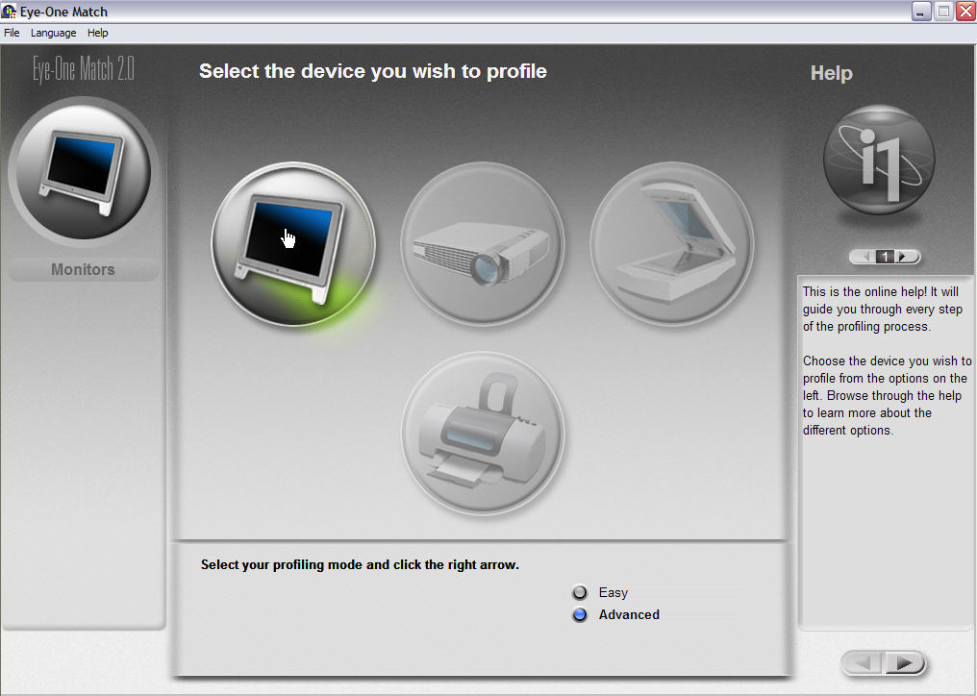
Organize your computer
Decide on a system that makes sense to you and stick with it. I prefer simple systems. My computer already has a My Pictures folder, why would I want to keep photos anywhere else?
I have a folder inside there called “to Burn,” which contains everything that hasn’t yet been burned to DVD. Why DVD? Because when the time comes to transfer my images from CD or DVD to whatever new storage device the future holds, I’d rather work with 500 DVD’s than
3000 CD’s.
Have backups
If you haven’t had a hard drive crash yet, you’re just lucky. It will happen sometime. Set up a system to back up your important files (not just photos—what about finance and business records?) and use it. I prefer fast external hard drives, with USB 2.0 or FireWire interfaces. If you’re not squeamish about opening up your computer, you can often add a second drive to your desktop computer. Windows XP supports both desktop and server systems: if you have a server, you can use it to provide a single backup store for your home or office.
Catalog your photos
You need to be able to find images quickly and easily. Otherwise you’ll waste a lot of time.

Digital Workflow—the details
RAW format
If you want to get the absolute maximum image quality out of your digital images, you’ll want to shoot in RAW format. That’s what we did with the Nikon D1’s back in 2000 for Eco-Challenge Borneo. We did that then mainly because we were working with a 2.7-megapixel camera and needed to be able to output LARGE sizes (posters, bus wraps, billboards). If we had shot JPEG files, they would have undergone one compression cycle before they ever left the camera. Being an unprocessed RAW file also meant we could decide later what white balance, tonal curve, exposure latitude, amount of sharpening and other parameters we wanted to apply to the rendering (processing) of the
image.
If you choose to go this route, you have to know that not just any editing software can open a RAW format file. You’ll need specialized software to do this. There are a number of powerful pieces of software for accomplishing this. Among them, some of the best are:
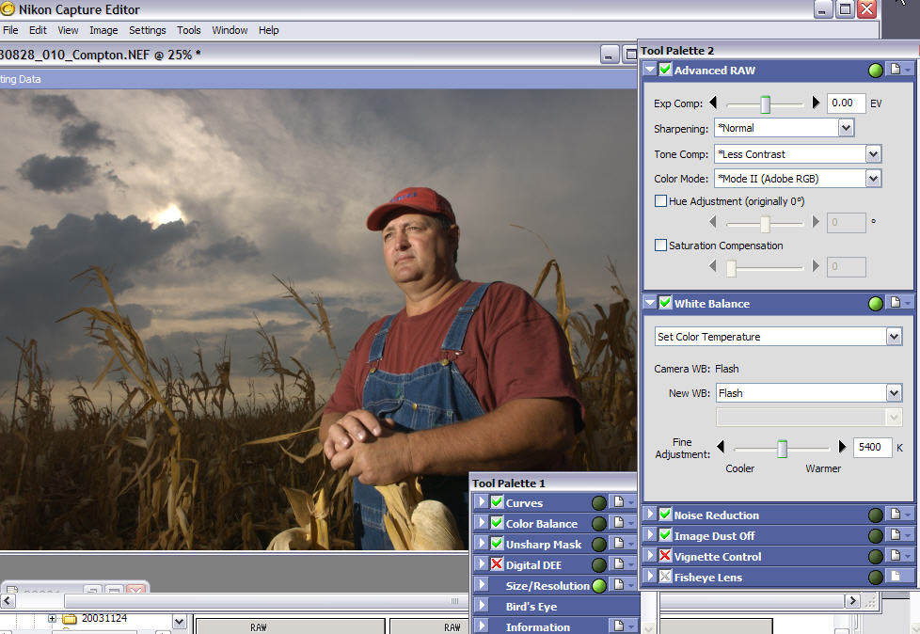
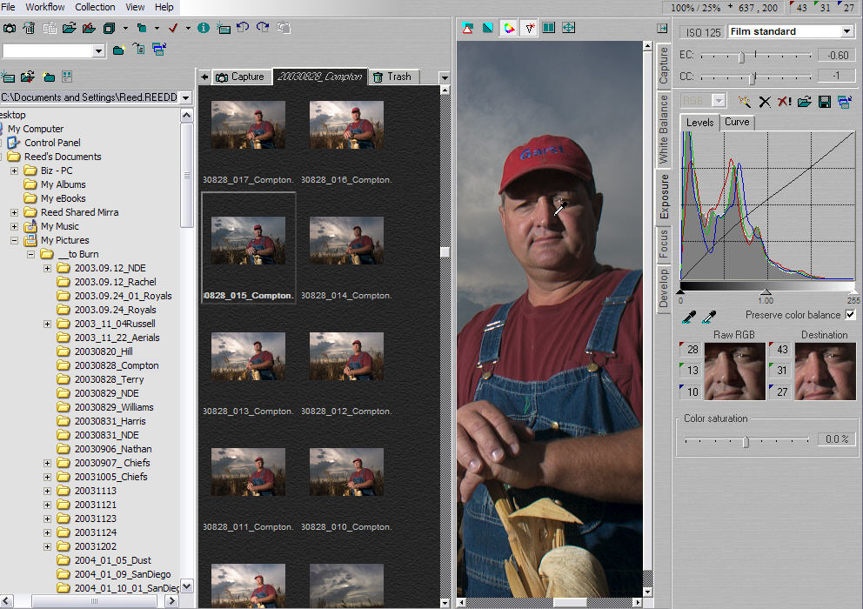
Nikon Capture – If you use a Nikon digital SLR and choose to shoot in their RAW format (NEF), you can’t go wrong with Nikon Capture. It’s powerful software written specifically for Nikon RAW files. Just about anything you could want to do to an image, you can do in Nikon Capture. On a fast Windows machine, you’re making adjustments in nearly real-time. It also offers powerful batch-processing capabilities, and can be set to watch an incoming folder to apply those steps to any new file that appears there. Nikon Capture can be purchased from Nikon or a Nikon dealer for $99.95 (www.nikontechusa.com).
Nikon Capture 4 is Nikon’s RAW image editor
Phase One’s C1 Pro is one of the best third-party RAW editors.

Canon Digital Photo Professional (DPP) – If you use a Canon digital SLR but were disappointed with Canon’s previous software offerings, you will likely be impressed with Digital Photo Professional released with the EOS-1D Mark II. Digital Photo Professional performs high-speed processing of RAW images in several formats, including Canon’s new .CR2. The software is so new we haven’t had time to test it yet, but Canon claims that DPP is five to six times faster than the File Viewer Utility bundled with the EOS-1D and 1Ds, a welcome
improvement. Digital Photo Professional allows multiple image adjustments to be saved and applied to other images, a comparison mode, color channels, tone curves, exposure compensation, white balance, dynamic range, brightness, contrast, color saturation, ICC Profile
embedding and assignment of monitor profiles.

Adobe Photoshop CS, or Photoshop 7 with Adobe Camera Raw plug-in – In 2003 Adobe released a plug-in for Photoshop 7 called Adobe Camera RAW that allowed third-party processing of different manufacturer’s RAW file formats. Photoshop CS has the plug-in built into the program, so it’s not an add-on. CS supports RAW files from Nikon, Canon, Konica, Olympus, Fuji and Leaf. There is also unofficial support for some Kodak cameras. It has a smooth interface and runs quickly on a fast Windows XP machine. Photographers may find that it’s more powerful than the software their cameras came with.
C1 Pro by Phase One – Formerly known as Capture One DSLR Pro (www.phaseone.com), this is another third-party program. Phase One makes four different versions of their RAW file processing software, at different price levels. The top of the line, C1 Pro, costs $599, supports Canon and Nikon RAW formats and is considered an excellent program. It’s aimed at professional photographers, and has a smooth, fast interface.

JPEG format
After reading the above, you may wonder, “Would I ever want to shoot JPEG format?” The answer is probably “yes.” If you’re confident of your white balance and exposure, then shooting in JPEG format can save you time. The processing (rendering) of the image will have happened in-camera, and so you can skip that step in your workflow. The files will also be smaller in size, so you’ll get more images per memory card and more images on the same amount of space on your hard drive and CD/DVD.
There can be a slight improvement in edge smoothness gained by not shooting JPEG, but for most uses this isn’t a major concern. Due to the high quality of most best-quality JPEG algorithms, you’ll only notice this, if at all, in very large prints (think 16 x 20 or larger).
The main thing to know when shooting JPEG is that you have to nail your exposure and white balance settings. Maintaining details in the highlights is critical to digital image quality, so shooting in-camera JPEGs is a lot like shooting transparency film: you have less exposure latitude and margin for error than when shooting negative film or RAW digital. Learn to meter accurately and not to rely exclusively on your camera’s auto shooting modes. The good news is that digital cameras provide built-in histogram display and image preview, which can tell you a lot about your exposure during a shooting situation. Turn on display of blinking highlights to show out-of-gamut areas during image preview.
Downloading
There are two major concerns when it comes to downloading images: speed of download and functionality. Speed is easy – you want to use the fastest method available, which means either a USB 2.0 card reader or a FireWire card reader. And of course your computer has to support that protocol (built-in to Windows XP).
Functionality has to do with what else you can get accomplished during the download process. After twelve hours of slogging through jungles or hanging off cliffs, the last thing we wanted to do during Eco-Challenge was spend several hours each night downloading, re-naming and captioning photos from that day. That had to be done, though, or it would take forever to find anything.
Windows XP has basic support for downloading and renaming images built in at the system level. When Windows XP sees a camera or card attached, an “Autoplay” window pops up offering to help you with those images. It’s called the Scanner and Camera Wizard, and using it you can designate where you want the photos downloaded to on your computer, create a folder name for them, and even rename the files on download. (If you don’t see the Scanner and Camera Wizard when you insert a card, right-click on the card reader icon in the My Computer window and change the Autoplay settings for the device.) For a consumer or even advanced amateur, the Scanner and Camera
Wizard may be all that is needed to simplify the download process.
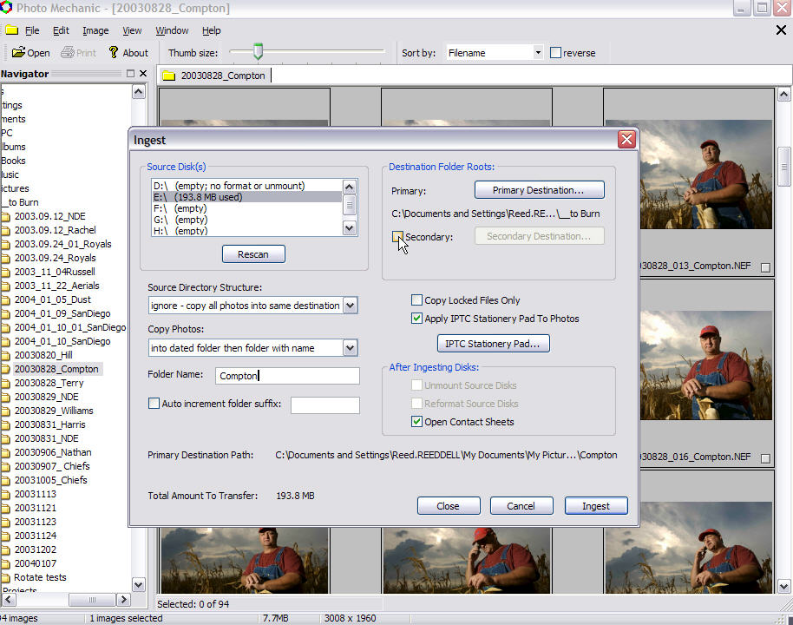
Photo Mechanic’s “Ingest” feature automates much of the download process.

A professional photographer, however, will usually want more power and options for download. Various image browsers offer assistance in downloading, and even re-naming and sometimes captioning. One example is Breeze Downloader Pro, from Breeze Systems. However, the program that quickly became our favorite, and has grown better and better over the years is Photo Mechanic (www.camerabits.com). For a time the best
versions of Photo Mechanic were available only for Macintosh systems, but the latest release for Windows is really terrific. Here’s how we use it:
- Photo Mechanic has a downloading feature called “Ingest Disk” (Control-G). Not only can you choose the card and reader you want to download from, you can choose multiple readers if you have them attached to your system, and download from all at the same time.
The program allows you to batch caption during the download, using what’s called the “IPTC Stationery Pad” (Control-I). IPTC is an international standard of embedding and reading “metadata” information such as caption, creator, location, date, etc. for news organizations and libraries. As an international standard, it can be read by any good archiving or editing program (such as Photoshop or Extensis Portfolio). Type in as much of that information as you want attached to your photos, and Photo Mechanic will do that during download, with almost no time added to the download. Even better, the program offers the ability to pull information from the camera’s EXIF data (shooting information such as make of camera, shutter speed, white balance, time of capture, etc.) and place that in the caption (or elsewhere) as well. It’s called the “Variable Naming Feature,” and is incredibly powerful for building more informative and valuable captions.
Photo Mechanic also allows you to designate a second location for images to be downloaded to at the same time as the original transfer. That meant we could have instant backup by having each card downloaded to both the laptop’s internal hard drive as well as an external, portable FireWire drive.
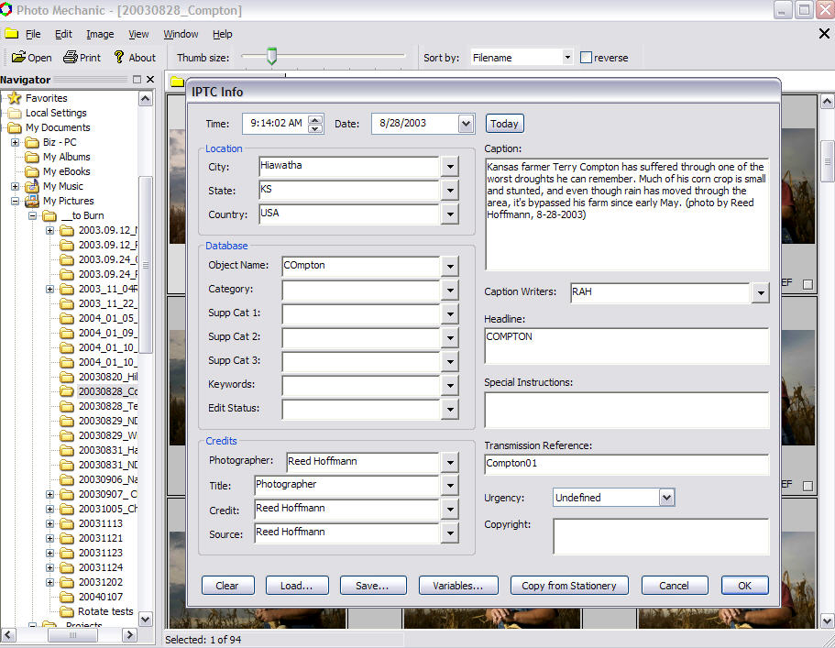
Once downloaded to the computer, images had final touches of captioning added that couldn’t be handled by batch captioning on download. The last step was to rename the images, which Photo Mechanic also automated, using an 8-digit date stamp (20021013 – year, month, day), one word with the photographer’s initials (“Day3rh” for example) and the number of the image (counting up from 001..jpg). An image file would then have a name such as 20021013_Day3rh_217.jpg, which would indicate it was taken on October 13 of 2002 by Reed Hoffmann, and was the 217th photo from day three of the race. In this way a day’s take of hundreds of images could be downloaded, captioned, renamed and backed up in less than 30 minutes. That let us focus on the more important things, like food and sleep!
Photo Mechanic’s ability to caption using IPTC standards can also be automated.

Photo Mechanic goes through regular upgrades that continue to improve its feature set. Among other things, it’s now color managed, which means that you can actually see what your photos truly look like.
Browsing
Windows XP has native features for organizing and working with images in the shell, particularly TIFF and JPEG images. You can view thumbnails, display images in a “filmstrip” view, print single images or make index prints of all images in a folder. The default behavior when you double-click on a JPEG image is to launch the Windows Picture and Fax Viewer, which allows quick previews of all images in a folder. Display of JPEG images in the Windows XP shell is now color-managed automatically by the operating system. If you’ve saved your pictures in a folder other than the built-in My Pictures folder, you can give this folder the same capabilities as My Pictures by right-clicking on it, choosing Properties, then Customize, to set the default template of the folder.
If you didn’t follow our advice when downloading, there is a little-known way of batch-renaming files in the Windows shell:
Click Start, and then click My Pictures or whatever folder in which you've saved the pictures. Switch the view from the default Filmstrip to Thumbnails by clicking the Views button on the toolbar.
Select all the pictures you want to rename by highlighting the last picture you want, then press and hold the Shift key as you move your mouse over them until you include all to be renamed, ending with the first picture in the list.
Right–click the first picture, and then click
Rename.
Rename the first picture with the name of your choice (for instance, my-new-name.jpg), then click in the white space next to one of the
pictures.
Windows XP renames all the pictures in sequence, my-new-name.jpg, my-new-name(1).jpg, my-new-name(2).jpg, and so on.
As nice as this is, there are many times when you need more than what is provided by the Windows shell: this is where browser software comes in.
Browser software differs from editing software in that its job is to let you quickly and easily look at all the images in a folder. In addition it should be able to quickly give you a large preview to check for focus and other image elements, allow you to mark images in some way, copy/delete and launch selected images into editing software (such as Adobe Photoshop). Photoshop 7 and Photoshop CS have a new built-in browser, but external programs are often still more flexible. Some browser software can also process RAW image files.
One of the best features of browsing software is image tagging. Using the tagging feature of browsers like Photo Mechanic or Nikon View allows you to quickly mark your best photos, then select them and copy them to a separate “Best” folder for further editing or RAW processing. You can even speed up your editing process by using the protect feature in the camera to mark your best images during the shoot, and Photo Mechanic and Nikon View will “see” that and the images will already be tagged in the browser.
Finally, it’s important to always have the original images intact so that if anything goes wrong you can go back to the original file that came out of the camera. Therefore it’s critical that your browser does lossless or “soft” rotation of images. Lossless rotation means the rotation is saved without a re-compression of the JPEG image. A “soft” rotation means that the image view is rotated, but not the image itself. Nikon View does lossless rotation, Photo Mechanic does soft rotation. If you’re using another browser, check to be sure of what it’s doing. Some newer cameras can set the EXIF image orientation at the time of capture. The best browsers and image editors such as Photoshop respect this orientation setting and automatically rotate the images.
Batch Processing
If you do much digital photography, then you’ll soon reach a point where you realize there are some tasks you do over and over (and over and over and over…). Harness the processing power of your PC (you did buy a fast, one, right?) and put it to work doing those repetitive jobs. Adobe Photoshop is an application you can put to work doing just this sort of thing.
“Actions” is the term Photoshop uses for the process in which you record a series of steps which can then be played back in that order. You can even combine several smaller Actions into a larger one. Once you have an Action, you can apply it to one image or to a folder full. To accomplish this, you’d go to File – Automate – Batch. Once there you choose the Action you want to use and to what folder you want it
applied, then where to save the new file and under what name. For instance, you can create an Action that preps images for your website. It can open an image, assign the right color space, re-size to a specific dimension, sharpen, then convert to another color space before
saving the image under a new name to another folder.
The better RAW file editing software can do the same type of thing to RAW files. Simply take one image from an assignment, find the optimal color balance, tone compensation, sharpening, noise reduction, etc., then save those settings and use them on a single image or an entire folder full.
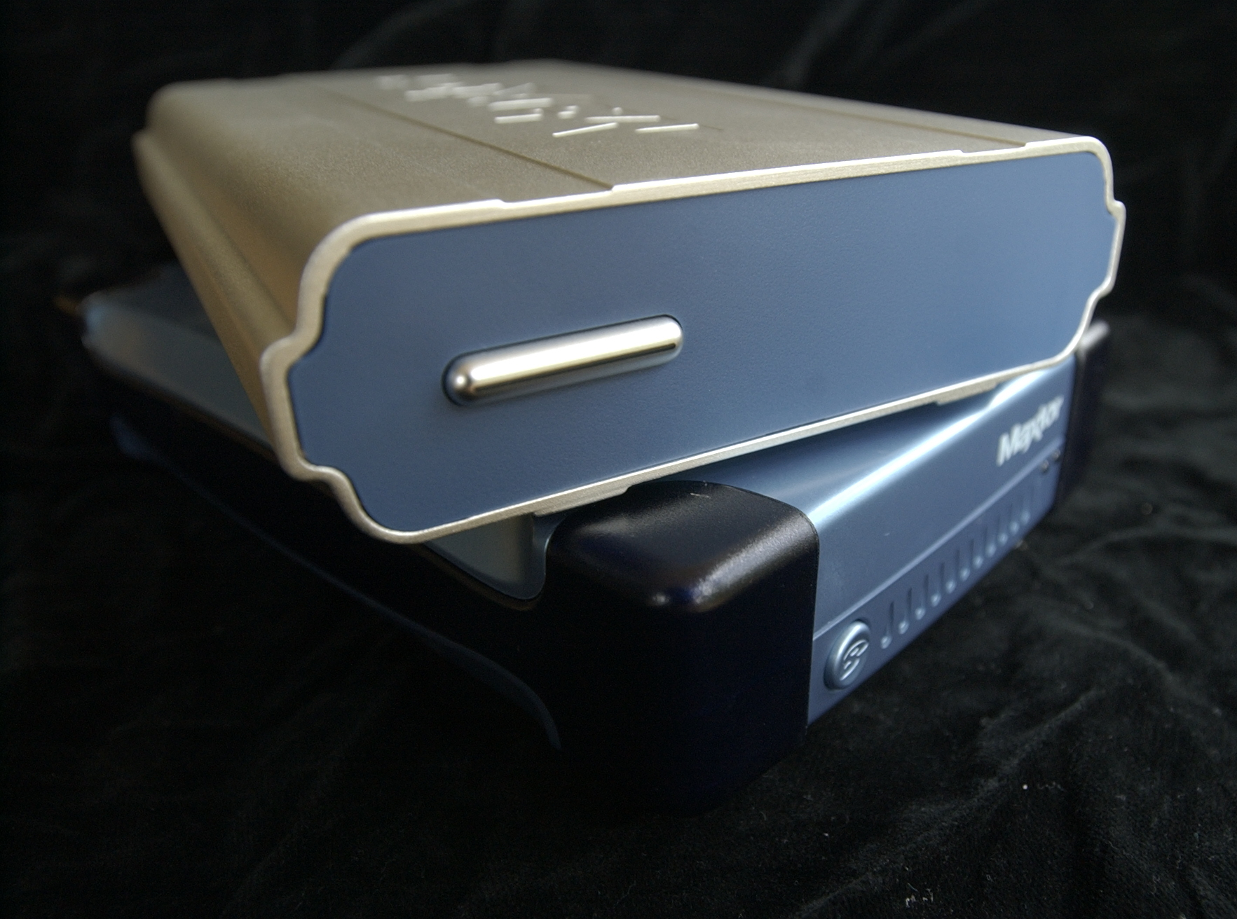
Backups
It’s a sad fact that while there are plenty of simple, easy ways to back up important data, many people still don’t do it. If your photos are important to you, then it’s worth implementing at least a basic backup strategy. With the low cost of external USB 2.0 and FireWire hard drives today, there’s no excuse not to copy a set of your images to the second drive once they’ve been downloaded.
Maxtor’s One-Touch drives make backup fast and easy.
Really, though, you should go a step further, and use backup software like the popular Retrospect Backup package (www.dantz.com). Simple to set up, it can be configured to do either complete backups or incremental (only save the new changes). Even easier is something like the Maxtor One-Touch series of drives (www.maxtor.com) which come with Retrospect Express software. With one push of a button on the front of the drive, your selected data will be instantly backed-up through a script. While Windows XP has its own built-in backup utility, special purpose software like Retrospect is more powerful and sometimes easier to use.
A step beyond this would be an NAS (Network Attached Storage) device, something like the new Mirra Personal Server (www.mirra.com). Connected to your home or office network, it will watch whatever Windows PC’s you designate and keep backups of any changes or additions that occur, even saving previous versions. The Mirra unit has the added advantage of letting you then share any document or folder on the server with anyone who has access to the internet, making delivery of large files a snap. Windows XP has made set-up of units like this simpler than ever.
Color management — WYSIWYG… or
is it?
How do you know that you’re seeing what your camera really recorded? How do you know that the image you’re looking at on screen is an accurate representation of what’s really there? How do you have confidence that the color image you delivered to a client or a lab is right? There’s only one answer to those questions, and it means you have to understand and use color management.
Color management used to be something only the very skilled could do, and was expensive. That’s no longer the case. Two things have helped change this:
More and more displays and printers have adopted the Windows-default sRGB color space (also a W3C standard for the Internet), which provides better color consistency for people working with basic software and with images that do not have embedded color profiles
For professionals and those who demand a true color-managed workflow, color calibration and ICC profiling packages for Windows have gotten much better and much more reasonably priced.
International Color Consortium (ICC) profiles are an industry-wide standard that allow reliable color management regardless of platform. An ICC profile contains information that describes how a device captures or reproduces color, or for images, what color space and gamut should be used to render the image. Windows XP contains a native color management service called Image Color Management (ICM) which helps applications use ICC profiles to obtain color consistency across devices. Printer profiles for popular inkjet printers have improved to the point that often the ones that come bundled with the printer are all you’ll need. If you haven’t bought into color management yet, now’s the time. Here’s a simple break-down of the steps you’ll need to follow to start using color management:
The camera
If your camera allows it, make a color space choice from its options. Generally speaking, most professional photographers prefer the wider gamut of the Adobe RGB 1998 to that of sRGB. This means that the images will be processed into the Adobe RGB 1998 color space. If you choose to shoot RAW, you can make that choice when shooting, or change it later during the processing of the image in the computer. If your camera doesn’t allow a choice, odds are it is processing images into the sRGB space, but you’d be wise to check with your camera’s manufacturer.
To make things just a bit more confusing, just because you’ve chosen the Adobe RGB 1998 space doesn’t mean you’ll be getting the color you want out of the camera. Because different companies choose to process color in different ways, you may find that with your camera you prefer the look that’s achieved with a setting other than Adobe RGB 1998. This is an individual choice that you’ll only be able to decide on once you’re viewing the image properly, which means on a well calibrated and profiled monitor.

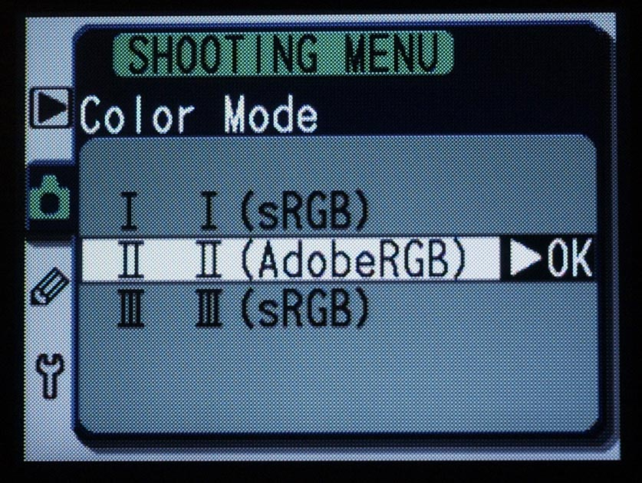
Many digital SLR’s offer the ability to choose what color space the color from the camera is processed into. This shows the choices on the Nikon D100.

Even though some cameras allow you to choose a different color space at capture or during RAW processing, the proper ICC profile is not always embedded into the image file when it is processed to a TIFF or JPEG. Check with your camera’s instructions to be sure. However, many browsers and Photoshop allow you to assign the proper profile when the image is imported. I will talk about this more in a minute.
The color management
software/hardware package
As with much of life, there are different options based on what you want to do and how much money you’re willing to spend. You’ll at least need to invest in a good monitor profiling package. If you can’t trust the color you’re seeing on your monitor, then you can’t do anything else with confidence.
GretagMacbeth makes a very good package that can be upgraded as your needs grow. Its Eye-One Display system ($250, www.i1color.com) allows for very accurate monitor calibration and profiling. It includes a colorimeter and software that allows you to create monitor profiles for either CRT or LCD monitors. The MonacoOPTIX XR package ($299) is a good choice also.
With either of these systems, setup is easy and fast, and once that’s done, using the colorimeter and software to calibrate and profile your
monitor takes five to ten minutes. Keep in mind that CRT monitors are constantly aging, so you should do this at least every two weeks for CRT monitors. Also, CRTs need time to warm up, so don’t calibrate and profile until the monitor’s been on for at least 60-minutes (make sure it doesn’t sleep – screensavers are okay). LCDs don’t drift as much, so once a month for them would probably be sufficient, and they only need a few minutes of warm-up time.
Very good quality 19-inch CRT monitors can be had for less than $400 (the LaCie ElectronBlue series has a good reputation). For now, LCD panels of high-enough quality for color-critical work are much more expensive. Expect to spend at least $1000 to find one that will do
the job.
More expensive packages will allow you to profile your other devices, including printers, flatbed and film scanners and even cameras. GretagMacbeth has even pioneered a device that can be used to profile projectors, called the Beamer.
The computer
When you run a calibration and profiling package like that offered by GretagMacbeth, the monitor profile you create will be automatically loaded as the active display profile. If you want to confirm that on your Windows XP machine, simple go to Control Panels, Display, choose Settings, then Advanced and click on the Color Management tab. The active profile will be highlighted, and you can change that from this window if you’d rather use a different monitor profile.
Browsers
What good is it to have images with color profiles attached if you can't see the photos with that profile applied? That's what's happening if you use a browser that's not color managed. And the bad news is that few of them are. Photo Mechanic, Nikon View, Canon’s Digital Photo Professional, and the Filmstrip view in the Windows XP shell all honor profiles and thus show the photos with the full effect of the profile.
The editing software
If you’ve stuck with me this long, then the next step is to make sure that all the work you’ve done up until now is taken into account by your editing software. You’ll want to confirm that the software you’re using is “color management savvy,” meaning that it understands ICC profiles and what to do with them. If you don’t know if the software you’re using does this, just go to the software’s Preferences and look for a Color Management or Color Settings tab. If it has one it supports Color Management, if not it doesn’t.
Photoshop has had color management for a long time, so it’s a good place to see how settings should be done. Photoshop 6, 7 and CS all handle color management in about the same way. In the menu go to Photoshop – Color Settings, or type Control-Shift-K. Lots of dialog boxes now appear. At the top you’ll see a Color Settings pull-down. Touch on that and select “US Prepress Defaults.” That sets your Working Color Space to Adobe RGB 1998 (which I’ll refer to as Adobe RGB from now on). If you’ve chosen to use sRGB instead, just change it with the Working Space pull-down. As a photographer you’re most concerned with setting the correct RGB Working Space and setting the Color Management Policies properly, so we’ll skip the Grayscale and CMYK boxes. Those are for people doing prepress work, and entail additional considerations.
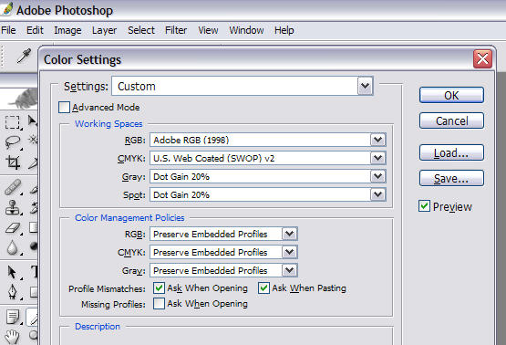
Photoshop’s Color Settings dialog box is where you set your color management policies.

“Color Management Policies” tells Photoshop what it should do with profiles. If Photoshop sees a profile attached to a file, I want Photoshop to show me what that image looks like using that profile before I make any decision on whether or not to change that image. Therefore I leave “Preserve Embedded Profiles” turned on. I also leave the “Ask When…” boxes checked, except for “Missing Profiles,” which I’ll uncheck. This is where things get a bit strange.
If Photoshop opens a file and sees that the embedded profile is different than that chosen in Color Settings, it will warn you and ask what you want to do. Different cameras store that color space information in different ways. Photoshop may or may not see it properly, and if it doesn’t, will say that an image is sRGB when in fact you’ve set the camera for Adobe RGB. This comes from Photoshop looking to the EXIF information in the file for the color space. Therefore we want to force Photoshop to ignore the EXIF data for color space info. You can do that with Photoshop 7 and Photoshop CS.
For Photoshop 7, go to the Adobe web site and download the Photoshop 7.0.1 Update and the Ignore EXIF Colorspace utilities (www.adobe.com/support/downloads/product.jsp?product=39&platform=Windows). Follow the instructions, installing the updater first, then the Ignore EXIF file. Now Photoshop 7 won’t look to the EXIF data for color space information.
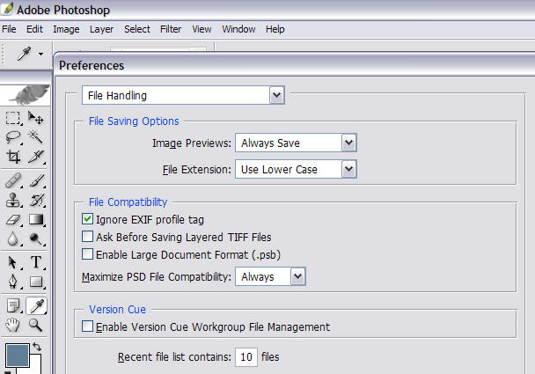
Photoshop CS includes the “Ignore EXIF Profile tag” option in its Preferences.

For Photoshop CS, go to Preferences – File Handling, and check the Ignore EXIF Profile box. This tells CS to ignore what it sees there.
Once you’ve done this, Photoshop won’t see the wrong profile (sRGB) attached to an image that you’ve set in-camera on some cameras as Adobe RGB. Instead it will see no profile, and since you’ve told it to do nothing if there’s a missing profile, will open it without complaint. This means that you’ll need to be sure to assign the correct profile after opening. You can easily do this by creating a set of Actions for the different profiles you commonly use.
Here are the steps I recommend:
Choose US Prepress Defaults in Photoshop’s Color Settings, then either Adobe RGB or sRGB as your chosen working space.
Make sure Photoshop is ignoring EXIF information in trying to read embedded color spaces (see above for how to do that).
Assign the correct color space to the photo when you open it.
This is the best process if you handle files from various cameras or sources. If the images you work with all come from the same source, you may be able to streamline this process a bit by changing the color management settings.
Other software that offers color management settings should work in a similar fashion. The keys are to choose your RGB working space and decide how to handle profiles that don’t match that working space.
The last step is to understand that when you decide to save that image, you need to save the profile along with it. Photoshop offers that option in the Save dialog. If you’re sending the image to a printer, you’ll need to make sure and convert to that printer’s working space when you do that, or know that they’ll honor the profile you’ve attached. Ask them which method they prefer.
If you’re going to print the image yourself, be sure to convert the image to the proper print space. I prefer doing this through the “Print with Preview,” dialog. Make sure that “Show More Options” is checked, then “Color Management,” and finally set the Print Space Profile dialog for the printer and paper type you’re using.
Digital noise reduction
All digital photos have some noise (often seen as a grainy look in shadows), but in-camera processing generally does a good job of removing it at low ISO’s. Once you move to higher ISO’s, or underexpose images, you’ll need to have a way of dealing with the resulting noise. While there are many products on the market, few do a good job of balancing the need to reduce noise while maintaining good image detail. There are two worth mentioning here:
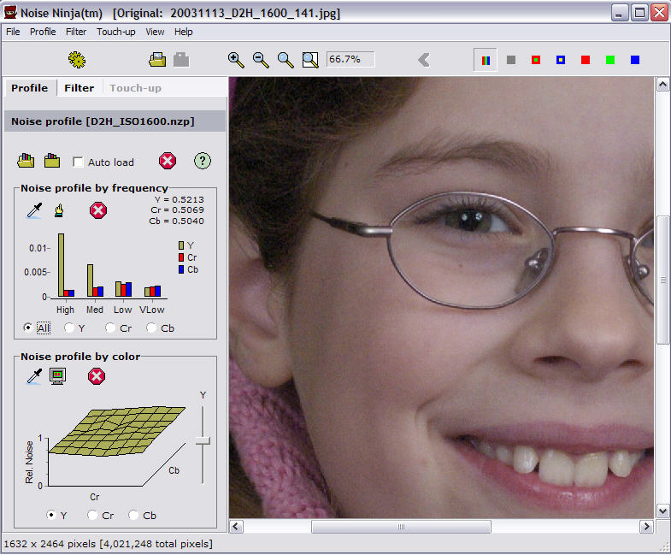
Noise Ninja (www.picturecode.com, Pro version $69), is the newest product, and does a very nice job. A stand-alone application, you start with a profile for your camera (many are included) and ISO and work from there. The interface is a little rough and previews could be faster, but with new versions on the horizon and a planned Photoshop plugin, this program is definitely worth looking into.
Noise Ninja offers powerful noise filtering of both Luminance and Chrominance noise.

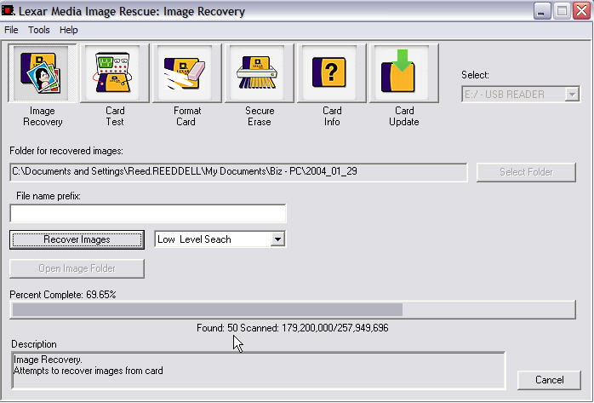
Nik Dfine (www.nikmultimedia.com, $99.95) is a Photoshop plugin that offers several different types of noise reduction with live previews. The interface takes a little getting used to, but you can start with the default settings. It also has algorithms for dealing with JPEG artifacts that can be helpful.
Lexar’s Image Rescue will bring smiles to panicked photographers

Image recovery – or, “I’ve lost my
photos!!!”
If your digital photos are important to you or mean money, then you have to know what to do if the computer can’t read the images on the card. Most of the time that means the directory structure on the card has gotten messed up, and normal recovery software won’t be able to help. Fortunately, there are two very good,
inexpensive (how often does that happen?)
solutions.
Lexar Image Rescue 2 ($39.95, free upgrade from version 1 and comes free with Lexar Professional Series cards, www.lexarmedia.com) will work with most card types and readers. It has a simple, friendly user interface. Rather than trying to repair the directory, the software simply looks for anything on the card that might be an image file and then copies that to the computer. I’ve had great success recovering images with it. It also has the ability to do a full-format on a card. This is a step that should be taken after recovering images from a troublesome card, to help prevent a repeat of the same problem with that card. The software can also perform a test, which can help you determine if you have a problem card or not. Lastly, Image Rescue 2 allows you to run a firmware update on a Lexar card if needed, saving you from shipping the card to the factory for that service.
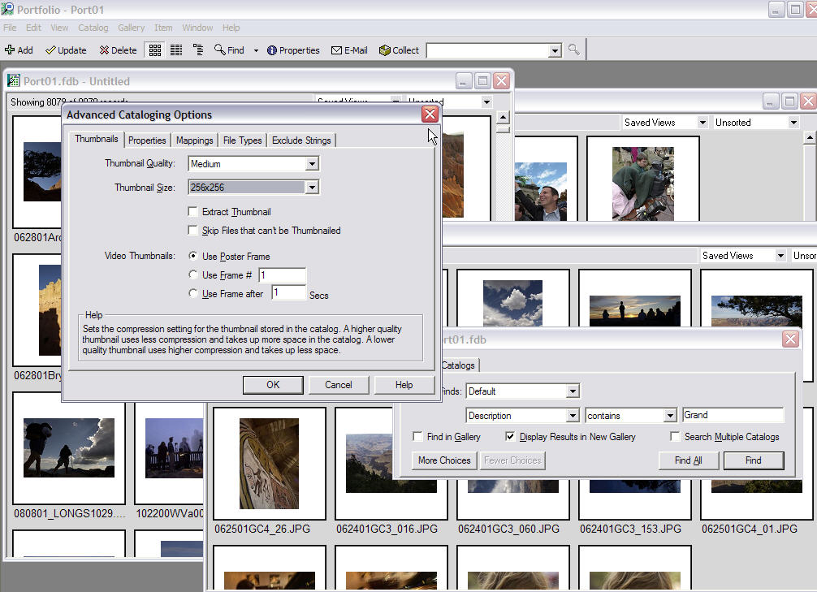
Photo Rescue (www.datarescue.com, two versions, $29 or $39, Windows 98/ME, NT/2000 and XP) is the other good software for card recovery. It works in the same sort of way that Lexar’s Image Rescue does, but without the ability to upload firmware.
Image archiving
There are two steps to archiving your images: having a second set of images (saved offsite) and being able to easily find an image.
Archiving to optical media
When it comes to long-term backup and storage of images, one of the best choices at this time is DVD. CD-R’s, with their limit of 700MB of data, are simply too small, forcing you to spend too much time burning images to disk. Single-sided DVD can store about 4.5GB of data on them. Manufacturers with good track records of high-quality media include Mitsui, Teac, Fuji and Kodak. Mitsui also makes archival disks. Properly stored (low humidity, no high temperatures, in hard cases), DVD’s should last for several decades, probably longer than readers will be available for them.
Many photographers also choose to have several high-capacity external drives (such as 250GB) so they can have their most important images live as well as on DVD.
Just as you have to keep your important business records backed up and safe, the same is true of your images. Keep one set at your office and a second set somewhere else, perhaps your home or a safe deposit box. Some cataloging and indexing software contains automated archiving that will make it easier to write images to multiple DVDs.
Cataloging and indexing
A key to saving time (and money!) is being able to quickly and easily find images. That means having a good software package that can create an offline index. Offline means you don’t have to have the original image available immediately (it can be on another disk or hard drive) but that you can see a thumbnail and preview, and have caption, keywords, filename, etc., easily available. Just as important, you need powerful and fast search capability that will find the image you need and tell you where the original is.
Extensis Portfolio is one of the leaders in serious image archiving software
Keeping in mind speed, power and flexibility in cataloging, here are a few products worth mentioning:
Extensis Portfolio (www.extensis.com) – One of the long-term leaders in cataloging, this package just keeps getting better with each release. It’s built with the pro in mind, and offers scalability, so you can start with the basic package and upgrade to server capability and web access.
iView Media (www.iview-multimedia.com) – A less powerful cataloging program, it has a good interface and the new version, MediaPro, is near release with IPTC support and catalog sizes of up to 128,000 images.
Microsoft Digital Image Library is part of Microsoft’s Digital Image Suite of image products. It provides indexing, captioning, and image archiving capabilities.
Conclusions
A digital photographer will soon find that sloppy work habits mean wasted time and money. Good planning and organization, from properly preparing for the assignment through good exposure and white balance choices and then smart digital workflow decisions, will pay off in better photos and saved time.

The computer system and software you choose and how you manage them are important too. Do your research and find equipment and software that helps you and makes your workflow simpler and more efficient. Take the time to lean about the image and color management features of Windows XP, and of the best professionally-oriented software tools and applications. Do this and you’ll have more time for doing what you really care about—making photos.
Reed Hoffmann is Director of Education and Training for Blue Pixel (www.bluepixel.net), a firm that specializes in digital photography and workflow consulting

© 2004 Reed Hoffmann, Blue Pixel. All rights reserved.

This whitepaper is for informational purposes only. MICROSOFT MAKES NO WARRANTIES, EXPRESS OR IMPLIED, IN THIS SUMMARY. Microsoft and Windows are either registered trademarks or trademarks of Microsoft Corporation in the United States and/or other countries. The names of actual companies and products mentioned herein may be the trademarks of their respective owners.

Photographs © Reed Hoffmann. Used by permission.

Document published March, 2004

