

Server Clusters: Cluster Configuration Best Practices for Windows Server 2003
Microsoft Corporation
Published: January 1, 2003

Abstract
Discusses cluster and application deployment, server load, and load balancing.

Information in this document, including URL and other Internet Web site references, is subject to change without notice. Unless otherwise noted, the example companies, organizations, products, domain names, e-mail addresses, logos, people, places, and events depicted herein are fictitious, and no association with any real company, organization, product, domain name, e-mail address, logo, person, place, or event is intended or should be inferred. Complying with all applicable copyright laws is the responsibility of the user. Without limiting the rights under copyright, no part of this document may be reproduced, stored in or introduced into a retrieval system, or transmitted in any form or by any means (electronic, mechanical, photocopying, recording, or otherwise), or for any purpose, without the express written permission of Microsoft Corporation.

Microsoft may have patents, patent applications, trademarks, copyrights, or other intellectual property rights covering subject matter in this document. Except as expressly provided in any written license agreement from Microsoft, the furnishing of this document does not give you any license to these patents, trademarks, copyrights, or other intellectual property.

© 2005 Microsoft Corporation. All rights reserved.

Microsoft, Windows, and Windows Server are either registered trademarks or trademarks of Microsoft Corporation in the United States and/or other countries.

All other trademarks are property of their respective owners.

Contents
Server Clusters: Cluster Configuration Best Practices for Windows Server 2003 1
Abstract 1
Contents 3
Cluster and Application Deployments 5
Server Load 6
Server Load The Basics 6
Server Load Some More Realistic Configurations 7
Application Style 11
Application Deployments 16
Failover Policies 18
Failover Pairs 18
Hot-Standby Server 19
N+I 21
Failover Ring 22
Random 24
Customized control 25
Load Balancing 26

Published: January 1, 2003

Cluster and Application Deployments
Historically, we have described clusters and applications as being active/active or active/passive, which is a natural result of the fact that the earliest products supported only 2-node clusters. In some cases, however, this has led to confusion because the terms can be interpreted in different ways depending on whether the context is 1) how a given application instance is running, 2) how different instances of an application are running or 3) whether the nodes in the cluster are performing useful work. To fully understand the specific application and cluster deployments, we need to understand the following:
• How many instances of the application are actually up and running?
• How many instances of the same data are in the cluster?
• Do instances of the data move around?
• Do different instances of the same application run on different cluster nodes?
• Can different applications run on different cluster nodes?
• What kind of load does the application put on a server, and how will this load be re-distributed after a failover?
Before describing how an application is deployed, we must first define what an application is. An application, for the purposes of this document, is defined as the running code and data required to provide a single service to an end-user or client. Consider a couple of different examples to illustrate the point: A single instance of Microsoft Word running on a workstation is a single application instance. If there are multiple instances of Word running, each instance is considered a different application instance. There are, however, more complex applications. For example, with Microsoft SQL Server, a single database is considered to be a single application instance. Independent databases are considered to be different application instances. A single database, however, can be partitioned into multiple SQL Server instances and tied-together using the SQL Server query engine. In this case, the set of SQL Server instances that are tied together to provide a single database image is considered a single application instance.
Fundamentally, there are five different attributes that together provide a complete view of the deployment and can be used to reason about or characterize the deployment:
• Server load How much of a servers resources are consumed by the applications it supports, and how will this resource utilization be affected by failover?
• Application style Is the application a single monolithic application that runs on a single node or is the complete application split into smaller pieces that can be deployed around the cluster?
• Application deployment How are the pieces of the application spread around the cluster in a given deployment?
• Failover policies How is the application configured to behave after a failover?
• Application implementation How is the application itself implemented?

Server Load
When deploying an application, it is always important to consider what demands it will make on a servers resources. With clustering, there is a related issue that also needs to be taken into account: how is the load re-distributed after a failover?

Server Load The Basics
Consider one of the simplest cases, an active/active, 2-node file server cluster, with node A and node B each serving a single share. If node A fails, its resources will move to node B, placing an additional load on node B. In fact, if node A and B were each running at only 50% capacity before the failure, node B will be completely saturated (100% of capacity) after the failover is completed, and performance may suffer.
While this situation may not be optimal, it is important to remember that having all of the applications still running, even in a reduced performance scenario, is a 100% improvement over what you would have without the high availability protection that clusters provide. But this does bring up the notion of risk, and what amount of it you are willing to accept in order to protect the performance, and ultimately the availability, of your applications.
We have intentionally chosen the worst case (an active/active, 2-node cluster with each node running a single application that consumes half of the servers resources) for the purpose of clarity. With an additional node, the equation changes: there are more servers to support the workload, but if all three nodes are running at 50% capacity and there are two failures, the single remaining server will simply not be able to handle the accumulated load of the applications from both of the failed servers. Of course, the likelihood of two failures is considerably less than that of a single failure, so the risk is mitigated somewhat.
Nevertheless, the load/risk tradeoff must be considered when deploying applications on a cluster. The more nodes in a cluster, the more options you have for distributing the workload. If your requirements dictate that all of your clustered applications must run with no performance degradation, then you may need to consider some form of active/passive configuration. But even in this scenario, you must consider the risks of the various configurations. If you cannot accept even the slightest risk of any reduced performance under any conditions whatsoever, you will need a dedicated passive node for each active node.
If, on the other hand, you are convinced that the risk of multiple failures is small, you have other choices. If you have a 4-node, or 8-node cluster, you may want to consider an N+I configuration. N+I, which is discussed in more detail in section 1.4.3, is a variant of active/passive, where N nodes are active, and I nodes are passive, or reserve nodes. Typically, the value for I is less than the value for N, and an N+I cluster topology can handle I failures before any performance degradation is likely. The risk is that with more than I failures, performance will likely decline, but once again, the likelihood of multiple failures is increasingly remote.
For this reason, N+I clusters are a useful configuration that balances the hardware cost of having 100% passive server capacity against the low level risk of multiple cluster node failures.

Server Load Some More Realistic Configurations
The scenarios above were intentionally simplistic, assuming that one application imposed a monolithic load on each server, and thus its resource utilization could not be spread among more than one other server in the event of a failover. That is often not the case in the real world, especially for file and print servers, so we will take a look at some additional scenarios with a 4-node cluster, named ABCD, and having nodes A, B, C, and D.
Typically a single server will support the load of more than one application. If under normal conditions, each server was loaded at 25%, then the ABCD cluster could survive the loss of three members before a likely loss of application availability, which would be nearly a worst-case scenario.
The following series of figures illustrates what would happen with the application load in a 4-node cluster for successive node failures. The shaded, or patterned, areas indicate the capacity demands of the running applications. Further, the example below assumes that the application load on any given server is divisible, and can be redistributed among any of the surviving nodes.


Figure 1.1: Cluster under normal operating conditions (each node loaded at 25%)


Figure 1.2: Cluster after a single node failure. Note redistribution of application load.


Figure 1.3: Cluster after two node failures. Each surviving node is now approximately 50% loaded.


Figure 1.4: After three node failures, single surviving node is at full capacity.
If each node were running at 75% capacity, then without sensible failover policies, even a single node failure could result in loss of application availability. Depending on the application(s), however, you can specify that, in the event of a server failure, some percentage of the applications should fail over to node A, node B, node C, and node D. If the applications are spread evenly among the surviving nodes, then this cluster could now survive the loss of a single machine, because one third of the failed servers load (one third of 75% is 25%) is allocated to each of the surviving three machines. The result is three fully loaded servers (each of the nodes running at 75% capacity now have an additional 25%), but all applications are still available.
As a variation on the example that was illustrated previously, the following series of figures will depict what happens to a 4-node cluster, each of which is running at approximately 33% capacity. Further, in this case, the application load is indivisible, and can not be spread among multiple other servers in the event of a failover (perhaps it is a single application or multiple applications that depend on the same resource).


Figure 2.1: Cluster under normal operating conditions (each node loaded at approximately 33%)


Figure 2.2: Cluster after a single node failure. Note redistributed application load.


Figure 2.3: Cluster after second node failure. Each surviving node is now running at approximately 66% capacity. Note that in the event of another node failure, this cluster will no longer be capable of supporting all four of these applications.


Figure 2.4: After third failure, the single surviving server can only support three of the four applications.
Another style of failover policy is Failover Pairs, also known as Buddy Pairs. Assuming each of the four servers is loaded at 50% or less, a failover buddy can be associated with each machine. This allows a cluster in this configuration to survive two failures. More details on Failover Pairs can be found in section 1.4.1.
Taking the previous Failover Pair example, we can convert it to an active/passive configuration by loading two servers at 100% capacity, and having two passive backup servers. This active/passive configuration can also survive two failures, but note that under ordinary circumstances, two servers remain unused. Furthermore, performance of these servers at 100% load is not likely to be as good as with the Failover Pair configuration, where each machine is only running at 50% utilization. Between these two examples, note that you have the same number of servers, the same number of applications, and the same survivability (in terms of how many nodes can fail without jeopardizing application availability). However, the Failover Pair configuration clearly comes out ahead of active/passive in terms of both performance and economy.
Still using our ABCD 4-node cluster, consider what happens if we configure it as an N+I cluster (explained in more detail in section 1.4.3) where three nodes are running at 100% capacity, and there is a single standby node. This cluster can only survive a single failure. As before, however, comparing it to the example where each server is running at 75% capacity, you again have the same number of servers, applications, and same survivability, but the performance and economy can suffer when you have passive servers backing up active servers running at 100% load.

Application Style
Now it is time to consider some aspects of the applications design, and how that affects the way it is deployed. Applications running in a cluster can be characterized as one of:
• Single Instance
In a single instance application, only one application instance is running in the cluster at any point in time. An example of this is the DHCP service in a server cluster. At any point in time, there is only one instance of the DHCP service running in a cluster. The service is made highly available using the failover support provided with server clusters. Single instance applications typically have state that cannot be partitioned across the nodes. In the case of DHCP, the set of IP addresses that have been leased is relatively small, but potentially highly volatile in a large environment. To avoid the complexities of synchronizing the state around the cluster, the service runs as a single instance application.
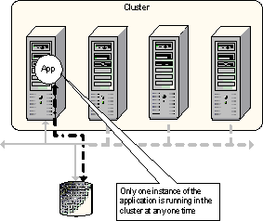

Figure 3: Single instance application
In the example above, the cluster has four nodes. The single instance application, by definition, can be running on only one node at a time.
• Multiple Instance
A multiple instance application is one where multiple instances of the same code or different pieces of code that cooperate to provide a single service can be executing around the cluster. Together these instances provide the illusion of a single service to an end-user or client computer. There are two different types of multiple instance applications that depend on the type of application and data:
• Cloned Application. A cloned application is a single logical application that consists of two or more instances of the same code running against the same data set. Each instance of the application is self-contained, thus enabling a client to make a request to any instance of the application with the guarantee that regardless of the instance, the client will receive the same result. A cloned application is scalable since additional application instances can be deployed to service client requests and the instances can be deployed across different nodes, thus enabling an application to grow beyond the capacity of a single node. By deploying application instances on different nodes, the application is made highly available. In the event that a node hosting application instances fails, there are instances running on other nodes that are still available to service client requests.
Typically, client requests are load-balanced across the nodes in the cluster to spread the client requests amongst the application instances. Applications that run in this environment do not have long-running in-memory state that spans client requests, since each client request is treated as an independent operation and each request can be load-balanced independently. In addition, the data set must be kept consistent across the entire application. As a result, cloning is a technique typically used for applications that have read-only data or data that is changed infrequently. Web server front-ends, scalable edge-servers such as arrays of firewalls and middle-tier business logic fall into this category.
While these applications are typically called stateless applications1 they can save client-specific session-oriented state in a persistent store that is available to all instances of the cloned application, however, the client must be given a token or a key that it can present with subsequent requests so that whichever application instance services each request can associate the request with the appropriate client state.
The Microsoft Windows platform provides Network Load Balancing as the basic infrastructure for building scale-out clusters with the ability to spray client requests across the nodes. Application Center provides a single image view of management for these environments.
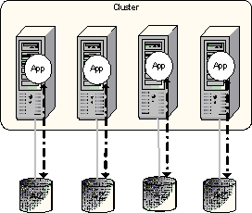

Figure 4: Cloned Application
In the example above, the same application App is running on each node. Each instance of the application is accessing the same data set, in this case the dataset A-Z. This example show each instance having access to its own data set (created and kept consistent using some form of staging or replication technique), some applications can share the same data set (where the data is available to the cluster using a file share for example).
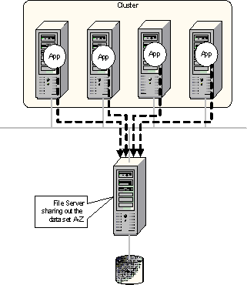

Figure 5: Cloned Application using a file share
• Partitioned Applications. Applications that have long-running in-memory state or have large, frequently updated data sets cannot be easily cloned. These applications are typically called stateful applications. The cost of keeping the data consistent across many instances of the application would be prohibitive.
Fortunately, however, many of these applications have data sets or functionality that can be readily partitioned. For example, a large file server can be partitioned by dividing the files along the directory structure hierarchy or a large customer database can be partitioned along customer number or customer name boundaries (customers from A to L in one database, customers from M to Z in another database, for example). In other cases, the functionality can be partitioned or componentized. Once an application is partitioned, the different partitions can be deployed across a set of nodes in a cluster, thus enabling the complete application to scale beyond the bounds of a single node. In order to present a single application image to the clients, a partitioned application requires an application-dependent decomposition, routing and aggregation mechanism that allows a single client request to be distributed across the set of partitions and the results from the partitions to be combined into a single response back to the client. For example, take a partitioned customer database, a single SQL query to return all of the accounts that have overdue payments requires that the query be sent to every partition of the database. Each partition will contain a subset of customer records that must be combined into a single data set to be retuned to the client. Partitioning an application allows it to scale but does not provide high availability. If a node fails that is hosting a partition of the application, that piece of the data set or that piece of functionality is no longer accessible.
Partitioning is typically application-specific, since the aggregation mechanism is dependent of the type of application and the type of data returned. SQL Server, Exchange data stores and DFS are all examples of applications and services that can be partitioned for scalability.
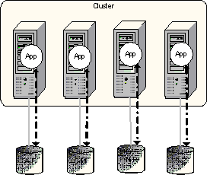

Figure 6: Partitioned Application Data Partitioning
In the example above, each node is running multiple instances of the same application against different pieces of the complete data set. A single request from a client application can span multiple instances, for example a query to return all the records in the database. This splitting of the client across the different application instances and the aggregation of the single result passed back to the client can be done either by the applications on the server cooperating amongst themselves (for example the SQLQuery engine) or it can be done by the client (as is the case with Exchange 2000 data stores).
Applications may also be partitioned along functional lines as well as data sets.
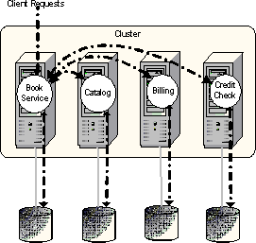

Figure 7: Partitioned Application - Functional Partitions
In the above example, each node in the cluster is performing a different function; however, the cluster together provides a single, uniform service. One node is providing a catalog service; one is providing a billing service, etc. The cluster, though, provides a single book buying service to clients.
Computational clusters are built to support explicitly massively parallel applications. In other words, the applications are specifically written to decompose a problem into many (potentially thousands) of sub-operations and execute them in parallel across a set of machines. This type of application is also a partitioned application. Computational clusters typically provide a set of libraries to provide cluster-wide communication and synchronization primitives tailored to the environment (MPI is one such set of libraries). These clusters have been termed Beowulf clusters. Microsoft has created the High Performance Computing initiative to provide support for this type of cluster.

Application Deployments
Applications can be deployed in different ways across a cluster depending on what style of application is being deployed and the number of applications that are being deployed on the same cluster. They can be characterized as follows:
1. One, single instance application
In this type of deployment, one node of the cluster is executing the application so that it can service user requests, the other nodes are in stand-by, waiting to host the application in the event of failure. This type of deployment is typically suited to 2-node failover clusters and is not typically used for N-node clusters since only 1/N of the total capacity is being used. This is what some people term an active/passive cluster.
2. Several, single instance applications
Several single instance applications can be deployed on the same cluster. Each application is independent from the others. In a failover cluster, each application can failover independently for the others, so in the case of a node hosting multiple applications, if that node fails, the different applications may failover to different nodes in the cluster. This type of deployment is typically used for consolidation scenarios where multiple applications are hosted on a set of nodes and the cluster provides a highly available environment. In this environment, careful capacity planning is required to ensue that in the event of failures, the nodes have sufficient capacity (CPU, memory IO bandwidth etc.) to support the increased load.
3. A single, multiple instance application
In this environment, while the cluster is only supporting one application, various pieces of the application are running on the different nodes. In the case of a cloned application, each node is running the same code against the same data. This is the typical web-front end scenario (all of the nodes in the cluster are identical). In the event of a failure, the capacity is reduced. In a partitioned application, the individual partitions are typically deployed across the nodes in the cluster. If a failure occurs, multiple partitions may be hosted on a single node. Careful planning is required to ensure that, in the event of a failure, the application SLA is achieved. Take a 4-node cluster as an example. If an application is partitioned into four pieces, then in normal running, each node would host a partition. In the event that one node failed, two nodes would continue to host one partition and the remaining node would end up hosting two partitions, giving the 3rd node twice the load, potentially. If the application were split into 12 partitions, each node would host three partitions in the normal case. In the event of a failure, each partition could be configured to failover to a different node, thereby; the remaining nodes could each host four partitions, spreading the load in the event of a failure. The cost however, is that support for 12 partitions may be more overhead than for four partitions.
4. Several, multiple instance applications
Of course, several multiple instance applications may be deployed on the same cluster (indeed single instance and multiple instances may be deployed on the same cluster). In the case of multiple cloned applications, each node is simply running one instance of each application. In the case of a partitioned application, capacity planning as well as defining failover targets becomes increasingly complex.

Failover Policies
Failover is the mechanism that single instance applications and the individual partitions of a partitioned application typically employ for high availability (the term Pack has been coined to describe a highly available, single instance application or partition).
In a 2-node cluster, defining failover policies is trivial. If one node fails, the only option is to failover to the remaining node. As the size of a cluster increases, different failover policies are possible and each one has different characteristics.

Failover Pairs
In a large cluster, failover policies can be defined such that each application is set to failover between two nodes. The simple example below shows two applications App1 and App2 in a 4-node cluster.
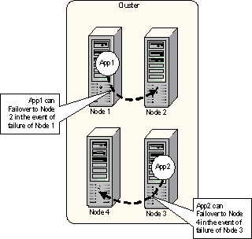

Figure 8: Failover pairs
This configuration has pros and cons:

Pro | Good for clusters that are supporting heavy-weight2 applications, such as databases. This configuration ensures that in the event of failure, two applications will not be hosted on the same node.
Pro | Very easy to plan capacity. Each node is sized based on the application that it will need to host (just like a 2-node cluster hosting one application).
Pro | Effect of a node failure on availability and performance of the system is very easy to determine.
Pro | Get the flexibility of a larger cluster. In the event that a node is taken out for maintenance, the buddy for a given application can be changed dynamically (may end up with standby policy below).
Con | In simple configurations, such as the one above, only 50% of the capacity of the cluster is in use.z
Con | Administrator intervention may be required in the event of multiple failures.

Failover pairs are supported by server clusters on all versions of Windows by limiting the possible owner list for each resource to a given pair of nodes.

Hot-Standby Server
To reduce the overhead of failover pairs, the spare node for each pair may be consolidated into a single node, providing a hot standby server that is capable of picking up the work in the event of a failure.
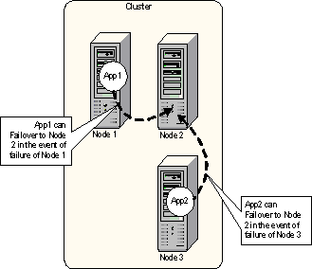

Figure 9: Standby Server
The standby server configuration has pros and cons:

Pro | Good for clusters that are supporting heavy-weight applications such as databases. This configuration ensures that in the event of a single failure, two applications will not be hosted on the same node.
Pro | Very easy to plan capacity. Each node is sized based on the application that it will need to host, the spare is sized to be the maximum of the other nodes.
Pro | Effect of a node failure on availability and performance of the system is very easy to determine.
Con | Configuration is targeted towards a single point of failure.
Con | Does not really handle multiple failures well. This may be an issue during scheduled maintenance where the spare may be in use.

Server clusters support standby servers today using a combination of the possible owners list and the preferred owners list. The preferred node should be set to the node that the application will run on by default and the possible owners for a given resource should be set to the preferred node and the spare node.

N+I
Standby server works well for 4-node clusters in some configurations, however, its ability to handle multiple failures is limited. N+I configurations are an extension of the standby server concept where there are N nodes hosting applications and I nodes which are spares.
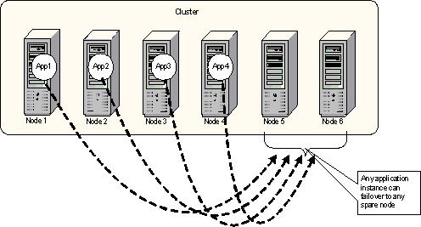

Figure 10: N+I Spare node configuration
N+I configurations have the following pros and cons:

Pro | Good for clusters that are supporting heavy-weight applications such as databases or Exchange. This configuration ensures that in the event of a failure, an application instance will failover to a spare node, not one that is already in use.
Pro | Very easy to plan capacity. Each node is sized based on the application that it will need to host.
Pro | Effect of a node failure on availability and performance of the system is very easy to determine.
Pro | Configuration works well for multiple failures.
Con | Does not really handle multiple applications running in the same cluster well. This policy is best suited to applications running on a dedicated cluster.

Server clusters supports N+I scenarios in the Windows Server 2003 release using a cluster group public property AntiAffinityClassNames. This property can contain an arbitrary string of characters. In the event of a failover, if a group being failed over has a non-empty string in the AntiAffinityClassNames property, the failover manager will check all other nodes. If there are any nodes in the possible owners list for the resource that are NOT hosting a group with the same value in AntiAffinityClassNames, then those nodes are considered a good target for failover. If all nodes in the cluster are hosting groups that contain the same value in the AntiAffinityClassNames property, then the preferred node list is used to select a failover target.

Failover Ring
Failover rings allow each node in the cluster to run an application instance. In the event of a failure, the application on the failed node is moved to the next node in sequence.
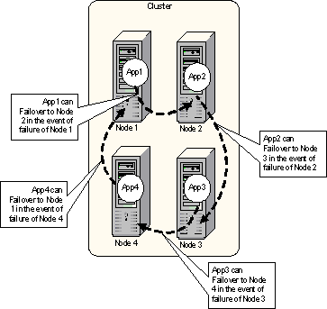

Figure 11: Failover Ring
This configuration has pros and cons:

Pro | Good for clusters that are supporting several small application instances where the capacity of any node is large enough to support several at the same time.
Pro | Effect on performance of a node failure is easy to predict.
Pro | Easy to plan capacity for a single failure.
Con | Configuration does not work well for all cases of multiple failures. If Node 1 fails, Node 2 will host two application instances and Nodes 3 and 4 will host one application instance. If Node 2 then fails, Node 3 will be hosting three application instances and Node 4 will be hosting one instance.
Con | Not well suited to heavy-weight applications since multiple instances may end up being hosted on the same node even if there are lightly-loaded nodes.

Failover rings are supported by server clusters on the Windows Server 2003 release. This is done by defining the order of failover for a given group using the preferred owner list. A node order should be chosen and then the preferred node list should be set up with each group starting at a different node.

Random
In large clusters or even 4-node clusters that are running several applications, defining specific failover targets or policies for each application instance can be extremely cumbersome and error prone. The best policy in some cases is to allow the target to be chosen at random, with a statistical probability that this will spread the load around the cluster in the event of a failure.
Random failover policies have pros and cons:

Pro | Good for clusters that are supporting several small application instances where the capacity of any node is large enough to support several at the same time.
Pro | Does not require an administrator to decide where any given application should failover to.
Pro | Provided that there are sufficient applications or the applications are partitioned finely enough, this provides a good mechanism to statistically load-balance the applications across the cluster in the event of a failure.
Pro | Configuration works well for multiple failures.
Pro | Very well tuned to handling multiple applications or many instances of the same application running in the same cluster well.
Con | Can be difficult to plan capacity. There is no real guarantee that the load will be balanced across the cluster.
Con | Effect on performance of a node failure is not easy to predict.
Con | Not well suited to heavy-weight applications since multiple instances may end up being hosted on the same node even if there are lightly-loaded nodes.

The Windows Server 2003 release of server clusters randomizes the failover target in the event of node failure. Each resource group that has an empty preferred owners list will be failed over to a random node in the cluster in the event that the node currently hosting it fails.

Customized control
There are some cases where specific nodes may be preferred for a given application instance.
A configuration that ties applications to nodes has pros and cons:

Pro | Administrator has full control over what happens when a failure occurs.
Pro | Capacity planning is easy, since failure scenarios are predictable.
Con | With many applications running in a cluster, defining a good policy for failures can be extremely complex.
Con | Very hard to plan for multiple, cascaded failures.

Server clusters provide full control over the order of failover using the preferred node list feature. The full semantics of the preferred node list can be defined as:

Preferred Node List | Move group to best possible initiated via administrator | Failover due to node or group failure
Contains all nodes in cluster | Group is moved to highest node in preferred node list that is up and running in the cluster. | Group is moved to the next node on the preferred node list.
Contains a subset of the nodes in the cluster | Group is moved to highest node in preferred node list that is up and running in the cluster.  If no nodes in the preferred node list are up and running, the group is moved to a random node. | Group is moved to the next node on the preferred node list.  If the node that was hosting the group is the last on the list or was not in the preferred node list, the group is moved to a random node.
Empty | Group is moved to a random node. | Group is moved to a random node.

1 This is really a misnomer, the applications have state, however, the state does not span individual client requests.
2 A heavy-weight application is one that consumes a significant number of system resources such as CPU, memory or IO bandwidth.

Load Balancing
Load balancing is a term that means many different things. Within a cluster environment, load balancing is typically used in two different ways:
• Spreading client requests across a set of clones In Windows, Network Load Balancing (NLB) provides the capability to spread client TCP/IP requests across a set of nodes (typically Web servers or ISA arrays or terminal server machines). This functionality can also be provided by external network infrastructure such as CISCO local director.
• Optimizing the compute resources across a failover cluster A cluster that supports failover allows application instances to move around the cluster. Historically this has been used to ensure that on failure, the application can be restarted elsewhere. However, using this same mechanism could be used with performance counters and application load metrics to provide a way to balance the load of applications across the nodes in a cluster. This can be done in one of two ways:
• Manual load balancing: Each group in a cluster can be moved around independently of the other cluster groups. By breaking down applications into finely defined groups where it is possible, manual load balancing can be done using the cluster administration tools. If the load on a given node is high relative to the other nodes in the cluster, one or more groups can be manually moved to other cluster nodes.
• Dynamic load balancing: Today, Server clusters do not provide any load balancing mechanism (beyond a randomized failover policy in Windows Server 2003). Dynamic load balancing is an extremely complex issue, while moving an application may at first appear to make sense, the cost of that move can be hard to determine. For example, moving SQL Server may not only incur the cost of having to re-mount the database, but it also loses the in-memory cache and state which may have a significant impact on performance from the client perspective.

