
Microsoft Office Accounting Express 2007

Microsoft® Office Accounting Express 2007 is an essential tool for managing your business finances. Whether you’re a small or home-based business, you can use this simple accounting program to make pen and paper-based tasks a thing of the past.

With the familiar look and feel of Microsoft Office, Office Accounting Express 2007 is easy to use and helps you save time, get organized, and do business online.

You only need to enter data once so you can save time managing everyday financial tasks. All of your customer and financial information is stored in one place so that you have a complete view of your business. You also have the tools you need to sell online through eBay® and get paid faster.
Save Time and Work More Efficiently
Office Accounting Express 2007 is easy to use and allows you to enter information only once. Whether you’re creating quotes and invoices or writing checks, Office Accounting Express 2007 can help you complete tasks in less time.
- Easy to learn and use.
With Office Accounting Express 2007, you can get up and running quickly. The simple Startup Wizard walks you through the process of getting started, and the familiar look and feel of Microsoft Office makes it easy to find the features you need. You can also quickly import your existing data from Microsoft Office Excel®, Microsoft Money, and Intuit QuickBooks, so there is no need to start from scratch.
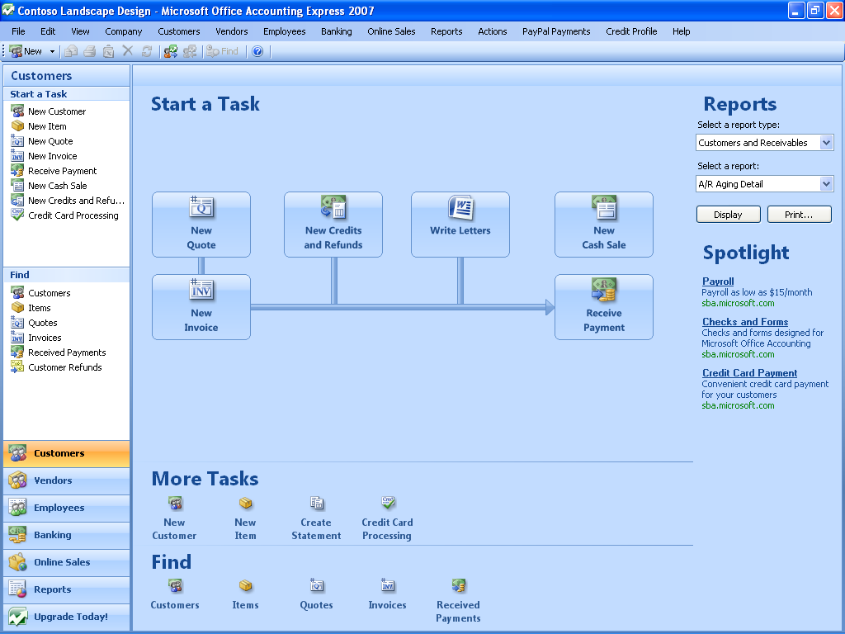
Get started quickly with the familiar look and feel of Microsoft Office.
- Spend less time managing everyday tasks.
Creating and tracking customer quotes and invoices can be a daunting task for any small business. You might have some information stored in Microsoft Office Excel or Microsoft Office Word, while other data is buried in a pile of paperwork on your desk.
Now you can use the integrated tools of Office Accounting Express 2007 to create quotes, invoices, and receipts quickly and easily. You can write checks, track expenses, and reconcile online bank accounts. You can also track employee time and manage payroll and taxes by using the integrated payroll services of Automatic Data Processing (ADPSM)*.
- Enter data only once.
With Office Accounting Express 2007, you no longer need to retype data into your computer. You only need to enter data once. All information is shared across commonly used forms and other Microsoft Office programs like Microsoft Office Word and Office Excel. This capability enables you to create a quote and convert it into an invoice in just one click. It’s a simple way to reduce errors and make sure you get it right the first time.
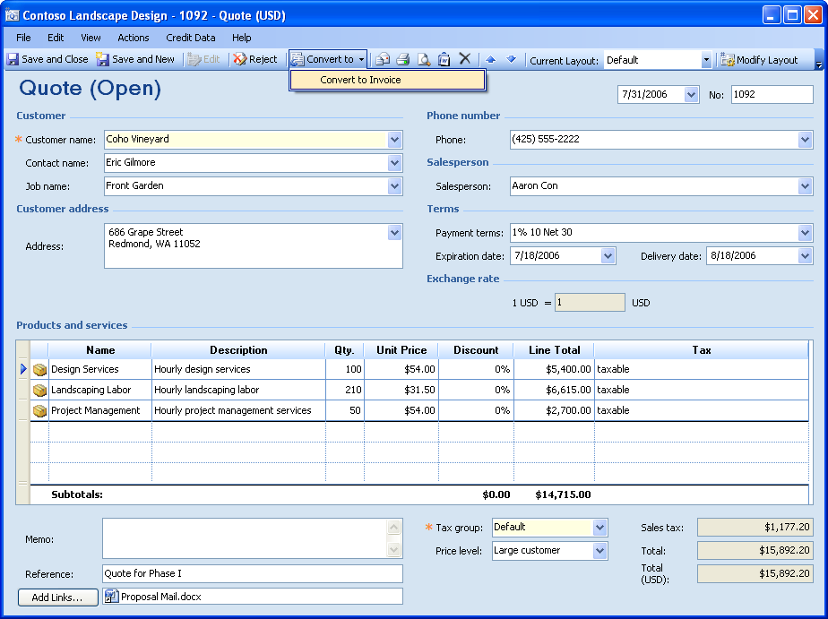
Save time by reusing information to create new
documents, such as invoices.

Get Organized
Office Accounting Express 2007 enables you to get organized by storing and organizing all your customer and financial information in one place so that you have a complete view of your business.
- Store and organize all your information in one place.
You can now store and organize your customer, contact, employee, vendor, and financial information in a single program. Office Accounting Express 2007 and Office Outlook® 2007 with Business Contact Manager share the same data, which helps ensure that all of your customer information stays up-to-date.
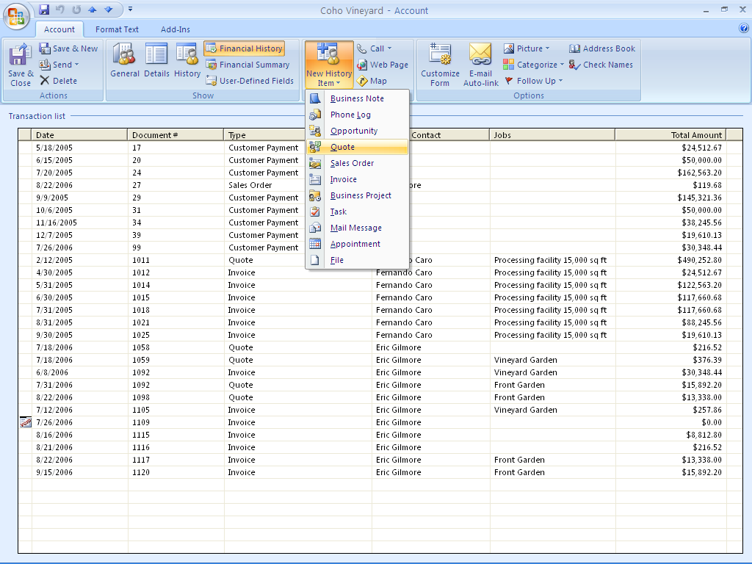
View a customer’s financial history and create quotes from Office Outlook 2007.
- Know how your business is doing.
With Office Accounting Express 2007, you can find out exactly how your business is doing at a glance. Choose from more than 20 predefined reports to gain insight into your business, or customize the reports to meet your specific business needs. You can also export the reports to Office Excel 2007 for further analysis in just one click.
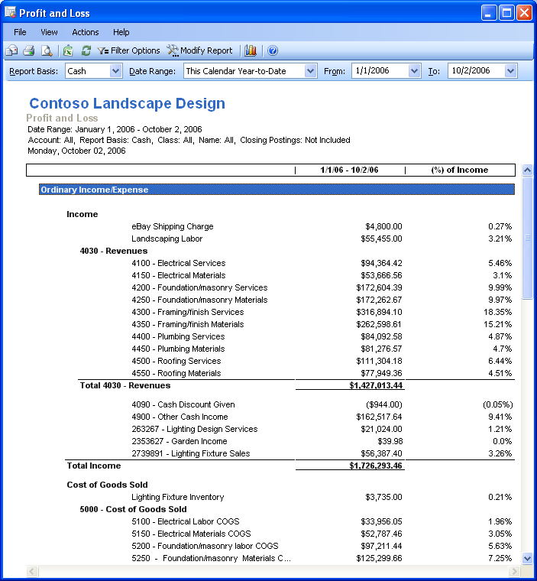
Use over 20 customizable reports to see how
your business is doing at a glance.
- Easily share information with your accountant.
Meeting with your accountant no longer requires days of preparation. Use Office Accounting Express 2007 to create a copy of your books for your accountant with a cutoff date so that you can continue to run your business. You can also share the data in a security-enhanced environment using Microsoft Office Live.
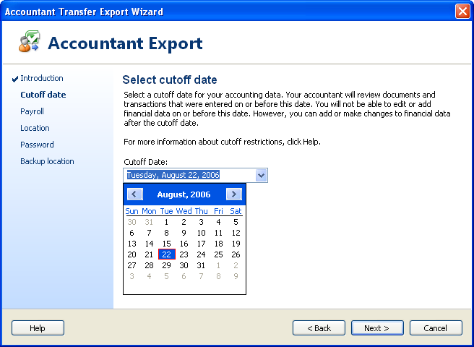
Send your books to your accountant with the Accountant Transfer Export Wizard.
Do Business Online
Are you ready to sell on eBay? Office Accounting Express 2007 gives you the tools you need to reach out to millions of potential customers by taking your business online—from simplifying online sales to making sure that you get paid faster.
- Easily sell on eBay.
Office Accounting Express 2007 makes it easy to sell on eBay*. You can list items, upload and manage pictures, and track activity in real-time. You can also download and process orders, track eBay sales and fees, and process PayPal® transactions automatically.
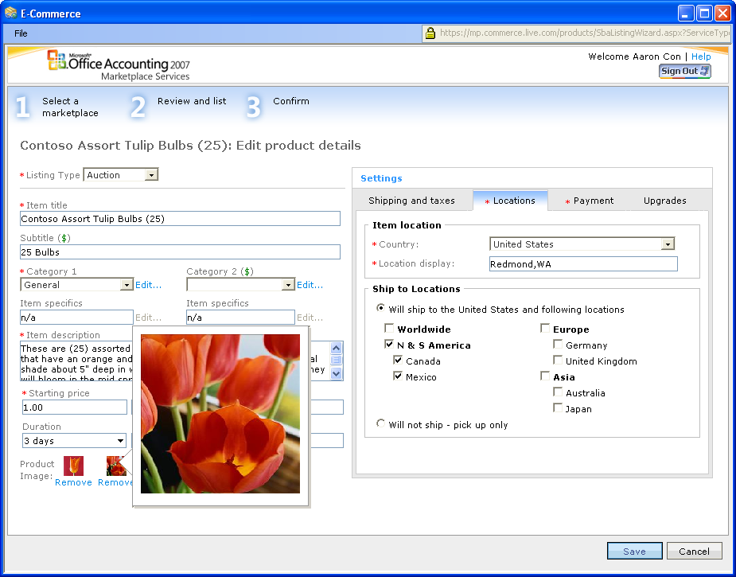
Sell online easily by using eBay.
- Get paid faster.
Now you can get paid faster with PayPal. Seamless integration with Office Outlook 2007 lets you send invoices in an e-mail message and include a direct link to PayPal*. Customers simply open the message to view the invoice, and then click the link to make a payment. You can also process credit card transactions quickly.
- Do business with confidence.
Office Accounting Express 2007 simplifies the sales process so that you can do business with confidence. Part of that confidence comes from learning more about your customers. You can now monitor your customers’ credit in real time by ordering reports through the integrated Equifax®* credit reporting services. You can also monitor your business credit by ordering a credit report for your company.
2007

This document is for informational purposes only. MICROSOFT MAKES NO WARRANTIES, EXPRESS OR IMPLIED, IN THIS SUMMARY.
The example companies, organizations, products, domain names, e-mail addresses, logos, people, places, and events depicted herein are fictitious. No association with any real company, organization, product, domain name, e-mail address, logo, person, places, or events is intended or should be inferred.

© 2006 Microsoft Corporation. All rights reserved. Microsoft, Excel, the Office logo, and Outlook are either registered trademarks or trademarks of Microsoft Corporation in the United States and/or other countries. All other trademarks are property of their respective owners.

ADP is a service mark of ADP of North America, Inc. in the United States and in other countries

eBay and the eBay logo are registered trademarks of eBay, Inc.

Equifax is a registered trademark of Equifax, Inc.

PayPal and the PayPal logo are registered trademarks of PayPal, Inc.

*Third-party service, additional fees may apply.

