Cluster Resource Monitoring and Management
A series about Windows high- performance cluster planning and administration
By Cornell Theory Center

Introduction

Resource monitoring and management are one of the most important aspects of providing a successful high performance computing, HPC, environment. Systems that are easy to manage are typically easier to use and provide a more productive computing environment. The manageability of a system is directly related to the tools provided by the operating system. Microsoft provides excellent tools built into the Windows 2000 operating system that make gathering status and performance information very easy. The Windows Management Instrumentation (WMI) technology, WMI, and the Performance Data Helper DLL (PDH.DLL) application programming interface. Microsoft uses these tools for its own applications. For example, Systems Management Server, SMS, and the Windows Management Console use WMI for gathering inventory information for the nodes it manages and Performance Monitor uses PDH. The problem with Performance Monitor and other such tools from Microsoft tools is that they are really designed to interface with a single to a few servers at a time. For example a common thing for an HPC user to want to do is to monitor all the compute nodes associated with a particular parallel job. In the case of a massively parallel application where a user my be using hundreds of compute nodes at one time, Performance Monitor would take too long to setup. However, the real beauty of these tools is not just that MS has built tools on top of them, but that you can too! In fact these tools are accessible not only from C and C++, but also Visual Basic, Perl, Python and other languages, scripting and compiled languages, which can access COM+ objects. WMI itself is a COM+ accessible object and a COM+ wrapper for PHD can easily be created.

In this paper we highlight the utilities that are built into Windows 2000 and describe their strengths and weaknesses with regard to HPC. We also describe how you can build your own custom tools, leveraging WMI, to meet your specific requirements. We also provide some simple examples of how to do this.

Built in Windows Utilities

1. Windows Management Console

A new, and very useful part of Windows 2000 is the Management Console. See Figure 1. This tool provides administrators and users the necessary interface to monitor and manage workstations and servers in a Windows 2000 domain. From this tool once can monitor system events, view detailed system information, monitor system performance, set system alerts, administer user accounts, manage hardware resources and much more. See the Windows Management Console document Reference at the end of this document for a very detailed description of this tool.

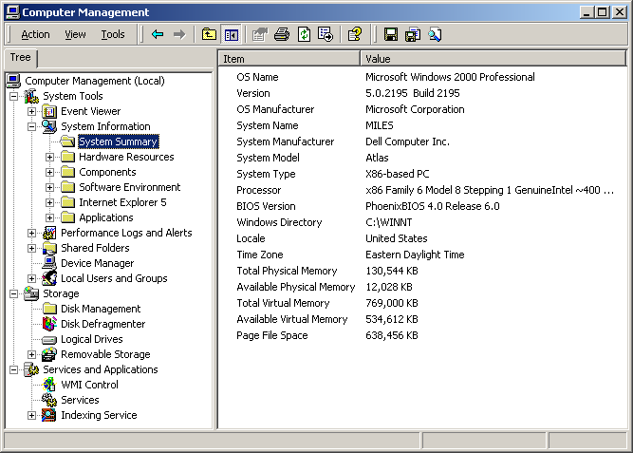

Figure 1: Windows Management Console

The Windows Management Console is a very important tool for routine Windows domain administration. It is completely integrated with the Windows security model so it can be customized to allow different users and groups to perform various administrative tasks. For example you could modify the interface such that an administrative person could create and delete user accounts.

Administrators of HPC clusters often want to verify that all compute nodes are configured identically, or that a given service is running on all nodes. The Management Console does not provide a cluster-wide overview. It is strictly designed for a node-at-a-time monitoring/maintenance. However, much of the information the Management Console provides is obtained from the Windows Management Instrumentation interface which can be accessed directly by scripting or compiled programming languages to develop tools that do provide a cluster-wide interface. The following sections provide some examples of this.

2. Performance Monitor

The Microsoft Performance Monitor is a useful tool for monitoring the complete range resource usage and system counters. If can be accessed as a separate application as in Figure 2 or as part of the Management Console, Figure 1. Like the Management Console it is integrated with the Windows 2000 security model so users and groups can be given the access rights to perform various types of monitoring activities. The Performance Monitoring tool also allows administrators to setup logging and alerts for various resources. For example, memory usage can be logged and an alert generated if usage reaches a specific threshold.

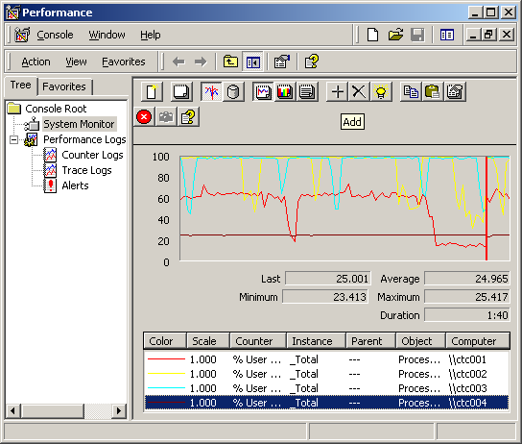
Figure 2: Windows Performance Monitor

Again, like the Management Console, using the Performance Monitor for HPC parallel applications is stretching the bounds of its usefulness. A common thing for a user to want to be able to do is to monitor all the compute nodes allocated to their parallel job for things like CPU and Memory utilization. Assume a user is allocated a large number of nodes (over 100 for argument sake) in a large cluster of over 1000 nodes, it would take the user an extremely long time to setup performance monitor to watch CPU utilization on those nodes. Again, Microsoft has provided an API to PDH.dll (the dynamic link library that Performance Monitor
Accesses) so that customized tools of this nature can easily be developed.

3. Windows Management Instrumentation

Windows Management Instrumentation, WMI, provides a COM and COM+ accessible interface for an incredibly rich set of information on systems in a Windows domain. Because WMI access is based on COM you can access from not only compiled languages like C and C++, but also scripting languages like Visual Basic, Perl and Python. The WMI Software Development Kit is available for no charge from the MSDN web site. (See the URL in the references section) It contains complete documentation for the complete list of items you can query. Several of the information classes even allow pre-emptive administration. For example, monitoring disks for errors so they can be addressed before a failure. The real value of WMI is that using scripts to monitor very large domains and reporting anomalies is far more efficient that trying to keep on a machine-to-machine basis. The best way to demonstrate the power of WMI is with a short example. Figure 4 shows a cmd shell that has just executed a short perl script, named wmi.pl, to capture the same information that the Management Console in Figure 1 is showing. Below Figure 4 is the source code for this Perl script. This was run under Windows 2000 using ActiveState Perl version 5.6. This script can easily be modified to collect far more information and over an entire Windows domain.

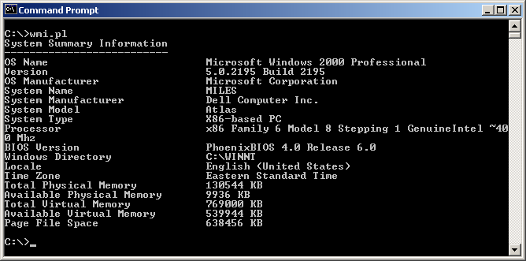Figure 4: Sample Perl-WMI Script Output

Perl Example: Accessing WMI from Perl to Collect System Information

#!perl

# Simple Perl Script to illustrate use of WMI to gather system information
# and display it in the same format at the Windows Management Console

use Win32::OLE qw(in with);
use Win32::Registry;

# Pick a host that you have the necessary rights to monitor

$host = "miles.tc.cornell.edu";

# Gather System Information

$WMI = Win32::OLE->new('WbemScripting.SWbemLocator') ||
die "Cannot access WMI on local machine: ", Win32::OLE->LastError;

$Services = $WMI->ConnectServer($host) ||
die "Cannot access WMI on remote machine: ", Win32::OLE->LastError;

# Gather Computer System Information

$sys_set = $Services->InstancesOf("Win32_ComputerSystem");
foreach $sys (in($sys_set))
{
$system_name = $sys->{'Caption'};
$system_type = $sys->{'SystemType'};
$system_manufacturer = $sys->{'Manufacturer'};
$system_model = $sys->{'Model'};
}

# Gather Processor Information
$processor_set = $Services->InstancesOf("Win32_Processor");
foreach $proc (in($processor_set))
{
$proc_description = $proc->{'Caption'};
$proc_manufacturer = $proc->{'Manufacturer'};
$proc_mhz = $proc->{'CurrentClockSpeed'};
}

# Gather BIOS Information

$bios_set = $Services->InstancesOf("Win32_BIOS");
foreach $bios (in($bios_set))
{
$bios_info = $bios->{'Version'};
}

# Gather Time Zone Information

$loc_set = $Services->InstancesOf("Win32_TimeZone");
foreach $loc (in($loc_set))
{
$loc_timezone = $loc->{'StandardName'};
}

# Gather Operating System Information

$os_set = $Services->InstancesOf("Win32_OperatingSystem");
foreach $os (in($os_set))
{
$os_name = $os->{'Caption'};
$os_version = $os->{'Version'};
$os_manufacturer = $os->{'Manufacturer'};
$os_build = $os->{'BuildNumber'};
$os_directory = $os->{'WindowsDirectory'};
$os_locale = $os->{'Locale'};
$os_totalmem = $os->{'TotalVisibleMemorySize'};
$os_freemem = $os->{'FreePhysicalMemory'};
$os_totalvirtmem = $os->{'TotalVirtualMemorySize'};
$os_freevirtmem = $os->{'FreeVirtualMemory'};
$os_pagefilesize = $os->{'SizeStoredInPagingFiles'};
}

# Now convert the system's Locale to a string
# Use the Rfc1766 Database stored in the Registry as a lookup table

$main::HKEY_LOCAL_MACHINE->Open("SOFTWARE\\Classes\\MIME\\Database\\Rfc1766",$Rfc1766);
$Rfc1766->GetValues(\%Values);
foreach $key (keys %Values)
{
$key = $Values{$key};
if ($$key[0] eq $os_locale)
{
($lang, $country) = split(/\;/, $$key[2]);
last;
}
}

print "System Summary Information\n";
print "--------------------------\n";
print "OS Name\t\t\t\t$os_name\n";
print "Version\t\t\t\t$os_version Build $os_build\n";
print "OS Manufacturer\t\t\t$os_manufacturer\n";
print "System Name\t\t\t$system_name\n";
print "System Manufacturer\t\t$system_manufacturer\n";
print "System Model\t\t\t$system_model\n";
print "System Type\t\t\t$system_type\n";
print "Processor\t\t\t$proc_description $proc_manufacturer ~$proc_mhz Mhz\n";
print "BIOS Version\t\t\t$bios_info\n";
print "Windows Directory\t\t$os_directory\n";
print "Locale\t\t\t\t$country\n";
print "Time Zone\t\t\t$loc_timezone\n";
print "Total Physical Memory\t\t$os_totalmem KB\n";
print "Available Physical Memory\t$os_freemem KB \n";
print "Total Virtual Memory\t\t$os_totalvirtmem KB\n";
print "Available Virtual Memory\t$os_freevirtmem KB\n";
print "Page File Space\t\t\t$os_pagefilesize KB\n";

Building Custom Tools

One of the most empowering aspects of Windows 2000 for HPC is that availability of tools like WMI that can be used to build custom tools for what a particular installation needs. At the Cornell Theory Center and interface was developed in Visual Basic that interfaces with WMI and the Cluster CoNTroller parallel job scheduling system so that users and administrators could monitor resources on a per job basis. A snapshot of this interace is shown in Figure 4. The Cornell Theory Center has developed a large number of custom tools to assist staff in the administration of the over 200 computing nodes of their Windows 2000 HPC cluster.

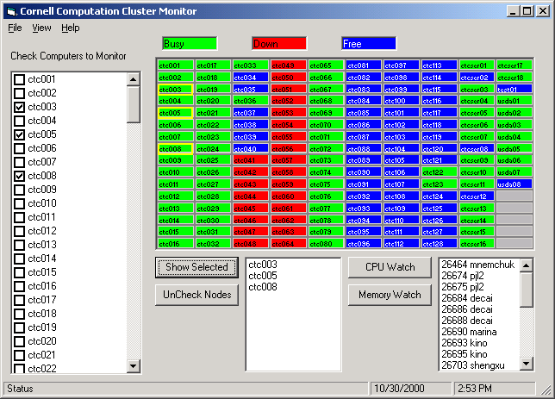

Figure 5: CTC Domain Monitor Tool

Perl Script to Monitor Cluster CoNTroller Node Status

Figure 7 illustrates the output of a simple Perl script using the Tk module to display cluster usage information that is obtained from Cluster CoNTroller. The Cluster CoNTroller command “ccusage” provides text based output like that in Figure 6. This information is easily parsed by the Perl script below Figure 7 and converted to a graphical interface that makes it easy to monitor the state of the cluster. One could easily combine the example Perl scripts in this document to allow administrators to poll WMI information from cluster nodes from this graphical interface.

ctc001.tc.cornell.edu Busy ripoll 26516 10/28 17:19
ctc002.tc.cornell.edu Busy ripoll 26516 10/28 17:19
ctc003.tc.cornell.edu Busy ripoll 26516 10/28 17:19
ctc004.tc.cornell.edu Busy ripoll 26516 10/28 17:19
ctc005.tc.cornell.edu Busy ripoll 26516 10/28 17:19
ctc006.tc.cornell.edu Busy ripoll 26516 10/28 17:19
.
.
.
ctc052.tc.cornell.edu Down
ctc053.tc.cornell.edu Down
ctc054.tc.cornell.edu Down
ctc055.tc.cornell.edu Down
ctc056.tc.cornell.edu Down
.
.
.
ctc124.tc.cornell.edu Free
ctc125.tc.cornell.edu Free
ctc126.tc.cornell.edu Free
ctc127.tc.cornell.edu Free
ctc128.tc.cornell.edu Free

Figure 6: Sample Cluster CoNTroller “ccusage” Output

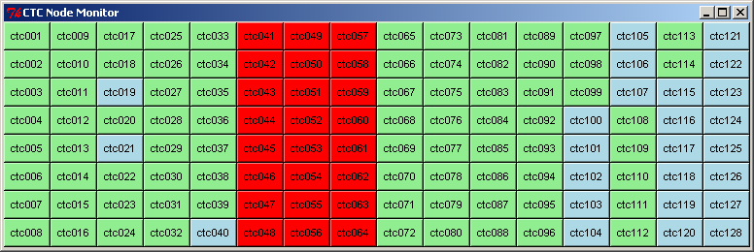

Figure 7: CTC Cluster CoNTroller Node Monitor Tool

Perl based Cluster CoNTroller Monitoring Tool

#!perl

use Tk;

$mw = MainWindow->new;
$mw->title("NTmon");
$node_frame = $mw->Frame()->pack;
$mode_frame = $mw->Frame()->pack;
&update;
$node_frame->repeat(60000, \&update); # refresh once every minute
MainLoop();

sub update
{
$rows = 0;
$cols = 0;
# Issue the Cluster CoNTroller command to list the status of each Cluster node
open(NODES,"ccusage |") || die "Cannot open ccusage\n";
while(<NODES>)
{
$chomp;
($host, $status, $user, $jid) = split;
next if (!($host =~ "\.cornell\.edu"));
($host) = split(/\./);
if ($status eq "Busy") { $bg_color = lightgreen; $abg_color = lightgreen; }
if ($status eq "Free") { $bg_color = lightblue; $abg_color = lightblue; }
if ($status eq "Down") { $bg_color = red; $abg_color = red; }

$rows = $rows % 8; # Display 8 nodes per row
$rows++;

$button{$host} = $node_frame->Button(-text => $host,
-font => "Arial 8 normal", -activebackground => $abg_color,
-background => $bg_color, -command => sub { })->
grid(-row => $rows, -column => $cols);
if ($rows == 8) { $cols++; }
}
close(NODES);
}

References

Cornell Theory Center:
http://www.tc.cornell.edu
http://www.tc.cornell.edu/AC3/
http://www.tc.cornell.edu/UserDoc/Cluster/

Cluster CoNTroller:
http://www.mpi-softtech.com/products/cluster_controller/default.asp

Microsoft Management Console:
http://www.microsoft.com/WINDOWS2000/library/howitworks/management/mmcover.asp

PDH:
http://www.microsoft.com/msj/0598/hood0598.htm

Perl:
http://www.perl.com/pub
http://www.perl.org/
http://www.roth.net/perl/
http://www.roth.net/books/extensions/
http://www.roth.net/books/handbook/
http://www.activestate.com/Products/ActivePerl/index.html
Python:
http://www.python.org/
http://www.python.org/windows/win32com/
http://www.activestate.com/Products/ActivePython/index.html

Visual Basic:
http://msdn.microsoft.com/vbasic/default.asp

WMI:
http://msdn.microsoft.com/downloads/sdks/wmi/default.asp
http://msdn.microsoft.com/library/backgrnd/html/wmicim.htm
http://www.microsoft.com/WINDOWS2000/library/howitworks/management/wmiscripts.asp

