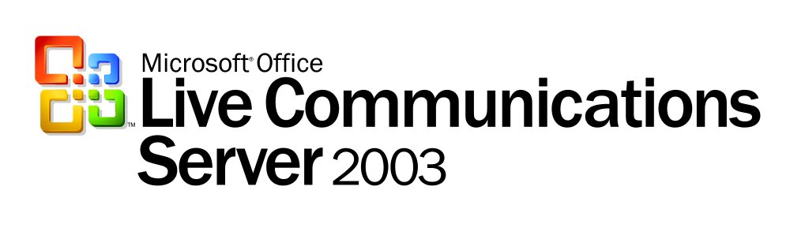
Feature Guide

Microsoft® Office Live Communications Server 2003 Standard Edition provides enterprise-ready instant messaging (IM), presence technology, and an extensible platform for connecting people, information and business processes all within a familiar, integrated user experience enabling better and faster decision making. Live Communications Server 2003 also offers standards-based, managed IM with functionality that includes logging, archiving, file transfer, audio and video conferencing, and application sharing.
The powerful presence technology included in Live Communications Server allows users to discover if others are available to collaborate, communicate and share information. Presence awareness is a critical enterprise capability that seamlessly integrates with the Microsoft Office System and line-of-business (LOB) applications, providing information workers with instant access to team members as they work. By combining Live Communications Server presence awareness and IM with the Microsoft Office System, businesses improve communication and achieve faster results.
Built on industry-standard protocols, Live Communications Server supports Session Initiation Protocol (SIP) and SIP for Instant Messaging and Presence Leveraging Extensions (SIMPLE). These standards ensure an extensible platform for all real-time communications, including chat, video and audio conferencing, data collaboration, and more.
This guide provides details about the features and capabilities of Live Communications Server. Features are grouped into three main benefit categories:
- Connect People, Information and Processes in Real Time
- Designed for Enterprise-Grade Security and Manageability
- An Extensible, Standards-Based Platform

Connect People, Information and Processes in Real Time

Instant Messaging
IM makes sending and receiving text messages in real time a fast and efficient way to communicate. Additionally, Live Communications Server IM allows people to do more than simply exchange text. Live Communications Server enables people to start a Web-based voice and video discussion, to exchange rich information and to share a document or application. Empowering people with Live Communications Server IM enables them to make decisions in real time and improves productivity through faster communication and decision making.
With multiparty IM, three or more people can participate in an IM conversation at the same time
(see the Business Scenario to the right). One IM participant may join or leave the session without interrupting the other participants, and any participant may add others to the session as needed. Using multiparty IM, users can come together with the right resources to resolve issues instantly and efficiently.
Business Scenario
As he prepared for an executive review the next day, Frank was growing concerned. He needed to gather information quickly to understand why sales figures were down in France. He checked his Contact list in Windows Messenger and noticed that his financial analyst and the French sales director were both online and available. Together they gave Frank the story in a live, three-way chat. Frank was able to share data, ask questions and get answers in less than 10 minutes.
Not only does Live Communications Server increase the speed of collaboration, but its multiparty IM feature also reduces the cost of doing business. Multiparty IM contributes to lower infrastructure costs, because of reduced telecom usage and e-mail server load. Real-time remote collaboration in Live Communications Server also can reduce the need for business trips.

Presence and Microsoft Office Integration

With Live Communications Server, users can reach each other more efficiently through IM when they see team members’ status indicators in Microsoft Excel, Microsoft Word, Microsoft Outlook®, or Microsoft Office SharePoint™ Portal Server sites (see the open menu in the following illustration) or even in critical LOB applications. An icon next to each team member’s name changes to indicate his or her availability. This feature, known as presence awareness, lets other team members know if someone is online, offline, busy, away, on the phone, or out to lunch.
Live Communications Server seamlessly integrates presence awareness with the Microsoft Office System, to connect people, information and business processes more effectively. The integration of Live Communications Server, Windows Messenger 5.0 and the Microsoft Office System adds power to the standard and popular Office programs that users already know. Users can collaborate in real time on spreadsheets, documents and other files. A user can open a file, initiate an IM or voice-and-video discussion with a team member and begin to collaborate instantly.
Business Scenario
At a large healthcare organization, the staff was becoming increasingly frustrated. They spent too much time paging, waiting on hold, taking callbacks, reporting results to and receiving orders from physicians—and then documenting those actions. To ease this communication burden, the IT department deployed Live Communications Server because of its integrated presence awareness.
Staff members can now see who is available in real time. They initiate, respond to or ignore IM conversations without the productivity drains of disruptive phone calls, phone tag and paging. Today the healthcare staff members spend more time doing what they do best—caring for their patients.
Presence awareness means that Office programs can take advantage of the ability for Live Communications Server to detect whether a user is active and which device the user is logged on to (see the Business Scenario to the right). While working in Office programs, users can see who is logged on and can begin collaborating whenever they need to.
Presence awareness enhances productivity, but sometimes users also need privacy. The My Status feature allows users to set their presence status to Offline, Busy, Away, On the Phone, Out to Lunch or even Appear Offline, ensuring privacy when needed. Because of the tight integration that Live Communications Server provides, this presence status is also available in Office programs.
The integrated system of Live Communications Server, Windows Messenger and the Microsoft Office System can also detect a user’s presence on multiple devices. The capability for these integrated programs to recognize where to contact a user is called Multiple Points of Presence (MPOP). MPOP makes it easy for users to send the right type of message to the right device, reaching team members quickly when time is tight.

Familiar Client
By minimizing disruption to the user’s experience during system migrations, IT departments can reduce user frustration and save time. With the familiar and easy-to-use Windows Messenger client, users can gain all of the benefits of converting to a centralized IM system without the pain of learning a new set of tools. Users see instant returns on the Live Communications Server deployment, with no time-consuming and expensive training investments required.
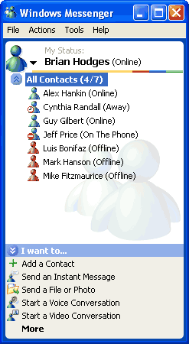
Windows Messenger 5.0 (see the illustration to the left) is a triple-stacked client, meaning that it supports three IM environments: Exchange IM, MSN® Instant Messaging and Live Communications Server. Users can continue to use the environment best suited to their needs.
This consistent user experience also allows for a phased migration from Exchange IM to Live Communications Server across the enterprise, without asking users to switch to a new client on multiple occasions.
The Windows Messenger client can also be custom-branded, for enterprises that wish to integrate IM into their corporate identity. Users can continue to interact with the same familiar client, while the enterprise gains flexibility to tie the look and feel of its IM system together with its other enterprise systems and LOB applications.

Seamless User Experience
With server-side contact lists in Live Communications Server, users can sign in from different machines and devices while preserving the same set of contacts. Users can also manage their contact list and their block list, in which they can block any other user from seeing whether they are online. With the increase in mobile computing, users frequently need to access the same lists from a desktop computer, a laptop computer and a mobile device. Server-side contact lists enable users to collaborate anytime, anywhere with ease.
In addition to accessing Live Communications Server from multiple devices, users may access it through multiple programs. One integrated console supports multiple entry points. These entry points include the following:
- Audio and visual communication
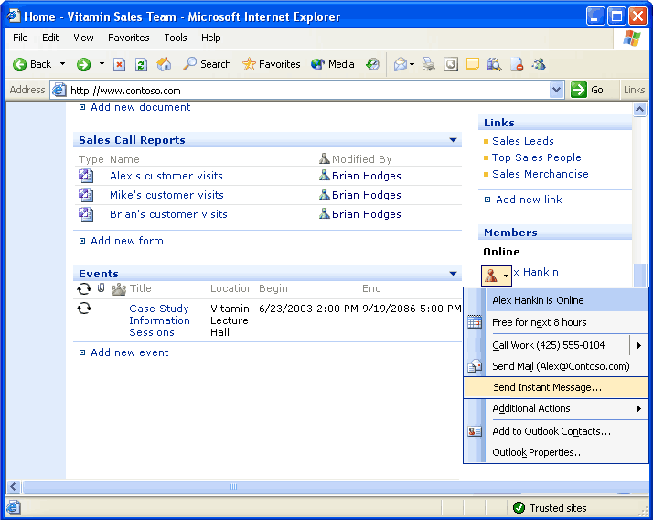
- Instant messaging
- Application sharing
- Notifications
- SharePoint sites
(see the illustration to the right)
- Microsoft Office System programs like Outlook and others
- Remote assistance
- File transfer

Audio, Visual and Data Collaboration
Live Communications Server makes it possible for collaboration and communication to be part of every application. Presence information from the server can be integrated into productivity applications and enterprise LOB applications. When users are working in a document and have questions, they can initiate an IM session with a team member, use Windows Messenger to share the file and make changes to the file together (see the following illustration).
In addition to sharing files during IM sessions, users can collaborate on several other levels:
- When IM does not provide enough collaborative discussion, users can immediately initiate an audio conversation, using a regular computer microphone and speakers or a headset device. Users can also make PC-to-phone and phone-to-PC audio calls through the standard public switched telephone network (PSTN) with an appropriate gateway deployment.
- Video conferencing adds another dimension to audio. In a video conference, users can see and hear each other in real time.
- With the whiteboard feature, users can write as they might in a conference room
on a traditional whiteboard. Additionally, users can paste content from other applications into the whiteboard if they want to share information without allowing other users to see their desktop.
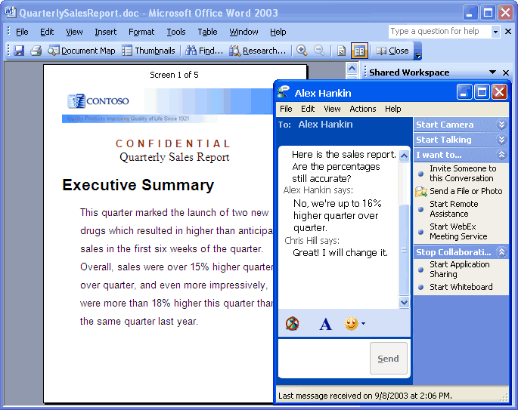
- With file transfer, users can transfer files as part of an IM conversation within Windows Messenger or another IM client.

Designed for Enterprise-Grade Security and Manageability

IM Archiving and Logging
IM in business has seen dramatic growth in popularity because of the advantages of real-time productivity. IM has replaced e-mail for many short or collaborative discussions. Live Communications Server enables companies to archive valuable business information and helps companies protect intellectual property and communication history (see the following Business Scenario).

Encryption and Authentication
Business Scenario
After implementing Live Communications Server, the IT department at a medium-sized company received an urgent call for help. The legal department needed memos, discussions and notes to help protect one of the company's patents. Before Live Communications Server, many staff members used public IM services to brainstorm and collaborate. Without an enterprise-wide standard
IM server, much of this intellectual property, critical to the company’s patent case, would have been lost.
With the IM archiving available in Live Communications Server, the IT department was able to respond with
a thorough record of the company’s intellectual property.
Although IM sessions may include valuable
intellectual property, many public IM sessions move as unencrypted clear text across an enterprise’s firewall. In some cases, these sessions are even routed through a third-party server that offers the enterprise no control over what happens to the information. This security problem has caused many enterprises to ban the use of IM, while enterprises that allow it are taking serious security risks.
Live Communications Server helps to provide an encrypted alternative to public IM services:
- All server-to-server traffic can be encrypted with Transport Layer Security (TLS).
- Clients have the option of encrypting traffic to the server by using Transport Layer Security (TLS).
- Real-Time Transfer Protocol (RTP) encryption is also supported.
As encryption in Live Communications Server helps to protect valuable intellectual property, authentication capabilities offer additional security and efficiency. To authenticate clients, Live Communications Server uses NTLM and Kerberos. Single sign-on for more secure IM sessions with users across multiple forests in Active Directory® directory service accelerates business processes. These capabilities enable real-time collaboration between branch offices, across geographical distances and with multiple teams and business partners in real time.

User Authorization through Active Directory
Active Directory is a central component of the Microsoft Windows® platform. It provides the means to manage the identities and relationships that make up a network environment.
Live Communications Server is tightly integrated with Active Directory to authorize users as they log in. This integration simplifies account management because IT departments can use existing Active Directory tools to manage accounts. Users retain the same identity within multiple applications across the network. IM applications, e-mail clients, Office programs, and customized bots that perform tasks on the network can all access account information from Active Directory and take advantage of the benefits of single sign-on access.
Integration with Active Directory also allows Live Communications Server to use Group Policy Object (GPO) in Active Directory to manage bandwidth policies. IT departments can set maximum limits on how much bandwidth is used in audio, video and file-transfer sessions.

Familiar Management Consoles
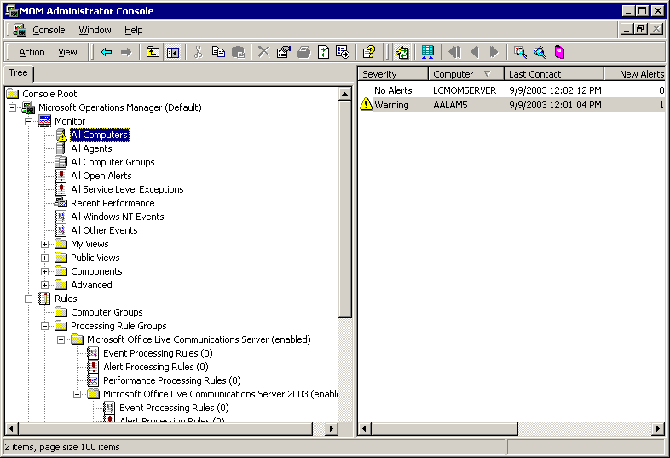
System administration across the enterprise requires investments in time and training.
To speed implementation and ease administrative hassles, Live Communications Server
can be monitored and managed through consoles that administrators already know (see
the following illustration). These consoles include Microsoft Operations Manager (MOM); Microsoft Management Console (MMC) snap-ins, including Active Directory Users and Computers; or any management console that is compliant with Windows Management Instrumentation (WMI). With a unified and familiar interface, administrative processes require less time and less training, reducing the overall cost of system management.

Scalability
The requirement for instant collaboration has redefined scalability in today’s enterprise. Rapidly changing business conditions demand that enterprises scale flexibly to respond to spikes in business and to support the rapid rollout of new products and services. Enterprise-level computing infrastructure must provide the ability to increase or decrease computing capacity almost instantly, while delivering quality and reliability. Live Communications Server delivers this combination of scalability, quality and reliability. Enterprises can scale their Live Communications Server systems on demand, in response to rapid changes in business.
With a server that meets the minimum recommended hardware requirements, a Live Communications Server system is capable of sustaining 10,000 peak concurrent users per server. During tests, this performance was achieved on a dual-processor 1.4-gigahertz Pentium III computer with two gigabytes of random access memory (RAM).

An Extensible, Standards-Based Platform

SIP Protocol Routing
SIP is an application layer control protocol that is used to create, modify and terminate sessions such as Internet telephone calls and multimedia conferences. It provides a bridge from IM signaling to richer multimodal signaling. SIP works across all networks and devices and has become an industry standard.
Business Scenario
The corporate store for a large bank was noticing an increasing backlog in its orders. Whenever branch offices had requests for stationery and other supplies, they needed to have long
e-mail and telephone conversations with corporate store workers. The current system could not keep up with demand.
The bank engaged a Microsoft partner to solve the problem. Developers quickly created an application that would take incoming orders and send automated instant messages using Live Communications Server technology to indicate supply availability and shipping status. Branch offices noticed the improved service immediately. They began receiving information as soon as they needed new supplies. Corporate store workers also appreciated their new level of efficiency. They no longer faced unmanageable order volumes, and instant messaging with customers made time-consuming phone tag a thing of the past.
By building its platform on SIP, Live Communications Server ensures extensibility and long-term integration options. IT departments that implement Live Communications Server solutions are adopting a standards-based platform that will increase and simplify interoperability between systems for many years to come.

Client and Server APIs
Live Communications Server makes its features and functionality available to developers through a set of application programming interfaces (APIs). These APIs support the industry-standard SIP and SIMPLE protocols and provide interoperability with PSTN. With these APIs, developers can create multimodal communications applications, integrate presence information about users into Line of Business applications and perform additional business logic on message traffic through the server (see the Business Scenario to the right).
Using the client API set developers can integrate IM and presence technology into a variety of Live Communications Server platform applications. So existing applications—like an ordering system or a customer database—can now show users who is online or offline and allow users to initiate live communication with another user within the application itself. Developers can also use the client API to build notification applications that act like users in the system. One notification scenario, for example, may track hundreds of users to see whether they are online or offline and send automated IMs to online users when an important event occurs.

The server API allows developers to build applications that interact with the SIP traffic on the server. By interacting with SIP traffic, applications can act as intelligent agents for users—for example, routing calls and messages to different devices during different hours of the day. Since the server API makes it possible to filter all of the SIP traffic on the server, developers also gain the power to introduce additional security measures like virus checking into their existing communications systems.

Rich Partner and Development Community
Because Live Communications Server is a Microsoft solution, customers have easy access to many experts in the development community, helping to ensure a hassle-free implementation. Microsoft is supported by more than 450,000 Microsoft Certified Systems Engineers (MCSEs) worldwide, plus vendors and partners. A large, established base of independent software vendors (ISVs) can help to extend the capabilities of Live Communications Server or provide customized solutions for vertical markets.
For more information about implementing a centralized, secure and extensible IM solution, visit http://www.microsoft.com/livecomm/ today.

The information contained in this document represents the current view of Microsoft Corporation on the issues discussed as of the date of publication. Because Microsoft must respond to changing market conditions, it should not be interpreted to be a commitment on the part of Microsoft, and Microsoft cannot guarantee the accuracy of any information presented after the date of publication.
This document is for informational purposes only. MICROSOFT MAKES NO WARRANTIES, EXPRESS, IMPLIED OR STATUTORY, AS TO THE INFORMATION IN THIS DOCUMENT.
Unless otherwise noted, the example companies, organizations, products, domain names, e-mail addresses, logos, people, places, and events depicted herein are fictitious, and no association with any real company, organization, product, domain name, email address, logo, person, place, or event is intended or should be inferred.
© 2003 Microsoft Corporation. All rights reserved.
Microsoft, Active Directory, Outlook, SharePoint, and Windows are either registered trademarks or trademarks of Microsoft Corporation in the United States and/or other countries.
The names of actual companies and products mentioned herein may be the trademarks of their respective owners.

